E
International Union for the Protection of New Varieties of Plants

Technical Working Party for Vegetables  Fifty-Seventh Session  Antalya, Türkiye, May 1 to 5, 2023 | TWV/57/21  Original: English  Date: March 28, 2023
Partial revision of the Test Guidelines for kohlrabi
Document prepared by an expert from the Netherlands
Disclaimer: this document does not represent UPOV policies or guidance
The purpose of this document is to present a proposal for a partial revision of the Test Guidelines for Kohlrabi (document TG/65/4 Rev.).
The Technical Working Party for Vegetables (TWV) at its fifty-sixth session, agreed that the Test Guidelines for Kohlrabi (Brassica oleracea L. convar. acephala (DC.) Alef. var. gongylodes L. (Brassica oleracea L. Gongylodes Group)) be partially revised (see document TWV/56/22 “Report”, Annex II).
The following changes are proposed:

- Revision of Characteristic 24 “Male sterility”
- Revision of explanation Ad. 24 “Male sterility”
- Addition of new Characteristics 25 to 28 “Resistance to Plasmodiophora brassicae (Pb)” Races Pb: 0, 1, 2 and 3 (clubroot)
- Addition of new explanation Ad. 25 to 28 “Resistance to Plasmodiophora brassicae (Pb)”
Races Pb: 0, 1, 2 and 3

The proposed changes are presented below in highlight and underline (insertion) and strikethrough (deletion).

Proposed revision of Characteristic 24 “Male sterility”

Current wording

 |  | English | français | deutsch | español | Example Varieties/  Exemples/  Beispielssorten/  Variedades ejemplo | Note/  Nota
24.  (*)  (+) | VG/  MS1 | Male sterility | Stérilité mâle | Männliche Sterilität | Androesterilidad
QL2 |  | absent | absente | fehlend | ausente | Expreß Forcer, Lanro | 1
 |  | present | présente | vorhanden | presente | Erika, Morre, Oasis | 9

¹ See document TGP/7 “Development of Test Guidelines”, Annex 3 “Guidance Notes (GN) for the TG Template”, GN 25 “Recommendations for conducting the examination” (http://www.upov.int/edocs/tgpdocs/en/tgp_7.pdf)

² See document TGP/7 “Development of Test Guidelines”, Annex 3 “Guidance Notes (GN) for the TG Template”, GN 20 “Presentation of characteristics: States of expression according to type of expression of a characteristic”, 2. “Qualitative Characteristics” (http://www.upov.int/edocs/tgpdocs/en/tgp_7.pdf)

Proposed new wording

 |  | English | français | deutsch | español | Example Varieties/  Exemples/  Beispielssorten/  Variedades ejemplo | Note/  Nota
24.  (*)  (+) | VG/  VS/  MS¹ | Male sterility | Stérilité mâle | Männliche Sterilität | Androesterilidad
QL² |  | absent | absente | fehlend | ausente | Expreß Forcer, Lanro | 1
 |  | present | présente | vorhanden | presente | Erika, Morre, Oasis | 9

¹ See document TGP/7 “Development of Test Guidelines”, Annex 3 “Guidance Notes (GN) for the TG Template”, GN 25 “Recommendations for conducting the examination” (http://www.upov.int/edocs/tgpdocs/en/tgp_7.pdf)

² See document TGP/7 “Development of Test Guidelines”, Annex 3 “Guidance Notes (GN) for the TG Template”, GN 20 “Presentation of characteristics: States of expression according to type of expression of a characteristic”, 2. “Qualitative Characteristics” (http://www.upov.int/edocs/tgpdocs/en/tgp_7.pdf)

Proposed revision of explanation Ad. 24 “Male sterility”

Current wording
Ad. 24: Male sterility
To be tested in a field trial and/or in a DNA marker test.
Field trial:
Check presence of pollen on stamen: if pollen on stamen is present then male sterility is absent; if pollen on stamen is absent then male sterility is present.
DNA marker test and/or field trial:

All varieties declared male sterile in the TQ can be examined in a field trial or in a DNA marker test³. In the case of a DNA marker test, if the CMS marker appears to be not present, a field trial should be performed to observe whether the variety is male sterile (on another mechanism) or fertile. All varieties declared fertile are to be tested in a field trial.

In case of a field trial, type of observation is VG. In case of a DNA marker test, type of observation is MS.

Proposed new wording

Ad. 24: Male sterility

To be tested in a field trial and/or in a DNA marker test.

Field trial:

Check presence of pollen on stamen: if pollen on stamen is present then male sterility is absent; if pollen on stamen is absent then male sterility is present.

DNA marker test and/or field trial:

All varieties, whether declared male fertile or male sterile in the TQ, can be examined in a field trial or in a DNA marker test.

In the case of a DNA marker test, if the CMS marker appears to be not present, a field trial should be perfomed to observe whether the variety is male sterile (on another mechanism) or fertile. the variety is expected to have male fertile flowers. In cases where the CMS marker appears to be present, the variety is expected to have male sterile flowers.All varieties declared fertile are to be tested in a field trial.

In case the DNA marker test result does not confirm the declaration in the TQ, a field trial should be performed to observe whether the variety has male fertile or male sterile flowers due to another mechanism.

In the case of a field trial, the type of observation is VG VS.In the case of a DNA marker test, the type of observation is MS.

Proposed addition of new Characteristics 25 to 28 “Resistance to Plasmodiophora brassicae (Pb)” Races Pb: 0, 1, 2 and 3 (clubroot)

 |  | English | français | deutsch | español | Example Varieties/  Exemples/  Beispielssorten/  Variedades ejemplo | Note/  Nota
25.  (+) | VG | Resistance to Plasmodiophora brassicae (Pb)  – Race Pb: 0 | Résistance à Plasmodiophora brassicae (Pb)  – Pathotype Pb: 0 | Resistenz gegen Plasmodiophora brassicae (Pb)  – Pathotyp Pb: 0 | Resistencia a Plasmodiophora brassicae (Pb)  – Raza Pb: 0
QL |  | absent | absente | fehlend | ausente | Express Forcer | 1
 |  | present | présente | vorhanden | presente | Fonda | 9
26.  (+) | VG | Resistance to Plasmodiophora brassicae (Pb)  – Race Pb: 1 | Résistance à Plasmodiophora brassicae (Pb)  – Pathotype Pb: 1 | Resistenz gegen Plasmodiophora brassicae (Pb)  – Pathotyp Pb: 1 | Resistencia a Plasmodiophora brassicae (Pb)  – Raza Pb: 1
QL |  | absent | absente | fehlend | ausente | Express Forcer | 1
 |  | present | présente | vorhanden | presente | Fonda | 9
27.  (+) | VG | Resistance to Plasmodiophora brassicae (Pb)  – Race Pb: 2 | Résistance à Plasmodiophora brassicae (Pb)  – Pathotype Pb: 2 | Resistenz gegen Plasmodiophora brassicae (Pb)  – Pathotyp Pb: 2 | Resistencia a Plasmodiophora brassicae (Pb)  – Raza Pb: 2
QL |  | absent | absente | fehlend | ausente | Express Forcer, Fonda | 1
 |  | present | présente | vorhanden | presente |  | 9
28.  (+) | VG | Resistance to Plasmodiophora brassicae (Pb)  – Race Pb: 3 | Résistance à Plasmodiophora brassicae (Pb)  – Pathotype Pb: 3 | Resistenz gegen Plasmodiophora brassicae (Pb)  – Pathotyp Pb: 3 | Resistencia a Plasmodiophora brassicae (Pb)  – Raza Pb: 3
QL |  | absent | absente | fehlend | ausente | Express Forcer | 1
 |  | present | présente | vorhanden | presente | Fonda | 9

Proposed addition of new explanation Ad. 25 to 28 “Resistance to Plasmodiophora brassicae (Pb)” Races Pb: 0, 1, 2 and 3

Ad. 25 to 28: Resistance to Plasmodiophora brassicae (Pb) Races Pb: 0, 1, 2 and 3

1. | Pathogen | Plasmodiophora brassicae
2. | Quarantine status | no
3. | Host species | Brassica oleracea
4. | Source of inoculum | Naktuinbouw (NL)
5. | Isolate | Race Pb: 0, Pb: 1, Pb: 2 and Pb: 3
6. | Establishment isolate identity | with genetically defined differentials from Naktuinbouw (NL)
7. | Establishment pathogenicity | symptoms on susceptible Brassica oleracea varieties
8. | Multiplication inoculum
8.1 | Multiplication medium | Plant roots
8.2 | Multiplication variety | Bartolo (WC), Granaat (CC) ²
8.3 | Plant stage at inoculation | Seedling, 1 week after sowing
8.4 | Inoculation medium | Water
8.5 | Inoculation method | 2 ml spore suspension (10⁷ sp/ml)  Pipette to the base of each seedling.
8.6 | Harvest of inoculum | Harvest roots 6-8 weeks after inoculation
8.7 | Check of harvested inoculum | Microscopic count
8.8 | Shelf life/viability inoculum | Frozen 3 years, room temp 1-2 days
9. | Format of the test
9.1 | Number of plants per genotype | 20 plants per genotype
9.2 | Number of replicates | 2 replicates (2 x 10)
9.3 | Control varieties | Susceptible: Bartolo (WC) ²  Resistant to race Pb: 0 051632 Bejo (WC), Clapton (CF),  Lodero (RC)  Resistant to race Pb: 1 Clapton (CF), Lodero (RC)  Resistant to race Pb: 2 Lodero (RC)  Resistant to race Pb: 3 Bejo 051632 (WC)
9.5 | Test facility | glasshouse
9.6 | Temperature | 20-22°C
9.7 | Light | Natural, extended to 16 h if needed
9.9 | Special measures | saturated soil in the first week, and keep the soil wet to  decrease the soil temperature, but keep in mind that a moderate  amount of water is required to prevent rotting,
10. | Inoculation
10.1 | Preparation inoculum | Symptomatic roots are homogenized ca. 1 min in a blender.  Dilute clubs 1:4 with demineralised water. Prevent overheating  of the suspension by blending longer than 1 minute. (Beware:  longer periods of blending may cause overheating of the suspension)
10.2 | Quantification inoculum | count spores; adjust to 10⁷ spores per ml
10.3 | Plant stage at inoculation | 1 week old seedlings
10.4 | Inoculation method | Pipetting of 2 ml to the base of each seedling
10.5 | First observation | 4 weeks after inoculation (visual)
10.6 | Second observation | 5 weeks after inoculation (visual)
10.7 | Final observations | 6 weeks after inoculation (visual)
11. | Observations
11.1 | Method | Visual: observation of severe galling and growth retardation  Destructive: observation on a 0-3 scale for galling
11.2 | Obervation scale | grade 0 = no swellings or a few small spheroid galls  grade 1 = very slight swelling, usually confined to the lateral roots  grade 2 = moderate swelling on lateral and/or tap roots or  slight swelling of the main root and browning and ultimately death of all the lateral roots  grade 3 = severe swelling on lateral and/or tap roots
11.3 | Validation of test | evaluation of variety resistance should be calibrated with results  of resistant and susceptible controls
12. | Interpretation of data in terms of UPOV characteristic states | absent [1] symptoms grade 2 and 3.  present [9] symptoms grade 0 and 1
13. | Critical control points

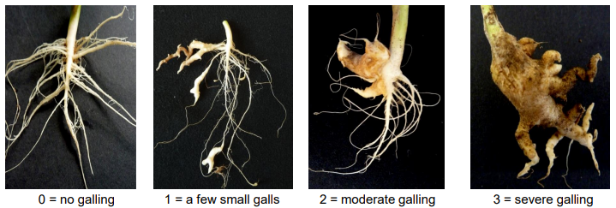

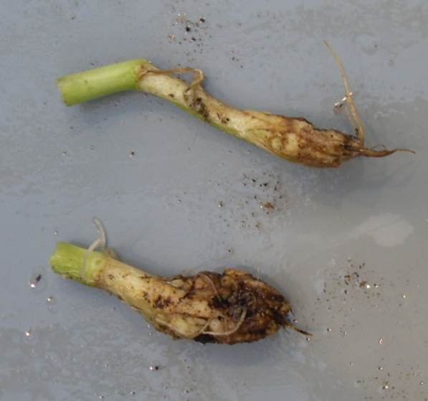
2 = slight swelling of the main root, no lateral roots

[End of document]

organized by electronic means, from April 18 to 22, 2022
The description of the method to test male sterility for Brassica (CMS marker) is covered by a trade secret. The owner of the trade secret, Syngenta Seeds B.V., has given its consent for the use of the CMS marker solely for the purposes of examination of Distinctness, Uniformity and Stability (DUS) and for the development of variety descriptions by UPOV and authorities of UPOV members. Syngenta Seeds B.V. declares that neither UPOV, nor authorities of UPOV members that use the CMS marker for the above purposes will be held accountable for possible (mis)use of the CMS marker by third parties. Please contact Naktuinbouw, Netherlands, to obtain the method and information on the CMS marker for the purposes mentioned above.
Naktuinbouw: resistentie@naktuinbouw.nl ² WC=White cabbage, CC=Chinese cabbage, RC=Red cabbage, CF=Cauliflower

