E
International Union for the Protection of New Varieties of Plants

Technical Working Party for Vegetables  Fifty-Seventh Session  Antalya, Türkiye, May 1 to 5, 2023  Technical Working Party for Agricultural Crops  Fifty-Second Session  Virtual meeting, May 22 to 26, 2023  Technical Working Party for Ornamental Plants and Forest Trees  Fifty-Fifth Session  Virtual meeting, June 12 to 16, 2023  Technical Working Party for Fruit Crops  Fifty-Fourth Session  Nîmes, France, July 3 to 7, 2023 | TWP/7/2  Original: English  Date: April 4, 2023
Development of guidance and information materials
Document prepared by the Office of the Union
Disclaimer: this document does not represent UPOV policies or guidance

EXECUTIVE SUMMARY

The purpose of this document is to provide an overview of the development of guidance and information materials.

This document is presented in two sections. The first section, “Matters for consideration by the Technical Working Parties” (TWPs) identifies matters where the Technical Committee has invited the TWPs to consider proposals for possible future revision of guidance and information materials. The second section, “Matters for information”, is provided for information but does not require consideration at this stage.

Matters for consideration by the Technical Working Parties

Document TGP/7 “Development of Test Guidelines”:

Example varieties for asterisked quantitative characteristics when illustrations are provided

The TWPs are invited to:

- consider the situations described by the TWO as the basis to develop guidance on possible exceptions to the requirement to provide example varieties for asterisked quantitative characteristics when illustrations were provided; and

- specify situations where such approach would be applicable.

Disease resistance characteristics: Addition of state of expression and placement of non-asterisked disease resistance characteristics in Section 5 of the Technical Questionnaire

The TWPs are invited to consider amending document TGP/7 GN 13 “Characteristics with specific functions” to clarify that disease resistance characteristics should be presented in Section 5 of Technical Questionnaires (TQ) with the addition of a state of expression “not tested”, as set out in paragraph 21 of this document.

Document TGP/12 ‘Guidance on certain physiological characteristics’

Example disease resistance characteristic: Word “highly” in only one state of expression

The TWV is invited to consider whether to revise the states of expression in the example characteristic in document TGP/12/2, Section 2.3.2, to address the use of the word “highly” in only one state of expression.

Matters for information

The TWPs are invited to note the matters for information on revision of guidance and information materials presented in this document.

Program for the development of relevant guidance and information materials

The TWPs are invited to note that the Council, at its fifty-sixth ordinary session, approved the work of the TC and the work programs of the TWPs reported to the Council, as provided in document TC/58/31 “Report”.

The structure of this document is as follows:
EXECUTIVE SUMMARY 1
Background 3
matters for consideration by the technical working parties 3
Document TGP/7 “Development of Test Guidelines” 3
Example varieties for asterisked quantitative characteristics when illustrations are provided 3
Disease resistance characteristics: Addition of state of expression and placement of non-asterisked disease resistance characteristics in Section 5 of the Technical Questionnaire 5
Document TGP/12 ‘Guidance on certain physiological characteristics’ 6
Example disease resistance characteristic: Word “highly” in only one state of expression 6
matters for information 7
Revisions of guidance and information materials adopted by the Council in 2022 7
Information Materials 7
Explanatory Notes 7
TGP Documents 7
Matters for adoption by the Council in 2023 7
Document UPOV/INF/23 “UPOV Code System” 7
Converting standard wording in Test Guidelines into optional wording 8
Proposals for future revision of guidance and information materials 8
Document TGP/7 “Development of Test Guidelines” 8
Document TGP/8: Trial Design and Techniques Used in the Examination of Distinctness, Uniformity and Stability 9
Document TGP/9 “Examining Distinctness” 9
Program for the development of relevant information materials 10

The following abbreviations are used in this document:

CAJ: Administrative and Legal Committee
TC: Technical Committee
TWA: Technical Working Party for Agricultural Crops
TWF: Technical Working Party for Fruit Crops
TWM: Technical Working Party on Testing Methods and Techniques
TWO: Technical Working Party for Ornamental Plants and Forest Trees
TWV: Technical Working Party for Vegetables
TWPs: Technical Working Parties

Background

The TC, at its fifty-eighth session, and the CAJ, at its seventy-eight session, approved the program for the development of TGP documents, as set out in documents TC/58/5 and CAJ/79/3, respectively, subject to the conclusions at their sessions (see documents TC/58/31 “Report”, paragraphs 38 to 40, and CAJ/79/11 “Report”, paragraphs 10 to 31).

The approved guidance and information materials are published on the UPOV website at
http://www.upov.int/upov_collection/en/.

matters for consideration by the technical working parties

Document TGP/7 “Development of Test Guidelines”

Example varieties for asterisked quantitative characteristics when illustrations are provided

Background

The TWO, at its fifty-third session, agreed that most quantitative and pseudo-qualitative characteristics in ornamental Test Guidelines could be illustrated by drawings or photographs and only a few required example varieties, such as height, length, width and diameter.

The TC, at its fifty-seventh session, agreed to request the TWPs, at their sessions in 2022, to consider the proposal to amend document TGP/7 to remove the requirement to provide example varieties for asterisked quantitative characteristics when illustrations were provided and to clarify the situations when example varieties would still be required (see document TC/57/25 “Report”, paragraphs 40 and 41).

The TWPs, at their sessions in 2022, did not reach a consensus on the proposal to remove the requirement to provide example varieties for asterisked quantitative characteristics when illustrations were provided.

The TC, at its fifty-eight session, agreed to invite the TWPs, at their sessions in 2023, to consider the situations described by the TWO as the basis to develop guidance on possible exceptions to the requirement to provide example varieties for asterisked quantitative characteristics when illustrations were provided. The TC agreed to invite the TWPs to specify situations where such approach would be applicable (see document TC/58/31 “Report”, paragraphs 23 and 24).

Situations where illustrations could replace example varieties for asterisked quantitative characteristics

The TWO, at its fifty-fourth session, noted that Test Guidelines for ornamental plants included many quantitative and pseudo-qualitative floral characteristics, which were not measured and only visually observed (VG). The TWO agreed that the use of illustrations would be suitable to replace example varieties for such characteristics and further facilitate international harmonization. The TWO agreed that the following characteristics could be used as examples of the approach to replace example varieties when illustrations were provided (see document TWO/54/6 “Report”, paragraph 24):

- Document TG/336/1 “Coreopsis”:
Ad. 24: Ray floret: attitude of basal part (QN)

1 | 2 | 3 | 4
strongly  ascending | moderately ascending | weakly  ascending | horizontal

5 | 6 | 7
weakly  descending | moderately descending | strongly descending

- Document TG/336/1 “Coreopsis”:

Ad. 29: Ray floret: distribution of main color (PQ)

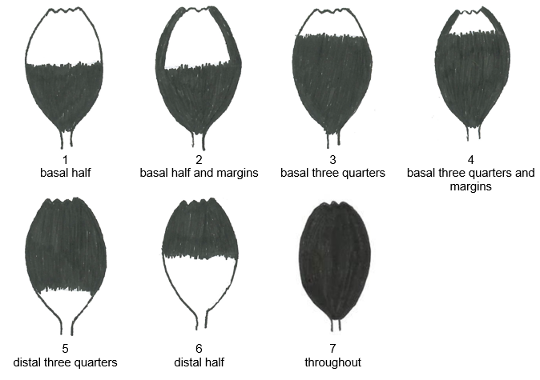

- Document TG/168/3 “Statice”: Ad. 24: Inflorescence: type (PQ)
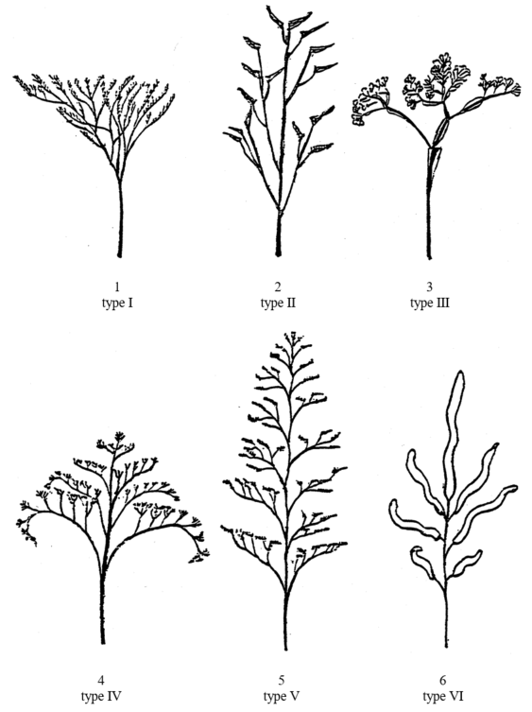
The TWPs are invited to consider the situations described by the TWO as the basis to develop guidance on possible exceptions to the requirement to provide example varieties for asterisked quantitative characteristics when illustrations were provided. The TWPs are invited to specify situations where such approach would be applicable.

The TWPs are invited to:

- consider the situations described by the TWO as the basis to develop guidance on possible exceptions to the requirement to provide example varieties for asterisked quantitative characteristics when illustrations were provided; and

- specify situations where such approach would be applicable.

Disease resistance characteristics: Addition of state of expression and placement of non-asterisked disease resistance characteristics in Section 5 of the Technical Questionnaire

Background

The TWV, at its fifty-fifth session, agreed to propose that disease resistance characteristics should be presented in Section 5 of Technical Questionnaires (TQ) with the addition of a state of expression “not tested”, when a characteristic was not indicated with an asterisk at the table of characteristics (see document TWV55/16 “Report”, paragraph 37 to 39).

The TC, at its fifty-eight session, agreed to invite the Office of the Union to present a proposal to the TWPs, at their sessions in 2023, to amend document TGP/7 GN 13 “Characteristics with specific functions” to clarify that non-compulsory disease resistance characteristics should be presented in Section 5 of Technical Questionnaires (TQ) with the addition of a state of expression “not tested”.

Proposal:

It is proposed that guidance in GN 13, paragraph 3.6, be amended to read as follows (additions indicated with highlighting and underline; and deletions indicated with highlighting and strikethrough):

“3.6 GN 13(4)(b) explains that “TQ characteristics selected from the Table of Characteristics should, in general, receive an asterisk in the Table of Characteristics”. Certain characteristics, particularly disease resistance characteristics, which are potentially useful as grouping characteristics might not be indicated with an asterisk in the Table of Characteristics. In the case of disease resistance characteristics, for example, there may be obstacles to the use of the characteristic for a number of members of the Union because of technical or quarantine requirements. Those same obstacles might also make it difficult for applicants to provide information on those characteristics if they were included in the Technical Questionnaire, Section 5 “Characteristics of the variety to be indicated”. Therefore, disease resistance characteristics not indicated with an asterisk at the table of characteristics may be presented in Section 5 of Technical Questionnaires (TQ) with the addition of a state of expression “not tested”. information should be sought in Section 7 “Additional information which may help in the examination of the variety” of the Technical Questionnaire. The guidance on the presentation of the characteristics for Section 5 (see GN 13.3 & 13.4 above would also apply for the presentation of characteristics in Section 7.”

The TWPs are invited to consider amending document TGP/7 GN 13 “Characteristics with specific functions” to clarify that disease resistance characteristics should be presented in Section 5 of Technical Questionnaires (TQ) with the addition of a state of expression “not tested”, as set out in paragraph 21 of this document.

Document TGP/12 ‘Guidance on certain physiological characteristics’

Example disease resistance characteristic: Word “highly” in only one state of expression

The TC, at its fifty-seventh session, considered the example disease resistance characteristic in document TGP/12, Section 2.3.2, and noted that the word “highly” was only used for the resistant state of expression. The TC agreed to invite the TWV to consider the example further (see document TC/57/25 “Report”, paragraphs 44 and 45):

“Example with “1–3” scale: Resistance to Sphaerotheca fuliginea (Podosphaera xanthii) “(Powdery mildew) in Melon (UPOV Test Guidelines: TG/104/5)

 |  | English |  |  | Example Varieties | Note
70.  (+) | VG | Resistance to Sphaerotheca fuliginea (Podosphaera xanthii)  (Powdery mildew)
70.1 |  | Race 1
QN |  | susceptible |  |  | […] | 1
 |  | moderately intermediate resistant |  |  | […] | 2
 |  | highly resistant |  |  | […] | 3

The TWV, at its fifty-sixth session, considered whether to revise the states of expression in the example characteristic in document TGP/12/2, Section 2.3.2, to address the use of the word “highly” in only one state of expression.

The TWV, at its fifty-sixth session, agreed to invite the experts from France and the Netherlands to propose draft guidance explaining the particular features of disease resistance characteristics that require special treatment in relation to general UPOV guidance, to be presented to the TWV, at its fifty-seventh session. The draft guidance should address matters such as establishing distinctness for quantitative disease resistance characteristics on the basis of a difference of one note between varieties; and explore possibilities for correlating the scales of UPOV characteristics with those used by phytopathologists for variety descriptions (see document TWV/56/22 “Report”, paragraph 19).

The TWV may wish to consider whether to revise the states of expression in the example characteristic in document TGP/12/2, Section 2.3.2, to address the use of the word “highly” in only one state of expression .

The TWV is invited to consider whether to revise the states of expression in the example characteristic in document TGP/12/2, Section 2.3.2, to address the use of the word “highly” in only one state of expression.

matters for information

Revisions of guidance and information materials adopted by the Council in 2022

The following guidance and information materials were adopted by the Council at its fifty-sixth ordinary session, held in Geneva on October 28, 2022 (see document C/56/15 “Report”, paragraphs 25 to 44):

Information Materials

Revision of document UPOV/INF/16 “Exchangeable Software”

The Council, at its fifty-sixth ordinary session, adopted a revision of document UPOV/INF/16/10 “Exchangeable Software”, on the basis of document UPOV/INF/16/11 Draft 1, with the inclusion of the PATHOSTAT application.

Revision of document UPOV/INF/22 “Software and Equipment Used by Members of the Union”

The Council, at its fifty-sixth ordinary session, adopted a revision of document UPOV/INF/22/8 “Software and equipment used by members of the Union”, on the basis of document UPOV/INF/22/9 Draft 1.

Explanatory Notes

Explanatory Notes on Variety Denominations under the UPOV Convention (document UPOV/EXN/DEN)

The Council, at its fifty-sixth ordinary session, to revise document UPOV/EXN/DEN/1, Annex I, Part II “Classes encompassing more than one genus” and agreed to propose the inclusion of genus “×Trititrigia” in the variety denomination Class 201.

TGP Documents

TGP/5: Experience and Cooperation in DUS Testing, Section 6: UPOV Report on Technical Examination and UPOV Variety Description (Revision) (document TGP/5: Section 6/4 Draft 1)

The Council, at its fifty-sixth ordinary session, adopted a revision of document TGP/5 “Experience and Cooperation in DUS Testing”, Section 6/3 “UPOV Report on Technical Examination and UPOV Variety Description”, on the basis of document TGP/5: Section 6/4 Draft 1.

TGP/8: Trial Design and Techniques Used in the Examination of Distinctness, Uniformity and Stability (Revision)

The Council, at its fifty-sixth ordinary session, adopted a revision of document TGP/8/4 for including guidance on “Different forms that variety descriptions could take and the relevance of scale levels”.

TGP/12: Guidance on Certain Physiological Characteristics (Revision)

The Council, at its fifty-sixth ordinary session, adopted a revision of document TGP/12/2 to replace state of expression “moderately resistant” by “intermediate resistant” in the example of disease resistance characteristic with ‘1-3’ scale.

Matters for adoption by the Council in 2023

Document UPOV/INF/23 “UPOV Code System”

Maximum number of characters in the appended element to UPOV codes

The TC, at its fifty-eight session, agreed to revise document UPOV/INF/23 “Guide to the UPOV Code System”, as follows (see document TC/58/31 “Report”, paragraph 22):

“5 UPOV CODE: APPENDED INFORMATION

“5.1 Appended element construction

“5.1.1. Where required, an element may be appended to a UPOV code to provide information on the variety group, variety type and/or denomination class.

“The appended element to UPOV codes is identifiable though the following naming convention:

- “A digit (number from 1 to 9) prefix identifies the new appended element.
- “Different digits or letters could, if appropriate, indicate different categories of information.
- “The appended element should contain a maximum of six digits or letters in total (e.g. ‘1AC2TG’)

“This element may be appended to any UPOV code, regardless of plant taxa (genera, species or subspecies levels). Examples:

“UPOV code for genus Abies: ABIES
“UPOV code with appended element: ABIES_1234 1AC2TG

“UPOV code for species Abies sibirica: ABIES_SIB
“UPOV code with appended element: ABIES_SIB_1234 1AC2TG

“UPOV code for sub-species Abies sibirica subsp. semenovii: ABIES_SIB_SEM
“UPOV code with appended element: ABIES_SIB_SEM_1234 1AC2TG”

Subject to agreement by the CAJ, at its eightieth session, an agreed version of document UPOV/INF/23 would be put forward for adoption by the Council, at its fifty-seventy ordinary session.

Converting standard wording in Test Guidelines into optional wording

The TC, at its fifty-eight session, agreed to amend document TGP/7 “Development of Test Guidelines” to convert the standard wording in the Test Guidelines template, paragraph 4.2.2, into additional standard wording (optional), as reproduced below (see document TC/58/31 “Report”, paragraph 26):

“4.2.2 These Test Guidelines have been developed for the examination of [type or types of propagation] varieties. For varieties with other types of propagation the recommendations in the General Introduction and document TGP/13 “Guidance for new types and species”, Section 4.5: “Testing Uniformity” should be followed.”

Subject to agreement by the CAJ, at its eightieth session, an agreed version of document TGP/7 would be put forward for adoption by the Council, at its fifty-seventy ordinary session.

Proposals for future revision of guidance and information materials

Document TGP/7 “Development of Test Guidelines”

Indication of grouping characteristics in UPOV Test Guidelines (Table of characteristics and TQ 5)

The TC, at its fifty-eight session, agreed to discontinue discussions on the proposal to revise document TGP/7 “Development of Test Guidelines” to indicate characteristics in the Table of Characteristics and Technical Questionnaire used as grouping characteristics (see document TC/58/31 “Report”, paragraph 25).

Document TGP/8: Trial Design and Techniques Used in the Examination of Distinctness, Uniformity and Stability

Section 9 “The Combined-Over-Years Uniformity Criterion (COYU)”

The TC, at its fifty-eight session, noted that a new version of DUSTNT incorporating COYU with splines (DUST9NT) was planned to be launched by September 2023, once the improvements identified from the testing campaign had been incorporated, including extrapolation (see document TC/58/31 “Report”, paragraphs 28 to 33).

The TC noted that further revisions to document TGP/8 would be required to incorporate guidance on extrapolation and minimum data requirements.

The TC noted the recommendation that there should be particular consideration of uniformity by the crop experts when extrapolation occurred.

The TC noted that the TWM had agreed that further discussion would be required on approaches when extrapolation was indicated and had agreed to invite the United Kingdom and other members to report at the second session of the TWM.

The TC agreed to request the TWM to prepare a report of the results of the test campaign of the software for COYU Splines for consideration by the TC, in conjunction with the revision of document TGP/8.

Document TGP/9 “Examining Distinctness”

Number of plants of comparing varieties in trial

The TWF, at its fifty-third session, considered document TWF/53/7 and a proposal prepared by experts from Brazil and the European Union to amend guidance in document TGP/9 “Examining Distinctness” to clarify the possibility to include in trials a lower number of plants for varieties of common knowledge under certain circumstances (see document TWF/53/14 “Report”, paragraphs 24 to 26).

The TWF agreed there were practical difficulties in implementing DUS trials of fruit crops with the same number of plants indicated in the Test Guidelines for both the candidate variety and a very similar variety of common knowledge. The TWF agreed that it should be possible to use a lower number of plants of the similar variety of common knowledge if uniformity does not need to be assessed.

The TWF agreed to propose amending document TGP/9 to read as follows:

“5.5.5 The required precision of records depends on the size of the difference between the candidate variety and the varieties of common knowledge. If two varieties are very similar it is important to ensure the same precision of the records for both varieties. The number of plants indicated in the Test Guidelines generally applies to both the candidate variety and the similar variety of common knowledge. In other cases, However, it may be possible to include in the trial a lower number of plants for the variety of common knowledge, provided that uniformity does not need to be assessed for that variety, i.e. varieties in the variety collection.”

The TC, at its fifty-eight session, considered the proposal from the TWF to amend document TGP/9 “Examining Distinctness” to clarify the possibility to include in trials a lower number of plants for varieties of common knowledge than the candidate variety, under certain circumstances, as set out in document TC/58/5, paragraph 60 (see document TC/58/31 “Report”, paragraphs 35 to 37).

The TC noted the practical difficulty reported by the TWF to organize growing trials with the same number of plants for example varieties and the candidate variety.

The TC agreed to invite the drafters from Brazil and European Union to develop the proposal taking into consideration the requirement of consistency with the other paragraphs of the section in document TGP/9, which concerned the required precision of records. The TC agreed that the revised proposal should be presented to the TWPs, at their sessions in 2023.

The experts from Brazil and the European Union have informed the Office of the Union that a document on this matter will be presented to the TWPs at their sessions in 2024.

Program for the development of relevant information materials

The Council, at its fifty-sixth ordinary session, approved the work of the TC and the work programs of the TWPs reported to the Council, as provided in document TC/58/31 “Report”. (see document C/56/15 “Report”, paragraph 60).

[End of document]

held via electronic means on October 24 and 25, 2022
held in Geneva on October 27, 2021
Hosted by the Netherlands and held via electronic means, from June 7 to 11, 2021
Held in Geneva, on October 24 and 25, 2022
Hosted by Germany and held via electronic means, from June 13 to 17, 2022
hosted by Turkey and held via electronic means, from May 3 to 7, 2021
Held in Geneva, on October 24 and 25, 2022
Held via virtual means on October 25 and 26, 2021
Held via virtual means, from April 18 to 22, 2022
Held via virtual means, from April 18 to 22, 2022
Held via virtual means, from July 11 to 15, 2022
Held in Geneva, on October 24 and 25, 2022

