E
International Union for the Protection of New Varieties of Plants

Technical Working Party for Vegetables  Fifty-Sixth Session  Virtual meeting, April 18 to 22, 2022 | TWV/56/8  Original: English  Date: March 8, 2022
MATTERS TO BE RESOLVED CONCERNING TEST GUIDELINES PUT FORWARD FOR ADOPTION BY THE TECHNICAL COMMITTEE: TOMATO ROOTSTOCKS
Document prepared by an expert from the Netherlands
Disclaimer: this document does not represent UPOV policies or guidance
The Enlarged Editorial Committee (TC-EDC), at its meeting held in Geneva, October 25 to 26, 2021, considered a proposal for a partial revision of the Test Guidelines for Tomato Rootstocks (document TC/57/18). The TC-EDC agreed that the technical issues raised on the proposed partial revision should be addressed by the TWV (see document TC/57/25 “Report”, Annex II).

The following table presents comments made by the TC-EDC on the proposed partial revision of the Test Guidelines for Tomato Rootstocks (document TC/57/18). The technical issues to be addressed by the TWV are indicated with “#”. The proposed responses from the Leading Expert, Ms. Cécile Marchenay (Netherlands), are presented under each comment from the TC-EDC.

#Char. 22,  Ad. 22 | to check whether to reduce the scale to 3 notes or to improve the explanation about scoring the characteristic using all notes on the scale of 5 notes.  Leading Expert: Scale 1 to 5 has been kept for the moment, including extra explanation about all notes.
#Ad. 22, 9.1, 9.4, 11.3 | to improve the explanation clarifying how would germination effect the scoring of the characteristic  Leading Expert: see Annex to this document
Ad. 22, 9.1 | to read “… due to nematode or not”  Leading expert: see Annex to this document (covered by comment above)
Ad. 22, 9.2 | to read “at least 2, preferably 3 to allow statistical analysis”  Leading Expert: prefer to keep “to allow statistical analysis”
Ad. 22, 9.6 | to read “20-26°C, the temperature may should be …”  Leading Expert: agreed
Ad. 22, 10.2 | to read “the ratio is depending of Quantity of inoculum depends on aggressiveness of test and lab’s growing conditions (e.g. between 30 g to 60 g of infested roots, for 100 plants in a tray of 45*30 cm containing approximately 5.5 kg of substrate);, galls should be homogeneously mixed with soil.”  Leading Expert: agreed
Ad. 22, 10.4 | to read “plants seed sown in soil contaminated with galls.”  Leading Expert: agreed
Ad. 22, 11.4 | to be deleted  Leading Expert: agreed
Ad. 22, 12. | in the figure, blue text: “Tyonoc” should read “Tyonic”  Leading Expert: figure removed, not applicable
Ad. 24, 12. | - to add the following wording:  “Absent [1] distribution of plants in the classes comparable with the susceptible controls.  “Present [9] distribution of plants in the classes comparable with the resistant controls.”  Leading Expert: agreed

The Annex to this document a new proposal for the explanation Ad. 22, based on the information above.

[Annex follows]

Proposed changes to the explanation Ad. 22 “Resistance to Meloidogyne incognita (Mi)”

Ad. 22: Resistance to Meloidogyne incognita (Mi)

1. | Pathogen | Meloidogyne incognita
2. | Quarantine status | -
3. | Host species | Tomato - Solanum lycopersicum
4. | Source of inoculum | GEVES (FR) or INIA (ES) or Naktuinbouw (NL)
5. | Isolate | non-resistance breaking
6. | Establishment isolate identity | use tomato standards
7 | Establishment pathogenicity | use susceptible rootstock or tomato standard
8. | Multiplication inoculum
8.1 | Multiplication medium | living plant
8.2 | Multiplication variety | susceptible variety, preferably resistant to powdery mildew
8.3 | Plant stage at inoculation | see 10.3 2nd leaf stage
8.5 | Inoculation method | see 10.4  deposit of piece of contaminated roots in soil (around 5-10g near each plant, to adapt depending on the population aggressivity)
8.6 | Harvest of inoculum | 6 to 10 weeks after inoculation, root systems are cut with scissors into pieces of about 1 cm length
8.7 | Check of harvested inoculum | visual check for presence of root knots and ripe egg masses
8.8 | Shelf life/viability inoculum | 1 day
9. | Format of the test
9.1 | Number of plants per genotype | 20 plants 30 plants  Remark: knowing that germination in rootstocks might be low and/or irregular it is recommended to sow more seeds to be sure to get at least 30 plants.
9.2 | Number of replicates | 1 replicate  at least 2, preferably 3 to allow statistical analysis
9.3 | Control varieties | Susceptible: Bruce and (Solanum lycopersicum) Clairvil, Casaque Rouge  Moderately Intermediate resistant: (Solanum lycopersicum)  Madyta, Campeon, Madyta, Vinchy, Tyonic  Highly resistant: Emperador and (Solanum lycopersicum) “Anahu x Casaque Rouge”, Anahu, Anabel
9.4 | Test design | include standard varieties  3 replicates of 10 plants in different trays by variety, non-inoculated plants in a separate tray
9.5 | Test facility | greenhouse or climate room
9.6 | Temperature | not over 28° C  20-26°C, the temperature should be adapted, depending on the aggressiveness of the test, to obtain the expected response of the controls, but should not exceed 26°C. Higher temperatures will cause breakdown of resistance.
9.7 | Light | at least 12 h per day
10 | Inoculation
10.1 | Preparation inoculum | small pieces of diseased roots mixed with soil  mix soil and infested root pieces
10.2 | Quantification inoculum | soil: root ratio = 8:1, or depending on experience  Quantity of inoculum depends on aggressivity of test and growing conditions (e.g. between 30g to 60g of infested roots for 100 plants in a tray of 45*30 cm containing approximately 5.5 kg of substrate); galls should be homogeneously mixed with soil.
10.3 | Plant stage at inoculation | seed, or cotyledons
10.4 | Inoculation method | plants are sown in infested soil or contamination of soil after sowing when plantlets are at cotyledon stage  Plants are sown in non-contaminated soil and contamination of soil is done after sowing when plantlets are at cotyledon stage.
10.7 | End of test | 28 to 45 days after inoculation depending on test conditions (temperature, season)
11. | Observations
11.1 | Method | root inspection per plant
11.2 | Observation scale
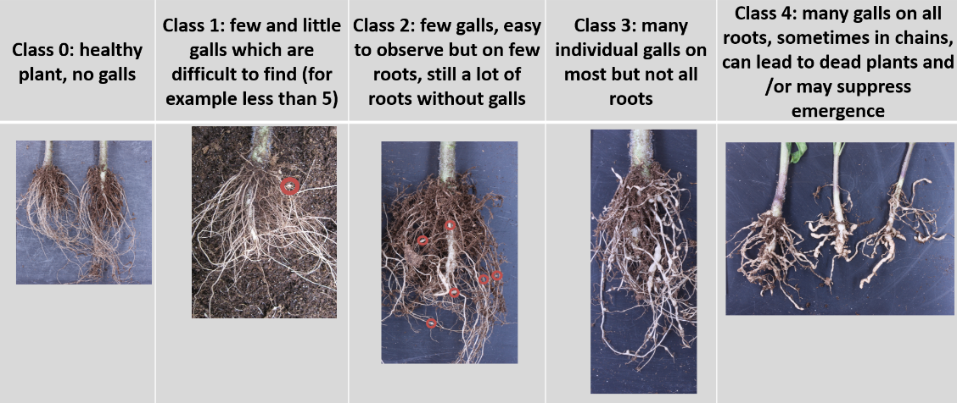

11.3 | Validation of test | evaluation of variety resistance should be calibrated with results of resistant and susceptible controls on standards  Validation on controls. Expected reactions of controls:  Susceptible control: most plants at classes 3 and 4.  Highly resistant: most plants at classes 0 and 1.  Intermediate resistant: clearly different from other controls with majority of plants around class 2.
11.4 | Off-types | resistant varieties may have a few plants with a few galls
12. | Interpretation of test results in comparison with control varieties data in terms of UPOV characteristic states | [1] Susceptible: distribution of plants in the classes comparable with the susceptible controls.  [2] Susceptible to intermediate resistant: distribution of plants in the classes between susceptible controls and intermediate resistant controls (significantly different from both).  [3] Intermediate resistant: distribution of plants in the classes comparable with the intermediate resistant controls.  [4] Intermediate resistant to highly resistant: distribution of plants in the classes between intermediate resistant controls and highly resistant controls (significantly different from both).  [5] Highly resistant: distribution of plants in the classes comparable with the highly resistant controls.  If results are not clear, statistical analysis is advised.
To consider that resistant varieties may have a few plants with falls. These are not considered as off-types.
absent (susceptible)………… [1] growth strongly reduced, high gall count
intermediate
(moderately resistant)………… [2] medium growth reduction, medium gall count
present (highly resistant)……… [3] no growth reduction, no galls
13. | Critical control points | Avoid rotting of roots; high temperature causes breakdown of resistance  Avoid overwatering. This may result in rotting of roots.  In case of aggressive test, decrease the quantity of inoculum.

[End of Annex and of document]

GEVES; matref@geves.fr
INIA; resistencias@inia.es
Naktuinbouw; resistentie@naktuinbouw.nl

