E
International Union for the Protection of New Varieties of Plants

Technical Working Party for Vegetables  Fifty-Sixth Session  Virtual meeting, April 18 to 22, 2022 | TWV/56/19  Original: English  Date: March 11, 2022
Partial revision of the Test Guidelines for Kohlrabi
Document prepared by an expert from the Netherlands
Disclaimer: this document does not represent UPOV policies or guidance
The purpose of this document is to present a proposal for a partial revision of the Test Guidelines for Kohlrabi (document TG/65/4 Rev.).

The Technical Working Party for Vegetables (TWV), at its fifty-fifth session organized by electronic means, from May 3 to May 7, 2021, agreed that the Test Guidelines for Kohlrabi (Brassica oleracea L. convar. acephala (DC.) Alef. var. gongylodes L.; Brassica oleracea L. Gongylodes Group) (document TG/65/4 Rev.) be partially revised for deleting Characteristic 11 “Leaf blade: divisions to midrib (on lower part of leaf)” and revising Characteristic 20 “Kohlrabi: color of skin” (see document TWV/55/16 “Report”, Annex III).

The following changes are proposed:

- Deletion of Characteristic 11 “Leaf blade: divisions to midrib (on lower part of leaf)” from Chapter VII. “Table of Characteristics”;
- Revision of explanation Ad. 11-13 in Chapter VIII. “Explanations on the Table of Characteristics” by removing the indication of Characteristic 11 from the illustration;
- Revision of Characteristic 20 “Kohlrabi: color of skin” in Chapter VII. “Table of Characteristics”
- Revision of Chapter X “Technical Questionnaire”, Section 5 “Characteristics of the variety to be given”:
  - Deletion of Characteristic 11 “Leaf blade: divisions to midrib (on lower part of leaf)”
  - Revision of Characteristic 20 “Kohlrabi: color of skin”

The proposed changes are presented below in highlight and underline (insertion) and strikethrough (deletion).

Proposal to delete Characteristic 11 “Leaf blade: divisions to midrib (on lower part of leaf)” from Chapter VII. “Table of Characteristics”

Current wording

 | English | français | deutsch | español | Example Varieties  Exemples  Beispielssorten  Variedades ejemplo | Note/  Nota
10.  (+) | Leaf blade: shape of apex | Limbe: forme de la partie apicale | Blattspreite: Form des oberen Teils | Limbo: forma del ápice
 | acute | aigüe | schmal spitz | aguda |  | 1
 | pointed | pointue | spitz | puntiaguda |  | 2
 | obtuse | obtuse | stumpf | obtusa | Avanti, Expreß Forcer | 3
 | rounded | arrondie | abgerundet | redondeada | Noriko, Spree | 4
 | broadly rounded | arrondie large | breit abgerundet | redondeada ancha | Gigant, Superschmelz | 5
11.  (*)  (+) | Leaf blade: divisions to midrib (on lower part of leaf) | Limbe: incisions jusqu’à la nervure principale (partie inférieure de la feuille) | Blattspreite: Einschnitte bis zur Mittelrippe (am unteren Teil des Blattes) | Limbo: divisiones de la nervadura principal (en la parte inferior de la hoja)
 | absent or very few | absentes ou très peu | fehlend oder  sehr wenige | ausentes o  muy escasas |  | 1
 | few | peu | wenige | escasas | Azur-Star | 3
 | medium | moyennes | mittel | medias | Noriko | 5
 | many | nombreuses | viele | numerosas | Avanti, Korist | 7
 | very many | très nombreuses | sehr viele | muy numerosas | Lanro | 9
12.  (+) | Leaf blade: number of margin incisions (on upper part of leaf) | Limbe: nombre d’incisions du bord (partie supérieure de la feuille) | Blattspreite: Anzahl Randeinschnitte  (am oberen Teil des Blattes) | Limbo: número de incisiones del borde (en la parte superior de la hoja)
 | absent or very few | nul ou très petit | fehlend oder  sehr gering | ausentes o  muy escasas |  | 1
 | few | petit | gering | escasas | Azur-Star | 3
 | medium | moyen | mittel | medias | Expreß Forcer | 5
 | many | grand | groß | numerosas |  | 7
 | very many | très grand | sehr groß | muy numerosas |  | 9

Proposed new wording

 | English | français | deutsch | español | Example Varieties  Exemples  Beispielssorten  Variedades ejemplo | Note/  Nota
10.  (+) | Leaf blade: shape of apex | Limbe: forme de la partie apicale | Blattspreite: Form des oberen Teils | Limbo: forma del ápice
 | acute | aigüe | schmal spitz | aguda |  | 1
 | pointed | pointue | spitz | puntiaguda |  | 2
 | obtuse | obtuse | stumpf | obtusa | Avanti, Expreß Forcer | 3
 | rounded | arrondie | abgerundet | redondeada | Noriko, Spree | 4
 | broadly rounded | arrondie large | breit abgerundet | redondeada ancha | Gigant, Superschmelz | 5
11.  (*)  (+) | Leaf blade: divisions to midrib (on lower part of leaf) | Limbe: incisions jusqu’à la nervure principale (partie inférieure de la feuille) | Blattspreite: Einschnitte bis zur Mittelrippe (am unteren Teil des Blattes) | Limbo: divisiones de la nervadura principal (en la parte inferior de la hoja)
 | absent or very few | absentes ou très peu | fehlend oder  sehr wenige | ausentes o  muy escasas |  | 1
 | few | peu | wenige | escasas | Azur-Star | 3
 | medium | moyennes | mittel | medias | Noriko | 5
 | many | nombreuses | viele | numerosas | Avanti, Korist | 7
 | very many | très nombreuses | sehr viele | muy numerosas | Lanro | 9
12. 11.  (+) | Leaf blade: number of margin incisions (on upper part of leaf) | Limbe: nombre d’incisions du bord (partie supérieure de la feuille) | Blattspreite: Anzahl Randeinschnitte  (am oberen Teil des Blattes) | Limbo: número de incisiones del borde (en la parte superior de la hoja)
 | absent or very few | nul ou très petit | fehlend oder  sehr gering | ausentes o  muy escasas |  | 1
 | few | petit | gering | escasas | Azur-Star | 3
 | medium | moyen | mittel | medias | Expreß Forcer | 5
 | many | grand | groß | numerosas |  | 7
 | very many | très grand | sehr groß | muy numerosas |  | 9

Proposal to revise explanation Ad. 11-13 in Chapter VIII. “Explanations on the Table of Characteristics” removing the indication of Characteristic 11 from the illustration

Current wording

Ad. 11-13: Leaf blade: divisions to midrib (11), margin incisions (12 and 13)

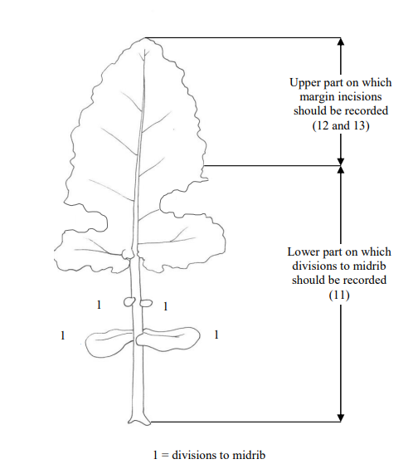

Proposed new wording

Ad. 11-13 11-12: Leaf blade: divisions to midrib (11), margin incisions (12 and 13) (11 and 12)

lobes: parts of the leaf blade are considered as lobes if the upper notch has at least half the length of the lobe itself.
Lappen: Teile der Blattspreite werden als Lappen angesehen, wenn der obere Einschnitt mindestens die Hälfte der Länge des Lappens ausmacht.
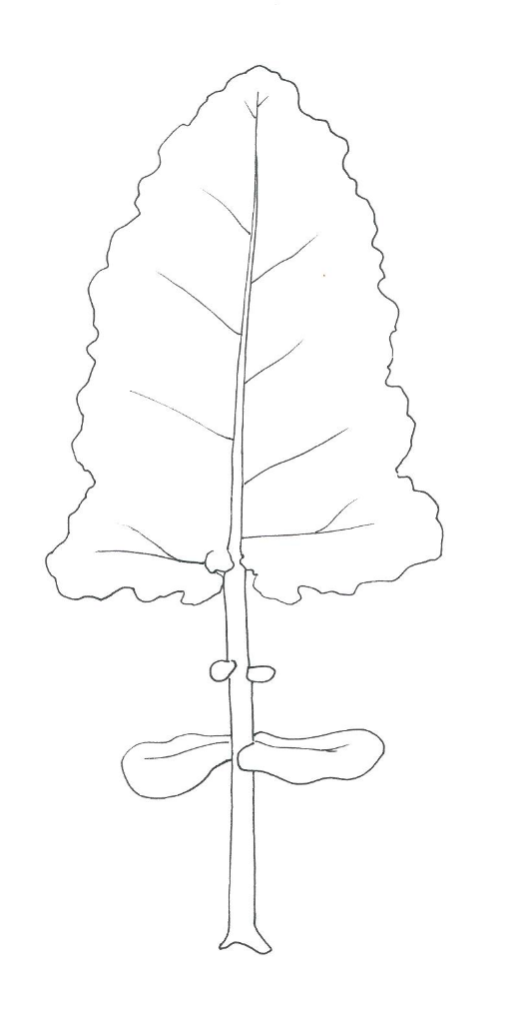

2
1
1
1
1
Lower part on which
divisions to midrib
should be recorded
(11)
Upper part on which
margin incisions
should be recorded
(12 11 and 13 12)

1
1
1 = divisions to midrib

Proposal to revise Characteristic 20 “Kohlrabi: color of skin” in Chapter VII. “Table of Characteristics”

Current wording

 | English | français | deutsch | español | Example Varieties  Exemples  Beispielssorten  Variedades ejemplo | Note/  Nota
20.  (*) | Kohlrabi: color of skin | Rave: couleur de l’épiderme | Kohlrabi: Farbe der Haut | Colinabo: color de la epidermis
 | white green | vert blanc | weißgrün | verde blanquecino | Expreß Forcer, Lanro | 1
 | green | vert | grün | verde | Erko, Noriko | 2
 | pale violet | violet clair | hellviolett | violeta pálido |  | 3
 | dark violet | violet foncé | dunkelviolett | violeta oscuro | Azur-Star | 4

Proposed new wording

 | English | français | deutsch | español | Example Varieties  Exemples  Beispielssorten  Variedades ejemplo | Note/  Nota
20.  (*) | Kohlrabi: color of skin | Rave: couleur de l’épiderme | Kohlrabi: Farbe der Haut | Colinabo: color de la epidermis
 | white | blanc | weiß | blanco | Beas | 1
 | white green | vert blanc | weißgrün | verde blanquecino | Bode, Expreß Forcer, Lanro, Timpano | 1 2
 | green | vert | grün | verde | Avaya, Erko, Gaston, Noriko | 2 3
 | pale violet | violet clair | hellviolett | violeta pálido |  | 3
 | dark violet | violet foncé | dunkelviolett | violeta oscuro | Azur-Star, Oder, Purpuran | 4

Proposal to revise Chapter X “Technical Questionnaire”, Section 5 “Characteristics of the variety to be given”

Current wording
5. Characteristics of the variety to be given (the number in brackets refers to the corresponding characteristics in the Test Guidelines; please mark the state of expression which best corresponds)

 | Characteristics | Example Varieties | Note
5.1  (1) | Seedling: anthocyanin coloration of cotyledons
 | absent | Expreß Forcer | 1[ ]
 | present | Azur-Star | 9[ ]
5.2  (11) | Leaf blade: divisions to midrib (on lower part of leaf)
 | absent or very few |  | 1[ ]
 | few | Azur-Star | 3[ ]
 | medium | Noriko | 5[ ]
 | many | Avanti, Korist | 7[ ]
 | very many | Lanro | 9[ ]
5.3  (15) | Leaf blade: blistering
 | weak | Avanti | 3[ ]
 | medium | Spree | 5[ ]
 | strong | Lanro | 7[ ]
5.4  (18) | Leaf blade: intensity of green color
 | very light |  | 1[ ]
 | light |  | 3[ ]
 | medium | Noriko, Quickstar | 5[ ]
 | dark | Avanti, Lanro | 7[ ]
 | very dark | Pader | 9[ ]
5.5  (20) | Kohlrabi: color of skin
 | white green | Expreß Forcer, Lanro | 1[ ]
 | green | Erko, Noriko | 2[ ]
 | pale violet |  | 3[ ]
 | dark violet | Azur-Star | 4[ ]
 | […]

Proposed new wording

5. Characteristics of the variety to be given (the number in brackets refers to the corresponding characteristics in the Test Guidelines; please mark the state of expression which best corresponds)

 | Characteristics | Example Varieties | Note
5.1  (1) | Seedling: anthocyanin coloration of cotyledons
 | absent | Expreß Forcer | 1[ ]
 | present | Azur-Star | 9[ ]
5.2  (11) | Leaf blade: divisions to midrib (on lower part of leaf)
 | absent or very few |  | 1[ ]
 | few | Azur-Star | 3[ ]
 | medium | Noriko | 5[ ]
 | many | Avanti, Korist | 7[ ]
 | very many | Lanro | 9[ ]
5.3 2  (15) | Leaf blade: blistering
 | weak | Avanti | 3[ ]
 | medium | Spree | 5[ ]
 | strong | Lanro | 7[ ]
5.4 3  (18) | Leaf blade: intensity of green color
 | very light |  | 1[ ]
 | light |  | 3[ ]
 | medium | Noriko, Quickstar | 5[ ]
 | dark | Avanti, Lanro | 7[ ]
 | very dark | Pader | 9[ ]
5.5 4  (20) | Kohlrabi: color of skin
 | white | Beas | 1[ ]
 | white green | Bode, Expreß Forcer, Lanro, Timpano | 1 2[ ]
 | green | Avaya, Erko, Gaston, Noriko | 2 3[ ]
 | pale violet |  | 3[ ]
 | dark violet | Azur-Star, Oder, Purpuran | 4[ ]
 | […]

[End of document]

