E
International Union for the Protection of New Varieties of Plants

Technical Working Party for Vegetables  Fifty-Sixth Session  Virtual meeting, April 18 to 22, 2022 | TWV/56/18  Original: English  Date: March 17, 2022
Partial revision of the Test Guidelines for Melon
Document prepared by an expert from France
Disclaimer: this document does not represent UPOV policies or guidance
The purpose of this document is to present a proposal for a partial revision of the Test Guidelines for Melon (document TG/104/5 Rev. 2).

The Technical Working Party for Vegetables (TWV), at its fifty-fifth session, hosted by Turkey and organized by electronic means, from May 3 to 7, 2022, agreed that the Test Guidelines for Melon (Cucumis melo L.) (document TG/104/5 Rev. 2) be partially revised for Characteristics 69 “Resistance to Fusarium oxysporum f. sp. melonis” and 70 “Resistance to Podosphaera xanthii (Sphaerotheca fuliginea) (Powdery mildew)” (see document TWV/54/9 “Report”, Annex III).

The following changes are proposed:

- Revision of Characteristics 69.1 to 69.4 “Resistances to Fusarium oxysporum f. sp. melonis (Fom) - races 0, 1, 2, and 1.2”;
- Revision of explanation Ad. 69 “Resistances to Fusarium oxysporum f. sp. melonis (Fom) - races 0, 1, 2, and 1.2” in Chapter 8.2 “Explanations for individual characteristics”;
- Revision of Characteristics 70.1 to 70.5 “Resistances to Podosphaera xanthii (Px) - races 1, 2, 3, 5, 3.5”;
- Revision of explanation Ads. 70.1 to 70.3, 71 “Resistances to Podosphaera xanthii (Px), Resistance to Golovinomyces cichoracearum (Erysiphe cichoracearum), race 1 (Powdery mildew) Gc (Ec)” in Chapter 8.2 “Explanations for individual characteristics”.

The proposed changes to are presented below in highlight and underline (insertion) and strikethrough (deletion).

Proposed revision of Characteristics 69.1 to 69.4 “Resistances to Fusarium oxysporum f. sp. melonis (Fom) - races 0, 1, 2, and 1.2”

Current wording

 |  | English | français | deutsch | español | Example Varieties/  Exemples/  Beispielssorten/  Variedades ejemplo | Note/  Nota
69. | VG | Resistance to Fusarium oxysporum f. sp. melonis | Résistance à Fusarium oxysporum f. sp. melonis | Resistenz gegen Fusarium oxysporum f. sp. Melonis | Resistencia al Fusarium oxysporum f. sp. melonis
 |  | ------------------------ | -------------------------- | -------------------------- | ------------------------ | --------------------------- | -------
69.1  (*)  (+) |  | Race 0 | Race 0 | Pathotyp 0 | Raza 0
QL |  | absent | absente | fehlend | ausente | Jaune Canari 2 | 1
 |  | present | présente | vorhanden | presente | Jador, Védrantais | 9
 |  | ------------------------ | -------------------------- | -------------------------- | ------------------------ | --------------------------- | -------
69.2  (*)  (+) |  | Race 1 | Race 1 | Pathotyp 1 | Raza 1
QL |  | absent | absente | fehlend | ausente | Jaune Canari 2, Védrantais | 1
 |  | present | présente | vorhanden | presente | Arapaho, Jador, Rubbens | 9
 |  | ------------------------ | -------------------------- | -------------------------- | ------------------------ | --------------------------- | -------
69.3  (*)  (+) |  | Race 2 | Race 2 | Pathotyp 2 | Raza 2
QL |  | absent | absente | fehlend | ausente | Arapaho,  Jaune Canari 2, Rubbens | 1
 |  | present | présente | vorhanden | presente | Anasta, Cléo, Jador, Védrantais | 9
 |  | ------------------------ | -------------------------- | -------------------------- | ------------------------ | --------------------------- | -------
69.4  (+) |  | Race 1.2 | Race 1.2 | Pathotyp 1.2 | Raza 1.2
QN |  | susceptible | sensible | anfällig | susceptible | Jaune Canari 2,  Védrantais, Virgos | 1
 |  | moderately resistant | moyennement résistant | mäßig resistent | moderadamente resistente | Lunasol | 2
 |  | highly resistant | hautement résistant | hochresistent | altamente resistente | Dinero, Isabelle | 3

Proposed new wording

 |  | English | français | deutsch | español | Example Varieties/  Exemples/  Beispielssorten/  Variedades ejemplo | Note/  Nota
69. A | VG | Resistance to Fusarium oxysporum f. sp. melonis (Fom) | Résistance à Fusarium oxysporum f. sp. melonis (Fom) | Resistenz gegen Fusarium oxysporum f. sp. melonis (Fom) | Resistencia al Fusarium oxysporum f. sp. melonis (Fom)
 |  | ------------------------ | -------------------------- | -------------------------- | ------------------------ | --------------------------- | -------
69.1  (*)  (+) |  | Race 0 (Fom: 0) | Race 0 | Pathotyp 0 | Raza 0
QL |  | absent | absente | fehlend | ausente | Jaune Canari 2  Atos, Charentais T | 1
 |  | present | présente | vorhanden | presente | Cadence,  Charentais Fom-2, Dibango, Jador, Jubilo, Karakal, Védrantais | 9
 |  | ------------------------ | -------------------------- | -------------------------- | ------------------------ | --------------------------- | -------
69.2  (*)  (+) |  | Race 1 (Fom: 1) | Race 1 | Pathotyp 1 | Raza 1
QL |  | absent | absente | fehlend | ausente | Jaune Canari 2  Atos, Charentais T,  Védrantais | 1
 |  | present | présente | vorhanden | presente | Arapaho, Jador, Rubbens  Cadence,  Charentais Fom-2, Dibango, Jubilo, Karakal | 9
 |  | ------------------------ | -------------------------- | -------------------------- | ------------------------ | --------------------------- | -------
69.3  (*)  (+) |  | Race 2 (Fom: 2) | Race 2 | Pathotyp 2 | Raza 2
QL |  | absent | absente | fehlend | ausente | Arapaho, Jaune Canari 2, Rubbens  Atos, Dibango, Marianna | 1
 |  | present | présente | vorhanden | presente | Anasta, Cléo, Jador, Cadence,  Charentais Fom-1, Jubilo, Karakal, Védrantais | 9
69. B  (+) | VG | Intermediate resistance to Fusarium oxysporum f. sp. melonis Race 1.2 (Fom: 1.2) | Resistance modérée à Fusarium oxysporum f. sp. melonis Race 1.2 (Fom: 1.2) | Mäßige Resistenz gegen Fusarium oxysporum f. sp. melonis Pathotyp 1.2 (Fom: 1.2) | Resistancia moderada a Fusarium oxysporum f. sp. melonis Raza 1.2 (Fom: 1.2)
QN |  | absent | absente | fehlend | ausente | Graffio, Prity, Virgos | 1
 |  | present | présente | vorhanden | presente | Isabelle, Kyriel, Lunasol, Meliance, Piboule | 9

Proposed revision of explanation Ad. 69 “Resistances to Fusarium oxysporum f. sp. melonis (Fom) - races 0, 1, 2, and 1.2” in Chapter 8.2 “Explanations for individual characteristics”

Current wording

Ads. 69.1 - 69.3: Resistance to Fusarium oxysporum f. sp. melonis, races 0, 1 and 2 (Fom)

1. | Pathogen | Fusarium oxysporum f. sp. melonis
2. | Quarantine status | no
3. | Host species | Cucumis melo
4. | Source of inoculum | GEVES (FR), Naktuinbouw (NL)
5. | Isolate | Fom: 0, Fom: 1, Fom: 2
6. | Establishment isolate identity | use differential varieties:

 | Gene | Race 0 | Race 1 | Race 2
Charentais T |  | S | S | S
Védrantais | Fom-1 | R | S | R
Charentais Fom-2 | Fom-2 | R | R | S
Isabelle, Jador |  | R | R | R

7. | Establishment pathogenicity | use susceptible melon varieties
8. | Multiplication inoculum
8.1 | Multiplication medium | on agar medium – e.g.Potato Dextrose Agar
8.2 | Multiplication variety | -
8.3 | Plant stage at inoculation | -
8.4 | Inoculation medium | on liquid medium
8.5 | Inoculation method | -
8.6 | Harvest of inoculum | -
8.7 | Check of harvested inoculum | -
8.8 | Shelflife/viability inoculum | -
9. | Format of the test
9.1 | Number of plants per genotype | at least 20
9.2 | Number of replicates | e.g. 3
9.3 | Control varieties | Jaune Canari 2 (susceptible)  Vedrantais, Arapaho, Rubbens, Anasta, Cleo (resistant, depending on the considered race)

 | Gene | Race 0 | Race 1 | Race 2
Jaune Canari 2 |  | S | S | S
Védrantais | Fom-1 | R | S | R
Arapaho, Rubbens | Fom-2 | R | R | S
Anasta, Cleo |  | R | R | R

9.4 | Test design | -
9.5 | Test facility | glasshouse or climatic room
9.6 | Temperature | 18-25°C
9.7 | Light | 12h
9.8 | Season | all seasons
9.9 | Special measures | optional: shading (no direct sunlight during 12 h after inoculation
10. | Inoculation
10.1 | Preparation inoculum | aerated culture 7-10 days, eg. Czapek Dox broth  some isolates need filtration or centrifugation  resuspend the pelleted spores in demineralized water
10.2 | Quantification inoculum | spore count; adjust to 10⁶ -10⁷ per mL
10.3 | Plant stage at inoculation | cotyledon expanded
10.4 | Inoculation method | soaking of the root system in a suspension of liquid medium of fungus  at least 30 sec - 5 min
10.5 | First observation | 7 days post inoculation
10.6 | Second observation | 14 -20 days post inoculation
10.7 | Final observations | 20 days post inoculation
11. | Observations
11.1 | Method | visual, comparative
11.2 | Observation scale
 | [1] absent | Growth retardation in combination with yellowing or wilting cotyledons (useful for judging the severity of the attack), possible internal vessel browning, death of plant.
 | [9] present | no symptoms
11.3 | Validation of test | on standards
11.4 | Off-types | -
12. | Interpretation of data in terms of UPOV characteristic states | QL
13. | Critical control points | For Race 1.2 the modified protocol on the next page should be used.

Ad. 69.4: Resistance to Fusarium oxysporum f. sp. melonis, race 1.2 (Fom)
1. | Pathogen | Fusarium oxysporum f. sp. melonis
2. | Quarantine status | no
3. | Host species | Cucumis melo
4. | Source of inoculum | GEVES (FR), Naktuinbouw (NL)
5. | Isolate | Fom: 1.2 (moderately aggressive): TST strain
6. | Establishment isolate identity | use differential varieties:  Védrantais, Virgos (susceptible)  Lunasol (moderately resistant)  Dinero, Isabelle (highly resistant)
7. | Establishment pathogenicity | use susceptible melon varieties
8. | Multiplication inoculum
8.1 | Multiplication medium | on agar medium e.g. Potato Dextrose Agar
8.2 | Multiplication variety | -
8.3 | Plant stage at inoculation | -
8.4 | Inoculation medium | on liquid medium
8.5 | Inoculation method | -
8.6 | Harvest of inoculum | -
8.7 | Check of harvested inoculum | -
8.8 | Shelflife/viability inoculum | -
9. | Format of the test
9.1 | Number of plants per genotype | at least 30
9.2 | Number of replicates | e.g. 3
9.3 | Control varieties
 | [1] susceptible | Védrantais, Virgos
 | [2] moderately resistant | Lunasol (the lowest accepted level)
 | [3] highly resistant | Dinero, Isabelle, Jador
9.4 | Test design | -
9.5 | Test facility | glasshouse or climatic room
9.6 | Temperature | 18-25°C
9.7 | Light | at least 12h
9.8 | Season | All seasons in a climatic room / in a greenhouse: be aware of the strong environmental effect: winter could be too severe and summer could be too mild.
9.9 | Special measures | optional shading (no direct sunlight during 12 h after inoculation)
10. | Inoculation
10.1 | Preparation inoculum | aerated culture 7-10 d old – e.g.: Czapek Dox broth
10.2 | Quantification inoculum | spore count; adjust to 2.10⁴ - 10⁵ per ml
10.3 | Plant stage at inoculation | cotyledons expanded
10.4 | Inoculation method | soaking of the trays in spore suspension; 700 ml for a tray with 25 - 30 plants, plants are not uprooted
10.5 | First observation | 7 - 14 days post inoculation
10.6 | Second observation | 14 - 21 days post inoculation
10.7 | Final observations | 21- 28 days post inoculation
11. | Observations
11.1 | Method | visual, comparative
11.2 | Observation scale | symptoms:
 | [1] susceptible | Védrantais: growth retardation, yellow cotyledons, drying, possible internal vessel browning, death of the plant
 | [2] moderately resistant | Symptoms may be present, but the level of expression must be distinctly lower than the susceptible control variety.  = the lowest level of resistance is defined by the behavior of Lunasol
 | [3] highly resistant | Symptoms may be present, but the level of expression must be lower than the moderately control variety Lunasol.
11.3 | Validation of test | on standards; Lunasol is intermediate and will show a percentage of diseased plants (quantitative evaluation)
11.4 | Off-types | calibrate with Lunasol
12. | Interpretation of data in terms of UPOV characteristic states | QN
13. | Critical control points | A moderately aggressive type of Fom: 1.2 should be used as this is likely to show the difference between the presence and absence of resistance most clearly.  There are two types of Fusarium oxysporum f. sp. melonis, Fom:1.2, viz. Fom: 1.2y which is a yellowing type with yellowing symptoms on leaves and another type and Fom: 1.2w which is a wilt type with wilting symptoms on leaves.

Proposed new wording

Ads. 69 A: 69.1 - 69.3: Resistance to Fusarium oxysporum f. sp. melonis, races 0, 1 and 2 (Fom: 0, Fom: 1, Fom: 2)

1. | Pathogen | Fusarium oxysporum f. sp. melonis races 0, 1, and 2
2. | Quarantine status | No
3. | Host species | Melon - Cucumis melo
4. | Source of inoculum | GEVES (FR) for races 0 and 1 Naktuinbouw (NL) for race 2
5. | Isolate | Fom: 0, Fom: 1, Fom: 2  e.g. Reference strain validated in an inter-laboratory test  Fom:0  - Strain MLZ  = MAT/REF/04-07-01-03-02¹  Fom: 1  - Strain FOM 26  = MAT/REF/04-07-01-01¹  Fom: 2  - Strain F185
6. | Establishment isolate identity | use differential varieties:  Test on differential hosts (potentially including Durango, see 13.). The most recent table is available through ISF at  https://www.worldseed.org/our-work/plant-health/differential-hosts/  Situation July 2019
Courtesy of Worldseed.org website

 | Gene | Race 0 | Race 1 | Race 2
Charentais T |  | S | S | S
Védrantais | Fom-1 | R | S | R
Charentais Fom-2 | Fom-2 | R | R | S
Isabelle, Jador |  | R | R | R

7. | Establishment pathogenicity | use susceptible melon varieties
8. | Multiplication inoculum
8.1 | Multiplication medium | on agar medium – e.g., Potato Dextrose Agar, Malt agar at 20°C to 25°C
8.2 | Multiplication variety | -
8.3 | Plant stage at inoculation | -
8.4 | Inoculation medium | on liquid medium
8.5 | Inoculation method | -
8.6 | Harvest of inoculum | 7-10 day-old culture
8.7 | Check of harvested inoculum | -
8.8 | Shelf life /viability inoculum | Between 4 to 8 h, keep cool to prevent spore germination
9. | Format of the test
9.1 | Number of plants per genotype | at least 20  at least 30 plants, it is important to have at least 5 non-inoculated plants per genotype to be able to judge growth reduction
9.2 | Number of replicates | At least e.g. 3 replicates
9.3 | Control varieties | Jaune Canari 2 (susceptible)  Vedrantais, Arapaho, Rubbens, Anasta, Cleo (resistant, depending on the considered race)

 | Gene | Race 0 | Race 1 | Race 2
Jaune Canari 2 |  | S | S | S
Védrantais | Fom-1 | R | S | R
Arapaho, Rubbens | Fom-2 | R | R | S
Anasta, Cleo |  | R | R | R

9.3.1 | Control varieties for the test with race 0 | Susceptible: Charentais T  Resistant: Védrantais, Charentais Fom-2
9.3.2 | Control varieties for the test with race 1 | Susceptible: Charentais T, Védrantais  Resistant: Charentais Fom-2
9.3.3 | Control varieties for the test with race 2 | Susceptible: Marianna (less susceptible than Charentais Fom-2, Charentais T)  Resistant: Charentais Fom-1
9.4 | Test design | 3 replicates of 10 plants to allow statistical analysis (in different trays) and at least 5 non-inoculated plants per genotype
9.5 | Test facility | glasshouse or climatic room
9.6 | Temperature | 18-25 24°C
9.7 | Light | At least 12h
9.8 | Season | all seasons
9.9 | Special measures | optional: shading (no direct sunlight during 12 h after inoculation  Recommend having really 18°C at night and not above 25°C during the day.
10. | Inoculation
10.1 | Preparation inoculum | aerated culture 7-10 days, eg. Czapek Dox broth  some isolates need filtration or centrifugation  resuspend the pelleted spores in demineralized water  Scrape spore cultures with water from agar medium (see 8.1) or optional multiplication on liquid medium (e.g. Messiaen (1991) synthetic liquid medium, sucrose 50g/L, on permanent agitator-shaker or aerated Czapek-Dox culture medium for 5-7 days at room temperature).  Remark: Beware of toxin productions by some isolates (see remark under 13.)
10.2 | Quantification inoculum | spore count; adjust to 10⁶ -10⁷ per mL  4x10⁵ to 1x10⁶ sp/mL
10.3 | Plant stage at inoculation | cotyledon expanded
10.4 | Inoculation method | soaking of the root system in a suspension of liquid medium of fungus  at least 30 sec - 5 min  Plant at the inoculation stage are harvested carefully, roots and hypocotyls are immersed in spore suspension for 2-15 min; trimming of roots is an option; transplant in trays.
10.5 | First observation | 7 days post inoculation
10.6 | Second observation | 14 -20 days post inoculation
10.7 | Final observations | 20 days post inoculation  1st notation: symptoms on susceptible control at classes 2 and 3 with a strong proportion at 3.  A second notation can be necessary to re-evaluate some unclear varieties
11. | Observations
11.1 | Method | Visual observation, comparative
11.2 | Observation scale
 | [1] absent | Growth retardation in combination with yellowing or wilting cotyledons (useful for judging the severity of the attack), possible internal vessel browning, death of plant.
 | [9] present | no symptoms
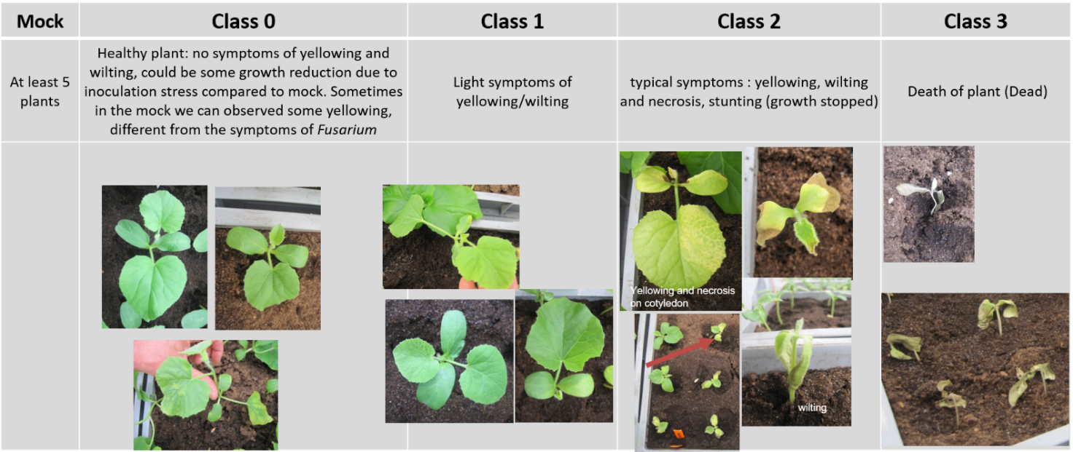
Courtesy of GEVES-SNES in the framework of CPVO Harmores project.

11.3 | Validation of test | on standards  Validation on controls. Controls expected response:  Resistant:  Plants at classes 0 and 1, sometimes very few plants at classes 2 or 3  Susceptible:  Plants at classes 2 and 3
11.4 | Off-types | -

12. | Interpretation of data in terms of UPOV characteristic states | QL  In case of varieties with a response between the susceptible and the resistant control, repeat the test.  In case of confirmation of the result, the variety will be judged heterogeneous.  In case of unclear results, retest or test in another lab.

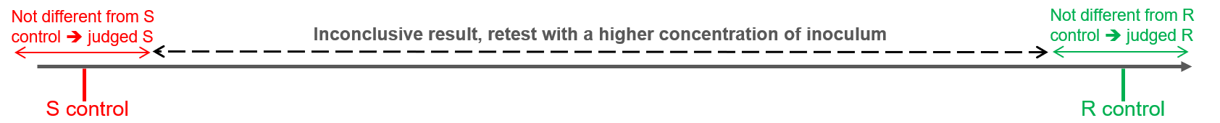

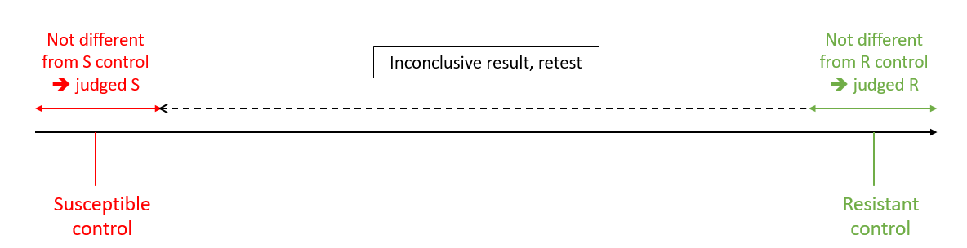
13. | Critical control points | For Race 1.2 the modified protocol on the next page should be used.  For race 2, a differential with Fom-3 gene (e.g. Durango) could be added, to validate the capacity of the isolate to partially attack this variety.  In the case of inoculum increased in Messiaen (1991) synthetic liquid medium, on permanent agitator-shaker, inoculum can be used after 5 to 7 days. For race 0 and 1, dilution 1/12 is recommended, while it must not be less than 1/20 for race 2. At a lower dilution (higher concentration of the medium), it has been observed that toxins released in the medium by the race 2 can cause some yellowing of melon plants, even if they are resistant. Alternatively, spores can be “washed” by resuspending a mass of spores collected on a Millipore filter with vacuum force.

Ad 69 B 69.4: Resistance to Fusarium oxysporum f. sp. melonis race 1.2 (Fom: 1.2)

1. | Pathogen | Fusarium oxysporum f. sp. melonis race 1.2 (Fom: 1.2)
2. | Quarantine status | No
3. | Host species | Melon - Cucumis melo L.
4. | Source of inoculum | GEVES (FR) , Naktuinbouw (NL)
5. | Isolate | Fom: 1.2 (moderately aggressive): TST strain  e.g.Reference strain validated in an inter-laboratory test  Fom: 1.2  - Strain TST  = MAT/REF/04-07-01-04³
6. | Establishment isolate identity | use differential varieties:  Védrantais, Virgos (susceptible)  Lunasol (moderately resistant)  Dinero, Isabelle (highly resistant)  Test on differentials (potentially including Durango, see 13.). The most recent table is available through ISF at  https://www.worldseed.org/our-work/plant-health/differential-hosts/  Situation July 2019
Courtesy of Worldseed.org website

7. | Establishment pathogenicity | use susceptible melon varieties
8. | Multiplication inoculum
8.1 | Multiplication medium | on agar medium e.g. Potato Dextrose Agar, Sabouraud, at 20°C to 25°C
8.2 | Multiplication variety | -
8.3 | Plant stage at inoculation | -
8.4 | Inoculation medium | on liquid medium
8.5 | Inoculation method | -
8.6 | Harvest of inoculum | 7-10 day-old culture
8.7 | Check of harvested inoculum | -
8.8 | Shelf life/viability inoculum | -
9. | Format of the test
9.1 | Number of plants per genotype | at least 30  30 plants per variety plus 5 non-inoculated controls
9.2 | Number of replicates | e.g. At least 3 (in different trays)
9.3 | Control varieties | Susceptible: Virgos  Intermediate resistant: Piboule and Lunasol and Isabelle (Isabelle is expected to have a lower disease index than Piboule and Lunasol).  Piboule and Lunasol are both needed to illustrate the lower level to intermediate resistance. They are representative of different genetic constructions which don’t have necessarily the same behavior according the tests, and the labs.
 | [1] susceptible | Védrantais, Virgos
 | [2] moderately resistant | Lunasol (the lowest accepted level)
 | [3] highly resistant | Dinero, Isabelle, Jador
9.4 | Test design | 3 replicates of 10 plants to allow statistical analysis (in different trays) and at least 5 non-inoculated plants per genotype.
9.5 | Test facility | glasshouse or climatic room
9.6 | Temperature | 18-25 24°C
9.7 | Light | at least 12h
9.8 | Season | All seasons in a climatic room / in a greenhouse: be aware of the strong environmental effect: winter could be too severe and summer could be too mild.
9.9 | Special measures | optional shading (no direct sunlight during 12 h after inoculation)
10. | Inoculation
10.1 | Preparation inoculum | aerated culture 7-10 d old – e.g.: Czapek Dox broth  Scrape cultures with water on agar medium (see 8.1) or optional multiplication on liquid medium (e.g. Potato Dextrose Broth (PDB), Czapek-Dox culture medium for 7 days at room temperature and darkness or Messiaen (1991) synthetic liquid medium, sucrose 50g/L, on permanent agitator-shaker, at room-temperature, inoculum can be used after 5 to 7 days)
10.2 | Quantification inoculum | spore count; adjust to 2.10⁴ - 10⁵ per ml  1x10⁵-1x10⁶ sp/mL, depending on inoculation method (see 10.4) and lab conditions
10.3 | Plant stage at inoculation | cotyledons expanded, first leaf emerging
10.4 | Inoculation method | soaking of the trays in spore suspension; 700 ml for a tray with 25 - 30 plants, plants are not uprooted  Two methods can be used for inoculation.  - Absorption:  Absorption of a suspension of spores, e.g. 700mL of a suspension at 1.10⁵ sp/mL for 50 plants in a tray 30 cm*30 cm.  - Injection:  Injection of a suspension of spores into the soil at the base of the plant, e.g. 5mL at 10⁶ sp/mL per plant.
10.5 | First observation | 7 - 14 days post inoculation
10.6 | Second observation | 14 - 21 days post inoculation
10.7 | Final observations | 21- 28 days post inoculation  1st notation: symptoms on susceptible control at least at class 3 [generally 10-21 dpi]. A second notation can be necessary to reevaluate some unclear varieties.
11. | Observations
11.1 | Method | Visual observation, comparative
11.2 | Observation scale | symptoms:
 | [1] susceptible | Védrantais: growth retardation, yellow cotyledons, drying, possible internal vessel browning, death of the plant
 | [2] moderately resistant | Symptoms may be present, but the level of expression must be distinctly lower than the susceptible control variety.  = the lowest level of resistance is defined by the behavior of Lunasol
 | [3] highly resistant | Symptoms may be present, but the level of expression must be lower than the moderately control variety Lunasol.
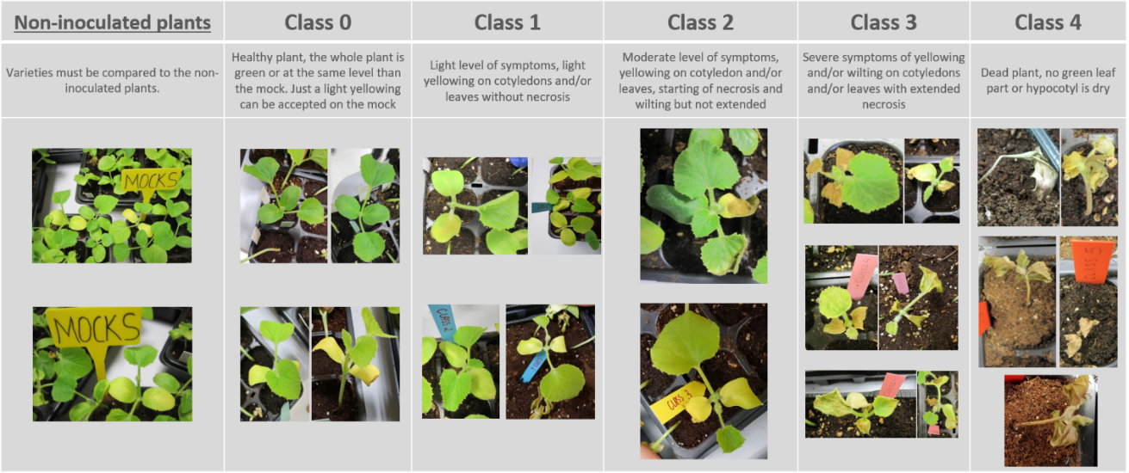
Courtesy of GEVES-SNES in the framework of CPVO Harmores project.

11.3 | Validation of test | Validation on controls. Controls expected response:  - Intermediate Resistant:  Maximum of plants at classes 0 and 1, with few plants in the other classes. Low level of disease index generally below 40%. A difference of disease index is generally observed between Piboule and Lunasol compared to Isabelle  - Susceptible:  Plants at classes 3 and 4, and in some cases few plants at class 2. Very high disease index above 80%.
11.4 | Off-types | calibrate with Lunasol  -
12. | Interpretation of data in terms of UPOV characteristic states | QN  Interpretation of varieties depending on controls (figure 1)  Note 1 = Intermediate resistance absent = susceptibility  Note 9 = Intermediate resistance present  Quantitative analysis is based on the disease index (DI) and the distribution of plants per class compared to the controls.  The varieties statistically not different from one of the intermediate resistant controls or with a lower disease index have to be judged as intermediate resistant.  The varieties between the susceptible and the intermediate resistant controls have to be judged as susceptible (not resistant enough to be considered intermediate resistant).  If not clear results, the use of statistic is highly suggested.
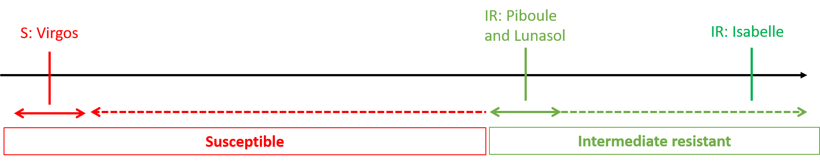

$$DI=\frac{\left(N0*0\right)+\left(N1*1\right)+\left(N2*2\right)+\left(N3*3\right)+\left(N4*4\right)}{\left(N0+N1+N2+N3+N4\right)*4}*100$$

Nx : number of plants at class x

Figure 1: disease index
13. | Critical control points | A moderately aggressive type of Fom: 1.2 should be used as this is likely to show the difference between the presence and absence of resistance most clearly.  There are two types of Fusarium oxysporum f. sp. melonis, Fom:1.2, viz. Fom: 1.2y which is a yellowing type with yellowing symptoms on leaves and another type and Fom: 1.2w which is a wilt type with wilting symptoms on leaves.  -

Proposed revision of Characteristics 70.1 to 70.5 “Resistances to Podosphaera xanthii (Px) - races 1, 2, 3, 5, 3.5”

Current wording

70. | VG | Resistance to Podosphaera xanthii (Sphaerotheca fuliginea) (Powdery mildew) | Résistance à Podosphaera xanthii (Sphaerotheca fuliginea) (oïdium) | Resistenz gegen Podosphaera xanthii (Sphaerotheca fuliginea) (Echter Mehltau) | Resistencia a Podosphaera xanthii (Sphaerotheca fuliginea) (Oidio)
 |  | ------------------------ | -------------------------- | -------------------------- | ------------------------ | --------------------------- | -------
70.1  (+) |  | Race 1 | Race 1 | Pathotyp 1 | Raza 1
QN |  | susceptible | sensible | anfällig | susceptible | Jaune Canari 2, Védrantais | 1
 |  | moderately resistant | moyennement résistant | mäßig resistent | moderadamente resistente | Escrito | 2
 |  | highly resistant | hautement résistant | hochresistent | altamente resistente | Anasta,Cézanne, | 3
 |  | ------------------------ | -------------------------- | -------------------------- | ------------------------ | --------------------------- | -------
70.2  (+) |  | Race 2 | Race 2 | Pathotyp 2 | Raza 2
QN |  | susceptible | sensible | anfällig | susceptible | Galoubet, Védrantais | 1
 |  | moderately resistant | moyennement résistant | mäßig resistent | moderadamente resistente | Escrito, Pendragon | 2
 |  | highly resistant | hautement résistant | hochresistent | altamente resistente | Anasta, Cézanne | 3
 |  | ------------------------ | -------------------------- | -------------------------- | ------------------------ | --------------------------- | -------
70.3  (+) |  | Race 3 | Race 3 | Pathotyp 3 | Raza 3
QN |  | susceptible | sensible | anfällig | susceptible | Védrantais | 1
 |  | moderately resistant | moyennement résistant | mäßig resistent | moderadamente resistente | Nettuno | 2
 |  | highly resistant | hautement résistant | hochresistent | altamente resistente | Batista, Godiva | 3
 |  | ------------------------ | -------------------------- | -------------------------- | ------------------------ | --------------------------- | -------
70.4  (+) |  | Race 5 | Race 5 | Pathotyp 5 | Raza 5
QN |  | susceptible | sensible | anfällig | susceptible | Védrantais | 1
 |  | moderately resistant | moyennement résistant | mäßig resistent | moderadamente resistente | Hugo, Pendragon | 2
 |  | highly resistant | hautement résistant | hochresistent | altamente resistente | Arapaho | 3
 |  | ------------------------ | -------------------------- | -------------------------- | ------------------------ | --------------------------- | -------
70.5  (+) |  | Race 3-5 | Race 3-5 | Pathotyp 3-5 | Raza 3-5
QN |  | susceptible | sensible | anfällig | susceptible | Védrantais | 1
 |  | moderately resistant | moyennement résistant | mäßig resistent | moderadamente resistente | Cisco | 2
 |  | highly resistant | hautement résistant | hochresistent | altamente resistente | 90625 | 3

Proposed new wording

70. | VG | Resistance to Podosphaera xanthii (Px) (ex Sphaerotheca fuliginea) (Powdery mildew) | Résistance à Podosphaera xanthii (Px) (ex Sphaerotheca fuliginea) (oïdium) | Resistenz gegen Podosphaera xanthii (Px) (ex Sphaerotheca fuliginea) (Echter Mehltau) | Resistencia a Podosphaera xanthii (Px) (ex Sphaerotheca fuliginea) (Oidio)
 |  | ------------------------ | -------------------------- | -------------------------- | ------------------------ | --------------------------- | -------
70.1  (+) |  | Race 1 (Px: 1) | Race 1 (Px: 1) | Pathotyp 1 (Px: 1) | Raza 1 (Px: 1)
QN |  | susceptible | sensible | anfällig | susceptible | Jaune Canari 2, Védrantais | 1
 |  | moderately intermediate resistant | moyennement résistant à un niveau intermédiaire | mäßig mittel resistent | moderadamente resistente  resistencia intermedia | Escrito | 2
 |  | highly resistant | hautement résistant | hochresistent | altamente resistente | Anasta,Cézanne Arum | 3
 |  | ------------------------ | -------------------------- | -------------------------- | ------------------------ | --------------------------- | -------
70.2  (+) |  | Race 2 (Px: 2) | Race 2 (Px: 2) | Pathotyp 2 (Px: 2) | Raza 2 (Px: 2)
QN |  | susceptible | sensible | anfällig | susceptible | Galoubet, Védrantais | 1
 |  | moderately intermediate resistant | moyennement résistant à un niveau intermédiaire | mäßig mittel resistent | moderadamente resistente  resistencia intermedia | Escrito, Pendragon | 2
 |  | highly resistant | hautement résistant | hochresistent | altamente resistente | Anasta, Cézanne Arum | 3
 |  | ------------------------ | -------------------------- | -------------------------- | ------------------------ | --------------------------- | -------
70.3  (+) |  | Race 3 (Px: 3) | Race 3 (Px: 3) | Pathotyp 3 (Px: 3) | Raza 3 (Px: 3)
QN |  | susceptible | sensible | anfällig | susceptible | Védrantais | 1
 |  | moderately intermediate resistant | moyennement résistant à un niveau intermédiaire | mäßig mittel resistent | moderadamente resistente  resistencia intermedia | Nettuno Arago, Durango | 2
 |  | highly resistant | hautement résistant | hochresistent | altamente resistente | Batista, Godiva Arum | 3
 |  | ------------------------ | -------------------------- | -------------------------- | ------------------------ | --------------------------- | -------
70.4  (+) |  | Race 5 (Px: 5) | Race 5 (Px: 5) | Pathotyp 5 (Px: 5) | Raza 5 (Px: 5)
QN |  | susceptible | sensible | anfällig | susceptible | Védrantais | 1
 |  | moderately intermediate resistant | moyennement résistant à un niveau intermédiaire | mäßig mittel resistent | moderadamente resistente  resistencia intermedia | Hugo, Pendragon Arago, Durango | 2
 |  | highly resistant | hautement résistant | hochresistent | altamente resistente | Arapaho Arum | 3
 |  | ------------------------ | -------------------------- | -------------------------- | ------------------------ | --------------------------- | -------
70.5  (+) |  | Race 3-5 (Px: 3.5) | Race 3-5 (Px: 3.5) | Pathotyp 3-5 (Px: 3.5) | Raza 3-5 (Px: 3.5)
QN |  | susceptible | sensible | anfällig | susceptible | Védrantais | 1
 |  | moderately intermediate resistant | moyennement résistant à un niveau intermédiaire | mäßig mittel resistent | moderadamente resistente  resistencia intermedia | Cisco Arago, Durango | 2
 |  | highly resistant | hautement résistant | hochresistent | altamente resistente | 90625 Arum | 3

Revision of explanation Ads. 70.1 to 70.3, 71 “Resistances to Podosphaera xanthii (Px), Resistance to Golovinomyces cichoracearum (Erysiphe cichoracearum), race 1 (Powdery mildew) Gc (Ec)” in Chapter 8.2 “Explanations for individual characteristics”

Current wording

Ads. 70.1 to 70.3: Resistance to Podosphaera xanthii (Sphaerotheca fuliginea) (Powdery mildew) Px (Sf)
Ad. 71: Resistance to Golovinomyces cichoracearum (Erysiphe cichoracearum), race 1 (Powdery mildew) Gc (Ec)

1. | Pathogen | Powdery mildew: Podosphaera xanthii (Spaerotheca fuliginea) races 1, 2, 3, 5 and 3-5  Golovinomyces cichoracearum (Erysiphe cichoracearum) race 1
2. | Quarantine status | no
3. | Host species | Cucumis melo
4. | Source of inoculum | GEVES (FR)
5. | Isolate | Px: races 1, 2, 3, 5 and 3-5; Gc: race 1
6. | Establishment isolate identity | on differentials:

 | Powdery Mildew
 | Podosphaera xanthii  (Sphaerotheca fuliginea) |  |  |  |  | Golovinomyces cichoracearum (Erysiphe cichoracearum)
 | race  1 | race  2 | race 3 | race 5 | race  3-5 | race 1
Védrantais | S | S | S | S | S | S
Nantais Oblong | S | S | S | S | S | R
PMR 45 | R | S | S | S | S | S
Edisto 47, WMR 29 | R | R | R | S | S | S
PI 124112, 90625 | R | R | R | R | R | R
PMR 5 | R | R | S | R | S | R
PI 414723 | R | R | IR | R | R/ IR | R
Legend: S susceptible (high sporulation); R resistant (low sporulation), IR (moderately resistant)

7. | Establishment pathogenicity | use susceptible melon varieties
8. | Multiplication inoculum
8.1 | Multiplication medium | detached cotyledon in Petri-dish on 0.35 – 0.5% Agar, 1-2% mannitol, possible add of 1% sucrose
8.2 | Multiplication variety | susceptible varieties
8.3 | Plant stage at inoculation | young, unfolded cotyledon; decontaminated with e.g. 0.05% mercuric chloride or 3 to 5% bleach (NaClO + NaCl)
8.4 | Inoculation medium | air
8.5 | Inoculation method | scatter conidia on the cotyledons transferred by blowing
8.6 | Harvest of inoculum | use cotyledons with strong sporulation
8.7 | Check of harvested inoculum | check presence of spores
8.8 | Shelf life/viability inoculum | on cotyledon, 17-23ºC, under very low light intensity; maximum storage time is 15 days, after the inoculation  Remark: In case of longer term preservation, inoculate locally with a few spores, store at 14°C/12h low light per day
9. | Format of the test
9.1 | Number of plants per genotype | at least 16 plants
9.2 | Number of replicates | e.g. 3
9.3 | Control varieties

 | Powdery Mildew
 | Podosphaera xanthii |  |  |  |  | Golovinomyces cichoracearum
 | race 1 | race 2 | race 3 | race 5 | race 3-5 | race 1
susceptible | Jaune Canari 2, Védrantais | Galoubet, Védrantais | Védrantais | Védrantais | Védrantais | Védrantais
moderately resistant | Escrito | Escrito, Pendragon | Nettuno | Hugo, Pendragon | Cisco | Anasta
highly resistant | Anasta, Cézanne | Anasta, Cézanne | Batista, Godiva | Arapaho | 90625 | Heliobel

9.4 | Test design | leaf discs placed on 0.4% agar with 1- 4% mannitol and possible add of 0.003% benzimidazol
9.5 | Test facility | climatic room
9.6 | Temperature | 20-24°C
9.7 | Light | 12 to 24h darkness after inoculation
9.8 | Season | -
9.9 | Special measures | Inoculation tower needed for even distribution of dry spores.
10. | Inoculation
10.1 | Preparation inoculum | -
10.2 | Quantification inoculum | -
10.3 | Plant stage at inoculation | Routine method: leaf disks, 2 cm in diameter, from young plants.  Complementary method, if necessary: young plants
10.4 | Inoculation method | Routine method: on leaf disks: inoculation tower needed for even distribution of dry spores.  Complementary method: take spores from a cotyledon covered with conidia and deposit them on a leaf or blow the spores from a cotyledon.
10.5 | First observation | 8-10 days post inoculation
10.6 | Second observation | -
10.7 | Final observations | 11-12 days post inoculation
11. | Observations | -
11.1 | Method | visual
11.2 | Observation scale
 | [1] susceptible | medium or intense sporulation all over the leaf disc surface
 | [2] intermediate | weak sporulation all over the surface or isolated colonies on more than 10% of the surface
 | [3] resistant | isolated colonies on less than 10% of the surface or no sporulation
11.3 | Validation of test | on controls
11.4 | Off-types | -
12. | Interpretation of data in terms of UPOV characteristic states | QN
13. | Critical control points | -

Proposed new wording

Ads. 70.1 to 70.3 5: Resistance to Podosphaera xanthii (Px) (ex Sphaerotheca fuliginea) (Powdery mildew) Px (Sf) races 1, 2, 3, 5, 3.5 (Px: 1, 2, 3, 5, 3.5)
Ad. 71: Resistance to Golovinomyces cichoracearum (Erysiphe cichoracearum), race 1 (Powdery mildew) Gc (Ec)

1. | Pathogen |  | Powdery mildew: Podosphaera xanthii (ex Spaerotheca fuliginea) races 1, 2, 3, 5 and 3.5  Golovinomyces cichoracearum (ex Erysiphe cichoracearum) race 1  Only Podosphaera xanthii was validated in Harmores 3 project.
2. | Quarantine status |  | No
3. | Host species |  | Melon - Cucumis melo L.
4. | Source of inoculum |  | GEVES (FR)
5. | Isolate |  | Px: races 1, 2, 3, 5 and 3-5;  e.g.Reference strain validated in an inter-laboratory test  Px: 1  - Strain Sm 3  = MAT/REF/04-07-03-01⁵  Px: 2  - Strain S87-7  = MAT/REF/04-07-03-02⁵  Px: 3  - Strain 00Sm39  = MAT/REF/04-07-03-04-02⁵  Px: 5  - Strain 98Sm65  = MAT/REF/04-07-03-03-01-02⁵  Px: 3.5  - Strain 04Sm2  = MAT/REF/04-07-03-05-01⁵  Gc: 1  - Strain GEVES  = MAT/REF/04-07-02-01)⁵
6. | Establishment isolate identity | on differentials (table1)

 | Powdery Mildew
 | Podosphaera xanthii  (Sphaerotheca fuliginea) |  |  |  |  | Golovinomyces cichoracearum (Erysiphe cichoracearum)
 | race  1 | race  2 | race 3 | race 5 | race  3-5 | race 1
Védrantais | S | S | S | S | S | S
Nantais Oblong | S | S | S | S | S | R
PMR 45 | R | S | S | S | S | S
Edisto 47, WMR 29 | R | R | R | S | S | S
PI 124112, 90625 | R | R | R | R | R | R
PMR 5 | R | R | S | R | S | R
PI 414723 | R | R | IR | R | R/ IR | R
Legend: S susceptible (high sporulation); R resistant (low sporulation), IR (moderately resistant)

Table 1:
Races of Podosphaera xanthii (Px) and Golovinomyces cichoracearum (Gc), J. McCreight and M. Pitrat
 |  | Podosphaera xanthii |  |  |  |  |  | Golovinomyces cichoracearum
 | Race 0 | Race 1 | Race 2 | Race 3 | Race 4 | Race 5 | Race 3.5 | Race 0 | Race 1
Iran H | S | S | S | S | S | S | S | S | S
Védrantais | R | S | S | S | S | S | S | R | S
PMR45 | R | R | S | S | S | S | S | R | S
WMR29 | R | R | R | R | S | S | S | R | S
Edisto 47 | R | R | R | R | R | S | S | R | S
MR-1, PI124112 | R | R | R | R | R | R | R | R | R
PMR5 | R | R | R | S | S | R | S | R | R
Nantais Oblong | R | S | S | S | S | S | S | R | R

7. | Establishment pathogenicity | use susceptible melon varieties
8. | Multiplication inoculum
8.1 | Multiplication medium | detached cotyledon in Petri-dish on 0.35 – 0.5% Agar, 1-2% mannitol, possible add of 1% sucrose  Melon plantlets
8.2 | Multiplication variety | susceptible varieties  Susceptible variety, for example Védrantais.  For higher isolates like 3.5 or 5, a variety with broken resistance is recommended to keep the isolate pure.
8.3 | Plant stage at inoculation | young, unfolded cotyledon; decontaminated with e.g. 0.05% mercuric chloride or 3 to 5% bleach (NaClO + NaCl)  Cotyledon
8.4 | Inoculation medium | Air
8.5 | Inoculation method | scatter conidia on the cotyledons transferred by blowing  Sowing in substrate, for example soil or disinfected peat inside a closed mini glasshouse. When the cotyledons have expanded, remove them from the plant. Disinfect the cotyledons by soaking them for 3 minutes in a mercuric chloride solution (0.05%) or in sodium hypochlorite solution. Rinse them with sterilized water. Dry the cotyledons with sterile paper towel, then place them in Petri dishes with the following medium:  Sucrose 10g  Mannitol 20g  Agar 5g  Distilled water 1 liter  Scatter conidia on the cotyledons and blow them or deposit conidia at the surface of cotyledons. Incubate the inoculated cotyledons in Petri dishes for example at 23°C during 14 hours in the light and at 18°C during 10 hours in the dark or 17°C permanently under very low light intensity. 9 to 11 days after the inoculation, the cotyledons will be covered with conidia and can be used as an inoculum.
8.6 | Harvest of inoculum | use cotyledons with strong sporulation  Sporulation on cotyledons
8.7 | Check of harvested inoculum | check presence of spores
8.8 | Shelf life /viability inoculum | on cotyledon, 17-23ºC, under very low light intensity; maximum storage time is 15 days, after the inoculation  Remark: In case of longer term preservation, inoculate locally with a few spores, store at 14°C/12h low light per day  Maximum 1 to 1.5 months after the inoculation.
9. | Format of the test
9.1 | Number of plants per genotype | at least 16 plants  At least 20 plants per variety and controls, 5 plants for other differentials.
9.2 | Number of replicates | e.g. 3  -
9.3 | Control varieties

 | Powdery Mildew
 | Podosphaera xanthii |  |  |  |  | Golovinomyces cichoracearum
 | race 1 | race 2 | race 3 | race 5 | race 3-5 | race 1
Susceptible | Jaune Canari 2, Védrantais | Galoubet, Védrantais | Védrantais | Védrantais | Védrantais | Védrantais
moderately resistant | Escrito | Escrito, Pendragon | Nettuno | Hugo, Pendragon | Cisco | Anasta
highly resistant | Anasta, Cézanne | Anasta, Cézanne | Batista, Godiva | Arapaho | 90625 | Heliobel

For Podosphaera xanthii (Px) race 1:
- Susceptible: Védrantais
- Intermediate resistant: Escrito
- Resistant: Arum

For Podosphaera xanthii (Px) race 2:
- Susceptible: Védrantais
- Intermediate resistant: Escrito, Pendragon
- Resistant: Arum

For Podosphaera xanthii (Px) races 3, 5, 3.5:
- Susceptible: Védrantais
- Intermediate resistant: Arago, Durango
- Resistant: Arum

For Golovinomyces cichoracearum (Gc) race 1:
- Susceptible: Escrito, Score, Védrantais
- Intermediate resistant: Flores, Anasta
- Resistant: Cézanne, Heliobel, Théo
9.4 | Test design | leaf discs placed on 0.4% agar with 1- 4% mannitol and possible add of 0.003% benzimidazole  Include differentials to validate the race (at least 5 plants per differentials) and compare the level of sporulation.
9.5 | Test facility | climatic room  Climatic chamber or greenhouse
9.6 | Temperature | 20-24°C
9.7 | Light | 12 to 24h darkness after inoculation  At least 12 hours
9.8 | Season | -
9.9 | Special measures | Inoculation tower needed for even distribution of dry spores.
10. | Inoculation
10.1 | Preparation inoculum | -
10.2 | Quantification inoculum | -
10.3 | Plant stage at inoculation | Routine method: leaf disks, 2 cm in diameter, from young plants.  Complementary method, if necessary: young plants  Whole plants at 3-4 true leaf fully expanded stage. Inoculation on the leaves 2 and 3 indicated on the diagram below.  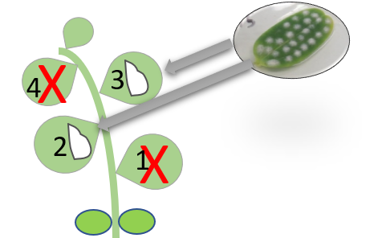  Courtesy of GEVES-SNES in the framework of CPVO Harmores project.
10.4 | Inoculation method | Routine method: on leaf disks: inoculation tower needed for even distribution of dry spores.  Complementary method: take spores from a cotyledon covered with conidia and deposit them on a leaf or blow the spores from a cotyledon.  Take spores from a cotyledon already covered with conidia and deposit them on a leaf. Different isolates can be tested on the same plant (or the same leaf) if the local deposit is well separated from each other and if a mark indicates the place of the deposit.
10.5 | First observation | 8-10 days post inoculation
10.6 | Second observation | -
10.7 | Final observations | 11-12 days post inoculation  The date of notation should be chosen based on expected symptoms on the three controls. Sporulation should be well expressed on the susceptible control.
11. | Observations
11.1 | Method | Visual observation of sporulation
11.2 | Observation scale
 | [1] susceptible | medium or intense sporulation all over the leaf disc surface
 | [2] intermediate | weak sporulation all over the surface or isolated colonies on more than 10% of the surface
 | [3] resistant | isolated colonies on less than 10% of the surface or no sporulation
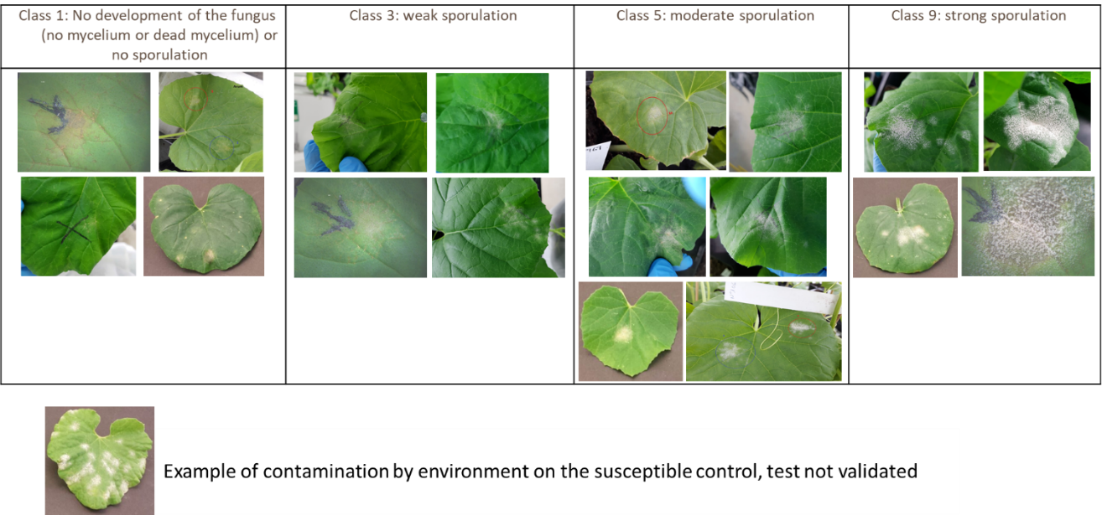
Courtesy of GEVES-SNES in the framework of CPVO Harmores project.
11.3 | Validation of test | on controls  Validation on controls.  Additional information for expected responses of Podosphaera xanthii controls  Resistant:  - Plants at class 1, or most of the plants at class 1 and few plants at class 3 (very low disease index).  - Plants at class 3 but in this case the susceptible control should be all at class 9.  - No plants at classes 5 or 9.  Intermediate Resistant:  - Between the resistant and the susceptible control.  - Generally, plants at classes 3 and 5.  Susceptible:  - Plants at class 9, or most of the plants at class 9 and few plants at class 5 (high disease index).  - Few plants at class 3 but in this case the resistant controls should be all at class 1 and the intermediate resistant control at classes 3 and 1.  - No plants at class 1.
11.4 | Off-types | -
12. | Interpretation of data in terms of UPOV characteristic states | QN  Interpretation of varieties depending on controls (figure 1)  Note 1 = Resistance absent = susceptibility  Note 2 = Intermediate resistance present  Note 3 = Resistance present  Quantitative analysis is based on the disease index and the distribution of plants per class compared to the controls.  Additional information for Podosphaera xanthii controls:  The varieties between the intermediate resistant and the resistant control have to be judged as intermediate resistant (because they are not resistant enough to be considered resistant).  The varieties between the susceptible and the intermediate resistant control have to be judged as susceptible (because they are not resistant enough to be considered intermediate resistant).
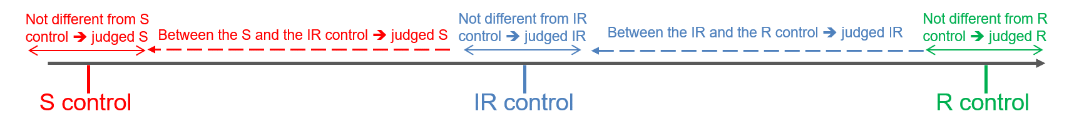
Figure 1: disease index
13. | Critical control points | To avoid cross contamination, it is advised to not produce inoculum of different races in the same room.

[End of document]

matref@geves.fr
Harmores 3 CPVO project (https://cpvo.europa.eu/sites/default/files/documents/report_harmores_3_final_meeting_v0_0.pdf
matref@geves.fr
Harmores 3 CPVO project (https://cpvo.europa.eu/sites/default/files/documents/report_harmores_3_final_meeting_v0_0.pdf
matref@geves.fr
Harmores 3 CPVO project (https://cpvo.europa.eu/sites/default/files/documents/report_harmores_3_final_meeting_v0_0.pdf

