E
International Union for the Protection of New Varieties of Plants

Technical Working Party for Vegetables  Fifty-Sixth Session  Virtual meeting, April 18 to 22, 2022 | TWV/56/17  Original: English  Date: March 17, 2022
PARTIAL REVISION OF THE TEST GUIDELINES FOR PEA
Document prepared by an expert from France
Disclaimer: this document does not represent UPOV policies or guidance
The purpose of this document is to present a proposal for a partial revision of the Test Guidelines for Pea (document TG/7/10 Rev. 2).

The Technical Working Party for Vegetables (TWV), at its fifty-fifth session, organized by electronic means, from May 3 to 7, 2021, agreed that the Test Guidelines for Pea (Pisum sativum L.) (document TG/7/10 Rev. 2) be partially revised for characteristics 58 “Resistance to Fusarium oxysporum f. sp. pisi”, 59 “Resistance to Erysiphe pisi Syd.” and 60 “Resistance to Ascochyta pisi – Race C” (see document TWV/55/16 “Report”, Annex III).

The following changes are proposed:

- Revision of Characteristic 58 “Resistance to Fusarium oxysporum f. sp. pisi”;
- Revision of explanation Ad. 58 “Resistance to Fusarium oxysporum f. sp. pisi” in Chapter 8.2 “Explanations for individual characteristics”;
- Revision of Characteristic 59 “Resistance to Erysiphe pisi Syd.”;
- Revision of explanation Ad. 59 “Resistance to Erysiphe pisi Syd.” in Chapter 8.2 “Explanations for individual characteristics”;
- Revision of explanation Ad. 60 “Resistance to Ascochyta pisi, Race C (Ascochyta Leaf and Pod Spot)” in Chapter 8.2 “Explanations for individual characteristics”.

The proposed changes to are presented below in highlight and underline (insertion) and strikethrough (deletion).

Proposed revision of Characteristic 58 “Resistance to Fusarium oxysporum f. sp. pisi.”

Current wording

 |  | English | français | deutsch | español | Example Varieties/  Exemples/  Beispielssorten/  Variedades ejemplo | Note/  Nota
58.  (+) | VG | Resistance to Fusarium oxysporum f. sp. pisi | Résistance à Fusarium oxysporum f. sp. pisi | Resistenz gegen Fusarium oxysporum f. sp. pisi | Resistencia a Fusarium oxysporum f. sp. pisi
QL |  | absent | absente | fehlend | ausente | Bartavelle | 1
 |  | present | présente | vorhanden | presente | New Era, Nina | 9

Proposed new wording

 |  | English | français | deutsch | español | Example Varieties/  Exemples/  Beispielssorten/  Variedades ejemplo | Note/  Nota
58.  (+) | VG | Resistance to Fusarium oxysporum f. sp. pisi | Résistance à Fusarium oxysporum f. sp. pisi | Resistenz gegen Fusarium oxysporum f. sp. pisi | Resistencia a Fusarium oxysporum f. sp. pisi
QL |  | absent | absente | fehlend | ausente | Bartavelle, Digit | 1
 |  | present | présente | vorhanden | presente | Bingo, Foudre, Kristoff, Namrata, New Era, Nina, Roitelet | 9

Proposed revision of explanation Ad. 58 “Resistance to Fusarium oxysporum f. sp. pisi” in Chapter 8.2 “Explanations for individual characteristics”

Current wording

Ad. 58: Resistance to Fusarium oxysporum f. sp. pisi race 1 (Near wilt)

1. | Pathogen | Fusarium oxysporum f. sp. pisi (race 1)
2. | Quarantine status | no
3. | Host species | Pea – Pisum sativum L.
4. | Source of inoculum | GEVES (FR), INIA (ES) or SASA (GB)
5. | Isolate | Fusarium oxysporum f. sp. pisi race 1 strain MATREF 04-02-01-01 (the test protocol has been validated with this isolate/race)
6. | Establishment isolate identity | genetically defined pea controls (See ISF website: http://www.worldseed.org)

Differentials host
susceptible: | M410, Bartavelle, Little Marvel
resistant: | New Era, Mini 93, Dark Skin Perfection, Vantage, WSU 23, New Season, WSU 31, 74SN5, Sundance II, Grant

7. | Establishment pathogenicity | Test on susceptible plants
8. | Multiplication inoculum
8.1 | Multiplication medium | Multiplication on agar medium: malt Agar or PDA for example
8.4 | Inoculation medium | Multiplication on agar medium: water for scraping agar plates.  Multiplication on liquid medium: Potato Dextrose Broth, Kerrs broth or Czapek-Dox (3 to 7 days old aerated culture) for example.
8.6 | Harvest of inoculum | see 10.1
8.7 | Check of harvested inoculum | see 10.2
8.8 | Shelflife/viability inoculum | between 4 and 8 hours, keep cool to prevent germination of spores. Viability of spores should be more than 3 years if stored at -20°C.
9. | Format of the test
9.1 | Number of plants per genotype | At least 20 plants and 5 non inoculated plants per variety.
9.2 | Number of replicates | -
9.3 | Control varieties | Susceptible controls: Bartavelle  Resistant controls: New Era and Nina
9.5 | Test facility | Climate room or greenhouse.
9.6 | Temperature | 20-25°C
9.7 | Light | 12 hours or longer
9.9 | Special measures | It is important to compare the inoculated plants with the negative non inoculated control plants of the same sample. This allows interpretation of symptoms of root rot, senescence or 'wilting' caused by the stress of having roots cutted and not caused by F. oxysporum infection.
10. | Inoculation
10.1 | Preparation inoculum | For agar plates, remove hyphen fragments by filtering solution through muslin.  For liquid medium, filter through muslin.
10.2 | Quantification inoculum | 10⁶ spores/ml
10.3 | Plant stage at inoculation | seeds or 2 weeks old seedlings (2-3 node stage).
10.4 | Inoculation method | For seeds:  sowing in contaminated substrate (soil based substrate), 750 ml of suspension of spores at 10⁶ sp/ml for 5 l of substrate.  For 2 weeks seedlings:  Sowing in a mix of vermiculite + soil or soil based substrate  Cut the apical 2/3 of the roots with scissors, dip the root of the seedling in the spores suspension for 1 to 5 minutes and transplant in clean soil based substrate in a new tray.
10.7 | Final observations | 28 days post-inoculation.
11. | Observations
11.1 | Method | Visual
11.2 | Observation scale | susceptible:  Class 2: Range from most of the plant wilted/dried but still alive, to plants brown and dead with stem collapsed.  resistant:  Class 0: No symptoms or equivalent to negative control, 1 or 2 wilted/dried lower leaves and slight reduction in growth compared to negative control of same variety are acceptable.  Class 1: Range from a few chlorotic or wilted/dried leaves not present on, or more than on the negative control, up to many leaves with symptoms of senescence or wilting, some leaf drop, upper part of the plant still green and growing.

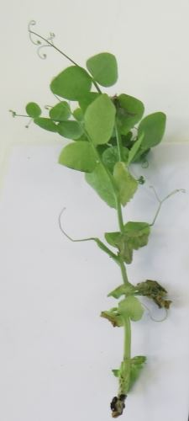 | 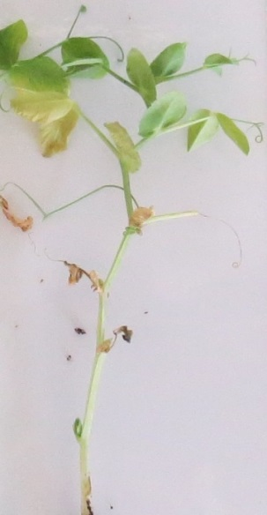 | 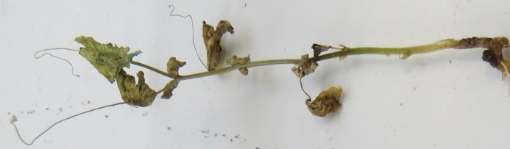 | 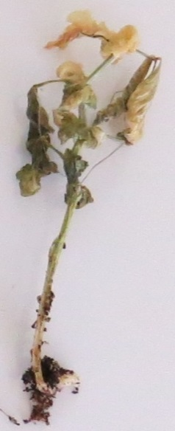
Class 0  resistant | Class 1  resistant | Class 2  susceptible

 |  | Varieties with the same or higher level of resistance as New Era will be interpreted as resistant. Varieties with a lower level of resistance than New Era will be interpreted as susceptible. Nina will be highly resistant, Bartavelle will be highly susceptible. New Era expresses weak symptoms and variation can occur in these weak symptoms depending on the agressivity of the test conditions.
11.3 | Validation of test | evaluation of variety resistance should be calibrated with results of resistant and susceptible controls.
12. | Interpretation of data in terms of UPOV characteristic states
 | absent [1] | susceptible
 | present [9] | resistant
13. | Critical control points | Each lab has to define the best method of inoculation in its lab depending on controls results.  Inoculation by sowing in contaminated soil can in some cases lead to germination problems. No conclusion can be done in this case, and the test should be repeated.

Proposed new wording

Ad. 58: Resistance to Fusarium oxysporum f. sp. pisi race 1 (Near wilt)

1. | Pathogen | Fusarium oxysporum f. sp. pisi (race 1)
2. | Quarantine status | No
3. | Host species | Pea – Pisum sativum L.
4. | Source of inoculum | GEVES (FR), INIA (ES) or SASA (GB)
5. | Isolate | Fusarium oxysporum f. sp. pisi race 1 strain MATREF 04-02-01-01 (the test protocol has been validated with this isolate/race.)  E.g. Reference strain validated in an inter laboratory test:  = MAT/REF 04-02-01-01⁴
6. | Establishment isolate identity | genetically defined pea controls  See ISF website  https://www.worldseed.org/our-work/plant-health/differential-hosts/  Version July 2019

Differentials host
susceptible: | M410, Bartavelle, Little Marvel
resistant: | New Era, Mini 93, Dark Skin Perfection, Vantage, WSU 23, New Season, WSU 31, 74SN5, Sundance II, Grant

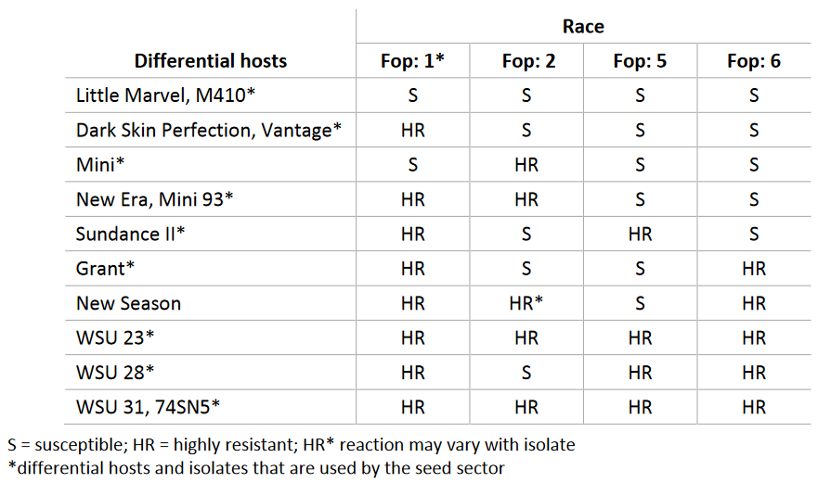
Courtesy of Worldseed.org website.

7. | Establishment pathogenicity | Test on susceptible plants
8. | Multiplication inoculum
8.1 | Multiplication medium | Multiplication on agar medium: malt Agar or PDA for example
8.4 | Inoculation medium | Multiplication on agar medium: water for scraping agar plates.  Multiplication on liquid medium: Potato Dextrose Broth, Kerrs broth or Czapek-Dox (3 to 7 days old aerated culture) for example.
8.6 | Harvest of inoculum | see 10.1
8.7 | Check of harvested inoculum | see 10.2
8.8 | Shelf life/viability inoculum | Between 4 and 8 hours, keep cool to prevent germination of spores. Viability of spores should be more than 3 years if stored at -20°C. The spores can be stored more than 3 years at -20°C.
9. | Format of the test
9.1 | Number of plants per genotype | At least 20 inoculated plants and 5 non inoculated plants per variety per genotype to be able to judge growth reduction.
9.2 | Number of replicates | -
9.3 | Control varieties | Susceptible controls: Bartavelle  Resistant controls: New Era and Nina
9.5 | Test facility | Climate room or greenhouse.
9.6 | Temperature | 20-25°C
9.7 | Light | 12 hours or longer
9.9 | Special measures | It is important to compare the inoculated plants with the negative non inoculated control plants of the same sample. This allows interpretation of symptoms of root rot, senescence or 'wilting' caused by the stress of having roots cut and not symptoms caused by F. oxysporum infection.
10. | Inoculation
10.1 | Preparation inoculum | For agar plates, remove hyphen fragments by filtering solution through muslin.  Initial fungal growth on agar plates (Malt or PDA). This is then used as liquid medium inoculum after removing hyphal fragments by filtering solution through muslin.  For liquid medium, filter through muslin to remove large hyphal fragments.
10.2 | Quantification inoculum | 10⁶ spores/ml
10.3 | Plant stage at inoculation | seeds or 2 weeks old seedlings (2-3 nodes stage).
10.4 | Inoculation method | For seeds:  sowing in contaminated substrate (soil-based substrate), 750 ml of suspension of spores at 10⁶ sp/ml for 5 l of substrate.  For 2 weeks seedlings:  Sowing in a mix of vermiculite + soil or soil-based substrate  Cut the apical 2/3 of the roots with scissors, dip the root of the seedling in the spores suspension for 1 to 5 minutes and transplant in clean soil based substrate in a new tray.
10.7 | Final observations | 28 days post-inoculation.
11. | Observations
11.1 | Method | Visual
11.2 | Observation scale | resistant:  Class 0: No symptoms or equivalent to non-inoculated negative control, 1 or 2 senesced (wilted/dried) lower leaves and slight reduction in growth compared to non-inoculated negative control of same variety are acceptable.  Class 1: Range from a few chlorotic or wilted/dried/senesced leaves not present on, or more than on the negative non-inoculated control, up to many leaves with symptoms of senescence or wilting, some leaf drop, upper part of the plant still green and growing.  susceptible:  Class 2: Range from most of the plant wilted/dried or senesced but still alive, to plants brown and dead with stem collapsed.  Classes 0 and 1 are generally resistant. Class 2 is generally susceptible.  General remark: 1 or 2 senescent (wilted/dried) lower leaves and slight reduction in growth compared to non-inoculated control plants of same variety are acceptable.

Class 0  resistant | Class 1  resistant | Class 2  susceptible
Courtesy of GEVES-SNES in the framework of CPVO Harmores project.

 |  | Varieties with the same or higher level of resistance as New Era will be interpreted as resistant. Varieties with a lower level of resistance than New Era will be interpreted as susceptible. Nina will be highly resistant, Bartavelle will be highly susceptible. New Era expresses weak symptoms and variation can occur in these weak symptoms depending on the agressivity of the test conditions.
11.3 | Validation of test | Evaluation of variety resistance should be calibrated with results of resistant and susceptible controls (distribution of plants per symptoms classes, eventually completed by a disease index).  New Era expresses weak symptoms and variations can occur in these weak symptoms depending on the aggressivity of the test conditions.  Susceptible: lower level of resistance than New Era (Bartavelle is highly susceptible)  Resistant: same or higher level of resistance than New Era (Nina is highly resistant)
12. | Interpretation of data in terms of UPOV characteristic states
 | absent [1] | Susceptible
 | present [9] | Resistant
13. | Critical control points | Each lab has to define the best method of inoculation in its lab depending on controls results.  Inoculation by sowing in contaminated soil can in some cases lead to germination problems, particularly if the humidity of the soil is too high during the test. No conclusion can be done in this case, and the test should be repeated.

Proposal to revise Characteristic 59 “Resistance to Erysiphe pisi Syd.”

Current wording

 |  | English | français | deutsch | español | Example Varieties/  Exemples/  Beispielssorten/  Variedades ejemplo | Note/  Nota
59.  (+) | VG | Resistance to Erysiphe pisi Syd. | Résistance à Erysiphe pisi Syd. | Resistenz gegen Erysiphe pisi Syd. | Resistencia a Erysiphe pisi Syd.
QL |  | absent | absente | fehlend | ausente | Cabro | 1
 |  | present | présente | vorhanden | presente | Stratford, Vivaldi | 9

Proposed new wording

 |  | English | français | deutsch | español | Example Varieties/  Exemples/  Beispielssorten/  Variedades ejemplo | Note/  Nota
59.  (+) | VG | Resistance to Erysiphe pisi Syd. | Résistance à Erysiphe pisi Syd. | Resistenz gegen Erysiphe pisi Syd. | Resistencia a Erysiphe pisi Syd.
QL |  | absent | absente | fehlend | ausente | Cabro, Aladin, Cabree, Ottoman | 1
 |  | present | présente | vorhanden | presente | Stratford, Alezan, Ema, Stratagem (JI2302),  Sugar Bon, Vivaldi, | 9

Proposed revision of explanation Ad. 59 “Resistance to Erysiphe pisi Syd.” in Chapter 8.2 “Explanations for individual characteristics”

Current wording

Ad. 59: Resistance to Erysiphe pisi Syd. (Powdery Mildew)

Resistant and Susceptible varieties
Cabro (susceptible = resistance absent (1))
Stratford, Vivaldi (resistant = resistance present (9))

Isolates and isolate identity
No isolates are maintained as infection is natural. There are no known races.

Genetic background
Two recessive genes confer resistance: er1 and er2

er1 er2 = resistant
Er1 Er2 = susceptible

Er1 er2 = susceptible
er1 Er2 = susceptible

Assessment of disease
Infected foliage surfaces are white and powdery. Tissue beneath the infected areas may turn purplish followed by the production of black fruiting structures. Badly infected tissue remains soft and fails to dry out naturally.

In resistant plants, infection is absent or localized in very small patches (pustules). Infestation may overtake resistant plants during senescence.

Proposed new wording

Ad. 59: Resistance to Erysiphe pisi Syd. (Powdery Mildew)

1. | Pathogen | Powdery mildew – Erysiphe pisi
2. | Quarantine status | No
3. | Host species | Pea – Pisum sativum L
4. | Source of inoculum | GEVES (FR)
5. | Isolate | Erysiphe pisi  e.g. Reference strain validated in an inter laboratory test  isolate 2430  =MAT/REF/ 04-17-01⁸
6. | Establishment isolate identity | Validation by use specific EryF/EryR primers to validate the species of Erysiphe (use ITS primers from Attanayake et al, 2010.)
7. | Establishment pathogenicity | use susceptible variety (e.g. Aladin, Cabree or Ottoman)
8. | Multiplication inoculum
8.1 | Multiplication medium | Living plant
8.2 | Multiplication variety | See 7
8.3 | Plant stage at inoculation | See 10.3
8.4 | Inoculation medium
8.5 | Inoculation method | See 10.4
8.6 | Harvest of inoculum | For spraying by washing off with demineralized water  For dry sprinkling by detaching leaves of a susceptible host plant
8.7 | Check of harvested inoculum | Visual check for presence of sporulation
8.8 | Shelf life/viability inoculum | 1-2 hours
9. | Format of the test
9.1 | Number of plants per genotype | 20 plants
9.2 | Number of replicates | -
9.3 | Control varieties | Susceptible:  For vegetable crops: Cabree  For agricultural crops: Aladin, Ottoman  Resistant:  For vegetable crop: Ema, Sugar Bon, Vivaldi, Stratagem (JI2302),  For agricultural crop: Alezan
9.4 | Test design | Exclude non-inoculated control plants of the same sample as it is impossible to place them exactly the same conditions (due to risk of contamination)
9.5 | Test facility | green house or climatic room
9.6 | Temperature | It is advised to perform the test at 20°C, but depending on laboratory conditions, test can be performed at temperature as high as 25°C. It is advised not to go below 18°C.  In some conditions it has been observed that increasing the day temperature up to 27°C allowed a good sporulation on the susceptible control or multiplication variety.
9.7 | Light | at least 12h per day
9.8 | Season
9.9 | Special measures
10. | Inoculation
10.1 | Preparation inoculum | By spraying:  Washing off from leaves by vigorous shaking in a closed container containing water. Sieve the suspension through muslin cloth.  By sprinkling:  Selection of leaves with strong sporulation.
10.2 | Quantification inoculum | By spraying:  Counting spores; spores density should be 1x105 to 1x106 spores/mL  By sprinkling:  An estimated proportion of one diseased plant (with a strong sporulation) can be used to inoculate 10 plants.
10.3 | Plant stage at inoculation | 3-4 leaf stage
10.4 | Inoculation method | By spraying:  Spraying of the suspension of spores on leaves  By sprinkling of the spores from the susceptible control plants used for multiplication:  To detach the spores for inoculation, the multiplication control plants are shaken above the tray of tested plants.
10.5 | First observation
10.6 | Second observation
10.7 | Final observations | Between 14-21 dpi, when sporulation is well expressed on the  susceptible control.
11. | Observations
11.1 | Method | Visual
11.2 | Observation scale
Courtesy of GEVES-SNES in the framework of CPVO Harmores project.

11.3 | Validation of test | Evaluation of variety resistance should be calibrated with results of resistant and susceptible controls.  Susceptible:  sporulation on leaves. These symptoms can be observed on stem and tendril (not always on the whole plant).  Resistant:  No sporulation or few mycelial pustules only on the lower leaves in case of high disease pressure, no evolution of the symptoms
11.4 | Off-types | -
12. | Interpretation of data in terms of UPOV characteristic states | Absent (susceptible) [1]  Present (resistant) [9]
13. | Critical control points | Watering for plant growth on the substrate (no spraying) to avoid washing the spores off the surface of the leaves.  It is not possible to revive frozen spores. This pathogen is an obligate biotroph and cannot survive outside a living plant.

Proposed revision of explanation Ad. 60 “Resistance to Ascochyta pisi, Race C (Ascochyta Leaf and Pod Spot)” in Chapter 8.2 “Explanations for individual characteristics”

Current wording

Ad. 60: Resistance to Ascochyta pisi, Race C

1. | Pathogen | Ascochyta pisi
2. | Quarantine status | no
3. | Host species | Pea – Pisum sativum L.
4. | Source of inoculum | GEVES (FR) or SASA (GB)
5. | Isolate | Ascochyta pisi race C strain 21A.13. (the test protocol has been validated with this isolate).
6. | Establishment isolate identity | genetically defined pea controls (Physiological races of A. pisi and differentials, adapted from Gallais et Bannerot, 1992)

Physiological race  (Dr Hubbeling)  Strain | C  Tézier  21A.13
Gullivert | S
Rondo | R
Finale | R
Kelvedon Wonder | S
Dark Skin Perfection | S
Arabal, Cobri, Starcovert, Sucovert, Vitalis | S
R = resistant; S = susceptible

7. | Establishment pathogenicity | test on susceptible plants
8. | Multiplication inoculum
8.1 | Multiplication medium | V8 agar or Mathur medium or Potato Dextrose Agar or a synthetic medium.
8.4 | Inoculation medium | water, option: add Tween 80 (wetting agent to aid dispersal of spores, e.g. 0.4%)
8.6 | Harvest of inoculum | see 10.1
8.7 | Check of harvested inoculum | see 10.2
8.8 | Shelflife/viability inoculum | between 4 and 8 hours, keep cool to prevent spores’ germination
9. | Format of the test
9.1 | Number of plants per genotype | at least 20 plants and 5 non inoculated plants per variety
9.2 | Number of replicates | -
9.3 | Control varieties
 | Susceptible | Crecerelle, Kelvedon Wonder
 | Resistant | Nina and Madonna or Rondo
9.4 | Test design | -
9.5 | Test facility | climate room or greenhouse
9.6 | Temperature | 20°C
9.7 | Light | 12 hours or longer
9.8 | Season | -
9.9 | Special measures | high humidity or watering by spraying 2 or 3 times per day
10. | Inoculation
10.1 | Preparation inoculum | remove hyphen fragments by straining solution through muslin
10.2 | Quantification inoculum | 10⁶ spores/mL (to adapt depending conditions of tests)
10.3 | Plant stage at inoculation | 2 weeks old seedlings (i.e. 2-3 node stage)
10.4 | Inoculation method | spraying on green leaves without surface moisture
10.5 | First observation | -
10.6 | Second observation | -
10.7 | Final observations | 10-18 days post-inoculation
11. | Observations
11.1 | Method | visual
11.2 | Observation scale | Class 0: no symptoms  Class 1: few small superficial necrosis  Class 2: bigger darker and deep necrosis  Class 3: necrosis on all parts of the plant or serious symptoms surrounding the stem  Madonna, Nina and Rondo will be resistant controls; varieties with same level of resistance as Madonna/Rondo and/or Nina will be interpreted as resistant. Crecerelle and Kelvedon Wonder will be susceptible controls, varieties with a lower level of resistance than Nina as well as Madonna/Rondo will be interpreted as susceptible.

Class 0:  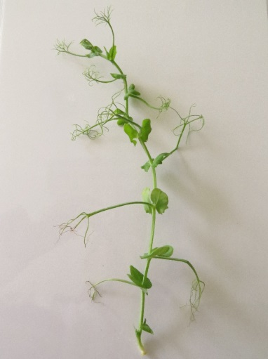 | Class 1:  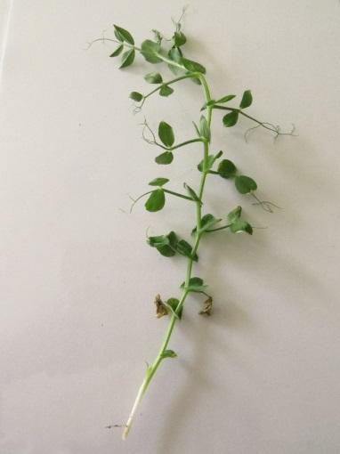
Class 2:  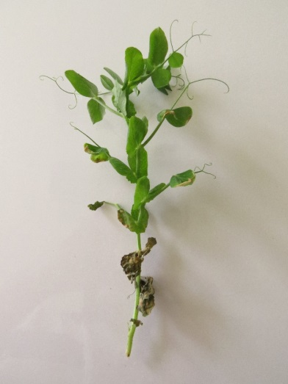 | Details on Class 2:  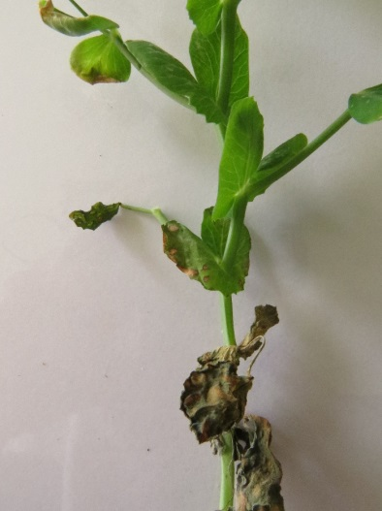
Class 3 :  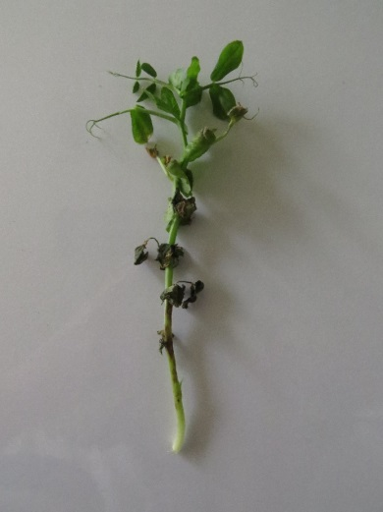 | Details on Class 3  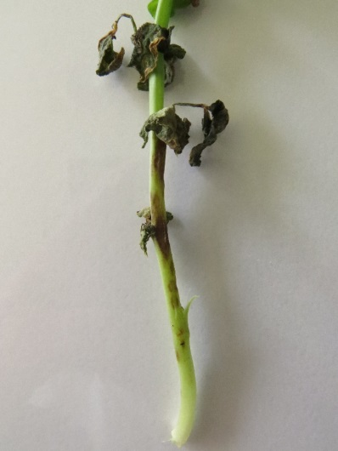

Resistant
Crecerelle
Madonna
Nina
Susceptible
Kelvedon Wonder
Rondo

11.3 | Validation of test | evaluation of variety resistance should be calibrated with results of resistant and susceptible controls
11.4 | Off-types | -
12. | Interpretation of data in terms of  UPOV characteristic states
 | absent [1]  present [9] | susceptible (classes 2 and 3)  resistant (classes 0 and 1)
13. | Critical control points | -

Proposed new wording

Ad. 60: Resistance to Ascochyta pisi, Race C (Ascochyta Leaf and Pod Spot)

1. | Pathogen | Ascochyta pisi
2. | Quarantine status | No
3. | Host species | Pea – Pisum sativum L.
4. | Source of inoculum | GEVES (FR) or SASA (UK)
5. | Isolate | Ascochyta pisi race C strain 21A.13.  The test protocol has been validated in a European CPVO co-funded project with this isolate.  E.g.: Reference strain validated in an inter-laboratory test  - strain 21A.13.  = MAT/REF/ 04-17-01¹⁴
6. | Establishment isolate identity | Genetically defined on Pea controls (Physiological races of A. pisi and differentials, adapted from Gallais et Bannerot, 1992)  see ISF website  https://www.worldseed.org/our-work/plant-health/differential-hosts/  Version July 2019
Physiological race  (Dr Hubbeling)  Strain | C  Tézier  21A.13
Gullivert | S
Rondo | R
Finale | R
Kelvedon Wonder | S
Dark Skin Perfection | S
Arabal, Cobri, Starcovert, Sucovert, Vitalis | S
R = resistant; S = susceptible

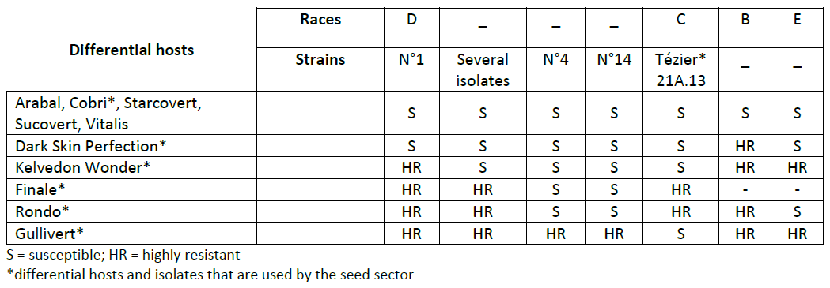
Courtesy of Worldseed.org website.

7. | Establishment pathogenicity | Test on susceptible plants
8. | Multiplication inoculum
8.1 | Multiplication medium | V8 agar or Mathur medium or Potato Dextrose Agar or a synthetic  medium.
8.2 | Multiplication variety | -
8.3 | Plant stage at inoculation | -
8.4 | Inoculation medium | water, option: add Tween 80 (wetting agent to aid dispersal of spores, e.g. 0.4%)
8.5 | Inoculation method | -
8.6 | Harvest of inoculum | See 10.1
8.7 | Check of harvested inoculum | See 10.2
8.8 | Shelf life/viability inoculum | 4/8h Between 4 and 8 hours, keep cool to prevent spores’ germination
9. | Format of the test
9.1 | Number of plants per genotype | At least 20 inoculated plants and 5 non-inoculated plants per variety.
9.2 | Number of replicates | -
9.3 | Control varieties | Susceptible controls: Crecerelle, Kelvedon Wonder  Resistant controls: Madonna or Rondo (lower resistance thresholds) and Nina (higher resistance control)
9.4 | Test design | -
9.5 | Test facility | Climatic room or greenhouse.
9.6 | Temperature | 20°C
9.7 | Light | 12 hours or longer
9.8 | Season | -
9.9 | Special measures | High humidity or watering by spraying 2 or 3 times per day.
10. | Inoculation
10.1 | Preparation inoculum | Remove hyphenal fragments by straining solution through muslin.
10.2 | Quantification inoculum | 10⁶ spores/mL (to adapt depending on conditions of tests).
10.3 | Plant stage at inoculation | 2 weeks old seedlings (i.e. 2-3 node stage).
10.4 | Inoculation method | Spraying on green leaves without surface moisture.
10.5 | First observation
10.6 | Second observation
10.7 | Final observations | 10-18 days post-inoculation.
11. | Observations
11.1 | Method | Visual
11.2 | Observation scale | Class 0: no symptoms  Class 1: few small superficial necrosis  Class 2: bigger darker and deep necrosis  Class 3: necrosis at each level of the plant or serious symptoms surrounding the stem  Madonna, Rondo, and Nina are resistant controls. Varieties with the same or higher level of resistance than Madonna or Rondo will be interpreted as resistant.  Crecerelle or Kelvedon Wonder are susceptible controls. Varieties with a lower level of resistance than Nina as well as Madonna or Rondo will be interpreted as susceptible.
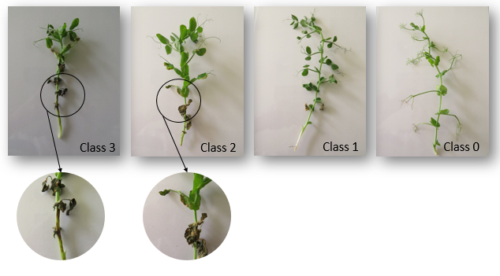
Courtesy of GEVES-SNES in the framework of CPVO Harmores project.

11.3 | Validation of test | Evaluation of variety resistance should be calibrated with results of  resistant and susceptible controls.
11.4 | Off-types
12. | Interpretation of data in terms of UPOV characteristic states | Susceptible:  Crecerelle or Kelvedon Wonder are susceptible controls. Varieties with a lower level of resistance than Madonna or Rondo will be interpreted as susceptible.  Resistant:  Madonna, Rondo, and Nina are resistant controls. Varieties with the same or higher level of resistance than Madonna or Rondo will be interpreted as resistant.  absent .............................. [1] susceptible (classes 2 and 3)  present ............................. [9] resistant (classes 0 and 1)
13. | Critical control points | -

[End of document]

matref@geves.fr / www.geves.fr
resistencias@inia.es
restest@sasa.gov.scot
matref@geves.fr
resistencias@inia.es
Marian.McEwan@sasa.gov.scot
Harmores 2 CPVO project: https://cpvo.europa.eu/sites/default/files/documents/vem15_7_b_harmores_2_final_report.pdf
GEVES; matref@geves.fr
Harmores 2 CPVO project: https://cpvo.europa.eu/sites/default/files/documents/vem15_7_b_harmores_2_final_report.pdf
matref@geves.fr / www.geves.fr
restest@sasa.gov.scot
Harmores 2 CPVO project
matref@geves.fr
Marian.McEwan@sasa.gov.scot
Harmores 2 CPVO project: (https://cpvo.europa.eu/sites/default/files/documents/vem15_7_b_harmores_2_final_report.pdf
Harmores 2 CPVO project: https://cpvo.europa.eu/sites/default/files/documents/vem15_7_b_harmores_2_final_report.pdf

