E
International Union for the Protection of New Varieties of Plants

Technical Working Party for Vegetables  Fifty-Sixth Session  Virtual meeting, April 18 to 22, 2022  Technical Working Party for Agricultural Crops  Fifty-First Session  Cambridge, United Kingdom, May 23 to 27, 2022  Technical Working Party for Ornamental Plants and Forest Trees  Fifty-Fourth Session  Hanover, Germany, June 13 to 17, 2022  Technical Working Party for Fruit Crops  Fifty-Third Session  Virtual meeting, July 11 to 15, 2022  Technical Working Party on Testing Methods and Techniques  First Session  Virtual meeting, September 19 to 23, 2022 | TWP/6/8  Original: English  Date: March 9, 2022
Guidance for drafters of Test Guidelines
Document prepared by the Office of the Union
Disclaimer: this document does not represent UPOV policies or guidance

EXECUTIVE Summary

The purpose of this document is to report developments on the web-based Test Guidelines template (web-based TG template).

UPOV has developed the web-based TG Template (see: https://www3.wipo.int/upovtg/) to implement the guidance for drafting Test Guidelines provided in document TGP/7 “Development of Test Guidelines”. A collection of characteristics, with their corresponding states of expression, which have already been approved for inclusion in existing Test Guidelines after the adoption of document TGP/7 (“approved characteristics”), is provided in the web-based TG template.

The TWPs are invited to note that:

(a) the web-based TG template and database of approved characteristics are currently being migrated to cloud servers, including an upgrade to new technologies in infrastructure and program to address issues reported by users and enabling use for drafting individual authorities’ test guidelines;

(b) that interviews will be conducted in 2022 to collect requirements for the development of individual authorities’ test guidelines using the web-based TG template; and

(c) training on the web-based TG template can be organized upon request.

The following abbreviations are used in this document:

TC: Technical Committee
TC-EDC: Enlarged Editorial Committee
TG: Test Guidelines
TWA: Technical Working Party for Agricultural Crops
TWC: Technical Working Party on Automation and Computer Programs
TWF: Technical Working Party for Fruit Crops
TWM: Technical Working Party on Testing Methods and Techniques
TWO: Technical Working Party for Ornamental Plants and Forest Trees
TWPs: Technical Working Parties
TWV: Technical Working Party for Vegetables

The structure of this document is as follows:
EXECUTIVE Summary 1
Background 2
Development of individual authorities’ test guidelines 2
Identification of requirements for Version 2 of the web-based TG template 2
Migration to cloud servers 3
Additional Functionalities 3
Training 3
Guidance for users of the web-based TG template 4

Background

Developments prior to 2021 are provided in document TWP/5/8 “Guidance for drafters of Test Guidelines”.

Development of individual authorities’ test guidelines

Version 1 of the web-based TG Template was designed for the development of Test Guidelines for UPOV. However, it has also been designed such that Version 2 will enable members of the Union to use:

(a) adopted UPOV Test Guidelines as a basis for the development of individual authorities’ test guidelines;

(b) the web-based TG Template and database of characteristics to develop individual authorities’ test guidelines for which there are no UPOV Test Guidelines; and

(c) use individual authorities’ test guidelines, developed using the web-based TG Template, as the basis for draft UPOV Test Guidelines.

Version 2 will have a feature for individual authorities to modify the template wording, within the same structure, to act as a template for their own test guidelines and a feature to allow individual authorities to convert UPOV Test Guidelines into individual authorities’ test guidelines, with necessary modifications.

Identification of requirements for Version 2 of the web-based TG template

Version 2 of the web-based TG template will be developed on the basis of requirements from individual authorities for developing their test guidelines.

On November 11, 2021, the Office of the Union issued Circular E-21/225 inviting members and observers in the Technical Committee and Technical Working Parties to express their interest to participate in interviews on the use of the web-based TG Template for the development of individual authorities’ test guidelines.

The following members and observers expressed their interest to participate: Australia, Brazil, Canada, China, Dominican Republic, Kenya, Netherlands, New Zealand, Peru, Poland, Republic of Korea, Spain, United Kingdom, United Republic of Tanzania, United States of America, Viet Nam and Zimbabwe.

The following members and observers responded to Circular E-21/225 indicating not to be interested in participating: Croatia, Czech Republic, France, Germany, Estonia, Latvia.

Interviews with members of the Union and observers will be conducted by a recruited business expert in charge of collecting the requirements until the end of 2022. The interviews will explore how test guidelines are developed and used by each member or observer.

Subject to the availability of resources, development of the new functionalities for version 2 of the web-based TG template will start in 2023.

Migration to cloud servers

The web-based TG template and database of characteristics are currently being migrated to cloud servers. The migration will be completed by mid-2022 and includes an upgrade to new technologies in infrastructure and program to address issues reported by users.

The current rich text editor (RTE) tool will be replaced to allow users to drag and drop images instead of uploading them. The new RTE will also allow adjusting the size of images.

The files exported from the web-based TG template in Word format will be improved, in particular for tables and image sizes. The new RTE will enable a preview of the final format for tables and images.

The migration to cloud servers will also replace the current login technology by WIPO accounts. Existing web-based TG Template accounts will be migrated to WIPO accounts. Further information will be provided to web-based TG Template users once the migration is completed.

Additional Functionalities

Summary of example varieties used in a particular Test Guidelines

Document TGP/7 “Development of Test Guidelines”, Guidance Note 28 “(Chapter 6.4) – Example varieties”, 2.2 “Minimizing the number” explains that:

“For practical reasons it is recommended to choose the overall set of example varieties for the Test Guidelines in a way that all the desired characteristics and states of expression are covered by the minimum total number of example varieties. This means that, if possible, each example variety should be used for as many characteristics as possible and example varieties should not be used only for one or very few characteristics.”

A new functionality will be developed in the web-based TG Template to generate the list of example varieties used in the Test Guidelines. This would enable leading experts to minimize the number of example varieties used in a particular Test Guidelines.

Training

The TC, at its fifty-third session, agreed that training on the use of the web-based TG template should be offered to the TWPs during the preparatory workshops of the session and/or during the discussions on the agenda item “guidance for drafters’ of Test Guidelines”. The TC agreed that training should also include FAQs and tutorials for users of the web-based TG template (see document TC/53/31 “Report”, paragraph 239).

In 2021, a series of preparatory webinars were held prior to the TWPs. A presentation on the web-based TG template was made on April 21, 2021, including a session for questions and answers. The webinar was recorded and is available on the following website: https://www.youtube.com/user/upov/videos

The Office of the Union provides assistance to individual experts on an ad hoc basis via e-mail and virtual meetings, upon request.

Guidance for users of the web-based TG template

Tutorials for the following user roles are available on the web-based TG Template under the link “Tutorials”:

- Leading Expert drafting tutorial
- Interested Expert comments tutorial
- Leading Expert checking tutorial

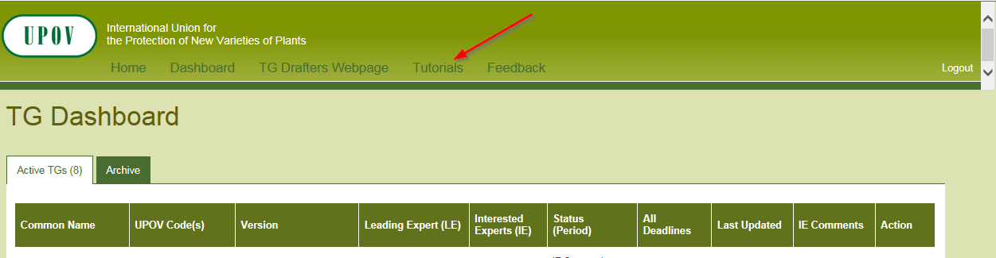

The tutorials are also available for download under the following link: http://upov.int/export/sites/upov/tgp/en/tg_template_tutorial_complete.pdf

The TWPs are invited to note that:

(a) the web-based TG template and database of approved characteristics are currently being migrated to cloud servers, including an upgrade to new technologies in infrastructure and program to address issues reported by users and enabling use for drafting individual authorities’ test guidelines;

(b) that interviews will be conducted in 2022 to collect requirements for the development of individual authorities’ test guidelines using the web-based TG template; and

(c) training on the web-based TG template can be organized upon request.

[End of document]

