E
International Union for the Protection of New Varieties of Plants

Technical Working Party for Vegetables  Fifty-Sixth Session  Virtual meeting, April 18 to 22, 2022  Technical Working Party for Agricultural Crops  Fifty-First Session  Cambridge, United Kingdom, May 23 to 27, 2022  Technical Working Party for Ornamental Plants and Forest Trees  Fifty-Fourth Session  Hanover, Germany, June 13 to 17, 2022  Technical Working Party for Fruit Crops  Fifty-Third Session  Virtual meeting, July 11 to 15, 2022  Technical Working Party on Testing Methods and Techniques  First Session  Virtual meeting, September 19 to 23, 2022 | TWP/6/3  Original: English  Date: March 29, 2022
UPOV PRISMA
Document prepared by the Office of the Union
Disclaimer: this document does not represent UPOV policies or guidance

EXECUTIVE SUMMARY

The purpose of this document is to report on developments concerning UPOV PRISMA.

The Technical Working Parties are invited to note the developments concerning UPOV PRISMA.

The structure of this document is as follows:
EXECUTIVE SUMMARY 1
Background 2
Developments in UPOV bodies 2
Technical Committee (TC) in October 2021 2
Administrative and Legal Committee (CAJ) in October 2021 2
Council in October 2021 2
Launch of Version 2.7 2
UPOV members 2
Crops/species 2
New functionalities 3
IT Quality Software Audit 3
Improvement of user-friendliness of UPOV PRISMA 3
CPVO participation in UPOV PRISMA 4
Using an Authority’s Technical Questionnaire in the absence of UPOV Test Guidelines 4
Version 2.8 5
Planned release date 5
UPOV member coverage 5
Updating of forms 5
Functionalities 5
Planned future developments (after Version 2.8) 6
Registered Users 6
Coverage 6
User-friendliness of the tool 6
New functionalities 6
IT improvements 6
UPOV PRISMA SUPPORT and development TEAM 6
Use of UPOV PRISMA (as of March 25, 2022) 7
Number of submissions via UPOV PRISMA 7
ANNEX United Kingdom Technical Questionnaire for Sugar beet (generated from UPOV PRISMA)

Background

The background to the development of the Electronic Application Form (EAF, now UPOV PRISMA) prior to the Technical Working Parties in 2021 is provided in document TWP/5/3 “UPOV PRISMA”.

Developments in UPOV bodies

Technical Committee (TC) in October 2021

The Technical Committee (TC), at its fifty-seventh session, noted the information provided in document TC/57/INF/2 in relation to recent developments in UPOV PRISMA (see document TC/57/25 “Report”, paragraph 88).

Administrative and Legal Committee (CAJ) in October 2021

The Administrative and Legal Committee (CAJ), at its seventy-eight session, noted the information provided in document CAJ/78/INF/4 in relation to recent developments in UPOV PRISMA (see document CAJ/78/10 “Report”, paragraph 44).

Council in October 2021

The Council, at its fifty-fifth ordinary session, noted the work of the Consultative Committee at its ninety-eighth session, as reported in document C/55/13 “Report by the President on the work of the ninety-eighth session of the Consultative Committee”, including information concerning UPOV PRISMA (see document C/55/18 “Report”, paragraph 18).

EAF/19 meeting in March 2022

The following sections report on developments reported and considered at the nineteenth meeting of the EAF, held by virtual means on March 16, 2022 (see document UPOV/EAF/19/3 “Report”).

Launch of Version 2.7

Version 2.7 of UPOV PRISMA (Version 2.7) was deployed in January 2022, which incorporated the following:

UPOV members

Saint Vincent and Grenadines was introduced in UPOV PRISMA as a new participating authority.

Crops/species

Forms were updated for the following participating PBR authorities: European Union, and the Netherlands.

New functionalities

The following new functionalities were introduced:

- Possibility to download the list of applications as displayed in the dashboard for PVP office in Excel format;
- Introduction of the WIPO IP Portal navigation bar;
- Bulk Upload (for maize, European Union);
- Provide the Co-agent with the right to view applications of other colleagues.

IT Quality Software Audit

In order to reduce the risk of problems when introducing new versions and/ or new functionalities, the following steps would be taken:

- Appoint an external company to perform a software quality audit;
- Organize user acceptance testing (UAT) before going live with any new functionalities.

An external company was appointed to perform a software quality audit and reported that according to the test maturity model, UPOV PRISMA had reached maturity level 2: “the organization has a fundamental test approach where some common test practices are implemented such as planning, monitoring and control over test activities”. The following recommendations were provided to move to maturity level 3: “the organization is rather proactive and the test approach is documented and described in standards, procedures, tools and methods”:

- Know the users and how UPOV PRISMA is used;
- Focus on what is important and urgent: Automate test cases for regression on the functionalities mostly used and the functionalities that generate 80% of the bugs;
- Define a clear Test strategy document;
- For each new requirement, an impact analysis should be made;
- Define a standard process for test case creation;
- Use a test repository tool.

In relation to user acceptance testing (UAT), it is planned to consult the UPOV PRISMA “Task Force” Group before implementing new functionalities.

Further to the above measures to improve the quality of the UPOV PRISMA software, it was decided to organize a code audit, which produced the following recommendations:

- Implement best practices in terms of coding in order to avoid concurrency and performance issues;
- Move to the cloud for a better resource management at infrastructure level and keep following the highest security standards ;
- Develop a dedicated configuration interface for a controlled management of the forms;

It is planned to start the implementation of the recommendations in 2022. A report on progress on implementing the recommendations will be made at future EAF meetings.

Improvement of user-friendliness of UPOV PRISMA

In order to improve the user-friendliness of UPOV PRISMA consultations were organized with users to review certain current existing functionalities (copy functionality, assignment of roles).
Participants in the UPOV PRISMA Task Force Group were consulted on the proposals made to improve the interface and the navigation through the system.
A report on progress will be made at future EAF meetings.

CPVO participation in UPOV PRISMA

The following online meetings UPOV PRISMA Task Force Group were organized on CPVO participation in UPOV PRISMA: November 15, 2021, and February 15, 2022 with interim meetings between CPVO and UPOV.

In order to achieve and maintain synchronization of TQs between UPOV PRISMA and CPVO the following projects have been agreed with CPVO:

- Project 1: “Audit” (current issues/ states of affairs) for exchange of data between UPOV PRISMA and CPVO in both directions
- Project 2: Part A: Resolving current issues; Part B : Synchronizing changes by UPOV/CPVO
- Project 3: Implementation of Project 2 outcome: Bi-directional exchange of application data (lettuce, tomato, rose)
- Project 4: Bulk upload of Maize applications from UPOV to CPVO
- Project 5: “Transitional arrangements”, to communicate to applicants about the situations in which they can use UPOV PRISMA for applications at the CPVO and the measures that need to be taken until all issues have been resolved

A report on progress will be made at future EAF meetings.

Using an Authority’s Technical Questionnaire in the absence of UPOV Test Guidelines

In relation to the coverage of the Test Guidelines, the following was agreed at the EAF/13 meeting (see document UPOV/EAF/13/3 “Report”, paragraphs 19 to 22):

“20. The participants received a presentation from the Office of the Union, as reproduced in the Annex II of document UPOV/EAF/12/3 “Report”, and noted that, for UPOV members following the UPOV Test Guidelines, where there were no UPOV Test Guidelines for a particular crop/species, a generic TQ was available. Alternatively, UPOV members could link these crop/species to a suitable UPOV TG. It was explained that it would not be appropriate to use national TGs for such crops/species because of the high level of maintenance, the translation burden and lack of harmonization. However, it would be possible for UPOV members participating in UPOV PRISMA to agree a common TQ and thereby to retain harmonization and minimize translation work.

“21. The participants noted that, in cases where a participating authority used a national Technical Questionnaire for the Table of Characteristics, for a specific crop, where there was no UPOV Test Guidelines (TGs) and where the generic TQ was not appropriate, there would be a possibility to develop a specific UPOV PRISMA TQ for this crop, subject to a procedure for consultation with other UPOV participating members in UPOV PRISMA and under the condition to follow UPOV TGs TQ and UPOV characteristics.

“22. The participants noted the process of consultation for authorities who do not follow the general approach but follow UPOV TGs TQ and UPOV characteristics, as follows:

1. Request from Country A for a specific crop (Country A TQ)
2. Inform other participating authorities in UPOV PRISMA
3. Circulate the Country A TQ to see if there are any objections to use as UPOV PRISMA TQ
4. If no objections: Country A TQ becomes UPOV PRISMA TQ (subject to resources available)
5. If objections: discussion among interested authorities to explore possibilities to develop a harmonized TQ (and then back to 3)

Any new request would be reported at the subsequent EAF meeting.”

There are no UPOV Test Guidelines for
beet and the approach above was considered but initial feedback indicated that it could be problematic to seek to apply a specific TQ for all UPOV members that use the UPOV TQ for all genera and species.

The EAF/19 participants approved the following revised procedure for utilizing authorities’ TQs as follows (see document UPOV/EAF/19/03 “Report”, paragraphs 16 and 17):

1. Request from Authority A for a specific crop (Authority A TQ)
2. Inform other participating authorities in UPOV PRISMA
3. Circulate the Authority A TQ to see if participating UPOV members that use the UPOV TQ for all genera and species would prefer to:
(a) use Authority A TQ or
(b) continue using the generic TQ
4. Implement Authority A TQ for UPOV members who wish to use Authority A TQ (subject to available resources).

According to the above procedure, more than one authority could make their TQ available for use by other participating UPOV members that use the UPOV TQ for all genera and species.

The EAF/19 participants noted that the United Kingdom TQ for sugar beet (see Annex to this document) would be circulated to the participating UPOV members that use the UPOV TQ for all genera and species to see if they would wish to use the United Kingdom TQ or to continue using the generic TQ.

A report on progress will be made at future EAF meetings.

Version 2.8

Planned release date

It is planned to release Version 2.8 of UPOV PRISMA in October 2022.

UPOV member coverage

No new participating authorities are anticipated for Version 2.8.

Updating of forms

The forms for France and the Netherlands will be updated.

Functionalities

The following functionalities are planned to be introduced in Version 2.8:

- Bulk Upload (Maize, United Kingdom);
- Bulk invoice upon request;
- Improve the download functionality for PVP Offices by including UPOV code information for crops not covered by UPOV TG and the addition of following columns (only for United Kingdom as Proof of Concept):
  - Country of Origin
  - NLI Maintainer
  - NLI Agent
  - NLI Applicant
  - PBR Breeder
  - PBR Applicant
  - PBR Agent
  - Date PBR application received
  - Date NL application Received
  - Provisional Marketing Authorization Code
  - Provisional Marketing Authorization Date
  - Seed Weight

Planned future developments (after Version 2.8)

Registered Users

The following requests have been received from users for new functionalities:

- Allow the possibility to upload multiple attachments for the same question;
- In the email notification message, remove the reference to the “applicant” since it is not correct when an agent submits the application data;
- For agents, accept invitations in bulk instead of clicking each one individually;
- Add an additional "notes" field to the agent profile to allow agents to provide further information to breeders/applicants, such as services offered and languages spoken.

It is planned to address these requests after Version 2.8 has been implemented.

Coverage

The following UPOV members have expressed an interest to join UPOV PRISMA in the future: Bosnia and Herzegovina, Brazil, Egypt, Japan, Nicaragua, Singapore, United Republic of Tanzania and Uzbekistan. The Office of the Union will consult the UPOV members concerned to discuss their requirements and timeline for joining UPOV PRISMA.

User-friendliness of the tool

The following elements would be considered at a later stage to increase the user-friendliness of UPOV PRISMA, according to resources available:

- Addition of non UPOV TQ characteristics in TQ Section 7 instead of TQ Section 5;
- Crop-specific TQs beyond Test Guidelines.

New functionalities

The following new functionalities will be considered for possible development:

- Machine translation;
- Information on DUS cooperation.

IT improvements

The following IT improvements will be considered for possible development at a later stage and according to resources available:

- Improve the performance of form generation.

UPOV PRISMA SUPPORT and development TEAM

A presentation of the new organization of the UPOV PRISMA support and development team was made at EAF/19 meeting, and will be made at the TWPs.

Use of UPOV PRISMA (as of March 25, 2022)

Information on the use of UPOV PRISMA, is provided below:

Number of submissions via UPOV PRISMA

 | 2017 | 2018 | 2019 | 2020 | 2021 | 2022
January | 1 |  | 7 | 18 | 106 | 232
February |  | 3 | 9 | 5 | 107 | 95
March | 2 | 3 | 6 | 21 | 67
April |  | 3 | 22 | 11 | 105
May | 1 | 1 | 32 | 11 | 65
June |  | 7 | 10 | 18 | 821
July |  | 7 | 3 | 9 | 58
August |  | 1 | 7 | 11 | 378
September | 3 | 8 | 16 | 29 | 154
October | 1 | 19 | 29 | 16 | 68
November | 3 | 16 | 26 | 41 | 406
December | 3 | 9 | 49 | 31 | 174
Total | 14 | 77 | 216 | 221 | 2509 | 327

The TWPs, at their sessions in 2022, will receive an oral report on further developments.

The TWPs are invited to note the developments concerning UPOV PRISMA.

[Annex follows]

United Kingdom Technical Questionnaire for Sugar beet (generated from UPOV PRISMA)

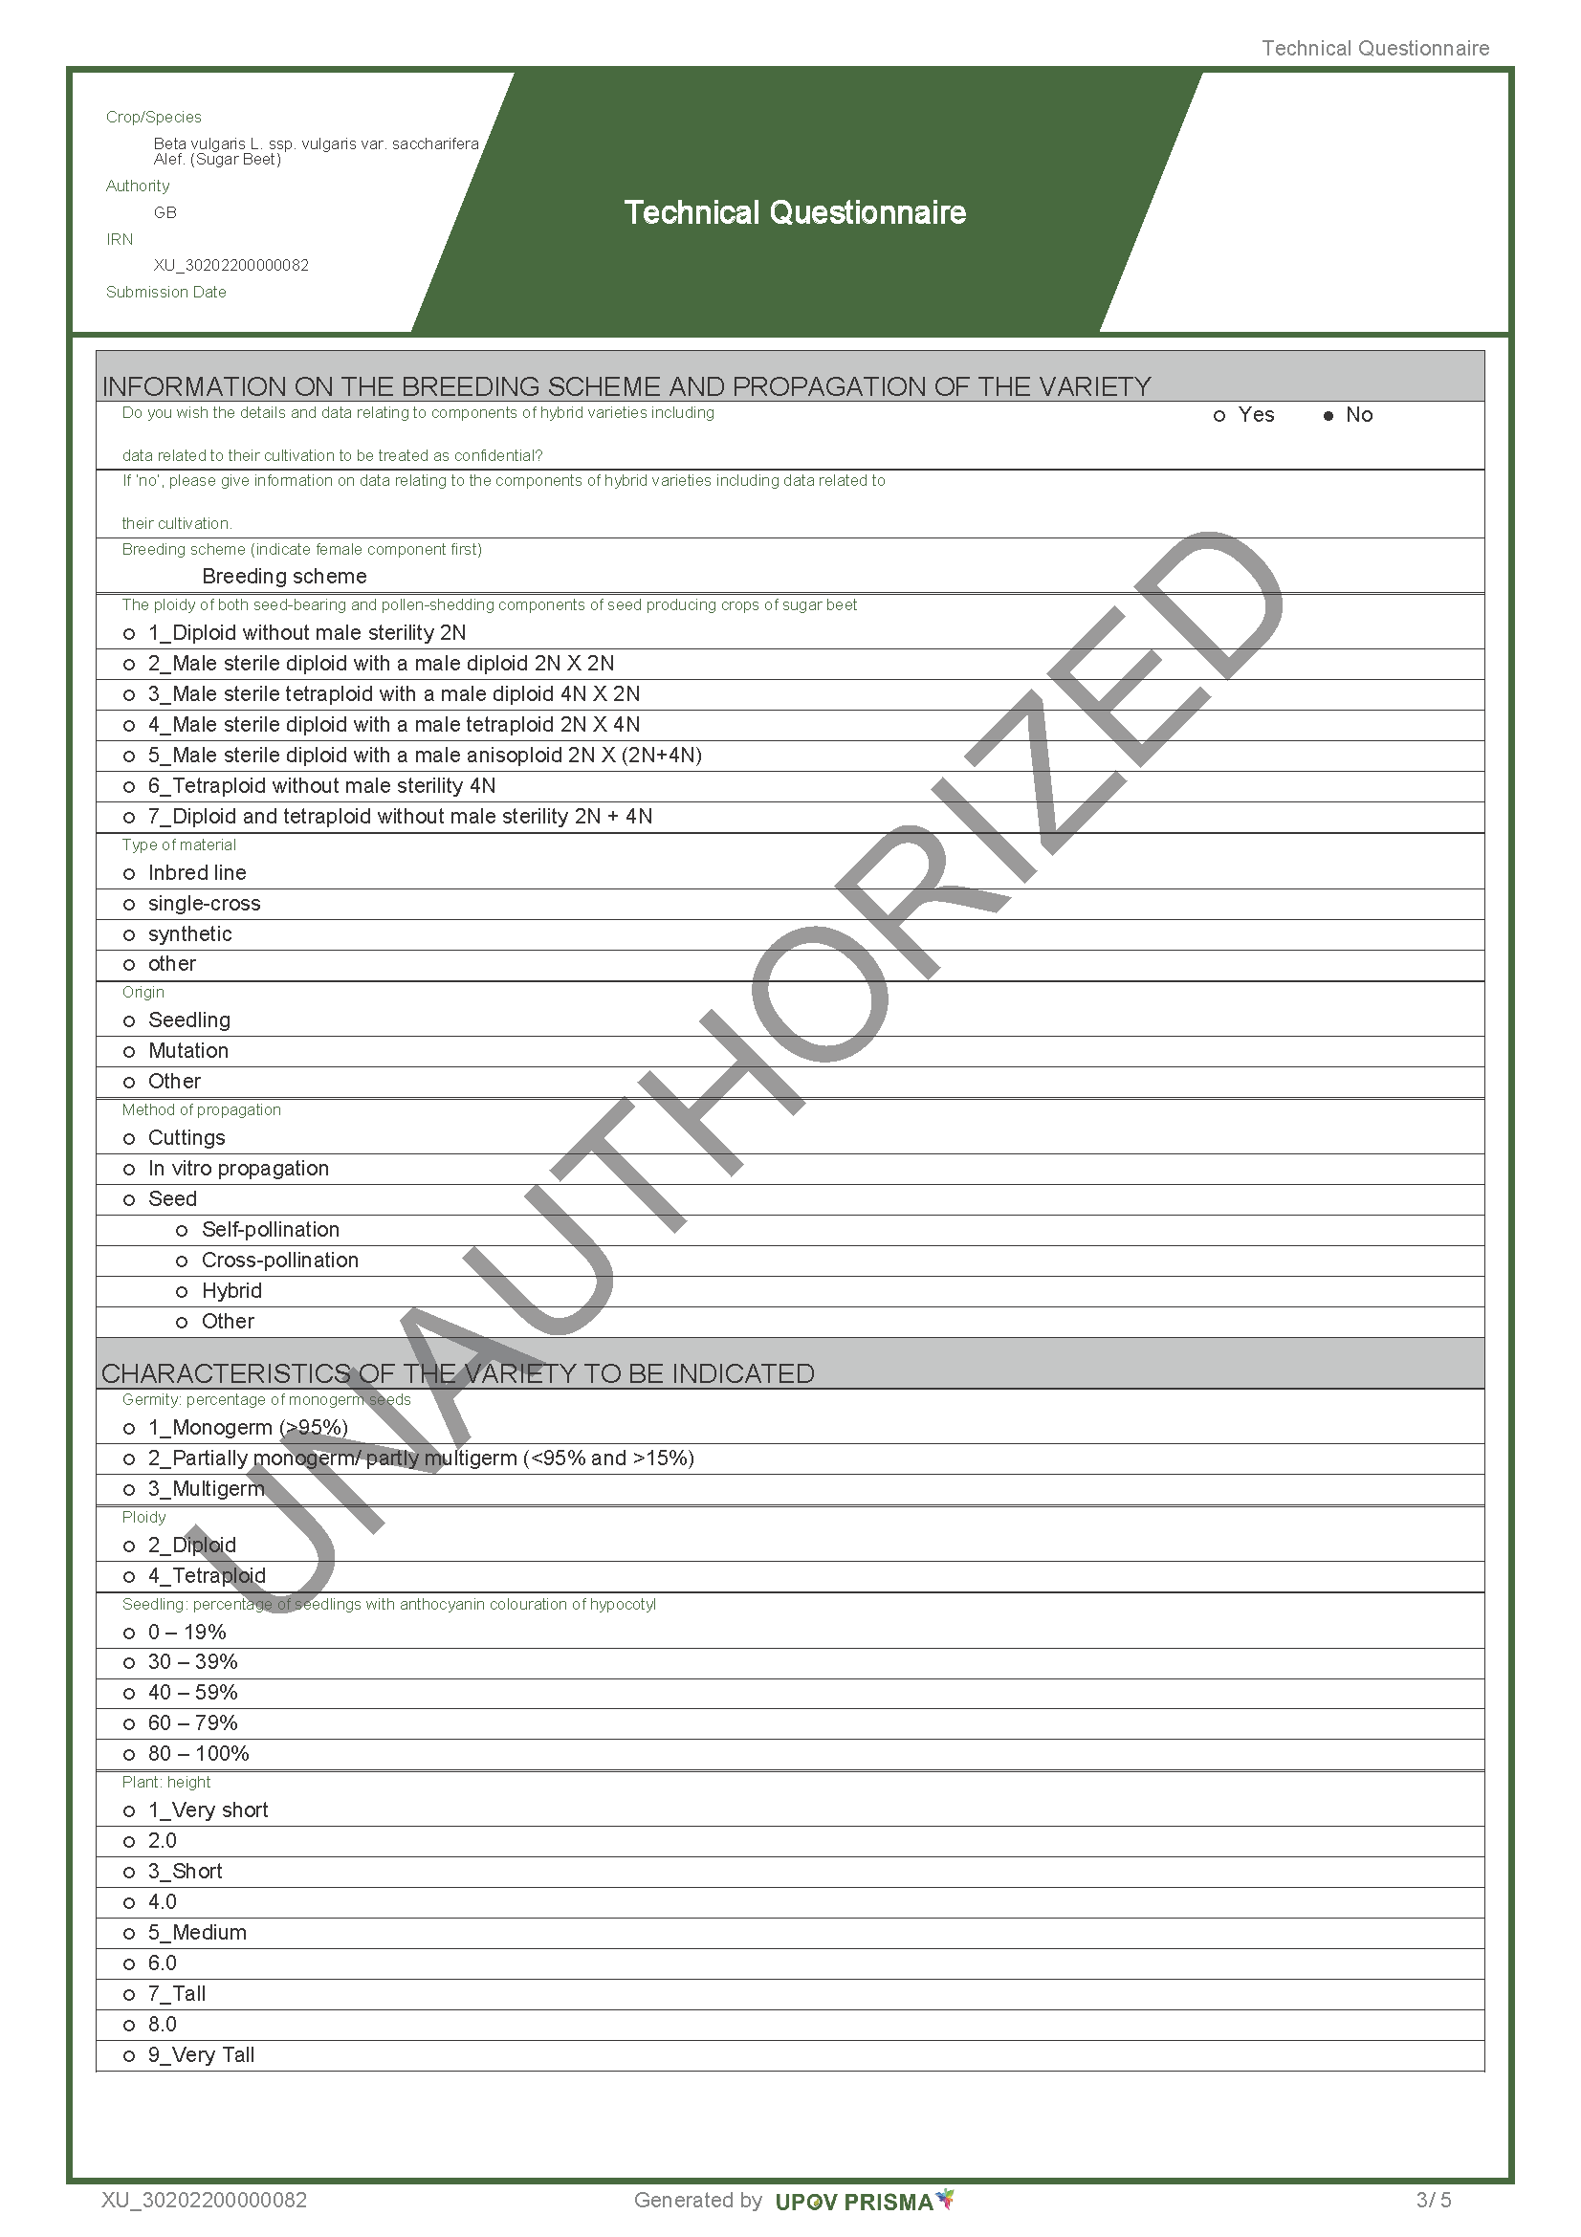
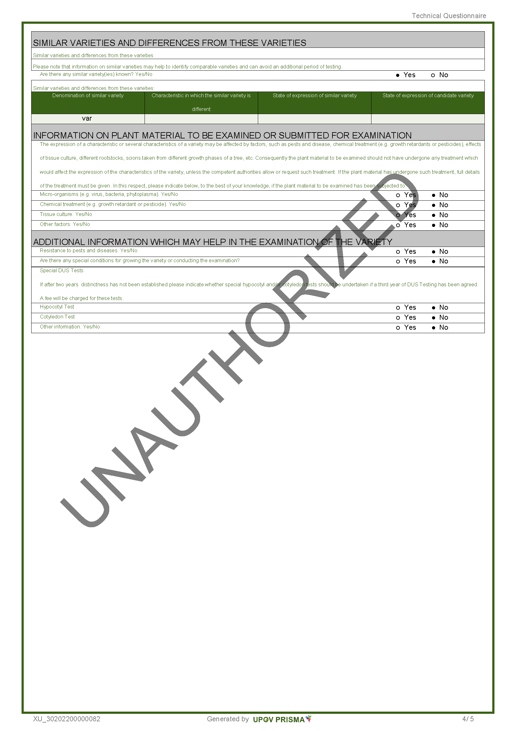
[End of Annex and of document]

organized via electronic means on October 25 and 26, 2021
organized via electronic means on October 27, 2021
organized via electronic means on October 29, 2021

