 |  | E
 | 
  TG/90/7(proj.4)
  ORIGINAL: English
  DATE: 2022-03-04
INTERNATIONAL UNION FOR THE PROTECTION OF NEW VARIETIES OF PLANTS
 | Geneva
  DRAFT
  KALE
  UPOV Code(s): BRASS_OLE_COS; BRASS_OLE_GAM; BRASS_OLE_GAS; BRASS_OLE_GAV; BRASS_OLE_PAL
  Brassica oleracea L. var. costata DC.;
  Brassica oleracea L. var. medullosa Thell.; Brassica oleracea L. var. sabellica L.; Brassica oleracea L. var. viridis L.; Brassica oleracea L. var. palmifolia DC.
  *
GUIDELINES
FOR THE CONDUCT OF TESTS
FOR DISTINCTNESS, UNIFORMITY AND STABILITY

prepared by experts from Japan
to be considered by the
Technical Working Party for Vegetables

at its fifty-sixth session, to be held virtually,
from 2022-04-18 to 2022-04-22

Disclaimer: this document does not represent UPOV policies or guidance

Alternative names:*

Botanical name | English | French | German | Spanish
  Brassica oleracea L. var. costata DC.
  Bedford cabbage, Braganza, Portugese cole, Portuguese kale, Seakale cabbage, Tronchuda cabbage, Tronchuda kale
  Brassica oleracea L. var. medullosa Thell.
  Marrow-stem kale
  Brassica oleracea L. var. sabellica L.
  Curly kale, Borecole, Dwarf Siberian kale, Kitchen kale, Scotch kale
  Brassica oleracea L. var. viridis L.
  Collards, Cow cabbage, Fodder kale, Kale, Spring-heading cabbage, Tall kale, Tree kale
  Brassica oleracea L. var. palmifolia DC.
  Giant Jersey kale, Jersey kale, Palm kale, Palm-tree kale, Tree kale

The purpose of these guidelines (“Test Guidelines”) is to elaborate the principles contained in the General Introduction (document TG/1/3), and its associated TGP documents, into detailed practical guidance for the harmonized examination of distinctness, uniformity and stability (DUS) and, in particular, to identify appropriate characteristics for the examination of DUS and production of harmonized variety descriptions.
ASSOCIATED DOCUMENTS
These Test Guidelines should be read in conjunction with the General Introduction and its associated TGP documents.

TABLE OF CONTENTS | PAGE
1. | SUBJECT OF THESE TEST GUIDELINES.......................................................................................................... | 4
2. | MATERIAL REQUIRED..................................................................................................................... | 4
3. | METHOD OF EXAMINATION............................................................................................................... | 4
3.1 | Number of Growing Cycles................................................................................................................. | 4
3.2 | Testing Place................................................................................................................... | 4
3.3 | Conditions for Conducting the Examination............................................................................................... | 5
3.4 | Test Design................................................................................................................. | 6
3.5 | Additional Tests................................................................................................................... | 6

4. | ASSESSMENT OF DISTINCTNESS, UNIFORMITY AND STABILITY................................................................. | 6
4.1 | Distinctness.......................................................................................................... | 6
4.2 | Uniformity............................................................................................................ | 7
4.3 | Stability............................................................................................................... | 7

5. | GROUPING OF VARIETIES AND ORGANIZATION OF THE GROWING TRIAL................................................ | 9
6. | INTRODUCTION TO THE TABLE OF CHARACTERISTICS................................................................................ | 9
6.1 | Categories of Characteristics...................................................................................................... | 9
6.2 | States of Expression and Corresponding Notes........................................................................................ | 9
6.3 | Types of Expression............................................................................................................ | 9
6.4 | Example Varieties.............................................................................................................. | 9
6.5 | Legend................................................................................................................. | 11

7. | TABLE OF CHARACTERISTICS/TABLEAU DES CARACTÈRES/MERKMALSTABELLE/TABLA DE CARACTERES.................................................................................................................. | 12
8. | EXPLANATIONS ON THE TABLE OF CHARACTERISTICS............................................................................... | 24
8.1 | Explanations covering several characteristics........................................................................................... | 24
 | Explanations for individual characteristics................................................................................................. | 25
  8.2

9. | LITERATURE................................................................................................................... | 36
10 | TECHNICAL QUESTIONNAIRE............................................................................................................ | 37

1. | Subject of these Test Guidelines
1.1
  These Test Guidelines apply to all varieties of Brassica oleracea L. var. costata DC., Brassica oleracea L. var. medullosa Thell., Brassica oleracea L. var. sabellica L., Brassica oleracea L. var. viridis L. and Brassica oleracea L. var. palmifolia DC.
1.2
  Guidance on the use of Test Guidelines for inter-variant hybrids that are not explicitly covered by Test Guidelines is provided in document TGP/13 “Guidance for New Types and Species”.

2. | Material Required
2.1
  The competent authorities decide on the quantity and quality of the plant material required for testing the variety and when and where it is to be delivered. Applicants submitting material from a State other than that in which the testing takes place must ensure that all customs formalities and phytosanitary requirements are complied with.
2.2
  The material is to be supplied in the form of seeds or seedlings.
2.3
  The minimum quantity of plant material, to be supplied by the applicant, should be:
seed-propagated varieties: 20g or 5000 seeds
vegetatively propagated varieties: 30 plants

 | In the case of seed, the seed should meet the minimum requirements for germination, species and analytical purity, health and moisture content, specified by the competent authority. In cases where the seed is to be stored, the germination capacity should be as high as possible and should, be stated by the applicant.
2.4
  The plant material supplied should be visibly healthy, not lacking in vigor, nor affected by any important pest or disease.
2.5
  The plant material should not have undergone any treatment which would affect the expression of the characteristics of the variety, unless the competent authorities allow or request such treatment. If it has been treated, full details of the treatment must be given.

3. | Method of Examination
3.1 | Number of Growing Cycles
 | The minimum duration of tests should normally be two independent growing cycles.
  3.1.1
 | The two independent growing cycles should be in the form of two separate plantings.
  3.1.2
 | The testing of a variety may be concluded when the competent authority can determine with certainty the outcome of the test.
  3.1.3

3.2 | Testing Place
 | Tests are normally conducted at one place. In the case of tests conducted at more than one place, guidance is provided in TGP/9 “Examining Distinctness”.
3.3 | Conditions for Conducting the Examination
 | The tests should be carried out under conditions ensuring satisfactory growth for the expression of the relevant characteristics of the variety and for the conduct of the examination.

3.4 | Test Design
  3.4.1
  In the case of seed-propagated varieties, each test should be designed to result in a total of at least 40 plants which should be divided between at least 2 replicates.
  3.4.2
  In the case of vegetatively propagated varieties, each test should be designed to result in a total of at least 20 plants which should be divided between at least 2 replicates.

  3.4.3
  The design of the tests should be such that plants or parts of plants may be removed for measurement or counting without prejudice to the observations which must be made up to the end of the growing cycle.
3.5 | Additional Tests
 | Additional tests, for examining relevant characteristics, may be established.

4. | Assessment of Distinctness, Uniformity and Stability
4.1 | Distinctness
4.1.1 | General Recommendations
 | It is of particular importance for users of these Test Guidelines to consult the General Introduction prior to making decisions regarding distinctness. However, the following points are provided for elaboration or emphasis in these Test Guidelines.
4.1.2 | Consistent Differences
 | The differences observed between varieties may be so clear that more than one growing cycle is not necessary. In addition, in some circumstances, the influence of the environment is not such that more than a single growing cycle is required to provide assurance that the differences observed between varieties are sufficiently consistent. One means of ensuring that a difference in a characteristic, observed in a growing trial, is sufficiently consistent is to examine the characteristic in at least two independent growing cycles.
4.1.3 | Clear Differences
 | Determining whether a difference between two varieties is clear depends on many factors, and should consider, in particular, the type of expression of the characteristic being examined, i.e. whether it is expressed in a qualitative, quantitative, or pseudo-qualitative manner. Therefore, it is important that users of these Test Guidelines are familiar with the recommendations contained in the General Introduction prior to making decisions regarding distinctness.
4.1.4
  Number of Plants or Parts of Plants to be Examined
In the case of seed-propagated varieties, unless otherwise indicated, for the purposes of distinctness, all observations on single plants should be made on 20 plants or parts taken from each of 20 plants and any other observation made on all plants in the test, disregarding any off-type plants.

In the case of vegetatively propagated varieties, unless otherwise indicated, for the purposes of distinctness, all observations on single plants should be made on 10 plants or parts taken from each of 10 plants and any other observation made on all plants in the test, disregarding any off-type plants.

4.1.5 | Method of Observation
 | The recommended method of observing the characteristic for the purposes of distinctness is indicated by the following key in the Table of Characteristics (see document TGP/9 “Examining Distinctness”, Section 4 “Observation of characteristics”):
MG: single measurement of a group of plants or parts of plants
MS: measurement of a number of individual plants or parts of plants
VG: visual assessment by a single observation of a group of plants or parts of plants
VS: visual assessment by observation of individual plants or parts of plants

 | Type of observation: visual (V) or measurement (M)
 | “Visual” observation (V) is an observation made on the basis of the expert’s judgment. For the purposes of this document, “visual” observation refers to the sensory observations of the experts and, therefore, also includes smell, taste and touch. Visual observation includes observations where the expert uses reference points (e.g. diagrams, example varieties, side-by-side comparison) or non-linear charts (e.g. color charts). Measurement (M) is an objective observation against a calibrated, linear scale e.g. using a ruler, weighing scales, colorimeter, dates, counts, etc.
  Type of record: for a group of plants (G) or for single, individual plants (S)
  For the purposes of distinctness, observations may be recorded as a single record for a group of plants or parts of plants (G), or may be recorded as records for a number of single, individual plants or parts of plants (S). In most cases, “G” provides a single record per variety and it is not possible or necessary to apply statistical methods in a plant-by-plant analysis for the assessment of distinctness.
 | In cases where more than one method of observing the characteristic is indicated in the Table of Characteristics (e.g. VG/MG), guidance on selecting an appropriate method is provided in document TGP/9, Section 4.2.
4.2 | Uniformity
4.2.1 | It is of particular importance for users of these Test Guidelines to consult the General Introduction prior to making decisions regarding uniformity. However, the following points are provided for elaboration or emphasis in these Test Guidelines:
  4.2.2
  These Test Guidelines have been developed for the examination of cross-pollinated, self-pollinated (inbred line), hybrid varieties and vegetatively propagated varieties. For varieties with other types of propagation, the recommendations in the General Introduction and document TGP/13 "Guidance for new types and species" Section 4.5 "Testing Uniformity" should be followed.
 | The assessment of uniformity for cross-pollinated varieties should be according to the recommendations for cross-pollinated varieties in the General Introduction.
  4.2.3
4.2.4 | The assessment of uniformity for hybrid varieties depends on the type of hybrid and should be according to the recommendations for hybrid varieties in the General Introduction.
4.2.5
  For the assessment of uniformity of single cross hybrids and self-pollinated varieties (inbred lines), a population standard of 1% and an acceptance probability of at least 95% should be applied. In the case of a sample size of 40 plants, 2 off-types are allowed. In addition, for single cross hybrids, a population standard of 3% and an acceptance probability of at least 95% should be applied for inbred plants obviously resulting from the selfing of a parent line. In the case of a sample size of 40 plants, 3 inbred plants are allowed.
4.2.6
  For the assessment of uniformity of vegetatively propagated varieties, a population standard of 1% and an acceptance probability of at least 95% should be applied. In the case of a sample size of 20 plants, 1 off-type is allowed.

4.3 | Stability
4.3.1 | In practice, it is not usual to perform tests of stability that produce results as certain as those of the testing of distinctness and uniformity. However, experience has demonstrated that, for many types of variety, when a variety has been shown to be uniform, it can also be considered to be stable.
4.3.2 | Where appropriate, or in cases of doubt, stability may be further examined by testing a new seed or plant stock to ensure that it exhibits the same characteristics as those shown by the initial material supplied.

5. | Grouping of Varieties and Organization of the Growing Trial
5.1 | The selection of varieties of common knowledge to be grown in the trial with the candidate varieties and the way in which these varieties are divided into groups to facilitate the assessment of distinctness are aided by the use of grouping characteristics.
5.2 | Grouping characteristics are those in which the documented states of expression, even where produced at different locations, can be used, either individually or in combination with other such characteristics: (a) to select varieties of common knowledge that can be excluded from the growing trial used for examination of distinctness; and (b) to organize the growing trial so that similar varieties are grouped together.
5.3 | The following have been agreed as useful grouping characteristics:
  (a)
  Plant: position of growing point (characteristic 3)
  (b)
  Leaf: color (characteristic 9)
  (c)
  Leaf: variegation (characteristic 11)
  (d)
  Leaf: number of lobes (characteristic 12)

5.4 | Guidance for the use of grouping characteristics, in the process of examining distinctness, is provided through the General Introduction and document TGP/9 “Examining Distinctness”.

6. | Introduction to the Table of Characteristics
6.1 | Categories of Characteristics
6.1.1 | Standard Test Guidelines Characteristics
 | Standard Test Guidelines characteristics are those which are approved by UPOV for examination of DUS and from which members of the Union can select those suitable for their particular circumstances.
6.1.2 | Asterisked Characteristics
 | Asterisked characteristics (denoted by *) are those included in the Test Guidelines which are important for the international harmonization of variety descriptions and should always be examined for DUS and included in the variety description by all members of the Union, except when the state of expression of a preceding characteristic or regional environmental conditions render this inappropriate.
6.2 | States of Expression and Corresponding Notes
6.2.1 | States of expression are given for each characteristic to define the characteristic and to harmonize descriptions. Each state of expression is allocated a corresponding numerical note for ease of recording of data and for the production and exchange of the description.
6.2.2 | All relevant states of expression are presented in the characteristic.
6.2.3 | Further explanation of the presentation of states of expression and notes is provided in document TGP/7 “Development of Test Guidelines”.

6.3 | Types of Expression
 | An explanation of the types of expression of characteristics (qualitative, quantitative and pseudo-qualitative) is provided in the General Introduction.

6.4 | Example Varieties
 | Where appropriate, example varieties are provided to clarify the states of expression of each characteristic.

6.5 | Legend
 |  | English |  | français |  | deutsch | español | Example Varieties  Exemples  Beispielssorten  Variedades ejemplo | Note/  Nota
  1
  2
  3
  4
  5
  6
  7
  Name of characteristics in English
  Nom du caractère en français
  Name des Merkmals auf Deutsch
  Nombre del carácter en español
  states of expression
  types d’expression
  Ausprägungsstufen
  tipos de expresión

1 | Characteristic number
2 | (*) | Asterisked characteristic | – see Chapter 6.1.2
3 | Type of expression
 | QL | Qualitative characteristic | – see Chapter 6.3
 | QN | Quantitative characteristic | – see Chapter 6.3
 | PQ | Pseudo-qualitative characteristic | – see Chapter 6.3
4 | Method of observation (and type of plot, if applicable)
 | MG, MS, VG, VS |  | – see Chapter 4.1.5
5
  (+)
  See Explanations on the Table of Characteristics in Chapter 8.2
6
  (a)-(d)
  See Explanations on the Table of Characteristics in Chapter 8.1
7
  Not applicable

7. | Table of Characteristics/Tableau des caractères/Merkmalstabelle/Tabla de caracteres

 |  | English |  | français |  | deutsch | español | Example Varieties  Exemples  Beispielssorten  Variedades ejemplo | Note/  Nota
1. | (*) | QN | MG/MS/VG | (+) | (a)
  Plant: height
 |  | very short |  |  |  |  |  |  | 1
 |  | very short to short |  |  |  |  |  |  | 2
 |  | short |  |  |  |  |  | Lage Moskrul, Starbor | 3
 |  | short to medium |  |  |  |  |  |  | 4
 |  | medium |  |  |  |  |  | Darkibor, Marriot, Rossignol | 5
 |  | medium to tall |  |  |  |  |  |  | 6
 |  | tall |  |  |  |  |  | Cottagers, Esthe, Fizz, Nero di Toscana, Redbor | 7
 |  | tall to very tall |  |  |  |  |  |  | 8
 |  | very tall |  |  |  |  |  | Ostfriesische Palme | 9
2. |  | QN | MS/VG | (+) | (a)
  Plant: diameter
 |  | very small |  |  |  |  |  |  | 1
 |  | very small to small |  |  |  |  |  |  | 2
 |  | small |  |  |  |  |  | Tintoreto | 3
 |  | small to medium |  |  |  |  |  |  | 4
 |  | medium |  |  |  |  |  | Darkibor,  Dwarf Green Curled | 5
 |  | medium to large |  |  |  |  |  |  | 6
 |  | large |  |  |  |  |  | Cottagers, Esthe,  Nero di Toscana | 7
 |  | large to very large |  |  |  |  |  |  | 8
 |  | very large |  |  |  |  |  |  | 9
3. | (*) | QN | VG | (+) | (a)
  Plant: position of growing point
 |  | lower part |  |  |  |  |  | Esthe, Fizz | 1
 |  | lower to middle part |  |  |  |  |  | Halbhoher grüner krauser | 2
 |  | middle part |  |  |  |  |  | Black Magic, Kobolt | 3
 |  | middle to upper part |  |  |  |  |  |  | 4
 |  | upper part |  |  |  |  |  | Dwarf Green Curled, Kadet, Westlandse Herfst | 5

 |  | English |  | français |  | deutsch | español | Example Varieties  Exemples  Beispielssorten  Variedades ejemplo | Note/  Nota
4. |  | QN | MG/MS/VG | (+) | (a)
  Plant: number of leaves
 |  | few |  |  |  |  |  | Fizz, Pentland Brig | 1
 |  | few to medium |  |  |  |  |  |  | 2
 |  | medium |  |  |  |  |  | Redbor,  Westlandse Herfst | 3
 |  | medium to many |  |  |  |  |  |  | 4
 |  | many |  |  |  |  |  | Esthe, Winnetou | 5
5. |  | QN | MG/MS/VG |  | (a)
  Stem: length
 |  | very short |  |  |  |  |  |  | 1
 |  | very short to short |  |  |  |  |  |  | 2
 |  | short |  |  |  |  |  | Rednex | 3
 |  | short to medium |  |  |  |  |  |  | 4
 |  | medium |  |  |  |  |  | Dwarf Green Curled, Fizz | 5
 |  | medium to long |  |  |  |  |  |  | 6
 |  | long |  |  |  |  |  | Cottagers | 7
 |  | long to very long |  |  |  |  |  |  | 8
 |  | very long |  |  |  |  |  |  | 9
6. |  | QN | MS/VG | (+) | (a), (d)
  Stem: diameter
 |  | very small |  |  |  |  |  |  | 1
 |  | very small to small |  |  |  |  |  |  | 2
 |  | small |  |  |  |  |  | Thousand Head | 3
 |  | small to medium |  |  |  |  |  |  | 4
 |  | medium |  |  |  |  |  | Goldeneye | 5
 |  | medium to large |  |  |  |  |  |  | 6
 |  | large |  |  |  |  |  | Camaro | 7
 |  | large to very large |  |  |  |  |  |  | 8
 |  | very large |  |  |  |  |  |  | 9

 |  | English |  | français |  | deutsch | español | Example Varieties  Exemples  Beispielssorten  Variedades ejemplo | Note/  Nota
7. |  | QN | VG | (+) | (a), (d)
  Stem: tendency to branch
 |  | weak |  |  |  |  |  | Bombardier | 1
 |  | weak to medium |  |  |  |  |  |  | 2
 |  | medium |  |  |  |  |  | Thousand Head | 3
 |  | medium to strong |  |  |  |  |  |  | 4
 |  | strong |  |  |  |  |  | Anglian Gold | 5
8. | (*) | QN | VG | (+) | (a), (b)
  Leaf: attitude
 |  | erect |  |  |  |  |  | Esthe, Nero di Toscana | 1
 |  | erect to semi-erect |  |  |  |  |  |  | 2
 |  | semi-erect |  |  |  |  |  | Cottagers, Redbor | 3
 |  | semi-erect to horizontal |  |  |  |  |  |  | 4
 |  | horizontal |  |  |  |  |  | Marriot | 5
9. | (*) | PQ | VG |  | (a), (b)
  Leaf: color
 |  | light green |  |  |  |  |  | Tintoreto | 1
 |  | medium green |  |  |  |  |  | Dwarf Green Curled, Esthe | 2
 |  | dark green |  |  |  |  |  | Kapitan | 3
 |  | grey green |  |  |  |  |  | Fizz | 4
 |  | blue green |  |  |  |  |  | Black Magic,  Nero di Toscana | 5
 |  | reddish green |  |  |  |  |  | Redbor | 6
 |  | purple |  |  |  |  |  | Rednex | 7

 |  | English |  | français |  | deutsch | español | Example Varieties  Exemples  Beispielssorten  Variedades ejemplo | Note/  Nota
10 |  | QN | VG | (+) | (a), (b)
  Leaf: intensity of anthocyanin coloration of main vein
 |  | absent or very weak |  |  |  |  |  | Darkibor,  Ostfriesische Palme | 1
 |  | weak |  |  |  |  |  |  | 2
 |  | medium |  |  |  |  |  | Midnight Sun | 3
 |  | strong |  |  |  |  |  | Redbor, Rednex | 4
 |  | very stong |  |  |  |  |  |  | 5
11 | (*) | QL | VG |  | (a), (b), (c)
  Leaf: variegation
 |  | absent |  |  |  |  |  | Esthe | 1
 |  | present |  |  |  |  |  | Frost Byte, Purple Varie | 9

12 |  | QN | MS/VG | (+) | (a), (b)
  Leaf: number of lobes
 |  | absent or very few |  |  |  |  |  | Esthe, Nero di Toscana | 1
 |  | few |  |  |  |  |  | Cottagers | 2
 |  | medium |  |  |  |  |  | Pentland Brig | 3
 |  | many |  |  |  |  |  | Darkibor | 4
 |  | very many |  |  |  |  |  | Lerchenzungen | 5
13 |  | QN | VG | (+) | (a), (d)
  Leaf: length of petiole wing
 |  | absent or very short |  |  |  |  |  | Harrier | 1
 |  | very short to short |  |  |  |  |  |  | 2
 |  | short |  |  |  |  |  | Coleor | 3
 |  | short to medium |  |  |  |  |  |  | 4
 |  | medium |  |  |  |  |  | Camaro | 5
 |  | medium to long |  |  |  |  |  |  | 6
 |  | long |  |  |  |  |  | Gruner Angeliter | 7
 |  | long to very long |  |  |  |  |  |  | 8
 |  | very long |  |  |  |  |  | Pavla | 9

 |  | English |  | français |  | deutsch | español | Example Varieties  Exemples  Beispielssorten  Variedades ejemplo | Note/  Nota
14 | (*) | QN | MS/VG | (+) | (a), (b), (c)
  Leaf blade: length
 |  | very short |  |  |  |  |  |  | 1
 |  | very short to short |  |  |  |  |  |  | 2
 |  | short |  |  |  |  |  | Redbor,  Westlandse Herfst | 3
 |  | short to medium |  |  |  |  |  |  | 4
 |  | medium |  |  |  |  |  | Esthe, Lerchenzungen | 5
 |  | medium to long |  |  |  |  |  |  | 6
 |  | long |  |  |  |  |  | Nero di Toscana | 7
 |  | long to very long |  |  |  |  |  |  | 8
 |  | very long |  |  |  |  |  |  | 9
15 | (*) | QN | MS/VG | (+) | (a), (b), (c)
  Leaf blade: width
 |  | very narrow |  |  |  |  |  |  | 1
 |  | very narrow to narrow |  |  |  |  |  | Raven | 2
 |  | narrow |  |  |  |  |  | Dwarf Green Curled, Redbor | 3
 |  | narrow to medium |  |  |  |  |  |  | 4
 |  | medium |  |  |  |  |  | Cottagers, Esthe, Fizz | 5
 |  | medium to broad |  |  |  |  |  |  | 6
 |  | broad |  |  |  |  |  | Beira | 7
 |  | broad to very broad |  |  |  |  |  |  | 8
 |  | very broad |  |  |  |  |  |  | 9
16 | (*) | QN | MS/VG |  | (a), (b), (c)
  Leaf blade: width/length ratio
 |  | very low |  |  |  |  |  | Nero di Toscana | 1
 |  | very low to low |  |  |  |  |  | Black Magic, Lerchenzungen | 2
 |  | low |  |  |  |  |  |  | 3
 |  | low to medium |  |  |  |  |  | Fizz | 4
 |  | medium |  |  |  |  |  | Esthe, Redbor, Tintoreto | 5
 |  | medium to high |  |  |  |  |  | Dauro | 6
 |  | high |  |  |  |  |  | Beira | 7
 |  | high to very high |  |  |  |  |  | Marriot | 8
 |  | very high |  |  |  |  |  |  | 9

 |  | English |  | français |  | deutsch | español | Example Varieties  Exemples  Beispielssorten  Variedades ejemplo | Note/  Nota
17 |  | QN | MS/VG | (+) | (a), (b)
  Leaf blade: number of incisions
 |  | absent or few |  |  |  |  |  | Esthe, Nero di Toscana | 1
 |  | few to medium |  |  |  |  |  |  | 2
 |  | medium |  |  |  |  |  | Westlandse Herfst | 3
 |  | medium to many |  |  |  |  |  |  | 4
 |  | many |  |  |  |  |  | Fizz | 5

18 |  | QN | VG | (+) | (a), (d)
  Leaf blade: dentation of margin
 |  | very weak |  |  |  |  |  |  | 1
 |  | very weak to weak |  |  |  |  |  |  | 2
 |  | weak |  |  |  |  |  | Harrier | 3
 |  | weak to medium |  |  |  |  |  |  | 4
 |  | medium |  |  |  |  |  | Pavla | 5
 |  | medium to strong |  |  |  |  |  |  | 6
 |  | strong |  |  |  |  |  | Anglian Gold | 7
 |  | strong to very strong |  |  |  |  |  |  | 8
 |  | very strong |  |  |  |  |  |  | 9
19 | (*) | QN | VG | (+) | (a), (b)
  Leaf blade: depth of incisions
 |  | absent or shallow |  |  |  |  |  | Esthe, Nero di Toscana | 1
 |  | shallow to medium |  |  |  |  |  |  | 2
 |  | medium |  |  |  |  |  |  | 3
 |  | medium to deep |  |  |  |  |  |  | 4
 |  | deep |  |  |  |  |  | Fizz | 5

 |  | English |  | français |  | deutsch | español | Example Varieties  Exemples  Beispielssorten  Variedades ejemplo | Note/  Nota
20 |  | QN | VG | (+) | (a), (b), (c)
  Leaf blade: curvature of midrib
 |  | incurved |  |  |  |  |  |  | 1
 |  | straight |  |  |  |  |  | Midnight Sun | 2
 |  | slightly recurved |  |  |  |  |  | Esthe, Kadet, Lerchenzungen | 3
 |  | moderately recurved |  |  |  |  |  | Westlandse Winter | 4
 |  | strongly recurved |  |  |  |  |  | Westlandse Herfst | 5
 |  | very strongly recurved |  |  |  |  |  |  | 6
21 |  | QN | VG | (+) | (a), (b), (c)
  Leaf blade: blistering
 |  | absent or very weak |  |  |  |  |  |  | 1
 |  | very weak to weak |  |  |  |  |  |  | 2
 |  | weak |  |  |  |  |  | Esthe | 3
 |  | weak to medium |  |  |  |  |  |  | 4
 |  | medium |  |  |  |  |  | Fizz | 5
 |  | medium to strong |  |  |  |  |  |  | 6
 |  | strong |  |  |  |  |  | Black Magic,  Nero di Toscana | 7
 |  | strong to very strong |  |  |  |  |  |  | 8
 |  | very strong |  |  |  |  |  |  | 9
22 |  | QN | VG | (+) | (a), (b), (c)
  Leaf blade: folding in cross section
 |  | absent or very weak |  |  |  |  |  |  | 1
 |  | weak |  |  |  |  |  | Rossignol, Tintoreto | 2
 |  | medium |  |  |  |  |  | Dwarf Green Curled, Redbor | 3
 |  | strong |  |  |  |  |  | Lerchenzungen | 4
 |  | very strong |  |  |  |  |  |  | 5

 |  | English |  | français |  | deutsch | español | Example Varieties  Exemples  Beispielssorten  Variedades ejemplo | Note/  Nota
23 |  | QN | VG | (+) | (a), (b), (c)
  Leaf blade: undulation
 |  | absent or very weak |  |  |  |  |  | Black Magic,  Nero di Toscana | 1
 |  | weak |  |  |  |  |  | Esthe | 2
 |  | medium |  |  |  |  |  | Cottagers | 3
 |  | strong |  |  |  |  |  |  | 4
 |  | very strong |  |  |  |  |  |  | 5
24 |  | QN | VG | (+) | (a), (b), (c)
  Leaf blade: undulation of margin
 |  | absent or very weak |  |  |  |  |  | Cottagers, Esthe | 1
 |  | weak |  |  |  |  |  | Pentland Brig | 2
 |  | medium |  |  |  |  |  | Redbor | 3
 |  | strong |  |  |  |  |  | Dwarf Green Curled | 4
 |  | very strong |  |  |  |  |  | Westlandse Herfst | 5
25 |  | QN | VG | (+) | (a), (b), (c)
  Only for varieties with Leaf blade: undulation of margin: absent or very weak to weak: Leaf blade: recurvature of margin
 |  | absent or weak |  |  |  |  |  | Esthe, Midnight Sun | 1
 |  | medium |  |  |  |  |  | Rossignol | 2
 |  | strong |  |  |  |  |  | Black Magic,  Nero di Toscana | 3
26 |  | QN | MS/VG | (+) | (a), (b)
  Petiole: length
 |  | absent or very short |  |  |  |  |  | Nero di Toscana | 1
 |  | short |  |  |  |  |  | Rossignol, Tintoreto | 2
 |  | medium |  |  |  |  |  | Halbhoher grüner krauser, Redbor | 3
 |  | long |  |  |  |  |  |  | 4
 |  | very long |  |  |  |  |  | Cottagers, Fizz | 5

 |  | English |  | français |  | deutsch | español | Example Varieties  Exemples  Beispielssorten  Variedades ejemplo | Note/  Nota
27 |  | QN | MS/VG | (+) | (a), (b)
  Petiole: width
 |  | very narrow |  |  |  |  |  |  | 1
 |  | narrow |  |  |  |  |  | Darkibor, Westlandse Herfst | 2
 |  | medium |  |  |  |  |  | Cottagers, Esthe, Halbhoher grüner krauser, Kobolt | 3
 |  | broad |  |  |  |  |  | Marriot | 4
 |  | very broad |  |  |  |  |  | Dauro | 5

28 |  | PQ | VG | (+) | (a)
  Young leaf: color
 |  | yellow green |  |  |  |  |  | Esthe, Tintoreto | 1
 |  | green |  |  |  |  |  | Dwarf Green Curled | 2
 |  | grey green |  |  |  |  |  | Lerchenzungen | 3
 |  | blue green |  |  |  |  |  | Black Magic,  Nero di Toscana | 4
 |  | red purple |  |  |  |  |  | Redbor, Rednex | 5
29 |  | QL | MS/VG | (+)
  Male sterility
 |  | absent |  |  |  |  |  | Esthe, Westlandse Herfst | 1
 |  | present |  |  |  |  |  | Winnetou | 9

8. | Explanations on the Table of Characteristics
8.1 | Explanations covering several characteristics
 | Characteristics containing the following key in the Table of Characteristics should be examined as indicated below:
  (a)
  Observations should be made on the plants which grew for 3 to 5 months after sowing.
  (b)
  Observations should be made on the fully developed leaves.
  (c)
  Leaf blade does not include the independent lateral lobes at the lower half of the leaf.
  (d)
  Characteristics which should be observed on fodder types only.

8.2 | Explanations for individual characteristics
Ad. 1: Plant: height

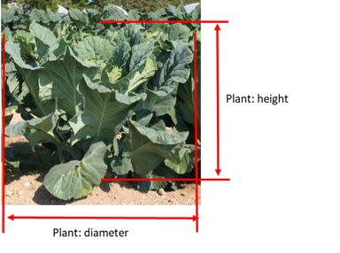

Ad. 2: Plant: diameter

See Ad.1

Ad. 3: Plant: position of growing point

Observations of the position of the growing point should be made in relation to the top of the plant.

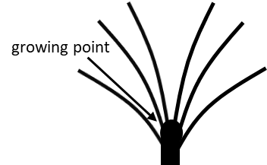 | 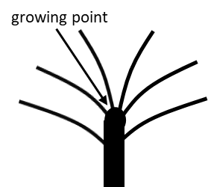 | 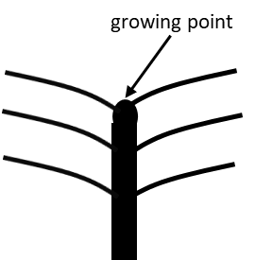
1 | 3 | 5
lower part | middle part | upper part

Ad. 4: Plant: number of leaves

Observations should be made on the number of leaves more than 10cm in length.

Ad. 6: Stem: diameter

Observations should be made on fodder-types only, at widest point.

Ad. 7: Stem: tendency to branch

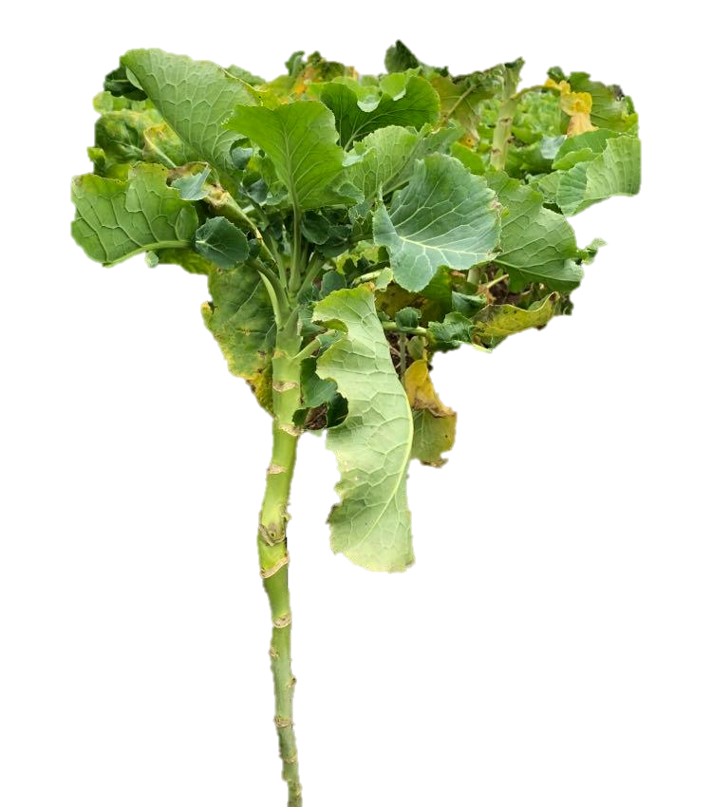 | 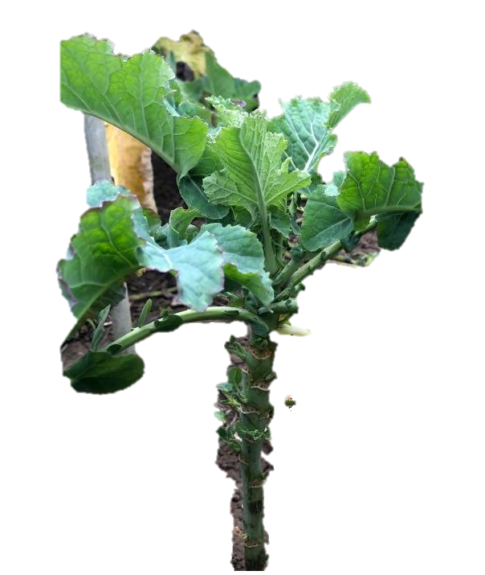 | 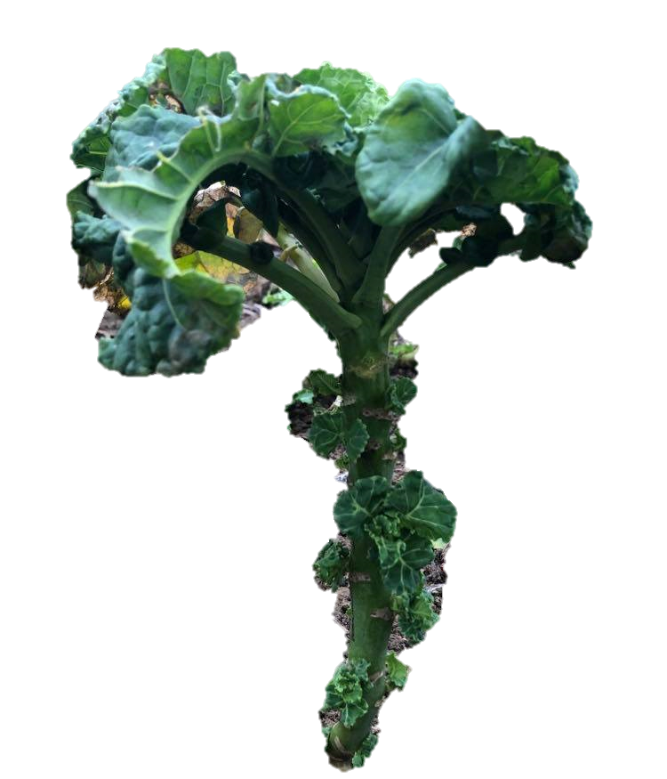
1 | 3 | 5
weak | medium | strong

Ad. 8: Leaf: attitude
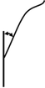 | 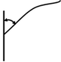 | 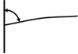
1 | 3 | 5
erect | semi-erect | horizontal

Ad. 10: Leaf: intensity of anthocyanin coloration of main vein

Observations should be made on the lower side of the leaf.

Ad. 12: Leaf: number of lobes

Parts of the leaf blade are considered to be lobes if:
1. They have a minimum length of 1 cm and
2. When folded back to the midrib as shown in Figs 1 and 2, the folded tissue meets the midrib
3. their length is at least equivalent to the width of the leaf petiole at their point of attachment

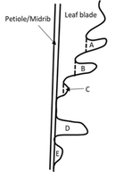 | 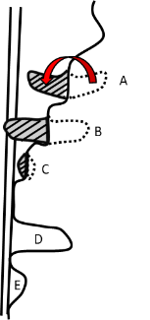
Figure 1 Figure 2

A is not a lobe as it does not meet the midrib when folded
B is a lobe as it meets the midrib when folded
C is too small to be a lobe as it is less than 1 cm in length and does not meet the midrib when folded
D is lobe as the length is longer than the width of the leaf petiole at the point of attachment
E is not a lobe as the length is shorter than the width of the leaf petiole at the point of attachment

Ad. 13: Leaf: length of petiole wing

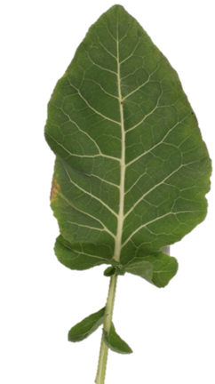 | 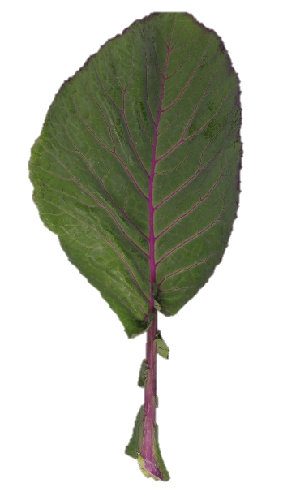 | 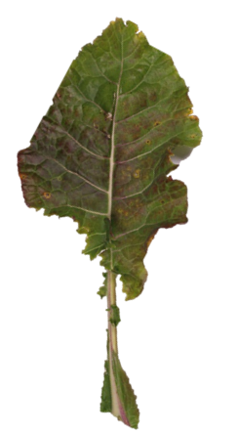 | 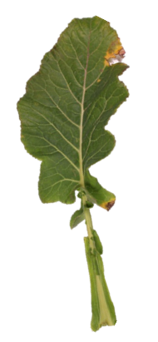 | 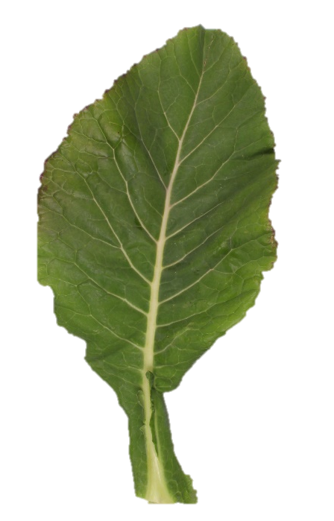
1 | 3 | 5 | 7 | 9
absent or very short | short | medium | long | very long

Ad. 14: Leaf blade: length
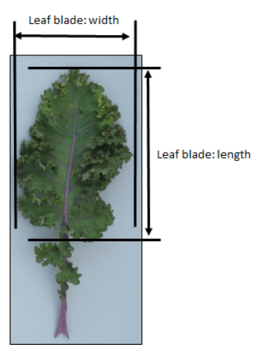

Ad. 15: Leaf blade: width

See Ad. 14

Ad. 17: Leaf blade: number of incisions

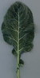 | 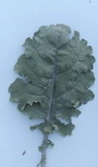 | 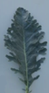
1  absent or few | 3  medium | 5  many

Observations should be made on the unfolded leaf blade excluding the lobes.

Ad. 18: Leaf blade: dentation of margin
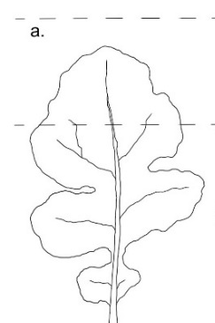 | 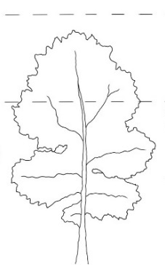 | 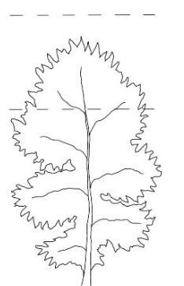
3 | 5 | 7
weak | medium | strong

Ad. 19: Leaf blade: depth of incisions

Observations should be made on upper third of the unfolded leaf blade.

 | 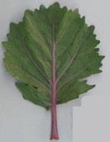
1  absent or shallow | 3  medium | 5  deep

Ad. 20: Leaf blade: curvature of midrib

Observations should be made on the whole leaf shape, not on partial shape.

If almost all of the midrib is straight but the apical part of the midrib is strongly recurved then it should be assessed as straight.

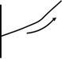 | 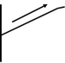 | 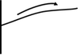 | 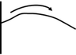 | 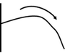 | 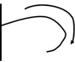
1 | 2 | 3 | 4 | 5 | 6
incurved | straight | slightly recurved | moderately recurved | strongly recurved | very strongly recurved

Ad. 21: Leaf blade: blistering
Blistering is the difference in height of the surface of the leaf between the veins.
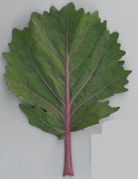 | 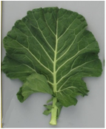 | 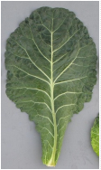 | 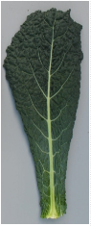
1 | 3 | 5 | 7
absent or very weak | weak | medium | strong

Ad. 22: Leaf blade: folding in cross section

Observations should be made at the middle third of the leaf blade.

 |  | 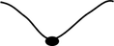 | 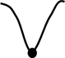 | 
1 | 2 | 3 | 4 | 5
absent or very weak | weak | medium | strong | very strong

Ad. 23: Leaf blade: undulation

Observations should be made on the undulation of the whole leaf as depicted by the line in each of the following photographs.

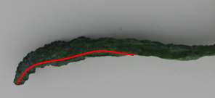 | 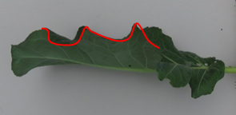
1 | 2
absent or very weak | weak

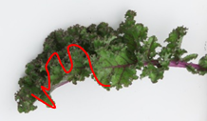 | 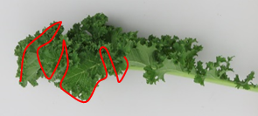
3 | 4
medium | strong

Ad. 24: Leaf blade: undulation of margin
Observations should be made on the small undulations of the margin of the leaf blade.
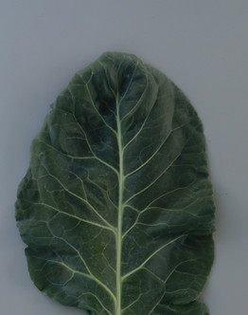 | 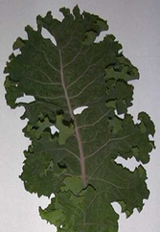 | 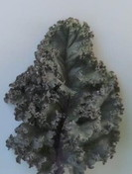 | 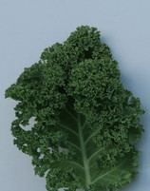 | 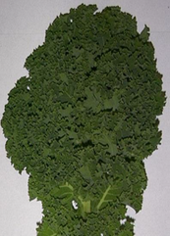
1 | 2 | 3 | 4 | 5
absent or very weak | weak | medium | strong | very strong

Ad. 25: Only for varieties with Leaf blade: undulation of margin: absent or very weak to weak: Leaf blade: recurvature of margin

Observations should be made at the middle third of the leaf blade.

 | 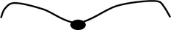 | 
1 | 2 | 3
absent or weak | medium | strong

Ad. 26: Petiole: length
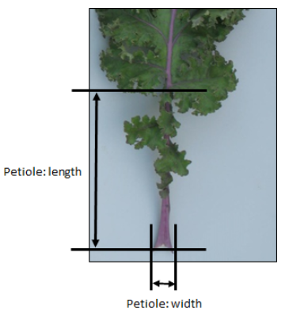

Ad. 27: Petiole: width

see Ad. 26
Observations should be made at the base of petiole.

Ad. 28: Young leaf: color

Observations should be made on immature leaves at the apex of the plant.

Ad. 29: Male sterility
To be tested in a field trial and/or in a DNA marker test.

Field trial:
Check presence of pollen on stamen: if pollen on stamen is present then male sterility is absent; if pollen on stamen is absent then male sterility is present.

DNA marker test and/or field trial:
All varieties declared male sterile in the TQ can be examined in a field trial or in a DNA marker testi. In the case of a DNA marker test^{i}, if the CMS marker appears to be not present, a field trial should be performed to observe whether the variety is male sterile (on another mechanism) or fertile. All varieties declared fertile are to be tested in a field trial.

In case of a field trial, type of observation is VG. In case of a DNA marker test, type of observation is MS.

^{i} The description of the method to test male sterility for Brassica (CMS marker) is covered by a trade secret. The owner of the trade secret, Syngenta Seeds B.V., has given its consent for the use of the CMS marker solely for the purposes of examination of Distinctness, Uniformity and Stability (DUS) and for the development of variety descriptions by UPOV and authorities of UPOV members. Syngenta Seeds B.V. declares that neither UPOV, nor authorities of UPOV members that use the CMS marker for the above purposes will be held accountable for possible (mis)use of the CMS marker by third parties. Please contact Naktuinbouw, Netherlands, to obtain the method and information on the CMS marker for the purposes mentioned above.

9.
Literature

Akihiro Y., 2004: Yasai-engei-daihyakka 20. Shadanhojin Nousan-gyoson-bunkakyokai. Tokyo, JP. pp. 97 to 101

IBPGR, 1990: Descriptors of Brassica and Raphanus. International Board for Plant Genetic Resources. Rome, IT.

Kaloo, G. and Bergh, B.O., 1993: Genetic Improvement of Vegetable Crops, 11 Kale. Pergamon Press. New York, US. pp.187 to 190

Langer, R.H.M., and Hill, G.D., 1982: Agricultural Plants 8, Cruciferae. Cambridge University Press. Cambridge, GB. pp.165 to 183

Lustinec, J., 1988: Biotechnology in Agriculture and Forestry 6. Ed. Y.P.S. Bajaj. Springer-Verlag Berlin, DE. pp.530 to 547

Nieuwhof, M., 1969: "Cole Crops. Botany, Cultivation and Utilisation”. Leonard Hill. London, UK.
Tsukamoto, Y., 1994: The Grand Dictionary of Horticulture Volume 1. The Shogakukan Ltd. Tokyo, JP. pp.829 to 830

Tsunoda, S., Hinata, K. and Gomez-Campo, C., 1980: Brassica Crops and Wild Allies. Biology and Breeding Japan Scientific Press. Tokyo, JP. pp163 to 167

10.
Technical Questionnaire

TECHNICAL QUESTIONNAIRE | Page {x} of {y} | Reference Number:

Application date:
(not to be filled in by the applicant)
TECHNICAL QUESTIONNAIRE
to be completed in connection with an application for plant breeders' rights

1. | Subject of the Technical Questionnaire
 |  | Botanical name
  1.1.1
  Brassica oleracea L. var. costata DC.
  [ ]
 |  | Common name
  1.1.2
  Bedford cabbage, Braganza, Portugese cole, Portuguese kale, Seakale cabbage, Tronchuda cabbage, Tronchuda kale
 |  | Botanical name
  1.2.1
  Brassica oleracea L. var. medullosa Thell.
  [ ]
 |  | Common name
  1.2.2
  Marrow-stem kale
 |  | Botanical name
  1.3.1
  Brassica oleracea L. var. sabellica L.
  [ ]
 |  | Common name
  1.3.2
  Curly kale, Borecole, Dwarf Siberian kale, Kitchen kale, Scotch kale
 |  | Botanical name
  1.4.1
  Brassica oleracea L. var. viridis L.
  [ ]
 |  | Common name
  1.4.2
  Collards, Cow cabbage, Fodder kale, Kale, Spring-heading cabbage, Tall kale, Tree kale
 |  | Botanical name
  1.5.1
  Brassica oleracea L. var. palmifolia DC.
  [ ]
 |  | Common name
  1.5.2
  Giant Jersey kale, Jersey kale, Palm kale, Palm-tree kale, Tree kale

2. | Applicant
 | Name
 | Address
 | Telephone No.
 | Fax No.
 | E-mail address
 | Breeder (if different from
 | applicant)

3. | Proposed denomination and breeder's reference
 | Proposed denomination
 | (if available)
 | Breeder's reference

TECHNICAL QUESTIONNAIRE |  |  | Page {x} of {y} | Reference Number:
 | Information on the breeding scheme and propagation of the variety
  #4.
 | 4.1 | Breeding scheme
 | Variety resulting from:
  4.1.1
  Crossing
 |  | [ ]
  (a)
  controlled cross
 |  | [ ]
  (b)
  partially known cross
 |  | [ ]
  (c)
  unknown cross
 |  | [ ]
  4.1.2
  Mutation
  (please state parent variety)
 |  | [ ]
  4.1.3
  Discovery and development
  (please state where and when discovered and how developed)
 | Other  (Please provide details) | [ ]
  4.1.4

TECHNICAL QUESTIONNAIRE  Page {x} of {y} | Reference Number:

 | 4.2 | Method of propagating the variety
  4.2.1
  Seed-propagated varieties
 |  | [ ]
  (a)
  Cross-pollination
 |  | [ ]
  (i)
  Population
 |  | [ ]
  (i)
  Single hybrid
 |  | [ ]
  (b)
  Hybrid
 |  | [ ]
  (c)
  Other (please provide details)
  4.2.2
  Vegetative propagation
 |  | [ ]
  (a)
  Cuttings
 |  | [ ]
  (b)
  Other (state method)
 | Other  (Please provide details) | [ ]
  4.2.3

TECHNICAL QUESTIONNAIRE | Page {x} of {y} | Reference Number:

5. | Characteristics of the variety to be indicated (the number in brackets refers to the corresponding characteristic in Test Guidelines; please mark the note which best corresponds).

 | Characteristics | Example Varieties | Note
  5.1
  (1)
  Plant: height
  very short
  1 [ ]
  very short to short
  2 [ ]
  short
  Lage Moskrul, Starbor
  3 [ ]
  short to medium
  4 [ ]
  medium
  Darkibor, Marriot, Rossignol
  5 [ ]
  medium to tall
  6 [ ]
  tall
  Cottagers, Esthe, Fizz, Nero di Toscana, Redbor
  7 [ ]
  tall to very tall
  8 [ ]
  very tall
  Ostfriesische Palme
  9 [ ]
  5.2
  (3)
  Plant: position of growing point
  lower part
  Esthe, Fizz
  1 [ ]
  lower to middle part
  Halbhoher grüner krauser
  2 [ ]
  middle part
  Black Magic, Kobolt
  3 [ ]
  middle to upper part
  4 [ ]
  upper part
  Dwarf Green Curled, Kadet, Westlandse Herfst
  5 [ ]
  5.3
  (8)
  Leaf: attitude
  erect
  Esthe, Nero di Toscana
  1 [ ]
  erect to semi-erect
  2 [ ]
  semi-erect
  Cottagers, Redbor
  3 [ ]
  semi-erect to horizontal
  4 [ ]
  horizontal
  Marriot
  5 [ ]
  5.4
  (9)
  Leaf: color
  light green
  Tintoreto
  1 [ ]
  medium green
  Dwarf Green Curled, Esthe
  2 [ ]
  dark green
  Kapitan
  3 [ ]
  grey green
  Fizz
  4 [ ]
  blue green
  Black Magic, Nero di Toscana
  5 [ ]
  reddish green
  Redbor
  6 [ ]
  purple
  Rednex
  7 [ ]

 | Characteristics | Example Varieties | Note
  5.5
  (11)
  Leaf: variegation
  absent
  Esthe
  1 [ ]
  present
  Frost Byte, Purple Varie
  9 [ ]
  5.6
  (14)
  Leaf blade: length
  very short
  1 [ ]
  very short to short
  2 [ ]
  short
  Redbor, Westlandse Herfst
  3 [ ]
  short to medium
  4 [ ]
  medium
  Esthe, Lerchenzungen
  5 [ ]
  medium to long
  6 [ ]
  long
  Nero di Toscana
  7 [ ]
  long to very long
  8 [ ]
  very long
  9 [ ]
  5.7
  (15)
  Leaf blade: width
  very narrow
  1 [ ]
  very narrow to narrow
  Raven
  2 [ ]
  narrow
  Dwarf Green Curled, Redbor
  3 [ ]
  narrow to medium
  4 [ ]
  medium
  Cottagers, Esthe, Fizz
  5 [ ]
  medium to broad
  6 [ ]
  broad
  Beira
  7 [ ]
  broad to very broad
  8 [ ]
  very broad
  9 [ ]
  5.8
  (16)
  Leaf blade: width/length ratio
  very low
  Nero di Toscana
  1 [ ]
  very low to low
  Black Magic, Lerchenzungen
  2 [ ]
  low
  3 [ ]
  low to medium
  Fizz
  4 [ ]
  medium
  Esthe, Redbor, Tintoreto
  5 [ ]
  medium to high
  Dauro
  6 [ ]
  high
  Beira
  7 [ ]
  high to very high
  Marriot
  8 [ ]
  very high
  9 [ ]

 | Characteristics | Example Varieties | Note
  5.9
  (19)
  Leaf blade: depth of incisions
  absent or shallow
  Esthe, Nero di Toscana
  1 [ ]
  shallow to medium
  2 [ ]
  medium
  3 [ ]
  medium to deep
  4 [ ]
  deep
  Fizz
  5 [ ]
  5.10
  (24)
  Leaf blade: undulation of margin
  absent or very weak
  Cottagers, Esthe
  1 [ ]
  weak
  Pentland Brig
  2 [ ]
  medium
  Redbor
  3 [ ]
  strong
  Dwarf Green Curled
  4 [ ]
  very strong
  Westlandse Herfst
  5 [ ]
  5.11
  (29)
  Male sterility
  absent
  Esthe, Westlandse Herfst
  1 [ ]
  present
  Winnetou
  9 [ ]

TECHNICAL QUESTIONNAIRE | Page {x} of {y} | Reference Number:

6. | Similar varieties and differences from these varieties
Please use the following table and box for comments to provide information on how your candidate variety differs from the variety (or varieties) which, to the best of your knowledge, is (or are) most similar. This information may help the examination authority to conduct its examination of distinctness in a more efficient way.

  Denomination(s) of variety(ies) similar to your candidate variety
  Characteristic(s) in which your candidate variety differs from the similar variety(ies)
  Describe the expression of the characteristic(s) for the similar variety(ies)
  Describe the expression of the characteristic(s) for your candidate variety

Example
  Stem: length
  medium
  short

 | Comments:

TECHNICAL QUESTIONNAIRE
Page {x} of {y}
Reference Number:

#7. | Additional information which may help in the examination of the variety
7.1 | In addition to the information provided in sections 5 and 6, are there any additional characteristics which may help to distinguish the variety?
 | Yes | [ ] | No | [ ]
 | (If yes, please provide details)
7.2 | Are there any special conditions for growing the variety or conducting the examination?
 | Yes | [ ] | No | [ ]
 | (If yes, please provide details)
7.3 | Other information

TECHNICAL QUESTIONNAIRE
Page {x} of {y} | Reference Number:

8. | Authorization for release
 | (a) | Does the variety require prior authorization for release under legislation concerning the protection of the environment, human and animal health?
 |  | Yes | [ ] | No | [ ]
 | (b) | Has such authorization been obtained?
 |  | Yes | [ ] | No | [ ]
 | If the answer to (b) is yes, please attach a copy of the authorization.

9. Information on plant material to be examined or submitted for examination

9.1 The expression of a characteristic or several characteristics of a variety may be affected by factors, such as pests and disease, chemical treatment (e.g. growth retardants or pesticides), effects of tissue culture, different rootstocks, scions taken from different growth phases of a tree, etc.
9.2 The plant material should not have undergone any treatment which would affect the expression of the characteristics of the variety, unless the competent authorities allow or request such treatment. If the plant material has undergone such treatment, full details of the treatment must be given. In this respect, please indicate below, to the best of your knowledge, if the plant material to be examined has been subjected to:

 | (a) | Microorganisms (e.g. virus, bacteria, phytoplasma) | Yes [ ] | No [ ]
 | (b) | Chemical treatment (e.g. growth retardant, pesticide) | Yes [ ] | No [ ]
 | (c) | Tissue culture | Yes [ ] | No [ ]
 | (d) | Other factors | Yes [ ] | No [ ]
 | Please provide details for where you have indicated “yes”.

10. | I hereby declare that, to the best of my knowledge, the information provided in this form is correct:
 | Applicant’s name
 | Signature |  | Date

[End of document]

