 |  | E
 | 
  TG/117/5(proj.3)
  ORIGINAL: English
  DATE: 2022-03-03
INTERNATIONAL UNION FOR THE PROTECTION OF NEW VARIETIES OF PLANTS
 | Geneva
  DRAFT
  EGG PLANT
  UPOV Code(s): SOLAN_MEL
  Solanum melongena L.
  *
GUIDELINES
FOR THE CONDUCT OF TESTS
FOR DISTINCTNESS, UNIFORMITY AND STABILITY

prepared by an expert from the European Union
to be considered by the
Technical Working Party for Vegetables

at its fifty-sixth session, to be held virtually,
from 2022-04-18 to 2022-04-22

Disclaimer: this document does not represent UPOV policies or guidance
Alternative names:*

Botanical name | English | French | German | Spanish
  Solanum melongena L., Solanum ovigerum Dunal
  Egg Plant, Aubergine
  Aubergine
  Aubergine, Eierfrucht
  Berenjena

The purpose of these guidelines (“Test Guidelines”) is to elaborate the principles contained in the General Introduction (document TG/1/3), and its associated TGP documents, into detailed practical guidance for the harmonized examination of distinctness, uniformity and stability (DUS) and, in particular, to identify appropriate characteristics for the examination of DUS and production of harmonized variety descriptions.
ASSOCIATED DOCUMENTS
These Test Guidelines should be read in conjunction with the General Introduction and its associated TGP documents.

TABLE OF CONTENTS | PAGE
1. | SUBJECT OF THESE TEST GUIDELINES.......................................................................................................... | 3
2. | MATERIAL REQUIRED..................................................................................................................... | 3
3. | METHOD OF EXAMINATION............................................................................................................... | 3
3.1 | Number of Growing Cycles................................................................................................................. | 3
3.2 | Testing Place................................................................................................................... | 3
3.3 | Conditions for Conducting the Examination............................................................................................... | 3
3.4 | Test Design................................................................................................................. | 4
3.5 | Additional Tests................................................................................................................... | 4

4. | ASSESSMENT OF DISTINCTNESS, UNIFORMITY AND STABILITY................................................................. | 4
4.1 | Distinctness.......................................................................................................... | 4
4.2 | Uniformity............................................................................................................ | 5
4.3 | Stability............................................................................................................... | 5

5. | GROUPING OF VARIETIES AND ORGANIZATION OF THE GROWING TRIAL................................................ | 6
6. | INTRODUCTION TO THE TABLE OF CHARACTERISTICS................................................................................ | 6
6.1 | Categories of Characteristics...................................................................................................... | 6
6.2 | States of Expression and Corresponding Notes........................................................................................ | 6
6.3 | Types of Expression............................................................................................................ | 7
6.4 | Example Varieties.............................................................................................................. | 7
6.5 | Legend................................................................................................................. | 8

7. | TABLE OF CHARACTERISTICS/TABLEAU DES CARACTÈRES/MERKMALSTABELLE/TABLA DE CARACTERES.................................................................................................................. | 9
8. | EXPLANATIONS ON THE TABLE OF CHARACTERISTICS............................................................................... | 26
8.1 | Explanations covering several characteristics........................................................................................... | 26
 | Explanations for individual characteristics................................................................................................. | 27
  8.2

9. | LITERATURE................................................................................................................... | 37
10 | TECHNICAL QUESTIONNAIRE............................................................................................................ | 38

1. | Subject of these Test Guidelines
  These Test Guidelines apply to all varieties of Solanum melongena L.

2. | Material Required
2.1
  The competent authorities decide on the quantity and quality of the plant material required for testing the variety and when and where it is to be delivered. Applicants submitting material from a State other than that in which the testing takes place must ensure that all customs formalities and phytosanitary requirements are complied with.
2.2
  The material is to be supplied in the form of seeds.
2.3
  The minimum quantity of plant material, to be supplied by the applicant, should be:
  12g or 2500 seeds
 | The seed should meet the minimum requirements for germination, species and analytical purity, health and moisture content, specified by the competent authority.
2.4
  The plant material supplied should be visibly healthy, not lacking in vigor, nor affected by any important pest or disease.
2.5
  The plant material should not have undergone any treatment which would affect the expression of the characteristics of the variety, unless the competent authorities allow or request such treatment. If it has been treated, full details of the treatment must be given.

3. | Method of Examination
3.1 | Number of Growing Cycles
 | The minimum duration of tests should normally be two independent growing cycles.
  3.1.1
 | The two independent growing cycles should be in the form of two separate plantings.
  3.1.2
 | The testing of a variety may be concluded when the competent authority can determine with certainty the outcome of the test.
  3.1.3
3.2 | Testing Place
 | Tests are normally conducted at one place. In the case of tests conducted at more than one place, guidance is provided in TGP/9 “Examining Distinctness”.
3.3 | Conditions for Conducting the Examination
 | The tests should be carried out under conditions ensuring satisfactory growth for the expression of the relevant characteristics of the variety and for the conduct of the examination.

3.4 | Test Design
  Each test should be designed to result in a total of at least 20 plants, which should be divided between at least 2 replicates.
3.5 | Additional Tests
 | Additional tests, for examining relevant characteristics, may be established.

4. | Assessment of Distinctness, Uniformity and Stability
4.1 | Distinctness
4.1.1 | General Recommendations
 | It is of particular importance for users of these Test Guidelines to consult the General Introduction prior to making decisions regarding distinctness. However, the following points are provided for elaboration or emphasis in these Test Guidelines.
4.1.2 | Consistent Differences
 | The differences observed between varieties may be so clear that more than one growing cycle is not necessary. In addition, in some circumstances, the influence of the environment is not such that more than a single growing cycle is required to provide assurance that the differences observed between varieties are sufficiently consistent. One means of ensuring that a difference in a characteristic, observed in a growing trial, is sufficiently consistent is to examine the characteristic in at least two independent growing cycles.
4.1.3 | Clear Differences
 | Determining whether a difference between two varieties is clear depends on many factors, and should consider, in particular, the type of expression of the characteristic being examined, i.e. whether it is expressed in a qualitative, quantitative, or pseudo-qualitative manner. Therefore, it is important that users of these Test Guidelines are familiar with the recommendations contained in the General Introduction prior to making decisions regarding distinctness.
4.1.4
  Number of Plants or Parts of Plants to be Examined
  Unless otherwise indicated, for the purposes of distinctness, all observations on single plants should be made on 10 plants or parts of plants taken from each of 10 plants and any other observations made on all plants in the test, disregarding any off-type plants.
  In the case of observations of parts taken from single plants, the number of parts to be taken from each of the plants should be 10.
4.1.5 | Method of Observation
 | The recommended method of observing the characteristic for the purposes of distinctness is indicated by the following key in the Table of Characteristics (see document TGP/9 “Examining Distinctness”, Section 4 “Observation of characteristics”):
MG: single measurement of a group of plants or parts of plants
MS: measurement of a number of individual plants or parts of plants
VG: visual assessment by a single observation of a group of plants or parts of plants
VS: visual assessment by observation of individual plants or parts of plants

Type of observation: visual (V) or measurement (M)
“Visual” observation (V) is an observation made on the basis of the expert’s judgment. For the purposes of this document, “visual” observation refers to the sensory observations of the experts and, therefore, also includes smell, taste and touch. Visual observation includes observations where the expert uses reference points (e.g. diagrams, example varieties, side-by-side comparison) or non-linear charts (e.g. color charts). Measurement (M) is an objective observation against a calibrated, linear scale e.g. using a ruler, weighing scales, colorimeter, dates, counts, etc.
Type of record: for a group of plants (G) or for single, individual plants (S)

For the purposes of distinctness, observations may be recorded as a single record for a group of plants or parts of plants (G), or may be recorded as records for a number of single, individual plants or parts of plants (S). In most cases, “G” provides a single record per variety and it is not possible or necessary to apply statistical methods in a plant-by-plant analysis for the assessment of distinctness.

 | In cases where more than one method of observing the characteristic is indicated in the Table of Characteristics (e.g. VG/MG), guidance on selecting an appropriate method is provided in document TGP/9, Section 4.2.
4.2 | Uniformity
4.2.1 | It is of particular importance for users of these Test Guidelines to consult the General Introduction prior to making decisions regarding uniformity. However, the following points are provided for elaboration or emphasis in these Test Guidelines:
  4.2.2
  These Test Guidelines have been developed for the examination of seed-propagated varieties. For varieties with other types of propagation, the recommendations in the General Introduction and document TGP/13 "Guidance for new types and species" Section 4.5 "Testing Uniformity" should be followed.
 | The assessment of uniformity for cross-pollinated varieties should be according to the recommendations for cross-pollinated varieties in the General Introduction. For the assessment of uniformity of cross-pollinated varieties, a population standard of 2% and an acceptance probability of at least 95% should be applied. In the case of a sample size of 20 plants, 2 off-types are allowed.
  4.2.3
4.2.4
  The assessment of uniformity for self-pollinated varieties should be according to the recommendations for self-pollinated varieties in the General Introduction. For the assessment of uniformity of self-pollinated varieties, a population standard of 1% and an acceptance probability of at least 95% should be applied. In the case of a sample size of 20 plants, 1 off-type is allowed.
4.3 | Stability
4.3.1 | In practice, it is not usual to perform tests of stability that produce results as certain as those of the testing of distinctness and uniformity. However, experience has demonstrated that, for many types of variety, when a variety has been shown to be uniform, it can also be considered to be stable.
4.3.2 | Where appropriate, or in cases of doubt, stability may be further examined by testing a new seed stock to ensure that it exhibits the same characteristics as those shown by the initial material supplied.

5. | Grouping of Varieties and Organization of the Growing Trial
5.1 | The selection of varieties of common knowledge to be grown in the trial with the candidate varieties and the way in which these varieties are divided into groups to facilitate the assessment of distinctness are aided by the use of grouping characteristics.
5.2 | Grouping characteristics are those in which the documented states of expression, even where produced at different locations, can be used, either individually or in combination with other such characteristics: (a) to select varieties of common knowledge that can be excluded from the growing trial used for examination of distinctness; and (b) to organize the growing trial so that similar varieties are grouped together.
5.3 | The following have been agreed as useful grouping characteristics:
  (a)
  Fruit: length (characteristic 15)
  (b)
  Fruit: ratio length/width (characteristic 17)
  (c)
  Fruit: shape (characteristic 18)
  (d)
  Fruit: main color of skin (characteristic 23)
  (e)
  Fruit: stripes (characteristic 27)
  (f)
  Fruit: color of flesh (characteristic 37)

5.4 | Guidance for the use of grouping characteristics, in the process of examining distinctness, is provided through the General Introduction and document TGP/9 “Examining Distinctness”.

6. | Introduction to the Table of Characteristics
6.1 | Categories of Characteristics
6.1.1 | Standard Test Guidelines Characteristics
 | Standard Test Guidelines characteristics are those which are approved by UPOV for examination of DUS and from which members of the Union can select those suitable for their particular circumstances.
6.1.2 | Asterisked Characteristics
 | Asterisked characteristics (denoted by *) are those included in the Test Guidelines which are important for the international harmonization of variety descriptions and should always be examined for DUS and included in the variety description by all members of the Union, except when the state of expression of a preceding characteristic or regional environmental conditions render this inappropriate.
6.2 | States of Expression and Corresponding Notes
6.2.1 | States of expression are given for each characteristic to define the characteristic and to harmonize descriptions. Each state of expression is allocated a corresponding numerical note for ease of recording of data and for the production and exchange of the description.
6.2.2 | All relevant states of expression are presented in the characteristic.

6.2.3 | Further explanation of the presentation of states of expression and notes is provided in document TGP/7 “Development of Test Guidelines”.
6.3 | Types of Expression
 | An explanation of the types of expression of characteristics (qualitative, quantitative and pseudo-qualitative) is provided in the General Introduction.
6.4 | Example Varieties
 | Where appropriate, example varieties are provided to clarify the states of expression of each characteristic.

6.5 | Legend
 |  | English |  | français |  | deutsch | español | Example Varieties  Exemples  Beispielssorten  Variedades ejemplo | Note/  Nota
  1
  2
  3
  4
  5
  6
  7
  Name of characteristics in English
  Nom du caractère en français
  Name des Merkmals auf Deutsch
  Nombre del carácter en español
  states of expression
  types d’expression
  Ausprägungsstufen
  tipos de expresión

1 | Characteristic number
2 | (*) | Asterisked characteristic | – see Chapter 6.1.2
3 | Type of expression
 | QL | Qualitative characteristic | – see Chapter 6.3
 | QN | Quantitative characteristic | – see Chapter 6.3
 | PQ | Pseudo-qualitative characteristic | – see Chapter 6.3
4 | Method of observation (and type of plot, if applicable)
 | MG, MS, VG, VS |  | – see Chapter 4.1.5
5
  (+)
  See Explanations on the Table of Characteristics in Chapter 8.2
6
  (a)-(e)
  See Explanations on the Table of Characteristics in Chapter 8.1
7
  Not applicable

7. | Table of Characteristics/Tableau des caractères/Merkmalstabelle/Tabla de caracteres

 |  | English |  | français |  | deutsch | español | Example Varieties  Exemples  Beispielssorten  Variedades ejemplo | Note/  Nota
1. |  | QN | VG |  | (a)
  Seedling: intensity of anthocyanin coloration of hypocotyl
 |  | absent or very weak |  |  |  |  |  | Lydia | 1
 |  | very weak to weak |  |  |  |  |  |  | 2
 |  | weak |  |  |  |  |  | Bonica | 3
 |  | weak to medium |  |  |  |  |  |  | 4
 |  | medium |  |  |  |  |  | Baluroi | 5
 |  | medium to strong |  |  |  |  |  |  | 6
 |  | strong |  |  |  |  |  | Wase Shinkuro | 7
 |  | strong to very strong |  |  |  |  |  |  | 8
 |  | very strong |  |  |  |  |  |  | 9
2. |  | QN | VG | (+) | (b)
  Plant: growth habit
 |  | erect |  |  |  |  |  | Baluroi, Brigitte, Wase Shinkuro | 1
 |  | erect to semi-erect |  |  |  |  |  |  | 2
 |  | semi-erect |  |  |  |  |  | Birgah, Bonica | 3
 |  | semi-erect to spreading |  |  |  |  |  |  | 4
 |  | spreading |  |  |  |  |  | Irene | 5
3. |  | QN | MS/VG |  | (b)
  Plant: height
 |  | very short |  |  |  |  |  |  | 1
 |  | very short to short |  |  |  |  |  |  | 2
 |  | short |  |  |  |  |  | Adona, Monstrueuse de New York | 3
 |  | short to medium |  |  |  |  |  |  | 4
 |  | medium |  |  |  |  |  | Tudela | 5
 |  | medium to tall |  |  |  |  |  |  | 6
 |  | tall |  |  |  |  |  | Avan, Baluroi | 7
 |  | tall to very tall |  |  |  |  |  |  | 8
 |  | very tall |  |  |  |  |  | Nilo | 9

 |  | English |  | français |  | deutsch | español | Example Varieties  Exemples  Beispielssorten  Variedades ejemplo | Note/  Nota
4. |  | QN | MS/VG | (+) | (b)
  Stem: distance from cotyledons to the node of the first flower
 |  | very short |  |  |  |  |  |  | 1
 |  | very short to short |  |  |  |  |  |  | 2
 |  | short |  |  |  |  |  | Leticia, TSX-250 | 3
 |  | short to medium |  |  |  |  |  |  | 4
 |  | medium |  |  |  |  |  | Bonica | 5
 |  | medium to long |  |  |  |  |  |  | 6
 |  | long |  |  |  |  |  | De Barbentane, Hakatanaga | 7
 |  | long to very long |  |  |  |  |  |  | 8
 |  | very long |  |  |  |  |  | Nilo | 9

5. |  | QN | VG | (+) | (b)
  Stem: intensity of anthocyanin coloration
 |  | absent or very weak |  |  |  |  |  | Blanche ronde à oeuf, Brigitte, Lato | 1
 |  | very weak to weak |  |  |  |  |  |  | 2
 |  | weak |  |  |  |  |  | Bonica | 3
 |  | weak to medium |  |  |  |  |  |  | 4
 |  | medium |  |  |  |  |  | Baluroi | 5
 |  | medium to strong |  |  |  |  |  |  | 6
 |  | strong |  |  |  |  |  | Ronde de Valence | 7
 |  | strong to very strong |  |  |  |  |  |  | 8
 |  | very strong |  |  |  |  |  | Money Maker No 2 | 9
6. |  | QN | VG | (+) | (b)
  Stem: pubescence
 |  | very weak |  |  |  |  |  | Kesia | 1
 |  | very weak to weak |  |  |  |  |  |  | 2
 |  | weak |  |  |  |  |  | Baluroi, Wase Shinkuro | 3
 |  | weak to medium |  |  |  |  |  |  | 4
 |  | medium |  |  |  |  |  | Abrivado, Bonica | 5
 |  | medium to strong |  |  |  |  |  |  | 6
 |  | strong |  |  |  |  |  | Mistral | 7
 |  | strong to very strong |  |  |  |  |  |  | 8
 |  | very strong |  |  |  |  |  | Black Pearl | 9

 |  | English |  | français |  | deutsch | español | Example Varieties  Exemples  Beispielssorten  Variedades ejemplo | Note/  Nota
7. |  | QN | MS/VG |  | (c)
  Leaf blade: size
 |  | very small |  |  |  |  |  | Blanche ronde à oeuf | 1
 |  | very small to small |  |  |  |  |  |  | 2
 |  | small |  |  |  |  |  |  | 3
 |  | small to medium |  |  |  |  |  |  | 4
 |  | medium |  |  |  |  |  | Baluroi | 5
 |  | medium to large |  |  |  |  |  |  | 6
 |  | large |  |  |  |  |  | Bonica | 7
 |  | large to very large |  |  |  |  |  |  | 8
 |  | very large |  |  |  |  |  | Giada | 9
8. |  | QN | VG | (+) | (c)
  Leaf blade: depth of sinuation of the margin
 |  | absent to very weak |  |  |  |  |  | Baluroi, Bonica | 1
 |  | very weak to weak |  |  |  |  |  |  | 2
 |  | weak |  |  |  |  |  | Birgah | 3
 |  | weak to medium |  |  |  |  |  |  | 4
 |  | medium |  |  |  |  |  | Epic, Fabiola | 5
 |  | medium to strong |  |  |  |  |  |  | 6
 |  | strong |  |  |  |  |  | Dalia | 7
 |  | strong to very strong |  |  |  |  |  |  | 8
 |  | very strong |  |  |  |  |  | Listada de Gandia | 9
9. |  | QN | VG |  | (c)
  Leaf blade: blistering
 |  | absent or very weak |  |  |  |  |  | Baluroi | 1
 |  | very weak to weak |  |  |  |  |  |  | 2
 |  | weak |  |  |  |  |  | Wase Shinkuro | 3
 |  | weak to medium |  |  |  |  |  |  | 4
 |  | medium |  |  |  |  |  | Bonica | 5
 |  | medium to strong |  |  |  |  |  |  | 6
 |  | strong |  |  |  |  |  | Listada de Gandia | 7
 |  | strong to very strong |  |  |  |  |  |  | 8
 |  | very strong |  |  |  |  |  |  | 9

 |  | English |  | français |  | deutsch | español | Example Varieties  Exemples  Beispielssorten  Variedades ejemplo | Note/  Nota
10 |  | QN | VG |  | (c)
  Leaf blade: intensity of green color
 |  | very light |  |  |  |  |  |  | 1
 |  | very light to light |  |  |  |  |  |  | 2
 |  | light |  |  |  |  |  | Black Beauty | 3
 |  | light to medium |  |  |  |  |  |  | 4
 |  | medium |  |  |  |  |  | Baluroi, Bonica | 5
 |  | medium to dark |  |  |  |  |  |  | 6
 |  | dark |  |  |  |  |  | Purpura | 7
 |  | dark to very dark |  |  |  |  |  |  | 8
 |  | very dark |  |  |  |  |  |  | 9
11 |  | QN | MG/VG |  | (d)
  Time of flowering
 |  | very early |  |  |  |  |  |  | 1
 |  | very early to early |  |  |  |  |  |  | 2
 |  | early |  |  |  |  |  | Lato | 3
 |  | early to medium |  |  |  |  |  |  | 4
 |  | medium |  |  |  |  |  | Bonica | 5
 |  | medium to late |  |  |  |  |  |  | 6
 |  | late |  |  |  |  |  | Monstrueuse de New York | 7
 |  | late to very late |  |  |  |  |  |  | 8
 |  | very late |  |  |  |  |  |  | 9
12 |  | QL | MS/VG |  | (d)
  Inflorescence: truss
 |  | absent |  |  |  |  |  |  | 1
 |  | present |  |  |  |  |  | Blanche ronde à oeuf | 9
13 |  | QN | MS/VG |  | (d)
  Flower: size
 |  | small |  |  |  |  |  | Cima viola | 1
 |  | small to medium |  |  |  |  |  |  | 2
 |  | medium |  |  |  |  |  | Monstrueuse de New York | 3
 |  | medium to large |  |  |  |  |  |  | 4
 |  | large |  |  |  |  |  | Prosperosa | 5

 |  | English |  | français |  | deutsch | español | Example Varieties  Exemples  Beispielssorten  Variedades ejemplo | Note/  Nota
14 |  | PQ | VG |  | (d)
  Flower: color
 |  | white |  |  |  |  |  |  | 1
 |  | light purple |  |  |  |  |  | Listada de Gandia | 2
 |  | medium purple |  |  |  |  |  | Baluroi, Tsudanaga | 3
 |  | dark purple |  |  |  |  |  | Ronde de Valence, Senryo Nigo | 4
15 | (*) | QN | MS/VG | (+) | (e)
  Fruit: length
 |  | very short |  |  |  |  |  | Blanche ronde à oeuf | 1
 |  | very short to short |  |  |  |  |  |  | 2
 |  | short |  |  |  |  |  | Birgah | 3
 |  | short to medium |  |  |  |  |  |  | 4
 |  | medium |  |  |  |  |  | Flavine, Nigral | 5
 |  | medium to long |  |  |  |  |  |  | 6
 |  | long |  |  |  |  |  | Melana, Mistral | 7
 |  | long to very long |  |  |  |  |  |  | 8
 |  | very long |  |  |  |  |  | Hakatanaga, Indira | 9
16 |  | QN | MS/VG | (+) | (e)
  Fruit: width
 |  | very narrow |  |  |  |  |  | Valentina, White Egg | 1
 |  | very narrow to narrow |  |  |  |  |  |  | 2
 |  | narrow |  |  |  |  |  | Avan, Mistral | 3
 |  | narrow to medium |  |  |  |  |  |  | 4
 |  | medium |  |  |  |  |  | Oriental, Tasca | 5
 |  | medium to broad |  |  |  |  |  |  | 6
 |  | broad |  |  |  |  |  | Bonica, Tudela | 7
 |  | broad to very broad |  |  |  |  |  |  | 8
 |  | very broad |  |  |  |  |  | Birgah | 9

 |  | English |  | français |  | deutsch | español | Example Varieties  Exemples  Beispielssorten  Variedades ejemplo | Note/  Nota
17 | (*) | QN | MS/VG | (+) | (e)
  Fruit: ratio length/width
 |  | very low |  |  |  |  |  | Birgah | 1
 |  | very low to low |  |  |  |  |  |  | 2
 |  | low |  |  |  |  |  | Bonica | 3
 |  | low to medium |  |  |  |  |  |  | 4
 |  | medium |  |  |  |  |  | Flavine | 5
 |  | medium to high |  |  |  |  |  |  | 6
 |  | high |  |  |  |  |  | Indira, Mistral | 7
 |  | high to very high |  |  |  |  |  |  | 8
 |  | very high |  |  |  |  |  | Hakatanaga | 9

18 | (*) | PQ | VG | (+) | (e)
  Fruit: shape
 |  | flattened globular |  |  |  |  |  | Birgah | 1
 |  | globular |  |  |  |  |  | Monstrueuse de New York, Purpura | 2
 |  | ovoid |  |  |  |  |  | Beatrice | 3
 |  | obovate |  |  |  |  |  | Black King | 4
 |  | pear shaped |  |  |  |  |  | Listada de Gandia | 5
 |  | club shaped |  |  |  |  |  | Baluroi, Mileda | 6
 |  | ellipsoid |  |  |  |  |  | Scorpio, Volta | 7
 |  | cylindrical |  |  |  |  |  | Mirabelle, Tango | 8
19 |  | QN | MS/VG | (+) | (e)
  Fruit: size of pistil scar
 |  | very small |  |  |  |  |  | Alabaster | 1
 |  | small |  |  |  |  |  | Baluroi, Wase Shinkuro | 2
 |  | medium |  |  |  |  |  | Bonica | 3
 |  | large |  |  |  |  |  | Monstrueuse de New York | 4
 |  | very large |  |  |  |  |  | Purpura | 5
20 |  | PQ | VG | (+) | (e)
  Fruit: apex
 |  | indented |  |  |  |  |  | Pietranera | 1
 |  | flattened |  |  |  |  |  | Prosperosa | 2
 |  | rounded |  |  |  |  |  | Baluroi | 3
 |  | acute |  |  |  |  |  | Tanyeli | 4

 |  | English |  | français |  | deutsch | español | Example Varieties  Exemples  Beispielssorten  Variedades ejemplo | Note/  Nota
21 |  | QN | VG | (+) | (e)
  Fruit: depth of indentation of pistil scar
 |  | absent to very shallow |  |  |  |  |  | Blanche ronde à oeuf, Cristal | 1
 |  | shallow |  |  |  |  |  | Cheryl | 2
 |  | medium |  |  |  |  |  |  | 3
 |  | deep |  |  |  |  |  | Pietranera | 4
 |  | very deep |  |  |  |  |  | Gascona | 5
22 |  | QN | VG | (+) | (e)
  Only for varieties with cylindrical fruits: Fruit: curvature
 |  | absent to weak |  |  |  |  |  | Abrivado, Freia | 1
 |  | medium |  |  |  |  |  | Hakatanaga | 2
 |  | strong |  |  |  |  |  | Alya, Gioleta | 3
23 | (*) | QL | VG | (+) | (e)
  Fruit: main color of skin
 |  | white |  |  |  |  |  | Alabaster, Blanche ronde à oeuf, Lato | 1
 |  | green |  |  |  |  |  | Samantha | 2
 |  | violet |  |  |  |  |  | Baluroi, Purpura | 3
24 |  | QN | VG |  | (e)
  Only for varieties with green and violet skin color: Fruit: intensity of main color of skin
 |  | very light |  |  |  |  |  | Circe | 1
 |  | very light to light |  |  |  |  |  |  | 2
 |  | light |  |  |  |  |  | Bride | 3
 |  | light to medium |  |  |  |  |  |  | 4
 |  | medium |  |  |  |  |  | Prosperosa, Purpura, Ruby, Shironasu | 5
 |  | medium to dark |  |  |  |  |  |  | 6
 |  | dark |  |  |  |  |  | Patio Baby | 7
 |  | dark to very dark |  |  |  |  |  |  | 8
 |  | very dark |  |  |  |  |  | Faselis | 9

 |  | English |  | français |  | deutsch | español | Example Varieties  Exemples  Beispielssorten  Variedades ejemplo | Note/  Nota
25 |  | QN | VG |  | (e)
  Fruit: glossiness
 |  | very weak |  |  |  |  |  | Long Tom | 1
 |  | weak |  |  |  |  |  | Prosperosa | 2
 |  | medium |  |  |  |  |  | Baluroi | 3
 |  | strong |  |  |  |  |  | Birgah | 4
 |  | very strong |  |  |  |  |  | Elisa | 5
26 | (*) | QL | VG | (+) | (e)
  Fruit: patches
 |  | absent |  |  |  |  |  | Baluroi | 1
 |  | present |  |  |  |  |  | Emerald Isle | 9

27 | (*) | QL | VG | (+) | (e)
  Fruit: stripes
 |  | absent |  |  |  |  |  | Baluroi | 1
 |  | present |  |  |  |  |  | Listada de Gandia | 9
28 |  | QN | VG | (+) | (e)
  Fruit: conspicuousness of stripes
 |  | very weak |  |  |  |  |  |  | 1
 |  | very weak to weak |  |  |  |  |  |  | 2
 |  | weak |  |  |  |  |  | Bride | 3
 |  | weak to medium |  |  |  |  |  |  | 4
 |  | medium |  |  |  |  |  |  | 5
 |  | medium to strong |  |  |  |  |  |  | 6
 |  | strong |  |  |  |  |  | Listada de Gandia | 7
 |  | strong to very strong |  |  |  |  |  |  | 8
 |  | very strong |  |  |  |  |  |  | 9

 |  | English |  | français |  | deutsch | español | Example Varieties  Exemples  Beispielssorten  Variedades ejemplo | Note/  Nota
29 |  | QN | VG |  | (e)
  Fruit: density of stripes
 |  | very sparse |  |  |  |  |  |  | 1
 |  | very sparse to sparse |  |  |  |  |  |  | 2
 |  | sparse |  |  |  |  |  |  | 3
 |  | sparse to medium |  |  |  |  |  |  | 4
 |  | medium |  |  |  |  |  |  | 5
 |  | medium to dense |  |  |  |  |  |  | 6
 |  | dense |  |  |  |  |  | Listada de Gandia | 7
 |  | dense to very dense |  |  |  |  |  |  | 8
 |  | very dense |  |  |  |  |  |  | 9
30 | (*) | QN | VG | (+) | (e)
  Fruit: grooves
 |  | absent or very weak |  |  |  |  |  | Bonica | 1
 |  | weak |  |  |  |  |  | Bibo | 2
 |  | medium |  |  |  |  |  |  | 3
 |  | strong |  |  |  |  |  | Black Beauty | 4
 |  | very strong |  |  |  |  |  |  | 5
31 |  | QN | MS/VG | (+) | (e)
  Fruit: length of peduncle
 |  | very short |  |  |  |  |  | Blanche ronde à oeuf | 1
 |  | very short to short |  |  |  |  |  |  | 2
 |  | short |  |  |  |  |  | Birgah | 3
 |  | short to medium |  |  |  |  |  |  | 4
 |  | medium |  |  |  |  |  | Madonna | 5
 |  | medium to long |  |  |  |  |  |  | 6
 |  | long |  |  |  |  |  | Alex, Tanyeli | 7
 |  | long to very long |  |  |  |  |  |  | 8
 |  | very long |  |  |  |  |  | Avan | 9

 |  | English |  | français |  | deutsch | español | Example Varieties  Exemples  Beispielssorten  Variedades ejemplo | Note/  Nota
32 |  | QN | VG |  | (e)
  Fruit: intensity of anthocyanin coloration underneath calyx
 |  | absent or very weak |  |  |  |  |  | Ronde de Valence | 1
 |  | weak |  |  |  |  |  | Bonica, Melana | 2
 |  | medium |  |  |  |  |  | Black Beauty, Tasca | 3
 |  | strong |  |  |  |  |  | Andia, Baluroi | 4
 |  | very strong |  |  |  |  |  | Gascona | 5

33 |  | QN | VG | (+) | (e)
  Fruit: size of calyx
 |  | very small |  |  |  |  |  | Blanche ronde à oeuf | 1
 |  | very small to small |  |  |  |  |  |  | 2
 |  | small |  |  |  |  |  | Lato | 3
 |  | small to medium |  |  |  |  |  |  | 4
 |  | medium |  |  |  |  |  | Bonica | 5
 |  | medium to large |  |  |  |  |  |  | 6
 |  | large |  |  |  |  |  | Abrivado | 7
 |  | large to very large |  |  |  |  |  |  | 8
 |  | very large |  |  |  |  |  | Dealmagro | 9
34 |  | QN | VG | (+) | (e)
  Fruit: intensity of anthocyanin coloration of calyx
 |  | absent or very weak |  |  |  |  |  | Blanche ronde à oeuf, Dourga | 1
 |  | very weak to weak |  |  |  |  |  |  | 2
 |  | weak |  |  |  |  |  | Mirval, Tsudanaga | 3
 |  | weak to medium |  |  |  |  |  |  | 4
 |  | medium |  |  |  |  |  | Abrivado, Baluroi | 5
 |  | medium to strong |  |  |  |  |  |  | 6
 |  | strong |  |  |  |  |  | Purpura, Wase Shinkuro | 7
 |  | strong to very strong |  |  |  |  |  |  | 8
 |  | very strong |  |  |  |  |  | Long Tom | 9

 |  | English |  | français |  | deutsch | español | Example Varieties  Exemples  Bei ejemplo | Note/
35 | (*) | QN | VG | (+) | (e)
  Fruit: spines on calyx
 |  | absent or very few |  |  |  |  |  | Freia, Lato | 1
 |  | very few to few |  |  |  |  |  |  | 2
 |  | few |  |  |  |  |  | Destan | 3
 |  | few to medium |  |  |  |  |  |  | 4
 |  | medium |  |  |  |  |  | Bonica, Rioca | 5
 |  | medium to many |  |  |  |  |  |  | 6
 |  | many |  |  |  |  |  | Baluroi, Bibo | 7
 |  | many to very many |  |  |  |  |  |  | 8
 |  | very many |  |  |  |  |  | Tasca | 9
36 |  | QN | VG | (+) | (e)
  Fruit: creasing of calyx
 |  | absent or weak |  |  |  |  |  | Birgah, Madalena | 1
 |  | medium |  |  |  |  |  | Angela, Baluroi | 2
 |  | strong |  |  |  |  |  | Linda, Listada de Gandia | 3
37 | (*) | QL | VG | (+) | (e)
  Fruit: color of flesh
 |  | white |  |  |  |  |  | Lato | 1
 |  | green |  |  |  |  |  | Baluroi | 2

38 |  | PQ | VG | (+)
  Ripe fruit: color of skin
 |  | yellow |  |  |  |  |  |  | 1
 |  | orange |  |  |  |  |  | Comprido Verde Claro | 2
 |  | brownish orange |  |  |  |  |  | Vernal | 3
 |  | brown |  |  |  |  |  | Abrivado, Baluroi | 4

8. | Explanations on the Table of Characteristics
8.1 | Explanations covering several characteristics
 | Characteristics containing the following key in the Table of Characteristics should be examined as indicated below:
  (a)
  Seedling: observations should be made at full development of the cotyledons, when the first leaf begins to develop, before transplanting
  (b)
  Plant and stem: observations should be made after the first inflorescence starts to flower and before the start of the harvest, excluding the fork inflorescence.
  (c)
  Leaf blade: observations should be made after the first inflorescence starts to flower and before the start of the harvest, at the middle third part of the plant and excluding the fork inflorescence.
  (d)
  Flower and inflorescence: observations should be made when 50% of the plants of the variety has opened flowers on the second or the third inflorescence. Observations on the flower should be made at fresh, fully opened flowers.
  (e)
  Fruit: all observations should be made on the first normally developed fruits when the seeds start to develop, and excluding the fork fruit.

 | Explanations for individual characteristics
  8.2
Ad. 2: Plant: growth habit

Drawings to be provided

For plants contained between two strings (which can modify the natural growth habit), we look at the angle of the branches at the fork level.

OR

This characteristic can only be observed when plants are grown under natural conditions. For trials where plants are staked or grown on a wire and pruned, this characteristic can not be observed.

Ad. 4: Stem: distance from cotyledons to the node of the first flower
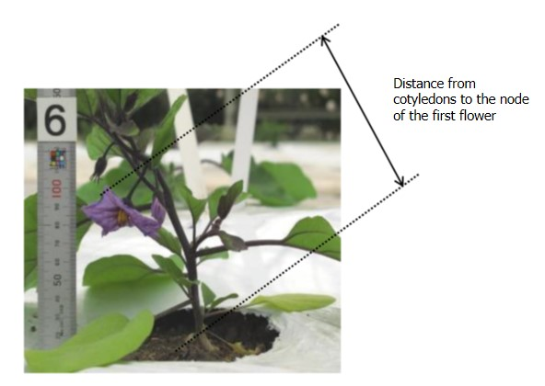

Ad. 5: Stem: intensity of anthocyanin coloration

Observations should be made on the upper third of the plant.

Ad. 6: Stem: pubescence

Observations should be made at the middle third of the plant.

Ad. 8: Leaf blade: depth of sinuation of the margin
Sinuation of margin is composed by incisions of the leaf margin. It may form some lobing that never reach the midrib. It must be explained that it does not involve undulation of the margin

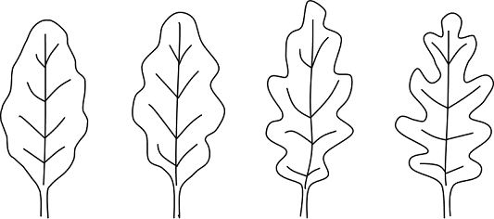

1 | 3 | 5 | 7
absent to very weak | weak | medium | strong

Ad. 15: Fruit: length

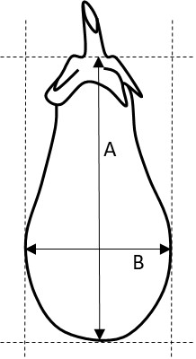

A: length
B: width (to be observed at the widest part)

Ad. 16: Fruit: width

See Ad. 16

Ad. 17: Fruit: ratio length/width
See Ad. 16

Ad. 18: Fruit: shape

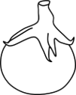 | 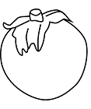 | 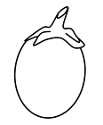 | 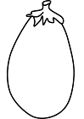
1 | 2 | 3 | 4
flattened globular | globular | ovoid | obovate

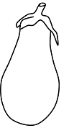 | 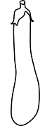 | 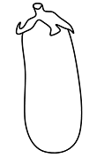 | 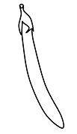
5 | 6 | 7 | 8
pear shaped | club shaped | ellipsoid | cylindrical

Ad. 19: Fruit: size of pistil scar

Observations should be made on the total area of the pistil scar (circled in red on the picture).

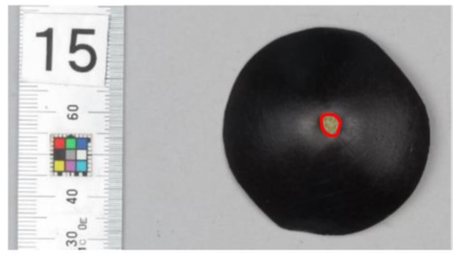.

Ad. 20: Fruit: apex
 |  |  | 
 | 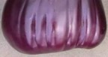 | 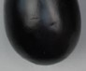 | 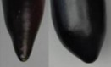
1  indented | 2  flattened | 3  rounded | 4  acute

Ad. 21: Fruit: depth of indentation of pistil scar

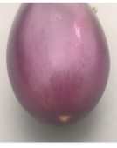 |  | 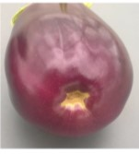
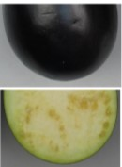 | 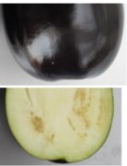 | 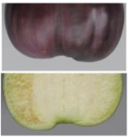
1  absent to very shallow | 3  medium | 5  very deep

Ad. 22: Only for varieties with cylindrical fruits: Fruit: curvature

Observations should be made on fruits that have been growing without any obstacles since that can affect the curvature.

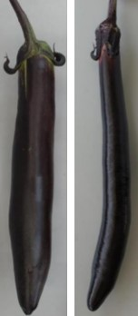 | 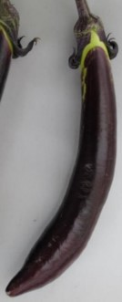 | 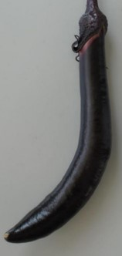
1 | 2 | 3
absent to weak | medium | strong

Ad. 23: Fruit: main color of skin

For varieties with stripes on the fruits, the color which occupies the largest area on the fruit is regarded as main color

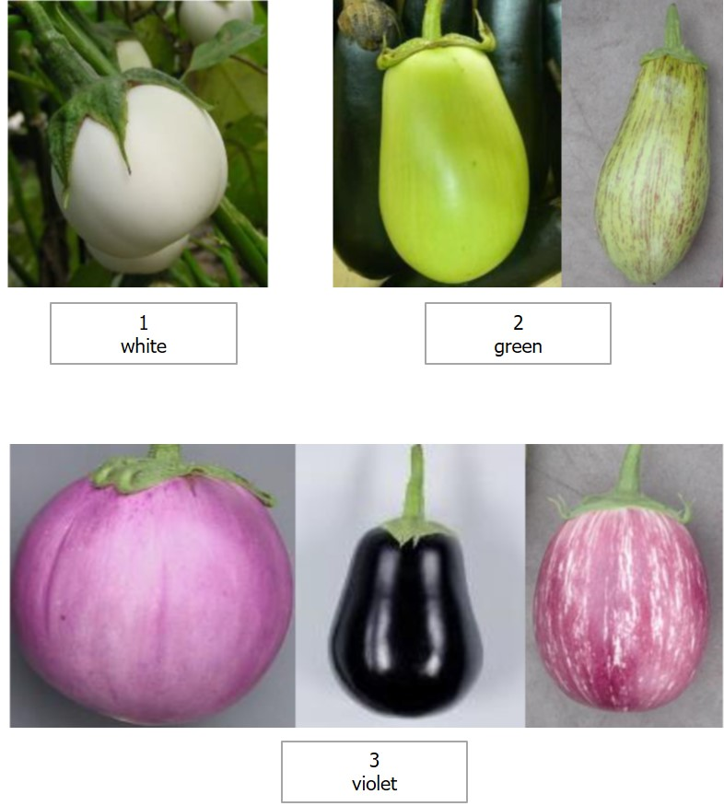

Ad. 26: Fruit: patches
Observations should be done directly after harvest, older fruits can appear to be patched, when in fact they are starting to discolor.

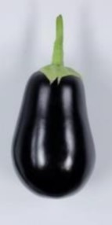 | 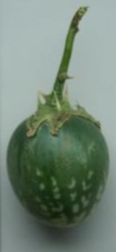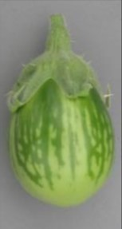
1 | 9
absent | present

Ad. 27: Fruit: stripes

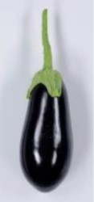 | 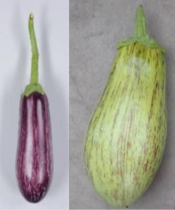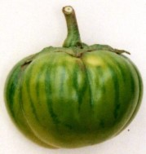
1  absent | 9  present

Ad. 28: Fruit: conspicuousness of stripes
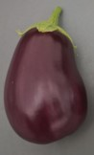 | 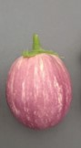 | 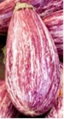 | 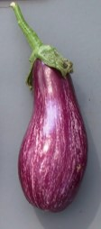 | 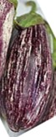
1 | 3 | 5 | 7 | 9
very weak | weak | medium | strong | very strong

Ad. 30: Fruit: grooves

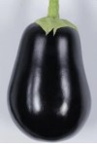 | 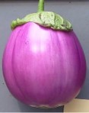 | 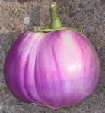
1  absent or very weak | 2  weak | 5  medium
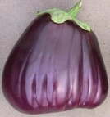
7  strong | 9  very strong

The observation of the number of grooves and their deepness should be both considered.

Ad. 31: Fruit: length of peduncle

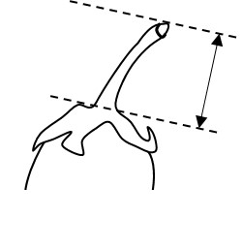

Ad. 33: Fruit: size of calyx

Observations should be made regarding the absolute size of the calyx, not the relative to the size of the fruit.

Ad. 34: Fruit: intensity of anthocyanin coloration of calyx

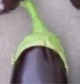 | picture to be provided | 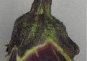 | 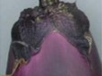 | 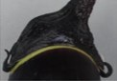
1 | 3 | 5 | 7 | 9
absent or very weak | weak | medium | strong | very strong

Ad. 35: Fruit: spines on calyx

Observations should be made on the number of the spines.

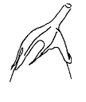 | 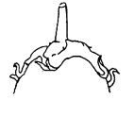 | 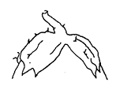 | 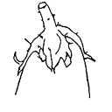
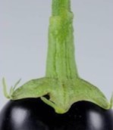 | 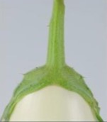 | 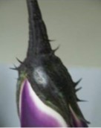 | 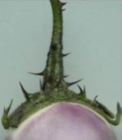
1  absent or very few | 3  few | 5  medium | 7  many

Ad. 36: Fruit: creasing of calyx
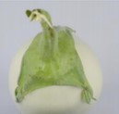 | 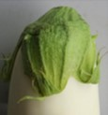 | 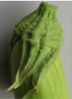
1  absent or weak | 2  medium | 3  strong

Ad. 37: Fruit: color of flesh

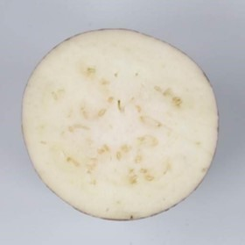 | 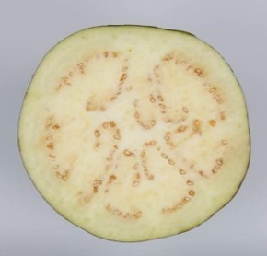
1  white | 2  green

Ad. 38: Ripe fruit: color of skin

Observations should be made on fruits at physiological ripeness, when the color stops changing.

9.
Literature

Adinolfi, A., Bianchi, M.: “Caratterizzazione di varieta di Melanzana,” Quaderno n. 38 dell’E.N.S.E.

Daunay, M. C., Lester, R. N., Ano, G., 2001: “Eggplant,” p. 199-222 in Tropical Plant Breeding (569 p.), Scient. Ed., Charrier, A., Jacquot, M., Hamon, S., Nicolas, D., CIRAD; Science Publishers, Inc., Enfield (USA), Plymouth GB, 569 p.

Naktuinbouw and NCSS(/NARO), 2019: Calibration Manual DUS Test for Eggplant

Phillips, R., Rix, M., 1995: “Vegetables”, Macmillan Reference Books.

10.
Technical Questionnaire

TECHNICAL QUESTIONNAIRE | Page {x} of {y} | Reference Number:

Application date:
(not to be filled in by the applicant)
TECHNICAL QUESTIONNAIRE
to be completed in connection with an application for plant breeders' rights

1. | Subject of the Technical Questionnaire
 |  | Botanical name
  1.1
  Solanum melongena L.
 |  | Common name
  1.2
  Egg Plant, Aubergine

2. | Applicant
 | Name
 | Address
 | Telephone No.
 | Fax No.
 | E-mail address
 | Breeder (if different from
 | applicant)

3. | Proposed denomination and breeder's reference
 | Proposed denomination
 | (if available)
 | Breeder's reference

TECHNICAL QUESTIONNAIRE |  |  | Page {x} of {y} | Reference Number:
 | Information on the breeding scheme and propagation of the variety
  #4.
 | 4.1 | Breeding scheme
 | Variety resulting from:
  4.1.1
  Crossing
 |  | [ ]
  (a)
  controlled cross
 |  | [ ]
  (b)
  partially known cross
 |  | [ ]
  (c)
  unknown cross
 |  | [ ]
  4.1.2
  Mutation
  (please state parent variety)
 |  | [ ]
  4.1.3
  Discovery and development
  (please state where and when discovered and how developed)
 | Other  (Please provide details) | [ ]
  4.1.4

TECHNICAL QUESTIONNAIRE  Page {x} of {y} | Reference Number:

 | 4.2 | Method of propagating the variety
  4.2.1
  Seed-propagated varieties
 |  | [ ]
  (a)
  Self-pollination
 |  | [ ]
  (b)
  Cross-pollination
 |  | [ ]
  (c)
  Hybrid
 |  | [ ]
  (d)
  Inbred line
 |  | [ ]
  (e)
  Other (please provide details)
 | Other  (Please provide details) | [ ]
  4.2.2

TECHNICAL QUESTIONNAIRE | Page {x} of {y} | Reference Number:

5. | Characteristics of the variety to be indicated (the number in brackets refers to the corresponding characteristic in Test Guidelines; please mark the note which best corresponds).

 | Characteristics | Example Varieties | Note
  5.1
  (3)
  Plant: height
  very short
  1 [ ]
  very short to short
  2 [ ]
  short
  Adona, Monstrueuse de New York
  3 [ ]
  short to medium
  4 [ ]
  medium
  Tudela
  5 [ ]
  medium to tall
  6 [ ]
  tall
  Avan, Baluroi
  7 [ ]
  tall to very tall
  8 [ ]
  very tall
  Nilo
  9 [ ]
  5.2
  (6)
  Stem: pubescence
  very weak
  Kesia
  1 [ ]
  very weak to weak
  2 [ ]
  weak
  Baluroi, Wase Shinkuro
  3 [ ]
  weak to medium
  4 [ ]
  medium
  Abrivado, Bonica
  5 [ ]
  medium to strong
  6 [ ]
  strong
  Mistral
  7 [ ]
  strong to very strong
  8 [ ]
  very strong
  Black Pearl
  9 [ ]
  5.3
  (15)
  Fruit: length
  very short
  Blanche ronde à oeuf
  1 [ ]
  very short to short
  2 [ ]
  short
  Birgah
  3 [ ]
  short to medium
  4 [ ]
  medium
  Flavine, Nigral
  5 [ ]
  medium to long
  6 [ ]
  long
  Melana, Mistral
  7 [ ]
  long to very long
  8 [ ]
  very long
  Hakatanaga, Indira
  9 [ ]

 | Characteristics | Example Varieties | Note
  5.4
  (17)
  Fruit: ratio length/width
  very low
  Birgah
  1 [ ]
  very low to low
  2 [ ]
  low
  Bonica
  3 [ ]
  low to medium
  4 [ ]
  medium
  Flavine
  5 [ ]
  medium to high
  6 [ ]
  high
  Indira, Mistral
  7 [ ]
  high to very high
  8 [ ]
  very high
  Hakatanaga
  9 [ ]
  5.5
  (18)
  Fruit: shape
  flattened globular
  Birgah
  1 [ ]
  globular
  Monstrueuse de New York, Purpura
  2 [ ]
  ovoid
  Beatrice
  3 [ ]
  obovate
  Black King
  4 [ ]
  pear shaped
  Listada de Gandia
  5 [ ]
  club shaped
  Baluroi, Mileda
  6 [ ]
  ellipsoid
  Scorpio, Volta
  7 [ ]
  cylindrical
  Mirabelle, Tango
  8 [ ]
  5.6
  (23)
  Fruit: main color of skin
  white
  Alabaster, Blanche ronde à oeuf, Lato
  1 [ ]
  green
  Samantha
  2 [ ]
  violet
  Baluroi, Purpura
  3 [ ]
  5.7
  (24)
  Only for varieties with green and violet skin color: Fruit: intensity of main color of skin
  very light
  Circe
  1 [ ]
  very light to light
  2 [ ]
  light
  Bride
  3 [ ]
  light to medium
  4 [ ]
  medium
  Prosperosa, Purpura, Ruby, Shironasu
  5 [ ]
  medium to dark
  6 [ ]
  dark
  Patio Baby
  7 [ ]
  dark to very dark
  8 [ ]
  very dark
  Faselis
  9 [ ]

 | Characteristics | Example Varieties | Note
  5.8
  (26)
  Fruit: patches
  absent
  Baluroi
  1 [ ]
  present
  Emerald Isle
  9 [ ]
  5.9
  (27)
  Fruit: stripes
  absent
  Baluroi
  1 [ ]
  present
  Listada de Gandia
  9 [ ]
  5.10
  (30)
  Fruit: grooves
  absent or very weak
  Bonica
  1 [ ]
  weak
  Bibo
  2 [ ]
  medium
  3 [ ]
  strong
  Black Beauty
  4 [ ]
  very strong
  5 [ ]
  5.11
  (35)
  Fruit: spines on calyx
  absent or very few
  Freia, Lato
  1 [ ]
  very few to few
  2 [ ]
  few
  Destan
  3 [ ]
  few to medium
  4 [ ]
  medium
  Bonica, Rioca
  5 [ ]
  medium to many
  6 [ ]
  many
  Baluroi, Bibo
  7 [ ]
  many to very many
  8 [ ]
  very many
  Tasca
  9 [ ]
  5.12
  (37)
  Fruit: color of flesh
  white
  Lato
  1 [ ]
  green
  Baluroi
  2 [ ]

TECHNICAL QUESTIONNAIRE | Page {x} of {y} | Reference Number:

6. | Similar varieties and differences from these varieties
Please use the following table and box for comments to provide information on how your candidate variety differs from the variety (or varieties) which, to the best of your knowledge, is (or are) most similar. This information may help the examination authority to conduct its examination of distinctness in a more efficient way.

  Denomination(s) of variety(ies) similar to your candidate variety
  Characteristic(s) in which your candidate variety differs from the similar variety(ies)
  Describe the expression of the characteristic(s) for the similar variety(ies)
  Describe the expression of the characteristic(s) for your candidate variety

Example
  Fruit: length
  1 - very short
  3 - short

 | Comments:

TECHNICAL QUESTIONNAIRE
Page {x} of {y}
Reference Number:

#7. | Additional information which may help in the examination of the variety
7.1 | In addition to the information provided in sections 5 and 6, are there any additional characteristics which may help to distinguish the variety?
 | Yes | [ ] | No | [ ]
 | (If yes, please provide details)
7.2 | Are there any special conditions for growing the variety or conducting the examination?
 | Yes | [ ] | No | [ ]
 | (If yes, please provide details)
7.3 | Other information
A representative color photograph of the variety displaying its main distinguishing feature(s), should accompany the Technical Questionnaire. The photograph will provide a visual illustration of the candidate variety which supplements the information provided in the Technical Questionnaire.
The key points to consider when taking a photograph of the candidate variety are:
• Indication of the date and geographic location
• Correct labeling (breeder’s reference)
• Good quality printed photograph (minimum 10 cm x 15 cm) and/or sufficient resolution electronic format version (minimum 960 x 1280 pixels)”
Further guidance on providing photographs with the Technical Questionnaire is available in document TGP/7 "Development of Test Guidelines", Guidance Note 35 (http://www.upov.int/tgp/en/).
[The link provided may be deleted by members of the Union when developing authorities’ own test guidelines.]
• | Resistance to pest and diseases

• | Type of culture: [ ] under glass [ ] in the open

TECHNICAL QUESTIONNAIRE
Page {x} of {y} | Reference Number:

8. | Authorization for release
 | (a) | Does the variety require prior authorization for release under legislation concerning the protection of the environment, human and animal health?
 |  | Yes | [ ] | No | [ ]
 | (b) | Has such authorization been obtained?
 |  | Yes | [ ] | No | [ ]
 | If the answer to (b) is yes, please attach a copy of the authorization.

9. Information on plant material to be examined or submitted for examination

9.1 The expression of a characteristic or several characteristics of a variety may be affected by factors, such as pests and disease, chemical treatment (e.g. growth retardants or pesticides), effects of tissue culture, different rootstocks, scions taken from different growth phases of a tree, etc.
9.2 The plant material should not have undergone any treatment which would affect the expression of the characteristics of the variety, unless the competent authorities allow or request such treatment. If the plant material has undergone such treatment, full details of the treatment must be given. In this respect, please indicate below, to the best of your knowledge, if the plant material to be examined has been subjected to:

 | (a) | Microorganisms (e.g. virus, bacteria, phytoplasma) | Yes [ ] | No [ ]
 | (b) | Chemical treatment (e.g. growth retardant, pesticide) | Yes [ ] | No [ ]
 | (c) | Tissue culture | Yes [ ] | No [ ]
 | (d) | Other factors | Yes [ ] | No [ ]
 | Please provide details for where you have indicated “yes”.

10. | I hereby declare that, to the best of my knowledge, the information provided in this form is correct:
 | Applicant’s name
 | Signature |  | Date

[

End of document]

