 |  | E
 | 
  TG/105/5(proj.2)
  ORIGINAL: English
  DATE: 2022-03-07
INTERNATIONAL UNION FOR THE PROTECTION OF NEW VARIETIES OF PLANTS
 | Geneva
  DRAFT
  CHINESE CABBAGE
  UPOV Code(s): BRASS_RAP_PEK; BRASS_RAP_PCH ; BRASS_RAP_PRA; BRASS_TUR
  Brassica rapa L. subsp. pekinensis (Lour.) Kitam.;
  hybrids between Brassica rapa L. Emend. Metzg. ssp. pekinensis (Lour.) Hanelt and Brassica rapa L. Emend. Metzg. ssp. chinensis (L.) Hanelt;
  hybrids between Brassica rapa L. Emend. Metzg. ssp. pekinensis (Lour.) Hanelt and Brassica rapa L. var. rapa (L.) Thell.;
  Brassica ×turicensis O. E. Schulz & Thell.
  *
GUIDELINES
FOR THE CONDUCT OF TESTS
FOR DISTINCTNESS, UNIFORMITY AND STABILITY

prepared by experts from the Republic of Korea
to be considered by the
Technical Working Party for Vegetables

at its fifty-sixth session, to be held virtually,
from 2022-04-18 to 2022-04-22

Disclaimer: this document does not represent UPOV policies or guidance

Alternative names:*

Botanical name | English | French | German | Spanish
  Brassica rapa L. subsp. pekinensis (Lour.) Kitam., Brassica campestris subsp. pekinensis (Lour.) G. Olsson, Brassica pekinensis (Lour.) Rupr., Brassica pe-tsai L. H. Bailey, Brassica rapa subvar. pe-tsai (L. H. Bailey) Kitam., Brassica rapa var. glabra Regel, Sinapis pekinensis Lour.
  Chinese Cabbage
  Chou chinois
  Chinakohl
  Repollo chino
hybrids between Brassica rapa L. Emend. Metzg. ssp. pekinensis (Lour.) Hanelt and Brassica rapa L. Emend. Metzg. ssp. chinensis (L.) Hanelt

hybrids between Brassica rapa L. Emend. Metzg. ssp. pekinensis (Lour.) Hanelt and Brassica rapa L. var. rapa (L.) Thell.

Brassica ×turicensis O. E. Schulz & Thell. , Brassica juncea × Brassica rapa ssp. Pekinensis

The purpose of these guidelines (“Test Guidelines”) is to elaborate the principles contained in the General Introduction (document TG/1/3), and its associated TGP documents, into detailed practical guidance for the harmonized examination of distinctness, uniformity and stability (DUS) and, in particular, to identify appropriate characteristics for the examination of DUS and production of harmonized variety descriptions.
ASSOCIATED DOCUMENTS
These Test Guidelines should be read in conjunction with the General Introduction and its associated TGP documents.

TABLE OF CONTENTS | PAGE
1. | SUBJECT OF THESE TEST GUIDELINES.......................................................................................................... | 4
2. | MATERIAL REQUIRED..................................................................................................................... | 4
3. | METHOD OF EXAMINATION............................................................................................................... | 4
3.1 | Number of Growing Cycles................................................................................................................. | 4
3.2 | Testing Place................................................................................................................... | 4
3.3 | Conditions for Conducting the Examination............................................................................................... | 4
3.4 | Test Design................................................................................................................. | 6
3.5 | Additional Tests................................................................................................................... | 6

4. | ASSESSMENT OF DISTINCTNESS, UNIFORMITY AND STABILITY................................................................. | 6
4.1 | Distinctness.......................................................................................................... | 6
4.2 | Uniformity............................................................................................................ | 7
4.3 | Stability............................................................................................................... | 7

5. | GROUPING OF VARIETIES AND ORGANIZATION OF THE GROWING TRIAL................................................ | 8
6. | INTRODUCTION TO THE TABLE OF CHARACTERISTICS................................................................................ | 8
6.1 | Categories of Characteristics...................................................................................................... | 8
6.2 | States of Expression and Corresponding Notes........................................................................................ | 8
6.3 | Types of Expression............................................................................................................ | 8
6.4 | Example Varieties.............................................................................................................. | 8
6.5 | Legend................................................................................................................. | 10

7. | TABLE OF CHARACTERISTICS/TABLEAU DES CARACTÈRES/MERKMALSTABELLE/TABLA DE CARACTERES.................................................................................................................. | 11
8. | EXPLANATIONS ON THE TABLE OF CHARACTERISTICS............................................................................... | 24
8.1 | Explanations covering several characteristics........................................................................................... | 24
 | Explanations for individual characteristics................................................................................................. | 25
  8.2

9. | LITERATURE................................................................................................................... | 32
10 | TECHNICAL QUESTIONNAIRE............................................................................................................ | 33

1. | Subject of these Test Guidelines
  These Test Guidelines apply to all varieties of Brassica rapa L. subsp. pekinensis (Lour.) Kitam., hybrids between Brassica rapa L. Emend. Metzg. ssp. pekinensis (Lour.) Hanelt and Brassica rapa L. Emend. Metzg. ssp. chinensis (L.) Hanelt, hybrids between Brassica rapa L. Emend. Metzg. ssp. pekinensis (Lour.) Hanelt and Brassica rapa L. var. rapa (L.) Thell. and Brassica ×turicensis O. E. Schulz & Thell.

2. | Material Required
2.1
  The competent authorities decide on the quantity and quality of the plant material required for testing the variety and when and where it is to be delivered. Applicants submitting material from a State other than that in which the testing takes place must ensure that all customs formalities and phytosanitary requirements are complied with.
2.2
  The material is to be supplied in the form of seed.
2.3
  The minimum quantity of plant material, to be supplied by the applicant, should be:
  10 g or 2,000 seeds
 | The seed should meet the minimum requirements for germination, species and analytical purity, health and moisture content, specified by the competent authority. In cases where the seed is to be stored, the germination capacity should be as high as possible and should, be stated by the applicant.
2.4
  The plant material supplied should be visibly healthy, not lacking in vigor, nor affected by any important pest or disease.
2.5
  The plant material should not have undergone any treatment which would affect the expression of the characteristics of the variety, unless the competent authorities allow or request such treatment. If it has been treated, full details of the treatment must be given.

3. | Method of Examination
3.1 | Number of Growing Cycles
 | The minimum duration of tests should normally be two independent growing cycles.
  3.1.1
 | The two independent growing cycles should be in the form of two separate plantings.
  3.1.2
 | The testing of a variety may be concluded when the competent authority can determine with certainty the outcome of the test.
  3.1.3
3.2 | Testing Place
 | Tests are normally conducted at one place. In the case of tests conducted at more than one place, guidance is provided in TGP/9 “Examining Distinctness”.

3.3 | Conditions for Conducting the Examination
 | The tests should be carried out under conditions ensuring satisfactory growth for the expression of the relevant characteristics of the variety and for the conduct of the examination.

3.4 | Test Design
3.4.1
  Each test should be designed to result in a total of at least 60 plants, which should be divided between at least 2 replicates.
  3.4.2
  The design of the tests should be such that plants or parts of plants may be removed for measurement or counting without prejudice to the observations which must be made up to the end of the growing cycle.
3.5 | Additional Tests
 | Additional tests, for examining relevant characteristics, may be established.

4. | Assessment of Distinctness, Uniformity and Stability
4.1 | Distinctness
4.1.1 | General Recommendations
 | It is of particular importance for users of these Test Guidelines to consult the General Introduction prior to making decisions regarding distinctness. However, the following points are provided for elaboration or emphasis in these Test Guidelines.
4.1.2 | Consistent Differences
 | The differences observed between varieties may be so clear that more than one growing cycle is not necessary. In addition, in some circumstances, the influence of the environment is not such that more than a single growing cycle is required to provide assurance that the differences observed between varieties are sufficiently consistent. One means of ensuring that a difference in a characteristic, observed in a growing trial, is sufficiently consistent is to examine the characteristic in at least two independent growing cycles.
4.1.3 | Clear Differences
 | Determining whether a difference between two varieties is clear depends on many factors, and should consider, in particular, the type of expression of the characteristic being examined, i.e. whether it is expressed in a qualitative, quantitative, or pseudo-qualitative manner. Therefore, it is important that users of these Test Guidelines are familiar with the recommendations contained in the General Introduction prior to making decisions regarding distinctness.
4.1.4
  Number of Plants or Parts of Plants to be Examined
  Unless otherwise indicated, for the purposes of distinctness, all observations on single plants should be made on 20 plants or parts of plants taken from each of 20 plants and any other observations made on all plants in the test, disregarding any off-type plants.
4.1.5 | Method of Observation
 | The recommended method of observing the characteristic for the purposes of distinctness is indicated by the following key in the Table of Characteristics (see document TGP/9 “Examining Distinctness”, Section 4 “Observation of characteristics”):
MG: single measurement of a group of plants or parts of plants
MS: measurement of a number of individual plants or parts of plants
VG: visual assessment by a single observation of a group of plants or parts of plants
VS: visual assessment by observation of individual plants or parts of plants

 | Type of observation: visual (V) or measurement (M)
 | “Visual” observation (V) is an observation made on the basis of the expert’s judgment. For the purposes of this document, “visual” observation refers to the sensory observations of the experts and, therefore, also includes smell, taste and touch. Visual observation includes observations where the expert uses reference points (e.g. diagrams, example varieties, side-by-side comparison) or non-linear charts (e.g. color charts). Measurement (M) is an objective observation against a calibrated, linear scale e.g. using a ruler, weighing scales, colorimeter, dates, counts, etc.
  Type of record: for a group of plants (G) or for single, individual plants (S)
  For the purposes of distinctness, observations may be recorded as a single record for a group of plants or parts of plants (G), or may be recorded as records for a number of single, individual plants or parts of plants (S). In most cases, “G” provides a single record per variety and it is not possible or necessary to apply statistical methods in a plant-by-plant analysis for the assessment of distinctness.
 | In cases where more than one method of observing the characteristic is indicated in the Table of Characteristics (e.g. VG/MG), guidance on selecting an appropriate method is provided in document TGP/9, Section 4.2.
4.2 | Uniformity
4.2.1 | It is of particular importance for users of these Test Guidelines to consult the General Introduction prior to making decisions regarding uniformity. However, the following points are provided for elaboration or emphasis in these Test Guidelines:
  4.2.2
  These Test Guidelines have been developed for the examination of seed-propagated varieties including cross-pollinated and hybrid varieties. For varieties with other types of propagation, the recommendations in the General Introduction and document TGP/13 "Guidance for new types and species" Section 4.5 "Testing Uniformity" should be followed.
 | The assessment of uniformity should be according to the recommendations for cross-pollinated varieties in the General Introduction.
  4.2.3
4.2.4
  For the assessment of uniformity of single cross hybrid varieties, a population standard of 1% and an acceptance probability of at least 95% should be applied. In the case of a sample size of 60 plants, 2 off-types are allowed.
4.3 | Stability
4.3.1 | In practice, it is not usual to perform tests of stability that produce results as certain as those of the testing of distinctness and uniformity. However, experience has demonstrated that, for many types of variety, when a variety has been shown to be uniform, it can also be considered to be stable.
4.3.2 | Where appropriate, or in cases of doubt, stability may be further examined by testing a new seed stock to ensure that it exhibits the same characteristics as those shown by the initial material supplied.

5. | Grouping of Varieties and Organization of the Growing Trial
5.1 | The selection of varieties of common knowledge to be grown in the trial with the candidate varieties and the way in which these varieties are divided into groups to facilitate the assessment of distinctness are aided by the use of grouping characteristics.
5.2 | Grouping characteristics are those in which the documented states of expression, even where produced at different locations, can be used, either individually or in combination with other such characteristics: (a) to select varieties of common knowledge that can be excluded from the growing trial used for examination of distinctness; and (b) to organize the growing trial so that similar varieties are grouped together.
5.3 | The following have been agreed as useful grouping characteristics:
  (a)
  Plant: height (characteristic 2)
  (b)
  Head: shape in longitudinal section (characteristic 24)
  (c)
  Head: type (characteristic 25)
  (d)
  Time of harvest maturity (characteristic 32)

5.4 | Guidance for the use of grouping characteristics, in the process of examining distinctness, is provided through the General Introduction and document TGP/9 “Examining Distinctness”.

6. | Introduction to the Table of Characteristics
6.1 | Categories of Characteristics
6.1.1 | Standard Test Guidelines Characteristics
 | Standard Test Guidelines characteristics are those which are approved by UPOV for examination of DUS and from which members of the Union can select those suitable for their particular circumstances.
6.1.2 | Asterisked Characteristics
 | Asterisked characteristics (denoted by *) are those included in the Test Guidelines which are important for the international harmonization of variety descriptions and should always be examined for DUS and included in the variety description by all members of the Union, except when the state of expression of a preceding characteristic or regional environmental conditions render this inappropriate.
6.2 | States of Expression and Corresponding Notes
6.2.1 | States of expression are given for each characteristic to define the characteristic and to harmonize descriptions. Each state of expression is allocated a corresponding numerical note for ease of recording of data and for the production and exchange of the description.
6.2.2 | All relevant states of expression are presented in the characteristic.
6.2.3 | Further explanation of the presentation of states of expression and notes is provided in document TGP/7 “Development of Test Guidelines”.
6.3 | Types of Expression
 | An explanation of the types of expression of characteristics (qualitative, quantitative and pseudo-qualitative) is provided in the General Introduction.

6.4 | Example Varieties
 | Where appropriate, example varieties are provided to clarify the states of expression of each characteristic.

6.5 | Legend
 |  | English |  | français |  | deutsch | español | Example Varieties  Exemples  Beispielssorten  Variedades ejemplo | Note/  Nota
  1
  2
  3
  4
  5
  6
  7
  Name of characteristics in English
  Nom du caractère en français
  Name des Merkmals auf Deutsch
  Nombre del carácter en español
  states of expression
  types d’expression
  Ausprägungsstufen
  tipos de expresión

1 | Characteristic number
2 | (*) | Asterisked characteristic | – see Chapter 6.1.2
3 | Type of expression
 | QL | Qualitative characteristic | – see Chapter 6.3
 | QN | Quantitative characteristic | – see Chapter 6.3
 | PQ | Pseudo-qualitative characteristic | – see Chapter 6.3
4 | Method of observation (and type of plot, if applicable)
 | MG, MS, VG, VS |  | – see Chapter 4.1.5
5
  (+)
  See Explanations on the Table of Characteristics in Chapter 8.2
6
  (a)-(c)
  See Explanations on the Table of Characteristics in Chapter 8.1
7
  Not applicable

7. | Table of Characteristics/Tableau des caractères/Merkmalstabelle/Tabla de caracteres

 |  | English |  | français |  | deutsch | español | Example Varieties  Exemples  Beispielssorten  Variedades ejemplo | Note/  Nota
1. |  | QN | VG | (+) | (a)
  Plant: habit
 |  | erect |  |  |  |  |  | Golden boy, Granaat | 1
 |  | semi-erect |  |  |  |  |  | Bilko, Daetong, Muso | 2
 |  | spreading |  |  |  |  |  | Bando | 3
2. | (*) | QN | MS/VG |  | (a)
  Plant: height
 |  | very short |  |  |  |  |  |  | 1
 |  | very short to short |  |  |  |  |  |  | 2
 |  | short |  |  |  |  |  | Natsuki | 3
 |  | short to medium |  |  |  |  |  |  | 4
 |  | medium |  |  |  |  |  | Bilko, Daetong, Muso | 5
 |  | medium to tall |  |  |  |  |  |  | 6
 |  | tall |  |  |  |  |  | Monument, Shousai | 7
 |  | tall to very tall |  |  |  |  |  |  | 8
 |  | very tall |  |  |  |  |  |  | 9
3. |  | QN | MS/VG |  | (a)
  Outer leaf: length
 |  | very short |  |  |  |  |  |  | 1
 |  | very short to short |  |  |  |  |  |  | 2
 |  | short |  |  |  |  |  | Salad, TheHan1ho | 3
 |  | short to medium |  |  |  |  |  |  | 4
 |  | medium |  |  |  |  |  | Daetong, Muso | 5
 |  | medium to long |  |  |  |  |  |  | 6
 |  | long |  |  |  |  |  | Shousai | 7
 |  | long to very long |  |  |  |  |  |  | 8
 |  | very long |  |  |  |  |  |  | 9

 |  | English |  | français |  | deutsch | español | Example Varieties  Exemples  Beispielssorten  Variedades ejemplo | Note/  Nota
4. |  | QN | MS/VG | (+) | (a)
  Outer leaf: width
 |  | very narrow |  |  |  |  |  |  | 1
 |  | very narrow to narrow |  |  |  |  |  |  | 2
 |  | narrow |  |  |  |  |  | Jinhongssam, Salad | 3
 |  | narrow to medium |  |  |  |  |  |  | 4
 |  | medium |  |  |  |  |  | Daetong, Muso | 5
 |  | medium to broad |  |  |  |  |  |  | 6
 |  | broad |  |  |  |  |  | Bando, Lycofresh Gimjang | 7
 |  | broad to very broad |  |  |  |  |  |  | 8
 |  | very broad |  |  |  |  |  |  | 9
5. | (*) | PQ | VG | (+) | (a)
  Outer leaf: shape
 |  | circular |  |  |  |  |  | Kenshin | 1
 |  | broad obovate |  |  |  |  |  | Daetong, Kaho | 2
 |  | obovate |  |  |  |  |  | Muso, Suho | 3
 |  | narrow obovate |  |  |  |  |  | Bando, Lycofresh Gimjang | 4
 |  | narrow elliptic |  |  |  |  |  | Shousai | 5
6. |  | PQ | VG | (+) | (a)
  Outer leaf: apex
 |  | obtuse |  |  |  |  |  | Shousai | 1
 |  | rounded |  |  |  |  |  | Daetong, Muso | 2
 |  | truncated |  |  |  |  |  | Lycofresh Gimjang, Ousho | 3

 |  | English |  | français |  | deutsch | español | Example Varieties  Exemples  Beispielssorten  Variedades ejemplo | Note/  Nota
7. | (*) | QN | VG |  | (a)
  Outer leaf: number of blisters on upper side
 |  | very few |  |  |  |  |  |  | 1
 |  | very few to few |  |  |  |  |  |  | 2
 |  | few |  |  |  |  |  | Granaat, Kinap, Sprinter | 3
 |  | few to medium |  |  |  |  |  |  | 4
 |  | medium |  |  |  |  |  | Daetong, Muso, Parkin | 5
 |  | medium to many |  |  |  |  |  |  | 6
 |  | many |  |  |  |  |  | Bando, Enduro, Jindaebak, Ming | 7
 |  | many to very many |  |  |  |  |  |  | 8
 |  | very many |  |  |  |  |  |  | 9

8. |  | QN | VG | (+) | (a)
  Outer leaf: size of blisters on upper side
 |  | very small |  |  |  |  |  |  | 1
 |  | very small to small |  |  |  |  |  |  | 2
 |  | small |  |  |  |  |  | Granaat | 3
 |  | small to medium |  |  |  |  |  |  | 4
 |  | medium |  |  |  |  |  | Daetong, Parkin | 5
 |  | medium to large |  |  |  |  |  |  | 6
 |  | large |  |  |  |  |  | Enduro | 7
 |  | large to very large |  |  |  |  |  |  | 8
 |  | very large |  |  |  |  |  |  | 9
9. | (*) | PQ | VG |  | (a)
  Outer leaf: color
 |  | yellow green |  |  |  |  |  | EX King santosai, Regina | 1
 |  | green |  |  |  |  |  | Daetong, Hayamidori, Kaho, Muso | 2
 |  | grey green |  |  |  |  |  |  | 3
 |  | purple |  |  |  |  |  | Jinhongssam, Kwonnongppalgang | 4

 |  | English |  | français |  | deutsch | español | Example Varieties  Exemples  Beispielssorten  Variedades ejemplo | Note/  Nota
10 |  | QN | VG |  | (a)
  Outer leaf : Intensity of color
 |  | very light |  |  |  |  |  |  | 1
 |  | very light to light |  |  |  |  |  |  | 2
 |  | light |  |  |  |  |  | Kaho, Red Dragon | 3
 |  | light to medium |  |  |  |  |  |  | 4
 |  | medium |  |  |  |  |  | Daetong, Muso, Sprinkin | 5
 |  | medium to dark |  |  |  |  |  |  | 6
 |  | dark |  |  |  |  |  | Hayamidori, Parkin, TheHan1ho | 7
 |  | dark to very dark |  |  |  |  |  |  | 8
 |  | very dark |  |  |  |  |  |  | 9
11 |  | QN | VG |  | (a)
  Outer leaf: glossiness
 |  | very weak |  |  |  |  |  |  | 1
 |  | very weak to weak |  |  |  |  |  |  | 2
 |  | weak |  |  |  |  |  | Hanko, Kaho, Kinap | 3
 |  | weak to medium |  |  |  |  |  |  | 4
 |  | medium |  |  |  |  |  | Daetong, Muso | 5
 |  | medium to dark |  |  |  |  |  |  | 6
 |  | strong |  |  |  |  |  | Shunjyu | 7
 |  | dark to very dark |  |  |  |  |  |  | 8
 |  | very dark |  |  |  |  |  |  | 9
12 |  | QN | VG | (+) | (a)
  Outer leaf: hairiness
 |  | absent or very weak |  |  |  |  |  | Salad | 1
 |  | weak |  |  |  |  |  | Cream, Kinap | 2
 |  | medium |  |  |  |  |  | Daetong, Shunjyu, Tardisto | 3
 |  | strong |  |  |  |  |  | Jinhongssam, Muso | 4
 |  | very strong |  |  |  |  |  |  | 5

 |  | English |  | français |  | deutsch | español | Example Varieties  Exemples  Beispielssorten  Variedades ejemplo | Note/  Nota
13 |  | QN | VG | (+) | (a)
  Outer leaf: profile in longitudinal section
 |  | concave |  |  |  |  |  | Bilko, Parkin | 1
 |  | straight |  |  |  |  |  | Daetong, Monument | 2
 |  | convex |  |  |  |  |  | Hanko | 3
14 |  | QN | VG | (+) | (a)
  Outer Leaf: undulation of margin
 |  | absent or very weak |  |  |  |  |  |  | 1
 |  | weak |  |  |  |  |  | Jinhongssam, Kaho, Red Dragon | 2
 |  | medium |  |  |  |  |  | Hanko, Suho | 3
 |  | strong |  |  |  |  |  | Monument, Shin-azuma | 4
 |  | very strong |  |  |  |  |  |  | 5
15 |  | QN | VG | (+) | (a)
  Outer leaf: incisions of margin
 |  | absent or weak |  |  |  |  |  | Hanko, Jinhongssam, Kenshin | 1
 |  | medium |  |  |  |  |  | Kasumi, Lycofresh Gimjang | 2
 |  | strong |  |  |  |  |  |  | 3
16 |  | QN | VG | (+) | (a)
  Outer leaf: serration of margin
 |  | absent or weak |  |  |  |  |  | Hanko, Jinhongssam, Kinap | 1
 |  | weak to medium |  |  |  |  |  |  | 2
 |  | medium |  |  |  |  |  | Daetong, Enduro | 3
 |  | medium to strong |  |  |  |  |  |  | 4
 |  | strong |  |  |  |  |  | Sinrok Utgari | 5

 |  | English |  | français |  | deutsch | español | Example Varieties  Exemples  Beispielssorten  Variedades ejemplo | Note/  Nota
17 |  | QN | MS/VG | (+) | (a)
  Outer leaf: length of midrib
 |  | very short |  |  |  |  |  |  | 1
 |  | very short to short |  |  |  |  |  |  | 2
 |  | short |  |  |  |  |  | Hamamidori | 3
 |  | short to medium |  |  |  |  |  |  | 4
 |  | medium |  |  |  |  |  | Daetong, Muso | 5
 |  | medium to long |  |  |  |  |  |  | 6
 |  | long |  |  |  |  |  | RCC65, Shousai | 7
 |  | long to very long |  |  |  |  |  |  | 8
 |  | very long |  |  |  |  |  |  | 9
18 |  | QN | MS/VG | (+) | (a)
  Outer leaf: width of midrib
 |  | very narrow |  |  |  |  |  |  | 1
 |  | very narrow to narrow |  |  |  |  |  |  | 2
 |  | narrow |  |  |  |  |  | Shousai | 3
 |  | narrow to medium |  |  |  |  |  |  | 4
 |  | medium |  |  |  |  |  | Enduro, Jinhongssam, Red Dragon | 5
 |  | medium to broad |  |  |  |  |  |  | 6
 |  | broad |  |  |  |  |  | Gorki, Harumaki 1 go, Jindaebak | 7
 |  | broad to very broad |  |  |  |  |  |  | 8
 |  | very broad |  |  |  |  |  |  | 9
19 |  | QN | VG | (+) | (a)
  Outer leaf: midrib in cross section
 |  | concave |  |  |  |  |  | Bilko, Jinhongssam, Parkin | 1
 |  | concave to flat |  |  |  |  |  |  | 2
 |  | flat |  |  |  |  |  | Daetong, Hanko, Kinap | 3

 |  | English |  | français |  | deutsch | español | Example Varieties  Exemples  Beispielssorten  Variedades ejemplo | Note/  Nota
20 |  | QN | MS/VG | (+) | (a)
  Outer leaf: thickness of midrib
 |  | thin |  |  |  |  |  | RCC65 | 1
 |  | thin to medium |  |  |  |  |  |  | 2
 |  | medium |  |  |  |  |  | Daetong | 3
 |  | medium to thick |  |  |  |  |  |  | 4
 |  | thick |  |  |  |  |  | Jinhongssam | 5

21 |  | PQ | VG | (+) | (a)
  Outer leaf: color of midrib
 |  | white |  |  |  |  |  | Lycofresh Gimjang, Muso | 1
 |  | green |  |  |  |  |  |  | 2
 |  | purple |  |  |  |  |  | RCC65, Red Dragon | 3
22 |  | QN | MS/VG |  | (b)
  Head: height
 |  | very short |  |  |  |  |  |  | 1
 |  | very short to short |  |  |  |  |  |  | 2
 |  | short |  |  |  |  |  | Golden boy | 3
 |  | short to medium |  |  |  |  |  |  | 4
 |  | medium |  |  |  |  |  | Muso, Parkin, Sprinkin, Suho | 5
 |  | medium to tall |  |  |  |  |  |  | 6
 |  | tall |  |  |  |  |  | Jinhongssam, Monument, Shousai | 7
 |  | tall to very tall |  |  |  |  |  |  | 8
 |  | very tall |  |  |  |  |  |  | 9

 |  | English |  | français |  | deutsch | español | Example Varieties  Exemples  Beispielssorten  Variedades ejemplo | Note/  Nota
23 |  | QN | MS/VG | (+) | (b)
  Head: width
 |  | very narrow |  |  |  |  |  |  | 1
 |  | very narrow to narrow |  |  |  |  |  |  | 2
 |  | narrow |  |  |  |  |  | Granaat, Jinhongssam | 3
 |  | narrow to medium |  |  |  |  |  |  | 4
 |  | medium |  |  |  |  |  | Muso, TheHan1ho | 5
 |  | medium to broad |  |  |  |  |  |  | 6
 |  | broad |  |  |  |  |  | Jindaebak | 7
 |  | broad to very broad |  |  |  |  |  |  | 8
 |  | very broad |  |  |  |  |  |  | 9
24 | (*) | PQ | VG | (+) | (b)
  Head: shape in longitudinal section
 |  | circular |  |  |  |  |  | Kenshin | 1
 |  | elliptic |  |  |  |  |  | Hayamidori, TheHan1ho | 2
 |  | ovate |  |  |  |  |  | Daetong, Shinjyu | 3
 |  | obovate |  |  |  |  |  | Gorki, Hamamidori | 4
 |  | oblong |  |  |  |  |  | Chushu, Golden boy, Hanko | 5
 |  | narrow oblong |  |  |  |  |  | Granaat, Jinhongssam, Shousai | 6
25 | (*) | QN | VG | (+) | (b)
  Head: type
 |  | open |  |  |  |  |  | Jinhongssam | 1
 |  | open to half-open |  |  |  |  |  |  | 2
 |  | half-open |  |  |  |  |  | Daetong, Spectrum | 3
 |  | half-open to closed |  |  |  |  |  |  | 4
 |  | closed |  |  |  |  |  | Golden boy, Kinap, Muso | 5

 |  | English |  | français |  | deutsch | español | Example Varieties  Exemples  Beispielssorten  Variedades ejemplo | Note/  Nota
26 |  | PQ | VG |  | (b)
  Head: color of top
 |  | white |  |  |  |  |  |  | 1
 |  | yellow green |  |  |  |  |  | Kasumi | 2
 |  | green |  |  |  |  |  | Daetong, Lycofresh Gimjang, Muso | 3
 |  | dark green |  |  |  |  |  | Bando | 4
 |  | purple |  |  |  |  |  | Jinhongssam, Red Dragon | 5
27 |  | QN | VG | (+) | (b)
  Head: blistering of wrapper leaf
 |  | absent or very weak |  |  |  |  |  |  | 1
 |  | weak |  |  |  |  |  | Granaat | 2
 |  | medium |  |  |  |  |  | Gorki, Jinhongssam | 3
 |  | strong |  |  |  |  |  | Daetong, Enduro | 4
 |  | very strong |  |  |  |  |  | TheHan1ho | 5
28 | (*) | PQ | VG | (+) | (b)
  Head: internal color
 |  | whitish |  |  |  |  |  | Bilko, Parkin | 1
 |  | light yellow |  |  |  |  |  | Golden boy | 2
 |  | medium yellow |  |  |  |  |  | Daetong, Enduro, Hanko | 3
 |  | dark yellow |  |  |  |  |  | TheHan1ho | 4
 |  | orange |  |  |  |  |  | Orange Queen | 5
 |  | purple |  |  |  |  |  | Jinhongssam, Red Dragon | 6
29 |  | QN | VG |  | (b)
  Head: firmness
 |  | very loose |  |  |  |  |  | Jinhongssam | 1
 |  | very loose to loose |  |  |  |  |  |  | 2
 |  | loose |  |  |  |  |  | Granaat, RCC65 | 3
 |  | loose to medium |  |  |  |  |  |  | 4
 |  | medium |  |  |  |  |  | Gorki, Lycofresh Gimjang | 5
 |  | medium to firm |  |  |  |  |  |  | 6
 |  | firm |  |  |  |  |  | Bando, Bazuko, Suho | 7
 |  | firm to very firm |  |  |  |  |  |  | 8
 |  | very firm |  |  |  |  |  | Shunjyu | 9

 |  | English |  | français |  | deutsch | español | Example Varieties  Exemples  Beispielssorten  Variedades ejemplo | Note/  Nota
30 |  | PQ | VG | (+) | (b)
  Head: shape of apex of internal stem
 |  | pointed |  |  |  |  |  | Kaho | 1
 |  | round |  |  |  |  |  | Bilko, Muso, Parkin | 2
 |  | truncate |  |  |  |  |  | Jindaebak, Syunju | 3

31 |  | QL | VG | (+) | (b)
  Head: coloration in vascular bundle of internal stem
 |  | absent |  |  |  |  |  | Daetong | 1
 |  | present |  |  |  |  |  | Betafresh | 9
32 | (*) | QN | MG/VG |  | (b)
  Time of harvest maturity
 |  | very early |  |  |  |  |  | Kenshin | 1
 |  | very early to early |  |  |  |  |  |  | 2
 |  | early |  |  |  |  |  | Blues, RCC65, Sprinkin | 3
 |  | early to medium |  |  |  |  |  |  | 4
 |  | medium |  |  |  |  |  | Enduro, Muso, Suho | 5
 |  | medium to late |  |  |  |  |  |  | 6
 |  | late |  |  |  |  |  | Chusyu, Jindaebak, Parkin, Red Dragon | 7
 |  | late to very late |  |  |  |  |  |  | 8
 |  | very late |  |  |  |  |  |  | 9

8. | Explanations on the Table of Characteristics
8.1 | Explanations covering several characteristics
 | Characteristics containing the following key in the Table of Characteristics should be examined as indicated below:
  (a)
  Observation should be made at the beginning of head formation, before harvest maturity.
  (b)
  Observations should be made at harvest maturity.

8.2 | Explanations for individual characteristics
Ad. 1: Plant: habit

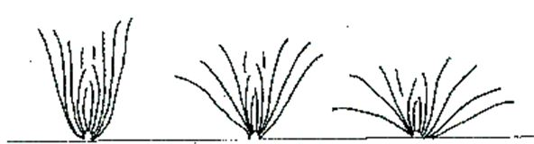
1 | 2 | 3
erect | semi-erect | spreading

Ad. 4: Outer leaf: width

Observation should be made on the broadest part.

Ad. 5: Outer leaf: shape

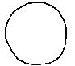 | 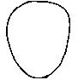 | 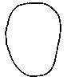 | 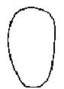 | 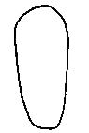
1 | 2 | 3 | 4 | 5
circular | broad obovate | obovate | narrow obovate | narrow elliptic

Ad. 6: Outer leaf: apex
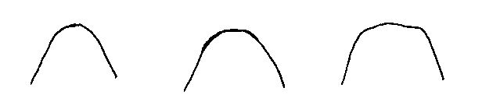
1 | 2 | 3
obtuse | rounded | truncated

Ad. 8: Outer leaf: size of blisters on upper side

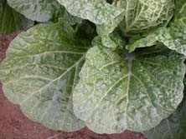 | 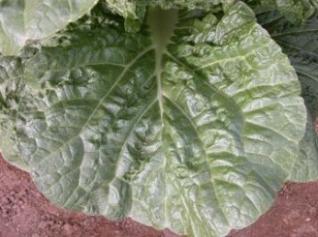 | 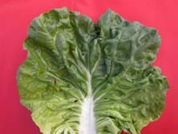
3 | 5 | 7
small | medium | large

Ad. 12: Outer leaf: hairiness
Observations should be made on the lower side.

Ad. 13: Outer leaf: profile in longitudinal section

Observation should be made excluding leaf base.

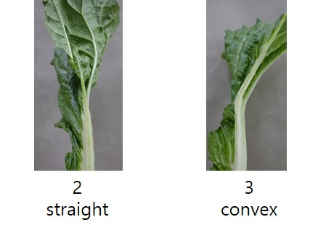

Ad. 14: Outer Leaf: undulation of margin

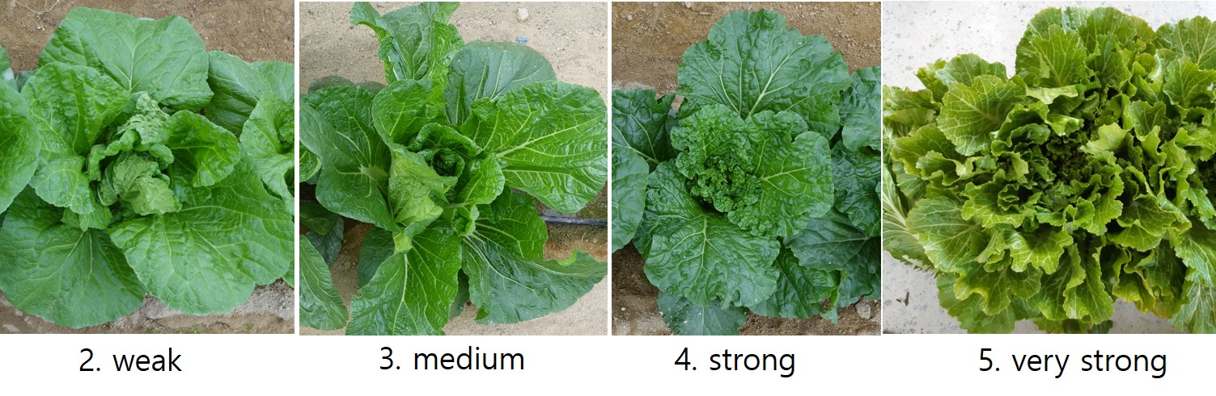

Ad. 15: Outer leaf: incisions of margin
Observations should be made on distal part of leaf.

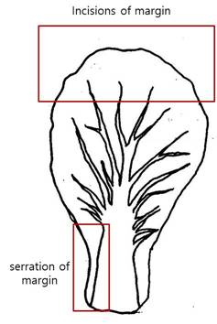
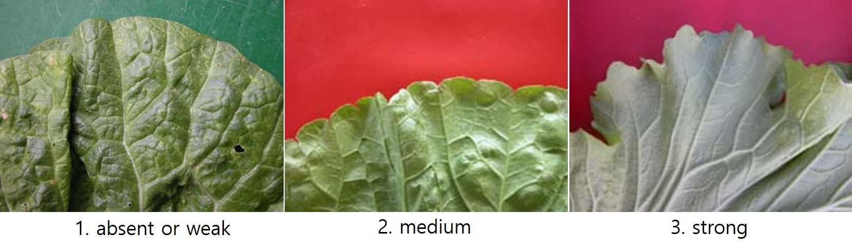

Ad. 16: Outer leaf: serration of margin

Observations should be made on the base part of leaf.

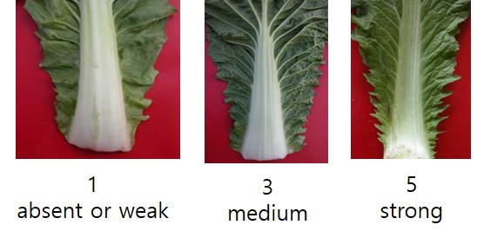

Ad. 17: Outer leaf: length of midrib
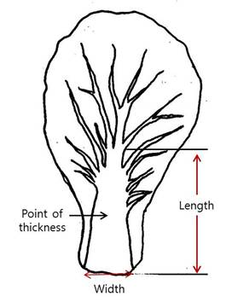

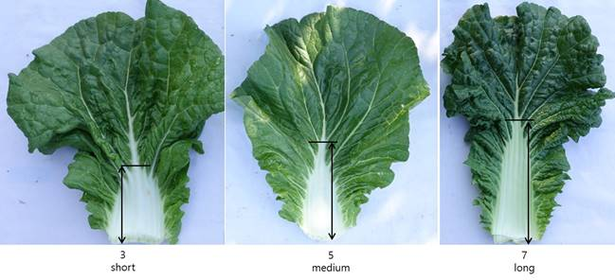

Ad. 18: Outer leaf: width of midrib

See Ad. 17

Ad. 19: Outer leaf: midrib in cross section

Observation should be made in the middle part of midrib.

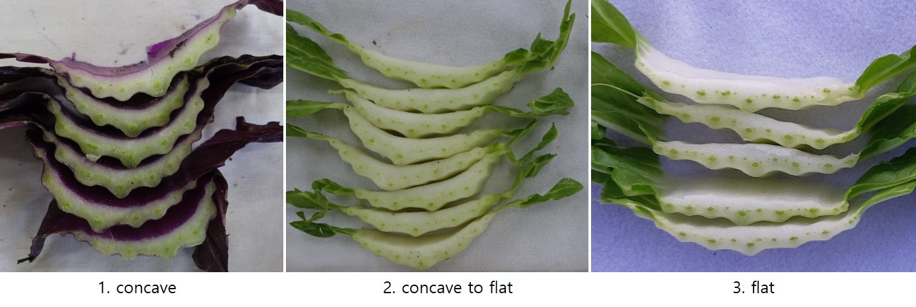

Ad. 20: Outer leaf: thickness of midrib

See Ad. 17

Observations should be made at the midpoint in middle part of the midrib where the characteristic 19 is observed.

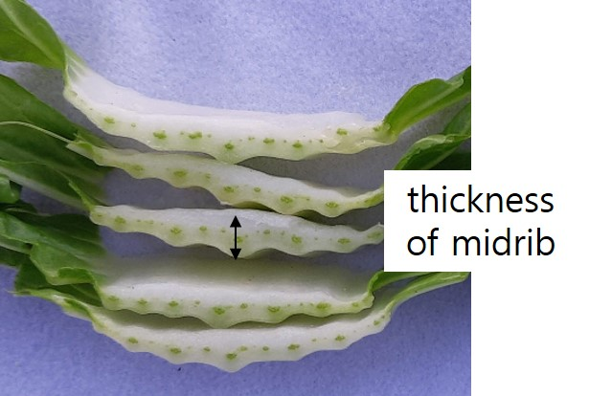

Ad. 21: Outer leaf: color of midrib
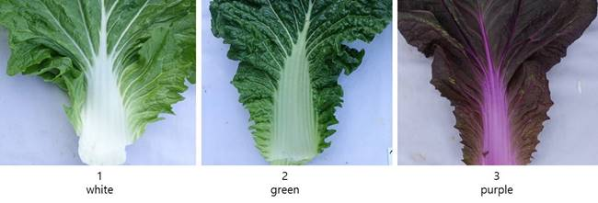

Ad. 23: Head: width

Observations should be made on the broadest part.

Ad. 24: Head: shape in longitudinal section

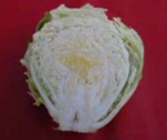 | 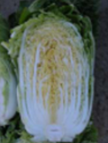 | 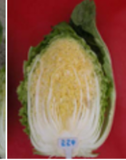
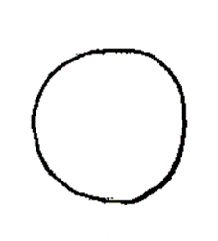 | 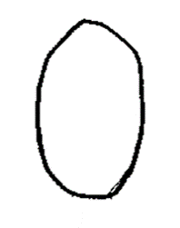 | 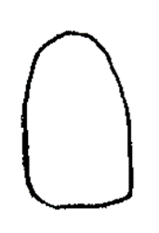
1 | 2 | 3
circular | elliptic | ovate

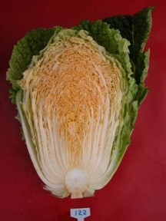 | 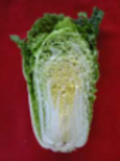 | 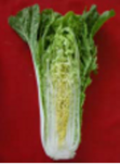
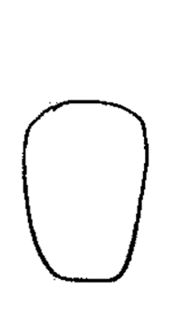 | 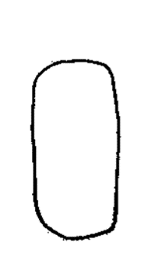 | 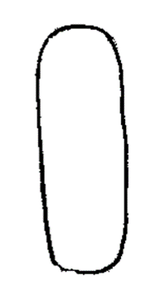
4 | 5 | 6
obovate | oblong | narrow oblong

Ad. 25: Head: type
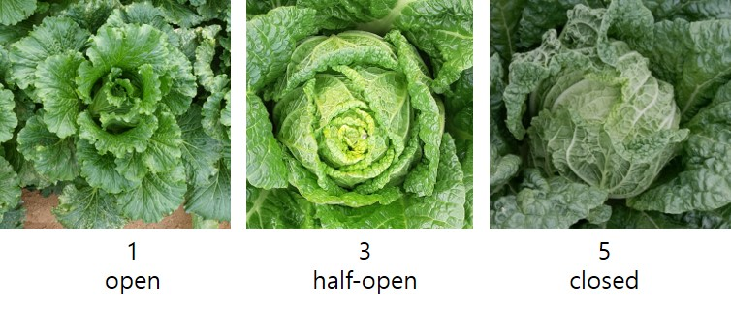

Ad. 27: Head: blistering of wrapper leaf

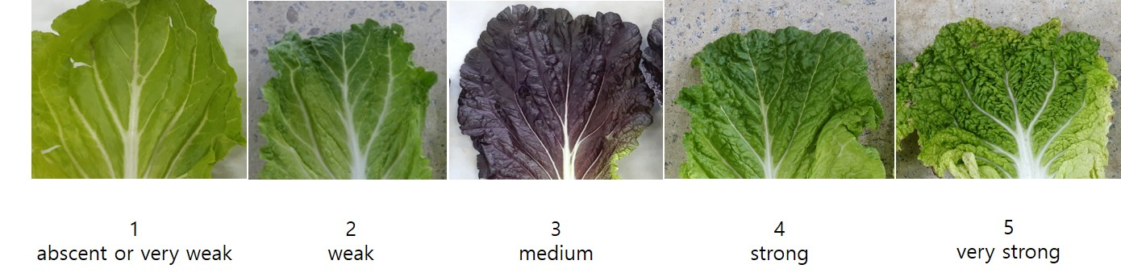

Ad. 28: Head: internal color

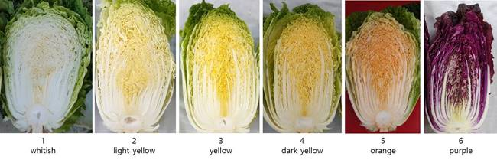

Ad. 30: Head: shape of apex of internal stem

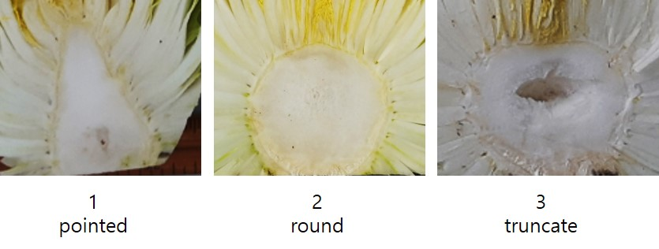

Ad. 31: Head: coloration in vascular bundle of internal stem
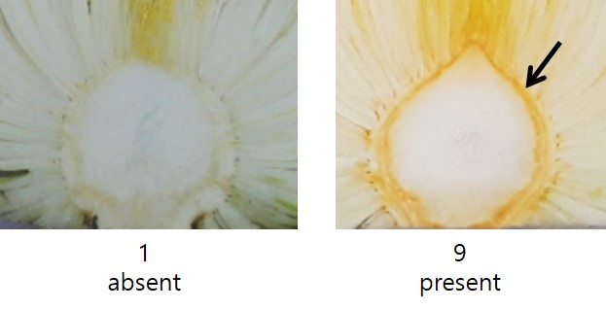

9.
Literature

Shogakukan, 1991: The Grand Dictionary of Horticuluture. pp.560-563

Tsunoda, S., Hinata, K., and Gommez-Campo, C., 1980: Brassica Crops and Wild Allies - Biology and Breeding. Japan Scientific Press, Tokyo

10.
Technical Questionnaire

TECHNICAL QUESTIONNAIRE | Page {x} of {y} | Reference Number:

Application date:
(not to be filled in by the applicant)
TECHNICAL QUESTIONNAIRE
to be completed in connection with an application for plant breeders' rights

1. | Subject of the Technical Questionnaire
 |  | Botanical name
  1.1.1
  Brassica rapa L. subsp. pekinensis (Lour.) Kitam.
  [ ]
 |  | Common name
  1.1.2
  Chinese Cabbage
 |  | Botanical name
  1.2.1
  hybrids between Brassica rapa L. Emend. Metzg. ssp. pekinensis (Lour.) Hanelt and Brassica rapa L. Emend. Metzg. ssp. chinensis (L.) Hanelt
  [ ]
 |  | Common name
  1.2.2
 |  | Botanical name
  1.3.1
  hybrids between Brassica rapa L. Emend. Metzg. ssp. pekinensis (Lour.) Hanelt and Brassica rapa L. var. rapa (L.) Thell.
  [ ]
 |  | Common name
  1.3.2
 |  | Botanical name
  1.4.1
  Brassica ×turicensis O. E. Schulz & Thell.
  [ ]
 |  | Common name
  1.4.2

2. | Applicant
 | Name
 | Address
 | Telephone No.
 | Fax No.
 | E-mail address
 | Breeder (if different from
 | applicant)

3. | Proposed denomination and breeder's reference
 | Proposed denomination
 | (if available)
 | Breeder's reference

TECHNICAL QUESTIONNAIRE |  |  | Page {x} of {y} | Reference Number:
 | Information on the breeding scheme and propagation of the variety
  #4.
 | 4.1 | Breeding scheme
 | Variety resulting from:
  4.1.1
  Crossing
 |  | [ ]
  (a)
  controlled cross
(please state parent variety)

(…………………..……………..…) x (……………..…………………..…)

female parent male parent

 |  | [ ]
  (b)
  partially known cross
(please state known parent variety(ies))

(…………………..……………..…) x (……………..…………………..…)

female parent male parent

 |  | [ ]
  (c)
  unknown cross
 |  | [ ]
  4.1.2
  Mutation
  (please state parent variety)
 |  | [ ]
  4.1.3
  Discovery and development
  (please state where and when discovered and how developed)
 | Other  (Please provide details) | [ ]
  4.1.4

TECHNICAL QUESTIONNAIRE  Page {x} of {y} | Reference Number:

 | 4.2 | Method of propagating the variety
  4.2.1
  Seed-propagated varieties
 |  | [ ]
  (a)
  Cross-pollination
 |  | [ ]
  (i)
  Population
 |  | [ ]
  (ii)
  Synthetic variety
 |  | [ ]
  (i)
  Single hybrid
 |  | [ ]
  (b)
  Hybrid
 |  | [ ]
  (ii)
  Three-way hybrid
 |  | [ ]
  (iii)
  Double hybrid
 |  | [ ]
  (c)
 |  | [ ]
  (d)
  Other (please provide details)
 | Other  (Please provide details) | [ ]
  4.2.2

In the case of hybrid varieties the production scheme for the hybrid should be provided on a separate sheet. This should provide details of all the lines required for propagating the hybrid, e.g.

Single Hybrid (SH)

(…female parent…) x (…male parent…)

Three-Way Hybrid (3WH)

(…female line…) x (…male line…)
=> single hybrid used as female parent x (…male parent…)

and should identify in particular:
(a) any male sterile lines
(b) maintenance system of male sterile lines.

TECHNICAL QUESTIONNAIRE | Page {x} of {y} | Reference Number:

5. | Characteristics of the variety to be indicated (the number in brackets refers to the corresponding characteristic in Test Guidelines; please mark the note which best corresponds).

 | Characteristics | Example Varieties | Note
  5.1
  (2)
  Plant: height
  very short
  1 [ ]
  very short to short
  2 [ ]
  short
  Natsuki
  3 [ ]
  short to medium
  4 [ ]
  medium
  Bilko, Daetong, Muso
  5 [ ]
  medium to tall
  6 [ ]
  tall
  Monument, Shousai
  7 [ ]
  tall to very tall
  8 [ ]
  very tall
  9 [ ]
  5.2
  (24)
  Head: shape in longitudinal section
  circular
  Kenshin
  1 [ ]
  elliptic
  Hayamidori, TheHan1ho
  2 [ ]
  ovate
  Daetong, Shinjyu
  3 [ ]
  obovate
  Gorki, Hamamidori
  4 [ ]
  oblong
  Chushu, Golden boy, Hanko
  5 [ ]
  narrow oblong
  Granaat, Jinhongssam, Shousai
  6 [ ]
  5.3
  (25)
  Head: type
  open
  Jinhongssam
  1 [ ]
  open to half-open
  2 [ ]
  half-open
  Daetong, Spectrum
  3 [ ]
  half-open to closed
  4 [ ]
  closed
  Golden boy, Kinap, Muso
  5 [ ]
  5.4
  (32)
  Time of harvest maturity
  very early
  Kenshin
  1 [ ]
  very early to early
  2 [ ]
  early
  Blues, RCC65, Sprinkin
  3 [ ]
  early to medium
  4 [ ]
  medium
  Enduro, Muso, Suho
  5 [ ]
  medium to late
  6 [ ]
  late
  Chusyu, Jindaebak, Parkin, Red Dragon
  7 [ ]
  late to very late
  8 [ ]
  very late
  9 [ ]

TECHNICAL QUESTIONNAIRE | Page {x} of {y} | Reference Number:

6. | Similar varieties and differences from these varieties
Please use the following table and box for comments to provide information on how your candidate variety differs from the variety (or varieties) which, to the best of your knowledge, is (or are) most similar. This information may help the examination authority to conduct its examination of distinctness in a more efficient way.

  Denomination(s) of variety(ies) similar to your candidate variety
  Characteristic(s) in which your candidate variety differs from the similar variety(ies)
  Describe the expression of the characteristic(s) for the similar variety(ies)
  Describe the expression of the characteristic(s) for your candidate variety

Example
  Head : type
  half-open
  closed

 | Comments:

TECHNICAL QUESTIONNAIRE
Page {x} of {y}
Reference Number:

#7. | Additional information which may help in the examination of the variety
7.1 | In addition to the information provided in sections 5 and 6, are there any additional characteristics which may help to distinguish the variety?
 | Yes | [ ] | No | [ ]
 | (If yes, please provide details)
7.2 | Are there any special conditions for growing the variety or conducting the examination?
 | Yes | [ ] | No | [ ]
 | (If yes, please provide details)
7.3 | Other information
A representative color photograph of the variety displaying its main distinguishing feature(s), should accompany the Technical Questionnaire. The photograph will provide a visual illustration of the candidate variety which supplements the information provided in the Technical Questionnaire.
The key points to consider when taking a photograph of the candidate variety are:
• Indication of the date and geographic location
• Correct labeling (breeder’s reference)
• Good quality printed photograph (minimum 10 cm x 15 cm) and/or sufficient resolution electronic format version (minimum 960 x 1280 pixels)”
Further guidance on providing photographs with the Technical Questionnaire is available in document TGP/7 "Development of Test Guidelines", Guidance Note 35 (http://www.upov.int/tgp/en/).
[The link provided may be deleted by members of the Union when developing authorities’ own test guidelines.]

TECHNICAL QUESTIONNAIRE
Page {x} of {y} | Reference Number:

8. | Authorization for release
 | (a) | Does the variety require prior authorization for release under legislation concerning the protection of the environment, human and animal health?
 |  | Yes | [ ] | No | [ ]
 | (b) | Has such authorization been obtained?
 |  | Yes | [ ] | No | [ ]
 | If the answer to (b) is yes, please attach a copy of the authorization.

9. Information on plant material to be examined or submitted for examination

9.1 The expression of a characteristic or several characteristics of a variety may be affected by factors, such as pests and disease, chemical treatment (e.g. growth retardants or pesticides), effects of tissue culture, different rootstocks, scions taken from different growth phases of a tree, etc.
9.2 The plant material should not have undergone any treatment which would affect the expression of the characteristics of the variety, unless the competent authorities allow or request such treatment. If the plant material has undergone such treatment, full details of the treatment must be given. In this respect, please indicate below, to the best of your knowledge, if the plant material to be examined has been subjected to:

 | (a) | Microorganisms (e.g. virus, bacteria, phytoplasma) | Yes [ ] | No [ ]
 | (b) | Chemical treatment (e.g. growth retardant, pesticide) | Yes [ ] | No [ ]
 | (c) | Tissue culture | Yes [ ] | No [ ]
 | (d) | Other factors | Yes [ ] | No [ ]
 | Please provide details for where you have indicated “yes”.

9.3 Has the plant material to be examined been tested for the presence of virus or other pathogens?

 | Yes | [ ]
 | (please provide details as specified by the Authority)
 | No | [ ]

10. | I hereby declare that, to the best of my knowledge, the information provided in this form is correct:
 | Applicant’s name
 | Signature |  | Date

[End of document]

