E
International Union for the Protection of New Varieties of Plants

Technical Working Party for Vegetables  Fifty-Fifth Session  Antalya, Turkey, May 3 to 7, 2021  Technical Working Party for Ornamental Plants and Forest Trees  Fifty-Third Session  Roelofarendsveen, Netherlands, June 7 to 11, 2021  Technical Working Party for Agricultural Crops  Fiftieth Session  Arusha, United Republic of Tanzania, June 21 to 25, 2021  Technical Working Party for Fruit Crops  Fifty-Second Session  Zhengzhou, China, July 12 to 16, 2021  Technical Working Party on Automation and Computer Programs  Thirty-Ninth Session  Alexandria, United States of America, September 20 to 22, 2021 | TWP/5/8  Original: English  Date: April 9, 2021
Guidance for drafters of Test Guidelines
Document prepared by the Office of the Union
Disclaimer: this document does not represent UPOV policies or guidance

EXECUTIVE Summary

The purpose of this document is to provide guidance for drafters of Test Guidelines and to report developments on the web-based Test Guidelines template (web-based TG template).

The TWPs are invited to note that:

(a) the web-based TG template and database of characteristics will be migrated to cloud servers by 2022, including an upgrade to new technologies in infrastructure and program to address issues reported by users and enabling use for drafting individual authorities’ test guidelines;

(b) that the Office of the Union will issue a circular to identify requirements of UPOV members for the development of individual authorities’ test guidelines using the web-based TG template; and

(c) training on the web-based TG template can be organized via electronic means upon experts’ request.

The following abbreviations are used in this document:

TC: Technical Committee
TC-EDC: Enlarged Editorial Committee
TG: Test Guidelines
TWA: Technical Working Party for Agricultural Crops
TWC: Technical Working Party on Automation and Computer Programs
TWF: Technical Working Party for Fruit Crops
TWO: Technical Working Party for Ornamental Plants and Forest Trees
TWPs: Technical Working Parties
TWV: Technical Working Party for Vegetables

The structure of this document is as follows:
EXECUTIVE Summary 1
Background 2
Developments in 2020 2
Comments by the Technical Working Parties 2
recent developments 2
Migration from on-premises to cloud servers 3
Training 4
Guidance for users of the web-based TG template 4

ANNEX Features of the Web-based TG Template

Background

Developments prior to 2020 are provided in document TWP/4/8 “Guidance for drafters of Test Guidelines”.

Developments in 2020

Comments by the Technical Working Parties

At their sessions in 2020, the TWV, TWO, TWA and TWF considered document TWP/4/8 “Guidance for drafters of Test Guidelines” (see documents TWV/54/9 “Report”, paragraphs 110 to 113; TWO/52/11 “Report”, paragraphs 92 to 95; TWA/49/7 “Report”, paragraphs 91 to 94; and TWF/51/10 “Report”, paragraphs 81 to 84).

The TWV, TWO, TWA and TWF noted developments on the web-based TG template, reported in document TWP/4/8, paragraphs 15 to 23.

The TWV, TWO, TWA and TWF noted that the Office of the Union would issue a circular to identify requirements of UPOV members for the development of individual authorities’ test guidelines using the web-based TG template.

The TWV, TWO, TWA and TWF noted that training on the web-based TG template via electronic means could be organized upon experts’ request.

recent developments

Individual authorities’ test guidelines

Background

Version 1 of the web-based TG Template has been designed for the development of Test Guidelines for UPOV. However, it has also been designed such that Version 2 will enable members of the Union to use:

(a) adopted UPOV Test Guidelines as a basis for the development of individual authorities’ test guidelines;

(b) the web-based TG Template and database of characteristics to develop individual authorities’ test guidelines for which there are no UPOV Test Guidelines; and

(c) use individual authorities’ test guidelines, developed using the web-based TG Template, as the basis for draft UPOV Test Guidelines.

Version 2 will have a feature for individual authorities to modify the template wording, within the same structure, to act as a template for their own test guidelines and a feature to allow individual authorities to convert UPOV Test Guidelines into individual authorities’ test guidelines, with necessary modifications.

Survey

A circular to identify requirements of UPOV members for the development of individual authorities’ test guidelines using the web-based TG template was scheduled to be issued in 2020 but was postponed until 2021.

Subject to the availability of resources, development of the new functionalities will start in 2021.

Migration from on-premises to cloud servers

The web-based TG template and database of characteristics will be migrated to cloud servers by 2022. The migration will include an upgrade to new technologies in infrastructure and program to address issues reported by users. Once this is complete, the web-based TG template will enable the online database of characteristics to be used for drafting individual authorities’ test guidelines (IATG) in different languages.

Issues implemented

New Standard Wording to Chapter 3.1 “Number of Growing Cycles”

The following standard wording has been added to the web-based TG Template, following the revision of document TGP/7/7 “Developments of Test Guidelines” (new standard wording indicated by underline and grey highlight):

“3.1 Number of Growing Cycles

The minimum duration of tests should normally be:

{ ASW 2 (Chapter 3.1(.1)) – number of growing cycles }
{ GN 8 (Chapter 3.1.2) – explanation of the growing cycle }
{ ASW 3 (Chapter 3.1.2) – explanation of the growing cycle }

The testing of a variety may be concluded when the competent authority can determine with certainty the outcome of the test.”

Guidance Note 3 “Subject of the Test Guidelines: More than one species” to Chapter 1 “Subject of these Test Guidelines”

Document TGP/7, Guidance Note 3 “Subject of the Test Guidelines: More than one species” establishes that “reference should not be made to the potential usefulness of the Test Guidelines for species other than those explicitly included in the coverage of the Test Guidelines, nor to the potential usefulness for hybrids involving the species covered by the Test Guidelines. If considered appropriate, the following sentence may be added:

“Guidance on the use of Test Guidelines for (e.g. [species in the same genus] / [interspecific hybrids] / [intergeneric hybrids]) that are not explicitly covered by Test Guidelines is provided in document TGP/13 ‘Guidance for New Types and Species.”

The above wording has been incorporated in the web-based TG Template, as follows:

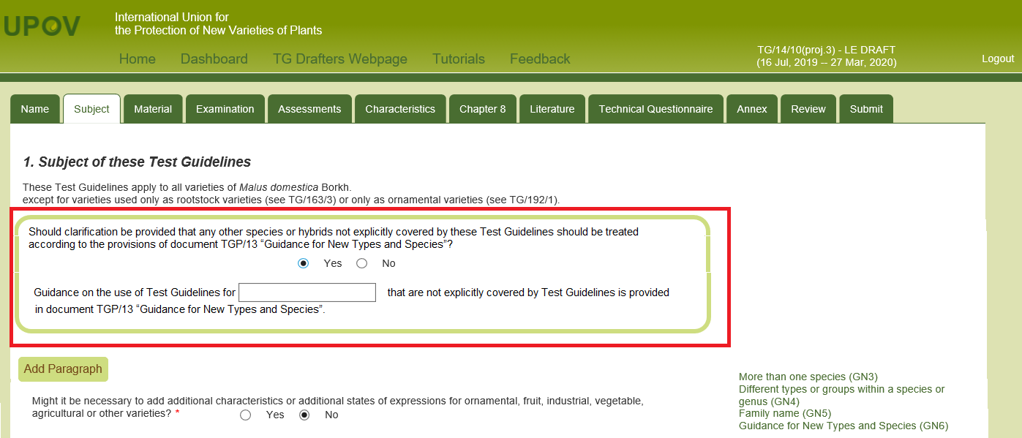

Issues currently being addressed

Summary of example varieties used in a particular Test Guidelines

Document TGP/7 “Development of Test Guidelines”, Guidance Note 28 “(Chapter 6.4) – Example varieties”, 2.2 “Minimizing the number” explains that:

“For practical reasons it is recommended to choose the overall set of example varieties for the Test Guidelines in a way that all the desired characteristics and states of expression are covered by the minimum total number of example varieties. This means that, if possible, each example variety should be used for as many characteristics as possible and example varieties should not be used only for one or very few characteristics.”

A new functionality in the TG Template generates the list of example varieties used in the Test Guidelines as a means of assisting the Leading Expert to minimize the number of example varieties.

Training

The TC, at its fifty-third session, agreed that training on the use of the web-based TG template should be offered to the TWPs during the preparatory workshops of the session and/or during the discussions on the agenda item “guidance for drafters’ of Test Guidelines”. The TC agreed that training should also include FAQs and tutorials for users of the web-based TG template (see document TC/53/31 “Report”, paragraph 239).

In 2021, a series of preparatory webinars will be held prior to the TWPs. A presentation on the web-based TG template is scheduled for April 21, 2021, including a session for questions and answers. The webinar will be recorded and made available on the TWPs webpages.

The Office of the Union has provided assistance to individual experts on ad hoc basis via e-mail, telephone and video conferencing tools.

Individual support to users of the web-based TG Template will be maintained by e-mail and telephone. Bilateral trainings via electronic means on the use of the web-based TG Template could also be organized upon experts’ request.

Guidance for users of the web-based TG template

Tutorials for the following user roles are available on the web-based TG Template under the link “Tutorials”:

- Leading Expert drafting tutorial
- Interested Expert comments tutorial
- Leading Expert checking tutorial

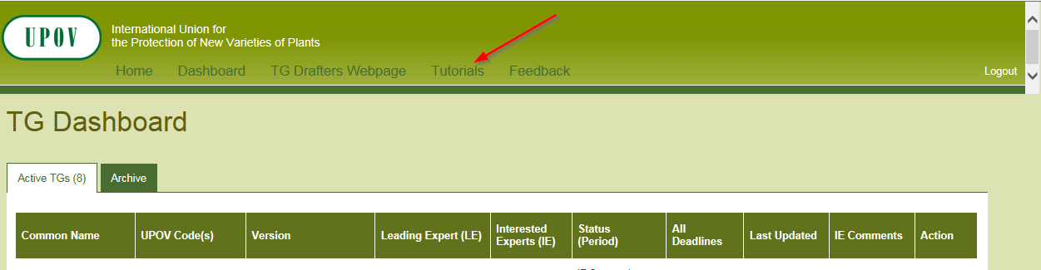

Alternatively, the tutorials are also available for download under the following link: http://upov.int/export/sites/upov/tgp/en/tg_template_tutorial_complete.pdf

The TWPs are invited to note that:

(a) the web-based TG template and database of characteristics will be migrated to cloud servers by 2022, including an upgrade to new technologies in infrastructure and program to address issues reported by users and enabling use for drafting individual authorities’ test guidelines;

(b) that the Office of the Union will issue a circular to identify requirements of UPOV members for the development of individual authorities’ test guidelines using the web-based TG template; and

(c) that training on the web-based TG template can be organized via electronic means upon experts’ request.

[Annex follows]

Features of the web-based TG Template

(Extract from document TC/50/10 “Report on developments in UPOV including relevant matters discussed in the last sessions of the Administrative and Legal Committee, the Consultative Committee and the Council”)

The web-based TG Template will be developed in two separate phases in the form of Versions 1 and 2.

Version 1

Version 1 of the web-based TG Template will be fully functional for the development of UPOV Test Guidelines by Leading Experts and will enable Interested Experts to provide comments. Version 1 of the web-based TG Template will be completed in 2016 and a demonstration will be made at the TWPs sessions in 2016.

Features

The main features of Version 1 are as follows:

- Draft Test Guidelines will be prepared by Leading Experts online via the web-based TG Template
- Fixed template containing all universal standard wording which is appropriate for all Test Guidelines (see document TGP/7 “Development of Test Guidelines”, Section 3.1 “The TG Template”)
- Options to add Additional Standard Wording (ASW) (see document TGP/7, Section 3.2 “Additional Standard Wording (ASW) for the TG Template”)
- Links to Guidance Notes (GN) (see document TGP/7, Section 3.3 “Guidance Notes (GN) for the TG Template”)
- A database of characteristics (in English, French, German and Spanish) from Test Guidelines adopted after the adoption of document TGP/7/1 “Development of Test Guidelines” the Collection of Approved Characteristics (adopted in 2004) (see document TGP/7, Annex 4 “Collection of Approved Characteristics”).
The database will contain all information from the Table of Characteristics, including states of expression, notes, example varieties, etc. The database can be searched for relevant characteristics and a relevant characteristic uploaded into draft Test Guidelines with subsequent modification as required.

- Comments boxes for Interested Experts to complete online with a facility to view all comments
- Options to produce output in HTML or Word format.
- English only version
- Translators’ facility for the Table of Characteristics (Chapter 7)

Characteristics uploaded, unchanged, from the database comprising the collection of approved characteristics will be indicated as not requiring translation. For other characteristics, translators will be able to search the database comprising the collection of approved characteristics and input the required translations. The translation of the other chapters of the Test Guidelines will be provided separately for Version 1.

Version 2

Version 2 of the web-based TG Template will provide the two following additional features:

Concurrent translation

In version 2 of the web-based TG Template, the French, German and Spanish language versions of the Test Guidelines will be automatically developed concurrently with the English draft for the standard wording, Additional Standard Wording (ASW) and characteristics uploaded, unchanged, from the database comprising the collection of approved characteristics. Text that has not been automatically translated will be indicated for translation in the language concerned.

Individual authorities’ test guidelines

Version 1 of the web-based TG Template has been designed for the development of Test Guidelines for UPOV. However, it has also been designed such that Version 2 will enable members of the Union to use:

(a) adopted UPOV Test Guidelines as a basis for the development of individual authorities’ test guidelines;

(b) the web-based TG Template and database of characteristics to develop individual authorities’ test guidelines for which there are no UPOV Test Guidelines; and

(c) use individual authorities’ test guidelines, developed using the web-based TG Template, as the basis for draft UPOV Test Guidelines.

Version 2 will have a feature for individual authorities to modify the template wording, within the same structure, to act as a template for their own test guidelines and a feature to allow individual authorities to convert UPOV Test Guidelines into individual authorities’ test guidelines, with necessary modifications.

[End of Annex and of document]

at its fifty-fourth session, hosted by Brazil and held via electronic means from May 11 to 15, 2020
at its fifty-second session, hosted by the Netherlands and held via electronic means from June 8 to 12, 2020
at its forty-ninth session, hosted by Canada and held via electronic means from June 22 to 26, 2020
at its fifty-first session, hosted by France and held via electronic means from July 6 to 10, 2020

