|  |  |
| --- | --- |
|  | E |
| International Union for the Protection of New Varieties of Plants |  |

|  |  |
| --- | --- |
| Technical Working Party for Vegetables  Fifty-Fifth Session  Antalya, Turkey, May 3 to 7, 2021  Technical Working Party for Ornamental Plants and Forest Trees  Fifty-Third Session  Roelofarendsveen, Netherlands, June 7 to 11, 2021  Technical Working Party for Agricultural Crops  Fiftieth Session  Arusha, United Republic of Tanzania, June 21 to 25, 2021  Technical Working Party for Fruit Crops  Fifty-Second Session  Zhengzhou, China, July 12 to 16, 2021  Technical Working Party on Automation and Computer Programs  Thirty-Ninth Session  Alexandria, United States of America, September 20 to 22, 2021 | TWP/5/7.  Original: English  Date: April 8, 2021 |

Molecular techniques

Document prepared by the Office of the Union

Disclaimer: this document does not represent UPOV policies or guidance

Executive summary

The purpose of this document is to report on developments and present matters for consideration by the Technical Working Parties (TWPs) on the use of biochemical and molecular techniques in DUS examination.

Developments at the nineteenth session of the Working Group on Biochemical and Molecular Techniques, and DNA-Profiling in particular

The TWPs are invited to note:

(a) the papers presented at the nineteenth session of the BMT, held in 2020, as set out in paragraph 12 of this document;

(b) that the BMT will hold its twentieth session jointly with the TWC, during the week of September 20, 2021; and

(c) the draft agenda for the BMT at its twentieth session, to be held in 2021, as set out in paragraph 14 of this document.

Merger of the Working Group on Biochemical and Molecular Techniques and DNA‑profiling in Particular (BMT) and the Technical Working Party on Automation and Computer Programs (TWC)

The TWPs are invited to note:

(a) that the Council established the Technical Working Party on Testing Methods and Techniques (TWM) encompassing the work of the TWC and BMT, to take effect from 2022; and

(b) the terms of reference for the TWM, as reproduced in paragraph 17 of this document

Session to Facilitate Cooperation in Relation to the Use of Molecular Techniques

The TWPs are invited to:

(a) note the information provided by participants at the nineteenth session of the BMT on their work on biochemical and molecular techniques and areas for cooperation, as reproduced in Annex I to this document; and

(b) form discussion groups to allow participants to exchange information on their work on biochemical and molecular techniques and explore areas for cooperation.

Review of document UPOV/INF/17 “Guidelines for DNA-Profiling: Molecular Marker Selection and Database Construction (‘BMT Guidelines’)”

The TWPs are invited to consider a draft revision of document UPOV/INF/17/1 on the basis of document UPOV/INF/17/2 Draft 5 and Annex II to this document.

Cooperation between international organizations

*Inventory on the use of molecular marker techniques, by crop*

The TWPs are invited to note that:

(a) on October 16, 2020, the Office of the Union issued Circular E-20/189 inviting members to complete the survey on the use of molecular marker techniques, per crop, by December 15, 2020; and

(b) that the results of the survey will be presented to the Technical Committee, at its fifty‑seventh session, to be held in 2021.

*Lists of possible joint initiatives with OECD and ISTA in relation to molecular techniques*

The TWPs are invited to note:

(a) that the TC, at its fifty-sixth session, agreed that another joint OECD, UPOV, ISTA workshop on molecular techniques should be organized in the near future; and

(b) that the TC agreed that a joint OECD, UPOV, ISTA workshop on molecular techniques would be an opportunity to discuss the definitions used in molecular techniques with a view to their harmonization.

*Joint document explaining the principal features of the systems of OECD, UPOV and ISTA*

The TWPs are invited to note that a draft joint document explaining the principal features of the systems of OECD, UPOV and ISTA will be presented for consideration by the TC at its fifty-seventh session.

The following abbreviations are used in this document:

BMT: Working Group on Biochemical and Molecular Techniques, and DNA-Profiling in Particular

ISTA: International Seed Testing Association

OECD: Organization for Economic Co-operation and Development

TC: Technical Committee

TWA: Technical Working Party for Agricultural Crops

TWC: Technical Working Party on Automation and Computer Programs

TWF: Technical Working Party on Fruit Crops

TWM: Technical Working Party on Testing Methods and Techniques

TWO: Technical Working Party on Ornamental Plants and Forest Trees

TWPs: Technical Working Parties

TWV: Technical Working Party for Vegetables

The structure of this document is as follows:

Executive summary 1

Papers presented 4

Date and place of next session 4

Future program 4

Merger of the Working Group on Biochemical and Molecular Techniques and DNA‑profiling in Particular (BMT) and the Technical Working Party on Automation and Computer Programs (TWC) 5

Session to facilitate cooperation in relation to the use of molecular techniques 6

Background 6

Developments at the TWPs and BMT at their sessions in 2020 6

Developments at the Technical Committee 7

Review of document UPOV/INF/17 “Guidelines for DNA-Profiling: Molecular Marker Selection and Database Construction (‘BMT Guidelines’)” 7

Cooperation between international organizations 8

Background 8

Inventory on the use of molecular marker techniques, by crop 8

Lists of possible joint initiatives with OECD and ISTA in relation to molecular techniques 10

Background 10

Consideration by the Technical Committee 10

Joint document explaining the principal features of the systems of OECD, UPOV and ISTA 10

Background 11

Draft joint document 11

A. INTRODUCTION 1

B. GENERAL PRINCIPLES 1

1. Selection of Molecular Markers 2

1.1 Sets of varieties for the selection process 2

1.2 Molecular markers – performance criteria 2

2. Selection of the Detection Method 3

2.1 DNA profiling methods - general considerations 3

2.2. Access to the Technology 3

3. Validation and harmonization of a marker set and detection method 3

3.1 Validation and harmonization – general considerations 3

3.2 Performance considerations - validation of markers and methods 3

3.3 Consistency considerations 4

4. Construction of a Species-Specific Database 4

4.1 Recommendations for database design 4

4.2 Requirements of the plant material 5

4.3 Processing of sequence data 5

4.4 Type of database 6

4.5 Database model 6

4.6 Data Dictionary 6

4.7 Data access – ownership 7

5. Data Exchange 7

5.1 Data exchange scenarios 7

5.2 Data exchange methods 7

6. Summary 7

C. LIST OF ACRONYMS 8

ANNEX I Information provided by participants at the nineteenth session of the BMT

ANNEX II Proposal for the revision of document UPOV/INF/17

Appendix to Annex II Data exchange scenarios and transfer models

ANNEX III Elements for draft joint document explaining the principal features of OECD, UPOV and ISTA

DEVELOPMENTS AT THE NINETEENTH SESSION OF THE WORKING GROUP ON BIOCHEMICAL AND MOLECULAR TECHNIQUES, AND DNA-PROFILING IN PARTICULAR

The BMT held its nineteenth session hosted by the United States of America and held via electronic means from September 21 to 23, 2020 (see document BMT/19/15 “Report”, paragraph 1).

## Papers presented

The papers presented under each of the agenda item of the nineteenth session of the BMT were as follows:

*Reports on developments in UPOV concerning biochemical and molecular techniques (document BMT/19/2)*

*Short presentations on new developments in biochemical and molecular techniques by DUS experts, biochemical and molecular specialists, plant breeders and relevant international organizations (oral reports by participants)*

*Report of work on molecular techniques in relation to DUS examination*

*(a) vmDUS: Value-molecular linked distinctness determination (document BMT/19/6)*

*(b) CPVO report on IMODDUS: Update on R&D projects (document BMT/19/4)*

*(c) Developing a strategy to apply SNP molecular markers in the framework of winter oilseed rape DUS testing (document BMT/19/11)*

*Review of document UPOV/INF/17 “Guidelines for DNA-Profiling: Molecular Marker Selection and Database Construction” (documents BMT/19/3 Rev. and UPOV/INF/17/2 Draft 3)*

*Confidentiality, ownership and access to molecular data1*

*(a) Access to reference material and molecular data from CPVO Examination Offices (document BMT/19/5)*

*(b) Survey on confidentiality and ownership of molecular information (document BMT/19/8)*

*Session to facilitate cooperation (document BMT/19/10)*

*Cooperation between international organizations (document BMT/19/9)*

*- International Seed Testing Association (BMT/19/12)*

*Organization of work of the TWC and the BMT (document BMT/19/7)*

## Date and place of next session

At the invitation of the United States of America, the BMT agreed to hold its twentieth session in Alexandria, Virginia, jointly with the TWC, during the week of September 20, 2021 (see document BMT/19/15 “Report”, paragraph 36).

## Future program

During its twentieth session, the BMT planned to discuss the following items (see document BMT/19/15 “Report”, paragraph 37):

1. Opening of the session

2. Adoption of the agenda

3. Reports on developments in UPOV concerning biochemical and molecular techniques (document to be prepared by the Office of the Union)

4. Short presentations on new developments in biochemical and molecular techniques by DUS experts, biochemical and molecular specialists, plant breeders and relevant international organizations (reports by participants)

5. Report of work on molecular techniques in relation to DUS examination (papers invited)

6. Variety description databases including databases containing molecular data (papers invited)

7. Methods for analysis of molecular data, management of databases and exchange of data and material (papers invited)

8. The use of molecular techniques in examining essential derivation[1] (papers invited)

9. The use of molecular techniques in variety identification* (papers invited)

10. Cooperation between international organizations (document to be prepared by the Office of the Union)

11. Confidentiality, ownership and access to molecular data, including model agreement template* (papers invited)

12. Session to facilitate cooperation

13. Date and place of next session

14. Future program

15. Report of the session (if time permits)

16. Closing of the session

*The TWPs are invited to note:*

*(a) the papers presented at the nineteenth session of the BMT, held in 2020, as set out in paragraph 12 of this document;*

*(b) that the BMT will hold its twentieth session jointly with the TWC, during the week of September 20, 2021; and*

*(c) the draft agenda for the BMT at its twentieth session, to be held in 2021, as set out in paragraph 14 of this document.*

# Merger of the Working Group on Biochemical and Molecular Techniques and DNA‑profiling in Particular (BMT) and the Technical Working Party on Automation and Computer Programs (TWC)

The Council, at its fifty-fourth session[2], considered document C/54/14 (see document C/54/17 “Outcome of consideration of documents by correspondence”, paragraphs 32 to 35).

The Council approved the establishment and the following terms of reference for the TWM, to encompass the work of the TWC and BMT:

Title:

Technical Working Party on Testing Methods and Techniques (TWM)

Tasks:

As directed by the Technical Committee, to:

1. Consider methods relevant for the examination of DUS.
2. Review and provide guidance on software and equipment relevant for:
   1. DUS trial design and data analysis
   2. Data recording and transfer
   3. Image analysis
   4. Biochemical and molecular data.
3. Consider matters relating to trial design and data analysis;
4. Consider the possible application of biochemical and molecular techniques in DUS testing;
5. Develop guidelines regarding the management and harmonization of databases;
6. If appropriate, establish guidelines for biochemical and molecular methodologies and their harmonization;
7. Review general developments in biochemical and molecular techniques;
8. Maintain an awareness of relevant applications of biochemical and molecular techniques in plant breeding;
9. Provide a forum for discussion on the use of biochemical and molecular techniques in the consideration of essential derivation and variety identification.

The Council established the TWM with the above terms of reference, to take effect from 2022.

The Council elected the Chairperson of the BMT, Ms. Beate Ruecker (Germany), to act as Chairperson of the TWM, ending with the fifty‑seventh ordinary session of the Council, in 2023.

*The TWPs are invited to note:*

*(a) that the Council established the Technical Working Party on Testing Methods and Techniques (TWM) encompassing the work of the TWC and BMT, to take effect from 2022; and*

*(b) the terms of reference for the TWM, as reproduced in paragraph 17 of this document.*

Session to facilitate cooperation in relation to the use of molecular techniques

Background

The background to this matter is provided in document TWP/4/7 “Molecular Techniques”.

The TC, at its fifty-fourth session[3], noted that discussion groups had been formed at the sixteenth session of the BMT for: agricultural crops; fruit crops; ornamental plants and forest trees; and vegetables, for BMT participants to exchange information on their work and explore areas for cooperation (see document TC/54/31 “Report”, paragraphs 278 and 281).

The TC, at its fifty-fourth session, agreed that the results of the coordination session in the BMT be reported to the TWPs. The TC agreed to invite the TWPs to undertake a similar session to build on the BMT outcomes and feed into the future work of the BMT. The TC agreed that discussion groups should be formed for the main crops at each TWP to allow participants to exchange information on their work and explore areas for cooperation.

Developments at the TWPs and BMT at their sessions in 2020

At their sessions in 2020, the TWV[4], TWO[5], TWA[6], TWF[7] and TWC[8] considered document TWP/4/7 “Molecular techniques”[9]. The BMT[10] considered document BMT/19/10 “Session to facilitate cooperation” (see document BMT/19/15 “Report”, paragraphs 24 to 28).

The TWPs and BMT noted that, at their sessions in 2019, discussion groups had been formed at the TWPs and BMT to allow participants to exchange information on their work on biochemical and molecular techniques and explore areas for cooperation.

The TWPs and BMT noted the outcomes of discussions on facilitating cooperation in relation to the use of molecular techniques at the TWPs and BMT, as presented in documents TWP/4/7.

The participants at the nineteenth session of the BMT were invited to report on their work on biochemical and molecular techniques and to explore areas for cooperation. The information provided by participants is reproduced in Annex I to this document.

The BMT noted the information by the Seed Association of the Americas about the recently released paper on "Single nucleotide polymorphisms facilitate distinctness-uniformity-stability testing of soybean cultivars for plant variety protection”, which was freely available via at following link: <https://acsess.onlinelibrary.wiley.com/doi/full/10.1002/csc2.20201>.

## Developments at the Technical Committee

The TC, at its fifty-sixth session, noted the information provided by participants at the nineteenth session of the BMT on their work on biochemical and molecular techniques and areas for cooperation, as reproduced in Annex I to this document (see document TC/56/27 “Report”, paragraphs 52 to 54).

The TC agreed to invite the TWPs and BMT to form discussion groups to allow participants to exchange information on their work on biochemical and molecular techniques and explore areas for cooperation.

The TC noted that the BMT had discussed “confidentiality, ownership and access to molecular data” at its nineteenth session.

*The TWPs are invited to:*

*(a) note the information provided by participants at the nineteenth session of the BMT on their work on biochemical and molecular techniques and areas for cooperation, as reproduced in Annex I to this document; and*

*(b) form discussion groups to allow participants to exchange information on their work on biochemical and molecular techniques and explore areas for cooperation.*

# Review of document UPOV/INF/17 “Guidelines for DNA-Profiling: Molecular Marker Selection and Database Construction (‘BMT Guidelines’)”

The background to this matter is provided in document TWP/4/7 “Molecular Techniques”.

The BMT, at its nineteenth session[11], considered documents BMT/19/3 Rev. “Revision of document INF/17” and UPOV/INF/17/2 Draft 3 (see document BMT/19/15 “Report”, paragraphs 11 and 12).

The BMT agreed that the draft guidance reproduced in Annex II to this document should be proposed to the Technical Committee as the basis for a future revision of document UPOV/INF/17.

The TC, at its fifty-sixth session[12], considered document TC/56/13 and the proposed revision of document UPOV/INF/17 on the basis of document UPOV/INF/17/2 Draft 4.

The TC agreed to request the TWPs to consider a draft revision of document UPOV/INF/17/1 (document UPOV/INF/17/2 Draft 5) at their sessions in 2021.

The TC noted that a draft revision of document UPOV/INF/17 (UPOV/INF/17/2 Draft 6) would be proposed for adoption by the Council, at its fifty-fifth session, to be held on October 29, 2021, subject to agreement by the TC at its fifty seventh session and the CAJ, at its seventy eighth session, to be held in 2021.

The draft revision of document UPOV/INF/17 is presented in document UPOV/INF/17/2 Draft 5 indicating the changes from the text of document UPOV/INF/17/1. A version of the text incorporating all changes proposed is reproduced in Annex II to this document.

*The TWPs are invited to consider a draft revision of document UPOV/INF/17/1 on the basis of document UPOV/INF/17/2 Draft 5 and Annex II to this document.*

Cooperation between international organizations

Background

The background to this matter is provided in document TWP/4/7 “Molecular Techniques”.

The TC, at its fifty-fourth session[13], agreed that UPOV and OECD should make progress on the matters previously agreed by the TC, namely (see document TC/54/31 “Report”, paragraphs 267 to 271):

(a) to develop a joint document explaining the principal features of the systems of the OECD, UPOV and ISTA;

(b) to develop an inventory on the use of molecular marker techniques, by crop, with a view to developing a joint OECD/UPOV/ISTA document containing that information, in a similar format to UPOV document UPOV/INF/16 “Exchangeable Software”, subject to the approval of the Council and in coordination with OECD and ISTA; and

(c) the BMT to develop lists of possible joint initiatives with OECD and ISTA in relation to molecular techniques for consideration by the TC.

The TC, at its fifty-fourth session, agreed to invite ISTA to join the initiatives when in position to do so.

Developments concerning the matters above are as follows:

Inventory on the use of molecular marker techniques, by crop

The TC, at its fifty-fifth session[14], agreed the following elements for the inventory on the use of molecular marker techniques, by crop (see document TC/55/25 “Report”, paragraphs 184 and 185):

* Country or Intergovernmental Organization using molecular marker technique
* Whether the Authority uses molecular marker techniques
* Source [name of the Authority] and Contact details [email address]
* Type of molecular marker technique [AFLP, Capillary electrophoresis fragment analysis, MNP, RAPD-STS, SSR, SNPs, Taqman, Whole genome sequencing, other technique (please specify)] [more than one answer allowed]
* Source of the molecular marker and contact details [email address]
* Availability of the marker [publicly available or a proprietary marker]
* Status (i.e. in current use or under development)
* Crop(s) for which the molecular marker technique is used and characteristic concerned [botanical name(s) and UPOV code(s) to be provided]
* Purpose of the use of the molecular technique [UPOV model “Characteristic-Specific Molecular Markers”, UPOV model “Combining Phenotypic and Molecular Distances in the Management of Variety Collections”, Purity, Identity, Verification of conformity of plant material to a protected variety for the exercise of breeders’ rights, Verification of hybridity]
* Whether the molecular marker technique was used as part of Seed Certification in the last two years [National certification, OECD certification] [relevant for OECD seed schemes]
* Number of times the Authority used the molecular marker technique in the last 2 years [routine, occasional] [e.g. 1 to 5, 6 to 20, 21 to 100, more than 100]
* Whether the molecular marker technique is covered by [UPOV Test Guideline(s), UPOV TGP document(s), other UPOV document(s)] (please specify)
* Whether the molecular technique is validated/recognized/authorized [yes to specify a particular organization or authority] [relevant for OECD seed schemes]
* Whether the Authority created databases with information obtained from use of the molecular marker technique

The TC agreed that a circular should be issued to request members of the Union to complete a survey as a basis to develop an inventory on the use of molecular marker techniques, by crop, in coordination with the OECD. The UPOV Office consulted the OECD Seed Schemes to the issuance of the survey and possible next steps to reporting the outcomes to the Seed Schemes.

After consultation with the OECD, the Office of the Union issued Circular E-20/189 on October 16, 2020, inviting members to complete a survey on the use of molecular marker techniques, by December 15, 2020.

In response to the Circular E-20/189, the following 23 members of the Union provided information on the use of molecular marker techniques:

|  |  |
| --- | --- |
| Australia | Lithuania |
| Belgium | Mexico |
| Brazil | Netherlands |
| China | Norway |
| Czech Republic | Panama |
| Estonia | Romania |
| European Union | Spain |
| France | Slovakia |
| Germany | Ukraine |
| Israel | United Kingdom |
| Japan | United States of America |
| Jordan |  |

The results of the survey will be presented to the Technical Committee, at its fifty-seventh session, to be held in 2021.

*The TWPs are invited to note that:*

*(a) on October 16, 2020, the Office of the Union issued Circular E-20/189 inviting members to complete the survey on the use of molecular marker techniques, by December 15, 2020; and*

*(b) that the results of the survey will be presented to the Technical Committee, at its fifty‑seventh session, to be held in 2021.*

Lists of possible joint initiatives with OECD and ISTA in relation to molecular techniques

*Background*

The BMT, at its eighteenth session[15], considered document BMT/18/4 “Cooperation between International Organizations” and the request to develop lists of possible joint initiatives with OECD and ISTA, in relation to molecular techniques. The BMT agreed to propose the repeating of joint workshops with ISTA and OECD in future. The BMT agreed to propose a joint initiative that each organization inform the others about use of molecular markers in their work (see document BMT/18/21 “Report”, paragraph 34).

The TC, at its fifty-fifth session[16], considered possible joint initiatives with OECD and ISTA in relation to molecular techniques and agreed with the proposal made by the BMT, at its eighteenth session, for joint workshops to be repeated in future (see document TC/55/25 “Report”, paragraphs 189 to 191).

The TC agreed with the BMT to propose a joint initiative that each organization inform the others about use of molecular markers in their work.

The TC noted there were no definitions on biochemical and molecular techniques in UPOV. The TC agreed that information from the survey on the techniques could help to clarify techniques that were considered to be biochemical or molecular.

The following joint UPOV/OECD/ISTA workshops on molecular techniques have been organized:

(a) hosted by UPOV and held in Seoul, Republic of Korea, on November 12, 2014, in conjunction with fourteenth session of the BMT;

(b) hosted by OECD and held in Paris, France, on June 8, 2016, prior to the Annual Meeting of the OECD Seed Schemes;

(c) hosted by ISTA and held in Hyderabad, India, on June 29, 2019, in conjunction with the 2019 ISTA Congress.

### Consideration by the Technical Committee

48. The TC, at its fifty-sixth session, agreed that another joint OECD, UPOV, ISTA workshop on molecular techniques should be organized in the near future (see document TC/56/23, paragraphs 48 and 49).

49. The TC recalled that, at its fifty-fifth session, it had noted that there were no definitions on biochemical and molecular techniques in UPOV and had agreed that information from the survey on the techniques could help to clarify techniques that were considered to be biochemical or molecular. The TC agreed that a joint OECD, UPOV, ISTA workshop on molecular techniques would be an opportunity to discuss the definitions used in molecular techniques with a view to their harmonization.

*The TWPs are invited to note:*

*(a) that the TC, at its fifty-sixth session, agreed that another joint OECD, UPOV, ISTA workshop on molecular techniques should be organized in the near future; and*

*(b) that the TC agreed that a joint OECD, UPOV, ISTA workshop on molecular techniques would be an opportunity to discuss the definitions used in molecular techniques with a view to their harmonization.*

Joint document explaining the principal features of the systems of OECD, UPOV and ISTA

*Background*

The TC, at its fifty-fifth session, agreed with the BMT, at its eighteenth session, that relevant elements from the World Seed Partnership and the FAQ on the use of molecular techniques in the examination of DUS, would be a suitable basis for the Office of the Union to develop a draft of a joint document explaining the principal features of the systems of OECD, UPOV and ISTA, in consultation with OECD (see document TC/55/25 “Report”, paragraph 182).

*Draft joint document*

The TC, at its fifty-sixth session, noted developments on a joint document explaining the principal features of the systems of OECD, UPOV and ISTA with the aim of proposing a draft joint document for consideration by the TC at its fifty-seventh session (see document TC/56/23 “Report”, paragraphs 50 and 51).

The TC noted that the joint document would provide information on the status of molecular techniques for the purposes of each organization. The TC recalled that UPOV provided guidance for harmonized use of molecular techniques in documents UPOV/INF/17, TGP/15 and Test Guidelines.

The elements of a draft joint document are provided in Annex III to this document

*The TWPs are invited to note that a draft joint document explaining the principal features of the systems of OECD, UPOV and ISTA will be presented for consideration by the TC at its fifty-seventh session.*

[Annexes follow]

INFORMATION PROVIDED BY PARTICIPANTS AT THE BMT/19 SESSION (ENGLISH ONLY)

1. Where do you work?

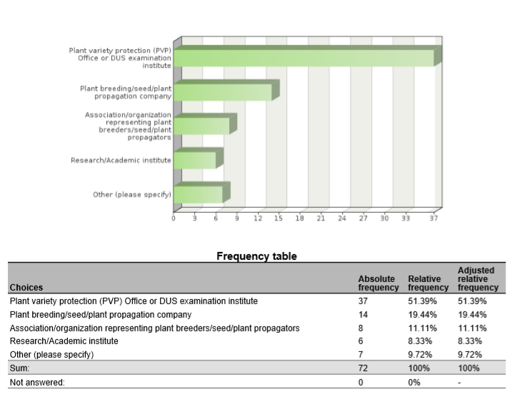

1. Are you cooperating with (other) UPOV members in the use of biochemical and molecular techniques?



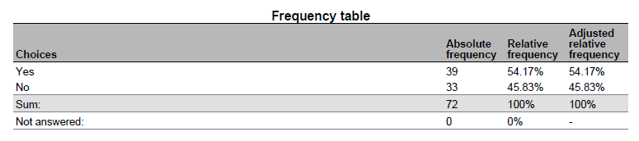

1. Please indicate with which UPOV members you are cooperating on biochemical and molecular techniques

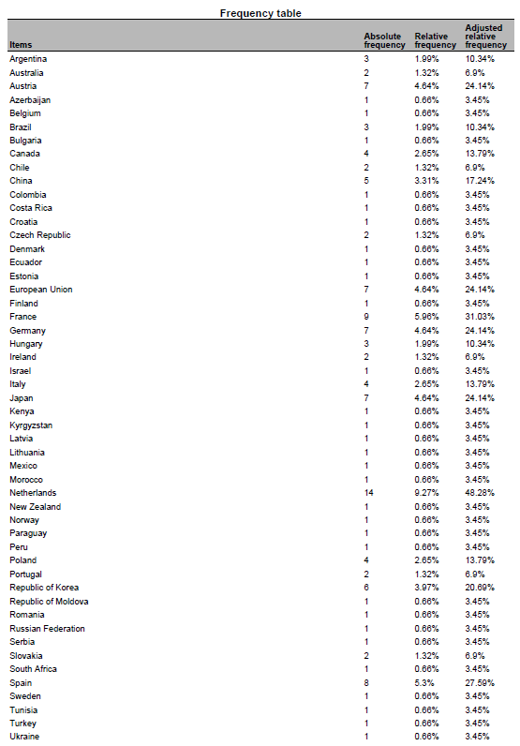

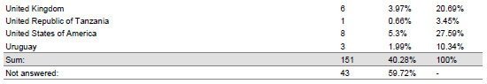

1. What are the objectives of the cooperation with the indicated UPOV members?

* validation and harmonization of crop-specific SNP sets My colleagues are also involved in projects to help with setting up a DUS examination procedures and facilities
* data base of tomato and wheat to improve the choose of comparators for DUS test
* Partner in Tomato project.
* tomato SNP project
* Associated partner in the OSR SNP research project.
* Use of SNP to varietal description
* Development of molecular tools for management of reference collection and assessment of specific traits
* gain knowledge
* Tomato SNP project
* Management of Reference collection; Quality management
* International harmonization and validation of a SNP set for the management of tomato reference collection
* molecular markers panel and method validation, molecular marker selection to describe varieties collection
* IMODDUS project of Tomato
* selection and validation of a molecular markers panel for genotyping core collection and varieties
* We are a member of the group involved in the use of SSR markers for potato DUS in Europe
* CPVO project
* Some research project are crop specific and are looking at identifying markers, some are more horizontal such as exchange on possible ideas for the use of molecular markers in DUS (within the IMODDUS group).
* expand use of SNP markers in DUS for soybeans
* developing SNP panels for soybean and barley
* Harmonization of marker sets
* identification of BMTs which can be applied in varietal identity and purity certification
* Build capacity for establishing distinction among varieties, based on genotype parameters.
* DUS, Infringements

5. Have you presented a paper on your cooperation with UPOV members at this BMT?

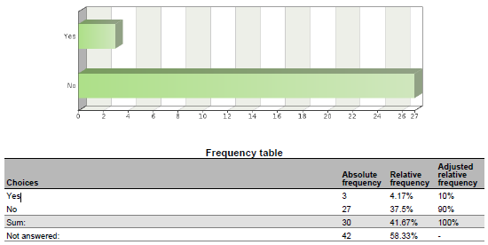

6. If you have not presented the paper, why not?

* I did in previous BMT sessions to introduce these cooperations. The projects we are working on are not yet in the phase to report on the results. Hopefully next year.
* The work is in progress and we are no acting as coordinators
* United Kingdom have not presented because France presented earlier in today.
* Because the work is in progress
* This project just starts from this year.
* This project just starts from this year.
* Because the project is not progressing.
* work is in progress
* There have been no significant changes in the work since the last BMT.
* involved with INVITE project
* I'm DUS expert
* Because the CPVO made a presentation, not necessary for breeders to do. ISF will present the outcome of a survey to which we (Euroseeds) also contributed.
* I have presented many in the past, but did contribute to a presentation this year.
* Cooperation with OECD was included into the Secretariat’s document on cooperation with IOs

7. In what areas would cooperation with UPOV members be valuable to you?

* harmonization of MM sets and also harmonized use of these MM sets in DUS examination. Common databases with variety descriptions and genotyping data to be used by all Examination offices world wide.
* fruit varieties
* Share markers used and platforms, and experience on the species.
* Interested in the development of a DNA reference database for potato.
* The use of DNA markers in DUS testing
* The use of biochemical and molecular techniques for management of reference collections
* Molecular techniques in variety identification, Variety description databases including databases containing molecular data
* Development of molecular tools to support DUS testing. Exploration of new markers (e.g. NGS) and new models (e.g. vmDUS)
* Obtaining information details on some specific procedures, if needed; Exchange of data; etc
* MODEL 1
* methods for analysis of molecular data and data management in database , molecular technique for varieties identification
* Share experience, platforms used and marker's set.
* Language barriers and general contact introductions.
* Developing new markers, sharing research cost, ring test to harmonize protocol between offices
* not main part of my work so wouldn't lead in this area
* Use of markers in creating efficiencies in DUS testing, organization of reference collection.
* standardized method, agreed marker sets agreement on molecular data access rules
* Standardization of methods and markers
* We perform variety identification by using SSR markers for grapevine, wheat and maize. 1) In future we would like to perform variety identification for rye, triticale and soybean - if someone has experience with applicable method. 2) DUS examination office is interested in molecular technique in relation to DUS for more effective management of ref. coll. for barley and wheat.
* Expand use of markers in DUS
* exchange of DUS examination reports, PVP statistics
* Exchange information on techniques/methods, molecular data of specific varieties.
* ISO seeks UPOV input for their use of ISO standards in Agriculture
* cannabis and hemp SNP panel development. Soybean and Barley.
* Give input from industry point of view
* Harmonization of MM techniques, including marker sets and distinctness thresholds.
* varietal identity
* Molecular techniques for identifying plant varieties
* Build capacity
* Representing ISTA
* DUS, Infringements

8. Please indicate which UPOV members you would wish to cooperate on biochemical and molecular techniques

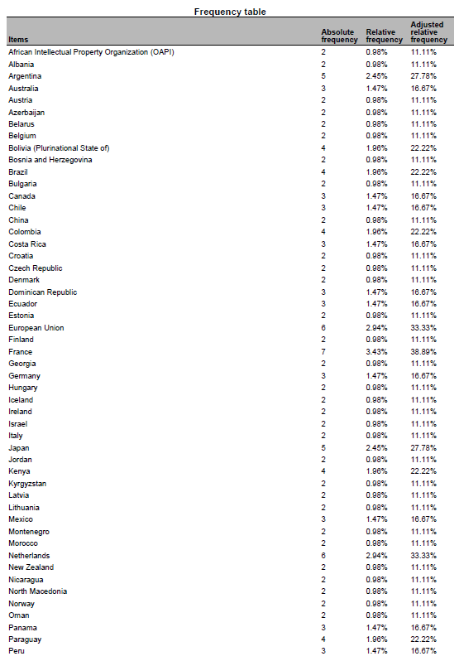

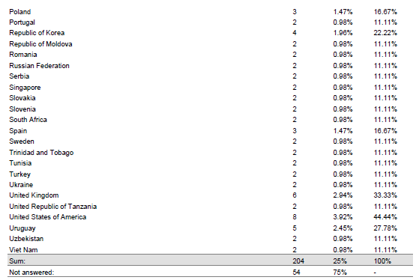

9. Please indicate the crops for which you would like to develop cooperation with UPOV members

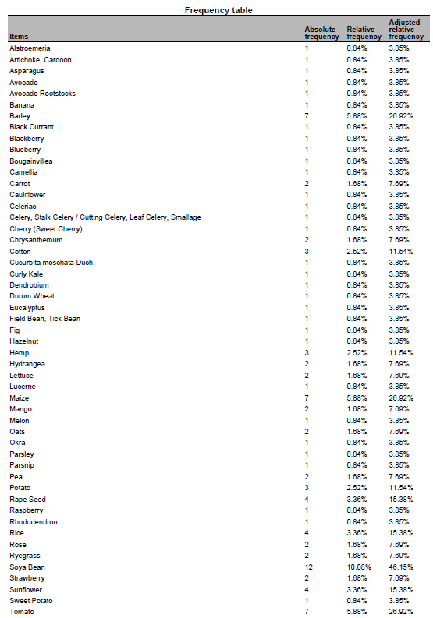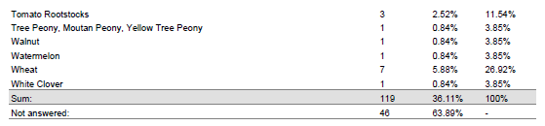

10. Please indicate the techniques for which you would like to develop cooperation with UPOV members

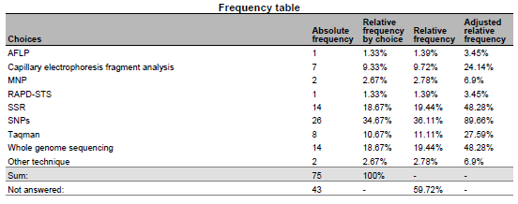

11. Please indicate the objectives of the cooperation:

* harmonization of SNP sets; common DNA databases
* To develop a potato reference collection including morphological and molecular info
* The use DNA markers in DUS testing
* A possibility to buy testing/pre-screening services from a testing authority
* Varietal description, Validation of protocols for the use of molecular markers in varietal description, collaboration to facilitate the exchange of knowledge in the use of new methodologies, Facilitate the acquisition of innovative processes
* Explore new approaches to solve Distinctness issues or test the potentialities of new markers
* To obtain a common database of MM for interested species in order to have better quality in the analysis of DUS (specially model 1)
* gathering information
* Varieties description, exchange of data and material, molecular technique in DUS examination, methods for integrating molecular and DUS and VCU data
* For DUS testing
* We have a lot of experience in potato but wish to broaden our work into other avenues particularly sweet potato, raspberry, strawberry, blackberry, pea
* sharing research cost, harmonization of methods
* harmonization of methods
* Standardisation of methods and open source markers
* to have an overview of available methods, ring trials participation if it's within the capabilities of our lab
* Expand use of markers in DUS
* Speed up DUS examination
* ISO provides methods across business and government. The methods provide a clear platform for their use.
* developing services useful for commercial protection
* Harmonization of MM techniques, including marker sets and distinctness thresholds.
* To train molecular techniques
* Build capacity
* Representing ISTA

12. What are the main obstacles to cooperation with UPOV members?

* Money; the agreement of the breeders to use their varieties for these purposes
* financing
* Development of internal and external MoU for accessing or generating DNA profiles
* The main obstacles are lack of experiences in introducing promised technologies to plant examination and some disadvantages in national legislation
* Lack of resources available for this kind of work
* Funding of non-EU members
* harmonization of methods and selected markers
* we do not have the clear vision
* Different level of expertise and available resources (technical and financial)
* lack of mechanisms and procedures to do so.
* UPOV acceptance of expanded marker use
* Not accepting to take over an existing DUS examination report
* UPOV is legislative, ISO is voluntary
* lack of contact information
* Time. Mutual interest. Organization/facilitation of interaction.
* Shared platform

13. What could UPOV do to help you to cooperate with UPOV members?

* research funds (similar to the IMODDUS by CPVO) agreement of the breeding industry
* For Canada to participate in any exercise for the development of an Agreement template
* We would like to participate in international projects and methodology testing
* Provide opportunities to exchange and establish concrete contacts.
* These forums at the BMT are a great way of putting researchers form different countries in contact. Maybe some kind of database with common interest could be created to facilitate new co-operation.
* Funding research project. Give information on the uses of Upov models by other members
* Provide agreed standards and protocols, alignment among PVP offices on the used methods, capacity building.
* establish liaison with ISO/TC34/SC16
* Make sure that a DUS examination report is accepted by another country. This would save both the applicant and the DUS offices time & money
* Save time in screening primers and share data on varieties
* Continue to observe ISO proceedings
* Cooperation between PVPOs and Breeders allows for expedited validation of MM use for PVP/PBR
* introducing upov members interested in the crops pointed above
* Organization/facilitation of interaction.
* Facilitate sharing methodology

[Annex II follows]

Proposal for the revision of document UPOV/INF/17

TABLE OF CONTENTS

A. INTRODUCTION 1

B. GENERAL PRINCIPLES 1

1. Selection of Molecular Markers 2

*1.1* *Sets of varieties for the selection process 2*

*1.2*  *Molecular markers – performance criteria 2*

2. Selection of the Detection Method 3

*2.1* *DNA profiling methods - general considerations 3*

*2.2.* *Access to the Technology 3*

3. Validation and harmonization of a marker set and detection method 3

*3.1* *Validation and harmonization – general considerations 3*

*3.2* *Performance considerations - validation of markers and methods 3*

*3.3* *Consistence considerations - harmonization of markers and methods between different laboratories in case of shared database – ring test 4*

4. Construction of a Species-specific Database 4

*4.1* *Recommendations for database design 4*

*4.2* *Requirements of the plant material 5*

*4.3* *Processing of sequence data 5*

*4.4*  *Type of database 6*

*4.5*  *Database model 6*

*4.6* *Data Dictionary 6*

*4.7* *Data access – ownership 7*

5. Data Exchange 7

*5.1* *Data exchange scenarios 7*

*5.2* *Data transfer methods 7*

6. Summary 7

C. LIST OF ACRONYMS 8

A. INTRODUCTION

The purpose of this document (BMT Guidelines) is to provide guidance on harmonized principles for the use of molecular markers with the aim of generating high quality molecular data for a range of applications. Only DNA molecular markers are considered in this document.

The BMT Guidelines are also intended to address the construction of databases containing molecular profiles of plant varieties, possibly produced in different laboratories using different technologies. In addition, the aim is to set high demands on the quality of markers and on the desire for generating reproducible data using these markers in situations where equipment and/or reaction chemicals might change. Specific precautions need to be taken to ensure quality entry into a database.

B. GENERAL PRINCIPLES

For DNA profiling of a plant variety, a set of molecular markers and a method to detect them are required. Two different sets of molecular markers detected with the same method will result in two different DNA profiles for a particular variety. In contrast, two different methods to detect the specific alleles of a given molecular marker set are expected to result in identical DNA profiles. Standardization of the detection method and technology is not required as long as the performance meets the quality criteria and the resulting DNA profiles are consistent. Irrespective of the technology used to detect defined marker sets, the genotype of a particular variety should not be affected.

Molecular marker sets, marker detection methods and subsequently the database developmental process can be subdivided into 5 different phases:

1. Selection of molecular markers

2. Selection of detection method

3. Validation and harmonization of the detection method

4. Construction of the database

5. Data exchange

This document describes these different phases in more detail. It is considered that these phases are independent from the stage of development of genotyping technologies and future improvements in high‑throughput sequencing.

1. Selection of Molecular Markers

*1.1 Sets of varieties for the selection process*

For DNA profiling of plant varieties and database construction, molecular markers should be selected according to the objective. To start the marker selection process an appropriate number of varieties (development set) is needed to reflect at the most the diversity observed within the group/crop/species/type for which the markers are intended to be discriminative. Further selection is performed by profiling additional varieties (validation set) to measure the performance of the markers. Criteria for the choice of the validation set could be:

(a) genetically very similar varieties or lines, NILs, RILs

(b) parental lines and offspring

(c) genetically close but morphologically distinct varieties (e.g. mutants)

(d) some morphologically close varieties with different pedigree

(e) different lots of the same variety

(f) different origins of the same variety

*1.2 Molecular markers – performance criteria*

The following general criteria for selecting a specific marker or set of markers are intended to be appropriate irrespective of the use of the markers:

(a) Repeatability, reproducibility and robustness within and between, laboratories in terms of scoring data;

(b) Possible sources of molecular markers

- Molecular markers derived from public resources

- Molecular markers derived from non-public resources, screening and selection of commercially available species-specific chips and arrays.

- Molecular markers selected from newly generated sequence data;

(c) The avoidance, as far as possible, of markers with “null” alleles (i.e. an allele whose effect is an absence of a PCR product at the molecular level), which again is not essential, but advisable;

(d) Allowance of easy, objective and indisputable scoring of marker profiles. These good performing markers are preferred over complex marker profiles that are sensitive to interpretation. Clear black and white answers also allows for easier harmonization;

(e) Co-dominant markers are generally preferred over dominant markers as they have a higher discriminative power;

(f) Markers located in coding and/or in non-coding regions; and

(g) The use of molecular markers is species-specific and should take into account the features of propagation of the species.

It is recognized that specific uses may impose certain additional considerations that may include (but are not limited to:

(a) The number of markers should be balanced with the accuracy of the genotype required for the objective. The number of markers to reach the necessary resolution or discriminative power depends on marker-type (dominant/co-dominant; bi-/multi-allelic), species and the quality of the marker performance;

(b) Coverage of the genome and the linkage disequilibrium should reflect the objectives. Knowing the physical and/or genetic position of the selected markers on the genome is not essential but enables a good selection of markers.

2. Selection of the Detection Method

*2.1 DNA profiling methods - general considerations*

2.1.1 Important considerations for choosing DNA profiling methods that generate high quality molecular data are:

(a) reproducibility of data production within and between laboratories and detection platforms (different types of equipment);

(b) repeatability over time;

(c) discrimination power;

(d) time and labor intensity;

(e) robustness of performance in time and conditions (sensitiveness to subtle changes in the protocol or condition);

(f) flexibility of the method, possibility to vary in the number of samples and/or number of markers;

(g) interpretation of the data produced is independent of the equipment;

(h) sustainability of databases;

(i) accessibility of methodology;

(j) independence of a specific machine, specific chemistry, specific supplier, particular partners or products;

(k) suitable for automation;

(l) suitable for multiplexing; and

(m) cost effective (costs, number of samples and number of markers are in balance).

*2.2. Access to the Technology*

Some molecular markers and materials are publicly available. However, a large investment is likely to be necessary to obtain high quality markers, consequently markers and other methods and/or materials may be covered by intellectual property rights. UPOV has developed guidance for the use of products or methodologies which are the subject of intellectual property rights and these should be followed. It is recommended that matters concerning intellectual property rights should be addressed at the start of any developmental work.

3. Validation and harmonization of a marker set and detection method

*3.1 Validation and harmonization – general considerations*

Molecular markers and detection methods should be robust and give rise to consistent DNA profiles. Performance of molecular markers and genotyping methods is evaluated in a validation process. In case of shared database, consistency of the DNA profiles in different laboratories is evaluated in the harmonization process using different equipment and chemistries. The usage of validated markers and methods will lead to harmonized results.

*3.2 Performance considerations - validation of markers and methods*

The selected marker set should be fit-for-purpose. The accuracy should be measured. To determine the suitability of a method and DNA marker set several points should be considered:

(a) Discriminative capacity/informativeness;

(b) Repeatability; where identical test results are obtained with the same method, on identical test items, in the same laboratory, by the same operator, using the same equipment within short intervals of time.

(c) Reproducibility; where test results are obtained with the same method, on identical test items, within the same laboratory or between different laboratories, with different operators, using different equipment.

(d) Robustness; a measure of its capacity to remain unaffected by small, but deliberate deviations from the experimental conditions described in the procedure parameters and provides an indication of its reliability during normal usage; and

(e) Error-rate.

Definitions of the performance characteristics are based on: ISO 16 577:2016

*3.3 Consistency considerations*

To achieve consistency of results, the process of harmonization of markers and methods between different laboratories in the case of a shared database (ring test) should consider:

(a) Use of a defined collection of varieties representing a wide range of alleles as a reference in all labs to test consistency between labs

(b) Inclusion of duplicates, sub-samples, individual plants of a variety to check the consistency of the DNA profiles and estimate the error-rate between labs

(c) Agreements on the scoring of molecular data. The necessity to develop a protocol for allele/band scoring between labs depends on the used marker type (e.g. essential for SSR). The protocol could address how to score the following:

i. rare alleles (i.e. those at a specific locus which appear with a frequency below an agreed threshold (commonly 5-10%) in a population);

ii. null alleles (an allele whose effect is an absence of PCR product at the molecular level);

iii. “faint” bands (i.e. bands where the intensity falls below an agreed threshold of detection, set either empirically or automatically, and the scoring of which may be open to question);

iv. missing data (i.e. any locus for which there are no data recorded for whatever reason in a variety or varieties); and

v. monomorphic bands or non-informative allele scores (those alleles/bands which appear in every variety analyzed, i.e. are not polymorphic in a particular variety collection).

4. Construction of a Species-Specific Database

The data that is stored in a database and how it is stored should reflect the process of producing the data. Therefore, database construction should consider different levels of data processing (*i.e.* raw data, sequence data…). The database should store the end results, e.g. the DNA profile as well as how it was derived both in terms of laboratory method description and the computational steps.

*4.1 Recommendations for database design*

Design of databases could consider the following aspects:

(a) The database architecture should be flexible, e.g. allow for storing both flat files as well as compressed archives.

(b) Separate tables and entries are required for laboratory experimental work, data processing and the allele scores.

(c) Storage of information at different levels for example allele scores and any rules for interpretation behind the decision and links to the raw data (tiff files, bam files) that were produced.

(d) For sequencing data, variant call files in VCF or BCF format corresponding to the standard version 4.2 or higher. Header entries should contain the name and version of the different scripts used for both sequence read mapping, read filtering, variant calling and variant filtering in such a way that a bioinformatician can repeat the analysis.

(e) In case of replicate samples where the DNA profile does not match, the record needs to be flagged or filtered out where appropriate. The rules applied for these cases need to be documented in a publicly accessible code repository that is referenced from the variant call file. Frequencies could also be used for heterogeneous varieties.

(f) Validation of the VCF and or BCF data against relevant specifications.

(g) Easy to share data, (e.g. API).

*4.2 Requirements of the plant material*

The source, type of the material and how many samples to be stored and shared in the database should be considered.

4.2.1 Source of plant material

The plant material to be analyzed should be an authentic, representative sample of the variety and, when possible, should be obtained from the sample of the variety used for examination for the purposes of Plant Breeders’ Rights or for official registration. Use of these samples will require the permission of the relevant authority, breeder and/or maintainer, as appropriate. The plant material from which the samples are taken should be traceable in case some of the samples subsequently prove not to be representative of the variety.

4.2.2 Type of plant material

The type of plant material to be sampled and the procedure for sampling the material for DNA extraction will, to a large extent, depend on the crop or plant species concerned. For example, in seed-propagated varieties, seed may be used as the source of DNA, whereas, in vegetatively propagated varieties, the DNA may be extracted from leaf material. Whatever the source of material, the method for sampling and DNA extraction should be documented. Furthermore, it should be verified that the sampling and extraction methods produce consistent results by DNA analysis.

4.2.3 Sample size and type (bulk or individual samples)

It is essential that the samples taken for analysis are representative of the variety. Consideration should be given to the features of propagation (see the General Introduction).

4.2.4 DNA reference sample

A DNA reference collection may be created from the plant material sampled. The method for sampling should follow recommended procedures and quality criteria for DNA extraction should be set. Both need to be documented.

The DNA samples should be stored in such a way as to prevent degradation (e.g. storing it at -80°C). The transfer of DNA reference samples is described in document TGP/5: section 1.

*4.3 Processing of sequence data*

A detailed log of the data processing pipeline may include:

(a) type and versions of tools;

(b) command line used for the tool including thresholds;

(c) reproducibility counts:

(d) possibility for sharing the data and process;

(e) raw alignment data (BAM or CRAM files) should be stored where possible;

(f) multi-sample VCF files are not suitable, one VCF file per variety must be present;

(g) if VCF files are stored, all positions (both variants & non-variants) and their depth should be stored;

(h) both heuristic and probabilistic approaches should be considered and compared for detection methods;

(i) databases should facilitate input and output of variant call data in standardized format (VCF or BCF);

(j) the data processing pipeline should result in a detailed log file which should be stored in conjunction to the variant call data;

(k) if possible, raw data should be stored so that data processing can be repeated with new or updated tools; and

(l) a p-value or uncertainty for a given allele should be stored.

*4.4 Type of database*

There are many ways in which molecular data can be stored, therefore, it is important that the database structure is developed to be compatible with all intended uses of the data.

*4.5 Database model*

The database model should be defined by IT database experts in conjunction with the users of the database. As a minimum the database model should contain six core objects: Species; Variety; Marker detection method; Marker; Locus; and Allele. For variants obtained from sequencing data, VCF files can be stored in a relational or no SQL database. In this case, each database record for a variant has a defined genome version, chromosome, position, reference allele.

|  |
| --- |
|  |
|  |

*4.6 Data Dictionary*

4.6.1 In a database, each of the objects becomes a table in which fields are defined. For example:

(a) Marker type: indicates the code or name of the technique or type of marker used, e.g. SSR, SNP, etc.

(b) Reference genome position or Locus code: Preferably, a genome assembly version, chromosome and position should be provided if a reference genome is available for the species concerned, e.g. SL2.50ch05:63309763 for tomato *Solanum lycopersicum* assembly version 2.50 on chromosome 5 position 63309763. If no reference genome is available or the location is unknown, a name or code of the locus for the species concerned can be used, e.g. gwm 149, A2, etc.

(c) Genotype: For SNP profiles, the allele composition of the SNP or MNP should be given, e.g. A/T or A/A. For other techniques, genotype indicates the name or code of the allele of a given locus for the species concerned, e.g. 1, 123, etc.

(d) Allele depths or Data value: For SNPs obtained from next generation sequencing data this should indicate the depth of coverage for alleles e.g. 10/20 for an A/T allele in which the A is covered by 10 reads and the T by 20. Otherwise, indicates a data value for a given sample on a given locus-allele, e.g. 0 (absence), 1 (presence), 0.25 (frequency) etc.

(e) Variety: Variety denomination or breeder’s reference: the variety is the object for which the data have been obtained.

(f) Type of variety: e.g. Inbred Line or Hybrid

(g) Species: the species is indicated by the botanical name or the national common name, which sometimes also refers to the type of variety (e.g. use, winter/spring type etc.). The use of the UPOV code is recommended to avoid problems of synonyms.

4.6.2 In each table, the number of fields, their name and definition, the possible values and the rules to be followed, need to be defined in the “data dictionary”.

*4.7 Data access – ownership*

It is recommended that all matters concerning ownership of data and access to data in the database be addressed at the beginning of any work.

5. Data Exchange

*5.1 Data exchange scenarios*

For cooperation purposes, the data model should allow different types of scenarios including the exchange of data produced from a standardized set of markers for a specific crop (Scenario 1), and search and view data of selected varieties generated from the same standardized set of markers (Scenario 2). Technical details on both scenarios are described in the Annex: Data exchange scenarios and data transfer methods.

*5.2 Data exchange methods*

5.2.1 Fingerprint data transmission may contain a range of information, such as loci, samples, DNA, fingerprint data and fingerprint profiles. Method of data transmission needs to be determined by the content to be transferred and should consider the following:

(a) amount of data

(b) complexity of data

(c) requirements for query or search functions

Technical details on data transfer methods are described in the Annex: Data exchange scenarios and data transfer methods.

5.2.2 Commonly used data formats include: zip, csv, json and xml. Their respective characteristics are as follows:

(1) The zip format allows a variety of data information files in the original format and due to its large data compression ratio and ease of transmission is suitable for large and complex data.

(2) The csv format is more suitable for data information in simple data format, which has the advantage of having less invalid data and faster processing speeds.

(3) The json and xml formats can contain more complex character data information and more redundant information, but both offer good readability.

6. Summary

The following is a summary of the approach recommended for high quality DNA profiling of varieties including the selection and use of molecular markers as well as the construction of shared and sustainable molecular databases (i.e. databases that can be populated in the future with data from a range of sources, independent of the technology used).

(a) consider the approach on a crop-by-crop basis;

(b) agree on an acceptable marker type and source;

(c) agree on acceptable detection platforms/equipment;

(d) agree on laboratories to be included in the test;

(e) agree on quality issues ;

(f) verify the source of the plant material used ;

(g) agree which markers are to be used in a preliminary collaborative evaluation phase, involving more than one laboratory and different detection equipment ;

(h) conduct an evaluation ;

(i) develop and agree a protocol for scoring the molecular data ;

(j) agree on the plant material/reference set to be analyzed, and the source(s);

(k) analyze the agreed variety collection, in different laboratories/different detection equipment, using duplicate samples, and exchanging samples/DNA extracts if problems occur;

(l) use references (varieties, DNA samples and alleles, as appropriate) in all analyses;

(m) verify all stages (including data entry) – automate as much as possible;

(n) conduct a ‘blind test’ in different laboratories using the database;

(o) adopt procedures for adding new data.

C. LIST OF ACRONYMS

API Application Programming Interface

BAM Binary Alignment Map

BCF Binary Call Format

CRAM Compressed Reference-oriented Alignment Map

MNP Multiple Nucleotide Polymorphism

NGS Next Generation Sequencing

NIL Near Isogenic Line

RIL Recombinant Inbred Line

SAM Sequence Alignment Map

SNP Single Nucleotide Polymorphism

SQL Structured Query Language

SSR Simple Sequence Repeats

TIFF Tagged Image File Format

VCF Variant Call Format

[Appendix to Annex follows]

DATA EXCHANGE SCENARIOS AND TRANSFER METHODS

**A: Data exchange scenarios**

*Scenario 1: exchange of data produced from a standardized set of markers for a specific crop*

In order to exchange data about the marker set used for a specific crop, the following web service can be used:

https://office.org/locus?upov_code={upovcode}&type={marker type}&method={observation method}

For example, to obtain marker set information for maize using SSR and CE method, the following URL should be accessed:

https://office.org/locus?upov_code=ZEAAA_MAY&type=SSR&method=CE

The result would be:

{"techniqueid": "CN_SSR_ZEAA_MAY_CE_V_1",

"description": "Laboratory method description"

["locusid": "M01",

"alleles":

["alleleid": "238/256",

"examplevariety":

],

["alleleid": "238/271",

"examplevariety":

],

["alleleid": "246/246",

"examplevariety":

],

["alleleid": "246/248",

"examplevariety":

],

["alleleid": "246/250",

"examplevariety":

],

["alleleid": "246/254",

"examplevariety":

],

["alleleid": "246/256",

"examplevariety":

],

["alleleid": "246/260",

"examplevariety":

],

["alleleid": "246/277",

"examplevariety":

],

["alleleid": "246/284",

"examplevariety":

],

["alleleid": "246/288",

"examplevariety":

],

["alleleid": "248/250",

"examplevariety":

],

["alleleid": "248/256",

"examplevariety":

],

["alleleid": "248/271",

"examplevariety":

],

["alleleid": "248/290",

"examplevariety":

],

["alleleid": "250/250",

"examplevariety":

],

["alleleid": "250/252",

"examplevariety":

],

["alleleid": "250/256",

"examplevariety":

],

["alleleid": "250/275",

"examplevariety":

],

["alleleid": "252/256",

"examplevariety":

],

["alleleid": "252/260",

"examplevariety":

],

["alleleid": "252/271",

"examplevariety":

],

["alleleid": "252/273",

"examplevariety":

],

["alleleid": "252/282",

"examplevariety":

],

["alleleid": "254/254",

"examplevariety":

],

["alleleid": "254/271",

"examplevariety":

],

["alleleid": "254/284",

"examplevariety":

],

["alleleid": "254/286",

"examplevariety":

],

["alleleid": "256/256",

"examplevariety":

],

["alleleid": "256/264",

"examplevariety":

],

["alleleid": "256/266",

"examplevariety":

],

["alleleid": "256/271",

"examplevariety":

],

["alleleid": "256/284",

"examplevariety":

],

["alleleid": "256/286",

"examplevariety":

],

["alleleid": "258/258",

"examplevariety":

],

["alleleid": "264/284",

"examplevariety":

],

["alleleid": "271/292",

"examplevariety":

]

],

["locusid"="M02”.

"alleles": […]

]} vi

*Scenario 2: search and view data of selected varieties generated from the same standardized set of markers*

In order to search and view molecular data of a variety, the following web service can be used:

https://office.org/variety?id={irn}&techniqueid={technique_code} vi

For example,

https://office.org/variety?id=XU_30201800000140 &techniqueid= CN_SSR_ZEAA_MAY_CE_V_1 vi

The result would be:

{"techniqueid": "CN_SSR_ZEAA_MAY_PAGE ",

"varietyid": " XU_30201800000140 ",

"computationalsteps": "xxxxxxxxxxxx"

"data":

[

"id": "M01",

"value" : "254/254"

],

[

"id": "M02",

"value" : "347/347"

],

[

"id": "M03",

"value" : "292/292"

],

[

"id": "M04",

"value" : "361/361"

],

…

} vi

**B: Data transfer methods**

The following provides an example of constructing a fingerprint packet in a zip format for data transmission. This method first needs to use independent IDs to identify samples, DNA, fingerprint data and fingerprint atlas. After that, the json format data file contains all the loci, samples and DNA information. Each fingerprint data is stored independently in its own json format file. The fingerprint ID will be bound to the corresponding locus of the fingerprint data, and all fingerprint data files and fingerprint spectrum files will be stored independently in the corresponding directory. So the format structure of the fingerprint data packet is as follows:

zip/markers.json

zip/samples.json

zip/dnas.json

zip/genes/gene_id_1.json

zip/genes/gene_id_2.json

......

zip/genes/gene_id_n.json

zip/maps/map_id_1.png

zip/maps/map_id_2.png

......

zip/maps/map_id_m.png

The zip format fingerprint packet can be extended to include more information. The core of the packet is the fingerprint data file, which is the core of the correlation, so that the correlation between the parts can be correctly parsed, allowing data transmission across different systems.

[Annex III follows]

ELEMENTS FOR DRAFT JOINT DOCUMENT explaining the principal features of the systems of the OECD, UPOV and ISTA

The Organisation for Economic Co-operation and Development (OECD)

*What are the OECD Seed Schemes?*

The OECD Seed Schemes provide an international framework for the varietal certification of agricultural seed moving in international trade. The Schemes were established in 1958 driven by a combination of factors including a fast-growing seed trade, regulatory harmonisation in Europe, the development of off-season production, the seed breeding and production potential of large exporting countries in America (North and South) and Europe, and the support of private industry. Membership of the Schemes is voluntary and participation varies. There are seven agricultural Seed Schemes.

*Participating countries*

59 countries from Europe, North and South America, Africa, the Middle-East, Asia and Oceania currently participate in the OECD Seed Schemes:

|  |  |  |  |
| --- | --- | --- | --- |
| ALBANIA | (2) | LITHUANIA | (2) |
| ARGENTINA | (2) | LUXEMBOURG | (1) |
| AUSTRALIA | (1) | MEXICO | (1) |
| AUSTRIA | (1) | MOLDOVA | (2) |
| BELGIUM | (1) | MOROCCO | (2) |
| BOLIVIA | (2) | NETHERLANDS | (1) |
| BRAZIL | (2) | NEW ZEALAND | (1) |
| BULGARIA | (2) | NORWAY | (1) |
| CANADA | (1) | POLAND | (1) |
| CHILE | (1) | PORTUGAL | (1) |
| CROATIA | (2) | ROMANIA | (2) |
| CYPRUS1 | (2) | RUSSIAN FEDERATION | (2) |
| CZECH REPUBLIC | (1) | SENEGAL | (2) |
| DENMARK | (1) | SERBIA | (2) |
| EGYPT | (2) | SLOVAKIA | (1) |
| ESTONIA | (1) | SLOVENIA | (1) |
| FINLAND | (1) | SOUTH AFRICA | (2) |
| FRANCE | (1) | SPAIN | (1) |
| GERMANY | (1) | SWEDEN | (1) |

1 Note by Turkey

The information in this document with reference to « Cyprus » relates to the southern part of the Island. There is no single authority representing both Turkish and Greek Cypriot people on the Island. Turkey recognises the Turkish Republic of Northern Cyprus (TRNC). Until a lasting and equitable solution is found within the context of the United Nations, Turkey shall preserve its position concerning the “Cyprus issue”.

Note by all the European Union Member States of the OECD and the European Union

The Republic of Cyprus is recognised by all members of the United Nations with the exception of Turkey. The information in this document relates to the area under the effective control of the Government of the Republic of Cyprus.

|  |  |  |  |
| --- | --- | --- | --- |
| GREECE | (1) | SWITZERLAND | (1) |
| HUNGARY | (1) | TUNISIA | (2) |
| ICELAND | (1) | TURKEY | (1) |
| INDIA | (2) | UGANDA | (2) |
| IRAN | (2) | UKRAINE | (2) |
| IRELAND | (1) | UNITED KINGDOM | (1) |
| ISRAEL | (1) | UNITED STATES | (1) |
| ITALY | (1) | URUGUAY | (2) |
| JAPAN | (1) | ZIMBABWE | (2) |
| KENYA | (2) |  |  |
| KYRGYZSTAN | (2) | (1) OECD Member Country |  |
| LATVIA | (2) | (2) Non OECD Member Country | |

Figure 1 Map of Participating Countries in the OECD Seed Schemes (2016)

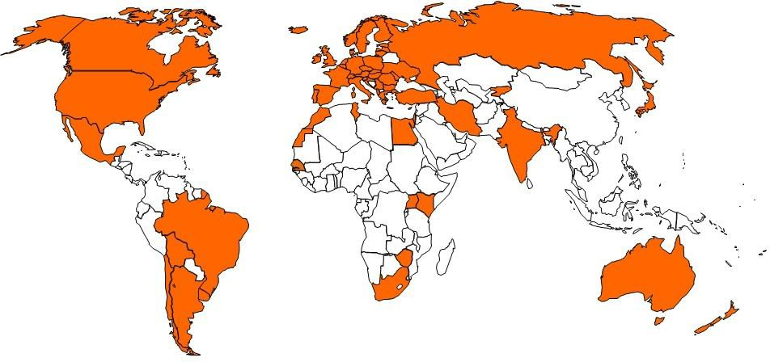

*Objectives*

The objectives of the Schemes are to encourage the production and use of “quality-guaranteed” seed in participating countries. The Schemes authorise the use of labels and certificates for seed produced and processed for international trade according to agreed principles ensuring varietal identity and purity.

The Schemes facilitate the import and export of seed, by the removal of technical barriers to trade by assuring identification and origin through internationally recognised labels (“passports”) for trade. They also lay down guidelines for seed multiplication abroad, as well as for the delegation of some control activities to the private sector (“authorisation”). The quantity of seed certified through the OECD Schemes has grown rapidly in recent years and now exceeds 1 million tonnes.

*How do the Seed Schemes operate*

The success of international certification depends upon close co-operation between maintainers, seed producers, traders and the designated authority (appointed by the government) in each participating country. Frequent meetings allow for a multi-stakeholder dialogue to exchange information, discuss case studies, revise rules and update the Schemes. A wide range of international and non-governmental organisations as well as and seed industry networks participate actively in the Schemes.

*Benefits of the Schemes*

* + To facilitate international trade by using harmonised certification procedures, crop inspection techniques and use of control plots. The varietal purity standards for the appropriate species are also agreed and standardised by all member states.
  + To provide a framework to develop seed production with other countries or companies.
  + To participate in the elaboration of international rules for seed certification.
  + To develop collaboration between the public and private sectors.
  + To benefit from regular exchanges of information with other national certification agencies and Observer organisations.

*Annual List of Varieties*

The Annual List of Varieties eligible for OECD certification includes varieties which are officially recognized as distinct, uniform and stable, and possess an acceptable value in one or more participating country. The List contains the seed varieties internationally traded using the OECD seed Schemes. The number of varieties included has grown steadily over the last thirty years. Currently, the number of listed varieties amounts to over 62 000, corresponding to 200 species. The List is available online and updated frequently.

*Outlook*

As seed “consumers” become more demanding, there are greater needs for uniform seed standards, while at the same time public financial resources for regulation and quality control are limited.

Co-operation among countries and stakeholders in the framework of the Schemes is a response to the concern for a market-responsive regulatory approach*.* Every country is confronted with a different legal framework, institutional barriers and trade relations whilst the different approaches must remain consistent between countries entering international markets as importers or exporters of seed.

Maintainers and seed companies are responsible for ensuring their varieties remain pure and true to the description and the definitive sample (which is the ‘living description’ of the variety) not only domestically, but also across borders. However, there is a need for minimum criteria to be commonly defined, endorsed and enforced when multiplying seed in large quantities for the trade. The OECD Seed Schemes provide this legal framework at international level.

*Status of Biochemical and Molecular Techniques (BMT) in the OECD Seed Schemes*

The OECD Seed Schemes do not specifically endorse any laboratory method for determining varietal identity or for determining varietal purity. The traditional OECD methods of using field inspection techniques together with pre- and post- control plots are to be regarded as the required methods of determining varietal identity and varietal purity.

However, the OECD Seed Schemes do recognise that there are occasions where these traditional methods limit the certainty of the varietal determination, and in some cases varieties of some species cannot be identified with certainty using these traditional methods. In these specific circumstances, it might be beneficial to use non-field based techniques such as BMT, which must be seen as supplementing and not replacing the more traditional methods.

For more information on the OECD Seed Schemes see: [**www.oecd.org/tad**/**seed**](http://www.oecd.org/tad/seed)

International Union for the Protection of New Varieties of Plants (UPOV)

Type of Organization: Intergovernmental

Membership

[List of UPOV members](http://www.upov.int/export/sites/upov/members/en/pdf/pub423.pdf)  / [Situation in UPOV](http://www.upov.int/export/sites/upov/images/worldmap_en.jpg)

*What is UPOV?*

The International Union for the Protection of New Varieties of Plants (UPOV) is an intergovernmental organization based in Geneva, Switzerland. UPOV was established in 1961 by the International Convention for the Protection of New Varieties of Plants (the "UPOV Convention").

The mission of UPOV is to provide and promote an effective system of plant variety protection, with the aim of encouraging the development of new varieties of plants, for the benefit of society.

The UPOV Convention provides the basis for members to encourage plant breeding by granting breeders of new plant varieties an intellectual property right: the breeder’s right.

*What does UPOV do?*

UPOV’s mission is to provide and promote an effective system of plant variety protection, with the aim of encouraging the development of new varieties of plants, for the benefit of society. The main objectives of UPOV are, in accordance with the UPOV Convention, to:

* provide and develop the legal, administrative and technical basis for international cooperation in plant variety protection;
* assist States and organizations in the development of legislation and the implementation of an effective plant variety protection system; and
* enhance public awareness and understanding of the UPOV system of plant variety protection.

*What are the benefits of plant variety protection and UPOV membership?*

The UPOV Report on the Impact of Plant Variety Protection demonstrated that in order to enjoy the full benefits which plant variety protection is able to generate, both implementation of the UPOV Convention and membership of UPOV are important. The introduction of the UPOV system of plant variety protection and UPOV membership were found to be associated with:

(a) increased breeding activities,

(b) greater availability of improved varieties,

(c) increased number of new varieties,

(d) diversification of types of breeders (e.g. private breeders, researchers),

(e) increased number of foreign new varieties,

(f) encouraging the development of a new industry competitiveness on foreign markets, and

(g) improved access to foreign plant varieties and enhanced domestic breeding programs.

In order to become a UPOV member the advice of the UPOV Council in respect of the conformity of the law of a future member with the provisions of the UPOV Convention is required. This procedure leads, in itself, to a high degree of harmony in those laws, thus facilitating cooperation between members in the implementation of the system.

*Does UPOV allow molecular techniques (DNA profiles) in the examination of Distinctness, Uniformity and Stability (“DUS”)?*

It is important to note that, in some cases, varieties may have a different DNA profile but be phenotypically identical, whilst, in other cases, varieties which have a large phenotypic difference may have the same DNA profile for a particular set of molecular markers (e.g. some mutations).

In relation to the use of molecular markers that are not related to phenotypic differences, the concern is that it might be possible to use a limitless number of markers to find differences between varieties at the genetic level that are not reflected in phenotypic characteristics.

On the above basis, UPOV has agreed the following uses of molecular markers in relation to DUS examination:

(a) Molecular markers can be used as a method of examining DUS characteristics that satisfy the criteria for characteristics set out in the General Introduction if there is a reliable link between the marker and the characteristic.

(b) A combination of phenotypic differences and molecular distances can be used to improve the selection of varieties to be compared in the growing trial if the molecular distances are sufficiently related to phenotypic differences and the method does not create an increased risk of not selecting a variety in the variety collection which should be compared to candidate varieties in the DUS growing trial.

The situation in UPOV is explained in documents TGP/15 “Guidance on the Use of Biochemical and Molecular Markers in the Examination of Distinctness, Uniformity and Stability (DUS)” and UPOV/INF/18 “Possible use of Molecular Markers in the Examination of Distinctness, Uniformity and Stability (DUS)”.

<https://www.upov.int/about/en/faq.html#QB80>

International Seed Testing Association (ISTA)

ISTA’S VISION: UNIFORMITY IN SEED TESTING

Founded in 1924, with the aim to develop and publish standard procedures in the field of seed testing, ISTA is inextricably linked with the history of seed testing. With member laboratories in over 80 countries/distinct economies worldwide, ISTA membership is truly a global network.

Our association produces internationally agreed rules for seed sampling and testing, accredits laboratories, promotes research, provides international seed analysis certificates and training, and disseminates knowledge in seed science and technology on behalf of our membership and governed by its member countries/distinct economies. This facilitates seed trading nationally and internationally, and therefore contributes to food security.

ISTA’S MEMBERSHIP 2019

With member laboratories in 82 countries/distinct economies worldwide, ISTA membership is a truly global network. Currently, ISTA membership consists of:

* 235 Member Laboratories, out of which 136 are ISTA accredited
* 63 Associate Members
* 39 Personal Members

ISTA’S TECHNICAL WORK

The principle objective of ISTA Technical Committees is to develop, standardise and validate methods for sampling and testing of seed quality, using the best scientific knowledge available. They enhance the **ISTA ‘International Rules for Seed Testing’** and develop ISTA Handbooks on seed methods including sampling and testing. Further they are responsible for the organisation of Symposia, Seminars and Workshops. ISTA Technical Committees regularly hold workshops which provide a platform for training as well as the exchange of information, experience and ideas.

There are 20 Technical Committees in ISTA:

|  |  |
| --- | --- |
|  | Technical Committees |
| 1. | Advanced Technologies Committee |
| 2. | Bulking and Sampling Committee |
| 3. | Editorial Board of Seed Science and Technology |
| 4. | Flower Seed Testing Committee |
| 5. | Forest Tree and Shrub Seed Committee |
| 6. | Germination Committee |
| 7. | GMO Committee |
| 8. | Moisture Committee |
| 9. | Nomenclature Committee |
| 10. | Proficiency Test Committee |
| 11. | Purity Committee |
| 12. | Rules Committee |
| 13. | Seed Health Committee |
| 14. | Seed Science Advisory Group |
| 15. | Statistics Committee |
| 16. | Seed Storage Committee |
| 17. | Tetrazolium Committee |
| 18. | Variety Committee |
| 19. | Vigour Committee |
| 20. | Wild Species Working Group |

ISTA ACCREDITATION PROGRAMME:

ISTA Accreditation verifies whether a laboratory is technically competent to carry out seed sampling and testing procedures in accordance with the [ISTA International Rules for Seed Testing](https://www.seedtest.org/en/international-rules-for-seed-testing-2019-_content---1--1083--1065.html). Accredited laboratories must run a quality assurance system, fulfilling the requirements of the [ISTA Accreditation Standard](https://www.seedtest.org/upload/cms/user/ISTAAccreditationStandardforSeedTestingandSeedSamplingV6.11.pdf). Accreditation can be granted for:

* entities performing sampling only
* laboratories performing testing only
* laboratories performing sampling and testing.

ISTA CERTIFICATES: PASSPORT FOR INTERNATIONAL SEED TRADING

Only ISTA-accredited laboratories are authorised to issue ISTA certificates for seed analysis.

By reporting seed test results on ISTA Certificates, the issuing laboratory assures that the sampling and testing has been carried out in accordance with the ISTA Rules. ISTA Certificates are accepted by most authorities and are mentioned in the seed Acts of several countries.

The ISTA certificates are assuring that the results are reproducible, true and represent the quality of the seed.

More than 200,000 ISTA Orange and Blue Certificates are issued every year, facilitating trading of seed internationally.

**THE STATUS OF BIOCHEMICAL AND MOLECULAR TECHNIQUE (BMT) IN ISTA.**

The ISTA International Rules for Seed Testing have included BMTs for many years. For example, BMTs are acceptable for GMO testing under a "performance-based approach"; methods that are frequently used include qualitative and quantitative protein detection analyses and various DNA-based methods. BMTs are used as diagnostic and quantitative assessment tools in seed health testing methods. Testing for species and varieties verification also makes use of BMTs by analysing storage protein profiles for sunflower, maize, oat, barley, wheat, rye grass and pea or by DNA fingerprint using molecular markers for maize and wheat. As the versatility of these methods increases and the cost of utilizing them decreases, they may in the future play an even larger role in seed testing.

To learn more about ISTA, visit our website: [www.seedtest.org](http://www.seedtest.org)

[End of Annex III and of document]

1. Breeders’ Day
2. Held via electronic means on October 30, 2020
3. at its fifty-fourth session, held in Geneva on October 29 and 30, 2018
4. at its fifty-fourth session, held from May 11 to 15, 2020.
5. at its fifty-second session, held from June 8 to 12, 2020.
6. at its forty-ninth session, held from June 22 to 26, 2020.
7. at its fifty-first session, held from July 6 to 10, 2020.
8. at its thirty-eighth session, held from September 21 to 23, 2020.
9. see documents TWV/54/9 “Report”, paragraphs 19 and 20; TWO/52/11 “Report”, paragraphs 90 and 91; TWA/49/7 “Report”, paragraphs 64 and 65; TWF/51/10 “Report”, paragraphs 19 and 20 and TWC/38/11 “Report”, paragraphs 72 and 73
10. at its nineteenth session, held from September 23 to 25, 2020.
11. Hosted by the United States of America and held via electronic means from September 23 to 25, 2020
12. Held via electronic means on October 26 and 27, 2020
13. held in Geneva, on October 29 and 30, 2018
14. held in Geneva, on October 28 and 29, 2019
15. held in Hangzhou, China, from October 16 to 18, 2019
16. held in Geneva, on October 28 and 29, 2019