E
International Union for the Protection of New Varieties of Plants

Technical Working Party for Vegetables  Fifty-Fifth Session  Antalya, Turkey, May 3 to 7, 2021  Technical Working Party for Ornamental Plants and Forest Trees  Fifty-Third Session  Roelofarendsveen, Netherlands, June 7 to 11, 2021  Technical Working Party for Agricultural Crops  Fiftieth Session  Arusha, United Republic of Tanzania, June 21 to 25, 2021  Technical Working Party for Fruit Crops  Fifty-Second Session  Zhengzhou, China, July 12 to 16, 2021  Technical Working Party on Automation and Computer Programs  Thirty-Ninth Session  Alexandria, United States of America, September 20 to 22, 2021 | TWP/5/5  Original: English  Date: April 9, 2021
Exchange and use of software and equipment
Document prepared by the Office of the Union
Disclaimer: this document does not represent UPOV policies or guidance

executive summary

The purpose of this document is to report on developments and consider proposals for the revision of documents UPOV/INF/16 “Exchangeable Software” and UPOV/INF/22 “Software and equipment used by members of the Union”.

The TWPs are invited to note that:

(a) the Council, at its fifty-fourth ordinary session, adopted in the procedure by correspondence, on October 25, 2020, document UPOV/INF/16/9 “Exchangeable software”;

(b) the Office of the Union issued on April 8, 2021, Circular E-21/030 inviting the designated persons of the members of the Union in the TC to provide or update information regarding the use of the software included in document UPOV/INF/16/10 Draft 1 “Exchangeable software” to the Office of the Union by May 7, 2021;

(c) the Office of the Union received a proposal from China to include in document UPOV/INF/16 software “DUS Excel 2.0 - Data Analysis System for DUS Testing of Plant Varieties”;

(d) the Council, at its fifty-fourth ordinary session, adopted in the procedure by correspondence, on October 25, 2020, document UPOV/INF/22/7 “Software and equipment used by members of the Union”;

(e) the Office of the Union issued on April 8, 2021, Circular E-21/030 inviting the designated persons of members of the Union in the TC to provide or update information in document UPOV/INF/22/8 Draft 1 “Use of software and equipment” to the Office of the Union by May 7, 2021;

(f) the TC, at its fifty-seventh session, will be invited to consider whether to include any proposed software or equipment in document UPOV/INF/22/8 Draft 1, on the basis of the recommendation of the TWC at its thirty-ninth session, or whether to request further guidance from other relevant bodies; and

(g) that the information in documents UPOV/INF/16 and UPOV/INF/22 is available in a searchable format on the UPOV website.

The TWC is invited to review the software “DUS Excel 2.0 - Data Analysis System for DUS Testing of Plant Varieties” and make a recommendation for consideration by the TC, at its fifty-seventh session, on whether to include the proposed software in document UPOV/INF/16.

The following abbreviations are used in this document:

CAJ: Administrative and Legal Committee
TC: Technical Committee
TWC: Technical Working Party on Automation and Computer Programs
TWPs: Technical Working Parties

The structure of this document is as follows:
executive summary 1
document UPOV/INF/16 “Exchangeable Software” 2
Adoption of document UPOV/INF/16/9 2
Revision of document UPOV/INF/16/9 2
Information on use by members 2
Procedure for inclusion of software 3
New proposal for inclusion of software in document UPOV/INF/16 3
Document UPOV/INF/22 “Software and equipment used by members of the Union” 3
Adoption of document UPOV/INF/22/7 3
Revision of document UPOV/INF/22/7 4
Availability of documents UPOV/INF/16 “Exchangeable software” and UPOV/INF/22 “Software and equipment used by members of the Union” in a searchable form 5

Annex User manual for software “DUS Excel 2.0 - Data Analysis System for DUS Testing of Plant Varieties”

document UPOV/INF/16 “Exchangeable Software”

Adoption of document UPOV/INF/16/9

The Council, at its fifty-fourth ordinary session, adopted in the procedure by correspondence, on October 25, 2020, a revision of document UPOV/INF/16 “Exchangeable software” (document UPOV/INF/16/9), on the basis of document UPOV/INF/16/9 Draft 2 (see document C/54/17 “Outcome of consideration of documents by correspondence”, paragraph 17). The adopted revision included information received from France and the United Kingdom.

Revision of document UPOV/INF/16/9

Information on use by members

Section 4 of document UPOV/INF/16 “Exchangeable Software” provides the following:

“4. Information on use by members of the Union

“4.1 A circular is issued to members of the Union on an annual basis, inviting them to provide information on their use of the software included in document UPOV/INF/16.

“4.2 The information on software use by members of the Union is indicated in the columns ‘Member(s) of the Union using the software’ and ‘Application by user(s)’. With regard to the indication of ‘Application by user(s)’, members of the Union can indicate, for example, crops or types of crop for which the software is used.”

The Office of the Union issued on April 8, 2021, Circular E-21/030 to the designated persons of the members of the Union in the TC, inviting them to provide or update information regarding the use of the software included in document UPOV/INF/16/10 Draft 1 “Exchangeable software” to the Office of the Union by May 7, 2021.

Procedure for inclusion of software

Section 2 of document UPOV/INF/16 “Exchangeable Software” provides the following:

“Software proposed for inclusion in document UPOV/INF/16 by members of the Union is, in the first instance, presented for review by the Technical Working Party on Automation and Computer Programs (TWC). On the basis of such presentations and the experience of members of the Union, the TWC makes a recommendation to the Technical Committee (TC) on whether to include that software in document UPOV/INF/16 […].”

Software proposed for inclusion in document UPOV/INF/16 by a member of the Union in response to Circular E-21/030 will be presented for review by the TWC, at its thirty-ninth session, to be held from September 20 to 22, 2021. The TWC will be invited to make a recommendation for consideration by the TC, at its fifty-seventh session, on whether to include the proposed software in document UPOV/INF/16.

New proposal for inclusion of software in document UPOV/INF/16

On March 6, 2021, the Office of the Union received a proposal from China to include in document UPOV/INF/16 the software “DUS Excel 2.0 - Data Analysis System for DUS Testing of Plant Varieties”. The user manual is provided in the Annex to this document. The software is available on the TWP webpages as an Excel file.

In accordance with the procedure in document UPOV/INF/16, the software “DUS Excel 2.0 - Data Analysis System for DUS Testing of Plant Varieties” will be presented for review by the TWC, at its thirty-ninth session. The TWC will be invited to make a recommendation for consideration by the TC, at its fifty-seventh session, on whether to include the proposed software in document UPOV/INF/16.

The TWPs are invited to note that

(a) the Council, at its fifty-fourth ordinary session, adopted in the procedure by correspondence, on October 25, 2020, document UPOV/INF/16/9 “Exchangeable software”;

(b) the Office of the Union issued on April 8, 2021, Circular E-21/030 inviting the designated persons of the members of the Union in the TC to provide or update information regarding the use of the software included in document UPOV/INF/16/10 Draft 1 “Exchangeable software” to the Office of the Union by May 7, 2021; and

(c) the Office of the Union received a proposal from China to include in document UPOV/INF/16 software “DUS Excel 2.0 - Data Analysis System for DUS Testing of Plant Varieties”.

The TWC is invited to review the software “DUS Excel 2.0 - Data Analysis System for DUS Testing of Plant Varieties” and make a recommendation for consideration by the TC, at its fifty-seventh session, on whether to include the proposed software in document UPOV/INF/16.

Document UPOV/INF/22 “Software and equipment used by members of the Union”

Adoption of document UPOV/INF/22/7

The Council, at its fifty-fourth ordinary session, adopted in the procedure by correspondence, on October 25, 2020, a revision of document UPOV/INF/22 “Software and Equipment Used by Members of the Union (Revision)” (document UPOV/INF/22/7), on the basis of document UPOV/INF/22/7 Draft 1 (see document C/54/17 “Outcome of consideration of documents by correspondence”, paragraph 17). The adopted revision included information received from Uruguay and Lithuania.

Revision of document UPOV/INF/22/7

The procedure for considering software and equipment proposed for inclusion in document UPOV/INF/22 is set out in document UPOV/INF/22, as follows:

“2.1 Software/equipment proposed for inclusion in this document by members of the Union is, in the first instance, presented to the TC.

“2.2 The TC will decide whether to:

- propose to include the information in the document;
- request further guidance from other relevant bodies (e.g. CAJ and TWPs); or
- propose not to include the information in the document.

“2.3 In the case of a positive recommendation by the TC and, subsequently by the CAJ, the software/equipment will be listed in a draft of the document, to be considered for adoption by the Council.

“4.1 A circular is issued to members of the Union on an annual basis, inviting them to provide information on their use of the software/equipment included in this document.”

The Office of the Union issued on April 8, 2021, Circular E-21/030 to the designated persons of the members of the Union in the TC, inviting them to provide information for document UPOV/INF/22/8 Draft 1 “Use of software and equipment” to the Office of the Union by May 7, 2021.

If a software or equipment is proposed by members of the Union for inclusion in document UPOV/INF/22 in response to Circular E-21/030, the TC, at its fifty-seventh session, will be invited to consider whether to include the proposed software or equipment in document UPOV/INF/22 or whether to request further guidance from other relevant bodies.

The TWPs are invited to note that:

(a) the Council, at its fifty-fourth ordinary session, adopted in the procedure by correspondence, on October 25, 2020, document UPOV/INF/22/7 “Software and equipment used by members of the Union”;

(b) the Office of the Union issued on April 8, 2021, Circular E-21/030 inviting the designated persons of members of the Union in the TC to provide or update information in document UPOV/INF/22/8 Draft 1 “Use of software and equipment” to the Office of the Union by May 7, 2021; and

(c) the TC, at its fifty-seventh session, will be invited to consider whether to include any proposed software or equipment in document UPOV/INF/22/8 Draft 1, on the basis of the recommendation of the TWC at its thirty-ninth session, or whether to request further guidance from other relevant bodies.

Availability of documents UPOV/INF/16 “Exchangeable software” and UPOV/INF/22 “Software and equipment used by members of the Union” in a searchable form

The information in documents UPOV/INF/16 and UPOV/INF/22 is available in a searchable format on the following UPOV website: https://www.upov.int/it_resources/en/index.html.

The TWPs are invited to note that the information in documents UPOV/INF/16 and UPOV/INF/22 is available in a searchable format on the UPOV website.

[Annex follows]

植物品种DUS测试数据分析系统V2.0
V2.0 Data Analysis System for DUS Testing of Plant Varieties
说
明
书
Manual

杨 坤
中国农业科学院蔬菜花卉研究所
农业农村部植物新品种测试（北京）分中心
Developed by Mr. Kun Yang
Beijing Sub-Center of New Plant Variety Tests, MARA
Institute of Vegetables and Flowers, CAAS

更新日期：2021年01月25日
Update date: January 25, 2021
目录Index
前言Preface 3
1. 界面介绍Introduction of Interface 6
2. 指南设置Setting TG Parameters 10
3. 数据记载Recording Data 11
3.1 横排格式Horizontal Format 11
3.2 竖排格式Vertical Format 12
3.3 横排和竖排的转换Conversion between Horizontal and Vertical Format 12
4. 照片管理Management of Photos 13
4.1 照片建档Archiving Photos 13
4.2 获取照片或文件路径Get path of Photos or Files 13
4.2 照片或文件批量改名Batch Renaming of Photos or Files 14
4.3 插入照片Inserting Photos 14
4.4 照片删除Deleting Photos 14
5. 异常值检验Outlier Test 14
5.1 数据有效性检验Validation of Data 14
5.2 箱线图法检验Boxplot Test 15
5.3 3σ法检验 3σ Test 15
5.4 异常值的处理Handling of Outliers 16
6. 一致性分析 Analysis of Uniformity 16
6.1 异型株法Off-type 16
7.2 相对方差法Relative Variance 17
6.3 数量性状跨年一致性分析COYU 17
7. 原始值转代码 Converting Original data to note 18
7.1 标准值形成Formation of Standard Value 18
7.2 计算代码Calculating note 21
7.3 计算区间代码Calculating Grading Note 21
7.4 计算区间代码、已知代码、回归代码Calculation of Grading Note, CK Note and Regression Note 22
8. 稳定性分析Analysis of Stability 24
8.1 跨年相关性分析Correlation Coefficient Analysis of COY Data 24
8.2 跨年转品种Copy Final Note from COY to CK 25
9. 特异性分析Analysis of Distinctness 25
9.1 近似品种筛选Selection of Similar Varieties 25
9.2 生成特异性报告Reporting Result of Distinctness 27
9.3 数量性状跨年特异性分析COYD 28
9.4 质量性状特异性分析Analysis of Distinctness for VS Characterisitcs 28
10. 试验设计和性状优化Trial design and Characteristics optimization 29
10.1 性状相关性分析Correlation coefficient analysis of characteristics 29
10.2 遗传多样性指数分析Genetic diversity index analysis 30
10.3 最优样本数计算Calculation of optimal sample size 30
11．编辑距离Edit Distance 31

前言Preface
DUS测试是一门以遗传学和统计学为基础的综合性学科，DUS测试结论的准确性取决于齐全的已知品种、完善的指南标准、科学的试验设计、准确的观测记载、严谨的统计分析。
DUS test is a comprehensive subject based on genetics and statistics. The accuracy of DUS test depends on collection of varieties of common knowledge, perfect guidelines and standards, scientific experimental design, accurate observations & records and rigorous statistical analysis.
植物品种DUS数据分析系统是由中国农业科学院蔬菜花卉研究所DUS课题（农业农村部植物新品种测试北京分中心）杨坤副研究员历时3年时间开发而成，编程技术采用EXCEL+VBA，算法依据UPOV《TGP/8应用于DUS测试的试验设计和诸多技术》和相关统计书籍，独创图像批量命名和管理方法，提供了一套DUS数据分析的整体解决方案，具有专业性强、操作简便、运行高效等特点。
DUS data analysis system for plant varieties was developed by Mr. Kun Yang, associate researcher of DUS research team of Institute of Vegetable and Flower, Chinese Academy of Agricultural Sciences. (Beijing Sub-Center of New Plant Variety Test, Ministry of Agriculture and Rural Affairs), This program was developed by Excel + VBA, and the algorithm was based on UPOV document "TGP / 8 Trial Design and Techniques Used in Examination of Distinctness, Uniformity and Stability" and related statistical books and created automatic image renaming and management method, featured by strong specialty, easy operation and high efficiency.
本软件主要从以下六个方面提高DUS测试数据分析的质量：
The software can improve the quality of data analysis of DUS test from the following six aspects:
一、定制了一套标准化的数据格式，其中指南参数格式一次性设置不再改变，原始数据有横排和竖排两种格式，互相可以切换，基于一套原始数据分步完成所有分析过程，确保分析结果的可重现性。
1. A set of standardized data format is customized, in which the parameter format of TG will not be changed once it was set up. The original data has two formats, horizontal and vertical, which can be switched between each other. Based on a set of original data, all the analysis processes are completed step by step to ensure the reproducibility of the analysis results.
二、针对异常值检验设计了非常完善的检查手段，针对所有性状设置了原始数据类型和范围，针对MS性状设计了BoxPlot和3σ法两种互补方法进行检测。优化了照片存储和批量重命名设计，以便在数据异常时快速调取照片核对或通过代码排序的方式批量调取照片核对。
2. For the abnormal value test, a very perfect inspection method was designed. The original data type and range were set for all characteristics. Two complementary methods, boxplot and 3 σ method, were designed for MS characteristics detection. The design of photo storage and batch renaming is optimized, so that photos can be quickly retrieved for checking when the data is abnormal or by note sorting.
三、针对数量性状转代码设计了一套由某个试验原始数据或者跨年平均值的LSD分析和频率分布分析，解决分级标准和标准品种设置问题，再其后试验中设计了利用标准品种实测值调整分级区间、提取已知品种代码、计算回归代码三种算法，综合后形成年度代码，再汇总年度代码形成跨年代码转入已知品种。
3. A set of LSD analysis and frequency distribution analysis based on the original data or Combination of Years average value of a certain test was designed to solve the problem of setting classification standards and standard varieties. In the subsequent experiments, three algorithms were designed to adjust the classification interval, extract the known variety note and calculate the regression note by using the measured value of standard varieties. After synthesis, the annual note was formed Summarize the annual note to form cross year note and transfer to known varieties.
四、针对特异性测试，先调用已知品种进行分组、相关系数、最小距离、有差异性状数、超过阈值差异性状数、jaccard距离等方法分析，再将利用数量性状单试验数据进行t检验批量分析或者多年试验数据进行COYD批量分析，最后调用两个品种历次试验原始数据和照片进行对比，或者结合田间并排观测结果进行最终判定。针对离散型数据（VS）提供了皮尔逊卡方和费氏精确检验两种分析方法。
4. For the examination of Distinctness, we first call the known varieties to group, correlation coefficient, minimum distance, the number of different characteristics, the number of differences in the number of characteristics beyond the threshold, Jaccard distance and other methods. Then we will use the quantitative trait single test data to carry out t test batch analysis or many years of test data for COYD batch analysis, and finally call the two varieties of previous experimental data and photos. Comparison, or combined with field side-by-side observation results for final judgment. For discrete data (VS), two analysis methods, Pearson chi square and Fisher exact test, are provided.
五、针对一致性测试，离散型数据采用异型株法，连续型数据单试验采用相对方差法，多试验采用COYU法批量分析。
5. For the examination of Uniformity, the method of heterotypic plant was used for discrete data, relative variance method was used for single test of continuous data, and COYU method was used for batch analysis of multiple tests.
六、提供了优化性状和调查株数的分析方法。针对性状之间的关系提供了相关性分析、分布频率分析、遗传多样性分析，针对最佳样本数计算提供了估算总体、平均值对比、百分数对比等不同算法。
6.The analysis methods of optimizing characteristics and investigating plant number were provided. The correlation analysis, distribution frequency analysis and genetic diversity analysis are provided for the relationship between characteristics, and different algorithms such as estimating population, average value comparison and percentage comparison are provided for calculating the optimal sample number.
未来，将进一步完善主成分和因子分析。
Principal component analysis and factor analysis will be further developed in the future.
欢迎各位使用后进行评论并将改进意见发至yangkun@caas.cn。
You are welcome to comment after use. Please send your improvement suggestions to yangkun@caas.cn

1. 界面介绍Introduction of Interface
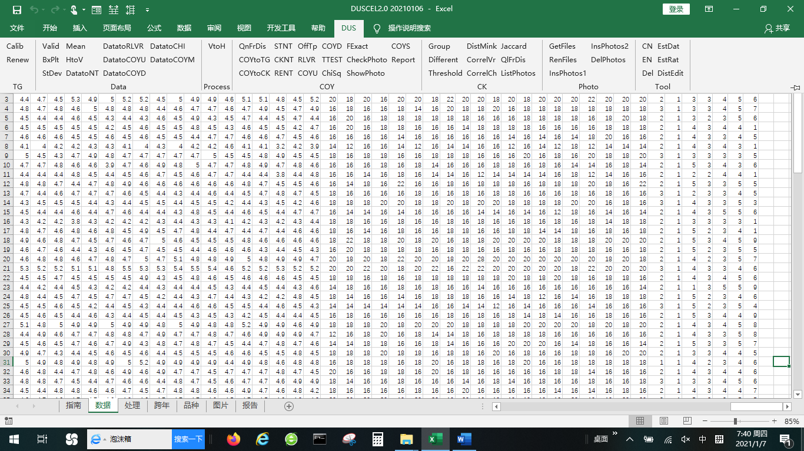
如上图所示，DUS测试数据分析系统包含7个固定格式表格，每个固定表格对应若干个分析方法，这些分析方法可以从DUS菜单下对应部分进行点击操作：
Data Analysis System of DUS Test is compound of 7 fixed sheets and corresponding analysis methods as shown in the figure above. The guidelines and correspondence analysis methods are as follows:
1）指南(TG)：存放与数据分析相关的指南性状、代码等参数。To store the parameters such as characteristics and Notes needed by data analysis. Make a separate TG sheet for each crop.
——Calib检查指南实测均值是否大于标准均值的10%，如果大于则红色显示to check whether the measured value of standard variety is greater than 10% of the standard value of standard varieties. If it is greater than 10%, it will be displayed in red.
——Renew用标准品种的标准均值和实测均值更新分级值及分级值索引to update grading value and grading value index with measured value and fixed value of standard varieties.
2）数据(Data)：按性状横排格式记录原始值。To record data on the horizontal arrangement format of characteristics.
——Valid检查横排数据是否符合指南中数据类型、最小值、最大值的设置，异常值红色显示。To check whether the horizontal data conforms to the data type, minimum value and maximum value settings in the TG, and the abnormal value is displayed in red.
——BxPlt柱线法检验异常值to test outliers by Boxplot method.
——StDev标准法检验异常值to test outliers by 3 times standard deviation.
——Mean取前后值得平均值代替异常值单元格to replace the outlier cell with the average of the values before and after.
——HtoV横排数据转竖排to transfer data from horizontal format to vertical format.
——DatatoNt将原始数据转成代码to transfer raw data to notes.
——DatatoRLVR将数据表中MS性状数据提取到跨年表中用于相对方差法、数量性状频率分布、最小显著差、t检验分析。to extract MS data from data sheet to the COY sheet for analysis of RLVR, QnFrDis, LSD, t test.
——DatatoCOYD将数据表中MS性状数据提取到跨年表中用于COYD分析to extract MS data to COY sheet for analysis of COYD.
——DatatoCOYU将数据表中MS性状数据提取到跨年表中用于COYU分析to extract MS data to COY sheet for analysis of COYU.
——DatatoCHI将数据表中VS性状数据提取到跨年表中用于卡方分析和费氏精确检验。to extract VS data to COY sheet for analysis of CHI test and FExact test.
——DatatoMean将数据表中各性状重复数据求平均提取到跨年表中。to calculate mean of replicate data of each characteristics to COY sheet.
——DatatoMerge将数据表中各性状重复数据求合并到一个单元格里提取到跨年表中。to merge replicate data of MS or VS characteristics into one cell.
3）处理(Process)：待测、品种、试验三列保持不变，MS性状原始值处理成平均值、标准差和样本数格式，VS性状原始值处理成众数、异型株数、总株数。to remain three columns of iscandidate, variety and trial. To calculate mean, Stdev, number of samples for MS characteristics and mode, number of offtypes, number of samples for VS characteristics.
——VtoH数据竖排转数据横排to transfer data from vertical format to horizontal format.
4）跨年(COY)：待测、品种列保持不变，其他数据按年份横排便于比较。to remain three columns of iscandidate and variety. Other data are displayed by trials.
——QnFrDis对MS性状原始数据进行频率分布分析。To analyze frequency distribution for original data of MS characteristics.
——QLFrDis对性状代码进行频率分布分析。To analyze frequency distribution for notes of each characteristics.
——COYtoTG提取标准品种实测值到指南。To copy trial mean value of standard varieties from COY sheet to TG sheet.
——COYtoCK 将跨年表中综合代码复制到品种表中。To copy notes from COY sheet to CK sheet.
——CKNT从品种表中代码复制到跨年表中的已知代码单元格。To copy notes from CK sheet to CK note cells of COY sheet.
——RENT依据平均值和已知代码计算回归代码。To calculate recessional notes by averages and CK notes in COY sheet.
——STNT依据指南表中分级值计算区间代码。To calculate grading notes by grading value of TG sheet.
——OffTp 用异型株法分析VS性状的一致性。To assess uniformity of VS characteristics by off-type method.
——RLVR用相对方差法分析MS性状的一致性。To assess uniformity of MS characteristics by relative variance method.
——COYU 用COYU方法评估MS性状的一致性。To assess uniformity of MS characteristics by COYU method.
——COYD用COYD方法评估MS性状的特异性（单试验等同于LSD分析）。To assess Distinctness of MS characteristics by COYD method (equal to LSD while one trial data).
——TTest 用t检验方法评估MS性状的特异性。To assess Distinctness of MS characteristics by t test method.
——ChiSq用皮尔逊卡方检验法评估VS性状的特异性（两种以上表达状态）。To assess Distinctness of VS characteristics by Person Chi Square method.
——FExact代码型数据的费舍尔精确检验（两种表达状态）。Fisher's exact test for note data (two expression states).
——ComPhotos打开窗体显示相应照片进行核查和比较。Extract corresponding photos in form for checking and comparing.
——ShowPhoto在单元格中直接显示相应照片进行核查和比较。Extract corresponding photo in cell for checking and comparing.
5）品种(CK)：待测和品种列保持不变，性状横排显示代码。Remain columns of iscandidate and variety. Note of each characteristics shows on horizontal arrangement.
——Group根据指南表中分组性状设置对品种进行分组排序。To group and sort the varieties according to the group characteristics setting in TG sheet.
——Different计算品种间有差异性状个数。To calculate the number of different characteristics among varieties.
——Threshold计算品种间大于阈值性状个数。To calculate the number of different characteristics with a distance greater than a threshold among varieties.
——DistMink计算品种间闵氏距离（通常用最小距离）。To calculate the Minkowski distance(Euclidean Distance as usually) among varieties.
——CorrelVr计算品种间相关系数。To calculate correlation coefficient among varieties.
——CorrelCh计算性状间相关系数。To calculate correlation coefficient among characteristics.
——Jaccard计算品种间杰卡德距离/系数。To calculate Jaccard distance/coefficient among varieties.
6）照片（photo）：进行照片查看、批量更名、对比操作的界面。Interface for photo viewing, batch renaming and comparison.
——GetFiles获取文件名称及路径。To get the file name and path.
——RenFiles批量修改文件或文件夹名称。To modify file names or folder names on batch.
——InsPhotos1将列表中照片加载到列1。To load photos according to the list into column 1.
——InsPhotos2将列表中照片加载到列2。To load photos according to the list into column 2.
——DelPhotos删除表中所有照片。To delete all photos in sheet.
7）工具（Tool）：与表格不相关的操作。Operations not related to sheets.
——CN中文界面。To show Chinese interface.
——EN英文界面。To show English interface.
——Del删除结果区和格式。To delete result area and color format.
——EstDat连续性数据最佳样本量估算。Estimation of optimum size of sample for continuous data.
——EstRat百分率数据最佳样本量估算。Estimation of optimum size of sample for percentage data.
——DistEdit红色显示与选中单元格内容相似的单元格，采用编辑距离计算。To display the cells similar to the selected cell in red by calculation of edit distance.

表格和分析方法关系图如下：
Relationship between Sheets and related analysis methods.
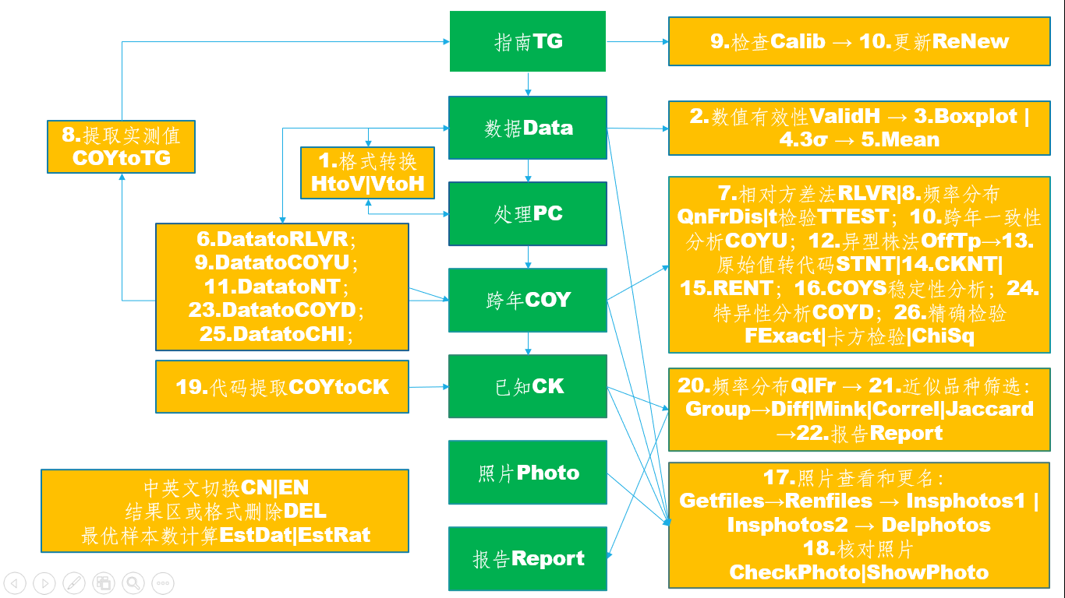

2. 指南设置Setting TG Parameters
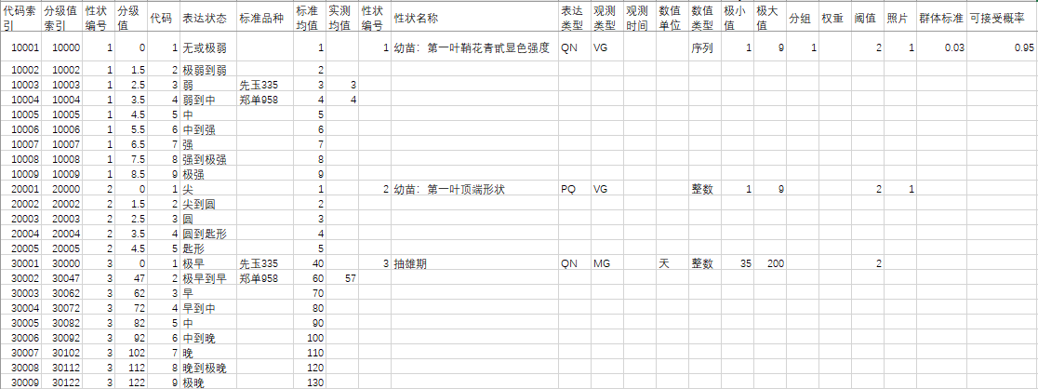
性状编号、代码、表达状态、标准品种、标准值、实测值、性状编号、性状名称、表达类型、观测类型、观测时间、数值单位、数值类型、极小值、极大值、分组、权重、阈值、照片、群体标准、可接受概率等参数均可根据DUS测试指南进行预设。具体含义和用途介绍如下：
Parameters such as character number, note, expression status, standard variety, standard value, measured value, character number, character name, expression type, observation type, observation time, numerical unit, numerical type, minimum value, maximum value, grouping, weight, threshold value and photo can be preset according to DUS test guidelines. The specific meanings and uses are as follows:
- 代码索引：为每行代码设置一个识别码，由“性状编号*10000+代码”组合而成，便于后面通过性状编号和代码提取对应信息。Note index: set an identification note for each line of note, which is composed of "character number * 10000 + note", so as to extract corresponding information through character number and note.
- 分级值索引：为每行代码设置的另一个识别码，由“性状编号*10000+分级值”组合而成，便于后面区间法将原始值转换成代码。Grading value index: another identification note set for each line of note, is composed of "character number * 10000 + grading value", which is convenient for later STNT method to convert the original value into note.
- 分级值：通过标准值和实测值自动生成，为每个表达状态的最小原始值，用于计算区间代码。Grading value: it is automatically generated by standard value and measured value, and is the minimum original value of each expression state, which is used to calculate ST note.
- 标准值：VG、VS性状标准值为代码本身，MG、MS性状标准值通过试验数据的LSD分析和频率分布分析确定，一般取整或保留一位有效位数。Standard value: the standard value of VG and VS characteristics is the note itself, and the standard value of MG and MS characteristics is determined by LSD analysis and frequency distribution analysis of original data, generally rounded or retained with one significant digit.
- 性状编号：性状的数值编号，必须为自然数或者有一位小数值。如1、2、20.1、20.2等。Character number: the numerical number of a character, which must be a natural number or a decimal value. Such as 1, 2, 20.1, 20.2, etc.
- 性状名称：性状的名称。Character name: the name of a character.
- 表达类型：QL表示质量性状，PQ表示假质量性状，QN表示数量性状。Expression type: QL for Qualitative Characteristics, PQ for Pseudo- qualitative Characteristics, QN for Quantitative Characteristics.
- 观测类型：VG群体观测、VS个体观测、MG群体测量、MS个体测量。Observation types: VG for group observation, VS for individual observation, MG for group measurement, MS for individual measurement.
- 观测时间：性状观测的最佳时间，一般用生育期代码表示。Observation time: the best time for character observation, generally expressed by growth period note.
- 数值单位：原始数据的测量单位，用cm、g等规范符号表示。Numerical unit: the unit of measurement of the original data, represented by standard symbols such as cm and G.
- 数值类型：整数、小数、序列、日期、时间、文本（比色卡和SNP数据属于此类）。Numerical type: integer, decimal, sequence, date, time, text(RHS color chart number and SNP data belong to text).
- 最小值、最大值：规范原始数值的取值范围，序列选项放在最小值里，用英文逗号隔开。Minimum value and maximum value: specify the value range of the original value, put the sequence options in the minimum value, and separate them with English commas.
- 分组：以自然数编号表示，优先分组的编号小，编号不能重复，不同于指南里的分组性状，这里用来分组的性状必须表达状态之间区分明显。Grouping: it is indicated by natural number. The number of priority grouping is small and can't be repeated. It's different from the grouping characteristics in the TG. The characteristics used for grouping here must be clearly distinguished between the expression states.
- 权重：某个性状表达的极差除以试验误差。Weight: the rate of range of expression divided by experimental error within a characteristics.
- 阈值：阈值法筛选近似品种时，某个性状能明显区分品种的代码差，一般用试验误差的整数。Threshold: when threshold method is used to select similar varieties, two varieties can be clearly distinguished by a node difference of a certain characteristics, and generally use the integer of test error.
- 照片：以数字编号表示，每个类型照片给一个特定编号，每个性状对应一个照片编号（如果没有对应照片则保留空值）。Photo: it is indicated by digital number. Each type of photo is given a specific number, and each character is corresponding to a photo number (if there is no corresponding photo, leave blank value).
- 群体标准：异型株法判定一致性时的参考值。Population standard: the reference value of uniformity determined by off-type method.
- 可接受概率：异型株法判定一致性的可接受概率。Acceptable probability: the acceptable probability of uniformity determined by off-type method.

3. 数据记载Recording Data

3.1 横排格式Horizontal Format
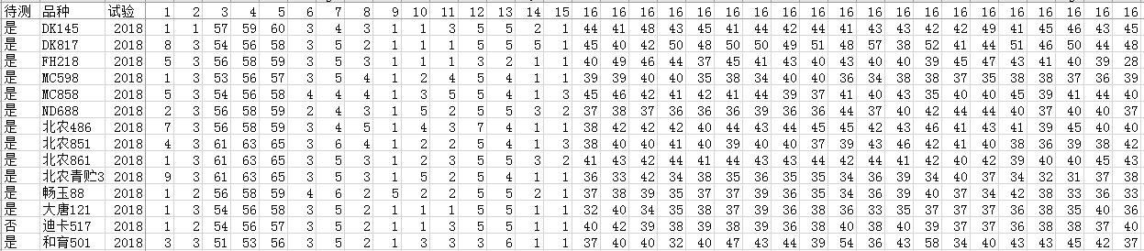
数据横排格式是比较理想的记载格式，主要字段有待测、品种、试验（可以是年份、地点、播期的任意组合）、性状。如果同一个性状有多个数据，则性状编号重复相应次数即可。Horizontal data format is an ideal record format, the main fields to be tested are including iscandidate, variety, trial (can be any combination of year, place, sowing season), characteristics. If there are more than one data for the same character, the character number can be repeated for the corresponding times.

3.2 竖排格式Vertical Format
也可以按竖排格式记载数据，竖排格式在设置数据有效性和利用条件格式筛选方面不如横排格式方便，但竖排格式与现有官方系统数据上传格式相符。竖排格式将性状向下排列。如下图显示：Data can also be recorded in vertical format. Vertical format is not as convenient as horizontal format in setting data validity and using conditional format screening, but vertical format is consistent with the existing official system data upload format. The vertical format arranges the characteristics downward. As shown in the figure below:
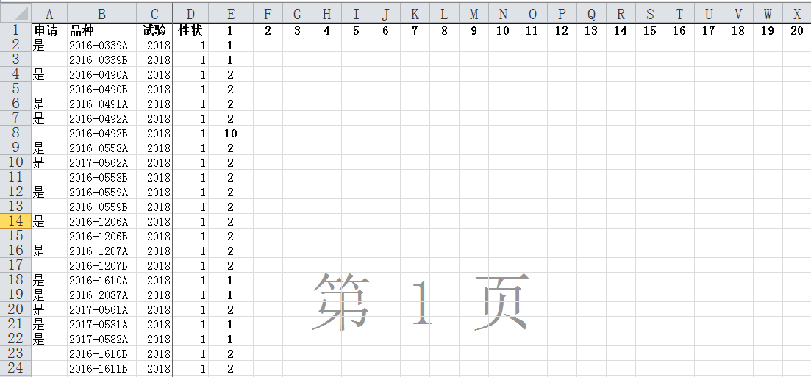

3.3 横排和竖排的转换Conversion between Horizontal and Vertical Format
数据表打开状态点击菜单栏命令HtoV可以将数据表中的横排数据转成处理表中的竖排数据；When the data sheet is open, click the menu bar command HtoV to convert the horizontal data in the data sheet into the vertical data in the processing sheet;
处理表打开状态点击菜单栏命令VtoH可以将处理表中的竖排数据转成数据表中的横排数据。注意：如果同一个品种在不同试验中的待测信息不一样，会导致多一行数据。When the processing sheet is open, click the menu bar command VtoH to convert the vertical data in the processing sheet into the horizontal data in the data sheet. Note: if field iscandidate have different description for same variety in different trial, it will lead to redundant record of data.

3.4 MS数据取平均Calculation of Mean from MS data
数据表打开状态点击菜单栏命令DatatoMean可以将数据表中的MS数据和VS数据分别计算平均值和众数。When the data sheet is open, click the menu bar command DatatoMean to calculate the average of MS data and mode of and VS data respectively.
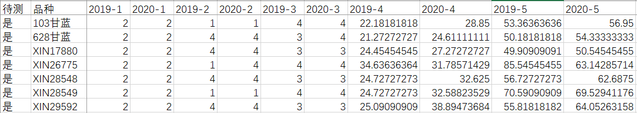

3.5 MS数据合并Merge MS Data to one cells
数据表打开状态点击菜单栏命令DatatoMerge可以将数据表中的MS数据和VS数据分别合并到一个单元格里，数据用逗号分开。When the data sheet is open, click the menu bar command DatatoMerge to merge the MS data and VS data into one cell, and separate the data with commas.
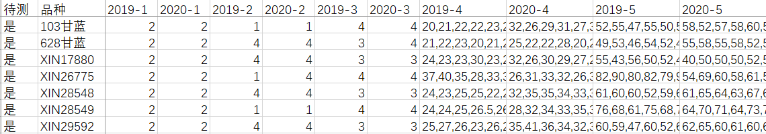

4. 照片管理Management of Photos

4.1 照片建档Archiving Photos
为优化照片处理和存储，方便分析调用，建议按如下方式建立照片文件夹，例如：D:\\DUS\玉米\2019\品种名称\照片编号.jpg。In order to optimize the photo processing and storage and facilitate the analysis and load, it is suggested to create a photo folder in the following way, for example: D:\ DUS\Corn\2019\variety name\photo number.jpg.
照片编号含义固定，对应植株或部位编号，由人工预设，并以该自然数进行编号，如玉米照片分为幼苗、植株、雄穗、花丝、果穗五个类型照片，分别以1、2、3、4、5进行编号，照片以这些编号进行命名，例如1.jpg，表示幼苗照片。The meaning of photo number is fixed, corresponding to the plant or part number, which is preset manually and numbered according to the natural number. For example, the photos of corn are divided into five types: seedling, plant, tassel, silk and ear, which are numbered by 1, 2, 3, 4 and 5 respectively. The photo is named by these numbers, for example, 1.jpg, which means seedling photo.
为方便调用，在指南表中的照片字段下预设每个性状对应的照片编号。For the convenience of downloading or showing, the photo number corresponding to each character is preset under the photo number field in the TG sheet.

4.2 获取照片或文件路径Get path of Photos or Files
在照片表打开时点击菜单命令GetFiles，会有路径提示，选中照片文件夹点击确认即可。ShowPhoto命令需要设置到试验（年份）文件夹下，ComPhotos和Report命令需要设置到作物文件夹下，照片批量更名、InsPhotos1和InsPhotos2命令需要设置到品种文件夹下。When the photo sheet is open, click getfiles. There will be a path prompt. Select the photo folder and click OK. The showphoto command needs to be set to the trial(year) folder, the ComPhotos and report commands need to be set to the crop folder, and the batch renaming of photos, InsPhotos1 and InsPhotos2commands need to be set to the variety folder.
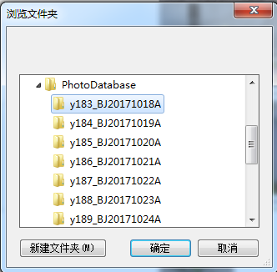

4.2 照片或文件批量改名Batch Renaming of Photos or Files
获取照片路径后显示下图表格，新名称可以为空，也可以人工重新命名，点击菜单命令RenPhotos后新名称得到保存。After obtaining the photo path, the sheet below will be displayed. The new name can be empty or manually renamed. Click RenPhotos to save the new name.
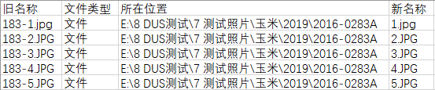

4.3 插入照片Inserting Photos
在照片表打开时点击菜单命令InsPhotos1或InsPhotos2，根据文件列表中的照片路径会自动提取照片显示在照片1和照片2列。When the photo sheet is open, click insphotos1 or insphotos2. According to the photo path in the file list, the photos will be automatically extracted and displayed in the photo 1 and photo 2 columns.
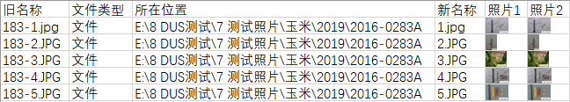

4.4 照片删除Deleting Photos
在任何表中点击菜单命令DelPhotos，表中所有照片将会被删除。Click DelPhotos in any sheet, and all photos in the sheet will be deleted.

5. 异常值检验Outlier Test

5.1 数据有效性检验Validation of Data
在数据表打开时点击菜单命令Valid，程序将根据指南表中数据类型、最小值、最大值进行检验，异常数值以红色显示。When the data sheet is open, click Valid, the program will check according to the data type, minimum value and maximum value setting in the TG sheet, and the abnormal value will be displayed in red.
例如，指南中前三个性状的数据类型、最小值和最大值规定如下：For example, the data types, minimum and maximum values of the first three characteristics in the guidelines are as follows：
点击Valid命令后，数据表显示如下结果：After clicking the valid command, the data sheet displays the following results:
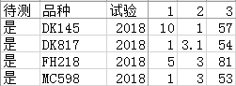→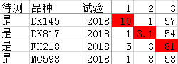

5.2 箱线图法检验Boxplot Test
MS性状可以采用箱线图法检验异常值，在数据表打开时点击菜单命令BxPlt后显示如下结果： the abnormal values of MS characteristics can be tested by boxplot diagram method. When the data sheet is open, click BxPlt, then the following results will be displayed:
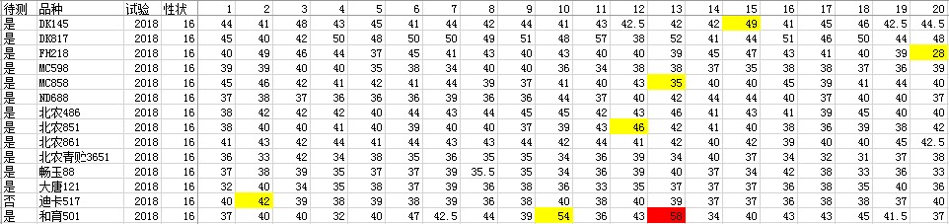
黄色显示1.5倍内距的异常值，红色显示3倍内距的异常值。箱线图法的特点是极端值不参与计算。The abnormal value of 1.5 times inner distance is shown in yellow, and the abnormal value of 3 times inner distance is shown in red. The distinguishing feature of boxplot method is that the extreme value does not participate in the calculation.

5.3 3σ法检验 3σ Test
MS性状也可以采用3σ法检验异常值，在数据表打开时点击菜单命令STDEV（即3σ）后显示如下结果：3 σ method can also be used to test the abnormal values of MS characteristics. When the data sheet is open, click StDev (i.e. 3 σ) to display the following results:
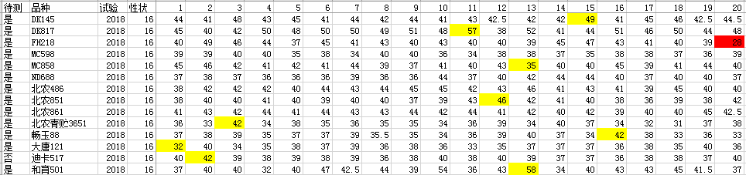
黄色表示1.5倍标准差外的异常值，红色表示3倍标准差外的异常值，3σ法特点是极端值参与计算。Yellow represents the abnormal value beyond 1.5 times of standard deviation, red represents the abnormal value beyond 3 times of standard deviation, and the distinguishing feature of 3 σ method is that the extreme value participates in the calculation.

5.4 异常值的处理Handling of Outliers
- 检查原始记录，确定是否为输入错误造成，如果是输入错误造成，直接修改电子记录。有些输入错误很明显，可以直接判定，如数字重复（88，正确为8），小数点打成0（4105，正确为41.5），漏小数点（105，正确为10.5），键盘同列错行（15，正确为45），两个数打一起（320335，正确为320, 335）等。Check the original record to determine whether it is caused by an input error. If it is caused by an input error, modify the electronic record directly. Some input errors are obvious and can be judged directly, such as repeated numbers (88, correct for 8), decimal point 0 (4105, correct for 41.5), missing decimal point (105, correct for 10.5), keyboard wrong line in the same column (15, correct for 45), two numbers together (320335, correct for 320, 335), etc.
- 如果不存在输入错误，分析是否是记载错误造成，如样品还在，可以进行复测，如样品已销毁，可以根据田间调查人员回忆或者综合历史记录判定是否可能是真实值。如果不是真实值，删除并补充数据，如果是真实值，确认是否是异型株导致，如果品种存在一致性问题，保留数据并做一致性分析，如果属于极不典型植株，删除数值并根据条件补充或修正。If there is no input error, analyze whether it is caused by record error. If the sample is still there, retest it. If the sample has been destroyed, judge whether it is possible to be the true value according to the recall of field investigators or comprehensive historical records. If it is not the true value, delete and supplement the data. If it is the true value, confirm whether it is caused by alien plants. If there is consistency problem in varieties, retain the data and do consistency analysis. If it is a very atypical plant, delete the value and supplement or correct according to the conditions.
- 数据的补充可以补测样品，或者采用统计方法恢复，虽然有些专业方法可以修正数据，如极大似然法估计，但实践中最有效的补正是取前后值得平均。在数据表打开时点击菜单命令Mean，可以自动取前后值平均，如果第一列值需要修正，取其后两个值平均，如果最后一列值需要修正，取其前两个值平均。数据一旦做了修改，必须在原始记录中进行圈注并记录下修改后的数据。Although some professional methods can correct the data, such as maximum likelihood estimation, the most effective correction in practice is to average the values before and after. When the data sheet is open, click mean to automatically average the values before and after. If the value of the first column needs to be corrected, average the next two values. If the value of the last column needs to be corrected, average the previous two values. Once the data is modified, it must be circled in the original record and the modified data must be recorded.
- 数据异常值多也可能是地力不均、栽培管理不一致、边际植株被测量等原因造成，必要时需要进一步优化试验设计和取样方式。Many outliers of data may also be caused by uneven soil fertility, inconsistent cultivation management, marginal plants being measured and other reasons. If so, it is necessary to optimize the experimental design and sampling methods for further step.

6. 一致性分析 Analysis of Uniformity

6.1 异型株法Off-type
适用于整个小区观测或者质量、假质量性状一致性分析。如果有VS性状，在数据表打开时点击DatatoNT基础上，再在跨年表打开时点击OffTp，会在VS性状的代码列显示U或NU。在空白表中，点击会显示提示：“请按此格式输入一致性原始数据，横排可以并列多个性状，结论列标题必须以U开头”，在此格式下输入数据，再次点击OFFTP即可计算结果： It is used for the whole plot observation or the analysis uniformity of qualitative or Pseudo-qualitative characteristics. If there are VS characteristics, click DatatoNT when the data sheet is open，then click OffTp when COY sheet is open, U or NU will be displayed in the note column of VS characterisitics. In a blank sheet, click OffTp to get a prompt: "please input the original data for uniformity in this format, more than one characteristics can be displayed in the horizontal row, and the title of the conclusion column must start with u". Enter the data in this format, and click OffTp again to calculate the result:
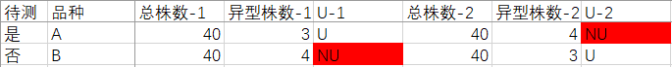

7.2 相对方差法Relative Variance
适用于MS数量性状一年数据分析。在DatatoRLVR分析的基础上，在跨年表打开时点击RLVR，显示如下结果，结果区在数据区的右边，结果区第一列统计每个品种不一致的数量性状个数，后面可以看到哪个性状不一致：It is suitable for one year data analysis of MS quantitative characteristics. On the basis of DatatoRLVR analysis, when the COY sheet is open, click RLVR to display the following results. The result area is on the right side of the data area. The first column of the result area counts the number of non-uniform quantitative characteristics of each variety. You can see which character is non-uniform.
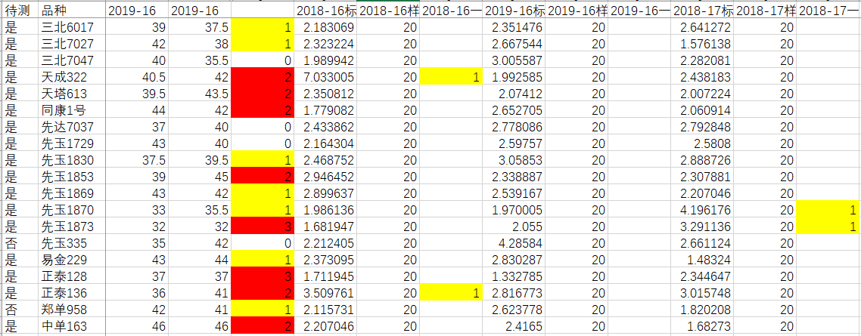

6.3 数量性状跨年一致性分析COYU
适用于MS数量性状两年以上数据分析。在数据表打开时点击DatatoCOYU就可以直接得到COYU分析格式，每个性状平均值按年份先列出，标准差在后列出。It is suitable for data analysis of MS quantitative characteristics for more than two trials. When the data sheet is open, click DatatoCOYU to get the COYU analysis format directly. The average value of each character is listed first by year, and the standard deviation is listed later.
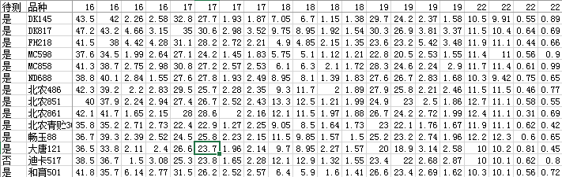
在跨年表打开时点击COYU，显示分析结果如下：When the COY sheet is open, click COYU to display the analysis results as follows:
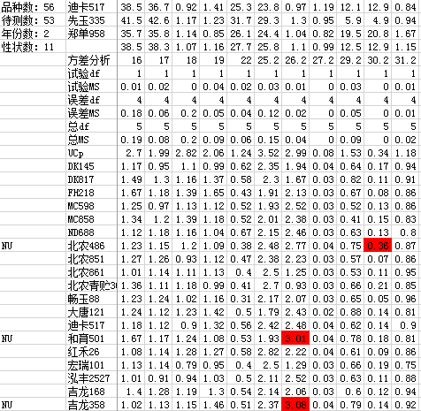
每个品种汇总的结果在结果区最左侧显示，具体U值超出阈值的红色显示，只要有一个性状不一致，总结果就是不一致。The summary results of each variety are displayed on the left side of the result area, and the specific U value exceeding the threshold is displayed in red. As long as one character is non-uniform, the summary result is non-uniform.

7. 原始值转代码 Converting Original data to note

7.1 标准值形成Formation of Standard Value
指南中标准值需要提前设好，对于VG和VS性状，标准值就代码本身。对于MG和MS性状，需要通过LSD和频率分布分析获得。The standard value in the TG needs to be set in advance. For VG and vs characteristics, the standard value is the note itself. For Mg and MS characteristics, LSD and frequency distribution analysis were needed.
在数据表打开时点击菜单命令DatatoRLVR生成MS性状的原始数据集。When the data sheet is open, click DatatoRLVR to generate the original data set of MS characteristics.
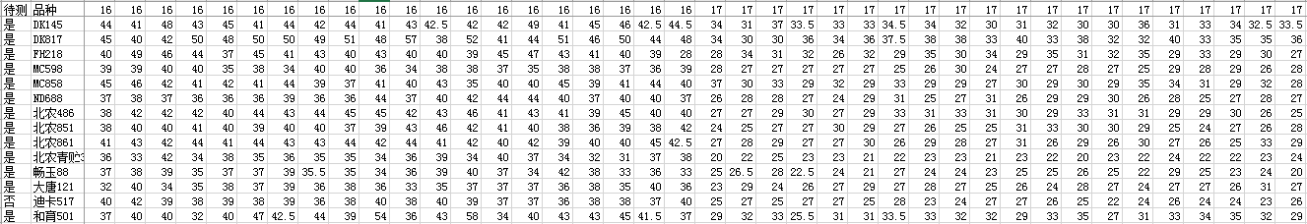
也可以点击菜单命令DatatoCOYD生成所有MG和MS性状的年度平均值集。You can also click DatatoCOYD to generate the annual average set of all MG and MS characteristics.
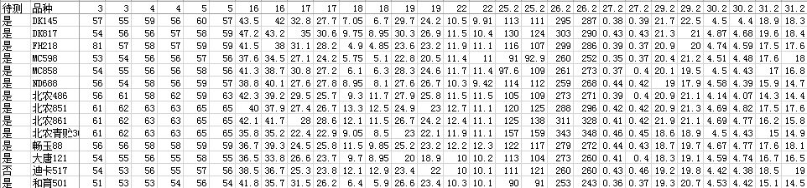
在跨年表打开时点击菜单命令QnFrDis批量获得频率分布分析结果如下：When the COY sheet is open, click QnFrDis to obtain the frequency distribution analysis results in batches as follows:
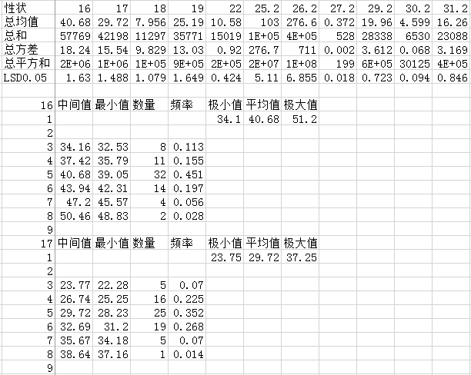
针对每个MS或MG性状，分别以所有品种的所有原始数据的平均值为代码5的中间值，以2倍LSD_{0.05}为级差，设定各级的中间值，相邻级中间值的平均值为下级的最大值和上级的最小值； 确定每级中间值和最小值后统计各个分级区间的品种数和百分比。根据统计结果做如下判定：品种覆盖级数小于3的性状不适宜用于品种描述，最好予以剔除；品种覆盖级数大于9的性状，调增LSD_{0.05}的倍数，并参考各级区间百分比是否均匀来调整分级，使得分级范围处于9级以内；处于3和9级之间的性状，可以在两端留出1-2级给将来出现的新品种。如果最小分级的最小值可能为零（如芒数量可能为0），则将最小分级区间的最小值设置为0，再按照前面确定的倍数的LSD_{0.05}从小到大进行分级以重新确定标准值。根据中间值挑选合适的标准品种，记录在指南表中的标准品种列相应单元格，本系统不支持同一个代码多个标准品种的存在。确定好标准品种后，标准值可以适当取整，以后保持不变。如下表所示：For each MS or Mg trait, take the average value of all original data of all varieties as the middle value of note 5, take 2 times lsd0.05 as the level difference, set the middle value of each level, and the average value of the middle value of adjacent levels as the maximum value of the lower level and the minimum value of the upper level; after determining the middle value and minimum value of each level, count the number and percentage of varieties in each grading interval. According to the statistical results, the following judgments are made: the characteristics with the variety coverage level less than 3 are not suitable for variety description, and it is better to eliminate them; for the characteristics with the variety coverage level greater than 9, the multiple of LSD 0.05 should be increased, and the grading range should be adjusted according to whether the interval percentage at all levels is uniform, so that the grading range is within 9; for the characteristics between 3 and 9, 1-2、8-9 grades can be reserved at both ends for the future New varieties appeared. If the minimum value of the minimum grading may be zero (for example, the number of awns could be 0), set the minimum value of the minimum grading interval to 0, and then grade from small to large according to the lsd0.05 of the multiple determined previously to re determine the standard value. Select the appropriate standard varieties according to the intermediate value, and record them in the corresponding cells of the standard varieties column in the TG sheet. This system does not support the existence of multiple standard varieties with the same note. After the standard variety is determined, the standard value can be rounded appropriately and remain unchanged in the future. As shown in the table below:
标准均值一旦形成，轻易不要改变，其他地点可以适当调整标准品种，但最好不要改变标准均值。Once the standard mean value is formed, it is better not to change. Other places can adjust the standard varieties appropriately, but it is better not to change the standard mean value.

7.2 计算代码Calculating note
在数据打开时点击菜单命令DatatoNT生成代码的跨年格式，如下图所示：When the data sheet is open, click DatatoNT to generate the cross year format of the note, as shown in the figure below:
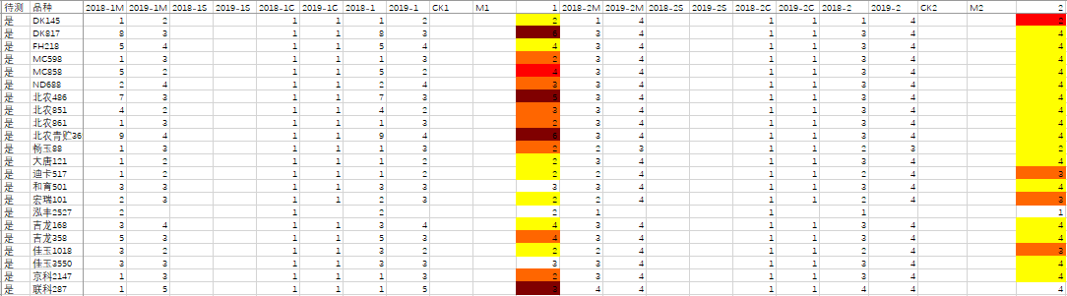

7.3 计算区间代码Calculating Grading Note
在数据转跨年的过程中，区间代码根据指南中默认分级值索引得到计算，但如果觉得年度间变化较大，可以根据标准品种的实测均值进行调整分级区间，步骤如下：In the process of transferring data to COY, the grading note is calculated according to the index of default grading value in the TG. However, if there is a big change between years, the grading interval can be adjusted according to the measured mean value of standard varieties. The steps are as follows:
——在跨年表打开时点击菜单命令COYtoTG，将标准品种的实测均值的年度平均值提取到指南表相应位置。When COY sheet is open, click COYtoTG to extract the average value of the measured average value of standard varieties to the corresponding position in the TG sheet.
——在指南表打开时点击菜单命令Calib，将会对实测均值与标准均值的差与标准均值的比值大于10%的实测均值标红。When TG sheet is open, click Calib to mark the measured mean in red if the ratio of the difference between the measured mean and the standard mean value divided by the standard mean is greater than 10%.
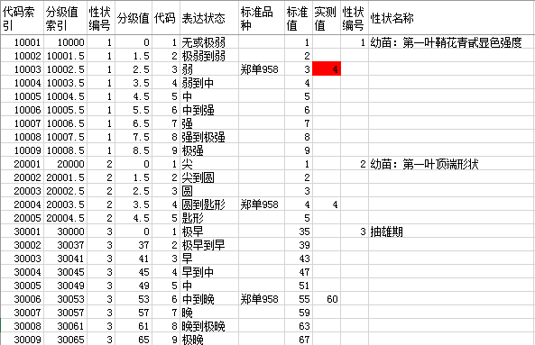
——如果觉得标红的实测均值不可用，可以删掉该值，点击Renew命令，分级值就会自动更新。If you feel that the measured mean value marked red is not available, you can delete the value and click the renew command, and the grading value will be automatically updated.
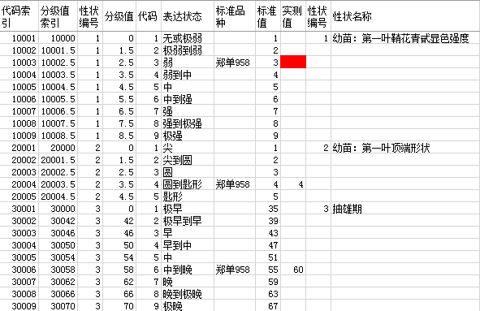

7.4 计算区间代码、已知代码、回归代码Calculation of Grading Note, CK Note and Regression Note
在跨年表打开时点击菜单命令STNT，则区间代码得到更新，两次试验一起分析，则以数量性状平均值进行分级。When the COY sheet is open, click STNT, the grading note will be updated, and the two experiments will be analyzed together, and the average value of quantitative characteristics will be used for grading.
继续点击CKNT，可以将品种表中的相应代码复制到跨年表中。Continue to click CKNT to copy the corresponding note in the variety sheet to the COY sheet.
继续点击RENT，则根据平均值和已知代码计算回归代码。Continue to click RENT to calculate the regression note according to the average and the CK note.
上述计算后，代码值结果会根据不同代码间差异大小显示特定颜色，例如，差1个代码显示黄色，差2个代码显示橙色，差3个代码显示红色，差4个代码显示紫色等。After the above calculation, the final note will display a specific color according to the difference between different notes. For example, one note difference will display in yellow, two notes difference in orange, three notes difference in red, four notes difference in purple, etc.
在显色提示下，人工检查原始数据，或调取照片确认，将鼠标放在需要调照片的代码上，点击ShowPhoto获得对应品种性状的标准照片，并展示在该代码同行空白位置处。（需要在照片表中第二行第三列单元格预设好照片所在文件夹地址）by the help of different color, you can check the original data, or call the photo for confirmation, put the mouse on the note which needs to be adjusted, click showphoto to get the standard photo of the corresponding variety character, and display it in the blank position of the same line of the note. (you need to preset the photo folder address in the second row and third column of the photo sheet).
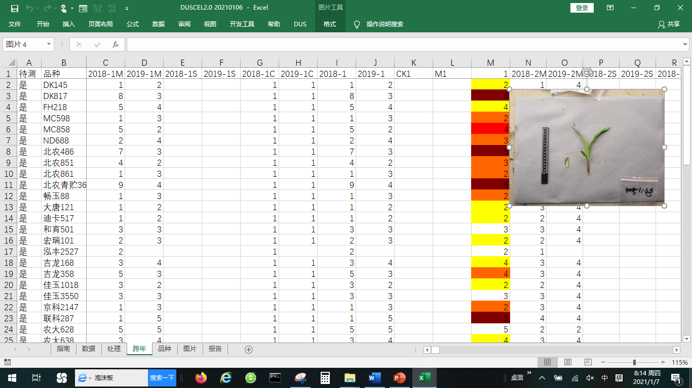
也可以点击ComPhotos，出现一个照片对比框，可以修改地址或选取不同品种、不同部位照片进行对比。You can also click Check photo and a photo comparison box will appear. You can modify the address or select photos of different varieties and parts for comparison.
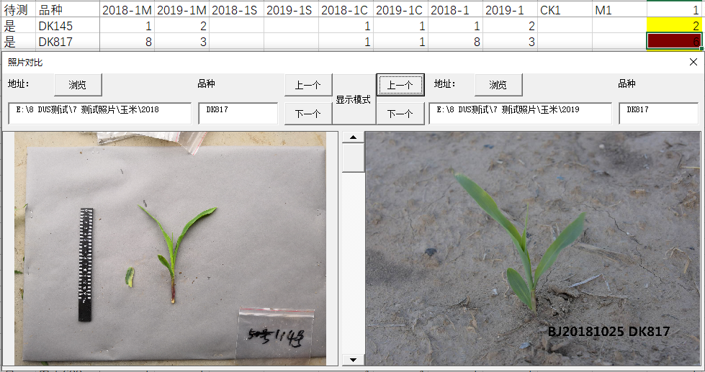
通过上述检查，可以人工修改代码。Through the above check, the note can be modified manually.

8. 稳定性分析Analysis of Stability

8.1 跨年相关性分析Correlation Coefficient Analysis of COY Data
在DatatoNT分析的基础上，在跨年表打开时点击COYS，会产生品种和性状年度间相关性分析。在DatatoNT分析的基础上，在跨年表打开时点击COYS，会产生品种和性状年度间相关性分析。On the basis of DatatoNT analysis, when the COY sheet is open, click COYS, and correlation analysis of varieties and characteristics will be produced below data area.
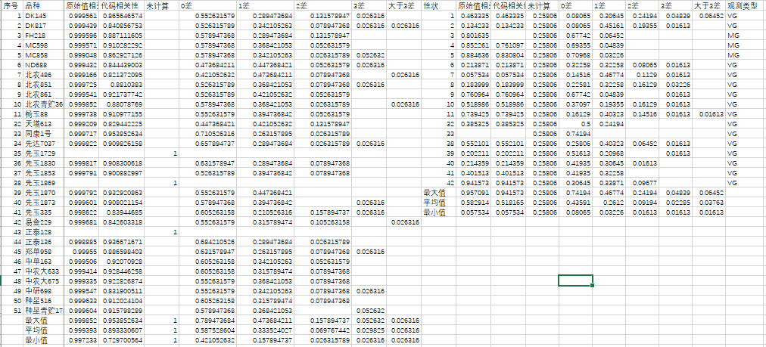
根据此结果结合繁殖材料是否是同一份种子可以判断试验间品种的稳定性是否合适，如果存在问题，需要进一步分析哪份样品或那个试验的数据是合适的，必要时需要人工确认品种的最终代码。According to this result, combined with whether the samples of material are same, we can judge whether the stability of variety among trials is existing. If there is a problem, we need to further analyze which sample or trial is appropriate. If necessary, we need to manually confirm the final note of varieties.

8.2 跨年转品种Copy Final Note from COY to CK
在跨年表打开时点击菜单命令COYtoCK，跨年表中的最终代码会自动覆盖品种表中相应代码，新增的品种或者性状会在行列的最后添加。When the COY sheet is open, click COYtoCK, the final note in the COY sheet will automatically cover the corresponding note in the variety（CK） sheet. The new varieties or new characteristics will be added after the last row or column.
在品种表中，鼠标放在某个性状列上，程序自动按代码按大小排序，并通过批量提取该性状对应的每个品种的照片，放在下一列对应位置，按顺序查看照片，人工确认是否有代码给错的情况。最终保证拟出具报告的代码和照片一致。In the variety(CK) sheet, put the mouse on a certain character column, and the program will automatically sort by note, and extract the photos of each variety corresponding to the character in batch, put them in the corresponding position of the next column, view the photos in order, and manually confirm whether there is a wrong note. Finally, ensure that the note of the report to be issued is consistent with the photo.
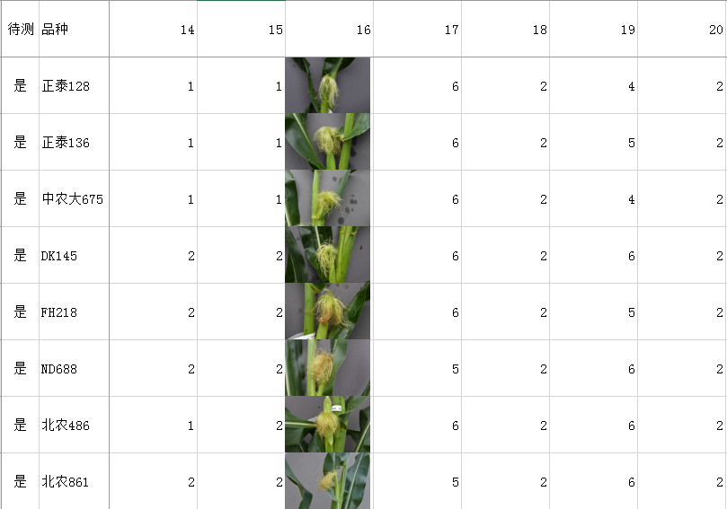

9. 特异性分析Analysis of Distinctness

9.1 近似品种筛选Selection of Similar Varieties
近似品种筛选是特异性测试的关键第一步，在品种表中，提供了一系列分析方法。Similar variety selection is the key first step of examination of distinctness. In the variety sheet, a series of analysis methods are provided.
点击Group，可以先利用指南表中的分组性状设置将品种进行排序。这里的分组性状不同真实指南中的分组性状，只选用那些表达状态区分明显的质量或者假质量性状作为分组性状，在指南表分组字段下用序号设置分组性状的排序优先顺序。Click group to sort the varieties by using the grouping character settings in the TG sheet. The grouping characteristics here are different from the grouping characteristics in the real guidelines. Only those quality or false quality characteristics with obvious expression state differentiation are selected as grouping characteristics. Under the grouping field of the TG sheet, the priority of grouping characteristics is set by serial number.
按分组顺序排好后，可以任意选择一种方法进行近似品种筛选分析，各种方法特点如下：According to the grouping order, any method can be selected to screen and analyze the approximate varieties
——Different差异法：当数据中包含比色卡类型数据时，只能选择该方法，计算品种间有差异性状个数，0差异红色显示，1-2个差异黄色显示。When the data contains the RHS color chart type data, only this method can be selected to calculate the number of different characteristics among varieties, 0 difference is shown in red, 1-2 difference is shown in yellow.
——Threshold阈值法：如果指南中设置了每个性状的阈值，可以采用此方法分析，统计有差异性状个数，0差异红色显示，1-2个差异用黄色显示。一般质量性状阈值设置为0，假质量性状设置为1，数量性状设置为2。If the threshold value of each characteristics is set in the TG, this method can be used to analyze and count the number of different characteristics. 0 difference is shown in red and 1-2 differences are shown in yellow. The threshold value of general quality characteristics is set to 0, false quality characteristics is set to 1, and quantitative characteristics is set to 2.
——DistMink闵氏距离法：计算品种间闵氏距离（1为绝对距离，2为最小距离），最小距离设置的阈值是7，小于7红色显示。The Minkowski distance between varieties is calculated (1 absolute distance, 2 minimum distance). The threshold value of the minimum distance is 7. If it is less than 7, it will be displayed in red.
——CorrelVr相关系数法：计算品种间相关系数，相关系数大于95%红色显示，小于95%大于90%黄色显示。The correlation coefficient between varieties was calculated. The correlation coefficient greater than 95% was shown in red, less than 95% and more than 90% in yellow.
——Jaccard杰卡德距离法：计算品种间杰卡德距离/系数，这个方法适合0和1表示的数据，如分子数据。This method is suitable for the data represented by 0 and 1, such as molecular data.
以相关系数为例展示一下结果区：Take the correlation coefficient as an example to show the result area
数据区下面显示计算结果：The calculation results are shown below the data area
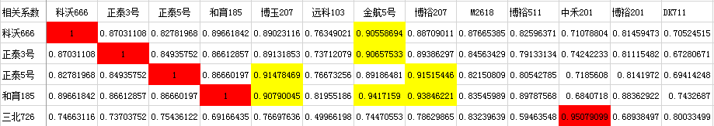
数据区后边显示筛选出来的近似品种：The silimar varieties are displayed on the right side of the data area
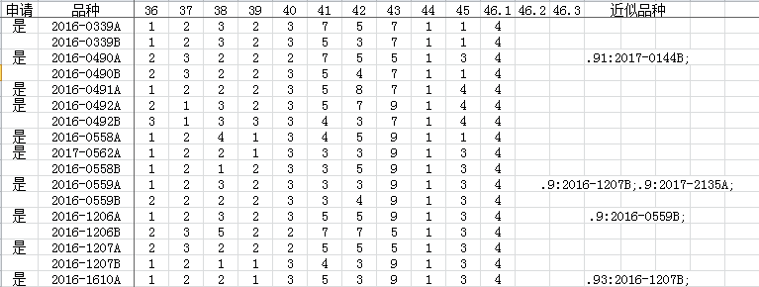

9.2 生成特异性报告Reporting Result of Distinctness
在跨年或者品种表打开时，选取品种矩阵表中相似度较大或距离较小的单元格，点击Report，程序会自动调取该单元格对应的上侧品种和左侧品种的历年数据平均值并列展现，MS性状提供t检验结果，并将极显著数据颜色标示，其他性状提供差值显示，MG性状差值除以平均值大于0.1的颜色标示，VG和VS性状按代码差异用不用颜色标示。不同试验的照片也将对比显示。（注意照片表中第二行第三列值保留到年份或试验上一级，如：E:\DUS\玉米）When the COY or CK sheet is open, select the cell with larger similarity or smaller distance in the variety matrix table, and click Report. The program will automatically retrieve the average data of the upper variety and the left variety corresponding to the cell, and display them side by side. For MS characteristics, t-test results are provided, and the most significant data are color marked. For other characteristics, the difference is displayed, and the difference of MG characteristics is divided by When the average value is more than 0.1, VG and VS characteristics are marked with or without color according to note difference. Photos of different trial will also be displayed together for comparison. (note that the values in the second row and the third column of the photo sheet are reserved for the year or the level above the test, such as E:\dus\corn)
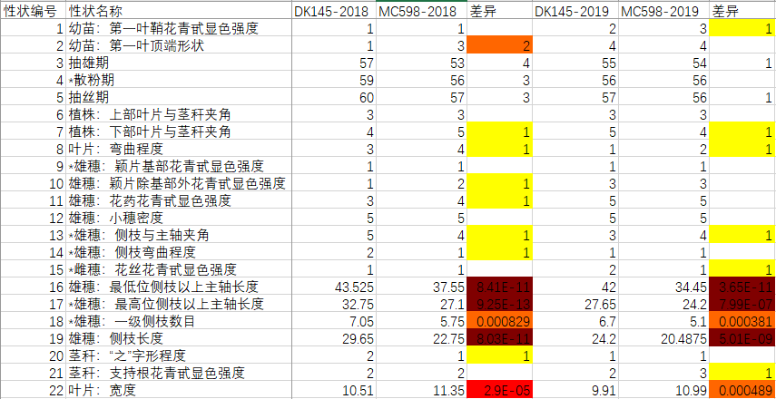
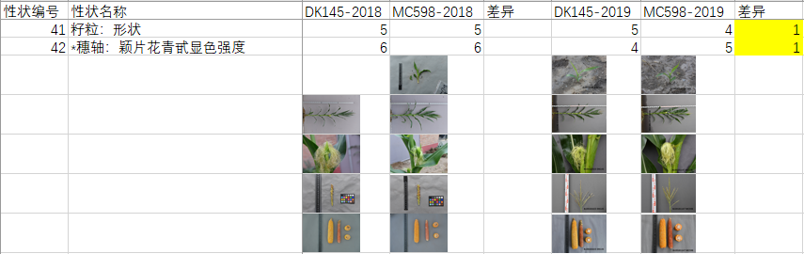

9.3 数量性状跨年特异性分析COYD
在数据表打开时点DatatoRLVR或DatatoCOYD，再在跨年表中点击TTEST或COYD，即可批量开展t检验或者COYD分析。结果以差异显著的性状个数为显示结果。0红色显示，1个橙色显示，2个红色显示。When the data sheet is open, click datatorlvr or datatocoyd, and then click ttest or coyd in the COY sheet to carry out t-test or coyd analysis in batches. Results the number of characteristics with significant difference was the result. 0 red, 1 orange and 2 red.
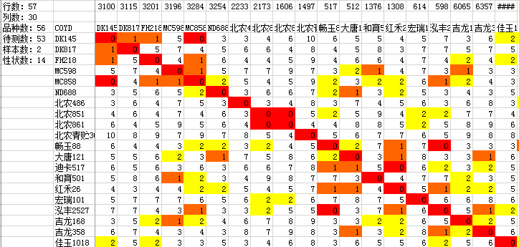

9.4 质量性状特异性分析Analysis of Distinctness for VS Characterisitcs
在数据表打开时点击菜单命令DatatoChi，生成VS质量性状的代码统计格式。When the data sheet is open, click DatatoChi to generate the note statistical format of quality characteristics.
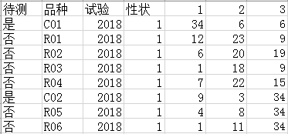
在跨年表打开时点击菜单命令ChiSq开始皮尔逊卡方分析，该方法针对VS性状数据进行统计分析，结果显示如下：When the COY sheet is open, click ChiSq to start Pearson chi square analysis. This method carries out statistical analysis on the vs characteristics data, and the results are as follows:
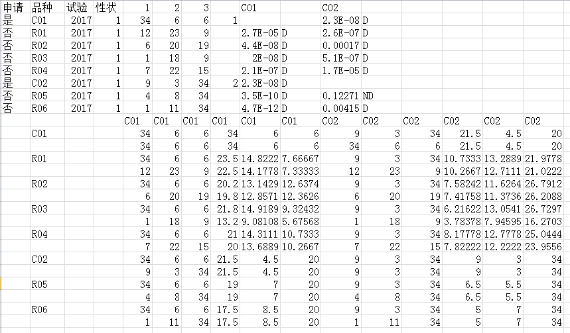
点击FExact开始费舍尔精确检验分析，该分析只针对二值型分布进行分析，参与计算的只有代码1和2，结果如下：Click FExact to start Fisher's exact test analysis, which only analyzes the binary distribution, and only notes 1 and 2 participate in the calculation:
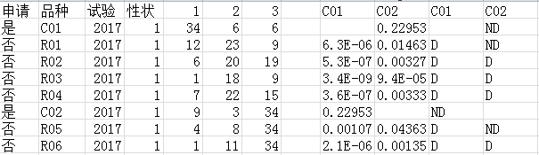

10. 试验设计和性状优化Trial design and Characteristics optimization

10.1 性状相关性分析Correlation coefficient analysis of characteristics
在品种表打开时点击CorrelCh可以分析性状之间的相关性，显示分析结果如下，相关系数大于95%以上的，制定指南时可以考虑取消其中一个性状：When the CK sheet is open, click CorrelCh to analyze the correlation coefficient between the characteristics. The analysis results are as follows. If the correlation coefficient is more than 95%, one of the characteristics can be considered to be cancelled when revising the guidelines
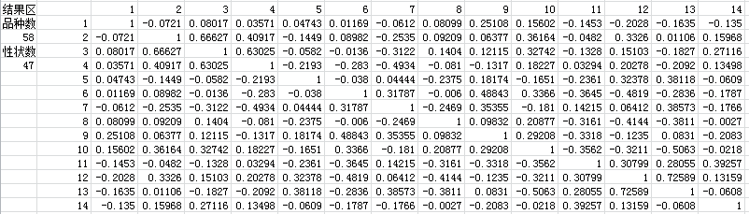

10.2 遗传多样性指数分析Genetic diversity index analysis
在品种表打开时点击QLFrDis，可以分析每个代码的品种频率分布和遗传多样性指标，结果如下：When the CK sheet is open, click QLFrDis to analyze the variety frequency and genetic diversity index of each note.
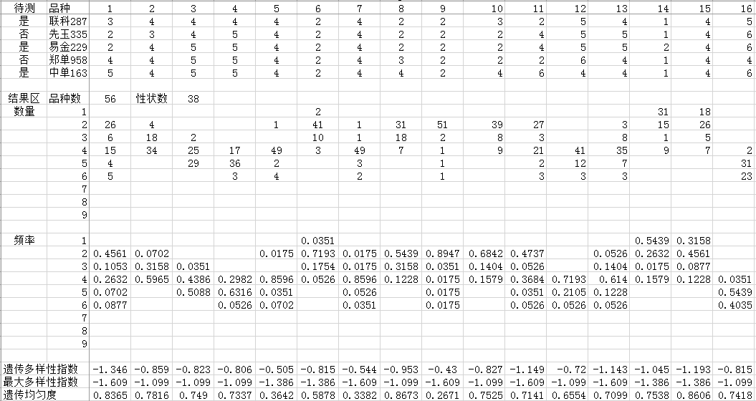
遗传均匀度是遗传多样性指数除以最大理论遗传多样性指数得出的数值，从表中可以看出，性状9遗传均匀度为0.2671，偏低，说明该性状上大部分品种表达状态相同。Genetic evenness is the value obtained by dividing the genetic diversity index by the maximum theoretical genetic diversity index. It can be seen from the table that the genetic evenness of character 9 is 0.2671, very low, indicating that the expression status of most varieties is the same in this characteristics.

10.3 最优样本数计算Calculation of optimal sample size
点击EstDat和EstRat可以分别打开连续型数据样本和百分数样本最优样本数计算界面：Click EstDat and EstRat to open the optimal sample number calculation interface for continuous data samples and percentage samples respectively:
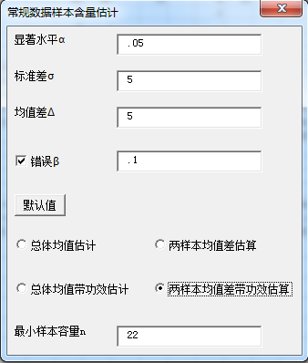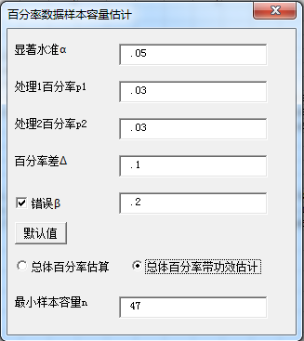
每个界面都分带功效和不带功效两种情况，对应DUS测试，不带功效的总体均值估计就是单试验品种描述最佳取样数估算，不带功效的两样本均值差估算就是单试验特异性判定最佳取样数估算，总体百分率估算就是单试验一致性判定最佳取样数估算，带功效是两年或多年情况的估算。Each interface is divided into two cases, with and without efficacy. Corresponding to DUS test, the estimation of population mean without efficacy is the estimation of the optimal sampling number for variety description by single trial, the estimation of two sample mean difference without efficacy is the estimation of the optimal sampling number for assessment of distinctness by single trial, and the estimation of population percentage is the estimation of the best sampling number for assessment of uniformity by single trial. Estimate with efficacy need data for more than one trial.

11．编辑距离Edit Distance
编辑距离主要用于文本型数据相似度分析，特别是品种命名审查时可以使用。在任何一列文本型数据中，选中待比较单元格，点击DistEdit，待比较单元格显示红色，相似单元格显示黄色，设定的阈值为2。 Edit distance is mainly used for text data similarity analysis, especially for variety denomination review. In any column of text data, select the cell to be compared, and click DistEdit. The cell to be compared will display red, and the similar cell will display yellow. The threshold value is 2.
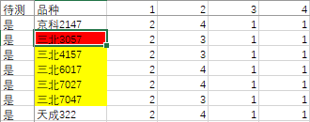
（文末）

[End of Annex and of document]

