E
International Union for the Protection of New Varieties of Plants

Technical Working Party for Vegetables  Fifty-Fifth Session  Antalya, Turkey, May 3 to 7, 2021  Technical Working Party for Ornamental Plants and Forest Trees  Fifty-Third Session  Roelofarendsveen, Netherlands, June 7 to 11, 2021  Technical Working Party for Agricultural Crops  Fiftieth Session  Arusha, United Republic of Tanzania, June 21 to 25, 2021  Technical Working Party for Fruit Crops  Fifty-Second Session  Zhengzhou, China, July 12 to 16, 2021  Technical Working Party on Automation and Computer Programs  Thirty-Ninth Session  Alexandria, United States of America, September 20 to 22, 2021 | TWP/5/12  Original: English  Date: February 26, 2021
Increasing participation in the work of the TC and TWPs
Document prepared by the Office of the Union
Disclaimer: this document does not represent UPOV policies or guidance

Executive summary

The purpose of this document is to report on developments concerning measures to increase participation in the work of the Technical Working Parties (TWPs) and Technical Committee (TC), including the use of meetings via electronic means

The TWPs are invited to:

- note the information on participation via electronic means at the TWPs and TC in 2020;

- note the measures to improve virtual meetings held in the future, as set out in paragraphs 15 to 21 of this document;

- consider the possible measures for physical and virtual participation at TWP meetings, as set out in paragraph 26 of this document.

The structure of this document is as follows:

Executive summary 1
Background 2
Participation at the TC and TWP meetings by electronic means 3
Issues identified in the survey of participants at the TWPs and BMT in 2020 4
Schedule of sessions (time zones): 4
Preparatory work prior to the meetings: 5
Online meeting platform: 5
Proposals to encourage participation in TWPS AND TC IN the future 5

Annex TWPs 2020 Evaluation survey

The following abbreviations are used in this document:

TC: Technical Committee
TWA: Technical Working Party for Agricultural Crops
TWC: Technical Working Party on Automation and Computer Programs
TWF: Technical Working Party for Fruit Crops
TWO: Technical Working Party for Ornamental Plants and Forest Trees
TWPs: Technical Working Parties
TWV: Technical Working Party for Vegetables

Background

The TC, at its fifty-sixth session, considered document TC/56/12 “Increasing the participation of members of the Union in the work of the TC and TWPs” (see document TC/56/23 “Report”, paragraphs 64 to 69).

The TC noted the outcome of organizing the 2020 sessions of the TWPs via electronic means, including the information provided by the Office of the Union on the TWC and BMT meetings held in September 2020.

The TC agreed that virtual meetings had shortcomings in relation to physical meetings, such as the difficulty to engage active participation and lack of possibility to have bilateral meetings.

The TC noted the increased number of participants at virtual meetings and agreed to explore integrating the benefits of this type of meetings into physical meetings.

The TC, at its fifty-sixth session, agreed to invite the TWPs to consider the following possible measures for physical and virtual participation at TWP meetings:

  - To organize Test Guidelines subgroup discussions by electronic means prior to the TWPs instead of during the TWPs. The conclusions from the subgroups would be reported to the TWP session in the same way as the current procedure.

  - To organize virtual preparatory workshops prior to the TWPs. Those preparatory workshops to be recorded and be made available on the UPOV website.

  - To offer the possibility to provide comments and questions on documents in advance of the meeting.

  - To organize electronic participation during the TWPs, using one of the following options, according to host facilities:

    - The host to provide the platform for virtual participants (with integrated audio/video on site), in addition to onsite participation in the meeting.

    - The UPOV Office to provide the platform for virtual participants. All participants (present on site or remotely) would be invited to join to the platform using their personal equipment.

  - To have virtual meeting sessions for part of the day (e.g. 2 sessions of 2 hours per day) with sessions for onsite participants for the following:

    - visits to DUS trials or related facilities;

    - pre-organized bilateral discussions/ meetings on cooperation;

    - sessions to facilitate discussion or exchange of knowledge for DUS examination.

Participation at the TC and TWP meetings by electronic means

As a part of the measures taken in response to the COVID 19 pandemic, it was agreed by the Chairpersons of the TWPs, after consultation with the TWP hosts and the TC Chairperson, to hold the TWP sessions in 2020 by electronic means.

In order to assess the impact of the organizing TWP sessions by electronic means, the level of participation and participant satisfaction was monitored.

The results on the level of participation were as follows:

Table: Total number of participants (members of the Union + observers) in TWPs (2015-2020)
 | TWV | TWO | TWA | TWF | TWC | BMT
2015 | 62 | 63 | 56 | 44 | 18 | no BMT in 2015
2016 | 45 | 53 | 68 | 49 | 34 | 107
2017 | 58 | 30 | 54 | 36 | 31 | 49
2018 | 46 | no TWO in 2018 | 64 | 40 | 28 | 55
2019 | 58 | 28 | 42 | 60 | 44 | 65
Average 2015-2019 | 54 | 44 | 57 | 46 | 31 | 69
2020 | 81 | 59 | 96 | 101 | 44 | 119
Change (%) | +50% | +34% | +68% | +120% | +41% | +72%
Figure: Number of TWP participants 2015-2020
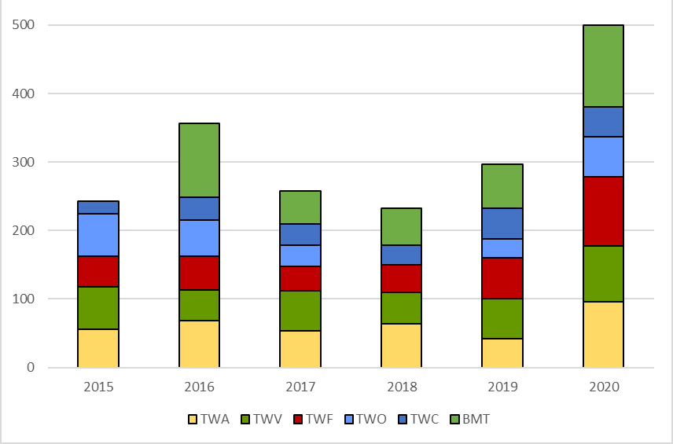

Table: Number of UPOV members participating in TWPs (2015-2020)
 | TWV | TWO | TWA | TWF | TWC | BMT
2015 | 20 | 16 | 17 | 16 | 7 | no BMT in 2015
2016 | 15 | 14 | 19 | 23 | 5 | 12
2017 | 18 | 14 | 28 | 19 | 9 | 19
2018 | 15 | no TWO in 2018 | 23 | 18 | 15 | 18
2019 | 15 | 12 | 20 | 19 | 16 | 18
Average 2015-2019 | 17 | 14 | 21 | 19 | 10 | 16
2020 | 27 | 20 | 28 | 26 | 19 | 26
Change (%) | +59% | +43% | +33% | +37% | +90% | +62%

To assess the level of satisfaction of participants at the virtual meetings, the Office of the Union conducted surveys of participants after each TWP session. The following chart illustrates the overall satisfaction of the participants that replied to the survey. Overall, 91% of participants replied that they were satisfied or very satisfied. The full set of responses from the TWA, TWF, TWO and TWV is reproduced in the Annex to this document.

Figure: General satisfaction of TWP participants in virtual meetings (2020)
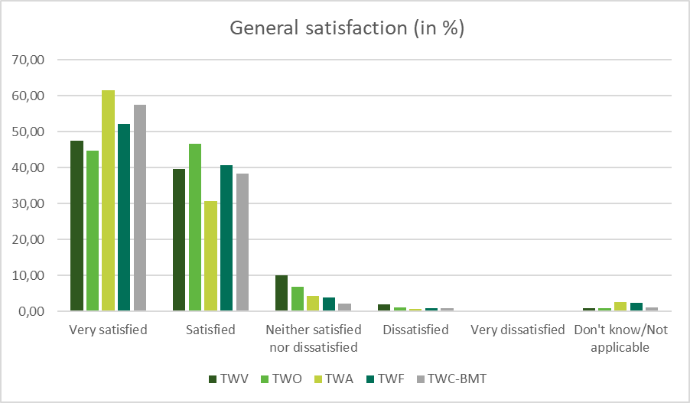

The following table summarizes certain aspects of virtual and in-person meetings, according to experiences in 2020:

Aspect | Virtual | In person
Participation | Significantly increased | Largely static
Efficiency, task focussed | High | Medium
Discussion | Restricted (compensated by prior consultations) | Open
Opportunity for interactions outside the meeting time | Reduced | Easy, unrestricted
Field trips | No (virtual only) | Yes
Time scheduling | Difficult time differences | Jetlag but no issues at the meeting itself
Mastering the technology | Can be challenging | Less applicable

Issues identified in the survey of participants at the TWPs and BMT in 2020

The survey of participants at the TWPs and BMT provided feedback on the organization of TWP sessions in 2020 by electronic means. Possible points of improvement were identified and addressed at TWPs held later in 2020 or will be addressed in 2021, in the case of meetings organized by electronic means. The possible points of improvement in relation to online meetings identified in the survey are summarized below, along with corresponding information and/or initiatives to address those points.

Schedule of sessions (time zones):

The time zone of registered participants to the TWPs and BMT in 2020 ranged from UTC-6 (e.g. MX, US) to UTC+13 (e.g. NZ). It was therefore not possible to schedule the meetings at a suitable time for all participants.

As far as possible, sessions will be scheduled according to best accommodate the time zone of registered participants, particularly in the case of Test Guidelines subgroup meetings.

Preparatory work prior to the meetings:

Participants at the TWPs and BMT were invited to submit comments on documents in advance of the session. The timely posting of documents and presentations in advance of the session was reported as a limiting factor for providing comments.

In 2021, documents will be posted earlier (six weeks prior to session) and experts making presentations at the TWPs will be requested to make presentations available sufficiently in advance of the session. The deadline for providing comments in advance of the sessions will be set for two weeks prior to the session. The compilation of comments received will be circulated at least one week before the meetings. An overview of the steps prior to the meeting will be provided in meeting invitations and accompanying information.

Online meeting platform:

Participants at the TWPs and BMT reported the following main difficulties using the online meeting platform Cisco WebEx:

- changing the name displayed: Information will be provided in the “users guide”, during the training sessions and before meetings start. Participants at virtual meetings may be requested to identify themselves when taking the floor.
- requesting the floor (using the “raise hand” and “chat” functions): mobile phones and tablets may not display the “raise hand” function. The “chat” function will not be monitored for providing contributions to discussions but participants may use this function to request the floor. This information will be added to the “users guide” and explained to participants at training sessions and before meetings.
- registering for different testing- and daily-sessions: each WebEx session will last for the duration of discussions in one day. Participants will receive separate links via email for each day. A separate email will be sent to each registered participant with relevant instructions.

In 2021, the UPOV Office will conduct testing sessions prior to any meetings via virtual means to enable participants to test equipment and become familiar with functions in the online meeting platform.

The TWPs are invited to note:

- the information on participation via electronic means at the TWPs and TC in 2020; and

- measures to improve virtual meetings held in the future, as set out in paragraphs 14 to 20 of this document.

Proposals to encourage participation in TWPS AND TC IN the future

A positive aspect of the virtual TWP sessions was the significant increase in the number of participants (increase ranging from 34-120%) and number of participating members of the Union (increase ranging from 33-59%), compared to previous years (see paragraph 12 of this document).

Although the surveys revealed a high level of overall satisfaction with the virtual meetings (see paragraph 13 of this document) under the given circumstances, participants identified disadvantages in not having a physical meeting. The surveys identified the following limitations for virtual meetings (full set of responses is reproduced in the Annex to this document):

- limited opportunities for in-depth discussions;
- reduced opportunities for bilateral/ small group discussions at the fringes of the session;
- reduced opportunities to network and meet other crop experts in DUS examination.

The TWF, at its fifty-first session, agreed to propose that meetings via electronic means could be considered for advancing discussions on Test Guidelines during the period between TWPs sessions (see document TWF/51/10 “Report”, paragraph 27).

In accordance with the request of the TC, at its fifty-sixth session, the TWPs are invited to consider the following possible measures for physical and virtual participation at TWP meetings:

  - To organize Test Guidelines subgroup discussions by electronic means prior to the TWPs instead of during the TWPs. The conclusions from the subgroups would be reported to the TWP session in the same way as the current procedure.

  - To organize virtual preparatory workshops prior to the TWPs. Those preparatory workshops to be recorded and be made available on the UPOV website.

  - To offer the possibility to provide comments and questions on documents in advance of the meeting.

  - To organize electronic participation during the TWPs, using one of the following options, according to host facilities:

    - The host to provide the platform for virtual participants (with integrated audio/video on site), in addition to onsite participation in the meeting.

    - The UPOV Office to provide the platform for virtual participants. All participants (present on site or remotely) would be invited to join to the platform using their personal equipment.

  - To have virtual meeting sessions for part of the day (e.g. 2 sessions of 2 hours per day) with sessions for onsite participants for the following:

    - visits to DUS trials or related facilities;

    - pre-organized bilateral discussions/ meetings on cooperation;

    - sessions to facilitate discussion or exchange of knowledge for DUS examination.

The TWPs are invited to consider the possible measures for physical and virtual participation at TWP meetings, as set out in paragraph 25 of this document.

[Annex follows]

EVALUATION SURVEY - COMPARISON REPORT ON TWPs (2020)

The following questions were asked via an online survey to the registered participants of each TWPs:

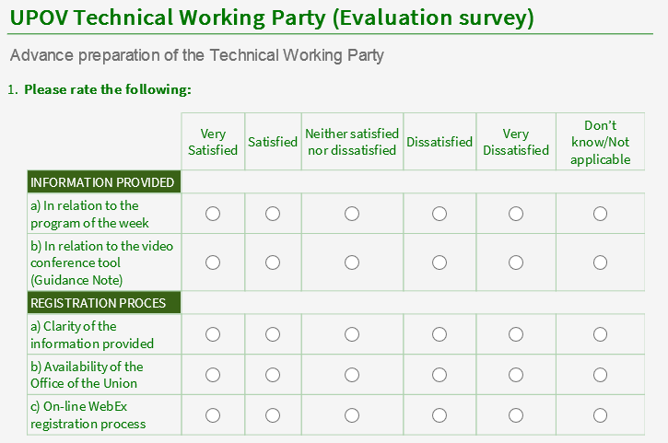
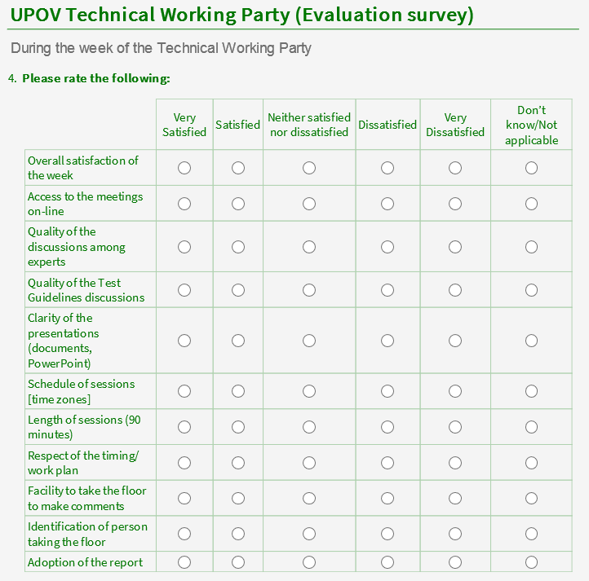

GENERAL LEVEL OF SATISFACTION

INDIVIDUAL QUESTIONS

COMMENTS

TWV:
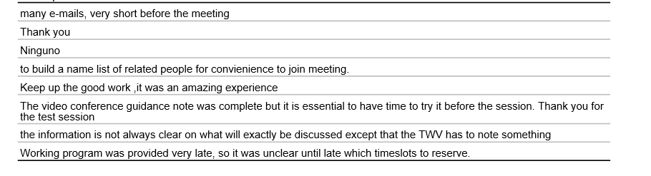
TWO:
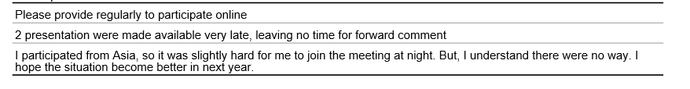
TWA:
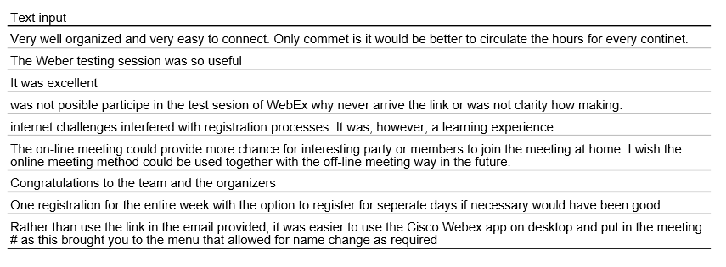
TWF:
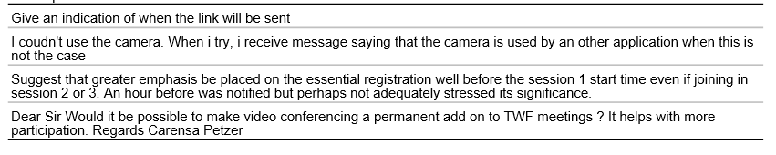
TWC-BMT:
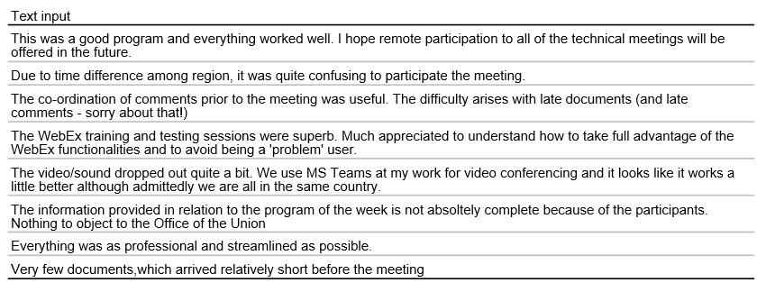

COMMENTS

TWV:
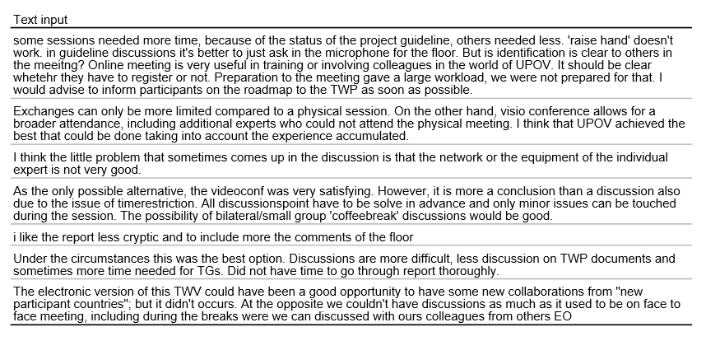

TWO:
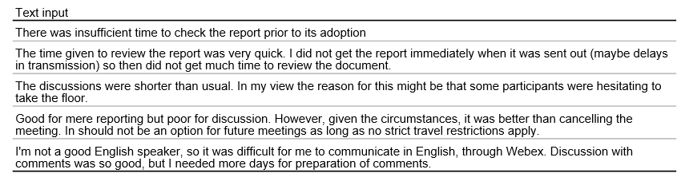

TWA:
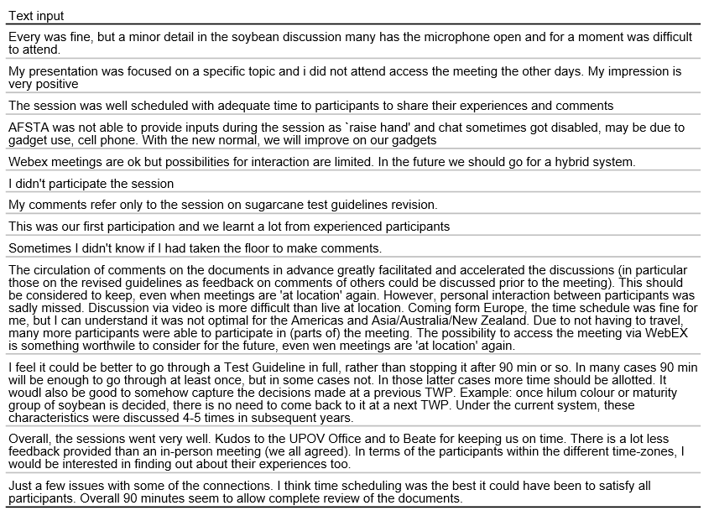

TWF:
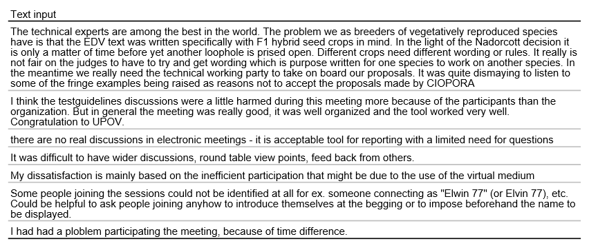

TWC-BMT:
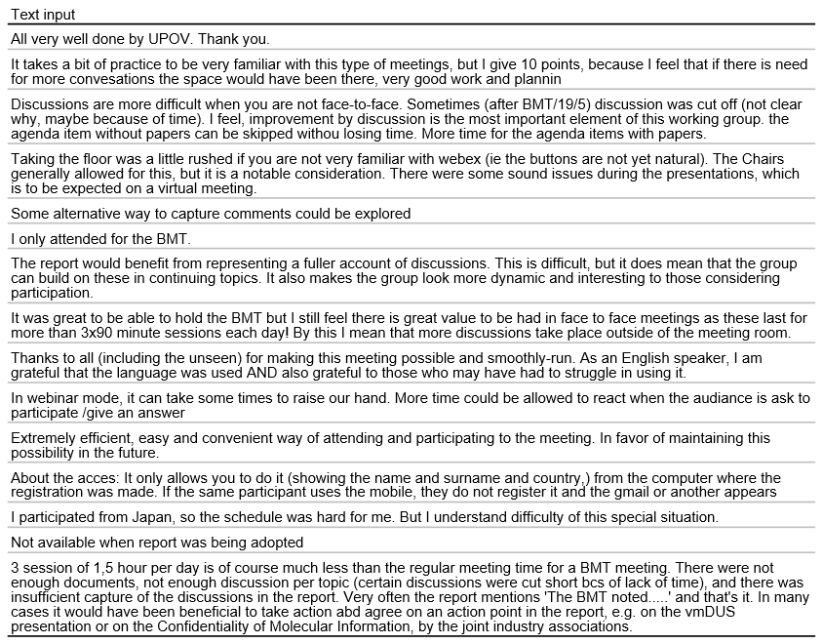

TEHNICAL PROBLEMS:

Participants were invited to report on any technical problems, ex. internet issues or audio issues.

TWF:
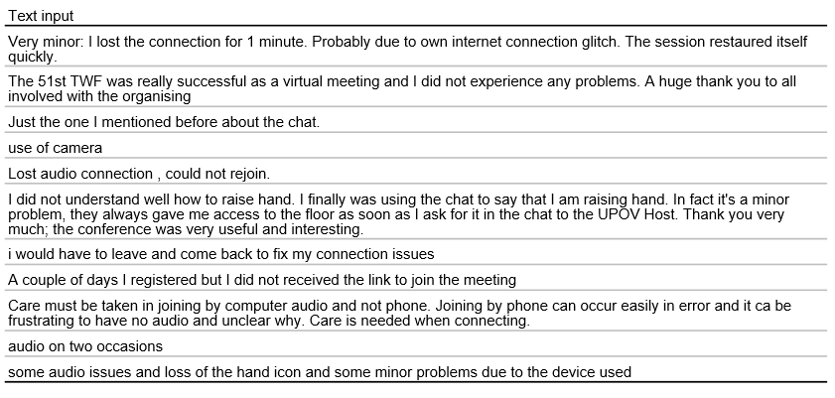

[End of Annex and of document]

Held via electronic means on October 26 and 27, 2020

