E
International Union for the Protection of New Varieties of Plants

Technical Working Party for Vegetables  Fifty-Fourth Session  Brasilia, Brazil, May 11 to 15, 2020  Technical Working Party for Ornamental Plants and Forest Trees  Fifty-Second Session  Roelofarendsveen, Netherlands, June 8 to 12, 2020  Technical Working Party for Agricultural Crops  Forty-Ninth Session  Saskatoon, Canada, June 22 to 26, 2020  Technical Working Party for Fruit Crops  Fifty-First Session  Nîmes, France, July 6 to 10, 2020  Technical Working Party on Automation and Computer Programs  Thirty-Eighth Session  Alexandria, United States of America, September 21 to 23, 2020 | TWP/4/8  Original: English  Date: April 14, 2020
Guidance for drafters of Test Guidelines
Document prepared by the Office of the Union
Disclaimer: this document does not represent UPOV policies or guidance

EXECUTIVE Summary

The purpose of this document is to provide guidance for drafters of Test Guidelines and to report developments on the web-based Test Guidelines template (web-based TG template).

The TWPs are invited to note:

(a) developments on the web-based TG template, reported in paragraphs 15 to 23 of this document;

(b) that the Office of the Union will issue a circular to identify requirements of UPOV members for the development of individual authorities’ test guidelines using the web-based TG template; and

(c) that training on the web-based TG template via electronic means can be organized upon experts’ request.

The following abbreviations are used in this document:

TC: Technical Committee
TC-EDC: Enlarged Editorial Committee
TG: Test Guidelines
TWA: Technical Working Party for Agricultural Crops
TWC: Technical Working Party on Automation and Computer Programs
TWF: Technical Working Party for Fruit Crops
TWO: Technical Working Party for Ornamental Plants and Forest Trees
TWPs: Technical Working Parties
TWV: Technical Working Party for Vegetables

The structure of this document is as follows:
EXECUTIVE Summary 1
Background 2
Developments in 2019 2
Comments by the Technical Working Parties 2
Comments by the Technical Committee 3
latest developments 3
Issues implemented 3
Issues being addressed 3
Database of adopted characteristics 3
Export files generated by the web-based TG template 3
Other issues identified 3
Individual authorities’ test guidelines 4
Background 4
Survey 4
Training 4
Guidance for users of the web-based TG template 5

ANNEX I Features of the Web-based TG Template
ANNEX II Latest developments on the web-based TG template

Background

Developments prior to 2019 are provided in document TWP/3/8 “Guidance for drafters of Test Guidelines”.

Developments in 2019

Comments by the Technical Working Parties

At their sessions in 2019, the TWPs considered document TWP/3/8 Guidance for drafters of Test Guidelines (see documents TWO/51/12 “Report”, paragraphs 70 to 74; TWV/53/14 Rev. “Revised Report”, paragraphs 73 to 78; TWF/50/13 “Report”, paragraphs 51 to 55; TWA/48/9 “Report”, paragraphs 45 to 49; and TWC/37/12 “Report”, paragraphs 67 to 72).

The TWPs noted the issues on the web-based TG template addressed during 2018, as set out in document TWP/3/8, paragraph 11.

The TWPs noted the issues currently being addressed on the web-based TG template, as set out in document TWP/3/8, paragraph 12.

The TWPs noted that the Office of the Union would issue a circular to identify requirements of UPOV members for the development of individual authorities’ test guidelines using the web-based TG template.

The TWPs received a demonstration by the Office of the Union and noted that training on the web-based TG template would be provided to all TWPs, at their sessions in 2019.

The TWV agreed that the comments provided by the Office of the Union on the draft Test Guidelines should be provided by using the web-based TG Template.

The TWF thanked the Office of the Union for the development of this efficient tool and welcomed regular presentations at Technical Working Parties, as an introduction to new participants and as an opportunity for experienced users to clarify matters of concern.

The TWC noted that the different elements displayed in the web-based TG template provided links to the respective “Guidance Notes” or “Additional Standard Wording” in document TGP/7. The TWC agreed to propose that links to standard wording from other TGP documents could also be accessible from the web-based TG template.

Comments by the Technical Committee

The TC, at its fifty-fifth session, noted the proposal by the TWC, at its thirty-seventh session, to indicate relevant guidance in TGP documents that could have links displayed in Test Guidelines, and agreed to invite the TWPs, at their sessions in 2020, to propose links that might be indicated (see document TC/55/25 “Report”, paragraphs 173 and 174). Developments on this topic are provided in document TWP/4/1 “TGP documents”.

latest developments

Issues implemented

Following the revision of document TGP/7 “Development of Test Guidelines”, new standard wording added to Chapter 3.1 “Number of Growing Cycles” to explain that “The testing of a variety may be concluded when the competent authority can determine with certainty the outcome of the test.” The new standard wording was added to draft Test Guidelines using the web-based TG Template (see document TGP/7/7 “Development of Test Guidelines”, Annex 1 “TG Structure and Universal Standard Wording”). Annex II to this document provides an extract from document TGP/7 Chapter 3.1.

Issues being addressed

Interface

The Office of the Union continues to address minor bugs and regressions due to deployment of improvements in the template. Continuous efforts are made to further stabilize the web-based TG Template.

The following issues on the web-based TG template are currently being addressed:

- restrict access to interested experts during the leading expert drafting and checking periods (no links to HTML or word previews for interested experts during those periods);
- provide comments by the Office of the Union on draft Test Guidelines using the web-based TG Template;
- possibility to generate a report on the list of example varieties used in a Test Guidelines (see Annex II to this document)
- import of tables (e.g. growth stages) and illustrations;
- automatic completion of abbreviated scales to full scale of notes for QN characteristics
- implementation of a workflow for each Test Guidelines in the administrators interface
- addition of the wording of Guidance Note 3 “Subject of the Test Guidelines: More than one species” to Chapter 1 “Subject of these Test Guidelines” in the web-based TG Template (see Annex II to this document)

The issues above will be implemented, subject to availability of resources.

Database of adopted characteristics

It is planned to make searches on the database of adopted characteristics publicly available on the TG Drafters webpage.

Export files generated by the web-based TG template

The Office of the Union is exploring options to improve the export files generated by the web-based TG template (Test Guidelines), in particular to address the export of tables (e.g. growth stages) and illustrations, including the possibility to display large tables in landscape format.

Other issues identified

The following issues on the web-based TG template have been identified and will be addressed, subject to availability of resources:

- addition of hyperlinks in exported documents to symbols indicating that a characteristic has explanations covering individual and/or several characteristics (facilitating electronic navigation in the document);
- creation of an interface for the translation of non-standard text in UPOV languages.

Individual authorities’ test guidelines

Background

Version 1 of the web-based TG Template has been designed for the development of Test Guidelines for UPOV. However, it has also been designed such that Version 2 will enable members of the Union to use:

(a) adopted UPOV Test Guidelines as a basis for the development of individual authorities’ test guidelines;

(b) the web-based TG Template and database of characteristics to develop individual authorities’ test guidelines for which there are no UPOV Test Guidelines; and

(c) use individual authorities’ test guidelines, developed using the web-based TG Template, as the basis for draft UPOV Test Guidelines.

Version 2 will have a feature for individual authorities to modify the template wording, within the same structure, to act as a template for their own test guidelines and a feature to allow individual authorities to convert UPOV Test Guidelines into individual authorities’ test guidelines, with necessary modifications.

Survey

A circular to identify requirements of UPOV members for the development of individual authorities’ test guidelines using the web-based TG template was scheduled to be issued in 2019. Due to ongoing efforts to stabilize the system and lack of resources, it was not possible to issue the survey in 2019. The survey is scheduled to be issued in 2020.

Subject to the availability of resources, development of the new functionalities would start in 2021.

Training

The TC, at its fifty-third session, agreed that training on the use of the web-based TG template should be offered to the TWPs during the preparatory workshops of the session and/or during the discussions on the agenda item “guidance for drafters’ of Test Guidelines”. The TC agreed that training should also include FAQs and tutorials for users of the web-based TG template (see document TC/53/31 “Report”, paragraph 239).

Live demonstrations of the web-based TG Template were provided to all TWPs, at their sessions in 2018 and 2019, under agenda item “Guidance for drafters’ of Test Guidelines”.

The Office of the Union has provided assistance to individual experts on ad hoc basis via e-mail and telephone.

Individual support to users of the web-based TG Template will be maintained by e-mail and telephone. Bilateral trainings via electronic means on the use of the web-based TG Template could also be organized upon experts’ request.

Users are invited to provide feedback or questions directly via the web-based TG Template by clicking on the link “Feedback”:

Guidance for users of the web-based TG template

Tutorials for the following user roles are available on the web-based TG Template under the link “Tutorials”:

- Leading Expert drafting tutorial
- Interested Expert comments tutorial
- Leading Expert checking tutorial

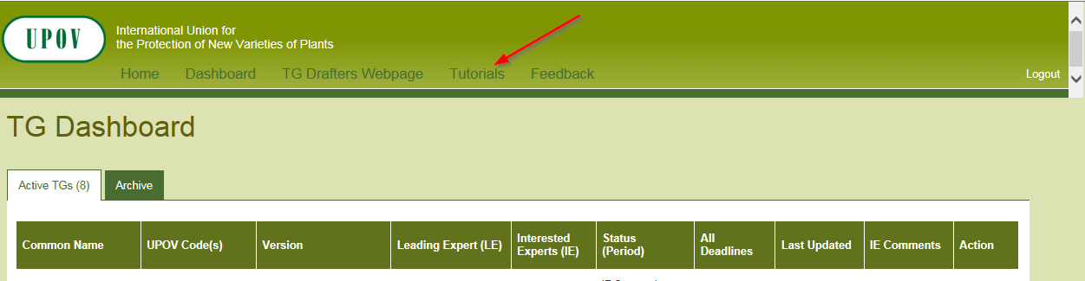

Alternatively, the tutorials are also available for download under the following link: http://upov.int/export/sites/upov/tgp/en/tg_template_tutorial_complete.pdf

The TWPs are invited to note:

(a) developments on the web-based TG template, reported in paragraphs 15 to 23 of this document;

(b) that the Office of the Union will issue a circular to identify requirements of UPOV members for the development of individual authorities’ test guidelines using the web-based TG template; and

(c) that training on the web-based TG template via electronic means can be organized upon experts’ request.

[Annex I follows]

Features of the web-based TG Template

(Extract from document TC/50/10 “Report on developments in UPOV including relevant matters discussed in the last sessions of the Administrative and Legal Committee, the Consultative Committee and the Council”)

The web-based TG Template will be developed in two separate phases in the form of Versions 1 and 2.

Version 1

Version 1 of the web-based TG Template will be fully functional for the development of UPOV Test Guidelines by Leading Experts and will enable Interested Experts to provide comments. Version 1 of the web-based TG Template will be completed in 2016 and a demonstration will be made at the TWPs sessions in 2016.

Features

The main features of Version 1 are as follows:

- Draft Test Guidelines will be prepared by Leading Experts online via the web-based TG Template
- Fixed template containing all universal standard wording which is appropriate for all Test Guidelines (see document TGP/7 “Development of Test Guidelines”, Section 3.1 “The TG Template”)
- Options to add Additional Standard Wording (ASW) (see document TGP/7, Section 3.2 “Additional Standard Wording (ASW) for the TG Template”)
- Links to Guidance Notes (GN) (see document TGP/7, Section 3.3 “Guidance Notes (GN) for the TG Template”)
- A database of characteristics (in English, French, German and Spanish) from Test Guidelines adopted after the adoption of document TGP/7/1 “Development of Test Guidelines” the Collection of Approved Characteristics (adopted in 2004) (see document TGP/7, Annex 4 “Collection of Approved Characteristics”).
The database will contain all information from the Table of Characteristics, including states of expression, notes, example varieties, etc. The database can be searched for relevant characteristics and a relevant characteristic uploaded into draft Test Guidelines with subsequent modification as required.

- Comments boxes for Interested Experts to complete online with a facility to view all comments
- Options to produce output in HTML or Word format.
- English only version
- Translators’ facility for the Table of Characteristics (Chapter 7)

Characteristics uploaded, unchanged, from the database comprising the collection of approved characteristics will be indicated as not requiring translation. For other characteristics, translators will be able to search the database comprising the collection of approved characteristics and input the required translations. The translation of the other chapters of the Test Guidelines will be provided separately for Version 1.

Version 2

Version 2 of the web-based TG Template will provide the two following additional features:

Concurrent translation

In version 2 of the web-based TG Template, the French, German and Spanish language versions of the Test Guidelines will be automatically developed concurrently with the English draft for the standard wording, Additional Standard Wording (ASW) and characteristics uploaded, unchanged, from the database comprising the collection of approved characteristics. Text that has not been automatically translated will be indicated for translation in the language concerned.

Individual authorities’ test guidelines

Version 1 of the web-based TG Template has been designed for the development of Test Guidelines for UPOV. However, it has also been designed such that Version 2 will enable members of the Union to use:

(a) adopted UPOV Test Guidelines as a basis for the development of individual authorities’ test guidelines;

(b) the web-based TG Template and database of characteristics to develop individual authorities’ test guidelines for which there are no UPOV Test Guidelines; and

(c) use individual authorities’ test guidelines, developed using the web-based TG Template, as the basis for draft UPOV Test Guidelines.

Version 2 will have a feature for individual authorities to modify the template wording, within the same structure, to act as a template for their own test guidelines and a feature to allow individual authorities to convert UPOV Test Guidelines into individual authorities’ test guidelines, with necessary modifications.

[Annex II follows]

LATEST DEVELOPMENTS on the web-based tg template

Issues implemented

New Standard Wording added to Chapter 3.1 “Number of Growing Cycles”

Extract of document TGP/7/7 “Developments of Test Guidelines”, Annex 1 “TG Structure and Universal Standard wording”; the new standard wording is indicated by underline and grey highlight:

“3.1 Number of Growing Cycles

The minimum duration of tests should normally be:

{ ASW 2 (Chapter 3.1(.1)) – number of growing cycles }
{ GN 8 (Chapter 3.1.2) – explanation of the growing cycle }
{ ASW 3 (Chapter 3.1.2) – explanation of the growing cycle }

The testing of a variety may be concluded when the competent authority can determine with certainty the outcome of the test.”

Issues currently being addressed

Summary of example varieties used in a particular Test Guidelines

Document TGP/7 “Development of Test Guidelines”, Guidance Note 28 “(Chapter 6.4) – Example varieties”, 2.2 “Minimizing the number” explains that:

“For practical reasons it is recommended to choose the overall set of example varieties for the Test Guidelines in a way that all the desired characteristics and states of expression are covered by the minimum total number of example varieties. This means that, if possible, each example variety should be used for as many characteristics as possible and example varieties should not be used only for one or very few characteristics.”

The new functionality to generate a list of example varieties used in a Test Guidelines could enable the creation of sets of example varieties with reduced total number of varieties.

Implementation of a workflow for each Test Guidelines in the administrator’s interface

Currently, all draft Test Guidelines generated using the web-based TG template are managed as independent documents. The purpose of implementing a workflow is to link all documents generated throughout the drafting cycle of a Test Guidelines, since the first draft to the adopted Test Guidelines. This functionality should minimize the issues generated when copying a previously discussed draft to create another draft for discussion at the subsequent TWP meeting.

Guidance Note 3 “Subject of the Test Guidelines: More than one species” to Chapter 1 “Subject of these Test Guidelines”

The wording of Guidance Note 3 “Subject of the Test Guidelines: More than one species” in Chapter 1 “Subject of these Test Guidelines” will be incorporated in the web-based TG Template in the tab “Subject”, presenting Chapter 1 “Subject of the Test Guidelines”. GN 3 reads as follows:

“GN 3 (Chapter 1.1) – Subject of the Test Guidelines: More than one species

Separate Test Guidelines are usually drawn up for each species. It may however be considered necessary to include two or more species, a whole genus or even a larger unit in one Test Guidelines document.

“Reference should not be made to the potential usefulness of the Test Guidelines for species other than those explicitly included in the coverage of the Test Guidelines, nor to the potential usefulness for hybrids involving the species covered by the Test Guidelines. If considered appropriate, the following sentence may be added:

“’Guidance on the use of Test Guidelines for (e.g. [species in the same genus] / [interspecific hybrids] / [intergeneric hybrids]) that are not explicitly covered by Test Guidelines is provided in document TGP/13 ‘Guidance for New Types and Species’.”

Implementation in Chapter 1 “Subject of the Test Guidelines” will look as follows

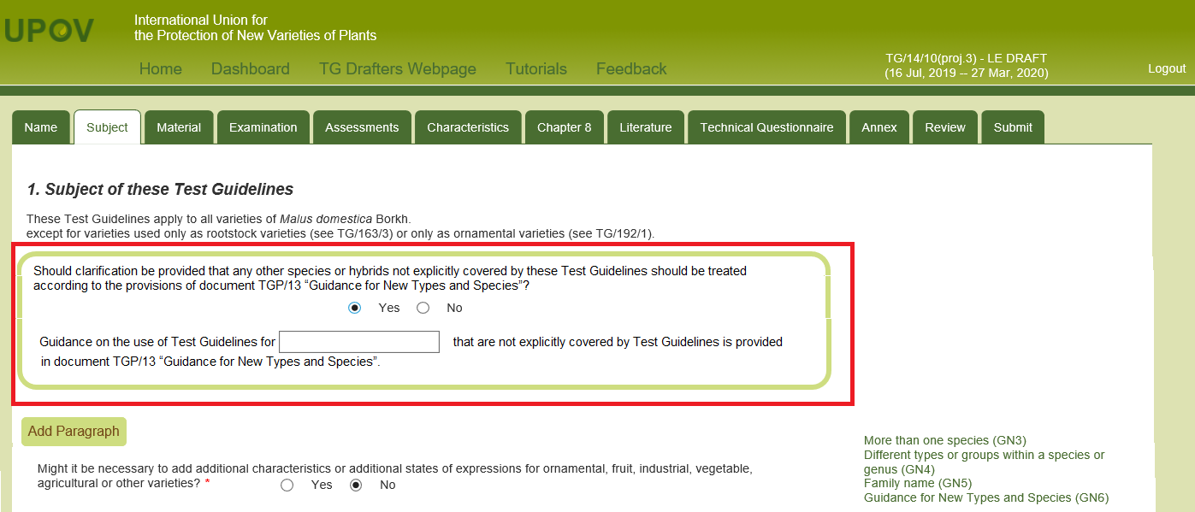

[End of Annex II and of document]

