E
International Union for the Protection of New Varieties of Plants

Technical Working Party for Vegetables  Fifty-Fourth Session  Brasilia, Brazil, May 11 to 15, 2020  Technical Working Party for Ornamental Plants and Forest Trees  Fifty-Second Session  Roelofarendsveen, Netherlands, June 8 to 12, 2020  Technical Working Party for Agricultural Crops  Forty-Ninth Session  Saskatoon, Canada, June 22 to 26, 2020  Technical Working Party for Fruit Crops  Fifty-First Session  Nîmes, France, July 6 to 10, 2020  Technical Working Party on Automation and Computer Programs  Thirty-Eighth Session  Alexandria, United States of America, September 21 to 23, 2020 | TWP/4/3  Original: English  Date: April 15, 2020
UPOV PRISMA
Document prepared by the Office of the Union
Disclaimer: this document does not represent UPOV policies or guidance

EXECUTIVE SUMMARY

The purpose of this document is to report on developments concerning the development of UPOV PRISMA.

The TWPs are invited to note the developments concerning UPOV PRISMA.

The structure of this document is as follows:

EXECUTIVE SUMMARY 1
Background 2
Developments in 2019 2
Developments in the Technical Committee (TC) in October 2019 2
Developments in the fourteenth Meeting on the Development of an Electronic Application Form (“EAF/14 meeting) in October 2019 2
Developments in the Administrative and Legal Committee (CAJ) in October 2019 3
Developments in the Consultative Committee and the Council in October 2019 3
Latest Developments 3
Version 2.4 3
Implementation of the new UPOV PRISMA Terms of Use 3
Coverage 4
Functionalities 5
UPOV PRISMA fee 5
Communication and promotion 5
Meeting on the development of an electronic application form (EAF/15) 5
Version 2.5 5
Possible future developments 6
Use of UPOV PRISMA and latest developments 6
Number of PBR submissions via UPOV PRISMA: (as of March 31, 2020) 6
Number of National Listing(NLI)* submissions via UPOV PRISMA (as of March 31, 2020) 7
Number of submissions (PBR + NLI) per month via UPOV PRISMA (as of March 31, 2020) 7
Number of submissions (PBR + NLI) via UPOV PRISMA chronologically (as of March 31, 2020) 7
Number of submissions (PBR + NLI) by crop type in UPOV PRISMA (as of March 31, 2020) 8
Number of PBR submissions per participating Authority in UPOV PRISMA (as of March 31, 2020) 8
ANNEX : UPOV PRISMA LEAFLET

Background

The background to the development of the EAF (now known as UPOV PRISMA) prior to the Technical Working Parties in 2019 is provided in document TWP/3/3 “UPOVP PRISMA”.

Developments in 2019

Developments in the Technical Committee (TC) in October 2019

The Technical Committee (TC), at its fifty-fifth session in Geneva on October 28 and 29, 2019, noted the information provided in document TC/55/INF/5 in relation to recent developments in UPOV PRISMA (see document TC/55/25 Corr. “Report”, paragraph 257).

Developments in the fourteenth Meeting on the Development of an Electronic Application Form (“EAF/14 meeting) in October 2019

At the fourteenth Meeting on the Development of an Electronic Application Form (“EAF/14 meeting”), held in Geneva on October 28, 2019, the participants considered document UPOV/EAF/14/2 “Developments concerning UPOV PRISMA” and received a presentation from the Office of the Union. The report of the meeting is provided in document EAF/14/3 “Report”.

At the EAF/14 meeting it was agreed to update the UPOV PRISMA Terms of Use (https://www.upov.int/upovprisma/en/termsuse.html) by introducing the following elements, under the “Specific acknowledgment for PVP Offices” section (see document EAF/14/3 “Report”, paragraph 15):

“In particular, the PBR authority agrees to the following:
  - Be part of UPOV PRISMA
  - Provide the Office of the Union with the most recent and updated application forms (including Technical Questionnaire)
  - Provide the Office of the Union with relevant verified translations (if applicable)
  - Complete the “Information for applicants” (PVP Office procedures) to be made available for applicants and provide updates as necessary
  - Test and check the output forms during the relevant Test campaigns
  - Specify all documents required for accepting a completed application and ensure all required information can be provided in UPOV PRISMA (with an exception for the electronic signature, if appropriate)
  - Accept application data submitted via UPOV PRISMA without the need for further data or information (except for signature)
  - Accept application data by machine-to-machine data transfer or as provided and presented in the output format (PDF), or provide a stylesheet or information that should be displayed on the PDF to be acceptable (e.g. logo)
  - Inform the Office of the Union of any changes or updates in the application forms (including Technical Questionnaire) and accept data according to the earlier version until UPOV PRISMA is updated - UPOV PRISMA will be updated at the next release or within 6 months following notification thereof, whatever is the sooner
  - Acknowledge receipt in UPOV PRISMA of any application data submitted via UPOV PRISMA within 7 days
  - PVP Office not to charge a higher application fee when receiving application data through UPOV PRISMA
  - Communicate information to applicants on the possibility to use UPOV PRISMA
  - Permit UPOV to disclose data about the number and crop types of applications received via UPOV PRISMA (no data on individual application will be disclosed)”

The EAF/14 meeting agreed that participation in UPOV PRISMA would require agreement to the new Terms of Use (see document EAF/14/3 “Report”, paragraph 17).

At the EAF/14 meeting it was agreed that the proposal to indicate the filing date in UPOV PRISMA within 7 days after it is duly filed with the participating PVP Office, should be discussed at a future EAF meeting.

Developments in the Administrative and Legal Committee (CAJ) in October 2019

The Administrative and Legal Committee (CAJ), at its seventy-sixth session on October 30, 2019, noted the information provided in document CAJ/76/INF/2 in relation to recent developments in UPOV PRISMA (see document CAJ/76/9 “Report”, paragraph 54).

Developments in the Consultative Committee and the Council in October 2019

The Council at its fifty-third ordinary session in Geneva on November 1, 2019, noted the work of the Consultative Committee at its ninety-sixth session, as reported in document C/53/9 “Report by the President on the work of the ninety-sixth session of the Consultative Committee”, which included the following information concerning UPOV PRISMA (see document C/53/15 “Report”, paragraph 23):

“The Council noted the developments concerning UPOV PRISMA and decided to re-introduce a UPOV PRISMA fee per application at 90 Swiss Francs, starting in January 2020, subject to resolution of the technical issues and improvements being made to the user experience, before a fee was introduced, as presented in document C/53/9. It further agreed that, where the same variety was submitted for both plant breeders’ rights and national listing in the same participating member of the Union, a single fee would be charged at the time of the first submission for the variety (see document C/53/15 “Report”, paragraph 23 (e)).”

Latest Developments

Version 2.4

Version 2.4 of UPOV PRISMA was released on February 24, 2020.

Implementation of the new UPOV PRISMA Terms of Use

Since the EAF/14, all participating authorities, except the African Intellectual Property Organization (OAPI), Bolivia (Plurinational State of) and Paraguay, have signed to the new Terms of Use for UPOV PRISMA (see paragraph 7 above), with the addition of the following disclaimer and footnotes:

Disclaimer for the Community Plant Variety Office of the European Union (CPVO): The CPVO accepts to make all best efforts so that the required information submitted through UPOV PRISMA can be accepted by the CPVO in due time. EU plant variety rights applications will only be accepted if all requirements under the applicable legislation are complied with.

- Accept application data submitted via UPOV PRISMA without the need for further data or information (except for signature)¹
Footnote 1: In the case of the CPVO, France and the Netherlands, additional useful information, including TQ characteristics for some crops, may need to be provided to the relevant PVP Office by the applicant after the data is submitted via UPOV PRISMA.

- Inform the Office of the Union of any changes or updates in the application forms (including Technical Questionnaire) and accept data according to the earlier version until UPOV PRISMA is updated - UPOV PRISMA will be updated at the next release or within 6 months following notification thereof, whatever is the sooner²
Footnote 2: In the case of the CPVO, if the data submitted under an earlier version of an application form or technical questionnaire is not sufficient for the purpose of filing an application for an EU plant variety right, the applicant will be asked by the CPVO to complement with the data required.

- Acknowledge receipt in UPOV PRISMA of any application data submitted via UPOV PRISMA within 7 days³
Footnote 3: In the case of the African Intellectual Property Organization (OAPI), CPVO, France and the Netherlands, the acknowledgement of receipt will be made by their own system and according to the applicable legislation.

The African Intellectual Property Organization (OAPI), Bolivia (Plurinational State of) and Paraguay informed the Office of the Union that more time was needed to finalize the requirements of the new Terms of Use for UPOV PRISMA. Until the required information is provided, applicants are not be able to submit application data via UPOV PRISMA for those participating authorities.

Coverage

There was no new addition of countries or crop coverage since the previous Version.

Authority |  | Crop coverage in Version 2.4
African Intellectual Property Organization (OAPI) * | OA | All genera and species
Argentina | AR | Apple (Fruit Varieties), Barley, Black Radish, Broad Bean, Brussels Sprouts, Cauliflower, Chili, Chinese Cabbage, Cotton, Egg Plant, Fig, Grapevine, Green onion, Grey Shallot, Hot Pepper, Indian mustard, Japanese Bunching Onion, Maize, Melon, Oriental Radish, Papaya, Paprika, Potato, Rose, Salvia, Shallot, Soya Bean, Spinach, Sugarcane, Sweet Pepper, Tomato Rootstocks, Watermelon, Welsh Onion, Wheat, Witloof Chicory
Australia | AU | All genera and species
Bolivia (Plurinational State of) * | BO | All genera and species
Canada | CA | All genera & species excluding algae, bacteria and fungi
Chile | CL | All genera and species
China | CN | Lettuce
Colombia | CO | All genera and species
Costa Rica | CR | All genera and species
Dominican Republic | DO | All genera and species
Ecuador | EC | All genera and species
European Union | QZ | All genera & species excluding agricultural crops apart from Bent, Cocksfoot, Fescue, Meadow Fescue, Potato, Soya Bean, Ryegrass, Timothy
France | FR | All genera & species
Georgia | GE | Apple (Fruit Varieties), Barley, Blackberry, Blueberry, Cherry (Sweet Cherry), Chick-Pea, Field Bean, French Bean, Hazelnut, Lentil, Maize, Oats, Peach, Pear, Potato, Raspberry, Soya Bean, Sunflower, Tomato, Walnut, Wheat
Kenya | KE | All genera and species
Morocco | MA | Melon
Mexico | MX | All genera and species
Netherlands | NL | All genera and species
New Zealand | NZ | All genera and species
Norway | NO | All genera and species
Paraguay * | PY | Soya Bean
Peru | PE | All genera and species
Republic of Moldova | MD | Apple (Fruit Varieties), Barley, Blackberry, Chili, European Plum, Grapevine, Hot Pepper, Lettuce, Maize, Oats, Onion, Paprika, Pea, Pear, Potato, Raspberry, Rose, Rye, Sour cherry, Soya Bean, Strawberry, Sunflower, Sunflower, Sweet Pepper, Tomato, Walnut, Wheat
Republic of Korea | KR | Apple (Fruit Varieties), Lettuce, Potato, Rose, Soya Bean
Serbia | RS | Apple (Fruit Varieties), Blueberry, Raspberry, Rose
South Africa | ZA | All genera and species
Sweden | SE | All genera and species
Switzerland | CH | All genera and species
Trinidad and Tobago | TT | Anthuriums , Bromeliaceae, Heliconiaceae, Orchidaceae, Sterculiaceae, Cajanus cajans, Vigna sp., Theobroma cacao L.
Tunisia | TN | All genera and species
Turkey | TR | All genera and species
United Kingdom | GB | All genera and species
United States of America | US | 192 crops including Lettuce, Potato, Soya Bean, Wheat
Uruguay | UY | All genera & species
Viet Nam | VN | Anthurium, Carnation, Chrysanthemum, Cucumber, Dahlia, Dragon Fruit, Japanese Bunching, Onion, Kohlrabi, Maize, Mango, Oranges (Citrus L. - Group 2), Peanut, Poinsettia, Potato, Rice, Rose, Soya Bean, Sunflower, Tomato, Welsh Onion, White-Red and Savoy Cabbage
Total | 35
*Until required information is provided, applicants will not be able to submit application data for the concerned authorities

Functionalities

Version 2.4 provides an improved user interface and provides a direct communication tool to the UPOV PRISMA team.

UPOV PRISMA fee

A UPOV PRISMA fee was reintroduced (90 Swiss francs per PVP application made using UPOV PRISMA) in Version 2.4 (see paragraph 11 above). This fee is in addition to the PVP application fee(s) for the UPOV member concerned. In the case of the United Kingdom, the UPOV PRISMA fee is paid by the United Kingdom PVP Office.

Communication and promotion

In relation to communication and promotion, the following initiatives have been taken:

- new design for UPOV PRISMA Webpages (public and restricted area);
- creation of new animated graphics targeted at benefits of UPOV PRISMA (available in English, French, Spanish, German and Chinese at: https://www.upov.int/upovprisma/en/index.html);
- creation of new Powtoons videos targeted for agents (available in English, French, Spanish, German and Chinese at: https://www.upov.int/upovprisma/en/quickguides.html);
- update of the UPOV PRISMA Leaflet, available in English, French, Spanish and Chinese, as reproduced in the Annex to this document;
- individual contacts with individuals and companies (breeders and agents) using or interested in UPOV PRISMA.

Meeting on the development of an electronic application form (EAF/15)

At the fifteenth Meeting on the Development of an Electronic Application Form (“EAF/15 meeting”), held in Geneva on March 26, 2020, the participants noted the proposed planned future developments for UPOV PRISMA, as follows:

Version 2.5

Coverage

UPOV members

The following authorities have indicated their intention to be part of Version 2.5:

Authority |  | intention to participate in Version 2.5 | Anticipated crop coverage in Version 2.5
Japan | JP |  | To be confirmed
Singapore | SG |  | All genera and species

Crops/ species

In relation to coverage of crop and species in UPOV PRISMA Version 2.5, the table below shows the anticipated changes compared to Version 2.4 for authorities participating in Version 2.4:

Authority |  | Anticipated new crop coverage in Version 2.5
European Union | QZ | Maize
China | CN | Selected crops

New Functionalities

Subject to available resources, the following new functionalities are planned to be introduced in Version 2.5:

- New version of payment interface (Epay V2) to facilitate payment by PayPal, China Union Pay and Bulk payment;
- National Listing for United Kingdom;
- Bulk upload functionality;
- Addition of national characteristics for the Netherlands;
- Customization of OAPI form layout;
- Machine-to-machine communication for Japan;
- Synchronization between UPOV PRISMA and CPVO for TQ changes;
- Machine-to-machine communication with Kenya and Uruguay.

Timetable for release

Version 2.5 is anticipated to be released in November 2020.

Possible future developments

The following members have expressed an interest to join UPOV PRISMA at a future date: Bosnia and Herzegovina, Nicaragua, United Republic of Tanzania and Uzbekistan.

In a future Version, it is proposed to work on the following new functionalities:
- Information on DUS cooperation (DUS Arrangement Recommendation Tool (DART));
- More PVP offices with machine-to-machine links/ communication to UPOV PRISMA;
- Machine translation;
- More countries with National Listing;
- Crop-specific TQs beyond Test Guidelines.

In a future Version and in order to assist members of the Union to receive, process and manage application data from UPOV PRISMA, it is proposed to develop and introduce a “PVP Office management interface”.

Variation in forms

The EAF/15 meeting noted that a report on variation between the Technical Questionnaire of participating authorities in UPOV PRISMA between UPOV members and the UPOV model application form, would be provided at the EAF/16 meeting, according to available resources.

Use of UPOV PRISMA and latest developments

Information on the use of UPOV PRISMA, is provided below:

Number of PBR submissions via UPOV PRISMA: (as of March 31, 2020)

 | 2017 | 2018 | 2019 | 2020
January | 1 |  | 7 | 18
February |  | 3 | 9 | 5
March | 2 | 3 | 6 | 21
April |  | 3 | 23
May | 1 | 1 | 33
June |  | 7 | 10
July |  | 7 | 3
August |  | 1 | 6
September | 3 | 8 | 14
October | 1 | 19 | 29
November | 3 | 16 | 26
December | 3 | 9 | 49
Total | 14 | 77 | 220 | 44

Number of National Listing(NLI)* submissions via UPOV PRISMA (as of March 31, 2020)

 | 2019 | 2020
August | 1 | -
September | 2 | -
October | - | -
November | -
December | 2
Total | 5
*functionality introduced in Version 2.2- June 2019

Number of submissions (PBR + NLI) per month via UPOV PRISMA (as of March 31, 2020)

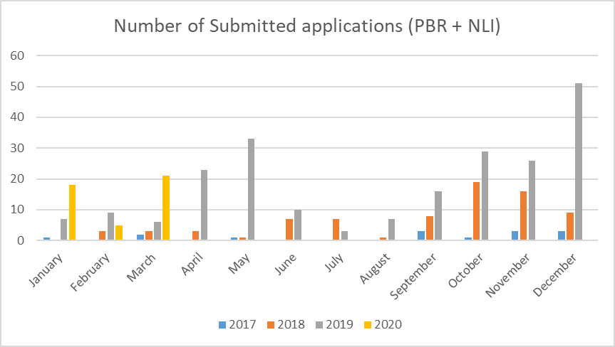

Number of submissions (PBR + NLI) via UPOV PRISMA chronologically (as of March 31, 2020)

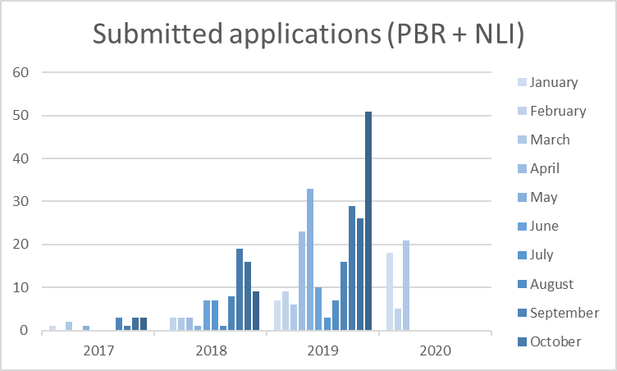

Number of submissions (PBR + NLI) by crop type in UPOV PRISMA (as of March 31, 2020)

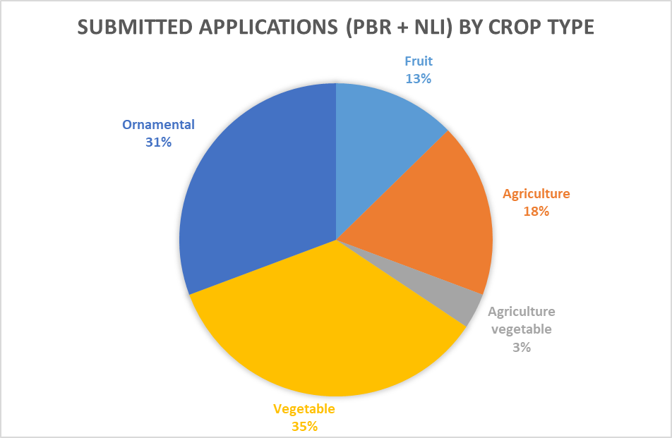

Number of PBR submissions per participating Authority in UPOV PRISMA (as of March 31, 2020)

Authority |  | Number of PBR submissions in UPOV PRISMA
African Intellectual Property Organization (OAPI) | OA | 3
Argentina | AR | -
Australia | AU | 33
Bolivia (Plurinational State of) | BO | 2
Canada | CA | 33
Chile | CL | 6
China | CN | -
Colombia | CO | 4
Costa Rica | CR | 4
Dominican Republic | DO | 2
Ecuador | EC | -
European Union | QZ | 46
France | FR | 20
Georgia | GE | 2
Kenya | KE | 20
Morocco | MA | -
Mexico | MX | 15
Netherlands | NL | 16
New Zealand | NZ | 16
Norway | NO | 6
Paraguay | PY | -
Peru | PE | -
Republic of Moldova | MD | 2
Republic of Korea | KR | 1
Serbia | RS | 2
South Africa | ZA | 5
Sweden | SE | 1
Switzerland | CH | 10
Trinidad and Tobago | TT | -
Tunisia | TN | 6
Turkey | TR | 48
United Kingdom | GB | 38
United States of America | US | 8
Uruguay | UY | -
Viet Nam | VN | -

The TWPs, at their sessions in 2020, will receive an oral report on further developments.

The TWPs are invited to note the developments concerning UPOV PRISMA.

[Annex follows]

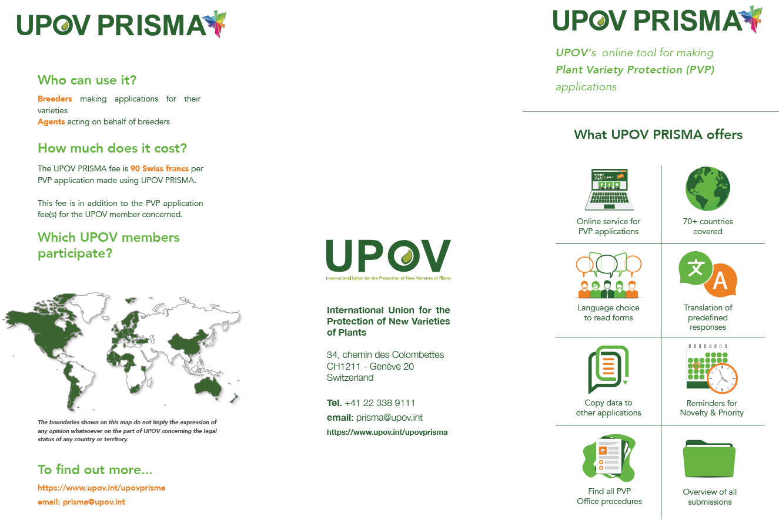
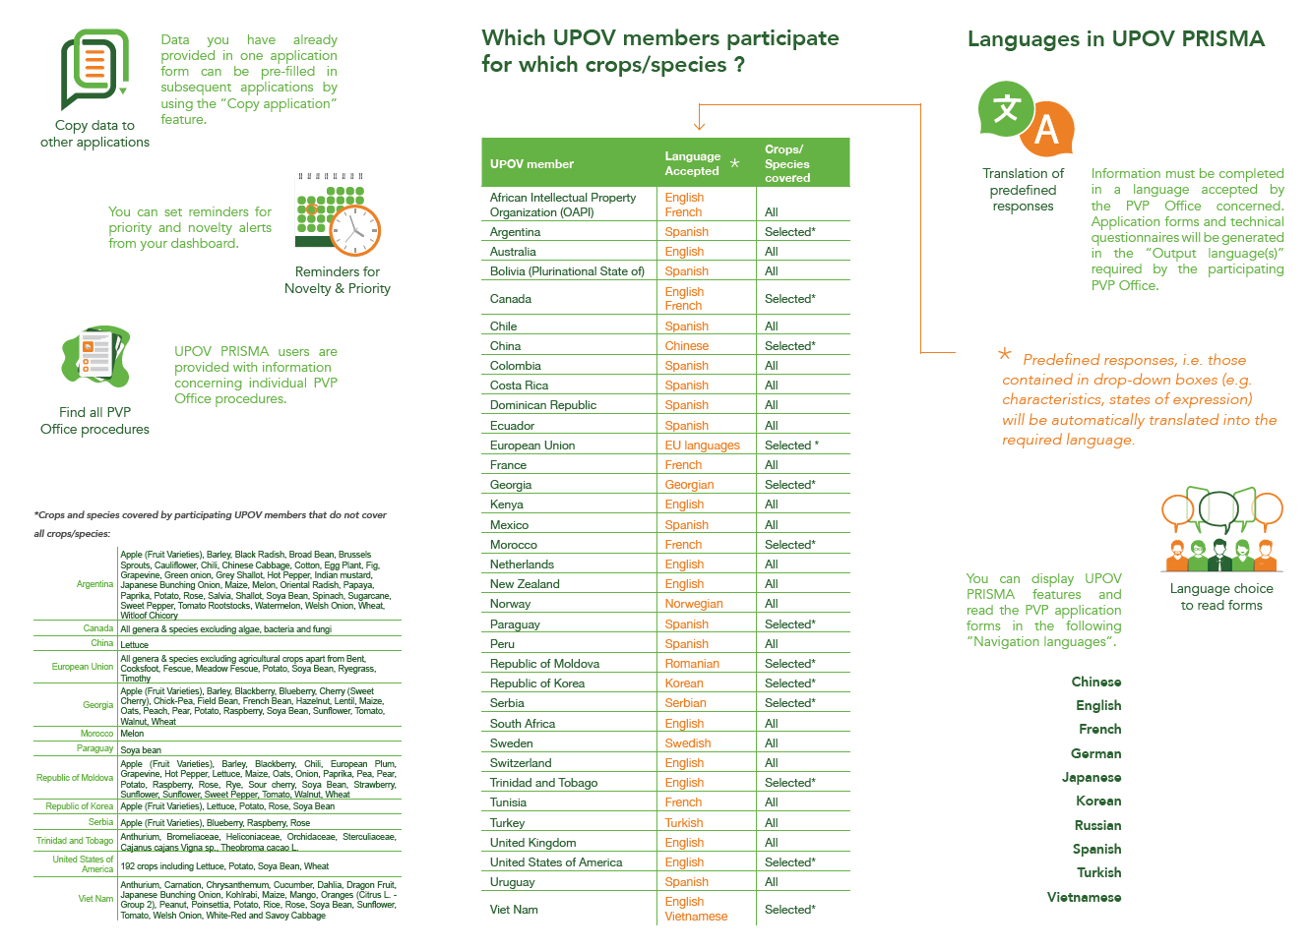
[End of Annex and of document]

