|  |  |
| --- | --- |
|  | E |
| International Union for the Protection of New Varieties of Plants |  |

|  |  |
| --- | --- |
| Technical Working Party for Vegetables  Fifty-Fourth Session  Brasilia, Brazil, May 11 to 15, 2020  Technical Working Party for Ornamental Plants and Forest Trees  Fifty-Second Session  Roelofarendsveen, Netherlands, June 8 to 12, 2020  Technical Working Party for Agricultural Crops  Forty-Ninth Session  Saskatoon, Canada, June 22 to 26, 2020  Technical Working Party for Fruit Crops  Fifty-First Session  Nîmes, France, July 6 to 10, 2020  Technical Working Party on Automation and Computer Programs  Thirty-Eighth Session  Alexandria, United States of America, September 21 to 23, 2020 | TWP/4/13  Original: English  Date: April 15, 2020 |

revision of test guidelines

Document prepared by the Office of the Union

Disclaimer: this document does not represent UPOV policies or guidance

# Executive summary

The purpose of this document is to assess the need for revision of adopted Test Guidelines, including Technical Questionnaires, to reflect the practices of members of the Union.

UPOV members at the TWPs are invited to:

(a) notify additional characteristics and states of expression to the Office of the Union using the tables provided in document TGP/5 Section 10; and

(b) complete the table with information on the use of Technical Questionnaires from UPOV Test Guidelines, as provided on the website, and return it to the Office of the Union by August 1, 2020.

The TWA and TWO are invited to consider:

(a) the additional characteristics and/or states of expression notified to the Office of the Union, as reproduced in Annexes I and II to this document,

(b) whether the additional characteristics and/or states of expression should be posted on the TG Drafters’ webpage of the UPOV website; and

(c) whether a revision or partial revision of the Test Guidelines concerned should be initiated to address the additional characteristics and/or states of expression notified.

The structure of this document is as follows:

Executive summary 1

Background 2

Technical Questionnaires 3

Additional characteristics and states of expression in individual authorities’ test guidelines 4

Additional characteristics and states of expression notified to the Office of the Union 4

Additional characteristics 4

New state of expression 4

ANNEX I Additional characteristics notified to the Office of the Union: *Dactylis glomerata* and *Lolium multiflorum*

ANNEX II Additional state of expression notified to the Office of the Union: *Lavandula*

ANNEX III Example table: additional characteristics in technical questionnaires of individual authorities’ test guidelines

The following abbreviations are used in this document:

TC: Technical Committee

TWA: Technical Working Party for Agricultural Crops

TWC: Technical Working Party on Automation and Computer Programs

TWF: Technical Working Party for Fruit Crops

TWO: Technical Working Party for Ornamental Plants and Forest Trees

TWP(s): Technical Working Party(ies)

TWV: Technical Working Party for Vegetables

# Background

Document TG/1/3 “General Introduction to the Examination of Distinctness, Uniformity and Stability and the Development of Harmonized Descriptions of new Varieties of Plants” (hereinafter referred to as “the General Introduction”) (Chapter 1.3) explains the importance of harmonization in DUS examination, including the role of Test Guidelines and Technical Questionnaire as follows:

1.2 The purpose of this document (hereinafter referred to as “the General Introduction”), and the associated series of documents specifying Test Guidelines’ Procedures (hereinafter referred to as “the TGP documents”), is to set out the principles which are used in the examination of DUS. The identification of those principles ensures that examination of new plant varieties is conducted in a harmonized way throughout the members of the Union2. This harmonization is important because it facilitates cooperation in DUS testing and also helps to provide effective protection through the development of harmonized, internationally recognized descriptions of protected varieties.

1.3 […]UPOV has developed “Guidelines for the Conduct of Tests for Distinctness, Uniformity and Stability,” or “Test Guidelines”, for many individual species or other variety groupings. The purpose of these Test Guidelines is to elaborate certain of the principles contained in this document, and the associated TGP documents, into detailed practical guidance for the harmonized examination of DUS and, in particular, to identify appropriate characteristics for the examination of DUS and production of harmonized variety descriptions. […].

5.3.1.4 To help in the process of examining varieties, certain information is requested from the breeder, usually through a Technical Questionnaire to be submitted with the application. The model Technical Questionnaire, included in the Test Guidelines, seeks information on specific characteristics of importance for distinguishing varieties, information on the breeding scheme of the variety and any other information which may help to distinguish the variety. It also requests the breeder to identify similar varieties and characteristics by which the candidate may be distinguished from these similar varieties.

The revision of Test Guidelines, including Technical Questionnaires, is important in order to maintain harmonization and the effectiveness of guidance UPOV provides for DUS examination.

Document TGP/7, section 2.3.3.2, explains that “[…] any member of the Union or observer State or observer organization to the Technical Committee may make a proposal for a partial revision directly to the relevant TWP(s).” It further explains in section 2.3.3.3 that “for a partial revision of Test Guidelines, a new draft of the Test Guidelines should not be prepared. The proposer of the partial revision should prepare a TWP document specifying only the revisions to be made to the adopted Test Guidelines.”

# Technical Questionnaires

The General Introduction (Chapter 5.3.1.4) explains that “To help in the process of examining varieties, certain information is requested from the breeder, usually through a Technical Questionnaire to be submitted with the application. The model Technical Questionnaire, included in the Test Guidelines, seeks information on specific characteristics of importance for distinguishing varieties, […].

Thus, the characteristics included in the Technical Questionnaire are intended to provide guidance to authorities on characteristics for which information from the breeder would be particularly useful.

Document TGP/7 “Development of Test Guidelines” (Annex 3, GN 13, Section 3) further explains that

“3.1 The model Technical Questionnaire included in the Test Guidelines seeks information on specific characteristics of importance for distinguishing varieties.

“3.2 Characteristics to be included in the Technical Questionnaire should comprise:

“(a) the grouping characteristics and

“(b) the most discriminating characteristics,

“unless it is considered unrealistic to expect breeders to describe these characteristics.

“3.3 In addition to the characteristics identified in Section 3.2, the Technical Questionnaire may also include characteristics that are agreed to be important for the management of the trial and the planning of observations.”

In 2017, UPOV introduced UPOV PRISMA, an online service to assist breeders to make PVP applications in participating UPOV members (see: <https://www.upov.int/upovprisma/en/index.html>). The efficiency of UPOV PRISMA is greatly enhanced for applicants where participating UPOV members follow the UPOV Test Guidelines, particularly the Technical Questionnaire in the Test Guidelines, because this means that the same information can be used in other applications. Furthermore, this also greatly reduces the cost of operating UPOV PRISMA by reducing the need for customized TQs and subsequent translation in all UPOV PRISMA supported languages.

Currently, 22 of the 35 UPOV members participating in UPOV PRISMA indicate that they follow the UPOV Test Guidelines. However, it has become apparent that, for certain crops/species, the Technical Questionnaires in the Test Guidelines do not always reflect the Technical Questionnaires being used by the UPOV members concerned, indicating that a review and possible revision of the Technical Questionnaires in the Test Guidelines concerned would be appropriate to meet the objectives of the Test Guidelines, to improve the efficiency of UPOV PRISMA for applicants and to reduce UPOV’s costs in maintaining UPOV PRISMA.

A table containing relevant Test Guidelines for each Technical Working Party is available on the respective Technical Working Party webpages to enable members of the Union to provide information on differences between their Technical Questionnaires and the Technical Questionnaires in the adopted Test Guidelines, as follows:

* Agricultural crops (TWA): <https://www.upov.int/meetings/en/details.jsp?meeting_id=55672>
* Fruit crops (TWF): <https://www.upov.int/meetings/en/details.jsp?meeting_id=55671>
* Ornamental plants and forest trees (TWO): <https://www.upov.int/meetings/en/details.jsp?meeting_id=55667>
* Vegetable crops (TWV): <https://www.upov.int/meetings/en/details.jsp?meeting_id=55670>

The structure of the table with example information is provided in Annex III to this document.

UPOV members are invited to complete the table for relevant genera and species and return it to the Office of the Union (e-mail: [upov.mail@upov.int](mailto:upov.mail@upov.int) copy to: [prisma@upov.int](mailto:prisma@upov.int)) by August 1, 2020. The information will be presented to the Technical Committee at its fifty-sixth session and the TWPs at their sessions in 2021 to assist in the planning of Test Guidelines revisions.

UPOV members at the TWPs are invited to complete the table with information on the use of the Technical Questionnaire from UPOV Test Guidelines, as provided on the website, and return it to the Office of the Union by August 1, 2020.

# Additional characteristics and states of expression in individual authorities’ test guidelines

The General Introduction states in section 4.2.3 that “The characteristics included in the individual Test Guidelines are not necessarily exhaustive and may be expanded with additional characteristics if that proves to be useful and the characteristics meet the conditions set out [in section 4.2.1]”. In addition, document TGP/7/2, Chapter 4.1.9, states that “It may become necessary for a characteristic in individual authorities’ test guidelines to be changed over time, e.g. to create new states of expression arising from breeding developments”.

In order to retain internationally harmonized variety descriptions, document TGP/5, Section 10 ‘Notification of Additional Characteristics’ provides a basis for such differences between the Test Guidelines and individual authorities’ test guidelines to be notified to all members of the Union.

Document TGP/5 Section 10: paragraph 4.2 states that “proposals for additional characteristics and states of expression notified to the Office of the Union by means of document TGP/5 Section 10, will be presented to the relevant Technical Working Party(ies) (TWP(s)) at the earliest opportunity with information on the extent of use of the characteristic. The characteristics will then, as appropriate, be posted on the TG Drafters’ webpage of the UPOV website (<http://www.upov.int/restricted_temporary/tg/index.html>) on the basis of comments made by the relevant TWP(s), and/or the TWP(s) may initiate a revision or a partial revision of the Test Guidelines concerned.”

The tables provided in document TGP/5 Section 10 have been developed for the notification of additional characteristics and additional states of expression by members of the Union (<https://www.upov.int/edocs/tgpdocs/en/tgp_5_section_10.pdf>).

UPOV members at the TWPs are invited to notify additional characteristics and states of expression to the Office of the Union using the tables provided in document TGP/5 Section 10.

## Additional characteristics and states of expression notified to the Office of the Union

The Office of the Union received notifications of the following additional characteristics or states of expression since the TWP sessions in 2019:

### Additional characteristics

Notified by the Community Plant Variety Office of the European Union (CPVO):

* *Dactylis glomerata* L.: See Annex VII (in English only)
  + “Plant: natural height in autumn (without vernalization)”
* *Lolium multiflorum* L.: See Annex VII (in English only)
  + “Plant: length in autumn of year of sowing”
  + “Leaf: length (at vegetative stage)”

### New state of expression

Notified by the Community Plant Variety Office of the European Union (CPVO)

* *Lavendula* L.: See Annex VIII
  + Spike: shape: “conical and cylindrical (50%-50%)”

The additional characteristics or states of expression notified will be presented to the TWPs, as appropriate, at their sessions in 2020, for consideration on whether these should be posted on the TG Drafters’ webpage of the UPOV website and/or whether to initiate a revision or partial revision of the Test Guidelines concerned.

The TWA and TWO are invited to consider:

(a) the additional characteristics and/or states of expression notified to the Office of the Union, as reproduced in Annexes VII and VIII to this document,

(b) whether the additional characteristics and/or states of expression should be posted on the TG Drafters’ webpage of the UPOV website; and

(c) whether a revision or partial revision of the Test Guidelines concerned should be initiated to address the additional characteristics and/or states of expression notified.

[Annexes follow]

Additional characteristics notified to the Office of the Union

Dactylis glomerata and lolium multiflorum

Submitted by the Community Plant Variety Office of the European Union (CPVO)

Contact expert: Anne Weitz

Date: 15/09/2019

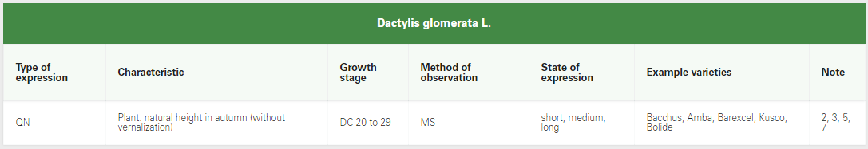

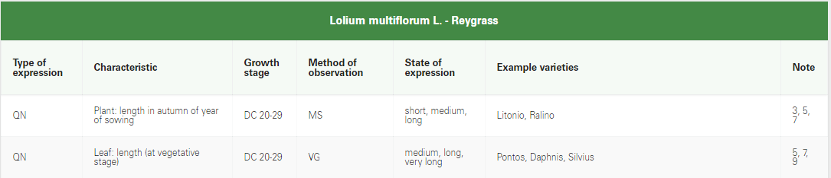

[Annex II follows]

Additional STATE OF EXPRESSION notified to the Office of the Union

TEST GUIDELINES FOR LAVANDULA: TG/194/1

Submitting Authority: Contact Expert: Renaud Florent

GEVES

on behalf of CPVO)

Date: 02/04/2019 Organization: GEVES

Tel.: +33 (0)4 90 78 66 79

E-mail: florent.renaud@geves.fr

**Existing characteristic:**

|  |  |  |  |  |  |  |  |
| --- | --- | --- | --- | --- | --- | --- | --- |
|  |  | english | français | deutsch | español | Example Varieties/ Exemples/ Beispielssorten/ Variedades ejemplo | Note/ Nota |
| 23 | VG | Spike : shape | Epi : forme | Ähre: Form | Espiga: forma |  |  |
| (+) | (*)(b) | narrow conical | conique étroit | schmal kegelförmig | cónica estrecha | Grey Hedge (L) | 1 |
| PQ |  | conical | conique | kegelförmig | cónica | Abrial (L), Silver Ghost (S/Ps) | 2 |
|  |  | truncate conical | tronconique | stumpf kegelförmig | cónica truncada | Reydovan (L), Tickled Pink (S/Ps) | 3 |
|  |  | cylindrical | cylindrique | zylindrisch | cilíndrica | 36.70 (L), Willowbridge White (S/Ps) | 4 |
|  |  | fusiform | fusiforme | spindelförmig | fusiforme | Lady (L), Sidonie (S/Ps) | 5 |
|  |  | narrow trullate | fusiforme conique | schmal rautenförmig | rómbica estrecha | Yuulong (L) | 6 |

**Characteristic with new state(s) of expression (including all information as above)**

|  |  |  |  |  |  |  |  |
| --- | --- | --- | --- | --- | --- | --- | --- |
|  |  | english | français | deutsch | español | Example Varieties/ Exemples/ Beispielssorten/ Variedades ejemplo | Note/ Nota |
| 23 | | VG | Spike : shape | Epi : forme | Ähre: Form | Espiga: forma |  |  |
| (+) | | (*)(b) | narrow conical | conique étroit | schmal kegelförmig | cónica estrecha | Grey Hedge (L) | 1 |
| PQ | |  | conical | conique | kegelförmig | cónica | Abrial (L), Silver Ghost (S/Ps) | 2 |
|  | |  | truncate conical | tronconique | stumpf kegelförmig | cónica truncada | Reydovan (L), Tickled Pink (S/Ps) | 3 |
|  | |  | cylindrical | cylindrique | zylindrisch | cilíndrica | 36.70 (L), Willowbridge White (S/Ps) | 4 |
|  | |  | fusiform | fusiforme | spindelförmig | fusiforme | Lady (L), Sidonie (S/Ps) | 5 |
|  | |  | narrow trullate | fusiforme conique | schmal rautenförmig | rómbica estrecha | Yuulong (L) | 6 |
|  | |  | conical and cylindrical (50%-50%) | conique et cylindrique (50%-50%) | Kegelförmig und zylindrisch (50%-50%) | Cónica y cilíndrica (50%-50%) | Adagio (L) | 7 |

Explanation / Illustration (including extent of the use of the characteristic(s)):

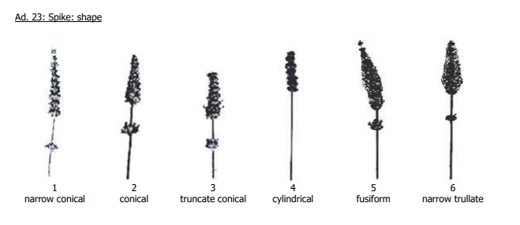

7. On each plant, 50% of spikes have a conical shape and 50% have a cylindrical shape.

[Annex III follows]

additional characteristics in technical questionnaireS of individual authorities test guidelines

The following table is for illustration purpose only. The Excel table with the list of UPOV Test Guidelines is available at:

Agricultural crops (TWA): <https://www.upov.int/meetings/en/details.jsp?meeting_id=55672>

Fruit crops (TWF): <https://www.upov.int/meetings/en/details.jsp?meeting_id=55671>

Ornamental plants and forest trees (TWO): <https://www.upov.int/meetings/en/details.jsp?meeting_id=55667>

Vegetable crops (TWV): <https://www.upov.int/meetings/en/details.jsp?meeting_id=55670>

|  |  |  |  |  |  |  |  |  |
| --- | --- | --- | --- | --- | --- | --- | --- | --- |
|  | | | **Are you following the Technical Questionnaire from UPOV Test Guidelines without changes** | | **Changes to the Technical Questionnaire**  **of UPOV Test Guidelines (if applicable)** | | | |
| *TG reference* | *Test Guidelines Common Name* | *Botanical Name* | **Yes** | **No** | **addition of characteristics from the UPOV TG Table of Characteristics** | **additional characteristics that are not included in the UPOV TG Table of Characteristics** | **Other (please specify in comments)** | **Comments/ Remarks** |
| *Examples* |  |  |  |  |  |  |  |  |
| TG/184/4 Rev. | Globe artichoke, Artichoke, Cardoon | Cynara cardunculus L. |  | X | X  Example for illustration purpose only!  See Excel file available at TWA, TWF, TWO and TWV webpages |  | X | 1. Not all UPOV TG TQ characteristics are included 2. Some of the states of expression are different |
| TG/44/11 Rev. 2 | Tomato | Solanum lycopersicum L. | X |  |  |  |  |  |
| TG/111/4 | Macadamia, Queensland Nut | Macadamia integrifolia Maiden et Betche; Macadamia tetraphylla L. Johns. |  | X |  |  |  | No TQ required |

[End of Annex III and of document]