E
International Union for the Protection of New Varieties of Plants

Technical Working Party for Vegetables  Fifty-Fourth Session  Brasilia, Brazil, May 11 to 15, 2020  Technical Working Party for Ornamental Plants and Forest Trees  Fifty-Second Session  Roelofarendsveen, Netherlands, June 8 to 12, 2020  Technical Working Party for Agricultural Crops  Forty-Ninth Session  Saskatoon, Canada, June 22 to 26, 2020  Technical Working Party for Fruit Crops  Fifty-First Session  Nîmes, France, July 6 to 10, 2020  Technical Working Party on Automation and Computer Programs  Thirty-Eighth Session  Alexandria, United States of America, September 21 to 23, 2020 | TWP/4/10  Original: English  Date: April 14, 2020
Data Processing for the PRODUCTION OF Variety Descriptions FOR MEASURED QUANTITATIVE CHARACTERISTICS
Document prepared by the Office of the Union
Disclaimer: this document does not represent UPOV policies or guidance

EXECUTIVE SUMMARY

The purpose of this document is to present developments concerning possible new guidance on methods to convert observations into notes for producing variety descriptions for measured quantitative characteristics for inclusion in document TGP/8 “Trial Design and Techniques Used in the Examination of Distinctness, Uniformity and Stability”.

The TWPs are invited to consider the different approaches to convert observations into notes for producing variety descriptions for measured quantitative characteristics, as presented in Annexes III to VII of this document, and information, if any, that could facilitate their application.

The structure of this document is as follows:
EXECUTIVE SUMMARY 1
background 2
summary of different approaches and Information on circumstances for use of methods 4
Comments by the technical working parties at their sessions in 2019 2

ANNEX I “Different forms that variety descriptions could take and the relevance of scale levels”, document prepared by an expert from Germany

ANNEX II “Compilation of explanations on methods for producing varieties descriptions for measured characteristics, and clarification of differences”, document prepared by an expert from the United Kingdom

ANNEX III “Short explanation on the French methods for producing varieties descriptions for measured characteristics”, document prepared by an expert from France

ANNEX IV “Short explanation on the Japanese methods for assessment table for producing variety descriptions”, document prepared by an expert from Japan

appendix to annex IV “Introduction to using fundamental assessment table system for quantitative characteristics in Japan”

ANNEX V “Short explanation on some United Kingdom methods for Data Processing for Producing Variety Descriptions for measured quantitative characters”, document prepared by an expert from the United Kingdom

ANNEX Vi “Data processing for (measurements of) quantitative characteristics in self-pollinated crops for the assessment of distinctness and variety description”, document prepared by an expert from Germany

aNNEX VII Short explanation on the Italian method for producing varietal descriptions

The following abbreviations are used in this document:

TC: Technical Committee
TC-EDC: Enlarged Editorial Committee
TWA: Technical Working Party for Agricultural Crops
TWC: Technical Working Party on Automation and Computer Programs
TWF: Technical Working Party for Fruit Crops
TWO: Technical Working Party for Ornamental Plants and Forest Trees
TWPs: Technical Working Parties
TWV: Technical Working Party for Vegetables

background

The Technical Committee (TC), at its forty-eighth session, held in Geneva from March 26 to 28, 2012, agreed to consider developing general guidance on data processing for the assessment of distinctness and for producing variety descriptions, on the basis of information provided in document TC/48/19 Rev. (see document TC/48/22 “Report on the Conclusions”, paragraph 52).

The TC, at its fifty-second session, held in Geneva from March 14 to 16, 2016, agreed with the TWC and the TWA that the guidance on “Different forms that variety descriptions could take and the relevance of scale levels”, as reproduced in Annex I to this document, should be used as an introduction to future guidance on data processing for the assessment of distinctness and for producing variety descriptions (see document TC/52/29 “Revised Report”, paragraph 117).

The TWC, at its thirty-sixth session, held in Hanover, Germany, from July 2 to 5, 2018, considered document TWC/36/2 “Compilation of explanations on methods for producing varieties descriptions for measured characteristics, and clarification of differences” and received a presentation by an expert from the United Kingdom, a copy of which was provided as document TWC/36/2 Add. (see document TWC/36/15 “Report”, paragraphs 20 to 23). The TWC agreed to propose that document TWC/36/2 be considered by the Technical Committee as the basis for the possible development of general guidance on different approaches used for converting observed data into notes. The content of document TWC/36/2 is reproduced in Annexes II to V of this document.

Other developments prior to 2019 are reported in document TWP/3/10 “Data Processing for the Assessment of Distinctness and for Producing Variety Descriptions”.

Developments in the Technical Working Parties at their sessions in 2019

At their sessions in 2019, the TWO, TWV, TWF and TWA noted the information provided in document TWP/3/10 “Data Processing for the Assessment of Distinctness and for Producing Variety Descriptions” (see documents TWO/51/12 “Report”, paragraphs 24 to 26, TWV/53/14 “Report”, paragraphs 17 to 20, TWF/50/13 “Report”, paragraphs 16 to 19 and TWA/48/9 “Report”, paragraphs 23 to 25).

The TWV, TWF and TWA also noted the information provided in documents TWV/53/12, TWF/50/12 and TWA/48/9 “Additional Information on Data Processing for the Assessment of Distinctness and for Producing Variety Descriptions”, respectively.

The TWA noted that software packages incorporating some of the methods presented in document TWP/3/10 were available for PVP offices through UPOV members providing information in documents TGP/8 “Trial design and techniques used in the examination of DUS” and UPOV/INF/16 “Exchangeable software”.

The TWA agreed that a flow chart or decision-tree could facilitate selection of a method to be used for converting observations into notes. The TWA agreed to propose the TWC experts from France, Germany, Japan and the United Kingdom to consider producing a flow chart with the following elements as starting point:

- Propagation type: self-pollinated; cross-pollinated
- Type of test to be performed
- Is a set of example varieties available to demonstrate the range of expression (e.g. notes 3; 5; 7)?
- Does the reference collection contain varieties to demonstrate the full range of expression of the characteristic (e.g. notes 1 to 9)?

The TWA noted that the Republic of Korea was developing a new method to convert observations into notes.

Technical Working Party on Automation and Computer Programs

The TWC, at its thirty-seventh session, held in Hangzhou, China, from October 14 to 16, 2019, considered document TWP/3/10 ““Data processing for the assessment of distinctness and for producing variety descriptions” (see document TWC/37/12 “Report”, paragraphs 26 to 34).

The TWC considered the summary of different approaches used by members of the Union to convert observations into notes for producing variety descriptions of measured characteristics, as set out in document TWP/3/10, Annex II.

The TWC noted that the different approaches described in the document were used for producing variety descriptions and did not mention assessment of distinctness. The TWC agreed to propose amending the title of the document to read “Data processing for the assessment of distinctness and for producing production of variety descriptions for measured quantitative characteristics”.

The TWC noted the request by the TC for the experts from France, Germany, Japan and the United Kingdom to provide information on the circumstances in which their methods would be suitable, including the method of propagation of the variety and other factors considered in deciding to use the method.

The TWC noted that the descriptions of the methods was not sufficient for application, and the situations when the methods would or would not be suitable.

The TWC agreed that the experts from France, Germany, Italy and Japan should be invited to provide the information requested by the TC to the expert from the United Kingdom.

The TWC considered the proposal for developing a decision tree on requirements and situations for using the different approaches described. The TWC agreed to invite the experts from France, Germany, Italy, Japan and the United Kingdom to consider providing the following information as a starting point for describing the requirements of each approach, as appropriate:

- Country
- Method
- Is a full set of example varieties required? [“yes”, “no” or “not applicable”]
- Is a partial set of example varieties required? [“yes”, “no” or “not applicable”]
- Varieties x Years degree of freedom > 15? [“yes”, “no” or “not applicable”]
- Are delineating varieties required? [“yes”, “no” or “not applicable”]
- Is crop expert judgment required? [“yes”, “no” or “not applicable”]
- Is the full range of expression in growing trial required? [“yes”, “no” or “not applicable”]
- Can the method be used with cyclical planting? [“yes”, “no” or “not applicable”]
- Is a continuous range of expression required? [“yes”, “no” or “not applicable”]

The TWC agreed the information provided could be displayed in the format of a table, as follows:

Methods suitable for quantitative characteristics
COUNTRY | Method : description | Full set of example varieties | Partial set of example varieties | Varieties x Years degree of freedom > 15 | Delineating varieties | Crop expert judgment | Full range of expression in growing trial | can be used with cyclical planting | Continuous range of expression

The TWC agreed that other criteria or requirements could be added by the experts providing information, as appropriate.

Developments in the Technical Committee

The TC, at its fifty-fifth session, held in Geneva on October 28 and 29, 2019, considered documents TC/55/13 and TC/55/13 Add. (see document TC/55/25 “Report”, paragraphs 148 to 153).

The TC agreed with the TWC that the title of the document should be amended to read “Data processing for the production of variety descriptions for measured quantitative characteristics”.

The TC agreed with the TWC that the descriptions of the methods was not sufficient for application, and the situations when the methods would or would not be suitable.

The TC agreed with the TWC to invite the experts from France, Germany, Italy, Japan and the United Kingdom to provide the following information as a starting point for describing the requirements of each approach, as appropriate:

- Country
- Method
- Is a full set of example varieties required? [“yes”, “no” or “not applicable”]
- Is a partial set of example varieties required? [“yes”, “no” or “not applicable”]
- Varieties x Years degree of freedom > 15? [“yes”, “no” or “not applicable”]
- Are delineating varieties required? [“yes”, “no” or “not applicable”]
- Is crop expert judgment required? [“yes”, “no” or “not applicable”]
- Is the full range of expression in growing trial required? [“yes”, “no” or “not applicable”]
- Can the method be used with cyclical planting? [“yes”, “no” or “not applicable”]
- Is a continuous range of expression required? [“yes”, “no” or “not applicable”]

The TC agreed with the TWC that other criteria or requirements could be added by the experts providing information, as appropriate.

The TC agreed with the TWC to invite the experts from France, Germany, Italy and Japan to provide the information requested by the TC to the expert from the United Kingdom. The Office of the Union has invited the experts from France, Germany, Italy and Japan to provide the information requested by the TC to the expert from the United Kingdom.

Following the invitation by the Office of the Union, the following information was provided by the experts from Italy and Japan:

Japan

- In which situations would the approach(es) used in your country be suitable? According to this method, the growth amount of the cultivation year can be adjusted based on the measurement data of the example varieties accumulated in the DUS tests, and the characteristics of the varieties can be relatively evaluated while minimizing the annual variations.
- In which situations would the approach(es) used in your country not be suitable? Qualitative characteristics and pseudo-qualitative characteristics are difficult to apply because they are not evaluated as numerical data.
- Is a full set of example varieties required? No, a full set is not necessarily required, however, the full set allows more reliable adjustment (evaluation).
- Is a partial set of example varieties required? Yes, even if there is no full set, adjustment (evaluation) can be performed if there are two or more example varieties having different characteristics.
- Varieties x Years degree of freedom > 15? There are many more than 15 but also less than 15
- Are delineating varieties required? No, there are no required.
- Is crop expert judgment required? No. there is no required
- Is the full range of expression in growing trial required? No. there is no required.
- Can the method be used with cyclical planting? Yes. It is possible. We have not demonstrated cyclic planting for COYD, but usually use a limited number of the same example varieties each year.
- Is a continuous range of expression required? Yes, a continuous range is required.

Italy

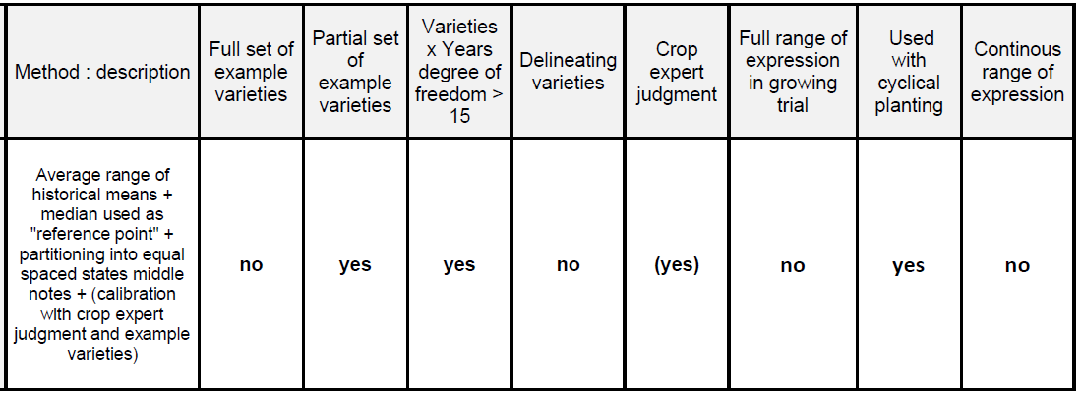
A description of the Italian method for producing variety descriptions is provided as Annex VII to this document.

Further information provided to the expert from the United Kingdom will be considered by the TWC, at its thirty-eighth session, and reported to the TC, at its fifty-sixth session.

summary of different approaches and Information on circumstances for use of methods

The information previously provided by the experts from France, Germany, Japan and the United Kingdom is presented in the descriptions of the respective methods, as set out in Annexes III to VI of this document.

The TWPs are invited to consider the different approaches to convert observations into notes for producing variety descriptions for measured quantitative characteristics, as presented in Annexes III to VII of this document, and information, if any, that could facilitate their application.

[Annexes follow]

DIFFERENT FORMS THAT VARIETY DESCRIPTIONS COULD TAKE
AND THE RELEVANCE OF SCALE LEVELS

Variety descriptions can be based on different data depending on the purpose of the description. Different variety descriptions may be used for the assessment of distinctness or in the official document which forms the basis for granting protection. When variety descriptions are used for the assessment of distinctness it is important to take into account on which data the descriptions for different varieties are based. Special attention has to be given to the potential influence of years and locations.

The different forms of variety descriptions and their relevance for the assessment of distinctness can be classified according to the different process levels to look at a characteristic. The process levels are defined in document TGP/8: Part I: DUS trial design and data analysis. Section 2 (New): Data to be recorded (see TC/50/5, Annex II) as follows:

Table 5: Definition of different process levels to consider characteristics

Process level | Description of the process level
1 | characteristics as expressed in trial
2 | data for evaluation of characteristics
3 | variety description

The process levels relevant for the assessment of distinctness are level 2 and 3. Any comparison between varieties in the same trial (same year(s), same location) is carried out on the actual data recorded in the trial. This approach relates to process level 2. If varieties are not grown in the same trial, they have to be compared on the basis of variety descriptions which relates to process level 3. In general, the identification of similar varieties to be included in the growing trial ("Management of variety collection") relates to process level 3, whereas data evaluation within the growing trial relates to process level 2.

Process level | Measurements  (QN) | Visual assessment  (QN/QL/PQ) | Remark
2 | Values | Notes | Basis for comparison within the same trial
3 | Transformation into notes  Notes | Same Notes as in Process level 1  Notes | Notes resulting from one year and location
 | "Mean variety description"  If varieties are assessed in several trials/years/locations mean descriptions can be established. |  | Basis for management of variety collection

In general, quantitative characteristics are influenced by the environment. An efficient way to reduce the environmental influence is the transformation of actual measurements into notes. The notes represent a standardized description of varieties in relation to example varieties (see TGP/7). In addition, the comparability of variety descriptions for varieties not tested in the same trial can be improved by calculating a mean description over several growing cycles. In particular, the mean description over several growing cycles at the same location can provide a representative description related to the location. The calculation of a mean description over different locations should only be considered if the effects of the locations are very well known and variety x location interactions can be excluded for all characteristics. The calculation of mean descriptions over locations should be restricted to the cases where these conditions are fulfilled.

If variety descriptions from different growing trials are used for the assessment of distinctness - that means for the management of variety collections - it is important to take into account the origin of the different variety descriptions of the candidate variety and the varieties of common knowledge. The comparability of variety descriptions is influenced by many factors, for example:

- Description based on a single year or a mean over several years?
- Description based on the same location or different locations?
- Are the effects of the different location known?
- Varieties described in relation to the same variety collection or a variety collection which might cover a different range of variation?

The potential bias of variety descriptions due to environmental effects between candidate varieties and varieties in the variety collection have to be taken into account in the process of distinctness testing, and in particular, for the identification of varieties of common knowledge to be included in the growing trial.

[Annex II follows]

Compilation of explanations on methods for producing varietIES descriptions for measured characteristics, and clarification of differences

- This document provides a compilation of explanations on methods for producing variety descriptions for measured characteristics, and a clarification of differences.

Introduction

- For crops with measured quantitative characteristics that vary within varieties, distinctness is determined in general by comparison of variety means through statistical analysis, and based on data from trials in a number of years or growing cycles. Because the data on the characteristics are quantitative, the variety means also are quantitative, e.g. measured in millimeters, and so are not on a 0 to 9 scale. To produce a variety description for a variety, the variety means for these characteristics are converted or transformed to notes.

- This document describes the different methods used by some UPOV members to transform variety means into notes for measured quantitative characteristics. It also clarifies the differences between the methods.

- The explanations of methods received from UPOV members to transform measurements into notes for measured quantitative characteristics are compiled in Annexes III to V of this document. A summary of these methods is included in the table below.

COUNTRY |  | Method: description | Example varieties | Crop expert judgment | Equal-spaced state
France | Method 1 | Combined use of example varieties and reference collection | X | X
 | Method 2 | Adjusted means from COY program + linear regression method calibrated with example varieties | X | X
Italy# |  | Average range of historical means + median used as "reference point" + partitioning into equal spaced states + calibration with crop expert judgment and example varieties | X | X | X
Germany* |  | Adjusted mean from COY program + partitioning based on example varieties and crop expert judgment | X | X
Japan |  | Adjusted Full Assessment Table (FAT) : states determined with historical data of example varieties | X |  | X
United Kingdom | Method 1 | Range of expression of the over-year means for the reference collection varieties (for the past 10 years) divided into equal spaced states |  |  | X
 | Method 2 | Crop experts define delineating varieties, in conjunction with example varieties, whose over-year means are used to delineate each state | X | X
* method not considered here as explanation of method not yet received
# method not considered here as method under development

- This is effectively done by:

- Calculation of the range of expression of the characteristic. This is then divided into states, each state relating to a note. To do this, characteristic values equivalent to the limits of the states/notes are calculated.
- Comparison of each candidate variety’s mean with these limits in order to decide the candidate variety’s note.

- The methods differ according to:

- The numbers of varieties and years used in the calculations and when subdividing the range of expression
- How the characteristic values equivalent to the limits of the states/notes are calculated.

- These are summarized in the table below. An equation for the characteristic value equivalent to the upper limit of state/note i is given for each method.

- In all methods, the aim is to produce notes for a candidate variety that are unchanging over time relative to the notes of other varieties. This is needed because these methods are used on crops and characteristics where varieties produce different values over years and locations due to genotype by environment interaction (GEI). The use of one permanent location for DUS trials as the official testing location helps mitigate this effect, as does the use of means over several years – the more years used, the less the influence of GEI effect on the description. This applies both to the means used to calculate the range of expression and divide it into states, and also to the candidate means. The more years used to calculate and divide the range of expression, and the more years contributing to the candidate variety’s mean, the less likely the candidate variety’s note is to change over time relative to the notes of other varieties. Further, the calculation of a candidate variety’s mean over years allows it to be adjusted for year effects, and so make it more comparable with other varieties’ means.

COUNTRY |  | Method: description | Calculations (range of expression of the characteristic, and the characteristic values equivalent to the limits of the states/notes) are based on | Equation for the characteristic value U_{i} equivalent to the upper limit of state/note i | Number of years the candidate variety’s mean is based on
France | Method 1 | Combined use of example varieties and reference collection | Range and limits based on current-year means of all reference varieties given each note in the previous year | $$U_{i}=\frac{{\overline{x}}_{i,n-1}}{2}+\frac{{\overline{x}}_{i+1,n-1}}{2}$$  Where ${\overline{x}}_{i,n-1}$is the current-year mean of all reference varieties given note i the previous year | current year
 | Method 2 | Adjusted means from COY program + linear regression method calibrated with example varieties | Range based on 5-year means for a set of example varieties. Limits based on coefficients of regression of their notes on these. | $$U_{i}=\frac{i+\frac{1}{2}-\hat{a}}{\hat{b}}$$Where $\hat{a}$ is the intercept from the regression of notes for a set of example varieties on their 5-year means  And $\hat{b}$ is the slope from the regression of notes for a set of example varieties on their 5-year means | 2 (3?) years
Japan |  | Adjusted Full Assessment Table (FAT) : states determined with historical data of example varieties | Range based on 10-year means of example varieties. Limits adjusted proportional to the current year mean of an example variety relative to its 10 year mean | $$U_{i}=U_{i.}×\frac{{\overline{x}}_{A,n}}{{\overset{̿}{x}}_{A}}$$  Where $U_{i.}$ is the characteristic value equivalent to the upper limit of state/note i in the fundamental assessment table (FAT)  And ${\overline{x}}_{A,n}$ is the current year mean of example variety A  And ${\overset{̿}{x}}_{A}$ is the 10 year mean of example variety A | current year
United Kingdom | Method 1 | Range of expression of the over-year means for the reference collection varieties (for the past 10 years) divided into equal spaced states | Range and limits based on means over any years where reference varieties have been tested | $$U_{i}={\overline{x}}_{min}+\frac{i×({\overline{x}}_{max}-{\overline{x}}_{min})}{N}$$  Where ${\overline{x}}_{max}$ is the maximum over year reference variety mean  And ${\overline{x}}_{min}$ is the minimum over year reference variety mean  And $N$ is the number of notes | 2 (3?) years
 | Method 2 | Crop experts define delineating varieties whose over-year means are used to delineate each state | Range and limits based on 10-year means of (delineating) reference varieties | $$U_{i}={\overline{x}}_{i}$$  Where ${\overline{x}}_{i}$ is the 10-year mean of the delineating reference variety for note i | 2 or 3 years

[Annex III follows]

SHORT EXPLANATION ON THE FRENCH METHODS FOR PRODUCING VARIETIES DESCRIPTIONS FOR MEASURED CHARACTERISTICS

Document prepared by an expert from France

In France, two main methods have been developed to produce varieties descriptions from measurements. The first one is used mainly on agricultural and vegetable crops and the second one mainly on herbage and some other agricultural crops. A third method can be used only on very stable characteristics observed under controlled conditions: variety description produced according to a fixed scale.

Method 1

Method 1 is based on experience on reference collection varieties and on example varieties. It can only be used for species with a living reference collection.

The first step is to determine the range of notes of the year. To do that, for example for note 5, we calculate the mean of year n of all the reference varieties which were noted 5 the year n-1. This mean becomes the middle of note 5 for year n. Then we determine the limits of notes by this simple formula:

Max (Note 5) = Middle note 5 + [Middle note 6 – Middle note 5] / 2

The main interest of this method is the fact that more reference varieties than only example varieties are taken into account. It increases the power of the transformation of measures into notes. It also takes into account the environmental effect of the considered year. This method is used in France on several species such as maize, oilseed rape or flax.

Method 2

Method 2 is based on a regression calculation from a set of example varieties to determine the notes of candidate varieties.

Means of example varieties are used to set the following regression model:

Y = a + Bx

Y is the note of the example variety

X is the mean of the measurement for this example variety (depending on the specie, the mean can be the arithmetic mean or the adjusted mean using COY analysis).

An equation is then obtained for each measured characteristic, which allows to calculate the notes of each candidate variety.

The choice of example varieties is crucial in this method and it can be difficult to find good example varieties for all the notes. However, it is a reliable method which shows a good stability of descriptions and notes and takes into account the environmental conditions of the year.

This method is used in France mainly on herbage and sunflower.

Example for the characteristic flowering time of sunflower:

Example varieties

In any methods, the crop expert judgment is fundamental to validate the transformation each year and he/she can perform adjustments if needed.

[Annex IV follows]

SHORT EXPLANATION ON THE JAPANESE METHODS FOR ASSESSMENT TABLE FOR PRODUCING VARIETY DESCRIPTIONS

Document prepared by an expert from Japan
- The measured data for QN characteristics in DUS growing trial are transformed to numerical notes based on the assessment table. The assessment table are developed by the measurement data of respective example variety which are allocated in the specific notes, are precisely defined each range of notes. In case of major crops as we have accumulated measured data from long standing DUS growing trials which have been carried out under the same places, similar circumstances and same condition for the crops growing.
- Under these circumstances, the fundamental assessment table (FAT) are developed by these accumulated measured data of the example variety. The FAT is corrected by the growing degree calculated by the comparison with current years measured data of example variety.

3. Sufficient data of example varieties in the DUS growing tests, carried out at the same site, in the same method, needs to be accumulated; preferably for more than 9 years.

4. The method is suitable for all vegetatively propagated and seed-propagated varieties. It is preferable to include example varieties with the same method of propagation as the candidate varieties in the trial. The method is mainly used to evaluate QN characteristics in the DUS testing of ornamental plants or vegetables.

5. If the type of variety is different (i.e. cut flower, garden or pot, etc.), it is necessary to prepare the fundamental assessment table (FAT) for each type separately even if the varieties are covered by the same Test Guidelines.

[Appendix follows]

INTRODUCTION TO USING FUNDAMENTAL ASSESSMENT TABLE SYSTEM FOR QUANTITATIVE CHARACTERISTICS IN JAPAN

- Assessment Table

Assessment Table had been working to transform measured data into numerical note in DUS test. Each note was allocated “Range” by their measured data of example varieties.

Table 1: Example of Assessment Table for characteristic ‘Length of leaf blade’
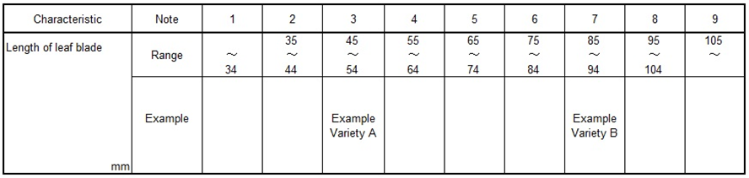

As growing of these example varieties have been affected by the yearly climatic situation or other environmental elements, their actual measured data for QN characteristics have tendency of fluctuation in some extent. Usually registered varieties have been used as similar varieties for DUS growing trials, in the case of registered variety as note 3, registered variety doesn’t always keep their original states when the variety registered by applying above Assessment Table because of fluctuating for the distance of measured data between example variety A and B.

To keep the evaluation unchangeably, the Assessment Table had been improved based on the accumulated measured data of example varieties.

- Fundamental Assessment Table (FAT) System
2.1. FUNDAMENTAL ASSESSMENT TABLE (FAT)
FAT is developed by more than 10 years’ average as “Trial Mean” of data of example varieties which are allocated “Median” of the Range of Note.

Following table is set by 10 years’ average of example varieties.

Table 2: Example FAT for characteristic ‘Length of leaf blade’
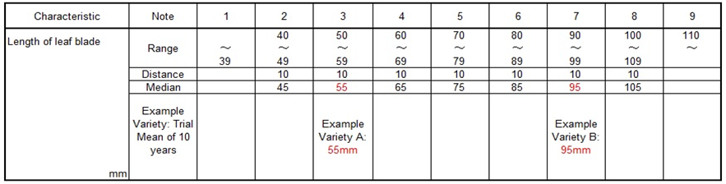

FAT is the assessment table which involved 10 years’ error as principle table, usually FAT is converted by current year’s data of example varieties before the evaluation of the note for QN characteristics.

Current trial data should always be assessed by transforming FUNDAMENTAL ASSESSMENT TABLE (FAT) to CURRENT ASSESSMENT TABLE (CAT).
2.2. Transforming CURRENT ASSESSMENT TABLE (CAT)
To transform from FAT to CAT, it is used “Growth Score” as followings.
2.2.1. Growth Score
Example
10 years’ average as “Trial Mean” of leaf length is 55mm with example variety A
“Current years’ Mean” of leaf length is 52mm with example variety A.
Current Mean of 52mm / Trial Mean of 55mm = 0.95 =“Growth Score”
2.2.2. Multiplying “Growth Score”
CAT is developed by multiplying “Growth Score” to FAT for adjustment to the current growth level.

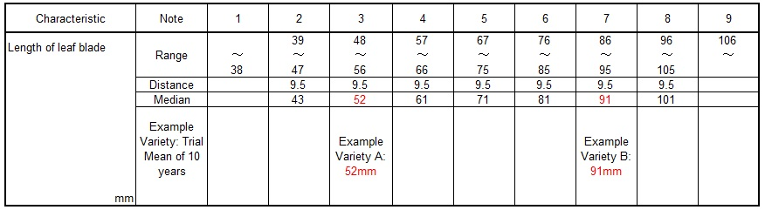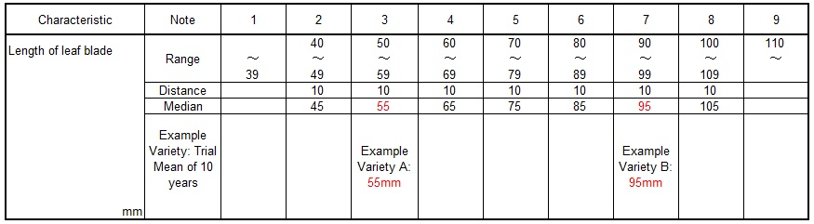
FAT is multiplied Growth Score 0.95
CAT is produced with reflected growth level of the trial (0.95)

2.3 Relevance of FAT and CAT
Following graph explains relation between FAT and CAT. FAT is always retained 1.00 Growth Score. Current trial Growth Score to be scored year by year.

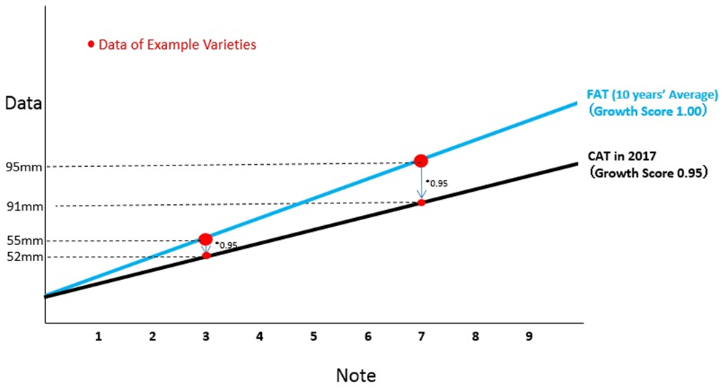

[Annex V follows]

Short explanation on some United Kingdom methods for Data Processing for Producing Variety Descriptions for measured quantitative characters

Document prepared by experts from the United Kingdom

1 For characteristics that are quantitative in expression and vary within varieties, distinctness is usually determined by comparison of variety means through statistical analysis. Such characteristics often arise in cross-pollinated species and in some self-pollinated species. To produce a variety description for the variety, the means for these characteristics are converted to notes by division of the range of expression of the characteristic into states. How this is done depends on the crop. In the United Kingdom for vegetable and herbage crops it is done either so that the states are equally spaced, or by the use of delineating varieties.
Method

2 This document provides an explanation of how measured, quantitative characteristics are handled and used to develop variety descriptions in the United Kingdom for vegetable and herbage crops.

3 In vegetable and herbage crops, which are mostly cross-pollinated except for pea which is self-pollinated, the trials are conducted according to the UPOV Test Guidelines.

4 For the measured, quantitative characteristics, as part of the determination of distinctness, COYD is applied on the original scale of the characteristics.

5 To develop variety descriptions, over-year variety means are calculated on the original scale of the characteristics. These over-year means are then converted to notes. Over-year means are used to minimise any observed variation in varieties due to differences in years. In effect, reference varieties (including example varieties) remain the same note year on year.

6 For each crop the over-year variety means of the varieties in trial are calculated from their yearly means in trials. For herbage crops the past 10 years are used, whereas for vegetable crops all years are included in which the reference collection varieties have been tested. As not all varieties are present in all years, a fitted constants analysis is used to adjust the over-year means for the different years varieties were present in. This is done using the DUSTNT module FITR in conjunction with the module FIND.

7 The over-year means are converted to notes using the DUSTNT module VDES. This permits two methods of division of the range of expression into states and notes as follows, where the number of states is as given in the UPOV Test Guideline:-

(a) By use of delineating varieties to divide the range of expression into states.
The delineating varieties are chosen by crop expert judgement and are based on the notes for example varieties. Delineating varieties differ from example varieties. A delineating variety defines each upper (or lower) intervening limit of the states within the range of expression. By contrast, an example variety usually represents the typical or mid-interval expression of each state within the range of expression.

(b) By division of the range of expression of the over-year means for the reference collection varieties into equal-spaced states.

These methods are illustrated by an example in Figures 1 and 2 respectively. Please note that the worked examples are based on an artificial data set in order to illustrate the method.

8 For vegetable crops excluding potato method (b) is used to divide the range of expression into states and notes, and for herbage crops method (a) is used.

9 For herbage crops the DUSTNT module SAME is used to check whether there are varieties with the same variety description.

10 For herbage crops the DUSTNT module MOST, is used in conjunction with the modules SSQR and DIST to find most similar varieties based on multivariate distances.

Figure 1: Example illustrating how Variety Descriptions are developed in the United Kingdom for Herbage crops using delineating varieties
Characteristic: UPOV No 20, Inflorescence: number of spikelets (see TG/4/8)
The five states for this characteristic are defined by the following delineating reference varieties (shown in bold in the table below).
Reference variety | Delineates
R2 | Upper limit of state 1
R5 | Lower limit of state 3
R10 | Upper limit of state 3
R14 | Lower limit of state 5

To obtain notes for the candidate varieties (C1…C5) for this characteristic, the over-year variety means of the candidate and reference varieties are calculated from their yearly means in a fitted constants analysis. The yearly and over-year variety means, sorted by the latter, are shown below.

As the yearly means for candidates C1 and C2 are between those for varieties R2 and R5, they have note 2.
As the yearly mean for candidate C3 is between those for varieties R10 and R14, it has note 4.
As the yearly mean for candidate C4 is between those for varieties R5 and R10, it has note 3.
As the yearly mean for candidate C5 is less than that for variety R2, it has note 1.

Reference variety | Yearly means |  |  |  |  |  |  |  |  |  | Over-year mean | Note
 | 1 | 2 | 3 | 4 | 5 | 6 | 7 | 8 | 9 | 10
R1 | * | * | * | 22.4 | 23.1 | 20.4 | 22.8 | 23.7 | 20.8 | 22.3 | 21.95 | 1
R2 | * | * | * | 23.4 | 22.9 | 21.7 | 21.4 | 24.2 | 19.5 | 23.3 | 22.05 | 1
R3 | * | * | * | * | * | 22.3 | 21.4 | 24.6 | 20.1 | 23.1 | 22.20 | 2
R4 | 19.8 | 22.1 | 22.2 | 25.3 | 21.8 | 20.6 | 22.6 | 23.6 | 21.8 | 23.6 | 22.32 | 2
R5 | 21.2 | 23.1 | 23.8 | 24.7 | 23.7 | 23.7 | 23.8 | 25.3 | 21.7 | 24.6 | 23.55 | 3
R6 | * | * | * | * | 24.6 | 23.0 | 23.8 | 25.0 | 22.2 | 24.3 | 23.62 | 3
R7 | * | * | * | * | * | 21.5 | 25.9 | 24.7 | 23.1 | 25.2 | 23.98 | 3
R8 | * | * | 25.0 | 24.9 | 25.0 | 23.5 | 24.6 | 26.0 | 22.3 | 25.9 | 24.34 | 3
R9 | * | 24.3 | 25.4 | 24.2 | 25.7 | 23.1 | 24.7 | 26.2 | 23.6 | 25.9 | 24.56 | 3
R10 | * | * | * | * | * | 22.2 | 24.8 | 26.3 | 25.1 | 25.6 | 24.72 | 3
R11 | * | * | * | * | * | * | 25.4 | 27.8 | 24.6 | 27.1 | 25.83 | 4
R12 | 25.1 | 27.6 | 28.6 | 27.0 | 28.0 | 25.4 | 28.5 | 27.9 | 27.3 | 27.3 | 27.27 | 4
R13 | * | * | * | * | 28.3 | 26.3 | 27.7 | 30.0 | 26.6 | 28.4 | 27.71 | 4
R14 | 26.8 | 27.5 | 28.7 | 28.9 | 29.3 | 28.2 | 28.2 | 29.8 | 27.9 | 28.0 | 28.32 | 5
R15 | * | * | * | * | 29.5 | 28.4 | 30.3 | 29.9 | 27.5 | 29.5 | 28.99 | 5
Candidate variety
C1 | * | * | * | * | * | * | * | 22.9 | 22.7 | 23.4 | 22.57 | 2
C2 | * | * | * | * | * | * | * | 24.8 | 22.3 | 23.2 | 23.01 | 2
C3 | * | * | * | * | * | * | * | 27.0 | 24.7 | 27.4 | 25.95 | 4
C4 | * | * | * | * | * | * | * | * | 22.6 | 26.1 | 24.47 | 3
C5 | * | * | * | * | * | * | * | * | 21.0 | 22.1 | 21.67 | 1
Year means | 22.3 | 24.17 | 24.99 | 25.27 | 25.12 | 23.36 | 24.75 | 25.93 | 23.37 | 25.31

Figure 2: Example illustrating how Variety Descriptions are developed in the United Kingdom for Peas by division of the range of expression into equal-spaced states
Characteristic: UPOV No 15, Stipule: length (see TG/7/10)
To obtain notes for the candidate varieties (C1…C5) for this characteristic, the over-year variety means of the candidate and reference varieties are calculated from their yearly means in a fitted constants analysis. The yearly and over-year variety means, sorted by the latter, are shown below.
The five states for this characteristic are defined here by division of the range of expression of the over-year means for the reference collection varieties into equal-spaced states. The range of expression is 109 (= 139 - 30). So each state is of width 109/5 = 21.8, and the upper limits of states 3, 4, 5 and 6 are 51.8, 73.6, 95.4 and 117.2 respectively.
If the technical experts judge the range of variation to be large, the 3-7 scale may be expanded to a 1-9 scale.
As the yearly means for candidates C1 and C2 are less than 51.8, they have note 3.
As the yearly mean for candidate C3 is between 51.8 and 73.6, it has note 4.
As the yearly mean for candidate C4 is between 73.6 and 95.4, it has note 5.
As the yearly mean for candidate C5 is greater than 117.2, it has note 7.

Reference variety | Yearly means |  |  |  |  |  |  |  |  | Over-year mean | Note
 | 1 | 2 | 3 | 4 | 5 | 6 | 7 | 8 | 9
R1 | * | * | * | * | * | 21 | 36 | 22 | 24 | 30.0 | 3
R2 | * | * | * | 29 | 39 | 29 | 39 | 25 | 28 | 35.4 | 3
R3 | * | 55 | 65 | 68 | 48 | 44 | 59 | 56 | 28 | 54.7 | 4
R4 | 72 | 61 | 73 | 45 | 59 | 52 | 68 | 56 | 53 | 59.9 | 4
R5 | * | * | * | * | * | 68 | 70 | 58 | 60 | 68.4 | 4
R7 | * | * | 77 | 61 | 73 | 72 | 80 | 64 | 61 | 72.2 | 4
R8 | * | * | * | * | 96 | 107 | 102 | 101 | 91 | 102.7 | 6
R9 | 121 | 120 | 113 | 78 | 117 | 102 | 109 | 105 | 79 | 104.7 | 6
R10 | * | 97 | 112 | 95 | 124 | 110 | 117 | 112 | 88 | 108.7 | 6
R11 | * | * | * | 122 | 121 | 128 | 105 | 102 | 85 | 117.7 | 7
R12 | * | * | * | * | 110 | 130 | 129 | 106 | 97 | 114.6 | 7
R13 | * | * | * | * | * | 132 | 133 | 130 | 112 | 131.2 | 7
R15 | * | * | * | * | * | 121 | 155 | 157 | 106 | 139.0 | 7
Candidate variety
C1 | * | * | * | * | * | * | 55 | 32 | 27 | 43.3 | 3
C2 | * | * | * | * | * | * | 55 | 58 | 25 | 51.2 | 3
C3 | * | * | * | * | * | * | * | 46 | 44 | 55.7 | 4
C4 | * | * | * | * | * | * | * | 75 | 54 | 75.2 | 5
C5 | * | * | * | * | * | * | * | 124 | 102 | 123.5 | 7
Year means | 96.9 | 83.9 | 90.6 | 75.2 | 84.4 | 80.9 | 87.9 | 79.4 | 64.7

[Annex VI follows]

Data processing for (measurements of) quantitative characteristics in self-pollinated crops for the assessment of distinctness and variety description

Document prepared by an expert from Germany

[Annex VII follows]

SHORT EXPLANATION ON THE ITALIAN METHOD FOR PRODUCING VARIETAL DESCRIPTIONS
(reference to TWC/35/10 - 2017)

The method is based on partitioning into states of ‘Total range of expression’, and ‘Total range of historical averages’.

TOTAL RANGE OF EXPRESSION

- The total range of expression is constructed using the values observed during past trials. Each variety contributes with a sample of the observed values during each trial, including the maximum and minimum value.

TOTAL RANGE OF HISTORICAL AVERAGES

- Reference and candidate varieties can be tested over two or more years, producing means. Therefore each variety can be represented by the range of its historical averages. Means from all varieties tested almost during 8-10 years’ trials are included.

PARTITIONING OF TOTAL RANGES INTO NOTES AND MID REFERENCE

- The smallest note (e. g. 1) and the largest note (e.g. 9) is the extreme notes that cover the tails of “Total expression range”. Extreme notes might be equally or not equally spaced according to the symmetry of range histogram. The other notes are intermediate (e.g. 2…,8) equally spaced, as submultiples of “Total range of historical averages”.

- The midpoint (median) of Total range of historical averages is considered a useful reference to dividing this range, and it also divides note 5 in half.

- After the calculation of extreme notes, the next step is the division of “Total range of historical averages” into middle notes as spaces of equal width. If the range is not an exact multiple of notes number, an adjustment of the range could be necessary.

- The partitioning of the Total range of historical averages after some years from the beginning of the construction appears stable.

TRANSFORMATION OF VARIETY MEANS INTO NOTES

- For each quantitative characteristic, the average of past trials means of each variety is transformed into notes according to values that limit each note.

Example of transformation into notes: Tall fescue - Plant: natural height at inflorescence emergence. (Case of skewed distribution).

Total range of historical averages: 13.9 – 51.4 cm = 37.50 cm
Total range of historical averages adjusted: 14.00 - 52.50 cm = 38.50 cm Midpoint: [(38.50/2) + 14] = 33.25 cm

EXTREME NOTES
Note 1: up to 14.00 cm
Note 9: more than 52.50 cm

INTERMEDIATE NOTES
Notes between 2 and 8: 5.5 cm in length (equally spaced) Note 2: 14.1 – 19.5 cm
Note 3: 19.6 – 25.0 cm
Note 4: 25.1 – 30.5 cm
Note 5: 30.6 – 36.0 cm
Note 6: 36.1 – 41.5 cm
Note 7: 41.6 – 47.0 cm
Note 8: 47.1 – 52.5 cm

Partitioning of “Total range of historical averages adjusted” to notes
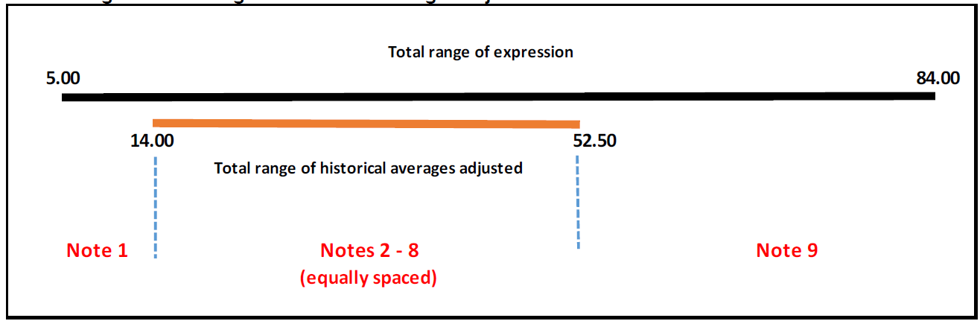

[End of Annex VII and of document]

