E
International Union for the Protection of New Varieties of Plants

Technical Working Party for Vegetables  Fifty-Third Session  Seoul, Republic of Korea, May 20 to 24, 2019 | TWV/53/6  Original: English  Date: April 9, 2019
Partial revision of the Test Guidelines for Vegetable Marrow, Squash
Document prepared by experts from France
Disclaimer: this document does not represent UPOV policies or guidance
The purpose of this document is to present a proposal for a partial revision of the Test Guidelines for Vegetable Marrow, Squash (document TG/119/4 Corr. 2).

The Technical Working Party for Vegetables (TWV), at its fifty-second session, held in Beijing, China, from September 17 to 21, 2018, agreed that the Test Guidelines for Vegetable Marrow, Squash (document TG/119/4 Corr. 2) be partially revised to add new Characteristic “Resistance to ZYMV” (see document TWV/52/20 “Report”, Annex V).

The following changes are proposed:

- Addition of a new Characteristic “Resistance to Zucchini yellow mosaic virus (ZYMV)” at the end of the Table of Characteristics
- Addition of an explanation for the new Characteristic “Resistance to Zucchini yellow mosaic virus (ZYMV)” in Chapter 8.2 “Explanations for individual characteristics”

Proposal to add a new Characteristic “Resistance to Zucchini yellow mosaic virus (ZYMV)” at the end of the Table of Characteristics

 | English | français | Deutsch | español | Example Varieties  Exemples  Beispielssorten  Variedades ejemplo | Note/  Nota
82. | Resistance to Zucchini yellow mosaic virus (ZYMV) | Resistance au Zucchini yellow mosaic virus (ZYMV) | Resistenz gegen Zucchini yellow mosaic virus (ZYMV) | Resistencia a Zucchini yellow mosaic virus (ZYMV)
 | susceptible | sensible | anfällig | sensible | Cora | 1
 | intermediate resistant | modérément résistante | mäßig resistent | moderadamente resistente | Mirza | 2
 | resistant | résistante | resistent | resistente | Mikonos | 3

Proposal to add an explanation for the new Characteristic “Resistance to Zucchini yellow mosaic virus (ZYMV)” in Chapter 8.2 “Explanations for individual characteristics”

Ad. 82: Resistance to Zucchini yellow mosaic virus (ZYMV)

1. | Pathogen | Zucchini yellow mosaic virus (ZYMV)
2. | Quarantine status | No
3. | Host species | Cucurbita pepo L.
4. | Source of inoculum | GEVES (FR)
5. | Isolate | e.g. strain E9
6. | Establishment isolate identity | -
7. | Establishment pathogenicity | Symptoms on susceptible squash variety
8. | Multiplication inoculum
8.1 | Multiplication medium | Living plant
8.2 | Multiplication variety | e.g. Cora
8.3 | Plant stage at inoculation | -
8.4 | Inoculation medium | -
8.5 | Inoculation method | -
8.6 | Harvest of inoculum | -
8.7 | Check of harvested inoculum | -
8.8 | Shelflife/viability inoculum | -
9. | Format of the test
9.1 | Number of plants per genotype | At least 20
9.2 | Number of replicates | At least 2
9.3 | Control varieties | Susceptible : Cora  Intermediate resistant: Mirza  Resistant: Mikonos  Up to now, no complete resistance is identified. The two intermediate and resistant controls are necessary to validate the agressiveness of the test.
9.4 | Test design | add non inoculated plants
9.5 | Test facility | Climatic room or greenhouse
9.6 | Temperature | e.g. 22°C or 24°C/18°C
9.7 | Light | 12h-16h
9.8 | Season
9.9 | Special measures | -
10. | Inoculation
10.1 | Preparation inoculum | 1 g leaf with symptoms with 4 mL of PBS with carborundum (400 mg) and activated carbon (400 mg) or similar buffer, homogenize
10.2 | Quantification inoculum | -
10.3 | Plant stage at inoculation | First expanded leaf
10.4 | Inoculation method | Rubbing with virus suspension
10.5 | First observation | 14 days post-inoculation
10.6 | Second observation | -
10.7 | Final observations | 21 days post-inoculation
11. | Observations
11.1 | Method | Visual observation
11.2 | Observation scale | Class 0: no symptoms  Class 1: few chlorotic spots  Class 2: some chlorotic spots  Class 3: large chlorotic spots (some spots on young leaves)  Class 4: mosaic, weak symptoms of vein banding  Class 5: distorting and vein banding
11.3 | Validation of test | Results should be compared with results of controls and are depending of the aggressiveness of the test and the distribution of the plants over the categories.
11.4 | Off-types | -
12. | Interpretation of data in terms of UPOV characteristic states | Classes 0, 1 are commonly judged as resistant – Note 3  Classes 2, 3 are commonly judged as intermediate resistant – Note 2  Classes 4 and 5 are commonly judged as susceptible – Note 1
13. | Critical control points | Recommended dates of notation should be adapted depending on expression of symptoms on controls.  Environmental conditions can have an effect on the expression of symptoms over time. In this case a second notation could be necessary.

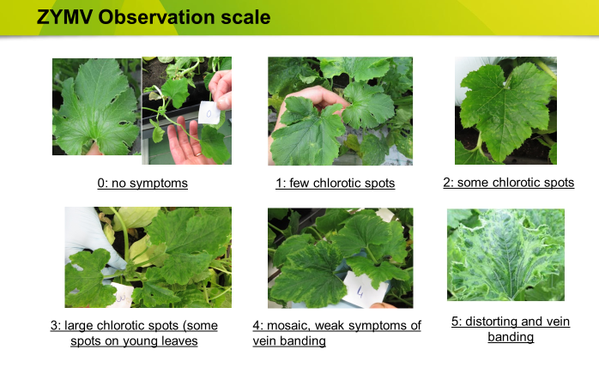

[End of document]

matref@geves.fr

