E
International Union for the Protection of New Varieties of Plants

Technical Working Party for Vegetables  Fifty-Second Session  Beijing, China, September 17 to 21, 2018 | TWV/52/10  Original: English  Date: August 17, 2018
Matters to be resolved concerning Test Guidelines adopted by the Technical Committee: Partial revision of the Test Guidelines for Pea
Document prepared by an expert from France
Disclaimer: this document does not represent UPOV policies or guidance
The Enlarged Editorial Committee (TC-EDC), at its meeting held in Geneva, from March 26 to 27, 2018, considered a proposal for a partial revision of the Test Guidelines for Pea (Pisum sativum L.) (see document TC-EDC/MAR18/5) and agreed that the technical issues raised on the proposed partial revision of the Test Guidelines for Pea should be addressed by the TWV (see document TC-ECD/MAR18/11 “Report”, paragraph 57).

The following table presents all the comments made by the TC-EDC on the proposed partial revision of the Test Guidelines for Pea (document TC-EDC/MAR18/5), including the technical issues, with the proposed responses by the Leading Expert, Mr. Pascal Coquin (France).

Ad. 60 | to magnify photos (Are the images large enough to see the detail required? If you zoom on the computer, they have very good resolution but are the details clear enough on the printed page?)  Leading Expert: please see new proposal below

11.2 | Observation scale | class 0: no symptoms  class 1: few small superficial necrosis  class 2: bigger darker and deep necrosis  class 3: necrosis at each level of the plant or serious symptoms surrounding the stem  Madonna, Nina and Rondo will be resistant controls; varieties with same level of resistance as Madonna/Rondo and/or Nina will be interpreted as resistant. Crecerelle and Kelvedon Wonder will be susceptible controls, varieties with a lower level of resistance than Nina as well as Madonna/Rondo will be interpreted as susceptible.

Notation scale

Class 0:  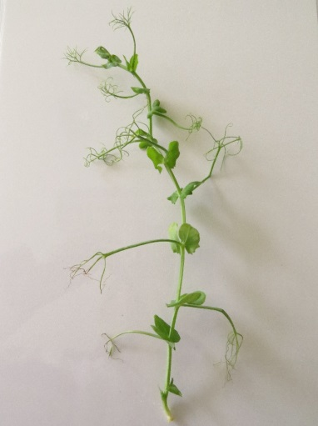 | Class 1:  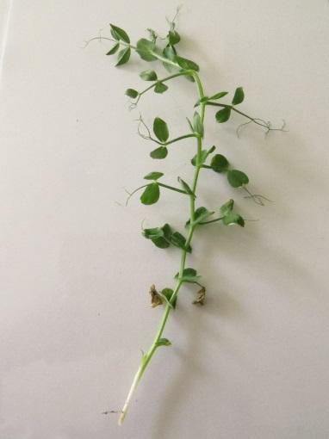
Class 2:  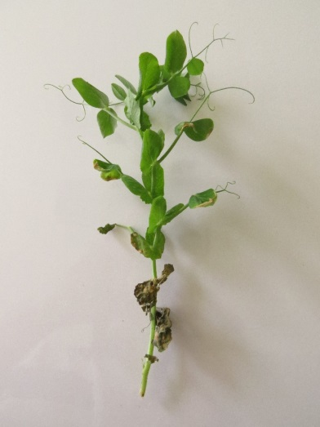 |  | Details on Class 2:  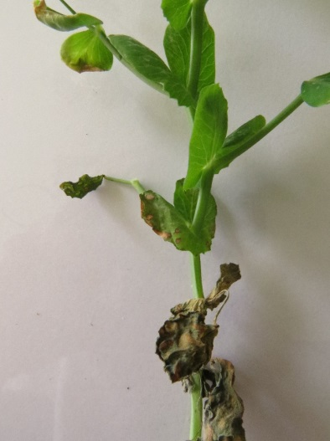
Class 3 :  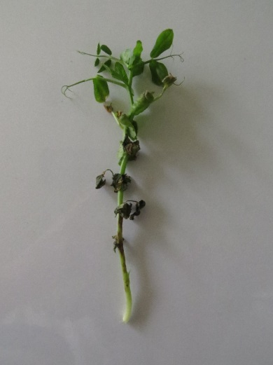 | Details on Class 3  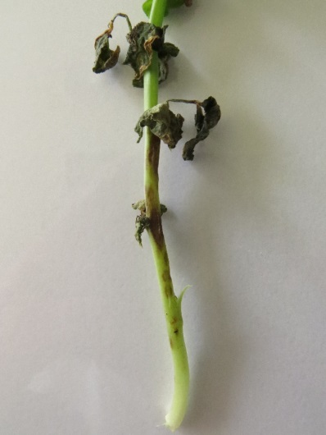

Interpretation depending on controls

Resistant
Crecerelle
Madonna
Nina
Susceptible
Kelvedon Wonder
Rondo

Ad. 60, 4.  Footnotes 1 and 2 | to indicate e-mail and web address of the institutions instead of personal e-mail addresses  Leading Expert: matref@geves.fr / www.geves.fr
Ad. 60, 5. | to read “Ascochyta pisi race C strain 21A.13. (the test protocol has been validated in a European CPVO co-funded project3 with this isolate)³”  Leading Expert: agreed
Ad. 60, Footnote 3 | to be moved to 9. Literature with standardized format of literature quotes.  Leading Expert: agreed
Ad. 60, 6. | to add “Gallais et Bannerot, 1992” to chapter 9. Literature  Leading Expert: agreed
Ad. 60 | to delete 8.2, 8.3 and 8.5  Leading Expert: agreed
Ad. 60, 8.8 | to clarify meaning of “4/8h” (does it mean “half hour”?)  Leading Expert: it means “between 4 and 8 hours”
Char. 60,  Ad. 60, 11. | - to provide clarification on type of expression: see explanation, doesn’t correspond to QL  - the 4-notes scale in Ad. 60, 11.2 “observation scale” indicates QN)  clarification by TWV needed  - in order to avoid confusion, avoid the term notes  Leading Expert: we propose to replace the word “note” by “class”. precisely, each type of expression is renamed “class”; therefore, the QL category would be OK.  - to check whether to have separate characteristics for each strain  (With this explanation it is very unlikely that notes absent/present are appropriate. In particular the photos and the drawing are confusing. Where is the clear gap between 1 and 9?)  Leading Expert: we propose to delete all other strains except the strain C as precised below:  Physiological races (Dr Hubbeling) Strains C Tézier 21A.13  Gullivert S  Rondo R  Finale R  Kelvedon Wonder S  Dark Skin Perfection S  Arabal, Cobri, Starcovert, Sucovert, Vitalis S  R = resistant; S = susceptible, VLS = very lightly susceptible, LS = lightly susceptible  - What means “necrosis at each level of the plant”? Clarification needed.  Leading Expert: we propose to replace this expression by “necrosis at all levels of the plant”.

[End of document]

