E
International Union for the Protection of New Varieties of Plants

Technical Working Party for Vegetables  Fifty-First Session  Roelofarendsveen, Netherlands, July 3 to 7, 2017 | TWV/51/6  Original: English  Date: June 14, 2017
Partial revision of the Test Guidelines for PEA (Document TG/7/10 Rev.)
Document prepared by the European Union
Disclaimer: this document does not represent UPOV policies or guidance
The purpose of this document is to present a proposal for a partial revision of the Test Guidelines for Pea (Pisum sativum L.) (document TG/7/10 Rev.).

The Technical Working Party for Vegetables (TWV), at its fiftieh session, held in Brno, Czech Republic, from June 27 to July 1, 2016, agreed that the Test Guidelines for Pea (document TG/7/10 Rev.) be partially revised for disease resistance explanations for Fusarium oxysporum f. sp. pisi race 1 (Ad. 58.1) and Ascochyta pisi race C (Ad. 60) (see document TWV/50/25 “Report”, Annex IV).

The following changes are proposed:

- To change the example varieties for Characteristic 58.1 “Resistance to Fusarium oxysporum f. sp. pisi Race 1”
- To change the methodology for Characteristic 58 under Ad. 58
- To add new example varieties for Characteristic 60 “Resistance to Ascochyta pisi Race”
- To change the methodology for Characteristic 60 under Ad. 60
The proposed changes are presented below in highlight and underline (insertion) and strikethrough (deletion).

Proposed change to the example varieties for Characteristic 58.1 “Resistance to Fusarium oxysporum f. sp. pisi Race 1”

Current wording

58.  (+) | VG | Resistance to Fusarium oxysporum f. sp. pisi | Résistance à Fusarium oxysporum f. sp. pisi | Resistenz gegen Fusarium oxysporum f. sp. pisi | Resistencia a Fusarium oxysporum f. sp. pisi
58.1 |  | Race 1 | Race 1 | Pathotyp 1 | Raza 1
QL |  | absent | absente | fehlend | ausente | Eden,  Mammoth Melting Sugar | 1
 |  | present | présente | vorhanden | presente | Solara, Twinkle | 9

Proposed new wording

58.  (+) | VG | Resistance to Fusarium oxysporum f. sp. pisi | Résistance à Fusarium oxysporum f. sp. pisi | Resistenz gegen Fusarium oxysporum f. sp. pisi | Resistencia a Fusarium oxysporum f. sp. pisi
58.1 |  | Race 1 | Race 1 | Pathotyp 1 | Raza 1
QL |  | absent | absente | fehlend | ausente | Eden, Mammoth Melting Sugar  Bartavelle | 1
 |  | present | présente | vorhanden | presente | Solara, Twinkle  New Era, Nina | 9

Proposed change to the methodology for Characteristic 58 under Ad. 58

Current wording

Ad. 58.1, 58.2, 58.3: Resistance to Fusarium oxysporum f. sp. pisi

Resistant and Susceptible varieties
Race 1: Eden, Mammoth Melting Sugar (susceptible = resistance absent (1))
Solara, Twinkle (resistant = resistance present (9))

Race 5: Little Marvel, Legacy (susceptible = resistance absent (1))
Serge, Sundance (resistant = resistance present (9))

Race 6: Little Marvel, Serge (susceptible = resistance absent (1))
Sundance (resistant = resistance present (9))

Isolates and isolate identity
Isolate identity is determined by testing against the host differential set described by Haglund and Kraft (1979). All isolates are derived from single spore cultures.

Isolates used in the test: Race 1: IPO culture collection no. 20379
Race 5: IPO culture collection no. 10279
Race 6: WSU culture type 6

Maintenance of isolates
Maintain in a refrigerator at 4ºC as a soil culture (loam) and pass through a susceptible variety every 2-3 years. Isolate identity is determined by testing against a host differential set.

Source for isolates
Races 1 and 5 Research Institute for Plant Protection (IPO)
PO Box 9060
NL-6700 GW Wageningen
The Netherlands

Race 6 Washington State University (WSU),
Research and Extension Unit,
Mount Vernon, Washington 98273,
United States of America

Preparation of inoculum and assessment of disease
Cultures of the fungus are grown in liquid Czapek-Dox medium at 2ºC in daylight conditions for 7 days. The liquid is continuously aerated by sterile air. The cultures are strained through muslin followed by centrifugation at 3,500 rpm for 10 minutes; the solution is diluted with distilled water to a concentration of 10⁶ spores/ml.

Inoculation and assessment of disease Test plants and controls are raised in 8 liters of 1:1 peat and sand mixture and adjusted to pH 5.0. 1 liter of spore suspension is used. Two replicates of 10 plants are grown for assessment; a third replicate is grown if any problems arise.

After 3 weeks, or 4 - 5 node stage, the basal third of the seedling roots can be cut and dipped into the inoculum for 3-5 seconds before being transplanted. Four weeks after inoculation, surviving seedlings are recorded as resistant.

Composition of the Czapek-Dox liquid medium

2.0 g Sodium Nitrate
0.5 g Potassium Chloride
1.0 g Dipotassium Phosphate
0.5 g Magnesium Sulphate
0.01 g Ferrous Sulphate
30.0 g Saccharose

The above mixture is added to 1 liter of distilled water and poured into a flask; the solution is sterilized in an autoclave at 115ºC for 20 minutes.

Genetic background
A single dominant gene Fw confers resistance to Race 1.
Proposed new wording

Ad. 58.1: Resistance to Fusarium oxysporum f. sp. pisi race 1 (Near wilt)

1. Pathogen Fusarium oxysporum f. sp. pisi race 1
2. Quarantine status no
3. Host species Pea – Pisum sativum L.
4. Source of inoculum For Fop: 1, GEVES (FR), INIA (SP) or SASA (UK)
5. Isolate Fusarium oxysporum f. sp. pisi race 1 strain MATREF 04-02-01-01 (the test protocol has been validated in a CPVO co-funded project with this isolate/race).
6. Establishment isolate identity genetically defined pea controls (See ISF website: http://www.worldseed.org/cms/medias/file/TradeIssues/DiseasesResistance/Differentials/Pea-near_wilt_2012.pdf )
Differentials host | Race (ISF Code)
 | 1 (Fop: 1) | 2 (Fop: 2) | 5 (Fop: 5) | 6 (Fop: 6)
Little Marvel, M410 | S | S | S | S
Dark Skin Perfection, Vantage | R | S | S | S
Mini | S | R | S | S
New Era, Mini 93 | R | R | S | S
Sundance II | R | S | R | S
Grant | R | S | S | R
New Season | R | R* | S | R
WSU 23 | R | R | R | S
WSU 28 | R | S | R | R
WSU 31, 74SN5 | R | R | R | R
R = resistant; S = susceptible, *= reaction may vary with isolate

7. Establishment pathogenicity Test on susceptible plants
8. Multiplication inoculum
8.1 Multiplication medium Multiplication on agar medium: malt Agar or PDA for example
8.2 Multiplication variety -
8.3 Plant stage at inoculation -
8.4 Inoculation medium Multiplication on agar medium: water for scraping agar plates Multiplication on liquid medium: Potato Dextrose Broth, Kerrs broth or Czapek-Dox (3 to 7 days old aerated culture) for example.
8.5 Inoculation method -
8.6 Harvest of inoculum see 10.1
8.7 Check of harvested inoculum see 10.2.
8.8 Shelf life/viability inoculum 4/8h, keep cool to prevent spore’s germination. More than 3 years at -20°C.
9. Format of the test
9.1 Number of plants per genotype At least 20 plants and 5 non inoculated plants per variety.
9.2 Number of replicates -
9.3 Control varieties Susceptible controls: Bartavelle
Resistant controls: New Era and Nina
9.4 Test design -
9.5 Test facility Climate room or greenhouse.
9.6 Temperature 20-25°C
9.7 Light 12 hours or longer
9.8 Season -
9.9 Special measures it is important to compare any plants with a negative control of the same sample to allow to interpret symptoms of root rot or senescence or 'wilting' due to the stress of having roots cutted and not due to F. oxysporum infection.

10. Inoculation
10.1 Preparation inoculum For agar plates, remove hyphen fragments by straining solution through muslin.
For liquid medium, filter through muslin.
10.2 Quantification inoculum 10⁶ spores/mL
10.3 Plant stage at inoculation seeds or 2 weeks old seedlings (2-3 node stage).
10.4 Inoculation method For seeds: sowing in contaminated substrate (soil based substrate), 750mL of suspension of spores at 10⁶sp/mL for 5L of substrate.
For 2 weeks seedlings:
Sowing in a mix of vermiculite + soil or soil based substrate
Cut roots, dip in the spores suspension for 1 to 5 minutes and transplant in soil based substrate in a new tray
10.7 Final observations 28 days post-inoculation.
11. Observations
11.1 Method Visual
11.2 Observation scale 0: no symptoms or equivalent to negative control, 1 or 2 senesced lower leaves and slight reduction in growth compared to negative control of same variety are acceptable
1: Range from a few chlorotic or wilting/senesced leaves not present on, or more than on the negative control, up to many leaves with symptoms of senescence or wilting, some leaf drop, upper part of the plant still green and growing
2: Range from most of the plant senesced or wilted but still alive, to plants brown and dead with stem collapsed
Notes 0 and 1 are resistant.
Note 2 is susceptible
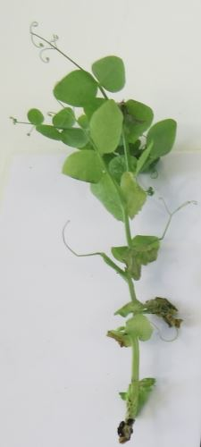 | 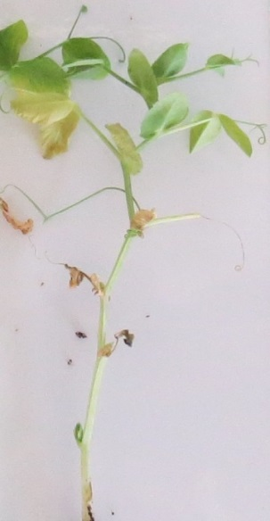 | 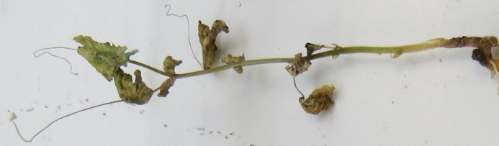 | 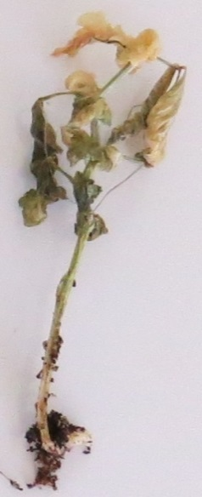
note 0  resistant | note1  resistant | note 2  susceptible | note 2  susceptible

Varieties with the same or higher level of resistance as New Era will be interpreted as resistant. Varieties with a lower level of resistance than New Era will be interpreted as susceptible. Nina will be highly resistant, Bartavelle will be highly susceptible. . New Era expresses weak symptoms and variation can occur in these weak symptoms depending on the agressivity of the test conditions.
11.3 Validation of test evaluation of variety resistance should be calibrated with results of resistant and susceptible controls.
12. Interpretation of data in terms of UPOV characteristic states
absent [1] susceptible
present [9] resistant
13. Critical control points each lab has to define the best method of inoculation in its lab depending on controls results.
Inoculation by sowing in contaminated soil can in some cases lead to germination problems. No conclusion can be done in this case, and the test should be repeated.
Ad. 58.2, 58.3: Resistance to Fusarium oxysporum f. sp. pisi races 5 and 6 (Near wilt)

1. Pathogen Fusarium oxysporum f. sp. pisi
2. Quarantine status no
3. Host species Pea – Pisum sativum L.
4. Source of inoculums For Fop: 5, Research Institute for Plant Protection (IPO)
For Fop: 6, Washington State University (WSU)
5. Isolate Fusarium oxysporum f. sp. pisi race 5: IPO culture collection no. 10279.
Fusarium oxysporum f. sp. pisi race 6: WSU culture type 6
6. Establishment isolate identity genetically defined pea controls (See ISF website: http://www.worldseed.org/cms/medias/file/TradeIssues/DiseasesResistance/Differentials/Pea-near_wilt_2012.pdf ). All isolates are derived from single spore cultures.

Differentials host | Race (ISF Code)
 | 1 (Fop: 1) | 2 (Fop: 2) | 5 (Fop: 5) | 6 (Fop: 6)
Little Marvel, M410 | S | S | S | S
Dark Skin Perfection, Vantage | R | S | S | S
Mini | S | R | S | S
New Era, Mini 93 | R | R | S | S
Sundance II | R | S | R | S
Grant | R | S | S | R
New Season | R | R* | S | R
WSU 23 | R | R | R | S
WSU 28 | R | S | R | R
WSU 31, 74SN5 | R | R | R | R
R = resistant; S = susceptible, *= reaction may vary with isolate

7. Establishment pathogenicity Test on susceptible plants
8. Multiplication inoculum
8.1 Multiplication medium liquid Czapek-Dox medium
Composition of the Czapek-Dox liquid medium
2.0 g Sodium Nitrate
0.5 g Potassium Chloride
1.0 g Dipotassium Phosphate
0.5 g Magnesium Sulphate
0.01 g Ferrous Sulphate
30.0 g Saccharose
The above mixture is added to 1 liter of distilled water and poured into a flask; the solution is sterilized in an autoclave at 115°C for 20 minutes.
8.2 Multiplication variety -
8.3 Plant stage at inoculation -
8.4 Inoculation medium Cultures of the fungus are grown in liquid Czapek-Dox medium at 2°C in daylight conditions for 7 days. The liquid is continuously aerated by sterile air. The cultures are strained through muslin followed by centrifugation at 3,500 rpm for 10 minutes; the solution is diluted with distilled water to a concentration of 10⁶ spores/mL.
8.5 Inoculation method -
8.6 Harvest of inoculum see 10.1
8.7 Check of harvested inoculum see 10.2.
8.8 Shelf life/viability inoculum Maintain in a refrigerator at 4°C as a soil culture (loam) and pass through a susceptible variety every 2-3 years. Isolate identity is determined by testing against a host differential set.
9. Format of the test
9.1 Number of plants per genotype Two replicates of 10 plants are grown for assessment.
9.2 Number of replicates -
9.3 Control varieties Race 5:
Susceptible controls: Legacy, Little Marvel
Resistant controls: Serge, Sundance
Race 6:
Susceptible controls: Little Marvel, Serge
Resistant controls: Sundance
9.4 Test design -
9.5 Test facility -
9.6 Temperature -
9.7 Light -
9.8 Season -
9.9 Special measures a third replicate is grown if any problems arise.
10. Inoculation
10.1 Preparation inoculum The cultures are strained through muslin followed by centrifugation at 3,500 rpm for 10 minutes; the solution is diluted with distilled water to a concentration of 10⁶ spores/mL.
10.2 Quantification inoculum 10⁶ spores/mL
10.3 Plant stage at inoculation 3 weeks old seedlings (4-5 node stage). Test plants and controls are raised in 8 liters of 1:1 peat and sand mixture and adjusted to pH 5.0.
10.4 Inoculation method 1 liter of spore suspension is used. The basal third of the seedling roots can be cut and dipped into the inoculum for 3-5 seconds before being transplanted.
10.7 Final observations Four weeks after inoculation.
11. Observations
11.1 Method Visual
11.2 Observation scale surviving seedlings are recorded as resistant
11.3 Validation of test evaluation of variety resistance should be calibrated with results of resistant and susceptible controls.
12. Interpretation of data in terms of UPOV characteristic states
absent [1] susceptible
present [9] resistant
13. Critical control points -

Proposed change to add new example varieties for Characteristic 60 “Resistance to Ascochyta pisi Race”

Current wording

60.  (+) | VG | Resistance to Ascochyta pisi,  Race C | Résistance à Ascochyta pisi,  race C | Resistenz gegen Ascochyta pisi, Pathotyp C | Resistencia a Ascochyta pisi,  Raza C
QL |  | absent | absente | fehlend | ausente | Kelvedon Wonder | 1
 |  | present | présente | vorhanden | presente | Rondo | 9

Proposed new wording

60.  (+) | VG | Resistance to Ascochyta pisi,  Race C | Résistance à Ascochyta pisi,  race C | Resistenz gegen Ascochyta pisi, Pathotyp C | Resistencia a Ascochyta pisi,  Raza C
QL |  | absent | absente | fehlend | ausente | Crecerelle,  Kelvedon Wonder | 1
 |  | present | présente | vorhanden | presente | Madonna, Nina, Rondo | 9

Proposed change to change the methodology for Characteristic 60 under Ad. 60

Current wording

Ad. 60: Resistance to Ascochyta pisi, Race C (Ascochyta Leaf and Pod Spot)

Resistant and Susceptible varieties
Kelvedon Wonder (susceptible = resistance absent (1))
Rondo (resistant = resistance present (9))
Isolates and isolate identity
Isolate used in the test: Tezier Strain
Isolate identity is determined by testing against a host differential set.

Maintenance of isolates
Maintain on Mathur medium at ambient temperature. Isolate identity is determined by testing against a host differential set.

Source for isolates: GEVES SNES
Station Nationale d’Essais de Semences
Rue George Morel, B.P.24
49071 Beaucouzé Cedex France

Preparation of inoculum
Add 0.4% Tween 80 wetting agent to aid dispersal of spores. Remove hyphal fragments by straining solution through muslin. Concentration of 10⁶ spores/ml

Inoculation and assessment of disease
Grow seedlings in glasshouse under natural daylength at 20ºC and high humidity. Spray inoculum on young seedlings 10-15 days after emergence; mist spray 2 or 3 times per day for 15 minutes. Alternatively, inoculation can be made at the apex of enclosed leaves. This method does not require conditions of high humidity.

Plants are assessed about 5 days after inoculation. Infection is very clear when present: necrotic lesions are slightly sunken, brown and sharply delineated. Lesions are circular on pods and elongated on stems. Two replicates of 10 plants are grown; a third replicate is grown if any problems arise.

Genetic background
The expression of resistance to Race C (also known as BP2) is controlled by a single dominant gene Rap2. At least five pathotypes and four resistance alleles are known.

Proposed new wording

Ad. 60: Resistance to Ascochyta pisi, Race C (Ascochyta Leaf and Pod Spot)

1. Pathogen Ascochyta pisi
2. Quarantine status no
3. Host species Pea – Pisum sativum L.
4. Source of inoculum GEVES (FR) or SASA (UK)
5. Isolate Ascochyta pisi race C strain 21A.13. (the test protocol has been validated in a European CPVO co-funded project with this isolate).
6. Establishment isolate identity genetically defined pea controls (Physiological races of A. pisi and differentials, adapted from Gallais et Bannerot, 1992)
Physiological races (Dr Hubbeling)  Strains | D  N°1 | _  Several isolates | _  N°4 | _  N°14 | C  Tézier  21A.13 | B  _ | E  _
Gullivert | R | R | R | R | S | R | R
Rondo | R | R | S | VLS | R | R | S
Finale | R | R | S | LS | R | - | -
Kelvedon Wonder | R | S | S | S | S | R | R
Dark Skin Perfection | S | S | S | S | S | R | S
Arabal, Cobri, Starcovert, Sucovert, Vitalis | S | S | S | S | S | S | S
R = resistant; S = susceptible, VLS = very lightly susceptible, LS = lightly susceptible

7. Establishment pathogenicity Test on susceptible plants
8. Multiplication inoculum
8.1 Multiplication medium V8 agar or Mathur medium or Potato Dextrose Agar or a synthetic medium.
8.2 Multiplication variety -
8.3 Plant stage at inoculation -
8.4 Inoculation medium water, option: add Tween 80 (wetting agent to aid dispersal of spores, e.g. 0.4%)
8.5 Inoculation method -
8.6 Harvest of inoculum see 10.1
8.7 Check of harvested inoculum see 10.2.
8.8 Shelf life/viability inoculum 4/8h, keep cool to prevent spores’ germination
9. Format of the test
9.1 Number of plants per genotype At least 20 plants and 5 non inoculated plants per variety.
9.2 Number of replicates -
9.3 Control varieties Susceptible controls: Crecerelle, Kelvedon Wonder
Resistant controls:
Nina and Madonna or Rondo
9.4 Test design -
9.5 Test facility Climate room or greenhouse.
9.6 Temperature 20°C
9.7 Light 12 hours or longer
9.8 Season -
9.9 Special measures high humidity or watering by spraying 2 or 3 times per day
10. Inoculation
10.1 Preparation inoculum remove hyphen fragments by straining solution through muslin.
10.2 Quantification inoculum 10⁶ spores/mL (to adapt depending conditions of tests)
10.3 Plant stage at inoculation 2 weeks old seedlings (i.e. 2-3 node stage)
10.4 Inoculation method spraying on green leaves without surface moisture.
10.7 Final observations 10-18 days post-inoculation.
11. Observations
11.1 Method Visual
11.2 Observation scale 0: no symptoms
1: few small superficial necrosis
2: bigger darker and deep necrosis
3: necrosis at each level of the plant or serious symptoms surrounding the stem
Madonna, Nina and Rondo will be resistant controls; varieties with same level of resistance as Madonna/Rondo and/or Nina will be interpreted as resistant. Crecerelle and Kelvedon Wonder will be susceptible controls, varieties with a lower level of resistance than Nina as well as Madonna/Rondo will be interpreted as susceptible.
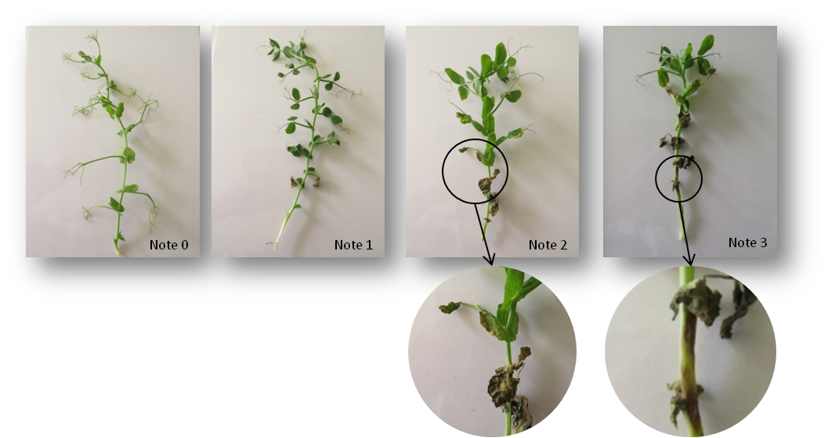

Resistant
Crecerelle
Madonna
Nina
Susceptible
Kelvedon Wonder
Rondo

11.3 Validation of test evaluation of variety resistance should be calibrated with results of resistant and susceptible controls.
12. Interpretation of data in terms of UPOV characteristic states
absent [1] susceptible
present [9] resistant
13. Critical control points -.

[End of document]

matref@geves.fr
cardaba@inia.es
Marian.McEwan@sasa.gsi.gov.uk
Harmores 2 CPVO project (http://www.cpvo.europa.eu/main/en/home/documents-and-publications/technical-projects-reports)
PO Box 9060, NL-6700 GW Wageningen, The Netherlands
Research and Extension Unit, Mount Vernon, Washington 98273, United States of America
matref@geves.fr
Marian.McEwan@sasa.gsi.gov.uk
Harmores 2 CPVO project (http://www.cpvo.europa.eu/main/en/home/documents-and-publications/technical-projects-reports)

