E
International Union for the Protection of New Varieties of Plants

Technical Working Party for Vegetables  Fifty-First Session  Roelofarendsveen, Netherlands, July 3 to 7, 2017 | TWV/51/2 Rev.  Original: English  Date: August 4, 2017
MOLECULAR TECHNIQUES
Document prepared by the Office of the Union
Disclaimer: this document does not represent UPOV policies or guidance
The Annexes to this document contain a copy of the following presentations made at the fifty-first session of the Technical Working Party for Vegetables:

- Annex I: “Management of variety collections - How we use molecular techniques in France” by an expert from France;
- Annex II: “Onion- Managing the variety collection with the use of DNA information” by an expert from the Netherlands;
- Annex III: “Efficient DUS test in French bean (Phaseolus vulgaris L.) by using molecular data” by an expert from the Netherlands.

[Annexes follow]

MANAGEMENT OF VARIETY COLLECTIONS - HOW WE USE MOLECULAR TECHNIQUES IN FRANCE BY AN EXPERT FROM FRANCE

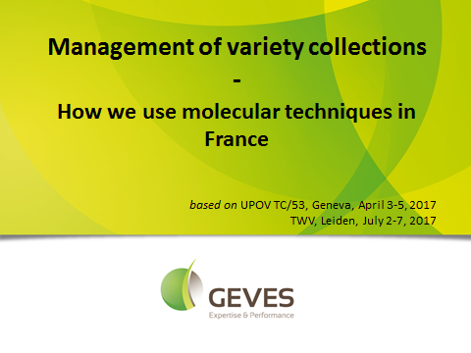

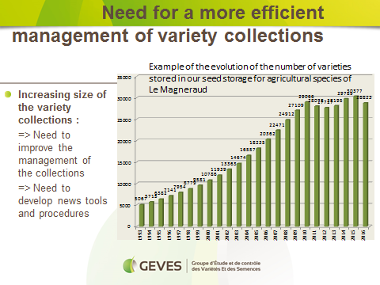

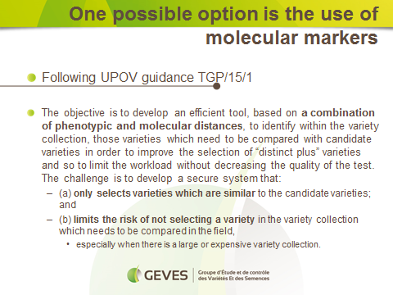

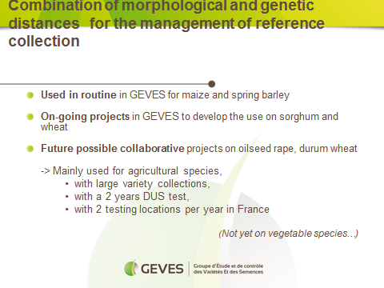

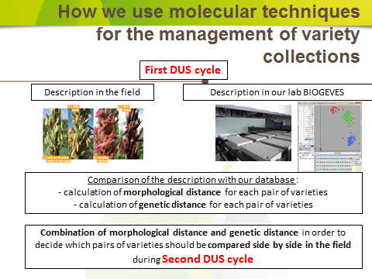

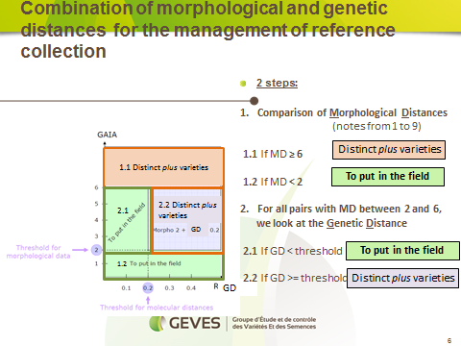

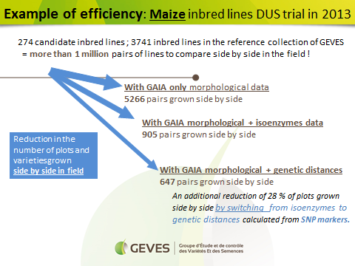

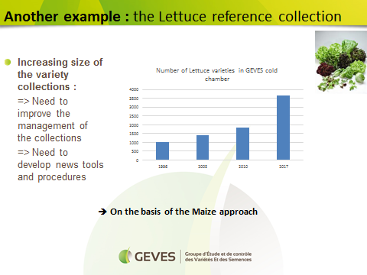

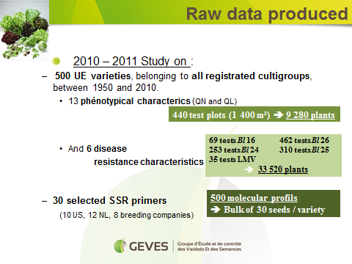

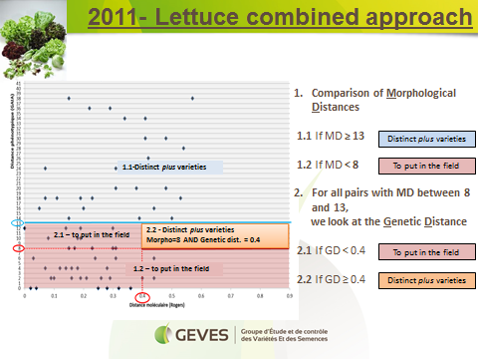

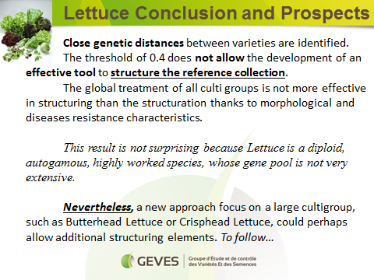

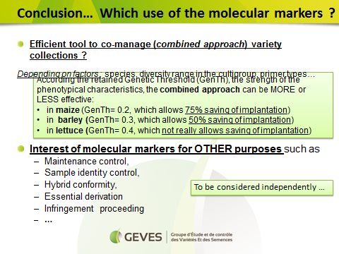

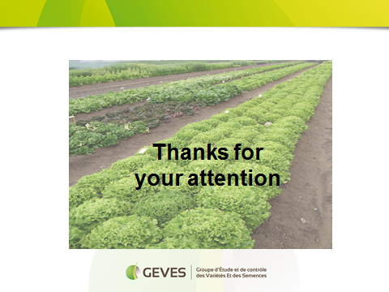

[Annex II follows]

ONION- MANAGING THE VARIETY COLLECTION WITH THE USE OF DNA INFORMATION”
BY AN EXPERT FROM THE NETHERLANDS

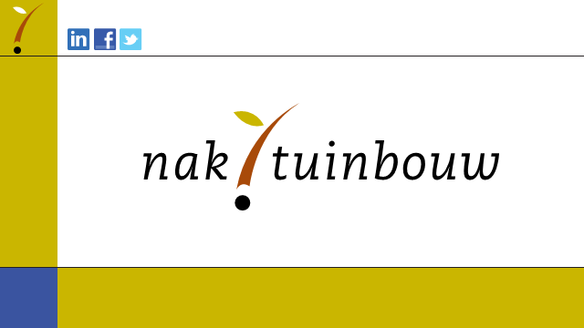

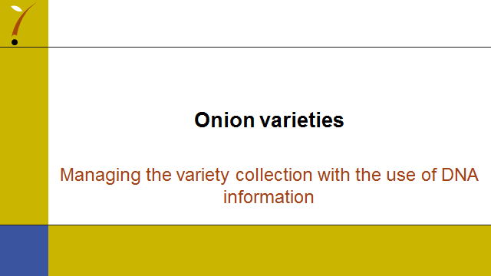

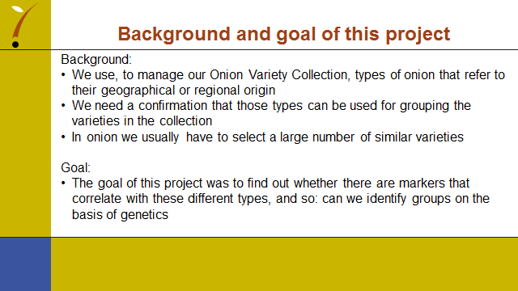

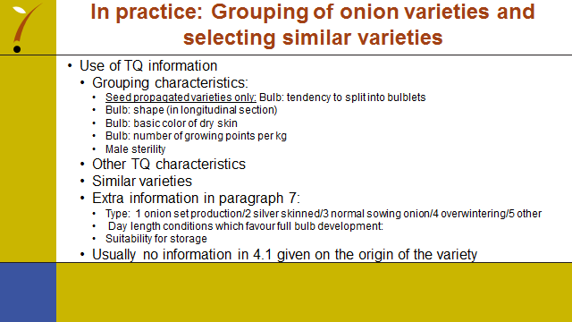

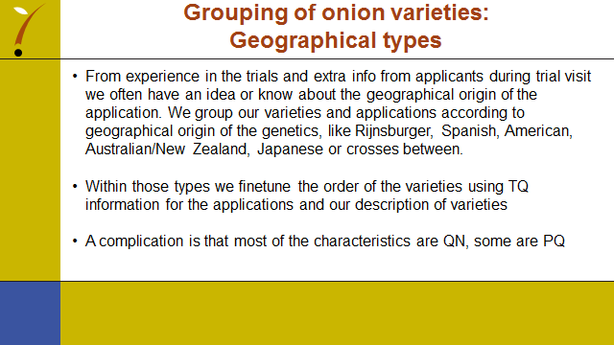

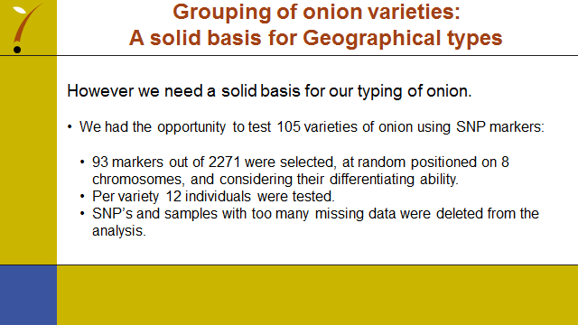

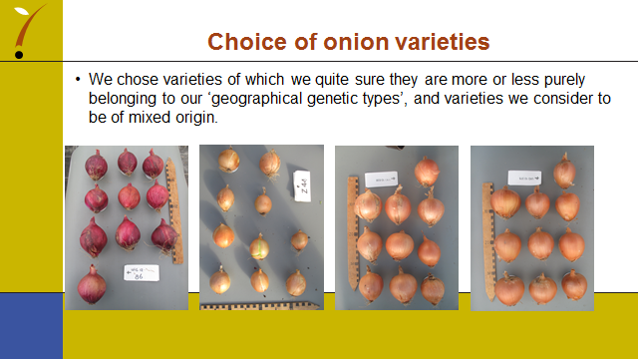

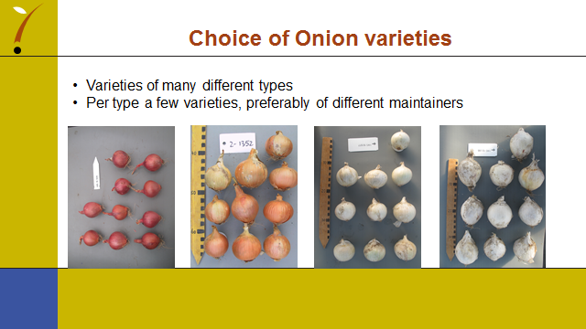

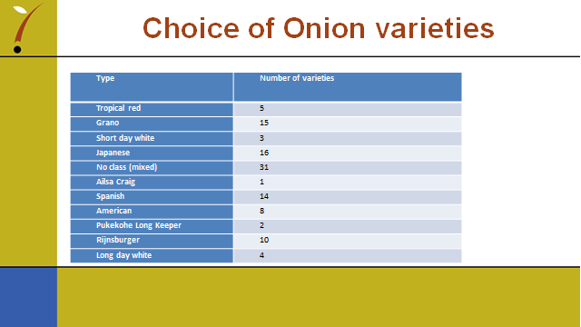

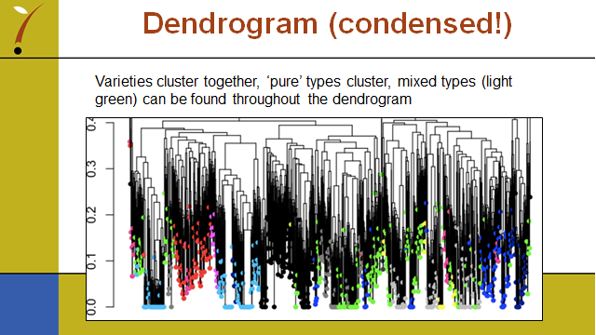

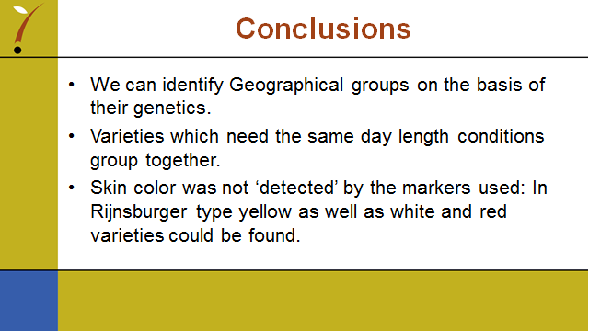

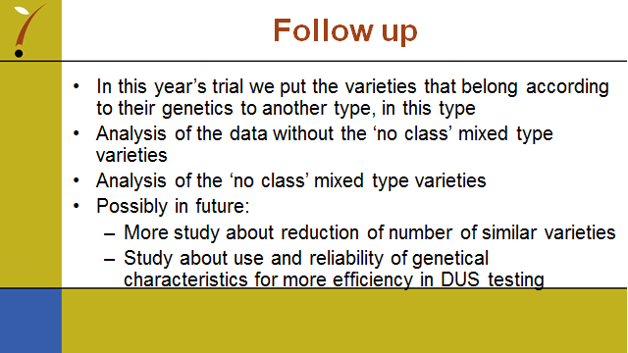

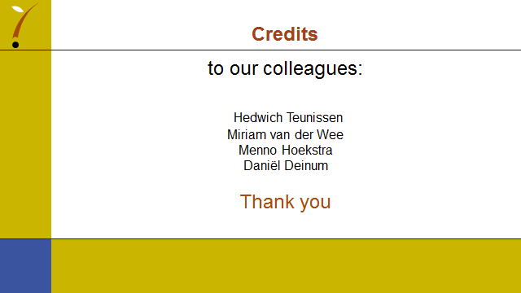

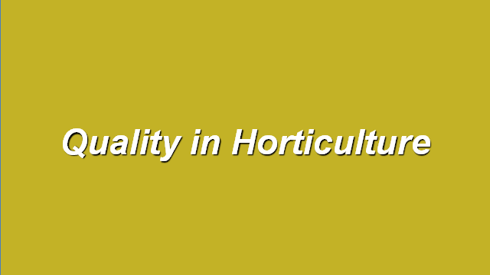

[Annex III follows]

EFFICIENT DUS TEST IN FRENCH BEAN (PHASEOLUS VULGARIS L.) BY USING MOLECULAR DATA
BY AN EXPERT FROM THE NETHERLANDS

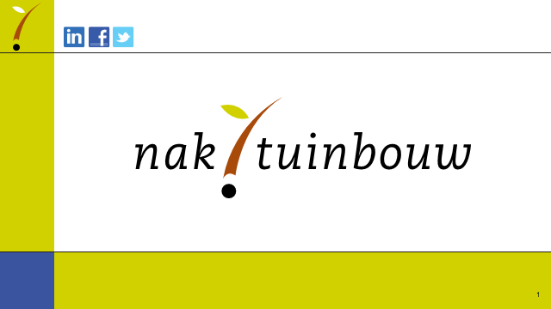

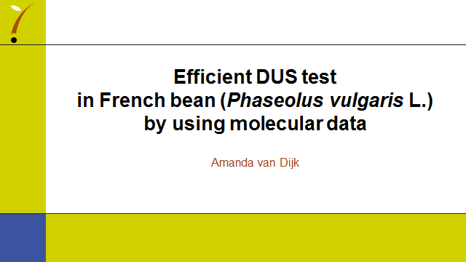

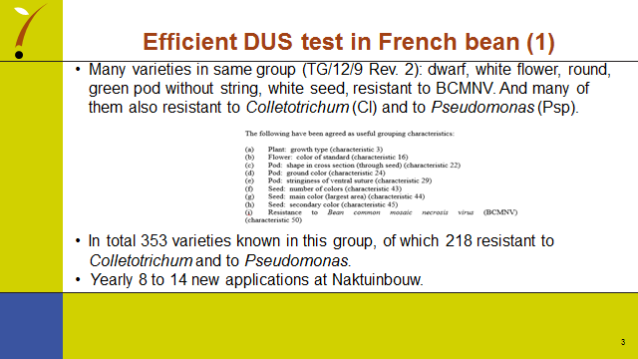

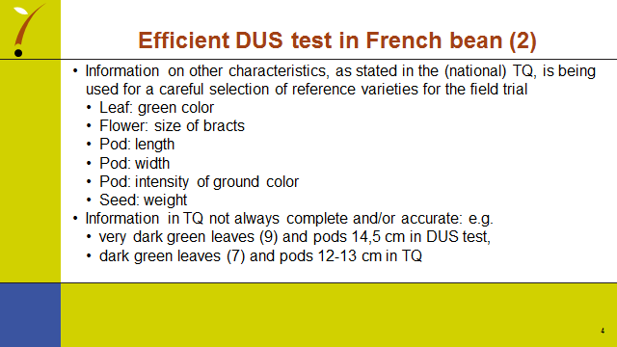

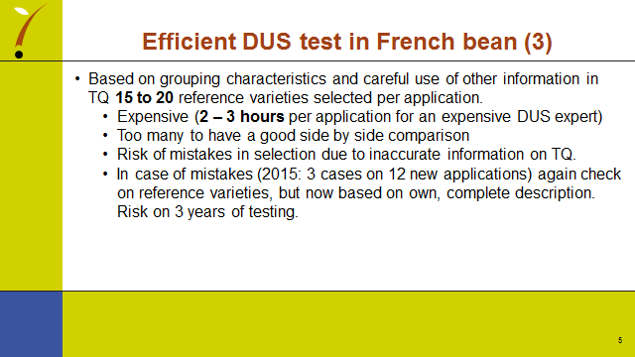

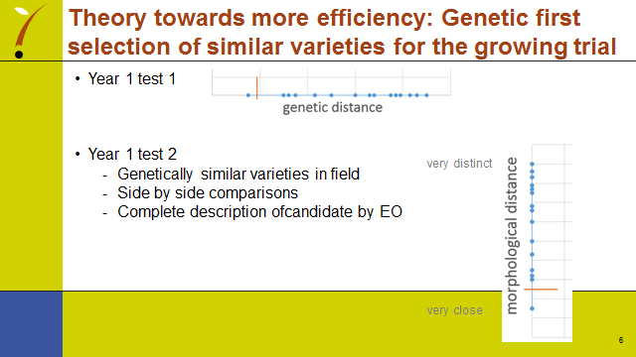

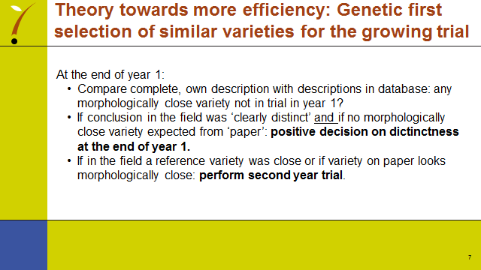

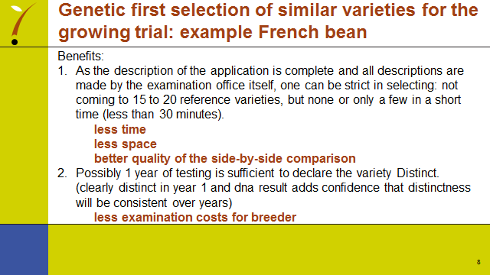

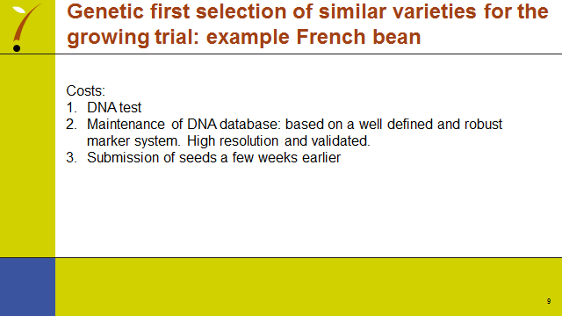

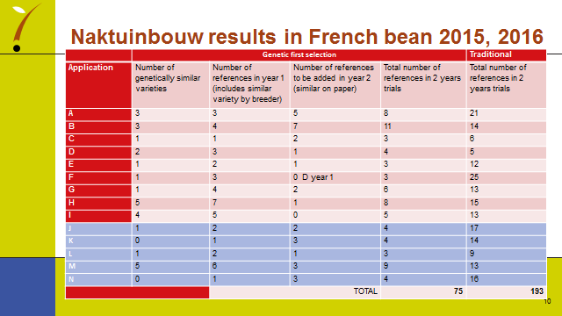

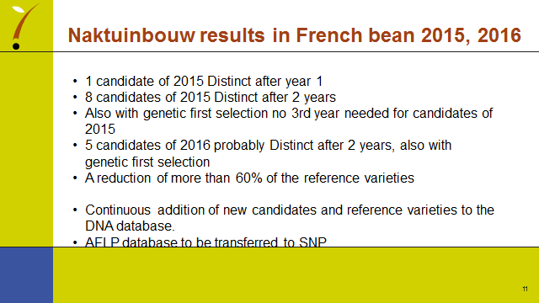

[End of Annex III and of document]

