E
TWV/50/24
ORIGINAL: English
DATE: June 24, 2016
INTERNATIONAL UNION FOR THE PROTECTION OF NEW VARIETIES OF PLANTS
Geneva
Technical working party for Vegetables
Fiftieth Session
Brno, Czech Republic, June 27 to July 1, 2016
Test Guidelines for Cassava
prepared by the Office of the Union
Disclaimer: this document does not represent UPOV policies or guidance
The Technical Working Party for Vegetables (TWV), at its forty-eighth session held in Paestum, Italy, from June 23 to 27, 2014, and the Technical Working Party for Agricultural Crops (TWA), at its forty-third session held in Mar del Plata, Argentina, from November 17 to 21, 2014, agreed to submit the draft Test Guidelines for Cassava for adoption to the Technical Committee (TC), at its fifty-first session held in Geneva from March 23 to 25, 2015, on the basis of documents TG/CASSAV(proj.5) and TG/CASSAV(proj.5) Rev. (see documents TWV/48/43 “Report”, Annex IV, and TWA/43/27 “Report”, Annex IV).

At its fifty-first session, the TC considered the draft Test Guidelines for Cassava (see document TG/CASSAV(proj.6) and adopted the Test Guidelines subject to the changes proposed by the Enlarged Editorial Committee (TC-EDC) in March 2015, which were still to be included in the document submitted to the TC. The changes are presented in Annex I to this document.

The changes proposed by the TC-EDC contained some information to be provided by the Leading Experts from Brazil and Kenya. The relevant items are highlighted in grey in Annex I.

With regard to the adoption of draft Test Guidelines by the Technical Committee, the following is set out in document TGP/7/4 “Developments of Test Guidelines”, Section 2 “Procedure for the Introduction and Revision of UPOV Test Guidelines”:

“2.2.8.3 Where the Technical Committee adopts the Test Guidelines subject to further information being provided by the Leading Expert with the agreement of all interested experts and the Chairman of the TWP concerned (see 2.2.7.3(b)), the necessary information, agreed with all interested experts, should be provided to the Office within three months of the Technical Committee meeting, or before the subsequent session of the TWP concerned, whichever is the sooner. In those cases where the necessary information is not provided within this time, the Test Guidelines concerned will not be adopted and will be re-presented at the TWP concerned (Step 4).”

The information requested by the TC-EDC has been provided but not within the period indicated above. The TWA is invited to consider the information provided by the Leading Expert in Annex II to this document.

In the absence of objections by the TWA and TWV, the Test Guidelines for Cassava will be proposed for adoption by the TC at its fifty-third session to be held in Geneva from April 3 to 5, 2017, on the basis of the changes to document TG/CASSAV(proj.6) presented in Annexes I and II to this document.

[Annex I follows]

Changes proposed by the Enlarged Editorial Committee (TC-EDC) in March 2015, which are still to be included in the document submitted to the TC

General | Leading Expert to confirm that all IP rights on photos, illustrations and text have been respected  Leading Expert: confirms that all IP rights have been respected
Char. 15 | to read “Stem: color of inner side of bark”
Char. 17 | to check whether to add (c)  Leading Expert: yes, to add (c)
Char. 19 | to clarify time of assessment whether (b) or (c)  Leading Expert: to be indicated as (c)
Char. 19 | to check whether to read “Stem: color of end of branches” (see Ad. 19)  Leading Expert: agreed
Char. 20 to 26 | to check if "root" should be replaced by "tuber"  Leading Expert: “root” is correct
Char. 20 | "Peduncle" normally refers to the flower. To check if "stipe" is more appropriate.  Leading Expert: yes, to replace “peduncle” with “stipe”
Chars. 23, 24 | state (1) to read “white”; state (2) to read “yellowish”
8.1 | Reference to days is critical. Provided that indication of time is appropriate for all growing areas reference to month might be sufficient.  to check whether to read  “(a) Observations should be made about 5 months after planting.  (b) Observations should be made 6-9 months after planting and at the middle third of the plant unless otherwise specified.  (c) Observations should be made about 12 months after planting.”  Leading Expert: agreed
Ad. 12 | to improve photos  Leading Expert: will be provided
Ad. 26 | to read “The adherence should be assessed by removing the cortex by hand from the middle third of freshly harvested root tubers.  Weak adherence = without any breakage of cortex  Medium adherence = minimal breakage of cortex  Strong adherence = a lot of breakage of cortex”
9. | - to check whether to delete the following literature reference, as the relevant characteristic was deleted from the TG:  “Williams, H. J. and Edwards, T. G. (1980). Estimation of cyanide with alkaline picrate. J. Sci. Food Agric. 31: 15-22.”  - to read: “Alves, A.A.C., …” (remove extra space)  - to read : “…caracterização de ...” (add space)  Leading Expert: agreed

[Annex II follows]

Outstanding information provided by the Leading Expert for Ad. 12 “Plant height”

Ad. 12 | to improve photos  Leading Expert: will be provided

 |  | English | français | deutsch | español | Example Varieties/  Exemples/  Beispielssorten/  Variedades ejemplo | Note/  Nota
12.  (*)  (+) | VG | Stipule: division | Stipule: division | Nebenblatt: Teilung | Estípula: división
QL | (b) | entire | entière | ganz | entera |  | 1
 |  | divided | divisée | geteilt | dividida |  | 2

Current explanation:

Ad. 12: Stipule: division

To be observed on the upper third of the plant

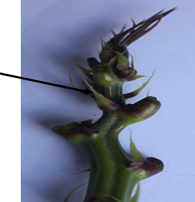 | 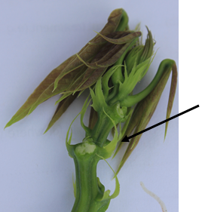
1 | 2
entire | divided

Proposed new explanation:

Ad. 12: Stipule: division

To be observed on the upper third of the plant

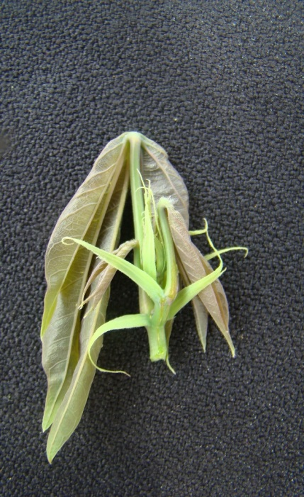 | 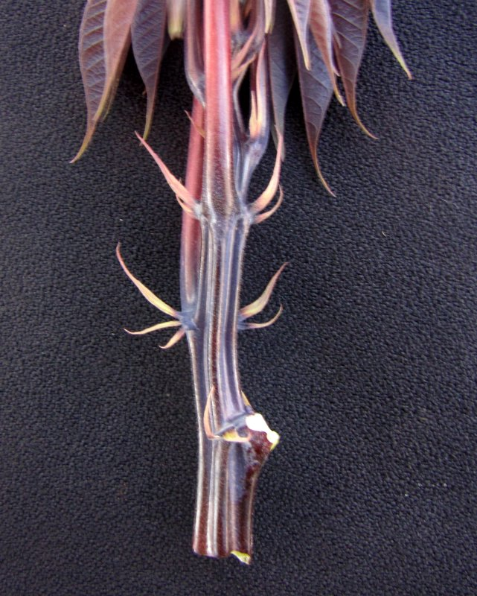
1 | 2
entire | divided

[End of Annex II and of document]

