E
TWV/50/19
ORIGINAL: English
DATE: May 31, 2016
INTERNATIONAL UNION FOR THE PROTECTION OF NEW VARIETIES OF PLANTS
Geneva
Technical working party for Vegetables
Fiftieth Session
Brno, Czech Republic, June 27 to July 1, 2016
Partial Revision of the Test Guidelines for Tomato Rootstocks
(Document TG/294/1 Corr. Rev.)
Document prepared by an expert from Spain
Disclaimer: this document does not represent UPOV policies or guidance
The Technical Working Party for Vegetables (TWV), at its forty-ninth session, held in Angers, France, from June 15 to 19, 2015, agreed that the Test Guidelines for Tomato Rootstocks (document TG/294/1 Corr. Rev.) be partially revised for disease resistance characteristics (see document TWV/49/32 Rev. “Revised Report”, Annex IV).

The purpose of this document is to present a proposal for a partial revision of the Test Guidelines for Tomato Rootstocks (document TG/294/1 Corr. Rev.).

The following changes are proposed:

- Extension of the coverage of the Test Guidelines to be reflected
  - on the cover page
  - in Chapter 1 “Subject of these Test Guidelines”
  - Chapter “Technical Questionnaire”, Section 1 “Subject of the Technical Questionnaire”

- Addition of a new state of expression and explanation for Characteristic 16

The proposed changes are presented below in highlight and underline (insertion) and strikethrough (deletion).

Comments received on the proposed changes by the Subgroup of Interested Experts and the replies to those comments by the Leading Expert are presented in the Annex to this document.

Extension of the coverage of the Test Guidelines

Extension of the coverage of the Test Guidelines on the cover page

Current wording:
 | TOMATO ROOTSTOCKS  UPOV Code: SOLAN_LHA;  SOLAN_LPE; SOLAN_LCH  Solanum lycopersicum L. x Solanum habrochaites S. Knapp & D.M. Spooner;  Solanum lycopersicum L. x  Solanum peruvianum (L.) Mill.;  Solanum lycopersicum L. x  Solanum cheesmaniae (L. Ridley) Fosberg | *

Alternative Names:*

Botanical name | English | French | German | Spanish
Solanum lycopersicum L. x
Solanum habrochaites S. Knapp & D.M. Spooner
Solanum lycopersicum L. x Solanum peruvianum (L.) Mill.
Solanum lycopersicum L. x Solanum cheesmaniae (L. Ridley) Fosberg

Proposed new wording:
 | TOMATO ROOTSTOCKS  UPOV Code: SOLAN_HAB; SOLAN_LHA;  SOLAN_LPE; SOLAN_LCH; SOLAN_PHA  Solanum habrochaites S. Knapp & D.M. Spooner;  Solanum lycopersicum L. x Solanum habrochaites S. Knapp & D.M. Spooner;  Solanum lycopersicum L. x  Solanum peruvianum (L.) Mill.;  Solanum lycopersicum L. x  Solanum cheesmaniae (L. Ridley) Fosberg  Solanum pimpinellifolium L. x Solanum habrochaites S. Knapp & D.M. Spooner | *

Alternative Names:*

Botanical name | English | French | German | Spanish
Solanum habrochaites S. Knapp & D.M. Spooner, Lycopersicon agrimoniifolium Dunal,
Lycopersicon hirsutum Dunal,
Lycopersicon hirsutum f. glabratum C. H. Müll.
Solanum lycopersicum L. x
Solanum habrochaites S. Knapp & D.M. Spooner
Solanum lycopersicum L. x
Solanum peruvianum (L.) Mill.
Solanum lycopersicum L. x
Solanum cheesmaniae (L. Ridley) Fosberg
Solanum pimpinellifolium L. x
Solanum habrochaites S. Knapp & D.M. Spooner

Extension of the coverage of the Test Guidelines in Chapter 1 “Subject of these Test Guidelines”

Current wording:

1. Subject of these Test Guidelines

1.1 These Test Guidelines apply to all varieties of Solanum lycopersicum L. x Solanum habrochaites S. Knapp & D.M. Spooner, Solanum lycopersicum L. x Solanum peruvianum L. (Mill.) and Solanum lycopersicum L. x Solanum cheesmaniae (L. Ridley) Fosberg. Such varieties are generally used as rootstocks for tomato varieties (varieties of Solanum lycopersicum L. (Lycopersicum esculentum L. (Mill.)).

1.2 Rootstocks belonging to Solanum lycopersicum L. (Lycopersicum esculentum Mill.) or to Solanum lycopersicum L. x Solanum pimpinellifolium L. (Lycopersicum esculentum Mill. x Lycopersicum pimpinellifolium Mill.) should be covered by UPOV Test Guidelines TG/44.

Proposed new wording:

1. Subject of these Test Guidelines

1.1 These Test Guidelines apply to all varieties of Solanum habrochaites S. Knapp & D.M. Spooner; Solanum lycopersicum L. x Solanum habrochaites S. Knapp & D.M. Spooner, Solanum lycopersicum L. x Solanum peruvianum L. (Mill.), and Solanum lycopersicum L. x Solanum cheesmaniae (L. Ridley) Fosberg and Solanum pimpinellifolium L. x Solanum habrochaites S. Knapp & D.M. Spooner. Such varieties are generally used as rootstocks for tomato varieties (varieties of Solanum lycopersicum L. (Lycopersicum esculentum L. (Mill.)).

1.2 Rootstocks belonging to Solanum lycopersicum L. (Lycopersicum esculentum Mill.) or to Solanum lycopersicum L. x Solanum pimpinellifolium L. (Lycopersicum esculentum Mill. x Lycopersicum pimpinellifolium Mill.) should be covered by UPOV Test Guidelines TG/44.

Extension of the coverage of the Test Guidelines Chapter “Technical Questionnaire”, Section 1 “Subject of the Technical Questionnaire”

Current wording:

TECHNICAL QUESTIONNAIRE |  | Page {x} of {y} | Reference Number:
 |  |  | Application date:
 |  |  | (not to be filled in by the applicant)
TECHNICAL QUESTIONNAIRE
to be completed in connection with an application for plant breeders’ rights

1. Subject of the Technical Questionnaire
Tomato Rootstocks belonging to:
1.1 Botanical name | Solanum lycopersicum L. x Solanum habrochaites S. Knapp & D.M. Spooner |  |  | […]
1.2 Botanical name | Solanum lycopersicum L. x Solanum peruvianum (L.) Mill. |  |  | […]
1.3 Botanical name | Solanum lycopersicum L. x Solanum cheesmaniae (L. Ridley) Fosberg |  |  | […]
.

Proposed new wording:

TECHNICAL QUESTIONNAIRE |  | Page {x} of {y} | Reference Number:
 |  |  | Application date:
 |  |  | (not to be filled in by the applicant)
TECHNICAL QUESTIONNAIRE
to be completed in connection with an application for plant breeders’ rights

1. Subject of the Technical Questionnaire
Tomato Rootstocks belonging to:
1.1 Botanical name | Solanum habrochaites S. Knapp & D.M. Spooner |  |  | […]
1.1 2 Botanical name | Solanum lycopersicum L. x Solanum habrochaites S. Knapp & D.M. Spooner |  |  | […]
1.2 3 Botanical name | Solanum lycopersicum L. x Solanum peruvianum (L.) Mill. |  |  | […]
1.3 4 Botanical name | Solanum lycopersicum L. x Solanum cheesmaniae (L. Ridley) Fosberg |  |  | […]
1.5 Botanical name | Solanum pimpinellifolium L. x Solanum habrochaites S. Knapp & D.M. Spooner |  |  | […]
.

Addition of a new state of expression and explanation to Characteristic 16

Current Wording:

 |  | English | français | deutsch | español | Example Varieties  Exemples  Beispielssorten  Variedades ejemplo | Note/  Nota
16.  (*) | VG | Fruit: size | Fruit : taille | Frucht: Größe | Fruto: tamaño
QN | (b) | small | petit | klein | pequeño | Body, Optifort | 3
 |  | medium | moyen | mittel | medio | Emperador | 5
 |  | large | grand | groß | grande | Titron | 7

Proposed new wording:

 |  | English | français | deutsch | español | Example Varieties  Exemples  Beispielssorten  Variedades ejemplo | Note/  Nota
16.  (*)  (+) | VG | Fruit: size | Fruit : taille | Frucht: Größe | Fruto: tamaño
QN | (b) | null or very small |  |  | nulo o muy pequeño | RT303 | 1
 |  | small | petit | klein | pequeño | Body, Optifort | 3
 |  | medium | moyen | mittel | medio | Emperador | 5
 |  | large | grand | groß | grande | Titron | 7

Ad. 16: Fruit: size

Varieties of certain interspecific crosses for tomato rootstocks, may have not viability for production of fruits, or exceptionally produce few very small fruits.

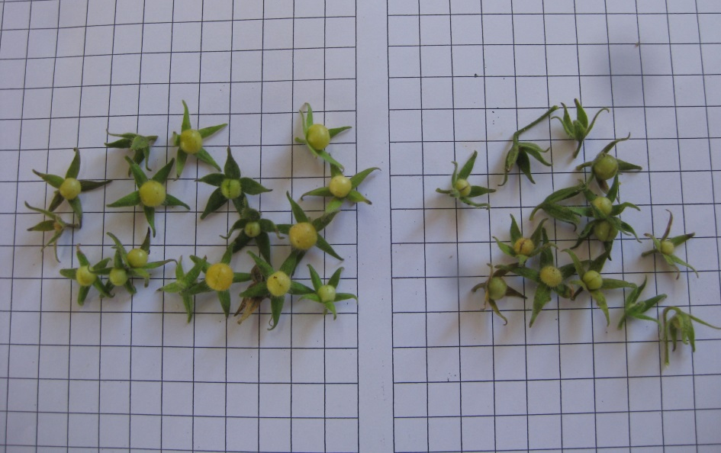
Scarce fruits of very small size produced by RT303
Scale of the photo: length of the squares: 1 cm

[Annex follows]

Comments received on the proposed changes by the Subgroup of Interested Experts

European Union:

I am in favor of your proposals and do not have any further remarks to make.

Netherlands

We agree partly with your proposal but have also some comments on it.

1. Last 2 years we had an application for the species Solanum habrochaites (a parent line of an interspecific cross hybrid). We think this species could also be described with and thus included in this protocol as well and would like therefore to add also the species Solanum habrochaites S. Knapp & D.M. Spooner in this partial revision.
Leading Expert: O.K. Included in the draft

2. We think that the new expression of note 1 should be “very small” instead of “null or very small”. In case certain interspecific crosses for tomato rootstocks, may have not viability for production of fruits, or exceptionally produce few very small fruits, we think that it is a better solution to include in the description an N or X than to add null to the expression.
Leading Expert: I admit that may seem peculiar the expression null or very small, but it reflects the real situation. I think it is a new situation in the TGs. We can discuss the best solution.

3. Furthermore the fruit size of the lines and accessions of the species the Solanum habrochaites is considered as 1. very small (in our trials prox. 5 to 7 grams). If this is the same as your variety/application RT303 we agree with the scale. If it is much smaller, could it be that RT303 should have the expression 2 and the Solanum habrochaites lines expression 1? What is the fruit size of RT303?
Leading Expert: The size of fruit of RT303 (when exists) is between 1 and 2 grs much smaller than any other actual variety. The 5 grs weight, for us is assessed as note 3 in this crop. A photo is added to the explanation.

4. Is RT303 the denomination of your Solanum pimpinellifolium L.x Solanum habrochaites S. Knapp & D.M. Spooner application or is it still the breeders’ reference? In that case this variety cannot be added with this reference in the draft.
Leading Expert: RT303 is the name indicated in the application and reported to national list. I will check if there is any further proposal for change it before to appear in the common catalogue.

[End of document]

