E
TWV/50/13
ORIGINAL: English
DATE: May 30, 2016
INTERNATIONAL UNION FOR THE PROTECTION OF NEW VARIETIES OF PLANTS
Geneva
Technical working party for VEGETABLES
Fiftieth Session
Brno, Czech Republic, June 27 to July 1, 2016
Revision of document TGP/10: New section: Assessing Uniformity by Off-Types
on the Basis of More than One growing cycle or on the basis of Sub-Samples
Document prepared by the Office of the Union
Disclaimer: this document does not represent UPOV policies or guidance
EXECUTIVE SUMMARY

The purpose of this document is to present a proposal for revision of document TGP/10 “Examining uniformity” to provide guidance on assessing uniformity by off-types on the basis of more than one growing cycle or on the basis of sub-samples.

The TWV is invited to:

(a) note that the TWA agreed to request a video link with the experts from the TWC to discuss the new proposed “Approach 3: Combining the results of two growing cycles” at its forty-fifth session, to be held in 2016; and

(b) consider the draft guidance as presented in Annexes I and II for inclusion in a future revision of document TGP/10.

The structure of this document is as follows:
DEVELOPMENTS IN 2015 2
Technical Working Parties 2
Technical Working Party for Vegetables 2
Technical Working Party on Automation and Computer Programs 2
Technical Working Party for Agricultural Crops 3
Technical Working Party for Fruit Crops 3
Technical Working Party on Ornamental Plants 3
DEVELOPMENTS IN 2016 4
Technical Committee 4
Summary of approaches 4
ANNEX I: Assessing uniformity by off-types on basis of more than one growing cycle
ANNEX II: Assessing uniformity by off-types on the basis of sub-samples within a single test/trial
ANNEX III: Assessing uniformity by off-types on the basis of more than one growing cycle: risks benefits and costs (Presentation by the experts from the United Kingdom) during the fifty-second session of the TC, held in Geneva from March 14 to 16, 2016)

The following abbreviations are used in this document:

TC: Technical Committee
TC-EDC: Enlarged Editorial Committee
TWA: Technical Working Party for Agricultural Crops
TWC: Technical Working Party on Automation and Computer Programs
TWF: Technical Working Party for Fruit Crops
TWO: Technical Working Party for Ornamental Plants and Forest Trees
TWPs: Technical Working Parties
TWV: Technical Working Party for Vegetables

BACKGROUND

The background to this matter is provided in document TC/52/20 “Assessing Uniformity by Off-Types on the Basis of More than One Sample or Sub-Samples” and TC/52/20 Add. “Addendum to document TC/52/20”.

DEVELOPMENTS IN 2015

Technical Working Parties

At their sessions in 2015, the TWV, TWC, TWA, TWF and TWO considered documents TWV/49/9, TWC/33/9, TWA/44/9, TWF/46/9 and TWO/48/9 “Revision of document TGP/10: New section: Assessing Uniformity by Off-Types on Basis of More than One Growing Cycle or on the Basis of Sub-Samples”, respectively (see documents TWV/49/32 “Revised Report”, paragraphs 62 and 63; TWC/33/30 “Report”, paragraphs 57 to 61; TWA/44/23 “Report”, paragraphs 52 to 55; TWF/46/29 Rev. “Revised Report”, paragraphs 55 to 60; and TWO/48/26 “Report”, paragraphs 51 to 53).

Technical Working Party for Vegetables

The TWV agreed with the draft guidance for inclusion in a future revision of document TGP/10, as presented in Annexes I and II to document TWV/49/9.

Technical Working Party on Automation and Computer Programs

The TWC considered the draft guidance in document TWC/33/9, Annex I, and agreed to propose amending the title of Approach 2 to read “Combining the results of two growing cycles in the case of inconsistent results”.

The TWC received a presentation by the experts from Germany and the United Kingdom, as reproduced in Annex III of this document (English only), and agreed to propose the addition of the third approach to the draft guidance as follows:

“Approach 3: Combining the results of two growing cycles

“A variety is considered uniform if the total number of off-types at the end of the two growing cycles does not exceed the number of allowed off-types for the combined sample.

“A variety is considered non-uniform if the total number of off-types at the end of the two growing cycles exceeds the number of allowed off-types for the combined sample.

“A variety may be rejected after a single growing cycle, if the number of off-types exceeds the number of allowed off-types for the combined sample (over two cycles).

“Care is needed when considering results that are very different in each of the growing cycles, such as when a type of off-type is observed at a high level in one growing cycle and is absent in another growing cycle. A statistical test for consistency is possible.”

The TWC noted that the approach presented by the experts from Germany and the United Kingdom was used in the United Kingdom and always combined the results of two growing cycles. The TWC noted the explanation that this approach allowed an early decision on uniformity to be taken when the number of off-types was greater in a sub-sample than the allowed number for the combined sample. The TWC also noted the explanation that this approach reduced the type 2 error (to accept a non-uniform variety), when compared with the other two approaches presented in the draft guidance, by considering the overall risk of the combined samples instead of the risks for each stage of evaluation separately.

The TWC agreed that the presentation made by the experts from Germany and the United Kingdom should be made available to the other TWPs.

Technical Working Party for Agricultural Crops

The TWA agreed that the draft guidance for inclusion in a future revision of document TGP/10, as presented in document TWA/44/9 Annex I, should continue to be developed considering the information provided by the TWC on the proposed “Approach 3: combining the results of two growing cycles” and the comparison between the overall risk of the combined samples and the risks for each stage of evaluation separately. The TWA agreed to request a video link with the experts from the TWC to discuss the proposed “Approach 3”.

The TWA agreed to propose that the first sentence in Annex I be amended to read: “two independent growing cycles could take place in a single location in different years, or in different locations in the same year, according to document TGP/8 Part I, Sections 1.2 and 1.3.”

The TWA considered the draft guidance provided in document TWA/44/9 Annex I, on the possibility to reject a variety on the basis of a lack of uniformity after a single growing cycle. The TWA agreed that a variety should not be rejected if the uniformity standard is slightly exceeded in the first year. This possibility should only be used if it can be foreseen that the maximum limit will be exceeded also in another growing cycle. In this regard, the TWA agreed to propose that the explanation provided in Annex I on the possibility to reject a variety on the basis of a lack of uniformity after a single growing cycle should be amended to read: “Furthermore, on the basis of a clear lack of uniformity, a variety may be rejected after a single growing cycle”.

Technical Working Party for Fruit Crops

The TWF received an oral report by an expert from New Zealand on the assessment of uniformity using more than one growing cycle: New Zealand’s experience for apple varieties originating as mutations.

The TWF also received an oral report by an expert from France on assessing uniformity by off types on basis of more than one growing cycle or on the basis of sub samples: considerations on uniformity, distinction and description.

The TWF agreed that the authority in charge of DUS examination should be able to refuse a candidate because of a lack of uniformity after the first growing cycle, in particular for fruit crops where number of growing cycles was normally two.

The TWF considered the draft guidance for inclusion in a future revision of document TGP/10, as presented in Annexes I and II to document TWF/46/9. The TWF agreed that it should be clarified in the document whether the guidance in Annex I was meant for combining the results of two growing cycles of the same plant material (perennial crops). The TWF agreed that the document should continue to be discussed at its next session.

The TWF agreed to propose the following amendment to clarify the decision rule in Annex I, Approach 2: “…a variety is considered uniform if the total number of off-types at the end of the two growing cycles does not exceed the number of allowed off-types for the combined sample size of growing cycles 1 and 2 combined”.

Technical Working Party on Ornamental Plants

The TWO noted that when assessing uniformity by off-types on the same plants in two growing cycles the same off-type plants observed in the first growing cycle would still be off-types in the second growing cycle in addition to any other off-type plants observed only in the second growing cycle and agreed that combining the sample sizes in both growing cycles was not useful for the assessment of uniformity by off-types in ornamental plants.

The TWO agreed that it should be clarified in document TWO/48/9 that the guidance provided was not intended to be used for the assessment of uniformity by off-types on the same plants in two growing cycles.

The TWO also agreed that the numbers of off-types in the examples provided in Annex I, second growing cycle column, lines 2 and 3 (number of off-types = 3), should have an asterisk to indicate that “care is needed when considering results that were very different in each of the growing cycles, such as when a type of off-type was observed at a high level in one growing cycle and was absent in another growing cycle.”

DEVELOPMENTS IN 2016

Technical Committee

The TC, at its fifty-second session, held in Geneva from March 14 to 16, 2016, considered document TC/52/20 and received a presentation by an expert from the United Kingdom on assessing uniformity by off-types on the basis of more than one growing cycle, a copy of which is reproduced in Annex III to this document (see document TC/52/29 Rev. “Revised Report”, paragraphs 118 to 121).

The TC agreed that the new proposed “Approach 3: Combining the results of two growing cycles” for the assessment of uniformity by off-types, as presented in Annex I to document TC/52/20, should be considered by the TWPs, at their sessions in 2016.

The TC noted that the TWA had agreed to request a video link with the experts from the TWC to discuss the new proposed “Approach 3: Combining the results of two growing cycles” at its forty-fifth session, to be held in 2016, and agreed that the video link should be open to all interested experts.

The TC agreed to clarify that the guidance in the Annex I to this document was not intended to be used for the assessment of uniformity by off-types on the same plants in two growing cycles, as the same off-type plants observed in the first growing cycle would still be off-types in the second growing cycle.

Summary of approaches

Annexes I and II to this document summarize different situations when different samples are combined for the overall assessment of uniformity of a variety in accordance with the conclusion of the TC at its fifty-second session.

The summary in Annexes I and II only relates to situations where more than one sample, or sub-sample, concern the examination of the same characteristic. In the case of different samples, or sub-samples (e.g. special test), to examine a different characteristic there is no requirement to combine the results because a variety is required to be uniform for all relevant characteristics.

The TWV is invited to:

(a) note that the TWA agreed to request a video link with the experts from the TWC to discuss the new proposed “Approach 3: Combining the results of two growing cycles” at its forty-fifth session, to be held in 2016; and

(b) consider the draft guidance as presented in Annexes I and II for inclusion in a future revision of document TGP/10.

[Annexes follow]

ASSESSING UNIFORMITY BY OFF-TYPES ON BASIS OF MORE THAN ONE GROWING CYCLE

Two independent growing cycles could take place in a single location in different years, or in different locations in the same year, according to document TGP/8 Part I, Sections 1.2 and 1.3.

The following guidance is not intended to be used for the assessment of uniformity by off-types on the same plants in two growing cycles.

Approach 1: Third growing cycle in the case of inconsistent results

A variety is considered uniform if it is within the uniformity standard in both of the two growing cycles.

A variety is considered non-uniform if it fails to meet the uniformity standard in both of the two growing cycles.

If at the end of the two growing cycles the variety is within the uniformity standard in one growing cycle but is not within the uniformity standard in the other growing cycle, then uniformity is assessed in a third growing cycle. If in the third growing cycle the variety is within the uniformity standard, the variety is considered uniform. If in the third growing cycle the variety fails to meet the uniformity standard, the variety is considered non-uniform.

Care is needed when considering results that were very different in each of the growing cycles, such as when a type of off-type was observed at a high level in one growing cycle and was absent in another growing cycle.

Furthermore, on the basis of a clear lack of uniformity, a variety may be rejected after a single growing cycle.

Approach 2: Combining the results of two growing cycles in the case of inconsistent results

A variety is considered uniform if it is within the uniformity standard in both of the two growing cycles.

A variety is considered non-uniform if it fails to meet the uniformity standard in both of the two growing cycles.

If at the end of the two growing cycles the variety is within the uniformity standard in one growing cycle but is not within the uniformity standard in the other growing cycle, a variety is considered uniform if the total number of off-types at the end of the two growing cycles does not exceed the number of allowed off-types for the sample size of growing cycles 1 and 2 combined.

Care is needed when considering results that were very different in each of the growing cycles, such as when a type of off-type was observed at a high level in one growing cycle and was absent in another growing cycle.

Furthermore, on the basis of a lack of uniformity, a variety may be rejected after a single growing cycle.

Approach 3: Combining the results of two growing cycles

A variety is considered uniform if the total number of off-types at the end of the two growing cycles does not exceed the number of allowed off-types for the combined sample.

A variety is considered non-uniform if the total number of off-types at the end of the two growing cycles exceeds the number of allowed off-types for the combined sample.

A variety may be rejected after a single growing cycle, if the number of off-types exceeds the number of allowed off-types for the combined sample (over two cycles).

Care is needed when considering results that are very different in each of the growing cycles, such as when a type of off-type is observed at a high level in one growing cycle and is absent in another growing cycle. A statistical test for consistency is possible.

Example:
 |  | Population Standard = 1%
 |  | Acceptance Probability ≥ 95%
 |  | Sample Size in each of growing cycles 1 and 2 = 50
 |  | Maximum number of Off-Types = 2
 |  | Sample Size in growing cycles 1 and 2 combined = 100
 |  | Maximum number of Off-Types = 3
 |  | Growing cycle |  |  | Decision
 |  | First | Second |  | Approach 1 |  | Approach 2 | Approach 3
 | Number of  Off-Types | 1 | 1 |  | uniform |  | uniform | uniform
 |  | 2 | 2 |  | uniform |  | uniform | non-uniform
 |  | 0 | 3* |  | third growing cycle* |  | uniform* | uniform*
 |  | 1 | 3* |  | third growing cycle* |  | non-uniform* | non-uniform*
 |  | 1 | 4* |  | third growing cycle* |  | non-uniform* | non-uniform*
 |  | 4 | 1* |  | third growing cycle* |  | non-uniform* | non-uniform

* Care is needed when considering results that were very different in each of the growing cycles, such as when a type of off-type was observed at a high level in one growing cycle and was absent in another growing cycle.

[Annex II follows]

SITUATION: ASSESSING UNIFORMITY BY OFF-TYPES ON THE BASIS OF SUB-SAMPLES
WITHIN A SINGLE TEST/TRIAL

Approach: Use of sub-sample as a first step of assessment

A variety is considered uniform if the number of off-types does not exceed a predefined lower limit in the sub-sample.

A variety is considered non–uniform if the number of off-types exceeds a predefined upper limit in the sub-sample.

If the number of off-types is between the predefined lower and upper limits, the whole sample is assessed. The lower and upper limits have to be chosen considering comparable type I and type II errors in the sub-sample and the whole sample.

Example:

In a sample size of 100 plants, the acceptable number of off-types is 3 (based on a population standard of 1% and an acceptance probability of at least 95%).

In a subsample of 20 plants used in the context of the sample size of 100 plants above:

A variety is considered uniform if no off-types are observed in the sub-sample.

A variety is considered non–uniform if the number of off-types in the sub-sample exceeds 3.

If the number of off-types is 1 to 3, the whole sample of 100 plants is assessed.

If the number of off-types in the sample of 100 plants exceeds 3, the variety is considered non-uniform.

Document TWC/32/9 Annex V provides a full description of the statistical basis for this approach.

[Annex III follows]

(in English only)

Assessing uniformity by off-types on the basis of more than one growing cycle: risks benefits and costs

Presentation by the experts from the United Kingdom during the fifty-second session of the TC, held in Geneva from March 14 to 16, 2016 (document TC/52/20 Add.)

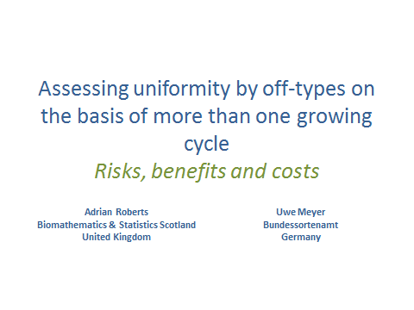

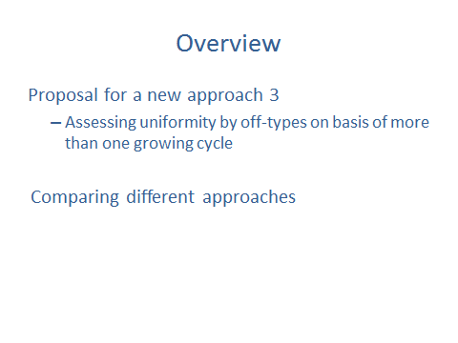

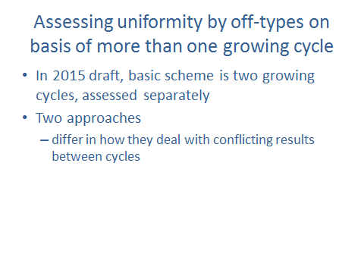

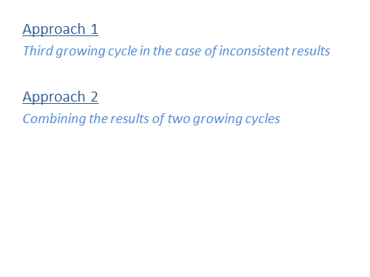

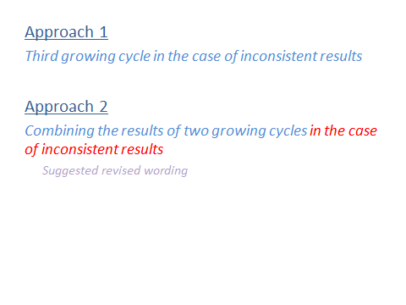

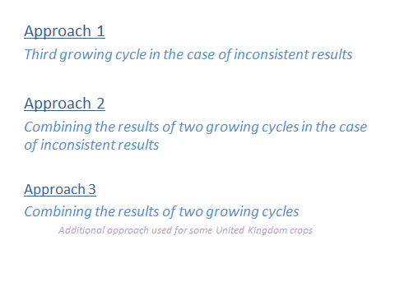

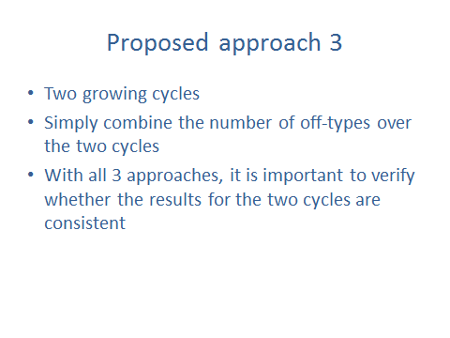

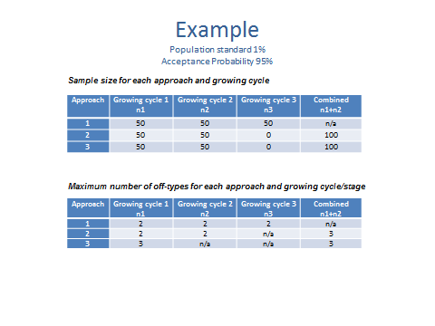

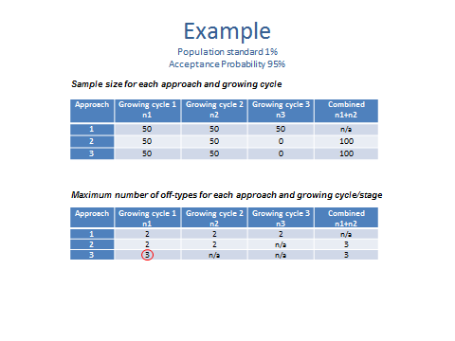

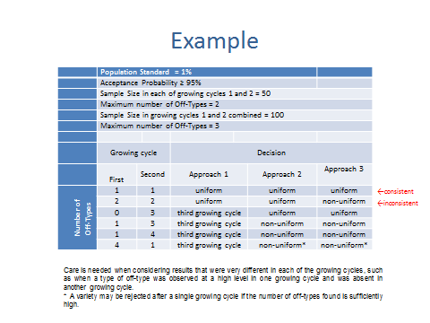

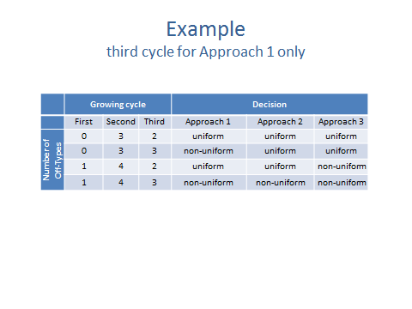

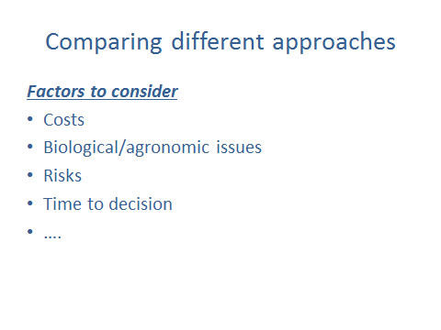

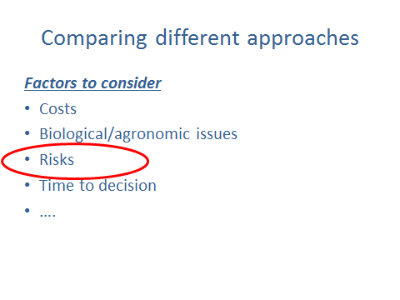

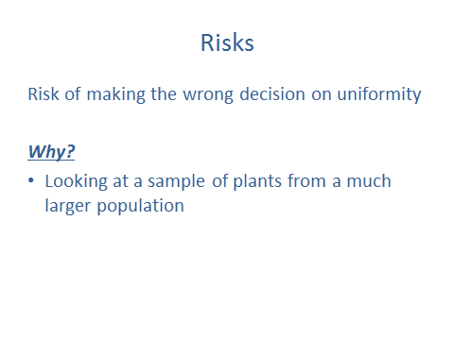

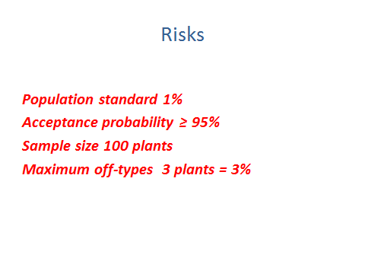

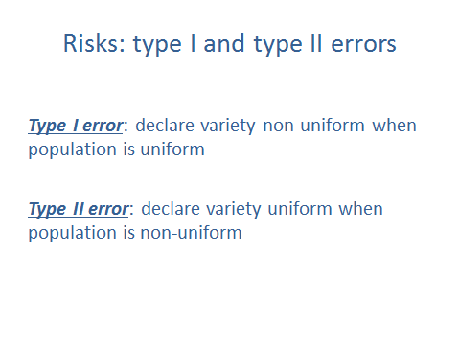

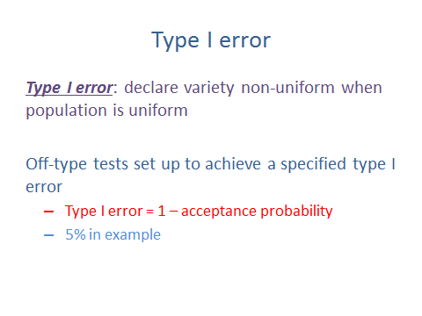

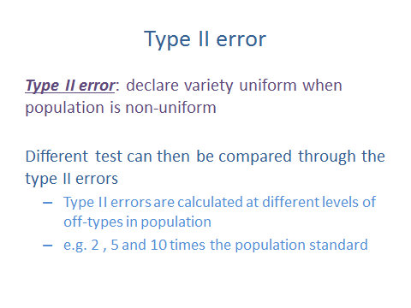

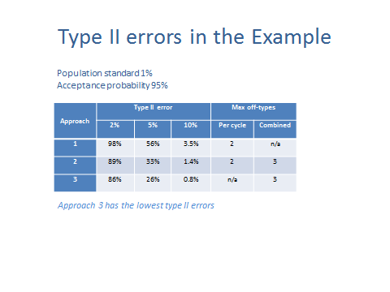

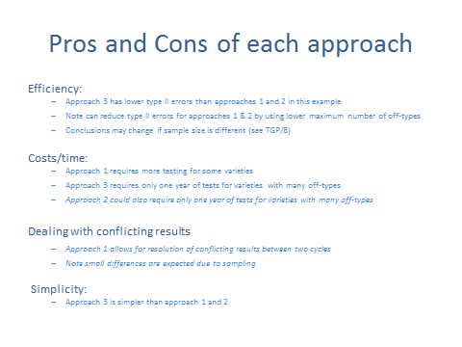

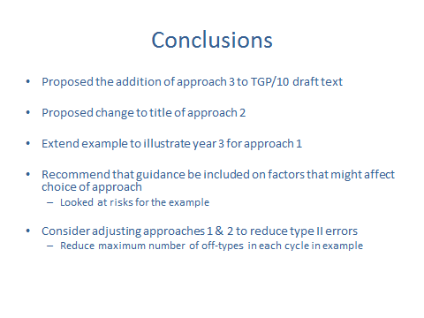

[End of Annex III and of document]

