 |  | E
 | 
  TG/BRASS_JUN(proj.4)
  ORIGINAL: English
  DATE: 2016-05-20
INTERNATIONAL UNION FOR THE PROTECTION OF NEW VARIETIES OF PLANTS
 | Geneva
  DRAFT
  BROWN MUSTARD
  UPOV Code(s): BRASS_JUN
  Brassica juncea (L.) Czern.
  *
GUIDELINES
FOR THE CONDUCT OF TESTS
FOR DISTINCTNESS, UNIFORMITY AND STABILITY

prepared by experts from Japan
to be considered by the
Technical Working Party for Vegetables

at its fiftieth session, to be held in Brno, Czech Republic,
from 2016-06-27 to 2016-07-01

Disclaimer: this document does not represent UPOV policies or guidance
Alternative names:*

Botanical name | English | French | German | Spanish
  Brassica juncea (L.) Czern.
  Brown mustard, India mustard, Indian mustard, Oriental mustard
  Moutarde brune
  Sareptasenf
  Mostaza de Sarepta, Mostaza india

The purpose of these guidelines (“Test Guidelines”) is to elaborate the principles contained in the General Introduction (document TG/1/3), and its associated TGP documents, into detailed practical guidance for the harmonized examination of distinctness, uniformity and stability (DUS) and, in particular, to identify appropriate characteristics for the examination of DUS and production of harmonized variety descriptions.
ASSOCIATED DOCUMENTS
These Test Guidelines should be read in conjunction with the General Introduction and its associated TGP documents.

TABLE OF CONTENTS | PAGE
1. | SUBJECT OF THESE TEST GUIDELINES.......................................................................................................... | 3
2. | MATERIAL REQUIRED......................................................................................................................................... | 3
3. | METHOD OF EXAMINATION................................................................................................................................ | 4
3.1 | Number of Growing Cycles........................................................................................................................ | 4
3.2 | Testing Place............................................................................................................................................. | 4
3.3 | Conditions for Conducting the Examination............................................................................................... | 4
3.4 | Test Design................................................................................................................................................ | 4
3.5 | Additional Tests......................................................................................................................................... | 4

4. | ASSESSMENT OF DISTINCTNESS, UNIFORMITY AND STABILITY................................................................. | 5
4.1 | Distinctness............................................................................................................................................... | 5
4.2 | Uniformity.................................................................................................................................................. | 5
4.3 | Stability...................................................................................................................................................... | 5

5. | GROUPING OF VARIETIES AND ORGANIZATION OF THE GROWING TRIAL................................................ | 6
6. | INTRODUCTION TO THE TABLE OF CHARACTERISTICS................................................................................ | 7
6.1 | Categories of Characteristics..................................................................................................................... | 7
6.2 | States of Expression and Corresponding Notes........................................................................................ | 7
6.3 | Types of Expression.................................................................................................................................. | 7
6.4 | Example Varieties...................................................................................................................................... | 7
6.5 | Legend....................................................................................................................................................... | 7

7. | TABLE OF CHARACTERISTICS/TABLEAU DES CARACTÈRES/MERKMALSTABELLE/TABLA DE CARACTERES...................................................................................................................................................... | 8
8. | EXPLANATIONS ON THE TABLE OF CHARACTERISTICS............................................................................... | 9
8.1 | Explanations covering several characteristics........................................................................................... | 9
 | Explanations for individual characteristics................................................................................................. | 9
  8.2

9. | LITERATURE......................................................................................................................................................... | 9
10. | TECHNICAL QUESTIONNAIRE............................................................................................................................ | 11

1.
Subject of these Test Guidelines
These Test Guidelines apply to all varieties of Brassica juncea (L.) Czern.

2. | Material Required
2.1
  The competent authorities decide on the quantity and quality of the plant material required for testing the variety and when and where it is to be delivered. Applicants submitting material from a State other than that in which the testing takes place must ensure that all customs formalities and phytosanitary requirements are complied with.
2.2
  The material is to be supplied in the form of seed.
2.3
  The minimum quantity of plant material, to be supplied by the applicant, should be:
  3,000 seeds for single spaced plants. 20,000 seeds for drilled plants.
 | The seed should meet the minimum requirements for germination, species and analytical purity, health and moisture content, specified by the competent authority. In cases where the seed is to be stored, the germination capacity should be as high as possible and should, be stated by the applicant.
2.4
  The plant material supplied should be visibly healthy, not lacking in vigor, nor affected by any important pest or disease.
2.5
  The plant material should not have undergone any treatment which would affect the expression of the characteristics of the variety, unless the competent authorities allow or request such treatment. If it has been treated, full details of the treatment must be given.

3. | Method of Examination
3.1 | Number of Growing Cycles
 | The minimum duration of tests should normally be two independent growing cycles.
3.2 | Testing Place
 | Tests are normally conducted at one place. In the case of tests conducted at more than one place, guidance is provided in TGP/9 “Examining Distinctness”.
3.3 | Conditions for Conducting the Examination
3.3.1 | The tests should be carried out under conditions ensuring satisfactory growth for the expression of the relevant characteristics of the variety and for the conduct of the examination.
  3.3.2
  The optimum stage of development for the assessment of each characteristic is indicated by a number in the second column of the Table of Characteristics. The stages of development denoted by each number are described in Chapter 8.
3.4 | Test Design
3.4.1
  single spaced plants: Each test should be designed to result in a total of at least 60 Plants, which should be divided between at least 2 replicates.
  3.4.2
  drilled plots: Each test should be design to result in a total of at least 200 Plants which should be divided between at least 2 replicates.
3.5 | Additional Tests
 | Additional tests, for examining relevant characteristics, may be established.

4.
Assessment of Distinctness, Uniformity and Stability
4.1 | Distinctness
4.1.1 | General Recommendations
 | It is of particular importance for users of these Test Guidelines to consult the General Introduction prior to making decisions regarding distinctness. However, the following points are provided for elaboration or emphasis in these Test Guidelines.
4.1.2 | Consistent Differences
 | The differences observed between varieties may be so clear that more than one growing cycle is not necessary. In addition, in some circumstances, the influence of the environment is not such that more than a single growing cycle is required to provide assurance that the differences observed between varieties are sufficiently consistent. One means of ensuring that a difference in a characteristic, observed in a growing trial, is sufficiently consistent is to examine the characteristic in at least two independent growing cycles.
4.1.3 | Clear Differences
 | Determining whether a difference between two varieties is clear depends on many factors, and should consider, in particular, the type of expression of the characteristic being examined, i.e. whether it is expressed in a qualitative, quantitative, or pseudo-qualitative manner. Therefore, it is important that users of these Test Guidelines are familiar with the recommendations contained in the General Introduction prior to making decisions regarding distinctness.
4.1.4
  Number of plants or parts of plants to be Examined
  Unless otherwise indicated, for the purposes of distinctness, all observations on single plants should be made on 30 plants or parts of plants taken from each of 30 plants and any other observations made on all plants in the test, disregarding any off-type plants.
4.1.5 | Method of Observation
 | The recommended method of observing the characteristic for the purposes of distinctness is indicated by the following key in the second column of the Table of Characteristics (see document TGP/9 “Examining Distinctness”, Section 4 “Observation of characteristics”):
MG: single measurement of a group of plants or parts of plants
MS: measurement of a number of individual plants or parts of plants
VG: visual assessment by a single observation of a group of plants or parts of plants
VS: visual assessment by observation of individual plants or parts of plants

 | Type of observation: visual (V) or measurement (M)
 | “Visual” observation (V) is an observation made on the basis of the expert’s judgment. For the purposes of this document, “visual” observation refers to the sensory observations of the experts and, therefore, also includes smell, taste and touch. Visual observation includes observations where the expert uses reference points (e.g. diagrams, example varieties, side-by-side comparison) or non-linear charts (e.g. color charts). Measurement (M) is an objective observation against a calibrated, linear scale e.g. using a ruler, weighing scales, colorimeter, dates, counts, etc.
  Type of record: for a group of plants (G) or for single, individual plants (S)
  For the purposes of distinctness, observations may be recorded as a single record for a group of plants or parts of plants (G), or may be recorded as records for a number of single, individual plants or parts of plants (S). In most cases, “G” provides a single record per variety and it is not possible or necessary to apply statistical methods in a plant-by-plant analysis for the assessment of distinctness.
 | In cases where more than one method of observing the characteristic is indicated in the Table of Characteristics (e.g. VG/MG), guidance on selecting an appropriate method is provided in document TGP/9, Section 4.2.
4.2 | Uniformity
4.2.1 | It is of particular importance for users of these Test Guidelines to consult the General Introduction prior to making decisions regarding uniformity. However, the following points are provided for elaboration or emphasis in these Test Guidelines:
4.2.2 | The assessment of uniformity for cross-pollinated varieties should be according to the recommendations for cross-pollinated varieties in the General Introduction.
4.2.3
  For the assessment of uniformity of self-pollinated varieties, a population standard of 2% and an acceptance probability of at least 95% should be applied. In the case of a sample size of 60 plants, 3 off-types are allowed. In the case of a sample size of 200 plants for drilled plants, 7 off-types are allowed.
4.3 | Stability
4.3.1 | In practice, it is not usual to perform tests of stability that produce results as certain as those of the testing of distinctness and uniformity. However, experience has demonstrated that, for many types of variety, when a variety has been shown to be uniform, it can also be considered to be stable.
4.3.2 | Where appropriate, or in cases of doubt, stability may be further examined by testing a new seed stock to ensure that it exhibits the same characteristics as those shown by the initial material supplied.

5.
Grouping of Varieties and Organization of the Growing Trial
5.1 | The selection of varieties of common knowledge to be grown in the trial with the candidate varieties and the way in which these varieties are divided into groups to facilitate the assessment of distinctness are aided by the use of grouping characteristics.
5.2 | Grouping characteristics are those in which the documented states of expression, even where produced at different locations, can be used, either individually or in combination with other such characteristics: (a) to select varieties of common knowledge that can be excluded from the growing trial used for examination of distinctness; and (b) to organize the growing trial so that similar varieties are grouped together.
5.3 | The following have been agreed as useful grouping characteristics:
  (a)
  Seed: color (characteristic 1)
  (b)
  Leaf blade: anthocyanin coloration (characteristic 14)
  (c)
  Leaf blade: density of incisions of margin (excluding type2) (characteristic 17)
  (d)
  Leaf blade: blistering (excluding type2) (characteristic 18)
  (e)
  Plant: head formation (characteristic 20)
In the first place, the collection should be divided according to leaf types in Table 1 of Chapter 8.1.

5.4 | Guidance for the use of grouping characteristics, in the process of examining distinctness, is provided through the General Introduction and document TGP/9 “Examining Distinctness”.

6. | Introduction to the Table of Characteristics
6.1 | Categories of Characteristics
6.1.1 | Standard Test Guidelines Characteristics
 | Standard Test Guidelines characteristics are those which are approved by UPOV for examination of DUS and from which members of the Union can select those suitable for their particular circumstances.
6.1.2 | Asterisked Characteristics
 | Asterisked characteristics (denoted by *) are those included in the Test Guidelines which are important for the international harmonization of variety descriptions and should always be examined for DUS and included in the variety description by all members of the Union, except when the state of expression of a preceding characteristic or regional environmental conditions render this inappropriate.
6.2 | States of Expression and Corresponding Notes
6.2.1 | States of expression are given for each characteristic to define the characteristic and to harmonize descriptions. Each state of expression is allocated a corresponding numerical note for ease of recording of data and for the production and exchange of the description.
6.2.2 | In the case of qualitative and pseudo-qualitative characteristics (see Chapter 6.3), all relevant states of expression are presented in the characteristic. However, in the case of quantitative characteristics with 5 or more states, an abbreviated scale may be used to minimize the size of the Table of Characteristics. For example, in the case of a quantitative characteristic with 9 states, the presentation of states of expression in the Test Guidelines may be abbreviated as follows:
State | Note
small | 3
medium | 5
large | 7

 | However, it should be noted that all of the following 9 states of expression exist to describe varieties and should be used as appropriate:
State | Note
very small | 1
very small to small | 2
small | 3
small to medium | 4
medium | 5
medium to large | 6
large | 7
large to very large | 8
very large | 9

6.2.3 | Further explanation of the presentation of states of expression and notes is provided in document TGP/7 “Development of Test Guidelines”.
6.3 | Types of Expression
 | An explanation of the types of expression of characteristics (qualitative, quantitative and pseudo-qualitative) is provided in the General Introduction.
6.4 | Example Varieties
 | Where appropriate, example varieties are provided to clarify the states of expression of each characteristic.
6.5 | Legend
 |  | English |  | français |  | deutsch | español | Example Varieties  Exemples  Beispielssorten  Variedades ejemplo | Note/  Nota
  1
  2
  3
  4
  5
  6
  7
  Name of characteristics in English
  Nom du caractère en français
  Name des Merkmals auf Deutsch
  Nombre del carácter en español
  states of expression
  types d’expression
  Ausprägungsstufen
  tipos de expresión

1 | Characteristic number
2 | (*) | Asterisked characteristic | – see Chapter 6.1.2
3 | Type of expression
 | QL | Qualitative characteristic | – see Chapter 6.3
 | QN | Quantitative characteristic | – see Chapter 6.3
 | PQ | Pseudo-qualitative characteristic | – see Chapter 6.3
4 | Method of observation (and type of plot, if applicable)
 | MG, MS, VG, VS |  | – see Chapter 4.1.5
5
  (+)
  See Explanations on the Table of Characteristics in Chapter 8.2
6
  (a)-(f)
  See Explanations on the Table of Characteristics in Chapter 8.1
7
  Growth stage key See Explanations on the Table of Characteristics in Chapter 8

7. | Table of Characteristics/Tableau des caractères/Merkmalstabelle/Tabla de caracteres

 |  | English |  | français |  | deutsch | español | Example Varieties  Exemples  Beispielssorten  Variedades ejemplo | Note/  Nota
1. | (*) | PQ | VG | (+) | (a) | 00
  Seed: color
 |  | yellow |  |  |  |  |  | Kigarashina | 1
 |  | brown |  |  |  |  |  | Akaoba Takana(Red Giant), Esperance, Miike Takana, Terrafit, Terraplus | 2
 |  | black |  |  |  |  |  | Hagarashina, TTK456(Chaplin) | 3
2. |  | QN | VG |  | (a) | 10
  Hypocotyl: anthocyanin coloration
 |  | absent or weak |  |  |  |  |  | Zasai FM-58 | 1
 |  | medium |  |  |  |  |  | Shinkoku Seisai | 2
 |  | strong |  |  |  |  |  | TTK456(Chaplin) | 3
3. |  | QN | MS/VG |  | (a), (c) | 10
  Cotyledon: length
 |  | short |  |  |  |  |  | Junkei Yamashiona, Vittasso | 3
 |  | medium |  |  |  |  |  | Katsuona, Terraplus | 5
 |  | long |  |  |  |  |  | Scala | 7
4. |  | QN | MS/VG |  | (a), (c) | 10
  Cotyledon: width
 |  | narrow |  |  |  |  |  | Junkei Yamashiona, Vittasso | 3
 |  | medium |  |  |  |  |  | Katsuona, Pacific Gold, Terraplus | 5
 |  | broad |  |  |  |  |  | Minaret, Terminator | 7
5. |  | PQ | VG | (+) | (a), (e) | 19
  Leaf: shape
 |  | ovate |  |  |  |  |  | Serihon | 1
 |  | circular |  |  |  |  |  | Kekkyu Takana | 2
 |  | elliptic |  |  |  |  |  | Akariasu | 3
 |  | oblong |  |  |  |  |  | Etamine, Zasai FM-58 | 4
 |  | obovate |  |  |  |  |  | Esperance, Katsuona | 5
 |  | spatulate |  |  |  |  |  | Kigarashina | 6
6. |  | QN | VG | (+) | (a), (e) | 19
  Leaf: attitude
 |  | erect |  |  |  |  |  | Wasabina | 1
 |  | semi-erect |  |  |  |  |  | Esperance, Shinkoku Seisai | 3
 |  | horizontal |  |  |  |  |  | Etamine, Miike Takana | 5
7. |  | QN | MS/VG |  | (a), (d), (e) | 19
  Leaf: length
 |  | short |  |  |  |  |  | Chirimen Hakarashina | 3
 |  | medium |  |  |  |  |  | Miike Takana | 5
 |  | long |  |  |  |  |  | Akaoba Takana(Red Giant) | 7
8. |  | QN | MS/VG |  | (a), (d), (e) | 19
  Leaf: width
 |  | narrow |  |  |  |  |  | Chirimen Hakarashina | 3
 |  | medium |  |  |  |  |  | Miike Takana | 5
 |  | broad |  |  |  |  |  | Katsuona | 7
9. |  | QN | MS/VG |  | (a), (d), (e) | 19
  Leaf: length of petiole
 |  | absent or very short |  |  |  |  |  | Serihon | 1
 |  | short |  |  |  |  |  | Miike Takana | 3
 |  | medium |  |  |  |  |  | Junkei Yamashiona | 5
 |  | long |  |  |  |  |  | Kigarashina | 7
10. |  | QN | MS/VG |  | (a), (d), (e) | 19
  Leaf: width of petiole
 |  | narrow |  |  |  |  |  | Kigarashina | 3
 |  | medium |  |  |  |  |  | Katsuona | 5
 |  | broad |  |  |  |  |  | Shinkoku Seisai | 7
11. |  | QN | MS/VG | (+) | (a), (b), (e) | 19
  Leaf blade: size of terminal lobe (total surface)
 |  | small |  |  |  |  |  | Chirimen Hakarashina, Etamine | 3
 |  | medium |  |  |  |  |  | Kigarashina | 5
 |  | large |  |  |  |  |  | Pacific Gold, Perm Green | 7
12. |  | QN | VG |  | (a), (b), (e) | 19
  Leaf blade: number of lateral lobes
 |  | absent or very few |  |  |  |  |  |  | 1
 |  | few |  |  |  |  |  | Minaret | 3
 |  | medium |  |  |  |  |  | Esperance, Kigarashina | 5
 |  | many |  |  |  |  |  | Akariasu, Etamine, TTK456(Chaplin) | 7
13. |  | QN | VG |  | (a), (e) | 19
  Leaf blade: pubescence on lower side
 |  | absent or weak |  |  |  |  |  | Miike Takana | 1
 |  | medium |  |  |  |  |  | Oba Takana | 2
 |  | strong |  |  |  |  |  | Kigarashina | 3
14. |  | QN | VG | (+) | (a), (e) | 19
  Leaf blade: anthocyanin coloration
 |  | absent or very weak |  |  |  |  |  | Kekkyu Takana, Vitamine | 1
 |  | weak |  |  |  |  |  |  | 3
 |  | medium |  |  |  |  |  | Miike Takana | 5
 |  | strong |  |  |  |  |  | Akaoba Takana(Red Giant) | 7
15. |  | QN | VG |  | (a), (e) | 19
  Only varieties with anthocyanin coloration absent or very weak: Leaf blade: intensity of green color
 |  | light |  |  |  |  |  | Wasabina | 3
 |  | medium |  |  |  |  |  | Etamine, Golden Streaks, Katsuona | 5
 |  | dark |  |  |  |  |  | Minaret | 7
16. |  | QN | VG |  | (a), (e) | 19
  Leaf blade: undulation of margin (excluding type2)
 |  | absent or very weak |  |  |  |  |  |  | 1
 |  | weak |  |  |  |  |  | Akaoba Takana(Red Giant) | 3
 |  | medium |  |  |  |  |  | Katsuona | 5
 |  | strong |  |  |  |  |  | Chirimen Hakarashina | 7
17. |  | QN | VG | (+) | (a), (e) | 19
  Leaf blade: density of incisions of margin (excluding type2)
 |  | absent or very sparse |  |  |  |  |  |  | 1
 |  | sparse |  |  |  |  |  | Etamine, Katsuona | 3
 |  | medium |  |  |  |  |  | Opaleska | 5
 |  | dense |  |  |  |  |  | Oportuna | 7
18. |  | QN | VG | (+) | (a), (b), (e) | 19
  Leaf blade: blistering (excluding type2)
 |  | absent or weak |  |  |  |  |  | Etamine, Kigarashina | 1
 |  | medium |  |  |  |  |  | Akaoba Takana(Red Giant) | 2
 |  | strong |  |  |  |  |  | Katsuona | 3
19. |  | QN | MS/VG |  | (a), (b), (c), (e) | 19
  Only varieties with leaf: type: type3 and 4: Leaf blade: width of midrib at widest point
 |  | narrow |  |  |  |  |  | Sagami Green | 3
 |  | medium |  |  |  |  |  | Katsuona | 5
 |  | broad |  |  |  |  |  | Shinkoku Seisai | 7
20. | (*) | QL | VG | (+) | (a), (b) | 19
  Plant: head formation
 |  | absent |  |  |  |  |  | Kigarashina | 1
 |  | present |  |  |  |  |  | Kekkyu Takana | 9
21. |  | QN | MS/VG |  | (a) | 19
  Head: height
 |  | short |  |  |  |  |  |  | 1
 |  | medium |  |  |  |  |  | Unzen Kekkyu Takana | 2
 |  | tall |  |  |  |  |  |  | 3
22. |  | QN | MS/VG |  | (a) | 19
  Head: width
 |  | narrow |  |  |  |  |  |  | 1
 |  | medium |  |  |  |  |  | Kekkyu Takana | 2
 |  | broad |  |  |  |  |  |  | 3
23. |  | QN | MS/VG | (+) | (a) | 19
  Head: number of leaves
 |  | few |  |  |  |  |  |  | 3
 |  | medium |  |  |  |  |  | Kekkyu Takana | 5
 |  | many |  |  |  |  |  |  | 7
24. |  | PQ | VG |  | (a) | 19
  Head: internal color
 |  | yellowish white |  |  |  |  |  | Unzen Kekkyu Takana | 1
 |  | light green |  |  |  |  |  |  | 2
 |  | medium green |  |  |  |  |  | Kekkyu Takana | 3
25. |  | PQ | VG | (+) | (a) | 20-29
  Stem: type of main stem (excluding heading type)
 |  | narrow type |  |  |  |  |  | Kigarashina | 1
 |  | round type |  |  |  |  |  | Umino | 2
 |  | oblong type |  |  |  |  |  | Zasai FM-58 | 3
 |  | budding type |  |  |  |  |  | FE-K226 | 4
26. |  | QN | MG |  | (a) | 31
  Time of beginning of bolting
 |  | early |  |  |  |  |  | Junkei Yamashiona, Scala | 3
 |  | medium |  |  |  |  |  | Katsuona | 5
 |  | late |  |  |  |  |  | Akaoba Takana(Red Giant) | 7
27. |  | QN | MG |  | (a) | 50
  Time of flowering
 |  | early |  |  |  |  |  | Terrafit | 3
 |  | medium |  |  |  |  |  | Terraplus | 5
 |  | late |  |  |  |  |  |  | 7
 |  | very late |  |  |  |  |  | Vittasso | 9
28. |  | QL | VG |  | (a) | 50-59
  Only varieties with head formation: absent: Production of pollen
 |  | absent |  |  |  |  |  |  | 1
 |  | present |  |  |  |  |  |  | 9
29. |  | QN | MS/VG |  | (a) | 61
  Only varieties with head formation: absent: Plant: length
 |  | short |  |  |  |  |  | Pacific Gold, Terminator | 3
 |  | medium |  |  |  |  |  | Terraplus | 5
 |  | long |  |  |  |  |  | Minaret | 7
 |  | very long |  |  |  |  |  | Vittasso | 9
30. |  | QN | MS/VG |  | (a), (f) | 79
  Only varieties with head formation: absent: siliqua: length
 |  | short |  |  |  |  |  | Terraplus, Vittasso | 3
 |  | medium |  |  |  |  |  | Pacific Gold | 5
 |  | long |  |  |  |  |  | Minaret | 7
31. |  | QN | MS/VG |  | (a), (f) | 61
  Only varieties with head formation: absent: Siliqua: length of beak
 |  | short |  |  |  |  |  | Terraplus, Vittasso | 3
 |  | medium |  |  |  |  |  | Terrafit | 5
 |  | long |  |  |  |  |  |  | 7
32. |  | QN | MS/VG |  | (a), (f) | 61
  Only varieties with head formation: absent: Siliqua: width
 |  | narrow |  |  |  |  |  | Vittasso | 3
 |  | medium |  |  |  |  |  | Energy, Terrafit | 5
 |  | broad |  |  |  |  |  |  | 7
33. |  | QN | MS/VG |  | (a), (f) | 61
  Only varieties with head formation: absent: Siliqua: length of peduncle
 |  | short |  |  |  |  |  | Vittasso | 3
 |  | medium |  |  |  |  |  | Energy | 5
 |  | long |  |  |  |  |  |  | 7
34. |  | QN | MS/VG |  | (a)
  Generative development in the year of sowing for late summer sown trials
 |  | absent or very weak |  |  |  |  |  | Vittasso | 1
 |  | weak |  |  |  |  |  |  | 3
 |  | medium |  |  |  |  |  | Terraplus | 5
 |  | strong |  |  |  |  |  | Energy, Terrafit, Terratop | 7
 |  | very strong |  |  |  |  |  |  | 9

8. | Explanations on the Table of Characteristics
8.1 | Explanations covering several characteristics
 | Characteristics containing the following key in the second column of the Table of Characteristics should be examined as indicated below:
  (a)
  Table1: KEY FOR THE STAGE OF DEVELOPMENT
  KEY | GENERAL DESCRIPTION
  0  01  03  05  07  08  09 | Principal growth stage 0:Germination  Beginning of seed imbibition  Seed imbibition complete  Radicle emerged from seed  Hypocotyl with cotyledons emerged from seed  Hypocotyl with cotyledons growing towards soil surface  Emergence: cotyledons emerge through soil surface
  1  10  11  12  13  14  15  16  17  18  19 | Principal growth stage 1: Leaf development  Cotyledons completely unfolded  First leaf unfolded  2 leaves unfolded  3 leaves unfolded  4 leaves unfolded  5 leaves unfolded  6 leaves unfolded  7 leaves unfolded  8 leaves unfolded  9 or more leaves unfolded
  2  20  21  22  23  24  25  26  27  28  29 | Principal growth stage 2: Formation of side shoots  No side shoots  First side shoot detectable  2 side shoots detectable  3 side shoots detectable  4 side shoots detectable  5 side shoots detectable  6 side shoots detectable  7 side shoots detectable  8 side shoots detectable  9 or more side shoots detectable
  3  30  31  32  33  34  35  36  37  38  39 | Principal growth stage 3: Stem elongation  no internodes(“rosette”)  1 visibly extended internode  2 visibly extended internodes  3 visibly extended internodes  4 visibly extended internodes  5 visibly extended internodes  6 visibly extended internodes  7 visibly extended internodes  8 visibly extended internodes  9 or more visibly extended internodes
  4  40  41  42  43  45  47  49 | Principal growth stage 5: Inflorescence emergence  Flower buds present, still enclosed by leaves  Flower buds visible from above (“green bud”)  Flower buds free, level with the youngest leaves  Flower buds raised above the youngest leaves  Individual flower buds (main inflorescence) visible but still closed  Individual flower buds (secondary inflorescence) visible but still closed  First petals visible, flower buds still closed by (“yellow bud”)
  5  50  51  52  53  54  55  57  59 | Principal growth stage 6: Formation of side shoots  First flowers open  10% of flowers on main raceme open, main raceme elongating  20% of flowers on main raceme open  30% of flowers on main raceme open  40% of flowers on main raceme open  Full flowering: 50% flowers on main raceme open, older petals falling  Flowering declining: majority of petals fallen  End of flowering
  6  61  62  63  64  65  66  67  68  69 | Principal growth stage 7: Development of fruit  10% of pods have reached final size  20% of pods have reached final size  30% of pods have reached final size  40% of pods have reached final size  50% of pods have reached final size  60% of pods have reached final size  70% of pods have reached final size  80% of pods have reached final size  Nearly all pods have reached final size
  7  70  71  72  73  74  75  76  77  78  79 | Principal growth stage 8: Ripening  seed green, filling pod cavity  10% of pods ripe, seeds dark and hard  20% of pods ripe, seeds dark and hard  30% of pods ripe, seeds dark and hard  40% of pods ripe, seeds dark and hard  50% of pods ripe, seeds dark and hard  60% of pods ripe, seeds dark and hard  70% of pods ripe, seeds dark and hard  80% of pods ripe, seeds dark and hard  Fully ripe: nearly all pods ripe, seeds dark and hard
  8  87  89 | Principal growth stage 2: Formation of side shoots  Plant dead and dry  Harvested product
  (b)
  Table 2: LEAF TYPE
  Leaf: type | Example varieties | Leaf blade: size of terminal lobe (12) | Leaf blade: number of lateral lobes (13) | Leaf blade: blistering (excluding type2) (20) | Leaf blade: width of midrib at widest point(21) | Plant: head formation (22)
  type1 | Hagarashina,  Kigarashina | medium to very large | few to medium | absent or weak to medium | - | absent
  type2 | Akariasu  Riasu Karashina | very small to small | many to very many | - | - | absent
  type3 | Oba Takana  Sagami Green | - | absent or very few | medium to strong | narrow | absent
  type4 | Kekkyu Takana  Miike Takana  Shinkoku Seisai | - | absent or very few | medium to strong | medium to broad | absent or present
  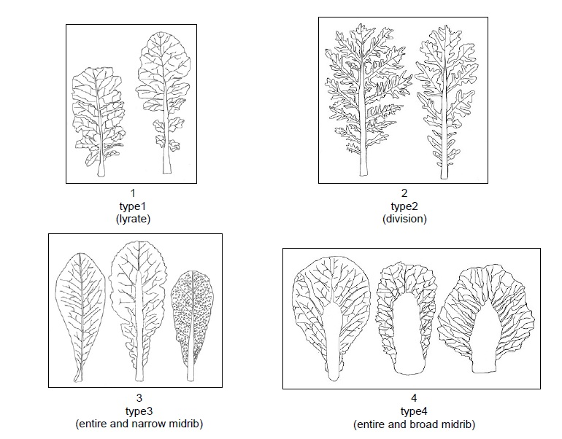
  (c)
  The measurements should be taken in the glasshouse on cotyledons of 30 seedlings. If the two cotyledons differ in size, the biggest one should be measured. The length is defined as distance between the inclination at top of the cotyledon and the point where the width of the petiole is about 4 mm. The width of the cotyledon should be measured at the widest point of the cotyledons. 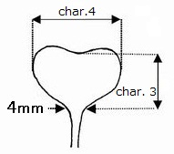
  (d)
  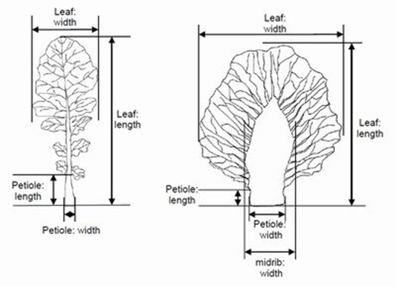
  (e)
  observations on the leaves should be made on the largest fully developed (non-senescent) leaf.
  (f)
  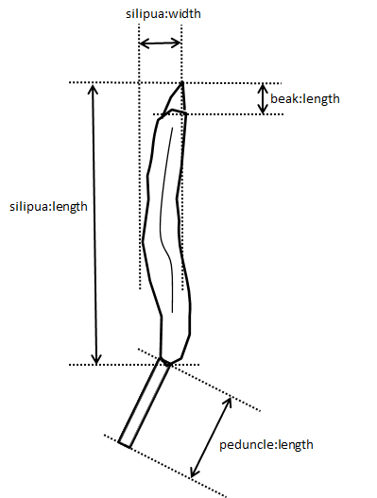

 | Explanations for individual characteristics
  8.2
Ad. 1: Seed: color

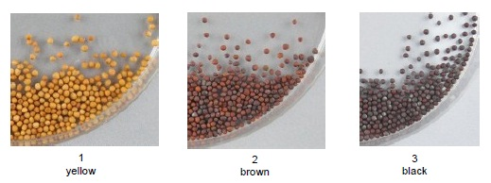

Ad. 5: Leaf: shape

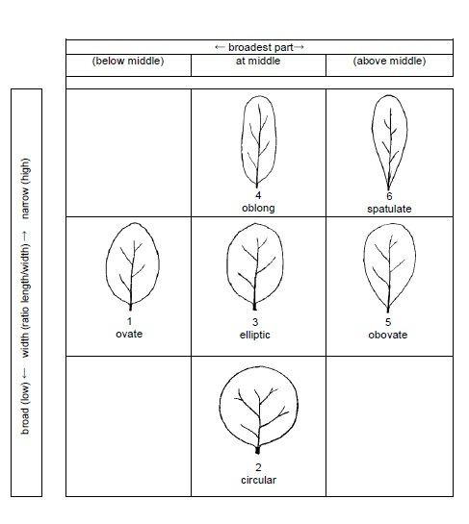

Ad. 6: Leaf: attitude

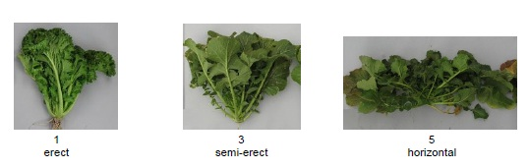

Ad. 11: Leaf blade: size of terminal lobe (total surface)

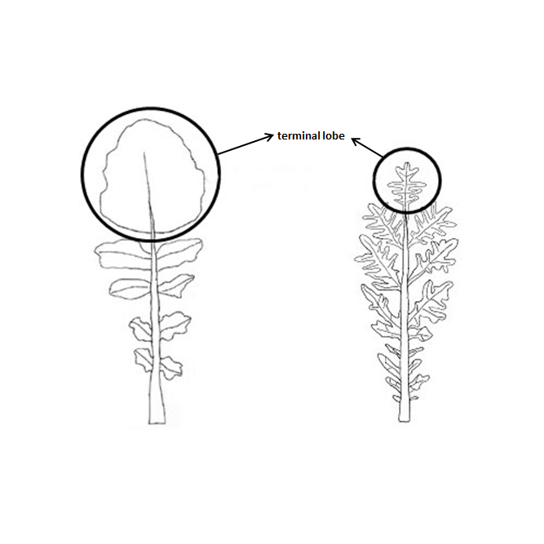

Ad. 14: Leaf blade: anthocyanin coloration

the strongest intensity of anthocyanin should be observed (not the extension).

Ad. 17: Leaf blade: density of incisions of margin (excluding type2)

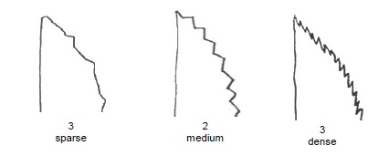

Ad. 18: Leaf blade: blistering (excluding type2)

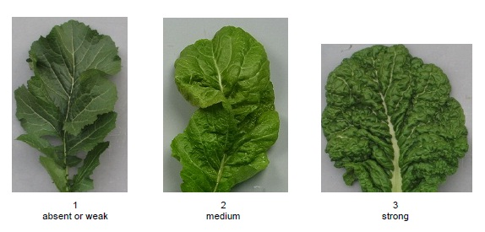

Ad. 20: Plant: head formation

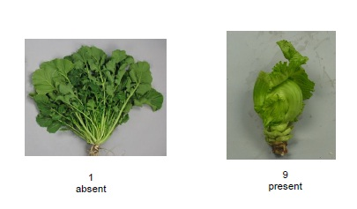

Ad. 23: Head: number of leaves

Observation on the leaves which form the head.

Ad. 25: Stem: type of main stem (excluding heading type)

Observation on type of main stem should be made on shape of main stem without lateral stem which locate at the base of main stem..
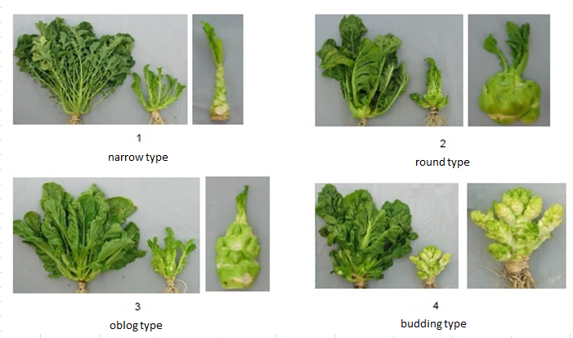

  8.3
  Other Names of the Example Varieties
  TTK456(1) | Chaplin(2)
  Akaoba Takana(3) | Red Giant(4)
  (1) official denomination registered under the law in Japan in 2011.
  (2) official denomination of TTK456 registered under the law in European Union in 2014.
  (3) commercial name in Japan.
  (4) commercial name of Akaoba Takana in European Union.

9. | Literature

Fujishiro, T., 1996: Breeding processes and characteristics of a newly bred leaf mustard (Brassica Juncea Coss.)., Kanagawa, Japan.
Joy Larkcom., 1991: Oriental Vegetables (The Complete guide for Garden and Kitchen) London, United Kingdom. pp. 39 to 45
Ministry of Agriculture, Forestry & Fisheries of Japan., 1994: National Test Guideline for Karashina.
Roger Phillips, Martyn Rix., 1993: VEGETABLES (The Pan Garden Plants Series) p.44
Tsukamoto, Y., 1994: The Grand Dictionary of Horticulture Volume 1. The Shogakukan Ltd., Tokyo, Japan, pp. 520 to 522.
Takasi A., 2004: Yasai-engei-daihyakka 17. Shadanhojin Nousan-gyoson-bunkakyokai. Tokyo, Japan. 169-233
Uwe Meier. Federal Biological Research Centre for Agriculture and Forestry, 2001: Growth stages of mono-and dicotyledonous plants, BBCH Monograph,

10.
Technical Questionnaire

TECHNICAL QUESTIONNAIRE | Page {x} of {y} | Reference Number:

Application date:
(not to be filled in by the applicant)
TECHNICAL QUESTIONNAIRE
to be completed in connection with an application for plant breeders' rights

1. | Subject of the Technical Questionnaire
 |  | Botanical name
  1.1
  Brassica juncea (L.) Czern.
 |  | Common name
  1.2
  Brown mustard, India mustard, Indian mustard, Oriental mustard

2. | Applicant
 | Name
 | Address
 | Telephone No.
 | Fax No.
 | E-mail address
 | Breeder (if different from
 | applicant)

3. | Proposed denomination and breeder's reference
 | Proposed denomination
 | (if available)
 | Breeder's reference

TECHNICAL QUESTIONNAIRE |  |  | Page {x} of {y} | Reference Number:
#4. | Information on the breeding scheme and propagation of the variety
 | 4.1 | Breeding scheme
Variety resulting from:
4.1.1 Crossing
(a) controlled cross [ ]
(please state parent varieties)
(…………………..……………..…) x (……………..…………………..…)
female parent male parent

(b) partially known cross [ ]
(please state known parent variety(ies))
(…………………..……………..…) x (……………..…………………..…)
female parent male parent

(c) unknown cross [ ]

4.1.2 Mutation [ ]
(please state parent variety)

4.1.3 Discovery and development [ ]
(please state where and when discovered and how developed)

4.1.4 Other [ ]
(please provide details)

 | 4.2 | Method of propagating the variety
  4.2.1
  Seed-propagated varieties
 |  | [ ]
  (a)
  Cross-pollination
 |  | [ ]
  (b)
  Other (please provide details)
 | Other  (Please provide details) | [ ]
  4.2.2

TECHNICAL QUESTIONNAIRE
Page {x} of {y} | Reference Number:

5. | Characteristics of the variety to be indicated (the number in brackets refers to the corresponding characteristic in Test Guidelines; please mark the note which best corresponds).

 | Characteristics | Example Varieties | Note
  5.1
  (1)
  Seed: color
  yellow
  Kigarashina
  1 [ ]
  brown
  Akaoba Takana(Red Giant), Esperance, Miike Takana, Terrafit, Terraplus
  2 [ ]
  black
  Hagarashina, TTK456(Chaplin)
  3 [ ]
  5.2
  (5)
  Leaf: shape
  ovate
  Serihon
  1 [ ]
  circular
  Kekkyu Takana
  2 [ ]
  elliptic
  Akariasu
  3 [ ]
  oblong
  Etamine, Zasai FM-58
  4 [ ]
  obovate
  Esperance, Katsuona
  5 [ ]
  spatulate
  Kigarashina
  6 [ ]
  5.3
  (6)
  Leaf: attitude
  erect
  Wasabina
  1 [ ]
  semi-erect
  Esperance, Shinkoku Seisai
  3 [ ]
  horizontal
  Etamine, Miike Takana
  5 [ ]
  5.4
  (14)
  Leaf blade: anthocyanin coloration
  absent or very weak
  Kekkyu Takana, Vitamine
  1 [ ]
  weak
  3 [ ]
  medium
  Miike Takana
  5 [ ]
  strong
  Akaoba Takana(Red Giant)
  7 [ ]

 | Characteristics | Example Varieties | Note
  5.5
  (16)
  Leaf blade: undulation of margin (excluding type2)
  absent or very weak
  1 [ ]
  very weak to weak
  2 [ ]
  weak
  Akaoba Takana(Red Giant)
  3 [ ]
  weak to medium
  4 [ ]
  medium
  Katsuona
  5 [ ]
  medium to strong
  6 [ ]
  strong
  Chirimen Hakarashina
  7 [ ]
  strong to very strong
  8 [ ]
  very strong
  9 [ ]
  5.6
  (17)
  Leaf blade: density of incisions of margin (excluding type2)
  absent or very sparse
  1 [ ]
  sparse
  Etamine, Katsuona
  3 [ ]
  medium
  Opaleska
  5 [ ]
  dense
  Oportuna
  7 [ ]
  5.7
  (18)
  Leaf blade: blistering (excluding type2)
  absent or weak
  Etamine, Kigarashina
  1 [ ]
  medium
  Akaoba Takana(Red Giant)
  2 [ ]
  strong
  Katsuona
  3 [ ]
  5.8
  (20)
  Plant: head formation
  absent
  Kigarashina
  1 [ ]
  present
  Kekkyu Takana
  9 [ ]

TECHNICAL QUESTIONNAIRE | Page {x} of {y} | Reference Number:

6. | Similar varieties and differences from these varieties
Please use the following table and box for comments to provide information on how your candidate variety differs from the variety (or varieties) which, to the best of your knowledge, is (or are) most similar. This information may help the examination authority to conduct its examination of distinctness in a more efficient way.

  Denomination(s) of variety(ies) similar to your candidate variety
  Characteristic(s) in which your candidate variety differs from the similar variety(ies)
  Describe the expression of the characteristic(s) for the similar variety(ies)
  Describe the expression of the characteristic(s) for your candidate variety

Example
  Leaf: shape
  ovate
  oblong

 | Comments:

TECHNICAL QUESTIONNAIRE |  |  | Page {x} of {y} | Reference Number:
#7. | Additional information which may help in the examination of the variety
7.1 | In addition to the information provided in sections 5 and 6, are there any additional characteristics which may help to distinguish the variety?
 | Yes | [ ] | No | [ ]
 | (If yes, please provide details)
7.2 | Are there any special conditions for growing the variety or conducting the examination?
 | Yes | [ ] | No | [ ]
 | (If yes, please provide details)
7.3 | Other information
(a) Main use
Vegetable [ ]
Seed i oil ii condiment [ ]
Green manure [ ]
other [ ]

(b) Leaf type (see chapter 8.1 (b) for explanation)
type 1 [ ]
type 2 [ ]
type 3 [ ]
type 4 [ ]

8. | Authorization for release
 | (a) | Does the variety require prior authorization for release under legislation concerning the protection of the environment, human and animal health?
 |  | Yes | [ ] | No | [ ]
 | (b) | Has such authorization been obtained?
 |  | Yes | [ ] | No | [ ]
 | If the answer to (b) is yes, please attach a copy of the authorization.

9. Information on plant material to be examined or submitted for examination

9.1 The expression of a characteristic or several characteristics of a variety may be affected by factors, such as pests and disease, chemical treatment (e.g. growth retardants or pesticides), effects of tissue culture, different rootstocks, scions taken from different growth phases of a tree, etc.
9.2 The plant material should not have undergone any treatment which would affect the expression of the characteristics of the variety, unless the competent authorities allow or request such treatment. If the plant material has undergone such treatment, full details of the treatment must be given. In this respect, please indicate below, to the best of your knowledge, if the plant material to be examined has been subjected to:

 | (a) | Microorganisms (e.g. virus, bacteria, phytoplasma) | Yes [ ] | No [ ]
 | (b) | Chemical treatment (e.g. growth retardant, pesticide) | Yes [ ] | No [ ]
 | (c) | Tissue culture | Yes [ ] | No [ ]
 | (d) | Other factors | Yes [ ] | No [ ]
 | Please provide details for where you have indicated “yes”.

10. | I hereby declare that, to the best of my knowledge, the information provided in this form is correct:
 | Applicant’s name
 | Signature |  | Date

[End of document]

