 |  | E
 | 
  TG/259/2(proj.2)
  ORIGINAL: English
  DATE: 2016-05-20
INTERNATIONAL UNION FOR THE PROTECTION OF NEW VARIETIES OF PLANTS
 | Geneva
  DRAFT
  AGARICUS
  UPOV Code(s): AGARI_BIS
  Agaricus bisporus (Lange.) Sing.
  *
GUIDELINES
FOR THE CONDUCT OF TESTS
FOR DISTINCTNESS, UNIFORMITY AND STABILITY

prepared by experts from European Union
to be considered by the
Technical Working Party for Vegetables

at its fiftieth session, to be held in Brno, Czech Republic,
from 2016-06-27 to 2016-07-01

Disclaimer: this document does not represent UPOV policies or guidance
Alternative names:*

Botanical name | English | French | German | Spanish
  Agaricus bisporus (Lange.) Sing.
  Mushroom; tukuritake
  Champignon de couche
  Champignon
  Champiñón

The purpose of these guidelines (“Test Guidelines”) is to elaborate the principles contained in the General Introduction (document TG/1/3), and its associated TGP documents, into detailed practical guidance for the harmonized examination of distinctness, uniformity and stability (DUS) and, in particular, to identify appropriate characteristics for the examination of DUS and production of harmonized variety descriptions.
ASSOCIATED DOCUMENTS
These Test Guidelines should be read in conjunction with the General Introduction and its associated TGP documents.

TABLE OF CONTENTS | PAGE
1. | SUBJECT OF THESE TEST GUIDELINES.......................................................................................................... | 3
2. | MATERIAL REQUIRED......................................................................................................................................... | 3
3. | METHOD OF EXAMINATION................................................................................................................................ | 4
3.1 | Number of Growing Cycles........................................................................................................................ | 4
3.2 | Testing Place............................................................................................................................................. | 4
3.3 | Conditions for Conducting the Examination............................................................................................... | 4
3.4 | Test Design................................................................................................................................................ | 4
3.5 | Additional Tests......................................................................................................................................... | 4

4. | ASSESSMENT OF DISTINCTNESS, UNIFORMITY AND STABILITY................................................................. | 5
4.1 | Distinctness............................................................................................................................................... | 5
4.2 | Uniformity.................................................................................................................................................. | 5
4.3 | Stability...................................................................................................................................................... | 5

5. | GROUPING OF VARIETIES AND ORGANIZATION OF THE GROWING TRIAL................................................ | 6
6. | INTRODUCTION TO THE TABLE OF CHARACTERISTICS................................................................................ | 7
6.1 | Categories of Characteristics..................................................................................................................... | 7
6.2 | States of Expression and Corresponding Notes........................................................................................ | 7
6.3 | Types of Expression.................................................................................................................................. | 7
6.4 | Example Varieties...................................................................................................................................... | 7
6.5 | Legend....................................................................................................................................................... | 7

7. | TABLE OF CHARACTERISTICS/TABLEAU DES CARACTÈRES/MERKMALSTABELLE/TABLA DE CARACTERES...................................................................................................................................................... | 8
8. | EXPLANATIONS ON THE TABLE OF CHARACTERISTICS............................................................................... | 9
8.1 | Explanations covering several characteristics........................................................................................... | 9
 | Explanations for individual characteristics................................................................................................. | 9
  8.2

9. | LITERATURE......................................................................................................................................................... | 9
10. | TECHNICAL QUESTIONNAIRE............................................................................................................................ | 11

1.
Subject of these Test Guidelines
These Test Guidelines apply to all varieties of Agaricus bisporus (Lange.) Sing..

2. | Material Required
2.1
  The competent authorities decide on the quantity and quality of the material required for testing the variety and when and where it is to be delivered. Applicants submitting material from a State other than that in which the testing takes place must ensure that all customs formalities and phytosanitary requirements are complied with.
2.2
  The material is to be supplied in the form of spawn or pure culture on a suitable medium.
2.3
  The minimum quantity of material, to be supplied by the applicant, should be:
(a) 15 litres of spawn.
or
(b) 2 slant tubes or agar plate (petri dish), containing a pure culture.

2.4
  The material supplied should be visibly healthy, not lacking in vigor, nor affected by any important pest or disease.
2.5
  The material should not have undergone any treatment which would affect the expression of the characteristics of the variety, unless the competent authorities allow or request such treatment. If it has been treated, full details of the treatment must be given.

3. | Method of Examination
3.1 | Number of Growing Cycles
3.1.1 | The minimum duration of tests should normally be two independent growing cycles.
  3.1.2
  The two independent growing cycles should be in the form of two separate cultivations.
  3.1.3
  The growing cycle is considered to be from spawn inoculation until the end of the first flush. Extension of the cultivation period can be requested by the applicant if the distinctness can only be demonstrated in the second and/or third flush.
3.2 | Testing Place
 | Tests are normally conducted at one place. In the case of tests conducted at more than one place, guidance is provided in TGP/9 “Examining Distinctness”.
3.3 | Conditions for Conducting the Examination
 | The tests should be carried out under conditions ensuring satisfactory growth for the expression of the relevant characteristics of the variety and for the conduct of the examination.
3.4 | Test Design
  3.4.1
  The design of the tests should be such that fruit bodies or parts of fruit bodies may be removed for measurement or counting without prejudice to the observations which must be made up to the end of the growing cycle.
  3.4.2
  Each test should be designed to result in a total of at least 90 fruit bodies in the first flush, which should be divided equally over 3 replicates. 45 fruit bodies should be collected at stage 2 and 45 fruit bodies should be collected at stage 5 (see chapter 8.1 (f))
  3.4.3. A minimum growing surface per strain of 1m² is advised in order to attain suffiient fruiting bodies in both stages.
3.5 | Additional Tests
 | Additional tests, for examining relevant characteristics, may be established.

4.
Assessment of Distinctness, Uniformity and Stability
4.1 | Distinctness
4.1.1 | General Recommendations
 | It is of particular importance for users of these Test Guidelines to consult the General Introduction prior to making decisions regarding distinctness. However, the following points are provided for elaboration or emphasis in these Test Guidelines.
4.1.2 | Consistent Differences
 | The differences observed between varieties may be so clear that more than one growing cycle is not necessary. In addition, in some circumstances, the influence of the environment is not such that more than a single growing cycle is required to provide assurance that the differences observed between varieties are sufficiently consistent. One means of ensuring that a difference in a characteristic, observed in a growing trial, is sufficiently consistent is to examine the characteristic in at least two independent growing cycles.
4.1.3 | Clear Differences
 | Determining whether a difference between two varieties is clear depends on many factors, and should consider, in particular, the type of expression of the characteristic being examined, i.e. whether it is expressed in a qualitative, quantitative, or pseudo-qualitative manner. Therefore, it is important that users of these Test Guidelines are familiar with the recommendations contained in the General Introduction prior to making decisions regarding distinctness.
4.1.4
  Number of fruit bodies or parts of fruit bodies to be Examined
  Unless otherwise indicated, for the purposes of distinctness, all observations on single fruit bodies should be made on 90 fruit bodies or parts of fruit bodies taken from each of 90 fruit bodies and any other observations made on all fruit bodies in the test, disregarding any off-type fruit bodies.
4.1.5 | Method of Observation
 | The recommended method of observing the characteristic for the purposes of distinctness is indicated by the following key in the second column of the Table of Characteristics (see document TGP/9 “Examining Distinctness”, Section 4 “Observation of characteristics”):
MG: single measurement of a group of fruit bodies or parts of fruit bodies
MS: measurement of a number of individual fruit bodies or parts of fruit bodies
VG: visual assessment by a single observation of a group of fruit bodies or parts of fruit bodies
VS: visual assessment by observation of individual fruit bodies or parts of fruit bodies

 | Type of observation: visual (V) or measurement (M)
 | “Visual” observation (V) is an observation made on the basis of the expert’s judgment. For the purposes of this document, “visual” observation refers to the sensory observations of the experts and, therefore, also includes smell, taste and touch. Visual observation includes observations where the expert uses reference points (e.g. diagrams, example varieties, side-by-side comparison) or non-linear charts (e.g. color charts). Measurement (M) is an objective observation against a calibrated, linear scale e.g. using a ruler, weighing scales, colorimeter, dates, counts, etc.
  Type of record: for a group of fruit bodies (G) or for single, individual fruit bodies (S)
  For the purposes of distinctness, observations may be recorded as a single record for a group of fruit bodies or parts of fruit bodies (G), or may be recorded as records for a number of single, individual fruit bodies or parts of fruit bodies (S). In most cases, “G” provides a single record per variety and it is not possible or necessary to apply statistical methods in a fruit body-by-fruit body analysis for the assessment of distinctness.
 | In cases where more than one method of observing the characteristic is indicated in the Table of Characteristics (e.g. VG/MG), guidance on selecting an appropriate method is provided in document TGP/9, Section 4.2.
4.2 | Uniformity
4.2.1 | It is of particular importance for users of these Test Guidelines to consult the General Introduction prior to making decisions regarding uniformity. However, the following points are provided for elaboration or emphasis in these Test Guidelines:
4.2.2 | For the assessment of uniformity of cross-pollinated varieties, a population standard of 1% and an acceptance probability of at least 95% should be applied. In the case of a sample size of 90 fruit bodies, 3 off-types are allowed.
4.3 | Stability
4.3.1 | In practice, it is not usual to perform tests of stability that produce results as certain as those of the testing of distinctness and uniformity. However, experience has demonstrated that, for many types of variety, when a variety has been shown to be uniform, it can also be considered to be stable.
4.3.2 | Where appropriate, or in cases of doubt, stability may be further examined by testing a new stock to ensure that it exhibits the same characteristics as those shown by the initial material supplied.

5.
Grouping of Varieties and Organization of the Growing Trial
5.1 | The selection of varieties of common knowledge to be grown in the trial with the candidate varieties and the way in which these varieties are divided into groups to facilitate the assessment of distinctness are aided by the use of grouping characteristics.
5.2 | Grouping characteristics are those in which the documented states of expression, even where produced at different locations, can be used, either individually or in combination with other such characteristics: (a) to select varieties of common knowledge that can be excluded from the growing trial used for examination of distinctness; and (b) to organize the growing trial so that similar varieties are grouped together.
5.3 | The following have been agreed as useful grouping characteristics:
  (a)
  Cap: color (characteristic 9)
  (b)
  Gills: color (characteristic 20)
  (c)
  Basidium: spores (characteristic 22)

5.4 | Guidance for the use of grouping characteristics, in the process of examining distinctness, is provided through the General Introduction and document TGP/9 “Examining Distinctness”.

6. | Introduction to the Table of Characteristics
6.1 | Categories of Characteristics
6.1.1 | Standard Test Guidelines Characteristics
 | Standard Test Guidelines characteristics are those which are approved by UPOV for examination of DUS and from which members of the Union can select those suitable for their particular circumstances.
6.1.2 | Asterisked Characteristics
 | Asterisked characteristics (denoted by *) are those included in the Test Guidelines which are important for the international harmonization of variety descriptions and should always be examined for DUS and included in the variety description by all members of the Union, except when the state of expression of a preceding characteristic or regional environmental conditions render this inappropriate.
6.2 | States of Expression and Corresponding Notes
6.2.1 | States of expression are given for each characteristic to define the characteristic and to harmonize descriptions. Each state of expression is allocated a corresponding numerical note for ease of recording of data and for the production and exchange of the description.
6.2.2 | In the case of qualitative and pseudo-qualitative characteristics (see Chapter 6.3), all relevant states of expression are presented in the characteristic. However, in the case of quantitative characteristics with 5 or more states, an abbreviated scale may be used to minimize the size of the Table of Characteristics. For example, in the case of a quantitative characteristic with 9 states, the presentation of states of expression in the Test Guidelines may be abbreviated as follows:
State | Note
small | 3
medium | 5
large | 7

 | However, it should be noted that all of the following 9 states of expression exist to describe varieties and should be used as appropriate:
State | Note
very small | 1
very small to small | 2
small | 3
small to medium | 4
medium | 5
medium to large | 6
large | 7
large to very large | 8
very large | 9

6.2.3 | Further explanation of the presentation of states of expression and notes is provided in document TGP/7 “Development of Test Guidelines”.
6.3 | Types of Expression
 | An explanation of the types of expression of characteristics (qualitative, quantitative and pseudo-qualitative) is provided in the General Introduction.
6.4 | Example Varieties
 | Where appropriate, example varieties are provided to clarify the states of expression of each characteristic.
6.5 | Legend
 |  | English |  | français |  | deutsch | español | Example Varieties  Exemples  Beispielssorten  Variedades ejemplo | Note/  Nota
  1
  2
  3
  4
  5
  6
  7
  Name of characteristics in English
  Nom du caractère en français
  Name des Merkmals auf Deutsch
  Nombre del carácter en español
  states of expression
  types d’expression
  Ausprägungsstufen
  tipos de expresión

1 | Characteristic number
2 | (*) | Asterisked characteristic | – see Chapter 6.1.2
3 | Type of expression
 | QL | Qualitative characteristic | – see Chapter 6.3
 | QN | Quantitative characteristic | – see Chapter 6.3
 | PQ | Pseudo-qualitative characteristic | – see Chapter 6.3
4 | Method of observation (and type of plot, if applicable)
 | MG, MS, VG, VS |  | – see Chapter 4.1.5
5
  (+)
  See Explanations on the Table of Characteristics in Chapter 8.2
6
  (a)-(e)
  See Explanations on the Table of Characteristics in Chapter 8.1
7
  Growth stage key See Explanations on the Table of Characteristics in Chapter 8

7. | Table of Characteristics/Tableau des caractères/Merkmalstabelle/Tabla de caracteres

 |  | English |  | français |  | deutsch | español | Example Varieties  Exemples  Beispielssorten  Variedades ejemplo | Note/  Nota
1. |  | QN | VG | (+)
  Mycelium: intensity
 |  | weak |  |  |  |  |  | J10263 | 1
 |  | medium |  |  |  |  |  | Horronda, Sylvan A15 | 2
 |  | strong |  |  |  |  |  | Brawn, Heirloom | 3
2. |  | QN | VG | (+)
  Pin setting: number of pins
 |  | few |  |  |  |  |  | Horronda | 3
 |  | medium |  |  |  |  |  | Amycel 2400 | 5
 |  | many |  |  |  |  |  | Horwitu, Sylvan A15 | 7
3. | (*) | QN | MG | (+) |  | 2
  Time beginning of harvest
 |  | early |  |  |  |  |  | Brawn | 3
 |  | medium |  |  |  |  |  | Amycel 2400 | 5
 |  | late |  |  |  |  |  | Euromycel 58 | 7
4. | (*) | QN | MG | (+) |  | 2
  Time of peak of first flush
 |  | early |  |  |  |  |  | Heirloom | 3
 |  | medium |  |  |  |  |  | Amycel 2400, Sylvan A15 | 5
 |  | late |  |  |  |  |  | Brawn, Euromycel 58 | 7
5. | (*) | QN | MS/VG | (+) | (a), (b) | 2
  Stipe: length
  Stipe : longueur
  Stiel: Länge
  Pie: longitud
 |  | short |  | court |  | kurz | corto | Brawn | 3
 |  | medium |  | moyen |  | mittel | mediano | Broncoh, Sylvan A15 | 5
 |  | long |  | long |  | lang | largo | Amycel 2400, Horwitu | 7
6. | (*) | QN | MS/VG | (+) | (a), (b) | 2
  Stipe: diameter
 |  | narrow |  |  |  |  |  | Somycel 53 | 3
 |  | medium |  |  |  |  |  | Brawn, Broncoh | 5
 |  | broad |  |  |  |  |  | Horronda | 7
7. | (*) | QN | MS/VG |  | (a) | 2
  Stipe: ratio length/diameter
 |  | moderately compressed |  | modérément compressé |  | mäßig zusammengedrückt | moderadamente comprimida |  | 3
 |  | medium |  | moyen |  | mittel | media | Sylvan A15 | 5
 |  | moderately elongated |  | modérément allongé |  | mäßig länglich | moderadamente alargada | Somycel 53 | 7
8. | (*) | QL | VG | (+) | (a) | 2
  Stipe: shape in longitudinal section
 |  | rectangular |  | rectangulaire |  | rechteckig | rectangular | Horronda | 1
 |  | trapezoidal |  | trapézoïdale |  | trapezförmig | trapezoidal | Euromycel 30 | 2
9. | (*) | PQ | VG |  | (c)
  Cap: color
 |  | white |  |  |  |  |  | Sylvan A15 | 1
 |  | greyish white |  |  |  |  |  | Somycel 76 | 2
 |  | brown |  |  |  |  |  | Amycel 2400 | 3
10. |  | QL | VG | (+) | (a) | 2
  Varieties with brown cap only: Stipe: color
 |  | white |  |  |  |  |  | Brawn, Heirloom | 1
 |  | greyish white |  |  |  |  |  | Amycel 2400 | 2
11. |  | QN | VG | (+) | (a) | 2
  Stipe: degree of discoloration
 |  | absent or weak |  |  |  |  |  | Sylvan A15 | 1
 |  | medium |  |  |  |  |  | Heirloom | 2
 |  | strong |  |  |  |  |  | Somycel 53 | 3
12. | (*) | QN | MS/VG | (+) | (a), (b) | 2
  Cap: height
  Chapeau : hauteur
  Hut: Höhe
  Sombrero: altura
 |  | short |  |  |  |  |  | J10263 | 3
 |  | medium |  |  |  |  |  | Brawn, Sylvan A15 | 5
 |  | tall |  |  |  |  |  | Euromycel 58 | 7
13. | (*) | QN | MS/VG | (+) | (a), (b) | 2
  Cap: diameter
 |  | small |  |  |  |  |  | Horwitu | 3
 |  | medium |  |  |  |  |  | Broncoh | 5
 |  | large |  |  |  |  |  | Heirloom, Sylvan A15 | 7
14. | (*) | QN | MS/VG |  | (a) | 2
  Cap: ratio height/diameter
 |  | moderately compressed |  |  |  |  |  | Somycel 76 | 3
 |  | medium |  |  |  |  |  | Broncoh, Sylvan A15 | 5
 |  | moderately elongated |  |  |  |  |  | Heirloom | 7
15. |  | QN | VG | (+) | (a) | 2
  Varieties with brown caps only: Cap: Shade of scales compared to surface
 |  | light |  |  |  |  |  | Amycel 2400, Heirloom | 1
 |  | medium |  |  |  |  |  |  | 2
 |  | dark |  |  |  |  |  | Brawn | 3
16. | (*) | QN | MS/VG | (+) | (a), (b) | 2
  Cap: thickness in longitudinal section
  Chapeau : épaisseur en section longitudinale
  Hut: Dicke im Längsschnitt
  Sombrero: espesor en sección longitudinal
 |  | thin |  | mince |  | dünn | delgado | J10263 | 3
 |  | medium |  | moyen |  | mittel | medio | Broncoh, Horronda | 5
 |  | thick |  | épais |  | dick | grueso | Sylvan A15 | 7
17. | (*) | QN | VG | (+) | (a) | 2
  Cap: scaling
 |  | absent or very weak |  | absentes ou très peu nombreuses |  | fehlend oder sehr gering | ausente o muy débil | Somycel 53 | 1
 |  | weak |  | peu nombreuses |  | gering | débil | Horwitu | 3
 |  | medium |  | moyennement nombreuses |  | mittel | medio | Heirloom, Horronda | 5
 |  | strong |  | nombreuses |  | stark | fuerte | Somycel 76 | 7
 |  | very strong |  | très nombreuses |  | sehr stark | muy fuerte | Broncoh | 9
18. | (*) | QN | VG |  | (a) | 2
  Brown varieties only: intensity of cap color
 |  | very light |  |  |  |  |  | Broncoh, J10263 | 1
 |  | light |  |  |  |  |  | Amycel 2400 | 3
 |  | medium |  |  |  |  |  | Heirloom | 5
 |  | dark |  |  |  |  |  | Brawn | 7
 |  | very dark |  |  |  |  |  |  | 9
19. |  | QN | VG | (+) | (a) | 2
  Cap: thickness of veil
 |  | thin |  |  |  |  |  | J10263 | 3
 |  | medium |  |  |  |  |  | Horronda, Sylvan A15 | 5
 |  | thick |  |  |  |  |  |  | 7
20. | (*) | PQ | VG |  | (d) | 3
  Gills: color
 |  | pink |  |  |  |  |  | BP-1 | 1
 |  | light brown |  | marron clair |  | hellbraun | marrón claro | Horronda, Horwitu | 2
 |  | dark brown |  | marron foncé |  | dunkelbraun | marrón oscuro | Broncoh | 3
21. |  | PQ | VG | (+) | (d) | 3
  Varieties with brown caps only: Veil: annulus color
 |  | white |  |  |  |  |  | Amycel 2400, Sylvan 800 | 1
 |  | brown |  |  |  |  |  | Brawn, Heirloom | 2
22. | (*) | QL | VG | (+) | (a), (c) | (b) (f)
  Basidium: spores
 |  | absent |  |  |  |  |  | J10263 | 1
 |  | present |  |  |  |  |  | Sylvan A15 | 9
23. | (*) | QL | MS | (+) | (d) | 3
  Basidium: number of spores
 |  | two |  |  |  |  |  | Heirloom, Horwitu | 1
 |  | four |  |  |  |  |  | JB-2 | 2
24. |  | QN | MG | (+) |  | 4
  Time of fully opening of cap
 |  | early |  |  |  |  |  | Horwitu | 3
 |  | medium |  |  |  |  |  | Amycel 2400, Sylvan A15 | 5
 |  | late |  |  |  |  |  | Brawn, Heirloom | 7
25. | (*) | QN | VG |  | (c), (e) | 5
  Open cap: Stipe distance from base to annulus
 |  | short |  |  |  |  |  | Amycel 2400 | 3
 |  | medium |  |  |  |  |  | Broncoh | 5
 |  | long |  |  |  |  |  | Horwitu | 7
26. | (*) | QN | MS/VG |  | (c), (e) | 5
  Open cap: diameter
 |  | small |  |  |  |  |  | Horwitu | 3
 |  | medium |  |  |  |  |  | Broncoh, Sylvan A15 | 5
 |  | large |  |  |  |  |  | Amycel 2400, Heirloom | 7
27. | (*) | QN | MS/VG |  | (c), (e) | 5
  Open cap: thickness
  Chapeau ouvert : épaisseur
  Offener Hut: Dicke
  Sombrero abierto: espesor
 |  | thin |  |  |  |  |  | J10263 | 3
 |  | medium |  |  |  |  |  | Horwitu, Sylvan A15 | 5
 |  | thick |  |  |  |  |  | Brawn, Heirloom | 7
28. | (*) | QN | VG | (+) | (c) | 5
  Open cap: fraying of margin
  Chapeau ouvert : effilochage du bord
  Offener Hut: Ausfransen des Randes
  Sombrero abierto: deshilachado del borde
 |  | absent or weak |  |  |  |  |  | Amycel 2400 | 1
 |  | moderate |  |  |  |  |  | Broncoh, Horwitu | 2
 |  | strong |  |  |  |  |  | Heirloom, Horronda | 3
29. | (*) | PQ | VG | (+) | (c) | 5
  Open cap: shape of central part of upper side
  Chapeau ouvert : forme de la partie centrale de la face supérieure
  Offener Hut: Form des mittleren Teils der Oberseite
  Sombrero abierto: forma del centro de la parte superior
 |  | rounded |  |  |  |  |  | Euromycel 58, Sylvan A15 | 1
 |  | plane |  |  |  |  |  | Heirloom | 2
 |  | depressed |  |  |  |  |  | Broncoh | 3

8. | Explanations on the Table of Characteristics
8.1 | Explanations covering several characteristics
 | Characteristics containing the following key in the second column of the Table of Characteristics should be examined as indicated below:
  (a)
  Stipe, cap: Unless otherwise indicated, all characteristics of the stipe and the cap should be made at growth stage 2, when the fruit body appears as a button mushroom with the veil closed
  (b)
  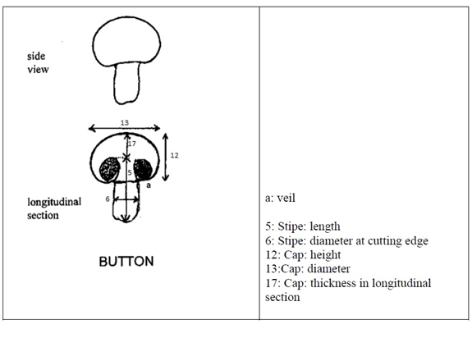
  (c)
  Open cap: Unless otherwise indicated, all characteristics of the open cap should be made at growth stage 5, when the cap of the fruit body is fully open and flat
  (d)
  Gills: Unless otherwise indicated, all characteristics of the gills should be made at growth stage 3, when the fruit body appears as a button mushroom with the veil breaking
  (e)
  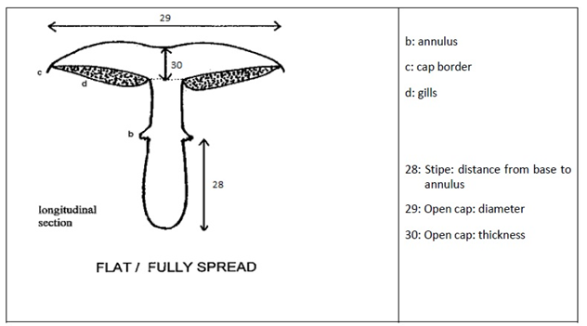

 | Explanations for individual characteristics
  8.2
Ad. 1: Mycelium: intensity

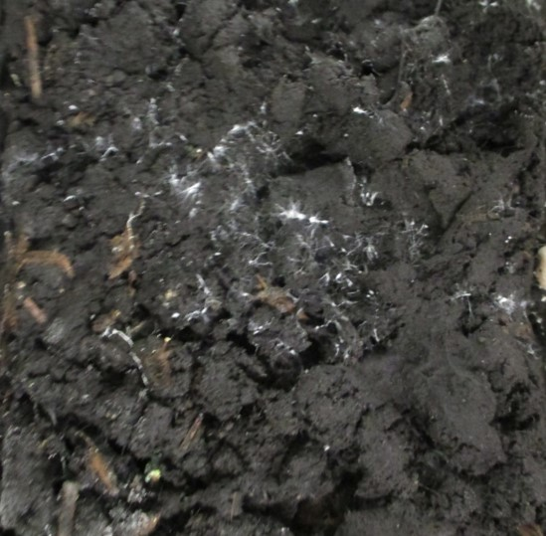 | 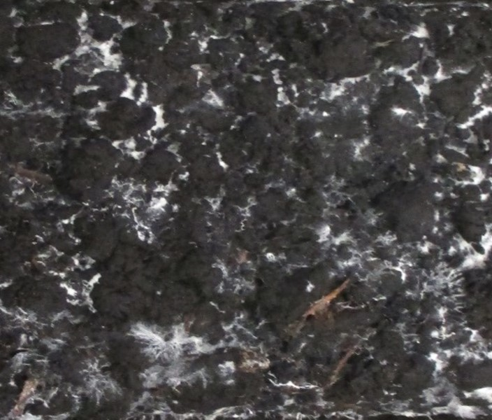 | 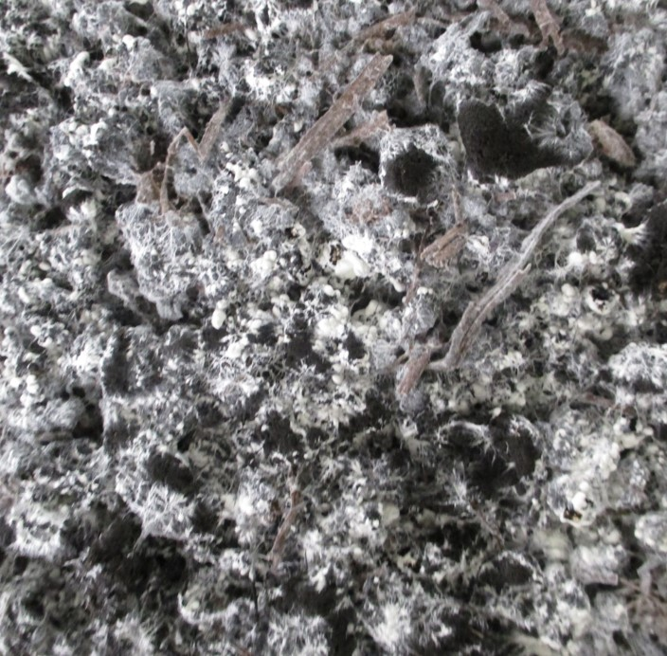
1 | 2 | 3
weak | medium | strong

Ad. 2: Pin setting: number of pins

The number of pins larger than 3 mm is visually assessed 4 days after aeration.

Ad. 3: Time beginning of harvest

The time of the first day of harvest is is recorded when 50% of the fruiting bodies in the first flush have reached growth stage 2

Ad. 4: Time of peak of first flush

The dates of harvest of fruit bodies at growth stage 2 are recorded. The time of the peak of the first flush is the time at which the largest number of fruit bodies was harvested.

Ad. 5: Stipe: length

The fruit bodies observed at growth stage 2 should be cut longitudinally.

Ad. 6: Stipe: diameter

To be observed half way along the length of the stipe

Ad. 8: Stipe: shape in longitudinal section

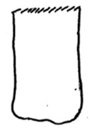 | 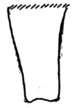
  1
  rectangular
  2
  trapezoidal

Ad. 10: Varieties with brown cap only: Stipe: color

The stipe color is assessed visually after removing the caps.

Ad. 11: Stipe: degree of discoloration

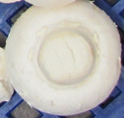 | 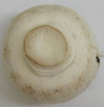
  1
  absent or weak
  2
  medium

Ad. 12: Cap: height

The fruit bodies observed at growth stage 2 should be cut longitudinally.

Ad. 13: Cap: diameter

The fruit bodies observed at growth stage 2 should be cut longitudinally.

Ad. 15: Varieties with brown caps only: Cap: Shade of scales compared to surface

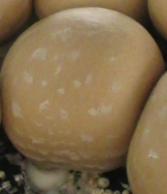 | 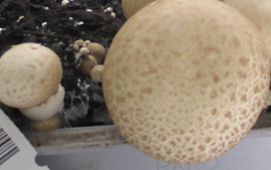
  1
  light
  2
  medium

Ad. 16: Cap: thickness in longitudinal section

The fruit bodies observed at growth stage 2 should be cut longitudinally.

Ad. 17: Cap: scaling

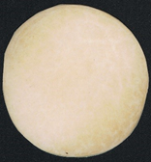 | 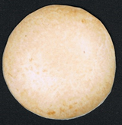 | 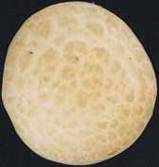
  1
  absent or very weak
  3
  weak
  5
  medium
 | 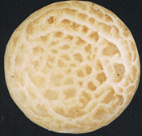
  7
  strong
  9
  very strong

Ad. 19: Cap: thickness of veil

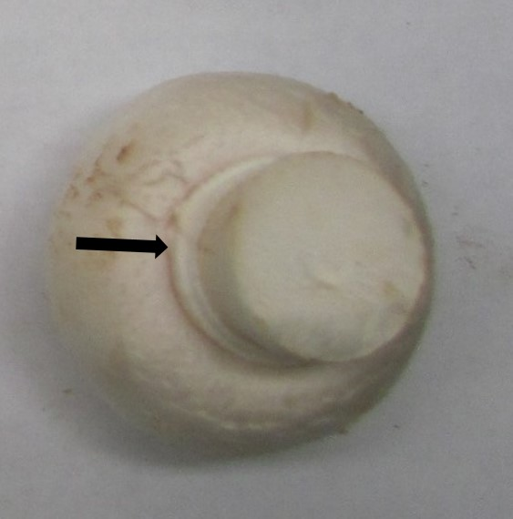 | 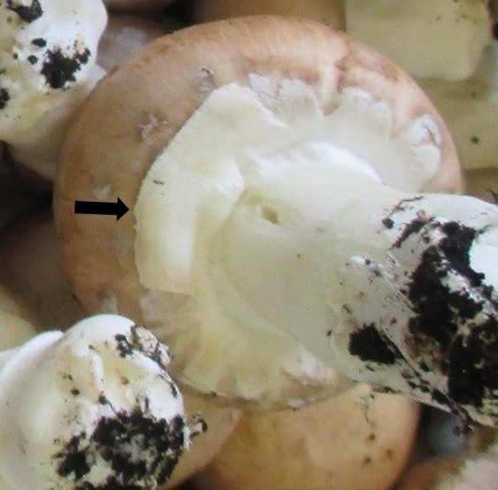
  3
  thin
  7
  thick

Ad. 21: Varieties with brown caps only: Veil: annulus color

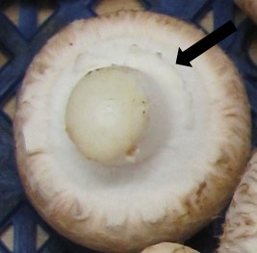 | 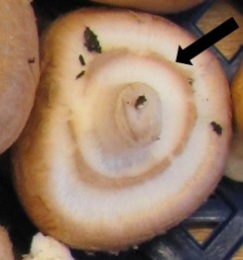
  1
  white
  2
  brown

Ad. 22: Basidium: spores

To be observed by rubbing mature gills (pictures to be provided)

Ad. 23: Basidium: number of spores

The number of spores in the majority of the basidia is counted in ten basidia within a single microscopic slide. The basidia and their spores can best be visualized using a 400× magnification of a dry mounted lamellar surface.

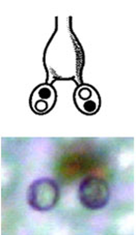 | 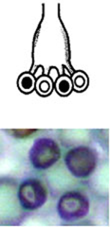
  1
  two
  4
  four

Ad. 24: Time of fully opening of cap

The time of cap opening is the first day on which the veil of a single fruiting body is completely torn.

Ad. 28: Open cap: fraying of margin

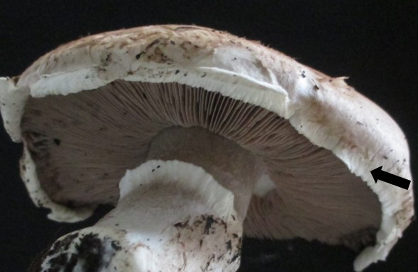 | 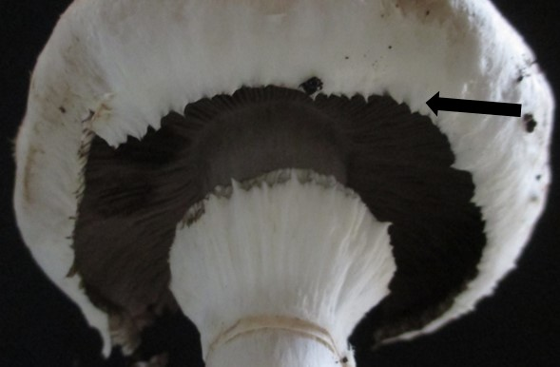 | 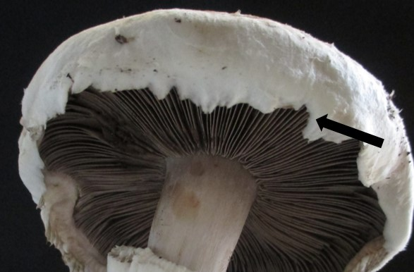
 |  | 3  strong
  1
  absent or weak
  2
  moderate

Ad. 29: Open cap: shape of central part of upper side

 | 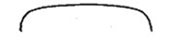 | 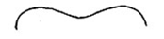
  1
  rounded
  2
  plane
  3
  depressed

  8.3
  Growth Stages
  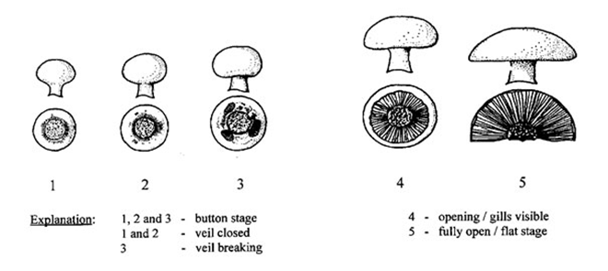

9. | Literature

Flegg, P.B., Spencer, D.M. and Wood, D.A., 1985: The biology and technology of the cultivated mushroom. J. Wiley & Son, 347 pp.

Fletcher, J.T. & Gaze R.H., 2007: Mushroom growing. In: Mushroom pest and disease control: a colour handbook, Manson Publishing Ltd, pp. 7-21.

Foulongne-Oriol., M, Rodier, A., Caumont, P., Spataro, C., Savoie, J.M., 2011: Agaricus bisporus cultivars: hidden diversity beyond apparent uniformity? In: Proceedings of the 7th international conference on mushroom biology and mushroom products, vol 2. pp 9–16.

Fritsche, G., 1964: Versuche zur Frage der Merkmalsübertragung beim Kulturchampignon Agaricus (Psalliota) bisporus (Lge.) Sing. Der Züchter 34-2: 76-93.

Fritsche, G., 1988: Spawn: properties and preparation, In: The Cultivation of Mushrooms, Darlington Mushroom Laboratories, pp. 91-99.

Neut, A. van der, 1991: The development of a set of characteristics for DUS tests of cultivated mushroom varieties. In: Genetics and breeding of Agaricus, Pudoc Wageningen, pp. 153-160.
Nichols, 1985. Post-harvest physiology and storage. Pp 195-210. In: Flegg P.B., Spencer D.M., Wood D.A. 1985: The biology and technology of the cultivated mushroom. J. Wiley & Son, 347 pp.

Parra Sánchez L.A. 2008: Fungi Europaei. Agaricus L. – Allopsalliota vol 1. Candusso Edizioni, 824 pp.

Parra Sánchez L.A., 2013: Fungi Europaei. Agaricus L. – Allopsalliota vol 2, Candusso Edizioni, 1168 pp.

Vooren, J.G. van de, Polder, G. & Heijden, G.W.A.M. van der, 1991: Application of image analysis for variety testing of mushroom. Euphytica 57: 245-250.

Vooren, J.G. van de, Polder, G. & Heijden, G.W.A.M. van der, 1992: Identification of mushroom cultivars using image analysis. Transactions of the ASAE 35-1: 347-350.

10.
Technical Questionnaire

TECHNICAL QUESTIONNAIRE | Page {x} of {y} | Reference Number:

Application date:
(not to be filled in by the applicant)
TECHNICAL QUESTIONNAIRE
to be completed in connection with an application for plant breeders' rights

1. | Subject of the Technical Questionnaire
 |  | Botanical name
  1.1
  Agaricus bisporus (Lange.) Sing.
 |  | Common name
  1.2
  Mushroom; tukuritake

2. | Applicant
 | Name
 | Address
 | Telephone No.
 | Fax No.
 | E-mail address
 | Breeder (if different from
 | applicant)

3. | Proposed denomination and breeder's reference
 | Proposed denomination
 | (if available)
 | Breeder's reference

TECHNICAL QUESTIONNAIRE |  |  | Page {x} of {y} | Reference Number:
#4. | Information on the breeding scheme and propagation of the variety
 | 4.1 | Breeding scheme

 | 4.2 | Method of propagating the variety
  4.2.1
  Vegetative propagation
 |  | [ ]
  (a)
  In vitro propagation
 |  | [ ]
  (b)
  Other (state method)
 | Other  (Please provide details) | [ ]
  4.2.2

TECHNICAL QUESTIONNAIRE
Page {x} of {y} | Reference Number:

5. | Characteristics of the variety to be indicated (the number in brackets refers to the corresponding characteristic in Test Guidelines; please mark the note which best corresponds).

 | Characteristics | Example Varieties | Note
  5.1
  (4)
  Time of peak of first flush
  early
  Heirloom
  3 [ ]
  medium
  Amycel 2400, Sylvan A15
  5 [ ]
  late
  Brawn, Euromycel 58
  7 [ ]
  5.2
  (9)
  Cap: color
  white
  Sylvan A15
  1 [ ]
  greyish white
  Somycel 76
  2 [ ]
  brown
  Amycel 2400
  3 [ ]
  5.3
  (13)
  Cap: diameter
  small
  Horwitu
  3 [ ]
  medium
  Broncoh
  5 [ ]
  large
  Heirloom, Sylvan A15
  7 [ ]
  5.4
  (20)
  Gills: color
  pink
  BP-1
  1 [ ]
  light brown
  Horronda, Horwitu
  2 [ ]
  dark brown
  Broncoh
  3 [ ]
  5.5
  (22)
  Basidium: spores
  absent
  J10263
  1 [ ]
  present
  Sylvan A15
  9 [ ]
  5.6
  (23)
  Basidium: number of spores
  two
  Heirloom, Horwitu
  1 [ ]
  four
  JB-2
  2 [ ]

TECHNICAL QUESTIONNAIRE | Page {x} of {y} | Reference Number:

6. | Similar varieties and differences from these varieties
Please use the following table and box for comments to provide information on how your candidate variety differs from the variety (or varieties) which, to the best of your knowledge, is (or are) most similar. This information may help the examination authority to conduct its examination of distinctness in a more efficient way.

  Denomination(s) of variety(ies) similar to your candidate variety
  Characteristic(s) in which your candidate variety differs from the similar variety(ies)
  Describe the expression of the characteristic(s) for the similar variety(ies)
  Describe the expression of the characteristic(s) for your candidate variety

Example

 | Comments:

TECHNICAL QUESTIONNAIRE |  |  | Page {x} of {y} | Reference Number:
#7. | Additional information which may help in the examination of the variety
7.1 | In addition to the information provided in sections 5 and 6, are there any additional characteristics which may help to distinguish the variety?
 | Yes | [ ] | No | [ ]
 | (If yes, please provide details)
7.2 | Are there any special conditions for growing the variety or conducting the examination?
 | Yes | [ ] | No | [ ]
 | (If yes, please provide details)
7.3 | Other information

8. | Authorization for release
 | (a) | Does the variety require prior authorization for release under legislation concerning the protection of the environment, human and animal health?
 |  | Yes | [ ] | No | [ ]
 | (b) | Has such authorization been obtained?
 |  | Yes | [ ] | No | [ ]
 | If the answer to (b) is yes, please attach a copy of the authorization.

9. Information on material to be examined or submitted for examination

9.1 The expression of a characteristic or several characteristics of a variety may be affected by factors, such as pests and disease, chemical treatment (e.g. growth retardants or pesticides), effects of tissue culture, different rootstocks, scions taken from different growth phases of a tree, etc.
9.2 The material should not have undergone any treatment which would affect the expression of the characteristics of the variety, unless the competent authorities allow or request such treatment. If the material has undergone such treatment, full details of the treatment must be given. In this respect, please indicate below, to the best of your knowledge, if the material to be examined has been subjected to:

 | (a) | Microorganisms (e.g. virus, bacteria, phytoplasma) | Yes [ ] | No [ ]
 | (b) | Chemical treatment (e.g. growth retardant, pesticide) | Yes [ ] | No [ ]
 | (c) | Tissue culture | Yes [ ] | No [ ]
 | (d) | Other factors | Yes [ ] | No [ ]
 | Please provide details for where you have indicated “yes”.

10. | I hereby declare that, to the best of my knowledge, the information provided in this form is correct:
 | Applicant’s name
 | Signature |  | Date

[End of document]

