E
TWV/49/24
ORIGINAL: English
DATE: May 21, 2015
INTERNATIONAL UNION FOR THE PROTECTION OF NEW VARIETIES OF PLANTS
Geneva
Technical working party for vegetables
Forty-Ninth Session
Angers, France, June 15 to 19, 2015
Partial Revision of the Test Guidelines for Onion, Shallot (Document TG/46/7)
Document prepared by an expert from the Netherlands
Disclaimer: this document does not represent UPOV policies or guidance
The Technical Working Party for Vegetables (TWV), at its forty-eighth session, held in Paestum, Italy, from June 23 to 27, 2014, agreed that the Test Guidelines for Onion, Shallot (document TG/46/7) be partially revised for Characteristic 27 “Bulb/Bulblet: number of growing points per kg” (see document TWV/48/43, Annex IV).

The Technical Committee (TC), at its fifty-first session, held in Geneva from March 23 to 25, 2015, agreed the program for the development of new Test Guidelines and for the revision of Test Guidelines, as shown in document TC/51/2, Annex III, including the partial revision of the Test Guidelines for Onion, Shallot (see document TC/51/39, paragraph 236).

After the fifty-first session of the TC, the Leading Expert, Mr. Kees van Ettekoven, Netherlands, provided the Office with the following explanation:

“Originally this partial revision was deemed necessary because the present guideline created problems in the discussion if material belonged to onion or to shallot. The discussion focussed on a possible more precise definition of characteristic 27 that in practice led to different interpretation notably between the French and Dutch DUS experts.

“In the meantime continued discussions and trials were carried out and in two joint meetings with experts from France, the Netherlands and CPVO it was concluded that in fact the present decision system in the guideline was not reliable at all. It meant that the authorities have to decide on a QN characteristic (number of growing points per kilo bulbs/bulblets) if material is onion or shallot. This was specially difficult as many seed shallots bolt in southern climates making the counting of number of growing points per kilo very difficult.

“As a conclusion of the discussions it was decided that another approach would be needed;
- The applicant should be able to indicate at application if the application is an onion or a shallot. During the DUS trial this could be checked. (shifting the responsibility more to the applicant)
- To ensure that in the market there is no confusion between the different types of material it was concluded that three groups would be more clear than two. So in stead of a division in onion/échallion vs shallot, it is now proposed to have three groups:
  - 1 onion/échallion
  - 2 traditional (vegetatively propagated) shallot
  - 3 seed shallot.
- It was decided to do more trials to ensure a clear definition of these three groups.”

On the above basis, the Leading Expert prepared a full draft of the Test Guidelines for Onion, Shallot in revision mode, a copy of which is presented in the Annex to this document, for consideration by the TWV at its forty-ninth session in order to decide whether to partially revise the Test Guidelines for Onion, Shallot, as agreed by the TWV at its forty-eighth session and the TC at its fifty-first session, or whether a full revision of the Test Guidelines for Onion, Shallot should be considered by the TWV at its fiftieth session.

The TWV is invited to consider whether to partially revise the Test Guidelines for Onion, Shallot or whether a full revision of the Test Guidelines for Onion, Shallot should be considered by the TWV at its fiftieth session.

[Annex follows]
E
TG/46/7REV
ORIGINAL: English
DATE: 2008-04-09
INTERNATIONAL UNION FOR THE PROTECTION OF NEW VARIETIES OF PLANTS
GENEVA

 | ONION, ECHALION; TRADITIONAL SHALLOT; SEED SHALLOT;  GREY SHALLOT  UPOV Code: ALLIU_CEP_CEP, ALLIU_CEP_AGG, ALLIU_CEP_SEE, ALLIU_OSC  Allium cepa (Cepa Group),  Allium cepa (Aggregatum Group), Allium cepa (Seed Shallot Group) and  Allium oschaninii O. Fedtsch.  and hybrids between them | *

GUIDELINES

FOR THE CONDUCT OF TESTS

FOR DISTINCTNESS, UNIFORMITY AND STABILITY

Alternative Names:*

Botanical name | English | French | German | Spanish
Allium cepa L. var. cepa,  Allium cepa (Cepa Group) | Onion, echalion,  bulb onion,  Spanish onion | Oignon, echalion | Zwiebel, Echalion | Cebolla,  echalion
Allium cepa L. var. aggregatum G. Don,  Allium cepa (Aggregatum Group) | Traditional Shallot, ever-ready onion, multiplier onion, potato onion | Échalote …….,  oignon patate | ………Schalotte | Chalota, escaluña
Allium cepa L. var. cepa,  Allium cepa (Seed Shallot Group) | Seed Shallot | ……………… | ………………. | …………..
Allium oschaninii O. Fedtsch. | Grey shallot | Échalote grise | Graue Schalotte | Chalota gris

The purpose of these guidelines (“Test Guidelines”) is to elaborate the principles contained in the General Introduction (document TG/1/3), and its associated TGP documents, into detailed practical guidance for the harmonized examination of distinctness, uniformity and stability (DUS) and, in particular, to identify appropriate characteristics for the examination of DUS and production of harmonized variety descriptions.

ASSOCIATED DOCUMENTS
These Test Guidelines should be read in conjunction with the General Introduction and its associated TGP documents.

TABLE OF CONTENTS PAGE

1. Subject of these Test Guidelines 6
2. Material Required 6
3. Method of Examination 6
3.1 Number of Growing Cycles 6
3.2 Testing Place 6
3.3 Conditions for Conducting the Examination 6
3.4 Test Design 7
3.5 Number of Plants / Parts of Plants to be Examined 7
3.6 Additional Tests 7
4. Assessment of Distinctness, Uniformity and Stability 7
4.1 Distinctness 7
4.2 Uniformity 8
4.3 Stability 8
5. Grouping of Varieties and Organization of the Growing Trial 8
6. Introduction to the Table of Characteristics 9
6.1 Categories of Characteristics 9
6.2 States of Expression and Corresponding Notes 9
6.3 Types of Expression 10
6.4 Example Varieties 10
6.5 Legend 10
7. Table of Characteristics/Tableau des caractères/Merkmalstabelle/Tabla de caracteres 11
8. Explanations on the Table of Characteristics 27
8.1 Explanations covering several characteristics 27
8.2 Explanations for individual characteristics 29
9. Literature 34
10. Technical Questionnaire 36

Subject of these Test Guidelines
These Test Guidelines apply to all varieties of: Allium cepa (Cepa Group), onion and echalion; Allium cepa (Aggregatum Group), traditional shallot; Allium cepa (Seed Shallot Group), seed shallot Allium oschaninii O. Fedtsch, grey shallot; and hybrids between Allium cepa L. and Allium oschaninii O. Fedtsch.

Material Required
2.1 The competent authorities decide on the quantity and quality of the plant material required for testing the variety and when and where it is to be delivered. Applicants submitting material from a State other than that in which the testing takes place must ensure that all customs formalities and phytosanitary requirements are complied with.

2.2 The material is to be supplied in the form of seed or bulblets.

2.3 The minimum quantity of plant material, to be supplied by the applicant, should be:

Seed-propagated varieties: 15,000 seeds
Vegetatively propagated varieties: 300 bulblets.

2.4 In the case of seed, the seed should meet the minimum requirements for germination, species and analytical purity, health and moisture content, specified by the competent authority.

2.5 The plant material supplied should be visibly healthy, not lacking in vigor, nor affected by any important pest or disease.

2.6 The plant material should not have undergone any treatment which would affect the expression of the characteristics of the variety, unless the competent authorities allow or request such treatment. If it has been treated, full details of the treatment must be given.

Method of Examination

3.1 Number of Growing Cycles
The minimum duration of tests should normally be two independent growing cycles.

3.2 Testing Place
Tests are normally conducted at one place. In the case of tests conducted at more than one place, guidance is provided in TGP/9 “Examining Distinctness”.

3.3 Conditions for Conducting the Examination
3.3.1 The tests should be carried out under conditions ensuring satisfactory growth for the expression of the relevant characteristics of the variety and for the conduct of the examination.

3.3.2 Type of observation

The recommended method of observing the characteristic is indicated by the following key in the second column of the Table of Characteristics:

MG: single measurement of a group of plants or parts of plants
MS: measurement of a number of individual plants or parts of plants
VG: visual assessment by a single observation of a group of plants or parts of plants
VS: visual assessment by observation of individual plants or parts of plants

3.4 Test Design
3.4.1 Each test should be designed to result in a total of at least 100 plants for vegetatively propagated varieties, 200 plants for seed-propagated varieties , which should be divided between 2 replicates.

3.4.2The design of the tests should be such that plants or parts of plants may be removed for measurement or counting without prejudice to the observations which must be made up to the end of the growing cycle.

3.4.3. To ensure proper development of the plants, a sufficiently wide planting distance should be applied for all material

3.5 Number of Plants / Parts of Plants to be Examined
Unless otherwise indicated: in the case of seed-propagated varieties, all observations on single plants should be made on 60 plants or parts taken from each of 60 plants; and in the case of vegetatively propagated varieties, all observations on single plants should be made on 40 plants or parts taken from each of 40 plants. Any other observations should be made on all plants in the test.

3.6 Additional Tests
Additional tests, for examining relevant characteristics, may be established.

Assessment of Distinctness, Uniformity and Stability

4.1 Distinctness

4.1.1 General Recommendations

It is of particular importance for users of these Test Guidelines to consult the General Introduction prior to making decisions regarding distinctness. However, the following points are provided for elaboration or emphasis in these Test Guidelines.

4.1.2 Consistent Differences

The differences observed between varieties may be so clear that more than one growing cycle is not necessary. In addition, in some circumstances, the influence of the environment is not such that more than a single growing cycle is required to provide assurance that the differences observed between varieties are sufficiently consistent. One means of ensuring that a difference in a characteristic, observed in a growing trial, is sufficiently consistent is to examine the characteristic in at least two independent growing cycles.

4.1.3 Clear Differences

Determining whether a difference between two varieties is clear depends on many factors, and should consider, in particular, the type of expression of the characteristic being examined, i.e. whether it is expressed in a qualitative, quantitative, or pseudo-qualitative manner. Therefore, it is important that users of these Test Guidelines are familiar with the recommendations contained in the General Introduction prior to making decisions regarding distinctness.

4.2 Uniformity
4.2.1 It is of particular importance for users of these Test Guidelines to consult the General Introduction prior to making decisions regarding uniformity. However, the following points are provided for elaboration or emphasis in these Test Guidelines:

4.2.2 The assessment of uniformity for cross-pollinated varieties should be according to the recommendations for cross pollinated varieties in the General Introduction.

4.2.3 The assessment of uniformity for hybrid varieties depends on the type of hybrid and should be according to the recommendations for hybrid varieties in the General Introduction.

4.2.4 For the assessment of uniformity of vegetatively propagated varieties, a population standard of 1% and an acceptance probability of at least 95% should be applied. In the case of a sample size of 40 plants, 2 off-types are allowed. In the case of a sample size of 100 plants, 3 off-types are allowed.

4.3 Stability
4.3.1 In practice, it is not usual to perform tests of stability that produce results as certain as those of the testing of distinctness and uniformity. However, experience has demonstrated that, for many types of variety, when a variety has been shown to be uniform, it can also be considered to be stable.

4.3.2 Where appropriate, or in cases of doubt, stability may be tested, either by growing a further generation, or by testing a new seed or plant stock to ensure that it exhibits the same characteristics as those shown by the previous material supplied.

Grouping of Varieties and Organization of the Growing Trial
5.1 The selection of varieties of common knowledge to be grown in the trial with the candidate varieties and the way in which these varieties are divided into groups to facilitate the assessment of distinctness are aided by the use of grouping characteristics.

5.2 Grouping characteristics are those in which the documented states of expression, even where produced at different locations, can be used, either individually or in combination with other such characteristics: (a) to select varieties of common knowledge that can be excluded from the growing trial used for examination of distinctness; and (b) to organize the growing trial so that similar varieties are grouped together.

5.3 The following have been agreed as useful grouping characteristics:

(a) Bulb: Tendency to split into bulblets (with dry skin around each bulblet) (characteristic 10)
(b)Bulb: number of growing points (characteristic 11)
(c) Bulb/Bulblet: shape (in longitudinal section) (characteristic 18)
(d) Bulb/Bulblet: base color of dry skin (characteristic 23)

(e) Bolting tendency (new characteristic 29)
(f) Male sterility (characteristic 36)

5.4 Guidance for the use of grouping characteristics, in the process of examining distinctness, is provided through the General Introduction.

5.5 To establish if a variety is to be considered as onion or as shallot, the explanation in Chapter 8.1 should be considered.

5.6 To ensure proper development of the plants, a sufficiently wide planting distance should be applied for all material

Introduction to the Table of Characteristics

6.1 Categories of Characteristics
6.1.1 Standard Test Guidelines Characteristics

Standard Test Guidelines characteristics are those which are approved by UPOV for examination of DUS and from which members of the Union can select those suitable for their particular circumstances.

6.1.2 Asterisked Characteristics

Asterisked characteristics (denoted by *) are those included in the Test Guidelines which are important for the international harmonization of variety descriptions and should always be examined for DUS and included in the variety description by all members of the Union, except when the state of expression of a preceding characteristic or regional environmental conditions render this inappropriate.

6.2 States of Expression and Corresponding Notes
States of expression are given for each characteristic to define the characteristic and to harmonize descriptions. Each state of expression is allocated a corresponding numerical note for ease of recording of data and for the production and exchange of the description.

6.3 Types of Expression
An explanation of the types of expression of characteristics (qualitative, quantitative and pseudo-qualitative) is provided in the General Introduction.

6.4 Example Varieties
Where appropriate, example varieties are provided to clarify the states of expression of each characteristic.

6.5 Legend
(*) Asterisked characteristic – see Chapter 6.1.2

QL: Qualitative characteristic – see Chapter 6.3
QN: Quantitative characteristic – see Chapter 6.3
PQ: Pseudo-qualitative characteristic – see Chapter 6.3

MG, MS, VG, VS: See Chapter 3.3.2

(ı) Type of example variety – see Chapter 8.1

(+) See Explanations on the Table of Characteristics in Chapter 8.2

Table of Characteristics/Tableau des caractères/Merkmalstabelle/Tabla de caracteres
 |  | English | français | Deutsch | español | Example Varieties^{(ı)}  Exemples^{(ı)}  Beispielssorten^{(ı)}  Variedades ejemplo^{(ı)} | Note/  Nota
1.  (*) | VG | Plant: number of leaves per pseudostem | Plante: nombre de feuilles par fausse tige | Pflanze: Anzahl Blätter je Pseudostamm | Planta: número de hojas por pseudotallo
QN |  | few | Petit | gering | bajo | SY300 (O) | 3
 |  | medium | Moyen | mittel | medio | The Kelsae (O) | 5
 |  | many | Grand | groß | alto | Yellow sweet  spanish (O) | 7
2.  (*) | VG | Foliage: attitude | Feuillage: port | Laub: Haltung | Follaje: porte
QN |  | erect | Dressé | aufrecht | erecto | Pikant (TS), Santé (TS) | 1
 |  | erect to  semi-erect | dressé à demi-dressé | aufrecht bis  halbaufrecht | erecto a  semierecto | Keep Well (O) | 2
 |  | semi-erect | demi-dressé | halbaufrecht | semierecto | Southport Red  Globe (O),  Bonilla (SS), Mirage(SS), Pikant (SS), Prisma (SS), Saffron (SS) | 3
 |  | semi-erect to  horizontal | demi-dressé  à horizontal | halbaufrecht bis  waagerecht | semierecto a  horizontal | Hygro (O) | 4
 |  | horizontal | horizontal | waagerecht | horizontal |  | 5
3.  (*) | VG | Foliage: waxiness | Feuillage: glaucescence | Laub: Bereifung | Follaje: cerosidad
QN |  | absent or very weak | nulle ou très faible | fehlend oder sehr gering | ausente o muy débil |  | 1
 |  | weak | Faible | gering | débil | Yellow sweet  spanish (O) | 3
 |  | medium | moyenne | mittel | media | Hikeeper (O),  Golden Gourmet (TS) | 5
 |  | strong | Forte | stark | fuerte | Santé (TS) | 7
 |  | very strong | très forte | sehr stark | muy fuerte |  | 9
4.  (*) | VG | Foliage: intensity of green color | Feuillage: intensité de la couleur verte | Laub: Intensität der Grünfärbung | Follaje: intensidad del color verde
QN |  | very light | très claire | sehr hell | muy claro |  | 1
 |  | light | Claire | hell | claro | Guimar (O), Yellow sweet  spanish (O),  Tropix (SS) | 3
 |  | medium | moyenne | mittel | medio | Texas grano 502 (O), Golden Gourmet (TS) | 5
 |  | dark | Foncée | dunkel | oscuro | Hikeeper (O), Blanca de la Reine (O), Santé (TS) | 7
5.  (+) | VG | Foliage: cranking | Feuillage: cassure | Laub: Abbiegen der Blattspitzen | Follaje: quebrado
QN |  | absent or weak | nulle ou faible | fehlend oder gering | ausente o débil | Golden Bear (O),  Santé (TS) | 1
 |  | intermediate | intermédiaire | mittel | intermedio | Hyduro (O) | 2
 |  | strong | Forte | stark | fuerte |  | 3
6.1 | VG/MS | Onion varieties only: Leaf: length | Seulement variétés d’oignon: Feuille: longueur | Nur Zwiebelsorten: Blatt: Länge | Solamente variedades de cebolla: Hoja: longitud
QN |  | very short | très courte | sehr kurz | muy corta | Extra hâtif de Barletta, Pompei | 1
 |  | short | Courte | kurz | corta | Nocera | 3
 |  | medium | moyenne | mittel | media | Jetset | 5
 |  | long | longue | lang | larga |  | 7
 |  | very long | très longue | sehr lang | muy larga | The Kelsae | 9
6.2 | VG/MS | Traditional and Seed shallot varieties only: Leaf: length | Seulement variétés d’échalote: Feuille: longueur | Nur Schalottensorten: Blatt: Länge | Solamente variedades de chalota: Hoja: longitud
QN |  | short | Courte | kurz | corta | Pikant (TS) | 3
 |  | medium | moyenne | mittel | media | Spring Field (TS) | 5
 |  | long | longue | lang | larga | Golden Gourmet, (TS) Topper (TS) | 7
7.1  (*) | VG | Onion varieties only: Leaf: diameter | Seulement variétés d’oignon: Feuille: diamètre | Nur Zwiebelsorten: Blatt: Durchmesser | Solamente variedades de cebolla: Hoja: diámetro
QN |  | small | Petit | klein | pequeño | Nocera, Hâtif de Paris | 3
 |  | medium | moyen | mittel | medio | Hyfast | 5
 |  | large | Grand | groß | grande | Dorata di Parma | 7
7.2  (*) | VG | Traditional and seed shallot varieties only: Leaf: diameter | Seulement variétés d’échalote: Feuille: diamètre | Nur Schalottensorten: Blatt: Durchmesser | Solamente variedades de chalota: Hoja: diámetro
QN |  | small | Petit | klein | pequeño | Pikant (TS) | 3
 |  | medium | moyen | mittel | medio | Spring Field (TS) | 5
 |  | large | Grand | groß | grande | Golden Gourmet (TS), Lyska (TS) | 7
8.  (+) | VG/MS | Onion varieties only: Pseudostem: length (up to  highest green leaf) | Seulement variétés d’oignon: Fausse tige: longueur (jusqu’à la feuille verte la plus haute) | Nur Zwiebelsorten: Pseudostamm: Länge (bis zum obersten grünen Blatt) | Solamente variedades de cebolla: Pseudotallo: longitud (hasta la hoja verde más alta)
QN |  | short | Courte | kurz | corto | Barletta | 3
 |  | medium | moyenne | mittel | medio | Hyduro, The Kelsae | 5
 |  | long | longue | lang | largo |  | 7
9.  (+) | VG/MS | Onion varieties only: Pseudostem: diameter  (at mid-point of length) | Seulement variétés d’oignon: Fausse tige: diamètre  (à demi-longueur) | Nur Zwiebelsorten: Pseudostamm: Durchmesser  (auf halber Länge) | Solamente variedades de cebolla: Pseudotallo:  diámetro  (a media longitud)
QN |  | small | Etroit | klein | estrecho |  | 3
 |  | medium | moyen | mittel | medio | Blanca de la Reine | 5
 |  | large | Grand | groß | ancho | Blanca grande tardía de Lérida, The Kelsae | 7
10.  (*)  (+) | VG | Bulb: Tendency to split into bulblets  (with dry skin around each bulblet) | Seulement variétés reproduites par voie sexuée : Bulbe : tendance à se séparer en bulbilles (avec des écailles sèches couvrant chaque bulbille) | Nur samen-vermehrte Sorten: Zwiebel: Neigung zur Aufspaltung in Bulbillen  (mit trockener Schale um jede Bulbille) | Solamente variedades de reproducción sexuada: Bulbo: tendencia a separarse en bulbillos (con piel seca alrededor de cada bulbillo)
QN |  | absent | absente | fehlend | ausente | Rijnsburger 5 (O), Cuisse de Poulet du Poitou (O) | 1
 |  | weak | Faible | gering | débil | Mirage (SS), Conservor (SS) | 2
 |  | strong | Forte | stark | fuerte | Delvad (TS), Tropix (SS) | 3
11.  (*)  (+) | VG | Bulb: number of growing points | Bulbe : degré de séparation en bulbilles  (avec des écailles sèches couvrant chaque bulbille) | Zwiebel: Grad der Aufspaltung in Bulbillen  (mit trockener Schale um jede Bulbille) | Bulbo: grado de separación entre bulbillos (con piel seca alrededor de cada bulbillo)
QN |  | very low | absent ou très faible | fehlend oder sehr gering | ausente o muy débil | Rijnsbureg 5 (O),Cuisse de Poulet du Poitou (O) | 1
 |  | low | Faible | gering | débil | ………….. | 3
 |  | medium | moyen | mittel | medio | ………….. | 5
 |  | high | Fort | stark | fuerte | ………….. | 7
 |  | very high | très fort | sehr stark | muy fuerte | Tropix (SS) | 9
12.1  (*) | VG | Onion varieties only: Bulb: size | Seulement variétés d’oignon: Bulbe: taille | Nur Zwiebelsorten: Zwiebel: Größe | Solamente variedades de cebolla: Bulbo: tamaño
QN |  | small | Petit | klein | pequeño |  | 3
 |  | medium | moyen | mittel | medio |  | 5
 |  | large | Grand | groß | grande | The Kelsae | 7
12.2  (*) | VG | Traditional and Seed shallot varieties only: Bulblet: size | Seulement variétés d’échalote : Bulbille: taille | Nur Schalottensorten: Bulbille: Größe | Solamente variedades de chalota: Bulbillo: tamaño
QN |  | small | Petit | klein | pequeño |  | 3
 |  | medium | moyen | mittel | medio | Spring Field (TS),  Topper (TS) | 5
 |  | large | Grand | groß | grande | Delicato (TS), Santé (TS) | 7
13.1  (*) | VG/MS | Onion varieties only: Bulb: height | Seulement variétés d’oignon: Bulbe: hauteur | Nur Zwiebelsorten: Zwiebel: Höhe | Solamente variedades de cebolla: Bulbo: altura
QN |  | very short | très bas | sehr niedrig | muy bajo | Prompto | 1
 |  | short | Bas | niedrig | bajo | Nocera, Stuttgarter Riesen | 3
 |  | medium | moyen | mittel | medio | Golden Bear | 5
 |  | tall | Haut | hoch | alto | Birnförmige, The Kelsae | 7
 |  | very tall | très haut | sehr hoch | muy alto | Cuisse de Poulet du Poitou | 9
13.2  (*) | VG/MS | Traditional and Seed shallot varieties only:  Bulblet: height | Seulement variétés d’échalote : Bulbille: hauteur | Nur Schalottensorten: Bulbille: Höhe | Solamente variedades de chalota: Bulbillo: altura
QN |  | very short | très basse | sehr niedrig | muy bajo |  | 1
 |  | short | basse | niedrig | bajo |  | 3
 |  | medium | moyenne | mittel | medio | Topper (TS) | 5
 |  | tall | haute | hoch | alto | Jermor (TS) | 7
 |  | very tall | très haute | sehr hoch | muy alto | Longor (TS), Pesandor (TS) | 9
14.1  (*) | VG/MS | Onion varieties only: Bulb: diameter | Seulement variétés d’oignon: Bulbe: diamètre | Nur Zwiebelsorten: Zwiebel: Durchmesser | Solamente variedades de cebolla: Bulbo: diámetro
QN |  | small | petit | klein | pequeño | Nocera, Owa | 3
 |  | medium | moyen | mittel | medio |  | 5
 |  | large | grand | groß | grande | Stuttgarter Riesen | 7
14.2  (*) | VG/MS | Traditional and Seed Shallot varieties only: Bulblet: diameter | Seulement variétés d’échalote: Bulbille: diamètre | Nur Schalottensorten: Bulbille: Durchmesser | Solamente variedades de chalota: Bulbillo: diámetro
QN |  | small | petit | klein | pequeño | Pikant (TS), Primalys (TS) | 3
 |  | medium | moyen | mittel | medio | Arvro (TS) | 5
 |  | large | grand | groß | grande | Santé (TS) | 7
15.1  (*) | VG/MS | Onion varieties only: Bulb: ratio height/diameter | Seulement variétés d’oignon: Bulbe: rapport hauteur/diamètre | Nur Zwiebelsorten: Zwiebel: Verhältnis Höhe/ Durchmesser | Solamente variedades de cebolla: Bulbo: relación altura/diámetro
QN |  | very small | très petit | sehr klein | muy pequeño | Pompei | 1
 |  | small | petit | klein | pequeño | Blanca hâtif de la Reine | 3
 |  | medium | moyen | mittel | medio | Valenciana Temprana | 5
 |  | large | grand | groß | grande | The Kelsae | 7
 |  | very large | très grand | sehr groß | muy grande | Owa | 9
15.2  (*) | VG/MS | Traditional and Seed Shallot varieties only: Bulblet: ratio height/diameter | Seulement variétés d’échalote: Bulbille: rapport hauteur/diamètre | Nur Schalottensorten: Bulbille: Verhältnis Höhe/ Durchmesser | Solamente variedades de chalota: Bulbillo: relación altura/diámetro
QN |  | very small | très petit | sehr klein | muy pequeño | Rondeline (TS) | 1
 |  | small | petit | klein | pequeño | Topper (TS) | 3
 |  | medium | moyen | mittel | medio | Pikant (TS) | 5
 |  | large | grand | groß | grande | Longor (TS) | 7
 |  | very large | très grand | sehr groß | muy grande | Pesandor (TS), Ploumor (TS) | 9
16.  (*)  (+) | VG | Bulb/Bulblet: position of maximum diameter | Bulbe/Bulbille: position du diamètre maximal | Zwiebel/Bulbille: Position des größten Durchmessers | Bulbo/Bulbillo: posición del diámetro máximo
QN |  | towards stem end | vers le sommet | zum Stielende hin | hacia el extremo del tallo | Dorata di Parma (O),  Texas grano 502 (O) | 1
 |  | at middle | au milieu | in der Mitte | en el punto medio | Valenciana tardía de exportación (O),  Red Sun (TS) | 2
 |  | towards root end | vers la base | zum Wurzelende hin | hacia el extremo de la raíz | The Kelsae (O),  Jermor (TS) | 3
17.  (+) | VG | Bulb/Bulblet: width of neck | Bulbe/Bulbille: épaisseur du collet | Zwiebel/Bulbille: Breite des Halses | Bulbo/Bulbillo: anchura del cuello
QN |  | very narrow | très étroit | sehr schmal | muy estrecho | Pikant (TS) | 1
 |  | narrow | étroit | schmal | estrecho | Blanca de la Reine (O),  Topper (TS) | 3
 |  | medium | moyen | mittel | medio | Hyduro (O), Santé (TS) | 5
 |  | broad | large | breit | ancho | Blanca grande tardía de Lérida (O) | 7
 |  | very broad | très large | sehr breit | muy ancho |  | 9
18.  (*)  (+) | VG | Bulb/Bulblet: shape (in longitudinal section) | Bulbe/Bulbille: forme (en section longitudinale) | Zwiebel/Bulbille: Form (im Längsschnitt) | Bulbo/Bulbillo: forma (en sección longitudinal)
PQ |  | elliptic | elliptique | elliptisch | elíptica | Owa (O), Longor (TS) | 1
 |  | medium ovate | ovoïde moyen | mittel eiförmig | oval media | Birnenförmige (O),  Rossa lunga di  Firenze (O) | 2
 |  | broad elliptic | arrondi(e) allongé(e) | breitelliptisch | elíptica ancha | Ailsa Craig (O),  Beacon (O), Hiball (O), Vigarmor (TS) | 3
 |  | circular | arrondi(e) | rund | circular | Pikant (TS) | 4
 |  | broad ovate | ovoïde large | breit eiförmig | ovalada ancha | Hysam (O), Arvro (TS) | 5
 |  | broad obovate | obovoïde large | breit verkehrt  eiförmig | obovada ancha | Lilia (O), Texas grano 502 (O) | 6
 |  | rhombic | losangique | rhombisch | rómbica | Zittauer gelbe (O) | 7
 |  | transverse medium elliptic | elliptique aplati(e) moyen(ne) | mittel querelliptisch | elíptica transversal media | Sturka (O), Stuttgarter Riesen (O),  Golden Gourmet (TS) | 8
 |  | transverse narrow  elliptic | elliptique très aplati(e) | schmal querelliptisch | elíptica transversal estrecha | Brunswijker (O), Paille des vertus (O), Pompei (O) | 9
19.  (*)  (+) | VG | Onion varieties only: Bulb: shape  of stem end  (as for 18) | Seulement variétés d’oignon: Bulbe: forme du sommet (comme pour 18) | Nur Zwiebelsorten: Zwiebel: Form des Stielendes  (wie unter 18) | Solamente variedades de cebolla: Bulbo: forma del extremo del tallo (como en 18)
QN |  | depressed | déprimé | eingesunken | deprimido | Dorata di Parma | 1
 |  | flat | aplati | flach | plano | Hâtif de la Reine | 2
 |  | slightly raised | légèrement proéminent | leicht vorgewölbt | ligeramente prominente | Valenciana Temprana | 3
 |  | rounded | arrondi | abgerundet | redondeado | Valenciana tardía de exportación | 4
 |  | slightly sloping | légèrement pointu | leicht abfallend | ligeramente puntiagudo | Ailsa Craig,  Rouge pale de Niort | 5
 |  | strongly sloping | fortement pointu | stark abfallend | fuertemente puntiagudo | Owa | 6
20.  (*)  (+) | VG | Bulb/Bulblet: shape of root end  (as for 18) | Bulbe/Bulbille: forme de la base (comme pour 18) | Zwiebel/Bulbille: Form des Wurzelendes  (wie unter 18) | Bulbo/Bulbillo: forma del extremo de la raíz  (como en 18)
QN |  | depressed | déprimé(e) | eingesunken | deprimida | Paille des vertus (O) | 1
 |  | flat | aplati(e) | flach | plana | Nocera (O), Valenciana  Temprana (O) | 2
 |  | round | arrondi(e) | abgerundet | redonda | Valenciana tardía de expórtacion (O), Delicato (TS) | 3
 |  | weakly tapered | légèrement conique | leicht konisch | ligeramente cónica | Pompei (O),  The Kelsae (O),  Bonilla (SS), Santé (TS) | 4
 |  | strongly tapered | fortement conique | stark konisch | fuertemente cónica | Owa (O) | 5
21. | VG | Bulb/Bulblet: adherence of dry skin after harvest | Bulbe/Bulbille: adhérence des écailles après la récolte | Zwiebel/Bulbille: Anhaften der Schale nach der Ernte | Bulbo/Bulbillo: adherencia de la piel seca tras la cosecha
QN |  | weak | faible | gering | débil | Ailsa Craig (O),  Tropix (SS) | 3
 |  | medium | moyenne | mittel | media | Golden Gourmet (TS) | 5
 |  | strong | forte | stark | fuerte | Stuttgarter Riesen (O),  Bonilla (SS), Santé (TS) | 7
22. | VG | Bulb/Bulblet: thickness of dry skin | Bulbe/Bulbille: épaisseur des écailles sèches | Zwiebel/Bulbille: Dicke der Schale | Bulbo/Bulbillo: espesor de la piel seca
QN |  | thin | minces | dünn | delgado | Hâtif de la Reine (O),  Pikant (TS) | 3
 |  | medium | moyennes | mittel | medio | Sturon (O), Santé (TS) | 5
 |  | thick | épaisses | dick | grueso | Birnförmige (O), Espagnol (O) | 7
23.  (*) | VG | Bulb/Bulblet: base color of dry skin | Bulbe/Bulbille: couleur de fond des écailles sèches | Zwiebel/Bulbille: Grundfarbe der Schale | Bulbo/Bulbillo: color de fondo de la piel seca
PQ |  | white | blanches | weiß | blanca | La Reine (O),  Pompei (O) | 1
 |  | grey | grises | grau | gris | Griselle (TS) | 2
 |  | green | vertes | grün | verde |  | 3
 |  | yellow | jaunes | gelb | amarilla | Zittauer gelbe (O),  Creation (SS),  Golden Gourmet (TS), Topper (TS) | 4
 |  | brown | brunes | braun | marrón | Valenciana  Temprana (O),  Delicato(TS), Mirage(SS), Mikor (TS), Pikant (TS) | 5
 |  | pink | roses | rosa | rosa | Colorada de Figueras (O), Santé (TS) | 6
 |  | red | rouges | rot | roja | Brunswijker (O),  Red Baron (O) | 7
24.  (*) | VG | Excluding varieties with white dry skin: Bulb/Bulblet: intensity of base color of dry skin | À l’exclusion des variétés à écailles sèches blanches : Bulbe/bulbille : intensité de la couleur de fond des écailles sèches | Ohne Sorten mit weißer Schale: Zwiebel/Bulbillen: Intensität der Grundfarbe der Schale | Excluidas las variedades con piel seca blanca: Bulbo/Bulbillo: intensidad del color de fondo de la piel seca
QN |  | light | claire | hell | claro |  | 3
 |  | medium | moyenne | mittel | medio |  | 5
 |  | dark | foncée | dunkel | oscuro |  | 7
25.  (*) | VG | Bulb/Bulblet: hue of color of dry skin  (in addition to base color) | Bulbe/Bulbille: teinte de la couleur des écailles sèches (en plus de la couleur de fond) | Zwiebel/Bulbille: Farbton der Schale (zusätzlich zu der Grundfarbe) | Bulbo/Bulbillo: matiz del color de la piel seca (además del color de fondo)
PQ |  | absent | absente | fehlend | ausente | Pompei (O) | 1
 |  | greyish | grisâtre | gräulich | grisáceo |  | 2
 |  | greenish | verdâtre | grünlich | verdusco |  | 3
 |  | yellowish | jaunâtre | gelblich | amarillento | Topper (TS) | 4
 |  | brownish | brunâtre | bräunlich | amarronado | Santé (TS) | 5
 |  | pinkish | rosâtre | rosa | rosáceo | Delicato (TS) | 6
 |  | reddish | rougeâtre | rötlich | rojizo | Mikor (TS), Mirage (SS), Pikant (TS) | 7
 |  | purplish | pourpre | purpurn | purpúreo |  | 8
26.  (*) | VG | Bulb/Bulblet: coloration of epidermis of fleshy scales | Bulbe/Bulbille: couleur de l'épiderme des écailles | Zwiebel/Bulbille: Farbe der Außenhaut der Schuppenblätter | Bulbo/Bulbillo: color de la epidermis de las escamas carnosas
PQ |  | absent | absente | fehlend | ausente |  | 1
 |  | greenish | verdâtre | grünlich | verdusco | Sturon (O), Golden Gourmet (TS) | 2
 |  | reddish | rougeâtre | rötlich | rojizo | Brunswijker (O),  Pikant (S), Santé (S) | 3
27.  (*)  (+) | MG | Bulb/Bulblet: dry matter content | Bulbe/Bulbille : teneur en matière sèche | Zwiebel/Bulbille: Trockensub-stanzgehalt | Bulbo/Bulbillo: contenido de materia seca
QN |  | very low | très faible | sehr niedrig | muy bajo | Exhibition (O) | 1
 |  | low | faible | niedrig | bajo | Golden Bear (O), The Kelsea (O) | 3
 |  | medium | moyenne | mittel | medio | Golden Gourmet (TS), Topper (TS) | 5
 |  | high | élevée | hoch | alto | Birnförmige (O),  Zittauer gelbe (O), Creation (SS), Longor (TS) | 7
 |  | very high | très élevée | sehr hoch | muy alto | Griselle (TS) | 9
28.  (*)  (+) | VG | Plant: Bolting tendency in spring sown trials
QL |  | absent |  |  |  | Longor (TS), Griselle (TS) | 1
 |  | present |  |  |  | Conservor (SS), Creation (SS), Stuttgarter Riesen (O) | 9
29. | VG | Degree of bolting in spring sown trials | Seulement variétés d’oignon: Tendance à la montaison dans les essais semés au printemps | Nur Zwiebelsorten: Neigung zum Schossen bei Frühjahrsaussaat | Solamente variedades de cebolla: Tendencia a la floración en los ensayos de campo sembrados en primavera
QN |  | very weak | nulle ou très faible | fehlend oder sehr gering | ausente o muy débil | Desihidrobat (O) | 1
 |  | weak | faible | gering | débil | Stuttgarter Riesen (O),  Zittauer gelbe (O), ……….(SS), ………….(SS) | 3
 |  | medium | moyenne | mittel | media | Legio (O), ………..(SS) | 5
 |  | strong | forte | stark | fuerte |  | 7
 |  | very strong | très forte | sehr stark | muy fuerte | Bronzé d’Amposta (O) | 9
30. | MS | Time of beginning of bolting in spring sown trials | Seulement variétés d’oignon: Époque du début de la montaison dans les essais semés au printemps | Nur Zwiebelsorten: Zeitpunkt des Schossbeginns bei Frühjahrsaussaat | Solamente variedades de cebolla: Época de comienzo de floración de los ensayos de campo sembrados en primavera
QN |  | early | précoce | früh | temprana | Bronzé d’Amposta | 3
 |  | medium | moyenne | mittel | media | Legio | 5
 |  | late | tardive | spät | tardía |  | 7
31. | VG | Bolting tendency in autumn sown trials | Seulement variétés d’oignon: Tendance à la montaison dans les essais semés en automne | Nur Zwiebelsorten: Neigung zum Schossen bei Herbstaussaat | Solamente variedades de cebolla: Tendencia a la floración en los ensayos de campo sembrados en otoño
QN |  | absent or very weak | nulle ou très faible | fehlend oder sehr gering | ausente o muy débil |  | 1
 |  | weak | faible | gering | débil | Valenciana Temprana | 3
 |  | medium | moyenne | mittel | media |  | 5
 |  | strong | forte | stark | fuerte | Guimar | 7
 |  | very strong | très forte | sehr stark | muy fuerte | Valenciana tardía de exportación | 9
32. | MS | Time of beginning of bolting in autumn sown trials | Seulement variétés d’oignon: Époque du début de la montaison dans les essais semés en automne | Nur Zwiebelsorten: Zeitpunkt des Schossbeginns bei Herbstaussaat | Solamente variedades de cebolla: Época de comienzo de floración de los ensayos de campo sembrados en otoño
QN |  | early | précoce | früh | temprana |  | 3
 |  | medium | moyenne | mittel | media |  | 5
 |  | late | tardive | spät | tardía |  | 7
33.  (*) | MS | Onion varieties only: Time of harvest maturity for autumn sown trials (foliage fall-over in 80% of plants) | Seulement variétés d’oignon: Époque de maturité dans les essais semés en automne (chute du feuillage sur 80% des plantes) | Nur Zwiebelsorten: Zeitpunkt der Erntereife bei Herbstaussaat (Umfallen des Laubes bei 80 % der Pflanzen) | Solamente variedades de cebolla: Época de madurez de cosecha de los ensayos de campo sembrados en otoño (caída de hojas en el 80% de las plantas)
QN |  | very early | très précoce | sehr früh | muy temprana |  | 1
 |  | early | précoce | früh | temprana | La Reine, Sonic | 3
 |  | medium | moyenne | mittel | media | Buffalo, Imai Early Yellow, Valenciana Temprana | 5
 |  | late | tardive | spät | tardía | Guimar,  Senshyu Semi Globe Yellow, Shakespeare | 7
 |  | very late | très tardive | sehr spät | muy tardía | Valencia tardía | 9
34.1  (*) | MS | Onion varieties only: Time of harvest maturity for spring sown trials (as for 33) | Seulement variétés d’oignon: Époque de maturité dans les essais semés au printemps  (comme pour 33) | Nur Zwiebelsorten: Zeitpunkt der Erntereife bei Frühjahrsaussaat (wie unter 33) | Solamente variedades de cebolla: Época de madurez de cosecha de los ensayos de campo sembrados en primavera  (como en 33)
QN |  | early | précoce | früh | temprana | Golden Bear | 3
 |  | medium | moyenne | mittel | media | Piroska | 5
 |  | late | tardive | spät | tardía | Beacon | 7
34.2  (*) | MS | Traditional and Seed shallot varieties only: Time of harvest maturity  (as for 33) | Seulement variétés d’échalote: Époque de maturité  (comme pour 33) | Nur Schalottensorten: Zeitpunkt der Erntereife  (wie unter 33) | Solamente variedades de chalota: Época de madurez de cosecha  (como en 33)
QN |  | early | précoce | früh | temprana |  | 3
 |  | medium | moyenne | mittel | media | Creation (SS), Pikant (TS) | 5
 |  | late | tardive | spät | tardía | Golden Gourmet (TS), Santé (TS) | 7
35.  (+) | MS | Time of sprouting during storage | Époque de germination pendant le stockage | Zeitpunkt des Austriebs während der Lagerung | Época de brotación durante el almacenamiento
QN |  | early | précoce | früh | temprana | Golden Bear (O), The Kelsae (O) | 3
 |  | medium | moyenne | mittel | media | Hygro (O), Hyper (O) | 5
 |  | late | tardive | spät | tardía |  | 7
36.  (*)  (+) | VG | Male sterility | Stérilité mâle | Männliche Sterilität | Esterilidad masculina
QN |  | absent or very weak | nulle ou très faible | fehlend oder sehr gering | ausente o muy débil | Rijnsburger 5 (O) | 1
 |  | weak | faible | gering | débil | Hyduro (O),  Creation (SS) | 2
 |  | strong | forte | stark | fuerte |  | 3

Explanations on the Table of Characteristics

8.1 Explanations covering several characteristics

Type of example variety: O = onion/echalion
TS = traditional shallot/grey shallot
SS = seed shallot

Grouping for onion and shallot:

Grouping for onion traditional shallot and seed shallot is based on characteristics 10, 11, and 28.

Characteristic 10

Varieties with note 1 will either be onion or seed shallot. Varieties with note 2 will be seed shallots and varieties with note 3 will be traditional shallots.

It should be observed that traditional shallots propagate vegetatively. This can be observed by the adhesive point at the underside of the bulblet.

Characteristic 11

Varieties with notes 1 to 3 for characteristic 11 are grouped as onion/echalion, varieties with notes 4 to 9 are grouped traditional or seed shallot.

Characteristic 28

Varieties with note 1 for characteristic 28 are grouped as traditional shallot. Varieties with note 9 for characteristic 28 are grouped as seed shallot or onion/echalion

8.2 Explanations for individual characteristics
Ad. 5: Foliage: cranking

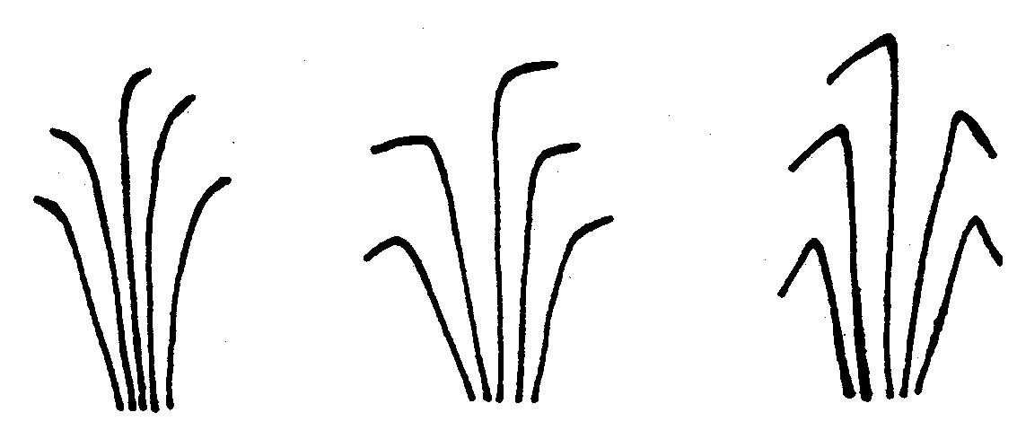
1 | 2 | 3
absent or weak | intermediate | strong

Ad. 8: Onion varieties only: Pseudostem: length (up to highest green leaf)
Ad. 9: Onion varieties only: Pseudostem: diameter (at midpoint of length)
Ad. 8: The length of the pseudo stem should be assessed from the top of the bulb (defined by the point of inflection to the neck) to the point where the highest green leaf emerges from the pseudo stem.
Ad. 9: The diameter of the pseudo stem should be assessed in the middle of the pseudo stem.

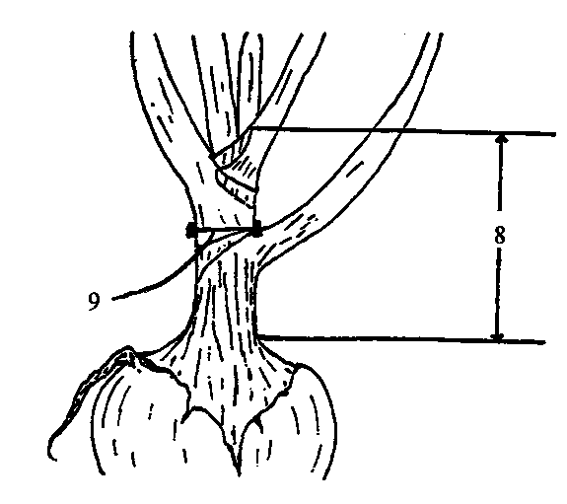

Ad. 10: Bulb: Tendency to split into bulblets (with dry skin around each bulblet)

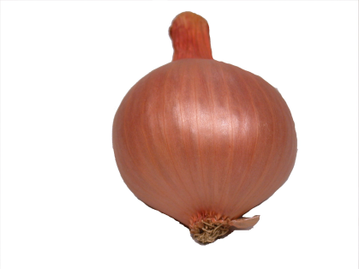 | 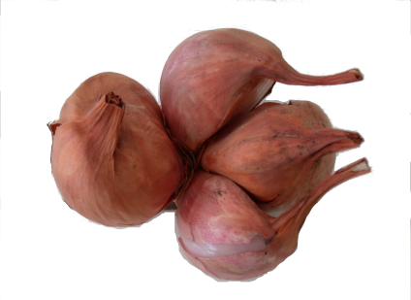 | 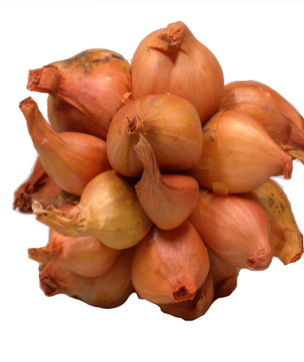
1 | 5 | 9
absent or very weak | medium | very strong

Ad. 11: Bulb: number of growing points
…………………………………………………………………………………………………………………………………………………………………………………………………..

Ad. 16: Bulb/Bulblet: position of maximum diameter

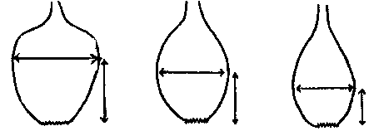
1 | 2 | 3
towards stem end | at middle | towards root end

Ad. 17: Bulb/Bulblet: width of neck

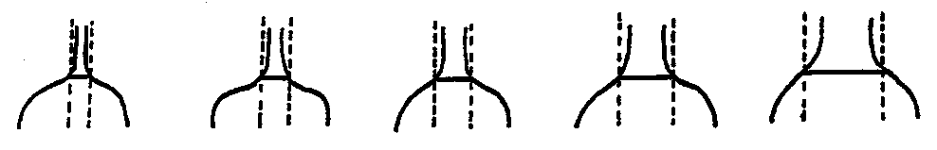
1  very narrow | 3  narrow | 5  medium | 7  broad | 9  very broad

Ad. 18: Bulb/Bulblet: shape (in longitudinal section)

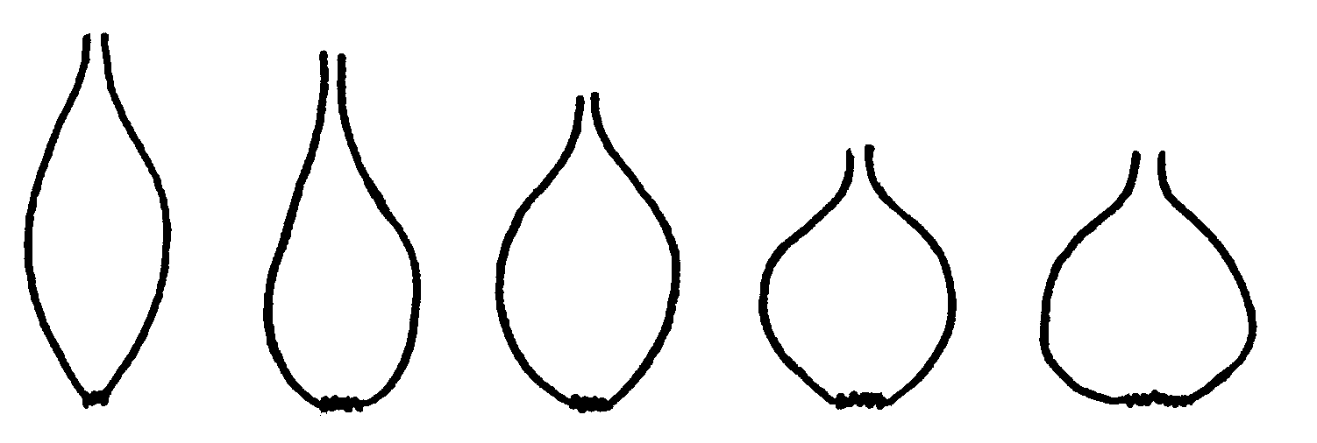
1 | 2 | 3 | 4 | 5
elliptic | medium ovate | broad elliptic | circular | broad ovate

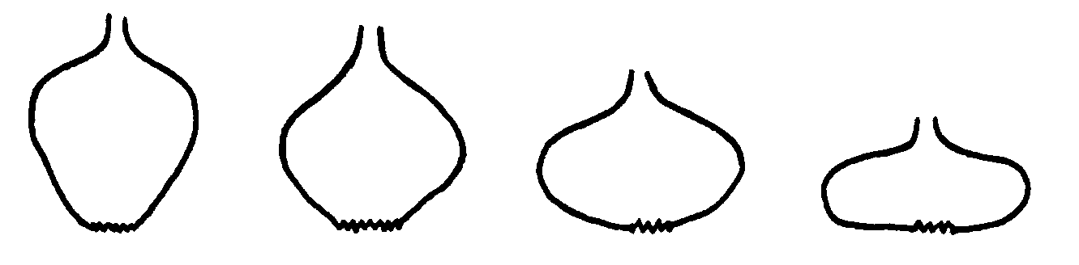
6 | 7 | 8 | 9
broad obovate | rhombic | transverse medium elliptic | transverse narrow elliptic

Ad. 19: Onion varieties only: Bulb: shape of stem end (as for 18)
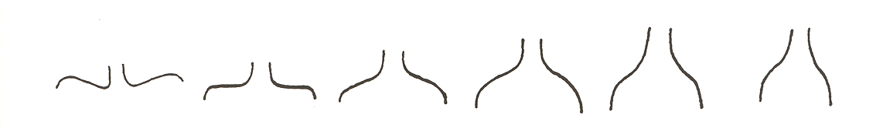
1 | 2 | 3 | 4 | 5 | 6
depressed | flat | slightly  raised | rounded | slightly sloping | strongly  sloping

Ad. 20: Bulb/Bulblet: shape of root end (as for 18)
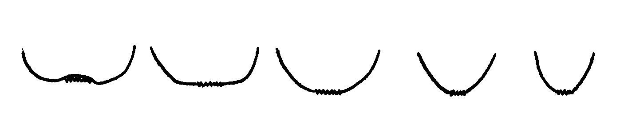
1 | 2 | 3 | 4 | 5
depressed | flat | round | weakly tapered | strongly tapered

Ad. 27: Bulb/Bulblet: dry matter content

Dry matter content should be determined according to Chapter 3.5 (e.g. one sample of 20 bulbs from each plot). From these bulbs the dry skin should be removed as well as the protruding part of the root disk. From these 20 bulbs a bulk sample should be prepared by cutting the bulbs into small pieces of 1-5 mm size. A representative sample should be weighed directly after cutting (the biodegradation of sugars and carbohydrates starts as soon as cells are damaged). The samples should be dried for 2 hours at 105ºC and then the temperature should be lowered to 65ºC during 22 hours. Lowering of temperature is necessary to avoid caramelisation. The remaining weight should be assessed after 24 hours. From these figures the dry matter content may be calculated.

The dry matter content could also be assessed by refractometer.

Ad 28: Plant: tendency to bolting in spring sown trials
…………………………………………………………………………………………………..

Ad. 35: Time of sprouting during storage

Care should be taken to exclude damaged bulbs. Storage temperature should be maintained between 2ºC and 5ºC with good ventilation which can be achieved by storing in stacking, slotted trays.

In climates which have cooler summer temperature, it is advisable to ‘cure’ bulbs for 2 weeks at a temperature of 30-35ºC. Temperatures above 40ºC should be avoided to prevent growth of Aspergillus niger.

A minimum of 50 bulbs are required to assess sprouting. Assessment should be carried out every 2 to 4 weeks.

Ad. 36: Male sterility

After re-planting of harvested bulbs in the second year, flowers will emerge. In dry weather, when flowers are completely open, male sterility should be assessed by checking if pollen is released from the anthers. This characteristic has to be observed plant by plant; the expression represents the percentage of male sterile plants.

State | Note | % male sterility
absent or very weak | 1 | 0-10 %
weak | 2 | 11-80 %
strong | 3 | 81-100 %

Literature
Brewster, J. L., 1994: Crop Production Science in Horticulture 3: Onions and other vegetables Alliums. CAB International.

Brewster, J. L., and Barnes, A., 1981: A Comparison of Relative Growth Rates of Different Individual Plants and Different Cultivars of Onion of Diverse Geographic Origin at Two Temperatures and Two Light Intensities. Journal of Applied Ecology Vol. 18, 589-604.

Brewster, J. L., Salter, P. J. and Darby, R. J., 1977: Analysis of the Growth and Yield of Over-wintered Onions. Journal of Horticultural Science Vol. 52, 335-346.

Clarke, A. E., Jones, H. A. and Little, T. M., 1994: Inheritance of Bulb Colour in the Onion. Genetics 29, pp 569-575.

El-Shafie, M. W. and Davies, G. N., 1967: Inheritance of Bulb Color in the Onion (Allium cepa L.). Hilgardia Vol. 38, No. 17, 607-622.

Jones, H. A., Clarke, A. E. and Stevenson, F. J., 1944: Studies in the Genetics of the Onion (Allium cepa, L.). Proceedings of the American Society for Horticultural Science 44, pp. 479-484.

Jones, H. A. and Mann, L. K., 1963: Onions and Their Allies: Botany, Cultivation and Utilisation. London, Leonard Hill.

Jones, H. A. and Peterson, C. E., 1952: Complementary Factors for Light-Red Bulb Colour in Onions. Proceedings of the American Society for Horticultural Science Vol. 59, 457.

Kappert and Rudorf, W. 1962: Züchtung von Gemüse, Obst, Reben and Forstpflanzen. Verlag Paul Parey, Berlin und Hamburg, pp. 270-312.

Kuckuck, H. and Kobake, G., 1962, in Roemer, T. and Rudorf, W., 1962: Handbuch der Pflanzen-Züchtung, Band VI. Verlag Paul Parey, Berlin und Hamburg.

Magruder, R. and Allard, H. A., 1937: Bulb Formation in Some American and European Varieties of Onions as Affected by Length of Day. Journal of Agricultural Research Vol 54, Part No. 10, 719-752.

Magruder, R. et al, 1941: Descriptions and Types of Principal American Varieties of Onion. USDA, Miscellaneous Publication No. 435, Washington DC.

Messiaen, C. M., Cohat, J., Leroux, J. P., Pichon, M., Beyries, A., 1993: Les allium alimentaires reproduits para voie végétative. INRA Editions, Paris.

Midmore, D. J., 1994. (Editor): International Symposium on Alliums for the Tropics. Acta Horticulturae. 358.

Rabinowitch, H. D. and Brewster J. L., 1990: Onions and Allied Crops. Vol. 1-3 CRC Press, Boca Raton.

Reieman, G. H., 1931: Genetic Factors for Pigmentation in the Onion and their Relation to Disease Resistance. Journal of Agricultural Research Vol. 42, No. 5, 251-278.

Scully, N. J., Parker, M. W. and Borthwick, H. A., 1945: Interaction of Nitrogen Nutrition and Photo-period as Expressed in Bulbing and Flower Stalk Development of Onion. Botanical Gazette Vol. 107, 52-61.

Schwartz, H. F., and Mohan S. K., 1995 (Editors): Compendium of Onion and Garlic Diseases. The American Phytopathological Society, (ISBN: 0-89054-170-1).

Wright, C. J. and Sobeigh, W. Y., 1986: The Photo-periodic Regulation of Bulbing in Onions (Allium cepa L.). Effects of Irradiance.” Journal of Horticultural Science Vol. 61, Part 3, 311-335.

Technical Questionnaire
TECHNICAL QUESTIONNAIRE |  |  |  | Page {x} of {y} |  | Reference Number:
 |  |  |  |  |  | Application date:
 |  |  |  |  |  | (not to be filled in by the applicant)
TECHNICAL QUESTIONNAIRE
to be completed in connection with an application for plant breeders’ rights
1. Subject of the Technical Questionnaire
1.1.1 Botanical name |  |  | Allium cepa (Cepa Group)
1.1.2 Common name |  |  | Onion, Echalion |  |  |  |  |  |  | [ ]
1.2.1 Botanical name |  |  | Allium cepa (Aggregatum Group)
1.2.2 Common name |  |  | Traditional Shallot |  |  |  |  |  |  | [ ]
1.3.1 Botanical name |  |  | Allium cepa (Seed Shallot Group)
1.3.2 Common name |  |  | Seed Shallot |  |  |  |  |  |  | [ ]
1.4.1 Botanical name |  |  | Allium oschaninii O. Fedtsch  ................................................................................
1.4.2 Common name |  |  | Grey shallot  .................................................................................. |  |  |  |  |  |  | [ ]
2. Applicant
Name
Address
Telephone No.
Fax No.
E-mail address
Breeder (if different from applicant)
3. Proposed denomination and breeder’s reference
Proposed denomination
(if available)

Breeder’s reference
#4. Information on the breeding scheme and propagation of the variety

4.1 Breeding scheme

Variety resulting from:

4.1.1 Crossing

(a) controlled cross [ ]
(please state parent varieties)

(b) partially known cross [ ]
(please state known parent variety(ies))

(c) unknown cross [ ]

4.1.2 Mutation [ ]
(please state parent variety)

4.1.3 Discovery and development [ ]
(please state where and when discovered
and how developed)

4.1.4 Other [ ]
(please provide details)

4.2 Method of propagating the variety
4.2.1 Seed-propagated varieties
  - open-pollinated [ ]
  - single hybrid [ ]
  - three-way hybrid [ ]
  - other (please provide details) [ ]

...........................................................................................................

4.2.2 Vegetatively propagated varieties
(a) clone [ ]
(b) other (please provide details) [ ]
...........................................................................................................

5. Characteristics of the variety to be indicated (the number in brackets refers to the corresponding characteristic in Test Guidelines; please mark the note which best corresponds).

 | Characteristics |  |  |  |  |  | Example Varieties |  |  | Note
5.1  (1) | Plant: number of leaves per pseudostem
 | few |  |  |  |  |  | SY300 (O) |  |  | 3[ ]
 | medium |  |  |  |  |  | The Kelsae (O) |  |  | 5[ ]
 | many |  |  |  |  |  | Yellow sweet spanish (O) |  |  | 7[ ]
5.2  (4) | Foliage: intensity of green color
 | very light |  |  |  |  |  | Bretor (S) |  |  | 1[ ]
 | light |  |  |  |  |  | Guimar (O), Yellow sweet spanish (O),  Tropix (S) |  |  | 3[ ]
 | medium |  |  |  |  |  | Caribo (O),  Texas grano 502 (O), Golden Gourmet (S) |  |  | 5[ ]
 | dark |  |  |  |  |  | Hikeeper (O), La Reine (O), Santé (S) |  |  | 7[ ]
5.3.1  (10) | Seed-propagated varieties only: Bulb: Tendency to split into bulblets (with dry skin around each bulblet)
 | absent or very weak |  |  |  |  |  | Cuisse de Poulet du Poitou (O), Lagos (O) |  |  | 1[ ]
 | weak |  |  |  |  |  |  |  |  | 3[ ]
 | medium |  |  |  |  |  | Mirage (S) |  |  | 5[ ]
 | strong |  |  |  |  |  | Bonilla (S), Creation (S), Longor (S), Mikor (S) |  |  | 7[ ]
 | very strong |  |  |  |  |  | Delvad (S), Rox (S), Tropix (S) |  |  | 9[ ]
 | Characteristics |  |  |  |  |  | Example Varieties |  |  | Note
5.3.2  (11) | Bulb: degree of splitting into bulblets (with dry skin around each bulblet)
 | absent or very weak |  |  |  |  |  | Cuisse de Poulet du Poitou (O) |  |  | 1[ ]
 | weak |  |  |  |  |  |  |  |  | 3[ ]
 | medium |  |  |  |  |  | Santé (S) |  |  | 5[ ]
 | strong |  |  |  |  |  |  |  |  | 7[ ]
 | very strong |  |  |  |  |  | Giselle (S) |  |  | 9[ ]
5.4.1  (12.1) | Onion varieties only: Bulb: size
 | small |  |  |  |  |  |  |  |  | 3[ ]
 | medium |  |  |  |  |  | Lagos |  |  | 5[ ]
 | large |  |  |  |  |  | The Kelsae |  |  | 7[ ]
5.4.2  (12.2) | Shallot varieties only: Bulblet: size
 | small |  |  |  |  |  | Atlas |  |  | 3[ ]
 | medium |  |  |  |  |  | Spring Field, Topper |  |  | 5[ ]
 | large |  |  |  |  |  | Delicato, Santé |  |  | 7[ ]
 | Characteristics |  |  |  |  |  | Example Varieties |  |  | Note
5.5  (18) | Bulb/Bulblet: shape (in longitudinal section)
 | elliptic |  |  |  |  |  |  | Owa (O), Longor (S) |  | 1[ ]
 | medium ovate |  |  |  |  |  |  | Birnenförmige (O),  Rossa lunga di Firenze (O), Breton (S) |  | 2[ ]
 | broad elliptic |  |  |  |  |  |  | Ailsa Craig (O),  Beacon (O), Hiball (O), Vigarmor (S) |  | 3[ ]
 | circular |  |  |  |  |  |  | Lagos (O), Pikant (S) |  | 4[ ]
 | broad ovate |  |  |  |  |  |  | Hysam (O), Arvro (S) |  | 5[ ]
 | broad obovate |  |  |  |  |  |  | Lilia (O), Texas grano 502 (O) |  | 6[ ]
 | rhombic |  |  |  |  |  |  | Zittauer gelbe (O) |  | 7[ ]
 | transverse medium elliptic |  |  |  |  |  |  | Sturka (O), Stuttgarter Riesen (O),  Atlantic (S),  Golden Gourmet (S) |  | 8[ ]
 | transverse narrow elliptic |  |  |  |  |  |  | Brunswijker (O),  De Moissac (O), Paille des vertus (O),  Pompei (O) |  | 9[ ]
5.6  (23) | Bulb/Bulblet: base color of dry skin
 | white |  |  |  |  |  |  | La Reine (O),  Pompei (O) |  | 1[ ]
 | grey |  |  |  |  |  |  | Griselle (S) |  | 2[ ]
 | green |  |  |  |  |  |  |  |  | 3[ ]
 | yellow |  |  |  |  |  |  | Zittauer gelbe (O),  Creation (S),  Golden Gourmet (S), Topper (S) |  | 4[ ]
 | brown |  |  |  |  |  |  | Valenciana Temprana (O),  Delicato(S), Mirage(S),  Mikor (S), Pikant (S) |  | 5[ ]
 | pink |  |  |  |  |  |  | Colorada de Figueras (O),  Rox (S), Santé (S) |  | 6[ ]
 | red |  |  |  |  |  |  | Brunswijker (O),  Red Baron (O) |  | 7[ ]
 | Characteristics |  |  |  |  |  | Example Varieties |  |  | Note
5.7  (25) | Bulb/Bulblet: hue of color of dry skin (in addition to base color)
 | absent |  |  |  |  |  |  | Pompei (O) |  | 1[ ]
 | greyish |  |  |  |  |  |  |  |  | 2[ ]
 | greenish |  |  |  |  |  |  |  |  | 3[ ]
 | yellowish |  |  |  |  |  |  | Topper (S) |  | 4[ ]
 | brownish |  |  |  |  |  |  | Santé (S) |  | 5[ ]
 | pinkish |  |  |  |  |  |  | Delicato (S) |  | 6[ ]
 | reddish |  |  |  |  |  |  | Mikor (S), Mirage (S), Pikant (S) |  | 7[ ]
 | purplish |  |  |  |  |  |  |  |  | 8[ ]
5.8  (27) | Bulb/Bulblet: number of growing points per kg
 | very low |  |  |  |  |  |  | Barletta (O), Pompei (O) |  | 1[ ]
 | low |  |  |  |  |  |  | Cuisse de Poulet du Poitou (O), Figaro (O), Owa (O) |  | 3[ ]
 | medium |  |  |  |  |  |  | Longor (S), Mirage (S),  Prisma (S) |  | 5[ ]
 | high |  |  |  |  |  |  | Bonilla (S), Creation (S),  Mikor (S) |  | 7[ ]
 | very high |  |  |  |  |  |  | Griselle (S), Rox (S), Tropix (S) |  | 9[ ]
5.9  (28) | Bulb/Bulblet: dry matter content
 | very low |  |  |  |  |  |  | Exhibition (O) |  | 1[ ]
 | low |  |  |  |  |  |  | Golden Bear (O),  The Kelsae (O) |  | 3[ ]
 | medium |  |  |  |  |  |  | Golden Gourmet (S), Topper (S) |  | 5[ ]
 | high |  |  |  |  |  |  | Birnförmige (O), Zittauer gelbe (O), Creation (S), Longor (S) |  | 7[ ]
 | very high |  |  |  |  |  |  | Griselle (S) |  | 9[ ]
 | Characteristics |  |  |  |  |  | Example Varieties |  |  | Note
5.10  (33) | Onion varieties only: Time of harvest maturity for autumn sown trials (foliage fall-over in 80% of plants)
 | very early |  |  |  |  |  |  |  |  | 1[ ]
 | early |  |  |  |  |  |  | La Reine, Sonic |  | 3[ ]
 | medium |  |  |  |  |  |  | Buffalo, Imai Early Yellow, Valenciana Temprana |  | 5[ ]
 | late |  |  |  |  |  |  | Guimar,  Senshyu Semi Globe Yellow, Shakespeare |  | 7[ ]
 | very late |  |  |  |  |  |  | Valencia tardía |  | 9[ ]
5.10.1  (34.1) | Onion varieties only: Time of harvest maturity for spring sown trials (foliage fall-over in 80% of plants)
 | early |  |  |  |  |  |  | Buffalo, Golden Bear |  | 3[ ]
 | medium |  |  |  |  |  |  | Piroska |  | 5[ ]
 | late |  |  |  |  |  |  | Beacon |  | 7[ ]
5.10.2  (34.2) | Shallot varieties only: Time of harvest maturity (foliage fall-over in 80% of plants)
 | early |  |  |  |  |  | Ploumor, Rox |  |  | 3[ ]
 | medium |  |  |  |  |  | Creation, Pikant |  |  | 5[ ]
 | late |  |  |  |  |  | Golden Gourmet, Santé |  |  | 7[ ]
5.11  (36) | Male sterility
 | absent or very weak |  |  |  |  |  | Rijnsburger 5 (O) |  |  | 1[ ]
 | weak |  |  |  |  |  | Hyduro (O), Creation (S) |  |  | 2[ ]
 | strong |  |  |  |  |  | Atlas (S) |  |  | 3[ ]
6. Similar varieties and differences from these varieties

Please use the following table and box for comments to provide information on how your candidate variety differs from the variety (or varieties) which, to the best of your knowledge, is (or are) most similar. This information may help the examination authority to conduct its examination of distinctness in a more efficient way.

Denomination(s) of variety(ies) similar to your candidate variety |  | Characteristic(s) in which your candidate variety differs from the similar variety(ies) |  |  | Describe the expression of the characteristic(s) for the similar variety(ies) |  |  |  | Describe the expression of the characteristic(s) for your candidate variety
Example |  | Bulb/Bulblet: shape  (in longitudinal section) |  |  | circular |  |  |  | broad ovate
Comments:

#7. Additional information which may help in the examination of the variety

7.1 In addition to the information provided in sections 5 and 6, are there any additional characteristics which may help to distinguish the variety?

Yes [ ] No [ ]

(If yes, please provide details)

7.2 Are there any special conditions for growing the variety or conducting the examination?

Yes [ ] No [ ]

(If yes, please provide details)

7.3 Resistance to pests and diseases

7.4 Special conditions for testing the variety
7.4.1 Day length conditions which favor full bulb development
  - short day [ ]
  - long day [ ]

7.4.2 Suitability for storage
(a) none [ ]
(b) short term [ ]
(c) long term [ ]

7.5 Other information

8. Authorization for release

(a) Does the variety require prior authorization for release under legislation concerning the protection of the environment, human and animal health?

Yes [ ] No [ ]

(b) Has such authorization been obtained?

Yes [ ] No [ ]

If the answer to (b) is yes, please attach a copy of the authorization.

9. Information on plant material to be examined or submitted for examination.

9.1 The expression of a characteristic or several characteristics of a variety may be affected by factors, such as pests and disease, chemical treatment (e.g. growth retardants or pesticides), effects of tissue culture, different rootstocks, scions taken from different growth phases of a tree, etc.

9.2 The plant material should not have undergone any treatment which would affect the expression of the characteristics of the variety, unless the competent authorities allow or request such treatment. If the plant material has undergone such treatment, full details of the treatment must be given. In this respect, please indicate below, to the best of your knowledge, if the plant material to be examined has been subjected to:

(a) Microorganisms (e.g. virus, bacteria, phytoplasma) Yes [ ] No [ ]

(b) Chemical treatment (e.g. growth retardant, pesticide) Yes [ ] No [ ]

(c) Tissue culture Yes [ ] No [ ]

(d) Other factors Yes [ ] No [ ]

Please provide details for where you have indicated “yes”.
……………………………………………………………
10. I hereby declare that, to the best of my knowledge, the information provided in this form is correct:

Applicant’s name

Signature Date

[End of Annex and of document]

* These names were correct at the time of the introduction of these Test Guidelines but may be revised or updated. [Readers are advised to consult the UPOV Code, which can be found on the UPOV Website (www.upov.int), for the latest information.]
# Authorities may allow certain of this information to be provided in a confidential section of the Technical Questionnaire.
# Authorities may allow certain of this information to be provided in a confidential section of the Technical Questionnaire.

