E
TWV/49/12
ORIGINAL: English
DATE: May 28, 2015
INTERNATIONAL UNION FOR THE PROTECTION OF NEW VARIETIES OF PLANTS
Geneva
Technical working party for vegetables
Forty-Ninth Session
Angers, France, June 15 to 19, 2015
Revision of document TGP/7: Drafter’s Kit for Test Guidelines
Document prepared by the Office of the Union
Disclaimer: this document does not represent UPOV policies or guidance
EXECUTIVE SUMMARY

The purpose of this document is to present a proposal for a revision of document TGP/7 “Development of Test Guidelines” to reflect the introduction of the web­based TG Template.

The TWV is invited to:

(a) consider the proposal to revise document TGP/7 to reflect the introduction of the web based TG Template after Version 1 is finalized;
(b) consider the proposal to standardize the format of the Table of Characteristics in all Test Guidelines with a structure as set out in paragraph 15 of this document.
(c) note that all Leading Experts have prepared the draft Test Guidelines for discussion during the TWPs at their sessions in 2015 using the web-based TG Template;
(d) note that all Interested Experts were required to provide their comments on draft Test Guidelines for discussion during the TWPs at their sessions in 2015 using the web-based TG Template;
(e) note the issues being addressed in response to the comments by Leading and Interested Experts that participated in the testing of the 2015 prototype of the web based TG Template, as set out in paragraphs 13 and 14 of this document;
(f) note that a demonstration of the planned resolution of the issues being addressed in the 2015 prototype of the web based TG Template, as set out in paragraphs 13 and 14 of this document, will be made at the TWV session; and
(g) note the time table for development of the web-based TG Template, as set out in paragraphs 17 to 19 of this document.

The structure of this document is as follows:

BACKGROUND 2
web-based tg template 2
Comments by the Technical Working Parties in 2014 2
Developments in the Technical Committee 2
Issues raised during testing of the web-based TG Template 2
Table of characteristics layout 3
Time table for development 4
Revision of document TGP/7 4

The following abbreviations are used in this document:

TC: Technical Committee
TC-EDC: Enlarged Editorial Committee
TWA: Technical Working Party for Agricultural Crops
TWC: Technical Working Party on Automation and Computer Programs
TWF: Technical Working Party for Fruit Crops
TWO: Technical Working Party for Ornamental Plants and Forest Trees
TWPs: Technical Working Parties
TWV: Technical Working Party for Vegetables

BACKGROUND

The TC, at its fiftieth session, held in Geneva from April 7 to 9, 2014, agreed that document TGP/7 Section 4.3: “Drafter’s Kit for Test Guidelines” and Annex 4 “Collection of Approved Characteristics” should be revised, subject to the introduction of the web­based TG Template in 2014 (see document TC/50/36 “Report on the Conclusions”, paragraph 70).

web-based tg template

Comments by the Technical Working Parties in 2014

The TWO, TWF, TWC, TWV and TWA considered documents TWO/47/10, TWF/45/10, TWC/32/10, TWV/48/10 and TWA/43/10, respectively, and received a presentation on the web-based TG Template, a copy of which is presented in the Annex to the respective documents (see documents TWO/47/28 “Report”, paragraphs 87 to 91; TWF/45/32 “Report”, paragraphs 99 to 102; TWC/32/28 “Report”, paragraphs 95 to 98; TWV/48/43 “Report”, paragraphs 106 to 110; and TWA/43/27 “Report”, paragraphs 111 to 115).

The TWPs noted the features of Version 1 of the web-based TG Template and the request for Leading Experts to participate in the testing of the 2014 prototype of the web-based TG Template. The TWPs noted the exclusive use of the web-based TG Template for the development of all Test Guidelines from 2015.

The TWO agreed that the web-based TG Template should allow the printing of comments made by interested experts sorted by interested expert or characteristic and noted that assistance would be provided by the UPOV Office for Leading Experts on the use of the web-based TG Template, if requested.

The TWV appreciated the considerable amount of work done for the development of the web-based TG template, which would be an important improvement for the development of Test Guidelines.

The TWA received a demonstration of the 2014 prototype of the web-based TG Template by the Office of the Union and noted the main features of the system for Leading and Interest experts. The TWA agreed that the comments and suggestions by the Leading Experts that used the web-based TG Template should be sent to the UPOV Office for improving the system.

Developments in the Technical Committee

The TC, at its fiftieth session, held in Geneva, from April 7 to 9, 2014, approved the plans for the implementation of the web-based TG Template, including the exclusive use of the web-based TG Template for the development of all Test Guidelines from 2015, as set out in document TC/50/10, paragraph 58 (see document TC/50/36 “Report on the Conclusions”, paragraph 15).

The TC, at its fifty-first session, held in Geneva from March 23 to 25, 2015, agreed that a detailed proposal for a revision of document TGP/7 be presented to the TWPs, at their sessions in 2015 to reflect the introduction of the web-based TG Template (see document TC/51/39 “Report”, paragraph 126).

Issues raised during testing of the web-based TG Template

The Office of the Union received comments by Leading and Interested Experts that participated in the testing of the 2014 prototype of the web-based TG Template in addition to the comments provided by the TWPs. The following issues are currently being addressed:

- Allow use of italics and underlined text
- Improve the organization of images in explanation of characteristics (Chapter 8.2)
- Improve formatting of the Test Guidelines generated
- Provide a print preview for each Chapter
- Allow inclusion of annexes and/or growth stage keys (Chapter 8.3)
- Ensure compatibility with different web browsers versions
- Provide a link to templates for grids for shape characteristics that include ratio elements
- Enable printing of comments by interested experts sorted by interested expert or characteristic
- Provide more options in Chapter 4 “Assessments” for complex arrangements of Uniformity assessment

Table of characteristics layout

Prior to the introduction of the web-based TG Template, the Table of Characteristics in the Test Guidelines were individually prepared and information on categories of characteristics, types of expression, explanations and recommendations for conducting the examination were organized within selected cells in the Table of Characteristics, as in the following extract from document TGP/7, on a case-by-case basis. However, the layout of each Table of Characteristics had to be individually adapted according to each Test Guidelines in order to avoid excessive blank spaces:

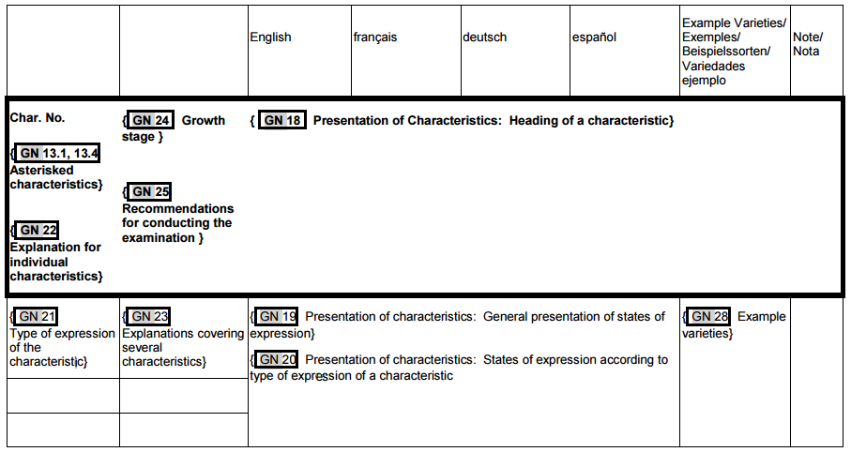

In order to have a standardized format for all Test Guidelines that will not result in excessive blank spaces, it is proposed to structure the Table of Characteristics as follows:

 |  | English |  | français |  | deutsch | español | Example Varieties  Exemples  Beispielssorten  Variedades ejemplo | Note/  Nota
105. | (*) | QN | MG A/VG B | (+) | (a) (b) (c) | 2201, 2202, 2302
 |  | Plant: growth habit |  | Plante: port |  | Pflanze: Wuchsform | Planta: porte
 |  | upright |  |  |  |  |  |  | 1
 |  | semi upright |  |  |  |  |  | Okayamazairai | 2
 |  | spreading |  |  |  |  |  |  | 3

A demonstration of the planned resolution of the above issues will be made at the TWV session.

Time table for development

Version 1 of the web-based TG Template (see Annex) will be finalized in 2015, including the resolution of the issues set out in paragraphs 13 to 15.

Because Version 1 of the web-based TG Template with all the features set out in paragraphs 13 to 15 will not be complete until after the 2015 TWP sessions, final draft Test Guidelines in 2015 will be manually formatted prior to preparation for the TC-EDC and the TC to allow consistency with Test Guidelines adopted prior to the introduction of the web-based TG Template. All Test Guidelines will be generated automatically by the web-based TG Template from 2016, after Version 1 is finalized.

Development of Version 2 (see Annex) of the web-based TG Template will not start before Version 1 has been fully stabilized and tested. This means that development will not start until at least after the TWP sessions in 2016.

Revision of document TGP/7

In order to address the comments and suggestions made by Leading and Interested Experts during the testing phase, Version 1 of the web-based TG Template has not yet been finalized. It is, therefore, proposed that a proposal for the revision of document TGP/7 reflecting the introduction of the web-based TG Template be presented to the TWPs and the TC in 2016, after Version 1 is finalized.

The TWV is invited to:

- consider the proposal to revise document TGP/7 to reflect the introduction of the web-based TG Template after Version 1 is finalized;

- consider the proposal to standardize the format of the Table of Characteristics in all Test Guidelines with a structure as set out in paragraph 15 of this document.

(c) note that all Leading Experts have prepared the draft Test Guidelines for discussion during the TWPs at their sessions in 2015 using the web-based TG Template;

(d) note that all Interested Experts were required to provide their comments on draft Test Guidelines for discussion during the TWPs at their sessions in 2015 using the web-based TG Template;

(e) note the issues being addressed in response to the comments by Leading and Interested Experts that participated in the testing of the 2015 prototype of the web-based TG Template, as set out in paragraphs 13 and 14 of this document;

(f) note that a demonstration of the planned resolution of the issues being addressed in the 2015 prototype of the web-based TG Template, as set out in paragraphs 13 and 14 of this document, will be made at the TWV session; and

(g) note the time table for development of the web-based TG Template, as set out in paragraphs 17 to 19 of this document.

[Annex follows]
Features of the web-based TG Template

The web-based TG Template will be developed in two separate phases in the form of Versions 1 and 2.

Version 1

Version 1 of the web-based TG Template will be fully functional for the development of UPOV Test Guidelines by Leading Experts and will enable Interested Experts to provide comments. Version 1 of the web-based TG Template will be completed in 2014 and a demonstration will be made at the TWPs sessions in 2014. A copy of the presentation is provided in the Annex to this document.

Features

The main features of Version 1 are as follows:

- Draft Test Guidelines will be prepared by Leading Experts online via the web-based TG Template
- Fixed template containing all universal standard wording which is appropriate for all Test Guidelines (see document TGP/7/3 “Development of Test Guidelines”, Section 3.1 “The TG Template”)
- Options to add Additional Standard Wording (ASW) (see document TGP/7/3, Section 3.2 “Additional Standard Wording (ASW) for the TG Template”)
- Links to Guidance Notes (GN) (see document TGP/7/3, Section 3.3 “Guidance Notes (GN) for the TG Template”)
- A database of characteristics (in English, French, German and Spanish) from Test Guidelines adopted after the adoption of document TGP/7/1 “Development of Test Guidelines” the Collection of Approved Characteristics (adopted in 2004) (see document TGP/7/3, Annex 4 “Collection of Approved Characteristics”).
The database will contain all information from the Table of Characteristics, including states of expression, notes, example varieties, etc. The database can be searched for relevant characteristics and a relevant characteristic uploaded into draft Test Guidelines with subsequent modification as required.

- Comments boxes for Interested Experts to complete online with a facility to view all comments
- Options to produce output in HTML or Word format.
- English only version
- Translators’ facility for the Table of Characteristics (Chapter 7)

Characteristics uploaded, unchanged, from the database comprising the collection of approved characteristics will be indicated as not requiring translation. For other characteristics, translators will be able to search the database comprising the collection of approved characteristics and input the required translations. The translation of the other chapters of the Test Guidelines will be provided separately for Version 1.

Version 2

Version 2 of the web-based TG Template will provide the two following additional features:

Concurrent translation

In version 2 of the web-based TG Template, the French, German and Spanish language versions of the Test Guidelines will be automatically developed concurrently with the English draft for the standard wording, Additional Standard Wording (ASW) and characteristics uploaded, unchanged, from the database comprising the collection of approved characteristics. Text that has not been automatically translated will be indicated for translation in the language concerned.

Individual authorities’ test guidelines

Version 1 of the web-based TG Template has been designed for the development of Test Guidelines for UPOV. However, it has also been designed such that Version 2 will enable members of the Union to use:

(a) adopted UPOV Test Guidelines as a basis for the development of individual authorities’ test guidelines;

(b) the web-based TG Template and database of characteristics to develop individual authorities’ test guidelines for which there are no UPOV Test Guidelines; and

(c) use individual authorities’ test guidelines, developed using the web-based TG Template, as the basis for draft UPOV Test Guidelines.

Version 2 will have a feature for individual authorities to modify the template wording, within the same structure, to act as a template for their own test guidelines and a feature to allow individual authorities to convert UPOV Test Guidelines into individual authorities’ test guidelines, with necessary modifications.

[End of Annex and of document]

