E
TG/BRASS_JUN(proj.3)
ORIGINAL: English
DATE: 2015-05-01
INTERNATIONAL UNION FOR THE PROTECTION OF NEW VARIETIES OF PLANTS
Geneva
DRAFT

 | Brown Mustard  UPOV Code: BRASS_JUN  Brassica juncea (L.) Czern. | *

GUIDELINES
FOR THE CONDUCT OF TESTS
FOR DISTINCTNESS, UNIFORMITY AND STABILITY

prepared by (an) expert(s) from Japan

to be considered by the
Technical Working Party for Vegetables
at its forty-ninth session
to be held in Angers, France,
from 2015-06-15
to 2015-06-19

Alternative Names:*
Botanical name | English | French | German | Spanish
Brassica juncea (L.) Czern. | Brown mustard, India mustard, Indian mustard, Oriental mustard | Moutarde brune | Sareptasenf | Mostaza de Sarepta, Mostaza india

The purpose of these guidelines (“Test Guidelines”) is to elaborate the principles contained in the General Introduction (document TG/1/3), and its associated TGP documents, into detailed practical guidance for the harmonized examination of distinctness, uniformity and stability (DUS) and, in particular, to identify appropriate characteristics for the examination of DUS and production of harmonized variety descriptions.

ASSOCIATED DOCUMENTS
These Test Guidelines should be read in conjunction with the General Introduction and its associated TGP documents.
TABLE OF CONTENTS PAGE

1. Subject of these Test Guidelines 3
2. Material Required 3
3. Method of Examination 3
3.1 Number of Growing Cycles 3
3.2 Testing Place 3
3.3 Conditions for Conducting the Examination 3
3.4 Test Design 3
3.5 Additional Tests 3
4. Assessment of Distinctness, Uniformity and Stability 4
4.1 Distinctness 4
4.2 Uniformity 5
4.3 Stability 5
5. Grouping of Varieties and Organization of the Growing Trial 5
6. Introduction to the Table of Characteristics 6
6.1 Categories of Characteristics 6
6.2 States of Expression and Corresponding Notes 6
6.3 Types of Expression 6
6.4 Example Varieties 6
6.5 Legend 7
7. Table of Characteristics/Tableau des caractères/Merkmalstabelle/Tabla de caracteres 8
8. Explanations on the Table of Characteristics 16
9. Literature 23
10. Technical Questionnaire 24

Subject of these Test Guidelines

These Test Guidelines apply to all varieties of Brassica juncea (L.) Czern..

Material Required

2.1 The competent authorities decide on the quantity and quality of the plant material required for testing the variety and when and where it is to be delivered. Applicants submitting material from a State other than that in which the testing takes place must ensure that all customs formalities and phytosanitary requirements are complied with.

2.2 The material is to be supplied in the form of seed.

2.3 The minimum quantity of plant material, to be supplied by the applicant, should be:

3,000 seeds for single spaced plants.
20,000 seeds for drilled plants.

The seed should meet the minimum requirements for germination, species and analytical purity, health and moisture content, specified by the competent authority. In cases where the seed is to be stored, the germination capacity should be as high as possible and should be stated by the applicant.

2.4 The plant material supplied should be visibly healthy, not lacking in vigor, nor affected by any important pest or disease.

2.5 The plant material should not have undergone any treatment which would affect the expression of the characteristics of the variety, unless the competent authorities allow or request such treatment. If it has been treated, full details of the treatment must be given.

Method of Examination

3.1 Number of Growing Cycles

3.1.1 The minimum duration of tests should normally be two independent growing cycles.

3.2 Testing Place

Tests are normally conducted at one place. In the case of tests conducted at more than one place, guidance is provided in TGP/9 “Examining Distinctness”.

3.3 Conditions for Conducting the Examination

3.3.1 The tests should be carried out under conditions ensuring satisfactory growth for the expression of the relevant characteristics of the variety and for the conduct of the examination.

3.4 Test Design

3.4.1 single spaced: Each test should be designed to result in a total of at least 60 plants which should be divided between at least 2 replicates.

3.4.2 drilled: Each test should be designed to result in a total of at least 200 plants, which should be divided between 2 replicates.

3.5 Additional Tests

Additional tests, for examining relevant characteristics, may be established.

Assessment of Distinctness, Uniformity and Stability

4.1 Distinctness

4.1.1 General Recommendations

It is of particular importance for users of these Test Guidelines to consult the General Introduction prior to making decisions regarding distinctness. However, the following points are provided for elaboration or emphasis in these Test Guidelines.

4.1.2 Consistent Differences

The differences observed between varieties may be so clear that more than one growing cycle is not necessary. In addition, in some circumstances, the influence of the environment is not such that more than a single growing cycle is required to provide assurance that the differences observed between varieties are sufficiently consistent. One means of ensuring that a difference in a characteristic, observed in a growing trial, is sufficiently consistent is to examine the characteristic in at least two independent growing cycles.

4.1.3 Clear Differences

Determining whether a difference between two varieties is clear depends on many factors, and should consider, in particular, the type of expression of the characteristic being examined, i.e. whether it is expressed in a qualitative, quantitative, or pseudo-qualitative manner. Therefore, it is important that users of these Test Guidelines are familiar with the recommendations contained in the General Introduction prior to making decisions regarding distinctness.

4.1.4 Number of Plants / Parts of Plants to be Examined

Unless otherwise indicated, for the purposes of distinctness, all observations on single plants should be made on 30 plants or parts taken from each of 30 plants and any other observations made on all plants in the test, disregarding any off-type plants.

4.1.5 Method of Observation

The recommended method of observing the characteristic for the purposes of distinctness is indicated by the following key in the second column of the Table of Characteristics (see document TGP/9 “Examining Distinctness”, Section 4 “Observation of characteristics”):

MG: single measurement of a group of plants or parts of plants
MS: measurement of a number of individual plants or parts of plants
VG: visual assessment by a single observation of a group of plants or parts of plants
VS: visual assessment by observation of individual plants or parts of plants

Type of observation: visual (V) or measurement (M)

“Visual” observation (V) is an observation made on the basis of the expert’s judgment. For the purposes of this document, “visual” observation refers to the sensory observations of the experts and, therefore, also includes smell, taste and touch. Visual observation includes observations where the expert uses reference points (e.g. diagrams, example varieties, side-by-side comparison) or non-linear charts (e.g. color charts). Measurement (M) is an objective observation against a calibrated, linear scale e.g. using a ruler, weighing scales, colorimeter, dates, counts, etc.

Type of record: for a group of plants (G) or for single, individual plants (S)

For the purposes of distinctness, observations may be recorded as a single record for a group of plants or parts of plants (G), or may be recorded as records for a number of single, individual plants or parts of plants (S). In most cases, “G” provides a single record per variety and it is not possible or necessary to apply statistical methods in a plant-by-plant analysis for the assessment of distinctness.

In cases where more than one method of observing the characteristic is indicated in the Table of Characteristics (e.g. VG/MG), guidance on selecting an appropriate method is provided in document TGP/9, Section 4.2.

4.2 Uniformity

    - It is of particular importance for users of these Test Guidelines to consult the General Introduction prior to making decisions regarding uniformity. However, the following points are provided for elaboration or emphasis in these Test Guidelines:

4.2.2 The assessment of uniformity for cross-pollinated varieties should be according to the recommendations for cross-pollinated varieties in the General Introduction.

4.2.3 For the assessment of uniformity of inbred lines, a population standard of 1 % and an acceptance probability of at least 95 % should be applied. In the case of a sample size of 60 plants for single spaced varieties, 2 off-types are allowed. In the case of a sample size of 200 plants for drilled plants, 5 off-types are allowed.

4.3 Stability

4.3.1 In practice, it is not usual to perform tests of stability that produce results as certain as those of the testing of distinctness and uniformity. However, experience has demonstrated that, for many types of variety, when a variety has been shown to be uniform, it can also be considered to be stable.

4.3.2 Where appropriate, or in cases of doubt, stability may be further examined by testing a new seed stock to ensure that it exhibits the same characteristics as those shown by the initial material supplied.

Grouping of Varieties and Organization of the Growing Trial

5.1 The selection of varieties of common knowledge to be grown in the trial with the candidate varieties and the way in which these varieties are divided into groups to facilitate the assessment of distinctness are aided by the use of grouping characteristics.

5.2 Grouping characteristics are those in which the documented states of expression, even where produced at different locations, can be used, either individually or in combination with other such characteristics: (a) to select varieties of common knowledge that can be excluded from the growing trial used for examination of distinctness; and (b) to organize the growing trial so that similar varieties are grouped together.

5.3 The following have been agreed as useful grouping characteristics:

(a) Seed: color (characteristic 1)
(b) Leaf: type (characteristic 5)
(c) Leaf: shape (characteristic 6)
(d) Leaf blade: intensity of anthocyanin coloration (characteristic 16)
(e) Leaf blade: density of incisions of margin (excluding type2) (characteristic 19)
(f) Leaf blade: blistering (excluding type2) (characteristic 20)
(g) Plant: head formation (characteristic 22)

In the first place, the collection should be divided according to leaf types in Table 1 of Chapter 8.1.

5.4 Guidance for the use of grouping characteristics, in the process of examining distinctness, is provided through the General Introduction and document TGP/9 “Examining Distinctness”.

Introduction to the Table of Characteristics

6.1 Categories of Characteristics

6.1.1 Standard Test Guidelines Characteristics

Standard Test Guidelines characteristics are those which are approved by UPOV for examination of DUS and from which members of the Union can select those suitable for their particular circumstances.

6.1.2 Asterisked Characteristics

Asterisked characteristics (denoted by *) are those included in the Test Guidelines which are important for the international harmonization of variety descriptions and should always be examined for DUS and included in the variety description by all members of the Union, except when the state of expression of a preceding characteristic or regional environmental conditions render this inappropriate.

6.2 States of Expression and Corresponding Notes

6.2.1 States of expression are given for each characteristic to define the characteristic and to harmonize descriptions. Each state of expression is allocated a corresponding numerical note for ease of recording of data and for the production and exchange of the description.

6.2.2 In the case of qualitative and pseudo-qualitative characteristics (see Chapter 6.3), all relevant states of expression are presented in the characteristic. However, in the case of quantitative characteristics with 5 or more states, an abbreviated scale may be used to minimize the size of the Table of Characteristics. For example, in the case of a quantitative characteristic with 9 states, the presentation of states of expression in the Test Guidelines may be abbreviated as follows:

State | Note
small | 3
medium | 5
large | 7

However, it should be noted that all of the following 9 states of expression exist to describe varieties and should be used as appropriate:

State | Note
very small | 1
very small to small | 2
small | 3
small to medium | 4
medium | 5
medium to large | 6
large | 7
large to very large | 8
very large | 9

6.2.3 Further explanation of the presentation of states of expression and notes is provided in document TGP/7 “Development of Test Guidelines”.

6.3 Types of Expression

An explanation of the types of expression of characteristics (qualitative, quantitative and pseudo-qualitative) is provided in the General Introduction.

6.4 Example Varieties

Where appropriate, example varieties are provided to clarify the states of expression of each characteristic.

6.5 Legend

(*) Asterisked characteristic – see Chapter 6.1.2

QL Qualitative characteristic – see Chapter 6.3
QN Quantitative characteristic – see Chapter 6.3
PQ Pseudo-qualitative characteristic – see Chapter 6.3

MG, MS, VG, VS – see Chapter 4.1.5

(a)-(e) See Explanations on the Table of Characteristics in Chapter 8.

(+) See Explanations on the Table of Characteristics in Chapter 8.

Table of Characteristics/Tableau des caractères/Merkmalstabelle/Tabla de caracteres

English | français | deutsch | español | Example Varieties Exemples Beispielssorten Variedades ejemplo | Note/ Nota
1. (*) PQ VG 00 (+) (a) (b)
Seed: color
yellow |  |  |  | Kigarashina | 1
brown |  |  |  | Miike Takana | 2
black |  |  |  | Akaoba Takana(Red Giant), Hagarashina | 3
2. QN VG 10 (a) (b)
Hypocotyl: anthocyanin coloration
absent or weak |  |  |  | Zasai FM-58 | 1
medium |  |  |  | Shinkoku Seisai | 2
strong |  |  |  | TTK456(Chaplin) | 3
3. QN MS VG 10 (a) (b) (c)
Cotyledon: length
short |  |  |  | Junkei Yamashiona | 3
medium |  |  |  | Katsuona | 5
long |  |  |  |  | 7
4. QN MS VG 10 (a) (b) (c)
Cotyledon: width
narrow |  |  |  | Junkei Yamashiona | 3
medium |  |  |  | Katsuona | 5
broad |  |  |  |  | 7
5. (*) PQ VG 19 (+) (a) (b)
Leaf: type
type 1 |  |  |  | Hagarashina, Kigarashina | 1
type 2 |  |  |  | Akariasu, Riasu Karashina, Scarlet Frills | 2
type 3 |  |  |  | Akaoba Takana(Red Giant), Kekkyu Takana, Oba Takana, Sagami Green | 3
type 4 |  |  |  | Miike Takana, Shinkoku Seisai | 4

English | français | deutsch | español | Example Varieties Exemples Beispielssorten Variedades ejemplo | Note/ Nota
6. PQ VG 19 (+) (a) (b)
Leaf: shape
ovate |  |  |  | Serihon | 1
circular |  |  |  | Kekkyu Takana | 2
elliptic |  |  |  | Akariasu | 3
oblong |  |  |  | Zasai FM-58 | 4
obovate |  |  |  | Katsuona | 5
spatulate |  |  |  | Kigarashina | 6
7. QN VG 19 (+) (a) (b)
Leaf: attitude
erect |  |  |  | Junkei Yamashiona | 1
semi-erect |  |  |  | Shinkoku Seisai | 3
horizontal |  |  |  | Miike Takana | 5
8. QN MS VG 19 (a) (b) (d)
Leaf: length
short |  |  |  | Chirimen Hakarashina | 3
medium |  |  |  | Miike Takana | 5
long |  |  |  | Akaoba Takana(Red Giant) | 7
9. QN MS VG 19 (a) (b) (d)
Leaf: width
narrow |  |  |  | Chirimen Hakarashina | 3
medium |  |  |  | Miike Takana | 5
broad |  |  |  | Katsuona | 7

English | français | deutsch | español | Example Varieties Exemples Beispielssorten Variedades ejemplo | Note/ Nota
10. QN MS VG 19 (a) (b) (d)
Leaf: length of petiole
absent or very short |  |  |  | Serihon | 1
short |  |  |  | Miike Takana | 3
medium |  |  |  | Junkei Yamashiona | 5
long |  |  |  | Kigarashina | 7
11. QN MS VG 19 (a) (b) (d)
Leaf: width of petiole
narrow |  |  |  | Kigarashina | 3
medium |  |  |  | Katsuona | 5
broad |  |  |  | Shinkoku Seisai | 7
12. QN MS VG 19 (+) (a) (b)
Leaf blade: size of terminal lobe
small |  |  |  | Chirimen Hakarashina | 3
medium |  |  |  | Kigarashina | 5
large |  |  |  | Perm Green | 7
13. QN VG 19 (a) (b)
Leaf blade: number of lateral lobes
few |  |  |  | Karajin | 3
medium |  |  |  | Kigarashina | 5
many |  |  |  | Akariasu, TTK456(Chaplin) | 7

English | français | deutsch | español | Example Varieties Exemples Beispielssorten Variedades ejemplo | Note/ Nota
14. QN VG 19 (a) (b)
Leaf blade: pubescence on lower side
absent or weak |  |  |  | Miike Takana | 1
medium |  |  |  | Oba Takana | 2
strong |  |  |  | Kigarashina | 3
15. QL VG 10-19 (a) (b)
Leaf blade: glaucosity
absent |  |  |  |  | 1
present |  |  |  |  | 9
16. QN VG 19 (a) (b) (e)
Leaf blade: intensity of anthocyanin coloration
absent or very weak |  |  |  | Kekkyu Takana | 1
weak |  |  |  |  | 3
medium |  |  |  | Miike Takana | 5
strong |  |  |  | Akaoba Takana(Red Giant) | 7
17. QN VG 19 (a) (b)
Excluding totally covered with anthocyanin varieties: Leaf blade: intensity of green color
light |  |  |  | Kekkyu Takana, Merapi, Wasabina | 3
medium |  |  |  | Katsuona | 5
dark |  |  |  | Kigarashina | 7
18. QN VG 19 (a) (b)
Leaf blade: undulation of margin (excluding type2)
absent or very weak |  |  |  |  | 1
weak |  |  |  | Akaoba Takana(Red Giant) | 3
medium |  |  |  | Katsuona | 5
strong |  |  |  | Chirimen Hakarashina | 7

English | français | deutsch | español | Example Varieties Exemples Beispielssorten Variedades ejemplo | Note/ Nota
19. QN VG 19 (+) (a) (b)
Leaf blade: density of incisions of margin (excluding type2)
absent or very sparse |  |  |  | Katsuona | 1
sparse |  |  |  |  | 3
medium |  |  |  | Junkei Yamashiona | 5
dense |  |  |  | Chirimen Hakarashina | 7
20. QN VG 19 (+) (a) (b)
Leaf blade: blistering (excluding type2)
absent or weak |  |  |  | Kigarashina | 1
medium |  |  |  | Junkei Yamashiona | 2
strong |  |  |  | Katsuona | 3
21. QN MS VG 19 (a) (b) (d)
Only varieties with leaf: type: type3 and 4: Leaf blade: width of midrib at widest point
narrow |  |  |  | Sagami Green | 3
medium |  |  |  | Katsuona | 5
broad |  |  |  | Shinkoku Seisai | 7
22. (*) QL VG 19 (+) (a) (b)
Plant: head formation
absent |  |  |  | Kigarashina | 1
present |  |  |  | Kekkyu Takana | 9
23. QN MS VG 19 (a) (b)
Only varieties with Head formation: present: Head: height
short |  |  |  |  | 1
medium |  |  |  | Unzen Kekkyu Takana | 2
tall |  |  |  |  | 3

English | français | deutsch | español | Example Varieties Exemples Beispielssorten Variedades ejemplo | Note/ Nota
24. QN MS VG 19 (a) (b)
Only varieties with Head formation: present: Head: diameter
narrow |  |  |  |  | 1
medium |  |  |  | Kekkyu Takana | 2
broad |  |  |  |  | 3
25. QN MS VG 19 (a) (b)
Only varieties with Head formation: present: Head: number of leaves
few |  |  |  |  | 3
medium |  |  |  | Kekkyu Takana | 5
many |  |  |  |  | 7
26. PQ VG 19 (a) (b)
Only varieties with Head formation: present: Head: internal color
yellowish white |  |  |  | Unzen Kekkyu Takana | 1
light green |  |  |  |  | 2
medium green |  |  |  | Kekkyu Takana | 3
27. PQ VG 20-29 (+) (a) (b)
Stem: type of main stem (excluding heading type)
type1 |  |  |  | Kigarashina | 1
type2 |  |  |  | Umino | 2
type3 |  |  |  | Zasai FM-58 | 3
type4 |  |  |  | FE-K226 | 4

English | français | deutsch | español | Example Varieties Exemples Beispielssorten Variedades ejemplo | Note/ Nota
28. QN MS VG 30-39 (a) (b)
Time of beginning of bolting
early |  |  |  | Junkei Yamashiona, Scala | 3
medium |  |  |  | Katsuona | 5
late |  |  |  | Akaoba Takana(Red Giant) | 7
29. QN MS VG 79 (a) (b)
Time of flowering
early |  |  |  |  | 3
medium |  |  |  |  | 5
late |  |  |  |  | 7
30. QN MS VG 79 (a) (b)
Only varieties with head formation: absent: Plant: length
short |  |  |  |  | 3
medium |  |  |  |  | 5
long |  |  |  |  | 7
31. QN MS VG 79 (a) (b)
Only varieties with head formation: absent: siliqua: length
short |  |  |  |  | 3
medium |  |  |  |  | 5
long |  |  |  |  | 7
32. QN MS VG 79 (a) (b)
Only varieties with head formation: absent: Siliqua: length of beak
short |  |  |  |  | 3
medium |  |  |  |  | 5
long |  |  |  |  | 7

English | français | deutsch | español | Example Varieties Exemples Beispielssorten Variedades ejemplo | Note/ Nota
33. QN MS VG 79 (a) (b)
Only varieties with head formation: absent: Siliqua: width
narrow |  |  |  |  | 3
medium |  |  |  |  | 5
broad |  |  |  |  | 7
34. QN MS VG 79 (a) (b)
Only varieties with head formation: absent: Siliqua: length of peduncle
short |  |  |  |  | 3
medium |  |  |  |  | 5
long |  |  |  |  | 7
35. QN MS VG (a) (b)
Generative development in the year of sowing for late summer sown trials
absent or very weak |  |  |  |  | 1
weak |  |  |  |  | 3
medium |  |  |  |  | 5
strong |  |  |  |  | 7
very strong |  |  |  |  | 9
36. QN VG 50-59 (a) (b)
Only varieties with head formation: absent: Production of pollen
absent or weak |  |  |  |  | 1
medium |  |  |  |  | 2
strong |  |  |  |  | 3

Explanations on the Table of Characteristics

8.1 Explanations covering several characteristics

Characteristics containing the following key in the second column of the Table of Characteristics should be examined as indicated below:
(a) KEY FOR THE STAGE OF DEVELOPMENT

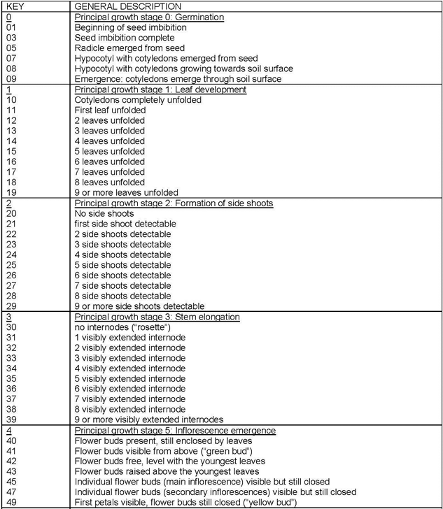
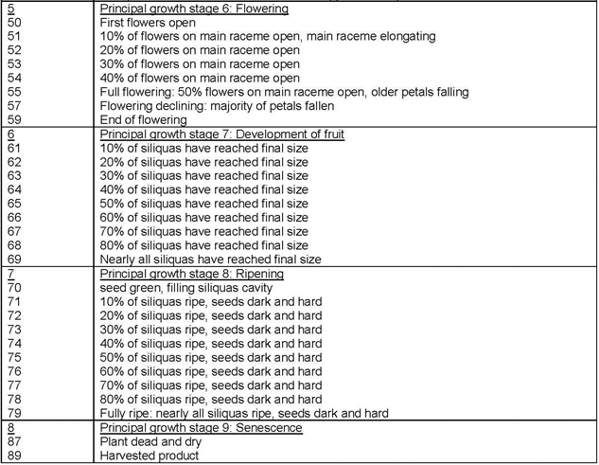
(b) Table 1
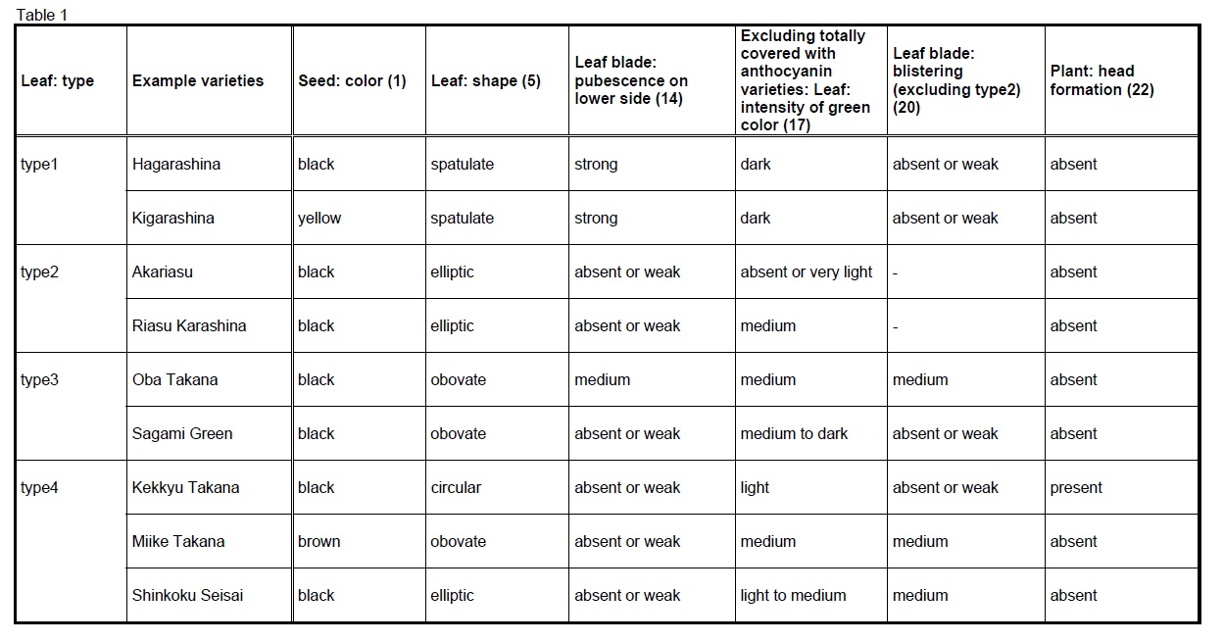

(c) The measurements should be taken in the glasshouse on cotyledons of 30 seedlings. If the two cotyledons differ in size, the biggest one should be measured. The length is defined as distance between the inclination at top of the cotelydon and the point where the width of the petiole is about 4 mm. The width of the cotyledon should be measured at the widest point of the cotyledons.
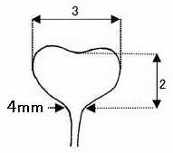
(d) Ad. 7: Leaf: length
Ad. 8: Leaf: width
Ad. 9: Leaf: length of petiole
Ad. 10: Leaf: width of petiole
Ad. 19: Leaf: Only varieties with leaf: type: type 3 and 4: Leaf blade: width of midrib at widest point
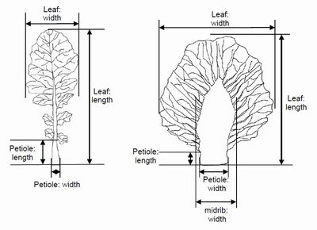
(e) the strongest intensity of anthocyanin should be observed (not the extension).

8.2 Explanations for individual characteristics

Ad. 1: Seed: color
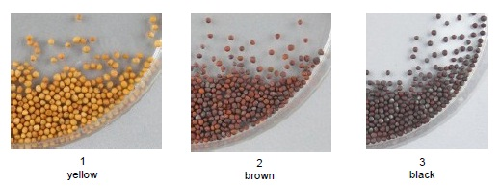

Ad. 5: Leaf: type
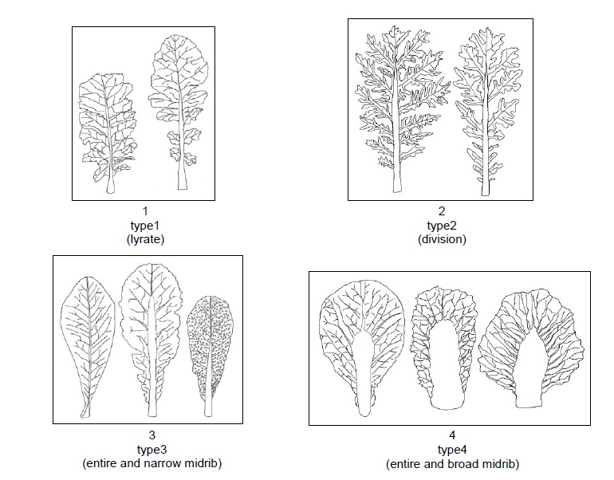

Ad. 6: Leaf: shape
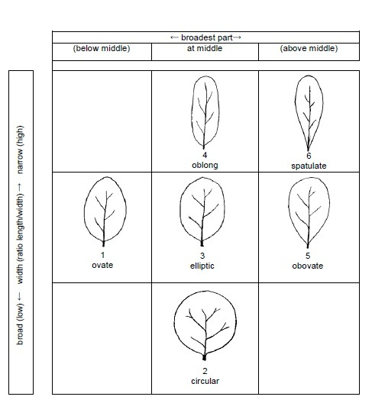
Ad. 7: Leaf: attitude
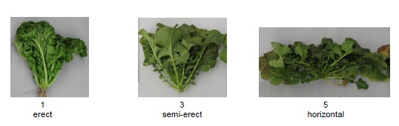

Ad. 12: Leaf blade: size of terminal lobe

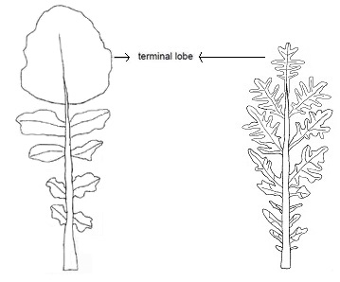

Ad. 19: Leaf blade: density of incisions of margin (excluding type2)
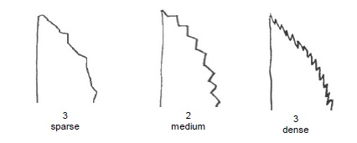

Ad. 20: Leaf blade: blistering (excluding type2)
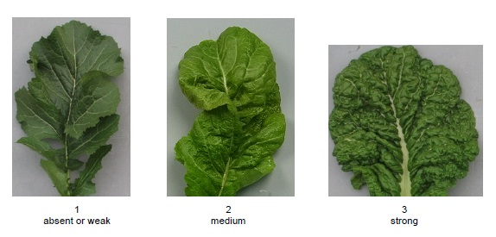

Ad. 22: Plant: head formation
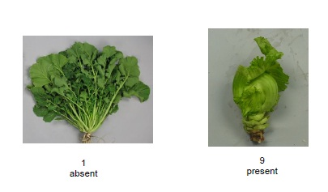

Ad. 27: Stem: type of main stem (excluding heading type)
Observation on type of main stem should be made on shape of main stem without lateral stem.
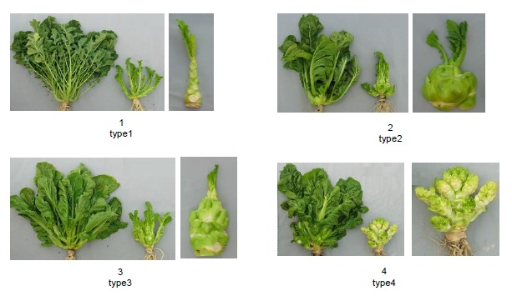

Literature

Ministry of Agriculture, Forestry & Fisheries of Japan., 1994: National Test Guideline for Karashina.

Tsukamoto, Y., 1994: The Grand Dictionary of Horticulture Volume 1. The Shogakukan Ltd., Tokyo, Japan, pp. 520 to 522.

Takasi A., 2004: Yasai-engei-daihyakka 17. Shadanhojin Nousan-gyoson-bunkakyokai. Tokyo, Japan. 169-233

Fujishiro, T., 1996: Breeding processes and characteristics of a newly bred leaf mustard (Brassica Juncea Coss.)., Kanagawa, Japan.

Uwe Meier. Federal Biological Research Centre for Agriculture and Forestry, 2001: Growth stages of mono-and dicotyledonous plants, BBCH Monograph,

Roger Phillips, Martyn Rix., 1993: VEGETABLES (The Pan Garden Plants Series) p.44

Joy Larkcom., 1991: Oriental Vegetables (The Complete guide for Garden and Kitchen) London, United Kingdom. pp. 39 to 45

Technical Questionnaire

TECHNICAL QUESTIONNAIRE |  | Page {x} of {y} | Reference Number:
 |  |  | Application date:
 |  |  | (not to be filled in by the applicant)
TECHNICAL QUESTIONNAIRE
to be completed in connection with an application for plant breeders’ rights

1. Subject of the Technical Questionnaire
1.1.1 | Botanical Name | Brassica juncea (L.) Czern.
1.1.2 | Common Name | Brown mustard, India mustard, Indian mustard, Oriental mustard
1.1.3

2. Applicant
Name
Address
Telephone No.
Fax No.
E-mail address
Breeder (if different from applicant)
3. Proposed denomination and breeder’s reference
Proposed denomination
(if available)

Breeder’s reference

TECHNICAL QUESTIONNAIRE |  | Page {x} of {y} | Reference Number:
4. Information on the breeding scheme and propagation of the variety

4.1 Breeding scheme

4.2 Method of propagating the variety

4.2.1 Seed-propagated varieties

(a) Cross-pollination [ ]
(b) Other [ ]
(please provide details)
..................................................................................................................................................
: :
: :
:................................................................................................................................................:

4.2.2 Other [ ]

(please provide details)
..................................................................................................................................................
: :
: :
:................................................................................................................................................:

 | TECHNICAL QUESTIONNAIRE |  |  |  | Page {x} of {y} |  | Reference Number:
 |  | 5. Characteristics of the variety to be indicated (the number in brackets refers to the corresponding characteristic in Test Guidelines; please mark the note which best corresponds).
 |  |  | Characteristics |  |  |  |  | Example Varieties |  | Note
 |  | 5.1 (1) | Seed: color
 |  |  | yellow |  |  |  |  | Kigarashina |  | 1[ ]
 |  |  | brown |  |  |  |  | Miike Takana |  | 2[ ]
 |  |  | black |  |  |  |  | Akaoba Takana(Red Giant), Hagarashina |  | 3[ ]
 |  | 5.2 (5) | Leaf: type
 |  |  | type 1 |  |  |  |  | Hagarashina, Kigarashina |  | 1[ ]
 |  |  | type 2 |  |  |  |  | Akariasu, Riasu Karashina, Scarlet Frills |  | 2[ ]
 |  |  | type 3 |  |  |  |  | Akaoba Takana(Red Giant), Kekkyu Takana, Oba Takana, Sagami Green |  | 3[ ]
 |  |  | type 4 |  |  |  |  | Miike Takana, Shinkoku Seisai |  | 4[ ]
 |  | 5.3 (6) | Leaf: shape
 |  |  | ovate |  |  |  |  | Serihon |  | 1[ ]
 |  |  | circular |  |  |  |  | Kekkyu Takana |  | 2[ ]
 |  |  | elliptic |  |  |  |  | Akariasu |  | 3[ ]
 |  |  | oblong |  |  |  |  | Zasai FM-58 |  | 4[ ]
 |  |  | obovate |  |  |  |  | Katsuona |  | 5[ ]
 |  |  | spatulate |  |  |  |  | Kigarashina |  | 6[ ]
 |  | 5.4 (7) | Leaf: attitude
 |  |  | erect |  |  |  |  | Junkei Yamashiona |  | 1[ ]
 |  |  | erect to semi-erect |  |  |  |  |  |  | 2[ ]
 |  |  | semi-erect |  |  |  |  | Shinkoku Seisai |  | 3[ ]
 |  |  | semi-erect to horizontal |  |  |  |  |  |  | 4[ ]
 |  |  | horizontal |  |  |  |  | Miike Takana |  | 5[ ]
 |  | 5.5 (16) | Leaf blade: intensity of anthocyanin coloration
 |  |  | absent or very weak |  |  |  |  | Kekkyu Takana |  | 1[ ]
 |  |  | very weak to weak |  |  |  |  |  |  | 2[ ]
 |  |  | weak |  |  |  |  |  |  | 3[ ]
 |  |  | weak to medium |  |  |  |  |  |  | 4[ ]
 |  |  | medium |  |  |  |  | Miike Takana |  | 5[ ]
 |  |  | medium to strong |  |  |  |  |  |  | 6[ ]
 |  |  | strong |  |  |  |  | Akaoba Takana(Red Giant) |  | 7[ ]
 |  |  | strong to very strong |  |  |  |  |  |  | 8[ ]
 |  |  | very strong |  |  |  |  |  |  | 9[ ]
 |  | 5.6 (18) | Leaf blade: undulation of margin (excluding type2)
 |  |  | absent or very weak |  |  |  |  |  |  | 1[ ]
 |  |  | very weak to weak |  |  |  |  |  |  | 2[ ]
 |  |  | weak |  |  |  |  | Akaoba Takana(Red Giant) |  | 3[ ]
 |  |  | weak to medium |  |  |  |  |  |  | 4[ ]
 |  |  | medium |  |  |  |  | Katsuona |  | 5[ ]
 |  |  | medium to strong |  |  |  |  |  |  | 6[ ]
 |  |  | strong |  |  |  |  | Chirimen Hakarashina |  | 7[ ]
 |  |  | strong to very strong |  |  |  |  |  |  | 8[ ]
 |  |  | very strong |  |  |  |  |  |  | 9[ ]
 |  | 5.7 (19) | Leaf blade: density of incisions of margin (excluding type2)
 |  |  | absent or very sparse |  |  |  |  | Katsuona |  | 1[ ]
 |  |  | very sparse to sparse |  |  |  |  |  |  | 2[ ]
 |  |  | sparse |  |  |  |  |  |  | 3[ ]
 |  |  | sparse to medium |  |  |  |  |  |  | 4[ ]
 |  |  | medium |  |  |  |  | Junkei Yamashiona |  | 5[ ]
 |  |  | medium to dense |  |  |  |  |  |  | 6[ ]
 |  |  | dense |  |  |  |  | Chirimen Hakarashina |  | 7[ ]
 |  |  | dense to very dense |  |  |  |  |  |  | 8[ ]
 |  |  | very dense |  |  |  |  |  |  | 9[ ]
 |  | 5.8 (20) | Leaf blade: blistering (excluding type2)
 |  |  | absent or weak |  |  |  |  | Kigarashina |  | 1[ ]
 |  |  | medium |  |  |  |  | Junkei Yamashiona |  | 2[ ]
 |  |  | strong |  |  |  |  | Katsuona |  | 3[ ]
 |  | 5.9 (22) | Plant: head formation
 |  |  | absent |  |  |  |  | Kigarashina |  | 1[ ]
 |  |  | present |  |  |  |  | Kekkyu Takana |  | 9[ ]
6. Similar varieties and differences from these varieties

Please use the following table and box for comments to provide information on how your candidate variety differs from the variety (or varieties) which, to the best of your knowledge, is (or are) most similar. This information may help the examination authority to conduct its examination of distinctness in a more efficient way.

Denomination(s) of variety(ies) similar to your candidate variety |  |  |  | Characteristic(s) in which your candidate variety differs from the similar variety(ies) |  | Describe the expression of the characteristic(s) for the similar variety(ies) |  |  | Describe the expression of the characteristic(s) for your candidate variety
Example |  |  |  | Leaf: shape |  | ovate |  |  | oblong
Comments:

7. Additional information which may help in the examination of the variety

7.1 In addition to the information provided in sections 5 and 6, are there any additional characteristics which may help to distinguish the variety?

Yes [ ] No [ ]

(If yes, please provide details)

7.2 Are there any special conditions for growing the variety or conducting the examination?

Yes [ ] No [ ]

(If yes, please provide details)

7.3 Other information

Main use: a. Vegetable […]
b. Seed
i oil […]
ii condiment […]
c. Green manure d. other […]

8. Authorization for release

(a) Does the variety require prior authorization for release under legislation concerning the protection of the environment, human and animal health?

Yes [ ] No [ ]

(b) Has such authorization been obtained?

Yes [ ] No [ ]

If the answer to (b) is yes, please attach a copy of the authorization.

TECHNICAL QUESTIONNAIRE | Page {x} of {y} | Reference Number:
9. Information on plant material to be examined or submitted for examination

9.1 The expression of a characteristic or several characteristics of a variety may be affected by factors, such as pests and disease, chemical treatment (e.g. growth retardants or pesticides), effects of tissue culture, different rootstocks, scions taken from different growth phases of a tree, etc.

9.2 The plant material should not have undergone any treatment which would affect the expression of the characteristics of the variety, unless the competent authorities allow or request such treatment. If the plant material has undergone such treatment, full details of the treatment must be given. In this respect, please indicate below, to the best of your knowledge, if the plant material to be examined has been subjected to:

(a) Microorganisms (e.g. virus, bacteria, phytoplasma) Yes [ ] No [ ]

(b) Chemical treatment (e.g. growth retardant, pesticide) Yes [ ] No [ ]

(c) Tissue culture Yes [ ] No [ ]

(d) Other factors Yes [ ] No [ ]

Please provide details for where you have indicated “yes”.

10. I hereby declare that, to the best of my knowledge, the information provided in this form is correct:

Applicant’s name

Signature Date

[End of document]

* These names were correct at the time of the introduction of these Test Guidelines but may be revised or updated. [Readers are advised to consult the UPOV Code, which can be found on the UPOV Website (www.upov.int), for the latest information.]

