E
TG/259/2(proj.1)
ORIGINAL: English
DATE: 2015-05-04
INTERNATIONAL UNION FOR THE PROTECTION OF NEW VARIETIES OF PLANTS
Geneva
DRAFT

 | Agaricus  UPOV Code: AGARI  Agaricus L. | *

GUIDELINES
FOR THE CONDUCT OF TESTS
FOR DISTINCTNESS, UNIFORMITY AND STABILITY

prepared by (an) expert(s) from European Union

to be considered by the
Technical Working Party for Vegetables
at its forty-ninth session
to be held in Angers, France,
from 2015-06-15
to 2015-06-19

Alternative Names:*
Botanical name | English | French | German | Spanish
Agaricus L. | Button Mushroom, Mushroom, Tsukuritake | Champignon de couche | Champignon | Champiñón

The purpose of these guidelines (“Test Guidelines”) is to elaborate the principles contained in the General Introduction (document TG/1/3), and its associated TGP documents, into detailed practical guidance for the harmonized examination of distinctness, uniformity and stability (DUS) and, in particular, to identify appropriate characteristics for the examination of DUS and production of harmonized variety descriptions.

ASSOCIATED DOCUMENTS
These Test Guidelines should be read in conjunction with the General Introduction and its associated TGP documents.
TABLE OF CONTENTS PAGE

1. Subject of these Test Guidelines 3
2. Material Required 3
3. Method of Examination 3
3.1 Number of Growing Cycles 3
3.2 Testing Place 3
3.3 Conditions for Conducting the Examination 3
3.4 Test Design 4
3.5 Additional Tests 4
4. Assessment of Distinctness, Uniformity and Stability 4
4.1 Distinctness 4
4.2 Uniformity 5
4.3 Stability 5
5. Grouping of Varieties and Organization of the Growing Trial 5
6. Introduction to the Table of Characteristics 6
6.1 Categories of Characteristics 6
6.2 States of Expression and Corresponding Notes 6
6.3 Types of Expression 7
6.4 Example Varieties 7
6.5 Legend 7
7. Table of Characteristics/Tableau des caractères/Merkmalstabelle/Tabla de caracteres 9
8. Explanations on the Table of Characteristics 16
9. Literature 29
10. Technical Questionnaire 30

Subject of these Test Guidelines

These Test Guidelines apply to all varieties of Agaricus L..

Material Required

2.1 The competent authorities decide on the quantity and quality of the plant material required for testing the variety and when and where it is to be delivered. Applicants submitting material from a State other than that in which the testing takes place must ensure that all customs formalities and phytosanitary requirements are complied with.

2.2 The material is to be supplied in the form of spawn or pure culture on a suitable medium.

2.3 The minimum quantity of plant material, to be supplied by the applicant, should be:

(a) Spawn should be of a quality which ensures that all relevant characteristics of the variety will be expressed. In particular, mycelium on grain should be visible to the naked eye, the grain should not be colonized to such an extent that kernels stick together. The spawn should not be older than 3 months and should have been stored at 2-4 °C.

(b) 2 slant tubes containing a pure culture.
Pure cultures must be on slant agar tubes with an appropriate medium such as PDA (Potato Dextrose Agar) or MEA (Malt Extract Agar). Tubes should be covered by cotton plugs or plastic caps allowing sterile air diffusion. Cultures should be fresh, i.e. not stored for longer than 3 weeks at low temperature.
Additionally the applicant may be requested to send uninoculated, sterile carrier that can be used to multiply both the new strain as well as the reference material.

2.4 The plant material supplied should be visibly healthy, not lacking in vigor, nor affected by any important pest or disease.

2.5 The plant material should not have undergone any treatment which would affect the expression of the characteristics of the variety, unless the competent authorities allow or request such treatment. If it has been treated, full details of the treatment must be given.

Method of Examination

3.1 Number of Growing Cycles

3.1.1 The minimum duration of tests should normally be two independent growing cycles.

3.1.2 The two independent growing cycles should be in the form of two separate plantings.

3.1.3 The growing cycle is considered to be from spawn inoculation until the end of the first flush. Extension of the cultivation period can be requested by the applicant if the distinctness can only be demonstrated in the second and/or third flush.

3.2 Testing Place

Tests are normally conducted at one place. In the case of tests conducted at more than one place, guidance is provided in TGP/9 “Examining Distinctness”.

3.3 Conditions for Conducting the Examination

3.3.1 The tests should be carried out under conditions ensuring satisfactory growth for the expression of the relevant characteristics of the variety and for the conduct of the examination.

3.3.2 The spawn inoculation and incubation process is carried out under sterile conditions in accordance with the methodologies described by Fritsche (1988). Once inoculated the spawn containers should be incubated at approximately 25 degrees C. After one week, the spawn should be shaken to redistribute the mycelium evenly through the container. When the carrier is completely covered with mycelium, the spawn containers should be refrigerated at 2-4 degrees C during 3 weeks before use in compost inoculation.
The cultivation should be conducted in line with the methodologies described by Fletcher &amp; Gaze (2007). Ideally compost with a moisture content of 68% is used at temperature of 24-25 degrees C. Pin setting is advantaged at 90-92% air humidity. Compost should be dropped down to 20 degrees C, and the carbon dioxide level should be aimed at 1400 PPM.

3.4 Test Design

3.4.1 Each test should be designed to result in a total of at least 120 fruit bodies, which should be divided between at least 6 replicates.

3.4.2 The design of the tests should be such that plants or parts of plants may be removed for measurement or counting without prejudice to the observations which must be made up to the end of the growing cycle.

120 fruit bodies collected per flush.
The fruit bodies should be distributed equally over the 6 replicates

3.5 Additional Tests

Additional tests, for examining relevant characteristics, may be established.

Assessment of Distinctness, Uniformity and Stability

4.1 Distinctness

4.1.1 General Recommendations

It is of particular importance for users of these Test Guidelines to consult the General Introduction prior to making decisions regarding distinctness. However, the following points are provided for elaboration or emphasis in these Test Guidelines.

4.1.2 Consistent Differences

The differences observed between varieties may be so clear that more than one growing cycle is not necessary. In addition, in some circumstances, the influence of the environment is not such that more than a single growing cycle is required to provide assurance that the differences observed between varieties are sufficiently consistent. One means of ensuring that a difference in a characteristic, observed in a growing trial, is sufficiently consistent is to examine the characteristic in at least two independent growing cycles.

4.1.3 Clear Differences

Determining whether a difference between two varieties is clear depends on many factors, and should consider, in particular, the type of expression of the characteristic being examined, i.e. whether it is expressed in a qualitative, quantitative, or pseudo-qualitative manner. Therefore, it is important that users of these Test Guidelines are familiar with the recommendations contained in the General Introduction prior to making decisions regarding distinctness.

4.1.4 Number of Plants / Parts of Plants to be Examined

Unless otherwise indicated, for the purposes of distinctness, all observations on single plants should be made on 120 plants or parts taken from each of 120 plants and any other observations made on all plants in the test, disregarding any off-type plants.

4.1.5 Method of Observation

The recommended method of observing the characteristic for the purposes of distinctness is indicated by the following key in the second column of the Table of Characteristics (see document TGP/9 “Examining Distinctness”, Section 4 “Observation of characteristics”):

MG: single measurement of a group of plants or parts of plants
MS: measurement of a number of individual plants or parts of plants
VG: visual assessment by a single observation of a group of plants or parts of plants
VS: visual assessment by observation of individual plants or parts of plants

Type of observation: visual (V) or measurement (M)

“Visual” observation (V) is an observation made on the basis of the expert’s judgment. For the purposes of this document, “visual” observation refers to the sensory observations of the experts and, therefore, also includes smell, taste and touch. Visual observation includes observations where the expert uses reference points (e.g. diagrams, example varieties, side-by-side comparison) or non-linear charts (e.g. color charts). Measurement (M) is an objective observation against a calibrated, linear scale e.g. using a ruler, weighing scales, colorimeter, dates, counts, etc.

Type of record: for a group of plants (G) or for single, individual plants (S)

For the purposes of distinctness, observations may be recorded as a single record for a group of plants or parts of plants (G), or may be recorded as records for a number of single, individual plants or parts of plants (S). In most cases, “G” provides a single record per variety and it is not possible or necessary to apply statistical methods in a plant-by-plant analysis for the assessment of distinctness.

In cases where more than one method of observing the characteristic is indicated in the Table of Characteristics (e.g. VG/MG), guidance on selecting an appropriate method is provided in document TGP/9, Section 4.2.

4.2 Uniformity

    - It is of particular importance for users of these Test Guidelines to consult the General Introduction prior to making decisions regarding uniformity. However, the following points are provided for elaboration or emphasis in these Test Guidelines:

4.2.2 For the assessment of uniformity, a population standard of 1% and an acceptance probability of at least 95 % should be applied. In the case of a sample size of 120 plants, 3 off-types are allowed.

4.3 Stability

4.3.1 In practice, it is not usual to perform tests of stability that produce results as certain as those of the testing of distinctness and uniformity. However, experience has demonstrated that, for many types of variety, when a variety has been shown to be uniform, it can also be considered to be stable.

4.3.2 Where appropriate, or in cases of doubt, stability may be further examined by testing a new plant stock to ensure that it exhibits the same characteristics as those shown by the initial material supplied.

Grouping of Varieties and Organization of the Growing Trial

5.1 The selection of varieties of common knowledge to be grown in the trial with the candidate varieties and the way in which these varieties are divided into groups to facilitate the assessment of distinctness are aided by the use of grouping characteristics.

5.2 Grouping characteristics are those in which the documented states of expression, even where produced at different locations, can be used, either individually or in combination with other such characteristics: (a) to select varieties of common knowledge that can be excluded from the growing trial used for examination of distinctness; and (b) to organize the growing trial so that similar varieties are grouped together.

5.3 The following have been agreed as useful grouping characteristics:

(a) Cap: diameter (characteristic 13)
(b) Cap: shape in longitudinal section (characteristic 15)
(c) Gills: color at time of breaking of veil (characteristic 24)
(d) Basidium: number of spores (characteristic 26)
(e) Open cap: Stipe distance from base to annulus (characteristic 28)

5.4 Guidance for the use of grouping characteristics, in the process of examining distinctness, is provided through the General Introduction and document TGP/9 “Examining Distinctness”.

Introduction to the Table of Characteristics

6.1 Categories of Characteristics

6.1.1 Standard Test Guidelines Characteristics

Standard Test Guidelines characteristics are those which are approved by UPOV for examination of DUS and from which members of the Union can select those suitable for their particular circumstances.

6.1.2 Asterisked Characteristics

Asterisked characteristics (denoted by *) are those included in the Test Guidelines which are important for the international harmonization of variety descriptions and should always be examined for DUS and included in the variety description by all members of the Union, except when the state of expression of a preceding characteristic or regional environmental conditions render this inappropriate.

6.2 States of Expression and Corresponding Notes

6.2.1 States of expression are given for each characteristic to define the characteristic and to harmonize descriptions. Each state of expression is allocated a corresponding numerical note for ease of recording of data and for the production and exchange of the description.

6.2.2 In the case of qualitative and pseudo-qualitative characteristics (see Chapter 6.3), all relevant states of expression are presented in the characteristic. However, in the case of quantitative characteristics with 5 or more states, an abbreviated scale may be used to minimize the size of the Table of Characteristics. For example, in the case of a quantitative characteristic with 9 states, the presentation of states of expression in the Test Guidelines may be abbreviated as follows:

State | Note
small | 3
medium | 5
large | 7

However, it should be noted that all of the following 9 states of expression exist to describe varieties and should be used as appropriate:

State | Note
very small | 1
very small to small | 2
small | 3
small to medium | 4
medium | 5
medium to large | 6
large | 7
large to very large | 8
very large | 9

6.2.3 Further explanation of the presentation of states of expression and notes is provided in document TGP/7 “Development of Test Guidelines”.

6.3 Types of Expression

An explanation of the types of expression of characteristics (qualitative, quantitative and pseudo-qualitative) is provided in the General Introduction.

6.4 Example Varieties

Where appropriate, example varieties are provided to clarify the states of expression of each characteristic.

In the first place, the collection should be divided according to the following species and growth types:

Mushroom species/ type: Examples:
1. White button mushroom (Agaricus bisporus): Euromycel 58, Horronda, Horwitu, Somycel 53, Somycel 76, Sylvan A15
2. Brown button Mushroom (Agaricus bisporus): Amycel 2400, Brawn, Broncoh, Heirloom, J10263, Sylvan 800
3. Horse mushroom (Agaricus arvensis): Horvensis
4. Spring mushroom (Agaricus bitorquis): Horbita
5. Almond mushroom (Agaricus subrufrescens): H1X1

For further information, and a list of characters to be applied per species or growth type, see Section 8.1 “Key to Agaricus Types”.

6.5 Legend

(*) Asterisked characteristic – see Chapter 6.1.2

QL Qualitative characteristic – see Chapter 6.3
QN Quantitative characteristic – see Chapter 6.3
PQ Pseudo-qualitative characteristic – see Chapter 6.3

MG, MS, VG, VS – see Chapter 4.1.5

(a)-(f) See Explanations on the Table of Characteristics in Chapter 8.

(+) See Explanations on the Table of Characteristics in Chapter 8.

Key to Agaricus types (under Section 5.3)

Cultivated Agaricus varieties can be grouped into the following species/types:

(1) White button mushroom (Agaricus bisporus)
Description: Pileus white to off-white, surface smooth or with scales in a radial arrangement. The stipe colour resembles the colour of the pileus. Lamelae in stage 2 (see Section 8.3) pinkish to reddish-brown. Annulus intermediately or inferous positioned on the stipe.

(2) Brown button mushroom (Agaricus bisporus)
Description: Brown button mushrooms resemble the white varieties, but are characterized by an ochraceous to dark brown pileus. The stipe is white to off-white. The inner side of the annulus can either be brown or white.

(3) Horse mushroom (Agaricus arvensis)
Description: Pileus and stipe white to ochraceous, becoming yellowish when bruised. Lamelae relatively broad and whitish to somewhat greyish in stage 2 (see Section 8.3). Veil somewhat scaled. Annulus superous positioned on the stipe. Typical anise odor and taste.

(4) Spring Mushroom (Agaricus bitorquis)
Description: Pileus and stipe white, with incidentally some yellowish or orange shades. Cap surface without scales. Lamelae in stage 2 (see Section 8.3) pinkish to reddish-brown.Veil smooth. Annulus inferous positioned on the stipe.

(5) Almond mushroom (Agaricus subrufrescens)
Description: Pileus ochraceous to reddish-brown, incidentally white. Lamelae greyish-white in stage 2 (see Section 8.3). The veil strongly scaled. Annulus superous positioned on the stipe. Typical almond-like odor and taste.

Table of Characteristics/Tableau des caractères/Merkmalstabelle/Tabla de caracteres

English | français | deutsch | español | Example Varieties Exemples Beispielssorten Variedades ejemplo | Note/ Nota
1. QL VG (+)
Mycelium: type
predominantly vegetative |  |  |  |  | 1
vegetative and generative |  |  |  | Horronda, Sylvan A15 | 2
predominantly generative |  |  |  | Brawn, Heirloom | 3
2. QN VG (+)
Pin setting: number of pins
few |  |  |  | H1X1 | 3
medium |  |  |  | Amycel 2400 | 5
many |  |  |  | Horwitu, Sylvan A15 | 7
3. QN MG (+)
Time of pinning
early |  |  |  | Brawn, Heirloom | 3
medium |  |  |  | Horronda, Sylvan A15 | 5
late |  |  |  | Euromycel 58 | 7
4. (*) QN MG 2 (+) (f)
Time of first day of harvest | Époque du premier jour de récolte | Zeitpunkt des ersten Erntetages | Época de primer día de cosecha
early |  |  |  |  | 3
medium |  |  |  | Amycel 2400 | 5
late |  |  |  | Euromycel 58 | 7
5. (*) QN MS VG 2 (+) (a) (d) (f)
Stipe: length | Stipe : longueur | Stiel: Länge | Pie: longitud
short | court | kurz | corto | Brawn | 3
medium | moyen | mittel | mediano | Broncoh, Sylvan A15 | 5
long | long | lang | largo | Amycel 2400, Horwitu | 7

English | français | deutsch | español | Example Varieties Exemples Beispielssorten Variedades ejemplo | Note/ Nota
6. (*) QN MS VG 2 (+) (a) (d) (f)
Stipe: diameter at cutting edge
narrow |  |  |  | Somycel 53 | 3
medium |  |  |  | Brawn, Broncoh | 5
broad |  |  |  | Horronda | 7
7. (*) QN MS VG 2 (a) (f)
Stipe: ratio length/diameter | Stipe : rapport longueur/diamètre | Stiel: Verhältnis Länge/Durchmesser | Pie: relación longitud/diámetro
moderately compressed | modérément compressé | mäßig zusammengedrückt | moderadamente comprimida |  | 3
medium | moyen | mittel | media | Sylvan A15 | 5
moderately elongated | modérément allongé | mäßig länglich | moderadamente alargada | Broncoh, Somycel 53 | 7
8. (*) PQ VG 2 (+) (a) (f)
Stipe: shape in longitudinal section | Stipe : forme en section longitudinale | Stiel: Form im Längsschnitt | Pie: forma en sección longitudinal
bulbous | bulbeux | knollig | bulbosa |  | 1
rectangular | rectangulaire | rechteckig | rectangular | Horronda, Horvensis | 2
trapezoidal | trapézoïdale | trapezförmig | trapezoidal | Horwitu | 3
9. PQ VG 2 (+) (a) (f)
Stipe: shape in cross section
round (smooth) |  |  |  |  | 1
irregular (lobbed) |  |  |  |  | 2
10. PQ VG 2 (+) (a) (f)
Varieties with brown cap only: Stipe: color
white |  |  |  | Brawn, Heirloom | 1
whitish |  |  |  | Amycel 2400 | 2
yellowish white |  |  |  | Horvensis | 3

English | français | deutsch | español | Example Varieties Exemples Beispielssorten Variedades ejemplo | Note/ Nota
11. QN VG 2 (+) (a) (f)
Stipe: degree of discoloration of cutting edge
absent or very weak |  |  |  |  | 1
weak |  |  |  | Horvensis, Sylvan A15 | 3
medium |  |  |  | Heirloom, Horbita | 5
strong |  |  |  | H1X1 | 7
very strong |  |  |  |  | 9
12. (*) QN MS VG 2 (+) (a) (d) (f)
Cap: height | Chapeau : hauteur | Hut: Höhe | Sombrero: altura
short |  |  |  | J10263 | 3
medium |  |  |  | Brawn, Sylvan A15 | 5
tall |  |  |  | Euromycel 58 | 7
13. (*) QN MS VG 2 (+) (a) (d) (f)
Cap: diameter | Chapeau : diamètre | Hut: Durchmesser | Sombrero: diámetro
small |  |  |  | Horwitu | 3
medium |  |  |  | Broncoh | 5
large |  |  |  | Heirloom, Sylvan A15 | 7
14. (*) QN MS VG 2 (a) (f)
Cap: ratio height/diameter | Chapeau : rapport hauteur/diamètre | Hut: Verhältnis Höhe/Durchmesser | Sombrero: relación altura/diámetro
moderately compressed |  |  |  | H1X1 | 3
medium |  |  |  | Broncoh, Sylvan A15 | 5
moderately elongated |  |  |  |  | 7

English | français | deutsch | español | Example Varieties Exemples Beispielssorten Variedades ejemplo | Note/ Nota
15. (*) PQ VG 2 (+) (a) (f)
Cap: shape in longitudinal section | Chapeau : forme en section longitudinale | Hut: Form im Längsschnitt | Sombrero: forma en sección longitudinal
obovate | obovale | eiförmig | oboval | H1X1 | 1
circular | circulaire | kreisförmig | circular | Horbita | 2
oblate | aplatie | breitrund | achatada | Broncoh, Sylvan A15 | 3
16. QN VG 2 (a) (f)
Varieties with brown caps only: Cap: Shade of scales compared to surface
light |  |  |  | Amycel 2400, Heirloom | 1
medium |  |  |  |  | 2
dark |  |  |  | Brawn | 3
17. (*) QN MS VG 2 (+) (a) (d) (f)
Cap: thickness in longitudinal section | Chapeau : épaisseur en section longitudinale | Hut: Dicke im Längsschnitt | Sombrero: espesor en sección longitudinal
thin | mince | dünn | delgado | J10263 | 3
medium | moyen | mittel | medio | Broncoh, Horronda | 5
thick | épais | dick | grueso | Sylvan A15 | 7
18. PQ VG 2 (a) (f)
Cap: shape of underside
rounded |  |  |  |  | 1
straight |  |  |  |  | 2
spherical |  |  |  |  | 3
19. (*) QN VG 2 (+) (a) (f)
Cap: scaling | Chapeau : écailles | Hut: Beschuppung | Sombrero: escamado
absent or very weak | absentes ou très peu nombreuses | fehlend oder sehr gering | ausente o muy débil | Horbita, Somycel 53 | 1
weak | peu nombreuses | gering | débil | Horwitu | 3
medium | moyennement nombreuses | mittel | medio | Heirloom, Horronda | 5
strong | nombreuses | stark | fuerte | Somycel 76 | 7
very strong | très nombreuses | sehr stark | muy fuerte |  | 9

English | français | deutsch | español | Example Varieties Exemples Beispielssorten Variedades ejemplo | Note/ Nota
20. (*) QN VG 2 (a) (f)
Varieties with brown caps only: shade of brown of strain
very light |  |  |  | Broncoh, J10263 | 1
light |  |  |  | Amycel 2400 | 3
medium |  |  |  | H1X1, Heirloom | 5
dark |  |  |  | Brawn | 7
very dark |  |  |  |  | 9
21. (*) PQ VG 2 (a) (f)
Varieties with white caps only: color of strains
white |  |  |  | Somycel 53, Sylvan A15 | 1
whtish |  |  |  | Somycel 76 | 2
yellowish white |  |  |  | Horvensis | 3
22. QN VG 2 (+) (a) (f)
Cap: thickness of veil
thin |  |  |  |  | 3
medium |  |  |  | Horronda, Sylvan A15 | 5
thick |  |  |  | H1X1, Horvensis | 7
23. (*) QN MG 2 (+) (f)
Time of peak of first flush | Époque du pic de la première période de floraison | Zeitpunkt des Höhepunktes des ersten Austriebs | Momento pico de los primeros brotes
early |  |  |  | Heirloom | 3
medium |  |  |  | Amycel 2400, Sylvan A15 | 5
late |  |  |  | Brawn, Euromycel 58 | 7

English | français | deutsch | español | Example Varieties Exemples Beispielssorten Variedades ejemplo | Note/ Nota
24. (*) PQ VG 3 (b) (f)
Gills: color at time of breaking of veil | Lamelles : couleur au moment de la rupture du voile | Lamellen: Farbe zum Zeitpunkt des Zerreißens der Manschette | Laminillas: color en el momento de ruptura del velo
light pink |  |  |  |  | 1
orange | orange | orange | anaranjado | Horvensis | 2
light brown | marron clair | hellbraun | marrón claro | Horronda, Horwitu | 3
dark brown | marron foncé | dunkelbraun | marrón oscuro | Broncoh | 4
25. PQ VG 3 (+) (b) (f)
Varieties with brown caps only: Stipe: annulus color
white |  |  |  | Amycel 2400, Sylvan 800 | 1
brown |  |  |  | Brawn, Heirloom | 2
26. (*) QL MS 3 (+) (b) (f)
Basidium: number of spores
zero |  |  |  | J10263 | 1
two |  |  |  | Heirloom, Horwitu | 2
four |  |  |  | Horbita, Horvensis | 3
27. QN MG 4 (+) (f)
Time of cap opening
early |  |  |  | Horwitu | 3
medium |  |  |  | Amycel 2400, Sylvan A15 | 5
late |  |  |  | Brawn, Heirloom | 7
28. (*) QN VG 5 (c) (e) (f)
Open cap: Stipe distance from base to annulus
short |  |  |  | Amycel 2400 | 3
medium |  |  |  | Broncoh | 5
long |  |  |  | Horvensis | 7

English | français | deutsch | español | Example Varieties Exemples Beispielssorten Variedades ejemplo | Note/ Nota
29. (*) QN MS VG 5 (c) (e) (f)
Open cap: diameter | Chapeau ouvert : diamètre | Offener Hut: Durchmesser | Sombrero abierto: diámetro
small |  |  |  | Horwitu | 3
medium |  |  |  | Broncoh, Sylvan A15 | 5
large |  |  |  | Amycel 2400, Heirloom | 7
30. (*) QN MS VG 5 (c) (e) (f)
Open cap: thickness | Chapeau ouvert : épaisseur | Offener Hut: Dicke | Sombrero abierto: espesor
thin |  |  |  | J10263 | 3
medium |  |  |  | Horwitu, Sylvan A15 | 5
thick |  |  |  | Brawn, Heirloom | 7
31. (*) QN VG 5 (c) (f)
Open cap: fraying of margin | Chapeau ouvert : effilochage du bord | Offener Hut: Ausfransen des Randes | Sombrero abierto: deshilachado del borde
absent or weak |  |  |  | Amycel 2400 | 1
moderate |  |  |  | Broncoh, Horwitu | 2
strong |  |  |  | Heirloom, Horronda | 3
32. (*) PQ VG 5 (+) (c) (f)
Open cap: shape of central part of upper side | Chapeau ouvert : forme de la partie centrale de la face supérieure | Offener Hut: Form des mittleren Teils der Oberseite | Sombrero abierto: forma del centro de la parte superior
rounded |  |  |  | Euromycel 58, Sylvan A15 | 1
plane |  |  |  | Heirloom | 2
depressed |  |  |  | Broncoh | 3

Explanations on the Table of Characteristics

8.1 Explanations covering several characteristics

Characteristics containing the following key in the second column of the Table of Characteristics should be examined as indicated below:
(a) Stipe, cap: Unless otherwise indicated, all characteristics of the stipe and the cap should be made at growth stage 2, when the fruit body appears as a button mushroom with the veil closed
(b) Gills: Unless otherwise indicated, all characteristics of the gills should be made at growth stage 3, when the fruit body appears as a button mushroom with the veil breaking
(c) Open cap: Unless otherwise indicated, all characteristics of the open cap should be made at growth stage 5, when the cap of the fruit body is fully open and flat
(d)
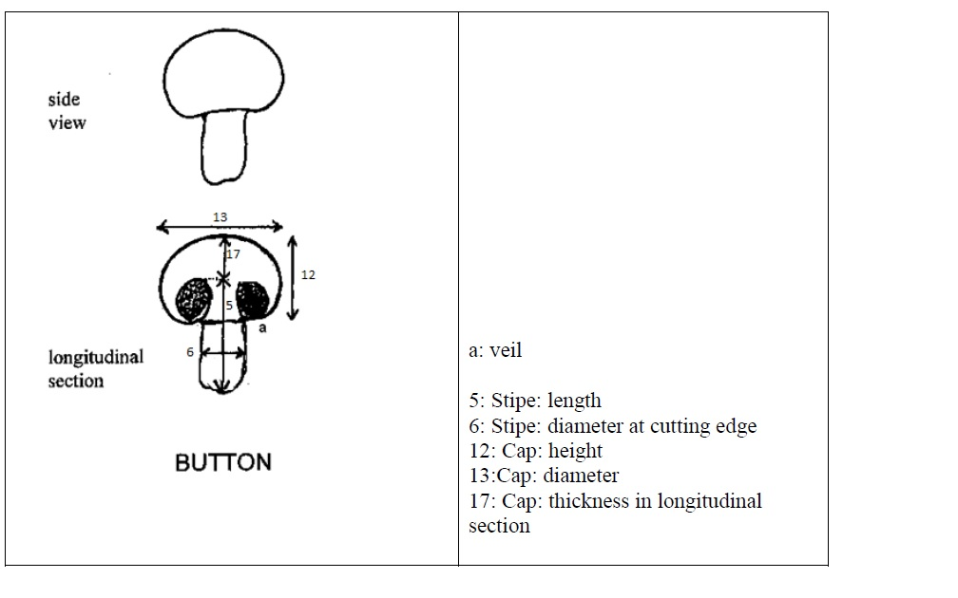

(e)
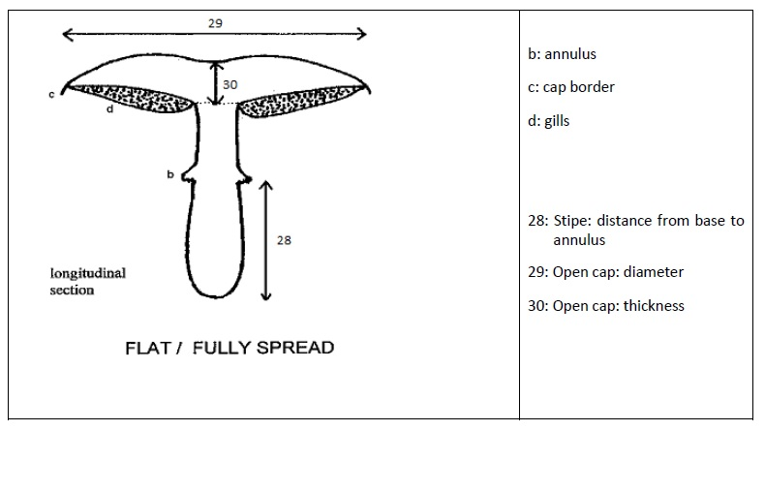
(f)
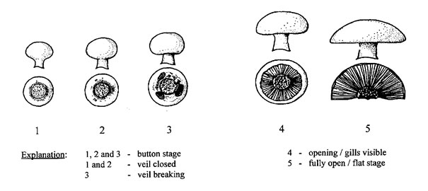

8.2 Explanations for individual characteristics

Ad. 1: Mycelium: type
The type of mycelium is assessed 3 days after aeration.

Ad. 2: Pin setting: number of pins
The number of pins larger than 3 mm is visually assessed 4 days after aeration.

Ad. 3: Time of pinning
The time of pinning is the first day on which the first pins larger than 3 mm diameter have emerged.

Ad. 4: Time of first day of harvest
The time of the first day of harvest is when first fruit body has reached growth stage 2.

Ad. 5: Stipe: length
The fruit bodies observed at growth stage 2 should be cut longitudinally once the stipe has broken free from the cap.

Ad. 6: Stipe: diameter at cutting edge
The fruit bodies observed at growth stage 2 should be cut longitudinally.

Ad. 8: Stipe: shape in longitudinal section

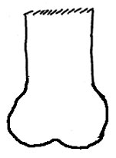
1 - bulbous
2 - rectangular
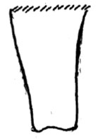
3 - trapezoidal

Ad. 9: Stipe: shape in cross section

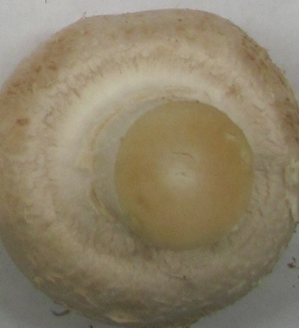
1 - round (smooth)
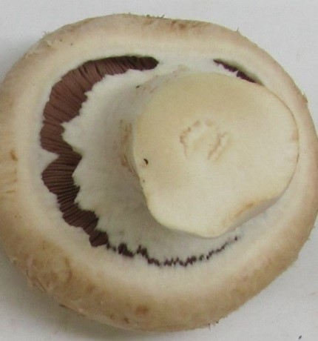
2 - irregular (lobbed)

Ad. 10: Varieties with brown cap only: Stipe: color
The stipe color is assessed visually after removing the caps.

Ad. 11: Stipe: degree of discoloration of cutting edge
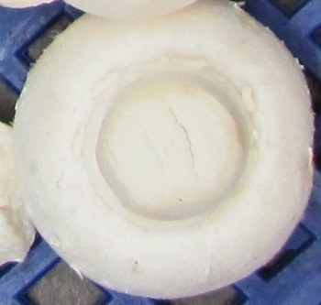
3 - weak
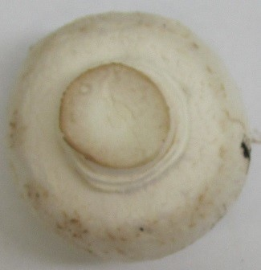
5 - medium
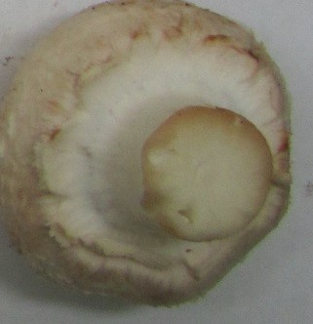
7 - strong
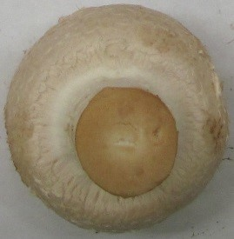
9 - very strong

Ad. 12: Cap: height
The fruit bodies observed at growth stage 2 should be cut longitudinally.

Ad. 13: Cap: diameter
The fruit bodies observed at growth stage 2 should be cut longitudinally.

Ad. 15: Cap: shape in longitudinal section
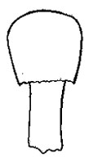
1 - obovate
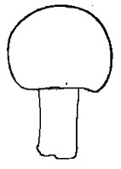
2 - circular
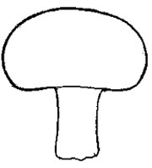
3 - oblate

Ad. 16: Varieties with brown caps only: Cap: Shade of scales compared to surface
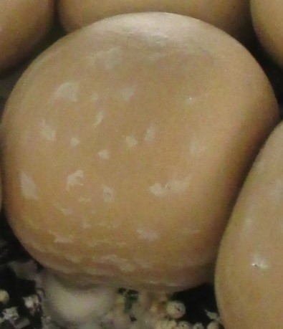
1 - light
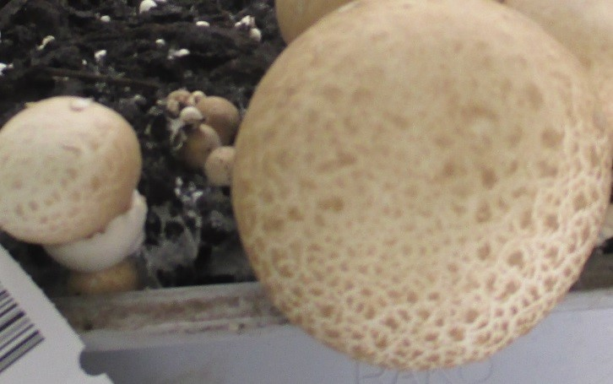
2 - medium

Ad. 17: Cap: thickness in longitudinal section
The fruit bodies observed at growth stage 2 should be cut longitudinally.

Ad. 19: Cap: scaling
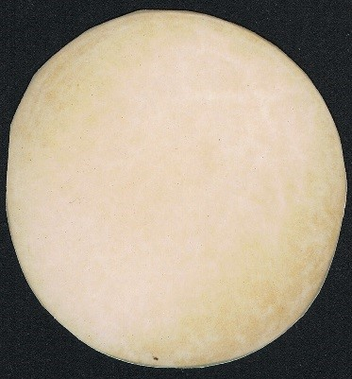
1 - absent or very weak
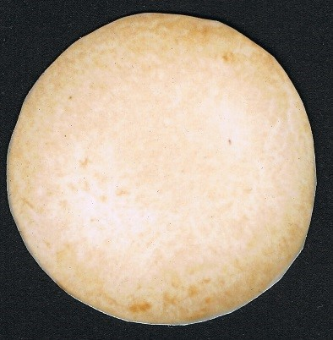
3 - weak
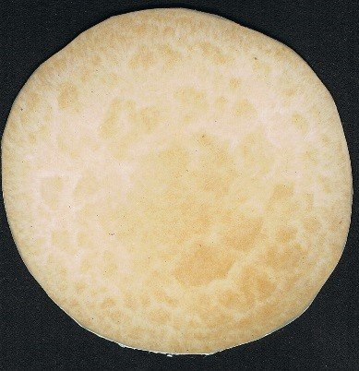
5 - medium
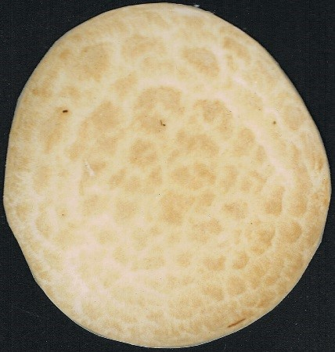
7 - strong
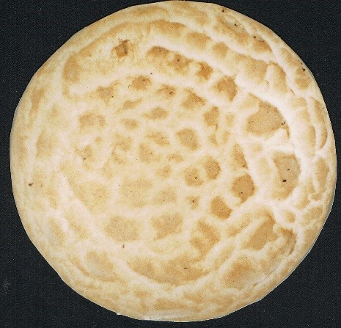
9 - very strong

Ad. 22: Cap: thickness of veil
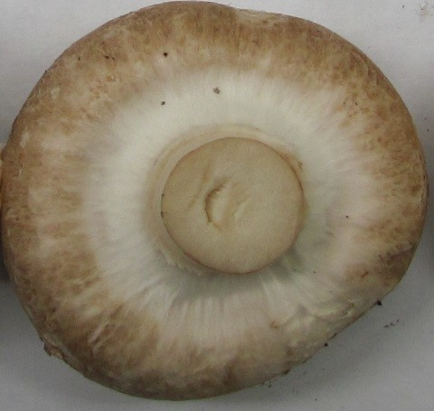
3 - thin
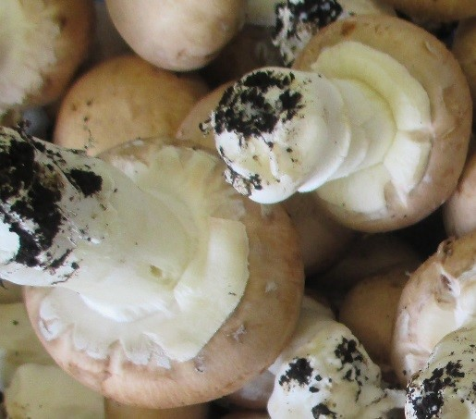
7 - thick

Ad. 23: Time of peak of first flush
The dates of harvest of fruit bodies at growth stage 2 are recorded. The time of the peak of the first flush is the time at which the largest number of fruit bodies was harvested.

Ad. 25: Varieties with brown caps only: Stipe: annulus color

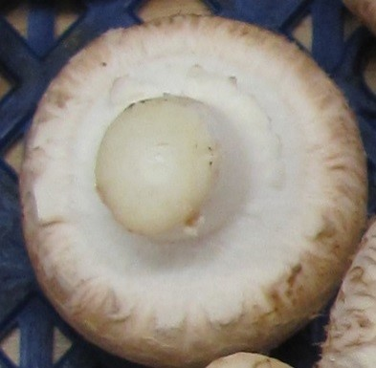
1 - white
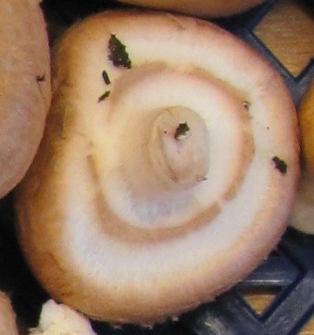
2 - brown
Ad. 26: Basidium: number of spores
The number of spores in the majority of the basidia is counted in ten basidia within a single microscopic slide. The basidia and their spores can best be visualized using a 400× magnification of a dry mounted lamellar surface.
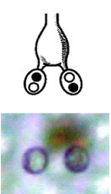
1 - zero
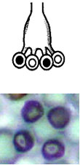
3 - four

Ad. 27: Time of cap opening
The time of cap opening is the first day on which the veil of a single fruiting body is completely torn.

Ad. 31: Open cap: fraying of margin
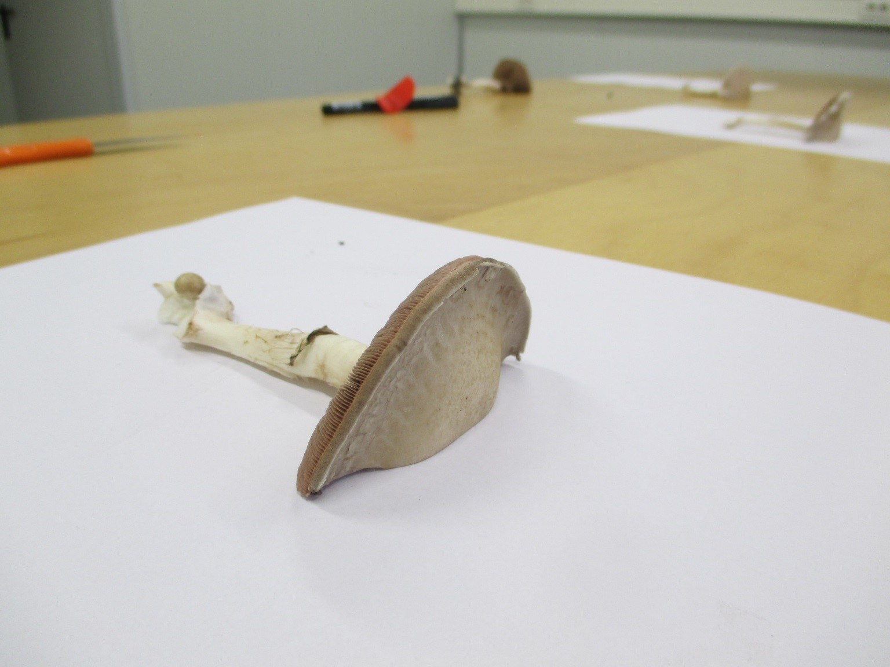
1 - absent or weak
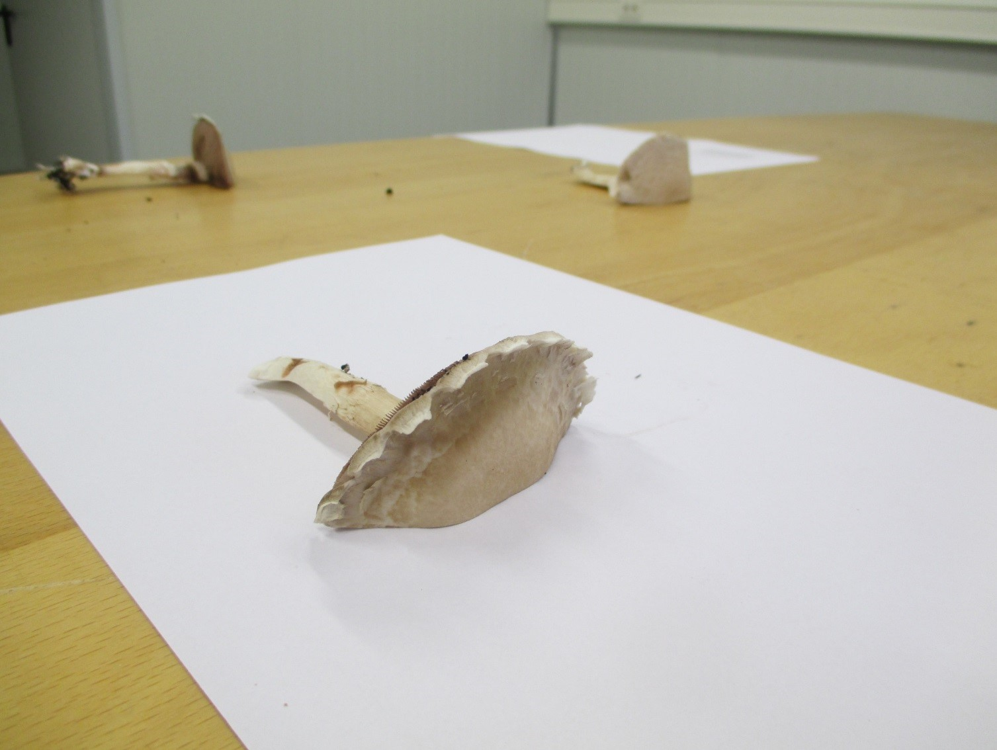
2 - moderate

Ad. 32: Open cap: shape of central part of upper side
1 - rounded
2 - plane
3 - depressed

Literature

Flegg, P.B., Spencer, D.M. and Wood, D.A., 1985: The biology and technology of the cultivated mushroom. J. Wiley & Son, 347 pp.

Fletcher, J.T. & Gaze R.H., 2007: Mushroom growing. In: Mushroom pest and disease control: a colour handbook, Manson Publishing Ltd, pp. 7-21.

Foulongne-Oriol., M, Rodier, A., Caumont, P., Spataro, C., Savoie, J.M., 2011: Agaricus bisporus cultivars: hidden diversity beyond apparent uniformity? In: Proceedings of the 7th international conference on mushroom biology and mushroom products, vol 2. pp 9–16.

Fritsche, G., 1964: Versuche zur Frage der Merkmalsübertragung beim Kulturchampignon Agaricus (Psalliota) bisporus (Lge.) Sing. Der Züchter 34-2: 76-93.

Fritsche, G., 1988: Spawn: properties and preparation, In: The Cultivation of Mushrooms, Darlington Mushroom Laboratories, pp. 91-99.

Neut, A. van der, 1991: The development of a set of characteristics for DUS tests of cultivated mushroom varieties. In: Genetics and breeding of Agaricus, Pudoc Wageningen, pp. 153-160.

Parra Sánchez L.A. 2008: Fungi Europaei. Agaricus L. – Allopsalliota vol 1. Candusso Edizioni, 824 pp.

Parra Sánchez L.A., 2013: Fungi Europaei. Agaricus L. – Allopsalliota vol 2, Candusso Edizioni, 1168 pp.

Vooren, J.G. van de, Polder, G. & Heijden, G.W.A.M. van der, 1991: Application of image analysis for variety testing of mushroom. Euphytica 57: 245-250.

Vooren, J.G. van de, Polder, G. & Heijden, G.W.A.M. van der, 1992: Identification of mushroom cultivars using image analysis. Transactions of the ASAE 35-1: 347-350.

Technical Questionnaire

TECHNICAL QUESTIONNAIRE |  | Page {x} of {y} | Reference Number:
 |  |  | Application date:
 |  |  | (not to be filled in by the applicant)
TECHNICAL QUESTIONNAIRE
to be completed in connection with an application for plant breeders’ rights

1. Subject of the Technical Questionnaire
1.1.1 | Botanical Name | Agaricus L.
1.1.2 | Common Name | Button Mushroom; Mushroom; Tsukuritake
1.1.3

2. Applicant
Name
Address
Telephone No.
Fax No.
E-mail address
Breeder (if different from applicant)
3. Proposed denomination and breeder’s reference
Proposed denomination
(if available)

Breeder’s reference

TECHNICAL QUESTIONNAIRE |  | Page {x} of {y} | Reference Number:
4. Information on the breeding scheme and propagation of the variety

4.1 Breeding scheme

Variety resulting from:

4.1.1 Crossing

(a) controlled cross [ ]
(please state parent varieties)

(…………………..……………..…) x (……………..…………………..…)
female parent male parent

(b) partially known cross [ ]
(please state known parent variety(ies))

(…………………..……………..…) x (……………..…………………..…)
female parent male parent

(c) unknown cross [ ]

4.1.2 Mutation [ ]
(please state parent variety)

4.1.3 Discovery and development [ ]
(please state where and when discovered and how developed)

4.1.4 Other [ ]
(please provide details)

4.2 Method of propagating the variety

4.2.1 Vegetative propagation

(a) in vitro propagation [ ]
(b) [ ]
(c) Other (state method) [ ]
..................................................................................................................................................
: :
: :
:................................................................................................................................................:

4.2.2 Other [ ]

(please provide details)
..................................................................................................................................................
: :
: :
:................................................................................................................................................:

TECHNICAL QUESTIONNAIRE |  | Page {x} of {y} | Reference Number:
In the case of hybrid varieties the production scheme for the hybrid should be provided on a separate sheet. This
should provide details of all the parent lines required for propagating the hybrid e.g.

Single Hybrid
(…………………..……………..…) x (……………..…………………..…)
female parent male parent

Three-Way Hybrid
(…………………..……………..…) x (……………..…………………..…)
female line male line

(……………..…………………..…) x (……………..…………………..…)
single hybrid used as female parent male parent

and should identify in particular:

(a) any male sterile lines
(b) maintenance system of male sterile lines.

5. Characteristics of the variety to be indicated (the number in brackets refers to the corresponding characteristic in Test Guidelines; please mark the note which best corresponds).

 | Characteristics | Example Varieties | Note
5.1 (13) | Cap: diameter
 | small | Horwitu | 3[ ]
 | medium | Broncoh | 5[ ]
 | large | Heirloom, Sylvan A15 | 7[ ]
5.2 (15) | Cap: shape in longitudinal section
 | obovate | H1X1 | 1[ ]
 | circular | Horbita | 2[ ]
 | oblate | Broncoh, Sylvan A15 | 3[ ]
5.3 (24) | Gills: color at time of breaking of veil
 | light pink |  | 1[ ]
 | orange | Horvensis | 2[ ]
 | light brown | Horronda, Horwitu | 3[ ]
 | dark brown | Broncoh | 4[ ]
5.4 (26) | Basidium: number of spores
 | zero | J10263 | 1[ ]
 | two | Heirloom, Horwitu | 2[ ]
 | four | Horbita, Horvensis | 3[ ]
5.5 (28) | Open cap: Stipe distance from base to annulus
 | short | Amycel 2400 | 3[ ]
 | medium | Broncoh | 5[ ]
 | long | Horvensis | 7[ ]

6. Similar varieties and differences from these varieties

Please use the following table and box for comments to provide information on how your candidate variety differs from the variety (or varieties) which, to the best of your knowledge, is (or are) most similar. This information may help the examination authority to conduct its examination of distinctness in a more efficient way.

Denomination(s) of variety(ies) similar to your candidate variety | Characteristic(s) in which your candidate variety differs from the similar variety(ies) | Describe the expression of the characteristic(s) for the similar variety(ies) | Describe the expression of the characteristic(s) for your candidate variety
Example
Comments:

7. Additional information which may help in the examination of the variety

7.1 In addition to the information provided in sections 5 and 6, are there any additional characteristics which may help to distinguish the variety?

Yes [ ] No [ ]

(If yes, please provide details)

7.2 Are there any special conditions for growing the variety or conducting the examination?

Yes [ ] No [ ]

(If yes, please provide details)

7.3 Other information

8. Authorization for release

(a) Does the variety require prior authorization for release under legislation concerning the protection of the environment, human and animal health?

Yes [ ] No [ ]

(b) Has such authorization been obtained?

Yes [ ] No [ ]

If the answer to (b) is yes, please attach a copy of the authorization.

TECHNICAL QUESTIONNAIRE | Page {x} of {y} | Reference Number:
9. Information on plant material to be examined or submitted for examination

9.1 The expression of a characteristic or several characteristics of a variety may be affected by factors, such as pests and disease, chemical treatment (e.g. growth retardants or pesticides), effects of tissue culture, different rootstocks, scions taken from different growth phases of a tree, etc.

9.2 The plant material should not have undergone any treatment which would affect the expression of the characteristics of the variety, unless the competent authorities allow or request such treatment. If the plant material has undergone such treatment, full details of the treatment must be given. In this respect, please indicate below, to the best of your knowledge, if the plant material to be examined has been subjected to:

(a) Microorganisms (e.g. virus, bacteria, phytoplasma) Yes [ ] No [ ]

(b) Chemical treatment (e.g. growth retardant, pesticide) Yes [ ] No [ ]

(c) Tissue culture Yes [ ] No [ ]

(d) Other factors Yes [ ] No [ ]

Please provide details for where you have indicated “yes”.

10. I hereby declare that, to the best of my knowledge, the information provided in this form is correct:

Applicant’s name

Signature Date

[End of document]

* These names were correct at the time of the introduction of these Test Guidelines but may be revised or updated. [Readers are advised to consult the UPOV Code, which can be found on the UPOV Website (www.upov.int), for the latest information.]

