E
TG/173/4(proj.3)
ORIGINAL: English
DATE: 2015-05-04
INTERNATIONAL UNION FOR THE PROTECTION OF NEW VARIETIES OF PLANTS
Geneva
DRAFT

 | Witloof Chicory  UPOV Code: CICHO_INT  Cichorium intybus L. | *

GUIDELINES
FOR THE CONDUCT OF TESTS
FOR DISTINCTNESS, UNIFORMITY AND STABILITY

prepared by (an) expert(s) from France

to be considered by the
Technical Working Party for Vegetables
at its forty-ninth session
to be held in Angers, France
from 2015-06-15
to 2015-06-19

Alternative Names:*
Botanical name | English | French | German | Spanish
Cichorium intybus L. | Chicory | Chicorée, Endive | Salatzichorie, Wurzelzichorie | Achicoria

The purpose of these guidelines (“Test Guidelines”) is to elaborate the principles contained in the General Introduction (document TG/1/3), and its associated TGP documents, into detailed practical guidance for the harmonized examination of distinctness, uniformity and stability (DUS) and, in particular, to identify appropriate characteristics for the examination of DUS and production of harmonized variety descriptions.

ASSOCIATED DOCUMENTS
These Test Guidelines should be read in conjunction with the General Introduction and its associated TGP documents.

Other associated UPOV documents: industrial chicory (TG/172/4) and leaf chicory (TG/154/3)
TABLE OF CONTENTS PAGE

1. Subject of these Test Guidelines 3
2. Material Required 3
3. Method of Examination 3
3.1 Number of Growing Cycles 3
3.2 Testing Place 3
3.3 Conditions for Conducting the Examination 3
3.4 Test Design 3
3.5 Additional Tests 4
4. Assessment of Distinctness, Uniformity and Stability 4
4.1 Distinctness 4
4.2 Uniformity 5
4.3 Stability 5
5. Grouping of Varieties and Organization of the Growing Trial 5
6. Introduction to the Table of Characteristics 6
6.1 Categories of Characteristics 6
6.2 States of Expression and Corresponding Notes 6
6.3 Types of Expression 6
6.4 Example Varieties 7
6.5 Legend 7
7. Table of Characteristics/Tableau des caractères/Merkmalstabelle/Tabla de caracteres 8
8. Explanations on the Table of Characteristics 17
9. Literature 24
10. Technical Questionnaire 25

Subject of these Test Guidelines

These Test Guidelines apply to all varieties of Cichorium intybus L..

excluding industrial chicory (TG/172/4) and leaf chicory (TG/154/3)

Material Required

2.1 The competent authorities decide on the quantity and quality of the plant material required for testing the variety and when and where it is to be delivered. Applicants submitting material from a State other than that in which the testing takes place must ensure that all customs formalities and phytosanitary requirements are complied with.

  - The material is to be supplied in the form of seed.

2.3 The minimum quantity of plant material, to be supplied by the applicant, should be:

50 grams or 30 000 seeds

The seed should meet the minimum requirements for germination, species and analytical purity, health and moisture content, specified by the competent authority. In cases where the seed is to be stored, the germination capacity should be as high as possible and should be stated by the applicant.

2.4 The plant material supplied should be visibly healthy, not lacking in vigor, nor affected by any important pest or disease.

2.5 The plant material should not have undergone any treatment which would affect the expression of the characteristics of the variety, unless the competent authorities allow or request such treatment. If it has been treated, full details of the treatment must be given.

Method of Examination

3.1 Number of Growing Cycles

3.1.1 The minimum duration of tests should normally be two independent growing cycles.

3.1.2 The two independent growing cycles should be in the form of two separate plantings.

All varieties should be included in one trial, regardless the season of forcing that a variety is bred for.

3.2 Testing Place

Tests are normally conducted at one place. In the case of tests conducted at more than one place, guidance is provided in TGP/9 “Examining Distinctness”.

3.3 Conditions for Conducting the Examination

3.3.1 The tests should be carried out under conditions ensuring satisfactory growth for the expression of the relevant characteristics of the variety and for the conduct of the examination.

3.4 Test Design

3.4.1 Each test should be designed to result in a total of at least 100 plants, which should be divided between at least 2 replicates.

3.4.2 The design of the tests should be such that plants or parts of plants may be removed for measurement or counting without prejudice to the observations which must be made up to the end of the growing cycle.

3.5 Additional Tests

Additional tests, for examining relevant characteristics, may be established.

Assessment of Distinctness, Uniformity and Stability

4.1 Distinctness

4.1.1 General Recommendations

It is of particular importance for users of these Test Guidelines to consult the General Introduction prior to making decisions regarding distinctness. However, the following points are provided for elaboration or emphasis in these Test Guidelines.

4.1.2 Consistent Differences

The differences observed between varieties may be so clear that more than one growing cycle is not necessary. In addition, in some circumstances, the influence of the environment is not such that more than a single growing cycle is required to provide assurance that the differences observed between varieties are sufficiently consistent. One means of ensuring that a difference in a characteristic, observed in a growing trial, is sufficiently consistent is to examine the characteristic in at least two independent growing cycles.

4.1.3 Clear Differences

Determining whether a difference between two varieties is clear depends on many factors, and should consider, in particular, the type of expression of the characteristic being examined, i.e. whether it is expressed in a qualitative, quantitative, or pseudo-qualitative manner. Therefore, it is important that users of these Test Guidelines are familiar with the recommendations contained in the General Introduction prior to making decisions regarding distinctness.

4.1.4 Number of Plants / Parts of Plants to be Examined

Unless otherwise indicated, for the purposes of distinctness, all observations on single plants should be made on 60 plants or parts taken from each of 60 plants and any other observations made on all plants in the test, disregarding any off-type plants.

4.1.5 Method of Observation

The recommended method of observing the characteristic for the purposes of distinctness is indicated by the following key in the second column of the Table of Characteristics (see document TGP/9 “Examining Distinctness”, Section 4 “Observation of characteristics”):

MG: single measurement of a group of plants or parts of plants
MS: measurement of a number of individual plants or parts of plants
VG: visual assessment by a single observation of a group of plants or parts of plants
VS: visual assessment by observation of individual plants or parts of plants

Type of observation: visual (V) or measurement (M)

“Visual” observation (V) is an observation made on the basis of the expert’s judgment. For the purposes of this document, “visual” observation refers to the sensory observations of the experts and, therefore, also includes smell, taste and touch. Visual observation includes observations where the expert uses reference points (e.g. diagrams, example varieties, side-by-side comparison) or non-linear charts (e.g. color charts). Measurement (M) is an objective observation against a calibrated, linear scale e.g. using a ruler, weighing scales, colorimeter, dates, counts, etc.

Type of record: for a group of plants (G) or for single, individual plants (S)

For the purposes of distinctness, observations may be recorded as a single record for a group of plants or parts of plants (G), or may be recorded as records for a number of single, individual plants or parts of plants (S). In most cases, “G” provides a single record per variety and it is not possible or necessary to apply statistical methods in a plant-by-plant analysis for the assessment of distinctness.

In cases where more than one method of observing the characteristic is indicated in the Table of Characteristics (e.g. VG/MG), guidance on selecting an appropriate method is provided in document TGP/9, Section 4.2.

4.2 Uniformity

    - It is of particular importance for users of these Test Guidelines to consult the General Introduction prior to making decisions regarding uniformity. However, the following points are provided for elaboration or emphasis in these Test Guidelines:

4.2.2 The assessment of uniformity for hybrid varieties depends on the type of hybrid and should be according to the recommendations for hybrid varieties in the General Introduction.

4.2.3 For the assessment of uniformity of seed-propagated varieties, a population standard of 1% and an acceptance probability of at least 95 % should be applied. In the case of a sample size of 100 plants, 3 off-types are allowed.

The population standard of 1% with an acceptance probability of at least 95% should be applied to off-type excluding clearly recognizable inbred plants.

In addition a population standard of 3% with an acceptance probability of at least 95% should be applied to clearly inbred plants in hybrid where male sterility has been used. In the case of a sample size of 100 plants, 6 inbred plants are allowed.

A population standard of 5% with an acceptance probability of at least 95% should be applied to clearly inbred plants in hybrid where male sterility has not been used. In the case of a sample size of 100 plants, 9 inbred plants are allowed.

4.3 Stability

4.3.1 In practice, it is not usual to perform tests of stability that produce results as certain as those of the testing of distinctness and uniformity. However, experience has demonstrated that, for many types of variety, when a variety has been shown to be uniform, it can also be considered to be stable.

4.3.2 Where appropriate, or in cases of doubt, stability may be further examined by testing a new seed stock to ensure that it exhibits the same characteristics as those shown by the initial material supplied.

Grouping of Varieties and Organization of the Growing Trial

5.1 The selection of varieties of common knowledge to be grown in the trial with the candidate varieties and the way in which these varieties are divided into groups to facilitate the assessment of distinctness are aided by the use of grouping characteristics.

5.2 Grouping characteristics are those in which the documented states of expression, even where produced at different locations, can be used, either individually or in combination with other such characteristics: (a) to select varieties of common knowledge that can be excluded from the growing trial used for examination of distinctness; and (b) to organize the growing trial so that similar varieties are grouped together.

5.3 The following have been agreed as useful grouping characteristics:

(a) Leaf: length (characteristic 5)
(b) Leaf: color (characteristic 8)
(c) Leaf: intensity of color (characteristic 9)
(d) Time of beginning of flowering (characteristic 20)
(e) Male sterility (characteristic 26)

5.4 Guidance for the use of grouping characteristics, in the process of examining distinctness, is provided through the General Introduction and document TGP/9 “Examining Distinctness”.

Introduction to the Table of Characteristics

6.1 Categories of Characteristics

6.1.1 Standard Test Guidelines Characteristics

Standard Test Guidelines characteristics are those which are approved by UPOV for examination of DUS and from which members of the Union can select those suitable for their particular circumstances.

6.1.2 Asterisked Characteristics

Asterisked characteristics (denoted by *) are those included in the Test Guidelines which are important for the international harmonization of variety descriptions and should always be examined for DUS and included in the variety description by all members of the Union, except when the state of expression of a preceding characteristic or regional environmental conditions render this inappropriate.

6.2 States of Expression and Corresponding Notes

6.2.1 States of expression are given for each characteristic to define the characteristic and to harmonize descriptions. Each state of expression is allocated a corresponding numerical note for ease of recording of data and for the production and exchange of the description.

6.2.2 In the case of qualitative and pseudo-qualitative characteristics (see Chapter 6.3), all relevant states of expression are presented in the characteristic. However, in the case of quantitative characteristics with 5 or more states, an abbreviated scale may be used to minimize the size of the Table of Characteristics. For example, in the case of a quantitative characteristic with 9 states, the presentation of states of expression in the Test Guidelines may be abbreviated as follows:

State | Note
small | 3
medium | 5
large | 7

However, it should be noted that all of the following 9 states of expression exist to describe varieties and should be used as appropriate:

State | Note
very small | 1
very small to small | 2
small | 3
small to medium | 4
medium | 5
medium to large | 6
large | 7
large to very large | 8
very large | 9

6.2.3 Further explanation of the presentation of states of expression and notes is provided in document TGP/7 “Development of Test Guidelines”.

6.3 Types of Expression

An explanation of the types of expression of characteristics (qualitative, quantitative and pseudo-qualitative) is provided in the General Introduction.

6.4 Example Varieties

Where appropriate, example varieties are provided to clarify the states of expression of each characteristic.

6.5 Legend

(*) Asterisked characteristic – see Chapter 6.1.2

QL Qualitative characteristic – see Chapter 6.3
QN Quantitative characteristic – see Chapter 6.3
PQ Pseudo-qualitative characteristic – see Chapter 6.3

MG, MS, VG, VS – see Chapter 4.1.5

(a)-(e) See Explanations on the Table of Characteristics in Chapter 8.

(+) See Explanations on the Table of Characteristics in Chapter 8.

Table of Characteristics/Tableau des caractères/Merkmalstabelle/Tabla de caracteres

English | français | deutsch | español | Example Varieties Exemples Beispielssorten Variedades ejemplo | Note/ Nota
1. QN VG (+)
Cotyledon: shape | Cotylédon : forme | Keimblatt: Form | Cotiledón: forma
narrow elliptic | elliptique étroit | schmal elliptisch | elíptica estrecha | Takine, Zoom | 1
medium elliptic | elliptique moyen | mittel elliptisch | elíptica media |  | 2
broad elliptic | elliptique large | breit elliptisch | elíptica ancha | Bea, Flash, Magnum | 3
2. PQ VG (+)
Cotyledon: shape of apex
truncate |  |  |  | Janus, Magnum | 1
rounded |  |  |  | Mechelse middelvroeg | 2
obcordate |  |  |  | Atlas | 3
3. (*) QN VG (+)
Plant: height | Plante: hauteur | Pflanze: Höhe | Planta: altura
short | basse | niedrig | baja | Janus | 3
medium | moyenne | mittel | media | Ecrine, Selkis | 5
tall | haute | hoch | alta | Topmodel, Zilia | 7
4. (*) QN VG (+) (a)
Foliage: attitude | Feuillage: port | Laub: Haltung | Follaje: porte
erect | dressé | aufrecht | erecto |  | 1
semi-erect | demi-dressé | halbaufrecht | semierecto | Ecrine, Ombline | 3
horizontal | horizontal | waagerecht | horizontal | Perfo | 5
5. (*) QN VG (+) (a)
Leaf: length
short |  |  |  | Janus | 3
medium |  |  |  | Ecrine, Ombline | 5
long |  |  |  | Atlas, Platine | 7
very long |  |  |  | Zilia | 9

English | français | deutsch | español | Example Varieties Exemples Beispielssorten Variedades ejemplo | Note/ Nota
6. (*) QN VG (a) (b)
Leaf: width | Feuille : largeur | Blatt: Breite | Hoja: anchura
narrow | étroite | schmal | estrecha | Monroe, Redoria | 3
medium | moyenne | mittel | media | Baccara, Bea, Extral, Flash, Zoom | 5
broad | large | breit | ancha | Atlas, Symphonie | 7
7. QN VG (a) (b)
Leaf: ratio width/length
low | faible | klein | baja | Zilia | 3
medium | moyen | mittel | media | Baccara, Bea, Ecrine | 5
high | élevé | groß | alta | Selkis | 7
8. (*) PQ VG (a)
Leaf: color
green |  |  |  | Zoom | 1
green and red |  |  |  | Festive | 2
red |  |  |  |  | 3
9. (*) QN VG (a)
Leaf: intensity of color
light |  |  |  |  | 3
medium |  |  |  | Excellence, Janus | 5
dark |  |  |  | Focus | 7
10. (*) QN VG (a)
Leaf: glossiness
absent or very weak |  |  |  |  | 1
weak |  |  |  | Abellis, Flash | 3
medium |  |  |  | Baccara, Fakir | 5
strong |  |  |  | Rikita | 7

English | français | deutsch | español | Example Varieties Exemples Beispielssorten Variedades ejemplo | Note/ Nota
11. (*) PQ VG (a)
Leaf: shape in cross-section | Feuille : forme en section transversale | Blatt: Form im Querschnitt | Hoja: forma en sección transversal
concave |  |  |  | Abellis, Crenoline | 1
flat |  |  |  | Excellence, Perfo, Zilia, Zoom | 2
convex |  |  |  |  | 3
12. (*) QN VG (a)
Leaf: blistering | Feuille : cloqûre | Blatt: Blasigkeit | Hoja: abullonado
absent or very weak |  |  |  |  | 1
weak |  |  |  | Abellis, Flash, Platine | 3
medium |  |  |  | Alliance, Ecrine | 5
strong |  |  |  | Rikita, Zoom | 7
13. QN VG (a)
Leaf: anthocyanin coloration of midrib | Feuille: pigmentation anthocyanique de la nervure médiane | Blatt: Anthocyanfärbung der Mittelrippe | Hoja: pigmentación antociánica del nervio central
absent or very weak | absente ou très faible | fehlend oder sehr gering | ausente o muy débil | Baccara, Excellence | 1
weak | faible | gering | débil | Abellis, Flash, Jocker | 3
medium | moyenne | mittel | media | Zoom | 5
strong | forte | stark | fuerte |  | 7
14. QN VG (a)
Leaf: undulation of margin | Feuille: ondulation du bord | Blatt: Wellung des Randes | Hoja: ondulación del borde
weak | faible | gering | débil |  | 3
medium | moyenne | mittel | media | Atlas, Baccara, Platine | 5
strong | forte | stark | fuerte | Montblanc | 7

English | français | deutsch | español | Example Varieties Exemples Beispielssorten Variedades ejemplo | Note/ Nota
15. QN VG (a)
Leaf: incision of basal part
absent or very weak |  |  |  |  | 1
weak |  |  |  | Crenoline, Selkis | 3
medium |  |  |  | Alliance, Bea, Topscore | 5
strong |  |  |  | Atlas, Zilia | 7
16. QN VG (a)
Leaf: depth of incisions of basal part
shallow |  |  |  | Abellis, Desir, Flash, Zoom | 3
medium |  |  |  | Baccara, Ombline, Symphonie | 5
deep |  |  |  | Rikita | 7
17. (*) QN VG (a)
Leaf: incisions of margin or upper third
absent or very weak |  |  |  | Selkis | 1
weak |  |  |  | Abellis, Flash, Janus, Topscore | 3
medium |  |  |  | Baccara, Jocker, Symphonie, Zoom | 5
strong |  |  |  | Platine | 7
18. QN VG (+) (a)
Leaf: shape of apex
rounded |  |  |  | Abellis, Magnum, Topscore | 1
weakly pointed |  |  |  | Atlas, Fakir, Takine | 2
strongly pointed |  |  |  | Platine | 3

English | français | deutsch | español | Example Varieties Exemples Beispielssorten Variedades ejemplo | Note/ Nota
19. QN VG (+) (c)
Bolting tendency
absent or very weak |  |  |  |  | 1
weak |  |  |  | Bea, Montblanc | 3
medium |  |  |  | Flash, Ombline | 5
strong |  |  |  | Topmodel | 7
very strong |  |  |  |  | 9
20. (*) QN MS (+) (c)
Time of beginning of flowering | Époque du début de la floraison | Zeitpunkt des Blühbeginns | Época de inicio de la floración
very early |  |  |  |  | 1
early |  |  |  | Jadore, Prestance, Takine | 3
medium |  |  |  | Abellis, Ecrine, Hermès | 5
late |  |  |  |  | 7
very late |  |  |  |  | 9
21. QN MS (+) (c)
Flowering stem: height | Tige florifère: hauteur | Blütenstandstiel: Höhe | Tallo floral: altura
short |  |  |  |  | 3
medium |  |  |  | Desir, Perfo | 5
tall |  |  |  | Atlas, Festive, Selkis | 7
22. QN MS (c)
Flowering stem: branching | Tige florifère: ramification | Blütenstandstiel: Verzweigung | Tallo floral: ramificación
weak |  |  |  |  | 3
medium |  |  |  | Atlas, Ecrine, Perfo | 5
strong |  |  |  | Abellis | 7

English | français | deutsch | español | Example Varieties Exemples Beispielssorten Variedades ejemplo | Note/ Nota
23. QN MS (+) (c)
Flowering stem: size of stipule
small |  |  |  | Crenoline, Excellence, Magnum | 3
medium |  |  |  | Bea, Desir, Festive, Topmodel | 5
large |  |  |  |  | 7
24. QN VS (+) (c)
Flowering stem: dentation of stipule
small |  |  |  | Alliance, Elegance, Flash, Jadore | 3
medium |  |  |  | Abellis, Platine | 5
large |  |  |  |  | 7
25. (*) PQ VS (c)
Flower: color | Fleur : couleur | Blüte: Farbe | Flor: color
white |  |  |  |  | 1
pink |  |  |  | Selkis | 2
blue |  |  |  | Bea, Flash | 3
26. (*) QL VS (+)
Male sterility | Stérilité mâle | Männliche Sterilität | Androesterilidad
absent |  |  |  | Flash | 1
present |  |  |  | Ombline | 9
27. PQ VG (+)
Seed: color
white |  |  |  | Atlas, Opale | 1
brown |  |  |  | Abellis | 2
black |  |  |  | Festive | 3

English | français | deutsch | español | Example Varieties Exemples Beispielssorten Variedades ejemplo | Note/ Nota
28. (*) QN MS VG (d) (e)
Head: length
very short |  |  |  |  | 1
short |  |  |  |  | 3
medium |  |  |  | Bea, Ombline | 5
long |  |  |  | Focus, Perfo, Prestance | 7
very long |  |  |  | Normale | 9
29. (*) QN MS VG (d) (e)
Head: diameter
small |  |  |  |  | 3
medium |  |  |  | Bea, Ecrine | 5
large |  |  |  | Zilia | 7
30. QN MS VG (d) (e)
Head: ratio diameter/length
low |  |  |  | Opale | 3
medium |  |  |  | Bea, Desir, Panache | 5
high |  |  |  | Atlas, Focus | 7
31. (*) PQ VG (+) (d) (e)
Head: shape in longitudinal section | Pomme: forme en section longitudinale | Kopf: Form in Längsschnitt | Cabeza: forma en sección longitudinal
ovate |  |  |  | Abellis, Selkis | 1
broad elliptic |  |  |  | Crenoline, Topmodel | 2
medium elliptic |  |  |  | Excellence, Jocker | 3
narrow elliptic |  |  |  | Symphonie | 4

English | français | deutsch | español | Example Varieties Exemples Beispielssorten Variedades ejemplo | Note/ Nota
32. (*) QN VG (d) (e)
Head: shape of apex
rounded |  |  |  | Abellis, Crenoline | 1
weakly pointed |  |  |  | Baccara, Elegance | 2
strongly pointed |  |  |  | Fakir, Symphonie, Zoom | 3
33. (*) PQ VG (d) (e)
Head: principale color of leaf blade
yellow |  |  |  | Flexine | 1
yellow and red |  |  |  |  | 2
red |  |  |  | Festive | 3
34. (*) QN VG (d) (e)
Head: intensity of principale color of leaf blade
light |  |  |  | Elegance, Perfo | 3
medium |  |  |  | Baccara, Ombline | 5
dark |  |  |  | Abellis, Ecrine | 7
35. QN VG (d) (e)
Head: blistering of leaf blade
absent or very weak |  |  |  | Hermès, Topmodel | 1
weak |  |  |  |  | 3
medium |  |  |  | Baccara, Festive, Zoom | 5
strong |  |  |  |  | 7

English | français | deutsch | español | Example Varieties Exemples Beispielssorten Variedades ejemplo | Note/ Nota
36. QN VG (d) (e)
Head: openness of apex
fully open |  |  |  | Sirion | 1
half open |  |  |  | Abellis, Zilia | 2
closed |  |  |  | Baccara, Hermès | 3
37. QN VG (+) (d) (e)
Head: length of the axis
very short |  |  |  | Selkis | 1
short |  |  |  | Extral | 3
medium |  |  |  | Ecrine, Takine | 5
long |  |  |  | Atlas, Zilia | 7
very long |  |  |  |  | 9

Explanations on the Table of Characteristics

8.1 Explanations covering several characteristics

Characteristics containing the following key in the second column of the Table of Characteristics should be examined as indicated below:
(a) Leaf: observations should be done in the vegetative stage in the field on the full-grown leaf.
(b) Observations should be done around 1 month before the harvest maturity
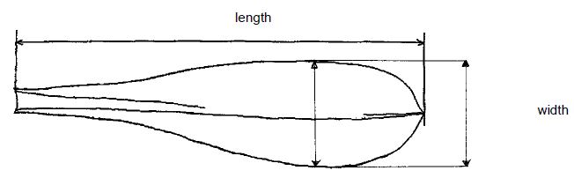
(c) Bolting and flowering characteristics : observations should be done in a special bolting trial in which a flowering stem is formed.
(d) Head: observations shoulb be done after a forcing period in a complete dark environment and before exposure to daylight.
(e) At the end of the trial in normal seedlings, roots are pulled out and forcing for description of the head's characteristics. The roots are stored at 0°C before plantation in container Mid-January (normal forcing period) in 2 repetition of 50 roots. In order to not hide the phenotype of the varieties, the application of calcium chloride should be avoid. The container are placed in an obscure forcing room in controlled conditions (temperature, hygrometry, fertilisation ). The air temperature is about 17°C and the water temperature of 18-19°C. The conduct of the water and air temperatures must allow the formation of the witloof chicory in 21 days.

8.2 Explanations for individual characteristics

Ad. 1: Cotyledon: shape
1 - narrow elliptic
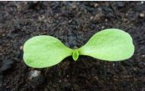
2 - medium elliptic
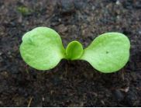
3 - broad elliptic
Ad. 2: Cotyledon: shape of apex
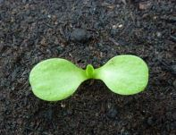
1 - truncate
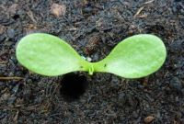
2 - rounded
3 - obcordate
Ad. 3: Plant: height
Observations should be done at the end of the cycle, around 1 month before the havest maturity.

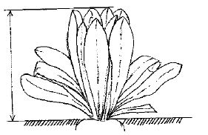

Ad. 4: Foliage: attitude
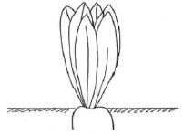
1 - erect
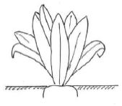
3 - semi-erect
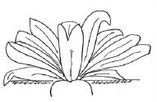
5 - horizontal

Ad. 5: Leaf: length
Observations should be done at the end of the cycle, around 1 month before the havest maturity

Ad. 18: Leaf: shape of apex
Observations should be done at the end of the cycle, around 1 month before the havest maturity
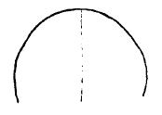
1 - rounded
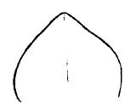
2 - weakly pointed
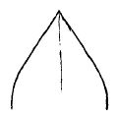
3 - strongly pointed

Ad. 19: Bolting tendency
This characterisitic should be observed in early sowing conditions (in order to expose the plant to cold temperature) with reference to the example varieties.
The variey with an absence of bolting tendancy or a very weak botling tendancy (note1) shows a hight tolerance to bolting (Resistance).
In the opposite, a variety with a very strong bolting tendancy (note 9) shows a very weak tolerance to bolting (Susceptible)

Ad. 20: Time of beginning of flowering
Observations are made on 2 replicate of 10 plants when the first flower opens. The time of beginning of flowering of a variety is the average of the dates recorded on the 20 plants

Ad. 21: Flowering stem: height
The height of the stem is measured on plant when the first flower opens on 2 replicates of 10 plants

Ad. 23: Flowering stem: size of stipule
Observations should be done on the stipules of the upper third

Ad. 24: Flowering stem: dentation of stipule
Observations should be done on the stipules of the upper third

Ad. 26: Male sterility
Observation should be done on the first flower opened.
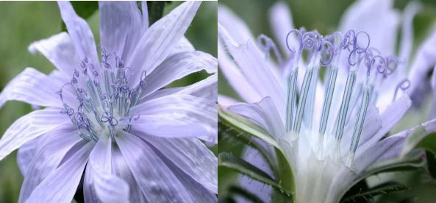
1 - absent
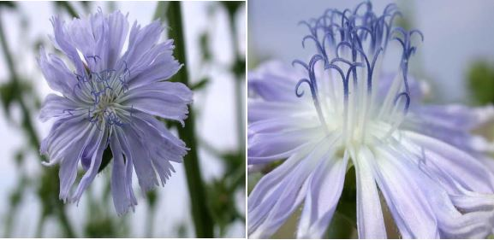
9 - present
Ad. 27: Seed: color
Observations should be made on the first flower opened

Ad. 31: Head: shape in longitudinal section
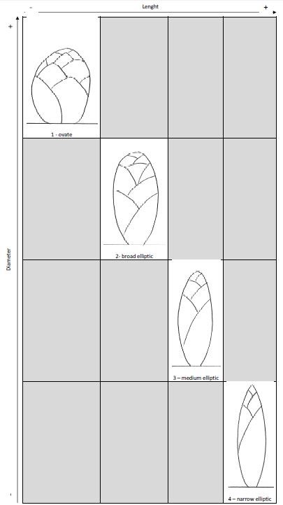

Ad. 37: Head: length of the axis
After a normal forcing period ( neither early nor late) as described in (e), the length of the axis should be evaluate depending the length of the head (characteristic 28)
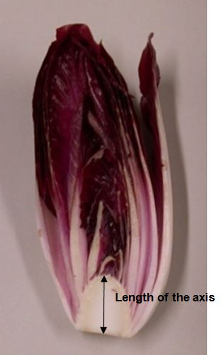
3 - short
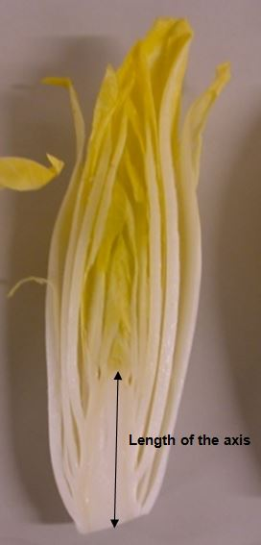
5 - medium
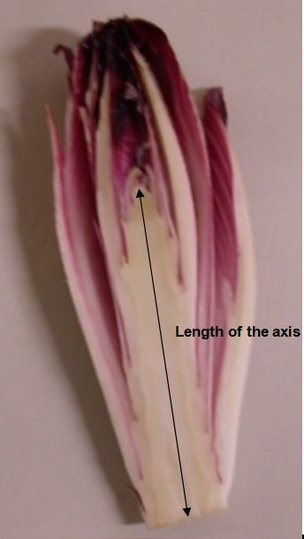
7 - long

Literature

Annon, C. R., 1970: “La chicorée de Bruxelles,” Symposium International à Gembloux (B), 17 et 18 février (Eucarpia), Ed. Min. de l’Agriculture, Recherche Agronomique, Bruxelles

Leteinturier, J. E. A., 1983 :“L'endive (chicorée witloof),” 3e ed., CTIEF, Paris, France

Ryder, E. J., 1979: Leafy Salad Vegetables, AVI Publishing Company, Westport, Connecticut

Technical Questionnaire

TECHNICAL QUESTIONNAIRE |  | Page {x} of {y} | Reference Number:
 |  |  | Application date:
 |  |  | (not to be filled in by the applicant)
TECHNICAL QUESTIONNAIRE
to be completed in connection with an application for plant breeders’ rights

1. Subject of the Technical Questionnaire
1.1.1 | Botanical Name | Cichorium intybus L.
1.1.2 | Common Name | Chicory
1.1.3

2. Applicant
Name
Address
Telephone No.
Fax No.
E-mail address
Breeder (if different from applicant)
3. Proposed denomination and breeder’s reference
Proposed denomination
(if available)

Breeder’s reference

TECHNICAL QUESTIONNAIRE |  | Page {x} of {y} | Reference Number:
4. Information on the breeding scheme and propagation of the variety

4.1 Breeding scheme

Variety resulting from:

4.1.1 Crossing

(a) controlled cross [ ]
(please state parent varieties)

(…………………..……………..…) x (……………..…………………..…)
female parent male parent

(b) partially known cross [ ]
(please state known parent variety(ies))

(…………………..……………..…) x (……………..…………………..…)
female parent male parent

(c) unknown cross [ ]

4.1.2 Mutation [ ]
(please state parent variety)

4.1.3 Discovery and development [ ]
(please state where and when discovered and how developed)

4.1.4 Other [ ]
(please provide details)

4.2 Method of propagating the variety

4.2.1 Seed-propagated varieties

(a) Self-pollination [ ]
(b) Cross-pollination [ ]
(i) population [ ]
(ii) synthetic variety [ ]
(c) Hybrid [ ]
(d) Other [ ]
(please provide details)
..................................................................................................................................................
: :
: :
:................................................................................................................................................:

4.2.2 Other [ ]

(please provide details)
..................................................................................................................................................
: :
: :
:................................................................................................................................................:

5. Characteristics of the variety to be indicated (the number in brackets refers to the corresponding characteristic in Test Guidelines; please mark the note which best corresponds).

 | Characteristics | Example Varieties | Note
5.1 (6) | Leaf: width
 | narrow | Monroe, Redoria | 3[ ]
 | medium | Baccara, Bea, Extral, Flash, Zoom | 5[ ]
 | broad | Atlas, Symphonie | 7[ ]
5.2 (8) | Leaf: color
 | green | Zoom | 1[ ]
 | green and red | Festive | 2[ ]
 | red |  | 3[ ]
5.3 (9) | Leaf: intensity of color
 | light |  | 3[ ]
 | medium | Excellence, Janus | 5[ ]
 | dark | Focus | 7[ ]
5.4 (26) | Male sterility
 | absent | Flash | 1[ ]
 | present | Ombline | 9[ ]
5.5 (28) | Head: length
 | very short |  | 1[ ]
 | short |  | 3[ ]
 | medium | Bea, Ombline | 5[ ]
 | long | Focus, Perfo, Prestance | 7[ ]
 | very long | Normale | 9[ ]
5.6 (31) | Head: shape in longitudinal section
 | ovate | Abellis, Selkis | 1[ ]
 | broad elliptic | Crenoline, Topmodel | 2[ ]
 | medium elliptic | Excellence, Jocker | 3[ ]
 | narrow elliptic | Symphonie | 4[ ]

6. Similar varieties and differences from these varieties

Please use the following table and box for comments to provide information on how your candidate variety differs from the variety (or varieties) which, to the best of your knowledge, is (or are) most similar. This information may help the examination authority to conduct its examination of distinctness in a more efficient way.

Denomination(s) of variety(ies) similar to your candidate variety | Characteristic(s) in which your candidate variety differs from the similar variety(ies) | Describe the expression of the characteristic(s) for the similar variety(ies) | Describe the expression of the characteristic(s) for your candidate variety
Example
Comments:

7. Additional information which may help in the examination of the variety

7.1 In addition to the information provided in sections 5 and 6, are there any additional characteristics which may help to distinguish the variety?

Yes [ ] No [ ]

(If yes, please provide details)

7.2 Are there any special conditions for growing the variety or conducting the examination?

Yes [ ] No [ ]

(If yes, please provide details)

7.3 Other information

A representative color photograph of the variety displaying its main distinguishing feature(s), should accompany the Technical Questionnaire. The photograph will provide a visual illustration of the candidate variety which supplements the information provided in the Technical Questionnaire. The key points to consider when taking a photograph of the candidate variety are: • Indication of the date and geographic location • Correct labeling (breeder’s reference) • Good quality printed photograph (minimum 10 cm x 15 cm) and/or sufficient resolution electronic format version (minimum 960 x 1280 pixels) Further guidance on providing photographs with the Technical Questionnaire is available at: http://www.upov.int/edocs/tgpdocs/en/tgp_7.pdf [to be provided] [The link provided may be deleted by members of the Union when developing authorities’ own test guidelines.]

8. Authorization for release

(a) Does the variety require prior authorization for release under legislation concerning the protection of the environment, human and animal health?

Yes [ ] No [ ]

(b) Has such authorization been obtained?

Yes [ ] No [ ]

If the answer to (b) is yes, please attach a copy of the authorization.

TECHNICAL QUESTIONNAIRE | Page {x} of {y} | Reference Number:
9. Information on plant material to be examined or submitted for examination

9.1 The expression of a characteristic or several characteristics of a variety may be affected by factors, such as pests and disease, chemical treatment (e.g. growth retardants or pesticides), effects of tissue culture, different rootstocks, scions taken from different growth phases of a tree, etc.

9.2 The plant material should not have undergone any treatment which would affect the expression of the characteristics of the variety, unless the competent authorities allow or request such treatment. If the plant material has undergone such treatment, full details of the treatment must be given. In this respect, please indicate below, to the best of your knowledge, if the plant material to be examined has been subjected to:

(a) Microorganisms (e.g. virus, bacteria, phytoplasma) Yes [ ] No [ ]

(b) Chemical treatment (e.g. growth retardant, pesticide) Yes [ ] No [ ]

(c) Tissue culture Yes [ ] No [ ]

(d) Other factors Yes [ ] No [ ]

Please provide details for where you have indicated “yes”.

10. I hereby declare that, to the best of my knowledge, the information provided in this form is correct:

Applicant’s name

Signature Date

[End of document]

* These names were correct at the time of the introduction of these Test Guidelines but may be revised or updated. [Readers are advised to consult the UPOV Code, which can be found on the UPOV Website (www.upov.int), for the latest information.]

