E
TWV/48/35
ORIGINAL: English
DATE: May 14, 2014
INTERNATIONAL UNION FOR THE PROTECTION OF NEW VARIETIES OF PLANTS
Geneva
Technical working party for vegetables
Forty-Eighth Session
Paestum, Italy, June 23 to 27, 2014

COMMENTS CONCERNING THE DRAFT TEST GUIDELINES FOR LETTUCE (DOCUMENT TG/13/11(PROJ.1))
Document prepared by experts from the Netherlands
Disclaimer: this document does not represent UPOV policies or guidance

The structure of the document is as follows:

I COMMENTS BY THE SUBGROUP

II PRESS RELEASE OF THE INTERNATIONAL BREMIA EVALUATION BOARD (IBEB)

III PRESENTATION: MEETING IBEB: FUSARIUM OXYSPORUM F: SP: LACTUCAE RACE 1: RINGTEST GEVES

I COMMENTS BY THE SUBGROUP

Comments on TG 13/11 (first draft) from Japan, Germany, Spain and ISF, received April 2014

RE Table 1 (chapter 5.3, page 8)
DE: If more than one expression is listed for the growth type, sometimes 'or' is used and sometimes 'to' is used. We wonder if it should be always 'to'? NL: Difference between QL and QN characteristics.

DE: The naming of the type should not be exactly like the denomination of varieties:
for example Frillice-type (instead of Frillice). NL: We propose not to take over. We followed endive TG/118/5.

ISF: Intensitie no longer maintained by RZ. NL: replaced by Curtis.

RE 7. Table of characteristics

Char. 5. Leaf: attitude at 10-12 leaf stage:
ES: We should keep this characteristic. NL: We propose to keep this characteristic deleted.

Char. 3. Plant: head formation:
JP: Our suggestion to indicate PQ. NL: We agree.

ES: We have frequent doubts with the concept of open head. The explanation may be not enough clear to solve them. Three concepts appear involved:
Head – a top and central part of the plant clearly separate of the rest of the plant, when cutting the stem (in the explanation of Ch3 with other wording)
Heart- More or less compact inside of the plant (related to the new Ch25 and the old Ch10) QN
Overlapping of leaves-(Ch26, old Ch9) QN
I understand that this characteristic intend to resume several components, some of them QN, in only one characteristic. So should be better considered as PQ
NL: We agree with PQ, we adapted the explanation and added pictures to it.

Char. 4. Only cutting lettuce varieties: Plant: number of leaves:
JP: Our suggestion to change wording of state from small - large to few - many. NL: We disagree.

ES: Not seems so easy to assess clearly as to be the unique char. for define the multileaf group of varieties. An explanation should be added. NL: We agree, explanation added, VG or MS.

EXTRA
ES: We propose to add 2 new characteristic:
Leaf: Length 1-9 QN MS or VG characteristic
Leaf: Width 1-9 QN MS or VG characteristic
These characteristics may help a lot for distinctness and to better define the multileaf type.
NL: to be discussed.

Char. 7. Only varieties with divided leaves: Leaf: number of divisions:
JP: Our suggestion to change wording of state from small - large to few - many. NL: We disagree.

Char. 8. Only oakleaf sub-types: Leaf: width of lobes:
JP: Provide clear diagram which parts or which lobe should be observed. NL: We agree, we will provide better pictures at the meeting.

ES: The lobbing is interesting not only for one type. For example in Iceberg type there is also variability, so I should insert before this Char. a new one
-Plant: Lobbing: 1entire or very slightly lobed 3slightly lobed 5medium lobed 7strongly lobed 9very strongly lobed (Explanation photos attached)
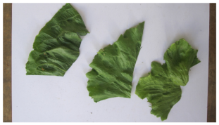
1.entire 3.slightly lobed 5.medium-lobed
NL: We propose not to add a new characteristic that combines incision of the margin and lobbing.

Char. 17. Leaf: shape of tip:
ISF: Why is this trait canceled? In principle it seems a clear distinguishing trait to me. Maybe because most varieties are in class 3? NL: To be discussed, most varieties are in class 3, some cos lettuce and Radichetta in class 1. We have no clear examples of class 2.

Char. 10. Only varieties with entire leaves: Leaf: cross section:
JP: Our suggestion 1 to 3 scale. NL: We propose to keep as it is (1-5).

ES: We think that in lettuce varieties concave is not clearly separated of flat in adult leaves. So I should redraft it as:
Varieties with entire leaves only: Leaf: cross section in the upper third of the leaf
- Flat or slightly concave
- Slightly convex
- Markedly convex
NL: We propose to keep as it is.

Char. 12, 13, 14. Leaf: area covered with anthocyanin coloration, hue of anthocyanin coloration, intensity of anthocyanin coloration:
ISF: This may differ between indoor and outdoor (also trait 12). How is this handled? NL: relative characteristics, to be compared with example varieties put in indoor trial and outdoor trial where relevant.

Char. 15 and 16. Leaf: hue of green color and Leaf: intensity of green color:
DE: To improve the explanation regarding the two colored varieties. NL: we agree and adapted the explanation at 15 and 16.

Char. 16. Leaf: intensity of green color:
ISF: Instead of Lollo, should it not be Lollo bionda? NL: We propose to keep Lollo. Lollo is in the EU Common Catalogue the conventional name (the official name given to the variety in the first known country of admission).

Char. 18. Leaf: thickness:
ISF: Intensitie no longer maintained by RZ. NL: replaced by Curtis.

Char. 25. Only cutting lettuce varieties: Heart: density:
JP: We are not familiar a wording of Heart at Lettuce. We would like to confirm “Heart” meaning. NL: We improved the explanation ad 3 and ad 25.

DE: To add to the explanation, that the head should be cut in longitudinal /crosswise section. NL: to be discussed.

ES: We propose to observe in all groups with open or closed head. NL: We propose to keep (and delete old 10).

Char. 26. Only varieties with closed head: Head: degree of overlapping of upper part of leaves:
ISF: Intensitie and Myosotie no longer maintained by RZ. NL: replaced by Curtis.

Char. 10. Head: density:
JP: We would like to know deleting reason. NL: Not much differentiation between heading varieties.

Char. 27 and 28. Head: size and Head: shape in longitudinal section:
DE: Varieties with "Plant head formation: open head" are difficult to compare to the varieties with closed head.
We propose to have
Only plant head formation: closed head: Head size and
Only plant head formation: closed head: Head: shape in longitudinal section
NL: We agree (slightly different wording).

Char. 27. Head: size:
ES: To indicate VG or MS. NL: We agree.

Char. 30. Axillary sprouting:
ES: To keep. NL: We propose to keep this characteristic deleted.

Char. 30. Time of beginning of bolting under long day conditions:
JP: In case of Japan, bolting often does not appear before deterioration. Because breeding target are focused on tolerance to bolting. On the other hand, our DUS trial, depending on the variety often appears the bolting. It is considered that there is significant distinctness between non bolting variety and bolting variety. But non bolting variety before deterioration can not be assessed in this characteristic. In order to resolve this matter, we would like to add a new characteristic “tendency to bolting, weak - strong” before the chara 30.
NL: We propose to discuss. We added an explanation ad 31 which may be useful.

Char. 36. Plant: height (flowering plant):
DE: We propose to keep the char. because the variation justifies it with less stages (1-3 or 1-5).
NL: To be discussed.

Char. 31. Plant: fasciation:
DE: We propose to delete the characteristic due to the environment influence on fasciation and therefore high effort to keep the characteristic uniform. NL: We partly agree and propose to use less classes (1-5).

Char. 32. Resistance to downy mildew (Bremia lactucae):
ISF: In the latest IBEB meeting is was agreed to skip the races Bl:1 up to and including Bl:15 per 1 September 2014. This will be officially communicated in the course of April. However, in the proposal you sent Bl:2, Bl:5, Bl:7, Bl:12, Bl:14 and Bl:15 still apply. If these races still apply, as a consequence we have to continue the testing for these races. We would appreciate if the UPOV guidelines could be in accordance with the IBEB agreements.
NL: We agree (attached communication of IBEB April 2014).

Char. 32.7 Isolate Bl: 16:
ISF: We think that more than 95% of the varieties nowadays is resistance against this isolate. Would it not be better to use another isolate? NL: Keep * at Bl: 16. Examination offices are free in their decisions which isolates they want to test extra to have smaller groups of comparing varieties.

Char. 32.8 Isolate Bl: 17:
ISF: If possible, keep Bl:17, as it has some unique distinguishing characteristics. NL: We agree.

Char. 35. Resistance to Fusarium oxysporum f. sp. lactucae race 1:
ISF: The explanation indicates that the observation scale is QN (0-4), which according to us is in accordance the level of resistance found in various varieties. This means that a variety has a repeatable and measurable resistance level, which in principle can lie on every position of a continuous scale from resistant to susceptible. Therefore, it is impossible to score such a characteristic as QL. Ringtestresults of GEVES from 2012 show this, see attached document. These results became available after the TWV 2012, when this characteristic was last discussed. It was then decided to include Salinas as susceptible, as a “solution” for the intermediate resistance. In the new draft Salinas has been deleted.
NL: We propose to discuss (attached ring test GEVES).

RE 8. Explanations on the Table of Characteristics

Ad 32. Resistance to downy mildew (Bremia lactucae):
ISF: We feel that class 3 is a "undecided"-class: the sporulation indicates susceptibility; however, the necrosis indicates resistance. This class should not be taken into account when observing uniformity of a variety. It is also better to exclude this class from the observation on susceptibility/resistance of a variety. When a large percentage of the tested plants scores class 3 (> 75%), then the test should be repeated.
NL: We agree.

Ad 35. Fusarium oxysporum f. sp. lactucae race 1:
ISF: Delete remark on susceptibility of Salinas. NL: We agree.

RE 10. Technical questionnaire

5.1:
ISF: Intensitie no longer maintained by RZ. NL: replaced by Curtis.

II PRESS RELEASE OF THE INTERNATIONAL BREMIA EVALUATION BOARD (IBEB)

22 April 2014

Press release Bremia lactucae races BI:1-15

Bremia lactucae races BI:1-15 are no longer relevant and resistance to these races will not be claimed any more from September 1st 2014.

Bremia lactucae (Downy Mildew) is known to be a lettuce disease in which frequently new isolates appear. In August 2013 the IBEB has nominated 3 new races of Bremia Bl:29, Bl:30 and Bl:31. As a result of the successful introduction of an increasingly wide range of resistance genes by breeding companies, a clear trend is visible. Local isolates of Bremia appear which spread less fast than races nominated in the past. The three newly nominated races are not evenly spread over Europe and do not cause problems everywhere.

The International Bremia Evaluation Board, collecting and evaluating more than 200 isolates per year, is noticing another important trend during recent years. Several physiological races of Bremia lactucae in lettuce (races Bl:1-15) are agronomical no longer relevant in Europe. As to the best of our knowledge these races are no longer observed in practice.

Therefore reference to the races Bl:1-15 is no longer made in resistance claims in seed catalogues with regard to B. lactucae. From September 1st 2014 onwards, the resistance claim of a variety will only refer to Bl:16-31.

The IBEB consists of representatives of the Dutch and French seed business associations Plantum and UFS, and the organisations of GEVES and Naktuinbouw. IBEB is supported by several Bremia investigators across Europe. The business associations were represented by lettuce breeders of Agrisemen, Enza Zaden, Gautier, Nunhems, Rijk Zwaan, Monsanto Seminis, Syngenta and Vilmorin.

For testing and breeding purposes all nominated races and EU-B determination set are available at
GEVES/SNES (France) and at Naktuinbouw (The Netherlands).

Editorial note:
For more information, please contact:
SNES-GEVES France
Mrs. Valérie Grimault or Mrs Sophie Perrot
telephone +33 (0)2 41 22 58 00
e-mail: Valerie.Grimault@geves.fr; or Sophie.perrot@geves.fr

Naktuinbouw Variety Testing department www.naktuinbouw.nl
Mr. Diederik Smilde, Mr. Richard Ludlage or Mrs. Amanda van Dijk,
telephone +31 (0)71 33 26 213
e-mail: Resistentie@naktuinbouw.nl

III PRESENTATION: MEETING IBEB: FUSARIUM OXYSPORUM F: SP: LACTUCAE RACE 1: RINGTEST GEVES

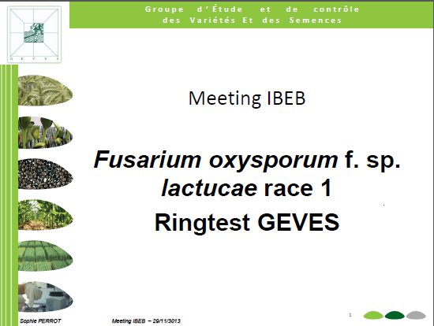

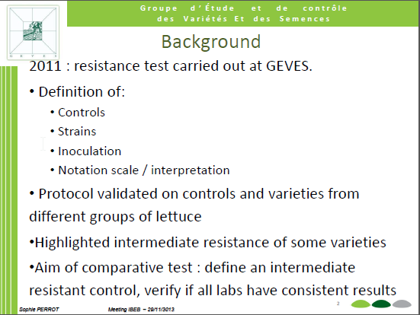

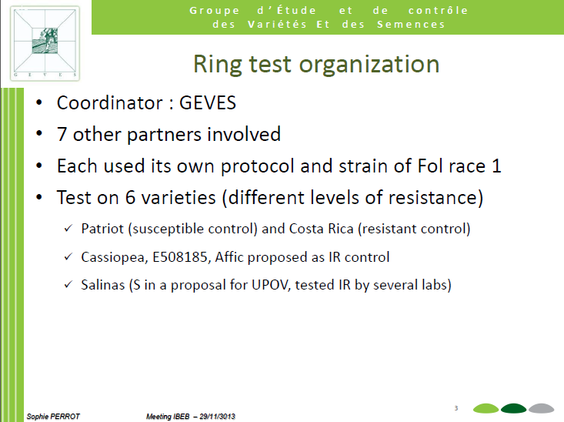

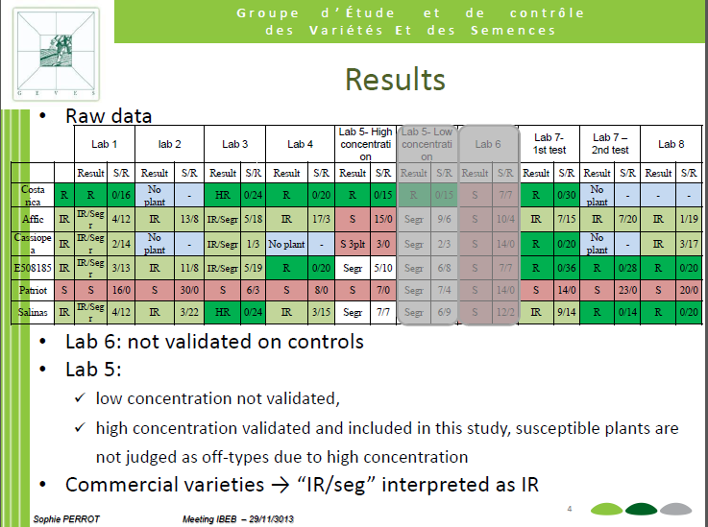

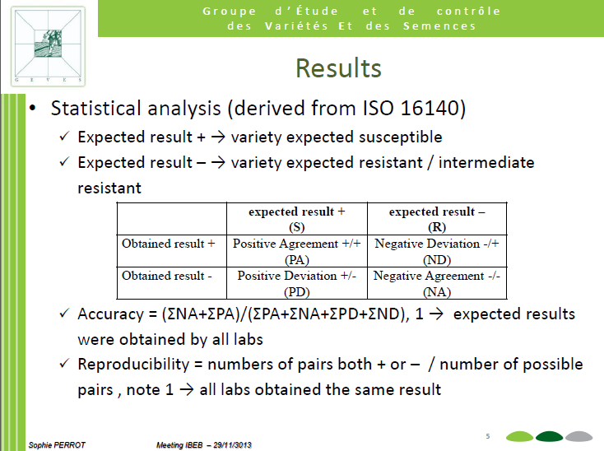

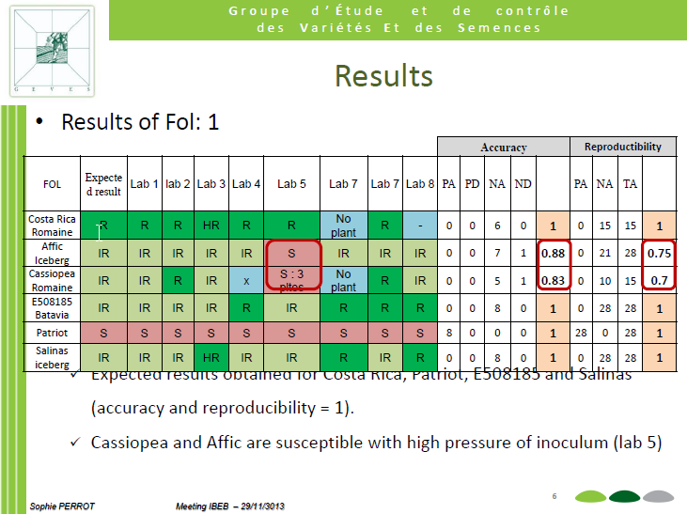

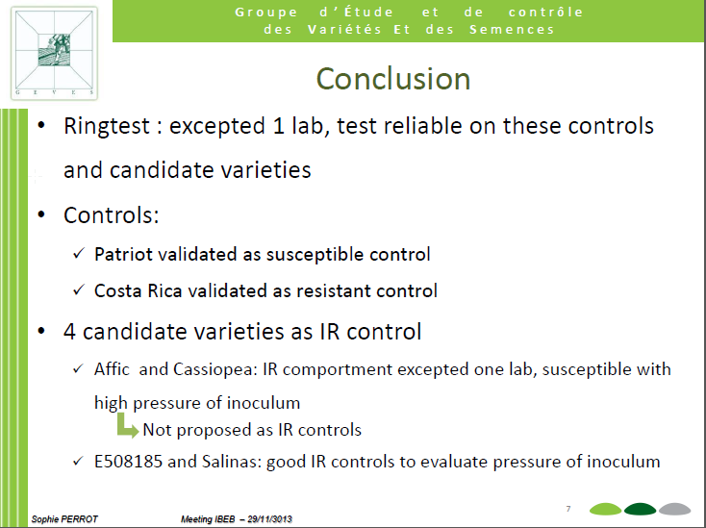

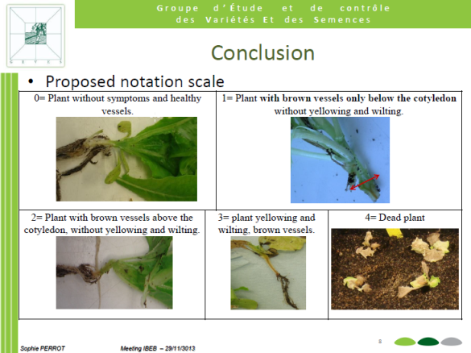

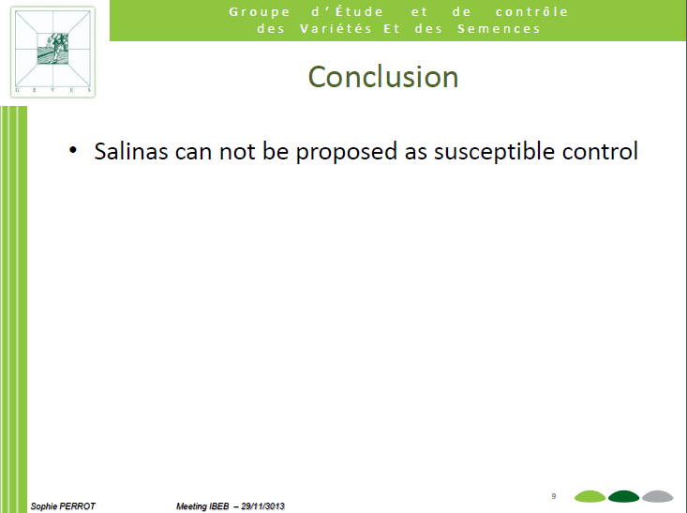

[End of document]

