E
TWV/48/26 Add.
ORIGINAL: English
DATE: September 16, 2014
INTERNATIONAL UNION FOR THE PROTECTION OF NEW VARIETIES OF PLANTS
Geneva
Technical working party for VEGETABLES
Forty-Eighth Session
Paestum, Italy, from June 23 to 27, 2014

ADDENDUM TO DOCUMENT TWV/48/26

use of statistical approaches in DUS examination

Document prepared by the Netherlands
Disclaimer: this document does not represent UPOV policies or guidance

The annex to this document contains the presentation made by an expert from The Netherlands, at the
forty-eighth session of the Technical Working Party for Vegetables (TWV), on “Use of statistical approaches in DUS examination”.

[Annex follows]

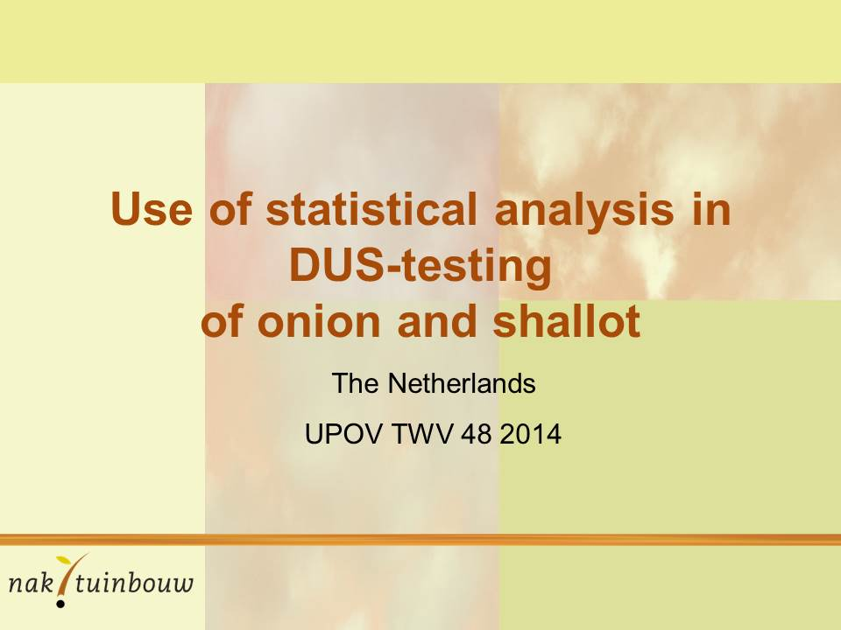
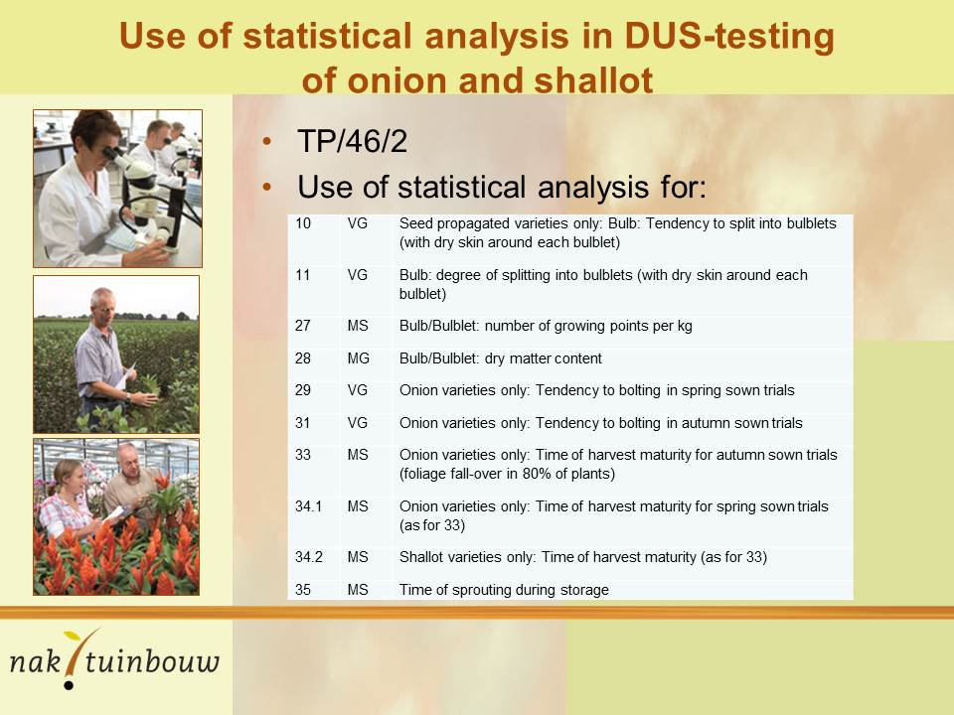

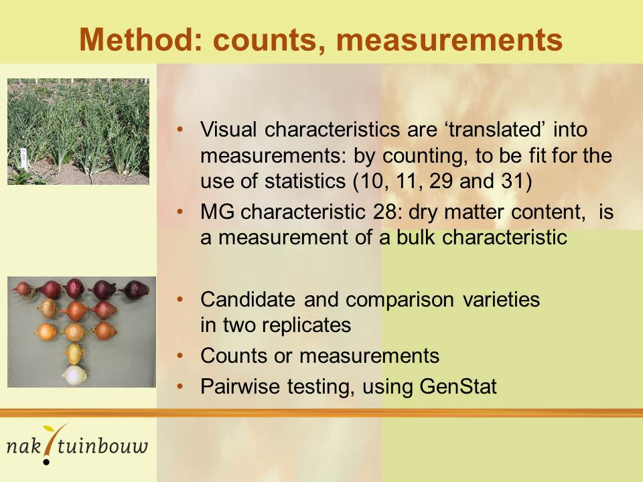
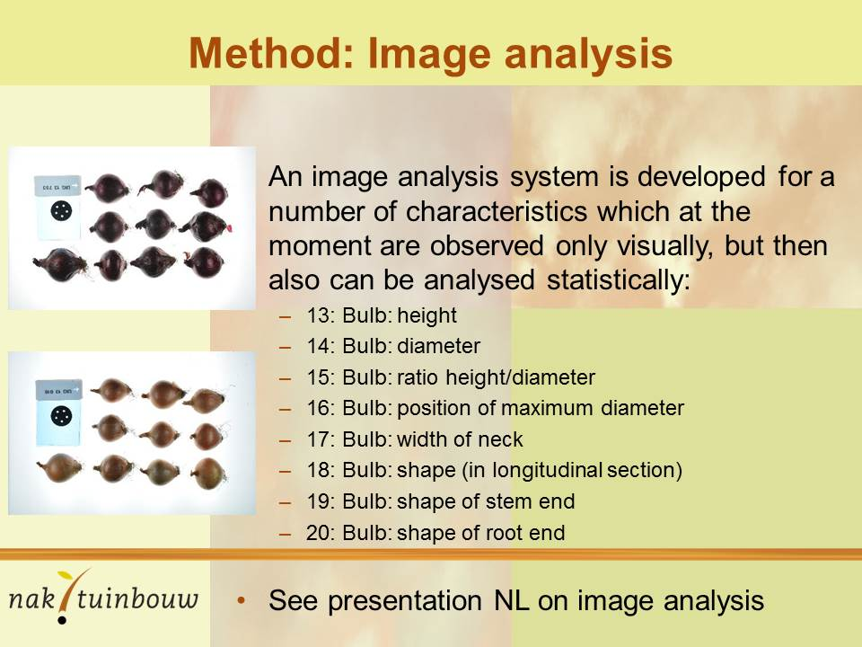

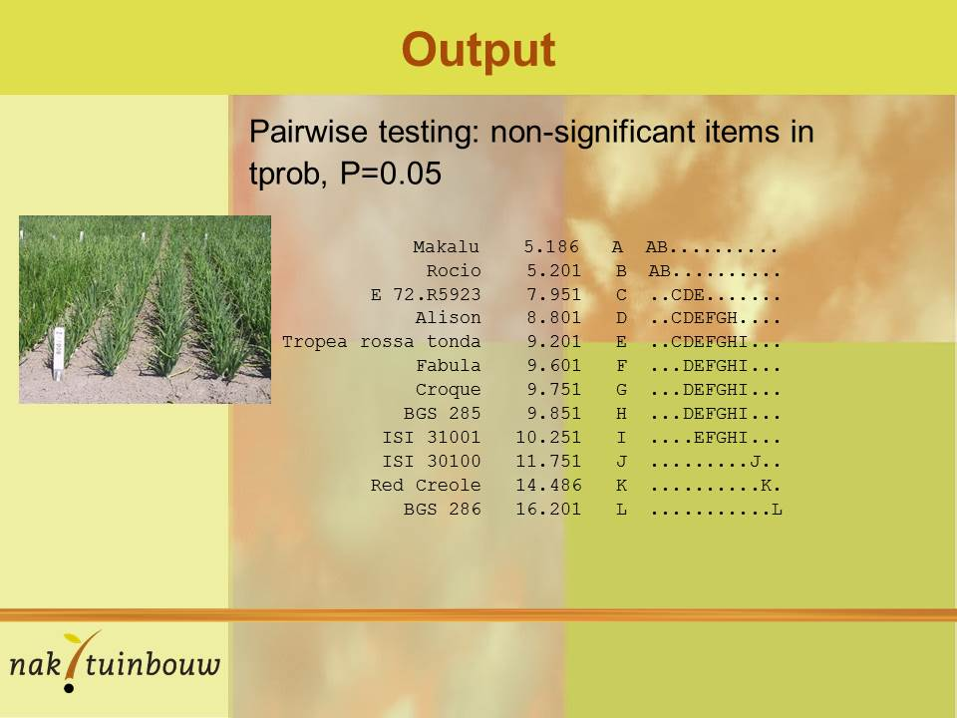
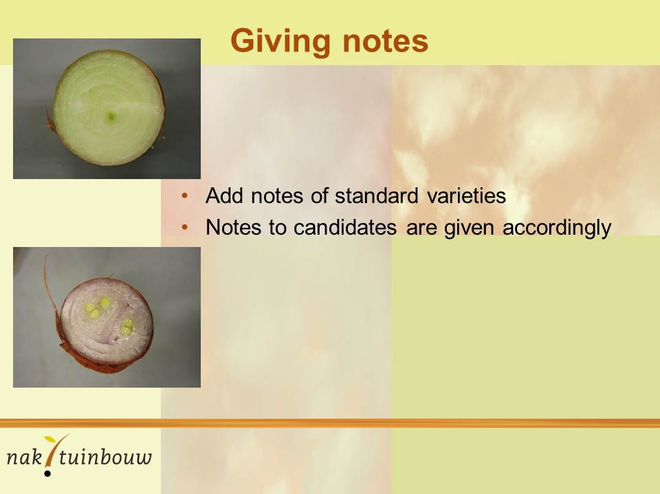

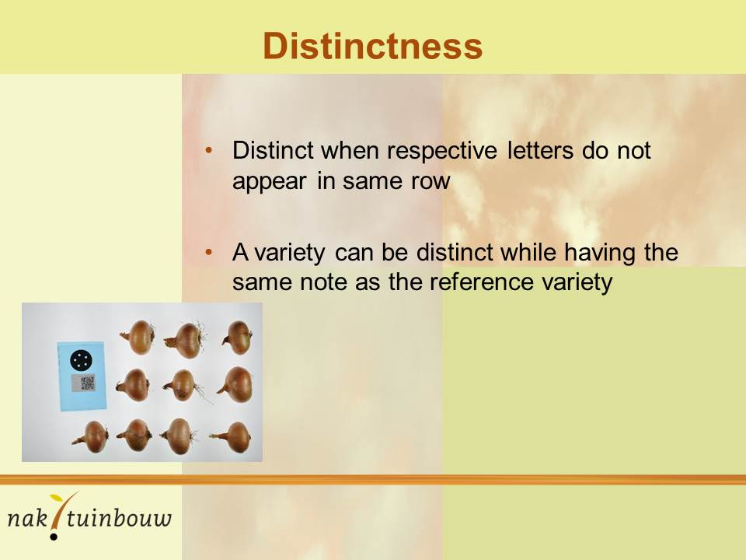

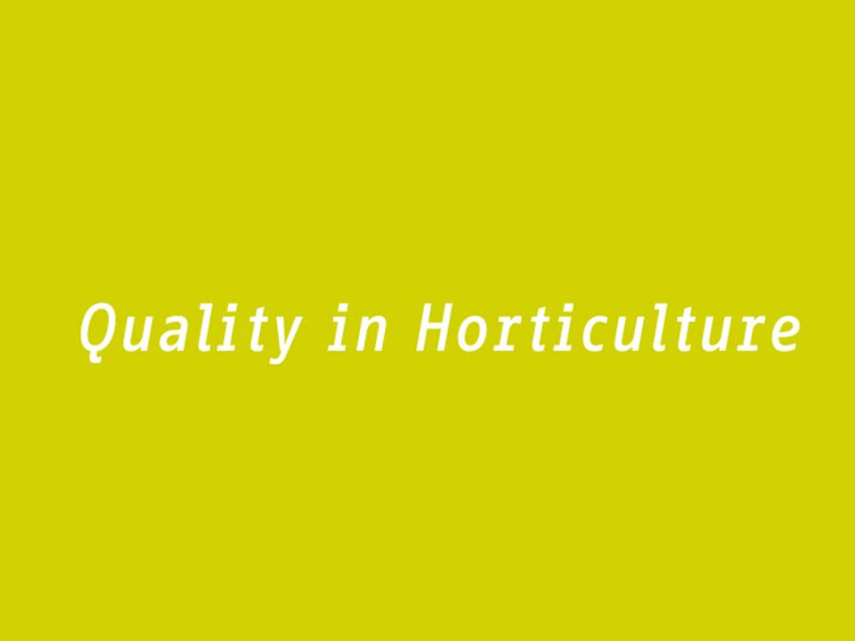

[End of Annex and of document]

