E
TWV/48/22
ORIGINAL: English
DATE: May 27, 2014
INTERNATIONAL UNION FOR THE PROTECTION OF NEW VARIETIES OF PLANTS
Geneva
Technical working party for VEGETABLES
Forty-Eighth Session
Paestum, Italy, from June 23 to 27, 2014
Revisions of document tgp/9: “examining distinctness”:
(i) section 1.6: “schematic overview of TGP DOCUMENTS CONCERNING DISTINCTNESS”; (ii) section 2.5: “photographs”;
(iii) section 4.3.2: “Single record for a group of plants or parts of plants (G)” and 4.3.4: “Schematic Summary”
Document prepared by the Office of the Union
Disclaimer: this document does not represent UPOV policies or guidance

Executive summary

The purpose of this document is to present proposals for the revision of document TGP/9 “Examining distinctness”, Section 1.6 “Schematic overview of TGP documents concerning distinctness”, Section 2.5 “Photographs”, Section 4.3.2 “Single record for a group of plants or parts of plants (G)” and Section 4.3.4 “Schematic Summary”.

The TWV is invited to consider the:

- revision of the flow diagram in TGP/9, Section 1.6 “Schematic overview of TGP documents concerning distinctness”, as set out in paragraph 7 and Annexes I and II to this document;

- proposed guidance on photographs for inclusion in document TGP/9, Section 2.5 “Photographs”, as set out in paragraph 14; and

- proposed example of a single record for a group of plants (MG) taken on plant parts for inclusion in a future revision of document TGP/9, Section 4.3.2 “Single record for a group of plants or parts of plants (G)” and Section 4.3.4 “Schematic Summary”, as set out in paragraphs 16 and 17.

The structure of this document is as follows:

Executive summary 1

PURPOSE 3

section 1.6 Schematic overview of TGP documents concerning distinctness 3

Section 2.5 “photographs” 3

Section 4.3.2 “Single record for a group of plants or parts of plants (G)” and Section 4.3.4 “Schematic Summary” 4

ANNEX I: SCHEMATIC OVERVIEW OF TGP DOCUMENTS CONCERNING DISTINCTNESS
ANNEX II: SCHEMATIC OVERVIEW OF TGP DOCUMENTS
ANNEX III: EXAMPLES OF CHARACTERISTICS USING SINGLE MEASUREMENT (MG) FOR PLANT PARTS

The following abbreviations are used in this document:

CAJ: Administrative and Legal Committee
TC: Technical Committee
TC-EDC: Enlarged Editorial Committee
TWA: Technical Working Party for Agricultural Crops
TWC: Technical Working Party on Automation and Computer Programs
TWF: Technical Working Party for Fruit Crops
TWO: Technical Working Party for Ornamental Plants and Forest Trees
TWV: Technical Working Party for Vegetables
TWPs: Technical Working Parties

PURPOSE

The purpose of this document is to present proposals for the revision of document TGP/9 “Examining distinctness”, Section 1.6 “Schematic overview of TGP documents concerning distinctness”, Section 2.5 “Photographs”, Section 4.3.2 “Single record for a group of plants or parts of plants (G)” and Section 4.3.4 “Schematic Summary”.

section 1.6 Schematic overview of TGP documents concerning distinctness

The TC, at its fiftieth session held in Geneva, from April 7 to 9, 2014, considered the revision of the flow diagram in TGP/9 and agreed that it should be reviewed in conjunction with other possible changes to be introduced in documents TGP/4 “Constitution and Maintenance of Variety Collections” and TGP/9 “Examining Distinctness” resulting from the adoption of document TGP/15 “Guidance on the Use of Biochemical and Molecular Markers in the Examination of Distinctness, Uniformity and Stability (DUS)” (see document TC/50/36 “Report on the Conclusions”, paragraph 72) .

On the above basis, and taking into account revisions to other TGP documents, it is proposed to amend the flow diagram in document TGP/9 as follows:

Box “Forms of variety collection:” to read: “Varieties or living plant material not included in the variety collection”
Box “Data analysis Methods:” to read: “COYD; 2x1%; Chi-Square Test; Fisher’s Exact Test”

In addition, in order to simplify the diagram it is proposed to delete the boxes for documents TGP/6 “Arrangements for DUS Testing” and TGP/7 “Development of Test Guidelines” and to create a new diagram to provide an overview of the relevant TGP documents, set out in Annexes I and II, respectively.

The TWV is invited to consider the revision of the flow diagram in TGP/9, Section 1.6 “Schematic overview of TGP documents concerning distinctness”, as set out in Annexes I and II to this document.

Section 2.5 “photographs”

The TC, at its forty-ninth session held in Geneva, from March 18 to 20, 2013, agreed to the new Additional Standard Wording (ASW 16) and Guidance Note (GN 35) in document TGP/7 “Development of Test Guidelines” to provide guidance for providing photographs with the Technical Questionnaire (see document TWO/45/37 “Report”, paragraphs 18 to 21, and document TC/49/41 “Report on the Conclusions”, paragraph 46). The new ASW 16 and GN 35 will be put forward for adoption by the Council at its forty-eighth ordinary session, to be held in Geneva on October 16, 2014.

The TC, at its fiftieth session held in Geneva, from April 7 to 9, 2014, agreed to request an expert from Germany to develop guidance on the use of photographs for the analysis of distinctness for inclusion in document TGP/9. The new guidance would make reference to the complete guidance available in document TGP/7, GN 35 “Providing Photographs with the Technical Questionnaire” (see document TC/50/36 “Report on the Conclusions”, paragraph 42).

The following amendment to document TGP/9: Section 2.5 “Photographs” is proposed by the expert from Germany:

“2.5 Photographs

“2.5.1 Photographs can provide useful information as a basis to exclude varieties in the variety collection from the growing trial used for the examination of distinctness. In particular, photographs may provide information on characteristics not included in the TQ. This may, for example, concern shapes, plant structures or color patterns which are not easy for applicants to describe by means of Notes in the Table of Characteristics and, therefore, might not be included as characteristics in Section 5 of the TQ. In addition, the information provided in photographs on characteristics included in the TQ may be more discriminatory than that provided in Section 5 of the TQ and may allow more varieties to be excluded from the growing trial.

“2.5.2 Document TGP/7 indicates that, where useful for the DUS examination, the UPOV Test Guidelines may require that a representative color photograph of the variety accompanies the information provided in the Technical Questionnaire. In such cases, it is recommended that guidance be provided by the authority to enhance the usefulness of the photograph (e.g. to include a metric scale and a color scale in the picture, to define what parts of the plant should be included, to specify the light conditions and the background color, etc). However, the use of photographs for selecting varieties for the growing trial should take into account that, despite such guidance and the best endeavors of the breeder, photographs may not always accurately reflect the characteristics of the variety.”

“2.5.3 The suitability of photographs for the identification of similar varieties is strongly influenced by the quality of the photographs taken by the authority for the varieties in the reference collection and the photograph of the candidate variety provided by the applicant with the Technical Questionnaire. Comprehensive guidance for taking suitable photographs is provided in TGP/7, GN 35 (new). The guidance was developed in particular for the applicants to provide suitable photographs of the candidate variety. The same instructions are important and useful for the authorities to take photographs of the varieties in the variety collection under standardized conditions.”

The TWV is invited to consider the proposed guidance on photographs for inclusion in document TGP/9, Section 2.5 “Photographs”, as set out in paragraph 12.

Section 4.3.2 “Single record for a group of plants or parts of plants (G)” and Section 4.3.4 “Schematic Summary”

The TC, at its fiftieth session held in Geneva, from April 7 to 9, 2014, agreed that examples and illustrations to explain a single measurement (MG) on plant parts should be compiled by the Office of the Union and presented to the TWPs for inclusion in a future revision of document TGP/9, Subsections 4.3.2 and 4.3.4 (see document TC/50/36 “Report on the Conclusions”, paragraph 71).

Annex III to this document provides examples of characteristics using single measurement (MG) for plant parts from Test Guidelines adopted in 2013 and 2014.

It is proposed to add the following example of single record for a group of plants (MG) taken on plant parts for inclusion in a future revision of document TGP/9, Subsection 4.3.2:

“Example (MG)

“Measurement (MG): “Leaf blade: width” in Hosta (vegetatively propagated) in a trial consisting of plants grown in pots: a leaf from a representative plant is measured.”

A suitable illustration would be provided for inclusion in Subsection 4.3.4.

The TWV is invited to consider the proposed example of a single record for a group of plants (MG) taken on plant parts for inclusion in a future revision of document TGP/9, Subsections 4.3.2 “Single record for a group of plants or part of plants (G)” and 4.3.4 “Schematic summary”, as set out in paragraphs 16 and 17.

[Annexes follow]

SCHEMATIC OVERVIEW OF TGP DOCUMENTS CONCERNING DISTINCTNESS

DUS trial design
Methods:
- parent formula (hybrids)
- GAIA
GROWING
TRIAL ORGANIZATIONNN
Constitution of variety collections
Elaborating
the notion of Varieties
of Common Knowledge
Forms of variety collection:
- descriptions
- living plant material
Range of the variety collection
Varieties or living plant material not included in the variety collection
Variety descriptions
Living plant material
Cooperation in maintenance
Types of varieties
Grouping varieties on the basis of characteristics
Characteristics in combination
Photographs
Parent formula (Hybrids)
Guidance
Side-by-side visual comparison
Notes / single variety records
Statistical analysis of growing trial data
SELECTING VARIETIES FOR THE GROWING TRIAL
MAINTENANCE OF VARIETY COLLECTIONS
TGP/3

Grouping similar varieties
TGP/4
TGP/9

TGP/8
Data analysis
Methods:
COYD
2x1%
Chi-Square Test
Fisher’s Exact Test
Match Approach

Validation of data and assumptions
Examining DUS in bulk samples
Methods of observation (V/M)
Type of record(s) (G/S)
Recommendations in UPOV Test Guidelines

OBSERVATION
OF CHARACTERISTICS

ASSESSING DISTINCTNESS IN THE GROWING TRIAL

Publication of variety descriptions
Cooperation between members of the Union
Use of randomized “blind” testing
The advice of plant experts
SUPPLEMENTARY PROCEDURES

SCHEMATIC OVERVIEW OF TGP DOCUMENTS

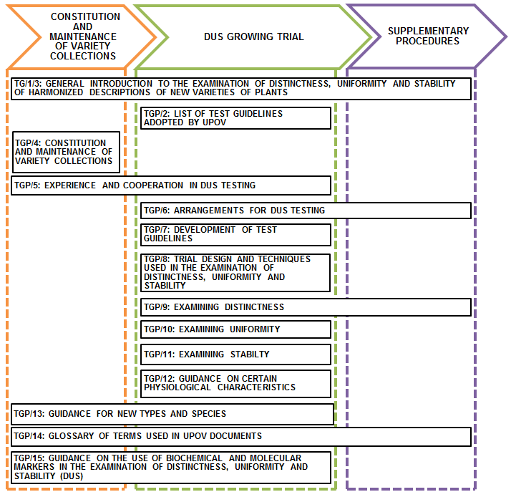

[Annex III follows]

EXAMPLES OF CHARACTERISTICS USING SINGLE MEASUREMENT (MG) FOR PLANT PARTS

Document TG/HOSTA(proj.9)

4.  (*) | VG/MG/MS | Petiole: length | Pétiole : longueur | Blattstiel: Länge | Pecíolo: longitud
QN | (a) | very short | très court | sehr kurz | muy corto | Desert Mouse | 1
 |  | short | court | kurz | corto | Time Tunnel | 3
 |  | medium | moyen | mittel | medio | Earth Angel | 5
 |  | long | long | lang | largo | Blue Circle | 7
 |  | very long | très long | sehr lang | muy largo | Big Boy, Flower Power, Green Acres | 9
9.  (*) | VG/MG/MS | Leaf blade: width | Limbe : largeur | Blattspreite: Breite | Limbo: anchura
QN | (a) | very narrow | très étroit | sehr schmal | muy estrecho | Desert Mouse | 1
 |  | narrow | étroit | schmal | estrecho | Secret Ambition | 3
 |  | medium | moyen | mittel | medio | Risky Business | 5
 |  | broad | large | breit | ancho |  | 7
 |  | very broad | très large | sehr breit | muy ancho | Big Boy,  Sum and Substance | 9

Document TG/286/1 Hebe

8.  (*) | VG/  MG | Stem: length of internodes | Tige : longueur des entre-nœuds | Trieb: Internodienlänge | Tallo: longitud de los entrenudos
QN | (c) | very short | très courts | sehr kurz | muy corta | Karo Golden Esk | 1
 |  | short | courts | kurz | corta | Beverley Hills | 3
 |  | medium | moyens | mittel | media | Wiri Desire | 5
 |  | long | longs | lang | larga | Moonlight | 7

Document TG/288/1 Dianella

3.  (+) | VG/  MG | Stem: internode length | Tige : longueur de l’entre-nœud | Stengel: Internodienlänge | Tallo: longitud del entrenudo
QN | (a) | very short | très court | sehr kurz | muy corto | TAS300 | 1
 |  | short | court | kurz | corto | TR20 | 3
 |  | medium | moyen | mittel | medio |  | 5
 |  | long | long | lang | largo | Goddess | 7
 |  | very long | très long | sehr lang | muy largo |  | 9

Ad. 3: Stem: internode length

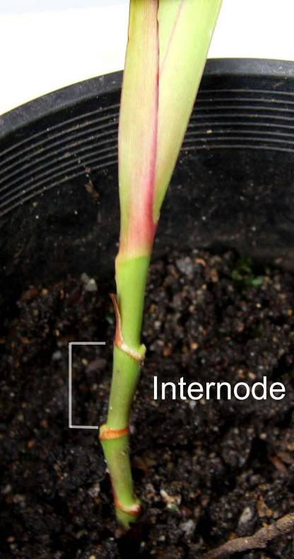

27. | VG/  MG | Perianth: diameter | Périanthe : diamètre | Blütenhülle: Durchmesser | Perianto: diámetro
QN | (c) | small | petit | klein | pequeño |  | 1
 |  | medium | moyen | mittel | medio |  | 2
 |  | large | grand | groß | grande |  | 3

[End Annex and of document]

Reference to document UPOV/TGP/15 “Guidance on the Use of Biochemical and Molecular Markers in the Examination of Distinctness, Uniformity and Stability (DUS)” corrected from document TC/50/36 “Report on the Conclusions”, paragraph 72.

