E
TWV/47/2 Add.
ORIGINAL: English
DATE: June 10, 2013
INTERNATIONAL UNION FOR THE PROTECTION OF NEW VARIETIES OF PLANTS
Geneva
Technical working party for vegetables
Forty-Seventh Session
Nagasaki, Japan, May 20 to 24, 2013
Addendum to Molecular Techniques
Document prepared by the Office of the Union
The Annexes to this document contain the following presentations:

ANNEX I Naktuinbouw Project Report on Male sterility detection (in cabbage) using Molecular Techniques

ANNEX II Molecular Techniques in DUS Testing in the Group for Study and Control of Varieties and Seeds (GEVES)

[Annexes follow]
NAKTUINBOUW PROJECT REPORT ON MALE STERILITY DETECTION (IN CABBAGE) USING MOLECULAR TECHNIQUES

PROJECT REPORT

Subject: Male sterility detection in Cabbage (Cabbage (Brassica oleracea L. convar. capitata (L.) Alef. var. sabauda L., Brassica oleracea L. convar. capitata (L.) Alef. var. rubra (L.) Thell., Brassica oleracea L. convar. capitata (L.) Alef. var. alba DC., Brassica oleracea L. var. gemmifera Zenker. Brassica oleracea L. var. gongylodes L.)) using molecular techniques.
Project leader: G. van Hameren

1. INTRODUCTION
The aim of this project is to investigate if a molecular marker can replace an expensive greenhouse test in Red cabbage, White cabbage, Savoy cabbage, Kohlrabi and Brussels sprouts. This molecular marker can also be used in the vegetables Cauliflower and Broccoli (Calabrese), but in those two crops there is no costs reduce, because in Cauliflower also the flower colour needs to be observed and in Broccoli the flowers (head) already develops in an early plant stage (first year).

2. METHOD/MATERIAL
From 47 varieties of 6 different cabbage species samples were taken. The varieties were sown within the framework of the DUS field trials of 2012. 5 pools of 5 individuals were sampled for fertile varieties and 24 individuals were sampled for sterile varieties (total of 668 samples representing 1128 individuals). The collected samples were freeze dried and DNA isolation was carried out following the standard Naktuinbouw CTAB DNA isolation protocol. DNA was not diluted before PCR protocol was carried out. The confidential PCR protocol for detection of the marker for CMS resistance was provided by Syngenta Seeds B.V. Before Naktuinbouw started to pool the fertile samples, tests were carried out (table 1) for investigating if a sterile plant can be found in a fertile pool.
Table 1: Investigation if a sterile plant can be found in a fertile pool.D CQ marker (CMS) CQ internal control conclusion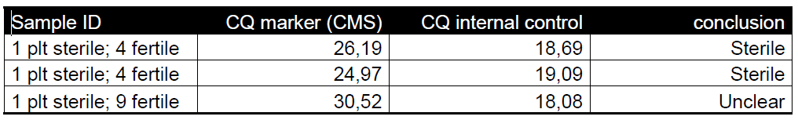

3. RESULTS
Results will be made publicly available in 2014

4. CONCLUSION
100% correlation between marker presence and Male Sterility is shown in this data set.
A sterile individual can be detected in a pool of 5 (4 fertile) individuals. A sterile plant in a pool of 10 individuals (9 fertile) is too difficult to detect. The presence of the marker is a reliable predictor for the characteristic male sterility (CMS) in cabbage (Brassica oleracea L. convar. capitata (L.) Alef. var. sabauda L., Brassica oleracea L. convar. capitata (L.) Alef. var. rubra (L.) Thell., Brassica oleracea L. convar. capitata (L.) Alef. var. alba DC., Brassica oleracea L. var. gemmifera Zenker. Brassica oleracea L. var. gongylodes L.).

Daniël Deinum and Hedwich Teunissen
Roelofarendsveen

[Annex II follows]

MOLECULAR TECHNIQUES IN DUS TESTING IN THE GROUP FOR STUDY AND CONTROL OF VARIETIES AND SEEDS (GEVES)

[End of Annex and of document]

