 |  |  |  |  |  |  | E  TG/LAGEN(proj.2)  ORIGINAL: English  DATE: 2013-04-15
INTERNATIONAL UNION FOR THE PROTECTION OF NEW VARIETIES OF PLANTS
Geneva
 |  |  | DRAFT
 |  | BOTTLE GOURD, CALABASH  UPOV Code: LAGEN_SIC  Lagenaria siceraria (Molina) Standl. |  |  | *

GUIDELINES

FOR THE CONDUCT OF TESTS

FOR DISTINCTNESS, UNIFORMITY AND STABILITY

prepared by experts from France

to be considered by the
Technical Working Party for Vegetables
at its forty-seventh session, to be held in Nagasaki, Japan, from May 20 to 24, 2013

Alternative Names:*

Botanical name | English | French | German | Spanish
Lagenaria siceraria (Molina) Standl.,  Lagenaria siceraria Standley, Lagenaria vulgaris Ser. | Bottle Gourd, Calabash,  Calabash Gourd, White-flower Gourd | Calebassier,  Gourde bouteille | Flaschenfrucht, Flaschenkürbis, Gewöhnlicher Flaschenkürbis | Acocote, Cajombre, Calabaza,  Guiro amargo

The purpose of these guidelines (“Test Guidelines”) is to elaborate the principles contained in the General Introduction (document TG/1/3), and its associated TGP documents, into detailed practical guidance for the harmonized examination of distinctness, uniformity and stability (DUS) and, in particular, to identify appropriate characteristics for the examination of DUS and production of harmonized variety descriptions.

ASSOCIATED DOCUMENTS
These Test Guidelines should be read in conjunction with the General Introduction and its associated TGP documents.

Other associated UPOV documents: -
TABLE OF CONTENTS PAGE

1. Subject of these Test Guidelines 3
2. Material Required 3
3. Method of Examination 3
3.1 Number of Growing Cycles 3
3.2 Testing Place 3
3.3 Conditions for Conducting the Examination 3
3.4 Test Design 3
3.5 Additional Tests 3
4. Assessment of Distinctness, Uniformity and Stability 4
4.1 Distinctness 4
4.2 Uniformity 5
4.3 Stability 5
5. Grouping of Varieties and Organization of the Growing Trial 5
6. Introduction to the Table of Characteristics 6
6.1 Categories of Characteristics 6
6.2 States of Expression and Corresponding Notes 6
6.3 Types of Expression 6
6.4 Example Varieties 7
6.5 Legend 7
7. Table of Characteristics/Tableau des caractères/Merkmalstabelle/Tabla de caracteres 8
8. Explanations on the Table of Characteristics 13
8.1 Explanations covering several characteristics 13
8.2 Explanations for individual characteristics 13
9. Literature 19
10. Technical Questionnaire 20

ANNEX COMMENTS FROM THE SUBGROUP ON DOCUMENT TG/LAGEN(PROJ.2)

Subject of these Test Guidelines

These Test Guidelines apply to all varieties of Lagenaria siceraria (Molina) Standl..

Material Required

2.1 The competent authorities decide on the quantity and quality of the plant material required for testing the variety and when and where it is to be delivered. Applicants submitting material from a State other than that in which the testing takes place must ensure that all customs formalities and phytosanitary requirements are complied with.

2.2 The material is to be supplied in the form of seeds.

2.3 The minimum quantity of plant material, to be supplied by the applicant, should be:

200g – 1,500 seeds.

The seed should meet the minimum requirements for germination, species and analytical purity, health and moisture content, specified by the competent authority.

2.4 The plant material supplied should be visibly healthy, not lacking in vigor, nor affected by any important pest or disease.

2.5 The plant material should not have undergone any treatment which would affect the expression of the characteristics of the variety, unless the competent authorities allow or request such treatment. If it has been treated, full details of the treatment must be given.

Method of Examination

3.1 Number of Growing Cycles

The minimum duration of tests should normally be two independent growing cycles.

3.2 Testing Place

Tests are normally conducted at one place. In the case of tests conducted at more than one place, guidance is provided in TGP/9 “Examining Distinctness”.

3.3 Conditions for Conducting the Examination

3.3.1 The tests should be carried out under conditions ensuring satisfactory growth for the expression of the relevant characteristics of the variety and for the conduct of the examination.

3.3.2 The optimum stage of development for the assessment of each characteristic is indicated by a number in the second column of the Table of Characteristics. The stages of development denoted by each number are described in Chapter 8.

3.4 Test Design

3.4.1 Each test should be designed to result in a total of at least 20 plants, which should be divided between at least 2 replicates.

3.4.2 The design of the tests should be such that plants or parts of plants may be removed for measurement or counting without prejudice to the observations which must be made up to the end of the growing cycle.

3.5 Additional Tests

Additional tests, for examining relevant characteristics, may be established.

Assessment of Distinctness, Uniformity and Stability

4.1 Distinctness

4.1.1 General Recommendations

It is of particular importance for users of these Test Guidelines to consult the General Introduction prior to making decisions regarding distinctness. However, the following points are provided for elaboration or emphasis in these Test Guidelines.

Further guidance is provided in documents TGP/9 “Examining Distinctness” and TGP/8 “Trial Design and Techniques Used in the Examination of Distinctness, Uniformity and Stability.

4.1.2 Consistent Differences

The differences observed between varieties may be so clear that more than one growing cycle is not necessary. In addition, in some circumstances, the influence of the environment is not such that more than a single growing cycle is required to provide assurance that the differences observed between varieties are sufficiently consistent. One means of ensuring that a difference in a characteristic, observed in a growing trial, is sufficiently consistent is to examine the characteristic in at least two independent growing cycles.

4.1.3 Clear Differences

Determining whether a difference between two varieties is clear depends on many factors, and should consider, in particular, the type of expression of the characteristic being examined, i.e. whether it is expressed in a qualitative, quantitative, or pseudo-qualitative manner. Therefore, it is important that users of these Test Guidelines are familiar with the recommendations contained in the General Introduction prior to making decisions regarding distinctness.

4.1.4 Number of Plants / Parts of Plants to be Examined

Unless otherwise indicated, for the purposes of distinctness, all observations on single plants should be made on 10 plants or parts taken from each of 10 plants and any other observations made on all plants in the test, disregarding any off-type plants.

4.1.5 Method of Observation

The recommended method of observing the characteristic for the purposes of distinctness is indicated by the following key in the second column of the Table of Characteristics (see document TGP/9 “Examining Distinctness”, Section 4 “Observation of characteristics”):

MG: single measurement of a group of plants or parts of plants
MS: measurement of a number of individual plants or parts of plants
VG: visual assessment by a single observation of a group of plants or parts of plants
VS: visual assessment by observation of individual plants or parts of plants

Type of observation: visual (V) or measurement (M)

“Visual” observation (V) is an observation made on the basis of the expert’s judgment. For the purposes of this document, “visual” observation refers to the sensory observations of the experts and, therefore, also includes smell, taste and touch. Visual observation includes observations where the expert uses reference points (e.g. diagrams, example varieties, side-by-side comparison) or non-linear charts (e.g. color charts). Measurement (M) is an objective observation against a calibrated, linear scale e.g. using a ruler, weighing scales, colorimeter, dates, counts, etc.

Type of record: for a group of plants (G) or for single, individual plants (S)

For the purposes of distinctness, observations may be recorded as a single record for a group of plants or parts of plants (G), or may be recorded as records for a number of single, individual plants or parts of plants (S). In most cases, “G” provides a single record per variety and it is not possible or necessary to apply statistical methods in a plant-by-plant analysis for the assessment of distinctness.

In cases where more than one method of observing the characteristic is indicated in the Table of Characteristics (e.g. VG/MG), guidance on selecting an appropriate method is provided in document TGP/9, Section 4.2.

4.2 Uniformity

4.2.1 It is of particular importance for users of these Test Guidelines to consult the General Introduction prior to making decisions regarding uniformity. However, the following points are provided for elaboration or emphasis in these Test Guidelines:

(a) Cross-pollinated varieties

4.2.2 The assessment of uniformity for seed-propagated varieties should be according to the recommendations for cross-pollinated varieties in the General Introduction.

(b) Hybrid varieties (and parent lines)

4.2.3 The assessment of uniformity for hybrid varieties depends on the type of hybrid and should be according to the recommendations for hybrid varieties and parental lines in the General Introduction.

(c) Uniformity assessment by off-types (all characteristics observed on the same sample size)

4.2.4 For the assessment of uniformity, a population standard of 2 % for open-pollinated varieties and of 1 % for hybrid varieties and parent lines with an acceptance probability of at least 95 % should be applied. In the case of a sample size of 20 plants, the maximum number of off-types allowed would be 1 for hybrid varieties whereas for open-pollinated varieties it would be 2.

4.3 Stability

4.3.1 In practice, it is not usual to perform tests of stability that produce results as certain as those of the testing of distinctness and uniformity. However, experience has demonstrated that, for many types of variety, when a variety has been shown to be uniform, it can also be considered to be stable.

4.3.2 Where appropriate, or in cases of doubt, stability may be further examined by testing a new seed stock to ensure that it exhibits the same characteristics as those shown by the initial material supplied.”

Grouping of Varieties and Organization of the Growing Trial

5.1 The selection of varieties of common knowledge to be grown in the trial with the candidate varieties and the way in which these varieties are divided into groups to facilitate the assessment of distinctness are aided by the use of grouping characteristics.

5.2 Grouping characteristics are those in which the documented states of expression, even where produced at different locations, can be used, either individually or in combination with other such characteristics: (a) to select varieties of common knowledge that can be excluded from the growing trial used for examination of distinctness; and (b) to organize the growing trial so that similar varieties are grouped together.

5.3 The following have been agreed as useful grouping characteristics:

- Plant: length of main stem (characteristic 2)
- Fruit: shape in longitudinal section ( characteristic 12)
- Fruit: length (characteristic 13)
- Fruit: diameter (characteristic 14)
- Fruit: neck (characteristic 15)
- Only necked varieties: Fruit: length of neck (characteristic 17)
- Fruit: texture of skin (characteristic 23)

5.4 Guidance for the use of grouping characteristics, in the process of examining distinctness, is provided through the General Introduction and document TGP/9 “Examining Distinctness”.

Introduction to the Table of Characteristics

6.1 Categories of Characteristics

6.1.1 Standard Test Guidelines Characteristics

Standard Test Guidelines characteristics are those which are approved by UPOV for examination of DUS and from which members of the Union can select those suitable for their particular circumstances.

6.1.2 Asterisked Characteristics

Asterisked characteristics (denoted by *) are those included in the Test Guidelines which are important for the international harmonization of variety descriptions and should always be examined for DUS and included in the variety description by all members of the Union, except when the state of expression of a preceding characteristic or regional environmental conditions render this inappropriate.

6.2 States of Expression and Corresponding Notes

6.2.1 States of expression are given for each characteristic to define the characteristic and to harmonize descriptions. Each state of expression is allocated a corresponding numerical note for ease of recording of data and for the production and exchange of the description.

6.2.2 In the case of qualitative and pseudo-qualitative characteristics (see Chapter 6.3), all relevant states of expression are presented in the characteristic. However, in the case of quantitative characteristics with 5 or more states, an abbreviated scale may be used to minimize the size of the Table of Characteristics. For example, in the case of a quantitative characteristic with 9 states, the presentation of states of expression in the Test Guidelines may be abbreviated as follows:

State | Note
small | 3
medium | 5
large | 7

However, it should be noted that all of the following 9 states of expression exist to describe varieties and should be used as appropriate:

State | Note
very small | 1
very small to small | 2
small | 3
small to medium | 4
medium | 5
medium to large | 6
large | 7
large to very large | 8
very large | 9

6.2.3 Further explanation of the presentation of states of expression and notes is provided in document TGP/7 “Development of Test Guidelines”.

6.3 Types of Expression

An explanation of the types of expression of characteristics (qualitative, quantitative and pseudo-qualitative) is provided in the General Introduction.

6.4 Example Varieties

Where appropriate, example varieties are provided to clarify the states of expression of each characteristic.

6.5 Legend

(*) Asterisked characteristic – see Chapter 6.1.2

QL Qualitative characteristic – see Chapter 6.3
QN Quantitative characteristic – see Chapter 6.3
PQ Pseudo-qualitative characteristic – see Chapter 6.3

MG, MS, VG, VS – see Chapter 4.1.5

(a)-(e) See Explanations on the Table of Characteristics in Chapter 8.1

(+) See Explanations on the Table of Characteristics in Chapter 8.2.

Table of Characteristics/Tableau des caractères/Merkmalstabelle/Tabla de caracteres

 |  | English | Français | Deutsch | español | Example Varieties  Exemples  Beispielssorten  Variedades ejemplo | Note/  Nota
1  (+) | VG/MS | Seedling: size of cotyledons
QN | (a) | small |  |  |  | Renshi | 1
 |  | medium |  |  |  | Shimotsukeshiro | 2
 |  | large |  |  |  | Omarukanpyo | 3
2  (+) | VG | Plant: length of main stem
QN | (b) | short |  |  |  | Koganeizairai | 3
 |  | medium |  |  |  | Shimotsukeshiro | 5
 |  | long |  |  |  | Aodainaga | 7
3. | MS/VG | Leaf blade: size
QN | (b) | small |  |  |  | Koganeizairai | 3
 |  | medium |  |  |  | Shimotsukeshiro | 5
 |  | large |  |  |  | Sakigake | 7
4. | VG | Leaf blade: intensity of green color
QN | (b) | light |  |  |  | Indo | 3
 |  | medium |  |  |  | Shimotsukeshiro | 5
 |  | dark |  |  |  | Don-K | 7
5. | VG | Leaf blade: blistering
QN | (b) | not to very slightly blistered |  |  |  |  | 1
 |  | slightly blistered |  |  |  |  | 2
 |  | medium to strongly blistered |  |  |  |  | 3
6.  (+) | VG | Leaf blade: lobing |  | TO DELETE
QN | (b) | very weak |  |  |  |  | 1
 |  | weak |  |  |  |  | 3
 |  | medium |  |  |  |  | 5
 |  | strong |  |  |  |  | 7
 |  | very strong |  |  |  |  | 9
7. | VG | Leaf blade: margin |  | TO DELETE
QN | (b) | entire to very weakly incised |  |  |  |  | 1
 |  | weakly incised |  |  |  |  | 2
 |  | moderately to strongly incised |  |  |  |  | 3
NEW  6.  (+) | VG | Leaf blade: degree of lobing
QN | (b) | absent or weak |  |  |  |  | 1
 |  | medium |  |  |  |  | 2
 |  | strong |  |  |  |  | 3
8. | MS/VG | Male flower: diameter of corolla
QN | (c) | small |  |  |  |  | 3
 |  | medium |  |  |  | Shimotsukeshiro | 5
 |  | large |  |  |  |  | 7
9.  (+) | VG | Male flower: overlapping of petals
QN | (c) | free |  |  |  | Mini bottle | 1
 |  | touching to slightly overlapping |  |  |  |  | 2
 |  | strongly overlapping |  |  |  | FR Strong | 3
10. | MS/VG | Female flower: diameter of corolla
 | (c) | small |  |  |  |  | 3
 |  | medium |  |  |  | Shimotsukeshiro | 5
 |  | large |  |  |  |  | 7
NEW (UA-1)  ***.  (+) | VG | Female flower: ring at inside corolla
QL | (c) | absent |  |  |  |  | 1
 |  | present |  |  |  |  | 9
NEW (UA-2)  ***.  (+) | VG | Female flower: arrangement of corolla petals
 |  | free |  |  |  |  | 1
QN | (c) | touching to slightly overlapping |  |  |  |  | 2
 |  | strongly overlapping |  |  |  |  | 3
11.  (+) | VG | Young fruit: bitterness
QL | (c) | absent |  |  |  | Shimotsukeshiro | 1
 |  | present |  |  |  |  | 9
12.  (*)  (+) | VG | Fruit: shape in longitudinal section
PQ | (d) | oblate |  |  |  | Plate de Corse | 1
 |  | circular |  |  |  | Canon Ball | 2
 |  | pyriform |  |  |  | Tarahumara canteen | 3
 |  | elongated pyriform |  |  |  | Mayo Giant Bule | 4
 |  | cavate |  |  |  | Bianca | 5
 |  | cylindrical |  |  |  | Massue comestible | 6
13.  (*)  (+) | MS/VG | Fruit: length
QN | (d) | very short |  |  |  | Canon Ball | 1
 |  | short |  |  |  | Pélerine pointue | 3
 |  | medium |  |  |  | Mayo Giant Bule | 5
 |  | long |  |  |  | Zucca | 7
 |  | very long |  |  |  | Snake speckled | 9
14.  (*)  (+) | MS/VG | Fruit: diameter
QN | (d) | very small |  |  |  | Mini Nigerian | 1
 |  | small |  |  |  | Massue comestible | 3
 |  | medium |  |  |  | Strawberry | 5
 |  | large |  |  |  | Blue Mayo | 7
 |  | very large |  |  |  | Figue | 9
15.  (*)  (+) | VG | Fruit: neck
QL | (d) | absent |  |  |  | Strawberry | 1
 |  | present |  |  |  | Figue | 9
16.  (+) | VG | Only necked varieties: Fruit: shape of neck
QL | (d) | fusiform |  |  |  | Medium Thai Bottle fr, Mayo gooseneck | 1
 |  | cylindrical |  |  |  | Lagenaria 12 A | 2
17.  (*)  (+) | MS/VG | Only necked varieties: Fruit: length of neck
QN | (d) | very short |  |  |  | Missionaris | 1
 |  | short |  |  |  | Indonesian bottle | 3
 |  | medium |  |  |  | Long handled dipper | 5
 |  | long |  |  |  | Duck Australie fr | 7
 |  | very long |  |  |  | Extra long dipper | 9
18.  (+) | MS/VG | Only necked varieties: Fruit: diameter of neck
QN | (d) | small |  |  |  | Duck Australie fr | 3
 |  | medium |  |  |  | Froggy | 5
 |  | large |  |  |  | Gigantesque | 7
19.  (*)  (+) | VG | Fruit : ground color |  | To DELETE
QL | (b) | yellow |  |  |  | Shimotsukeshiro | 1
 |  | green |  |  |  |  | 2
20.  (+) | VG | Fruit: intensity of main green color
QN | (d) | very light |  |  |  | Shimotsukeshiro | 1
 |  | light |  |  |  |  | 3
 |  | medium |  |  |  |  | 5
 |  | dark |  |  |  |  | 7
 |  | very dark |  |  |  |  | 9
21.  (*)  (+) | VG | Fruit: speckles
QL | (d) | absent |  |  |  | Marenka Limegreen, Shimotsukeshiro | 1
 |  | present |  |  |  | Froggy, Shimotsukeao | 9
22.  (+) | VG | Only speckled varieties: Fruit: number of speckles
QN | (d) | few |  |  |  | Basket Ball Brasil | 3
 |  | medium |  |  |  | Drague | 5
 |  | many |  |  |  | Froggy | 7
NEW (NL-1) | VG | Only speckled varieties: Fruit: size of speckles
QN | (d) | small |  |  |  | Basket Ball Brasil | 3
 |  | medium |  |  |  | Chata P. Alegre | 5
 |  | large |  |  |  | Babaka mahafaly, Froggy | 7
23.  (*)  (+) | VG | Fruit: Texture of skin
PQ | (d) | smooth |  |  |  | Kroochneck fr | 1
 |  | verrucose |  |  |  | Bule Mayo | 2
 |  | corrugated |  |  |  | Marenka | 3
24.  (+) | VG | Only varieties with: Fruit: Texture of skin: warted: Density Number of warts
QN | (d) | few |  |  |  | Bule Mayo | 3
 |  | medium |  |  |  | Warthy Australia fr | 5
 |  | many |  |  |  | Verruqueuse Africaine | 7
25.  (+) | MS/VG | Seed: size width
QN | (e) | small narrow |  |  |  | Mayo Groosneck, Suisukanpyo | 3
 |  | medium |  |  |  | Mayo Giant Bule, Shimotsukeshiro | 5
 |  | large broad |  |  |  | Nkombo fr, Omarukanpyo | 7
26.  (+) | VG | Seed: color
PQ | (e) | light brown |  |  |  | Lagenaria 12A | 1
 |  | dark brown |  |  |  | Little Man, Shimotsukeshiro | 2
 |  | black |  |  |  | Hopi Sonaja | 3

Explanations on the Table of Characteristics

8.1 Explanations covering several characteristics

Characteristics containing the following key in the second column of the Table of Characteristics should be examined as indicated below:

- Observations should be made at appearing of the first leaf.
- Observations should be made on fully developed leaves, at beginning of flowering.
- Observations should be made on flowers at full flowering.
- Observations should be made on fruits at physiological maturity.
- Observations should be made on fully developed dry seeds, after washing and drying in the shade.

8.2 Explanations for individual characteristics

Ad. 1: Seedling: size of cotyledons

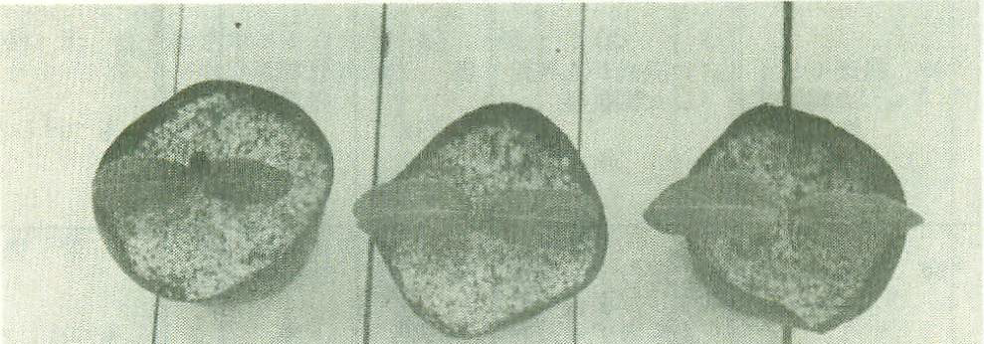  _{1st leaf} | _{1st leaf} | _{1st leaf}
1 | 2 | 3
small | medium | large

Ad. 2: Plant: Length vigor of the main stem

It can be assessed thought the volume of the plant or the surface the plant covers in the field after the beginning of flowering -8.1.(b) stage. At this stage, theoretically, even the faster varieties don’t start yet to touch each other in the field. (planting space suggested 1.80m).

Ad.NEW 6: Leaf blade: degree of lobing

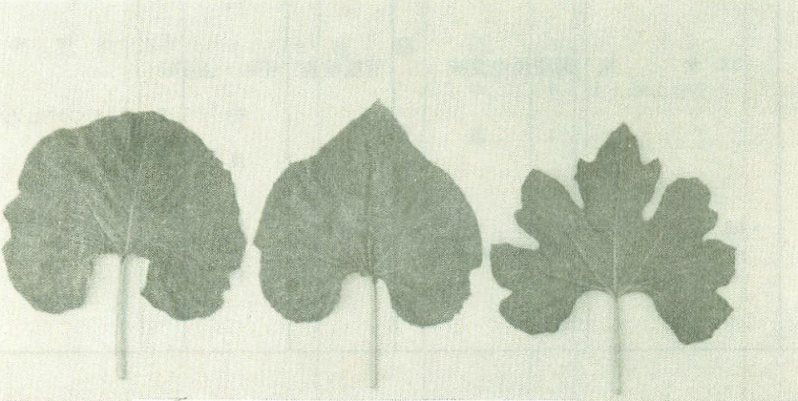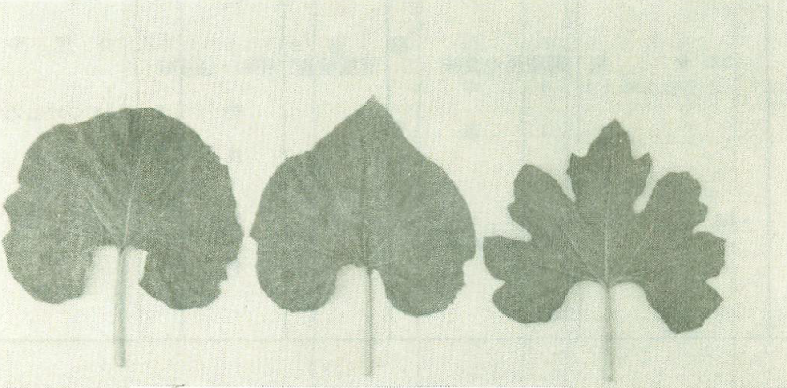 | 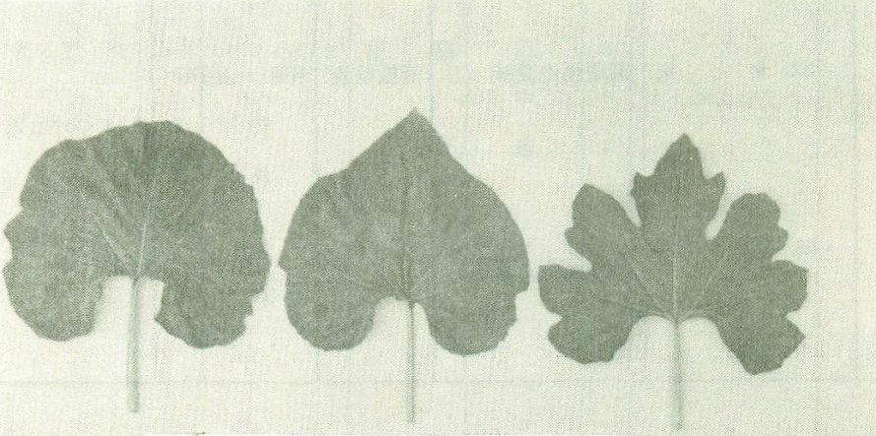
1 | 2 | 3
absent or weak | medium | strong

Ad. 9: Male flower: overlapping of petals

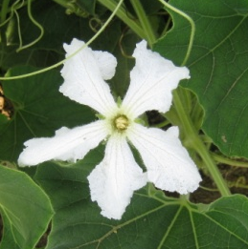 | 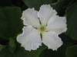 | 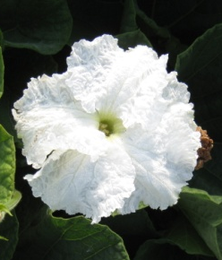
1 | 2 | 3
free | touching to slightly overlapping | strongly overlapping

Ad. NEW (UA-1): Female flower: ring at inner side of corolla

 | 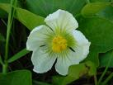
1 | 9
absent | present

Ad. NEW (UA-2): Female flower: overlapping of petals

1 | 2 | 3
free | touching to slightly overlapping | strongly overlapping

Ad.11: Young fruit: bitterness

The bitterness of the young fruit should be observed by tasting.

Ad. 12: Fruit: shape in longitudinal section

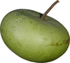 | 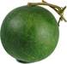 | 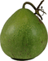 | 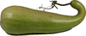 | 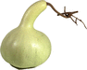 | 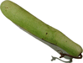
1 | 2 | 3 | 4 | 5 | 6
oblate | circular | pyriform | elongated pyrifom | cavate | cylindrical

Definition according TGP/14/1:
- oblate: transverse elliptic; ellipse shaped but shorter than broad, broadest at the middle,
with margins tapering convexly and evenly to the base and apex, the longest
dimension orientated transversely. Forms part of the ‘elliptic’ series.
- circular: Round; length/width ratio as well as dimension in all directions 1:1. The term ‘circular’ is preferable to ‘round’ and ‘orbicular’ for UPOV use. Forms part of ‘elliptic’ series. Also applies to arrangement. Compare ‘rounded’ which applies to the part of an outline, not the full shape. Instead of Round use “circular”. Applies to the base, apex, lateral sides, etc. but not to be used for describing the general outline of a plane figure.
- pyriform: Pear-shaped; obovoid with a contraction towards the base.
- cavate: Club shaped - shaped like a club; thickening towards the apex from a tapered base

Ad. 13: Fruit: length

This assessment is based on the developed length of the fruit.

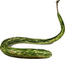  Base of the fruit  Top of the fruit | Top of the fruit  Base of the fruit
Base of the fruit
Top of the fruit

Ad. 14: Fruit: diameter

This assessment is based on the widest part of the fruit.

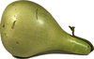 | 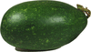 | 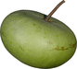

Ad. 15: Fruit: neck


1 | 9
absent | present

Ad. 16: Only necked varieties: Fruit: shape of neck

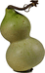 | 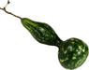 | 
1 |  | 2
fusiform shaped |  | cylindrical

Definition according TGP/14/1:
- fusiform: Spindle-shaped; long and narrow, circular in transverse section, thick in the middle and tapering to both ends.

Ad. 17: Only necked varieties: Fruit: length of neck

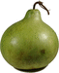 | 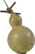 |  | 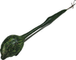 | 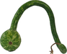
1 | 3 | 5 | 7 | 9
very short | short | medium | long | very long

Ad. 18: Only necked varieties: Fruit: diameter of neck

 |  | 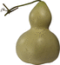
3 | 5 | 7
small | medium | large

Ad.20: Fruit: intensity of main green color

 | 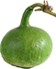 | 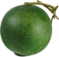 | 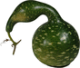 | 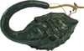
1 | 3 | 5 | 7 | 9
very light | light | medium | dark | very dark

The main color is the color with the largest surface.

Ad. 21: Fruit: speckles

 | 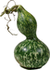
absent | present
1 | 9

Ad. 22: Only speckled varieties: Fruit: number of speckles

 | 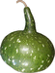
3 | 5 | 7
few | medium | many

Ad. NEW (NL-1): Only speckled varieties: Fruit: size of speckles

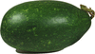 | 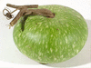 | 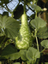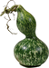
3 | 5 | 7
small | medium | large

Ad. 23: Fruit: texture of skin

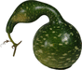 | 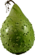 | 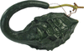
smooth | verrucose | corrugated
1 | 2 | 3

Ad. 24: Only varieties with: Fruit: Texture of skin: warted: Density number of warts

 |  | 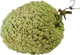
3 | 5 | 7
few | medium | many

Ad. 25: Seed: size width

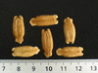 | 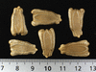 | 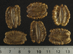
3 | 5 | 7
small narrow | medium | large broad

Ad. 26: Seed: color

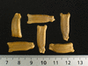 | 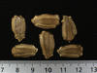 | 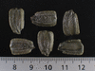
1 | 2 | 3
light brown | dark brown | black

Literature

http://cucurbitophile.fr/esp/051/esp.php

http://www.ars-grin.gov/~sbmljw/cgi-bin/taxon.pl?21385

http://plants.usda.gov/java/profile?symbol=LASI

http://www.prota4u.org/protav8.asp?h=M4&t=lagenaria,siceraria&p=Lagenaria+siceraria#Synonyms

Darekar, K.S., Mhase, N.L. & Shelke, S.S., 1989. Effect of nematicidal seed treatment on root knot nematode and yield of bottle-gourd. International Nematology Network Newsletter 6(1): 14–16.
Decker-Walters, D., Staub, J., López-Sesé, A. & Nakata, E., 2001. Diversity in landraces and cultivars of bottle gourd (Lagenaria siceraria: Cucurbitaceae) as assessed by random amplified polymorphic DNA. Genetic Resources and Crop Evolution 48: 369–380.
Heiser, C.B., 1979. The gourd book. University of Oklahoma Press, Norman, United States. 248 pp.
Jeffrey, C., 1967. Cucurbitaceae. In: Milne-Redhead, E. & Polhill, R.M. (Editors). Flora of Tropical East Africa. Crown Agents for Oversea Governments and Administrations, London, United Kingdom. 157 pp.
Maundu, P.M., Ngugi, G.W. & Kabuye, C.H.S., 1999. Traditional food plants of Kenya. Kenya Resource Centre for Indigenous Knowledge (KENRIK), Nairobi, Kenya. 270 pp.
Morimoto, Y. & Mvere, B., 2004. Lagenaria siceraria (Molina) Standl. [Internet] Record from Protabase. Grubben, G.J.H. & Denton, O.A. (Editors). PROTA (Plant Resources of Tropical Africa / Ressources végétales de l’Afrique tropicale), Wageningen, Netherlands. < http://database.prota.org/search.htm>.

Richardson, J.B., 1972. The pre-Columbian distribution of the bottle gourd (Lagenaria siceraria): a re-evaluation. Economic Botany 26: 265–273.
Schippers, R.R., 2002. African indigenous vegetables, an overview of the cultivated species 2002. Revised edition on CD-ROM. National Resources International Limited, Aylesford, United Kingdom.
Shah, B.N., Seth, A.K., Desai, R.V., 2010. Phytopharmacological Profile of Lagenaria siceraria: A Review. Asian Journal of Plant Sciences 9 (3), pp.152 to pp.157.

Widjaja, E.A. & Reyes, M.E.C., 1993. Lagenaria siceraria (Molina) Standley. In: Siemonsma, J.S. & Kasem Piluek (Editors). Plant Resources of South-East Asia No 8. Vegetables. Pudoc Scientific Publishers, Wageningen, Netherlands. pp. 190–192.

Technical Questionnaire

TECHNICAL QUESTIONNAIRE |  |  |  | Page {x} of {y} |  | Reference Number:
 |  |  |  |  |  | Application date:
 |  |  |  |  |  | (not to be filled in by the applicant)
TECHNICAL QUESTIONNAIRE
to be completed in connection with an application for plant breeders’ rights

1. Subject of the Technical Questionnaire
1.1 Botanical name |  |  | Lagenaria siceraria (Molina) Standl.
1.2 Common name |  |  | Bottle Gourd, Calabash
2. Applicant
Name
Address
Telephone No.
Fax No.
E-mail address
Breeder (if different from applicant)
3. Proposed denomination and breeder’s reference
Proposed denomination
(if available)

Breeder’s reference
4. Information on the breeding scheme and propagation of the variety

4.1 Breeding scheme

Variety resulting from:

4.1.1 Crossing

(a) controlled cross [ ]
(please state parent varieties)

(…………………..……………..…) x (……………..…………………..…)
female parent male parent

(b) partially known cross [ ]
(please state known parent variety(ies))

(…………………..……………..…) x (……………..…………………..…)
female parent male parent

(c) unknown cross [ ]

4.1.2 Mutation [ ]
(please state parent variety)

4.1.3 Discovery and development [ ]
(please state where and when discovered and how developed)

4.1.4 Other [ ]
(please provide details)

4.2 Method of propagating the variety (hybride)

4.2.1 Seed-propagated varieties

In the case of hybrid varieties the production scheme for the hybrid should be provided on a separate sheet.
This should provide details of all the parent lines required for propagating the hybrid e.g.

Single Hybrid

(…………………..……………..) x (……………..…………………..)
female parent male parent

Three-Way Hybrid

(…………………..……………..) x (……………..…………………..)
female line male line

(……………..…………………..) x (……………..…………………..)
single hybrid used as female parent male parent

and should identify in particular:

(a) any male sterile lines
(b) maintenance system of male sterile lines.”

4.2.2 Vegetatively propagated varieties [...]

4.2.3 Other [ ]
(please provide details)

5. Characteristics of the variety to be indicated (the number in brackets refers to the corresponding characteristic in Test Guidelines; please mark the note which best corresponds).

 | Characteristics |  |  |  |  |  | Example Varieties |  |  | Note
5.1  (2) | Plant: length of main stem
 | very short |  |  |  |  |  |  |  |  | 1 [ ]
 | very short to short |  |  |  |  |  |  |  |  | 2 [ ]
 | short |  |  |  |  |  | Koganeizairai |  |  | 3 [ ]
 | short to medium |  |  |  |  |  |  |  |  | 4 [ ]
 | medium |  |  |  |  |  | Shimotsukeshiro |  |  | 5 [ ]
 | medium to long |  |  |  |  |  |  |  |  | 6 [ ]
 | long |  |  |  |  |  | Aodainaga |  |  | 7 [ ]
 | long to very long |  |  |  |  |  |  |  |  | 8 [ ]
 | very long |  |  |  |  |  |  |  |  | 9 [ ]
5.2  (12) | Fruit: shape in longitudinal section
 | oblate |  |  |  |  |  | Plate de Corse |  |  | 1 [ ]
 | circular |  |  |  |  |  | Canon Ball |  |  | 2 [ ]
 | pyriform |  |  |  |  |  | Tarahumara canteen |  |  | 3 [ ]
 | elondated pyriform |  |  |  |  |  | Mayo Giant Bule |  |  | 4 [ ]
 | cavate |  |  |  |  |  | Bianca |  |  | 5 [ ]
 | cylindrical |  |  |  |  |  | Massue comestible |  |  | 6 [ ]
5.3  (13) | Fruit: length
 | very short |  |  |  |  |  | Canon Ball |  |  | 1 [ ]
 | very short to short |  |  |  |  |  |  |  |  | 2 [ ]
 | short |  |  |  |  |  | Pélerine pointue |  |  | 3 [ ]
 | short to medium |  |  |  |  |  |  |  |  | 4 [ ]
 | medium |  |  |  |  |  | Mayo Giant Bule |  |  | 5 [ ]
 | medium to long |  |  |  |  |  |  |  |  | 6 [ ]
 | long |  |  |  |  |  | Zucca |  |  | 7 [ ]
 | long to very long |  |  |  |  |  |  |  |  | 8 [ ]
 | very long |  |  |  |  |  | Snake speckled |  |  | 9 [ ]
 | Characteristics |  |  |  |  |  | Example Varieties |  |  | Note
5.4  (14) | Fruit: diameter
 | very small |  |  |  |  |  | Mini Nigerian |  |  | 1 [ ]
 | very small to small |  |  |  |  |  |  |  |  | 2 [ ]
 | small |  |  |  |  |  | Massue comestible |  |  | 3 [ ]
 | small to medium |  |  |  |  |  |  |  |  | 4 [ ]
 | medium |  |  |  |  |  | Strawberry |  |  | 5 [ ]
 | medium to large |  |  |  |  |  |  |  |  | 6 [ ]
 | large |  |  |  |  |  | Blue Mayo |  |  | 7 [ ]
 | large to very large |  |  |  |  |  |  |  |  | 8 [ ]
 | very large |  |  |  |  |  | Figue |  |  | 9 [ ]
5.5  (15) | Fruit: neck
 | absent |  |  |  |  |  | Strawberry |  |  | 1 [ ]
 | present |  |  |  |  |  | Figue |  |  | 9 [ ]
5.6  (17) | Only necked varieties: Fruit: length of neck
 | very short |  |  |  |  |  | Missionaris |  |  | 1 [ ]
 | very short to short |  |  |  |  |  |  |  |  | 2 [ ]
 | short |  |  |  |  |  | Indonesian bottle |  |  | 3 [ ]
 | short to medium |  |  |  |  |  |  |  |  | 4 [ ]
 | medium |  |  |  |  |  | Long handled dipper |  |  | 5 [ ]
 | medium to long |  |  |  |  |  |  |  |  | 6 [ ]
 | long |  |  |  |  |  | Duck Australie fr |  |  | 7 [ ]
 | long to very long |  |  |  |  |  |  |  |  | 8 [ ]
 | very long |  |  |  |  |  | Extra long dipper |  |  | 9 [ ]
5.7  (19) | Fruit : ground color |  |  |  |  |  | DELETED
 | yellow |  |  |  |  |  |  |  |  | 1
 | green |  |  |  |  |  |  |  |  | 2
5.8  (21) | Fruit: speckles
 | absent |  |  |  |  |  | Marenka Limegreen, Shimotsukeshiro |  |  | 1 [ ]
 | present |  |  |  |  |  | Froggy, Shimotsukeao |  |  | 9 [ ]
 | Characteristics |  |  |  |  |  | Example Varieties |  |  | Note
5.9  (23) | Fruit: texture of skin
 | smooth |  |  |  |  |  | Kroochneck fr |  |  | 1 [ ]
 | verrucose |  |  |  |  |  | Bule Mayo |  |  | 2 [ ]
 | corrugated |  |  |  |  |  | Marenka |  |  | 3 [ ]
6. Similar varieties and differences from these varieties

Please use the following table and box for comments to provide information on how your candidate variety differs from the variety (or varieties) which, to the best of your knowledge, is (or are) most similar. This information may help the examination authority to conduct its examination of distinctness in a more efficient way.

Denomination(s) of variety(ies) similar to your candidate variety |  | Characteristic(s) in which your candidate variety differs from the similar variety(ies) |  |  | Describe the expression of the characteristic(s) for the similar variety(ies) |  |  | Describe the expression of the characteristic(s) for your candidate variety
Example |  | Only necked varieties: Fruit: length of neck |  |  | long |  |  | very long
Comments:

7. Additional information which may help in the examination of the variety

7.1 In addition to the information provided in sections 5 and 6, are there any additional characteristics which may help to distinguish the variety?
 | not tested | susceptible | resistant | Resistance level:  moderately ? highly?
Colletotrichum orbiculare race 1
Colletotrichum orbiculare race 2
Colletotrichum orbiculare race 3
Fusarium oxysporum f.sp. lagenariae
Podosphaera xanthii
Cucumber green mottle mosaic virus (CGMMV)
Cucumber mosaic virus (CMV)
Papaya ringspot virus (PRSV)
Zucchini yellow mosaic virus (ZYMV)
Meloidogyne arenaria
Meloidogyne incognita
Meloidogyne javanica
Meloidogyne hapla

7.2 Are there any special conditions for growing the variety or conducting the examination?

Yes [ ] No [ ]
(If yes, please provide details)

7.3 Other information
Variety use
(a) vegetable [ ]
(b) rootstock, with an impact on:
- the adaptation to abiotic stresses (low temperature, salinity, water excess or shortage) |  |  |  |  | [ ]
- the yield via an increased vigor |  |  |  |  | [ ]
- Improving fruit quality |  |  |  |  | [ ]
- the control of soil-borne diseases |  |  |  |  | [ ]
 | not tested | susceptible | resistant | Resistance level:  intermediate ? highly?
Didymella bryoniae
Fusarium oxysporum f.sp. melonis Race 1
Fusarium oxysporum f.sp. melonis Race 1-2
Fusarium oxysporum f.sp. melonis Race 2
Fusarium oxysporum f.sp. niveum Race 0
Fusarium oxysporum f.sp. niveum Race 1
Fusarium oxysporum f.sp. niveum Race 2
Fusarium oxysporum f.sp. radicis cucumerinum
Macrophomina phaseolina
Monosporascus cannonballus
Phomopsis sclerotioïdes
Rhizoctonia solani
Verticillium albo- atrum
Verticillium dahliae
(please provide details)
(c) other: container, ornamental, musical instrument… [ ]
(please provide details)

A representative color image of the fruit at full development should accompany the Technical Questionnaire.
8. Authorization for release

(a) Does the variety require prior authorization for release under legislation concerning the protection of the environment, human and animal health?

Yes [ ] No [ ]

(b) Has such authorization been obtained?

Yes [ ] No [ ]

If the answer to (b) is yes, please attach a copy of the authorization.

9. Information on plant material to be examined or submitted for examination.

9.1 The expression of a characteristic or several characteristics of a variety may be affected by factors, such as pests and disease, chemical treatment (e.g. growth retardants or pesticides), effects of tissue culture, different rootstocks, scions taken from different growth phases of a tree, etc.

9.2 The plant material should not have undergone any treatment which would affect the expression of the characteristics of the variety, unless the competent authorities allow or request such treatment. If the plant material has undergone such treatment, full details of the treatment must be given. In this respect, please indicate below, to the best of your knowledge, if the plant material to be examined has been subjected to:

(a) Microorganisms (e.g. virus, bacteria, phytoplasma) Yes [ ] No [ ]

(b) Chemical treatment (e.g. growth retardant, pesticide) Yes [ ] No [ ]

(c) Tissue culture Yes [ ] No [ ]

(d) Other factors Yes [ ] No [ ]

Please provide details for where you have indicated “yes”.

……………………………………………………………

10. I hereby declare that, to the best of my knowledge, the information provided in this form is correct:

Applicant’s name

Signature Date

[Annex follows]
Comments from the Subgroup on document TG/LAGEN(proj.2)

Chapter 7-Table of Characteristics/Tableau des caractères/Merkmalstabelle/Tabla de characters

2.  (+) | VG | Plant: Length of the main stem
(NL) It is very difficult to observe this, because the plant tends to develop many branches. We used to look at the volume of the plant or the surface the plant covers in the field, just before the plants of the variety which grows fastest, start to ‘touch’ each other in the field.
(HU) Same problem as Cucurbita. It has to be observed earlier than “8.1 key (b): before the development of fruits.
(FR proposal)
The wording “Length” is probably not the optimal one…
I propose to consider the vigor of the plant at relative early stage (new stage 8.1 (a)), not “when the 1st fruit is fully developed”, but “after the beginning of flowering”.

(+) It can be assessed thought the volume of the volume of the plant or the surface the plant covers in the field after the beginning of flowering -8.1.(b) stage. At this stage, theoretically, even the faster varieties don’t start yet to touch each other in the field. (planting space suggested 1.80m).
To be discussed.

5. | VG | Leaf blade: blistering
(NL) Char. 5: we cannot provide example varieties
(FR proposal)
Without example varieties, to delete this characteristic.
To be discussed.

6.  (+) | VG | Leaf blade: lobing
7. | VG | Leaf blade: margin
NL) Char.6: this is a QN characterisitic, so we prefer a combination with char. 7: (seeTGP/14/1 page 49)
Leaf blade: degree of lobing: 1 absent or weak 2 medium 3 strong. Note that it is not a characteristic of the margin, but of the blade as a whole.
(HU) Ch.6: Two characters are under one character.
1 and 3 is two different leaf shape without lobing
3 and 5 are almost similar leaf shape with acute top but without lobing (3)
and with lobing (5)
(HU) Ch.7: propose to delete it
(FR proposal)
To delete Char.6 and Char. 7 as they are.
To create a “new” character 6.

NEW  6. | VG | Leaf blade: degree of lobing
 |  | absent or weak |  | 1
QN |  | medium |  | 2
 |  | strong |  | 3

8.  (+) | VG | Male flower: diameter of corolla
 |  | small |  | 1
QN |  | medium | Shimotsukeshiro | 2
 |  | large |  | 3
(FR) example varieties to provide. At last state (1) or state (3).
FR proposal
To be discussed

9.  (+) | VG | Male flower: overlapping of petals
(NL) Char 9: According to TGP/14/1 page 48 the wording of the states could be: 1 free/2 touching to slightly overlapping/3 strongly overlapping
(FR answer)
I agree. Updated.

10. | MS/VG | Female flower: diameter of corolla
 |  | small |  | 1
QN |  | medium | Shimotsukeshiro | 2
 |  | large |  | 3
(FR) example varieties to provide. At last state (1) or state (3).
FR proposal
To be discussed

NEW (UA-1)  ***. | VG | Female flower: ring inside corolla
(+) |  | absent |  | 1
QL |  | present |  | 9
(UA) To add another characteristic:
(FR proposal)
- To be consistent with a similar characterisitc (Char.19 (TG//119/4 Corr. Vegetable Marrow, Squash), I propose the char.“Female flower: ring at inner side of corolla”
- Example varieties to provide.
To be discussed

NEW (UA-2)  ***. | VG | Female flower: arrangement of corolla petals
(+) |  | separate |  | 1
QL |  | adjacent |  | 2
 |  | overlapping |  | 3
(UA) To add another characteristic
(FR proposal)
- to be consistent with char 10. “Male flower: overlapping of petals”, I propose to replace by the char. “Female flower: overlapping of petals” with the states: 1 free /2 touching to slightly overlapping /3 strongly overlapping (TGP/14/1 page 48, wording states).
To be discussed.

11.  (+) | VG | Young fruit: bitterness
(FR) example variety for state (9) to provide. Some proposals?
(FR proposal)
To be discussed

12.  (*)  (+) | VG | Fruit: shape in longitudinal section
(NL) Char 12 state 2 should read circular
(FR answer)
I agree. Corrected.
All the states correspond to TGP/14.

19.  (*)  (+) | VG | Fruit : ground color
(JP) We checked color of “Shimotukesiro” and it was “very light green” rather than “Yellow”.
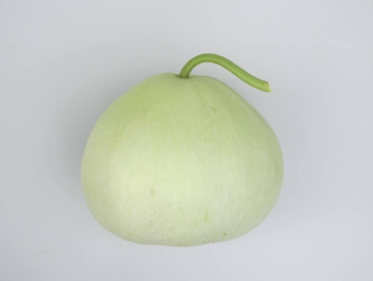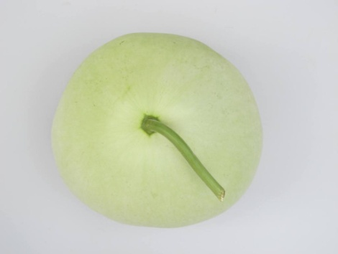
Color of “Shimotukeshiro”
(JP) We agree to delete “Chara.19”
and to change Chara.20 to “Intensity of green color”.
FR proposal
To update:
- Deletion of the char 19
- New wording of char 20 “Intensity of green color”.
- Updating of the TQ: 5.7 deleted

20.  (+) | VG | Fruit : intensity of ground color
(NL) Char 20: The wording could be: Fruit: intensity of the main green color
In Ad 20 it could be explained that the main color is the color with the largest surface
FR answer
I agree NL proposal.
- Fruit : intensity of main green color
- Ad.20 to be included

21.  (*)  (+) | VG | Fruit : speckles
(NL) Char 21: maybe blotch is better because they have only one intensity
(FR answer)
Could you please precise the reference of the definitions of the term “blotch” and “speckles”, to introduce in the respective current UPOV drafts (TG_LAGEN (proj 2) – this draft, and TG-CUCUR_MMO (proj.1))?
The definition I found states that “Speckle” means: a small or slight mark usually of a contrasting color, as on the skin, a bird's plumage, or eggs.
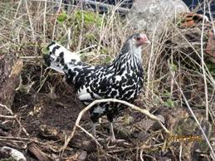 | 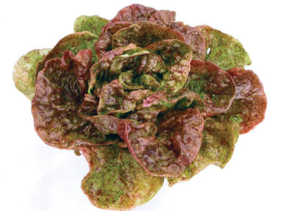
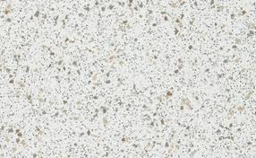
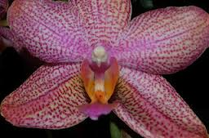
This wording was proposed last year to describe the “blotches” on the Lagenaria fruits.
To be discussed.

22.  (+) | VG | Only speckled varieties: Fruit : Number of speckles
(NL) Char 22: maybe blotch is better because they have only one intensity
(FR answer)
To be discussed
and updated where appropriate (draft TG-CUCUR_MMO (proj.1) and TG_LAGEN (proj 2) – this draft).

NEW (NL-1) | VG | Only speckled varieties: Fruit : Size of speckles
(NL) To add another characteristic: size of blotches
(FR) States small (3) / medium (5) / big (7). Pictures and example varieties provided.
(FR proposal)
I agree this proposal.
Updating where appropriate the use of “blotch” or “speckle” in this draft).

23.  (*)  (+) | VG | Fruit : Texture of skin
(NL) Char 23: prefer to keep the wording as it was: warted and ridged, because:
- it is easier to understand
- and in char 24 ‘warts’ is used
FR answer
The proposed states are : smooth (1), verrucose (2), corrugated (3), which correspond to the following TGP/14/1 definitions:

Verrucose Warty; with more or less irregularly shaped wart-like elevations. Compare ‘bullate’, where the convexities are blister-like.
Corrugated Wrinkled; crumpled or folded into alternating furrows and ridges, e.g. Papaver petals in the bud. Compare ‘rugose’.
rugose bullate verrucose | corrugated

To be discussed.

24.  (+) | VG | Only varieties with: Fruit: Texture of skin: warted: Number of warts
(NL) Char 24: prefer density of warts instead of number of warts

FR answer
I agree. To update states of expression (small (3), medium (5), high (7)
To be discussed.

25.  (+) | MS/VG | Seed : size
(NL) Char 25: prefer Seed: width instead of size

FR answer
I agree. To update states of expression (narrow (3), medium (5), broad (7)
To be discussed.

Chapter 8 - Explanations on the Table of Characteristics

8.1 Explanations covering several characteristics

(UA) Proposal of growth and development stage:
Codes | Plant growth stage and development stage
1 | Cotyledon emergence
2 | Leaf rosette (tent-shaped)
3 | Stem development
4 | Blooming of male and female flowers
5 | Fruit-bearing (first fruit formation)
6 | Industrial maturity (first fruit)
7 | Biological maturity (first fruit)

(FR proposal)
Up-dating of the key:
- Observations which should be made at appearing of the first leaf
- Observations which should be made on fully developed leaves, at beginning of flowering.
- Observations which should be made on flowers at full flowering
- Observations which should be made on fruits at physiological maturity.
- Observations which should be made on fully developed dry seeds, after washing and drying in the shade.
To be discussed.
To update the distribution in Chapter 7.

8.2 Explanations for individual characteristics

Ad.1: Seedling: Size of cotyledons

_{1st leaf} | _{1st leaf} | _{1st leaf}
1 | 2 | 3
small | medium | large

- (TWV 2012) Explanations on how to measure (KR to provide)
FR proposal
At emergence of the first leaf
(FR questions)
- Is possible to increase the quality of picture?
- To make a drawing? Instead of the pictures which can be confusing.
To be discussed.

Ad.2: Plant: length of the main stem

NL It is not easy to observe because the plant tends to develop many branches. NL colleague suggest looking at the volume of the plant or the surface the plant covers in the field, just before the plants of the variety which grows fastest, start to ‘touch’ each other in the field.
FR proposal
The wording “Length” is probably not the optimal one…
I propose to consider the vigor of the plant at relative early stage (new stage 8.1 (a)):
Not “when the 1st fruit is fully developed”, but “after the beginning of flowering”.
It can be assessed thought the volume of the plant or the surface the plant covers in the field after the beginning of flowering -8.1.(b) stage. At this stage, theoretically, even the faster varieties don’t start yet to touch each other in the field. (planting space suggested 1.80m).
To be discussed.

Ad.NEW 6: Leaf blade: degree of lobing

1 | 2 | 3
absent or weak | medium | strong

(FR questions
Is it possible to increase the quality of picture? Or make a drawing.
To be discussed.

Ad. 9: Male flower: overlapping of petals

1 | 2 | 3
free | touching to slightly overlapping | strongly overlapping

Ad. NEW (UA-1): Female flower: ring inside corolla Female flower: ring at inner side of corolla

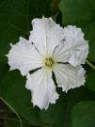
1 | 9
absent | present

(FR questions) to (UA)
- To replace a picture of male flower by picture of female flower

Ad. NEW (UA-2): Female flower: arrangement of corolla petals Female flower: overlapping of petals

 |  | 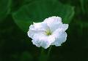
1 | 2 | 3
free | touching to slightly overlapping | strongly overlapping

(FR questions) to (UA)
- Picture for state State (1) could it be more clear? because it could illustrate quite state (2)…
- To replace a picture of male flower by picture of female flower
To be discussed

Ad. 20: Fruit: intensity of the main green color
(NL) The main color is the color with the largest surface
FR answer
To add this sentence.

Ad. NEW (NL-1): Only speckled varieties: Fruit : Size of speckles

3 | 5 | 7
small | medium | large
(NL) To add another characteristic: size of blotches
(FR) Pictures to illustrate – provided
small / Basket Ball Brasil | Medium / Chata P. Alegre | Large / Babaka mahafaly/ Froggy

FR answer:
To update the wording if necessary.: blotch / speckle.

Ad. 25: Seed : size

3 | 5 | 7
small narrow | medium | large broad
(NL) Char 25: prefer Seed: width instead of size
FR answer
I agree.
To be discussed.

Chapter 10 - Technical Questionnaire

4. Information on the breeding scheme and propagation of the variety

(ISF) TQ / 4 –
“please use the same lay-out as in Cucurbita maxima x Cucurbita moschata:
FR answer
I am not sure in this species we need a so complete document as the paragraph 4 included in the TG/CUCUR_MMO (proj.1).
4.1 Breeding scheme
4.2 Method of propagating the variety (hybride)

I think I misunderstand your proposal… For me this lightened version could be enough.
4. Information on the breeding scheme and propagation of the variety

4.1 Breeding scheme

Variety resulting from:

4.1.1 Crossing

(a) controlled cross [ ]

(b) partially known cross [ ]

(c) unknown cross [ ]

4.1.2 Mutation [ ]
(please state parent variety)

4.1.3 Discovery and development [ ]
(please state where and when discovered and how developed)

4.1.4 Other [ ]”
(please provide details)”

4.2 Method of propagating the variety

4.2.1 Seed-propagated varieties

(a) Self-pollination [ ]

(b) Cross-pollination
(i) population [ ]

(ii) synthetic variety [ ]

(c) Hybrid [ ]

(d) Other [ ]
(please provide details)

To be clarified and discussed.

7. Additional information which may help in the examination of the variety

(ISF) In the Technical Questionnaire several diseases are mentioned. However, none of them appear in the Table of characteristics. Is this correct?
FR answer
I can’t provide up to now the disease resistance test protocols, which have to be associated in paragraph 8.2 to each disease resistance characteristic included.
We have to prioritize these characteristics, to identify which protocol(s) could have to be finalized first.

(NL) TQ/ 7.1 and 7.3
If these diseases cannot affect the crop because of non host resistance, and no susceptible varieties exist, then not to include these in the TQ.
FR answer
I agree. Could you propose me the diseases to exclude?

(ISF) We propose to delete Didymella bryoniae and all races of Fusarium .... melonis and Fusarium ..... niveum, since Lagenaria is a non host.
FR answer
I clearly agree for F. o. melonis and F. o. niveum. But I didn’t find information about the situation of D. bryoniae. You can confirm?

Comments on Pathogens / Soil borne diseases

(UA) It is recommended that the examination of resistance to the pathogens above is carried out under a binding stipulation that a candidate variety differs from that of common knowledge variety by the characteristic of resistance to specific pathogen(s) as included into the Table of Characteristics.
However, we consider that being resistant to pathogens does not constitute a morphological distinction of a variety.
FR answer
I don’t agree with you. The behavior of a variety against a pathogene is the expression of its genotype. So, we can consider this type of characteristics “as an over phenotypical characteristic” in the exam of Distinctness (length of the fruit, color of the leaf…, resistance to Verticillium dahliae …). A disease resistance characteristic requires an appropriate protocol to be assessed. A harmonized protocol has to be included in the paragraph “8.2 Explanations for individual characteristics” of the UPOV guideline of the concerned species to allow a harmonized method to describe it.

[End of Annex and of document]

* These names were correct at the time of the introduction of these Test Guidelines but may be revised or updated. [Readers are advised to consult the UPOV Code, which can be found on the UPOV Website (www.upov.int), for the latest information.]

