 |  |  |  |  |  |  | E  TG/CASSAV(proj.4)  ORIGINAL: English  DATE: 2013-04-11
INTERNATIONAL UNION FOR THE PROTECTION OF NEW VARIETIES OF PLANTS
Geneva
 |  |  | DRAFT
 |  | CASSAVA  UPOV Code: MANIH_ESC  (Manihot esculenta Crantz.) |  |  | *

GUIDELINES

FOR THE CONDUCT OF TESTS

FOR DISTINCTNESS, UNIFORMITY AND STABILITY

prepared by experts from Brazil and Kenya

to be considered by the

Technical Working Party for Vegetables
at its forty-seventh session, to be held in Nagasaki, Japan, from May 20 to 24, 2013

Alternative Names:*

Botanical name | English | French | German | Spanish
Manihot esculenta Crantz | Cassava | Manioc | Maniok | Mandioca, Yuca

The purpose of these guidelines (“Test Guidelines”) is to elaborate the principles contained in the General Introduction (document TG/1/3), and its associated TGP documents, into detailed practical guidance for the harmonized examination of distinctness, uniformity and stability (DUS) and, in particular, to identify appropriate characteristics for the examination of DUS and production of harmonized variety descriptions.

ASSOCIATED DOCUMENTS
These Test Guidelines should be read in conjunction with the General Introduction and its associated TGP documents.
TABLE OF CONTENTS PAGE

1. Subject of these Test Guidelines 3
2. Material Required 3
3. Method of Examination 3
3.1 Number of Growing Cycles 3
3.2 Testing Place 3
3.3 Conditions for Conducting the Examination 3
3.4 Test Design 3
3.5 Additional Tests 3
4. Assessment of Distinctness, Uniformity and Stability 4
4.1 Distinctness 4
4.2 Uniformity 5
4.3 Stability 5
5. Grouping of Varieties and Organization of the Growing Trial 5
6. Introduction to the Table of Characteristics 5
6.1 Categories of Characteristics 5
6.2 States of Expression and Corresponding Notes 6
6.3 Types of Expression 6
6.4 Example Varieties 6
6.5 Legend 7
7. Table of Characteristics/Tableau des caractères/Merkmalstabelle/Tabla de caracteres 8
8. Explanations on the Table of Characteristics 14
8.1 Explanations covering several characteristics 14
8.2 Explanations for individual characteristics 14
9. Literature 21
10. Technical Questionnaire 22

Subject of these Test Guidelines

These Test Guidelines apply to all varieties of Manihot esculenta Crantz.

In the case of ornamental varieties, it may, in particular, be necessary to use additional characteristics to those included in the Table of Characteristics in order to examine Distinctness, Uniformity and Stability.

Material Required

2.1 The competent authorities decide on the quantity and quality of the plant material required for testing the variety and when and where it is to be delivered. Applicants submitting material from a State other than that in which the testing takes place must ensure that all customs formalities and phytosanitary requirements are complied with.

2.2 The material is to be supplied in the form of cuttings.

2.3 The minimum quantity of plant material, to be supplied by the applicant, should be:

30 cuttings, each one with a length of 20cm with 5 to 8 buds.

2.4 The plant material supplied should be visibly healthy, not lacking in vigor, nor affected by any important pest or disease.

2.5 The plant material should not have undergone any treatment which would affect the expression of the characteristics of the variety, unless the competent authorities allow or request such treatment. If it has been treated, full details of the treatment must be given.

Method of Examination

3.1 Number of Growing Cycles

The minimum duration of tests should normally be a single growing cycle.

3.2 Testing Place

Tests are normally conducted at one place. In the case of tests conducted at more than one place, guidance is provided in TGP/9 “Examining Distinctness”.

3.3 Conditions for Conducting the Examination

The tests should be carried out under conditions ensuring satisfactory growth for the expression of the relevant characteristics of the variety and for the conduct of the examination.

3.4 Test Design

3.4.1 Each test should be designed to result in a total of at least 20 plants, which should be divided between two or more replicates.

3.4.2 The design of the tests should be such that plants or parts of plants may be removed for measurement or counting without prejudice to the observations which must be made up to the end of the growing cycle.

3.5 Additional Tests

Additional tests, for examining relevant characteristics, may be established.

Assessment of Distinctness, Uniformity and Stability

4.1 Distinctness

4.1.1 General Recommendations

It is of particular importance for users of these Test Guidelines to consult the General Introduction prior to making decisions regarding distinctness. However, the following points are provided for elaboration or emphasis in these Test Guidelines.

4.1.2 Consistent Differences

The differences observed between varieties may be so clear that more than one growing cycle is not necessary. In addition, in some circumstances, the influence of the environment is not such that more than a single growing cycle is required to provide assurance that the differences observed between varieties are sufficiently consistent. One means of ensuring that a difference in a characteristic, observed in a growing trial, is sufficiently consistent is to examine the characteristic in at least two independent growing cycles.

4.1.3 Clear Differences

Determining whether a difference between two varieties is clear depends on many factors, and should consider, in particular, the type of expression of the characteristic being examined, i.e. whether it is expressed in a qualitative, quantitative, or pseudo-qualitative manner. Therefore, it is important that users of these Test Guidelines are familiar with the recommendations contained in the General Introduction prior to making decisions regarding distinctness.

4.1.4 Number of Plants / Parts of Plants to be Examined

Unless otherwise indicated, for the purposes of distinctness, all observations on single plants should be made on 10 plants or parts taken from each of 10 plants and any other observations made on all plants in the test, disregarding any off-type plants.

4.1.5 Method of Observation

The recommended method of observing the characteristic for the purposes of distinctness is indicated by the following key in the second column of the Table of Characteristics (see document TGP/9 “Examining Distinctness”, Section 4 “Observation of characteristics”):

MG: single measurement of a group of plants or parts of plants
MS: measurement of a number of individual plants or parts of plants
VG: visual assessment by a single observation of a group of plants or parts of plants
VS: visual assessment by observation of individual plants or parts of plants

Type of observation: visual (V) or measurement (M)

“Visual” observation (V) is an observation made on the basis of the expert’s judgment. For the purposes of this document, “visual” observation refers to the sensory observations of the experts and, therefore, also includes smell, taste and touch. Visual observation includes observations where the expert uses reference points (e.g. diagrams, example varieties, side-by-side comparison) or non-linear charts (e.g. color charts). Measurement (M) is an objective observation against a calibrated, linear scale e.g. using a ruler, weighing scales, colorimeter, dates, counts, etc.

Type of record: for a group of plants (G) or for single, individual plants (S)

For the purposes of distinctness, observations may be recorded as a single record for a group of plants or parts of plants (G), or may be recorded as records for a number of single, individual plants or parts of plants (S). In most cases, “G” provides a single record per variety and it is not possible or necessary to apply statistical methods in a plant-by-plant analysis for the assessment of distinctness.

In cases where more than one method of observing the characteristic is indicated in the Table of Characteristics (e.g. VG/MG), guidance on selecting an appropriate method is provided in document TGP/9, Section 4.2.

4.2 Uniformity

4.2.1 It is of particular importance for users of these Test Guidelines to consult the General Introduction prior to making decisions regarding uniformity. However, the following points are provided for elaboration or emphasis in these Test Guidelines:

4.2.2 For the assessment of uniformity of clones, a population standard of 1% and an acceptance probability of at least 95% should be applied. In the case of a sample size of 20 plants, 1 off-type is allowed.

4.3 Stability

4.3.1 In practice, it is not usual to perform tests of stability that produce results as certain as those of the testing of distinctness and uniformity. However, experience has demonstrated that, for many types of variety, when a variety has been shown to be uniform, it can also be considered to be stable.

4.3.2 Where appropriate, or in cases of doubt, stability may be further examined by testing a new seed stock to ensure that it exhibits the same characteristics as those shown by the initial material supplied.

Grouping of Varieties and Organization of the Growing Trial

5.1 The selection of varieties of common knowledge to be grown in the trial with the candidate varieties and the way in which these varieties are divided into groups to facilitate the assessment of distinctness are aided by the use of grouping characteristics.

5.2 Grouping characteristics are those in which the documented states of expression, even where produced at different locations, can be used, either individually or in combination with other such characteristics: (a) to select varieties of common knowledge that can be excluded from the growing trial used for examination of distinctness; and (b) to organize the growing trial so that similar varieties are grouped together.

5.3 The following have been agreed as useful grouping characteristics:

- Apical leaf: pubescence (characteristic 2)
- Leaf: predominant shape of central lobe (characteristic 3)
- Petiole: color (characteristic 4)
- Leaf: variegation (characteristic 6)
- Petiole: attitude in relation to stem (characteristic 10)
- Branching habit (characteristic 15)
- Stem: color of cortex (characteristic 16)
- Stem: growth habit (characteristic 19)
- Stem: color of end branches (at top 20 cm of plant) (characteristic 22)
- Root: color of flesh (characteristic 27)

5.4 Guidance for the use of grouping characteristics, in the process of examining distinctness, is provided through the General Introduction and document TGP/9 “Examining Distinctness”.

Introduction to the Table of Characteristics

6.1 Categories of Characteristics

6.1.1 Standard Test Guidelines Characteristics

Standard Test Guidelines characteristics are those which are approved by UPOV for examination of DUS and from which members of the Union can select those suitable for their particular circumstances.

6.1.2 Asterisked Characteristics

Asterisked characteristics (denoted by *) are those included in the Test Guidelines which are important for the international harmonization of variety descriptions and should always be examined for DUS and included in the variety description by all members of the Union, except when the state of expression of a preceding characteristic or regional environmental conditions render this inappropriate.

6.2 States of Expression and Corresponding Notes

6.2.1 States of expression are given for each characteristic to define the characteristic and to harmonize descriptions. Each state of expression is allocated a corresponding numerical note for ease of recording of data and for the production and exchange of the description.

6.2.2 In the case of qualitative and pseudo-qualitative characteristics (see Chapter 6.3), all relevant states of expression are presented in the characteristic. However, in the case of quantitative characteristics with 5 or more states, an abbreviated scale may be used to minimize the size of the Table of Characteristics. For example, in the case of a quantitative characteristic with 9 states, the presentation of states of expression in the Test Guidelines may be abbreviated as follows:

State | Note
small | 3
medium | 5
large | 7

However, it should be noted that all of the following 9 states of expression exist to describe varieties and should be used as appropriate:

State | Note
very small | 1
very small to small | 2
small | 3
small to medium | 4
medium | 5
medium to large | 6
large | 7
large to very large | 8
very large | 9

6.2.3 Further explanation of the presentation of states of expression and notes is provided in document TGP/7 “Development of Test Guidelines”.

6.3 Types of Expression

An explanation of the types of expression of characteristics (qualitative, quantitative and pseudo-qualitative) is provided in the General Introduction.

6.4 Example Varieties

Where appropriate, example varieties are provided to clarify the states of expression of each characteristic.

6.5 Legend

(*) Asterisked characteristic – see Chapter 6.1.2

QL Qualitative characteristic – see Chapter 6.3
QN Quantitative characteristic – see Chapter 6.3
PQ Pseudo-qualitative characteristic – see Chapter 6.3

MG, MS, VG, VS – see Chapter 4.1.5

(a)-(c) See Explanations on the Table of Characteristics in Chapter 8.1
(+) See Explanations on the Table of Characteristics in Chapter 8.2.

Table of Characteristics/Tableau des caractères/Merkmalstabelle/Tabla de caracteres

 |  | English | français | deutsch | español | Example Varieties/  Exemples/  Beispielssorten/  Variedades ejemplo | Note/  Nota
1  (*)  (+) | VG | Apical leaf: color
PQ | (a) | light green |  |  |  |  | 1
 |  | dark green |  |  |  | Clone 2005/0034 | 2
 |  | purplish green |  |  |  | Clone 82/001 | 3
 |  | purple |  |  |  |  | 4
2  (*)  (+) | VG | Apical leaf: pubescence
QL | (a) | absent |  |  |  | Clone 2005/0034 | 1
 |  | present |  |  |  | Clone 82/0058 | 9
3  (*)  (+) | VG | Leaf: predominant shape of central lobe
PQ | (b) | linear |  |  |  |  | 1
 |  | elliptic |  |  |  |  | 2
 |  | obovate |  |  |  |  | 3
4  (*)  (+) | VG | Petiole: color
PQ | (b) | yellowish green |  |  |  | Nzalauka, Shibe, Siri | 1
 |  | green |  |  |  | Karibuni | 2
 |  | reddish green |  |  |  | Clone 517, Karembo, Tajirika | 3
 |  | greenish red |  |  |  |  | 4
 |  | red |  |  |  | Clone 2021, Kibandameno, Nguzo | 5
 |  | purple |  |  |  | Clone 1366 | 6
5 | VG | Leaf: color
PQ | (b) | light green |  |  |  | Kibandameno, Nguzo | 1
 |  | dark green |  |  |  | Example varieties will be provide until TWV | 2
 |  | purplish green |  |  |  |  | 3
 |  | purple |  |  |  |  | 4
6  (*) | VG | Leaf: variegation
QL | (b) | absent |  |  |  | Example varieties wil be provide until TWV | 1
 |  | present |  |  |  |  | 9
7  (+) | VG/  MS | Leaf: length of central lobe
QN | (b) | short |  |  |  | Clone 2021 | 3
 |  | medium |  |  |  | Nzalauka, Siri | 5
 |  | long |  |  |  | Kibandameno, Tajirika | 7
8  (+) | VG/  MS | Leaf: width of central lobe
QN | (b) | narrow |  |  |  | Clone 2021 | 3
 |  | medium |  |  |  | Siri | 5
 |  | broad |  |  |  | Kibandameno | 7
9  (+) | VG | Leaf: color of veins |  |  |  | Example varieties will be provide until TWV
PQ | (b) | green |  |  |  | Siri | 1
 |  | reddish green |  |  |  | Kibandameno | 2
 |  | red |  |  |  |  | 3
 |  | purple |  |  |  |  | 4
10  (*)  (+) | VG | Petiole: attitude in relation to stem
PQ | (b) | semi erect |  |  |  | Karembo, Tajirika | 1
 |  | horizontal |  |  |  | Nguzo, Siri | 2
 |  | drooping |  |  |  | Clone 1380, Kibandameno | 3
 |  | irregular |  |  |  | Nzalauka | 4
11.  (*)  (+) | VG/  MS | Stipule: length
QN | (b) | short |  |  |  | Karibuni | 3
 |  | medium |  |  |  | Karembo, Karibuni | 5
 |  | long |  |  |  | Clone 517, Nguzo | 7
12.  (+) | VG | Stipule: margin
QL | (b) | entire |  |  |  |  | 1
 |  | split |  |  |  |  | 2
13. | VG/  MS | Plant: height
QN | (c) | short |  |  |  |  | 3
 |  | medium |  |  |  |  | 5
 |  | tall |  |  |  | Kibandameno | 7
14.  (+) | VG | Plant: type
PQ | (c) | compact |  |  |  |  | 1
 |  | open |  |  |  |  | 2
 |  | umbrella |  |  |  |  | 3
 |  | cylindrical |  |  |  |  | 4
15.  (+) | VG | Plant: branching habit
QL | (c) | unbranched |  |  |  |  | 1
 |  | branched |  |  |  |  | 2
16.  (+) | VG | Stem: color of cortex
PQ | (c) | light green |  |  |  | mfaransa | 1
 |  | dark green |  |  |  | B2C20-65 | 2
 |  | cream |  |  |  |  | 3
 |  | purplish |  |  |  |  | 4
17.  (*) | VG | Stem: color of exterior
PQ | (c) | orange |  |  |  |  | 1
 |  | greyish yellow |  |  |  | Kibandameno | 2
 |  | greenish yellow |  |  |  | Clone 2021, Siri | 3
 |  | brownish yellow |  |  |  | Example varieties will be provide until TWV | 4
 |  | light brown |  |  |  | Clone 1380 | 5
 |  | dark brown |  |  |  | Kiroba | 6
 |  | grey |  |  |  | Karibuni, Nguzo | 7
18. | VG | Stem: color of epidermis
PQ | (c) | cream |  |  |  | Karembo, Kibandameno | 1
 |  | light brown |  |  |  | Shibe, Tajirika | 2
 |  | dark brown |  |  |  |  | 3
 |  | orange |  |  |  |  | 4
 |  | purple |  |  |  |  | 5
19.  (*)  (+) | VG | Stem: growth habit
QL | (c) | straight |  |  |  |  | 1
 |  | zigzag |  |  |  |  | 2
20. | VG | Stem: prominence of leaf scars on nodes
QN |  | weak |  |  |  | Kibandameno, Nguzo | 3
 |  | medium |  |  |  | Karembo, Karibuni | 5
 |  | strong |  |  |  | Example varieties will be provide until TWV | 7
21.  (+) | MS | Stem: distance between leaf scars on nodes |  |  |  | Example varieties will be provide until TWV
QN | (c) | short |  |  |  |  | 3
 |  | medium |  |  |  |  | 5
 |  | long |  |  |  |  | 7
22.  (*) | VG | Stem: color of end branches (at top of plant)
PQ | (c) | green |  |  |  | Karembo, Karibuni | 1
 |  | reddish green |  |  |  | Kibandameno | 2
 |  | purplish green |  |  |  | Nguzo, Nzalauka | 3
 |  | greenish purple |  |  |  | Example varieties will be provide until TWV | 4
 |  | purple |  |  |  |  | 5
 |  | red |  |  |  | Clone 2021 | 6
23.  (+) | VG | Root: peduncle
QL | (c) | absent |  |  |  | Clone 1366, Nzalauka | 1
 |  | present |  |  |  | Karembo, Nguzo, Tajirika | 9
24. | VG | Root: external color of epidermis
PQ | (c) | whitish |  |  |  | Karembo, Kibandameno, Tajirika | 1
 |  | light brown |  |  |  | Karibuni, Nguzo, Siri, | 2
 |  | dark brown |  |  |  | Clone 1380 | 3
25. | VG | Root: texture of epidermis
QL | (c) | smooth |  |  |  | Clone 2021, Karembo | 1
 |  | rough |  |  |  | Nguzo, Nzalauka | 2
26. | VG | Root: color of cortex |  |  |  | Example varieties will be provide until TWV
PQ | (c) | white |  |  |  |  | 1
 |  | cream |  |  |  |  | 2
 |  | yellow |  |  |  |  | 3
 |  | pink |  |  |  |  | 4
 |  | purple |  |  |  |  | 5
27. | VG | Root: color of flesh |  |  |  | Example varieties will be provide until TWV
PQ | (c) | white |  |  |  |  | 1
 |  | cream |  |  |  |  | 2
 |  | light yellow |  |  |  |  | 3
 |  | dark yellow |  |  |  |  | 4
 |  | pink |  |  |  |  | 5
27. | VG | Root: texture of epidermis
QL | (c) | smooth |  |  |  | Clone 2021, Karembo | 1
 |  | rough |  |  |  | Nguzo, Nzalauka | 9
28.  (+) | VG | Root: shape
PQ | (c) | conical |  |  |  | Karibuni, Nguzo, Nzalauka | 1
 |  | conical to cylindrical |  |  |  | Clone 2021, Kibandameno | 2
 |  | cylindrical |  |  |  | Clone 1380, Clone 2095 | 3
 |  | irregular |  |  |  | Shibe, Siri | 4
29.  (+) | MS/  MG | Root: cyanide content |  |  |  | Example varieties will be provide until TWV
QN | (c) | low |  |  |  |  | 1
 |  | medium |  |  |  |  | 2
 |  | high |  |  |  |  | 3
30.  (+) | VG | Root: adherence of cortex to flesh
QN | (c) | weak |  |  |  | Karembo, Karibuni, Kibandameno | 3
 |  | medium |  |  |  | Clone 1380, Clone 2021, Nguzo | 5
 |  | strong |  |  |  | Clone 1366 | 7

Explanations on the Table of Characteristics

8.1 Explanations covering several characteristics

Characteristics containing the following key in the second column of the Table of Characteristics should be examined as indicated below:

(a) Observations should be made after 90 days (3 months) from planting
(b) Observations should be made after 180 days (6-9 months) from planting and at the middle third of the plant unless otherwise specified
(c) Observations should be made after 360 days (12 months) from planting

8.2 Explanations for individual characteristics

Ad. 1: Apical leaf: color

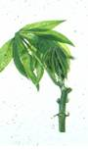 | 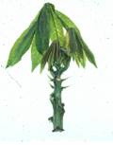 | 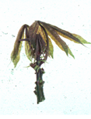 | 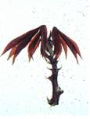
1 | 2 | 3 | 4
light green | dark green | purplish green | purple

Ad. 2: Apical leaf: pubescence

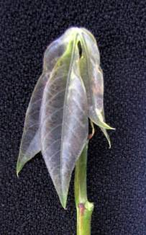 | 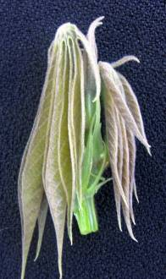
1 | 9
absent | present

Ad. 3: Leaf: predominent shape of central lobe

 |  | 
1 | 2 | 3
linear | obovate | elliptic

Ad. 4: Petiole: color
 | 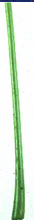 |  | 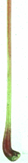 |  | 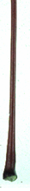
1 | 2 | 3 | 4 | 5 | 6
yellowish green | green | reddish green | greenish red | red | purple

Ad. 7: Leaf: length of central lobe Ad. 8: Leaf: width of central lobe

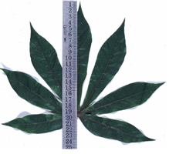 | 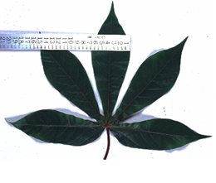

Ad. 9: Leaf: color of veins

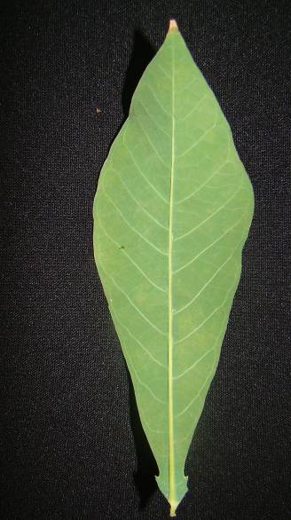 | 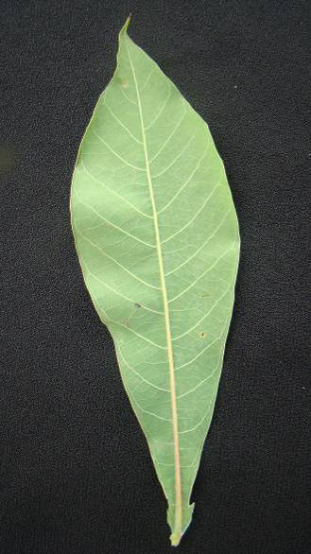 | 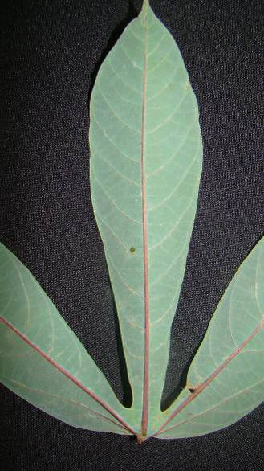 | 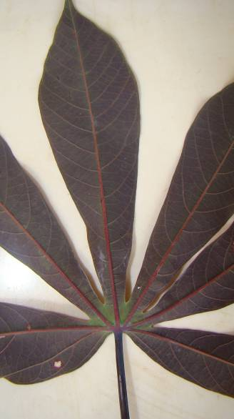
1 | 2 | 3 | 4
green | reddish green | red | purple

Ad. 10: Petiole: attitude in relation to stem

1 | 2 | 3 | 4
semi erect | horizontal | drooping | irregular

Ad. 11: Stipule: length

To be observed on the upper third of the plant.

 |  | 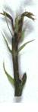
3 | 5 | 7
short | medium | long

Ad. 12: Stipule: margin

To be observed on the upper third of the plant

 | 
1 | 2
entire | split

Ad. 14: Plant: type

1 | 2 | 3 | 4
compact | open | umbrella | cylindrical

Ad. 15: Plant: branching habit

To be observed on the upper third of the plant

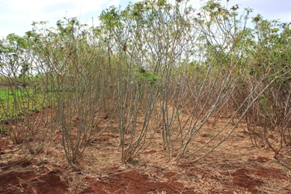 | 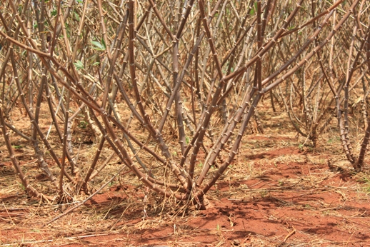
1 | 2
unbranched | branched

Ad. 16: Stem: color of cortex

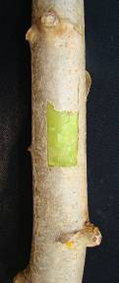 | 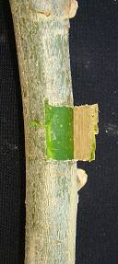 | 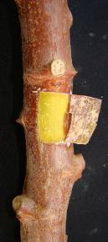 | 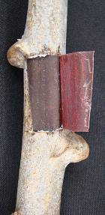
1 | 2 | 3 | 4
light green | dark green | cream | purplish

Ad. 19: Stem: growth habit

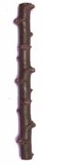 | 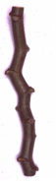
1 | 2
straight | zigzag

Ad. 21: Stem: distance between leaf scars on nodes

The characteristic should be observed at the middle third of the plant, and two scars in the same alignment are to be observed

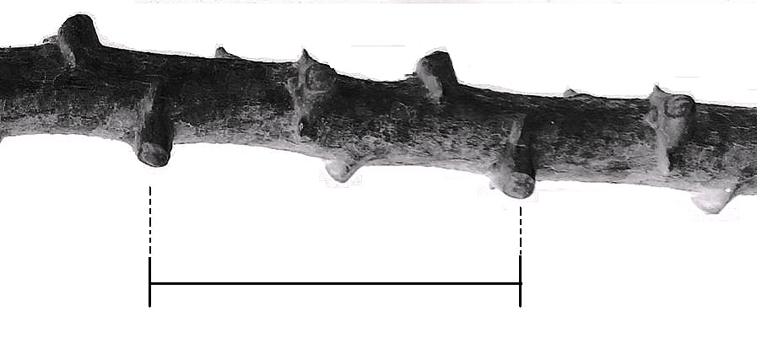

Ad. 23: Root: peduncle

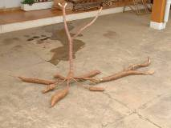 |  | 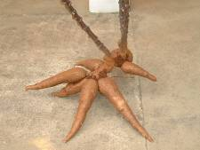
1 |  | 9
absent |  | present

Ad. 28: Root: shape

 | 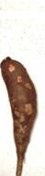 | 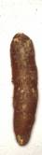 | 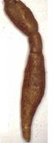
1 | 2 | 3 | 4
conical | conical to cylindrical | cylindrical | irregular

Ad. 29: Root: cyanide content

Rapid screening assay of cyanide content of cassava (Williams and Edward (1980) method)

This is a rapid, inexpensive screening assay developed in order to measure the cyanide content of cassava (Manihot esculenta Crantz.) tubers. A small disc of parenchyma tissue cut with a cork borer or alternatively grated tissue placed in a stoppered glass tube with a filter paper previously spotted with a drop of tetra-base [4,4'-methylenebis-(N,N-dimethylaniline)] and cupric acetate and hydrogen. Cyanide liberated produces a blue color on the filter paper. The intensity of the blue color developed within one hour is rated visually on a graded scale from 0 to 5. The correlation coefficient between samples accurately analyzed for total cyanide and also tested using the rapid assay is 0.77.

Low cyanide content 0 to 1.9
Medium cyanide content 2.0 to 3.9
High cyanide content 4.0 to 5.0

The reference for Williams and Edward (1980) method to chapter 9

Ad. 30: Root: adherence of cortex to flesh

Involves hand removal of root cortex from the middle third of freshly harvested root tuber. Weak adherence is when the cortex is removed round the root tuber without any breakage while strong adherence is when peeling of the cortex exhibits a lot of breaking and for medium adherence there is minimal breaking of the cortex.

Literature

Allem, A.C., 2002: The origin and taxonomy of cassava. CABI, pp. 1-16.

Alves, A.A. C., 2002: Cassava botany and physiology. CABI, pp. 67-89.

Brazilian Agricultural Research Corporation (EMBRAPA) test guideline for cassava.

Kenya Agricultural Research Institute (KARI) 2008/2009 National cassava breeding & improvement program.

Technical Questionnaire

TECHNICAL QUESTIONNAIRE |  |  |  | Page {x} of {y} |  | Reference Number:
 |  |  |  |  |  | Application date:
 |  |  |  |  |  | (not to be filled in by the applicant)
TECHNICAL QUESTIONNAIRE
to be completed in connection with an application for plant breeders’ rights

1. Subject of the Technical Questionnaire
1.1 Botanical name |  |  | Manihot esculenta Crantz.
1.2 Common name |  |  | Cassava
2. Applicant
Name
Address
Telephone No.
Fax No.
E-mail address
Breeder (if different from applicant)
3. Proposed denomination and breeder’s reference
Proposed denomination
(if available)

Breeder’s reference
#4. Information on the breeding scheme and propagation of the variety

4.1 Breeding scheme

Variety resulting from:

4.1.1 Crossing

(a) controlled cross [ ]
(please state parent varieties)

(…………………..……………..…) x (……………..…………………..…)
female parent male parent

(b) partially known cross [ ]
(please state known parent variety(ies))

(…………………..……………..…) x (……………..…………………..…)
female parent male parent

(c) unknown cross [ ]

4.1.2 Mutation [ ]
(please state parent variety)

4.1.3 Discovery and development [ ]
(please state where and when discovered and how developed)

4.1.4 Other [ ]
(please provide details)

4.2 Method of propagating the variety

4.2.1 Vegetative propagation

(a) cuttings [ ]

(b) in vitro propagation [ ]

(c) other (state method) [ ]

4.2.2 Seed [ ]

4.2.3 Other [ ]
(please provide details)

5. Characteristics of the variety to be indicated (the number in brackets refers to the corresponding characteristic in Test Guidelines; please mark the note which best corresponds).

 | Characteristics |  |  |  |  |  | Example Varieties |  |  | Note
5.1  (1) | Apical leaf: color
 | light green |  |  |  |  |  |  |  |  | 1[ ]
 | dark green |  |  |  |  |  | Clone 2005/0034 |  |  | 2[ ]
 | purplish green |  |  |  |  |  | Clone 82/001 |  |  | 3[ ]
 | purple |  |  |  |  |  |  |  |  | 4[ ]
5.2  (2) | Apical leaf: pubescence
 | absent |  |  |  |  |  | Clone 2005/0034 |  |  | 1[ ]
 | present |  |  |  |  |  | Clone 82/0058 |  |  | 9[ ]
5.3  (3) | Leaf: predominant shape of central lobe
 | linear |  |  |  |  |  |  |  |  | 1[ ]
 | elliptic |  |  |  |  |  |  |  |  | 2[ ]
 | obovate |  |  |  |  |  |  |  |  | 3[ ]
5.4  (4) | Petiole: color
 | yellowish green |  |  |  |  |  | Nzalauka, Shibe, Siri |  |  | 1[ ]
 | green |  |  |  |  |  | Karibuni |  |  | 2[ ]
 | reddish green |  |  |  |  |  | Clone 517, Karembo, Tajirika |  |  | 3[ ]
 | greenish red |  |  |  |  |  |  |  |  | 4[ ]
 | red |  |  |  |  |  | Clone 2021, Kibandameno, Nguzo |  |  | 5[ ]
 | purple |  |  |  |  |  | Clone 1366 |  |  | 6[ ]
5.5  (6) | Leaf: variegation
 | absent |  |  |  |  |  |  |  |  | 1[ ]
 | present |  |  |  |  |  |  |  |  | 9[ ]
 | Characteristics |  |  |  |  |  | Example Varieties |  |  | Note
5.6  (10) | Petiole: attitude in relation to stem
 | semi erect |  |  |  |  |  | Karembo, Tajirika |  |  | 3[ ]
 | horizontal |  |  |  |  |  | Nguzo, Siri |  |  | 5[ ]
 | drooping |  |  |  |  |  | Clone 1380, Kibandameno |  |  | 7[ ]
 | irregular |  |  |  |  |  | Nzalauka |  |  | 9[ ]
5.7  (11) | Stipule: length
 | very short |  |  |  |  |  |  |  |  | 1[ ]
 | very short to short |  |  |  |  |  |  |  |  | 2[ ]
 | short |  |  |  |  |  | Karibuni |  |  | 3[ ]
 | short to medium |  |  |  |  |  |  |  |  | 4[ ]
 | medium |  |  |  |  |  | Karembo, Karibuni |  |  | 5[ ]
 | medium to long |  |  |  |  |  |  |  |  | 6[ ]
 | long |  |  |  |  |  | Clone 517, Nguzo |  |  | 7[ ]
 | long to very long |  |  |  |  |  |  |  |  | 8[ ]
 | very long |  |  |  |  |  |  |  |  | 9[ ]
5.8  (17) | Stem: color of exterior
 | orange |  |  |  |  |  |  |  |  | 1[ ]
 | greyish yellow |  |  |  |  |  | Kibandameno |  |  | 2[ ]
 | greenish yellow |  |  |  |  |  | Clone 2021, Siri |  |  | 3[ ]
 | brownish yellow |  |  |  |  |  |  |  |  | 4[ ]
 | light brown |  |  |  |  |  | Clone 1380 |  |  | 5[ ]
 | dark brown |  |  |  |  |  | Kiroba |  |  | 6[ ]
 | silver |  |  |  |  |  | Karibuni, Nguzo |  |  | 7[ ]
5.9  (19) | Stem: growth habit
 | straight |  |  |  |  |  |  |  |  | 1[ ]
 | zigzag |  |  |  |  |  |  |  |  | 2[ ]
 | Characteristics |  |  |  |  |  | Example Varieties |  |  | Note
5.10  (22) | Stem: color of end branches (at top 20 cm of plant)
 | green |  |  |  |  |  | Karembo, Karibuni |  |  | 1[ ]
 | reddish green |  |  |  |  |  | Kibandameno |  |  | 2[ ]
 | purplish green |  |  |  |  |  | Nguzo, Nzalauka |  |  | 3[ ]
 | greenish purple |  |  |  |  |  |  |  |  | 4[ ]
 | purple |  |  |  |  |  |  |  |  | 5[ ]
 | red |  |  |  |  |  | Clone 2021 |  |  | 6[ ]
5.11  (29) | Root: cyanide content
 | low |  |  |  |  |  |  |  |  | 1[ ]
 | medium |  |  |  |  |  |  |  |  | 2[ ]
 | high |  |  |  |  |  |  |  |  | 3[ ]
6. Similar varieties and differences from these varieties

Please use the following table and box for comments to provide information on how your candidate variety differs from the variety (or varieties) which, to the best of your knowledge, is (or are) most similar. This information may help the examination authority to conduct its examination of distinctness in a more efficient way.

Denomination(s) of variety(ies) similar to your candidate variety |  | Characteristic(s) in which your candidate variety differs from the similar variety(ies) |  |  | Describe the expression of the characteristic(s) for the similar variety(ies) |  |  | Describe the expression of the characteristic(s) for your candidate variety
Example |  | Stem: color of cortex |  |  | light green |  |  | dark green
Comments:

#7. Additional information which may help in the examination of the variety

7.1 In addition to the information provided in sections 5 and 6, are there any additional characteristics which may help to distinguish the variety?

Yes [ ] No [ ]

(If yes, please provide details)

7.2 Are there any special conditions for growing the variety or conducting the examination?

Yes [ ] No [ ]

(If yes, please provide details)

7.3 Other information

8. Authorization for release

(a) Does the variety require prior authorization for release under legislation concerning the protection of the environment, human and animal health?

Yes [ ] No [ ]

(b) Has such authorization been obtained?

Yes [ ] No [ ]

If the answer to (b) is yes, please attach a copy of the authorization.

9. Information on plant material to be examined or submitted for examination.

9.1 The expression of a characteristic or several characteristics of a variety may be affected by factors, such as pests and disease, chemical treatment (e.g. growth retardants or pesticides), effects of tissue culture, different rootstocks, scions taken from different growth phases of a tree, etc.

9.2 The plant material should not have undergone any treatment which would affect the expression of the characteristics of the variety, unless the competent authorities allow or request such treatment. If the plant material has undergone such treatment, full details of the treatment must be given. In this respect, please indicate below, to the best of your knowledge, if the plant material to be examined has been subjected to:

(a) Microorganisms (e.g. virus, bacteria, phytoplasma) Yes [ ] No [ ]

(b) Chemical treatment (e.g. growth retardant, pesticide) Yes [ ] No [ ]

(c) Tissue culture Yes [ ] No [ ]

(d) Other factors Yes [ ] No [ ]

Please provide details for where you have indicated “yes”.

……………………………………………………………

10. I hereby declare that, to the best of my knowledge, the information provided in this form is correct:

Applicant’s name

Signature Date

[End of document]

* These names were correct at the time of the introduction of these Test Guidelines but may be revised or updated. [Readers are advised to consult the UPOV Code, which can be found on the UPOV Website (www.upov.int), for the latest information.]
# Authorities may allow certain of this information to be provided in a confidential section of the Technical Questionnaire.
# Authorities may allow certain of this information to be provided in a confidential section of the Technical Questionnaire.

