 |  |  |  |  |  |  | E  TG/BRASS_JUN(proj.1)  ORIGINAL: English  DATE: 2013-04-08
INTERNATIONAL UNION FOR THE PROTECTION OF NEW VARIETIES OF PLANTS
Geneva
 |  |  | DRAFT
 |  | BROWN MUSTARD  UPOV Code: BRASS_JUN  Brassica juncea (L.) Czern. |  |  | *

GUIDELINES

FOR THE CONDUCT OF TESTS

FOR DISTINCTNESS, UNIFORMITY AND STABILITY

prepared by an expert from Japan

to be considered by the
Technical Working Party for Vegetables
at its forty-seventh session, to be held in Nagasaki, Japan, from May 20 to 24, 2013

Alternative Names:*

Botanical name | English | French | German | Spanish
Brassica juncea (L.) Czern. | Brown mustard,  India mustard,  Indian mustard, Oriental mustard | Moutarde brune | Sareptasenf | Mostaza de Sarepta, Mostaza india

The purpose of these guidelines (“Test Guidelines”) is to elaborate the principles contained in the General Introduction (document TG/1/3), and its associated TGP documents, into detailed practical guidance for the harmonized examination of distinctness, uniformity and stability (DUS) and, in particular, to identify appropriate characteristics for the examination of DUS and production of harmonized variety descriptions.

ASSOCIATED DOCUMENTS
These Test Guidelines should be read in conjunction with the General Introduction and its associated TGP documents.

TABLE OF CONTENTS PAGE

1. Subject of these Test Guidelines 3
2. Material Required 3
3. Method of Examination 3
3.1 Number of Growing Cycles 3
3.2 Testing Place 3
3.3 Conditions for Conducting the Examination 3
3.4 Test Design 3
3.5 Additional Tests 3
4. Assessment of Distinctness, Uniformity and Stability 4
4.1 Distinctness 4
4.2 Uniformity 5
4.3 Stability 5
5. Grouping of Varieties and Organization of the Growing Trial 5
6. Introduction to the Table of Characteristics 6
6.1 Categories of Characteristics 6
6.2 States of Expression and Corresponding Notes 6
6.3 Types of Expression 6
6.4 Example Varieties 6
6.5 Legend 7
7. Table of Characteristics/Tableau des caractères/Merkmalstabelle/Tabla de caracteres 8
8. Explanations on the Table of Characteristics 15
8.1 Explanations for individual characteristics 15
8.2 Key for the Stages of Development 19
9. Literature 21
10. Technical Questionnaire 22

ANNEX SUBGROUP COMMENTS ON DOCUMENT TG/BRASS_JUN(proj.1)

Subject of these Test Guidelines

These Test Guidelines apply to all varieties of Brassica juncea (L.) Czern and its hybrids.

Material Required

2.1 The competent authorities decide on the quantity and quality of the plant material required for testing the variety and when and where it is to be delivered. Applicants submitting material from a State other than that in which the testing takes place must ensure that all customs formalities and phytosanitary requirements are complied with.

2.2 The material is to be supplied in the form of seed.

2.3 The minimum quantity of plant material, to be supplied by the applicant, should be:

20,000 seeds or 100g for drilled plots.

The seed should meet the minimum requirements for germination, species and analytical purity, health and moisture content, specified by the competent authority. In cases where the seed is to be stored, the germination capacity should be as high as possible and should, be stated by the applicant.

2.4 The plant material supplied should be visibly healthy, not lacking in vigor, nor affected by any important pest or disease.

2.5 The plant material should not have undergone any treatment which would affect the expression of the characteristics of the variety, unless the competent authorities allow or request such treatment. If it has been treated, full details of the treatment must be given.

Method of Examination

3.1 Number of Growing Cycles

The minimum duration of tests should normally be two independent growing cycles.

3.2 Testing Place

Tests are normally conducted at one place. In the case of tests conducted at more than one place, guidance is provided in TGP/9 “Examining Distinctness”.

3.3 Conditions for Conducting the Examination

The tests should be carried out under conditions ensuring satisfactory growth for the expression of the relevant characteristics of the variety and for the conduct of the examination.

(a) Stage of development for the assessment

“The optimum stage of development for the assessment of each characteristic is indicated by a number in the second column of the Table of Characteristics. The stages of development denoted by each number are described in Chapter 8. EXPLANATIONS ON THE TABLE OF CHARACTERISTICS

3.4 Test Design

Each test should be designed to result in a total of at least 40 for vegetable 300 for agricultural plants, which should be divided between at least 2 replicates.

3.5 Additional Tests

Additional tests, for examining relevant characteristics, may be established.

Assessment of Distinctness, Uniformity and Stability

4.1 Distinctness

4.1.1 General Recommendations

It is of particular importance for users of these Test Guidelines to consult the General Introduction prior to making decisions regarding distinctness. However, the following points are provided for elaboration or emphasis in these Test Guidelines.

4.1.2 Consistent Differences

The differences observed between varieties may be so clear that more than one growing cycle is not necessary. In addition, in some circumstances, the influence of the environment is not such that more than a single growing cycle is required to provide assurance that the differences observed between varieties are sufficiently consistent. One means of ensuring that a difference in a characteristic, observed in a growing trial, is sufficiently consistent is to examine the characteristic in at least two independent growing cycles.

4.1.3 Clear Differences

Determining whether a difference between two varieties is clear depends on many factors, and should consider, in particular, the type of expression of the characteristic being examined, i.e. whether it is expressed in a qualitative, quantitative, or pseudo-qualitative manner. Therefore, it is important that users of these Test Guidelines are familiar with the recommendations contained in the General Introduction prior to making decisions regarding distinctness.

4.1.4 Number of Plants / Parts of Plants to be Examined

Unless otherwise indicated, for the purposes of distinctness, all observations on single plants should be made on 20 plants or parts taken from each of 20 plants for vegetable, 60 plants or parts taken from each of 60 plants for agricultural plants and any other observations made on all plants in the test, disregarding any off-type plants.

4.1.5 Method of Observation

The recommended method of observing the characteristic for the purposes of distinctness is indicated by the following key in the second column of the Table of Characteristics (see document TGP/9 “Examining Distinctness”, Section 4 “Observation of characteristics”):

MG: single measurement of a group of plants or parts of plants
MS: measurement of a number of individual plants or parts of plants
VG: visual assessment by a single observation of a group of plants or parts of plants
VS: visual assessment by observation of individual plants or parts of plants

Type of observation: visual (V) or measurement (M)

“Visual” observation (V) is an observation made on the basis of the expert’s judgment. For the purposes of this document, “visual” observation refers to the sensory observations of the experts and, therefore, also includes smell, taste and touch. Visual observation includes observations where the expert uses reference points (e.g. diagrams, example varieties, side-by-side comparison) or non-linear charts (e.g. color charts). Measurement (M) is an objective observation against a calibrated, linear scale e.g. using a ruler, weighing scales, colorimeter, dates, counts, etc.

Type of record: for a group of plants (G) or for single, individual plants (S)

For the purposes of distinctness, observations may be recorded as a single record for a group of plants or parts of plants (G), or may be recorded as records for a number of single, individual plants or parts of plants (S). In most cases, “G” provides a single record per variety and it is not possible or necessary to apply statistical methods in a plant-by-plant analysis for the assessment of distinctness.

In cases where more than one method of observing the characteristic is indicated in the Table of Characteristics (e.g. VG/MG), guidance on selecting an appropriate method is provided in document TGP/9, Section 4.2.

4.2 Uniformity

4.2.1 It is of particular importance for users of these Test Guidelines to consult the General Introduction prior to making decisions regarding uniformity. However, the following points are provided for elaboration or emphasis in these Test Guidelines:

4.2.2 The assessment of uniformity should be according to the recommendations for cross pollinated varieties in the General Introduction.

4.2.3 The assessment of uniformity for hybrid varieties depends on the type of hybrid and should be according to the recommendations for hybrid varieties in the General Introduction.

4.2.4 For the assessment of uniformity of inbred line varieties, a population standard of 1 % and an acceptance probability of at least 95 % should be applied. In the case of a sample size of 40 plants, 2 off-types are allowed. In the case of a sample size of 300 plants, 6 off-types are allowed.

4.3 Stability

4.3.1 In practice, it is not usual to perform tests of stability that produce results as certain as those of the testing of distinctness and uniformity. However, experience has demonstrated that, for many types of variety, when a variety has been shown to be uniform, it can also be considered to be stable.

4.3.2 Where appropriate, or in cases of doubt, stability may be further examined by testing a new seed stock to ensure that it exhibits the same characteristics as those shown by the initial material supplied.

4.3.3 Where appropriate, or in cases of doubt, the stability of a hybrid variety may, in addition to an examination of the hybrid variety itself, also be assessed by examination of the uniformity and stability of its parent lines.

Grouping of Varieties and Organization of the Growing Trial

5.1 The selection of varieties of common knowledge to be grown in the trial with the candidate varieties and the way in which these varieties are divided into groups to facilitate the assessment of distinctness are aided by the use of grouping characteristics.

5.2 Grouping characteristics are those in which the documented states of expression, even where produced at different locations, can be used, either individually or in combination with other such characteristics: (a) to select varieties of common knowledge that can be excluded from the growing trial used for examination of distinctness; and (b) to organize the growing trial so that similar varieties are grouped together.

5.3 The following have been agreed as useful grouping characteristics:

(a) Seed: color (characteristic 1)
(b) Leaf: type (characteristic 6)
(c) Leaf blade: anthocyanin coloration (characteristic 17)
(d) Leaf blade: density of incision of margin (characteristic 20)
(e) Leaf blade: blistering (characteristic 22)
(f) Head: formation (characteristic 27)

5.4 Guidance for the use of grouping characteristics, in the process of examining distinctness, is provided through the General Introduction and document TGP/9 “Examining Distinctness”.

Introduction to the Table of Characteristics

6.1 Categories of Characteristics

6.1.1 Standard Test Guidelines Characteristics

Standard Test Guidelines characteristics are those which are approved by UPOV for examination of DUS and from which members of the Union can select those suitable for their particular circumstances.

6.1.2 Asterisked Characteristics

Asterisked characteristics (denoted by *) are those included in the Test Guidelines which are important for the international harmonization of variety descriptions and should always be examined for DUS and included in the variety description by all members of the Union, except when the state of expression of a preceding characteristic or regional environmental conditions render this inappropriate.

6.2 States of Expression and Corresponding Notes

6.2.1 States of expression are given for each characteristic to define the characteristic and to harmonize descriptions. Each state of expression is allocated a corresponding numerical note for ease of recording of data and for the production and exchange of the description.

6.2.2 In the case of qualitative and pseudo-qualitative characteristics (see Chapter 6.3), all relevant states of expression are presented in the characteristic. However, in the case of quantitative characteristics with 5 or more states, an abbreviated scale may be used to minimize the size of the Table of Characteristics. For example, in the case of a quantitative characteristic with 9 states, the presentation of states of expression in the Test Guidelines may be abbreviated as follows:

State | Note
small | 3
medium | 5
large | 7

However, it should be noted that all of the following 9 states of expression exist to describe varieties and should be used as appropriate:

State | Note
very small | 1
very small to small | 2
small | 3
small to medium | 4
medium | 5
medium to large | 6
large | 7
large to very large | 8
very large | 9

6.2.3 Further explanation of the presentation of states of expression and notes is provided in document TGP/7 “Development of Test Guidelines”.

6.3 Types of Expression

An explanation of the types of expression of characteristics (qualitative, quantitative and pseudo-qualitative) is provided in the General Introduction.

6.4 Example Varieties

Where appropriate, example varieties are provided to clarify the states of expression of each characteristic.

6.5 Legend

(*) Asterisked characteristic – see Chapter 6.1.2

QL Qualitative characteristic – see Chapter 6.3
QN Quantitative characteristic – see Chapter 6.3
PQ Pseudo-qualitative characteristic – see Chapter 6.3

MG, MS, VG, VS – see Chapter 4.1.5

(+) See Explanations on the Table of Characteristics in Chapter 8.
Stage of development: see Section 3.3. (a)

Table of Characteristics/Tableau des caractères/Merkmalstabelle/Tabla de caracteres

 |  | English | français | deutsch | español | Example Varieties  Exemples  Beispielssorten  Variedades ejemplo | Note/  Nota
1  (*)  (+) | 00  VG | Seed: color
PQ |  | yellow |  |  |  |  | 1
 |  | brown |  |  |  |  | 2
 |  | black |  |  |  |  | 3
2  (+) | 10  VG | Hypocotyl: anthocyanin coloration
QN |  | absent or weak |  |  |  | Zasai FM-58 | 1
 |  | medium |  |  |  | Shinkoku seisai | 2
 |  | strong |  |  |  | Kigarashina | 3
3 | 10  MS/VG | Cotyledon: length
QN |  | short |  |  |  | Junkei yamashiona | 3
 |  | medium |  |  |  | Katsuona | 5
 |  | long |  |  |  |  | 7
4 | 10  MS/VG | Cotyledon: width
QN |  | narrow |  |  |  | Junkei yamashiona | 3
 |  | medium |  |  |  | Katsuona | 5
 |  | broad |  |  |  |  | 7
5  (*)  (+) | 10  VG | Cotyledon: anthocyanin coloration
QL |  | absent |  |  |  | Zasai FM-58 | 1
 |  | present |  |  |  | Akariasu | 9
6  (*)  (+) | 19,  49  VG | Leaf: type
PQ |  | type 1 |  |  |  | Kigarashina | 1
 |  | type 2 |  |  |  | Riasu karashina | 2
 |  | type 3 |  |  |  | Katsuona | 3
 |  | type 4 |  |  |  | Miike takana | 4
7  (*)  (+) | 19,  49  VG | Leaf: shape
PQ |  | lanceolate |  |  |  |  | 1
 |  | oblanceolate |  |  |  |  | 2
 |  | ovate |  |  |  |  | 3
 |  | obovate |  |  |  |  | 4
 |  | elliptic |  |  |  |  | 5
 |  | broad elliptic |  |  |  | Zasai FM-58 | 6
 |  | circular |  |  |  | Shinkoku seisai | 7
 |  | compressed circular |  |  |  |  | 8
 |  | spatulate |  |  |  |  | 9
8  (*) | 19,  49  VG | Leaf: attitude
QN |  | erect |  |  |  | Junkei yamashiona | 1
 |  | semi-erect |  |  |  | Akaoba takana | 2
 |  | horizontal |  |  |  | Miike takana | 3
9  (+) | 19,  49  MS/VG | Leaf: length (blade and petiole)
QN |  | short |  |  |  | Chirimen hakarashina | 3
 |  | medium |  |  |  | Miike takana | 5
 |  | long |  |  |  |  | 7
10  (+) | 19,  49  MS/VG | Leaf: width (widest point)
QN |  | narrow |  |  |  |  | 3
 |  | medium |  |  |  |  | 5
 |  | broad |  |  |  |  | 7
11  (+) | 19,  49  MS/VG | Leaf: length of petiole
QN |  | absent or very short |  |  |  | Serihon | 1
 |  | medium |  |  |  | Miike takana | 3
 |  | medium |  |  |  | Junkei yamashiona | 5
 |  | long |  |  |  | Kigarashina | 7
12 | 19,-49  MS/VG | Leaf: thickness of petiole at widest point
QN |  | thin |  |  |  | Akaoba takana | 3
 |  | medium |  |  |  | Shinkoku seisai | 5
 |  | thick |  |  |  | Kekkyu takana | 7
13 | 19,  49  VG | Leaf: intensity of green color
QN |  | light |  |  |  | Kekkyu takana | 3
 |  | medium |  |  |  | Katsuona | 5
 |  | dark |  |  |  | Kigarashina | 7
14  (+) | 19,  49  MS/VG | Leaf blade: size of terminal lobe (only variety with leaf type 1 or type2)
QN |  | small |  |  |  | Chirimen hakarashina | 3
 |  | medium |  |  |  | Kigarashina | 5
 |  | large |  |  |  |  | 7
15  (+) | 19,  49  MS/VG | Leaf blade: intensity of lateral lobe (only variety with leaf type 1 or type2)
QN |  | sparse |  |  |  | Akariasu | 3
 |  | medium |  |  |  | Kigarashina | 5
 |  | dense |  |  |  |  | 7
16 | 19,  49  VG | Leaf blade: pubescence
QN |  | absent or very few |  |  |  | Miike takana | 1
 |  | few |  |  |  |  | 3
 |  | medium |  |  |  | Katsuona | 5
 |  | many |  |  |  | Kigarashina | 7
17  (*) | 19,  49  VG | Leaf blade: anthocyanin coloration
QL |  | absent |  |  |  | Kekkyu takana | 1
 |  | present |  |  |  | Akaoba takana | 9
18  (*) | 19,  49  VG | Variety with anthocyanin coloration present only: Leaf blade: intensity of anthocyanin coloration
QN |  | weak |  |  |  | Kigarashina | 3
 |  | medium |  |  |  | Miike takana | 5
 |  | strong |  |  |  | Akaoba takana | 7
19  (*) | 19,  49  VG | Leaf blade: undulation of margin
QN |  | absent or very weak |  |  |  |  | 1
 |  | weak |  |  |  | Akaoba takana | 3
 |  | medium |  |  |  | Katsuona | 5
 |  | strong |  |  |  | Chirimen hakarashina | 7
20  (*)  (+) | 19,  49  VG | Leaf blade: density of incision of margin
QN |  | absent or very sparse |  |  |  | Katsuona | 1
 |  | sparse |  |  |  |  | 3
 |  | medium |  |  |  | Junkei yamashiona | 5
 |  | dense |  |  |  | Chirimen hakarashina | 7
21  (*) | 19,  49  VG | Leaf blade: depth of incision of margin
QN |  | absent or very shallow |  |  |  | Kigarashina | 1
 |  | shallow |  |  |  |  | 3
 |  | medium |  |  |  |  | 5
 |  | deep |  |  |  | Riasu karashina | 7
22  (*)  (+) | 19,  49  VG | Leaf blade: blistering
QN |  | weak |  |  |  | Kigarashina | 3
 |  | medium |  |  |  |  | 5
 |  | strong |  |  |  | Katsuona | 7
23 | 19,  49  MS/VG | Leaf blade: width of midrib at widest point
QN |  | narrow |  |  |  | Kigarashina | 3
 |  | medium |  |  |  | Katsuona | 5
 |  | broad |  |  |  | Shinkoku seisai | 7
24 | 19,  49  VG | Leaf blade: anthocyanin coloration of midrib
QL |  | absent |  |  |  |  | 1
 |  | present |  |  |  |  | 9
25  (+) | 20-29  VG | Stem: type of main stem (excluding heading type)
PQ |  | not enlarged |  |  |  |  | 1
 |  | laterally enlarged |  |  |  |  | 2
 |  | longitudinally enlarged |  |  |  |  | 3
 |  | budding enlarged |  |  |  |  | 4
26 | 30-39  VG | Time of beginning of bolting
QN |  | early |  |  |  | Junkei yamashiona | 3
 |  | medium |  |  |  | Katsuona | 5
 |  | late |  |  |  | Akaoba takana | 7
27  (*) | 41-49  VG | Head: formation
QL |  | absent |  |  |  | Kigarashina | 1
 |  | present |  |  |  | Kekkyu takana | 9
28 | 49  MS/VG | Head: height (head type only)
QN |  | short |  |  |  |  | 3
 |  | medium |  |  |  | Unzen kekkyu takana | 5
 |  | tall |  |  |  |  | 7
29 | 49  MS/VG | Head: diameter (head type only)
QN |  | narrow |  |  |  |  | 3
 |  | medium |  |  |  | Kekkyu takana | 5
 |  | broad |  |  |  |  | 7
30 | 49  MS/VG | Head: number of leaf (head type only)
QN |  | few |  |  |  |  | 3
 |  | medium |  |  |  | Kekkyu takana | 5
 |  | many |  |  |  |  | 7
31  (*) | 49  VG | Head: color of inside (head type only)
PQ |  | yellowish white |  |  |  | Unzen kekkyu takana | 1
 |  | light green |  |  |  |  | 2
 |  | green |  |  |  | Kekkyu takana | 3
32 | 49  MS/VG | Head: length of core (head type only)
QN |  | short
 |  | medium
 |  | long
33  (*)  (+) | 19,  49  VG | Plant: tillering
QL |  | absent |  |  |  | Akaoba takana | 1
 |  | present |  |  |  | Riasu karashina, | 9
34  (*) | 60  VG | Time of flowering
QN |  | early |  |  |  |  | 3
 |  | medium |  |  |  |  | 5
 |  | late |  |  |  |  | 7
35 | 65  MS/VG | Flower: length of petal
QN |  | short |  |  |  |  | 3
 |  | medium |  |  |  |  | 5
 |  | long |  |  |  |  | 7
36 | 65  MS/VG | Flower: width of petal
QN |  | narrow |  |  |  |  | 3
 |  | medium |  |  |  |  | 5
 |  | broad |  |  |  |  | 7
37 | 69-89  MS/VG | Plant: total length (after flowering, side branches included) (not for vegetable mustard)
QN |  | short |  |  |  |  | 3
 |  | medium |  |  |  |  | 5
 |  | tall |  |  |  |  | 7
38 | 79-89  MS/VG | Siliqua: length(between peduncle and beak) (not for vegetable mustard)
QN |  | short |  |  |  |  | 3
 |  | medium |  |  |  |  | 5
 |  | long |  |  |  |  | 7
39 | 79-89  MS/VG | Siliqua: width (not for vegetable mustard)
QN |  | narrow |  |  |  |  | 3
 |  | medium |  |  |  |  | 5
 |  | broad |  |  |  |  | 7
40 | 79-89  MS/VG | Siliqua: length of beak (not for vegetable mustard)
QN |  | short |  |  |  |  | 3
 |  | medium |  |  |  |  | 5
 |  | long |  |  |  |  | 7
41 | 79-89  MS/VG | Siliqua: length of peduncle (not for vegetable mustard)
QN |  | short |  |  |  |  | 3
 |  | medium |  |  |  |  | 5
 |  | long |  |  |  |  | 7

Explanations on the Table of Characteristics

8.1 Explanations for individual characteristics

Ad. 1: Seed: color

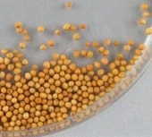 | 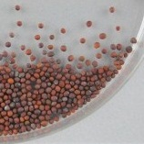 | 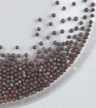
1 | 2 | 3
yellow | brown | black

Ad. 2: Hypocotyl: anthocyanin coloration

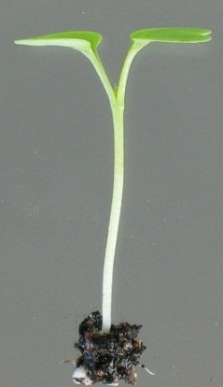 | 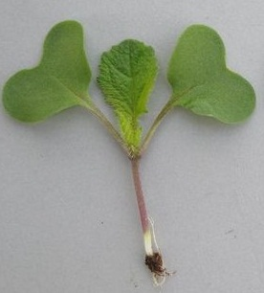 | 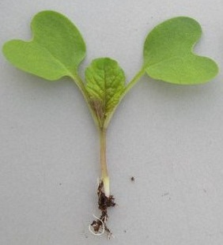
1 | 2 | 3
absent or weak | medium | strong

Ad. 5: Cotyledon: anthocyanin coloration

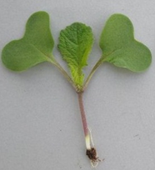 | 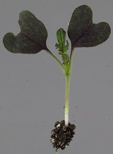
1 | 9
absent | present

Ad. 6: Leaf: type

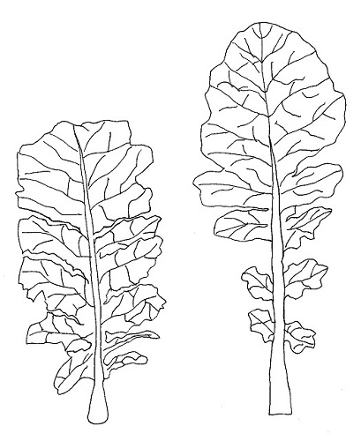 | 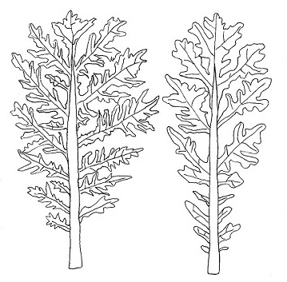
1 | 2
type 1  (lyrate) | type 2  (division)

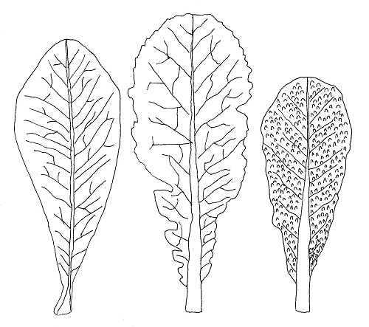 | 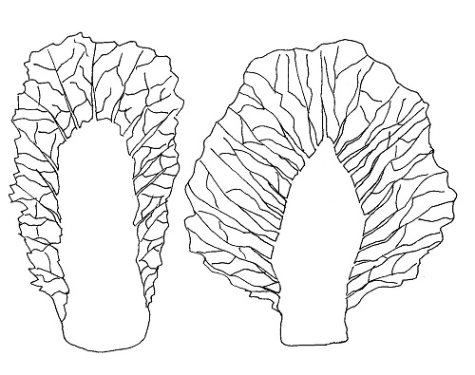
3 | 4
type 3  (entire and narrow midrib) | type 4  (entire and broad midrib)

Ad. 7: Leaf: shape

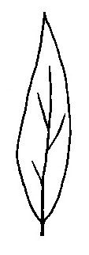 | 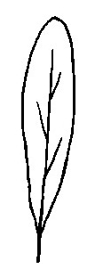 | 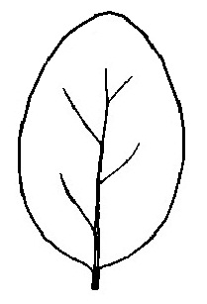 | 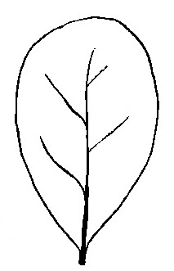 | 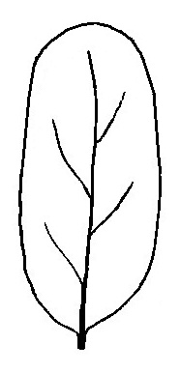
1 | 3 | 2 | 4 | 5
lanceolate | oblanceolate | ovate | obovate | elliptic
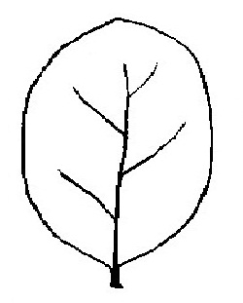 | 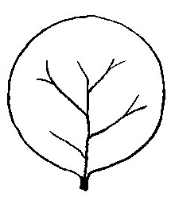 | 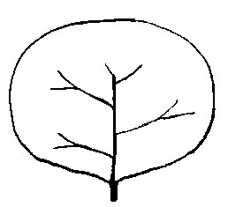 | 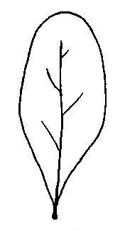
6 | 7 | 8 | 9
broad elliptic | circular | compressed circular | spatulate
Ad. 9: Leaf: length (blade and petiole)
Ad. 10: Leaf: width (widest point)
Ad. 11: Leaf: length of petiole

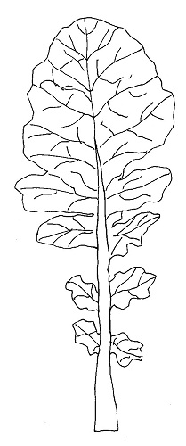  Leaf: length  Leaf: width  Petiole: length | 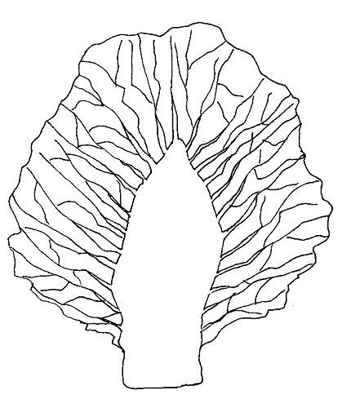  Petiole: length  Leaf: length  Leaf: width

Ad. 14: Leaf blade: size of terminal lobe (only variety with leaf type 1 or type 2)
Ad. 15: Leaf blade: intensity of lateral lobe (only variety with leaf type 1 or type 2)

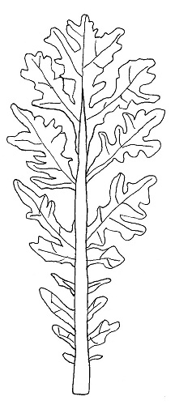
terminal
lobe
lateral
lobe
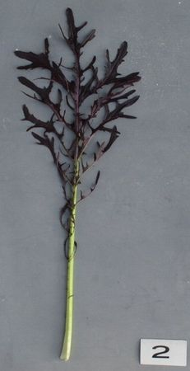 | 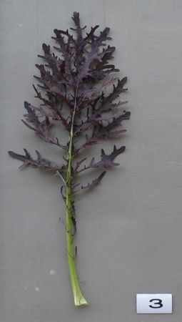 | 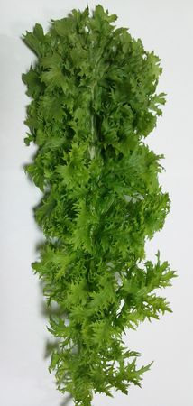
3 | 5 | 7
sparse | medium | dense
Ad. 20: Leaf blade: density of incision of margin

JP: To be provided appropriate diagram

Ad. 22: Leaf blade: blistering

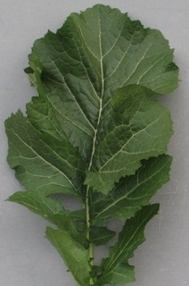 | 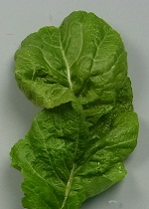 | 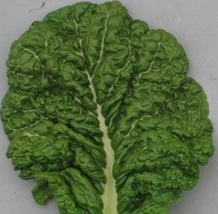
3 | 5 | 7
weak | medium | strong

Ad. 25: Stem: type of main stem (excluding heading type)

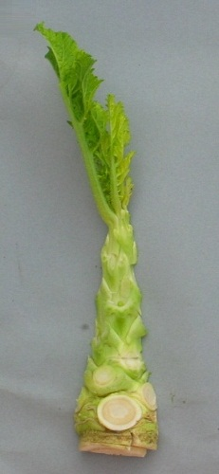 | 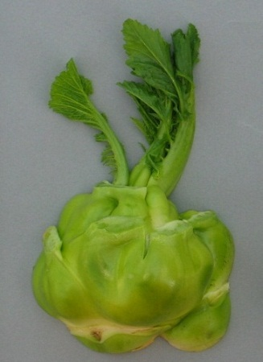 | 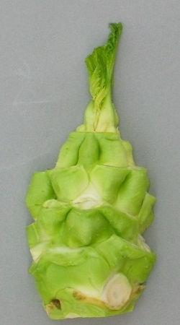 | 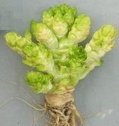
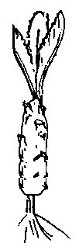 | 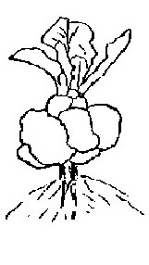 | 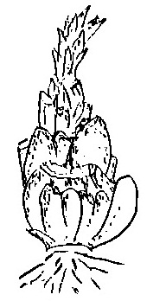 | 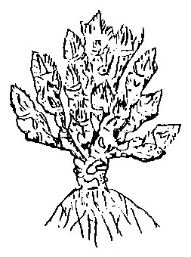
1 | 2 | 3 | 4
not enlarged | laterally enlarged | longitudinally enlarged | budding enlarged

Ad. 33: Plant: tillering

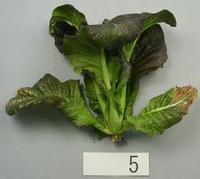 | 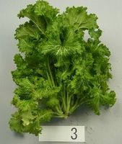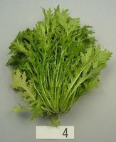
1 | 9
absent | present

8.2 Key for the Stages of Development

KEY | GENERAL DESCRIPTION
0  01  03  05  07  08  09 | Principal growth stage 0: Germination  Beginning of seed imbibition  Seed imbibition complete  Radicle emerged from seed  Hypocotyl with cotyledons emerged from seed  Hypocotyl with cotyledons growing towards soil surface  Emergence: cotyledons emerge through soil surface
1  10  11  12  13  14  15  16  17  18  19 | Principal growth stage 1: Leaf development  Cotyledons completely unfolded  First leaf unfolded  2 leaves unfolded  3 leaves unfolded  4 leaves unfolded  5 leaves unfolded  6 leaves unfolded  7 leaves unfolded  8 leaves unfolded  9 or more leaves unfolded
2  20  21  22  23  24  25  26  27  28  29 | Principal growth stage 2: Formation of side shoots  No side shoots  first side shoot detectable  2 side shoots detectable  3 side shoots detectable  4 side shoots detectable  5 side shoots detectable  6 side shoots detectable  7 side shoots detectable  8 side shoots detectable  9 or more side shoots detectable
3  30  31  32  33  34  35  36  37  38  39 | Principal growth stage 3: Stem elongation  no internodes (“rosette”)  1 visibly extended internode  2 visibly extended internode  3 visibly extended internode  4 visibly extended internode  5 visibly extended internode  6 visibly extended internode  7 visibly extended internode  8 visibly extended internode  9 or more visibly extended internodes
4  41  42  43  44  45  46  47  48  49 | Principal growth stage 4: Development of head  the two youngest leaves do not unfold  20% of the expected head size reached  30% of the expected head size reached  40% of the expected head size reached  50% of the expected head size reached  60% of the expected head size reached  70% of the expected head size reached  80% of the expected head size reached  Typical size, form and firmness of heads reached
5  50  51  52  53  55  57  59 | Principal growth stage 5: Inflorescence emergence  Flower buds present, still enclosed by leaves  Flower buds visible from above (“green bud”)  Flower buds free, level with the youngest leaves  Flower buds raised above the youngest leaves  Individual flower buds (main inflorescence) visible but still closed  Individual flower buds (secondary inflorescences) visible but still closed  First petals visible, flower buds still closed (“yellow bud”)
6  60  61  62  63  64  65  67  69 | Principal growth stage 6: Flowering  First flowers open  10% of flowers on main raceme open, main raceme elongating  20% of flowers on main raceme open  30% of flowers on main raceme open  40% of flowers on main raceme open  Full flowering: 50% flowers on main raceme open, older petals falling  Flowering declining: majority of petals fallen  End of flowering
7  71  72  73  74  75  76  77  78  79 | Principal growth stage 7: Development of fruit  10% of pods have reached final size  20% of pods have reached final size  30% of pods have reached final size  40% of pods have reached final size  50% of pods have reached final size  60% of pods have reached final size  70% of pods have reached final size  80% of pods have reached final size  Nearly all pods have reached final size
8  80  81  82  83  84  85  86  87  88  89 | Principal growth stage 8: Ripening  seed green, filling pod cavity  10% of pods ripe, seeds dark and hard  20% of pods ripe, seeds dark and hard  30% of pods ripe, seeds dark and hard  40% of pods ripe, seeds dark and hard  50% of pods ripe, seeds dark and hard  60% of pods ripe, seeds dark and hard  70% of pods ripe, seeds dark and hard  80% of pods ripe, seeds dark and hard  Fully ripe: nearly all pods ripe, seeds dark and hard
9  97  99 | Principal growth stage 9: Senescence  Plant dead and dry  Harvested product

Literature

Fujishiro, T., 1996: Breeding processes and characteristics of a newly bred leaf mustard (Brassica Juncea Coss.)., Kanagawa, Japan

Joy Larkcom., 1991: Oriental Vegetables (The Complete guide for Garden and Kitchen) London, United Kingdom. pp. 39 to 45

Ministry of Agriculture, Forestry & Fisheries of Japan., 1994: National Test Guideline for Karashina

Roger Phillips, Martyn Rix., 1993: VEGETABLES (The Pan Garden Plants Series) p.44

Takasi A., 2004: Yasai-engei-daihyakka 17. Shadanhojin Nousan-gyoson-bunkakyokai. Tokyo, Japan. pp. 169 to 233

Tsukamoto, Y., 1994: The Grand Dictionary of Horticulture Volume 1. The Shogakukan Ltd., Tokyo, Japan, pp. 520 to 522

Meier, U. Federal Biological Research Centre for Agriculture and Forestry, 2001: Growth stages of mono-and dicotyledonous plants, BBCH Monograph

Technical Questionnaire

TECHNICAL QUESTIONNAIRE |  |  |  | Page {x} of {y} |  | Reference Number:
 |  |  |  |  |  | Application date:
 |  |  |  |  |  | (not to be filled in by the applicant)
TECHNICAL QUESTIONNAIRE
to be completed in connection with an application for plant breeders’ rights

1. Subject of the Technical Questionnaire
1.1 Botanical name |  |  | Brassica juncea (L.) Czern
1.2 Common name |  |  | Brown Mustard
2. Applicant
Name
Address
Telephone No.
Fax No.
E-mail address
Breeder (if different from applicant)
3. Proposed denomination and breeder’s reference
Proposed denomination
(if available)

Breeder’s reference
#4. Information on the breeding scheme and propagation of the variety

4.1 Breeding scheme

Variety resulting from:

4.1.1 Crossing

(a) controlled cross [ ]
(please state parent varieties)

(…………………..……………..…) x (……………..…………………..…)
female parent male parent

(b) partially known cross [ ]
(please state known parent variety(ies))

(…………………..……………..…) x (……………..…………………..…)
female parent male parent

(c) unknown cross [ ]

4.1.2 Mutation [ ]
(please state parent variety)

4.1.3 Discovery and development [ ]
(please state where and when discovered and how developed)

4.1.4 Other [ ]”
(please provide details)

4.2 Method of propagating the variety

4.2.1 Seed-propagated varieties

(a) Self-pollination [ ]
(b) Cross-pollination
(i) population [ ]
(ii) synthetic variety [ ]
(c) Hybrid [ ]
(d) Other [ ]
(please provide details)

4.2.2 Other [ ]”
(please provide details)

In the case of hybrid varieties the production scheme for the hybrid should be provided on a separate sheet. This should provide details of all the parent lines required for propagating the hybrid e.g.

Single Hybrid

(…………………..……………..) x (……………..…………………..)
female parent male parent

Three-Way Hybrid

(…………………..……………..) x (……………..…………………..)
female line male line

(……………..…………………..) x (……………..…………………..)
single hybrid used as female parent male parent

and should identify in particular:

(a) any male sterile lines
(b) maintenance system of male sterile lines.
5. Characteristics of the variety to be indicated (the number in brackets refers to the corresponding characteristic in Test Guidelines; please mark the note which best corresponds).

 | Characteristics |  |  |  |  |  | Example Varieties |  |  | Note
5.1  (5) | Cotyledon: anthocyanin coloration
 | absent |  |  |  |  |  | Zasai FM 58 |  |  | 1 [ ]
 | present |  |  |  |  |  | Akariasu |  |  | 9 [ ]
5.2  (6) | Leaf: type
 | type1 |  |  |  |  |  | Kigarashina |  |  | 1 [ ]
 | type2 |  |  |  |  |  | Riasu karashina |  |  | 2 [ ]
 | type3 |  |  |  |  |  | Katsuona |  |  | 3 [ ]
 | type4 |  |  |  |  |  | Miike takana |  |  | 4 [ ]
5.3  (18) | Variety with anthocyanin coloration present only: Leaf blade: intensity of anthocyanin coloration
 | absent or very weak |  |  |  |  |  | Kekkyu takana |  |  | 1 [ ]
 | very weak to weak |  |  |  |  |  |  |  |  | 2 [ ]
 | weak |  |  |  |  |  | Kigarashina |  |  | 3 [ ]
 | weak to medium |  |  |  |  |  |  |  |  | 4 [ ]
 | medium |  |  |  |  |  | Miike takana |  |  | 5 [ ]
 | medium to strong |  |  |  |  |  |  |  |  | 6 [ ]
 | strong |  |  |  |  |  | Akaoba takana |  |  | 7 [ ]
 | strong to very strong |  |  |  |  |  |  |  |  | 8 [ ]
 | very strong |  |  |  |  |  |  |  |  | 9 [ ]
5.4  (20) | Leaf blade: density of incision of margin
 | absent or very sparse |  |  |  |  |  | Katsuona |  |  | 1 [ ]
 | very sparse to sparse |  |  |  |  |  |  |  |  | 2 [ ]
 | sparse |  |  |  |  |  |  |  |  | 3 [ ]
 | sparse to medium |  |  |  |  |  |  |  |  | 4 [ ]
 | medium |  |  |  |  |  | Junkei yamashiona |  |  | 5 [ ]
 | medium to dense |  |  |  |  |  |  |  |  | 6 [ ]
 | dense |  |  |  |  |  | Chirimen hakarashina |  |  | 7 [ ]
 | dense to very dense |  |  |  |  |  |  |  |  | 8 [ ]
 | very dense |  |  |  |  |  |  |  |  | 9 [ ]
 | Characteristics |  |  |  |  |  | Example Varieties |  |  | Note
5.5  (22) | Leaf blade: blistering
 | very weak |  |  |  |  |  |  |  |  | 1 [ ]
 | very weak to weak |  |  |  |  |  |  |  |  | 2 [ ]
 | weak |  |  |  |  |  | Kigarashina |  |  | 3 [ ]
 | weak to medium |  |  |  |  |  |  |  |  | 4 [ ]
 | medium |  |  |  |  |  |  |  |  | 5 [ ]
 | medium to strong |  |  |  |  |  |  |  |  | 6 [ ]
 | strong |  |  |  |  |  | Katsuona |  |  | 7 [ ]
 | strong to very strong |  |  |  |  |  |  |  |  | 8 [ ]
 | very strong |  |  |  |  |  |  |  |  | 9 [ ]
5.6  (23) | Leaf blade: shape of apex
 | acute |  |  |  |  |  | Nagasaki takana |  |  | 1 [ ]
 | obtuse |  |  |  |  |  | Katsuona |  |  | 2 [ ]
 | rounded |  |  |  |  |  | Miike takana |  |  | 3 [ ]
5.7  (27) | Head: formation
 | absent |  |  |  |  |  | Kigarashina |  |  | 1 [ ]
 | present |  |  |  |  |  | Kekkyu takana |  |  | 2 [ ]
5.8  (31) | Head: color of inside (heading type only)
 | yellowish white |  |  |  |  |  | Unzen kekkyu takana |  |  | 1 [ ]
 | light green |  |  |  |  |  |  |  |  | 2 [ ]
 | green |  |  |  |  |  | Kekkyu takana |  |  | 3 [ ]
6. Similar varieties and differences from these varieties

Please use the following table and box for comments to provide information on how your candidate variety differs from the variety (or varieties) which, to the best of your knowledge, is (or are) most similar. This information may help the examination authority to conduct its examination of distinctness in a more efficient way.

Denomination(s) of variety(ies) similar to your candidate variety |  | Characteristic(s) in which your candidate variety differs from the similar variety(ies) |  |  | Describe the expression of the characteristic(s) for the similar variety(ies) |  |  | Describe the expression of the characteristic(s) for your candidate variety
Example |  | Leaf blade: shape of apex |  |  | acute |  |  | obtuse
Comments:

#7. Additional information which may help in the examination of the variety

7.1 In addition to the information provided in sections 5 and 6, are there any additional characteristics which may help to distinguish the variety?

Yes [ ] No [ ]

(If yes, please provide details)

7.2 Are there any special conditions for growing the variety or conducting the examination?

Yes [ ] No [ ]

(If yes, please provide details)

7.3 Other information

7.3.1 Main use

(a) | vegetable | [ ]
(b) | seed | [ ]
(c) | other  (please provide details) | [ ]

A representative color image of the variety should accompany the Technical Questionnaire.

8. Authorization for release

(a) Does the variety require prior authorization for release under legislation concerning the protection of the environment, human and animal health?

Yes [ ] No [ ]

(b) Has such authorization been obtained?

Yes [ ] No [ ]

If the answer to (b) is yes, please attach a copy of the authorization.

9. Information on plant material to be examined or submitted for examination.

9.1 The expression of a characteristic or several characteristics of a variety may be affected by factors, such as pests and disease, chemical treatment (e.g. growth retardants or pesticides), effects of tissue culture, different rootstocks, scions taken from different growth phases of a tree, etc.

9.2 The plant material should not have undergone any treatment which would affect the expression of the characteristics of the variety, unless the competent authorities allow or request such treatment. If the plant material has undergone such treatment, full details of the treatment must be given. In this respect, please indicate below, to the best of your knowledge, if the plant material to be examined has been subjected to:

(a) Microorganisms (e.g. virus, bacteria, phytoplasma) Yes [ ] No [ ]

(b) Chemical treatment (e.g. growth retardant, pesticide) Yes [ ] No [ ]

(c) Tissue culture Yes [ ] No [ ]

(d) Other factors Yes [ ] No [ ]

Please provide details for where you have indicated “yes”.

……………………………………………………………

10. I hereby declare that, to the best of my knowledge, the information provided in this form is correct:

Applicant’s name

Signature Date

[Annex follows]
SUBGROUP COMMENTS ON DOCUMENT TG/BRASS_JUN(proj.1)

E
TG/BRASS_JUN(proj.1)
ORIGINAL: English
DATE: 2013-02-08
INTERNATIONAL UNION FOR THE PROTECTION OF NEW VARIETIES OF PLANTS
Geneva
 |  |  | DRAFT
 |  | Brown Mustard  UPOV Code: BRASS_JUN  Brassica juncea (L.) Czern. |  |  | *

GUIDELINES

FOR THE CONDUCT OF TESTS

FOR DISTINCTNESS, UNIFORMITY AND STABILITY

prepared by an expert from Japan

to be considered by the
Technical Working Party for Vegetables
at its forty-seventh session, to be held in Japan from 20 to 24 May 2013

Alternative Names:*

Botanical name | English | French | German | Spanish
Brassica juncea (L.) Czern. | Brown mustard ; India mustard; Indian mustard; Oriental mustard | Moutarde brune | Sareptasenf | Mostaza de Sarepta; Mostaza india

The purpose of these guidelines (“Test Guidelines”) is to elaborate the principles contained in the General Introduction (document TG/1/3), and its associated TGP documents, into detailed practical guidance for the harmonized examination of distinctness, uniformity and stability (DUS) and, in particular, to identify appropriate characteristics for the examination of DUS and production of harmonized variety descriptions.

ASSOCIATED DOCUMENTS
These Test Guidelines should be read in conjunction with the General Introduction and its associated TGP documents.

TABLE OF CONTENTS PAGE

1. Subject of these Test Guidelines 3
2. Material Required 3
3. Method of Examination 3
3.1 Number of Growing Cycles 3
3.2 Testing Place 3
3.3 Conditions for Conducting the Examination 3
3.4 Test Design 3
3.5 Additional Tests 4
4. Assessment of Distinctness, Uniformity and Stability 4
4.1 Distinctness 4
4.2 Uniformity 5
4.3 Stability 5
5. Grouping of Varieties and Organization of the Growing Trial 5
6. Introduction to the Table of Characteristics 6
6.1 Categories of Characteristics 6
6.2 States of Expression and Corresponding Notes 6
6.3 Types of Expression 7
6.4 Example Varieties 7
6.5 Legend 7
7. Table of Characteristics/Tableau des caractères/Merkmalstabelle/Tabla de caracteres 8
8. Explanations on the Table of Characteristics 21
9. Literature 27
10. Technical Questionnaire 28

1. Subject of these Test Guidelines

These Test Guidelines apply to all varieties of Brassica juncea (L.) Czern.

2. Material Required

2.1 The competent authorities decide on the quantity and quality of the plant material required for testing the variety and when and where it is to be delivered. Applicants submitting material from a State other than that in which the testing takes place must ensure that all customs formalities and phytosanitary requirements are complied with.

2.2 The material is to be supplied in the form of seed.

2.3 The minimum quantity of plant material, to be supplied by the applicant, should be:

3000 seeds
DE needs appr. 20.000 seeds or 100 g for drilled plots
JP: We accept to cover for quantity of agricultural plants.

The seed should meet the minimum requirements for germination, species and analytical purity, health and moisture content, specified by the competent authority. In cases where the seed is to be stored, the germination capacity should be as high as possible and should, be stated by the applicant.

2.4 The plant material supplied should be visibly healthy, not lacking in vigor, nor affected by any important pest or disease.

2.5 The plant material should not have undergone any treatment which would affect the expression of the characteristics of the variety, unless the competent authorities allow or request such treatment. If it has been treated, full details of the treatment must be given.

3. Method of Examination

3.1 Number of Growing Cycles

The minimum duration of tests should normally be two independent growing cycles.

3.2 Testing Place

Tests are normally conducted at one place. In the case of tests conducted at more than one place, guidance is provided in TGP/9 “Examining Distinctness”.

3.3 Conditions for Conducting the Examination

The tests should be carried out under conditions ensuring satisfactory growth for the expression of the relevant characteristics of the variety and for the conduct of the examination.

(a) Stage of development for the assessment

“The optimum stage of development for the assessment of each characteristic is indicated by a number in the second column of the Table of Characteristics. The stages of development denoted by each number are described in Chapter 8. EXPLANATIONS ON THE TABLE OF CHARACTERISTICS

3.4 Test Design

Each test should be designed to result in a total of at least 40 for vegetable 300 for agricultural plants, which should be divided between at least 2 replicates.
Nl:40 plants seems to be low for the non vegetable varieties and proposes to have at least 80 plants for the agricultural varieties.

JP: We accept to add for quantity of agricultural plants.
3.5 Additional Tests

Additional tests, for examining relevant characteristics, may be established.

4. Assessment of Distinctness, Uniformity and Stability

4.1 Distinctness

4.1.1 General Recommendations

It is of particular importance for users of these Test Guidelines to consult the General Introduction prior to making decisions regarding distinctness. However, the following points are provided for elaboration or emphasis in these Test Guidelines.

4.1.2 Consistent Differences

The differences observed between varieties may be so clear that more than one growing cycle is not necessary. In addition, in some circumstances, the influence of the environment is not such that more than a single growing cycle is required to provide assurance that the differences observed between varieties are sufficiently consistent. One means of ensuring that a difference in a characteristic, observed in a growing trial, is sufficiently consistent is to examine the characteristic in at least two independent growing cycles.

4.1.3 Clear Differences

Determining whether a difference between two varieties is clear depends on many factors, and should consider, in particular, the type of expression of the characteristic being examined, i.e. whether it is expressed in a qualitative, quantitative, or pseudo-qualitative manner. Therefore, it is important that users of these Test Guidelines are familiar with the recommendations contained in the General Introduction prior to making decisions regarding distinctness.

4.1.4 Number of Plants / Parts of Plants to be Examined

Unless otherwise indicated, for the purposes of distinctness, all observations on single plants should be made on 20 plants or parts taken from each of 20 plants and any other observations made on all plants in the test, disregarding any off-type plants.
DE: propose to have 60 plants as for UPOV TG 179/3.
JP: We accept to add for quantity of agricultural plants.

4.1.5 Method of Observation

The recommended method of observing the characteristic for the purposes of distinctness is indicated by the following key in the second column of the Table of Characteristics (see document TGP/9 “Examining Distinctness”, Section 4 “Observation of characteristics”):

MG: single measurement of a group of plants or parts of plants
MS: measurement of a number of individual plants or parts of plants
VG: visual assessment by a single observation of a group of plants or parts of plants
VS: visual assessment by observation of individual plants or parts of plants

Type of observation: visual (V) or measurement (M)

“Visual” observation (V) is an observation made on the basis of the expert’s judgment. For the purposes of this document, “visual” observation refers to the sensory observations of the experts and, therefore, also includes smell, taste and touch. Visual observation includes observations where the expert uses reference points (e.g. diagrams, example varieties, side-by-side comparison) or non-linear charts (e.g. color charts). Measurement (M) is an objective observation against a calibrated, linear scale e.g. using a ruler, weighing scales, colorimeter, dates, counts, etc.

Type of record: for a group of plants (G) or for single, individual plants (S)

For the purposes of distinctness, observations may be recorded as a single record for a group of plants or parts of plants (G), or may be recorded as records for a number of single, individual plants or parts of plants (S). In most cases, “G” provides a single record per variety and it is not possible or necessary to apply statistical methods in a plant-by-plant analysis for the assessment of distinctness.”

In cases where more than one method of observing the characteristic is indicated in the Table of Characteristics (e.g. VG/MG), guidance on selecting an appropriate method is provided in document TGP/9, Section 4.2.

4.2 Uniformity

4.2.1 It is of particular importance for users of these Test Guidelines to consult the General Introduction prior to making decisions regarding uniformity. However, the following points are provided for elaboration or emphasis in these Test Guidelines:

4.2.2 The assessment of uniformity should be according to the recommendations for cross pollinated varieties in the General Introduction.

4.2.3 The assessment of uniformity for hybrid varieties depends on the type of hybrid and should be according to the recommendations for hybrid varieties in the General Introduction.

4.2.4 For the assessment of uniformity of self-pollinated varieties, a population standard of 1 % and an acceptance probability of at least 95 % should be applied. In the case of a sample size of 40 plants, 2 off-types are allowed.
DE: Should be deleted. Brassica juncea is not self-pollinating
JP: We made a mistake in the sentence. It should be replaced inbred line.

4.3 Stability

4.3.1 In practice, it is not usual to perform tests of stability that produce results as certain as those of the testing of distinctness and uniformity. However, experience has demonstrated that, for many types of variety, when a variety has been shown to be uniform, it can also be considered to be stable.

4.3.2 Where appropriate, or in cases of doubt, stability may be further examined by testing a new seed stock to ensure that it exhibits the same characteristics as those shown by the initial material supplied.

4.3.3 Where appropriate, or in cases of doubt, the stability of a hybrid variety may, in addition to an examination of the hybrid variety itself, also be assessed by examination of the uniformity and stability of its parent lines.

5. Grouping of Varieties and Organization of the Growing Trial

5.1 The selection of varieties of common knowledge to be grown in the trial with the candidate varieties and the way in which these varieties are divided into groups to facilitate the assessment of distinctness are aided by the use of grouping characteristics.

5.2 Grouping characteristics are those in which the documented states of expression, even where produced at different locations, can be used, either individually or in combination with other such characteristics: (a) to select varieties of common knowledge that can be excluded from the growing trial used for examination of distinctness; and (b) to organize the growing trial so that similar varieties are grouped together.

5.3 The following have been agreed as useful grouping characteristics:

Nl: We want to add Seed: color
JP: We accept to add seed color for grouping characteristic and table of characteristic.
(a) Cotyledon: anthocyanin coloration (characteristic 7)

Nl: We have proposed to deleted this characteristic in the table, but we do want to add one of the leaf blade characteristics with anthocynin coloration absent or present in the grouping characteristics
JP: Although we can accept to delete this grouping characteristic, characteristic 20 is to be discussed and resolved in Nagasaki.

(b) Leaf: type (characteristic 8)
(c) Leaf blade: anthocyanin coloration (characteristic 20)
(d) Leaf blade: density of incision of margin (characteristic 22)
(e) Leaf blade: blistering (characteristic 24)
(f) Leaf blade: shape of apex (characteristic 25)
NL: Characteristic c, d, e and f are QN charactersistics. We would like to delete them as grouping characteristics
JP: to be discussed in Nagasaki.

(g) Head: formation (characteristic 30)
(h) Head: color of inside (heading type only) (characteristic 34)

DE : to be adapted according to the changes in the Table of Char.
JP: we think discussion of grouping characteristic, it might be speculated to set characteristics such as NL proposal to split characteristic 20.

5.4 Guidance for the use of grouping characteristics, in the process of examining distinctness, is provided through the General Introduction and document TGP/9 “Examining Distinctness”.

6. Introduction to the Table of Characteristics

6.1 Categories of Characteristics

6.1.1 Standard Test Guidelines Characteristics

Standard Test Guidelines characteristics are those which are approved by UPOV for examination of DUS and from which members of the Union can select those suitable for their particular circumstances.

6.1.2 Asterisked Characteristics

Asterisked characteristics (denoted by *) are those included in the Test Guidelines which are important for the international harmonization of variety descriptions and should always be examined for DUS and included in the variety description by all members of the Union, except when the state of expression of a preceding characteristic or regional environmental conditions render this inappropriate.

6.2 States of Expression and Corresponding Notes

6.2.1 States of expression are given for each characteristic to define the characteristic and to harmonize descriptions. Each state of expression is allocated a corresponding numerical note for ease of recording of data and for the production and exchange of the description.

6.2.2 In the case of qualitative and pseudo-qualitative characteristics (see Chapter 6.3), all relevant states of expression are presented in the characteristic. However, in the case of quantitative characteristics with 5 or more states, an abbreviated scale may be used to minimize the size of the Table of Characteristics. For example, in the case of a quantitative characteristic with 9 states, the presentation of states of expression in the Test Guidelines may be abbreviated as follows:

State | Note
small | 3
medium | 5
large | 7

However, it should be noted that all of the following 9 states of expression exist to describe varieties and should be used as appropriate:

State | Note
very small | 1
very small to small | 2
small | 3
small to medium | 4
medium | 5
medium to large | 6
large | 7
large to very large | 8
very large | 9

6.2.3 Further explanation of the presentation of states of expression and notes is provided in document TGP/7 “Development of Test Guidelines”.

6.3 Types of Expression

An explanation of the types of expression of characteristics (qualitative, quantitative and pseudo-qualitative) is provided in the General Introduction.

6.4 Example Varieties

Where appropriate, example varieties are provided to clarify the states of expression of each characteristic.

6.5 Legend

(*) Asterisked characteristic – see Chapter 6.1.2

QL Qualitative characteristic – see Chapter 6.3
QN Quantitative characteristic – see Chapter 6.3
PQ Pseudo-qualitative characteristic – see Chapter 6.3

MG, MS, VG, VS – see Chapter 4.1.5

(+) See Explanations on the Table of Characteristics in Chapter 8.
Stage of development: see Section 3.3. (a)

7. Table of Characteristics/Tableau des caractères/Merkmalstabelle/Tabla de caracteres

 |  | English | français | deutsch | español | Example Varieties  Exemples  Beispielssorten  Variedades ejemplo | Note/  Nota
1. | 00  MG | Seed: erucic acid content (not for vegetable mustard)
QL |  | absent |  |  |  | ask to TWA for example variety | 1
 |  | present |  |  |  |  | 9
DE: Not needed for German Brassica juncea, which are all for agricultural purpose
JP: We don’t have experience of examination for this characteristic.
What is more this characteristic is no need for the vegetable type.
We delete this characteristic.
2. | 00  MG | Seed: glucosinolate content (not for vegetable mustard)
QN |  | low |  |  |  | ask to TWA for example variety | 3
 |  | medium |  |  |  |  | 5
DE: Not needed for German Brassica juncea, which are all for agricultural purpose
JP: We don’t have experience of examination for this characteristic.
What is more this characteristic is no need for the vegetable type.
We delete this characteristic.
 |  | high |  |  |  |  | 7
3. | 00  MG | Seed: oil content (not for vegetable mustard)
DE: Not needed for German Brassica juncea, which are all for agricultural purpose
JP: We don’t have experience of examination for this characteristic.
What is more this characteristic is no need for the vegetable type.
We delete this characteristic.
QN |  | low |  |  |  | ask to TWA for example variety | 3
 |  | medium |  |  |  |  | 5
 |  | high |  |  |  |  | 7
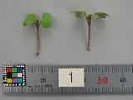  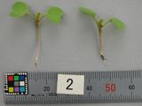  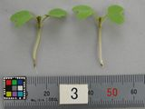  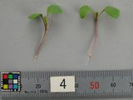  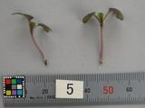  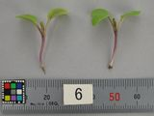  4.  (+) | 10  VG | Hypocotyl: anthocyanin coloration  weak | DE: no variation up to now for anthocyanin characteristics. Correlation between Char. 4, 7 (14 note 4) and 20 should be checked to choose most informative char.  Nl Proposes to make this a QL characteristic with the expressions 1 absent and 9 present  JP: we recognize anthocyanin coloration is continuous expression.  There is no possibility to accept QL for this characteristic.  strong
QN |  | absent or weak |  |  |  | Zasai FM-58 | 1
 |  | medium |  |  |  | Shinkoku seisai | 2
 |  | strong |  |  |  | Kigarashina | 3
5. | 10  MS/VG | Cotyledon: length
QN |  | short |  |  |  | Junkei yamashiona | 3
 |  | medium |  |  |  | Katsuona | 5
 |  | long |  |  |  |  | 7
6. | 10  MS/VG | Cotyledon: width
QN |  | narrow |  |  |  | Junkei yamashiona | 3
 |  | medium |  |  |  | Katsuona | 5
 |  | broad |  |  |  |  | 7
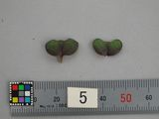  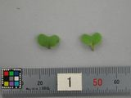  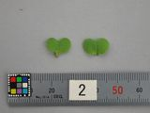  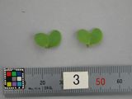  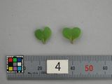  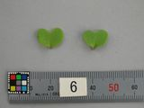  7.  (*)  (+)  absent  present | 10  VG | Cotyledon: anthocyanin coloration | DE: no variation up to now for anthocyanin characteristics. Correlation between Char. 4, 7(14 note 4) and 20, 27 should be checked to choose most informative char.  Nl: Does this characteristic add valuable information, next to the other anthocyanin characteristics, for us delete  Nl: Is a QN characterisitic instead of a QL  JP: However we don’t have valuable information, it is very clear for identification of varieties.  We would like to keep this characteristic as QL absent / present.
QL |  | absent or weak |  |  |  | Zasai FM-58 | 1
 |  | medium |  |  |  |  | 2
 |  | strong |  |  |  | Akariasu | 3
8.  (*)  (+) | 19,  49  VG | Leaf: type | DE: Propose to have two new characteristics instead of Leaf: type:  8a) Leaf: Number of lobes (absent or very few(1) to very many (9))  8b) Leaf: Secondary lobing (absent or very few(1) to very many (9))  Nl: in the explanation there seems not to be a lot of difference between the last example of expression 2: type 2 and expression 3 type 3?  JP to DE: Leaf type is very specific feature for identification of the type of vegetable mustard in East Asia country. If you don’t prefer for agriculture type, we would like to confine this characteristic to vegetable type.  JP to NL: we delete last example of type 2
PQ |  | type1 |  |  |  | Kigarashina | 1
 |  | type2 |  |  |  | Riasu karashina | 2
 |  | type3 |  |  |  | Katsuona | 3
 |  | type4 |  |  |  | Miike takana | 4
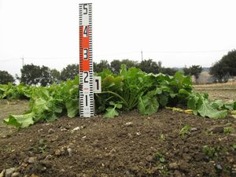  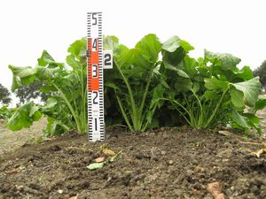  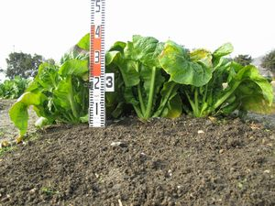  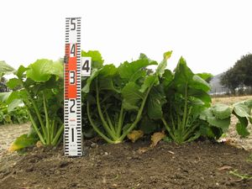  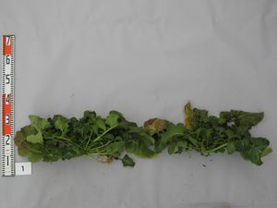  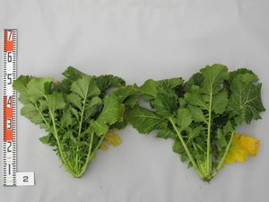  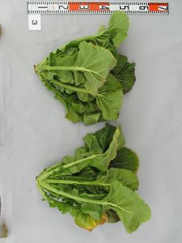  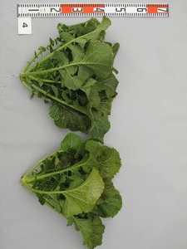  9.  (*) | 19,  49  VG | Leaf: attitude | DE: we have problems to understand. Leaves to be observed should be defined (middle part…?). Probably no variation in German agricultural varieties.  Nl proposes to uses the notes 1 (erect) 3 semi-erect and 5 horizontal because we find that there is enough variation between the varieties.  JP to DE: Please make sure this expression from following photographs of Japanese DUS trial.  JP to NL: We accept your suggestion 1-5 states.
QN |  | erect |  |  |  | Junkei yamashiona | 1
 |  | semi-erect |  |  |  | .Akaoba takana | 2
 |  | horizontal, |  |  |  | Miike takana | 3
10.  (+) | 19,  49  MS/VG | Leaf: length(include petiole) | DE: Propose to adapt to UPOV TG 179/3: Char. 8: Leaf: length (blade and petiole) and to use the same definitions in the drawing  JP to DE: We accept to make consistent with UPOV TG 179/3
QN |  | short |  |  |  | Chirimen hakarashina | 3
 |  | medium |  |  |  | Miike takana | 5
 |  | long |  |  |  |  | 7
11.  (+) | 19,  49  MS/VG | Leaf: width | DE: Propose to adapt to UPOV TG 179/3: Char. 9: Leaf: width (widest point)  Nl proposes to change into: Leaf: width (at broadest part)  JP: We accept to make consistent with UPOV TG 179/3
QN |  | narrow |  |  |  |  | 3
 |  | medium |  |  |  |  | 5
 |  | broad |  |  |  |  | 7
12.  (+) | 19,  49  MS/VG | Leaf: length of petiole
QN |  | absent or very short |  |  |  | Serihon | 1
 |  | medium |  |  |  | Miike takana | 3
 |  | medium |  |  |  | Junkei yamashiona | 5
 |  | long |  |  |  | Kigarashina | 7
13. | 19,-49  MS/VG | Leaf: thickness of petiole | DE: Correlation between Char. 13 and 26? Definition should be added: "at widest point" or "at base"….  JP: We accept to add a definition.
QN |  | thin |  |  |  | Akaoba takana | 3
 |  | medium |  |  |  | Shinkoku seisai | 5
 |  | thick |  |  |  | Kekkyu takana | 7
14. | 19,  49  VG | Leaf: hue of green color | DE: propose to delete or modify However, yellowish hue is probably the same than Char. 15 'light', greyish hue refers to glaucosity, reddish to Char 20.  JP: We accept to delete this characteristic.
PQ |  | absent |  |  |  | Kigarashina | 1
 |  | yellowish |  |  |  |  | 2
 |  | greyish |  |  |  |  | 3
 |  | reddish |  |  |  | Riasu karashina | 4
15. | 19,  49  VG | Leaf: intensity of green coloration | DE: propose to ad "Only varieties with : Leaf :hue of green color: absent:"  Nl: proposes to change into Leaf intensity of color  JP: We would like to keep this characteristic according to the information from DE on characteristic 14.  yellowish is included light green.  reddish is included characteristic 20  greyish is guessed no existing expression.
QN |  | light |  |  |  | Kekkyu takana | 3
 |  | medium |  |  |  | Katsuona | 5
 |  | dark |  |  |  | Kigarashina | 7
16. | 19,  49  MS/VG | Leaf: number of leaves on fully developed plant | DE: for non-heading types, it is not easy to assess and may be correlated with length of plant. For heading types, diameter of head may be easier to asses?  JP: We delete this characteristic.
QN |  | few |  |  |  | Shinkoku seisai | 3
 |  | medium |  |  |  | Akaoba takana | 5
 |  | many |  |  |  | Kigarashina | 7
17.  (+) | 19,  49  MS/VG | Leaf blade: size of terminal leaflet (only variety with leaf type 1 or type2) | Nl Proposes to change into:  Leaf blade: size of terminal lob (only variety with leaf type 1 or leaf type 2)  JP: We accept to change into lobe.
QN |  | small |  |  |  | Chirimen hakarashina | 3
 |  | medium |  |  |  | Kigarashina | 5
 |  | large |  |  |  |  | 7
18.  (+) | 19,  49  MS/VG | Leaf blade: number of lateral leaflets (only variety with leaf type 1 or type2) | DE: propose to have "Only varieties with : Leaf: lobing : present: Leaf: Number of lobes"  Nl Proposes to change into:  Leaf: number of lobes (on fully developed leaves)  with expressions  1 absent or very few  3 few  5 medium  7 many  9 very many  JP: We accept NL proposal because according to TGP 14 page 48, it is difficult to define the expression of lobbing present. Although we accept NL proposal, there is possibility for degree of lobe as this characteristic.
QN |  | few |  |  |  |  | 3
 |  | medium |  |  |  | Kigarashina | 5
 |  | many |  |  |  | Chirimen hakarashina | 7
19. | 19,  49  VG | Leaf blade: pubescence | DE: will be checked in the field 2013, probably no variation up to now  JP: We already checked actual DUS trial in February 2013 in Japan. It was able to confirm lower surface rather than upper surface. Please carefully observe.
QN |  | absent or very few |  |  |  | Miike takana | 1
 |  | few |  |  |  |  | 3
 |  | medium |  |  |  | Katsuona | 5
 |  | many |  |  |  | Kigarashina | 7
20.  (*) | 19,  49  VG | Leaf blade: anthocyanin coloration | DE: no variation up to now for anthocyanin characteristics. Correlation between Char. 4, 7(14 note 4) and 20, 27 should be checked to choose most informative char.  Nl: proposes to change split into two characteristics. The first:  (QL) Leafblade: anthocyanin coloration  1 absent/9 present  the second  (QN) Varietis with anthocyanin coloration present only: Leafblade:intensity of anthocyanin coloration  3 weak/ 5 medium/ 7 strong  JP: Although we can accept NL suggestion to set grouping characteristic as QL, NL suggestion to be discussed in Nagasaki.
QN |  | absent or very weak |  |  |  | Kekkyu takana | 1
 |  | weak |  |  |  | Kigarashina | 3
 |  | medium |  |  |  | Miike takana | 5
 |  | strong |  |  |  | Akaoba takana | 7
21.  (*) | 19,  49  VG | Leaf blade: undulation of margin | DE: will be checked in the field 2013, probably no variation up to now  Nl proposes to add expression  1 absent or very weak  JP: The expression of example variety ‘Chirimen hakarashina’  we accept NL proposal absent or very weak expression.  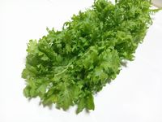  ‘Chirimen hakarashina’ strong
QN |  | weak |  |  |  | Akaoba takana | 3
 |  | medium |  |  |  | Katsuona | 5
 |  | strong |  |  |  | Chirimen hakarashina | 7
22.  (*)  (+) | 19,  49  VG | Leaf blade: density of incision of margin | DE: will be checked in the field 2013, probably no variation up to now. Drawing could be improved to make clear whether Number of incision should be observed or symmetry of incisions  JP: We would like to modify the diagram to make clear.
QN |  | absent or very sparse |  |  |  | Katsuona | 1
 |  | sparse |  |  |  |  | 3
 |  | medium |  |  |  | Junkei yamashiona | 5
 |  | dense |  |  |  | Chirimen hakarashina | 7
23.  (*) | 19,  49  VG | Leaf blade: depth of incision of margin | DE: will be checked in the field 2013, probably no variation up to now  Nl: should be absent or very shallow  JP: We modify to NL indication.
QN |  | absent or shallow |  |  |  | Kigarashina | 1
 |  | shallow |  |  |  |  | 3
 |  | medium |  |  |  |  | 5
 |  | deep |  |  |  | Riasu karashina | 7
24.  (*)  (+) | 19,  49  VG | Leaf blade: blistering | DE: will be checked in the field 2013, probably only weak types up to now.
QN |  | weak |  |  |  | Kigarashina | 3
 |  | medium |  |  |  |  | 5
 |  | strong |  |  |  | Katsuona | 7
25.  (+) | 19,  49  VG | Leaf blade: shape of apex | DE: Is it used to declare varieties distinct, if it is the only character? Are the leaves within the plant uniform? How to assess a char. 8/Typ 2 variety?  JP: We checked actual DUS trial in February 2013 in Japan. We considered it is not useful and decided to delete this characteristic.
PQ |  | acute |  |  |  | Nagasaki takana | 1
 |  | obtuse |  |  |  | Katsuona | 2
 |  | rounded |  |  |  | Miike takana | 3
26. | 19,  49  MS/VG | Leaf blade: width of midrib | DE: Correlation between Char. 13 and 26? Definition should be added: "at widest point" or "at base"…  JP: We accept to add a definition.
QN |  | narrow |  |  |  | Kigarashina | 3
 |  | medium |  |  |  | Katsuona | 5
 |  | broad |  |  |  | Shinkoku seisai | 7
27. | 19,  49  VG | Leaf blade: anthocyanin coloration of midrib | DE: no variation up to now for anthocyanin characteristics. Correlation between Char. 4, 7(14 note 4) and 20, 27 should be checked to choose most informative char  Nl: is there enough variation between all varieties to use all different expressions  We use the characteristic as well, but as a QL characteristic with the expressions 1 absent/ 9 present  JP: We checked our past DUS result and experiences. But we couldn’t confirm enough variation for this characteristic. We can accept NL proposal as QL.  Ask to NL: Can you provide example variety for anthocyanin present?
QN |  | absent or very weak |  |  |  |  | 1
 |  | weak |  |  |  |  | 3
 |  | medium |  |  |  |  | 5
 |  | strong |  |  |  |  | 7
28.  (+) | 20-29  VG | Stem: type of main stem (excluding heading type) | DE. Looking forward to learn about this characteristic. Unknown types in Germany.  Nl proposes to use  1: not enlarged  2 laterally enlarged  3 longitudinally enlarged  4 budding enlarged  like in the explantion insterad of type1/2/3 and4  JP to DE: This characteristic is very specific feature for identification of the type of vegetable mustard in East Asia country.  http://www.agrohaitai.com/rootstem/tsatsai/tsatsai.htm  JP: We accept the wording of each expression from NL.
PQ |  | type1 |  |  |  |  | 1
 |  | type2 |  |  |  |  | 2
 |  | type3 |  |  |  |  | 3
 |  | type4 |  |  |  |  | 4
29. | 30-39  VG | Time of beginning of bolting | DE: propose to add: Only varieties heading: formation: head/present?  JP: Why do you confine heading type for bolting?
QN |  | early |  |  |  | Junkei yamashiona | 3
 |  | medium |  |  |  | Katsuona | 5
 |  | late |  |  |  | Akaoba takana | 7
30.  (*) | 41-49  VG | Head: formation | DE: unknown types in Germany Expression could also be absent /present?  JP: We accept your opinion absent / present.
QL |  | no head |  |  |  | Kigarashina | 1
 |  | head |  |  |  | Kekkyu takana | 2
31. | 49  MS/VG | Head: height (head type only)
QN |  | short |  |  |  |  | 3
 |  | medium |  |  |  | Unzen kekkyu takana | 5
 |  | tall |  |  |  |  | 7
32. | 49  MS/VG | Head: diameter (head type only)
QN |  | narrow |  |  |  |  | 3
 |  | medium |  |  |  | Kekkyu takana | 5
 |  | broad |  |  |  |  | 7
33. | 49  MS/VG | Head: number of leaf (head type only)
QN |  | few |  |  |  |  | 3
 |  | medium |  |  |  | Kekkyu takana | 5
 |  | many |  |  |  |  | 7
34.  (*) | 49  VG | Head: color of inside (head type only)
PQ |  | yellowish white |  |  |  | Unzen kekkyu takana | 1
 |  | light green |  |  |  |  | 2
 |  | green |  |  |  | Kekkyu takana | 3
35. | 49  MS/VG | Head: length of core (head type only)
QN |  | short |  |  |  |  | 3
 |  | medium |  |  |  | Unzen kekkyu takana | 5
 |  | long |  |  |  | Kekkyu takana | 7
36. | 51  MS/VG | Plant: height at appearance of the flower bud | DE: propose to discuss for which types of varieties it should be assessed. We probably have high correlation between 36 and 38  JP: We would like to delete this characteristic because we don’t have experience for this characteristic.
QN |  | short |  |  |  |  | 3
 |  | medium |  |  |  |  | 5
 |  | tall |  |  |  |  | 7
37.  (*) | 60  VG | Time of flowering
QN |  | early |  |  |  |  | 3
 |  | medium |  |  |  |  | 5
 |  | late |  |  |  |  | 7
38. | 65  MS/VG | Plant: height at flowering (at full flowering) | DE: propose to discuss for which types of varieties it should be assessed. We probably have high correlation between 36 and 38 for agricultural types  JP: We would like to delete this characteristic because we don’t have experience for this characteristic.
QN |  | short |  |  |  |  | 3
 |  | medium |  |  |  |  | 5
 |  | tall |  |  |  |  | 7
39. | 65  MS/VG | Flower: length of petal
QN |  | short |  |  |  |  | 3
 |  | medium |  |  |  |  | 5
 |  | long |  |  |  |  | 7
40. | 65  MS/VG | Flower: width of petal
QN |  | narrow |  |  |  |  | 3
 |  | medium |  |  |  |  | 5
 |  | broad |  |  |  |  | 7
41. | 67-69  VG | Flower: male sterility | DE: we have no sterile agricultural varieties  JP: We would like to delete this characteristic because we don’t have experience for this characteristic
PQ |  | absent |  |  |  |  | 1
 |  | partially male sterile |  |  |  |  | 2
 |  | male sterile |  |  |  |  | 3
42. | 69 -89  MS/VG | Plant: total length (after flowering, side branches included) (not for vegetable mustard) | DE We measure at the time of ripening. |  |  | ask to TWA for example variety
QN |  | short |  |  |  |  | 3
 |  | medium |  |  |  |  | 5
 |  | tall |  |  |  |  | 7
43. | 69  MS/VG | Plant: diameter of main stem (not for vegetable mustard) | DE: not necessary for agricultural varieties  JP: We would like to delete this characteristic because we don’t have experience for this characteristic |  |  | ask to TWA for example variety
QN |  | narrow |  |  |  |  | 3
 |  | medium |  |  |  |  | 5
 |  | broad |  |  |  |  | 7
44. | 69  MS/VG | Plant: number of internodes (after flowering) (not for vegetable mustard) | DE: not necessary for agricultural varieties  JP: We would like to delete this characteristic because we don’t have experience for this characteristic |  |  | ask to TWA for example variety
QN |  | few |  |  |  |  | 3
 |  | medium |  |  |  |  | 5
 |  | many |  |  |  |  | 7
45. | 75  VG | Siliqua: color for before drying (not for vegetable mustard) | DE: not necessary for agricultural varieties  JP: We would like to delete this characteristic because we don’t have experience for this characteristic |  |  | ask to TWA for example variety
QN |  | light green |  |  |  |  | 1
 |  | green |  |  |  |  | 2
 |  | dark green |  |  |  |  | 3
46. | 79 - 89  MS/VG | Siliqua: length between stalk and beak (not for vegetable mustard) | DE: propose to use the same wording as for Sinapis alba guideline (UPOV TG 179/3) Char. No 17: Siliqua: length (between peduncle and beak). |  |  | ask to TWA for example variety
QN |  | short |  |  |  |  | 3
 |  | medium |  |  |  |  | 5
 |  | long |  |  |  |  | 7
47. | 79 - 89  MS/VG | Siliqua: width (not for vegetable mustard) |  |  |  | ask to TWA for example variety
QN |  | narrow |  |  |  |  | 3
 |  | medium |  |  |  |  | 5
 |  | broad |  |  |  |  | 7
48. | 79 - 89  MS/VG | Siliqua: length of beak (not for vegetable mustard) |  |  |  | ask to TWA for example variety
QN |  | short |  |  |  |  | 3
 |  | medium |  |  |  |  | 5
 |  | long |  |  |  |  | 7
49. | 79 - 89  MS/VG | Siliqua: length of pedicel (not for vegetable mustard) | DE: propose to use the same wording as for Sinapis alba guideline (UPOV TG 179/3) Char. No 20: Siliqua : length of peduncle. |  |  | ask to TWA for example variety
QN |  | short |  |  |  |  | 3
 |  | medium |  |  |  |  | 5
 |  | long |  |  |  |  | 7
50. | 79  VG | Siliqua: attitude (not for vegetable mustard) | DE: not necessary for agricultural varieties  JP: We would like to delete this characteristic because we don’t have experience for this characteristic |  |  | ask to TWA for example variety
QN |  | erect |  |  |  |  | 1
 |  | horizontal |  |  |  |  | 2
 |  | drooping |  |  |  |  | 3

DE Propose to have another characteristic Seed: color, expression yellowish (1) blackish brown (2), QL, VG, Stage 89 to 99, example varieties (Fotos will be checked)

NL proposal Seed: Color
1 whitish
2 yellow
3 yellow brown
4 brown
5 red brown
6 red
7 black

JP to DE: Are your proposal of stage correct?
We recognize stage 89 to 99 which has possibility of metamorphosed variety. Therefore we have to observe stage 0 and it can be observed original color of the variety.

JP to NL: Your proposal is too much expression which is confused classification of the color. For example yellow – yellow brown – brown – red brown. If you would like to set this expression, please provide example variety and photograph of several varieties.

JP proposal:
Seed: Color
Stage 00
PQ/VG
1 yellow
2 brown
3 black

After characteristic 20 Leaf blade: anthocyanin coloration
23 Only for varieties with Leaf blade: anthocyanin coloration: Leaf blade: division of anthocyanin coloration

1 local
2 entire

explanation
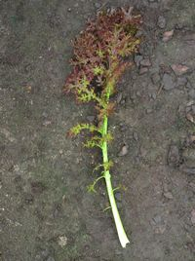
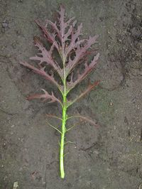

1 local 2 entire

JP to NL: It might be not stable for local variety. In our DUS test, distribution of anthocyanin is depended on the environment or variety. Of course we know there is stable variety too.
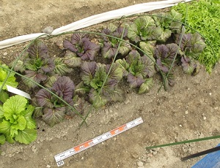
Therefore we can’t accept NL proposal.

DUS trial in Japan: in case of not stable distribution.

After 38 Plant: height at flowering (at full flowering)
PQ/VG
Flower: Color of petals
1 White
2 Light yellow
3 Yellow
4 Orange

We have not seen the expressions white and orange yet. But they are used (without example varieties in a protocol, therefore we would like to ask if any one knows any examples, and if there are add the characteristic with the expressions white and orange.

JP to NL: Also we have never seen withe and orange color. It will be discussed in Nagasaki.

8. Explanations on the Table of Characteristics

Ad. 4: Hypocotyl: anthocyanin coloration

1
absent or weak
2
medium
3
strong

Ad. 7: Cotyledon: anthocyanin coloration

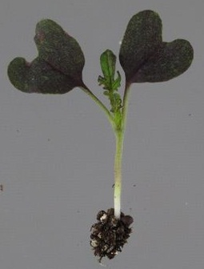
1
absent or weak
3
strong

Ad. 8: Leaf: type

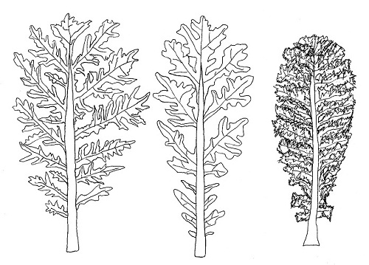
1
type1
(lyrate)
2
type2
(division)
3
type3
(entire and narrow midrib)
4
type4
(entire and broad midrib)

Ad. 10: Leaf: length (include petiole)
Ad. 11: Leaf: width
Ad. 12: Leaf: length of petiole
Leaf: length
Leaf: width
Petiole: length
Petiole: length
Leaf: length
Leaf: width

Ad. 17: Leaf blade: size of terminal leaflet (only variety with leaf type 1 or type2)
Ad. 18: Leaf blade: number of lateral leaflets (only variety with leaf type 1 or type2)
terminal leaflet
lateral leaflets

Ad. 22: Leaf blade: density of incision of margin
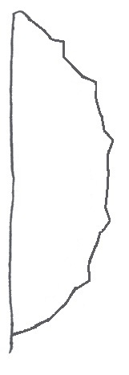
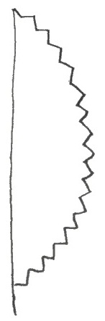
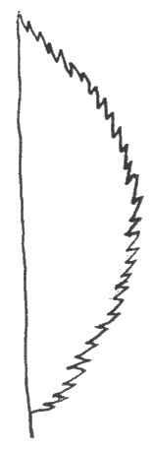
1
absent or sparse
2
medium
3
dense

Ad. 24: Leaf blade: blistering

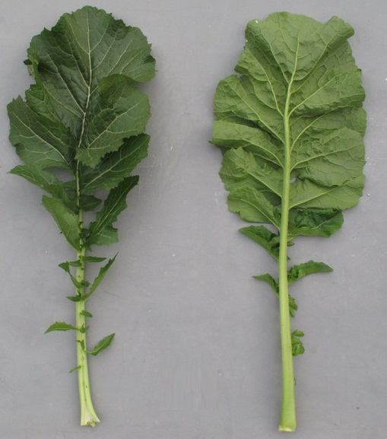
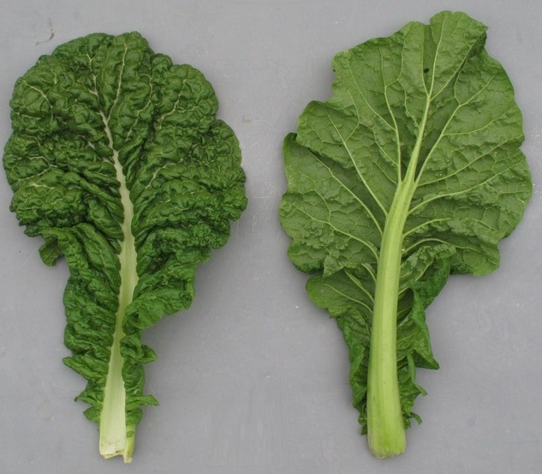
Japan: to be provided photograph for state 5
3
weak
5
medium
7
strong

Ad. 25: Leaf blade: shape of apex

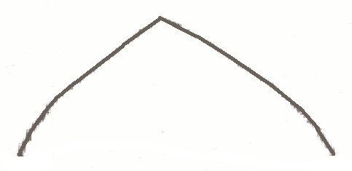
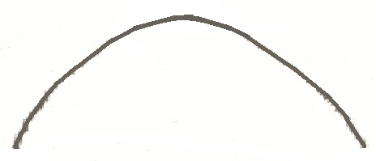
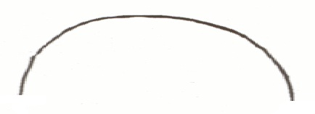
1
acute
2
obtuse
3
rounded

Ad. 28: Stem: type of main stem (exclude head type)

1
type1
(no enlarged)
2
type2
(laterally enlarged)
3
type3
(longitudinally enlarged)
4
type4
(budding enlarged)

KEY FOR THE STAGE OF DEVELOPMENT

KEY | GENERAL DESCRIPTION
0  01  03  05  07  08  09 | Principal growth stage 0: Germination  Beginning of seed imbibition  Seed imbibition complete  Radicle emerged from seed  Hypocotyl with cotyledons emerged from seed  Hypocotyl with cotyledons growing towards soil surface  Emergence: cotyledons emerge through soil surface
1  10  11  12  13  14  15  16  17  18  19 | Principal growth stage 1: Leaf development  Cotyledons completely unfolded  First leaf unfolded  2 leaves unfolded  3 leaves unfolded  4 leaves unfolded  5 leaves unfolded  6 leaves unfolded  7 leaves unfolded  8 leaves unfolded  9 or more leaves unfolded
2  20  21  22  23  24  25  26  27  28  29 | Principal growth stage 2: Formation of side shoots  No side shoots  first side shoot detectable  2 side shoots detectable  3 side shoots detectable  4 side shoots detectable  5 side shoots detectable  6 side shoots detectable  7 side shoots detectable  8 side shoots detectable  9 or more side shoots detectable
3  30  31  32  33  34  35  36  37  38  39 | Principal growth stage 3: Stem elongation  no internodes (“rosette”)  1 visibly extended internode  2 visibly extended internode  3 visibly extended internode  4 visibly extended internode  5 visibly extended internode  6 visibly extended internode  7 visibly extended internode  8 visibly extended internode  9 or more visibly extended internodes
4  41  42  43  44  45  46  47  48  49 | Principal growth stage 4: Development of head  the two youngest leaves do not unfold  20% of the expected head size reached  30% of the expected head size reached  40% of the expected head size reached  50% of the expected head size reached  60% of the expected head size reached  70% of the expected head size reached  80% of the expected head size reached  Typical size, form and firmness of heads reached
5  50  51  52  53  55  57  59 | Principal growth stage 5: Inflorescence emergence  Flower buds present, still enclosed by leaves  Flower buds visible from above (“green bud”)  Flower buds free, level with the youngest leaves  Flower buds raised above the youngest leaves  Individual flower buds (main inflorescence) visible but still closed  Individual flower buds (secondary inflorescences) visible but still closed  First petals visible, flower buds still closed (“yellow bud”)
6  60  61  62  63  64  65  67  69 | Principal growth stage 6: Flowering  First flowers open  10% of flowers on main raceme open, main raceme elongating  20% of flowers on main raceme open  30% of flowers on main raceme open  40% of flowers on main raceme open  Full flowering: 50% flowers on main raceme open, older petals falling  Flowering declining: majority of petals fallen  End of flowering
7  71  72  73  74  75  76  77  78  79 | Principal growth stage 7: Development of fruit  10% of pods have reached final size  20% of pods have reached final size  30% of pods have reached final size  40% of pods have reached final size  50% of pods have reached final size  60% of pods have reached final size  70% of pods have reached final size  80% of pods have reached final size  Nearly all pods have reached final size
8  80  81  82  83  84  85  86  87  88  89 | Principal growth stage 8: Ripening  seed green, filling pod cavity  10% of pods ripe, seeds dark and hard  20% of pods ripe, seeds dark and hard  30% of pods ripe, seeds dark and hard  40% of pods ripe, seeds dark and hard  50% of pods ripe, seeds dark and hard  60% of pods ripe, seeds dark and hard  70% of pods ripe, seeds dark and hard  80% of pods ripe, seeds dark and hard  Fully ripe: nearly all pods ripe, seeds dark and hard
9  97  99 | Principal growth stage 9: Senescence  Plant dead and dry  Harvested product

9. Literature

Ministry of Agriculture, Forestry & Fisheries of Japan., 1994: National Test Guideline for Karashina.

Tsukamoto, Y., 1994: The Grand Dictionary of Horticulture Volume 1. The Shogakukan Ltd., Tokyo, Japan, pp. 520 to 522.

Takasi A., 2004: Yasai-engei-daihyakka 17. Shadanhojin Nousan-gyoson-bunkakyokai. Tokyo, Japan. 169-233

Fujishiro, T., 1996: Breeding processes and characteristics of a newly bred leaf mustard (Brassica Juncea Coss.)., Kanagawa, Japan.

Uwe Meier. Federal Biological Research Centre for Agriculture and Forestry, 2001: Growth stages of mono-and dicotyledonous plants, BBCH Monograph,

Roger Phillips, Martyn Rix., 1993: VEGETABLES (The Pan Garden Plants Series) p.44

Joy Larkcom., 1991: Oriental Vegetables (The Complete guide for Garden and Kitchen) London, United Kingdom. pp. 39 to 45

10. Technical Questionnaire

TECHNICAL QUESTIONNAIRE |  |  |  | Page {x} of {y} |  | Reference Number:
 |  |  |  |  |  | Application date:
 |  |  |  |  |  | (not to be filled in by the applicant)
TECHNICAL QUESTIONNAIRE
to be completed in connection with an application for plant breeders’ rights

1. Subject of the Technical Questionnaire
1.1 Botanical name |  |  | Brassica juncea (L.) Czern
1.2 Common name |  |  | Brown Mustard
2. Applicant
Name
Address
Telephone No.
Fax No.
E-mail address
Breeder (if different from applicant)
3. Proposed denomination and breeder’s reference
Proposed denomination
(if available)

Breeder’s reference
#4. Information on the breeding scheme and propagation of the variety

4.1 Breeding scheme

“Variety resulting from:

“4.1.1 Crossing

“(a) controlled cross [ ]
(please state parent varieties)

(…………………..……………..…) x (……………..…………………..…)
female parent male parent

“(b) partially known cross [ ]
(please state known parent variety(ies))

(…………………..……………..…) x (……………..…………………..…)
female parent male parent

“(c) unknown cross [ ]

“4.1.2 Mutation [ ]
(please state parent variety)

“4.1.3 Discovery and development [ ]
(please state where and when discovered and how developed)

“4.1.4 Other [ ]”
(please provide details)”

4.2 Method of propagating the variety

“4.2.1 Seed-propagated varieties

“(a) Self-pollination [ ]
“(b) Cross-pollination
(i) population [ ]
(ii) synthetic variety [ ]
“(c) Hybrid [ ]
“(d) Other [ ]
(please provide details)”

“4.2.2 Other [ ]”
(please provide details)”

“In the case of hybrid varieties the production scheme for the hybrid should be provided on a separate sheet. This should provide details of all the parent lines required for propagating the hybrid e.g.

“Single Hybrid

(…………………..……………..) x (……………..…………………..)
female parent male parent

“Three-Way Hybrid

(…………………..……………..) x (……………..…………………..)
female line male line

(……………..…………………..) x (……………..…………………..)
single hybrid used as female parent male parent

“and should identify in particular:

“(a) any male sterile lines
“(b) maintenance system of male sterile lines.”
5. Characteristics of the variety to be indicated (the number in brackets refers to the corresponding characteristic in Test Guidelines; please mark the note which best corresponds).

 | Characteristics |  |  |  |  |  | Example Varieties |  |  | Note
5.1  (6) | Cotyledon: anthocyanin coloration
 | absent |  |  |  |  |  | Kigarasina |  |  | 1 [ ]
 | present |  |  |  |  |  | Akariasu |  |  | 9 [ ]
5.2  (7) | Leaf: type
 | type1 |  |  |  |  |  | Kigarashina |  |  | 1 [ ]
 | type2 |  |  |  |  |  | Riasu karashina |  |  | 2 [ ]
 | type3 |  |  |  |  |  | Katsuona |  |  | 3 [ ]
 | type4 |  |  |  |  |  | Miike takana |  |  | 4 [ ]
5.3  (18) | Leaf blade: anthocyanin coloration
 | absent or very weak |  |  |  |  |  | Kekkyu takana |  |  | 1 [ ]
 | weak |  |  |  |  |  | Kigarashina |  |  | 3 [ ]
 | medium |  |  |  |  |  | Miike takana |  |  | 5 [ ]
 | strong |  |  |  |  |  | Akaoba takana |  |  | 7 [ ]
5.4  (20) | Leaf blade: density of incision of margin
 | absent or sparse |  |  |  |  |  | Katsuona |  |  | 1 [ ]
 | medium |  |  |  |  |  | Junkei yamashiona |  |  | 2 [ ]
 | dense |  |  |  |  |  | Chirimen hakarashina |  |  | 3 [ ]
5.5  (22) | Leaf blade: blistering
 | weak |  |  |  |  |  | Kigarashina |  |  | 3 [ ]
 | medium |  |  |  |  |  |  |  |  | 5 [ ]
 | strong |  |  |  |  |  | Katsuona |  |  | 7 [ ]
5.6  (23) | Leaf blade: shape of apex
 | acute |  |  |  |  |  | Nagasaki takana |  |  | 1 [ ]
 | obtuse |  |  |  |  |  | Katsuona |  |  | 2 [ ]
 | rounded |  |  |  |  |  | Miike takana |  |  | 3 [ ]
5.7  (29) | Head: formation
 | no heading |  |  |  |  |  | Kigarashina |  |  | 1 [ ]
 | heading |  |  |  |  |  | Kekkyu takana |  |  | 2 [ ]
5.8  (33) | Head: color of inside (heading type only)
 | yellowish white |  |  |  |  |  | Unzen kekkyu takana |  |  | 1 [ ]
 | light green |  |  |  |  |  |  |  |  | 2 [ ]
 | green |  |  |  |  |  | Kekkyu takana |  |  | 3 [ ]
6. Similar varieties and differences from these varieties

Please use the following table and box for comments to provide information on how your candidate variety differs from the variety (or varieties) which, to the best of your knowledge, is (or are) most similar. This information may help the examination authority to conduct its examination of distinctness in a more efficient way.

Denomination(s) of variety(ies) similar to your candidate variety |  | Characteristic(s) in which your candidate variety differs from the similar variety(ies) |  |  | Describe the expression of the characteristic(s) for the similar variety(ies) |  |  | Describe the expression of the characteristic(s) for your candidate variety
Example |  | Leaf blade: shape of apex |  |  | acute |  |  | obtuse
Comments:

#7. Additional information which may help in the examination of the variety

7.1 In addition to the information provided in sections 5 and 6, are there any additional characteristics which may help to distinguish the variety?

Yes [ ] No [ ]

(If yes, please provide details)

7.2 Are there any special conditions for growing the variety or conducting the examination?

Yes [ ] No [ ]

(If yes, please provide details)

7.3 Other information

7.3.1 Main use

(a) | vegetable | [ ]
(b) | seed | [ ]
(c) | other  (please provide details) | [ ]

A representative color image of the variety should accompany the Technical Questionnaire.

8. Authorization for release

(a) Does the variety require prior authorization for release under legislation concerning the protection of the environment, human and animal health?

Yes [ ] No [ ]

(b) Has such authorization been obtained?

Yes [ ] No [ ]

If the answer to (b) is yes, please attach a copy of the authorization.

9. Information on plant material to be examined or submitted for examination.

9.1 The expression of a characteristic or several characteristics of a variety may be affected by factors, such as pests and disease, chemical treatment (e.g. growth retardants or pesticides), effects of tissue culture, different rootstocks, scions taken from different growth phases of a tree, etc.

9.2 The plant material should not have undergone any treatment which would affect the expression of the characteristics of the variety, unless the competent authorities allow or request such treatment. If the plant material has undergone such treatment, full details of the treatment must be given. In this respect, please indicate below, to the best of your knowledge, if the plant material to be examined has been subjected to:

(a) Microorganisms (e.g. virus, bacteria, phytoplasma) Yes [ ] No [ ]

(b) Chemical treatment (e.g. growth retardant, pesticide) Yes [ ] No [ ]

(c) Tissue culture Yes [ ] No [ ]

(d) Other factors Yes [ ] No [ ]

Please provide details for where you have indicated “yes”.

……………………………………………………………

10. I hereby declare that, to the best of my knowledge, the information provided in this form is correct:

Applicant’s name

Signature Date

[End of document]

* These names were correct at the time of the introduction of these Test Guidelines but may be revised or updated. [Readers are advised to consult the UPOV Code, which can be found on the UPOV Website (www.upov.int), for the latest information.]
# Authorities may allow certain of this information to be provided in a confidential section of the Technical Questionnaire.
# Authorities may allow certain of this information to be provided in a confidential section of the Technical Questionnaire.
* These names were correct at the time of the introduction of these Test Guidelines but may be revised or updated. [Readers are advised to consult the UPOV Code, which can be found on the UPOV Website (www.upov.int), for the latest information.]
# Authorities may allow certain of this information to be provided in a confidential section of the Technical Questionnaire.
# Authorities may allow certain of this information to be provided in a confidential section of the Technical Questionnaire.

