 |  | E  TWV/46/35  ORIGINAL: English  DATE: May 30, 2012
INTERNATIONAL UNION FOR THE PROTECTION OF NEW VARIETIES OF PLANTS
Geneva
Technical working party for VEGETABLES
Forty-Sixth Session
near the city of Venlo, Netherlands, June 11 to 15, 2012
PROPOSED PARTIAL REVISION OF THE TEST GUIDELINES FOR LETTUCE
(DOCUMENT TG/13/10 Rev.)
Document prepared by experts from the Netherlands

1. It is proposed to make a partial revision of the Test Guidelines for Lettuce (document TG/13/10 Rev.) in order to amend Characteristic 39. Resistance to downy mildew (Bremia lactuca) as follows:

- to revise the example varieties
- to provide a revised explanation for resistance to downy mildew according to the explanations for disease resistance characteristics in Test Guidelines, as set out in document TGP/12/2 Draft 2 “Guidance on Certain Physiological Characteristics”, Section 2.4.

2. The Annex to this document contains the proposals as set out in paragraph 1 of this document.

[Annex follows]
PROPOSED PARTIAL REVISION OF THE TEST GUIDELINES FOR LETTUCE (DOCUMENT TG/13/10 REV.)

 |  | English | français | deutsch | español | Example Varieties  Exemples  Beispielssorten  Variedades ejemplo | Note/  Nota
39.  (+)  QL | VG | Resistance to downy mildew  (Bremia lactucae) | Résistance au mildiou  (Bremia lactucae) | Resistenz gegen Falschen Mehltau (Bremia lactucae) | Resistencia al mildiú (Bremia lactucae)
39.1 | (b) (c) | Isolate Bl:2 | Isolat Bl:2 | Isolat Bl:2 | Aislado Bl:2
 |  | absent | absente | fehlend | ausente | Cobham Green,  Green Towers | 1
 |  | present | présente | vorhanden | presente | Ninja | 9
39.2 | (c) | Isolate Bl:5 | Isolat Bl:5 | Isolat Bl:5 | Aislado Bl:5
 |  | absent | absente | fehlend | ausente | Cobham Green,  Green Towers | 1
 |  | present | présente | vorhanden | presente | Sabine | 9
39.3 | (c) | Isolate Bl:7 | Isolat Bl:7 | Isolat Bl:7 | Aislado Bl:7
 |  | absent | absente | fehlend | ausente | Cobham Green,  Green Towers | 1
 |  | present | présente | vorhanden | presente | Valmaine | 9
39.4 | (c) | Isolate Bl:12 | Isolat Bl:12 | Isolat Bl:12 | Aislado Bl:12
 |  | absent | absente | fehlend | ausente | Cobham Green,  Green Towers | 1
 |  | present | présente | vorhanden | presente | Dandie, UCDm2 | 9
39.5 | (c) | Isolate Bl:14 | Isolat Bl:14 | Isolat Bl:14 | Aislado Bl:14
 |  | absent | absente | fehlend | ausente | Cobham Green,  Green Towers | 1
 |  | present | présente | vorhanden | Presente | Colorado, Ninja | 9
39.6 | (c) | Isolate Bl:15 | Isolat Bl:15 | Isolat Bl:15 | Aislado Bl:15
 |  | absent | absente | fehlend | ausente | Cobham Green,  Green Towers, | 1
 |  | present | présente | vorhanden | presente | Colorado, Sabine | 9
39.7  (*) | (c) | Isolate Bl:16 | Isolat Bl:16 | Isolat Bl:16 | Aislado Bl:16
 |  | absent | absente | fehlend | ausente | Cobham Green,  Green Towers | 1
 |  | present | présente | vorhanden | presente | Argelès, Ninja | 9
39.8 | (c) | Isolate Bl:17 | Isolat Bl:17 | Isolat Bl:17 | Aislado Bl:17
 |  | absent | absente | fehlend | ausente | Cobham Green,  Green Towers | 1
 |  | present | présente | vorhanden | presente | Argelès, Ninja | 9
39.9 | (c) | Isolate Bl:18 | Isolat Bl:18 | Isolat Bl:18 | Aislado Bl:18
 |  | absent | absente | fehlend | ausente | Cobham Green,  Green Towers | 1
 |  | present | présente | vorhanden | presente | Argelès, Ninja | 9
39.10 | (c) | Isolate Bl:20 | Isolat Bl:20 | Isolat Bl:20 | Aislado Bl:20
 |  | absent | absente | fehlend | ausente | Cobham Green,  Green Towers | 1
 |  | present | présente | vorhanden | presente | Argelès, Ninja | 9
39.11 | (c) | Isolate Bl:21 | Isolat Bl:21 | Isolat Bl:21 | Aislado Bl:21
 |  | absent | absente | fehlend | ausente | Cobham Green,  Green Towers | 1
 |  | present | présente | vorhanden | presente | Argelès Colorado, Ninja | 9
39.12 | (c) | Isolate Bl:22 | Isolat Bl:22 | Isolat Bl:22 | Aislado Bl:22
 |  | absent | absente | fehlend | ausente | Cobham Green,  Green Towers | 1
 |  | present | présente | vorhanden | presente | Discovery, Ninja | 9
39.13 | (c) | Isolate Bl:23 | Isolat Bl:23 | Isolat Bl:23 | Aislado Bl:23
 |  | absent | absente | fehlend | ausente | Cobham Green,  Green Towers | 1
 |  | present | présente | vorhanden | presente | Colorado, Discovery, Ninja | 9
39.14 | (c) | Isolate Bl:24 | Isolat Bl:24 | Isolat Bl:24 | Aislado Bl:24
 |  | absent | absente | fehlend | ausente | Argelès, Colorado | 1
 |  | present | présente | vorhanden | presente | Dandie, UC DM14,  PIVT 1309 NunDm15 | 9
39.15 | (c) | Isolate Bl:25 | Isolat Bl:25 | Isolat Bl:25 | Aislado Bl:25
 |  | absent | absente | fehlend | ausente | Colorado, Discovery, Pennlake | 1
 |  | present | présente | vorhanden | presente | Argelès, Ninja | 9
39.16 | (c) | Isolate Bl:26 | Isolat Bl:26 | Isolat Bl:26 | Aislado Bl:26
 |  | absent | absente | fehlend | ausente | Colorado, Discovery | 1
 |  | present | présente | vorhanden | presente | Balesta, Bedford | 9
39.17 | (c) | Isolate Bl:27 | Isolat Bl:27 | Isolat Bl:27 | Aislado Bl:27
 |  | absent | absente | fehlend | ausente | Balesta, Colorado, Green Towers | 1
 |  | present | présente | vorhanden | presente | Balesta, Bedford, Discovery | 9

Ad 39. Resistance to Bremia lactuae (Bl)
* 1. Pathogen | Bremia lactucae
2. Quarantine status | -
* 3. Host species | Lactuca sativa L.
* 4. Source of inoculum | GEVES (France) or Naktuinbouw (The Netherlands)
* 5. Isolate | Bl :1 – Bl :27 (see table below)
6. Establishment isolate identity | Test on differentials
7. Establishment pathogenicity | Test on susceptible varieties
8. Multiplication inoculum
8.1 Multiplication medium | Lettuce leaf
8.2 Multiplication variety | Susceptible variety, for example Green Towers.  For higher races, a variety with defeated resistance may be preferable to keep the isolate fit.
8.3 Plant stage at inoculation | Cotyledon to first leaf
8.4 Inoculation medium | Tap water
8.5 Inoculation method | Spraying a spore suspension
8.6 Harvest of inoculum | Washing off from leaves
8.7 Check of harvested inoculum | Counting spores
8.8 Shelf life/viability inoculum | 2 hours at room temperature; 2 days in fridge
9. Format of the test
* 9.1 Number of plants per genotype | Normally 60, minimum 20
* 9.2 Number of replicates | -
* 9.3 Control varieties | (Informative) differentials
* 9.4 Test design | Include control varieties
9.5 Test facility | Climate room
9.6 Temperature | 15°C-17°C
9.7 Light | Adequate for good plant growth;  seedlings should not etiolate.  Reduced light 24 hours after inoculation
9.8 Season | -
9.9 Special measures | Plants may grow on wet blotting paper with or without a nutrient solution, or on potting soil. High humidity (>90%) is essential for infection and sporulation.
10. Inoculation
10.1 Preparation inoculum | Washing off from leaves by vigorous shaking in a closed container
10.2 Quantification inoculum | Counting spores ; spore density should be 3.10⁴-1.10⁵
*10.3 Plant stage at inoculation | Cotyledon stage
*10.4 Inoculation method | Spraying till run-off  Reduced light 24 hours after inoculation
10.5 First observation | 7 days after inoculation
10.6 Second observation | 10 days after inoculation
*10.7 Final observations | 13 days after inoculation; two of these three time points may be sufficient. The day of maximum sporulation should occur in this period.
11. Observations
*11.1 Method | Visual observation of sporulation and necrotic reaction to infection
*11.2 Observation scale | + 1. Abundant sporulation on both sides of the cotyledon  (+) 2. Normal sporulation on the lower side of the cotyledon  (+) 3. Normal sporulation on the lower side of the cotyledons combined with necrotic spots  (-) 4. Sparse sporulation on the lower side of the cotyledons combined with necrosis  (-) 5. Necrotic pinpoints  - 6. No symptoms
*11.3 Validation of test | on standards
11.4 Off-types | Susceptible plants in a resistant variety  Resistant plants in a susceptible variety  3 or less off-types in 60 plants
*12. Interpretation of data | Class 1, 2 and 3: susceptible  Class 4, 5 and 6: resistant
13. Critical control points: | Reaction of standards. The infection pressure may vary between experiments, leading to slight differences in sporulation intensity. When the reactions are not clear the experiment should be repeated.
For reference: The international Bremia evaluation board (IBEB) produces regular updates of the host differential reaction table. The most recent table is available through ISF at www.worldseed.org. The table for Bl:1-27 is given below. Some differentials and race names are printed in gray. These varieties and races are considered less important.

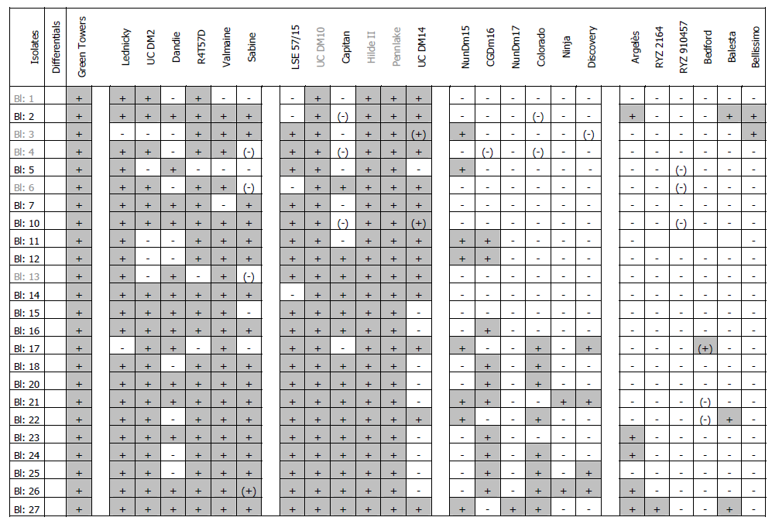

[End of Annex and of document]

