 |  | E  TWV/46/33  ORIGINAL: English  DATE: May 30, 2012
INTERNATIONAL UNION FOR THE PROTECTION OF NEW VARIETIES OF PLANTS
Geneva
Technical working party for VEGETABLES
Forty-Sixth Session
near the city of Venlo, Netherlands, June 11 to 15, 2012

TEST GUIDELINES FOR CASSAVA
Document prepared by the Office of the Union
1 At its forty-first session, held in Angers, France, from May 21 to 25, 2012, the Technical Working Party for Agricultural Crops (TWA) considered the draft Test Guidelines for Cassava (Manihot esculenta Crantz.) on the basis of document TG/CASSAV(proj.3), as presented by Mr. Luis Pacheco (Brazil) and Mr. Simeon Kibet Kogo (Kenya). The TWA made the following comments (see document TWA/41/34 “Report”, paragraph 62):

Cover page | - to add Spanish common names “Mandioca” and “Yuca”  - to add German and French common names
5.3 | - to check whether number of grouping chars. can be reduced  - to correct number of characteristic 5.3 (b)
General remark on Table of Chars. | - to add an annex with regional example varieties from Brazil and Tanzania
Char. 9 | to add example varieties for states (3) and (4) and improve existing photos and add photo for state (4) as follows:  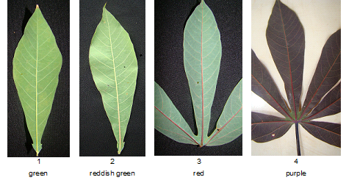
Char. 11 | to add to Ad. 11 that to be observed on the upper third of the plant
Char. 12 | to add to Ad. 12 that to be observed on the upper third of the plant
Char. 17 | state (4) to read “brownish yellow” instead of “golden”
Char. 19 | to be indicated as QL
Char. 21 | to read “Stem: distance between leaf scars”
Char. 22 | to read “Stem: color of end branches (at apex)”
Char. 23 | to check whether the term “peduncle” is correct
Ad. 14 | to be added as follows:  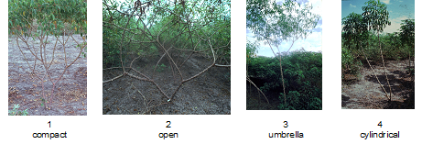
Ad. 15 | to be added as follows:  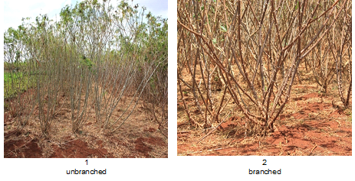
Ad. 16 | to be added as follows:  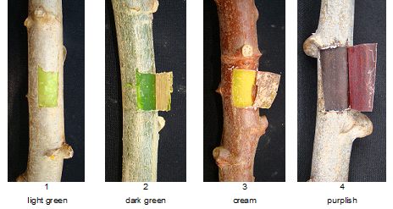
Ad. 21 | - to add an explanation that the characteristic should be observed at the middle third of the plant  - to delete indication of length  - to add illustration as follows:  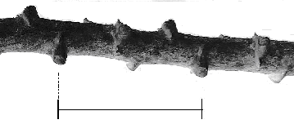
TQ 6 | to add example

2 The TWA agreed to rediscuss the draft Test Guidelines for Cassava at its forty-second session, to be held in Kiev, Ukraine, from June 17 to 21, 2013 (see document TWA/41/34, paragraph 76).

[End of document]

