 |  | E  TWV/46/32  ORIGINAL: English  DATE: May 14, 2012
INTERNATIONAL UNION FOR THE PROTECTION OF NEW VARIETIES OF PLANTS
Geneva
Technical working party for VEGETABLES
Forty-Sixth Session
near the city of Venlo, Netherlands, June 11 to 15, 2012
Partial revision of the Test guidelines for spinach
(document TG/55/7 Rev.)
Document prepared by experts from the Netherlands
Introduction

1. At its forty-fifth session held in Monterey, United States of America from July, 25 to 29, 2011, the Technical Working Party for Vegetables (TWV) decided to include “Spinacia oleracea L. (Partial revision)” in the agenda of the forty-sixth session to be held near the city of Venlo, Netherlands, from June 11 to 15, 2012.

Partial Revision of Test Guidelines for Spinach (TG/55/7 Rev,)

2. It is proposed to revise the Test Guidelines for Spinach TG/55/7Rev. as follows:

(a) Addition of a characteristic Plant: red coloration of stem, petioles and veins , to place after characteristic 1

(b) Addition of “Race Pfs: 12” and ” Race Pfs: 13” in Characteristic 17, including example varieties, and to add an asterisk for Race Pfs: 5, Race Pfs: 6 and Race Pfs: 7.

- Plant: red coloration of stem, petioles and veins

..  (+) | VG | Plant: red coloration of stem, petioles and veins
QL |  | absent | absentes | fehlend | ausentes | Resistoflay, Nores | 1
 |  | present | présentes | vorhanden | presentes | Red Cardinal, Reddy | 9

And to put an explanation in Chapter 8:

Ad ..: Plant: red coloration of stem, petioles and veins

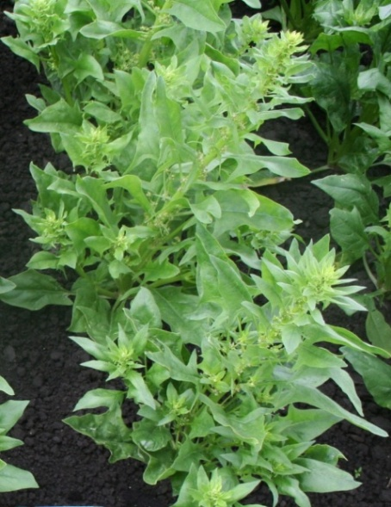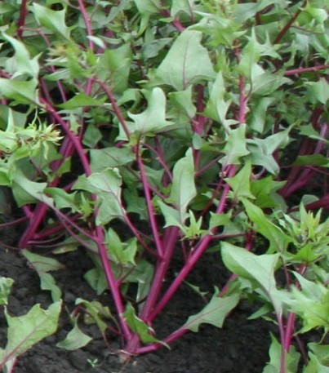

1 | 9
absent | present

Proposal to add 17.11 and 17.2 to characteristic 17 and to put an asterisk * to 17.5, 17.6 and 17.7

17.  (+) | VG | Resistance to Peronospora farinosa f. sp.  spinaciae | Résistance à Peronospora farinosa f. sp.  spinaciae | Resistenz gegen Peronospora farinosa f. sp.  spinaciae | Resistencia a Peronospora farinosa f. sp. spinaciae
QL |  | -------------------------- | -------------------------- | -------------------------- | -------------------------- | ------------------------------ | ---------
17.5 |  | Race Pfs: 5 | Race Pfs: 5 | Pathotyp Pfs: 5 | Raza Pfs: 5
(*) |  | absent | absente | fehlend | ausente | Clermont | 1
 |  | present | présente | vorhanden | presente | Califlay, Campania | 9
 |  | -------------------------- | -------------------------- | -------------------------- | -------------------------- | ------------------------------ | ---------
17.6 |  | Race Pfs: 6 | Race Pfs: 6 | Pathotyp Pfs: 6 | Raza Pfs: 6
(*) |  | absent | absente | fehlend | ausente | Califlay, Campania | 1
 |  | present | présente | vorhanden | presente | Boeing | 9
 |  | -------------------------- | -------------------------- | -------------------------- | -------------------------- | ------------------------------ | ---------
17.7 |  | Race Pfs: 7 | Race Pfs: 7 | Pathotyp Pfs: 7 | Raza Pfs: 7
(*) |  | absent | absente | fehlend | ausente | Califlay | 1
 |  | present | présente | vorhanden | presente | Campania | 9
 |  | -------------------------- | -------------------------- | -------------------------- | -------------------------- | ------------------------------ | ---------
17.11 |  | Race Pfs: 12 | Race Pfs: 12 | Pathotyp Pfs: 12 | Raza Pfs: 12
 |  | absent | absente | fehlend | ausente | Campania, Boeing | 1
 |  | present | présente | vorhanden | presente | Finch, Pigeon,  Red Kitten, Zebu, | 9
 |  | -------------------------- | -------------------------- | -------------------------- | -------------------------- | ------------------------------ | ---------
17.12 |  | Race Pfs: 13 | Race Pfs: 13 | Pathotyp Pfs: 13 | Raza Pfs: 13
 |  | absent | absente | fehlend | ausente | Campania | 1
 |  | present | présente | vorhanden | presente | Boeing, Lion | 9

Modification to Chapter 8, Ad 17:

Differential varieties to identify races

Races Pfs: 1-8 and 10-13 of Peronospora farinosa f. sp. spinaciae are defined with a standard set of “differential varieties” according to the following table:

Differential variety | Pfs: 1 | Pfs: 2 | Pfs: 3 | Pfs: 4 | Pfs: 5 | Pfs: 6 | Pfs: 7 | Pfs: 8 | Pfs: 10 | Pfs: 11 | Pfs: 12 | Pfs: 13
Viroflay | S | S | S | S | S | S | S | S | S | S | S | S
Resistoflay | R | R | S | S | S | S | S | S | S | S | S | S
Califlay | R | S | R | S | R | S | S | R | S | R | R | S
Clermont | R | R | R | R | S | S | S | S | S | S | S | S
Campania | R | R | R | R | R | S | R | S | S | R | S | S
Boeing | R | R | R | R | R | R | R | S | S | R | S | R
Lion | R | R | R | R | R | R | R | R | S | R | R | R
Lazio | R | R | R | R | R | R | R | R | R | S | S | S

Legend: R= resistance present; S = resistance absent, susceptible

[End of document]

