 |  | E  TWV/46/23  ORIGINAL: English  DATE: May 11, 2012
INTERNATIONAL UNION FOR THE PROTECTION OF NEW VARIETIES OF PLANTS
Geneva
Technical working party for vegetables
Forty-Sixth Session
near the city of Venlo, Netherlands, June 11 to 15, 2012
revision of document tgp/8:
PArt II: techniques used in dus examination
Section 3: The Combined-Over-Years Criteria for Distinctness (COYD)
Document prepared by an expert from United Kingdom

background

1 The Technical Committee, at its forty-eighth session, held in Geneva from March 26 to 28, 2012, considered the revision of document TGP/8 “Trial Design and Techniques Used in the Examination of Distinctness, Uniformity and Stability” on the basis of document TC/48/19 Rev. The TC noted that new drafts of relevant sections would need to be prepared by April 26, 2012, in order that the sections could be included in the draft to be considered by the Technical Working Parties (TWPs) at their sessions in 2012 (see document TC/48/22 “Report on conclusions” paragraph 49).

2 The TC, at its forty-eighth session, agreed that the reference to COYD and COYU should be checked throughout the section. The TC also requested data to be provided in support of the proposal to reduce the minimum degrees of freedom for the varieties-by-years mean square in the COYD analysis of variance from 20 to 10. It also agreed that the following wording in Section 3.1 “Summary of requirements for application of method” should be amended because it meant that Long-Term COYD could be used with less than 10 degrees of freedom:

“there should be at least 10, and preferably at least 20, degrees of freedom for the varieties-by-years mean square in the COYD analysis of variance, or if there are not, then Long-Term COYD can be used (see 3.6.2 below);”

(see document TC/48/22 “Report on conclusions” paragraph 64).

3 The Annex to this document contains a proposed revised text (highlighted) of the Section 3 “The Combined Over -Years Criteria for Distinctness (COYD)”.
TGP/8/: PART II: SECTION 3: THE COMBINED OVER-YEARS CRITERIA FOR DISTINCTNESS (COYD)

3.1 Summary of requirements for application of method

COYD is an appropriate method for assessing the distinctness of varieties where:

- the characteristic is quantitative;

- there are some differences between plants (or plots) of a variety;

- observations are made on a plant (or plot) basis over at least two years or growing cycles, and these should be carried out at a single location;

- there should be at least 10, and preferably at least 20 degrees of freedom for the varieties-by-years mean square in the COYD analysis of variance., or If there are not, then in some circumstances Long-Term COYD can be used whereby additional data from other varieties and earlier years are used and the degrees of freedom for the varieties-by-years mean square is increased correspondingly (see 3.6.2 below);

[…]

3.5 Use of COYD

3.5.1 COYD is an appropriate method for assessing the distinctness of varieties where:

- the characteristic is quantitative;

- there are some differences between plants (or plots) of a variety;

- observations are made on a plant (or plot) basis over two or more years;

- there should be at least 10, and preferably at least 20 degrees of freedom for the varieties-by-years mean square in the COYD analysis of variance. If there are not, then in some circumstances Long-Term COYD can be used whereby additional data from other varieties and earlier years are used and the degrees of freedom for the varieties-by-years mean square is increased correspondingly (see 3.6.2 below);
The reason for this recommendation is to ensure that the varieties-by-years mean square is based on sufficient data to be a reliable estimate of the varieties-by-years variation in the LSD. The fewer the data, the fewer the degrees of freedom for the varieties-by-years mean square, and the less reliable the estimate of the varieties-by-years variation used in the LSD. This is compensated for by use of a larger critical t-value, t_{p}, in the LSD. The result is a less powerful test, which means that there is a reduced chance of declaring varieties as being distinct. From the graph below, it can be seen that the power of the test is good with 20 or more degrees of freedom for the varieties-by-years mean square, that it is still reasonably powerful if the degrees of freedom drop to 10, though more is preferable.
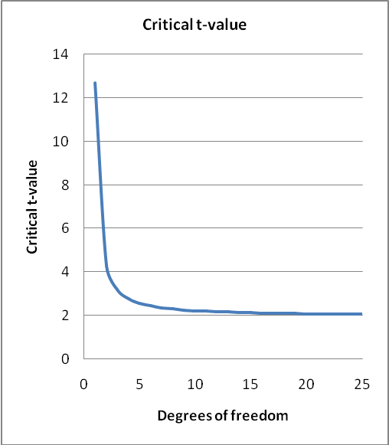
Twenty degrees of freedom corresponds to 11 varieties common in three years of trials, or 21 varieties common in two years, whereas, ten degrees of freedom corresponds to 6 varieties common in three years of trials, or 11 varieties common in two years. Trials with fewer varieties in common over years are considered to have small numbers of varieties in trial.

3.5.2 A pair of varieties is considered to be distinct if their over-years means differ by at least the COYD LSD in one or more characteristics.

3.5.3 The UPOV recommended probability level p for the t_{p} value used to calculate the COYD LSD differs depending on the crop and for some crops depends on whether the test is over two or three years. The testing schemes that usually arise in distinctness testing are described in document TGP/8/1 Part II section 3.11.

[…]

3.6.2 Small numbers of varieties in trials: Long-Term COYD

3.6.2.2 In trials with small numbers of varieties the variety-by-year tables of means can be expanded to include means for earlier years, and if necessary, other established varieties. As not all varieties are present in all years, the resulting tables of variety-by-year means are not balanced. Consequently, each table is analyzed by the least squares method of fitted constants (FITCON) or by REML, which produces an alternative varieties-by-years mean square as a long-term estimate of variety-by-years variation. This estimate has more degrees of freedom as it is based on more years and varieties.
$$\text{degrees} \text{of} \text{freedom}=\begin{aligned}\left(\text{No}\text{.}\text{ values in expanded } | \right) \\ \end{aligned}$$
3.6.2.3 The alternative varieties-by-years mean square is used in equation [1] above to calculate an LSD. This LSD is known as a “Long-Term LSD” to distinguish it from COYD LSD based on just the test years and varieties. The Long-Term LSD is used in the same way as the COYD LSD is used to assess the distinctness of varieties by comparing their over-year (the test years) means. The act of comparing the means of varieties using a “Long-Term LSD” is known as “Long-Term COYD”.

3.6.2.4 Long-Term COYD should only be applied to those characteristics lacking the recommended minimum degrees of freedom. However, when there is evidence that a characteristic’s LSD fluctuates markedly across years, it may be necessary to base the LSD for that characteristic on the current two or three-years of data, even though it has few degrees of freedom.

      - Figure 2 gives an example of the application of Long-Term COYD to the Italian ryegrass characteristic “Growth habit in spring”. A flow diagram of the stages and DUST modules used to produce Long-Term LSD’s and perform Long-Term COYD is given in Figure B2 in Part II: section 3.10.

      - Marked year-to-year changes in an individual variety’s characteristic

Occasionally, a pair of varieties may be declared distinct on the basis of a t-test which is significant solely due to a very large difference between the varieties in a single year. To monitor such situations a check statistic is calculated, called F₃, which is the variety-by-years mean square for the particular variety pair expressed as a ratio of the overall variety-by-years mean square. This statistic should be compared with F-distribution tables with 1 and g, or 2 and g, degrees of freedom, for tests with two or three years of data respectively where g is the degrees of freedom for the variety-by-years mean square. If the calculated F₃ value exceeds the tabulated F value at the 1% level then an explanation for the unusual result should be sought before making a decision on distinctness.

3.7 Implementing COYD

COYD is an appropriate method for assessing the distinctness of varieties where:

- the characteristic is quantitative;

- there are some differences between plants (or plots) of a variety;

- observations are made on a plant (or plot) basis over two or more years;

- there should be at least 10, and preferably at least 20 degrees of freedom for the varieties-by-years mean square in the COYD analysis of variance, or if there are not, then Long-Term COYD can be used (see 3.6.2 above) ;

The COYD method can be applied using TVRP module of the DUST package for the statistical analysis of DUS data, which is available from Dr. Sally Watson (Email: info@afbini.gov.uk) or from http://www.afbini.gov.uk/dustnt.htm. Sample outputs are given in Part II section 3.10.

3.8 References

DIGBY, P.G.N. (1979). Modified joint regression analysis for incomplete variety x environment data. J. Agric. Sci. Camb. 93, 81-86.

PATTERSON, H.D. & WEATHERUP, S.T.C. (1984). Statistical criteria for distinctness between varieties of herbage crops. J. Agric. Sci. Camb. 102, 59-68.

TALBOT, M. (1990). Statistical aspects of minimum distances between varieties. UPOV TWC Paper TWC/VIII/9, UPOV, Geneva.

[End of Annex and of document]

