 |  |  |  |  |  |  | E  TG/154/4(proj.1)  ORIGINAL: English  DATE: 2012-05-01
INTERNATIONAL UNION FOR THE PROTECTION OF NEW VARIETIES OF PLANTS
Geneva
 |  |  | DRAFT
 |  | LEAF CHICORY  UPOV Code: CICHO_INT_FOL  Cichorium intybus L. var. foliosum Hegi |  |  | *

GUIDELINES

FOR THE CONDUCT OF TESTS

FOR DISTINCTNESS, UNIFORMITY AND STABILITY

prepared by experts from France

to be considered by the
Technical Working Party for Vegetables at its forty-sixth session,
to be held near the City of Venlo, Netherlands, from June 11 to 15, 2012

Alternative Names:*

Botanical name | English | French | German | Spanish
Cichorium intybus L. var. foliosum Hegi | Leaf chicory | Chicorée à feuilles | Blattzichorie | Achicoria de hoja

The purpose of these guidelines (“Test Guidelines”) is to elaborate the principles contained in the General Introduction (document TG/1/3), and its associated TGP documents, into detailed practical guidance for the harmonized examination of distinctness, uniformity and stability (DUS) and, in particular, to identify appropriate characteristics for the examination of DUS and production of harmonized variety descriptions.

ASSOCIATED DOCUMENTS
These Test Guidelines should be read in conjunction with the General Introduction and its associated TGP documents.
TABLE OF CONTENTS PAGE

1. Subject of these Test Guidelines 3
2. Material Required 3
3. Method of Examination 3
3.1 Number of Growing Cycles 3
3.2 Testing Place 3
3.3 Conditions for Conducting the Examination 3
3.4 Test Design 3
3.5 Additional Tests 3
4. Assessment of Distinctness, Uniformity and Stability 4
4.1 Distinctness 4
4.2 Uniformity 5
4.3 Stability 5
5. Grouping of Varieties and Organization of the Growing Trial 5
6. Introduction to the Table of Characteristics 6
6.1 Categories of Characteristics 6
6.2 States of Expression and Corresponding Notes 6
6.3 Types of Expression 6
6.4 Example Varieties 6
6.5 Legend 7
7. Table of Characteristics/Tableau des caractères/Merkmalstabelle/Tabla de caracteres 8
8. Explanations on the Table of Characteristics 16
8.1 Explanations covering several characteristics 16
8.2 Explanations for individual characteristics 16
9. Literature 21
10. Technical Questionnaire 22
ANNEX COMMENTS BY THE NETHERLANDS

Highlighted and underlined : additions proposed

Highlighted and strikethrough : deletions

Subject of these Test Guidelines

These Test Guidelines apply to all varieties of Cichorium intybus L. var. foliosum Hegi excluding Cichorium intybus L. Partim (witloof chicory).

Material Required

2.1 The competent authorities decide on the quantity and quality of the plant material required for testing the variety and when and where it is to be delivered. Applicants submitting material from a State other than that in which the testing takes place must ensure that all customs formalities and phytosanitary requirements are complied with.

2.2 The material is to be supplied in the form of seed.

2.3 The minimum quantity of plant material, to be supplied by the applicant, should be:

25 g.

The seed should meet the minimum requirements for germination, species and analytical purity, health and moisture content, specified by the competent authority. In cases where the seed is to be stored, the germination capacity should be as high as possible and should, be stated by the applicant.

2.4 The plant material supplied should be visibly healthy, not lacking in vigor, nor affected by any important pest or disease.

2.5 The plant material should not have undergone any treatment which would affect the expression of the characteristics of the variety, unless the competent authorities allow or request such treatment. If it has been treated, full details of the treatment must be given.

Method of Examination

3.1 Number of Growing Cycles

The minimum duration of tests should normally be two independent growing cycles.

3.2 Testing Place

Tests are normally conducted at one place. In the case of tests conducted at more than one place, guidance is provided in TGP/9 “Examining Distinctness”.

3.3 Conditions for Conducting the Examination

The tests should be carried out under conditions ensuring satisfactory growth for the expression of the relevant characteristics of the variety and for the conduct of the examination.

3.4 Test Design

3.4.1 Each test should be designed to result in a total of at least 100 plants which should be divided between at least 2 replicates.

3.4.2 The design of the tests should be such that plants or parts of plants may be removed for measurement or counting without prejudice to the observations which must be made up to the end of the growing cycle.

3.5 Additional Tests

Additional tests, for examining relevant characteristics, may be established.

Assessment of Distinctness, Uniformity and Stability

4.1 Distinctness

4.1.1 General Recommendations

It is of particular importance for users of these Test Guidelines to consult the General Introduction prior to making decisions regarding distinctness. However, the following points are provided for elaboration or emphasis in these Test Guidelines.

4.1.2 Consistent Differences

The differences observed between varieties may be so clear that more than one growing cycle is not necessary. In addition, in some circumstances, the influence of the environment is not such that more than a single growing cycle is required to provide assurance that the differences observed between varieties are sufficiently consistent. One means of ensuring that a difference in a characteristic, observed in a growing trial, is sufficiently consistent is to examine the characteristic in at least two independent growing cycles.

4.1.3 Clear Differences

Determining whether a difference between two varieties is clear depends on many factors, and should consider, in particular, the type of expression of the characteristic being examined, i.e. whether it is expressed in a qualitative, quantitative, or pseudo-qualitative manner. Therefore, it is important that users of these Test Guidelines are familiar with the recommendations contained in the General Introduction prior to making decisions regarding distinctness.

4.1.4 Number of Plants / Parts of Plants to be Examined

Unless otherwise indicated, for the purposes of distinctness, all observations on single plants should be made on 40 plants or parts taken from each of 40 plants and any other observations made on all plants in the test, disregarding any off-type plants.

4.1.5 Method of Observation

The recommended method of observing the characteristic for the purposes of distinctness is indicated by the following key in the second column of the Table of Characteristics (see document TGP/9 “Examining Distinctness”, Section 4 “Observation of characteristics”):

MG: single measurement of a group of plants or parts of plants
MS: measurement of a number of individual plants or parts of plants
VG: visual assessment by a single observation of a group of plants or parts of plants
VS: visual assessment by observation of individual plants or parts of plants

Type of observation: visual (V) or measurement (M)

“Visual” observation (V) is an observation made on the basis of the expert’s judgment. For the purposes of this document, “visual” observation refers to the sensory observations of the experts and, therefore, also includes smell, taste and touch. Visual observation includes observations where the expert uses reference points (e.g. diagrams, example varieties, side-by-side comparison) or non-linear charts (e.g. color charts). Measurement (M) is an objective observation against a calibrated, linear scale e.g. using a ruler, weighing scales, colorimeter, dates, counts, etc.

Type of record : for a group of plants (G) or for single, individual plants (S)

For the purposes of distinctness, observations may be recorded as a single record for a group of plants or parts of plants (G), or may be recorded as records for a number of single, individual plants or parts of plants (S). In most cases, “G” provides a single record per variety and it is not possible or necessary to apply statistical methods in a plant-by-plant analysis for the assessment of distinctness.

In cases where more than one method of observing the characteristic is indicated in the Table of Characteristics (e.g. VG/MG), guidance on selecting an appropriate method is provided in document TGP/9, Section 4.2.

4.2 Uniformity

4.2.1 It is of particular importance for users of these Test Guidelines to consult the General Introduction prior to making decisions regarding uniformity. However, the following points are provided for elaboration or emphasis in these Test Guidelines:

4.2.2 The assessment of uniformity for open-pollinated varieties should be according to the recommendations for cross-pollinated varieties in the General Introduction.

4.2.3 For the assessment of uniformity of inbred lines and hybrids, a population standard of 3% and an acceptance probability of at least 95% should be applied. In the case of a sample size of 100 plants, 6 off-types are allowed. In addition, the same population standard and acceptance probability should apply to clear cases of out-crossed plants in inbred lines as well as plants obviously resulting from the selfing of a parent line in hybrids.

4.3 Stability

4.3.1 In practice, it is not usual to perform tests of stability that produce results as certain as those of the testing of distinctness and uniformity. However, experience has demonstrated that, for many types of variety, when a variety has been shown to be uniform, it can also be considered to be stable.

4.3.2 Where appropriate, or in cases of doubt, stability may be further examined by testing a new seed stock to ensure that it exhibits the same characteristics as those shown by the initial material supplied.

Grouping of Varieties and Organization of the Growing Trial

5.1 The selection of varieties of common knowledge to be grown in the trial with the candidate varieties and the way in which these varieties are divided into groups to facilitate the assessment of distinctness are aided by the use of grouping characteristics.

5.2 Grouping characteristics are those in which the documented states of expression, even where produced at different locations, can be used, either individually or in combination with other such characteristics: (a) to select varieties of common knowledge that can be excluded from the growing trial used for examination of distinctness; and (b) to organize the growing trial so that similar varieties are grouped together.

5.3 The following have been agreed as useful grouping characteristics:

- Plant: sub-type (characteristic 1)
- Leaf: color (excluding midrib) (characteristic 8)
- Leaf: anthocyanin coloration at harvest maturity (characteristic 12)
- Plant: head formation (characteristic 20)
- Head: shape in longitudinal section (characteristic 24)
- Male sterility (characteristic 36)

5.4 Guidance for the use of grouping characteristics, in the process of examining distinctness, is provided through the General Introduction and document TGP/9 “Examining Distinctness”.

Introduction to the Table of Characteristics

6.1 Categories of Characteristics

6.1.1 Standard Test Guidelines Characteristics

Standard Test Guidelines characteristics are those which are approved by UPOV for examination of DUS and from which members of the Union can select those suitable for their particular circumstances.

6.1.2 Asterisked Characteristics

Asterisked characteristics (denoted by *) are those included in the Test Guidelines which are important for the international harmonization of variety descriptions and should always be examined for DUS and included in the variety description by all members of the Union, except when the state of expression of a preceding characteristic or regional environmental conditions render this inappropriate.

6.2 States of Expression and Corresponding Notes

6.2.1 States of expression are given for each characteristic to define the characteristic and to harmonize descriptions. Each state of expression is allocated a corresponding numerical note for ease of recording of data and for the production and exchange of the description.

6.2.2 In the case of qualitative and pseudo-qualitative characteristics (see Chapter 6.3), all relevant states of expression are presented in the characteristic. However, in the case of quantitative characteristics with 5 or more states, an abbreviated scale may be used to minimize the size of the Table of Characteristics. For example, in the case of a quantitative characteristic with 9 states, the presentation of states of expression in the Test Guidelines may be abbreviated as follows:

State | Note
small | 3
medium | 5
large | 7

However, it should be noted that all of the following 9 states of expression exist to describe varieties and should be used as appropriate:

State | Note
very small | 1
very small to small | 2
small | 3
small to medium | 4
medium | 5
medium to large | 6
large | 7
large to very large | 8
very large | 9

6.2.3 Further explanation of the presentation of states of expression and notes is provided in document TGP/7 “Development of Test Guidelines”.

6.3 Types of Expression

An explanation of the types of expression of characteristics (qualitative, quantitative and pseudo-qualitative) is provided in the General Introduction.

6.4 Example Varieties

Where appropriate, example varieties are provided to clarify the states of expression of each characteristic.

6.5 Legend

(*) Asterisked characteristic – see Chapter 6.1.2

QL Qualitative characteristic – see Chapter 6.3
QN Quantitative characteristic – see Chapter 6.3
PQ Pseudo-qualitative characteristic – see Chapter 6.3

MG, MS, VG, VS – see Chapter 4.1.5

(a)-(d) See Explanations on the Table of Characteristics in Chapter 8.1.

(+) See Explanations on the Table of Characteristics in Chapter 8.2.

Table of Characteristics/Tableau des caractères/Merkmalstabelle/Tabla de caracteres

 |  | English | français | deutsch | español | Example Varieties  Exemples  Beispielssorten  Variedades ejemplo | Note/  Nota
1  (*) | VG | Plant: sub-type | Plante : sous-type | Pflanze: Untergruppe | Plant: subtipo
QL |  | Chioggia | Chioggia | Chioggia | Chioggia |  | 1
 |  | Trevise | Trevise | Trevise | Trevise |  | 2
 |  | Verone | Verone | Verone | Verone |  | 3
 |  | Pain de sucre | Pain de sucre | Pain de sucre | Pain de sucre |  | 4
 |  | Améliorée Blonde ou Verte | Améliorée Blonde ou Verte | Améliorée Blonde ou Verte | Améliorée Blonde ou Verte |  | 5
 |  | Barbe de capucin | Barbe de capucin | Barbe de capucin | Barbe de capucin |  | 6
 |  | Catalogna | Catalogna | Catalogna | Catalogna |  | 7
2  (old 1)  (*) | VG | Young plant: anthocyanin coloration at 5-6 leaf stage | Plantule : pigmentation anthocyanique au stade 5 à 6 feuilles | Jungpflanze: Anthocyanfärbung im 5- bis 6-Blattstadium | Planta joven: pigmentación antociánica en estado  5 a 6 hojas
QL |  | absent | absente | fehlend | ausente | Améliorée,  Pan di zucchero | 1
 |  | present | présente | vorhanden | presente | Palla rossa 2 / Trevise | 9
3  (old 3)  (*) | VG | Plant: diameter (plant fully developed) | Plante : diamètre (plante entièrement développée) | Pflanze: Durchmesser (Pflanze voll entwickelt) | Planta: diámetro (planta totalmente desarrollada)
QN | (a) | very small | très petit | sehr klein | muy pequeño | Silla | 1
 |  | small | petit | klein | pequeño | Palla rossa 2 | 3
 |  | medium | moyen | mittel | medio | Palla rossa 3 | 5
 |  | large | grand | groß | grande | Pan di zucchero | 7
 |  | very large | très grand | sehr groß | muy grande | Catalogna puntarelle a foglia stretta | 9
4  (old 3)  (*) | VG | Leaf: attitude | Feuille : port | Blatt: Haltung | Hoja: porte
QN | (b) | erect | dressé | aufrecht | erecto | Vérone | 1
 |  | semi-erect | demi-dressé | halbaufrecht | semierecto | Palla rossa 2 | 3
 |  | horizontal | horizontal | waagerecht | horizontal | Selvatica da campo | 5
5  (old 4)  (*) | VG | Leaf: length (at harvest maturity) | Feuille : longueur (à maturité de récolte) | Blatt: Länge (zur Erntereife) | Hoja: longitud (en la madurez de cosecha)
QN | (b) | very short | très courte | sehr kurz | muy corta | Silla,  Zuccherina di Trieste | 1
 |  | short | courte | kurz | corta | Palla rossa 2 | 3
 |  | medium | moyenne | mittel | media | Pan di zucchero | 5
 |  | long | longue | lang | larga | Rossa di Treviso | 7
 |  | very long | très longue | sehr lang | muy larga | Catalogna a foglie frastagliate | 9
6  (old 5)  (*) | VG | Leaf: width (as for 4) | Feuille : largeur (comme pour 4) | Blatt: Breite (wie unter 4) | Hoja: anchura (como para 4)
 |  | very narrow | très étroite | sehr schmal | muy estrecha | Catalogna puntarelle a foglia stretta | 1
QN | (b) | narrow | étroite | schmal | estrecha | Rossa di Treviso 2 | 3
 |  | medium | moyenne | mittel | media | Pan di zucchero, Silla | 5
 |  | broad | large | breit | ancha | Bianca invernale,  Variegata di Chioggia | 7
 |  | very broad | très large | sehr breit | muy ancha |  | 9
7  (old 6)  (*) | VG | Leaf: shape | Feuille: forme | Blatt: Form | Hoja: forma
QN | (b) | narrow elliptic | elliptique étroit | schmal elliptisch | elíptica estrecha | Catalogna pugliese | 1
 |  | elliptic | elliptique | elliptisch | elíptica | Vérone | 2
 |  | broad elliptic | elliptique large | breit elliptisch | elíptica ancha | Pan di zucchero | 3
 |  | round | ronde | rund | redonda | Silla | 4
8  (old 7)  (*) | VG | Leaf: color (excluding midrib) | Feuille : couleur (à l’exclusion de la nervure médiane) | Blatt: Farbe (Mittelrippe ausgenommen) | Hoja: color (excluyendo el nervio central)
QL | (b) | yellow | jaune | gelb | amarillo | Bianca invernale | 1
 |  | green | verte | grün | verde | Pan di zucchero | 2
 |  | red | rouge | rot | rojo | Red Devil | 3
9  (old 8)  (*) | VG | Leaf: intensity of color (as for 7) | Feuille : intensité de la couleur (comme pour 7) | Blatt: Intensität der Farbe (wie unter 7) | Hoja: intensidad del color (como para 7)
QN | (b) | light | claire | hell | claro |  | 3
 |  | medium | moyenne | mittel | medio |  | 5
 |  | dark | foncée | dunkel | oscuro |  | 7
10  (old 9) | VG | Leaf: glossiness | Feuille : brillance | Blatt: Glanz | Hoja: brillo
QN | (b) | weak | faible | gering | débil | Jupiter, Scarpia | 3
 |  | medium | moyenne | mittel | medio | Chioggia, Vérone | 5
 |  | strong | forte | stark | fuerte | Vulcano | 7
11  (old 10)  (*) | VG | Leaf: color of midrib | Feuille : couleur de la nervure médiane | Blatt: Farbe der Mittelrippe | Hoja: color del nervio central
QL | (b) | whitish | blanchâtre | weißlich | blancuzco | Bianca invernale | 1
 |  | green | verte | grün | verde | Pan di zucchero | 2
 |  | red | rouge | rot | rojo | Medusa, Silla | 3
12  (old 11)  (*) | VG | Leaf: anthocyanin coloration at harvest maturity | Feuille : pigmentation anthocyanique à maturité de récolte | Blatt: Anthocyanfärbung zur Erntereife | Hoja: pigmentación antociánica en la madurez de cosecha
QL | (b) | absent | absente | fehlend | ausente | Pan di zucchero | 1
 |  | present | présente | vorhanden | presente | Red Devil | 9
13  (old 12) | VG | Leaf: anthocyanin distribution  (as for 4) | Feuille : distribution de l’anthocyane (comme pour 4) | Blatt: Verteilung des Anthocyans (wie unter 4) | Hoja: distribución de la antocianina (como para 4)
QL | (b) | localized | localisée | lokal begrenzt | localizada | Variegata di Lusia | 1
 |  | entire | répartie sur toute la surface | auf der gesamten Blattfläche | esparcida | Palla rossa 2 | 9
14  (old 13)  (*) | VG | Leaf: type of anthocyanin distribution  (as for 4) | Feuille : type de distribution de l’anthocyane (comme pour 4) | Blatt: Art der Verteilung des Anthocyans (wie unter 4) | Hoja: tipo de distribución de la antocianina (como para 4)
QL | (b) | diffused only | seulement diffuse | nur diffus | sólamente difusa | Red Devil | 1
 |  | in spots patches only | seulement en taches | nur in Flecken | sólamente en manchas | Variegata di Lusia | 2
 |  | diffused and in spots patches | diffuse et en taches | diffus und in Flecken | difusa y en manchas | Variegata di Castelfranco | 3
15  (old 14) | VG | Leaf: profile of upper surface | Feuille : profil de la face supérieure | Blatt: Profil der Oberseite | Hoja: perfil del haz
QN | (b) | strongly concave | fortement concave | stark konkav | fuertemente cóncavo | Palla rosa 2 | 1
 |  | weakly concave | faiblement concave | schwach konkav | débilmente cóncavo |  | 2
 |  | flat | plane | eben | plano | Rossa di Treviso 2 | 3
 |  | weakly convex | faiblement convexe | schwach konvex | débilmente convexo |  | 4
 |  | strongly convex | fortement convexe | stark konvex | fuertemente convexo |  | 5
16  (old 15)  (*) | VG | Leaf: blistering | Feuille : cloqûre | Blatt: Blasigkeit | Hoja: abullonado
QN | (b) | absent or very weak | nulle ou  très faible | fehlend oder sehr gering | ausente o muy débil | Vérone | 1
 |  | weak | faible | gering | débil | Pan di zucchero, Villa | 3
 |  | medium | moyenne | mittel | media |  | 5
 |  | strong | forte | stark | fuerte | Jupiter | 7
 |  | very strong | très forte | sehr stark | muy fuerte |  | 9
17  (old 16) | VG | Leaf: undulation of margin | Feuille : ondulation du bord | Blatt: Randwellung | Hoja: ondulación del margen
QN | (b) | absent or very weak | nulle ou très faible | fehlend oder sehr gering | ausente o muy débil | Rossa di Treviso 2 | 1
 |  | weak | faible | gering | débil | Variegata di Chioggia | 3
 |  | medium | moyenne | mittel | media | Barba di cappuccino, 24 Ore | 5
 |  | strong | forte | stark | fuerte |  | 7
 |  | very strong | très forte | sehr stark | muy fuerte |  | 9
18  (old 17) | VG | Leaf: depth of incisions of margin | Feuille : profondeur des incisions du bord | Blatt: Tiefe der Randeinschnitte | Hoja: profundidad de las incisiones del margen
QN | (b) | absent or very weak | nulle ou très faible | fehlend oder sehr gering | ausente o muy débil | Palla rossa 2 | 1
 |  | weak | faible | gering | débil | A grumolo bionda | 3
 |  | medium | moyenne | mittel | media | 24 Ore | 5
 |  | strong | forte | stark | fuerte | Catalogna puntarelle di Galatina | 7
 |  | very strong | très forte | sehr stark | muy fuerte | Catalogna puntarelle di Gaeta | 9
19  (old 18) | VG | Leaf: type of incision of margin | Feuille : type d’incision du bord | Blatt: Art der Randeinschnitte | Hoja: tipo de incisión del margen
PQ | (b) | sinuate | sinué | gebuchtet | sinuosa | Zuccherina di Trieste | 1
 |  | dentate | denté | gezähnt | dentada | Catalogna gigante di Chioggia, Karyvos | 2
 |  | serrate | dentelé | gesägt | serrada | Catalogna a foglie frastagliate | 3
20  (old 19)  (*) | VG | Plant: head formation | Plante : formation de la pomme | Pflanze: Kopfbildung | Planta: formación del repollo
QL | (a) | absent | absente | fehlend | ausente | Catalogna gigante di Chioggia | 1
 |  | present | présente | vorhanden | presente | Palla rossa 2 | 9
21  (old 20)  (*) | VG | Plant: intensity of head formation | Plante : intensité de la formation de la pomme | Pflanze: Stärke der Kopfbildung | Planta: intensidad de la formación del repollo
QN | (a) | weak | faible | gering | débil | Améliorée blonde | 3
 |  | medium | moyenne | mittel | media | A grumolo bionda,  Pan di zucchero | 5
 |  | strong | forte | stark | fuerte | Palla rossa 2 | 7
22  (old 21)  (*) | VG | Head: length | Pomme : longueur | Kopf: Länge | Repollo: longitud
QN | (c) | short | courte | kurz | corta | Palla rossa 2 | 3
 |  | medium | moyenne | mittel | media | Bianca di Milano, Jupiter | 5
 |  | long | longue | lang | larga | Pan di zucchero | 7
23  (old 22)  (*) | VG | Head: diameter | Pomme: diamètre | Kopf : Durchmesser | Repollo: diámetro
QN | (c) | very small | très petit | sehr klein | muy pequeño |  | 1
 |  | small | petit | klein | pequeño | Silla | 3
 |  | medium | moyen | mittel | medio | Palla rossa 2 | 5
 |  | large | grand | groß | grande | Palla rossa 5 | 7
 |  | very large | très grand | sehr groß | muy grande |  | 9
24  (old 23)  (*) | VG | Head: shape in longitudinal section | Pomme : forme en section longitudinale | Kopf: Form im Längsschnitt | Repollo: forma en sección longitudinal
PQ | (c) | rectangular | rectangulaire | rechteckig | rectangular |  | 1
 |  | elliptic | elliptique | elliptisch | elíptico | Nerone, Vulcane | 2
 |  | ovate | ovale | eiförmig | ovalado | Bianca di Milano | 3
 |  | circular | arrondie | rund | circular | Silla | 4
 |  | transverse elliptic | elliptique transverse | quer elliptisch | elíptico transverso | Palla rossa 2 | 5
25  (*) | VG | Head: shape of top | Pomme : forme de la tête
QL | (c) | flattened | aplatie |  |  |  | 1
 |  | rounded | arrondie |  |  |  | 2
 |  | pointed | pointue |  |  |  | 3
26  (old 24)  (*) | VG | Head: main color of outer leaves | Pomme : couleur principale des feuilles externes | Kopf: Hauptfarbe der Außenblätter | Repollo: color principal de las hojas exteriores
QL | (c) | yellow | jaunes | gelb | amarillas | Bianca invernale | 1
 |  | green | vertes | grün | verdes | Pan di zucchero | 2
 |  | red | rouges | rot | rojas | Red Devil | 3
27  (old 25) | VG | Head: intensity of color of outer leaves | Pomme : intensité de la couleur des feuilles externes | Kopf: Intensität der Farbe der Außenblätter | Repollo: intensidad del color en las hojas exteriores
QN | (c) | light | claire | hell | claro |  | 3
 |  | medium | moyenne | mittel | medio |  | 5
 |  | dark | foncée | dunkel | oscuro |  | 7
28  (old 26)  (*) | VG | Head: anthocyanin coloration of outer leaves | Pomme : pigmentation anthocyanique des feuilles externes | Kopf: Anthocyan-färbung der Außenblätter | Repollo: pigmentación antociánica de las hojas exteriores
QL | (c) | absent | absente | fehlend | ausente | Pan di zucchero | 1
 |  | present | présente | vorhanden | presente | Red Devil,  Variegata di Lusia | 9
29  (old 27)  (*) | VG | Head: anthocyanin distribution in outer leaves | Pomme : distribution de l’anthocyane sur les feuilles externes | Kopf: Anthocyan-verteilung in den Außenblättern | Repollo: distribución de la antocianina en las hojas exteriores
QL | (c) | localized | localisée | lokal begrenzt | localizada | Variegata di Lusia | 1
 |  | entire | répartie sur toute la surface | auf der gesamten Blattfläche | esparcida | Red Devil | 2
30  (*) | VG | Head: type of anthocyanin distribution of outer leaves | Pomme : type de distribution de l’anthocyane sur les feuilles externes
QL | (c) | diffused only | diffusée seulement |  |  |  | 1
 |  | in patches only | en taches seulement |  |  |  | 2
 |  | diffused and in patches | diffusées et en taches |  |  |  | 3
 |  | densely speckled |  |  |  |  | 4
31  (old 28)  (*) | VG | Plant: stem: formation at harvest maturity | Plante : formation d’une tige à l’époque de maturité de récolte | Pflanze: Stengelbildung zum Zeitpunkt der Ernte | Planta: formación de tallo en la fecha de madurez de cosecha
QL |  | absent | absente | fehlend | ausente | Palla rossa 2 | 1
 |  | present | présente | vorhanden | presente | Catalogna puntarelle a foglia frastagliata | 9
32  (old 29) | VG | Stem forming types only: Stem: degree of fasciation | Seulement les variétés formant une tige : Tige: intensité de la fasciation | Nur Sorten mit Stengelbildung: Stengel: Stärke der Verbänderung | Solo variedades que formen tallo: Tallo: grado de fasciación
QN | (d) | weak | faible | gering | baja | Clio, Koryvos | 3
 |  | medium | moyenne | mittel | media | Catalogna pugliese | 5
 |  | strong | forte | stark | alta | Catalogna puntarelle di Gaeta | 7
33  (old 30) | VG | Flower: color | Fleur : couleur | Blüte: Farbe | Flor: color
QL |  | white | blanche | weiß | blanco | Koryvos | 1
 |  | blue | bleue | blau | azul | Barba di cappuccino | 9
 |  | pink | rose | rosa | rosa
34  (old 31)  (*) | MS | Time of harvest maturity | Époque de maturité de récolte | Zeitpunkt der Erntereife | Fecha de madurez de cosecha
QN |  | early | précoce | früh | temprana | Palla rossa 2 | 3
 |  | medium | moyenne | mittel | media | Pan di zucchero | 5
 |  | late | tardive | spät | tardía | A grumola verde,  Barba di cappuccino | 7
35  (old 32) | MS | Time of beginning of bolting | Époque de début de montaison | Zeitpunkt des Schoßbeginns | Fecha del comienzo de la salida a flor
QN |  | very early | très précoce | sehr früh | muy temprana | Catalogna pugliese, Koryvos | 1
 |  | early | précoce | früh | temprana | Poncho | 3
 |  | medium | moyen | mittel | media | Verone | 5
 |  | late | tardif | spät | tardía | Giulio | 7
 |  | very late | très tardif | sehr spät | muy tardía | Lady | 9
36  (*) | VG | Male sterility | Stérilité mâle
QL |  | absent | absente |  |  |  | 1
 |  | partial | partielle |  |  |  | 3
 |  | full present | totale |  |  |  | 5
37 | VG | Production of an edible root | Production d’une racine consommable
QL |  | absent | absente |  |  |  | 1
 |  | present | présente |  |  | Tête d’anguille | 9

Explanations on the Table of Characteristics

8.1 Explanations covering several characteristics

Characteristics containing the following key in the second column of the Table of Characteristics should be examined as indicated below:

(a) Plant : All observations on the plant should be made just before harvest maturity.

(b) Leaf : All observations on the leaf should be made just before harvest maturity on leaves excluding the outer and center leaves.

(c) Head : All observations on the head should be made just before harvest maturity.

(d) Stem : All observations on the stem should be made on a flowering stem.

8.2 Explanations for individual characteristics

Ad. 1: Plant: sub-type

(1) Chioggia : leaf chicory type characterized by a prostrated attitude of the outer leaves which are rounded and short; leaves are intensively red with, among varieties, presence of green color more or less distributed; the midrib is white and divided; the head formation is strong and with a dark red color.

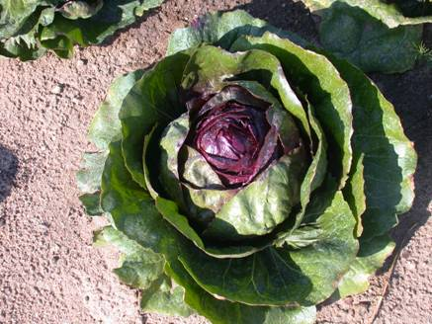

(2) Trevise : leaf chicory characterized by an elliptic plant shape with red, narrow and long leaves and with a large white midrib, by a long and pointed head whose density is weak to medium. This type is eaten after a forcing period (like witloof).

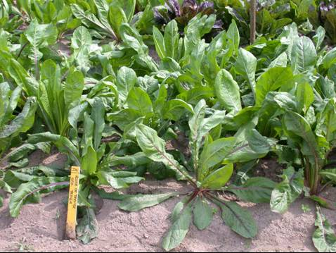

(3) Verone : leaf chicory characterized by a red limb and a distribution on the limb of red and green colors different among varieties, by elliptic and mid size leaves and a more erected leaves attitude than this of the Trevise type.

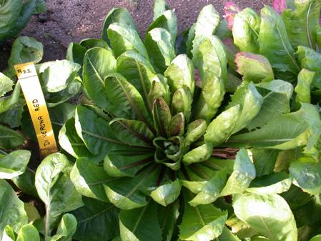

(4) Pain de sucre : leaf chicory characterized by the absence of anthocyanin, an ovate head and by prostrated outer leaves.

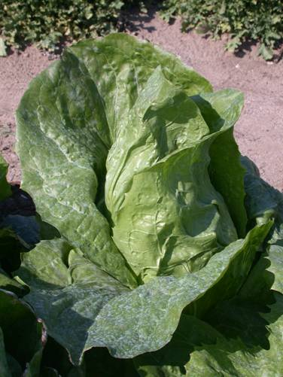

(5) Améliorée vert ou blonde : leaf chicory characterized by very strong head, by the absence of anthocyanin, by oboval, short and large leaves and by different degree of blistering.

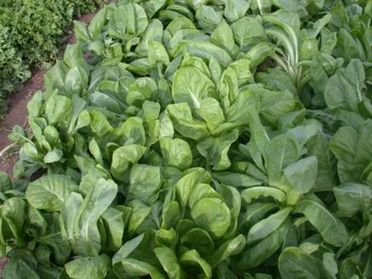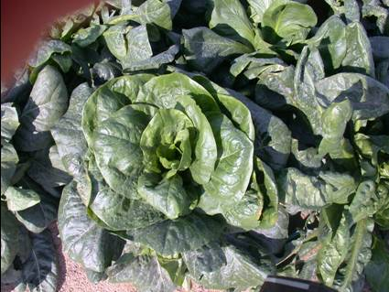

(6) Barbe de capucin : leaf chicory characterized by the absence of head, by long, narrow and dentate leaves and by a dark green foliage; this type is eaten after a forcing period.

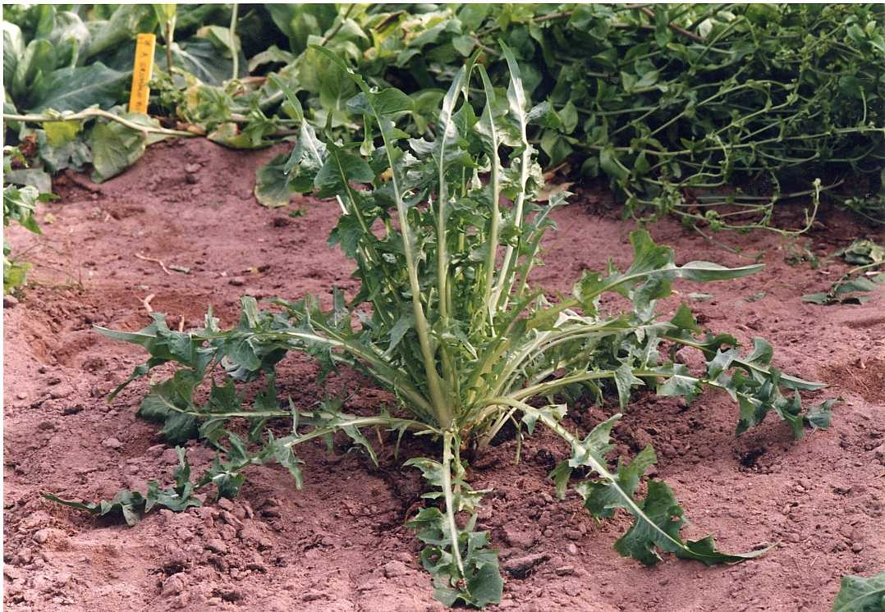

(7) Catalogna : leaf chicory characterized by narrow, lanceolate, green and very long leaves. Part of this type which is eaten is the flowering stem at a non maturity stage.

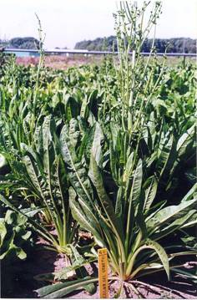

Ad. 6: Leaf: width

Photos to be provided
1  very narrow | 3  narrow | 5  medium | 7  broad | 9  very broad

Ad. 7: Leaf: shape

Photos to be provided
1  narrow elliptic | 2  elliptic | 3  broad elliptic | 4  round

Ad. 11: Leaf: color of midrib

Photos to be provided
1  whitish | 2  green | 3  red

Ad. 13: Leaf: anthocyanin distribution

Photos to be provided

1  localized | 9  entire

Ad. 14: Leaf : type of anthocyanin distribution

Photos to be provided
1  diffused only | 2  in patches only | 3  diffused and in patches

Ad. 15: Leaf: profile of upper surface

Photos to be provided
1  strongly concave | 2  weakly concave | 3  flat | 4  weakly convex | 5  strongy convex

Ad. 17: Leaf: undulation of margin

Photos to be provided
1  absent or very weak | 3  weak | 5  medium | 7  strong | 9  very strong

Ad. 19: Leaf: type of incision of margin

Photos to be provided
1  sinuate | 2  dentate | 3  serrate

Ad. 22: Head: length

Photos to be provided
3  short | 5  medium | 7  long

Ad. 24: Head: shape in longitudinal section

Photos to be provided
1  rectangular | 2  elliptic | 3  ovate | 4  circular | 5  transverse elliptic

Ad. 31: Plant: stem: formation at harvest maturity

Literature

Adinolfi, A., Bianchi, M. & Frusciante, E., 1995: “Caratterizzazione Morfo-Fisiologica Delle Varietà di Cicoria a Foglia Verde Iscritte al Registro Nazionale,” Ente Nazionale Sementi Elette (E.N.S.E.), Milan, Quaderno n. Dell’ E.N.S.E., No. 45.

Ryder, E., 1979: “Leafy Salad Vegetable,” AVI Publishing Company, Westport, Connecticut.

Technical Questionnaire

TECHNICAL QUESTIONNAIRE |  |  |  | Page {x} of {y} |  | Reference Number:
 |  |  |  |  |  | Application date:
 |  |  |  |  |  | (not to be filled in by the applicant)
TECHNICAL QUESTIONNAIRE
to be completed in connection with an application for plant breeders’ rights

1. Subject of the Technical Questionnaire
1.1 Botanical name |  |  | Cichorium intybus L. var. foliosum Hegi
1.2 Common name |  |  | Leaf chicory
2. Applicant
Name
Address
Telephone No.
Fax No.
E-mail address
Breeder (if different from applicant)
3. Proposed denomination and breeder’s reference
Proposed denomination
(if available)

Breeder’s reference
#4. Information on the breeding scheme and propagation of the variety

4.1 Method of propagating the variety

4.1.1 Seed-propagated varieties

(a) Self-pollination [ ]
(b) Cross-pollination
(i) population [ ]
(ii) synthetic variety [ ]
(c) Hybrid [ ]
(d) Other [ ]
(please provide details)”

5. Characteristics of the variety to be indicated (the number in brackets refers to the corresponding characteristic in Test Guidelines; please mark the note which best corresponds).

 | Characteristics |  |  |  |  |  | Example Varieties |  |  | Note
5.1  (1) | Plant: sub-type
 | Chioggia |  |  |  |  |  |  |  |  | 1[ ]
 | Trevise |  |  |  |  |  |  |  |  | 2[ ]
 | Verone |  |  |  |  |  |  |  |  | 3[ ]
 | Pain de sucre |  |  |  |  |  |  |  |  | 4[ ]
 | Améliorée Blonde ou Verte |  |  |  |  |  |  |  |  | 5[ ]
 | Barbe de Capucin |  |  |  |  |  |  |  |  | 6[ ]
 | Catalogna |  |  |  |  |  |  |  |  | 7[ ]
5.2  (5) | Leaf: length (at harvest maturity)
 | very short |  |  |  |  |  | Silla, Zuccherina di Trieste |  |  | 1[ ]
 | very short to short |  |  |  |  |  |  |  |  | 2[ ]
 | short |  |  |  |  |  | Palla rossa 2 |  |  | 3[ ]
 | short to medium |  |  |  |  |  |  |  |  | 4[ ]
 | medium |  |  |  |  |  | Pan di zucchero |  |  | 5[ ]
 | medium to long |  |  |  |  |  |  |  |  | 6[ ]
 | long |  |  |  |  |  | Rossa di Treviso |  |  | 7[ ]
 | long to very long |  |  |  |  |  |  |  |  | 8[ ]
 | very long |  |  |  |  |  | Catalogna a foglie frastagliate |  |  | 9[ ]
5.3  (8) | Leaf: color (excluding midrib)
 | yellow |  |  |  |  |  | Bianca invernale |  |  | 1[ ]
 | green |  |  |  |  |  | Pan di zucchero |  |  | 2[ ]
 | red |  |  |  |  |  | Red Devil |  |  | 3[ ]
5.4  (11) | Leaf: color of midrib
 | whitish |  |  |  |  |  | Bianca invernale |  |  | 1[ ]
 | green |  |  |  |  |  | Pan di zucchero |  |  | 2[ ]
 | red |  |  |  |  |  | Medusa, Silla |  |  | 3[ ]
 | Characteristics |  |  |  |  |  | Example Varieties |  |  | Note
5.5  (12) | Leaf: anthocyanin coloration at harvest maturity
 | absent |  |  |  |  |  | Pan di zucchero |  |  | 1[ ]
 | present |  |  |  |  |  | Red Devil |  |  | 2[ ]
5.6  (20) | Plant: head formation
 | absent |  |  |  |  |  | Catalogna gigante di Chioggia |  |  | 1[ ]
 | present |  |  |  |  |  | Palla rossa 2 |  |  | 9[ ]
5.7  (24) | Head: shape in longitudinal section
 | rectangular |  |  |  |  |  |  |  |  | 1[ ]
 | elliptic |  |  |  |  |  | Nerone, Vulcane |  |  | 2[ ]
 | ovate |  |  |  |  |  | Bianca di Milano |  |  | 3[ ]
 | circular |  |  |  |  |  | Silla |  |  | 4[ ]
 | transverse elliptic |  |  |  |  |  | Palla rossa 2 |  |  | 5[ ]
5.8  (27) | Head: intensity of color of outer leaves
 | very light |  |  |  |  |  |  |  |  | 1[ ]
 | very light to light |  |  |  |  |  |  |  |  | 2[ ]
 | light |  |  |  |  |  |  |  |  | 3[ ]
 | light to medium |  |  |  |  |  |  |  |  | 4[ ]
 | medium |  |  |  |  |  |  |  |  | 5[ ]
 | medium to dark |  |  |  |  |  |  |  |  | 6[ ]
 | dark |  |  |  |  |  |  |  |  | 7[ ]
 | dark to very dark |  |  |  |  |  |  |  |  | 8[ ]
 | very dark |  |  |  |  |  |  |  |  | 9[ ]
5.9  (28) | Head: anthocyanin coloration of outer leaves
 | absent |  |  |  |  |  | Pan di zucchero |  |  | 1[ ]
 | present |  |  |  |  |  | Red Devil, Variegata di Lusia |  |  | 9[ ]
5.10  (31) | Plant: stem: formation at harvest maturity
 | absent |  |  |  |  |  | Palla rossa 2 |  |  | 1[ ]
 | present |  |  |  |  |  | Catalogna puntarelle a foglia frastagliata |  |  | 9[ ]
 | Characteristics |  |  |  |  |  | Example Varieties |  |  | Note
5.11  (36) | Male sterility
 | absent |  |  |  |  |  |  |  |  | 1[ ]
 | partial |  |  |  |  |  |  |  |  | 3[ ]
 | full present |  |  |  |  |  |  |  |  | 5[ ]
6. Similar varieties and differences from these varieties

Please use the following table and box for comments to provide information on how your candidate variety differs from the variety (or varieties) which, to the best of your knowledge, is (or are) most similar. This information may help the examination authority to conduct its examination of distinctness in a more efficient way.

Denomination(s) of variety(ies) similar to your candidate variety |  | Characteristic(s) in which your candidate variety differs from the similar variety(ies) |  |  | Describe the expression of the characteristic(s) for the similar variety(ies) |  |  | Describe the expression of the characteristic(s) for your candidate variety
Example |  | Leaf: color |  |  | yellow |  |  | green
Comments:

#7. Additional information which may help in the examination of the variety

7.1 In addition to the information provided in sections 5 and 6, are there any additional characteristics which may help to distinguish the variety?

Yes [ ] No [ ]

(If yes, please provide details)

7.2 Are there any special conditions for growing the variety or conducting the examination?

Yes [ ] No [ ]

(If yes, please provide details)

7.3 Other information

A representative color image of the variety should accompany the Technical Questionnaire.

8. Authorization for release

(a) Does the variety require prior authorization for release under legislation concerning the protection of the environment, human and animal health?

Yes [ ] No [ ]

(b) Has such authorization been obtained?

Yes [ ] No [ ]

If the answer to (b) is yes, please attach a copy of the authorization.

9. Information on plant material to be examined or submitted for examination.

9.1 The expression of a characteristic or several characteristics of a variety may be affected by factors, such as pests and disease, chemical treatment (e.g. growth retardants or pesticides), effects of tissue culture, different rootstocks, scions taken from different growth phases of a tree, etc.

9.2 The plant material should not have undergone any treatment which would affect the expression of the characteristics of the variety, unless the competent authorities allow or request such treatment. If the plant material has undergone such treatment, full details of the treatment must be given. In this respect, please indicate below, to the best of your knowledge, if the plant material to be examined has been subjected to:

(a) Microorganisms (e.g. virus, bacteria, phytoplasma) Yes [ ] No [ ]

(b) Chemical treatment (e.g. growth retardant, pesticide) Yes [ ] No [ ]

(c) Tissue culture Yes [ ] No [ ]

(d) Other factors Yes [ ] No [ ]

Please provide details for where you have indicated “yes”.

……………………………………………………………

10. I hereby declare that, to the best of my knowledge, the information provided in this form is correct:

Applicant’s name

Signature Date

[Annex follows]
Comments by the Netherlands

2.3: 10,000 seeds instead of 25 g

7. Table of characteristics

In general: example varieties to be added or revised

Char. 1: Should the type Variegata also be added?

Char. 7, 11, 13, 14, 15, 17, 19: Explanations to be added

Char 24: Explanation to be added

Char 29: Explanation to be added

Char 32: Maybe to split for the types

Char 34: Until now we did not observe

Char 35: not to add

[End of Annex and of document]

* These names were correct at the time of the introduction of these Test Guidelines but may be revised or updated. [Readers are advised to consult the UPOV Code, which can be found on the UPOV Website (www.upov.int), for the latest information.]
# Authorities may allow certain of this information to be provided in a confidential section of the Technical Questionnaire.
# Authorities may allow certain of this information to be provided in a confidential section of the Technical Questionnaire.

