 |  |  |  |  |  |  | E  TG/142/5(proj.3)  ORIGINAL: English  DATE: 2012-05-04
INTERNATIONAL UNION FOR THE PROTECTION OF NEW VARIETIES OF PLANTS
Geneva
 |  |  | DRAFT
 |  | WATERMELON  UPOV Code: CTRLS_LAN  (Citrullus lanatus (Thunb.) Matsum. et Nakai) |  |  | *

GUIDELINES

FOR THE CONDUCT OF TESTS

FOR DISTINCTNESS, UNIFORMITY AND STABILITY

prepared by an expert from the Netherlands

to be considered by the
Technical Working Party for Vegetables at its forty-sixth session,
to be held near the City of Venlo, Netherlands, from June 11 to 15, 2012

Alternative Names:*

Botanical name | English | French | German | Spanish
Citrullus lanatus (Thunb.) Matsum. et Nakai,  Citrullus vulgaris Schrad. | Watermelon | Pastèque | Wassermelone | Sandía

The purpose of these guidelines (“Test Guidelines”) is to elaborate the principles contained in the General Introduction (document TG/1/3), and its associated TGP documents, into detailed practical guidance for the harmonized examination of distinctness, uniformity and stability (DUS) and, in particular, to identify appropriate characteristics for the examination of DUS and production of harmonized variety descriptions.

ASSOCIATED DOCUMENTS
These Test Guidelines should be read in conjunction with the General Introduction and its associated TGP documents.
TABLE OF CONTENTS PAGE

1. Subject of these Test Guidelines 3
2. Material Required 3
3. Method of Examination 3
3.1 Number of Growing Cycles 3
3.2 Testing Place 3
3.3 Conditions for Conducting the Examination 3
3.4 Test Design 3
3.5 Additional Tests 4
4. Assessment of Distinctness, Uniformity and Stability 4
4.1 Distinctness 4
4.2 Uniformity 5
4.3 Stability 5
5. Grouping of Varieties and Organization of the Growing Trial 5
6. Introduction to the Table of Characteristics 6
6.1 Categories of Characteristics 6
6.2 States of Expression and Corresponding Notes 6
6.3 Types of Expression 6
6.4 Example Varieties 7
6.5 Legend 7
7. Table of Characteristics/Tableau des caractères/Merkmalstabelle/Tabla de caracteres 8
8. Explanations on the Table of Characteristics 19
8.1 Explanations covering several characteristics 19
8.2 Explanations for individual characteristics 19
9. Literature 35
10. Technical Questionnaire 37

ANNEX REMARKS TO THE WATERMELON DRAFT 2010 TO 2012

Subject of these Test Guidelines

These Test Guidelines apply to all varieties of Citrullus lanatus (Thunb.) Matsum. et Nakai. Varieties belonging to Citrullus colocynthis (L.) Schrad. are excluded.

Material Required

2.1 The competent authorities decide on the quantity and quality of the plant material required for testing the variety and when and where it is to be delivered. Applicants submitting material from a State other than that in which the testing takes place must ensure that all customs formalities and phytosanitary requirements are complied with.

2.2 The material is to be supplied in the form of seed.

2.3 The minimum quantity of plant material, to be supplied by the applicant, should be:

1,200 seeds.

The seed should meet the minimum requirements for germination, species and analytical purity, health and moisture content, specified by the competent authority.

2.4 The plant material supplied should be visibly healthy, not lacking in vigor, nor affected by any important pest or disease.

2.5 The plant material should not have undergone any treatment which would affect the expression of the characteristics of the variety, unless the competent authorities allow or request such treatment. If it has been treated, full details of the treatment must be given.

Method of Examination

3.1 Number of Growing Cycles

The minimum duration of tests should normally be two independent growing cycles.

3.2 Testing Place

Tests are normally conducted at one place. In the case of tests conducted at more than one place, guidance is provided in TGP/9 “Examining Distinctness”.

3.3 Conditions for Conducting the Examination

The tests should be carried out under conditions ensuring satisfactory growth for the expression of the relevant characteristics of the variety and for the conduct of the examination.

3.4 Test Design

3.4.1 Each test should be designed to result in a total of at least 20 plants which should be divided between at least two replicates.

3.4.2 The design of the tests should be such that plants or parts of plants may be removed for measurement or counting without prejudice to the observations which must be made up to the end of the growing cycle.

3.4.3 For pollination and fruit set of triploid varieties it is needed to interplant with diploid varieties in a trial lay out so that the diploid pollenizers will be close to the triploid plants. The minimum percentage of diploid plants should not be less than 30%. When pollinators (e.g. bees, bumblebees) are used a slightly lower percentage of pollenizer may be required.

3.5 Additional Tests

Additional tests, for examining relevant characteristics, may be established.

Assessment of Distinctness, Uniformity and Stability

4.1 Distinctness

4.1.1 General Recommendations

It is of particular importance for users of these Test Guidelines to consult the General Introduction prior to making decisions regarding distinctness. However, the following points are provided for elaboration or emphasis in these Test Guidelines.

4.1.2 Consistent Differences

The differences observed between varieties may be so clear that more than one growing cycle is not necessary. In addition, in some circumstances, the influence of the environment is not such that more than a single growing cycle is required to provide assurance that the differences observed between varieties are sufficiently consistent. One means of ensuring that a difference in a characteristic, observed in a growing trial, is sufficiently consistent is to examine the characteristic in at least two independent growing cycles.

4.1.3 Clear Differences

Determining whether a difference between two varieties is clear depends on many factors, and should consider, in particular, the type of expression of the characteristic being examined, i.e. whether it is expressed in a qualitative, quantitative, or pseudo-qualitative manner. Therefore, it is important that users of these Test Guidelines are familiar with the recommendations contained in the General Introduction prior to making decisions regarding distinctness.

4.1.4 Number of Plants / Parts of Plants to be Examined

Unless otherwise indicated, for the purposes of distinctness, all observations on single plants should be made on 10 plants or parts taken from each of 10 plants and any other observations made on all plants in the test, disregarding any off-type plants.

4.1.5 Method of Observation

The recommended method of observing the characteristic for the purposes of distinctness is indicated by the following key in the second column of the Table of Characteristics (see document TGP/9 “Examining Distinctness”, Section 4 “Observation of characteristics”):

MG: single measurement of a group of plants or parts of plants
MS: measurement of a number of individual plants or parts of plants
VG: visual assessment by a single observation of a group of plants or parts of plants
VS: visual assessment by observation of individual plants or parts of plants

Type of observation: visual (V) or measurement (M)

“Visual” observation (V) is an observation made on the basis of the expert’s judgment. For the purposes of this document, “visual” observation refers to the sensory observations of the experts and, therefore, also includes smell, taste and touch. Visual observation includes observations where the expert uses reference points (e.g. diagrams, example varieties, side-by-side comparison) or non-linear charts (e.g. color charts). Measurement (M) is an objective observation against a calibrated, linear scale e.g. using a ruler, weighing scales, colorimeter, dates, counts, etc.

Type of record: for a group of plants (G) or for single, individual plants (S)

For the purposes of distinctness, observations may be recorded as a single record for a group of plants or parts of plants (G), or may be recorded as records for a number of single, individual plants or parts of plants (S). In most cases, “G” provides a single record per variety and it is not possible or necessary to apply statistical methods in a plant-by-plant analysis for the assessment of distinctness.”

In cases where more than one method of observing the characteristic is indicated in the Table of Characteristics (e.g. VG/MG), guidance on selecting an appropriate method is provided in document TGP/9, Section 4.2.

4.2 Uniformity

4.2.1 It is of particular importance for users of these Test Guidelines to consult the General Introduction prior to making decisions regarding uniformity. However, the following points are provided for elaboration or emphasis in these Test Guidelines:

(a) Cross-pollinated varieties

4.2.2 The assessment of uniformity for cross-pollinated varieties should be according to the recommendations for cross-pollinated varieties in the General Introduction.

(b) Hybrid varieties and inbred lines

4.2.3 For the assessment of uniformity of hybrids and inbred lines, a population standard of 2% and an acceptance probability of at least 95% should be applied. In the case of a sample size of 20 plants, 2 off-types are allowed.

4.3 Stability

4.3.1 In practice, it is not usual to perform tests of stability that produce results as certain as those of the testing of distinctness and uniformity. However, experience has demonstrated that, for many types of variety, when a variety has been shown to be uniform, it can also be considered to be stable.

4.3.2 Where appropriate, or in cases of doubt, stability may be further examined by testing a new seed stock to ensure that it exhibits the same characteristics as those shown by the initial material supplied.

Grouping of Varieties and Organization of the Growing Trial

5.1 The selection of varieties of common knowledge to be grown in the trial with the candidate varieties and the way in which these varieties are divided into groups to facilitate the assessment of distinctness are aided by the use of grouping characteristics.

5.2 Grouping characteristics are those in which the documented states of expression, even where produced at different locations, can be used, either individually or in combination with other such characteristics: (a) to select varieties of common knowledge that can be excluded from the growing trial used for examination of distinctness; and (b) to organize the growing trial so that similar varieties are grouped together.

5.3 The following have been agreed as useful grouping characteristics:

(a) Ploidy (characteristic 1)
(b) Leaf blade: degree of lobing (characteristic 8)
(c) Fruit: weight (1st mature fruit) (characteristic 11)
(d) Fruit: shape in longitudinal section (characteristic 12)
(e) Fruit: ground color of skin (characteristic 16)
(f) Only varieties with Fruit: ground color of skin: green: Fruit: intensity of ground color of skin (characteristic 17)
(g) Fruit: width of stripes (characteristic 21)
(h) Fruit: margin of stripes (characteristic 24)
(j) Fruit: main color of flesh (characteristic 30)
(k) Only diploid and tetraploid varieties: Seed: size (characteristic 35)
(l) Only diploid and tetraploid varieties: Seed: ground color of testa (characteristic 36)

5.4 Guidance for the use of grouping characteristics, in the process of examining distinctness, is provided through the General Introduction and document TGP/9 “Examining Distinctness”.

Introduction to the Table of Characteristics

6.1 Categories of Characteristics

6.1.1 Standard Test Guidelines Characteristics

Standard Test Guidelines characteristics are those which are approved by UPOV for examination of DUS and from which members of the Union can select those suitable for their particular circumstances.

6.1.2 Asterisked Characteristics

Asterisked characteristics (denoted by *) are those included in the Test Guidelines which are important for the international harmonization of variety descriptions and should always be examined for DUS and included in the variety description by all members of the Union, except when the state of expression of a preceding characteristic or regional environmental conditions render this inappropriate.

6.2 States of Expression and Corresponding Notes

6.2.1 States of expression are given for each characteristic to define the characteristic and to harmonize descriptions. Each state of expression is allocated a corresponding numerical note for ease of recording of data and for the production and exchange of the description.

6.2.2 In the case of qualitative and pseudo-qualitative characteristics (see Chapter 6.3), all relevant states of expression are presented in the characteristic. However, in the case of quantitative characteristics with 5 or more states, an abbreviated scale may be used to minimize the size of the Table of Characteristics. For example, in the case of a quantitative characteristic with 9 states, the presentation of states of expression in the Test Guidelines may be abbreviated as follows:

State | Note
small | 3
medium | 5
large | 7

However, it should be noted that all of the following 9 states of expression exist to describe varieties and should be used as appropriate:

State | Note
very small | 1
very small to small | 2
small | 3
small to medium | 4
medium | 5
medium to large | 6
large | 7
large to very large | 8
very large | 9

6.2.3 Further explanation of the presentation of states of expression and notes is provided in document TGP/7 “Development of Test Guidelines”.

6.3 Types of Expression

An explanation of the types of expression of characteristics (qualitative, quantitative and pseudo-qualitative) is provided in the General Introduction.

6.4 Example Varieties

Where appropriate, example varieties are provided to clarify the states of expression of each characteristic.

6.5 Legend

(*) Asterisked characteristic – see Chapter 6.1.2

QL Qualitative characteristic – see Chapter 6.3
QN Quantitative characteristic – see Chapter 6.3
PQ Pseudo-qualitative characteristic – see Chapter 6.3

MG, MS, VG, VS – see Chapter 4.1.5

(a) – (d) See Explanations on the Table of Characteristics in Chapter 8.1.

(+) See Explanations on the Table of Characteristics in Chapter 8.2.

Table of Characteristics/Tableau des caractères/Merkmalstabelle/Tabla de caracteres

 |  | English | français | deutsch | español | Example Varieties  Exemples  Beispielssorten  Variedades ejemplo | Note/  Nota
1  (*)  (+) | VG | Ploidy
QL |  | diploid |  |  |  | SP 4, Sugar Baby, Yamato 3 | 2
 |  | triploid |  |  |  | Boston,  Kimiwa Red Seedless, TRIX 313 | 3
 |  | tetraploid |  |  |  |  | 4
2 | MS/  VG | Cotyledon: size
QN | (a) | small |  |  |  | Crimson Glory, Kanro, Rapid | 3
 |  | medium |  |  |  | Crisby, Granit, Panni, Yamato 3 | 5
 |  | large |  |  |  | Farao, Kurobe,  Royal flesh hybrid | 7
3  (+) | VG | Cotyledon: shape
QN | (a) | narrow elliptic |  |  |  | Kahô | 1
 |  | medium elliptic |  |  |  | Crimson Sweet, Farao, Napsugár, Yamato 3, | 2
 |  | broad elliptic |  |  |  | Kanro | 3
4 | VG | Cotyledon: intensity of green color
QN | (a) | light |  |  |  | À graine rouge à confire à chair verte,  Shin Kurobe 7 | 1
 |  | medium |  |  |  | Jenny, Yamato 3 | 3
 |  | dark |  |  |  | Boston, Kahô, SP 4 | 5
5 | VG | Leaf blade: size
QN | (b) | small |  |  |  | SP 1, SP 4 | 1
 |  | medium |  |  |  | Sugar Baby | 3
 |  | large |  |  |  | Topgun | 5
6  (+) | MS/ VG | Leaf blade: ratio length/width | Limbe: rapport longueur/largeur | Blattspreite: Verhältnis Länge/Breite | Limbo: relación entre la longitud y la anchura
QN | (b) | slightly elongated |  |  |  | Kanro | 1
 |  | moderately elongated |  |  |  | Sugar Baby, Yamato 3 | 2
 |  | strongly elongated |  |  |  | Kurobe | 3
7 | VG | Leaf blade: color
PQ | (b) | yellowish green |  |  |  | Baby Fun, Okan | 1
 |  | green |  |  |  | Crimson Sweet, Yamato 3 | 2
 |  | greyish green |  |  |  | Sugar Baby | 3
 |  | bluish green |  |  |  | SP 4 | 4
8  (*)  (+) | VG | Leaf blade: degree of lobing
QN | (b) | absent or very weak |  |  |  | Sunshade | 1
 |  | weak |  |  |  | Estrella, Karistan | 3
 |  | medium |  |  |  | Crimson Sweet, Crisby | 5
 |  | strong |  |  |  | Cadans | 7
 |  | very strong |  |  |  | SP 1 | 9
9 | VG | Leaf blade: blistering (on 10th to 15th leaf)
QN | (b) | weak |  |  |  | Tabata, Estel | 1
 |  | medium |  |  |  | Yamato 3 | 2
 |  | strong |  |  |  | Klondike Striped II, Sakura | 3
10  (+) | VG | Leaf blade: color of veins
QL | (b) | green |  |  |  | Asahiyamato | 1
 |  | yellow |  |  |  | Taiyô | 2
11  (*) | MS/ MG | Fruit: weight (1st mature fruit)
QN | (c) | very low |  |  |  | Monaco,  New Hampshire Midget | 1
 |  | very low to low |  |  |  | Mini, Petite Perfection | 2
 |  | low |  |  |  | Angela | 3
 |  | low to medium |  |  |  | Pasión, Sugar Baby | 4
 |  | medium |  |  |  | Boston | 5
 |  | medium to high |  |  |  | Crimson Sweet, Panonia | 6
 |  | high |  |  |  | Fabiola | 7
 |  | high to very high |  |  |  | Jubilee | 8
 |  | very high |  |  |  | Carolina Cross,  Cobb’s Gem  Florida Giant | 9
12  (*)  (+) | VG | Fruit: shape in longitudinal section
QN | (c) | circular |  |  |  | Camilla, Kanro | 1
 |  | broad elliptic |  |  |  | Fumin, Gray Belle,  Yellow Baby, Zorba | 2
 |  | medium elliptic |  |  |  | Congo, Kurobe, Picnic | 3
 |  | elongated elliptic |  |  |  | Allsweet,  Charleston Gray | 4
13  (+) | VG | Fruit: depression at base
QN | (c) | shallow |  |  |  | Kahô, Yellow Baby | 3
 |  | medium |  |  |  | Triple Sweet, Yamato 3 | 5
 |  | deep |  |  |  | À graine rouge à confire à chair verte, Kanro | 7
14  (+) | VG | Fruit: shape of apical part
PQ | (c) | flat |  |  |  | Cream Sinka, Kanro | 1
 |  | flat to rounded |  |  |  |  | 2
 |  | rounded |  |  |  | Glory, Sugar Baby, Toro, Yamato 3 | 3
 |  | rounded to conical |  |  |  |  | 4
 |  | conical |  |  |  | Kahô | 5
15  (+) | VG | Fruit: depression at apex
QN | (c) | shallow |  |  |  | Burpee Hybrid, Kahô, Valdoria | 3
 |  | medium |  |  |  | Asahi Miyako, Fumin | 5
 |  | deep |  |  |  | Cobb’s Gem | 7
16  (*)  (+) | VG | Fruit: ground color of skin
QL | (c) | yellow |  |  |  | Golden Dragon, Okan, Taiyô | 1
 |  | green |  |  |  | Crimson Sweet,  Blanca de Benocaz, Fabiola, Napsugar , Sugar Baby, Sugar Belle | 2
17  (*) | VG | Only varieties with Fruit: ground color of skin: green: Fruit: intensity of ground color of skin
QN | (c) | very light |  |  |  | Tiger Baby | 1
 |  | very light to light |  |  |  |  | 2
 |  | light |  |  |  | Napsugar | 3
 |  | light to medium |  |  |  | Tigre | 4
 |  | medium |  |  |  | Pepsin | 5
 |  | medium to dark |  |  |  |  | 6
 |  | dark |  |  |  | Odem, Resistant,  Sweet Marvel | 7
 |  | dark to very dark |  |  |  | Sugar Baby | 8
 |  | very dark |  |  |  | Augusta, Rocio | 9
18 | VG | Only varieties with Fruit: ground color of skin: yellow: Fruit: intensity of ground color of skin
QN | (c) | light |  |  |  |  | 1
 |  | medium |  |  |  |  | 2
 |  | dark |  |  |  |  | 3
19  (+) | VG | Fruit: conspicuousness of veining
QN | (c) | absent or very weak |  |  |  | Napsugar | 1
 |  | weak |  |  |  |  | 2
 |  | medium |  |  |  | Crimson Sweet | 3
 |  | strong |  |  |  | Trix Palomar | 4
 |  | very strong |  |  |  |  | 5
20  (*)  (+) | VG | Fruit: patternation of stripes
PQ | (c) | one colored |  |  |  | Congo | 1
 |  | one colored and veins |  |  |  | Trix Palomar | 2
 |  | one colored, veins and marbled |  |  |  | Boston | 3
 |  | one colored and marbled |  |  |  | À graine rouge à confire à chair verte | 4
 |  | two colored, veins and marbled |  |  |  | Crisby | 5
 |  | only veins |  |  |  | Charleston Gray | 6
21  (*)  (+) | VG | Fruit: width of stripes
QN | (c) | very narrow |  |  |  | Charleston Gray.  Tiny Orchid | 1
 |  | narrow |  |  |  | Boston | 3
 |  | medium |  |  |  | Crimson Sweet | 5
 |  | broad |  |  |  | Sangria | 7
 |  | very broad |  |  |  | All Sweet | 9
22  (+) | VG | Fruit: intensity of main color of stripes
QN | (c) | very light |  |  |  |  | 1
 |  | light |  |  |  |  | 2
 |  | medium |  |  |  |  | 3
 |  | dark |  |  |  |  | 4
 |  | very dark |  |  |  |  | 5
23  (*)  (+) | VG | Fruit: conspicuousness of stripes
QN | (c) | absent or very weak |  |  |  | Augusta | 1
 |  | weak |  |  |  | Odem | 2
 |  | medium |  |  |  | Trix Palomar | 3
 |  | strong |  |  |  | Jenny | 4
 |  | very strong |  |  |  | A graine rouge à confire à chaire verte | 5
24  (*)  (+) | VG | Fruit: margin of stripes
QN | (c) | sharp |  |  |  | Jenny, Jubilee | 1
 |  | medium |  |  |  | Crimson Sweet | 2
 |  | diffuse |  |  |  | Crimson Glory, Crisby | 3
25  (+) | VG | Fruit: size of insertion of peduncle
QN | (c) | small |  |  |  | Charleston Gray,  Sugar Bush | 3
 |  | medium |  |  |  | Fumin, Picnic | 5
 |  | large |  |  |  | Dixie Queen, Kanro | 7
26 | VG | Fruit: size of pistil scar
QN | (c) | small |  |  |  | Charleston Gray, Daisen | 3
 |  | medium |  |  |  | Yamato 3 | 5
 |  | large |  |  |  | Kanro, Trix Palomar | 7
27  (+) | VG | Fruit: degree of grooving
QN | (c) | absent or very weak |  |  |  | Sugar Baby | 1
 |  | weak |  |  |  | Augusta, Kanro, Rapid | 2
 |  | medium |  |  |  | Asahi, Bego, Miyako | 3
 |  | strong |  |  |  | Marsowszky, Napsugár, Panni | 4
28.  (+) | VG | Fruit: waxy layer
QN | (c) | absent or very weak |  |  |  | Betica | 1
 |  | medium |  |  |  | Sugar Baby | 3
 |  | very strong |  |  |  | Red Star, Romanza | 5
29.  (old 41.)  (*)  (+) | MS/  VG | Fruit: thickness of pericarp
QN | (c) | very thin |  |  |  | Bibo, Tiny Orchid, Luciano | 1
 |  | thin |  |  |  | À graine rouge à confire à chair verte, Beni-kodama, Jenny, Kahô, Kassai | 3
 |  | medium |  |  |  | Panonia, Sugar Baby, Sugar Belle, Yamato 3 | 5
 |  | thick |  |  |  | Charleston Gray, Crimson Sweet, Kurobe, Triple Sweet, Sunrise | 7
 |  | very thick |  |  |  | Coles Early, Kholodok | 9
30.  (old 42.)  (*) | VS | Fruit: main color of flesh
PQ | (c) | white |  |  |  | SP 4, SP1,  Yamato Cream 3 | 1
 |  | yellow |  |  |  | Napsugár,  Yamato Cream 1 | 2
 |  | orange |  |  |  | Kahô, Tendersweet | 3
 |  | pink |  |  |  | Sadul | 4
 |  | pinkish red |  |  |  | Bingo, Crimson Sweet | 5
 |  | red |  |  |  | Asahiy, Sugar Baby, Topgun | 6
31.  (old 43.) | VG | Fruit: intensity of main color of flesh
QN | (c) | light |  |  |  |  | 3
 |  | medium |  |  |  |  | 5
 |  | dark |  |  |  |  | 7
32  (old 44.)  (+) | MS | Fruit: firmness of flesh
QN | (c) | soft |  |  |  | Yamato Cream 2 | 3
 |  | medium |  |  |  | Miyako 3 | 5
 |  | firm |  |  |  | Fumin | 7
33.  (old 45.)  (+) | MS/  VG | Only triploid varieties: Seed coat: size
QN | (d) | very small |  |  |  | Petite Perfection | 1
 |  | small |  |  |  | Boston, Valdoria, Sweet Sun | 2
 |  | medium |  |  |  | Ortal, Tigre, Pasion | 3
 |  | large |  |  |  | Sunrise, Mabel | 4
34.  (old 46.) | QN | Only diploid and tetraploid varieties: Fruit: number of seeds
VG | (d) | absent or few |  |  |  | Tanenashi Kôyô | 1
 |  | medium |  |  |  | Miyako 3 | 2
 |  | many |  |  |  | Fumin | 3
35.  (old 47.)  (*)  (+) | MS/  VG | Only diploid and tetraploid varieties: Seed: size
QN | (d) | very small |  |  |  | Kudam | 1
 |  | small |  |  |  | Panonia, Tabata | 3
 |  | medium |  |  |  | Sugar Baby | 5
 |  | large |  |  |  | Charleston Gray, Kurobe | 7
 |  | very large |  |  |  | Malali, Wanli | 9
36.  (old 48.)  (+) | VG | Only diploid and tetraploid varieties: Seed: ground color of testa
PQ | (d) | white |  |  |  | Sanpaku | 1
 |  | cream |  |  |  | Kurobe | 2
 |  | green |  |  |  | A confire allongée à graine verte,  Green Citron | 3
 |  | red |  |  |  | A graine rouge à confire à chair verte, Red Citron | 4
 |  | red-brown |  |  |  | Kahô | 5
 |  | brown |  |  |  | Otome, Sugar Baby | 6
 |  | black |  |  |  | Yamato Cream | 7
37.  (old 49.)  (+) | VG | Only diploid and tetraploid varieties: Seed: secondary color of testa
QL | (d) | absent |  |  |  | Kahô | 1
 |  | present |  |  |  | Charleston Gray | 9
38.  (old 50.)  (+) | VG | Only diploid and tetraploid varieties: Seed: distribution of secondary color of testa
PQ | (d) | in dots only |  |  |  | Charleston Gray, Excel | 1
 |  | in dots and in patches |  |  |  | Lady, Yamato 3 | 2
 |  | in patches only |  |  |  | Kurobe, Rattle Snake | 3
39.  (old 51.) | VG | Only diploid and tetraploid varieties: Seed: area of secondary color in relation to that of ground color
QN | (d) | absent or very small |  |  |  | Estela roja | 1
 |  | small |  |  |  | Sugar Baby | 3
 |  | medium |  |  |  | Crimson Sweet | 5
 |  | large |  |  |  | Furia | 7
 |  | very large |  |  |  | Starlich | 9
40.  (old 52.)  (+) | VG | Only diploid and tetraploid varieties: Seed: patches at hilum
QL | (d) | absent |  |  |  | Daisen, Kahô | 1
 |  | present |  |  |  | Kurobe, Rattle Snake, Yamato 3 | 9
41.  (old 53.) | VG | Time of female flowering (50% of plants with at least one female flower)
QN |  | early |  |  |  | Tiny Orchid | 3
 |  | medium |  |  |  | Sugar Baby, Yamato 3 | 5
 |  | late |  |  |  | Kurobe | 7
42.  (old 54.) | VG | Time of maturity (50% of plants with at least one ripe fruit)
QN |  | early |  |  |  | Kahô, Sugar Baby | 3
 |  | medium |  |  |  | Panonia, Yamato 3 | 5
 |  | late |  |  |  | Charleston Gray, Fumin, Kurobe | 7
43.  (old 55.)  (+) |  | Resistance to Fusarium oxysporum f.sp. niveum
43.1 (old 55.1) |  | Race 0
 |  | absent |  |  |  | Kahô, Sugar Baby | 1
 |  | present |  |  |  | Calhoun Gray, Charleston Gray | 9
43.2 (old 55.2) |  | Race 1
 |  | absent |  |  |  | Charleston Gray, Kahô, Sugar Baby | 1
 |  | present |  |  |  | Calhoun Gray | 9
43.3 (old 55.3) |  | Race 2
 |  | absent |  |  |  | Calhoun Gray, Kahô | 1
 |  | present |  |  |  | PI 296341-FR | 9
44.  (old 56)  (+) |  | Resistance to Colletotrichum orbiculare
44.1 (old 56.1) |  | Race 1
 |  | absent |  |  |  | Black Diamond,  Calhoun Gray, Kahô | 1
 |  | present |  |  |  | Charleston Gray, Congo, Jubilee | 9
44.2  (old 56.2) |  | Race 2
 |  | absent |  |  |  | Kahô; | 1
 |  | present |  |  |  |  | 9
44.3 (old 56.3) |  | Race 3
 |  | absent |  |  |  | Kahô, | 1
 |  | present |  |  |  | Charleston Gray, Congo | 9

Explanations on the Table of Characteristics

8.1 Explanations covering several characteristics

Characteristics containing the following key in the second column of the Table of Characteristics should be examined as indicated below:

(a) Cotyledon: All observations on the cotyledon should be observed when the cotyledons are fully developed and before the development of the first leaf: the surface is flat and the attitude is horizontal

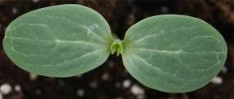

Right stage for observation

(b) Leaf blade: All observations on the leaf blade should be made on fully
developed leaves on the main vine, from the 10th to the 15th leaf, during fruit
set, before the fruits are developed.

(c) Fruit: Unless otherwise indicated, all observations on the fruit should be made on first well developed, mature fruits.

(d) Seed: All observations on the seed should be recorded on fully developed, mature seeds harvested from the fruit.

8.2 Explanations for individual characteristics

Ad. 1: Ploidy

Ploidy level may be detected by several methods:

- By counting chromosomes of cells under the microscope;
- By counting the number chloroplasts of stomatal guard cells using a leaf peel under the microscope;
- By flow cytometry.
- Triploid varieties show a whitish seed coat without embryo.

Ad. 3: Cotyledon: shape

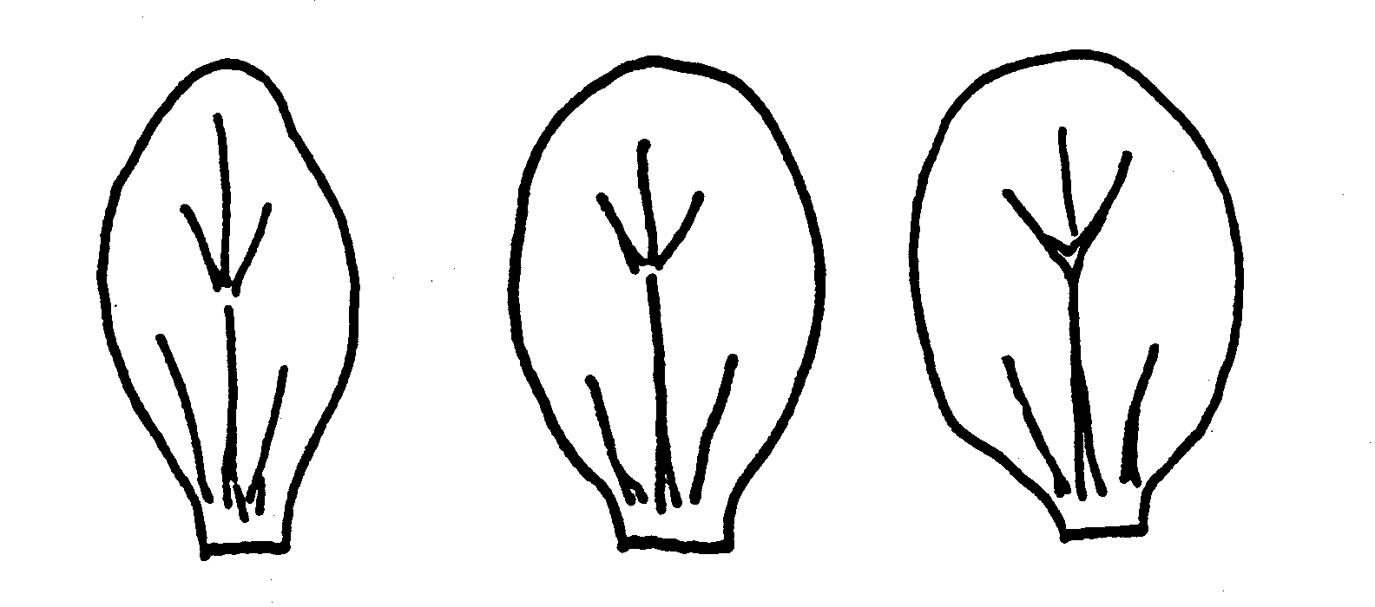

1 | 2 | 3
narrow elliptic | medium elliptic | broad elliptic

Ad. 6: Leaf blade: ratio length/width

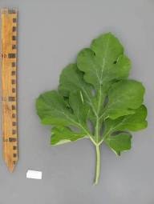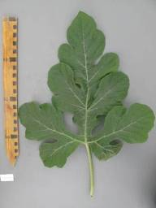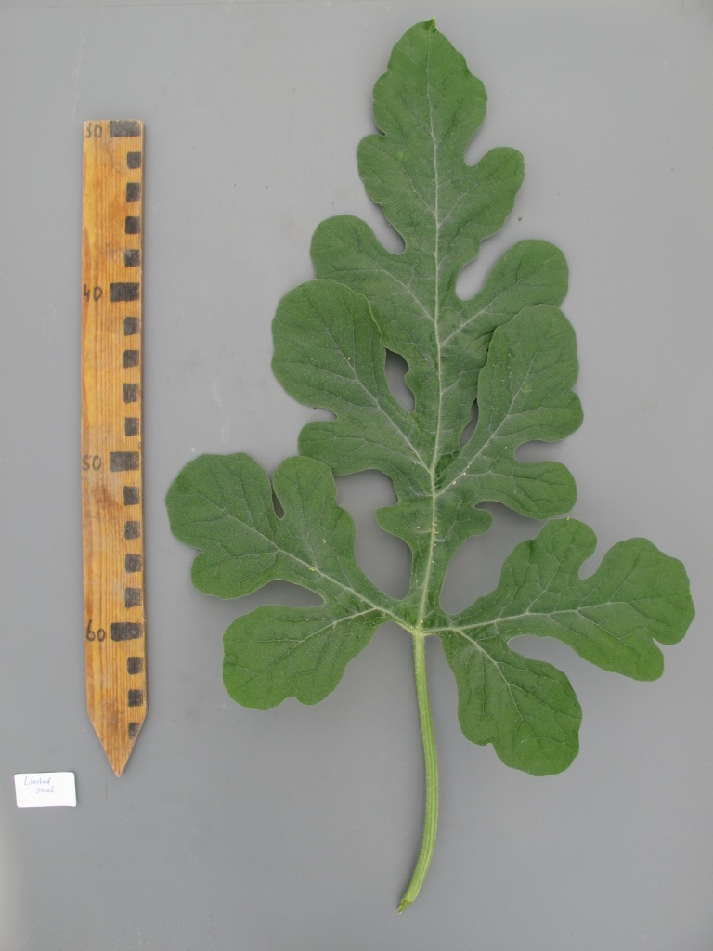
1 | 2 | 3
slightly elongated | moderately elongated | strongly elongated

Ad. 8: Leaf blade: degree of lobing

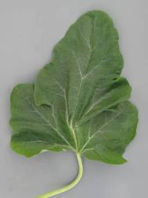 | 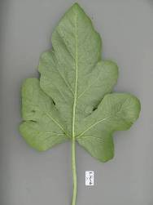 | 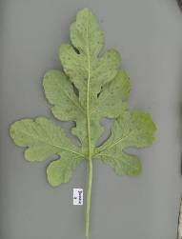
1 | 3 | 5
absent or very weak | weak | medium

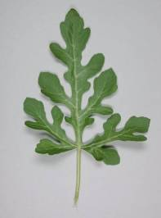 | 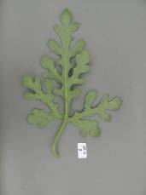
7 | 9
strong | very strong

Ad. 9: Leaf blade: blistering (on 10th to 15th leaf)

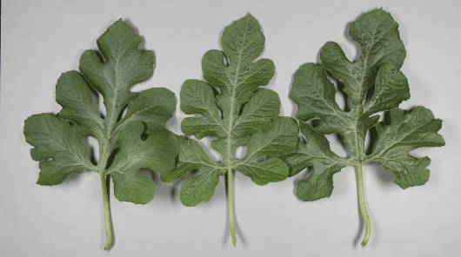

1 | 2 | 3
weak | medium | strong

Ad. 10: Leaf blade: color of veins

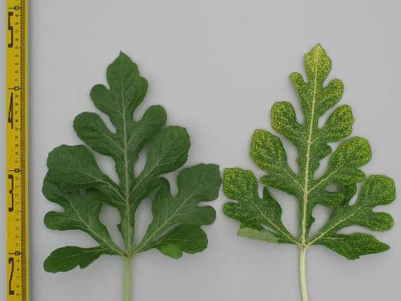
1 | 2
green | yellow

Ad. 12: Fruit: shape in longitudinal section

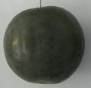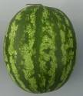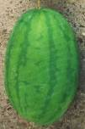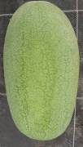
1 | 2 | 3 | 4
circular | broad elliptic | medium elliptic | elongated elliptic

Ad. 13: Fruit: depression at base

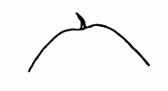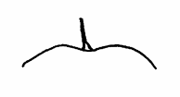
3 | 5 | 7
shallow | medium | deep

Ad. 14: Fruit: shape of apical part

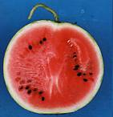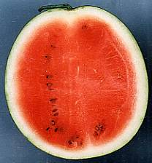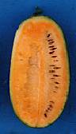
1 | 3 | 5
flat | rounded | conical

Ad. 15: Fruit: depression at apex

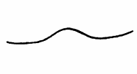
3 | 5 | 7
shallow | medium | deep

Ad. 16: Fruit: ground color of skin
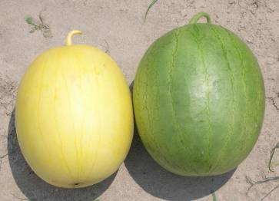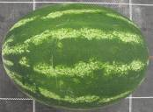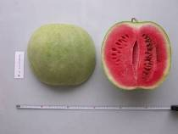

1 | 2
yellow | green

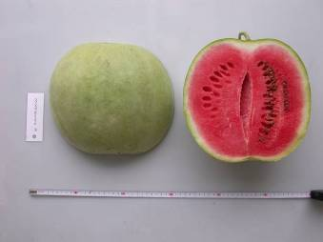

In the case of striped fruits the ground color is defined as the lighter color and the color of the stripes as the darker color.

Ad. 17: Only varieties with Fruit: ground color of skin: green: Fruit: intensity of ground color of skin

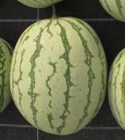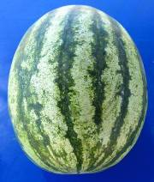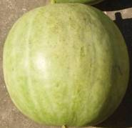
1 | 2 | 3
very light | very light to light | light

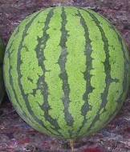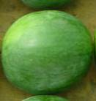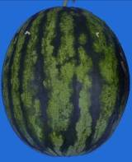
4 | 5 | 6
light to medium | medium | medium to dark

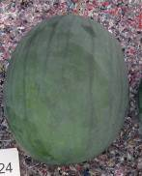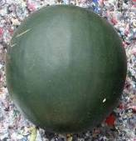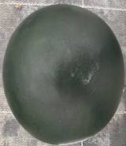
7 | 8 | 9
dark | dark to very dark | very dark

Ad. 19: Fruit: conspicuousness of veining

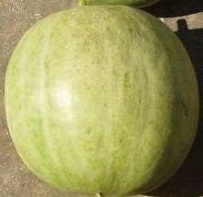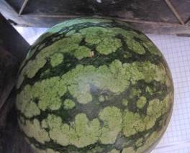
1 | 2
absent or very weak | weak

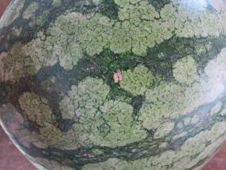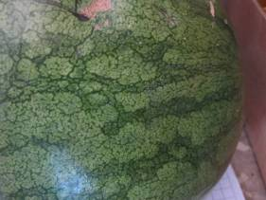
3 | 4
medium | strong

Ad. 20: Fruit: patternation of stripes

In the case of striped fruits the ground color is defined as the lighter color and the color of the stripes as the darker color.

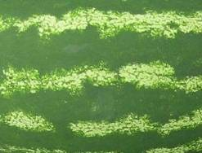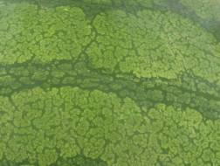
1 | 2
one colored | one colored and veins

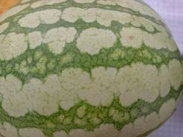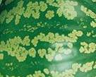
3 | 4
one colored, veins and marbled | one colored and marbled

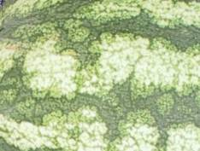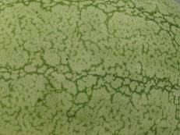
5 | 6
two colored, veins and marbled | only veins

Ad. 21: Fruit: width of stripes

In the case of striped fruits the ground color is defined as the lighter color and the color of the stripes as the darker color.

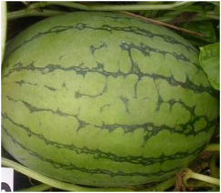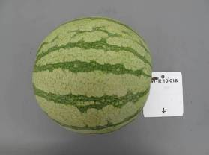
1 | 3
very narrow | narrow

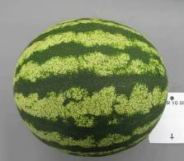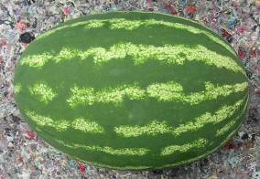
5 | 7
medium | broad

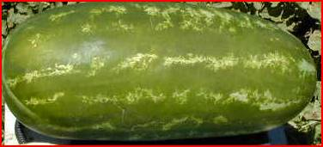
9
very broad

Ad. 22: Fruit: intensity of main color of stripes

In the case of striped fruits the ground color is defined as the lighter color and the color of the stripes as the darker color.
Use the same scale as ground color.

Ad. 23: Fruit: conspicuousness of stripes

In the case of striped fruits the ground color is defined as the lighter color and the color of the stripes as the darker color.

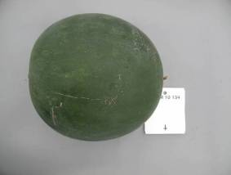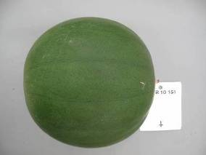
1 | 2
absent or very weak | weak

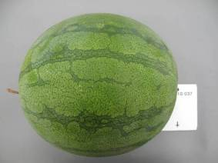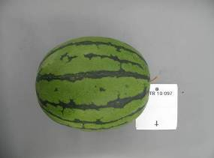
3 | 4
medium | strong

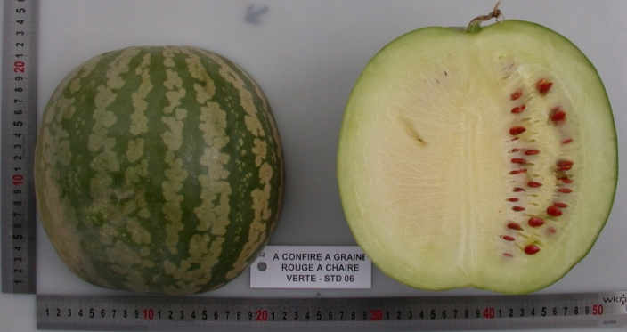
5
very strong

Ad. 24: Fruit: margin of stripes

In the case of striped fruits the ground color is defined as the lighter color and the color of the stripes as the darker color.

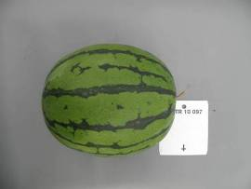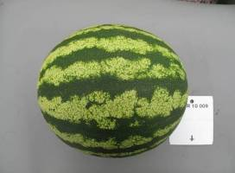
1 | 2
sharp | medium

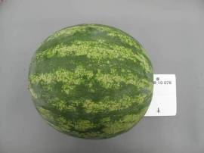
3
diffuse

Ad. 25: Fruit: size of insertion of peduncle

The size of the insertion of the peduncle is absolute and not relative to fruit size.

Ad. 27: Fruit: degree of grooving

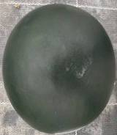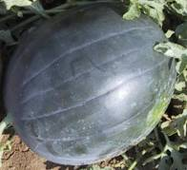
1 | 3
absent or very weak | medium

Ad. 28: Fruit: waxy layer

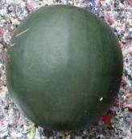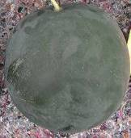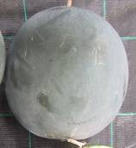
1 | 3 | 5
absent or very weak | medium | very strong

Ad. 29 (old 41): Fruit: thickness of pericarp

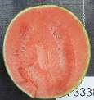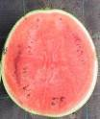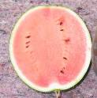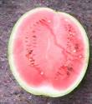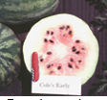
1 | 3 | 5 | 7 | 9
very thin | thin | medium | thick | very thick

Ad. 32 (old 44): Fruit: firmness of flesh

Testing method: Firmness is measured by a hardness meter (tester), which has 9 mm (diameter head) and measures from 10 g/cm² 2000 g/cm²:

Ad. 33 (old 45): Only triploid varieties: Seed coat: size

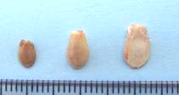
1 | 2 | 3 | 4
very small | small | medium | large

Ad. 35 (old 47): Only diploid and tetraploid varieties: Seed: size

1 | 2 | 3 | 4 | 5 | 6 | 7 | 8 | 9
very small | very small to small | small | small to medium | medium | medium to large | large | large to very large | very large

Ad. 36 (old 48): Only diploid and tetraploid varieties: Seed: ground color of testa

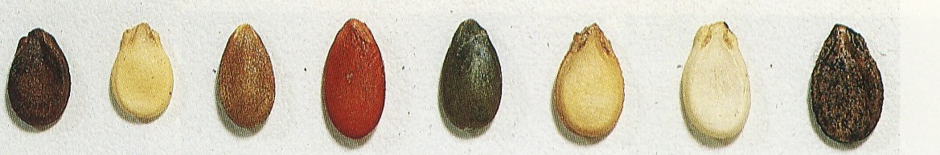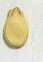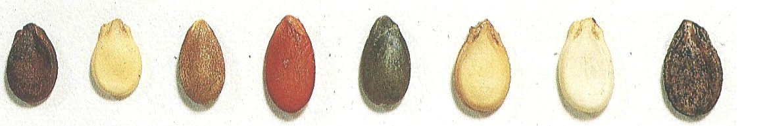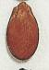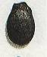
1 | 2 | 3 | 4 | 5 | 6 | 7
white | cream | green | red | red brown | brown | black

Ad. 37 (old 49): Only diploid and tetraploid varieties: Seed: secondary color of testa

1 | 9
absent | present

Ad. 38 (old 50): Only diploid and tetraploid varieties: Seed: distribution of secondary color of testa
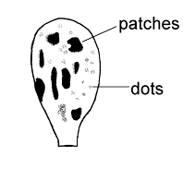
patches
dots
Ad. 39 (old 51): Only diploid and tetraploid varieties: Seed: area of secondary color in relation to that of ground color

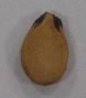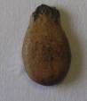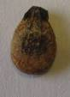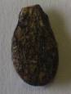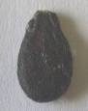
1 | 3 | 5 | 7 | 9
absent or very small | small | medium | large | very large

Ad 40 (old 52): Only diploid and tetraploid varieties: Seed: patches at hilum

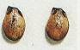
1 | 9
absent | present

Ad 43 (old 55): Resistance to Fusarium oxysporum f. sp. niveum

1. Pathogen Fusarium oxysporum f. sp. niveum
2. Quarantine status no
3. Host species watermelon (Citrullus lanatus)
4. Source of inoculum Naktuinbouw
5. Isolate Fon: 0, 1, 2
6. Establishment isolate identity differentials
7. Establishment pathogenicity susceptible varieties
8. Multiplication inoculums…………... PDA or PSA; renew from frozen stock annually
9. Format of the test
9.1 Number of plants per genotype 20
9.2 Number of replicates 2
9.3 Control varieties differentials
 | Fon: 0 | Fon: 1 | Fon: 2
Black Diamond, Kahô | S | S | S
Charleston Gray | R | S | S
Calhoun Gray | R | R | S
P.I. 296341-FR | R | R | R
9.4 Test design include at least the two most informative differentials
9.5 Test facility glasshouse or climate room
9.6 Temperature day 25°C, night 15°C
9.7 Light > 12 hours
9.9 Special measures Apply liquid fertilizer once a week
10. Inoculation
10.1 Preparation inoculum Czapek Dox or PS (potato and sugar) ; aerated liquid culture at 28ºC; filter through double muslin
10.2 Quantification inoculum count 1.3 x 10⁷ spores per ml, dilute if necessary
10.3 Plant stage at inoculation 2nd to 3rd leaf just expanding
10.4 Inoculation method Soaking of roots and of hypocotyl axis for one minute
in inoculum solution. After inoculation, transplantation
of plantlets in steam-sterilised soil or perlite.
10.5 First observation 7 days after inoculation
10.6 Second observation 14 days after inoculation
10.7 End of test 21 days after inoculation
11. Observations
11.1 Method Visual, external
11.2 Observation scale Symptoms: Yellowing, wilting and plant death
11.3 Validation of test standard varieties
12. Interpretation of data in terms of UPOV characteristic states
[1] with external symptoms
[9] without external symptoms
13. Critical control points
Resistant plants show no or little delayed growth but no internal or external symptoms.
Vascular browning is the most reliable diagnostic symptom. Plants with external symptoms should have vascular browning, otherwise the symptom may be caused by Pythium.

Ad 44 (old 56): Resistance to Colletotrichum orbiculare

1. Pathogen Colletotrichum orbiculare (anthracnose)
2. Quarantine status no
3. Host species Citrullus lanatus (watermelon )
4. Source of inoculum Academic research
5. Isolate Co: 1
6. Establishment isolate identity on differentials
7. Establishment pathogenicity on susceptible varieties
8. Multiplication inoculum
8.1 Multiplication medium ……………… PSA, renew from frozen stock annually
9.1 Number of plants per genotype 20
9.2 Number of replicates 2
9.3 Control varieties differentials: Calhoun Gray susceptible,
Charleston Gray resistant
9.4 Test design including at least the most informative differentials
9.5 Test facility glasshouse or climate room
9.6 Temperature day 25°C, night 16°C
9.7 Light >12 hours
9.9 Special measures Inoculated plants should be placed in a dark and
humid chamber at 25°C with 100% relative humidity
for 48 hours before being moved to the greenhouse.
10. Inoculation
10.1 Preparation inoculum Shaking culture in P.D. (Potato and Dextrose)
liquid medium for 7 to 10 days at 28°C.
Filter the medium through double muslin cloth.
10.2 Quantification inoculum 1.5*10⁴ spores per ml
10.3 Plant stage at inoculation 2nd or 3rd leaf just expanding
10.4 Inoculation method spraying of inoculum on leaf and stem
10.5 First observation 7 days
10.7 End of test 10 days
11. Observations
11.1 Method Visual
11.2 Observation scale Lesions > 2 mm indicate susceptibility.
Lesions may coalesce and kill the leaf back to the petiole.

11.3 Validation of test on standard varieties
12. Interpretation of data in terms of UPOV characteristic states
[1] lesions more than 2 mm in size
[9] lesions absent or less than 2 mm in size
13. Critical control points
Lesions that stay small and tend towards necrosis indicate resistance. Complete absence of symptoms indicates a low disease pressure or high resistance.

Literature

Corell J.C, T. E. Morelock and R. E. McNew, 1993. Reexamination of races of the cucurbit anthracnose pathogen Colletotrichum orbiculare. Phytopathology 83: 1190-1198

Crall, J.M., 1959: Effect of Seed Source on Watermelon Maturity, Proc. Amer. Soc. Hort. Sci. 74, pp 555-557

Crall, J.M., Montelaro, J., 1972: Fusarium Wilt Resistance in Jubilee Watermelon, Proc. Fra. State Hoet. Soc. 85, pp 102-105

Cucurbit Genetics Cooperative, Cucurbit Gene List Committee, 1987: Gene List for Watermelon, Cucurbit Gent.Coop. Rpt. 10, pp 106-110

Cucurbit Genetics Cooperative, 2007: Gene List for Watermelon

Elmstrom, G.W., Hopkins, D.L., 1981: Resistance of Watermelon Cultivars to Fusarium Wilt, Plant Disease 65(10), pp 825-827

Grubben, G.J.H., Denton, O.A. (Editors), 2004: Plant Resources of Tropical Africa 2: Vegetables , Prota Foundation, Wageningen pp 185-191

Gusmini, G., Wehner, T. C., 2005: Genes determining rind pattern inheritance in watermelon: a review, HortScience 40: pp 1928-1930

Gusmini, G. and Wehner, T. C., 2006: Qualitative inheritance of rind pattern and flesh color in watermelon, J. Hered. 97: pp 177-185

Kanda, T., 1951: Triploid Watermelons, Proc. Am. Soc. Hortic. Sci. 58, pp 217-230

Kensler, T.R., Barham, W.S., 1958: The Inheritance of Seed Size in Watermelon, Proc. Amer. Soc. Hort. Sci. 71, pp 480-484

Martyn, R.D., McLaughin, R.J., 1983: Susceptibility of Summer Squash to the Watermelon Wilt Pathogen (Fusarium oxysporum f. sp. niveum), Plant Disease 67(3), pp 263-266

Martyn, R.D., Netzer, D., 1991: Resistance to Race 0, 1 and 2 of Fusarium Wilt of Watermelon in Citrullus sp., PI-296341-FR

Maynard, D.N., Xingping Zhang, Jannick, J., 2007: Watermelons: New Choices, new Trends, Chronica Horticulturae 47(4), pp 26-29

McCuiston, Fred and Wehner, Todd C., 2010: Seedless Watermelon Breeding: Tetraploid Production, Unpublished, NC State University

Mizyno, S., Pratt, H.K., 1973: Relations of Respiration and Ethylene Production to Maturity in the Watermelon, J. Amer. Soc. Hort. Sci. 98(6), pp 614-617

Mohr, H.C., 1963: Utilization of the Genetic Character for Short-internode in Improvement of the Watermelon, J. Amer. Soc. Hort. Sci. 82, pp 454-459

Ochatt, Sergio J.,: Flow Cytometry, (ploidy determination, cell cycle analysis, DNA content per nucleus), Medicago truncatula handbook version November 2006; INRA France

Pool, C.F., Porter, D.R., 1933: Pollen Germination and Development in Watermelon, Proc. Amer. Soc. Hort. Sci. 30, pp 526-530

Pool, C.F., Grimball, P.C., Porter, D.R., 1941: Inheritance of Seed Characters in Watermelon, Jour. Agr. Res. 66, pp 433-456

Prusky, D., S. Freeman, M.B. Dickman, eds., 2000. Colletotrichum:, Host specificity, Pathology and Host-pathogen interactions. APS, St. Paul, Chapter 21 Host-pathogen interaction and variability of Colletotrichum lindemuthianum.Wasilwa L.A.,

Siemonsma, J.S., Piluek, K. (ed.), 1993: Plant resources of South East Asia No.8: Vegetables, Wageningen Pudoc, pp 144-148

Shinohara, S., 1984: Vegetable Seed Production Technology of Japan Elucidated with Respective Variety Development Histories, Particulars, Volume 1. Shinohara’s Authorized Agricultural Consulting Engineer Office, Tokyo, Japan, pp 318-339

Shomotsuma, M., Jines, C.M., 1972: Effect of Ethephon and Daylight on Sex Expression of Muskmelon and Watermelon, Hort. Sci. 7, pp 73-75

Wasilwa, L.A., J.C. Correll, T.E. Morelock, and R.E. McNew. 1993. Reexamination of races of the cucurbit anthracnose pathogen Colletotrichum orbiculare. Phytopathology 83: 1190-1198.

Wehner, T. C., 2008: Overview of the Genes of Watermelon, Proc. Cucurbitaceae 2008, EUCARPIA meeting, (ed. M. Pitrat) p. 79-89

Wehner, T.C., 2008: Watermelon In: J. Prohens and F. Nuez (eds.). Handbook of Plant Breeding; Vegetables I: Asteraceae, Brassicaceae, Chenopodiaceae, and Cucurbitaceae. Springer Science+Business LLC, New York, NY, 426 p.17, pp 381-418

Technical Questionnaire

TECHNICAL QUESTIONNAIRE |  |  |  | Page {x} of {y} |  | Reference Number:
 |  |  |  |  |  | Application date:
 |  |  |  |  |  | (not to be filled in by the applicant)
TECHNICAL QUESTIONNAIRE
to be completed in connection with an application for plant breeders’ rights

1. Subject of the Technical Questionnaire
1.1 Botanical name |  |  | Citrullus lanatus (Thunb.) Matsum. et Nakai
1.2 Common name |  |  | Watermelon
2. Applicant
Name
Address
Telephone No.
Fax No.
E-mail address
Breeder (if different from applicant)
3. Proposed denomination and breeder’s reference
Proposed denomination
(if available)

Breeder’s reference
#4. Information on the breeding scheme and propagation of the variety

4.1 Breeding scheme

Variety resulting from:

4.1.1 Crossing

(a) controlled cross [ ]
(please state parent varieties)

(…………………..……………..…) x (……………..…………………..…)
female parent male parent

(b) partially known cross [ ]
(please state known parent variety(ies))

(…………………..……………..…) x (……………..…………………..…)
female parent male parent

(c) unknown cross [ ]

4.1.2 Mutation [ ]
(please state parent variety)

4.1.3 Discovery and development [ ]
(please state where and when discovered and how developed)

4.1.4 Other [ ]
(please provide details)

4.2 Method of propagating the variety

4.2.1 Seed-propagated varieties

(a) Self-pollination [ ]
(b) Cross-pollination
(i) population [ ]
(ii) synthetic variety [ ]
(c) Hybrid [ ]
(d) Other [ ]
(please provide details)

5. Characteristics of the variety to be indicated (the number in brackets refers to the corresponding characteristic in Test Guidelines; please mark the note which best corresponds).

 | Characteristics |  |  |  |  |  | Example Varieties |  |  | Note
5.1  (1) | Ploidy
 | diploid |  |  |  |  |  | SP 4, Sugar Baby, Yamato 3 |  |  | 2[ ]
 | triploid |  |  |  |  |  | Boston, Kimiwa Red Seedless,  TRIX 313 |  |  | 3[ ]
 | tetraploid |  |  |  |  |  |  |  |  | 4[ ]
5.2  (8) | Leaf blade : degree of lobing
 | absent or very weak |  |  |  |  |  | Sunshade |  |  | 1[ ]
 | very weak to weak |  |  |  |  |  |  |  |  | 2[ ]
 | weak |  |  |  |  |  | Estrella, Karistan |  |  | 3[ ]
 | weak to medium |  |  |  |  |  |  |  |  | 4[ ]
 | medium |  |  |  |  |  | Crimson Sweet, Crisby |  |  | 5[ ]
 | medium to strong |  |  |  |  |  |  |  |  | 6[ ]
 | strong |  |  |  |  |  | Cadans |  |  | 7[ ]
 | strong to very strong |  |  |  |  |  |  |  |  | 8[ ]
 | very strong |  |  |  |  |  | SP 1 |  |  | 9[ ]
5.3  (11) | Fruit: weight (1st mature fruit)
 | very low |  |  |  |  |  | Monaco, New Hampshire Midget |  |  | 1[ ]
 | very low to low |  |  |  |  |  | Mini, Petite Perfection |  |  | 2[ ]
 | low |  |  |  |  |  | Angela |  |  | 3[ ]
 | low to medium |  |  |  |  |  | Pasión, Sugar Baby |  |  | 4[ ]
 | medium |  |  |  |  |  | Boston |  |  | 5[ ]
 | medium to high |  |  |  |  |  | Crimson Sweet, Panonia |  |  | 6[ ]
 | high |  |  |  |  |  | Fabiola |  |  | 7[ ]
 | high to very high |  |  |  |  |  | Jubilee |  |  | 8[ ]
 | very high |  |  |  |  |  | Carolina Cross, Cobb’s Gem,  Florida Giant |  |  | 9[ ]
 | Characteristics |  |  |  |  |  | Example Varieties |  |  | Note
5.4  (12) | Fruit: shape in longitudinal section
 | circular |  |  |  |  |  | Camilla, Kanro, Sugar Baby |  |  | 1[ ]
 | broad elliptic |  |  |  |  |  | Fumin, Gray Belle, Yellow Baby, Zorba |  |  | 2[ ]
 | medium elliptic |  |  |  |  |  | Congo, Kurobe, Picnic |  |  | 3[ ]
 | elongated elliptic |  |  |  |  |  | Allsweet, Charleston Gray |  |  | 4[ ]
5.5  (16) | Fruit: ground color of skin
 | yellow |  |  |  |  |  | Golden Dragon, Okan, Taiyô |  |  | 1[ ]
 | green |  |  |  |  |  | Crimson Sweet, Blanca de Benocaz, Fabiola, Napsugar, Sugar Baby, Sugar Belle |  |  | 2[ ]
5.6  (17) | Only varieties with Fruit: ground color of skin: green: Fruit: intensity of ground color of skin
 | very light |  |  |  |  |  | Tiger Baby |  |  | 1[ ]
 | very light to light |  |  |  |  |  |  |  |  | 2[ ]
 | light |  |  |  |  |  | Napsugar |  |  | 3[ ]
 | light to medium |  |  |  |  |  | Tigre |  |  | 4[ ]
 | medium |  |  |  |  |  | Pepsin |  |  | 5[ ]
 | medium to dark |  |  |  |  |  |  |  |  | 6[ ]
 | dark |  |  |  |  |  | Odem, Resistant, Sweet Marvel |  |  | 7[ ]
 | dark to very dark |  |  |  |  |  | Sugar Baby |  |  | 8[ ]
 | very dark |  |  |  |  |  | Augusta, Rocio |  |  | 9[ ]
5.7  (21) | Fruit: width of stripes
 | very narrow |  |  |  |  |  | Charleston Gray, Tiny Orchid |  |  | 1[ ]
 | very narrow to narrow |  |  |  |  |  |  |  |  | 2[ ]
 | narrow |  |  |  |  |  | Boston |  |  | 3[ ]
 | narrow to medium |  |  |  |  |  |  |  |  | 4[ ]
 | medium |  |  |  |  |  | Crimson Sweet |  |  | 5[ ]
 | medium to broad |  |  |  |  |  |  |  |  | 6[ ]
 | broad |  |  |  |  |  | Sangria |  |  | 7[ ]
 | broad to very broad |  |  |  |  |  |  |  |  | 8[ ]
 | very broad |  |  |  |  |  | All Sweet |  |  | 9[ ]
 | Characteristics |  |  |  |  |  | Example Varieties |  |  | Note
5.8  (24) | Fruit: margin of stripes
 | sharp |  |  |  |  |  | Jenny, Jubilee |  |  | 1[ ]
 | medium |  |  |  |  |  | Crimson Sweet |  |  | 2[ ]
 | diffuse |  |  |  |  |  | Crimson Glory, Crisby |  |  | 3[ ]
5.9  (30) | Fruit: main color of flesh
 | white |  |  |  |  |  | SP 4, SP1,Yamato Cream 3 |  |  | 1[ ]
 | yellow |  |  |  |  |  | Napsugár, Yamato Cream 1 |  |  | 2[ ]
 | orange |  |  |  |  |  | Kahô, Tendersweet |  |  | 3[ ]
 | pink |  |  |  |  |  | Sadul |  |  | 4[ ]
 | pinkish red |  |  |  |  |  | Bingo, Crimson Sweet |  |  | 5[ ]
 | red |  |  |  |  |  | Asahiy, Sugar Baby, Topgun |  |  | 6[ ]
5.10  (35) | Only diploid and tetraploid varieties: Seed: size
 | very small |  |  |  |  |  | Kudam |  |  | 1[ ]
 | very small to small |  |  |  |  |  |  |  |  | 2[ ]
 | small |  |  |  |  |  | Panonia, Tabata |  |  | 3[ ]
 | small to medium |  |  |  |  |  |  |  |  | 4[ ]
 | medium |  |  |  |  |  | Sugar Baby |  |  | 5[ ]
 | medium to large |  |  |  |  |  |  |  |  | 6[ ]
 | large |  |  |  |  |  | Charleston Gray, Kurobe |  |  | 7[ ]
 | large to very large |  |  |  |  |  |  |  |  | 8[ ]
 | very large |  |  |  |  |  | Malali, Wanli |  |  | 9[ ]
5.11  (36) | Only diploid and tetraploid varieties: Seed: ground color of testa
 | white |  |  |  |  |  | Sanpaku |  |  | 1
 | cream |  |  |  |  |  | Kurobe |  |  | 2
 | green |  |  |  |  |  | A confire allongée à graine verte, Green Citron |  |  | 3
 | red |  |  |  |  |  | A graine rouge à confire à chair verte, Red Citron |  |  | 4
 | red-brown |  |  |  |  |  | Kahô |  |  | 5
 | brown |  |  |  |  |  | Otome, Sugar Baby |  |  | 6
 | black |  |  |  |  |  | Yamato Cream |  |  | 7
6. Similar varieties and differences from these varieties

Please use the following table and box for comments to provide information on how your candidate variety differs from the variety (or varieties) which, to the best of your knowledge, is (or are) most similar. This information may help the examination authority to conduct its examination of distinctness in a more efficient way.

Denomination(s) of variety(ies) similar to your candidate variety |  | Characteristic(s) in which your candidate variety differs from the similar variety(ies) |  |  | Describe the expression of the characteristic(s) for the similar variety(ies) |  |  | Describe the expression of the characteristic(s) for your candidate variety
Example |  | Fruit: width of stripes |  |  | narrow |  |  | medium
Comments:

#7. Additional information which may help in the examination of the variety

7.1 In addition to the information provided in sections 5 and 6, are there any additional characteristics which may help to distinguish the variety?

Yes [ ] No [ ]

(If yes, please provide details)

7.2 Are there any special conditions for growing the variety or conducting the examination?

Yes [ ] No [ ]

(If yes, please provide details)

7.3 Other information

A representative color image of the variety should accompany the Technical Questionnaire.

8. Authorization for release

(a) Does the variety require prior authorization for release under legislation concerning the protection of the environment, human and animal health?

Yes [ ] No [ ]

(b) Has such authorization been obtained?

Yes [ ] No [ ]

If the answer to (b) is yes, please attach a copy of the authorization.

9. Information on plant material to be examined or submitted for examination.

9.1 The expression of a characteristic or several characteristics of a variety may be affected by factors, such as pests and disease, chemical treatment (e.g. growth retardants or pesticides), effects of tissue culture, different rootstocks, scions taken from different growth phases of a tree, etc.

9.2 The plant material should not have undergone any treatment which would affect the expression of the characteristics of the variety, unless the competent authorities allow or request such treatment. If the plant material has undergone such treatment, full details of the treatment must be given. In this respect, please indicate below, to the best of your knowledge, if the plant material to be examined has been subjected to:

(a) Microorganisms (e.g. virus, bacteria, phytoplasma) Yes [ ] No [ ]

(b) Chemical treatment (e.g. growth retardant, pesticide) Yes [ ] No [ ]

(c) Tissue culture Yes [ ] No [ ]

(d) Other factors Yes [ ] No [ ]

Please provide details for where you have indicated “yes”.

……………………………………………………………

10. I hereby declare that, to the best of my knowledge, the information provided in this form is correct:

Applicant’s name

Signature Date

[Annex follows]
ANNEX WITH REMARKS TO UPOV WATERMELON DRAFT 2010-2012

5.3 Grouping characteristics

(2011) The grouping characteristics were not discussed in 2010/2011, proposal to discuss this new proposal after the contents of chapter 7: table of characteristics are discussed.
Es: Not agree with the lobing added. This crop has enough other grouping characteristics, and the lobbing have certain risk of lack of consistency, for the variability into the plant.

7. Table of Characteristics

(2011) Nb: The order of the characteristics (shape, color, etc.) has been changed, according to the proposals in 2010, and the numbering of the characterisics has been changed accordingly up to number 28. From characteristic 40 the numbering from TG/142/5( proj.1) 2010-5-21 has been followed.

(2011) ISF: Consider the use of the Royal Horticulture Color Chart or the reading of Colorimeter for colors as this will provide more measurement of distinctness. The reference varieties should be replaced with the varieties that are available for breeder to reference. Some of the reference varieties are simply not available.
NL: the experts are asked to go through their files or collection to find out whether the example varieties are still available.

Char. 1: Japan to check whether Kimiwa Red Seedless still exists

Char. 14: see explanation, other photo for stage 5 needed from Japan, to be rediscussed 2012.
France: the stages 4 and 5 are not clear. The conical shape of the apical part can be due - sometimes…- to a default of pollination.
To see pictures in Ad.14

Char. 17: IT to provide names of example varieties for state 2 and 6; see table Ad 17

Char. 18: Japan to provide example varieties

Characteristics still to be discussed in 2012

Char. 29 (old 41):
(2010) Fr accepts mod ex. vars
(2011) Hu : are still seeds available from Coles Early (1892)?
(2011) NL: answer or example of living variety to be provided by ISF
(2012) photo's of Coles Early and/or Kholodok needed

Char. 31 (old 43)
Proposal NL to delete Char 43. (old 37), as this is very dependent on state of maturity of the fruit Hu agrees with deletion;

FR and IT agree to delete.

ISF (2010) proposes Add CHARLESTON GRAY for level 3; Add TRIX 313 for level 5; Add SUNSUGAR and TOP GUN for level 7

(2011)

KR: very dependant on state of maturity, but still distinctive at the time of ordinary maturity. Proposal to provide photo’s, if included.

HU: the harvesting time influences this characteristic, evaluation of the little genetical difference is difficult

ISF proposes New Hampshire Midget for 3, Kholodok for 5
ES: Not a big variability, but easy to assess and may be useful to distinctness of pair of varieties. To keep

NL: keep proposal to delete, 42 is sufficient for distinctness

Char. 32 (old 44)

Proposal NL to delete Char 44 (old 38), as this is very dependent on state of maturity of the fruit

HU, KR, IT, ES, FR agree

ISF: Add SANGRIA for level 7

NL: keep proposal to delete

Char. 33 (old 45)

HU, IT and FR agree with new 45

ES: We observe it since several years, and we found it quite variable, probably by the difficulty to observe properly. There are variability into the same fruit, inter fruits and along the years. Not possible to assess the uniformity. Considering it as average tendency, we propose to consider only 3 notes as condensed quantitative.
1.Small Valdoria, Merisin, Sweet Sun, Petite Perfection
2.Medium Tigre, Pasion
3.Big Sunrise, Mabel
Scale 3 to 7 is more than enough

NL: proposal to make it a scale from 1 to 4

Char. 37 (old 49)

ES: Char 49 Seed: secondary color (To add excluding hilum)
1- Absent or very weak
2- Present

NL: Not to take over as Kahô is really absent

Char. 38 (old 50)

ES: It is very difficult to assess in many cases. It is clear in the drawing of the explanation, but not in the reality, nor in many of the photos. I propose to delete it.

NL: agree to delete

Char. 39 (old 51)

Proposal NL to delete characteristic 51 (old 44)
FR, KR, IT agree
New proposal ES (2012):
In our opinion should be more useful a condensed quantitative because there are varieties that can be recognized by the very intense black patches at hilum. So our proposal is
1.Absent or very weak expressed Kahô
2.Medium Betica, Kameni, Desvelo
3 Strongly expressed Furia, Augusta, Nubia

NL: to be discussed, see also explanation
Char. 40 (old 52)
ISF: skip
ES: To replace absent with absent or very weak
NL: to be discussed

Char. 42 (old 54)

Proposal NL to delete characteristic 54 (old 47) HU and ES agree with deletion, ES because abortion of small fruits is very usual, which makes the characteristic not useful for distinctness.

FR: the deletion have to be discussed. It is an important characteristic, but not so easy to assess.... If it is maintained, it needs further explanations.

ISF proposes to add Bonanza for 3 NL: not to take over, as the proposal is to delete char. 54 (old 47)

IT: Time of maturity is difficult to assess. We suggest to determine the time of maturity with the observation of browning of basal cirrus closer to the fruit

NL keeps the proposal to delete

Char 43 (old 55): Resistance to Fon, Char 44 (old 56): Resistance to Colletotrichum orbiculare
FR: need to display example varieties easier (most recent) to obtain

8. Explanations on the Table of Characteristics

Ad 14: other photo for stage 5 needed, if there is not any, proposal NL and FR to delete state 4 and 5

Remark of FR:
ie: 2 pictures of the variety EMERALD, in 2002, and 2003. The fruit in the second one is slightly conical, but the observation is not typical of this variety. This fruit is not really well formed.

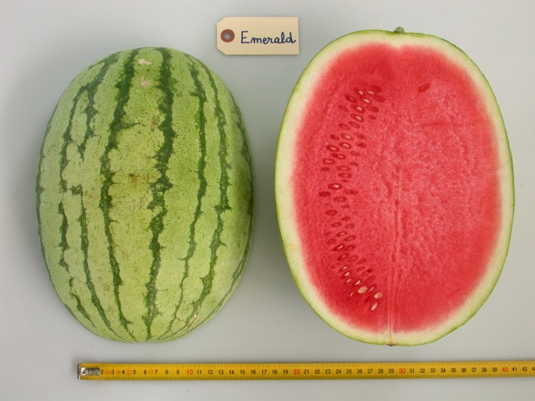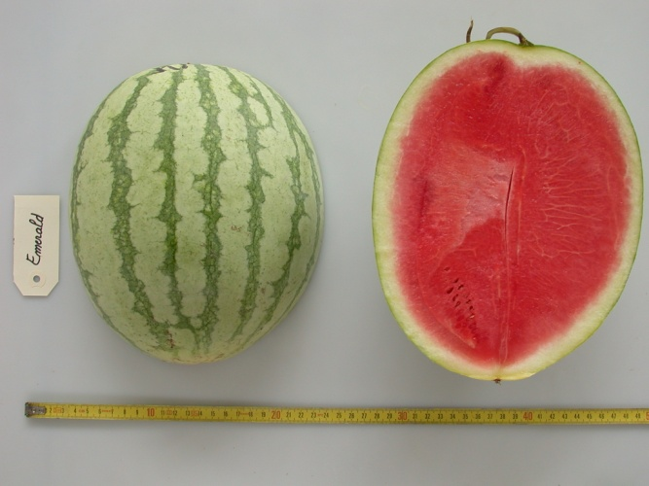

Ad 15: To replace drawings by photo’s

Ad 17: FR: State 3: light
The picture is not really relevant… the fruit in the picture looks like a fruit at overmaturity …

Ad 19: Fruit: conspicuousness of veining

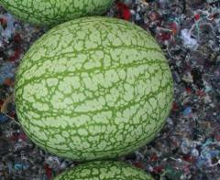

Question: how to describe this? FR proposal: very narrow stripes, without veining

Ad.20: Fruit: patternation of stripes
FR: I still have difficulties to clearly understand the meaning of the word “marbled”…, in the state 4.
The example variety to illustrate this sate is ‘A graine rouge à confire à chaire verte’

Or eventually the example variety : A confire allongée à graine verte
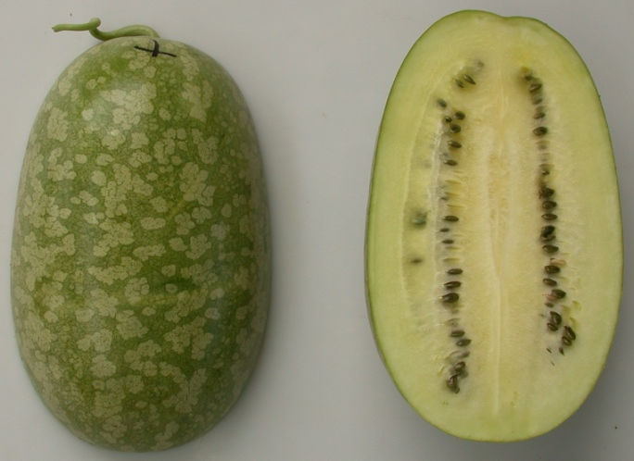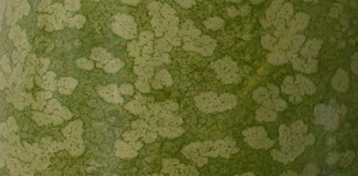

"To explain verbally..."

ES: Referring to Chrystelle comment:
The type 4: one coloured and marbled is not very frequent. The varieties in this group must not have veining into the stripes. The enlarged photo of the variety”A confire allongée à graine verte” shows clearly veins into the stripes, so it belongs to type 3. The actual photo in the ad 20 explanation seems not to have veining and consequently would be good for explanation. Other possibility would be some variety with very dark stripes, where the veining be not visible, but may have marbling.
The marbling in the context of this characteristic means the presence into the stripes of closed regions, more or less rounded, with the subjacent clearer colour.

Ad 23
France to provide picture for state (5) (“a graine rouge a confire a chair verte”)

Technical Questionnaire

ISF: delete following sentence: In the case of hybrid varieties etc.

4.1.1: ISF: Crossing: this scheme is appropriate for hybrid varieties. Which choice should be made when applying for a parental line, since usually it is a controlled cross, but with a larger number of “parent varieties”.

5. Characteristics to be included: NL: proposal to include only the grouping characteristics

[End of Annex and of document]

* These names were correct at the time of the introduction of these Test Guidelines but may be revised or updated. [Readers are advised to consult the UPOV Code, which can be found on the UPOV Website (www.upov.int), for the latest information.]
# Authorities may allow certain of this information to be provided in a confidential section of the Technical Questionnaire.
# Authorities may allow certain of this information to be provided in a confidential section of the Technical Questionnaire.

