 | E
International Union for the Protection of New Varieties of Plants

Technical Working Party for Ornamental Plants and Forest Trees  Fifty-Seventh Session  Roelofarendsveen, Kingdom of the Netherlands, March 31 to April 3, 2025  Technical Working Party on Testing Methods and Techniques  Third Session  Beijing, China, April 28 to May 1, 2025  Technical Working Party for Vegetables  Fifty-Ninth Session  Virtual meeting, May 5 to 8, 2025  Technical Working Party for Agricultural Crops  Fifty-Fourth Session  Arusha, United Republic of Tanzania, May 19 to 22, 2025  Technical Working Party for Fruit Crops  Fifty-Sixth Session  Bursa, Türkiye, June 23 to 26, 2025 | TWP/9/2  Original: English  Date: March 11, 2025
UPOV information databases
Document prepared by the Office of the Union
Disclaimer: this document does not represent UPOV policies or guidance

Executive summary

The purpose of this document is to report developments and present proposals on the “Genera and Species Database” (GENIE database) and UPOV codes for the Citrus complex.

How to identify UPOV members with experience and cooperation in DUS examination

This document presents a proposal to discontinue the section on “Cooperation in examination” in the GENIE database. The proposal is aimed at acknowledging the preferred use by UPOV members of information available in the GENIE database under “Practical experience in DUS examination”. The proposal to discontinue the section on “Cooperation in examination” would increase efficiency for UPOV members providing data and streamline searches using information on “Practical experience in DUS examination”.

UPOV Codes: Reclassification of Citrus, ×Citroncirus, Fortunella and Poncirus taxa

This document presents a proposal to revise UPOV codes for genera and species of the Citrus complex which are no longer recognized as valid botanical names, including the several Citrus species and the genera ×Citroncirus, Fortunella and Poncirus.

The Technical Working Party for Fruit Crops (TWF) is invited to consider the proposed list of UPOV codes to be deleted and the UPOV codes to be used for genera and species no longer recognized as valid botanical names, as provided in Annex I to this document.

The structure of this document is as follows:

Executive summary 1
GENIE database: cooperation in DUS examination 2
Background: 2
Reports on cooperation in DUS examination: data collection and publications 2
How to identify UPOV members with experience in DUS examination of different crops 4
GENIE Database: Practical experience in DUS examination 4
PLUTO database 5
UPOV e-PVP DUS Report Exchange Platform 5
Proposal 5
TWF: UPOV codes for Citrus 6
Background 6
Proposal 6
Matters for information 7
PLUTO database 7
GENIE database 7
Background 7
UPOV code developments 8
ANNEX I: AMENDING THE UPOV CODES FOR CITRUS AND RELATED GENERA AND SPECIES
Annex iI: REPORT ON DATA CONTRIBUTED TO PLUTO BY MEMBERS OF THE UNION AND OTHER CONTRIBUTORS

The following abbreviations are used in this document:

TC: Technical Committee
TWA: Technical Working Party for Agricultural Crops
TWF: Technical Working Party for Fruit Crops
TWM: Technical Working Party for Testing Methods and Techniques
TWO: Technical Working Party for Ornamental Plants and Forest Trees
TWP(s): Technical Working Party(ies)
TWV: Technical Working Party for Vegetables

GENIE database: cooperation in DUS examination

The following section presents a proposal to streamline the “Genera and Species Database” (GENIE Database) by discontinuing the section on “Cooperation in DUS Examination”. This would encompass the declarations on existence of formal cooperation agreements for DUS examination on behalf of other UPOV members; and declarations on the use of DUS test reports provided by other UPOV members.

Discontinuing the section on “Cooperation in DUS Examination” would allow focusing support identifying experience in DUS examination through a single mechanism in the GENIE database, where members provide information on the different crops they have experience (“Practical experience in DUS examination”).

Background:

The TC, at its sixtieth session, agreed that members sought cooperation in DUS examination directly with authorities with experience in examination of the crops of their interest. The TC agreed that information in the GENIE database and the Council document “Cooperation in Examination” was outdated and could possibly be discontinued.

Discontinuing the “Cooperation in DUS Examination” part of the GENIE Database would not affect the provision of information on “Practical experience in DUS examination”, which would continue to be collected and searchable online in the GENIE database, as well as in printable format in the TC document “List of genera and species for which authorities have practical experience in the examination of DUS” (see document TC/60/4).

Reports on cooperation in DUS examination: data collection and publications

UPOV members are periodically invited to provide and update information on cooperation in DUS examination. The information is to be provided in spreadsheets, as follows:

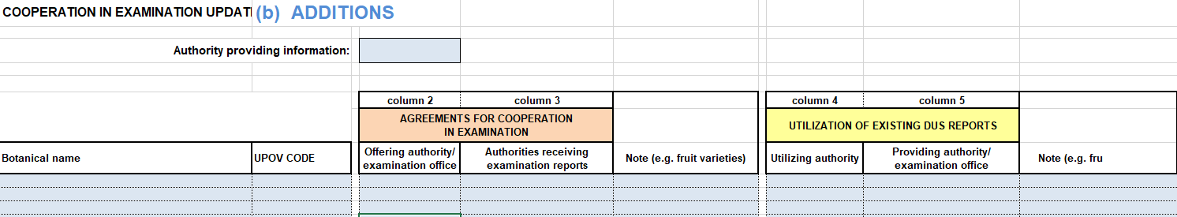

The information is compiled and organized to be presented in the Council document “Cooperation in Examination”. The document provides “general notes” and a list of genera and species with the authorities that that carry out examination on behalf or utilize DUS reports provided by other authorities, as follows:

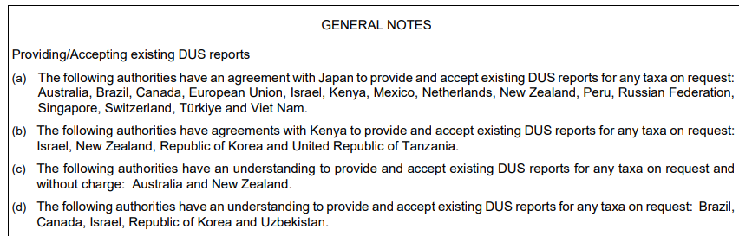

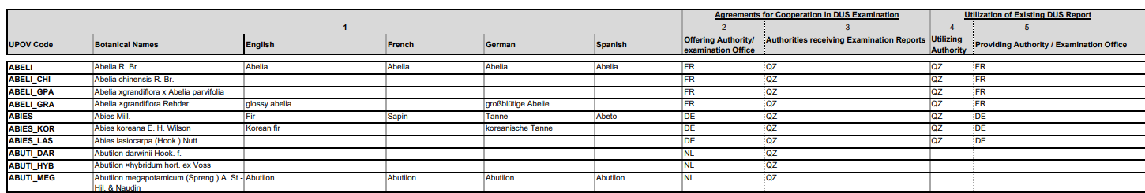

The same information provided in the Council document is available online on the GENIE database:

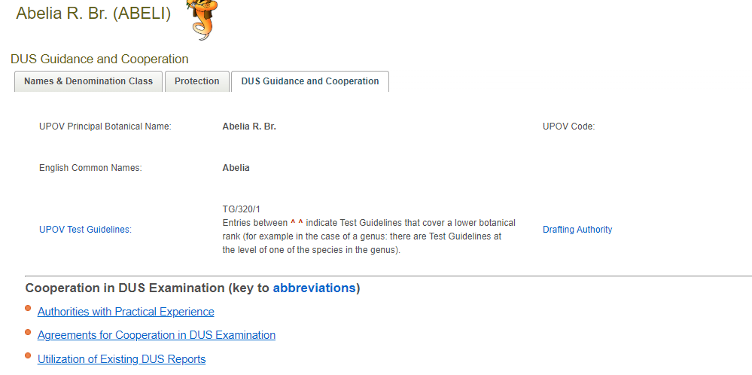

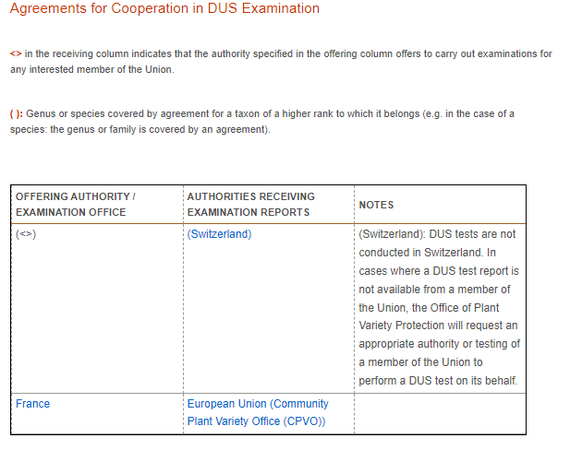 | 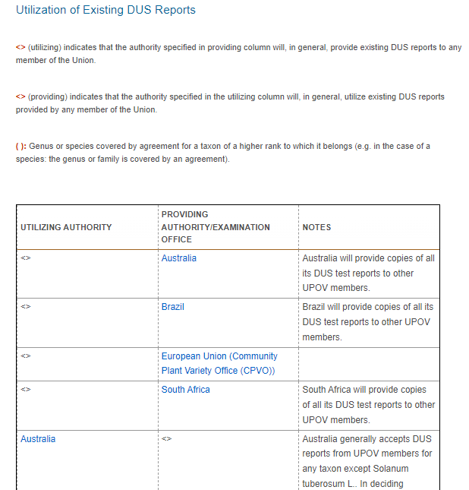

Since 2019, a total of 38 members provided information on cooperation in DUS examination. The largest number of contributions was received in 2024, when 14 members provided information.

Discontinuing “Cooperation in Examination” part of the GENIE database would not affect the other part of the database dealing with “Practical experience in DUS examination”.

How to identify UPOV members with experience in DUS examination of different crops

UPOV members may seek cooperation in DUS examination directly with the authorities with experience in the examination of crops of their interest. This information is provided in the GENIE database for any particular crop under “Practical experience in DUS examination”.

GENIE Database: Practical experience in DUS examination

Contact persons of members of the Union at the Technical Committee are invited every year to update the list of genera and species for which they have practical experience in DUS examination. The information is compiled in the TC document “List of genera and species for which authorities have practical experience in DUS examination”. The document provides information as a list of genera and species with the respective authorities declaring experience examining the crop, as follows:

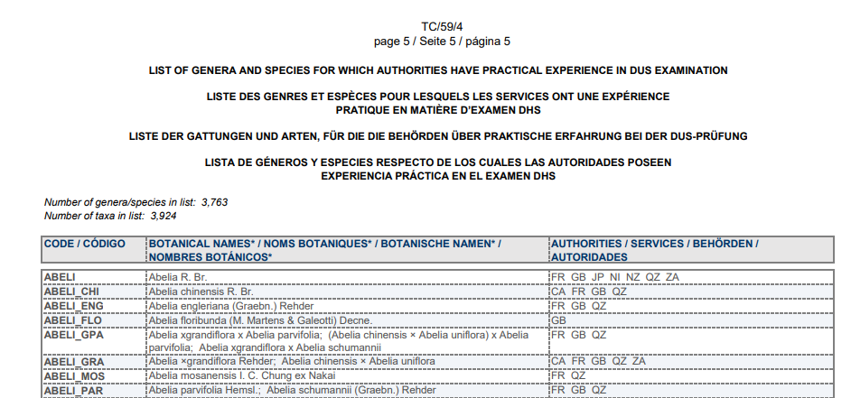

The same information provided in the TC document is made available on the GENIE database:
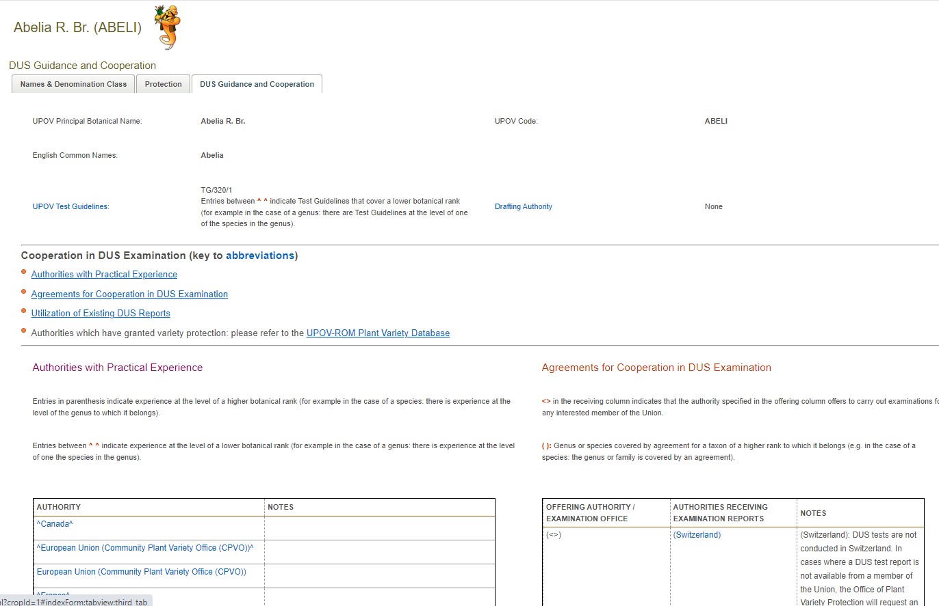

Since 2019, a total of 28 members provided information on practical experience in DUS examination. The largest number of contributions was received in 2024, when 14 members provided information.

PLUTO database

The TC, at its sixtieth session, considered how UPOV members can search for information on experience in DUS examination and noted that the UPOV Plant Variety Database (PLUTO) was commonly used by members.

Experience in DUS examination may be derived from the PLUTO database by searching for UPOV members receiving applications and granting titles for the different genera and species. Searches can be conducted for a defined period of time, identifying UPOV members with recent experience handling applications for particular crops.

The TC considered options to identify the authority that had conducted the technical examination of a variety and agreed that this information was required in the UPOV model form for the application for plant breeders’ rights (document TGP/5, Section 2).

UPOV e-PVP DUS Report Exchange Platform

The UPOV e-PVP DUS Report Exchange Platform enables users to commission DUS examination and exchange existing test reports. Information on the authorities offering DUS test reports can be derived directly from the UPOV e-PVP DUS Report Exchange Platform. A report on developments will be provided to the TWPs, at their sessions in 2025.

The TC, at its sixtieth session, noted that the UPOV e-PVP DUS Report Exchange Platform provided information on test reports available for exchange and offers to conduct DUS examination on behalf of other authorities.

Proposal

The TWPs may wish to consider discontinuing the section on “Cooperation in DUS Examination” in the GENIE database (e.g. formal cooperation agreements for DUS examination on behalf of other UPOV members; and declarations on the use of DUS test reports provided by other UPOV members.

The discontinuing the section on “Cooperation in DUS Examination” would not affect the “Practical experience in DUS examination” section of the GENIE database, nor the publication of document “List of genera and species for which authorities have practical experience in the examination of DUS” (see document TC/60/4).

The TWPs are invited to consider discontinuing the section on “Cooperation in DUS Examination” in the GENIE database, as set out in paragraphs 7 to 26 of this document.

TWF: UPOV codes for Citrus

The following section reports on proposed amendments to UPOV codes for genera and species of the Citrus complex, which are no longer recognized as valid botanical names. In addition to the genus Citrus (Oranges, Mandarins, Lemons, Limes, Pummelo), the proposed amendments include the UPOV codes for species under the genera ×Citroncirus, Fortunella and Poncirus.

Following the reclassification of several species of Citrus and related genera and species, a revision of the UPOV codes related to the Citrus complex is proposed. The list of UPOV codes to be deleted and the proposed UPOV codes to be used for the genera and species no longer recognized as valid botanical names is provided in Annex I to this document.

Background

The TC, at its fifty-seventh session, agreed to amend the UPOV code CITRU_AUM, following the reclassification of Citrus clementina hort. ex Tanaka (UPOV code: CITRU_CLE) as a synonym of Citrus aurantium L. (UPOV code: CITRU_AUM), as provided below. The TC agreed to append information to UPOV code CITRU_AUM to create groups “1MA” for mandarins; and “2OR” for oranges.

Old |  |  |  |  | New
Entries in PLUTO | TG | UPOV Code | Principal botanical name | Other botanical name(s) | UPOV Code | Principal botanical name | Other botanical name(s)
10 | TG/202 | CITRU_AUM | Citrus aurantium L. | n.a. | CITRU_AUM_1MA  CITRU_AUM_2OR | Citrus ×aurantium L. | Citrus amara Link;  Citrus bigarradia Loisel.;  Citrus intermedia hort. ex Tanaka;  Citrus taitensis Risso;  Citrus vulgaris Risso;  Citrus ×aurantium subsp. aurantium L.;  Citrus ×aurantium subsp. jambiri Engl.;  Citrus ×aurantium subsp. keonla Engl.;  Citrus ×aurantium subsp. suntara Engl.;  Citrus ×aurantium var. aurantium L.;  Citrus ×aurantium var. citrina Lush.;  Citrus ×bigarradia var. volkameriana Risso;  Citrus ×clementina hort. ex Tanaka;  Citrus ×crenatifolia Lush.;  Citrus reticulata × C. maxima
115 | TG/201 | CITRU_CLE | Citrus clementina hort. ex Tanaka | n.a.
1 | / | CITRU_MRE | Citrus maxima X Citrus reticulata | n.a.
0 | TG/201 | CITRU_CRE | Citrus crenatifolia Lush. | n.a.
0 | TG/204 | CITRU_INT | Citrus intermedia hort. ex Tanaka | n.a.

As consequential changes, the TC agreed that the UPOV codes CITRU_CLE, CITRU_MRE, CITRU_CRE, CITRU_INT, CITRU_AUR, CITRU_DAV, CITRU_EXC, CITRU_KER, CITRU_BAL and CITRU_KAR and CITRU_BEN should be deleted. The TC agreed with the proposal from the TWF for partial revision of the Test Guidelines for Citrus to move obsolete species from the “principle botanical names” box to the “alternative botanical names”.

Proposal

The TC, at its sixtieth session, noted the reclassification of genera and species of the Citrus complex which are no longer recognized as valid botanical names. The TC noted that UPOV codes in the genera Citrus, ×Citroncirus, Fortunella and Poncirus would be affected. The TC agreed to submit to the TWF a proposal for amending the UPOV codes for Citrus and related genera and species, as provided in Annex I to this document (see document TC/60/8 “Report”, paragraph 56).

The TWF is invited to consider the proposals for amending the UPOV codes for Citrus and related genera and species, as provided in Annex I to this document.

Matters for information

PLUTO database

The number and different types of subscriptions to the PLUTO premium service from 2021 to 2024 are indicated in the table below.

Subscription | 2021 | 2022 | 2023 | 2024
Paying Premium Users | 9 | 21 | 52 | 8
Non-paying premium Users (Eligible Officials) | 97 | 136 | 149 | 151
PVP Contributors | 28 | 43 | 59 | 61
Other Users (Standard Service) | 1,131 | 2,704 | 4,370 | 4,855

The frequency and completeness of data contributions to the PLUTO database differs from one authority to another.

Last contribution year | No data submission | 2021 | 2022 | 2023 | 2024
Number of authorities | 12 | 9 | 5 | 11 | 44
Percentage | 14% | 11% | 6% | 13% | 54%

A report on data contributed to PLUTO by members of the Union and other contributors is provided in Annex II to this document.

The Office of the Union is arranging initial online sessions with new contributors to outline the contribution process and familiarize them with the PLUTO database interface for contributors.

A database of high quality is to the benefit for all UPOV members. The quality of a database depends on high quality contributions. Data contributors to the PLUTO database are invited to consider the following aspects of data quality:

- Timeliness: PLUTO contributors should aim to submit data as frequently as possible, ideally right after its publication in the gazette.
- Uniqueness: To prevent duplicates, a control on the variety identifier is implemented in PLUTO (application number or grant number).
- Validity: Denominations that are empty or dates that are invalid must be identified and corrected.
- Consistency: Application/grant numbers should be consistent within the data provided by an authority.
- Accuracy: It is crucial to identify species correctly and link them to the UPOV code to test denominations accurately. The PLUTO database has a rigorous process to propose UPOV codes and validate them with data contributors.
- Completeness: The quality of the PLUTO database would benefit from receiving complete sets of data contributions from all UPOV members.

A workshop on data quality was held in September 2024 for UPOV Office staff and experts from the Community Plant Variety Office of the European Union (CPVO) to identify data quality issues; consider options for support to data contributors between Q4 2024 and Q1 2025; and explore options for automating quality checks.

GENIE database

Background

The GENIE database (http://www.upov.int/genie/en/) has been developed to provide online information on the status of protection, cooperation in examination, experience in DUS testing and existence of UPOV Test Guidelines for different GENera and specIEs (hence GENIE). The GENIE database is used to generate the relevant Council and TC documents concerning that information.
The GENIE database is the repository of the UPOV codes and provides information concerning the principal and alternative botanical names and common names of plant taxa.

UPOV code developments

In 2024, 505 new UPOV codes were created. The total number of UPOV codes in the GENIE database as of December 31, 2024 was 10,109.

 | 2014 | 2015 | 2016 | 2017 | 2018 | 2019 | 2020 | 2021 | 2022 | 2023 | 2024
New UPOV codes | 577 | 188 | 173 | 440 | 242 | 243 | 177 | 131 | 183 | 78 | 505
Total UPOV Codes | 7,808 | 7,992 | 8,149 | 8,589 | 8,844 | 9,077 | 9,213 | 9,342 | 9,525 | 9,605 | 10,109

[Annexes follow]

PROPOSAL FOR AMENDING THE UPOV CODES FOR CITRUS AND RELATED GENERA AND SPECIES

TC PROPOSAL TO THE TWF FOR AMENDING THE UPOV CODES FOR CITRUS AND RELATED GENERA AND SPECIES
Entries in PLUTO | UPOV TG | Current |  | Proposal for Amendment
 |  | UPOV code |  | New or Integrated  UPOV code | Valid botanical name | Other botanical name(s) | Common Name EN | Common Name FR | Common Name DE | Common Name ES
0 |  | CITRO_NTR |  | CITRU_ATR | Hybrids between Citrus ×aurantium L. var. chrysocarpa (Hassk.) ined. and Citrus trifoliata L. | hybrids between Citrus nobilis Lour. and Poncirus trifoliata (L.) Raf. | none | none | none | none
0 |  | FOPON |  | CITRU_HYB | CITRUS × CITRUS | Fortunella × Poncirus | none | none | none | none
0 |  | FOPON_TRI |  | CITRU_TRI | Citrus × Citrus trifoliata L. | Fortunella sp. x Poncirus trifoliata (L.) Raf. | none | none | none | none
5 |  | CITRU_AUS |  | CITRU_AUS | Citrus australasica F. Muell. |  | Australian finger-lime; Finger-lime | none | none | none
0 | TG/201 | CITRU_CAV |  | CITRU_CAV | Citrus cavaleriei H. Lév. ex Cavalerie |  | Ichang papeda | none | none | none
0 |  | FORTU_OBO |  | CITRU_HYB | CITRUS Hybr. | Fortunella × obovata hort. ex Tanaka | Changshou kumquat | none | none | none
0 | TG/203 | CITRU_KER |  | CITRU_HYS | Citrus hystrix DC. | Citrus hyalopulpa Tanaka; Citrus kerrii (Swingle) Tanaka | none | none | none | none
0 |  | CITRU_INO |  | CITRU_INO | Citrus inodora F. M. Bailey |  | North Queensland-lime; Russell River-lime | none | none | none
0 |  | FORTU_CRA |  | CITRU_JAP | Citrus japonica Thunb | Fortunella japonica (Thunb.) Swingle; Citrus madurensis Lour.; Fortunella × crassifolia Swingle; Fortunella hindsii (Champ. ex Benth.) Swingle; Fortunella margarita (Lour.) Swingle | meiwa kumquat | none | none | none
0 |  | FORTU_HIN |  |  |  |  | golden-bean kumquat, Hong Kong kumquat | none | none | none
0 | TG/201 | FORTU_JAP |  |  |  |  | marumi kumquat; marumi kumquat, round cumquat, round kumquat; round cumquat; round kumquat | none | none | none
2 |  | FORTU_MAR |  |  |  |  | none | none | none | none
14 | TG/204 | CITRU_MAX |  | CITRU_MAX | Citrus maxima (Burm.) Merr. (Citrus Pummelo Group) | Citrus grandis Osbeck; Citrus pseudograndis; Citrus truncata; Citrus panuban (Wester) Tanaka | Pomelo; Pomelo ; Pummelo; Shaddock; Shaddock | none | none | Toronja
0 | TG/204 | CITRU_PAN |  |  |  |  |  | none | none
7 |  | CITRU_MED |  | CITRU_MED | Citrus medica L. (Citrus Citron Group) |  | Citron | none | none | none
0 | TG/203 | CITRU_MON |  | CITRU_MON | Citrus montana (Wester) Tanaka |  | none | none | none | none
0 | TG/202 | CITRU_OBL |  | CITRU_OBL | Citrus oblonga hort. Ex Yu. Tanaka |  | none | none | none | none
0 | TG/203 | CITRU_PAP |  | CITRU_PAP | Citrus papaya Hassk |  | none | none | none | none
0 | TG/203 | CITRU_PSM |  | CITRU_PSM | Citrus pseudolimonum Wester |  | none | none | none | none
0 | TG/202 | CITRU_PSS |  | CITRU_PSS | Citrus pseudopapillaris Tanaka |  | none | none | none | none
0 |  | CITRU_RPC |  | CITRU_RAM | Citrus reticulata Blanco × (Citrus ×aurantium L. var. racemosa (Risso) ined. × Citrus ×aurantium L. var. chrysocarpa (Hassk.) ined.) × Citrus ×aurantium L. | Citrus reticulata Hort Ex. Tan. x (Citrus paradisi Macf x Citrus tangerina Hort. Ex. Tan.) x Citrus clementina Hort. Ex. Tan | none | none | none | none
0 | TG/201 | CITRU_BEN |  | CITRU_RET | Citrus reticulata Blanco (Citrus Mandarin Orange Group) | Citrus benikoji hort. ex Tanaka | none | none | none | none
526 | TG/201 | CITRU_RET |  | CITRU_RET | Citrus reticulata Blanco (Citrus Mandarin Orange Group) | Citrus benikoji hort. ex Tanaka | Tangerine | none | none | Mandarina Ponkan
0 |  | CITRU_TST |  | CITRU_RAM | Citrus reticulata Blanco × Citrus ×aurantium L. var. sinensis L. × Citrus ×aurantium L. var. chrysocarpa (Hassk.) ined. | Citrus reticulata Blanco x Citrus sinensis (L.) Osbeck X Citrus temple | none | none | none | none
5 | TG/202 | CITRU_SIO |  | CITRU_SIO | Citrus sinograndis hort. ex Yu. Tanaka |  | none | none | none | none
0 | TG/202 | CITRU_TAK |  | CITRU_TAK | Citrus tankan Hayata |  | none | none | none | none
36 |  | PONCI_TRI |  | CITRU_TRI | Citrus trifoliata L. | Poncirus trifoliata (L.) Raf. | Japanese bitter-orange; hardy orange; trifoliate-orange | none | none | naranjo trébol
0 | TG/201 | CITRU_AMB |  | CITRU_AMB | Citrus ×amblycarpa (Hassk.) Ochse |  | Nasnaran mandarin | none | none | none
0 | TG/203 | CITRU_AUA |  | CITRU_AUR | Citrus ×aurantiifolia (Christm.) Swingle (Citrus Lime Group) | Citrus ×javanica Blume; Citrus aurata Risso; Citrus davaoensis (Wester) Tanaka; Citrus excelsa Wester; Citrus macrophylla Wester | none | none | none | none
14 | TG/203 | CITRU_AUR |  |  |  |  | Lime; Mexican Lime | none | none | Lima mexicana; Limón mexicano
0 | TG/203 | CITRU_DAV |  |  |  |  | none | none | none | none
0 | TG/203 | CITRU_EXC |  |  |  |  | none | none | none | none
0 |  | CITRU_MAR |  |  |  |  | colo | none | none | none
12 |  | CITRU_AUM |  | CITRU_AUM | Citrus ×aurantium L. (Citrus Sour Orange Group) | Citrus clementina hort. ex Tanaka; Citrus crenatifolia Lush.; Citrus flavicarpa hort. ex Tanaka; Citrus hainanensis Tanaka; Citrus intermedia hort. ex Tanaka; Citrus maderaspatana hort. ex Tanaka; Citrus pseudogulgul hort. ex Shirai; Citrus shunkokan hort. ex Tanaka; Citrus taiwanica Tanaka & Y. Shimada; Citrus tamurana hort. ex Tanaka; Hybrids between Citrus reticulata and Citrus paradisi; Citrus x tangelo J. W. Ingram & H. E. Moore; Citrus yamabuki hort. ex Yu. Tanaka | Bigarade; Bitter orange; Seville orange; Sour orange | none | none | Naranja agria; Naranja amarga
127 | TG/201 | CITRU_CLE |  |  |  |  | Clementine | none | none
0 | TG/201 | CITRU_CRE |  |  |  |  | none | none | none | none
0 | TG/204 | CITRU_FLA |  |  |  |  | none | none | none | none
0 | TG/201 | CITRU_HAI |  |  |  |  | none | none | none | none
0 | TG/204 | CITRU_INT |  |  |  |  | none | none | none | none
0 | TG/202 | CITRU_MAD |  |  |  |  | guntur sour orange; kichili | none | none | none
0 | TG/204 | CITRU_PSE |  |  |  |  | none | none | none | none
0 | TG/202 | CITRU_SHU |  |  |  |  | none | none | none | none
0 | TG/202 | CITRU_TAI |  |  |  |  | none | none | none | none
0 | TG/202 | CITRU_TAM |  |  |  |  | none | none | none | none
16 | TG/201 | CITRU_TNG |  |  |  |  | tangelo; uglifruit | none | none | none
0 | TG/204 | CITRU_YAM |  |  |  |  | none | none | none | none
0 | TG/202 | CITRU_FUN |  | CITRU_AUM_AUM | Citrus ×aurantium L. var. aurantium (Citrus Sour Orange Group) | Citrus funadoko hort. ex Yu. Tanaka; Citrus myrtifolia Raf. | none | none | none | none
0 | TG/202 | CITRU_MYR |  |  |  |  | myrtle-leaf orange | none | none | naranja mirtifolia
79 | TG/201 | CITRU_DEL |  | CITRU_AUM_CHR | Citrus ×aurantium L. var. chrysocarpa (Hassk.) ined. (Citrus Sour Orange Group) | Citrus deliciosa Ten.; Citrus lycopersiciformis (Lush.) hort. ex Tanaka; Citrus nobilis Lour. x Citrus deliciosa Ten; Citrus nobilis Lour.; Citrus oto hort. ex Yu. Tanaka; Citrus paratangerina hort. ex Tanaka; Citrus papillaris Blanco; Citrus platymamma hort. ex Tanaka; Citrus pseudosunki hort. ex Tanaka; Citrus reshni hort. ex Tanaka; Citrus suavissima hort. ex Tanaka; Citrus succosa hort. ex Tanaka; Citrus suhuiensis hort. ex Tanaka; Citrus sunki (Hayata) hort. ex Tanaka; Citrus tardiva hort. ex Shirai; Citrus tangerina Tanaka; Citrus tarogayo hort. ex Yu. Tanaka; Citrus tardiferax hort. ex Tanaka; Citrus temple hort. ex Yu. Tanaka; Citrus tumida hort. ex Tanaka; Citrus unshiu Marcow.; Citrus yatsushiro hort. ex Tanaka, Citrus nobilis Lour. x Citrus tangerina Hort ex Tan, Citrus nobilis × Citrus temple | Italian tangerine; Mediterranean mandarin; Willow-leaf mandarin | none | none | Mandarina; Mandarina común
0 | TG/201 | CITRU_LYC |  |  |  |  | none | none | none | none
0 |  | CITRU_NDE |  |  |  |  | none | none | none | none
0 | TG/201 | CITRU_NOB |  |  |  |  | King of Siam; king orange; tangor | none | none | none
0 | TG/201 | CITRU_PAA |  |  |  |  | ladoo; ladu | none | none | none
0 | TG/202 | CITRU_PAI |  |  |  |  | none | none | none | none
0 | TG/201 | CITRU_PLA |  |  |  |  | none | none | none | none
0 | TG/201 | CITRU_PSK |  |  |  |  | none | none | none | none
2 | TG/201 | CITRU_RES |  |  |  |  | Cleopatra mandarin; Spice mandarin | none | none | none
0 | TG/201 | CITRU_SUA |  |  |  |  | none | none | none | none
0 | TG/201 | CITRU_SUC |  |  |  |  | jimikan mandarin | none | none | none
0 | TG/201 | CITRU_SUH |  |  |  |  | none | none | none | none
0 | TG/201 | CITRU_SUN |  |  |  |  | sour mandarin; sunki mandarin | none | none | none
0 | TG/201 | CITRU_TAD |  |  |  |  | none | none | none | none
1 | TG/201 | CITRU_TAN |  |  |  |  | dancy tangerine; tangerine | none | none | none
0 | TG/201 | CITRU_TAO |  |  |  |  | none | none | none | none
0 | TG/201 | CITRU_TAR |  |  |  |  | none | none | none | none
0 | TG/201 | CITRU_TEM |  |  |  |  | temple orange | none | none | none
0 | TG/201 | CITRU_TUM |  |  |  |  | none | none | none | none
137 | TG/201 | CITRU_UNS |  |  |  |  | Satsuma mandarin; Satsuma orange | none | none | none
0 | TG/201 | CITRU_YAT |  |  |  |  | none | none | none | none
0 | TG/201 | CITRU_TPA |  | CITRU_AUM_CRA | Citrus ×aurantium L. var. chrysocarpa (Hassk.) ined. × Citrus ×aurantium L. var. racemosa (Risso) ined. | Citrus temple hort. ex Yu. Tanaka X Citrus ×paradisi Macfad. Notho | none | none | none | none
2 |  | CITRU_USU |  | CITRU_AUM_CSI | Citrus ×aurantium L. var. chrysocarpa (Hassk.) ined. × Citrus ×aurantium L. var. sinensis L.) × Citrus ×aurantium L. var. chrysocarpa (Hassk.) ined. | ((Citrus unshiu x Citrus sinensis) x Citrus unshiu) | none | none | none | none
0 | TG/204 | CITRU_GLA |  | CITRU_AUM_RAC | Citrus ×aurantium L. var. racemosa (Risso) ined. | Citrus glaberrima hort. ex Tanaka; Citrus hassaku hort. ex Tanaka; Citrus hiroshimana hort. ex Yu. Tanaka; Citrus iwaikan hort. ex Yu. Tanaka; Citrus kotokan Hayata; Citrus medioglobosa hort. ex Tanaka; Citrus miaray Wester; Citrus natsudaidai Hayata; Citrus obovoidea hort. ex I. Takah.; Citrus otachibana hort. ex Yu. Tanaka; Citrus mitsuharu Hort. ex Yu. Tanaka; Citrus omikanto hort. ex Yu. Tanaka; Citrus tosa-asahi hort. ex Yu. Tanaka; Citrus x paradisi Macfad.; Citrus yuge-hyokan hort. ex Yu. Tanaka; Citrus pseudoparadisi hort. ex Yu. Tanaka; Citrus rugulosa hort. ex Tanaka; Citrus sulcata hort. ex I. Takah.; Citrus ujukitsu Tanaka | none | none | none | none
0 | TG/204 | CITRU_HAS |  |  |  |  | hassaku orange | none | none | none
0 | TG/204 | CITRU_HIR |  |  |  |  | none | none | none | none
0 | TG/204 | CITRU_IWA |  |  |  |  | none | none | none | none
0 | TG/204 | CITRU_KOT |  |  |  |  | none | none | none | none
0 | TG/204 | CITRU_MEI |  |  |  |  | Naruto orange | none | none | none
0 | TG/204 | CITRU_MIA |  |  |  |  | none | none | none | none
0 | TG/204 | CITRU_NAT |  |  |  |  | Japanese summer grapefruit | none | none | pomelo japonés de verano
0 | TG/204 | CITRU_OBO |  |  |  |  | kinkoji | none | none | none
0 | TG/204 | CITRU_OTA |  |  |  |  | none | none | none | none
51 | TG/204 | CITRU_PAR |  |  |  |  | Grapefruit | none | none | Pomelo; Pummelo; Toronja
0 | TG/204 | CITRU_PSI |  |  |  |  | none | none | none | none
0 | TG/204 | CITRU_RUG |  |  |  |  | none | none | none | none
0 | TG/204 | CITRU_SUL |  |  |  |  | none | none | none | none
0 | TG/202 | CITRU_UJU |  |  |  |  | none | none | none | none
0 | TG/201 | CITRU_GEN |  | CITRU_AUM_SIN | Citrus ×aurantium L. var. sinensis L. | Citrus genshokan (Hayata) hort. ex Tanaka; Citrus iyo hort. ex Tanaka; Citrus sinensis (L.) Osbeck; Citrus sinensis (L.) Pers.; Citrus tengu hort. ex Tanaka | none | none | none | none
0 | TG/202 | CITRU_IYO |  |  |  |  | none | none | none | none
450 | TG/202 | CITRU_SIN |  |  |  |  | Sweet Orange | none | none | Naranjo dulce
0 | TG/204 | CITRU_TEN |  |  |  |  | none | none | none | none
0 | TG/201 | CITRU_DEP |  | CITRU_DEP | Citrus ×depressa Hayata |  | none | none | none | none
4 | TG/203 | CITRU_JAM |  | CITRU_JAM | Citrus ×granulata Raf. | Citrus jambhiri Lush. | Citronelle; Jamberi; Jambhiri-orange; Mazoe lemon; Rough lemon | none | none | Limón rugoso; Rugoso
0 | TG/201 | CITRU_INF |  | CITRU_INF | Citrus ×inflata hort. ex Tanaka |  |  | none | none
8 |  | CITRO |  | CITRU_INS | Citrus ×insitorum Mabb. | Citrus × Poncirus; ×Citroncirus J. W. Ingram & H. E. Moore; ×Citroncirus webberi J. W. Ingram & H. E. Moore; Citrus sinensis × Poncirus trifoliata | none | none | none | none
21 |  | CITRO_WEB |  |  |  |  | Citrange | none | none | none
6 |  | CITRU_JUN |  | CITRU_JUN | Citrus ×junos Siebold ex Tanaka (Citrus Yuzu Group) | Citrus junos Sieb ex Tanaka | Yuzu | none | none | Yuzu
5 | TG/203 | CITRU_LAT |  | CITRU_LAT | Citrus ×latifolia (Yu. Tanaka) Tanaka |  | Bearss lime; Khasi papeda; Persian lime; Tahiti lime | none | none | Limón Pesa
0 | TG/201 | CITRU_LEI |  | CITRU_LEI | Citrus ×leiocarpa hort. ex Tanaka |  | none | none | none | none
0 | TG/203 | CITRU_BAL |  | CITRU_LIM | Citrus ×limon (L.) Osbeck (Citrus Rangpur Lime Group) | Citrus limon (L.) Burm. f.; Citrus ×limon (L.) Osbeck; Citrus medica var. limon L.; Citrus rissoi Risso; Citrus ×limonia Osbeck; Citrus ×mellarosa Risso; Citrus ×volkameriana (Risso) V. Ten. & Pasq.; Citrus balotina Poit. & Turpin; Citrus karna Raf.; Citrus limetta Risso; Citrus meyeri Yu. Tanaka | balotin bergamot | none | none | none
0 | TG/203 | CITRU_KAR |  |  |  |  | karna | none | none | none
1 | TG/203 | CITRU_LIE |  |  |  |  | limetta of the Mediterranean; sweet lemon | none | none | lima; limero dulce
223 | TG/203 | CITRU_LIM |  |  |  |  | Lemon; lemon | none | none | Limonero; Limón; limonero; limón
2 | TG/203 | CITRU_MEY |  |  |  |  | Chinese dwarf lemon; Meyer lemon; dwarf lemon | none | none | none
2 | TG/203 | CITRU_BER |  | CITRU_BER | Citrus ×limon (L.) Osbeck var. bergamia (Loisel.) ined. | Citrus bergamia Risso & Poit. | bergamot orange | none | none | bergamoto
0 |  | CITRU_LOI |  | CITRU_LOI | Citrus ×longispina Wester |  | none | none | none | none
1 | TG/203 | CITRU_LMT |  | CITRU_LUM | Citrus ×lumia Risso | Citrus limettioides Tanaka; Citrus pyriformis Hassk. | Indian sweet lime, Palestine sweet lemon, Palestine sweet lime, sweet lime | none | none | lima dulce de India, lima dulce de Palestina
0 | TG/203 | CITRU_LUM |  |  |  |  | none | none | none | none
0 |  | CITRU_PYR |  |  |  |  | none | none | none | none
0 | TG/203 | CITRU_MEG |  | CITRU_MEG | Citrus ×megaloxycarpa Lush. |  | sour pummelo | none | none | none
0 |  | CITFO_MIC |  | CITRU_MIC | Citrus ×microcarpa Bunge | Citrus madurensis auct.; Citrus microcarpa Bunge; Citrus mitis Blanco; Citrus reticulata × Fortunella japonica; X Citrofortunella mitis (Blanco) J. W. Ingram & H. E. Moore; ×Citrofortunella microcarpa (Bunge) Wijnands | China-orange; Panama-orange; Philippine-lime; calamandarin; calamondin; calamonding; golden-lime; musk-lime | none | none | naranjita de San José
0 | TG/201 | CITRU_NIP |  | CITRU_NIP | Citrus ×nippokoreana Tanaka |  | Korai tachibana mandarin | mandarinier | none | none
0 |  | PONCI_POL |  | CITRU_POL | Citrus ×polytrifolia Govaerts |  | none | none | none | none
0 | TG/202 | CITRU_ROK |  | CITRU_ROK | Citrus ×rokugatsu hort. ex Yu. Tanaka |  | none | none | none | none
0 |  | FORTU_POL |  | CITRU_SWI | Citrus ×swinglei Burkill ex Harms | Fortunella polyandra (Ridl.) Tanaka | Malayan kumquat | none | none | none
0 | TG/203 | CITRU_WEB |  | CITRU_WEB | Citrus ×webberi Wester |  | kalpi | none | none | none
0 | TG/201 | CITRU_YUK |  | CITRU_YUK | Citrus ×yuko hort. ex Tanaka |  | none | none | none | none
1 |  | CITFO |  | CITRU | Citrus L. |  | none | none | none | none
16 |  | FORTU |  | CITRU | Citrus L. |  | Kumquat | Kumquat | Kumquat | Kumquat
1 |  | PONCI |  | CITRU | Citrus L. | Poncirus Raf. | none | none | none | none
0 |  | CITRO_ATR |  | CITRU_ATR | Hybrids between Citrus ×aurantium L. and Citrus trifoliata L. | Citrus aurantium L. × Poncirus trifoliata (L.) Raf | none | none | none | none
0 |  | CITRU_CUN |  | CITRU_CAU | Hybrids between Citrus cavaleriei H. Lév. ex Cavalerie and Citrus ×aurantium L. var. chrysocarpa (Hassk.) ined. | Citrus cavaleriei H. Lév. ex Cavalerie x Citrus unshiu (Mak.) Marc. | none | none | none | none
0 |  | CITRU_CET |  | CITRU_CET | Hybrids between Citrus cavaleriei H. Lév. ex Cavalerie and Citrus reticulata Blanco |  | none | none | none | none
0 |  | CITRU_IAU |  | CITRU_IAU | Hybrids between Citrus inodora and Citrus australasica F. Muell. |  | none | none | none | none
2 |  | CITRO_LTR |  | CITRU_LTR | Hybrids between Citrus latipes (Swingle) Tanaka and Citrus trifoliata L. | CITRO_LTR (Citrus latipes (Swingle) Tanaka x Poncirus trifoliata (L.) Raf.) | none | none | none | none
20 |  | CITRU_MRE |  | CITRU_MRE | Hybrids between Citrus maxima (Burm.) Merr. and Citrus reticulata Blanco |  | none | none | none | none
1 |  | CITRU_MLA |  | CITRU_MLA | Hybrids between Citrus medica L. , Citrus ×limon (L.) Osbeck) and Citrus ×aurantiifolia (Christm.) Swingle |  | none | none | none | none
0 |  | CITRU_MLI |  | CITRU_MLI | Hybrids between Citrus medica L. and Citrus ×limon (L.) Osbeck |  | none | none | none | none
0 | TG/201 | CITFO_RHI |  | CITRU_RJA | Hybrids between Citrus reticulata Blanco and Citrus japonica Thunb. | Citrus reticulata x Fortunella hindsii) | none | none | none | none
1 |  | CITRU_RDE |  | CITRU_RAM | Hybrids between Citrus reticulata Blanco and Citrus ×aurantium L. var. chrysocarpa (Hassk.) ined. |  | none | none | none | none
1 |  | CITRU_RAU |  | CITRU_RAU | Hybrids between Citrus reticulata Blanco and Citrus australasica F. Muell. |  | none | none | none | none
10 |  | CITRO_RTR |  | CITRU_RTI | Hybrids between Citrus reticulata Blanco and Citrus trifoliata L. | Citrus reticulata Blanco × Poncirus trifoliata (L.) Raf. | Citrandarin | Citrandarin | none | none
13 |  | CITRU_RCL |  | CITRU_RAM | Hybrids between Citrus reticulata Blanco and Citrus ×aurantium L. | Citrus reticulata Blanco x Citrus clementina hort. ex Tanaka | none | none | none | none
33 | TG/201 | CITRU_RSI |  | CITRU_RAM | Hybrids between Citrus reticulata Blanco and Citrus ×aurantium L. var. sinensis L. | Hybrids between Citrus reticulata Blanco and Citrus sinensis (L.) Osbeck | Tangor | Tangor | Tangor | Tangor
0 |  | CITRO_TLI |  | CITRU_TLI | Hybrids between Citrus trifoliata L. and Citrus ×limon (L.) Osbeck | Hybrids between Poncirus trifoliata and Citrus limon | none | none | none | none
0 |  | CITRU_ALA |  | CITRU_ALA | Hybrids between Citrus ×aurantium L. and Citrus latipes (Swingle) Tanaka |  | none | none | none | none
0 |  | CITRU_CTA |  | CITRU_AUM | Hybrids between Citrus ×aurantium L. and Citrus ×aurantium L. var. chrysocarpa (Hassk.) ined. | Citrus clementina Hort ex. Tan. x Citrus tangerina Hort ex. Tan | none | none | none | none
1 |  | CITRU_CPA |  | CITRU_AUM | Hybrids between Citrus ×aurantium L. and Citrus ×aurantium L. var. racemosa (Risso) ined. | Citrus clementina hort. ex Tanaka. x Citrus paradisi Macfad | none | none | none | none
3 |  | CITRO_HTR |  | CITRU_HTR | Hybrids between Citrus ×aurantium L. var. chrysocarpa (Hassk.) ined. and Citrus trifoliata L. | Citrus reshni hort. ex Tanaka × Poncirus trifoliata (L.) Raf.); Hybrids between Citrus nobilis Lour. and Poncirus trifoliata (L.) Raf.; Hybrids between Citrus sunki (Hayata) hort. ex Tanaka and Poncirus trifoliata (L.) Raf. | none | none | none | none
0 |  | CITRO_HTS |  | CITRU_HTS | Hybrids between Citrus ×aurantium L. var. chrysocarpa (Hassk.) ined., × Citrus trifoliata L. and Citrus ×aurantium L. var. sinensis L. | Citrus reshni hort. ex Tanaka × Poncirus trifoliata (L.) Raf. × Citrus sinensis (L.) Osbeck | none | none | none | none
0 | TG/203 | CITRU_PTA |  | CITRU_AUM | Hybrids between Citrus ×aurantium L. var. racemosa (Risso) ined. and Citrus ×aurantium L. var. chrysocarpa (Hassk.) ined. | Citrus paradisi Macf. x Citrus tangerina Hort. Ex. Tan. | none | none | none | none
1 |  | CITRU_PMA |  | CITRU_AMX | Hybrids between Citrus ×aurantium L. var. racemosa (Risso) ined. and Citrus maxima (Burm.) Merr. | Hybrids between Citrus paradisi and Citrus maxima | none | none | none | none
8 |  | CITRO_PTR |  | CITRU_ATR | Hybrids between Citrus ×aurantium L. var. racemosa (Risso) ined. and Citrus trifoliata L. | Citrus ×paradisi Macfad. × Poncirus trifoliata (L.) Raf. | Citrumelo | Citrumelo | none | none
1 |  | CITRU_SCL |  | CITRU_AUM | Hybrids between Citrus ×aurantium L. var. sinensis L. and Citrus ×aurantium L. | Hybrids between Citrus sinensis and Citrus clementina | none | none | none | none
0 |  | CITRU_CPT |  | CITRU_AUM | Hybrids between Citrus ×aurantium L., Citrus ×aurantium L. var. racemosa (Risso) ined. and Citrus ×aurantium L. var. chrysocarpa (Hassk.) ined. | hybrids between Citrus ×clementina hort. ex Tanak, Citrus ×paradisi Macfad. and Citrus ×tangerina Tanaka | none | none | none | none
0 |  | CITRO_JTR |  | CITRU_JTR | Hybrids between Citrus ×granulata Raf. and Citrus trifoliata L. | Citrus jambhiri Lush. × Poncirus trifoliata (L.) Raf. | none | none | none | none
0 | TG/203 | CITRU_LAU |  | CITRU_LAU | Hybrids between Citrus ×limon (L.) Osbeck and Citrus ×aurantiifolia (Christm.) Swingle |  | none | none | none | none
32 |  | CITRO_CTR |  | CITRU_ATR | Hybrids between Citrus ×aurantium L. and Citrus trifoliata L. | Citrus clementina × Poncirus trifoliata | none | none | none | none
0 |  | CITRU_NTA |  | CITRU_AUM_CHR | Citrus ×aurantium L. var. chrysocarpa (Hassk.) ined. | Citrus nobilis Lour. x C. tangerina Hort ex Tan | none | none | none | none
0 |  | CITRU_NTE |  | CITRU_AUM_CHR | Citrus ×aurantium L. var. chrysocarpa (Hassk.) ined. | Citrus nobilis × Citrus temple | none | none | none | none
0 | TG/201 | CITRU_OTO |  | CITRU_AUM_CHR | Citrus ×aurantium L. var. chrysocarpa (Hassk.) ined. |  | none | none | none | none
0 |  | CITRO_STR |  | CITRU_ATR | Hybrids between Citrus ×aurantium L. var. chrysocarpa (Hassk.) ined. and Citrus trifoliata L. | hybrids between Citrus sunki (Hayata) hort. ex Tanaka and Poncirus trifoliata (L.) Raf. | none | none | none | none
1 | TG/201 | CITRU_MCA |  | CITRU_MCA | hybrids between Citrus maxima (Burm.) Merr. and Citrus cavaleriei H. Lév. ex Cavalerie |  | none | none | none | none
2 |  | CITRO_HYB |  | CITRU_HYB | Citrus hybr. | ×Citroncirus hybr. | none | none | none | none
0 | TG/204 | CITRU_AMP |  | CITRU_HYB | Citrus hybr. | Citrus ampullacea hort. ex Tanaka | none | none | none | none
0 | TG/204 | CITRU_ASA |  | CITRU_HYB | Citrus hybr. | Citrus asahikan hort. ex Tanaka | none | none | none | none
0 | TG/203 | CITRU_ASS |  | CITRU_HYB | Citrus hybr. | Citrus assamensis S. Dutta & S. C. Bhattach. | none | none | none | none
0 | TG/204 | CITRU_AUC |  | CITRU_HYB | Citrus hybr. | Citrus aurantiaca hort. ex Tanaka | none | none | none | none
0 | TG/202 | CITRU_AUE |  | CITRU_HYB | Citrus hybr. | Citrus aurea hort. ex Tanaka | none | none | none | none
0 | TG/202 | CITRU_CAN |  | CITRU_HYB | Citrus hybr. | Citrus canaliculata hort. ex Yu. Tanaka | kikudaidai | none | none | none
0 | TG/203 | CITRU_LON |  | CITRU_HYB | Citrus hybr. | Citrus longilimon Tanaka | none | none | none | none
0 | TG/203 | CITRU_MAC |  | CITRU_HYB | Citrus hybr. | Citrus macrolimon Tanaka | colo | none | none | none
0 | TG/203 | CITRU_PSN |  | CITRU_HYB | Citrus hybr. | Citrus pseudolimon Tanaka | gulgal; hill-lemon | none | none | none

[Annex II follows]

REPORT ON DATA CONTRIBUTED TO PLUTO BY MEMBERS OF THE UNION AND OTHER CONTRIBUTORS

Contributor |  | Number of applications for PBR in 2023 | Number of new data submissions to PLUTO
 |  |  | 2019 | 2020 | 2021 | 2022 | 2023 | 2024
African Intellectual Property Organization | OA | 10 | 0 | 0 | 0 | 0 | 0 | 0
Albania | AL | 0 | 0 | 0 | 0 | 0 | 0 | 0
Argentina | AR | 425 | 3 | 0 | 7 | 30 | 17 | 32
Australia | AU | 296 | 21 | 5 | 5 | 16 | 8 | 2
Austria | AT | 0 | 5 | 4 | 0 | 0 | 3 | 5
Azerbaijan | AZ | 24 | 0 | 0 | 0 | 0 | 0 | 0
Belarus | BY | 25 | 0 | 1 | 0 | 0 | 1 | 1
Belgium | BE | 3 | 4 | 3 | 5 | 0 | 4 | 9
Bolivia (Plurinational State of) | BO | 6 | 0 | 1 | 0 | 0 | 1 | 0
Bosnia and Herzegovina | BA | 0 | 0 | 0 | 0 | 0 | 0 | 0
Brazil | BR | 397 | 11 | 3 | 2 | 9 | 8 | 11
Bulgaria | BG | 21 | 10 | 3 | 0 | 6 | 6 | 8
Canada | CA | 399 | 11 | 11 | 0 | 3 | 12 | 11
Chile | CL | 91 | 4 | 5 | 3 | 4 | 6 | 7
China | CN | 16,184 | 1 | 1 | 3 | 0 | 0 | 2
Colombia | CO | 115 | 0 | 2 | 0 | 1 | 0 | 0
Costa Rica | CR | 9 | 0 | 2 | 1 | 0 | 0 | 0
Croatia | HR | 15 | 2 | 2 | 0 | 1 | 1 | 2
Czech Republic | CZ | 45 | 7 | 9 | 0 | 4 | 6 | 4
Denmark | DK | 5 | 10 | 10 | 0 | 0 | 0 | 2
Dominican Republic | DO | 16 | 0 | 0 | 1 | 2 | 1 | 1
Ecuador | EC | 90 | 0 | 1 | 1 | 0 | 0 | 0
Egypt | EG | 73 | 0 | - | - | 1 | 2 | 10
Estonia | EE | 3 | 6 | 3 | 0 | 2 | 4 | 7
European Union | QZ | 2,866 | 9 | 7 | 2 | 9 | 7 | 4
Finland | FI | n/a | 3 | 2 | 0 | 4 | 1 | 3
France | FR | 117 | 12 | 8 | 0 | 8 | 9 | 9
Georgia | GE | 13 | 0 | 0 | 1 | 0 | 1 | 0
Germany | DE | 26 | 10 | 8 | 0 | 9 | 5 | 10
Ghana | GH | 0 | - | - | - | 0 | 0 | 0
Hungary | HU | 16 | 13 | 14 | 0 | 5 | 9 | 8
Iceland | IS | 0 | 0 | 0 | 1 | 0 | 0 | 0
Ireland | IE | 2 | 3 | 1 | 0 | 2 | 2 | 4
Israel | IL | 71 | 0 | 1 | 0 | 2 | 1 | 0
Italy | IT | 4 | 5 | 6 | 0 | 1 | 1 | 0
Japan | JP | 591 | 1 | 2 | 1 | 0 | 0 | 1
Jordan | JO | 7 | 0 | 0 | 1 | 0 | 0 | 0
Kenya | KE | 103 | 0 | 0 | 1 | 0 | 1 | 0
Kyrgyzstan | KG | 2 | 0 | 0 | 1 | 0 | 0 | 0
Latvia | LV | 16 | 1 | 2 | 0 | 2 | 0 | 1
Lithuania | LT | 5 | 5 | 4 | 0 | 2 | 1 | 1
Mexico | MX | 230 | 0 | 4 | 1 | 2 | 2 | 4
Montenegro | ME | 0 | 0 | 0 | 0 | 0 | 0 | 0
Morocco | MA | 73 | 0 | 1 | 1 | 1 | 0 | 0
Netherlands (Kingdom of the) | NL | 856 | 12 | 12 | 0 | 7 | 11 | 2
New Zealand | NZ | 118 | 6 | 7 | 3 | 6 | 6 | 7
Nicaragua | NI | 59 | 0 | 1 | 1 | 1 | 0 | 0
North Macedonia | MK | n/a | 0 | 0 | 0 | 0 | 0 | 0
Norway | NO | 15 | 7 | 3 | 0 | 4 | 3 | 2
Oman | OM | 0 | 0 | 0 | 1 | 0 | 0 | 0
Panama | PA | 0 | 0 | 0 | 0 | 0 | 1 | 0
Paraguay | PY | 42 | 0 | 0 | 1 | 2 | 1 | 1
Peru | PE | 28 | 1 | 0 | 1 | 1 | 2 | 1
Poland | PL | 159 | 3 | 4 | 0 | 2 | 4 | 8
Portugal | PT | 0 | 1 | 4 | 0 | 0 | 3 | 2
Republic of Korea | KR | 625 | 3 | 1 | 1 | 0 | 0 | 0
Republic of Moldova | MD | 17 | 2 | 2 | 3 | 1 | 1 | 2
Romania | RO | 33 | 5 | 4 | 0 | 1 | 3 | 4
Russian Federation | RU | 852 | 3 | 1 | 1 | 0 | 0 | 0
Serbia | RS | 20 | 1 | 2 | 2 | 1 | 3 | 1
Singapore | SG | 4 | 0 | 0 | 0 | 0 | 0 | 0
Slovakia | SK | 6 | 4 | 3 | 0 | 0 | 2 | 5
Slovenia | SI | 1 | 3 | 2 | 0 | 2 | 2 | 4
South Africa | ZA | 318 | 3 | 0 | 1 | 0 | 0 | 1
Spain | ES | 51 | 4 | 8 | 0 | 7 | 5 | 7
Sweden | SE | 0 | 8 | 9 | 0 | 7 | 5 | 9
Switzerland | CH | 57 | 6 | 8 | 1 | 3 | 7 | 1
Trinidad and Tobago | TT | 0 | 0 | 0 | 0 | 0 | 0 | 0
Tunisia | TN | 15 | 0 | 0 | 0 | 0 | 0 | 0
Türkiye | TR | 233 | 1 | 0 | 0 | 0 | 1 | 1
Ukraine | UA | 768 | 5 | 0 | 0 | 0 | 6 | 23
United Kingdom | GB | 819 | 8 | 8 | 0 | 7 | 7 | 12
United Republic of Tanzania | TZ | 8 | 0 | 0 | 0 | 0 | 0 | 0
United States of America | US | 305 | 12 | 10 | 0 | 13 | 1 | 18
Uruguay | UY | 55 | 0 | 1 | 1 | 1 | 1 | 0
Uzbekistan | UZ | 95 | 0 | 0 | 1 | 0 | 0 | 0
Viet Nam | VN | 201 | 0 | 0 | 0 | 1 | 0 | 3
OECD | QM | - | 2 | 2 | 0 | 0 | 1 | 0
Total |  | 28,154 | 257 | 218 | 56 | 193 | 196 | 273

[End of Annex II and document]

Technical Committee, sixtieth session, held in Geneva on October 21 and 22, 2024. See document TC/60/8 “Report”, paragraph 40
Held in Geneva, on October 21 and 22, 2024.
Held in Geneva, on October 21 and 22, 2024.
Held in Geneva, on October 25 and 26, 2021.
Technical Committee, sixtieth session, held in Geneva on October 21 and 22, 2024. See document TC/60/8 “Report”, paragraph 56
See documents C/[session]/INF/6 “List of the taxa protected by the members of the Union; C/[session]/INF/5 “Cooperation in Examination”; TC/[session]/INF/4 “List of genera and species for which authorities have practical experience in the examination of distinctness, uniformity and stability”; and TC/[session]/2 “Test Guidelines”.
see document C/58/7 Highlighted in grey indicates data provided via the CPVO.

