|  |  |  |  |  |  |
| --- | --- | --- | --- | --- | --- |
|  | 75 | | | E  **TG/HELLE(proj.1) Corr.**  ORIGINAL: English  **DATE**: 2025-03-18 | |
| INTERNATIONAL UNION FOR THE PROTECTION OF NEW VARIETIES OF PLANTS | | | | |
| Geneva | | | | |
| DRAFT |

|  |  |  |
| --- | --- | --- |
|  | HELLEBORE  UPOV Code(s): HELLE  *Helleborus* L. | * |

GUIDELINESFOR THE CONDUCT OF TESTS  
FOR DISTINCTNESS, UNIFORMITY AND STABILITY

prepared by an expert from the Kingdom of the Netherlands

to be considered by the

Technical Working Party for Ornamental Plants and Forest Trees at its fifty-seventh session,

to be held in Roelofarendsveen, Kingdom of the Netherlands,

from 2025-03-31 to 2025-04-03

Disclaimer: this document does not represent UPOV policies or guidance

Alternative Names:*

| *Botanical name* | *English* | *French* | *German* | *Spanish* |
| --- | --- | --- | --- | --- |
| *Helleborus* L. | Christmas Rose, Hellebore, Lenten Rose | Hellébore, Rose de Noël | Christrose, Nieswurz, Schneerose | Eléboro |

The purpose of these guidelines (“Test Guidelines”) is to elaborate the principles contained in the General Introduction (document TG/1/3), and its associated TGP documents, into detailed practical guidance for the harmonized examination of distinctness, uniformity and stability (DUS) and, in particular, to identify appropriate characteristics for the examination of DUS and production of harmonized variety descriptions.

**ASSOCIATED DOCUMENTS**

These Test Guidelines should be read in conjunction with the General Introduction and its associated

TGP documents.

TABLE OF CONTENTS PAGE

1. Subject of these Test Guidelines 3

2. Material Required 3

3. Method of Examination 3

3.1  Number of Growing Cycles 3

3.2  Testing Place 3

3.3  Conditions for Conducting the Examination 3

3.4  Test Design 3

3.5  Additional Tests 3

4. Assessment of Distinctness, Uniformity and Stability 4

4.1  Distinctness 4

4.2  Uniformity 5

4.3  Stability 5

5. Grouping of Varieties and Organization of the Growing Trial 5

6. Introduction to the Table of Characteristics 6

6.1  Categories of Characteristics 6

6.2  States of Expression and Corresponding Notes 6

6.3  Types of Expression 6

6.4  Example Varieties 6

6.5  Legend 7

7. Table of Characteristics/Tableau des caracteres/Merkmalstabelle/Tabla de caracteres 8

8. Explanations on the Table of Characteristics 18

8.1  Explanations covering several characteristics 18

8.2  Explanations for individual characteristics 20

9. Literature 31

10. Technical Questionnaire 32

# Subject of these Test Guidelines

These Test Guidelines apply to all varieties of *Helleborus* L..

# Material Required

2.1 The competent authorities decide on the quantity and quality of the plant material required for testing the variety and when and where it is to be delivered. Applicants submitting material from a State other than that in which the testing takes place must ensure that all customs formalities and phytosanitary requirements are complied with.

2.2 The material is to be supplied in the form of young plants.

2.3 The minimum quantity of plant material, to be supplied by the applicant, should be:

10 young plants

2.4 The plant material supplied should be visibly healthy, not lacking in vigor, nor affected by any important pest or disease.

2.5 The plant material should not have undergone any treatment which would affect the expression of the characteristics of the variety, unless the competent authorities allow or request such treatment. If it has been treated, full details of the treatment must be given.

# Method of Examination

## 3.1  Number of Growing Cycles

3.1.1 The minimum duration of tests should normally be a single growing cycle.

3.1.2 The testing of a variety may be concluded when the competent authority can determine with certainty the outcome of the test.

## 3.2  Testing Place

Tests are normally conducted at one place. In the case of tests conducted at more than one place, guidance is provided in TGP/9 “Examining Distinctness”.

## 3.3  Conditions for Conducting the Examination

3.3.1 The tests should be carried out under conditions ensuring satisfactory growth for the expression of the relevant characteristics of the variety and for the conduct of the examination.

3.3.2 Because daylight varies, color determinations made against a color chart should be made either in a suitable cabinet providing artificial daylight or in the middle of the day in a room without direct sunlight. The spectral distribution of the illuminant for artificial daylight should conform with the CIE Standard of Preferred Daylight D 6500 and should fall within the tolerances set out in the British Standard 950, Part I. These determinations should be made with the plant part placed against a white background. The color chart and version used should be specified in the variety description.

## 3.4  Test Design

3.4.1 Each test should be designed to result in a total of at least 10 plants.

3.4.2 The design of the tests should be such that plants or parts of plants may be removed for measurement or counting without prejudice to the observations which must be made up to the end of the growing cycle.

## 3.5  Additional Tests

Additional tests, for examining relevant characteristics, may be established.

# Assessment of Distinctness, Uniformity and Stability

## 4.1  Distinctness

4.1.1 General Recommendations

It is of particular importance for users of these Test Guidelines to consult the General Introduction prior to making decisions regarding distinctness. However, the following points are provided for elaboration or emphasis in these Test Guidelines.

4.1.2 Consistent Differences

The differences observed between varieties may be so clear that more than one growing cycle is not necessary. In addition, in some circumstances, the influence of the environment is not such that more than a single growing cycle is required to provide assurance that the differences observed between varieties are sufficiently consistent. One means of ensuring that a difference in a characteristic, observed in a growing trial, is sufficiently consistent is to examine the characteristic in at least two independent growing cycles.

4.1.3 Clear Differences

Determining whether a difference between two varieties is clear depends on many factors, and should consider, in particular, the type of expression of the characteristic being examined, i.e. whether it is expressed in a qualitative, quantitative, or pseudo-qualitative manner. Therefore, it is important that users of these Test Guidelines are familiar with the recommendations contained in the General Introduction prior to making decisions regarding distinctness.

4.1.4 Number of Plants or Parts of Plants to be Examined

Unless otherwise indicated, for the purposes of distinctness, all observations on single plants should be made on 9 plants or parts of plants taken from each of 9 plants and any other observations made on all plants in the test, disregarding any off-type plants.

4.1.5 Method of Observation

The recommended method of observing the characteristic for the purposes of distinctness is indicated by the following key in the Table of Characteristics (see document TGP/9 “Examining Distinctness”, Section 4 “Observation of characteristics”):

MG: single measurement of a group of plants or parts of plants

MS: measurement of a number of individual plants or parts of plants

VG: visual assessment by a single observation of a group of plants or parts of plants

VS: visual assessment by observation of individual plants or parts of plants”):

Type of observation: visual (V) or measurement (M)

“Visual” observation (V) is an observation made on the basis of the expert’s judgment. For the purposes of this document, “visual” observation refers to the sensory observations of the experts and, therefore, also includes smell, taste and touch. Visual observation includes observations where the expert uses reference points (e.g. diagrams, example varieties, side-by-side comparison) or non-linear charts (e.g. color charts). Measurement (M) is an objective observation against a calibrated, linear scale e.g. using a ruler, weighing scales, colorimeter, dates, counts, etc.

Type of record: for a group of plants (G) or for single, individual plants (S)

For the purposes of distinctness, observations may be recorded as a single record for a group of plants or parts of plants (G), or may be recorded as records for a number of single, individual plants or parts of plants (S). In most cases, “G” provides a single record per variety and it is not possible or necessary to apply statistical methods in a plant-by-plant analysis for the assessment of distinctness.

In cases where more than one method of observing the characteristic is indicated in the Table of Characteristics (e.g. VG/MG), guidance on selecting an appropriate method is provided in document TGP/9, Section 4.2.

## 4.2  Uniformity

4.2.1 It is of particular importance for users of these Test Guidelines to consult the General Introduction prior to making decisions regarding uniformity. However, the following points are provided for elaboration or emphasis in these Test Guidelines:

4.2.2 These Test Guidelines have been developed for the examination of vegetatively propagated varieties. For varieties with other types of propagation, the recommendations in the General Introduction and document TGP/13 "Guidance for new types and species" Section 4.5 "Testing Uniformity" should be followed.

4.2.3 For the assessment of uniformity of vegetatively propagated varieties a population standard of 1% and an acceptance probability of at least 95% should be applied. In the case of a sample size of 10 plants, 1 off-type is allowed.

## 4.3  Stability

4.3.1 In practice, it is not usual to perform tests of stability that produce results as certain as those of the testing of distinctness and uniformity. However, experience has demonstrated that, for many types of variety, when a variety has been shown to be uniform, it can also be considered to be stable.

4.3.2 Where appropriate, or in cases of doubt, stability may be further examined by testing a new plant stock to ensure that it exhibits the same characteristics as those shown by the initial material supplied.

# Grouping of Varieties and Organization of the Growing Trial

5.1 The selection of varieties of common knowledge to be grown in the trial with the candidate varieties and the way in which these varieties are divided into groups to facilitate the assessment of distinctness are aided by the use of grouping characteristics.

5.2 Grouping characteristics are those in which the documented states of expression, even where produced at different locations, can be used, either individually or in combination with other such characteristics: (a) to select varieties of common knowledge that can be excluded from the growing trial used for examination of distinctness; and (b) to organize the growing trial so that similar varieties are grouped together.

5.3 The following have been agreed as useful grouping characteristics:

(a) Only varieties with Young terminal leaflet: marbling: present: Young terminal leaflet: pinkish color (characteristic 7)

(b) Terminal leaflet: main color (characteristic 10)

(c) Terminal leaflet: variegation (characteristic 11)

(d) Terminal leaflet: area of marbling (characteristic 12)

(e) Flowering stem: length (characteristic 17)

(f) Flower: type (characteristic 25)

(g) Flower: diameter (characteristic 27)

(h) Sepal: ground color (characteristic 32) with the following groups:

Gr. 1: white

Gr. 2: green

Gr. 3: yellow

Gr. 4: pink

Gr. 5: purple red

Gr. 6: violet

(i) Sepal: over color (characteristic 33) with the following groups:

Gr. 1: white

Gr. 2: green

Gr. 3: yellow

Gr. 4: pink

Gr. 5: purple red

Gr. 6: violet

(j) Sepal: number of spots (characteristic 36)

5.4 Guidance for the use of grouping characteristics, in the process of examining distinctness, is provided through the General Introduction and document TGP/9 “Examining Distinctness”.

# Introduction to the Table of Characteristics

## 6.1  Categories of Characteristics

6.1.1 Standard Test Guidelines Characteristics

Standard Test Guidelines characteristics are those which are approved by UPOV for examination of DUS and from which members of the Union can select those suitable for their particular circumstances.

6.1.2 Asterisked Characteristics

Asterisked characteristics (denoted by *) are those included in the Test Guidelines which are important for the international harmonization of variety descriptions and should always be examined for DUS and included in the variety description by all members of the Union, except when the state of expression of a preceding characteristic or regional environmental conditions render this inappropriate.

## 6.2  States of Expression and Corresponding Notes

6.2.1 States of expression are given for each characteristic to define the characteristic and to harmonize descriptions. Each state of expression is allocated a corresponding numerical note for ease of recording of data and for the production and exchange of the description.

6.2.2 All relevant states of expression are presented in the characteristic.

6.2.3 Further explanation of the presentation of states of expression and notes is provided in document TGP/7 “Development of Test Guidelines”.

## 6.3  Types of Expression

An explanation of the types of expression of characteristics (qualitative, quantitative and pseudo-qualitative) is provided in the General Introduction.

## 6.4  Example Varieties

Where appropriate, example varieties are provided to clarify the states of expression of each characteristic.

## 6.5  Legend

|  |  |  |  |  |  |  |  |  |  |
| --- | --- | --- | --- | --- | --- | --- | --- | --- | --- |
|  | | English | | français | | deutsch | español | Example Varieties  Exemples  Beispielssorten  Variedades ejemplo | Note/  Nota |
| **1** | **2** | **3** | **4** | **5** | **6** | **7** |  |  |  |
|  |  | **Name of characteristics in English** | | **Nom du caractère en français** | | **Name des Merkmals auf Deutsch** | **Nombre del carácter en español** |  |  |
|  | states of expression | | types d’expression | | Ausprägungsstufen | tipos de expresión |  |  |

1 Characteristic number

2 (*) Asterisked characteristic – see Chapter 6.1.2

3 Type of expression

QL Qualitative characteristic – see Chapter 6.3

QN Quantitative characteristic – see Chapter 6.3

PQ Pseudo-qualitative characteristic – see Chapter 6.3

4 Method of observation (and type of plot, if applicable)

MG, MS, VG, VS – see Chapter 4.1.5

5 (+) See Explanations on the Table of Characteristics in Chapter 8.2

6 (a)-(x) See Explanations on the Table of Characteristics in Chapter 8.1

7 Growth stage key (if applicable) See Explanations on the Table of Characteristics in Chapter 8.3

# Table of Characteristics/Tableau des caracteres/Merkmalstabelle/Tabla de caracteres

|  | | English | | français | | deutsch | español | Example Varieties  Exemples  Beispielssorten  Variedades ejemplo | Note/  Nota |
| --- | --- | --- | --- | --- | --- | --- | --- | --- | --- |
| **1.** |  | **QN** | **MS/VG** |  | **(a)** |  |  |  |  |
|  | | **Petiole: length** | |  | |  |  |  |  |
| very short | |  | |  |  | COSEH 1000 | 1 |
| short | |  | |  |  | JHE00325 | 2 |
| medium | |  | |  |  | ET EPB 1717 | 3 |
| long | |  | |  |  | HLR 210 | 4 |
| very long | |  | |  |  | JHE00209 | 5 |
| **2.** |  | **QN** | **VG** | **(+)** | **(a)** |  |  |  |  |
|  | | **Petiole: anthocyanin coloration** | |  | |  |  |  |  |
| absent or very weak | |  | |  |  | HLR 150 | 1 |
| weak | |  | |  |  | Winter Passion | 2 |
| medium | |  | |  |  | HL 1044 | 3 |
| strong | |  | |  |  | COSEH 6300 | 4 |
| very strong | |  | |  |  | ET EPB 1717 | 5 |
| **3.** |  | **QN** | **VG** |  | **(a)** |  |  |  |  |
|  | | **Petiolule: anthocyanin coloration** | |  | |  |  |  |  |
| absent or very weak | |  | |  |  | HLR 150 | 1 |
| weak | |  | |  |  | Winter Passion | 2 |
| medium | |  | |  |  | COSEH 1000 | 3 |
| strong | |  | |  |  | COSEH 4100 | 4 |
| very strong | |  | |  |  | ET EPB 1717 | 5 |
| **4.** |  | **QN** | **MS/VG** | **(+)** | **(a)** |  |  |  |  |
|  | | **Leaf: width** | |  | |  |  |  |  |
| very narrow | |  | |  |  | JHE00325 | 1 |
| narrow | |  | |  |  | 42NB | 2 |
| medium | |  | |  |  | HL 1024 | 3 |
| broad | |  | |  |  | HF 1116 | 4 |
| very broad | |  | |  |  | HG 1410 | 5 |
| **5.** |  | **QN** | **MS/VG** | **(+)** | **(a)** |  |  |  |  |
|  | | **Leaf: number of leaflets** | |  | |  |  |  |  |
| few | |  | |  |  | EPB 29 | 1 |
| medium | |  | |  |  | COSEH 1030 | 2 |
| many | |  | |  |  | JHE00294 | 3 |
| **6.** |  | **QL** | **VG** |  | **(b)** |  |  |  |  |
|  | | **Young terminal leaflet: marbling** | |  | |  |  |  |  |
| absent | |  | |  |  | COSEH 4200 | 1 |
| present | |  | |  |  | JHE00326 | 9 |
| **7.** | **(*)** | **QL** | **VG** | **(+)** | **(b)** |  |  |  |  |
|  | | **Only varieties with Young terminal leaflet: marbling: present: Young terminal leaflet: pinkish color** | |  | |  |  |  |  |
| absent | |  | |  |  | EPBRD01 | 1 |
| present | |  | |  |  | EPB 30 | 9 |
| **8.** |  | **QN** | **MS/VG** | **(+)** | **(a)** |  |  |  |  |
|  | | **Terminal leaflet: length** | |  | |  |  |  |  |
| very short | |  | |  |  | JHE00325 | 1 |
| short | |  | |  |  | ET EPB 716 | 2 |
| medium | |  | |  |  | HL 1024 | 3 |
| long | |  | |  |  | HG 1412 | 4 |
| very long | |  | |  |  | HG 1410 | 5 |
| **9.** |  | **QN** | **MS/VG** | **(+)** | **(a)** |  |  |  |  |
|  | | **Terminal leaflet: width** | |  | |  |  |  |  |
| very narrow | |  | |  |  | JHE00325 | 1 |
| narrow | |  | |  |  | JHE00091 | 2 |
| medium | |  | |  |  | HL 1024 | 3 |
| broad | |  | |  |  | HG 1410 | 4 |
| very broad | |  | |  |  | ET EPB 716 | 5 |
| **10.** | **(*)** | **PQ** | **VG** |  | **(a)** |  |  |  |  |
|  | | **Terminal leaflet: main color** | |  | |  |  |  |  |
| light green | |  | |  |  | HLR 150 | 1 |
| medium green | |  | |  |  | COSEH 6000 | 2 |
| dark green | |  | |  |  | JHE00325 | 3 |
| grey green | |  | |  |  | Diego Ice | 4 |
| **11.** | **(*)** | **QL** | **VG** | **(+)** | **(a)** |  |  |  |  |
|  | | **Terminal leaflet: variegation** | |  | |  |  |  |  |
| absent | |  | |  |  | COSEH 750 | 1 |
| present | |  | |  |  | COSEH 900 | 9 |
| **12.** | **(*)** | **QN** | **VG** | **(+)** | **(a)** |  |  |  |  |
|  | | **Terminal leaflet: area of marbling** | |  | |  |  |  |  |
| absent or very small | |  | |  |  | COSEH 4200 | 1 |
| small | |  | |  |  | EPB 31 | 2 |
| medium | |  | |  |  | EPBRD01 | 3 |
| large | |  | |  |  | ABCRD02 | 4 |
| very large | |  | |  |  | EPB 29 | 5 |
| **13.** |  | **QN** | **VG** |  | **(a)** |  |  |  |  |
|  | | **Terminal leaflet: glossiness** | |  | |  |  |  |  |
| absent or weak | |  | |  |  | Diego Ice | 1 |
| medium | |  | |  |  | HLR 150 | 2 |
| strong | |  | |  |  | HG 1412 | 3 |
| **14.** | **(*)** | **QN** | **VG** | **(+)** | **(a)** |  |  |  |  |
|  | | **Terminal leaflet: density of incisions of margin** | |  | |  |  |  |  |
| absent or very sparse | |  | |  |  | HELNI 16 | 1 |
| sparse | |  | |  |  | COSEH 3010 | 2 |
| medium | |  | |  |  | HG 1426 | 3 |
| dense | |  | |  |  | COSEH 4200 | 4 |
| very dense | |  | |  |  | JHE00291 | 5 |
| **15.** | **(*)** | **QN** | **VG** | **(+)** | **(a)** |  |  |  |  |
|  | | **Terminal leaflet: depth of incisions of margin** | |  | |  |  |  |  |
| absent or very shallow | |  | |  |  | Winter Princess | 1 |
| shallow | |  | |  |  | JHE00291 | 2 |
| medium | |  | |  |  | COSEH 4200 | 3 |
| deep | |  | |  |  | Winter Passion | 4 |
| very deep | |  | |  |  | HG 1414 | 5 |
| **16.** |  | **QN** | **VG** | **(+)** | **(a)** |  |  |  |  |
|  | | **Terminal leaflet: undulation of margin** | |  | |  |  |  |  |
| absent or weak | |  | |  |  | Winter Passion | 1 |
| medium | |  | |  |  | COSEH 4100 | 2 |
| strong | |  | |  |  | HG 1426 | 3 |
| **17.** | **(*)** | **QN** | **MS/VG** | **(+)** | **(c)** |  |  |  |  |
|  | | **Flowering stem: length** | |  | |  |  |  |  |
| very short | |  | |  |  | COSEH 1030 | 1 |
| short | |  | |  |  | White Princess | 2 |
| medium | |  | |  |  | HL 1044 | 3 |
| long | |  | |  |  | HM 1212 | 4 |
| very long | |  | |  |  | HG 1410 | 5 |
| **18.** |  | **QN** | **MS/VG** | **(+)** | **(c)** |  |  |  |  |
|  | | **Flowering stem: diameter** | |  | |  |  |  |  |
| very small | |  | |  |  | HLR 210 | 1 |
| small | |  | |  |  | HLR 150 | 2 |
| medium | |  | |  |  | COSEH 6200 | 3 |
| large | |  | |  |  | ET EPB 1717 | 4 |
| very large | |  | |  |  | JHE00316 | 5 |
| **19.** | **(*)** | **QN** | **VG** | **(+)** | **(c)** |  |  |  |  |
|  | | **Flowering stem: anthocyanin coloration** | |  | |  |  |  |  |
| absent or very weak | |  | |  |  | HLR 210 | 1 |
| weak | |  | |  |  | JHE00277 | 2 |
| medium | |  | |  |  | HL 1014 | 3 |
| strong | |  | |  |  | ET EPB 716 | 4 |
| very strong | |  | |  |  | ET EPB 1717 | 5 |
| **20.** | **(*)** | **QN** | **VG** | **(+)** | **(c)** |  |  |  |  |
|  | | **Inflorescence: attitude** | |  | |  |  |  |  |
| erect | |  | |  |  | HG 1412 | 1 |
| semi-erect | |  | |  |  | COSEH 7700 | 2 |
| horizontal | |  | |  |  | Pirouette | 3 |
| semi-drooping | |  | |  |  | JHE00221 | 4 |
| drooping | |  | |  |  | JHE00208 | 5 |
| **21.** | **(*)** | **QN** | **VG** | **(+)** | **(d)** |  |  |  |  |
|  | | **Flower bud: conspicuousness of veins** | |  | |  |  |  |  |
| absent or weak | |  | |  |  | EPB 29 | 1 |
| medium | |  | |  |  | JHE00234 | 2 |
| strong | |  | |  |  | RD06 | 3 |
| **22.** | **(*)** | **PQ** | **VG** |  | **(d),(h)** |  |  |  |  |
|  | | **Flower bud: ground color** | |  | |  |  |  |  |
| RHS Colour Chart (indicate reference number) | |  | |  |  |  |  |
| **23.** | **(*)** | **PQ** | **VG** | **(+)** | **(d),(h)** |  |  |  |  |
|  | | **Flower bud: over color** | |  | |  |  |  |  |
| RHS Colour Chart (indicate reference number) | |  | |  |  |  |  |
| **24.** |  | **QN** | **VG** | **(+)** | **(e)** |  |  |  |  |
|  | | **Flower: attitude** | |  | |  |  |  |  |
| erect | |  | |  |  | JHE00091 | 1 |
| semi-erect | |  | |  |  | COSEH 4500 | 2 |
| horizontal | |  | |  |  | HLR 150 | 3 |
| semi-drooping | |  | |  |  | Frozen Kristof | 4 |
| drooping | |  | |  |  | EPB 29 | 5 |
| **25.** | **(*)** | **QL** | **VG** | **(+)** | **(e)** |  |  |  |  |
|  | | **Flower: type** | |  | |  |  |  |  |
| single | |  | |  |  | HLR 150 | 1 |
| anemone | |  | |  |  | Tutu | 2 |
| double | |  | |  |  | HLR 210 | 3 |
| **26.** | **(*)** | **QN** | **MS/VG** | **(+)** | **(e)** |  |  |  |  |
|  | | **Only varieties with Flower: type: double: Flower: number of petals** | |  | |  |  |  |  |
| very few | |  | |  |  | HL 1036 | 1 |
| few | |  | |  |  | HLR 210 | 2 |
| medium | |  | |  |  |  | 3 |
| many | |  | |  |  |  | 4 |
| very many | |  | |  |  |  | 5 |
| **27.** | **(*)** | **QN** | **MS/VG** | **(+)** | **(e)** |  |  |  |  |
|  | | **Flower: diameter** | |  | |  |  |  |  |
| very small | |  | |  |  | JHE00300 | 1 |
| small | |  | |  |  | HG 1414 | 2 |
| medium | |  | |  |  | COSEH 750 | 3 |
| large | |  | |  |  | HM 1212 | 4 |
| very large | |  | |  |  | HG 1418 | 5 |
| **28.** |  | **QN** | **VG** | **(+)** | **(e)** |  |  |  |  |
|  | | **Only varieties with Flower: type: single and anemone: Flower: overlapping of sepals** | |  | |  |  |  |  |
| absent or weak | |  | |  |  | Winter Passion | 1 |
| medium | |  | |  |  | HLR 150 | 2 |
| strong | |  | |  |  | JHE00316 | 3 |
| **29.** |  | **QN** | **MS/VG** | **(+)** | **(e),(f)** |  |  |  |  |
|  | | **Sepal: length** | |  | |  |  |  |  |
| very short | |  | |  |  | JHE00300 | 1 |
| short | |  | |  |  | JHE00209 | 2 |
| medium | |  | |  |  | EPBRD01 | 3 |
| long | |  | |  |  | HM 1212 | 4 |
| very long | |  | |  |  | COSEH 7700 | 5 |
| **30.** |  | **PQ** | **VG** | **(+)** | **(e),(f)** |  |  |  |  |
|  | | **Sepal: shape** | |  | |  |  |  |  |
| broad ovate | |  | |  |  | HF 1112 | 1 |
| medium ovate | |  | |  |  | COSEH 710 | 2 |
| narrow ovate | |  | |  |  | JHE00325 | 3 |
| broad elliptic | |  | |  |  | ET EPB 731 | 4 |
| medium elliptic | |  | |  |  | HON 1610 | 5 |
| narrow elliptic | |  | |  |  | COSEH 960 | 6 |
| **31.** |  | **PQ** | **VG** | **(+)** | **(e),(f)** |  |  |  |  |
|  | | **Sepal: shape of apex** | |  | |  |  |  |  |
| acuminate | |  | |  |  | HLR 150 | 1 |
| obtuse | |  | |  |  | Frozen Kristof | 2 |
| rounded | |  | |  |  | HF 1112 | 3 |
| **32.** | **(*)** | **PQ** | **VG** |  | **(e),(f),(h)** |  |  |  |  |
|  | | **Sepal: ground color** | |  | |  |  |  |  |
| RHS Colour Chart (indicate reference number) | |  | |  |  |  |  |
| **33.** | **(*)** | **PQ** | **VG** |  | **(e),(f),(h)** |  |  |  |  |
|  | | **Sepal: over color** | |  | |  |  |  |  |
| RHS Colour Chart (indicate reference number) | |  | |  |  |  |  |
| **34.** |  | **PQ** | **VG** |  | **(e),(f)** |  |  |  |  |
|  | | **Sepal: color of veins** | |  | |  |  |  |  |
| RHS Colour Chart (indicate reference number) | |  | |  |  |  |  |
| **35.** |  | **PQ** | **VG** |  | **(e),(f)** |  |  |  |  |
|  | | **Sepal: color of margin** | |  | |  |  |  |  |
| RHS Colour Chart (indicate reference number) | |  | |  |  |  |  |
| **36.** | **(*)** | **QN** | **VG** | **(+)** | **(e),(f)** |  |  |  |  |
|  | | **Sepal: number of spots** | |  | |  |  |  |  |
| absent or very few | |  | |  |  | Winter Passion | 1 |
| few | |  | |  |  | HG 1412 | 2 |
| medium | |  | |  |  | HLR 150 | 3 |
| many | |  | |  |  | Frozen Kristof | 4 |
| very many | |  | |  |  | JHE00209 | 5 |
| **37.** |  | **PQ** | **VG** |  | **(e),(f)** |  |  |  |  |
|  | | **Sepal: color of spots** | |  | |  |  |  |  |
| RHS Colour Chart (indicate reference number) | |  | |  |  |  |  |
| **38.** |  | **PQ** | **VG** | **(+)** | **(e),(f)** |  |  |  |  |
|  | | **Sepal: color of macule** | |  | |  |  |  |  |
| RHS Colour Chart (indicate reference number) | |  | |  |  |  |  |
| **39.** |  | **QN** | **VG** | **(+)** | **(e),(f)** |  |  |  |  |
|  | | **Sepal: undulation of margin** | |  | |  |  |  |  |
| absent or weak | |  | |  |  | Frozen Kristof | 1 |
| medium | |  | |  |  | HLR 150 | 2 |
| strong | |  | |  |  | Painted Bunting | 3 |
| **40.** |  | **QN** | **VG** |  | **(e),(g)** |  |  |  |  |
|  | | **Only varieties with Flower: type: single: Nectary: anthocyanin coloration** | |  | |  |  |  |  |
| absent or very weak | |  | |  |  | HL 1038 | 1 |
| weak | |  | |  |  | COSEH 6500 | 2 |
| medium | |  | |  |  | ET EPB 716 | 3 |
| strong | |  | |  |  | ET EPB 731 | 4 |
| very strong | |  | |  |  | JHE00291 | 5 |
| **41.** |  | **QN** | **VG** | **(+)** | **(e),(g)** |  |  |  |  |
|  | | **Only varieties with Flower: type: single: Nectary: distribution of anthocyanin coloration** | |  | |  |  |  |  |
| at base | |  | |  |  | HL 1044 | 1 |
| basal three quarters | |  | |  |  | JHE00375 | 2 |
| distal quarter | |  | |  |  | ET EPB 731 | 3 |
| throughout | |  | |  |  |  | 4 |
| **42.** |  | **PQ** | **VG** | **(+)** | **(e),(g)** |  |  |  |  |
|  | | **Only varieties with Flower: type: single: Nectary: color of distal quarter** | |  | |  |  |  |  |
| whitish | |  | |  |  | HL 1024 | 1 |
| yellowish | |  | |  |  | HL 1038 | 2 |
| greenish | |  | |  |  | Frozen Kristof | 3 |
| **43.** |  | **QN** | **MS/VG** |  | **(e)** |  |  |  |  |
|  | | **Filament: length** | |  | |  |  |  |  |
| very short | |  | |  |  | JHE00214 | 1 |
| short | |  | |  |  | JHE00221 | 2 |
| medium | |  | |  |  | HL 1038 | 3 |
| long | |  | |  |  | ET EPB 731 | 4 |
| very long | |  | |  |  | HL 1024 | 5 |
| **44.** |  | **QN** | **VG** |  | **(e)** |  |  |  |  |
|  | | **Filament: anthocyanin coloration** | |  | |  |  |  |  |
| absent or very weak | |  | |  |  | HL 1038 | 1 |
| weak | |  | |  |  | COSEH 7300 | 2 |
| medium | |  | |  |  | COSEH 5300 | 3 |
| strong | |  | |  |  | COSEH 4900 | 4 |
| very strong | |  | |  |  |  | 5 |
| **45.** |  | **PQ** | **VG** | **(+)** | **(e)** |  |  |  |  |
|  | | **Filament: color** | |  | |  |  |  |  |
| whitish | |  | |  |  | COSEH 7300 | 1 |
| yellowish | |  | |  |  | HL 1038 | 2 |
| greenish | |  | |  |  | COSEH 6200 | 3 |
| **46.** |  | **QN** | **VG** |  | **(e)** |  |  |  |  |
|  | | **Style: anthocyanin coloration** | |  | |  |  |  |  |
| absent or very weak | |  | |  |  | COSEH 7700 | 1 |
| weak | |  | |  |  | PINKPRIN01 | 2 |
| medium | |  | |  |  | COSEH 6400 | 3 |
| strong | |  | |  |  | COSEH 6200 | 4 |
| very strong | |  | |  |  | HL 1024 | 5 |
| **47.** |  | **PQ** | **VG** | **(+)** | **(e)** |  |  |  |  |
|  | | **Style: color** | |  | |  |  |  |  |
| whitish | |  | |  |  | COSEH 7700 | 1 |
| yellowish | |  | |  |  |  | 2 |
| greenish | |  | |  |  | JHE00424 | 3 |
| **48.** |  | **QN** | **VG** |  | **(e)** |  |  |  |  |
|  | | **Ovary: anthocyanin coloration** | |  | |  |  |  |  |
| absent or very weak | |  | |  |  | COSEH 7700 | 1 |
| weak | |  | |  |  | COSEH 4200 | 2 |
| medium | |  | |  |  | COSEH 6600 | 3 |
| strong | |  | |  |  | Miyohere Nyr | 4 |
| very strong | |  | |  |  | COSEH 5300 | 5 |
| **49.** | **(*)** | **QN** | **VG** | **(+)** | **(c)** |  |  |  |  |
|  | | **Only varieties with Sepal: ground color: white, yellow or green: Flower: pink or red coloration at aging** | |  | |  |  |  |  |
| absent or weak | |  | |  |  | COSEH 750 | 1 |
| medium | |  | |  |  | 42NB | 2 |
| strong | |  | |  |  | COSEH 7700 | 3 |

# Explanations on the Table of Characteristics

## 8.1  Explanations covering several characteristics

Characteristics containing the following key in the Table of Characteristics should be examined as indicated below:

(a) Observations should be made on full grown leaves after the flowering period.  
  
a = Petiole  
b = Petiolule  
c = Terminal leaflet

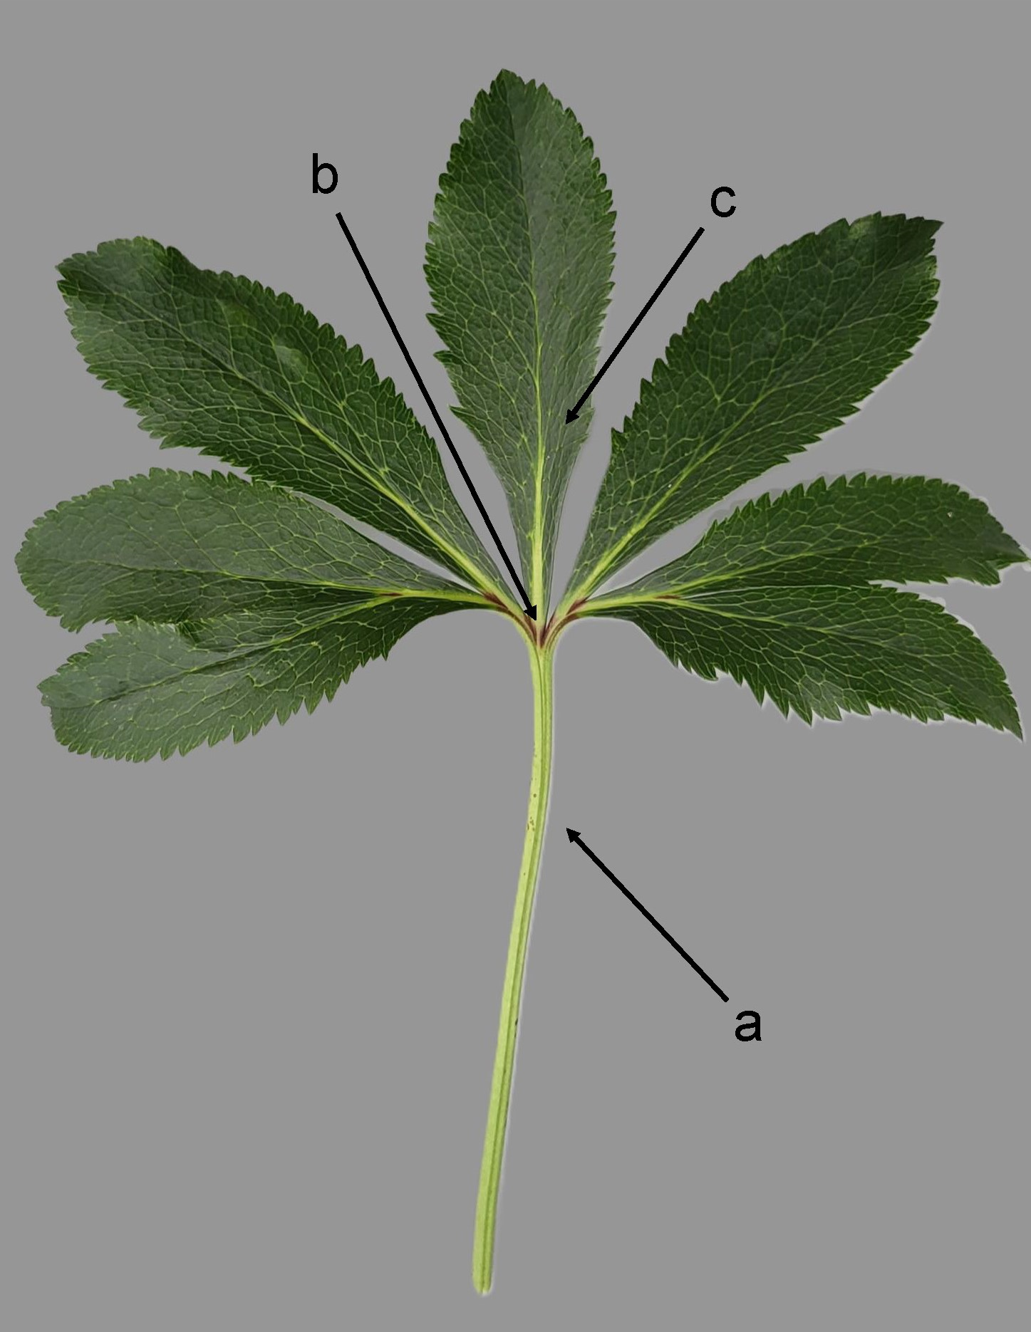

(b) Observations should be made after the flowering period before the leaves are fully grown.

(c) Observations should be made at the end of the flowering period.

(d) Observations should be made just before opening.

(e) Observations should be made on the second flower of a primary inflorescence when approximately 10-30% of the filaments are full grown.  
  
a = first flower  
b = second flower

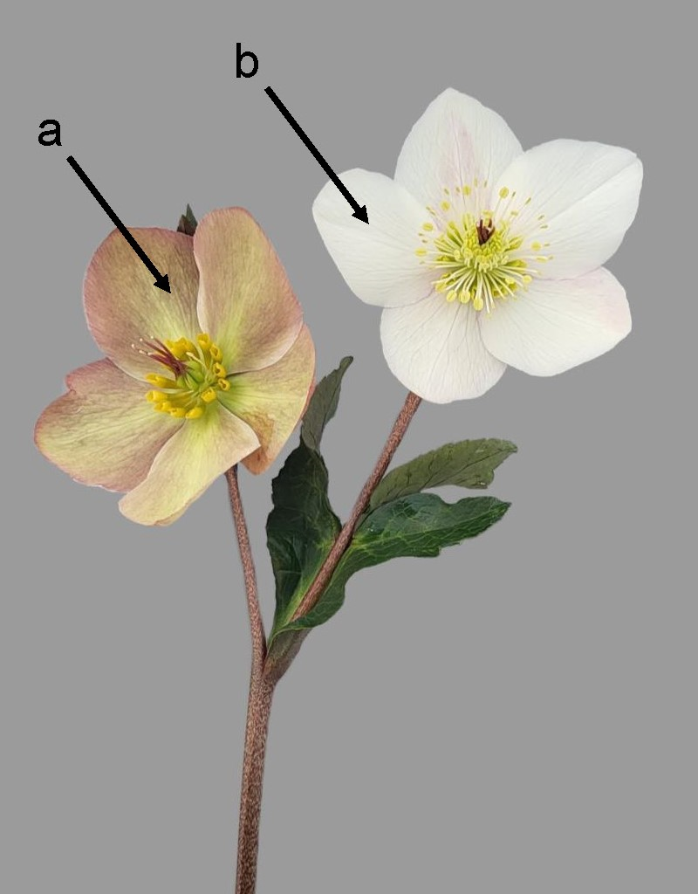

a = outer sepals  
b = intermediate sepal  
c = inner sepals  
d = nectary  
e = filament  
f = style

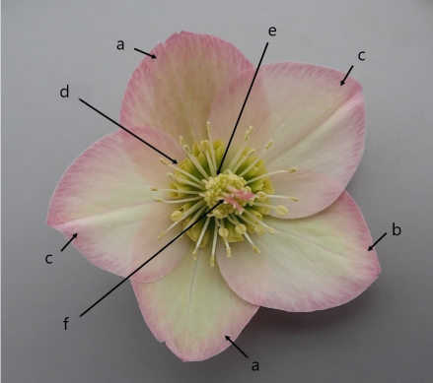

(f) Observations should be made on the inner sepals.

(g) Observations should be made after the flower bud has opened, but before 10% of the filaments are fully grown. It is common for varieties to change from greenish or whitish to yellowish upon maturing.

(h) Ground color is the color which has a continuous dispersion across the surface. The ground color is not always the color occupying the largest surface area. In the case there is a ground color upon which a second color such as a flush develops over time, the flush is considered the over color. The over color is not always the color occupying the smallest surface area.

## 8.2  Explanations for individual characteristics

Ad. 2: Petiole: anthocyanin coloration

Observations should be made on the middle third of the petiole.

Ad. 4: Leaf: width

a = Leaf: width  
b = Terminal leaflet: length  
c = Terminal leaflet: width  
  
  
  
  
Ad. 5: Leaf: number of leaflets

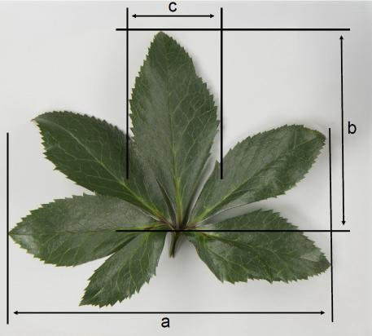

A true leaflet can be identified by a clear visible midrib on the underside of the leaf.

|  |  |  |
| --- | --- | --- |
|  |  |  |
| 1 | 2 | 3 |
| few | medium | many |

Ad. 7: Only varieties with Young terminal leaflet: marbling: present: Young terminal leaflet: pinkish color

|  |  |
| --- | --- |
|  |  |
| 1 | 9 |
| absent | present |

Ad. 8: Terminal leaflet: length

Observations should be made including the petiolule.  
  
See Ad. 4

Ad. 9: Terminal leaflet: width

See Ad. 4

Ad. 11: Terminal leaflet: variegation

Variegation should not be confused with marbling. Variegation is the appearance of differently colored zones which could be speckled or blotched. With marbling the different color is always present along the veines.

|  |  |
| --- | --- |
|  |  |
| 1 | 9 |
| absent | present |

Ad. 12: Terminal leaflet: area of marbling

|  |  |  |  |  |
| --- | --- | --- | --- | --- |
|  |  |  |  |  |
| 1 | 2 | 3 | 4 | 5 |
| absent or very small | small | medium | large | very large |

Ad. 14: Terminal leaflet: density of incisions of margin

|  |  |  |  |  |
| --- | --- | --- | --- | --- |
|  |  |  |  |  |
| 1 | 2 | 3 | 4 | 5 |
| absent or very sparse | sparse | medium | dense | very dense |

Ad. 15: Terminal leaflet: depth of incisions of margin

|  |  |  |  |  |
| --- | --- | --- | --- | --- |
|  |  |  |  |  |
| 1 | 2 | 3 | 4 | 5 |
| absent or very shallow | shallow | medium | deep | very deep |

Ad. 16: Terminal leaflet: undulation of margin

|  |  |  |
| --- | --- | --- |
|  |  |  |
| 1 | 2 | 3 |
| absent or weak | medium | strong |

Ad. 17: **Flowering stem: length**

Observations should be made on the longest flowering stem from the soil level to the end of the flowering stem, excluding the last flower.  
  
a = Flowering stem: length  
b = Flowering stem: diameter  
c = Flowering stem: anthocyanin coloration

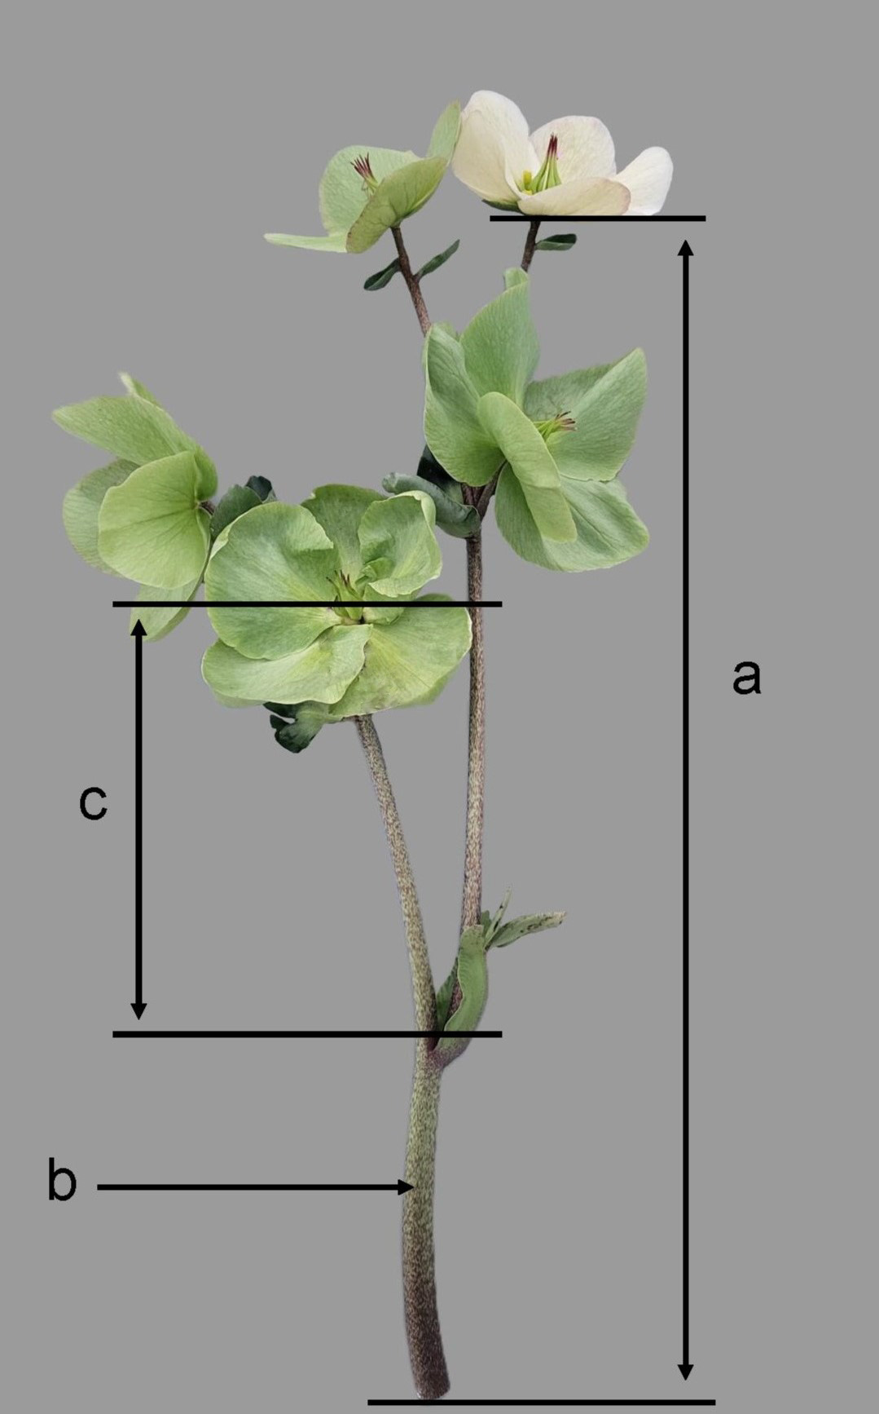

Ad. 18: Flowering stem: diameter

Observations should be made on the longest flowering stem at the part below the point where the stem starts making lateral branches. This should be done at the middle third.

See Ad. 17

Ad. 19: Flowering stem: anthocyanin coloration

Observations should be made on the middle third of the flowering stem.

See Ad. 17

Ad. 20: Inflorescence: attitude

|  |  |  |
| --- | --- | --- |
|  |  |  |
| 1 | 2 | 3 |
| erect | semi-erect | horizontal |

|  |  |
| --- | --- |
|  |  |
| 4 | 5 |
| semi-drooping | drooping |

Ad. 21: Flower bud: conspicuousness of veins

The conspicuousness is defined as the contrast between the color of the flower bud and the color of the veins. A greater contrast in color will give stronger conspicuousness of the veins.

|  |  |  |
| --- | --- | --- |
|  |  |  |
| 1 | 2 | 3 |
| absent or weak | medium | strong |

Ad. 23: Flower bud: over color

Veins should be excluded.

Ad. 24: Flower: attitude

|  |  |  |  |  |
| --- | --- | --- | --- | --- |
|  |  |  |  |  |
| 1 | 2 | 3 | 4 | 5 |
| erect | semi-erect | horizontal | semi-drooping | drooping |

Ad. 25: Flower: type

1. single: flower has only sepals and nectaries are present.  
2. anemone: nectaries are more petal-like, but still have the closed shape of nectaries.  
3. double: nectaries are absent and replaced by petals.

|  |  |  |
| --- | --- | --- |
|  |  |  |
| 1 | 2 | 3 |
| single | anemone | double |

Ad. 26: Only varieties with Flower: type: double: Flower: number of petals

|  |  |  |  |  |
| --- | --- | --- | --- | --- |
|  |  |  |  |  |
| 1 | 2 | 3 | 4 | 5 |
| few | few to medium | medium | medium to many | very many |

Ad. 27: Flower: diameter

Observations should be made on the broadest part of the flower.

Ad. 28: Only varieties with Flower: type: single and anemone: Flower: overlapping of sepals

|  |  |  |
| --- | --- | --- |
|  |  |  |
| 1 | 2 | 3 |
| absent or weak | medium | strong |

Ad. 29: Sepal: length

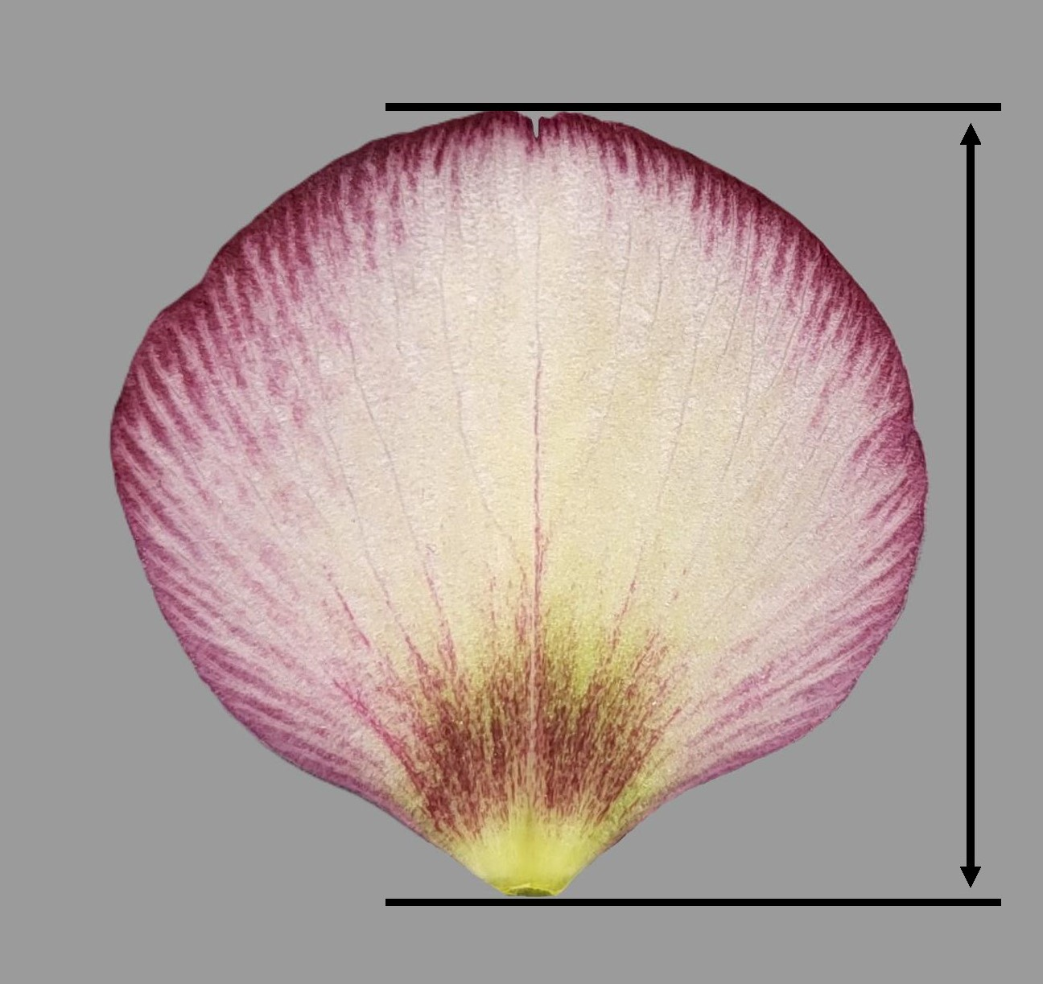

Ad. 30: Sepal: shape

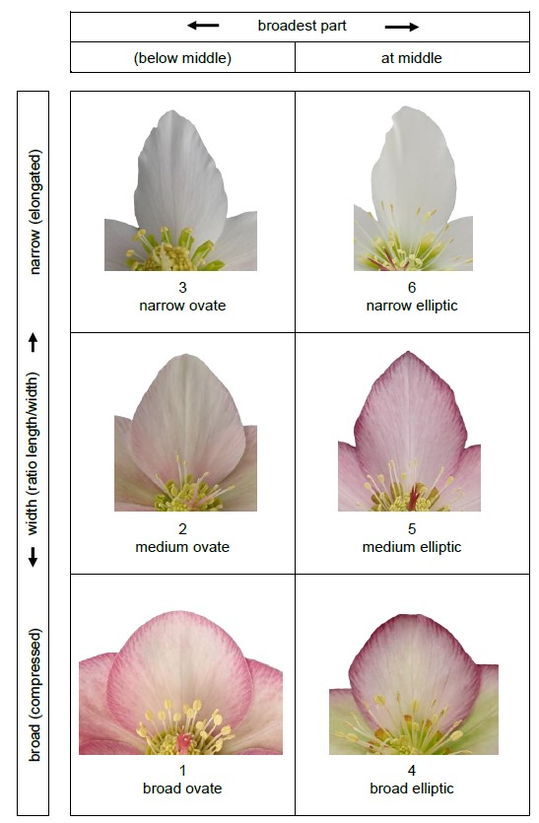

Ad. 31: Sepal: shape of apex

|  |  |  |
| --- | --- | --- |
|  |  |  |
| 1 | 2 | 3 |
| acuminate | obtuse | rounded |

Ad. 36: Sepal: number of spots

|  |  |  |
| --- | --- | --- |
|  |  |  |
| 1 | 2 | 3 |
| absent or very few | few | medium |

|  |  |
| --- | --- |
|  |  |
| 4 | 5 |
| many | very many |

Ad. 38: Sepal: color of macule

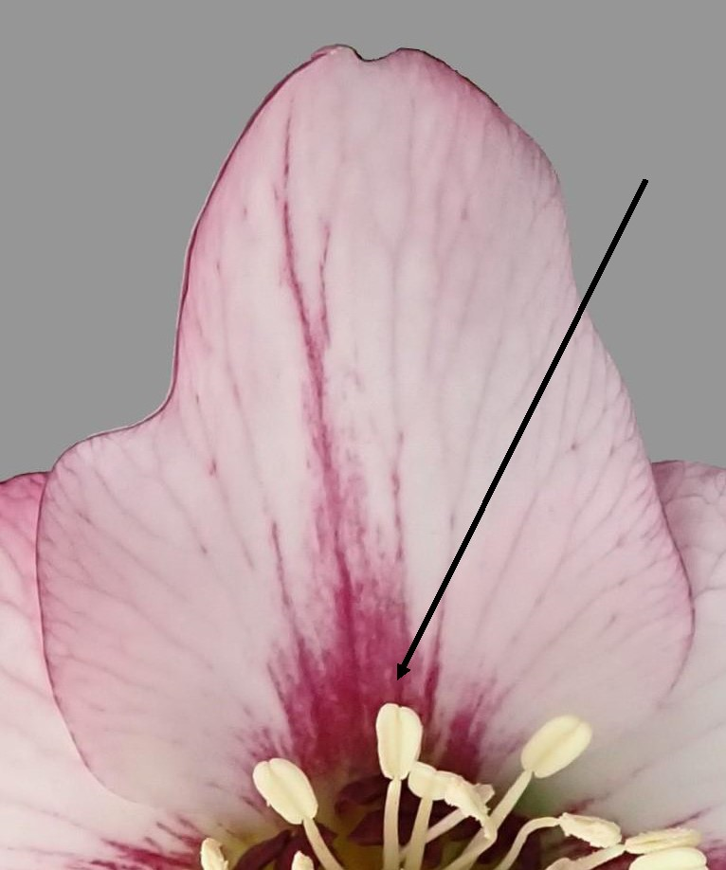

Ad. 39: Sepal: undulation of margin

|  |  |  |
| --- | --- | --- |
|  |  |  |
| 1 | 2 | 3 |
| absent or weak | medium | strong |

Ad. 41: Only varieties with Flower: type: single: Nectary: distribution of anthocyanin coloration

|  |  |  |
| --- | --- | --- |
|  |  |  |
| 1 | 2 | 3 |
| at base | basal three quarters | distal quarter |

Ad. 42: Only varieties with Flower: type: single: Nectary: color of distal quarter

Only to be observed for varieties with 'Nectary: distribution of anthocyanin coloration' at base and at basal three quarters (note 1 and 2).

Ad. 45: Filament: color

Only to be observed for varieties with ‘Filament: anthocyanin coloration’ less than strong (less than note 4 to 5).

Ad. 47: Style: color

Only to be observed for varieties with ‘Style: anthocyanin coloration’ less than strong (less than note 4 to 5).

Ad. 49: Only varieties with Sepal: ground color: white, yellow or green: Flower: pink or red coloration at aging

|  |  |  |
| --- | --- | --- |
|  |  |  |
| 1 | 2 | 3 |
| absent or weak | medium | strong |

# Literature

Bavcon, J., Eler, K., Susek, A., 2012: Helleborus (Helleborus L.) in Slovenia. University Botanic Gardens Ljubljana, SI  
Clarke, I., Lee, H., 2019: Name that Flower: The Identification of Flowering Plants. Melbourne University Press, AU  
Eggelte, H. 2012: Botanisch woordenboek. Knnv Uitgeverij, NL  
Hickey, M., King, C., 2000: The Cambridge Illustrated Glossary of Botanical Terms. Cambridge University Press, UK  
Leijger, E. 2017: Alles over het plantengeslacht Helleborus. Micha, NL  
McLewin, W., 2019: Helleborus and the Helleborastrum Problem. Wellesley-Cambridge Press, UK  
Thomsen, M., 2022: Lenzrosen, Die Wildarten – Schönheiten für jeden Garten. Haupt Verlag, DE

# Technical Questionnaire

|  |  |  |  |
| --- | --- | --- | --- |
| TECHNICAL QUESTIONNAIRE | Page {x} of {y} | Reference Number: | |
|  |  |  | |
|  |  | Application date:  (not to be filled in by the applicant) | |
| TECHNICAL QUESTIONNAIRE  to be completed in connection with an application for plant breeders' rights | | | |
| 1. Subject of the Technical Questionnaire | | | |
| 1.1.1 Botanical name | *Helleborus* L. | |  |
|  |  | |  |
| 1.1.2 Common name | Christmas Rose, Hellebore, Lenten Rose | |  |
|  |  | |  |
| 1.1.3 Species: |  | |  |
| 2. Applicant | | | |
| Name |  | |  |
|  |  | |  |
| Address |  | |  |
|  |  | |  |
| Telephone No. |  | |  |
|  |  | |  |
| Fax No. |  | |  |
|  |  | |  |
| E-mail address |  | |  |
|  |  | |  |
| Breeder (if different from  applicant) |  | |  |
|  |  | |  |

|  |  |  |  |
| --- | --- | --- | --- |
| TECHNICAL QUESTIONNAIRE | Page {x} of {y} | Reference Number: | |
|  | | | |
| 3. Proposed denomination and breeder's reference | | | |
| Proposed denomination  (if available) |  | |  |
|  |  | |  |
| Breeder's reference |  | |  |

|  |  |  |
| --- | --- | --- |
| TECHNICAL QUESTIONNAIRE | Page {x} of {y} | Reference Number: |

|  |
| --- |
| #4. Information on the breeding scheme and propagation of the variety  4.1 Breeding scheme  Variety resulting from:  4.1.1 Crossing  (a) controlled cross [ ]  (please state parent variety)  (…………………..……………..…) x (……………..…………………..…)  female parent male parent  (b) partially known cross [ ]  (please state parent variety(ies))  (…………………..……………..…) x (……………..…………………..…)  female parent male parent  (c) unknown cross [ ] |
| 4.1.2 Mutation  (please state parent variety) |
| 4.1.3 Discovery and development  (please state where and when discovered and how developed) |
| 4.1.4 Other  (Please provide details) |

|  |  |  |
| --- | --- | --- |
| TECHNICAL QUESTIONNAIRE | Page {x} of {y} | Reference Number: |

|  |
| --- |
| 4.2 Method of propagating the variety  4.2.1 Seed-propagated varieties  (a) Other (please provide details) [ ]  4.2.2 Vegetative propagation  (a) Other (state method) [ ]    4.2.3 Other  (Please provide details) [ ] |
|  |

|  |  |  |  |  |  |
| --- | --- | --- | --- | --- | --- |
| TECHNICAL QUESTIONNAIRE | | Page {x} of {y} | | Reference Number: | |
|  | | | | | |
| 5. Characteristics of the variety to be indicated (the number in brackets refers to the corresponding characteristic in Test Guidelines; please mark the note which best corresponds). | | | | | |
|  | Characteristics | | Example Varieties | | Note |
| **5.1**  **(7)** | **Only varieties with Young terminal leaflet: marbling: present: Young terminal leaflet: pinkish color** | |  | |  |
|  | absent | | EPBRD01 | | 1 [ ] |
|  | present | | EPB 30 | | 9 [ ] |
| **5.2**  **(10)** | **Terminal leaflet: main color** | |  | |  |
|  | light green | | HLR 150 | | 1 [ ] |
|  | medium green | | COSEH 6000 | | 2 [ ] |
|  | dark green | | JHE00325 | | 3 [ ] |
|  | grey green | | Diego Ice | | 4 [ ] |
| **5.3**  **(11)** | **Terminal leaflet: variegation** | |  | |  |
|  | absent | | COSEH 750 | | 1 [ ] |
|  | present | | COSEH 900 | | 9 [ ] |
| **5.4**  **(12)** | **Terminal leaflet: area of marbling** | |  | |  |
|  | absent or very small | | COSEH 4200 | | 1 [ ] |
|  | small | | EPB 31 | | 2 [ ] |
|  | medium | | EPBRD01 | | 3 [ ] |
|  | large | | ABCRD02 | | 4 [ ] |
|  | very large | | EPB 29 | | 5 [ ] |
| **5.5**  **(17)** | **Flowering stem: length** | |  | |  |
|  | very short | | COSEH 1030 | | 1 [ ] |
|  | short | | White Princess | | 2 [ ] |
|  | medium | | HL 1044 | | 3 [ ] |
|  | long | | HM 1212 | | 4 [ ] |
|  | very long | | HG 1410 | | 5 [ ] |
| **5.6**  **(25)** | **Flower: type** | |  | |  |
|  | single | | HLR 150 | | 1 [ ] |
|  | anemone | | Tutu | | 2 [ ] |
|  | double | | HLR 210 | | 3 [ ] |
|  |  | |  | |  |

|  |  |  |  |  |  |
| --- | --- | --- | --- | --- | --- |
| TECHNICAL QUESTIONNAIRE | | Page {x} of {y} | | Reference Number: | |
|  | |  | |  | |
|  | Characteristics | | Example Varieties | | Note |
| **5.7**  **(27)** | **Flower: diameter** | |  | |  |
|  | very small | | JHE00300 | | 1 [ ] |
|  | small | | HG 1414 | | 2 [ ] |
|  | medium | | COSEH 750 | | 3 [ ] |
|  | large | | HM 1212 | | 4 [ ] |
|  | very large | | HG 1418 | | 5 [ ] |
| **5.8 (i)**  **(32)** | **Sepal: ground color** | |  | |  |
|  | RHS Colour Chart (indicate reference number) | |  | |  |
| **5.8 (ii)**  **(32)** | **Sepal: ground color** | |  | |  |
|  | white | |  | | 1 [ ] |
|  | green | |  | | 2 [ ] |
|  | yellow | |  | | 3 [ ] |
|  | pink | |  | | 4 [ ] |
|  | purple red | |  | | 5 [ ] |
|  | violet | |  | | 6 [ ] |
| **5.9 (i)**  **(33)** | **Sepal: over color** | |  | |  |
|  | RHS Colour Chart (indicate reference number) | |  | |  |
| **5.9 (ii)**  **(33)** | **Sepal: over color** | |  | |  |
|  | white | |  | | 1 [ ] |
|  | green | |  | | 2 [ ] |
|  | yellow | |  | | 3 [ ] |
|  | pink | |  | | 4 [ ] |
|  | purple red | |  | | 5 [ ] |
|  | violet | |  | | 6 [ ] |
| **5.10**  **(36)** | **Sepal: number of spots** | |  | |  |
|  | absent or very few | | Winter Passion | | 1 [ ] |
|  | few | | HG 1412 | | 2 [ ] |
|  | medium | | HLR 150 | | 3 [ ] |
|  | many | | Frozen Kristof | | 4 [ ] |
|  | very many | | JHE00209 | | 5 [ ] |
|  |  | |  | |  |

|  |  |  |  |  |  |
| --- | --- | --- | --- | --- | --- |
| TECHNICAL QUESTIONNAIRE | | Page {x} of {y} | | Reference Number: | |
|  | | | | | | |
| 6. Similar varieties and differences from these varieties  *Please use the following table and box for comments to provide information on how your candidate variety differs from the variety (or varieties) which, to the best of your knowledge, is (or are) most similar. This information may help the examination authority to conduct its examination of distinctness in a more efficient way.* | | | | | | |
| Denomination(s) of variety(ies) similar to your candidate variety | Characteristic(s) in which your candidate variety differs from the similar variety(ies) | | Describe the expression of the characteristic(s) for the **similar** variety(ies) | | Describe the expression of the characteristic(s) for **your** candidate variety |
| *Example* | *Flowering stem: length* | | *very short* | | *medium* |
|  | | | | | | |
|  | | | | | | |
|  | | | | | | |
| Comments | | | | | | |

|  |  |  |
| --- | --- | --- |
| TECHNICAL QUESTIONNAIRE | Page {x} of {y} | Reference Number: |
|  | | | |
| #7. Additional information which may help in the examination of the variety  7.1 In addition to the information provided in sections 5 and 6, are there any additional characteristics which may help to distinguish the variety?  Yes [ ] No [ ]  (If yes, please provide details)  7.2 Are there any special conditions for growing the variety or conducting the examination?  Yes [ ] No [ ]  (If yes, please provide details)  7.3 Other information  A representative color photograph of the variety displaying its main distinguishing feature(s), should accompany the Technical Questionnaire. The photograph will provide a visual illustration of the candidate variety which supplements the information provided in the Technical Questionnaire.  The key points to consider when taking a photograph of the candidate variety are:  • Indication of the date and geographic location  • Correct labeling (breeder’s reference)  • Good quality printed photograph (minimum 10 cm x 15 cm) and/or sufficient resolution electronic format version (minimum 960 x 1280 pixels)”  Further guidance on providing photographs with the Technical Questionnaire is available in document TGP/7 "Development of Test Guidelines", Guidance Note 35 (http://www.upov.int/tgp/en/).  [The link provided may be deleted by members of the Union when developing authorities’ own test guidelines.] | | | |

|  |  |  |  |
| --- | --- | --- | --- |
| TECHNICAL QUESTIONNAIRE | Page {x} of {y} | Reference Number: | |
|  | | | |
| 8. Authorization for release Does the variety require prior authorization for release under legislation concerning the protection of the environment, human and animal health? Yes [ ] No [ ]  (b) Has such authorization been obtained?  Yes [ ] No [ ]  If the answer to (b) is yes, please attach a copy of the authorization. | | | |
| 9. Information on plant material to be examined or submitted for examination  9.1 The expression of a characteristic or several characteristics of a variety may be affected by factors, such as pests and disease, chemical treatment (e.g. growth retardants or pesticides), effects of tissue culture, different rootstocks, scions taken from different growth phases of a tree, etc.  9.2 The plant material should not have undergone any treatment which would affect the expression of the characteristics of the variety, unless the competent authorities allow or request such treatment. If the plant material has undergone such treatment, full details of the treatment must be given. In this respect, please indicate below, to the best of your knowledge, if the plant material to be examined has been subjected to:  (a) Microorganisms (e.g. virus, bacteria, phytoplasma) Yes [ ] No [ ]  (b) Chemical treatment (e.g. growth retardant, pesticide) Yes [ ] No [ ]  I Tissue culture Yes [ ] No [ ]  (d) Other factors Yes [ ] No [ ]  Please provide details for where you have indicated “yes”.  ____________________________________________________________  9.3 Has the plant material to be examined been tested for the presence of virus or other pathogens?  Yes [ ]  (please provide details as specified by the Authority)  No [ ] | | | |
| I hereby declare that, to the best of my knowledge, the information provided in this form is correct: | | | |
| Applicant’s name |  | | |
| Signature |  | Date |  |
|  | [End of document] | | |