 |  | E
TG/NELUM(proj.2)
ORIGINAL: English
DATE: 2024-03-16

INTERNATIONAL UNION FOR THE PROTECTION OF NEW VARIETIES OF PLANTS
 | Geneva
 | DRAFT
 | LOTUS  UPOV Code(s): NELUM  Nelumbo Adans. | *
GUIDELINES
FOR THE CONDUCT OF TESTS
FOR DISTINCTNESS, UNIFORMITY AND STABILITY

prepared by experts from China
to be considered by the
Technical Working Party for Ornamental Plants and Forest Trees

at its fifty-sixth session, to be held virtually
from 2024-04-29 to 2024-05-02

Disclaimer: this document does not represent UPOV policies or guidance
Alternative names:*

Botanical name | English | French | German | Spanish
Nelumbo Adans. | Lotus |  | Lotus

The purpose of these guidelines (“Test Guidelines”) is to elaborate the principles contained in the General Introduction (document TG/1/3), and its associated TGP documents, into detailed practical guidance for the harmonized examination of distinctness, uniformity and stability (DUS) and, in particular, to identify appropriate characteristics for the examination of DUS and production of harmonized variety descriptions.
ASSOCIATED DOCUMENTS
These Test Guidelines should be read in conjunction with the General Introduction and its associated TGP documents.

TABLE OF CONTENTS | PAGE
1. | SUBJECT OF THESE TEST GUIDELINES.......................................................................................................... | 3
2. | MATERIAL REQUIRED..................................................................................................................... | 3
3. | METHOD OF EXAMINATION............................................................................................................... | 3
3.1 | Number of Growing Cycles................................................................................................................. | 3
3.2 | Testing Place................................................................................................................... | 3
3.3 | Conditions for Conducting the Examination............................................................................................... | 3
3.4 | Test Design................................................................................................................. | 5
3.5 | Additional Tests................................................................................................................... | 5

4. | ASSESSMENT OF DISTINCTNESS, UNIFORMITY AND STABILITY................................................................. | 5
4.1 | Distinctness.......................................................................................................... | 5
4.2 | Uniformity............................................................................................................ | 6
4.3 | Stability............................................................................................................... | 7

5. | GROUPING OF VARIETIES AND ORGANIZATION OF THE GROWING TRIAL................................................ | 8
6. | INTRODUCTION TO THE TABLE OF CHARACTERISTICS................................................................................ | 8
6.1 | Categories of Characteristics...................................................................................................... | 8
6.2 | States of Expression and Corresponding Notes........................................................................................ | 9
6.3 | Types of Expression............................................................................................................ | 9
6.4 | Example Varieties.............................................................................................................. | 9
6.5 | Legend................................................................................................................. | 10

7. | TABLE OF CHARACTERISTICS/TABLEAU DES CARACTÈRES/MERKMALSTABELLE/TABLA DE CARACTERES.................................................................................................................. | 11
8. | EXPLANATIONS ON THE TABLE OF CHARACTERISTICS............................................................................... | 34
8.1 | Explanations covering several characteristics........................................................................................... | 34
8.2 | Explanations for individual characteristics................................................................................................. | 35

9. | LITERATURE................................................................................................................... | 53
10 | TECHNICAL QUESTIONNAIRE............................................................................................................ | 54

1. | Subject of these Test Guidelines
 | These Test Guidelines apply to all varieties of Nelumbo Adans.

2. | Material Required
2.1 | The competent authorities decide on the quantity and quality of the plant material required for testing the variety and when and where it is to be delivered. Applicants submitting material from a State other than that in which the testing takes place must ensure that all customs formalities and phytosanitary requirements are complied with.
2.2 | The material is to be supplied in the form of rhizome propagules or seed.
2.3 | The minimum quantity of plant material, to be supplied by the applicant, should be:
12 rhizome propagules to meet at least 10 survivals after planting.
15 seeds to meet at least 10 survivals after germination and planting.

 | In the case of seed, the seed should meet the minimum requirements for germination, species and analytical purity, health and moisture content, specified by the competent authority. In cases where the seed is to be stored, the germination capacity should be as high as possible and should, be stated by the applicant.
In the case of rhizome propagule, a standard propagule (meeting market requirement) should be fresh and healthy, and each should have two internodes with healthy shoot

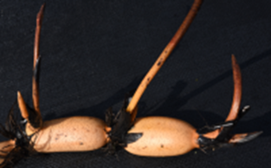
A standard propagule with two expanded internodes

In the case of seed, the applicant should guarantee the seeds to meet the requirement for purity, maturity and high germination capacity.

2.4 | The plant material supplied should be visibly healthy, not lacking in vigor, nor affected by any important pest or disease.
2.5 | The plant material should not have undergone any treatment which would affect the expression of the characteristics of the variety, unless the competent authorities allow or request such treatment. If it has been treated, full details of the treatment must be given.

3. | Method of Examination
3.1 | Number of Growing Cycles
3.1.1 | The minimum duration of tests should normally be a single growing cycle.
3.1.2 | The testing of a variety may be concluded when the competent authority can determine with certainty the outcome of the test.
3.2 | Testing Place
 | Tests are normally conducted at one place. In the case of tests conducted at more than one place, guidance is provided in TGP/9 “Examining Distinctness”.

3.3 | Conditions for Conducting the Examination
3.3.1 | The tests should be carried out under conditions ensuring satisfactory growth for the expression of the relevant characteristics of the variety and for the conduct of the examination.
3.3.2 | The optimum stage of development for the assessment of each characteristic is indicated by a number in the Table of Characteristics. The stages of development denoted by each number are described in Chapter 8.
3.3.3 | Because daylight varies, color determinations made against a color chart should be made either in a suitable cabinet providing artificial daylight or in the middle of the day in a room without direct sunlight. The spectral distribution of the illuminant for artificial daylight should conform with the CIE Standard of Preferred Daylight D 6500 and should fall within the tolerances set out in the British Standard 950, Part I. These determinations should be made with the plant part placed against a white background. The color chart and version used should be specified in the variety description.
3.3.4 | Based on its main use, the lotus is usually divided into three types, namely rhizome lotus (producing underground expanded rhizome for vegetable), seed lotus (producing seeds for food or medicine), and ornamental lotus (also called flower lotus for ornamental plant).  Except the characteristics shared by these three types of lotus, there are some specified characteristics for each type of them. The seed lotus can also be treated as ornamental plant because it produce numerous flowers which are usually used in wetland landscape.
3.4 | Test Design
3.4.1 | In the case of rhizome propagated varieties, each test should be designed to result in a total of at least 10 plants.
3.4.2 | In the case of seed propagated varieties, each test should be designed to result in a total of at least 10 plants.

3.4.3 | The design of the tests should be such that plants or parts of plants may be removed for measurement or counting without prejudice to the observations which must be made up to the end of the growing cycle.
3.4.4 | During growth season, some of the flowers and mature fruits will he collected for counting or measurement, but it has no influence on plant development and growth. At the end of growth cycle, the underground rhizomes will be harvested for observation of shoot shape, measurement of expanded rhizome diameter and counting of propagule number during dormancy or before planting.
3.5 | Additional Tests
 | Additional tests, for examining relevant characteristics, may be established.

4. | Assessment of Distinctness, Uniformity and Stability
4.1 | Distinctness
4.1.1 | General Recommendations
 | It is of particular importance for users of these Test Guidelines to consult the General Introduction prior to making decisions regarding distinctness. However, the following points are provided for elaboration or emphasis in these Test Guidelines.
To assess distinctness of hybrids, the parent lines and the formula may be used according to the following recommendations:
(i) description of parent lines according to the Test Guidelines;
(ii) check of the originality of the parent lines in comparison with the variety collection, based on the characteristics in Chapter 7, in order to identify similar parent lines;
(iii) check of the originality of the hybrid formula in relation to the hybrids in the variety collection, taking into account the most similar lines; and
(iv) assessment of the distinctness at the hybrid level for varieties with a similar formula.
Further guidance is provided in documents TGP/9 "Examining Distinctness" and TGP/8 "Trial Design and Techniques Used in the Examination of Distinctness, Uniformity and Stability".

4.1.2 | Consistent Differences
 | The differences observed between varieties may be so clear that more than one growing cycle is not necessary. In addition, in some circumstances, the influence of the environment is not such that more than a single growing cycle is required to provide assurance that the differences observed between varieties are sufficiently consistent. One means of ensuring that a difference in a characteristic, observed in a growing trial, is sufficiently consistent is to examine the characteristic in at least two independent growing cycles.
4.1.3 | Clear Differences
 | Determining whether a difference between two varieties is clear depends on many factors, and should consider, in particular, the type of expression of the characteristic being examined, i.e. whether it is expressed in a qualitative, quantitative, or pseudo-qualitative manner. Therefore, it is important that users of these Test Guidelines are familiar with the recommendations contained in the General Introduction prior to making decisions regarding distinctness.
4.1.4 | Number of Plants or Parts of Plants to be Examined
In the case of vegetatively propagated varieties, unless otherwise indicated, for the purposes of distinctness, all observations on single plants should be made on 10 plants or parts taken from each of 10 plants and any other observation made on all plants in the test, disregarding any off-type plants.

In the case of observations of parts taken from single plants, the number of parts to be taken from each of the plants should be 1.

In the case of seed-propagated varieties, unless otherwise indicated, for the purposes of distinctness, all observations on single plants should be made on 10 plants or parts taken from each of 10 plants and any other observation made on all plants in the test, disregarding any off-type plants.

In the case of observations of parts taken from single plants, the number of parts to be taken from each of the plants should be 1.

4.1.5 | Method of Observation
 | The recommended method of observing the characteristic for the purposes of distinctness is indicated by the following key in the Table of Characteristics (see document TGP/9 “Examining Distinctness”, Section 4 “Observation of characteristics”):
MG: single measurement of a group of plants or parts of plants
MS: measurement of a number of individual plants or parts of plants
VG: visual assessment by a single observation of a group of plants or parts of plants
VS: visual assessment by observation of individual plants or parts of plants

 | Type of observation: visual (V) or measurement (M)
 | “Visual” observation (V) is an observation made on the basis of the expert’s judgment. For the purposes of this document, “visual” observation refers to the sensory observations of the experts and, therefore, also includes smell, taste and touch. Visual observation includes observations where the expert uses reference points (e.g. diagrams, example varieties, side-by-side comparison) or non-linear charts (e.g. color charts). Measurement (M) is an objective observation against a calibrated, linear scale e.g. using a ruler, weighing scales, colorimeter, dates, counts, etc.
 | Type of record: for a group of plants (G) or for single, individual plants (S)
 | For the purposes of distinctness, observations may be recorded as a single record for a group of plants or parts of plants (G), or may be recorded as records for a number of single, individual plants or parts of plants (S). In most cases, “G” provides a single record per variety and it is not possible or necessary to apply statistical methods in a plant-by-plant analysis for the assessment of distinctness.
 | In cases where more than one method of observing the characteristic is indicated in the Table of Characteristics (e.g. VG/MG), guidance on selecting an appropriate method is provided in document TGP/9, Section 4.2.
4.2 | Uniformity
4.2.1 | It is of particular importance for users of these Test Guidelines to consult the General Introduction prior to making decisions regarding uniformity. However, the following points are provided for elaboration or emphasis in these Test Guidelines:
4.2.2 | These Test Guidelines have been developed for the examination of vegetatively propagated varieties. For varieties with other types of propagation, the recommendations in the General Introduction and document TGP/13 "Guidance for new types and species" Section 4.5 "Testing Uniformity" should be followed.
4.2.3 | The assessment of uniformity for seed-propagated varieties should be according to the recommendations for cross-pollinated varieties in the General Introduction.
4.2.4 | The assessment of uniformity for hybrid varieties depends on the type of hybrid and should be according to the recommendations for hybrid varieties in the General Introduction.
4.2.5 | For the assessment of uniformity of seed-propagated varieties, a population standard of 5% and an acceptance probability of at least 95% should be applied. In the case of a sample size of 10 plants, 1 off-type is allowed.
4.3 | Stability
4.3.1 | In practice, it is not usual to perform tests of stability that produce results as certain as those of the testing of distinctness and uniformity. However, experience has demonstrated that, for many types of variety, when a variety has been shown to be uniform, it can also be considered to be stable.
4.3.2 | Where appropriate, or in cases of doubt, stability may be further examined by testing a new seed or plant stock to ensure that it exhibits the same characteristics as those shown by the initial material supplied.

5. | Grouping of Varieties and Organization of the Growing Trial
5.1 | The selection of varieties of common knowledge to be grown in the trial with the candidate varieties and the way in which these varieties are divided into groups to facilitate the assessment of distinctness are aided by the use of grouping characteristics.
5.2 | Grouping characteristics are those in which the documented states of expression, even where produced at different locations, can be used, either individually or in combination with other such characteristics: (a) to select varieties of common knowledge that can be excluded from the growing trial used for examination of distinctness; and (b) to organize the growing trial so that similar varieties are grouped together.
5.3 | The following have been agreed as useful grouping characteristics:
(a) |  | Plant: height (characteristic 1)
(b) |  | Emerging leaf: texture of adaxial surface (characteristic 8)  Leaf: texture of blade
(c) |  | Flower: position relative to leaf (characteristic 19)  Flower: position in relation to leaf
(d) |  | Flower: type (characteristic 22)
(e) |  | Flower: shape (characteristic 23)
(f) |  | Flower: color group (characteristic 24)
(g) |  | Carpel: status of development (characteristic 41)
(h) |  | Expanded rhizome: thickness (characteristic 60)
(i) |  | Main expanded rhizome: shape of internode (characteristic 62)

5.4 | Guidance for the use of grouping characteristics, in the process of examining distinctness, is provided through the General Introduction and document TGP/9 “Examining Distinctness”.

6. | Introduction to the Table of Characteristics
6.1 | Categories of Characteristics
6.1.1 | Standard Test Guidelines Characteristics
 | Standard Test Guidelines characteristics are those which are approved by UPOV for examination of DUS and from which members of the Union can select those suitable for their particular circumstances.
6.1.2 | Asterisked Characteristics
 | Asterisked characteristics (denoted by *) are those included in the Test Guidelines which are important for the international harmonization of variety descriptions and should always be examined for DUS and included in the variety description by all members of the Union, except when the state of expression of a preceding characteristic or regional environmental conditions render this inappropriate.
6.2 | States of Expression and Corresponding Notes
6.2.1 | States of expression are given for each characteristic to define the characteristic and to harmonize descriptions. Each state of expression is allocated a corresponding numerical note for ease of recording of data and for the production and exchange of the description.
6.2.2 | All relevant states of expression are presented in the characteristic.
6.2.3 | Further explanation of the presentation of states of expression and notes is provided in document TGP/7 “Development of Test Guidelines”.
6.3 | Types of Expression
 | An explanation of the types of expression of characteristics (qualitative, quantitative and pseudo-qualitative) is provided in the General Introduction.
6.4 | Example Varieties
 | Where appropriate, example varieties are provided to clarify the states of expression of each characteristic.

6.5 | Legend
 |  | English |  | français |  | deutsch | español | Example Varieties/  Exemples/  Beispielssorten/  Variedades ejemplo | Note/  Nota
1 | 2 | 3 | 4 | 5 | 6 | 7
 |  | Name of characteristics in English |  | Nom du caractère en français |  | Name des Merkmals auf Deutsch | Nombre del carácter en español
 |  | states of expression |  | types d’expression |  | Ausprägungsstufen | tipos de expresión

1 | Characteristic number
2 | (*) | Asterisked characteristic | – see Chapter 6.1.2
3 | Type of expression
 | QL | Qualitative characteristic | – see Chapter 6.3
 | QN | Quantitative characteristic | – see Chapter 6.3
 | PQ | Pseudo-qualitative characteristic | – see Chapter 6.3
4 | Method of observation (and type of plot, if applicable)
 | MG, MS, VG, VS |  | – see Chapter 4.1.5
5 | (+) | See Explanations on the Table of Characteristics in Chapter 8.2
6 | (a)-(b) | See Explanations on the Table of Characteristics in Chapter 8.1
7 | Growth stage key See Explanations on the Table of Characteristics in Chapter 8.3

7. | Table of Characteristics/Tableau des caractères/Merkmalstabelle/Tabla de caracteres

 |  | English |  | français |  | deutsch | español | Example Varieties/  Exemples/  Beispielssorten/  Variedades ejemplo | Note/  Nota
1. | (*) | QN | MS|A/VG | (+) |  | 30
 |  | Plant: height
 |  | very short |  |  |  |  |  | Nelumbo `Chuzi Luo` | 1
 |  | very short to short |  |  |  |  |  |  | 2
 |  | short |  |  |  |  |  | Nelumbo `Xing Huo` | 3
 |  | short to medium |  |  |  |  |  |  | 4
 |  | medium |  |  |  |  |  | Nelumbo `Yijian Lian` | 5
 |  | medium to tall |  |  |  |  |  |  | 6
 |  | tall |  |  |  |  |  | Nelumbo lutea `Yellow Bird` | 7
 |  | tall to very tall |  |  |  |  |  |  | 8
 |  | very tall |  |  |  |  |  | Nelumbo nucifera `Fen Bawang` | 9
2. |  | QN | MG/VG | (+) |  | 30
 |  | Emerging leaf: number
 |  | absent |  |  |  |  |  | Nelumbo `Ai Xiangsi Hong` | 1
 |  | very few |  |  |  |  |  | Nelumbo `Jin Fuwa` | 2
 |  | few |  |  |  |  |  | Nelumbo nucifera `Zhongshan Hongtai` | 3
 |  | medium |  |  |  |  |  | Nelumbo nucifera `Honghu Hong` | 4
 |  | many |  |  |  |  |  | Nelumbo nucifera `Qian Ban` | 5
 |  | very many |  |  |  |  |  | Nelumbo `Hong Sijuan` | 6
3. | (*) | QN | MS/VG |  |  | 30
 |  | Emerging leaf: size of blade
 |  | very small |  |  |  |  |  | Nelumbo `Chuzi Luo` | 1
 |  | very small to small |  |  |  |  |  |  | 2
 |  | small |  |  |  |  |  | Nelumbo `Yanzhi Wan` | 3
 |  | small to medium |  |  |  |  |  |  | 4
 |  | medium |  |  |  |  |  | Nelumbo `Jiuhua Haoyue` | 5
 |  | medium to large |  |  |  |  |  |  | 6
 |  | large |  |  |  |  |  | Nelumbo nucifera `Qian Ban` | 7
 |  | large to very large |  |  |  |  |  |  | 8
 |  | very large |  |  |  |  |  | Nelumbo nucifera `Fen Bawang` | 9
4. | (*) | QL | VG | (+) |  | 20-30
 |  | Leaf: variegation of blade
 |  | absent |  |  |  |  |  | Nelumbo `Cai Xia` | 1
 |  | present |  |  |  |  |  | Nelumbo 'Furong Sajin' | 9
5. | (*) | PQ | VG | (+) |  | 20-30
 |  | Emerging leaf: main color of blade
 |  | light or medium green |  |  |  |  |  |  | 1
 |  | dark green |  |  |  |  |  | Nelumbo lutea `Yellow Bird` | 2
 |  | yellow green |  |  |  |  |  | Nelumbo nucifera `Baiyangdian Bai` | 3
6. | (*) | PQ | VG | (+) |  | 20-30
 |  | Emerging leaf: shape of blade
 |  | rounded or nearly rounded |  |  |  |  |  | Nelumbo lutea `Yellow Bird` | 1
 |  | elliptic |  |  |  |  |  |  | 2
 |  | narrow elliptic |  |  |  |  |  |  | 3
7. | (*) | PQ | VG | (+) |  | 20-30
 |  | Emerging leaf: attitude of blade
 |  | strongly concave |  |  |  |  |  |  | 1
 |  | moderately concave |  |  |  |  |  | Nelumbo nucifera `Dan Sajin` | 2
 |  | weakly concave |  |  |  |  |  |  | 3
 |  | flat |  |  |  |  |  | Nelumbo `Jia Jingying` | 4
 |  | concave center with dropping edge |  |  |  |  |  | Nelumbo nucifera `Elian 1` | 5
8. | (*) | QN | VG | (+) |  | 20-30
 |  | Emerging leaf: texture of adaxial surface
 |  | very rough |  |  |  |  |  | Nelumbo nucifera `Daye Chi` | 1
 |  | rough |  |  |  |  |  | Nelumbo nucifera `Honghu Hong` | 2
 |  | medium |  |  |  |  |  |  | 3
 |  | smooth |  |  |  |  |  | Nelumbo nucifera `Fenhong Lingxiao` | 4
 |  | very smooth |  |  |  |  |  | Nelumbo lutea `Yellow Bird` | 5
9. |  | PQ | VG | (+) |  | 20-30
 |  | Emerging leaf: upper margin of blade
 |  | rounded |  |  |  |  |  |  | 1
 |  | weakly concave |  |  |  |  |  | Nelumbo `Honghe Zhanchi` | 2
 |  | moderately concave |  |  |  |  |  | Nelumbo `Danban Jinxia` | 3
 |  | strongly concave |  |  |  |  |  |  | 4
10 | (*) | QL | VG | (+) |  | 20-30
 |  | Emerging leaf: red line of margin
 |  | absent |  |  |  |  |  |  | 1
 |  | present |  |  |  |  |  |  | 9
11 |  | QN | MG/VG | (+) |  | 20-40
 |  | Leaf nose: gap
 |  | absent or very narrow |  |  |  |  |  | Nelumbo `Jia Jingying` | 1
 |  | narrow |  |  |  |  |  | Nelumbo nucifera `Honghu Hong` | 2
 |  | medium |  |  |  |  |  | Nelumbo `Yijian Lian` | 3
 |  | broad |  |  |  |  |  |  | 4
12 |  | QN | MG | (+) |  | 30
 |  | Petiole: thickness
 |  | very thin |  |  |  |  |  | Nelumbo `Chuzi Luo` | 1
 |  | thin |  |  |  |  |  | Nelumbo `Hong Sijuan` | 2
 |  | medium |  |  |  |  |  |  | 3
 |  | thick |  |  |  |  |  | Nelumbo nucifera `Honghu Hong` | 4
 |  | very thick |  |  |  |  |  | Nelumbo nucifera `Fen Bawang` | 5
13 |  | QN | VG | (+) |  | 20-40
 |  | Petiole: density of spines
 |  | absent or very sparse |  |  |  |  |  | Nelumbo lutea `Yellow Bird` | 1
 |  | sparse |  |  |  |  |  | Nelumbo `Bian Lian` | 2
 |  | medium |  |  |  |  |  | Nelumbo nucifera `Honghu Hong` | 3
 |  | dense |  |  |  |  |  | Nelumbo `Jia Jingying` | 4
14 | (*) | PQ | VG | (+) |  | 20-30
 |  | Flower bud: shape
 |  | globose |  |  |  |  |  | Nelumbo 'Xiao Hong Dan' | 1
 |  | ellipsoid |  |  |  |  |  | Nelumbo `Jin Fuwa` | 2
 |  | ovoid |  |  |  |  |  | Nelumbo nucifera `Fenhong Lingxiao` | 3
 |  | conic |  |  |  |  |  | Nelumbo nucifera `Dan Sajin` | 4
 |  | narrow conic |  |  |  |  |  | Nelumbo `Tan Kong` | 5
15 | (*) | PQ | VG |  |  | 20-30
 |  | Flower bud: color
 |  | green |  |  |  |  |  | Nelumbo nucifera `Baiyangdian Bai` | 1
 |  | green with purple-red edge |  |  |  |  |  | Nelumbo `Furong Qipa` | 2
 |  | green yellow |  |  |  |  |  |  | 3
 |  | green red |  |  |  |  |  | Nelumbo `Jiangnan Mingzhu` | 4
 |  | purple red |  |  |  |  |  | Nelumbo nucifera `Zhongshan Hongtai` | 5
 |  | grey purple |  |  |  |  |  | Nelumbo `Yinxiang Xihu` | 6
16 | (*) | QN | VG |  | (a) | 30
 |  | Flowering: time of starting to bloom
 |  | early |  |  |  |  |  | Nelumbo `Jiuhua Haoyue` | 1
 |  | medium |  |  |  |  |  | Nelumbo nucifera `Honghu Hong` | 2
 |  | late |  |  |  |  |  | Nelumbo nucifera `Fenhong Lingxiao` | 3
17 | (*) | QN | MG |  |  | 30
 |  | Flowering time
 |  | very short |  |  |  |  |  |  | 1
 |  | short |  |  |  |  |  |  | 2
 |  | medium |  |  |  |  |  | Nelumbo `Yijian Lian` | 3
 |  | long |  |  |  |  |  | Nelumbo `Bian Lian` | 4
 |  | very long |  |  |  |  |  | Nelumbo nucifera `Fenhong Lingxiao` | 5
18 | (*) | QN | MS/VG |  |  | 30
 |  | Flower: number
 |  | absent or very few |  |  |  |  |  | Nelumbo nucifera `Elian 1` | 1
 |  | few |  |  |  |  |  | Nelumbo `Bo Ai` | 2
 |  | medium |  |  |  |  |  | Nelumbo nucifera `Zhongshan Hongtai` | 3
 |  | many |  |  |  |  |  | Nelumbo `Hong Sijuan` | 4
 |  | very many |  |  |  |  |  | Nelumbo `Xing Huo` | 5
19 | (*) | QN | VG | (+) |  | 30
 |  | Flower: position relative to leaf
 |  | below |  |  |  |  |  |  | 1
 |  | same level |  |  |  |  |  | Nelumbo nucifera `Zhongshan Hongtai` | 2
 |  | slightly above |  |  |  |  |  | Nelumbo `Hong Sijuan` | 3
 |  | moderately above |  |  |  |  |  | Nelumbo nucifera `Honghu Hong` | 4
 |  | strongly above |  |  |  |  |  | Nelumbo `Bian Lian` | 5
20 | (*) | QN | MG/VG | (+) |  | 30
 |  | Flower: height
 |  | very short |  |  |  |  |  | Nelumbo `Chuzi Luo` | 1
 |  | short |  |  |  |  |  | Nelumbo `Yanzhi Wan` | 2
 |  | medium |  |  |  |  |  | Nelumbo `Bo Ai` | 3
 |  | tall |  |  |  |  |  | Nelumbo nucifera `Zhizun Qianban` | 4
 |  | very tall |  |  |  |  |  | Nelumbo nucifera `Fen Bawang` | 5
21 | (*) | QN | MG/VG |  |  | 30
 |  | Flower: diameter
 |  | very small |  |  |  |  |  | Nelumbo `Chuzi Luo` | 1
 |  | small |  |  |  |  |  | Nelumbo `Hong Sijuan` | 2
 |  | medium |  |  |  |  |  | Nelumbo `Yijian Lian` | 3
 |  | large |  |  |  |  |  | Nelumbo nucifera `Honghu Hong` | 4
 |  | very large |  |  |  |  |  | Nelumbo nucifera `Fen Bawang` | 5
22 | (*) | PQ | MG/VG | (+) |  | 30
 |  | Flower: type
 |  | single |  |  |  |  |  | Nelumbo nucifera `Honghu Hong` | 1
 |  | semi-double |  |  |  |  |  | Nelumbo `Cai Xia` | 2
 |  | double |  |  |  |  |  | Nelumbo nucifera `Dan Sajin` | 3
 |  | dual-layered |  |  |  |  |  | Nelumbo nucifera `Hongtai Lian` | 4
 |  | thousand-petalled |  |  |  |  |  | Nelumbo nucifera `Qian Ban` | 5
23 | (*) | PQ | VG | (+) |  | 30
 |  | Flower: shape
 |  | cup-shaped |  |  |  |  |  | Nelumbo `Furong Qipa` | 1
 |  | bowl-shaped |  |  |  |  |  | Nelumbo nucifera `Honghu Hong` | 2
 |  | plate-shaped |  |  |  |  |  | Nelumbo `Jin Se` | 3
 |  | Irregularly shaped |  |  |  |  |  | Nelumbo nucifera `Chenshan Feiyan` | 4
 |  | head-shaped |  |  |  |  |  | Nelumbo nucifera `Zhizun Qianban` | 5
 |  | ball-shaped |  |  |  |  |  | Nelumbo 'Xiao Hong Dan' | 6
24 | (*) | PQ | VG |  |  | 30
 |  | Flower: color group
 |  | white |  |  |  |  |  | Nelumbo nucifera `Baiyangdian Bai` | 1
 |  | green |  |  |  |  |  | Nelumbo `Pujin Diecui` | 2
 |  | yellow |  |  |  |  |  | Nelumbo lutea `Yellow Bird` | 3
 |  | orange |  |  |  |  |  | Nelumbo `Xingse Chunshan` | 4
 |  | pink purple |  |  |  |  |  | Nelumbo nucifera `Hongtai Lian` | 5
 |  | red purple |  |  |  |  |  | Nelumbo `Weifang Mohong` | 6
 |  | purple |  |  |  |  |  | Nelumbo 'Chenshan Zihe' | 7
25 | (*) | QL | VG | (+) |  | 30
 |  | Flower: pattern of color distribution
 |  | evenly distributed |  |  |  |  |  |  | 1
 |  | blended |  |  |  |  |  |  | 2
 |  | variegated |  |  |  |  |  | Nelumbo nucifera `Dan Sajin` | 3
26 | (*) | QN | VG |  |  | 30
 |  | Flower: fading of color with age
 |  | absent or very weak |  |  |  |  |  | Nelumbo `Yijian Lian` | 1
 |  | medium |  |  |  |  |  | Nelumbo `Yi Xian` | 2
 |  | strong |  |  |  |  |  | Nelumbo `Bian Lian` | 3
27 | (*) | QN | MG/VG | (+) |  | 30
 |  | Tepal: number
 |  | very few |  |  |  |  |  | Nelumbo `Xianxian Yuzhi` | 1
 |  | few |  |  |  |  |  | Nelumbo nucifera `Honghu Hong` | 2
 |  | medium |  |  |  |  |  | Nelumbo `Jin Se` | 3
 |  | many |  |  |  |  |  | Nelumbo nucifera `Zhongshan Hongtai` | 4
 |  | very many |  |  |  |  |  | Nelumbo `Youyi Mudan` | 5
28 | (*) | PQ | VG |  |  | 30
 |  | Tepal: shape
 |  | obovate |  |  |  |  |  |  | 1
 |  | long-obovate |  |  |  |  |  |  | 2
 |  | obovate-lanceolate |  |  |  |  |  | Nelumbo `Yijian Lian` | 3
 |  | oblanceolate |  |  |  |  |  |  | 4
 |  | clawed |  |  |  |  |  | Nelumbo `Jiangnan Mingzhu` | 5
 |  | long-oblanceolate |  |  |  |  |  | Nelumbo `Tan Kong` | 6
29 | (*) | QN | MS/VG | (+) |  | 30
 |  | Tepal: size
 |  | very small |  |  |  |  |  | Nelumbo `Chuzi Luo` | 1
 |  | small |  |  |  |  |  |  | 2
 |  | medium |  |  |  |  |  | Nelumbo `Yanzhi Wan` | 3
 |  | large |  |  |  |  |  | Nelumbo `Yijian Lian` | 4
 |  | very large |  |  |  |  |  | Nelumbo nucifera `Fen Bawang`, Nelumbo nucifera `Honghu Hong` | 5
30 | (*) | PQ | VG | (+) |  | 30
 |  | Tepal: main color on the inner side
 |  | RHS Colour Chart (indicate reference number)
31 | (*) | PQ | VG | (+) |  | 30
 |  | Tepal: distribution of main color
 |  | throughout |  |  |  |  |  |  | 1
 |  | distal three quarters |  |  |  |  |  |  | 2
 |  | distal half |  |  |  |  |  |  | 3
 |  | basal half |  |  |  |  |  |  | 4
 |  | basal three quarters |  |  |  |  |  |  | 5
32 | (*) | PQ | VG |  |  | 30
 |  | Tepal: type of secondary color
 |  | absent |  |  |  |  |  |  | 1
 |  | white |  |  |  |  |  |  | 2
 |  | yellow |  |  |  |  |  |  | 3
 |  | orange |  |  |  |  |  |  | 4
 |  | green |  |  |  |  |  |  | 5
 |  | pink |  |  |  |  |  |  | 6
 |  | red |  |  |  |  |  |  | 8
 |  | purple |  |  |  |  |  |  | 9
33 | (*) | QN | VG |  |  | 30
 |  | Tepal: distribution of secondary color
 |  | at tip |  |  |  |  |  |  | 1
 |  | distal quarter |  |  |  |  |  |  | 2
 |  | distal half |  |  |  |  |  |  | 3
 |  | distal three quarters |  |  |  |  |  |  | 4
 |  | basal three quarters |  |  |  |  |  |  | 5
 |  | throughout |  |  |  |  |  |  | 6
 |  | basal half |  |  |  |  |  |  | 7
 |  | basal quarter |  |  |  |  |  |  | 8
 |  | at base |  |  |  |  |  |  | 9
 |  | at margin |  |  |  |  |  |  | 10
 |  | irregular |  |  |  |  |  |  | 11
34 | (*) | PQ | VG |  |  | 30
 |  | Tepal: shape of apex
 |  | acute |  |  |  |  |  |  | 1
 |  | acuminate |  |  |  |  |  | Nelumbo `Xianxian Yuzhi` | 2
 |  | abtuse |  |  |  |  |  |  | 3
 |  | rounded |  |  |  |  |  |  | 4
 |  | retuse |  |  |  |  |  | Nelumbo `Jingshui Guanyin` | 5
35 |  | QN | VG | (+) |  | 30
 |  | Tepal: abaxial veins
 |  | absent or weak |  |  |  |  |  | Nelumbo nucifera `Zhongri Youyi` | 1
 |  | medium |  |  |  |  |  | Nelumbo nucifera `Honghu Hong` | 2
 |  | strong |  |  |  |  |  | Nelumbo nucifera `Taikong 36` | 3
36 | (*) | QN | MG/VG |  |  | 30
 |  | Stamen: number
 |  | absent |  |  |  |  |  | Nelumbo nucifera `Zhizun Qianban` | 1
 |  | very few |  |  |  |  |  | Nelumbo `Piaocheng Fanying` | 2
 |  | few |  |  |  |  |  | Nelumbo nucifera `Zhongshan Hongtai` | 3
 |  | medium |  |  |  |  |  | Nelumbo `Hong Sijuan` | 4
 |  | many |  |  |  |  |  | Nelumbo `Yijian Lian` | 5
 |  | very many |  |  |  |  |  | Nelumbo nucifera `Jianxuan 17` | 6
37 | (*) | QL | VG |  |  | 30
 |  | Anther: color
 |  | yellow |  |  |  |  |  |  | 1
 |  | orange |  |  |  |  |  |  | 2
38 | (*) | PQ | VG |  |  | 30
 |  | Stamen appendage: color
 |  | white |  |  |  |  |  | Nelumbo nucifera `Baiyangdian Bai` | 1
 |  | white with purple-pink spotted apex |  |  |  |  |  | Nelumbo `Hong Mudan` | 2
 |  | light-yellow |  |  |  |  |  | Nelumbo lutea `Yellow Bird` | 3
 |  | purple-pink |  |  |  |  |  | Nelumbo `Yijian Lian` | 4
 |  | purple-red |  |  |  |  |  | Nelumbo `Gudu Jiangfang` | 5
 |  | dark-brown in upper part |  |  |  |  |  |  | 6
39 |  | PQ | VG | (+) |  | 30
 |  | Stamen appendage: shape
 |  | obvate |  |  |  |  |  |  | 1
 |  | long obvate |  |  |  |  |  |  | 2
 |  | long ellipsoid |  |  |  |  |  |  | 3
 |  | hastiform |  |  |  |  |  | Nelumbo `Jiangnan Mingzhu` | 4
40 | (*) | QN | MS |  |  | 30
 |  | Stamen appendage: length
 |  | very short |  |  |  |  |  |  | 1
 |  | short |  |  |  |  |  | Nelumbo nucifera `Fenhong Lingxiao` | 2
 |  | medium |  |  |  |  |  | Nelumbo nucifera `Honghu Hong` | 3
 |  | long |  |  |  |  |  | Nelumbo `Ms. Perry D. Slocum` | 4
 |  | very long |  |  |  |  |  | Nelumbo `Jin Fuwa` | 5
41 | (*) | QN | VG | (+) |  | 20-30
 |  | Carpel: status of development
 |  | normal |  |  |  |  |  | Nelumbo nucifera `Honghu Hong` | 1
 |  | partially bubbled |  |  |  |  |  |  | 2
 |  | completely bubbled |  |  |  |  |  | Nelumbo `Qinhuai Yueye` | 3
 |  | partially petaloid |  |  |  |  |  | Nelumbo `Huang Lingyang` | 4
 |  | completely petaloid |  |  |  |  |  | Nelumbo nucifera `Zhizun Qianban` | 5
42 | (*) | QN | MG |  |  | 20-40
 |  | Carpel: number
 |  | absent |  |  |  |  |  | Nelumbo nucifera `Qian Ban` | 1
 |  | very few |  |  |  |  |  | Nelumbo `Hong Sijuan` | 2
 |  | few |  |  |  |  |  | Nelumbo `Chuzi Luo` | 3
 |  | medium |  |  |  |  |  | Nelumbo `Yi Xian` | 4
 |  | many |  |  |  |  |  | Nelumbo nucifera `Taikong 36` | 5
 |  | very many |  |  |  |  |  | Nelumbo nucifera `Jianxuan 17` | 6
43 |  | PQ | VG | (+) |  | 30
 |  | Receptacle: color of top surface
 |  | yellow |  |  |  |  |  |  | 1
 |  | green-yellow |  |  |  |  |  |  | 2
 |  | yellow-green |  |  |  |  |  |  | 3
 |  | green |  |  |  |  |  | Nelumbo `Cuixin Xiangyang` | 4
44 | (*) | QN | VG | (+) |  | 20-30
 |  | Receptacle: status of development
 |  | normal |  |  |  |  |  |  | 1
 |  | partially degenerated |  |  |  |  |  | Nelumbo nucifera `Hongtai Lian` | 2
 |  | absent |  |  |  |  |  | Nelumbo nucifera `Zhizun Qianban` | 3
45 |  | PQ | VG | (+) |  | 30-40
 |  | Seedpod: shape
 |  | trumpet-shaped |  |  |  |  |  | Nelumbo `Hong Sijuan` | 1
 |  | obconical |  |  |  |  |  | Nelumbo nucifera `Jin Furong 2` | 2
 |  | cup-shaped |  |  |  |  |  | Nelumbo `Jin Fuwa` | 3
 |  | bowl-shaped |  |  |  |  |  | Nelumbo `Perry`s Giant Suburst` | 4
 |  | oblate |  |  |  |  |  |  | 5
 |  | umbrella-shaped |  |  |  |  |  | Nelumbo nucifera `Thai Hongyuan` | 6
46 |  | PQ | VG | (+) |  | 30-40
 |  | Seedpod: color of top surface
 |  | grey-green |  |  |  |  |  | Nelumbo `Cuixin Xiangyang` | 1
 |  | green |  |  |  |  |  | Nelumbo nucifera `Honghu Hong` | 2
 |  | green-yellow |  |  |  |  |  |  | 3
 |  | purple-red |  |  |  |  |  | Nelumbo `Cai Xia` | 4
47 | (*) | PQ | VG | (+) |  | 30-40
 |  | Seedpod: shape of top surface
 |  | concave |  |  |  |  |  | Nelumbo nucifera `Jin Furong 2` | 1
 |  | plate-like concave |  |  |  |  |  |  | 2
 |  | flat |  |  |  |  |  |  | 3
 |  | slightly convex |  |  |  |  |  |  | 4
 |  | convex |  |  |  |  |  |  | 5
48 | (*) | PQ | VG | (+) |  | 30-40
 |  | Seedpod: groove depth of margine
 |  | absent or very shallow |  |  |  |  |  | Nelumbo nucifera `Jianxuan 17` | 1
 |  | shallow |  |  |  |  |  |  | 2
 |  | medium |  |  |  |  |  | Nelumbo `Jiuhua Haoyue` | 3
 |  | deep |  |  |  |  |  |  | 4
49 | (*) | QN | VG |  |  | 30-40
 |  | Fruit: rate of fruit setting
 |  | absent |  |  |  |  |  | Nelumbo nucifera `Zhizun Qianban` | 1
 |  | very low |  |  |  |  |  |  | 2
 |  | low |  |  |  |  |  | Nelumbo `Moling Qiuse` | 3
 |  | medium |  |  |  |  |  | Nelumbo `Jiuhua Haoyue` | 4
 |  | high |  |  |  |  |  | Nelumbo nucifera `Jin Furong 2` | 5
 |  | very high |  |  |  |  |  | Nelumbo nucifera `Honghu Hong` | 6
50 | (*) | QN | MG |  |  | 30-40
 |  | Fruit: position relative to top surface of seedpod
 |  | below |  |  |  |  |  |  | 1
 |  | same level |  |  |  |  |  |  | 2
 |  | weakly above |  |  |  |  |  |  | 3
 |  | moderately above |  |  |  |  |  |  | 4
 |  | strongly above |  |  |  |  |  |  | 5
51 | (*) | PQ | VG | (+) |  | 30-40
 |  | Fruit: shape
 |  | narrow ellipsoid |  |  |  |  |  |  | 1
 |  | narrow obovoid |  |  |  |  |  | Nelumbo `Jiuhua Haoyue` | 2
 |  | narrow ovoid |  |  |  |  |  |  | 3
 |  | ellipsoid |  |  |  |  |  |  | 4
 |  | obovoid |  |  |  |  |  |  | 5
 |  | ovoid |  |  |  |  |  |  | 6
 |  | globose |  |  |  |  |  | Nelumbo nucifera `Honghu Hong` | 7
52 | (*) | PQ | VG | (+) |  | 30-40
 |  | Fruit: anthocyanin coloration of endocarp
 |  | absent |  |  |  |  |  |  | 1
 |  | weak |  |  |  |  |  | Nelumbo nucifera `Dan Sajin` | 2
 |  | medium |  |  |  |  |  | Nelumbo nucifera `Honghu Hong` | 3
 |  | strong |  |  |  |  |  | Nelumbo `Yijian Lian` | 4
53 | (*) | QN | MG | (+) |  | 30-40
 |  | Fruit: size
 |  | very small |  |  |  |  |  | Nelumbo `Chuzi Luo` | 1
 |  | small |  |  |  |  |  |  | 2
 |  | medium |  |  |  |  |  | Nelumbo nucifera `Honghu Hong` | 3
 |  | large |  |  |  |  |  | Nelumbo `Jiuhua Haoyue` | 4
 |  | very large |  |  |  |  |  | Nelumbo nucifera `Jianxuan 17` | 5
54 | (*) | PQ | VG | (+) |  | 30-40
 |  | Fruit: color
 |  | brown |  |  |  |  |  | Nelumbo lutea `Yellow Bird` | 1
 |  | grey-brown |  |  |  |  |  | Nelumbo `Ms. Perry D. Slocum` | 2
 |  | gray |  |  |  |  |  | Nelumbo nucifera `Honghu Hong` | 3
 |  | black or dark brown |  |  |  |  |  | Nelumbo `Jiuhua Haoyue` | 4
55 | (*) | QN | VG | (+) |  | 30-40
 |  | Fruit: white waxy powder
 |  | absent or weak |  |  |  |  |  | Nelumbo nucifera `Honghu Hong` | 1
 |  | medium |  |  |  |  |  | Nelumbo `Yanzhi Wan` | 2
 |  | strong |  |  |  |  |  | Nelumbo `Perry`s Giant Suburst` | 3
56 |  | QN | VG | (+) |  | 30-40
 |  | Fruit: glossiness
 |  | absent or weak |  |  |  |  |  | Nelumbo nucifera `Yingquan Xike` | 1
 |  | medium |  |  |  |  |  | Nelumbo `Jiuhua Haoyue` | 2
 |  | strong |  |  |  |  |  |  | 3
57 | (*) | QN | VG | (+) |  | 30-40
 |  | Fruit: longitudinal stripes
 |  | absent or weak |  |  |  |  |  | Nelumbo nucifera `Honghu Hong` | 1
 |  | medium |  |  |  |  |  | Nelumbo `Jiuhua Haoyue` | 2
 |  | strong |  |  |  |  |  |  | 3
58 | (*) | PQ | VG | (+) |  | 30-40
 |  | Expanded rhizome: color
 |  | white |  |  |  |  |  | Nelumbo nucifera `Elian 1` | 1
 |  | yellow brown |  |  |  |  |  |  | 2
 |  | brown red |  |  |  |  |  |  | 3
59 | (*) | QN | VG |  |  | 40
 |  | Expanded rhizome: time of maturity
 |  | early |  |  |  |  |  | Nelumbo nucifera `Elian 7` | 1
 |  | medium |  |  |  |  |  | Nelumbo nucifera `Elian 6` | 2
 |  | late |  |  |  |  |  | Nelumbo nucifera `Elian 8` | 3
60 | (*) | QN | MG/VG |  |  | 40-50
 |  | Expanded rhizome: thickness
 |  | very thin |  |  |  |  |  | Nelumbo nucifera `Fenhong Lingxiao` | 1
 |  | thin |  |  |  |  |  | Nelumbo `Bian Lian` | 2
 |  | medium |  |  |  |  |  | Nelumbo `Hong Sijuan` | 3
 |  | thick |  |  |  |  |  | Nelumbo `Wu Fei` | 4
 |  | very thick |  |  |  |  |  | Nelumbo nucifera `Elian 1` | 5
61 | (*) | QN | MG/VG |  | (b) | 40-50
 |  | Main expanded rhizome: number of internodes
 |  | absent or very few |  |  |  |  |  | Nelumbo nucifera `Fenhong Lingxiao` | 1
 |  | few |  |  |  |  |  |  | 2
 |  | medium |  |  |  |  |  |  | 3
 |  | many |  |  |  |  |  | Nelumbo nucifera `Elian 1` | 4
62 | (*) | PQ | VG |  |  | 40-50
 |  | Main expanded rhizome: shape of internode
 |  | ovoid or ellipsoid |  |  |  |  |  |  | 1
 |  | short tubular |  |  |  |  |  |  | 2
 |  | medium tubular |  |  |  |  |  | Nelumbo nucifera `Elian 1` | 3
 |  | long tubular |  |  |  |  |  | Nelumbo nucifera `Zhongshan Hongtai` | 4
 |  | very long tubular |  |  |  |  |  |  | 5
63 | (*) | QN | VG | (+) |  | 40-50
 |  | Expanded rhizome: number of branches (for rhizome lotus only)
 |  | few |  |  |  |  |  |  | 1
 |  | medium |  |  |  |  |  |  | 2
 |  | many |  |  |  |  |  |  | 3
64 | (*) | QN | MG/VG | (+) |  | 40-50
 |  | Rhizome propagule: number
 |  | absent or very few |  |  |  |  |  | Nelumbo nucifera `Fenhong Lingxiao` | 1
 |  | few |  |  |  |  |  | Nelumbo nucifera `Zhongshan Hongtai` | 2
 |  | medium |  |  |  |  |  |  | 3
 |  | many |  |  |  |  |  |  | 4
 |  | very many |  |  |  |  |  |  | 5
65 | (*) | QL | VG | (+) |  | 40-50
 |  | Terminal internode: shape of apex (for rhizome lotus only)
 |  | acute |  |  |  |  |  |  | 1
 |  | obtuse |  |  |  |  |  |  | 2
66 | (*) | PQ | VG |  |  | 40-50
 |  | Rhizome shoot: color
 |  | white |  |  |  |  |  | Nelumbo nucifera `Anhui Piaohua` | 1
 |  | light-yellow |  |  |  |  |  |  | 2
 |  | purple-red |  |  |  |  |  |  | 3
 |  | light-brown |  |  |  |  |  | Nelumbo nucifera `Jinghua Dabai` | 4
67 |  | QL | VG |  |  | 40-50
 |  | Expanded rhizome: texture of surface (for rhizome lotus only)
 |  | smooth |  |  |  |  |  | Nelumbo nucifera `Anhui Piaohua` | 1
 |  | rough |  |  |  |  |  |  | 2
68 | (*) | QL | VG |  |  | 40-50
 |  | Expanded rhizome: texture of flesh (for rhizome lotus only)
 |  | crispy |  |  |  |  |  | Nelumbo nucifera `Elian 1` | 1
 |  | intermediate |  |  |  |  |  | Nelumbo nucifera `Elian 4` | 2
 |  | starchy |  |  |  |  |  | Nelumbo nucifera `Elian 5` | 3

8. | Explanations on the Table of Characteristics
8.1 | Explanations covering several characteristics
 | Characteristics containing the following key in the Table of Characteristics should be examined as indicated below:
(a) | For flower, all characteristics are observed and measured on day 2 flower around 8:00–10:00 am（7:00–9:00 am in hot summer) except a few of special varieties, because a flower, particularly single and semidouble flower types, starts to open in the early morning and completely closes afternoon from day 1 to day 3. One flower usually lasts for only four days and then its tepals fall off on the 5th day or afternoon of the 4th day. For most of varieties, the second day flower has the best appearance.  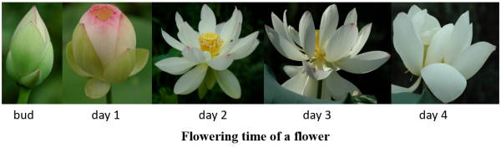
(b) | The underground expanded rhizome can be classified into three categories: Main (primary) expanded rhizome, primary branch of (secondary) expanded rhizome, secondary branch of (third) expanded rhizome.  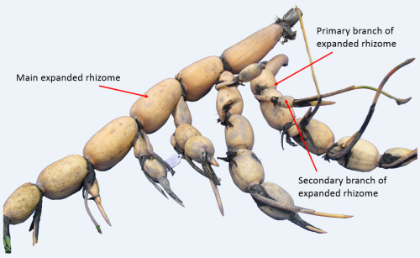

8.2 | Explanations for individual characteristics
Ad. 1: Plant: height

Plant height of lotus is defined by the height of the tallest leaf and it must be measured from the base of petiole to the top of leaf blade to meet DUS test requirement. Lotus plant usually can not reach the tallest before flowering peak, therefore plant height must be measured right after flowering peak.
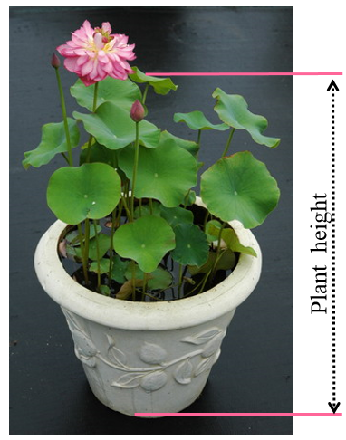

Ad. 2: Emerging leaf: number

Lotus usually has both floating leaves and emerging leaves. The floating leaf has soft petiole with leaf blade floating on water surface. The emerging leaf, also called standing leaf or erect leaf, which has erect petiole with leaf blade above water (arrow indicates in figure). Only the emerging leaves will be counted based on leaf number per square meter of cultivation area. It is not counted for the varieties without emerging leaves. The later mentioned characteristics related to emerging leaves are only associated with the varieties with emerging leaf.

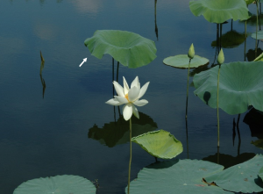

Ad. 4: Leaf: variegation of blade

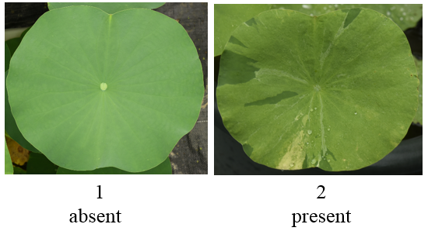

Ad. 5: Emerging leaf: main color of blade

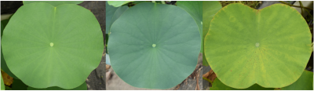
1 | 2 | 3
light or medium green | dark green | yellow green

Ad. 6: Emerging leaf: shape of blade

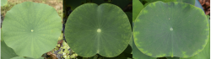
1 | 2 | 3
rounded or nearly rounded | elliptic | narrow elliptic

Ad. 7: Emerging leaf: attitude of blade

The attitude of leaf blade should be based on observation of mature emerging leaves.

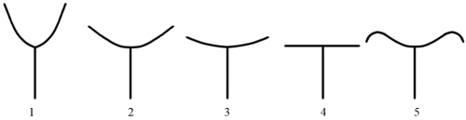

strongly concave | medium concave | weakly concave | flat | concave center with dropping edge

Ad. 8: Emerging leaf: texture of adaxial surface

The adaxial surface texture of mature leaf can be identified by finger touch based on rough area, and degree of roughness and smoothness.
1. Very rough: fully rough
2. Medium rough: half leaf area is rough
3. Weakly rough: ¼ or less leaf area to edge is rough
4. Smooth: not rough
5. Very smooth: much smoother than 4

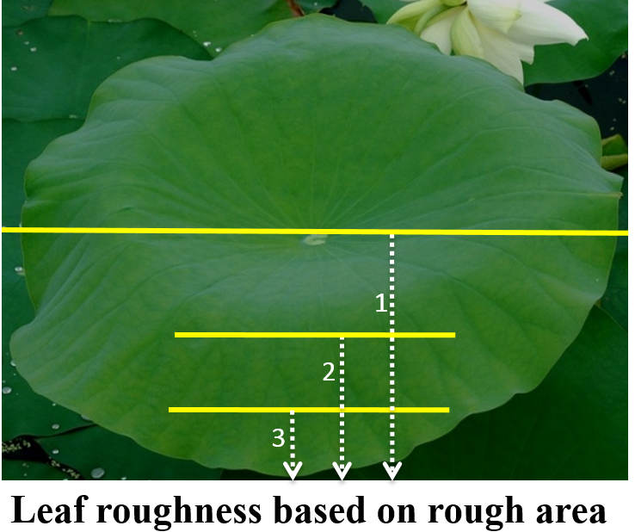

Ad. 9: Emerging leaf: upper margin of blade

Definition on direction of leaf blade: actually the lotus leaf is bilaterally symmetric considering shape of both blade and its nose (leaf center). It is convenient for describing leaf apex by defining direction of blade side like photo showing below. For leaf edge, usually the middle position of northern side (upper side) is more concave than that of southern side (lower side). Therefore, for shape of leaf apex, only the northern side is observed for comparison.
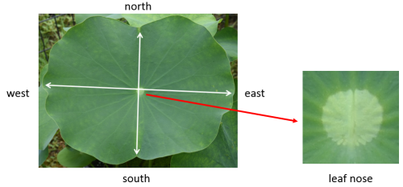
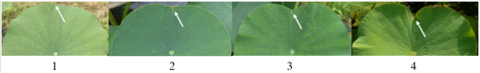
rounded or nearly so | weakly concave | medium | strongly concave

Ad. 10: Emerging leaf: red line of margin

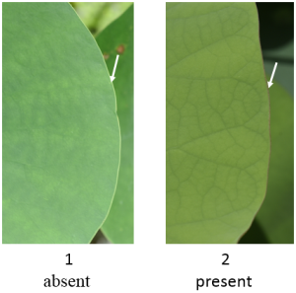

Ad. 11: Leaf nose: gap

Definition: leaf nose is the nose-shaped structure located at the center of leaf. The distance between two halves of nose is defined as nose gap. The wild American lotus and some hybrid of American-Asian lotus have the widest gap, Asian lotus have the narrowest gap, and most of Asian-American hybrids have intermediate gap.
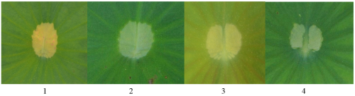
absent or very narrow narrow medium broad

Ad. 12: Petiole: thickness

The diameter of petiole should be measured from the middle position of petiole for mature leaf.

Ad. 13: Petiole: density of spines

Spine density is observed based on the middle position of petiole since it is not evenly distributed from base to top of petiole.

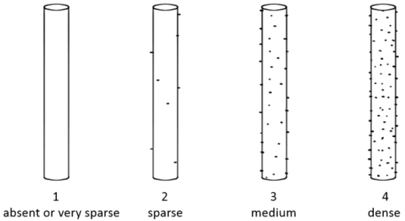

Ad. 14: Flower bud: shape

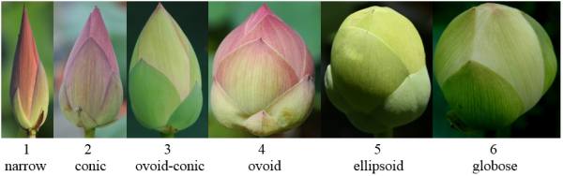

The shape of flower buds should be observed about at least two days before flower opening.

Ad. 19: Flower: position relative to leaf

The position of flower in relation to leaf is based on the relative height of a flower and its accompanying leaf for comparability. For the varieties without flowers, this data is not collected.

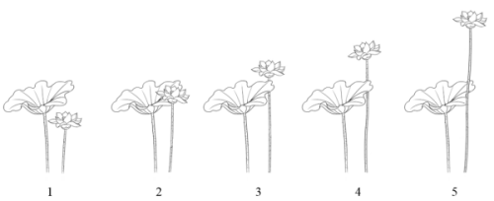
below same level slightly above moderately above strongly above

Ad. 20: Flower: height

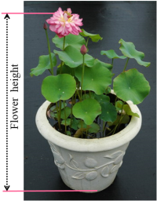

The height of flower is defined by the length measuring from the base of flower stalk to the top of opening flower.

Ad. 22: Flower: type

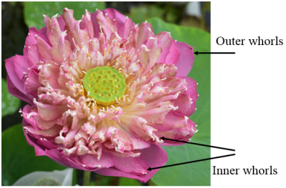

For a double flower, the difference of the tepals between outer whorls and inner whorls can be easily recognized by either (a) the tepals of inner whorls downsize sharply comparing those of outer whorls, and (b) the tepals of inner whorls remain the degenerated stamen appendage on apex.

Ad. 23: Flower: shape

Definition and classification on flower shape
1. Cup-shaped: for the first day flower of most lotus cultivars, it can not fully open and looks like a cup. For a very few of cultivars, the second day flower also can not fully open.
2. Bowl-shaped: the second day flower can be usually fully open like a bowl.
3. Plate-shaped: the fully open flower looks like a plate, with nearly horizontally arranged tepals.
4. Irregularly shaped: a special flower shape of usually single flower, with irregularly arranged tepals.
5. Head-shaped: the head-shaped and fully double flower with numerous tepals, most of which come from petaloid stamens and carpels.
6. Ball-shaped: for a very few cultivars, some or most of the flower buds can not open and remain a ball shape.

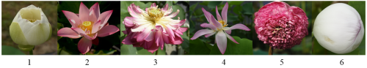

Ad. 25: Flower: pattern of color distribution

The pattern of color distribution on flower is observed on the tepals of outer whorls, excluding tepal base.
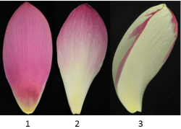
evenly distributed blended variegated

Ad. 29: Tepal: size

The size of tepal is defined by calculation according to (length + width)/2.

Ad. 30: Tepal: main color on the inner side

The main color is measured by RHS Color Chart during 8:00 am and 10:00 am (7:00 - 9:00 am in peak summer) based on the largest tepal of the day 2 flower.

Ad. 31: Tepal: distribution of main color

This characteristic is based on the largest (or nearly so) tepal for comparability.​

Ad. 35: Tepal: abaxial veins

The longitudinal veins on tepal should be observed on abaxial surface of tepal (largest one or nearly so).
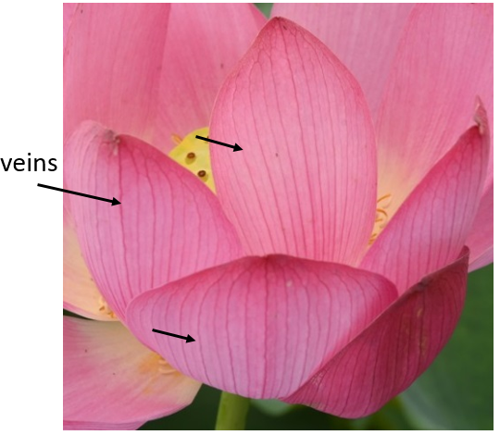

Ad. 39: Stamen appendage: shape

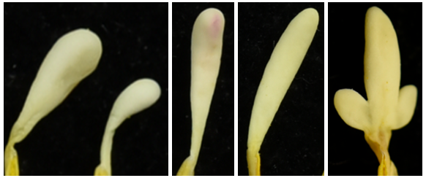
1 2 3 4
obvate long obvate long ellipsoid hastiform

Ad. 41: Carpel: status of development

1. normal: all carpels develop normally;
2. partially bubbled: part of carpels become bubbled (degerated) and could not develop into the fruits;
3. completely bubbled: all carpels become bubbled and could not develop into the fruits;
4. partially petaloid: part of carpels become petaloid;
5. completely petaloid: all carpels become petaloid.

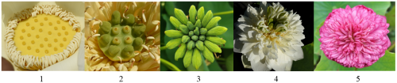

Ad. 44: Receptacle: status of development

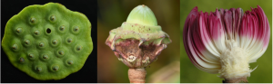
1 2 3
normal partially degenerated absent

Ad. 45: Seedpod: shape

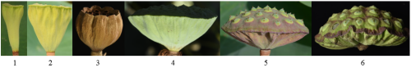
1. trumpet-shaped, 2. obconical, 3. cup-shaped, 4. bowl-shaped, 5. oblate, 6. umbrella-shaped

Ad. 46: Seedpod: color of top surface

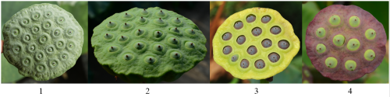
grey-green green green-yellow purple-red

Ad. 47: Seedpod: shape of top surface

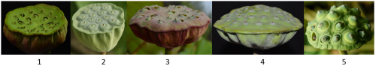
concave plate-like concave flat slightly convex convex
​

Ad. 48: Seedpod: groove depth of margin

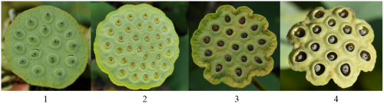
absent or very shallow shallow medium deep

Ad. 51: Fruit: shape

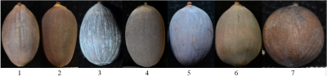
1. narrow ellipsoid; 2. narrow obovoid; 3. narrow ovoid; 4. elllipsoid; 5. obovoid; 6. ovoid; 7. globose

Ad. 52: Fruit: anthocyanin coloration of endocarp

For some varieties, the color may be different in two halves of endocarp, and in such case, the characteristic should be based on the half with deeper color.
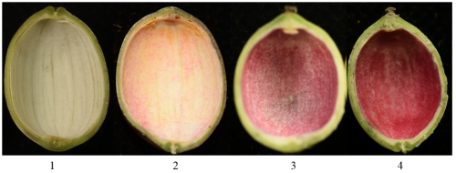
absent weak medium strong

Ad. 53: Fruit: size

The size of dried fruit is calculated by (Length X Width)/2.

Ad. 54: Fruit: color

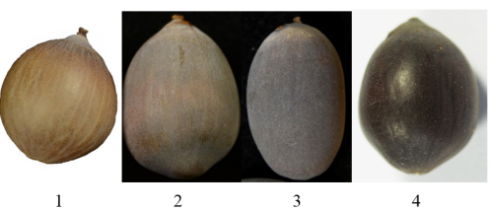
brown grey-brown gray black or dark-brown
The color of dried fruits should be observed after the white waxy powder is removed form the surface of fruit coat.

Ad. 55: Fruit: white waxy powder

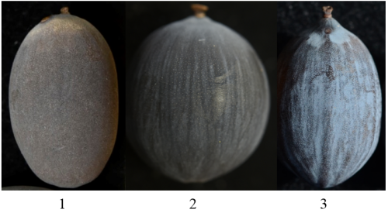
absent or weak medium strong

Ad. 56: Fruit: glossiness

Glossiness of the dried fruits should be observed on the mature fruits, in which the waxy powder should be wiped off by hand, cloth or napkin.
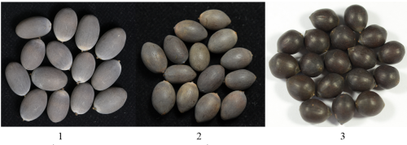
absent or weak medium strong

Ad. 57: Fruit: longitudinal stripes

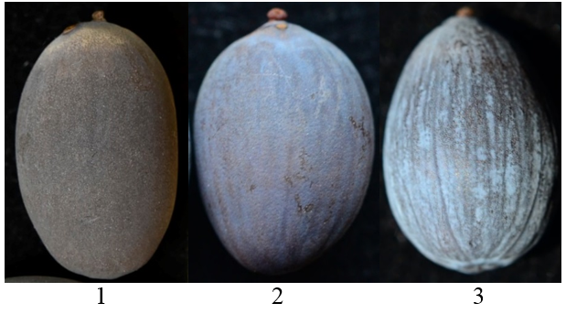
absent weak strong

Ad. 58: Expanded rhizome: color

Since the color of expanded rhizome may be different between early developing stage and late mature stage, it should be observed after lotus entered into dormancy in the fall.

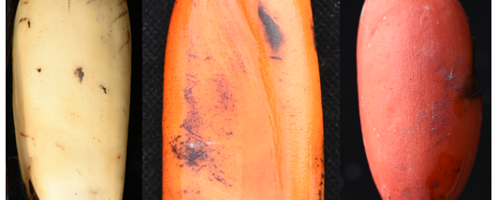
1 2 3
white yellow-brown brown-red

Ad. 63: Expanded rhizome: number of branches (for rhizome lotus only)

This characteristic is only applied for rhizome lotus.

Ad. 64: Rhizome propagule: number

The number of rhizome propagules is based on count of the standard rhizome propagule which consists of two internodes (usually two or one expanded) with terminal shoot at least.

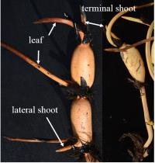

Ad. 65: Terminal internode: shape of apex (for rhizome lotus only)

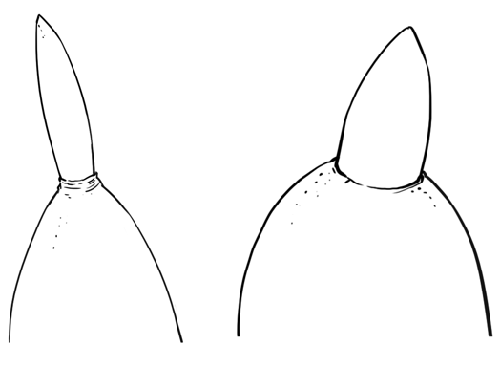
1 2
acute obtuse

8.3 | Growth stages  10 Growth of shoots, coin leaves and floating leaves after planting in spring  20 Growth of emerging leaves and flower buds before flowering in early summer  30 Flowering, fruit setting, fruit maturation and rhizome expansion between summer and fall  40 Leaf aging, yellowing, and died after end of flowering in fall.  50 Plant dormancy in winter  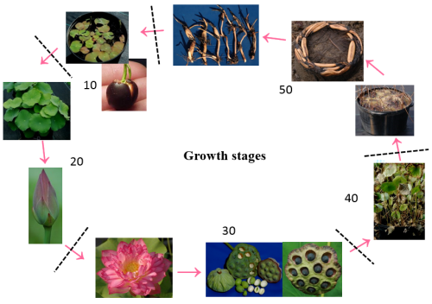

9. | Literature

Agricultural Department of China. 2015. Guidlines for The Conduct of Tests for Distinctness, Uniformity and Stability——Lotus (Nelumbo Adans.) , Standards of Agricultural Industry of China (NY/T 2756—2015）. China Agriculture Press, Beijing, China, 15pp.

Agricultural Department of China. 2016. Descriptor for Lotus Germplasm Resources. Standards of Agricultural Industry of China (NY/T 2937—2016）. . China Agriculture Press, Beijing, China, 17pp.

Ke WD, Li F, et al. 2005. Descriptors and Data Standard for Lotus (Nelumbo nucifera Gaertn.). China Agriculture Press, Beijing, China, 85pp.

Tian DK. 2020. Application to Register a Cultivar of Nelumbo. 8pp. https://iwgs.org/nymphaea-and-nelumbo-registration/ (2023-2-26 accessed).

Wang QC, Zhang XY. 2005. Colored Illustration of Lotus Cultivars in China. China Forestry Press, Beijing, China, 306pp.

10. | Technical Questionnaire

TECHNICAL QUESTIONNAIRE | Page {x} of {y} | Reference Number:

Application date:
(not to be filled in by the applicant)
TECHNICAL QUESTIONNAIRE
to be completed in connection with an application for plant breeders' rights
In the case of hybrid varieties which are the subject of an application for plant breeders' rights, and where the parent lines are to be submitted as a part of the examination of the hybrid variety, this Technical Questionnaire should be completed for each of the parent lines, in addition to being completed for the hybrid variety.

1. | Subject of the Technical Questionnaire
 | 1.1 | Botanical name | Nelumbo Adans.
 | 1.2 | Common name | Lotus

2. | Applicant
 | Name
 | Address
 | Telephone No.
 | Fax No.
 | E-mail address
 | Breeder (if different from
 | applicant)

3. | Proposed denomination and breeder's reference
 | Proposed denomination
 | (if available)
 | Breeder's reference

TECHNICAL QUESTIONNAIRE |  |  | Page {x} of {y} | Reference Number:
#4. | Information on the breeding scheme and propagation of the variety
 | 4.1 | Breeding scheme
 | Variety resulting from:
4.1.1 | Crossing
(a) | controlled cross | [ ]
(please state parent variety)

(…………………..……………..…) x (……………..…………………..…)

female parent male parent

(b) | partially known cross | [ ]
(please state known parent variety(ies))

(…………………..……………..…) x (……………..…………………..…)

female parent male parent

(c) | unknown cross | [ ]
4.1.2 | Mutation  (please state parent variety) | [ ]
4.1.3 | Discovery and development  (please state where and when discovered and how developed) | [ ]
4.1.4 | Other  (Please provide details) | [ ]

TECHNICAL QUESTIONNAIRE | Page {x} of {y} | Reference Number:

 | 4.2 | Method of propagating the variety
4.2.1 | Seed-propagated varieties
(a) | Cross-pollination | [ ]
(b) | Hybrid | [ ]
(i) | Single hybrid | [ ]
(c) | Inbred line | [ ]
(i) | Male sterile line | [ ]
(ii) | Male fertile line | [ ]
(d) | Apomictic Variety | [ ]
(e) | Other (please provide details) | [ ]
4.2.2 | Vegetative propagation
(a) | In vitro propagation | [ ]
(b) | Division | [ ]
(c) | Rhizomes | [ ]
(d) | Other (state method) | [ ]
4.2.3 | Other  (Please provide details) | [ ]

In the case of hybrid varieties the production scheme for the hybrid should be provided on a separate sheet. This should provide details of all the parent lines required for propagating the hybrid e.g.
Single Hybrid
(…………………..……………..…) x (……………..…………………..…)
female parent male parent

Three-Way Hybrid
(…………………..……………..…) x (……………..…………………..…)
female line male line

(…………………..……………..…) x (……………..…………………..…)
single hybrid used as female parent male parent

and should identify in particular:
(a) any male sterile lines
(b) maintenance system of male sterile lines.”

TECHNICAL QUESTIONNAIRE | Page {x} of {y} | Reference Number:

5. | Characteristics of the variety to be indicated (the number in brackets refers to the corresponding characteristic in Test Guidelines; please mark the note which best corresponds).

 | Characteristics | Example Varieties | Note
5.1  (1) | Plant: height
 | very short | Nelumbo `Chuzi Luo` | 1 [ ]
 | very short to short |  | 2 [ ]
 | short | Nelumbo `Xing Huo` | 3 [ ]
 | short to medium |  | 4 [ ]
 | medium | Nelumbo `Yijian Lian` | 5 [ ]
 | medium to tall |  | 6 [ ]
 | tall | Nelumbo lutea `Yellow Bird` | 7 [ ]
 | tall to very tall |  | 8 [ ]
 | very tall | Nelumbo nucifera `Fen Bawang` | 9 [ ]
5.2  (2) | Emerging leaf: number
 | absent | Nelumbo `Ai Xiangsi Hong` | 1 [ ]
 | very few | Nelumbo `Jin Fuwa` | 2 [ ]
 | few | Nelumbo nucifera `Zhongshan Hongtai` | 3 [ ]
 | medium | Nelumbo nucifera `Honghu Hong` | 4 [ ]
 | many | Nelumbo nucifera `Qian Ban` | 5 [ ]
 | very many | Nelumbo `Hong Sijuan` | 6 [ ]
5.3  (7) | Emerging leaf: attitude of blade
 | strongly concave |  | 1 [ ]
 | moderately concave | Nelumbo nucifera `Dan Sajin` | 2 [ ]
 | weakly concave |  | 3 [ ]
 | flat | Nelumbo `Jia Jingying` | 4 [ ]
 | concave center with dropping edge | Nelumbo nucifera `Elian 1` | 5 [ ]
5.4  (8) | Emerging leaf: texture of adaxial surface
 | very rough | Nelumbo nucifera `Daye Chi` | 1 [ ]
 | rough | Nelumbo nucifera `Honghu Hong` | 2 [ ]
 | medium |  | 3 [ ]
 | smooth | Nelumbo nucifera `Fenhong Lingxiao` | 4 [ ]
 | very smooth | Nelumbo lutea `Yellow Bird` | 5 [ ]

 | Characteristics | Example Varieties | Note
5.5  (9) | Emerging leaf: upper margin of blade
 | rounded |  | 1 [ ]
 | weakly concave | Nelumbo `Honghe Zhanchi` | 2 [ ]
 | moderately concave | Nelumbo `Danban Jinxia` | 3 [ ]
 | strongly concave |  | 4 [ ]
5.6  (11) | Leaf nose: gap
 | absent or very narrow | Nelumbo `Jia Jingying` | 1 [ ]
 | narrow | Nelumbo nucifera `Honghu Hong` | 2 [ ]
 | medium | Nelumbo `Yijian Lian` | 3 [ ]
 | broad |  | 4 [ ]
5.7  (13) | Petiole: density of spines
 | absent or very sparse | Nelumbo lutea `Yellow Bird` | 1 [ ]
 | sparse | Nelumbo `Bian Lian` | 2 [ ]
 | medium | Nelumbo nucifera `Honghu Hong` | 3 [ ]
 | dense | Nelumbo `Jia Jingying` | 4 [ ]
5.8  (19) | Flower: position relative to leaf
 | below |  | 1 [ ]
 | same level | Nelumbo nucifera `Zhongshan Hongtai` | 2 [ ]
 | slightly above | Nelumbo `Hong Sijuan` | 3 [ ]
 | moderately above | Nelumbo nucifera `Honghu Hong` | 4 [ ]
 | strongly above | Nelumbo `Bian Lian` | 5 [ ]
5.9  (20) | Flower: height
 | very short | Nelumbo `Chuzi Luo` | 1 [ ]
 | short | Nelumbo `Yanzhi Wan` | 2 [ ]
 | medium | Nelumbo `Bo Ai` | 3 [ ]
 | tall | Nelumbo nucifera `Zhizun Qianban` | 4 [ ]
 | very tall | Nelumbo nucifera `Fen Bawang` | 5 [ ]
5.10  (22) | Flower: type
 | single | Nelumbo nucifera `Honghu Hong` | 1 [ ]
 | semi-double | Nelumbo `Cai Xia` | 2 [ ]
 | double | Nelumbo nucifera `Dan Sajin` | 3 [ ]
 | dual-layered | Nelumbo nucifera `Hongtai Lian` | 4 [ ]
 | thousand-petalled | Nelumbo nucifera `Qian Ban` | 5 [ ]

 | Characteristics | Example Varieties | Note
5.11  (23) | Flower: shape
 | cup-shaped | Nelumbo `Furong Qipa` | 1 [ ]
 | bowl-shaped | Nelumbo nucifera `Honghu Hong` | 2 [ ]
 | plate-shaped | Nelumbo `Jin Se` | 3 [ ]
 | Irregularly shaped | Nelumbo nucifera `Chenshan Feiyan` | 4 [ ]
 | head-shaped | Nelumbo nucifera `Zhizun Qianban` | 5 [ ]
 | ball-shaped | Nelumbo 'Xiao Hong Dan' | 6 [ ]
5.12  (25) | Flower: pattern of color distribution
 | evenly distributed |  | 1 [ ]
 | blended |  | 2 [ ]
 | variegated | Nelumbo nucifera `Dan Sajin` | 3 [ ]
5.13  (29) | Tepal: size
 | very small | Nelumbo `Chuzi Luo` | 1 [ ]
 | small |  | 2 [ ]
 | medium | Nelumbo `Yanzhi Wan` | 3 [ ]
 | large | Nelumbo `Yijian Lian` | 4 [ ]
 | very large | Nelumbo nucifera `Fen Bawang`, Nelumbo nucifera `Honghu Hong` | 5 [ ]
5.14  (31) | Tepal: distribution of main color
 | throughout |  | 1 [ ]
 | distal three quarters |  | 2 [ ]
 | distal half |  | 3 [ ]
 | basal half |  | 4 [ ]
 | basal three quarters |  | 5 [ ]
5.15  (35) | Tepal: abaxial veins
 | absent or weak | Nelumbo nucifera `Zhongri Youyi` | 1 [ ]
 | medium | Nelumbo nucifera `Honghu Hong` | 2 [ ]
 | strong | Nelumbo nucifera `Taikong 36` | 3 [ ]
5.16  (39) | Stamen appendage: shape
 | obvate |  | 1 [ ]
 | long obvate |  | 2 [ ]
 | long ellipsoid |  | 3 [ ]
 | hastiform | Nelumbo `Jiangnan Mingzhu` | 4 [ ]

 | Characteristics | Example Varieties | Note
5.17  (41) | Carpel: status of development
 | normal | Nelumbo nucifera `Honghu Hong` | 1 [ ]
 | partially bubbled |  | 2 [ ]
 | completely bubbled | Nelumbo `Qinhuai Yueye` | 3 [ ]
 | partially petaloid | Nelumbo `Huang Lingyang` | 4 [ ]
 | completely petaloid | Nelumbo nucifera `Zhizun Qianban` | 5 [ ]
5.18  (44) | Receptacle: status of development
 | normal |  | 1 [ ]
 | partially degenerated | Nelumbo nucifera `Hongtai Lian` | 2 [ ]
 | absent | Nelumbo nucifera `Zhizun Qianban` | 3 [ ]
5.19  (47) | Seedpod: shape of top surface
 | concave | Nelumbo nucifera `Jin Furong 2` | 1 [ ]
 | plate-like concave |  | 2 [ ]
 | flat |  | 3 [ ]
 | slightly convex |  | 4 [ ]
 | convex |  | 5 [ ]
5.20  (51) | Fruit: shape
 | narrow ellipsoid |  | 1 [ ]
 | narrow obovoid | Nelumbo `Jiuhua Haoyue` | 2 [ ]
 | narrow ovoid |  | 3 [ ]
 | ellipsoid |  | 4 [ ]
 | obovoid |  | 5 [ ]
 | ovoid |  | 6 [ ]
 | globose | Nelumbo nucifera `Honghu Hong` | 7 [ ]
5.21  (52) | Fruit: anthocyanin coloration of endocarp
 | absent |  | 1 [ ]
 | weak | Nelumbo nucifera `Dan Sajin` | 2 [ ]
 | medium | Nelumbo nucifera `Honghu Hong` | 3 [ ]
 | strong | Nelumbo `Yijian Lian` | 4 [ ]

 | Characteristics | Example Varieties | Note
5.22  (53) | Fruit: size
 | very small | Nelumbo `Chuzi Luo` | 1 [ ]
 | small |  | 2 [ ]
 | medium | Nelumbo nucifera `Honghu Hong` | 3 [ ]
 | large | Nelumbo `Jiuhua Haoyue` | 4 [ ]
 | very large | Nelumbo nucifera `Jianxuan 17` | 5 [ ]
5.23  (54) | Fruit: color
 | brown | Nelumbo lutea `Yellow Bird` | 1 [ ]
 | grey-brown | Nelumbo `Ms. Perry D. Slocum` | 2 [ ]
 | gray | Nelumbo nucifera `Honghu Hong` | 3 [ ]
 | black or dark brown | Nelumbo `Jiuhua Haoyue` | 4 [ ]
5.24  (56) | Fruit: glossiness
 | absent or weak | Nelumbo nucifera `Yingquan Xike` | 1 [ ]
 | medium | Nelumbo `Jiuhua Haoyue` | 2 [ ]
 | strong |  | 3 [ ]
5.25  (57) | Fruit: longitudinal stripes
 | absent or weak | Nelumbo nucifera `Honghu Hong` | 1 [ ]
 | medium | Nelumbo `Jiuhua Haoyue` | 2 [ ]
 | strong |  | 3 [ ]
5.26  (58) | Expanded rhizome: color
 | white | Nelumbo nucifera `Elian 1` | 1 [ ]
 | yellow brown |  | 2 [ ]
 | brown red |  | 3 [ ]
5.27  (63) | Expanded rhizome: number of branches (for rhizome lotus only)
 | few |  | 1 [ ]
 | medium |  | 2 [ ]
 | many |  | 3 [ ]

 | Characteristics | Example Varieties | Note
5.28  (64) | Rhizome propagule: number
 | absent or very few | Nelumbo nucifera `Fenhong Lingxiao` | 1 [ ]
 | few | Nelumbo nucifera `Zhongshan Hongtai` | 2 [ ]
 | medium |  | 3 [ ]
 | many |  | 4 [ ]
 | very many |  | 5 [ ]
5.29  (65) | Terminal internode: shape of apex (for rhizome lotus only)
 | acute |  | 1 [ ]
 | obtuse |  | 2 [ ]
5.30  (68) | Expanded rhizome: texture of flesh (for rhizome lotus only)
 | crispy | Nelumbo nucifera `Elian 1` | 1 [ ]
 | intermediate | Nelumbo nucifera `Elian 4` | 2 [ ]
 | starchy | Nelumbo nucifera `Elian 5` | 3 [ ]

TECHNICAL QUESTIONNAIRE | Page {x} of {y} | Reference Number:

6. | Similar varieties and differences from these varieties
Please use the following table and box for comments to provide information on how your candidate variety differs from the variety (or varieties) which, to the best of your knowledge, is (or are) most similar. This information may help the examination authority to conduct its examination of distinctness in a more efficient way.

Denomination(s) of variety(ies) similar to your candidate variety | Characteristic(s) in which your candidate variety differs from the similar variety(ies) | Describe the expression of the characteristic(s) for the similar variety(ies) | Describe the expression of the characteristic(s) for your candidate variety

Example

 | Comments:

TECHNICAL QUESTIONNAIRE | Page {x} of {y} | Reference Number:

#7. | Additional information which may help in the examination of the variety
7.1 | In addition to the information provided in sections 5 and 6, are there any additional characteristics which may help to distinguish the variety?
 | Yes | [ ] | No | [ ]
 | (If yes, please provide details)
7.2 | Are there any special conditions for growing the variety or conducting the examination?
 | Yes | [ ] | No | [ ]
 | (If yes, please provide details)
7.3 | Other information

TECHNICAL QUESTIONNAIRE | Page {x} of {y} | Reference Number:

8. | Authorization for release
 | (a) | Does the variety require prior authorization for release under legislation concerning the protection of the environment, human and animal health?
 |  | Yes | [ ] | No | [ ]
 | (b) | Has such authorization been obtained?
 |  | Yes | [ ] | No | [ ]
 | If the answer to (b) is yes, please attach a copy of the authorization.

9. Information on plant material to be examined or submitted for examination

9.1 The expression of a characteristic or several characteristics of a variety may be affected by factors, such as pests and disease, chemical treatment (e.g. growth retardants or pesticides), effects of tissue culture, different rootstocks, scions taken from different growth phases of a tree, etc.
9.2 The plant material should not have undergone any treatment which would affect the expression of the characteristics of the variety, unless the competent authorities allow or request such treatment. If the plant material has undergone such treatment, full details of the treatment must be given. In this respect, please indicate below, to the best of your knowledge, if the plant material to be examined has been subjected to:

 | (a) | Microorganisms (e.g. virus, bacteria, phytoplasma) | Yes [ ] | No [ ]
 | (b) | Chemical treatment (e.g. growth retardant, pesticide) | Yes [ ] | No [ ]
 | (c) | Tissue culture | Yes [ ] | No [ ]
 | (d) | Other factors | Yes [ ] | No [ ]
 | Please provide details for where you have indicated “yes”.

10. | I hereby declare that, to the best of my knowledge, the information provided in this form is correct:
 | Applicant’s name
 | Signature |  | Date

[End of document]

