 |  | E
TG/MAGNO(proj.5)
ORIGINAL: English
DATE: 2024-03-16

INTERNATIONAL UNION FOR THE PROTECTION OF NEW VARIETIES OF PLANTS
 | Geneva
 | DRAFT
 | MAGNOLIA  UPOV Code(s): MAGNO  Magnolia L. | *
GUIDELINES
FOR THE CONDUCT OF TESTS
FOR DISTINCTNESS, UNIFORMITY AND STABILITY

prepared by experts from China
to be considered by the
Technical Working Party for Ornamental Plants and Forest Trees

at its fifty-sixth session, to be held virtually
from 2024-04-29 to 2024-05-02

Disclaimer: this document does not represent UPOV policies or guidance
Alternative names:*

Botanical name | English | French | German | Spanish
Magnolia L.,  Michelia L. | Magnolia | Magnolia | Magnolie | Magnolia

The purpose of these guidelines (“Test Guidelines”) is to elaborate the principles contained in the General Introduction (document TG/1/3), and its associated TGP documents, into detailed practical guidance for the harmonized examination of distinctness, uniformity and stability (DUS) and, in particular, to identify appropriate characteristics for the examination of DUS and production of harmonized variety descriptions.
ASSOCIATED DOCUMENTS
These Test Guidelines should be read in conjunction with the General Introduction and its associated TGP documents.

TABLE OF CONTENTS | PAGE
1. | SUBJECT OF THESE TEST GUIDELINES.......................................................................................................... | 3
2. | MATERIAL REQUIRED..................................................................................................................... | 3
3. | METHOD OF EXAMINATION............................................................................................................... | 3
3.1 | Number of Growing Cycles................................................................................................................. | 3
3.2 | Testing Place................................................................................................................... | 3
3.3 | Conditions for Conducting the Examination............................................................................................... | 3
3.4 | Test Design................................................................................................................. | 4
3.5 | Additional Tests................................................................................................................... | 4

4. | ASSESSMENT OF DISTINCTNESS, UNIFORMITY AND STABILITY................................................................. | 4
4.1 | Distinctness.......................................................................................................... | 4
4.2 | Uniformity............................................................................................................ | 5
4.3 | Stability............................................................................................................... | 5

5. | GROUPING OF VARIETIES AND ORGANIZATION OF THE GROWING TRIAL................................................ | 6
6. | INTRODUCTION TO THE TABLE OF CHARACTERISTICS................................................................................ | 6
6.1 | Categories of Characteristics...................................................................................................... | 6
6.2 | States of Expression and Corresponding Notes........................................................................................ | 6
6.3 | Types of Expression............................................................................................................ | 7
6.4 | Example Varieties.............................................................................................................. | 7
6.5 | Legend................................................................................................................. | 8

7. | TABLE OF CHARACTERISTICS/TABLEAU DES CARACTÈRES/MERKMALSTABELLE/TABLA DE CARACTERES.................................................................................................................. | 9
8. | EXPLANATIONS ON THE TABLE OF CHARACTERISTICS............................................................................... | 28
8.1 | Explanations covering several characteristics........................................................................................... | 28
8.2 | Explanations for individual characteristics................................................................................................. | 30

9. | LITERATURE................................................................................................................... | 47
10 | TECHNICAL QUESTIONNAIRE............................................................................................................ | 48

1. | Subject of these Test Guidelines
 | These Test Guidelines apply to all varieties of Magnolia L.

2. | Material Required
2.1 | The competent authorities decide on the quantity and quality of the plant material required for testing the variety and when and where it is to be delivered. Applicants submitting material from a State other than that in which the testing takes place must ensure that all customs formalities and phytosanitary requirements are complied with.
2.2 | The material is to be supplied in the form of young plants, grafted or on their own roots.
2.3 | The minimum quantity of plant material, to be supplied by the applicant, should be:
 | 6 plants
2.4 | The plant material supplied should be visibly healthy, not lacking in vigor, nor affected by any important pest or disease.
2.5 | The plant material should not have undergone any treatment which would affect the expression of the characteristics of the variety, unless the competent authorities allow or request such treatment. If it has been treated, full details of the treatment must be given.

3. | Method of Examination
3.1 | Number of Growing Cycles
3.1.1 | The minimum duration of tests should normally be a single growing cycle.
3.1.2 | The testing of a variety may be concluded when the competent authority can determine with certainty the outcome of the test.
3.2 | Testing Place
 | Tests are normally conducted at one place. In the case of tests conducted at more than one place, guidance is provided in TGP/9 “Examining Distinctness”.
3.3 | Conditions for Conducting the Examination
3.3.1 | The tests should be carried out under conditions ensuring satisfactory growth for the expression of the relevant characteristics of the variety and for the conduct of the examination.
3.3.2 | Because daylight varies, color determinations made against a color chart should be made either in a suitable cabinet providing artificial daylight or in the middle of the day in a room without direct sunlight. The spectral distribution of the illuminant for artificial daylight should conform with the CIE Standard of Preferred Daylight D 6500 and should fall within the tolerances set out in the British Standard 950, Part I. These determinations should be made with the plant part placed against a white background. The color chart and version used should be specified in the variety description.
3.4 | Test Design
3.4.1 | Each test should be designed to result in a total of at least 6 plants.
3.4.2 | The design of the tests should be such that plants or parts of plants may be removed for measurement or counting without prejudice to the observations which must be made up to the end of the growing cycle.
3.5 | Additional Tests
 | Additional tests, for examining relevant characteristics, may be established.
4. | Assessment of Distinctness, Uniformity and Stability
4.1 | Distinctness
4.1.1 | General Recommendations
 | It is of particular importance for users of these Test Guidelines to consult the General Introduction prior to making decisions regarding distinctness. However, the following points are provided for elaboration or emphasis in these Test Guidelines.
4.1.2 | Consistent Differences
 | The differences observed between varieties may be so clear that more than one growing cycle is not necessary. In addition, in some circumstances, the influence of the environment is not such that more than a single growing cycle is required to provide assurance that the differences observed between varieties are sufficiently consistent. One means of ensuring that a difference in a characteristic, observed in a growing trial, is sufficiently consistent is to examine the characteristic in at least two independent growing cycles.
4.1.3 | Clear Differences
 | Determining whether a difference between two varieties is clear depends on many factors, and should consider, in particular, the type of expression of the characteristic being examined, i.e. whether it is expressed in a qualitative, quantitative, or pseudo-qualitative manner. Therefore, it is important that users of these Test Guidelines are familiar with the recommendations contained in the General Introduction prior to making decisions regarding distinctness.
4.1.4 | Number of Plants or Parts of Plants to be Examined
 | Unless otherwise indicated, for the purposes of distinctness, all observations on single plants should be made on 5 plants or parts of plants taken from each of 5 plants and any other observations made on all plants in the test, disregarding any off-type plants.
 | In the case of observations of parts taken from single plants, the number of parts to be taken from each of the plants should be 2.
4.1.5 | Method of Observation
 | The recommended method of observing the characteristic for the purposes of distinctness is indicated by the following key in the Table of Characteristics (see document TGP/9 “Examining Distinctness”, Section 4 “Observation of characteristics”):
MG: single measurement of a group of plants or parts of plants
MS: measurement of a number of individual plants or parts of plants
VG: visual assessment by a single observation of a group of plants or parts of plants
VS: visual assessment by observation of individual plants or parts of plants

 | Type of observation: visual (V) or measurement (M)
 | “Visual” observation (V) is an observation made on the basis of the expert’s judgment. For the purposes of this document, “visual” observation refers to the sensory observations of the experts and, therefore, also includes smell, taste and touch. Visual observation includes observations where the expert uses reference points (e.g. diagrams, example varieties, side-by-side comparison) or non-linear charts (e.g. color charts). Measurement (M) is an objective observation against a calibrated, linear scale e.g. using a ruler, weighing scales, colorimeter, dates, counts, etc.
 | Type of record: for a group of plants (G) or for single, individual plants (S)
 | For the purposes of distinctness, observations may be recorded as a single record for a group of plants or parts of plants (G), or may be recorded as records for a number of single, individual plants or parts of plants (S). In most cases, “G” provides a single record per variety and it is not possible or necessary to apply statistical methods in a plant-by-plant analysis for the assessment of distinctness.
 | In cases where more than one method of observing the characteristic is indicated in the Table of Characteristics (e.g. VG/MG), guidance on selecting an appropriate method is provided in document TGP/9, Section 4.2.
4.2 | Uniformity
4.2.1 | It is of particular importance for users of these Test Guidelines to consult the General Introduction prior to making decisions regarding uniformity. However, the following points are provided for elaboration or emphasis in these Test Guidelines:
4.2.2 | These Test Guidelines have been developed for the examination of vegetatively propagated varieties. For varieties with other types of propagation, the recommendations in the General Introduction and document TGP/13 "Guidance for new types and species" Section 4.5 "Testing Uniformity" should be followed.
4.2.3 | The assessment of uniformity for vegetatively propagated varieties should be according to the recommendations for cross-pollinated varieties in the General Introduction.
4.2.4 | For the assessment of uniformity of vegetatively propagated varieties, a population standard of 1% and an acceptance probability of at least 95% should be applied. In the case of a sample size of 6 plants, 1 off-type is allowed.
4.3 | Stability
4.3.1 | In practice, it is not usual to perform tests of stability that produce results as certain as those of the testing of distinctness and uniformity. However, experience has demonstrated that, for many types of variety, when a variety has been shown to be uniform, it can also be considered to be stable.
4.3.2 | Where appropriate, or in cases of doubt, stability may be further examined by testing a new plant stock to ensure that it exhibits the same characteristics as those shown by the initial material supplied.

5. | Grouping of Varieties and Organization of the Growing Trial
5.1 | The selection of varieties of common knowledge to be grown in the trial with the candidate varieties and the way in which these varieties are divided into groups to facilitate the assessment of distinctness are aided by the use of grouping characteristics.
5.2 | Grouping characteristics are those in which the documented states of expression, even where produced at different locations, can be used, either individually or in combination with other such characteristics: (a) to select varieties of common knowledge that can be excluded from the growing trial used for examination of distinctness; and (b) to organize the growing trial so that similar varieties are grouped together.
5.3 | The following have been agreed as useful grouping characteristics:
(a) |  | Plant: seasonality (characteristic 1)
(b) |  | Plant: position of flower buds on branch (characteristic 4)
(c) |  | Flower: number of tepals (characteristic 29)
(d) |  | First whorl petaloid tepals: main color on outer side (characteristic 37)  with the following groups  Gr. 1: white  Gr. 2: green  Gr. 3: yellow  Gr. 4: red pink  Gr. 5: red  Gr. 6: purple
(e) |  | Time of beginning of first flowering (characteristic 54)

5.4 | Guidance for the use of grouping characteristics, in the process of examining distinctness, is provided through the General Introduction and document TGP/9 “Examining Distinctness”.

6. | Introduction to the Table of Characteristics
6.1 | Categories of Characteristics
6.1.1 | Standard Test Guidelines Characteristics
 | Standard Test Guidelines characteristics are those which are approved by UPOV for examination of DUS and from which members of the Union can select those suitable for their particular circumstances.
6.1.2 | Asterisked Characteristics
 | Asterisked characteristics (denoted by *) are those included in the Test Guidelines which are important for the international harmonization of variety descriptions and should always be examined for DUS and included in the variety description by all members of the Union, except when the state of expression of a preceding characteristic or regional environmental conditions render this inappropriate.
6.2 | States of Expression and Corresponding Notes
6.2.1 | States of expression are given for each characteristic to define the characteristic and to harmonize descriptions. Each state of expression is allocated a corresponding numerical note for ease of recording of data and for the production and exchange of the description.
6.2.2 | All relevant states of expression are presented in the characteristic.
6.2.3 | Further explanation of the presentation of states of expression and notes is provided in document TGP/7 “Development of Test Guidelines”.
6.3 | Types of Expression
 | An explanation of the types of expression of characteristics (qualitative, quantitative and pseudo-qualitative) is provided in the General Introduction.
6.4 | Example Varieties
 | Where appropriate, example varieties are provided to clarify the states of expression of each characteristic.
Example variety
Magnolia 'Betty'
Magnolia cylindrica 'Lv Xing'
Magnolia denudata 'Jade Lamp'
Magnolia figo 'Purple Queen'
Magnolia 'Fragrant Cloud'
Magnolia 'Frank's Masterpiece'
Magnolia grandiflora 'Bracken's Brown Beauty'
Magnolia 'Hong Jixing'
Magnolia ×loebneri 'Mag's Pirouette'
Magnolia sargentiana 'Mossman's Giant'
Magnolia sieboldii 'Qingxin'
Magnolia 'Silver Parasol'
Magnolia ×soulangiana 'Burgundy'
Magnolia sprengerii 'Diva'
Magnolia 'Sun Spire'
Magnolia virginiana 'Tensaw'
Magnolia 'Yellow Bird'

6.5 | Legend
 |  | English |  | français |  | deutsch | español | Example Varieties/  Exemples/  Beispielssorten/  Variedades ejemplo | Note/  Nota
1 | 2 | 3 | 4 | 5 | 6 | 7
 |  | Name of characteristics in English |  | Nom du caractère en français |  | Name des Merkmals auf Deutsch | Nombre del carácter en español
 |  | states of expression |  | types d’expression |  | Ausprägungsstufen | tipos de expresión

1 | Characteristic number
2 | (*) | Asterisked characteristic | – see Chapter 6.1.2
3 | Type of expression
 | QL | Qualitative characteristic | – see Chapter 6.3
 | QN | Quantitative characteristic | – see Chapter 6.3
 | PQ | Pseudo-qualitative characteristic | – see Chapter 6.3
4 | Method of observation (and type of plot, if applicable)
 | MG, MS, VG, VS |  | – see Chapter 4.1.5
5 | (+) | See Explanations on the Table of Characteristics in Chapter 8.2
6 | (a)-(f) | See Explanations on the Table of Characteristics in Chapter 8.1
7 | Not applicable

7. | Table of Characteristics/Tableau des caractères/Merkmalstabelle/Tabla de caracteres

 |  | English |  | français |  | deutsch | español | Example Varieties/  Exemples/  Beispielssorten/  Variedades ejemplo | Note/  Nota
1. | (*) | QL | VG |  | (a)
 |  | Plant: seasonality
 |  | deciduous |  |  |  |  |  | Burgundy, Yellow Bird | 1
 |  | evergreen |  |  |  |  |  | Bracken`s Brown Beauty, Purple Queen | 2
2. | (*) | QN | VG | (+) | (a)
 |  | Plant: growth habit
 |  | fastigiate |  |  |  |  |  | Sun Spire | 1
 |  | upright |  |  |  |  |  | Yellow Bird | 2
 |  | upright to spreading |  |  |  |  |  | Burgundy | 3
 |  | spreading |  |  |  |  |  | Jade Lamp | 4
 |  | drooping |  |  |  |  |  | Frank's Masterpiece | 5
3. |  | QN | VG |  | (a)
 |  | Plant: density of branches
 |  | sparse |  |  |  |  |  | Silver Parasol | 1
 |  | sparse to medium |  |  |  |  |  | Jade Lamp | 2
 |  | medium |  |  |  |  |  | Burgundy | 3
 |  | medium to dense |  |  |  |  |  | Mag`s Pirouette | 4
 |  | dense |  |  |  |  |  |  | 5
4. | (*) | QL | VG | (+)
 |  | Plant: position of flower buds on branch
 |  | terminal only |  |  |  |  |  | Bracken`s Brown Beauty, Frank's Masterpiece | 1
 |  | terminal and axillary |  |  |  |  |  | Mag`s Pirouette, Yellow Bird | 2
 |  | axillary only |  |  |  |  |  | Purple Queen | 3
5. |  | QN | MG | (+)
 |  | Plant: number of terminal or axillary flowers on branch
 |  | only one |  |  |  |  |  | Bracken`s Brown Beauty, Frank's Masterpiece | 1
 |  | one and two |  |  |  |  |  | Fragrant Cloud, Purple Queen | 2
 |  | more than two |  |  |  |  |  |  | 3
6. |  | QN | MG/MS | (+)
 |  | Plant: number of fruit in relation to flowers
 |  | absent or few |  |  |  |  |  | Hong Jixing, Purple Queen | 1
 |  | medium |  |  |  |  |  | Yellow Bird | 2
 |  | many |  |  |  |  |  | Jade Lamp | 3
7. | (*) | QN | MG/VG | (+) | (a)
 |  | Flowering shoot: length of internodes
 |  | short |  |  |  |  |  | Fragrant Cloud | 1
 |  | medium |  |  |  |  |  | Burgundy | 2
 |  | long |  |  |  |  |  | Frank's Masterpiece | 3
8. | (*) | PQ | VG | (+) | (a)
 |  | One-year-old shoot: color
 |  | green |  |  |  |  |  | Hong Jixing | 1
 |  | yellow green |  |  |  |  |  | Tensaw | 2
 |  | brown purple |  |  |  |  |  | Yellow Bird | 3
 |  | brown |  |  |  |  |  | Bracken`s Brown Beauty | 4
 |  | yellow brown |  |  |  |  |  | Burgundy | 5
 |  | grey |  |  |  |  |  | Qingxin, Silver Parasol | 6
9. |  | QN | VG | (+) | (b)
 |  | Young leaf blade: anthocyanin coloration of upper side
 |  | absent or very weak |  |  |  |  |  | Bracken`s Brown Beauty | 1
 |  | weak |  |  |  |  |  | Mag`s Pirouette | 2
 |  | medium |  |  |  |  |  |  | 3
 |  | strong |  |  |  |  |  |  | 4
 |  | very strong |  |  |  |  |  |  | 5
10 |  | PQ | VG |  | (b)
 |  | Young leaf blade: color of lower side
 |  | white |  |  |  |  |  | Qingxin, Silver Parasol | 1
 |  | green |  |  |  |  |  | Hong Jixing, Purple Queen | 2
 |  | grey green |  |  |  |  |  | Diva | 3
 |  | brown red |  |  |  |  |  |  | 4
 |  | brown purple |  |  |  |  |  | Bracken`s Brown Beauty | 5
 |  | yellow brown |  |  |  |  |  |  | 6
11 |  | QN | VG |  | (b)
 |  | Young leaf blade: pubescence on lower side
 |  | absent or very sparse |  |  |  |  |  | Diva | 1
 |  | sparse |  |  |  |  |  | Mag`s Pirouette | 2
 |  | medium |  |  |  |  |  | Yellow Bird | 3
 |  | dense |  |  |  |  |  |  | 4
 |  | very dense |  |  |  |  |  | Bracken`s Brown Beauty | 5
12 | (*) | QN | MG/MS | (+) | (c)
 |  | Leaf blade: length
 |  | very short |  |  |  |  |  | Tensaw | 1
 |  | short |  |  |  |  |  | Burgundy, Mag`s Pirouette | 2
 |  | medium |  |  |  |  |  | Bracken`s Brown Beauty | 3
 |  | long |  |  |  |  |  |  | 4
 |  | very long |  |  |  |  |  | Silver Parasol | 5
13 |  | QN | MG/MS | (+) | (c)
 |  | Leaf blade: width
 |  | very narrow |  |  |  |  |  | Tensaw | 1
 |  | narrow |  |  |  |  |  | Mag`s Pirouette | 2
 |  | medium |  |  |  |  |  | Jade Lamp | 3
 |  | broad |  |  |  |  |  | Mossman`s Giant | 4
 |  | very broad |  |  |  |  |  | Silver Parasol | 5
14 |  | QN | MG/MS | (+) | (c)
 |  | Leaf blade: ratio length/width
 |  | very low |  |  |  |  |  | Jade Lamp | 1
 |  | low |  |  |  |  |  | Burgundy | 2
 |  | medium |  |  |  |  |  | Betty | 3
 |  | high |  |  |  |  |  | Bracken`s Brown Beauty | 4
 |  | very high |  |  |  |  |  | Silver Parasol | 5
15 | (*) | PQ | VG | (+) | (c)
 |  | Leaf blade: shape
 |  | ovate |  |  |  |  |  | Yellow Bird | 1
 |  | elliptic |  |  |  |  |  | Bracken`s Brown Beauty | 2
 |  | obovate |  |  |  |  |  | Diva | 3
16 |  | PQ | VG | (+) | (c)
 |  | Leaf blade: shape of base
 |  | decurrent |  |  |  |  |  |  | 1
 |  | attenuate |  |  |  |  |  | Hong Jixing | 2
 |  | acute cuneate |  |  |  |  |  | Burgundy | 3
 |  | obtuse cuneate |  |  |  |  |  | Diva | 4
 |  | rounded |  |  |  |  |  | Jade Lamp | 5
 |  | truncate |  |  |  |  |  |  | 6
 |  | cordate |  |  |  |  |  | Silver Parasol | 7
 |  | auriculate |  |  |  |  |  |  | 8
17 | (*) | PQ | VG | (+) | (c)
 |  | Leaf blade: shape of apex
 |  | acute |  |  |  |  |  | Bracken`s Brown Beauty | 1
 |  | obtuse |  |  |  |  |  |  | 2
 |  | rounded |  |  |  |  |  | Jade Lamp | 3
 |  | truncate |  |  |  |  |  |  | 4
 |  | apiculate |  |  |  |  |  | Diva | 5
 |  | acuminate |  |  |  |  |  | Burgundy | 6
 |  | caudate |  |  |  |  |  |  | 7
 |  | retuse |  |  |  |  |  | Mag`s Pirouette | 8
 |  | emarginate |  |  |  |  |  |  | 9
18 |  | QL | VG |  | (c)
 |  | Leaf: variegation
 |  | absent |  |  |  |  |  |  | 1
 |  | present |  |  |  |  |  |  | 9
19 |  | PQ | VG | (+) | (c)
 |  | Leaf blade: color of upper side
 |  | yellow |  |  |  |  |  |  | 1
 |  | yellow green |  |  |  |  |  | Tensaw | 2
 |  | green |  |  |  |  |  | Bracken`s Brown Beauty | 3
 |  | grey green |  |  |  |  |  | Qingxin, Silver Parasol | 4
 |  | red brown |  |  |  |  |  |  | 5
20 |  | PQ | VG | (+)
 |  | Only varieties with Plant: seasonality: deciduous: Leaf blade: color in autumn
 |  | green |  |  |  |  |  |  | 1
 |  | yellow green |  |  |  |  |  | Betty | 2
 |  | yellow |  |  |  |  |  | Mag`s Pirouette | 3
 |  | yellow brown |  |  |  |  |  | Yellow Bird | 4
 |  | brown |  |  |  |  |  | Silver Parasol | 5
 |  | brown purple |  |  |  |  |  |  | 6
21 | (*) | PQ | VG | (+) | (c)
 |  | Leaf blade: texture
 |  | thin-papery |  |  |  |  |  | Mag`s Pirouette | 1
 |  | thick-papery |  |  |  |  |  | Jade Lamp | 2
 |  | thin-leathery |  |  |  |  |  | Purple Queen | 3
 |  | thick-leathery |  |  |  |  |  | Bracken`s Brown Beauty | 4
22 |  | QN | VG |  | (c)
 |  | Leaf blade: glossiness of upper side
 |  | absent or weak |  |  |  |  |  | Diva | 1
 |  | medium |  |  |  |  |  | Jade Lamp | 2
 |  | strong |  |  |  |  |  | Bracken`s Brown Beauty | 3
23 |  | PQ | VG | (+)
 |  | Flower bud: color of spathaceous bract
 |  | green |  |  |  |  |  | Hong Jixing | 1
 |  | grey green |  |  |  |  |  |  | 2
 |  | yellow green |  |  |  |  |  | Betty | 3
 |  | yellow |  |  |  |  |  |  | 4
 |  | grey yellow |  |  |  |  |  | Mag`s Pirouette | 5
 |  | brown |  |  |  |  |  | Bracken`s Brown Beauty | 6
 |  | brown red |  |  |  |  |  |  | 7
24 |  | QN | MG/VG
 |  | Flower pedicel: length
 |  | short |  |  |  |  |  | Betty, Purple Queen | 1
 |  | medium |  |  |  |  |  | Bracken`s Brown Beauty | 2
 |  | long |  |  |  |  |  | Silver Parasol | 3
25 | (*) | QN | VG | (+) | (d)
 |  | Flower: attitude
 |  | erect |  |  |  |  |  | Bracken`s Brown Beauty | 1
 |  | semi-erect |  |  |  |  |  | Burgundy | 2
 |  | drooping |  |  |  |  |  | Qingxin | 3
26 |  | QN | MG/VG | (+) | (d), (e)
 |  | Flower: height
 |  | short |  |  |  |  |  |  | 1
 |  | short to medium |  |  |  |  |  | Purple Queen | 2
 |  | medium |  |  |  |  |  | Burgundy | 3
 |  | medium to tall |  |  |  |  |  |  | 4
 |  | tall |  |  |  |  |  | Silver Parasol | 5
27 | (*) | QN | MG/VG |  | (d), (e)
 |  | Flower: diameter
 |  | very small |  |  |  |  |  | Purple Queen | 1
 |  | very small to small |  |  |  |  |  |  | 2
 |  | small |  |  |  |  |  | Jade Lamp | 3
 |  | small to medium |  |  |  |  |  |  | 4
 |  | medium |  |  |  |  |  | Bracken`s Brown Beauty | 5
 |  | medium to large |  |  |  |  |  |  | 6
 |  | large |  |  |  |  |  | Frank's Masterpiece | 7
 |  | large to very large |  |  |  |  |  |  | 8
 |  | very large |  |  |  |  |  | Mossman`s Giant | 9
28 | (*) | PQ | VG | (+) | (d)
 |  | Flower: form
 |  | obovoid |  |  |  |  |  | Sun Spire | 1
 |  | globose |  |  |  |  |  |  | 2
 |  | cup-shaped |  |  |  |  |  | Yellow Bird | 3
 |  | campanulate |  |  |  |  |  | Burgundy | 4
 |  | cup-plate-shaped |  |  |  |  |  |  | 5
 |  | bowl-shaped |  |  |  |  |  | Bracken`s Brown Beauty | 6
 |  | saucer-shaped |  |  |  |  |  |  | 7
 |  | stellate |  |  |  |  |  | Mag`s Pirouette | 8
 |  | goldfish-shaped |  |  |  |  |  | Silver Parasol | 9
 |  | irregular |  |  |  |  |  | Betty | 10
29 | (*) | QN | MG/MS | (+) | (d)
 |  | Flower: number of tepals
 |  | very few |  |  |  |  |  | Purple Queen | 1
 |  | few |  |  |  |  |  | Burgundy | 2
 |  | medium |  |  |  |  |  | Diva | 3
 |  | many |  |  |  |  |  | Jade Lamp | 4
 |  | very many |  |  |  |  |  | Mag`s Pirouette | 5
30 | (*) | QL | VG | (+) | (e)
 |  | Flower: sepaloid tepals
 |  | absent |  |  |  |  |  | Jade Lamp | 1
 |  | present |  |  |  |  |  | Mag`s Pirouette | 9
31 | (*) | QN | VG |  | (d)
 |  | Flower: fragrance
 |  | absent or weak |  |  |  |  |  | Mag`s Pirouette | 1
 |  | medium |  |  |  |  |  | Bracken`s Brown Beauty | 2
 |  | strong |  |  |  |  |  | Purple Queen | 3
32 |  | QN | VG | (+) | (d), (e)
 |  | First whorl petaloid tepals: attitude
 |  | inwards |  |  |  |  |  | Sun Spire | 1
 |  | upwards |  |  |  |  |  | Purple Queen, Yellow Bird | 2
 |  | outwards |  |  |  |  |  | Burgundy | 3
 |  | horizontal |  |  |  |  |  | Bracken`s Brown Beauty, Mag`s Pirouette | 4
 |  | downwards |  |  |  |  |  | Silver Parasol | 5
33 |  | QN | MG |  | (d), (e)
 |  | First whorl petaloid tepals: length
 |  | very short |  |  |  |  |  | Purple Queen | 1
 |  | very short to short |  |  |  |  |  |  | 2
 |  | short |  |  |  |  |  | Burgundy | 3
 |  | short to medium |  |  |  |  |  |  | 4
 |  | medium |  |  |  |  |  | Bracken`s Brown Beauty | 5
 |  | medium to long |  |  |  |  |  |  | 6
 |  | long |  |  |  |  |  | Frank's Masterpiece | 7
 |  | long to very long |  |  |  |  |  |  | 8
 |  | very long |  |  |  |  |  | Mossman`s Giant | 9
34 |  | QN | MG | (+) | (d), (e)
 |  | First whorl petaloid tepals: width
 |  | very narrow |  |  |  |  |  | Mag`s Pirouette | 1
 |  | narrow |  |  |  |  |  | Burgundy | 2
 |  | medium |  |  |  |  |  | Bracken`s Brown Beauty | 3
 |  | broad |  |  |  |  |  |  | 4
 |  | very broad |  |  |  |  |  | Mossman`s Giant | 5
35 | (*) | PQ | VG | (+) | (d), (e)
 |  | First whorl petaloid tepals: shape
 |  | narrow ovate |  |  |  |  |  |  | 1
 |  | medium ovate |  |  |  |  |  |  | 2
 |  | circular |  |  |  |  |  | Bracken`s Brown Beauty | 3
 |  | elliptic |  |  |  |  |  | Diva | 4
 |  | oblong |  |  |  |  |  |  | 5
 |  | linear |  |  |  |  |  |  | 6
 |  | oblanceolate |  |  |  |  |  | Mag`s Pirouette | 7
 |  | obovate |  |  |  |  |  | Jade Lamp | 8
 |  | spatulate |  |  |  |  |  |  | 9
36 |  | QN | VG | (+) | (d), (e)
 |  | First whorl petaloid tepals: shape in cross section
 |  | concave |  |  |  |  |  | Bracken`s Brown Beauty | 1
 |  | flat |  |  |  |  |  | Betty | 2
 |  | convex |  |  |  |  |  |  | 3
37 | (*) | PQ | VG |  | (d), (e), (f)
 |  | First whorl petaloid tepals: main color on outer side
 |  | RHS Colour Chart（indicate reference number）
38 | (*) | PQ | VG |  | (d), (e), (f)
 |  | First whorl petaloid tepals: secondary color on outer side
 |  | RHS Colour Chart (indicate reference number)
39 | (*) | PQ | VG | (+) | (d), (e), (f)
 |  | First whorl petaloid tepals: distribution of secondary color on outer side
 |  | none |  |  |  |  |  | Bracken`s Brown Beauty | 1
 |  | at base only |  |  |  |  |  | Jade Lamp | 2
 |  | basal quarter |  |  |  |  |  |  | 3
 |  | basal half |  |  |  |  |  | Yellow Bird | 4
 |  | at apex only |  |  |  |  |  |  | 5
 |  | distal quarter |  |  |  |  |  |  | 6
 |  | distal half |  |  |  |  |  |  | 7
 |  | basal and central |  |  |  |  |  |  | 8
 |  | only central |  |  |  |  |  |  | 9
 |  | basal transverse |  |  |  |  |  |  | 10
 |  | on margin only |  |  |  |  |  |  | 11
 |  | throughout |  |  |  |  |  |  | 12
40 | (*) | PQ | VG | (+) | (d), (e), (f)
 |  | First whorl petaloid tepals: pattern of secondary color on outer side
 |  | none |  |  |  |  |  | Bracken`s Brown Beauty | 1
 |  | flush only |  |  |  |  |  | Yellow Bird | 2
 |  | flush and stripes |  |  |  |  |  | Lv Xing | 3
 |  | stripes only |  |  |  |  |  |  | 4
 |  | aciculate |  |  |  |  |  |  | 5
 |  | speckles |  |  |  |  |  |  | 6
41 |  | PQ | VG |  | (d), (e), (f)
 |  | First whorl petaloid tepals: tertiary color on outer side
 |  | none |  |  |  |  |  |  | 1
 |  | yellow |  |  |  |  |  |  | 2
 |  | green |  |  |  |  |  | Sun Spire | 3
 |  | orange |  |  |  |  |  |  | 4
 |  | pink |  |  |  |  |  |  | 5
 |  | red |  |  |  |  |  |  | 6
 |  | red purple |  |  |  |  |  |  | 7
42 | (*) | PQ | VG |  | (d), (e), (f)
 |  | First whorl petaloid tepals: main color on inner side
 |  | RHS Colour Chart (indicate reference number)
43 |  | PQ | VG |  | (d), (e), (f)
 |  | First whorl petaloid tepals: secondary color on inner side
 |  | RHS Colour Chart (indicate reference number)
44 |  | PQ | VG | (+) | (d), (e), (f)
 |  | First whorl petaloid tepals: distribution of secondary color on inner side
 |  | none |  |  |  |  |  | Bracken`s Brown Beauty | 1
 |  | at base only |  |  |  |  |  |  | 2
 |  | basal quarter |  |  |  |  |  | Yellow Bird | 3
 |  | basal half |  |  |  |  |  |  | 4
 |  | at apex only |  |  |  |  |  |  | 5
 |  | distal quarter |  |  |  |  |  |  | 6
 |  | distal half |  |  |  |  |  |  | 7
 |  | basal and central |  |  |  |  |  |  | 8
 |  | only central |  |  |  |  |  |  | 9
 |  | basal transverse |  |  |  |  |  |  | 10
 |  | on margin only |  |  |  |  |  |  | 11
 |  | throughout |  |  |  |  |  |  | 12
45 |  | PQ | VG | (+) | (d), (e), (f)
 |  | First whorl petaloid tepals: pattern of secondary color on inner side
 |  | none |  |  |  |  |  |  | 1
 |  | flush only |  |  |  |  |  |  | 2
 |  | flush and stripes |  |  |  |  |  |  | 3
 |  | stripes only |  |  |  |  |  |  | 4
 |  | aciculate |  |  |  |  |  |  | 5
 |  | speckles |  |  |  |  |  |  | 6
46 | (*) | PQ | VG | (+) | (e)
 |  | First whorl tepals: texture
 |  | membranous |  |  |  |  |  | Mag`s Pirouette | 1
 |  | fleshy |  |  |  |  |  | Bracken`s Brown Beauty | 2
 |  | leathery |  |  |  |  |  | Silver Parasol | 3
47 |  | PQ | VG | (+) | (d), (e)
 |  | Second whorl petaloid tepals: attitude
 |  | inwards |  |  |  |  |  | Sun Spire | 1
 |  | upwards |  |  |  |  |  | Yellow Bird | 2
 |  | outwards |  |  |  |  |  | Burgundy | 3
 |  | horizontal |  |  |  |  |  | Bracken`s Brown Beauty | 4
 |  | downwards |  |  |  |  |  |  | 5
48 | (*) | PQ | VG |  | (d), (e), (f)
 |  | Second whorl petaloid tepals: main color on outer side
 |  | RHS Colour Chart (indicate reference number)
49 |  | PQ | VG |  | (d), (e), (f)
 |  | Second whorl petaloid tepals: secondary color on outer side
 |  | RHS Colour Chart (indicate reference number)
50 |  | PQ | VG | (+) | (d), (e), (f)
 |  | Second whorl petaloid tepals: distribution of secondary color on outer side
 |  | none |  |  |  |  |  |  | 1
 |  | at base only |  |  |  |  |  |  | 2
 |  | basal quarter |  |  |  |  |  |  | 3
 |  | basal half |  |  |  |  |  |  | 4
 |  | at apex only |  |  |  |  |  |  | 5
 |  | distal quarter |  |  |  |  |  |  | 6
 |  | distal half |  |  |  |  |  |  | 7
 |  | basal and central |  |  |  |  |  |  | 8
 |  | only central |  |  |  |  |  |  | 9
 |  | basal transverse |  |  |  |  |  |  | 10
 |  | on margin only |  |  |  |  |  |  | 11
 |  | throughout |  |  |  |  |  |  | 12
51 |  | PQ | VG | (+) | (d), (e), (f)
 |  | Second whorl petaloid tepals: pattern of secondary color on outer side
 |  | none |  |  |  |  |  |  | 1
 |  | flush only |  |  |  |  |  |  | 2
 |  | flush and stripes |  |  |  |  |  |  | 3
 |  | stripes only |  |  |  |  |  |  | 4
 |  | aciculate |  |  |  |  |  |  | 5
 |  | speckles |  |  |  |  |  |  | 6
52 | (*) | PQ | VG |  | (d), (e)
 |  | Stamens: color
 |  | white |  |  |  |  |  | Tensaw | 1
 |  | yellow |  |  |  |  |  | Yellow Bird | 2
 |  | red |  |  |  |  |  |  | 3
 |  | purple red |  |  |  |  |  | Fragrant Cloud | 4
 |  | purple |  |  |  |  |  | Betty | 5
53 |  | PQ | VG |  | (d), (e)
 |  | Gynoecium: color
 |  | green |  |  |  |  |  |  | 1
 |  | yellow green |  |  |  |  |  | Bracken`s Brown Beauty | 2
 |  | yellow |  |  |  |  |  |  | 3
 |  | red |  |  |  |  |  |  | 4
 |  | purple red |  |  |  |  |  | Fragrant Cloud | 5
 |  | purple |  |  |  |  |  | Betty | 6
54 | (*) | QN | MG/VG | (+)
 |  | Time of beginning of first flowering
 |  | very early |  |  |  |  |  |  | 1
 |  | early |  |  |  |  |  | Mag`s Pirouette | 2
 |  | medium |  |  |  |  |  | Burgundy | 3
 |  | late |  |  |  |  |  | Hong Jixing | 4
 |  | very late |  |  |  |  |  | Bracken`s Brown Beauty, Qingxin | 5
55 | (*) | QN | MG/VG | (+)
 |  | Length of flowering period
 |  | very short |  |  |  |  |  |  | 1
 |  | short |  |  |  |  |  | Mag`s Pirouette | 2
 |  | medium |  |  |  |  |  | Burgundy | 3
 |  | long |  |  |  |  |  | Bracken`s Brown Beauty | 4
 |  | very long |  |  |  |  |  | Purple Queen | 5
56 | (*) | QN | VG | (+)
 |  | Flowering: frequency
 |  | once |  |  |  |  |  | Diva | 1
 |  | twice |  |  |  |  |  | Yellow Bird | 2
 |  | more than twice |  |  |  |  |  | Purple Queen | 3
57 |  | QN | MG/VG | (+)
 |  | Only varieties with Plant: seasonality: deciduous: Time of leaf fall
 |  | very early |  |  |  |  |  | Yellow Bird | 1
 |  | early |  |  |  |  |  |  | 2
 |  | medium |  |  |  |  |  | Burgundy | 3
 |  | late |  |  |  |  |  |  | 4
 |  | very late |  |  |  |  |  | Hong Jixing | 5

8. | Explanations on the Table of Characteristics
8.1 | Explanations covering several characteristics
 | Characteristics containing the following key in the Table of Characteristics should be examined as indicated below:
(a) | Observations should be made during dormancy.
(b) | Observations should be made on new leaves at the end of a shoot in the upper half of the plant.
(c) | Observations should be made on fully developed leaves from the middle third of the current-year shoot in the upper half of the plant.
(d) | Observations should be made on fully opened flowers at the beginning of anther dehiscence in the upper half of the plant.

(e) | Flower structure:  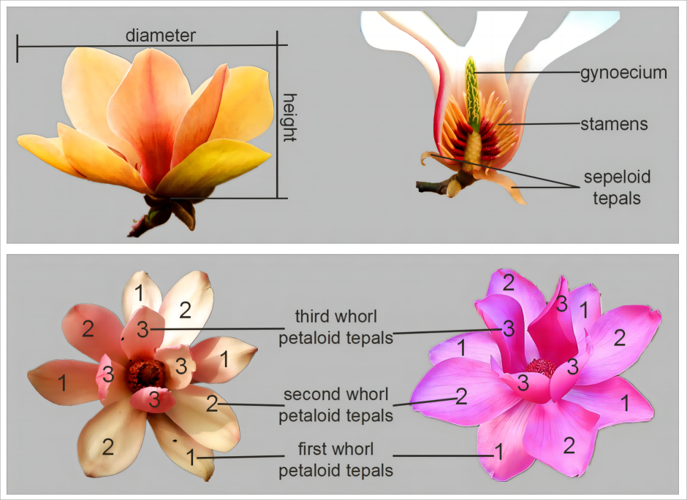  Sepaloid tepals are the first whorl tepals whose shape or texture are obviously different with those petaloid tepals.  If no sepaloid tepals, first whorl of tepals are the first whorl petaloid tepals.
(f) | The main color is the color with the largest surface area, the secondary color is the color with the second largest surface area, and the tertiary color is the color with the third largest surface area. In cases where the area of the main and secondary color are too similar to reliably decide which color has the largest area, the darker color is considered to be the main color. In cases where the area of the secondary and tertiary color are too similar to reliably decide which color has the second largest area, the darker color is considered to be the secondary color.

8.2 | Explanations for individual characteristics
Ad. 2: Plant: growth habit

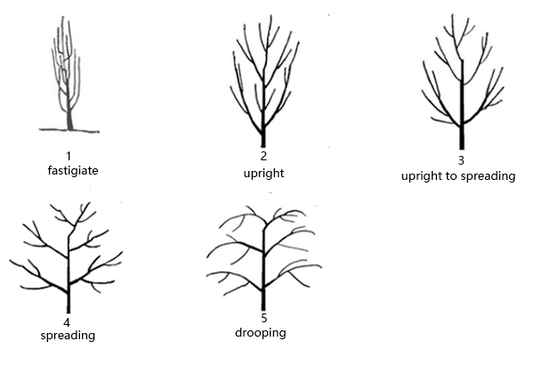

Ad. 4: Plant: position of flower buds on branch

Observations should be made at time of beginning of flowering.
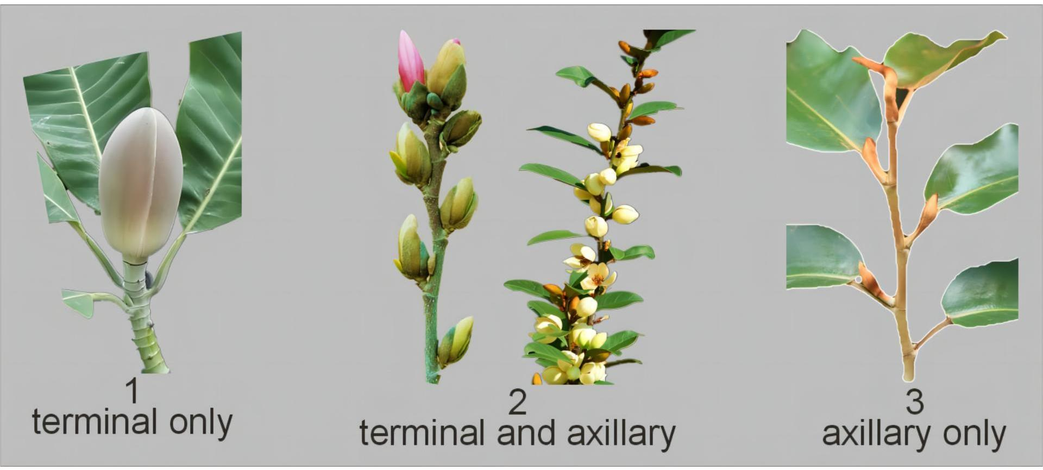

Ad. 5: Plant: number of terminal or axillary flowers on branch

Observations should be made at time of beginning of flowering.
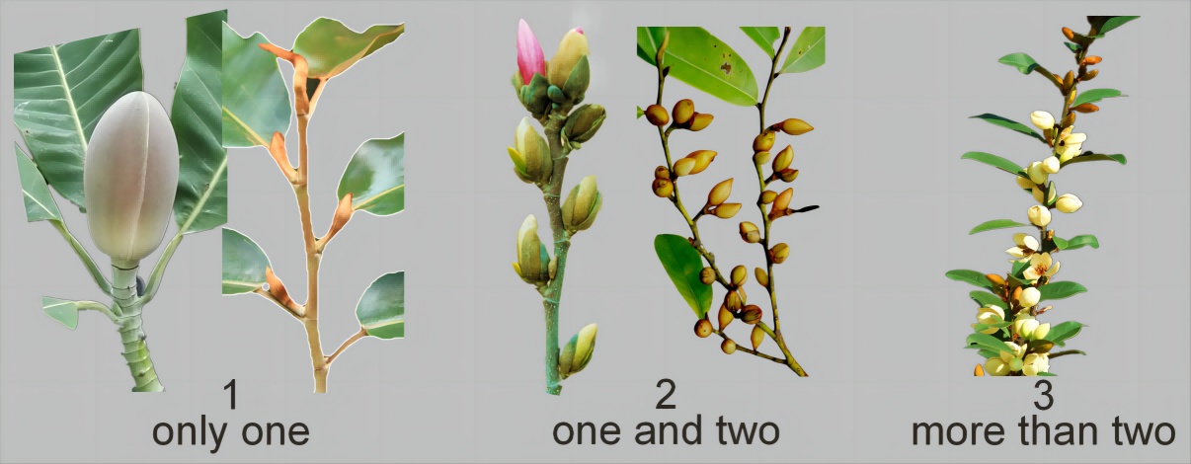

Ad. 6: Plant: number of fruit in relation to flowers

Observations should be made four months after flowering begins.

Ad. 7: Flowering shoot: length of internodes

Observations should be made on the middle third of a flowering shoot.

Ad. 8: One-year-old shoot: color

Observations should be made on the side exposed to the sun.

Ad. 9: Young leaf blade: anthocyanin coloration of upper side

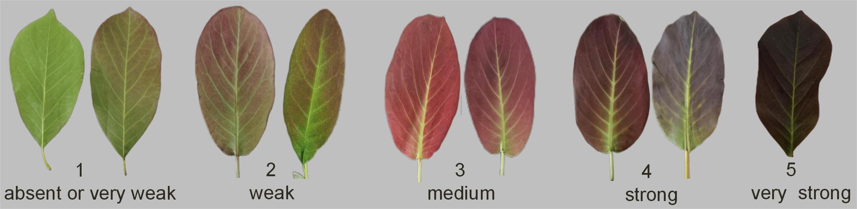

Ad. 12: Leaf blade: length

Observations should be made excluding the petiole.

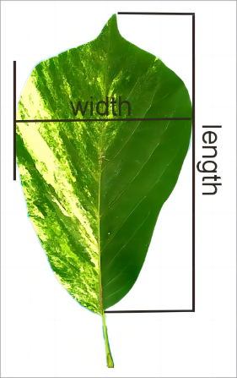

Ad. 13: Leaf blade: width

See Ad.12.

Ad. 14: Leaf blade: ratio length/width

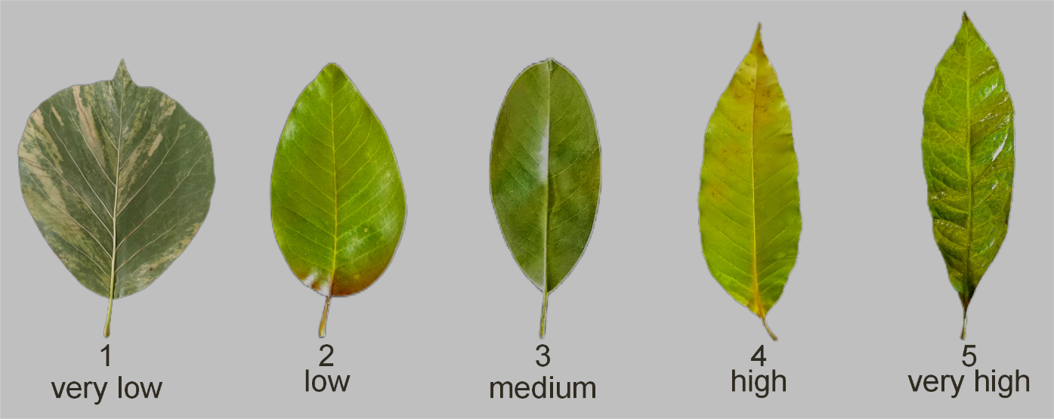
very low: <1.5
low: ≥1.5 to <2.0
medium: ≥ 2.0 to <2.5
high: ≥ 2.5 to <3.0
very high: ≥ 3.0

Ad. 15: Leaf blade: shape

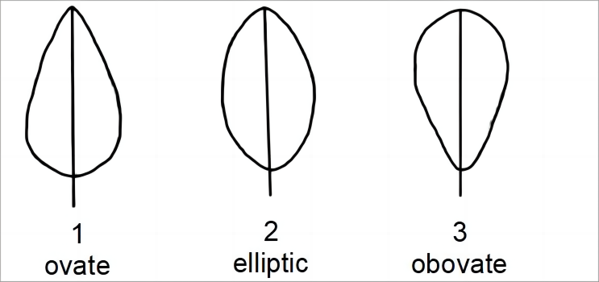

Ad. 16: Leaf blade: shape of base

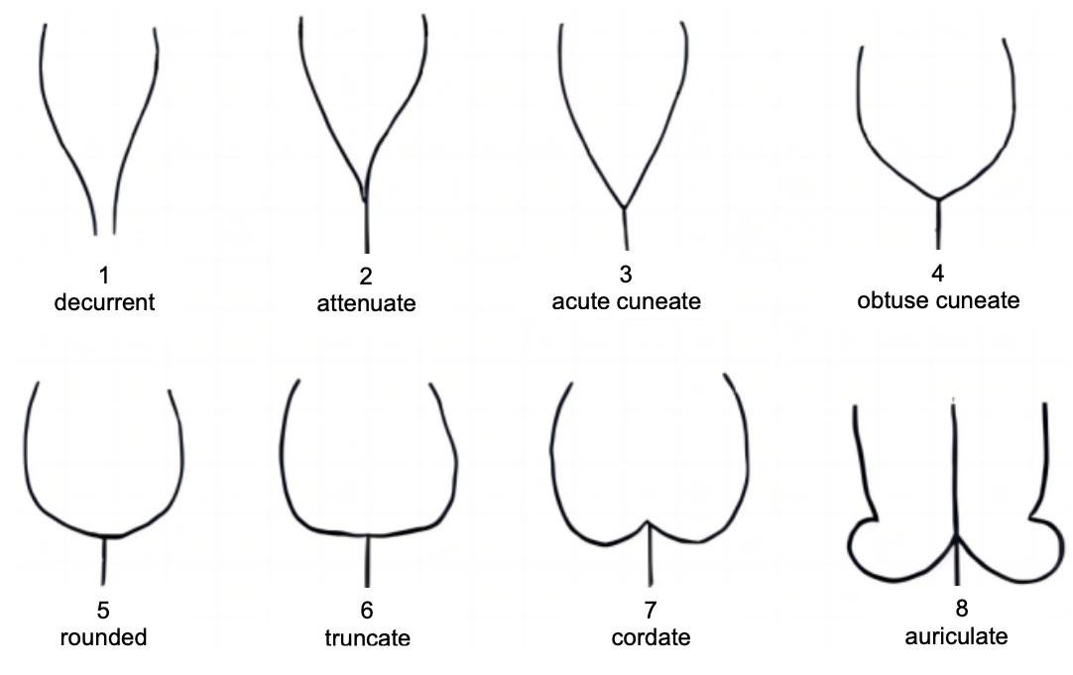

Ad. 17: Leaf blade: shape of apex

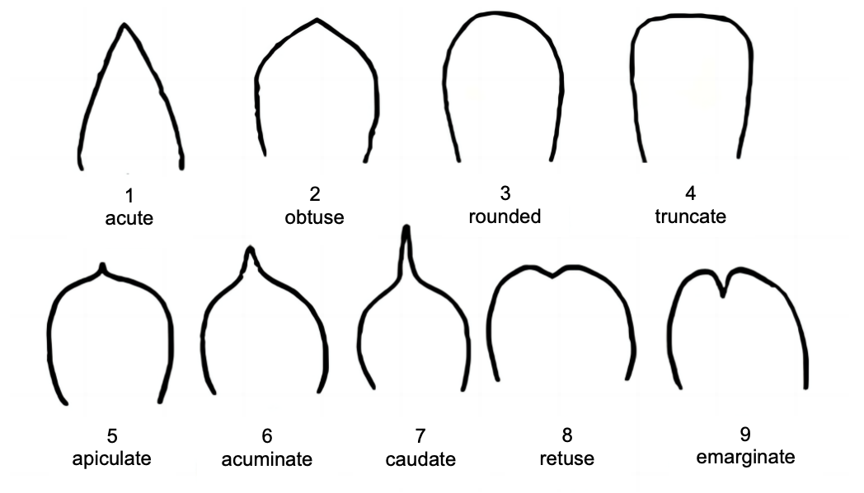

Ad. 19: Leaf blade: color of upper side

Observations should be made on the color covering the largest surface area.

Ad. 20: Only varieties with Plant: seasonality: deciduous: Leaf blade: color in autumn

Observations should be made shortly before leaf drop.

Ad. 21: Leaf blade: texture

Texture refers to the tactile sensations achieved by touching the leaf, such as thickness, softness, firmness, smoothness etc.
Leathery leaf: waxiness on surface of leaves, with a firm and thick texture, such as Magnolia grandiflora 'Bracken's Brown Beauty'.
Papery leaf: a pliable and thin texture, such as Magnolia denudata 'Jade Lamp'.

Ad. 23: Flower bud: color of spathaceous bract

Spathaceous bract: flower buds of Magnolias have big and obvious spathe-like bract with colorful hair or glabrous, membranous or leathery texture, which protect flower buds.

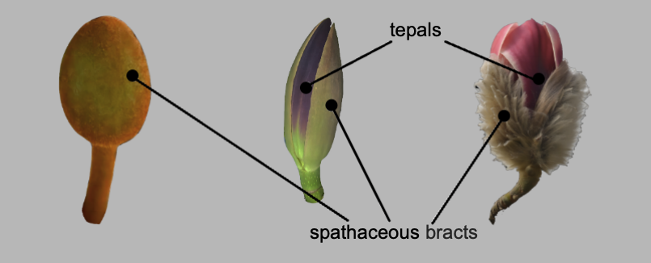

Observations should be made before the bud has opened.

Ad. 25: Flower: attitude

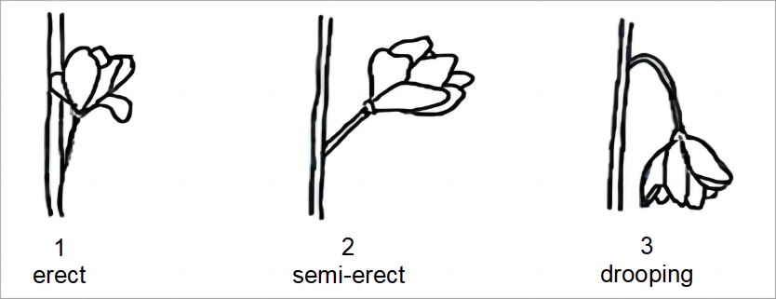

Ad. 26: Flower: height

Observations on goldfish-shaped or irregular flowers should be made from the upper edge of the flower pedicel to the upper edge of the upper tepals.

Ad. 28: Flower: form

Observations should be made in lateral view.
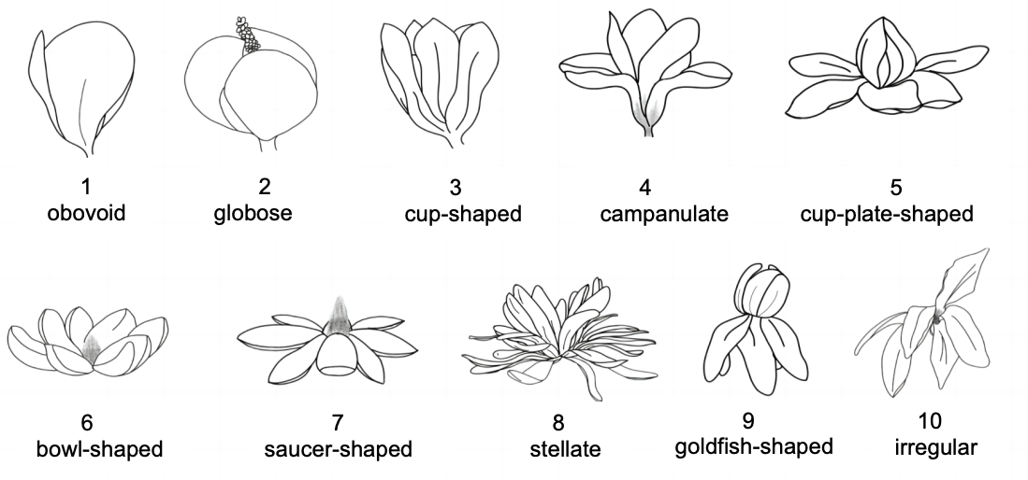

Ad. 29: Flower: number of tepals

very few: up to 6
few: from 7 to 10
medium: from 11 to 14
many: from 15 to 18
very many: more than 18

Ad. 30: Flower: sepaloid tepals

Observations should be made on the first whorl tepals at the beginning of flowering.

Ad. 32: First whorl petaloid tepals: attitude

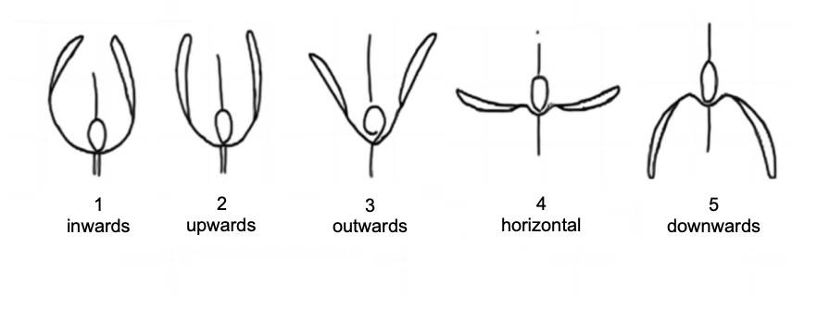

Ad. 34: First whorl petaloid tepals: width

Observations should be made at the broadest part of the tepal.

Ad. 35: First whorl petaloid tepals: shape

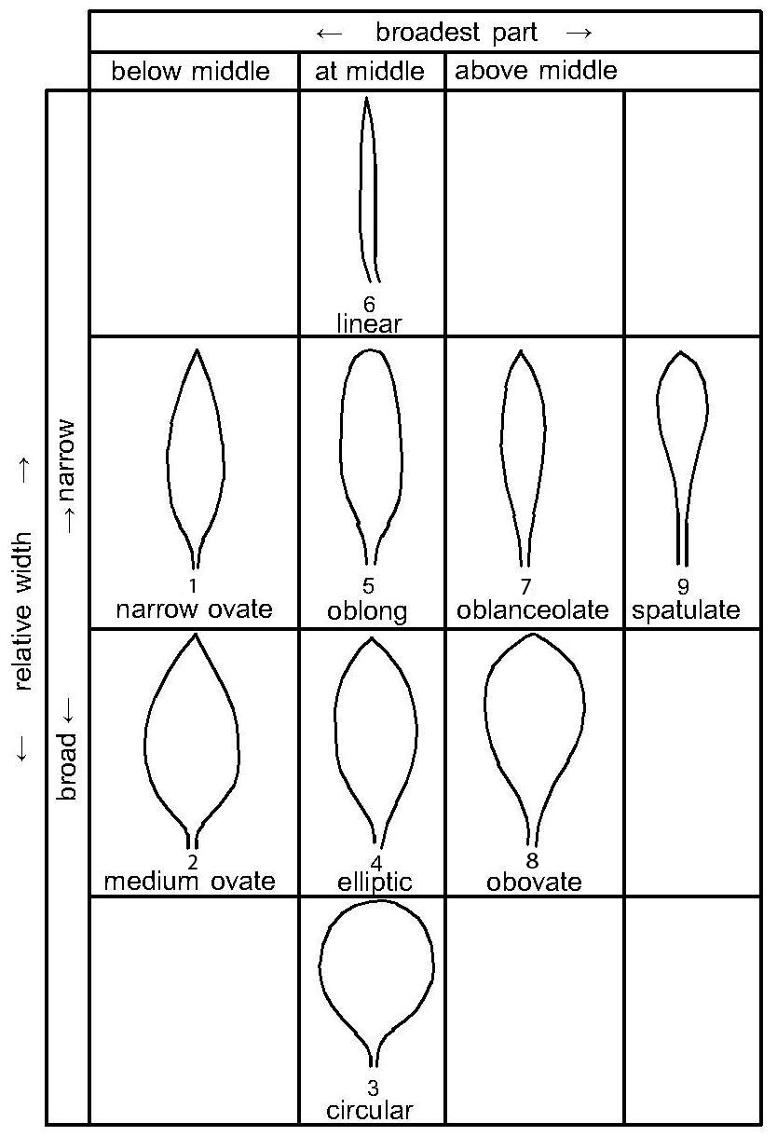

Ad. 36: First whorl petaloid tepals: shape in cross section

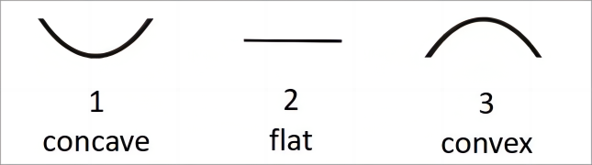

Ad. 39: First whorl petaloid tepals: distribution of secondary color on outer side

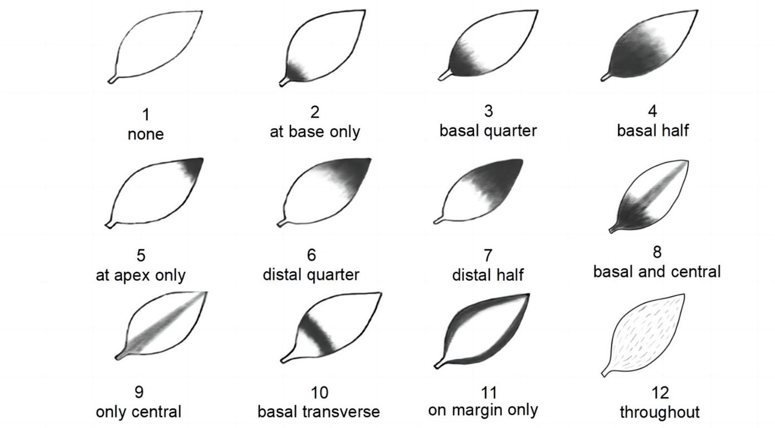

Ad. 40: First whorl petaloid tepals: pattern of secondary color on outer side

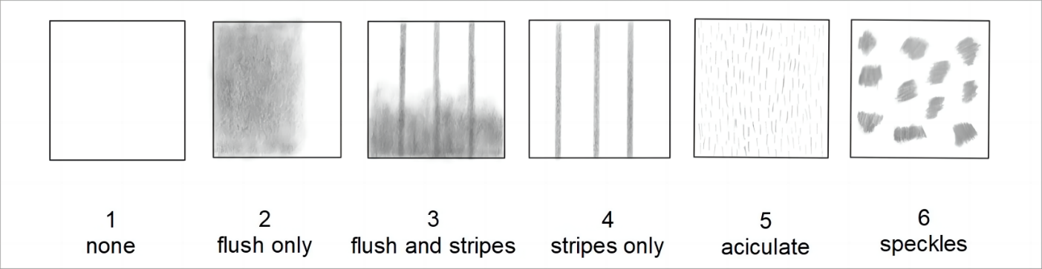

Ad. 44: First whorl petaloid tepals: distribution of secondary color on inner side

See Ad. 39.

Ad. 45: First whorl petaloid tepals: pattern of secondary color on inner side

See Ad. 40.

Ad. 46: First whorl tepals: texture

Texture refers to the tactile sensations achieved by touching the tepals, such as thickness, softness, firmness, smoothness etc.
Membranous tepals have a thin epidermis, without cutin thickening.
Fleshy tepals are soft and thick.
Leathery tepals are waxy on the surface, with a firm and thick texture.

Ad. 47: Second whorl petaloid tepals: attitude

See Ad. 32.

Ad. 50: Second whorl petaloid tepals: distribution of secondary color on outer side

See Ad. 39.

Ad. 51: Second whorl petaloid tepals: pattern of secondary color on outer side

See Ad. 40.

Ad. 54: Time of beginning of first flowering

Observation should be made when more than 3% flower buds bloom on all plants.
In the case of more than one flowering period, the first flowering period should be observed.

Ad. 55: Length of flowering period

Observation should be made for the full time of flowering, from beginning to end. In the case of more than one flowering period, the first flowering period should be observed.
The time of beginning of flowering occurs when at least 3% of the flower buds open on all plants.
The end of flowering occurs when less than 3% of flowers are left in bloom on all plants.

Ad. 56: Flowering: frequency

The frequency is defined by the number of flowering periods within a growing season.
One flowering period is from the beginning to the end of blooming.
See Ad. 55.

Ad. 57: Only varieties with Plant: seasonality: deciduous: Time of leaf fall

Observations should be made when 50% of leaves on all plants have fallen from the plants.

9. | Literature

Callaway, D. J., 1994: The World of Magnolias. Timber Press, Oregon.
Figlar, R. B., Nooteboom, H. P., 2004: Notes on Magnoliaceae IV. Blumea, 49: 87-100.
Gardiner J, 2000: Magnolias: A Gardener' s Guide. Timber Press. Portland.
Lobdell, M. S., 2021: Register of Magnolia cultivars. HortScience, 56: 1614-1675.
Xia, N.H., Liu Y.H., Nooteboom H.P., 2008: Magnoliaceae. In: Wu ZY et al, Flora of China Vol.7. Science Press and Missouri Botanical Garden Press, pp. 47-91.

10. | Technical Questionnaire

TECHNICAL QUESTIONNAIRE | Page {x} of {y} | Reference Number:

Application date:
(not to be filled in by the applicant)
TECHNICAL QUESTIONNAIRE
to be completed in connection with an application for plant breeders' rights

1. | Subject of the Technical Questionnaire
 | 1.1 | Botanical name | Magnolia L.
 | 1.2 | Common name | Magnolia
 | 1.3 | Species (please indicate):

2. | Applicant
 | Name
 | Address
 | Telephone No.
 | Fax No.
 | E-mail address
 | Breeder (if different from
 | applicant)

3. | Proposed denomination and breeder's reference
 | Proposed denomination
 | (if available)
 | Breeder's reference

TECHNICAL QUESTIONNAIRE |  |  | Page {x} of {y} | Reference Number:
#4. | Information on the breeding scheme and propagation of the variety
 | 4.1 | Breeding scheme
 | Variety resulting from:
4.1.1 | Crossing
(a) | controlled cross | [ ]
(please state parent variety)

(…………………..……………..…) x (……………..…………………..…)

female parent male parent

(b) | partially known cross | [ ]
(please state known parent variety(ies))

(…………………..……………..…) x (……………..…………………..…)

female parent male parent

(c) | unknown cross | [ ]
4.1.2 | Mutation  (please state parent variety) | [ ]
4.1.3 | Discovery and development  (please state where and when discovered and how developed) | [ ]
4.1.4 | Other  (Please provide details) | [ ]

TECHNICAL QUESTIONNAIRE | Page {x} of {y} | Reference Number:

 | 4.2 | Method of propagating the variety
4.2.1 | Vegetative propagation
(a) | Cuttings | [ ]
(b) | In vitro propagation | [ ]
(c) | Division | [ ]
(d) | Budding and grafting (please specify rootstock): | [ ]
(e) | Other (state method) | [ ]
4.2.2 | Other  (Please provide details) | [ ]

TECHNICAL QUESTIONNAIRE | Page {x} of {y} | Reference Number:

5. | Characteristics of the variety to be indicated (the number in brackets refers to the corresponding characteristic in Test Guidelines; please mark the note which best corresponds).

 | Characteristics | Example Varieties | Note
5.1  (1) | Plant: seasonality
 | deciduous | Burgundy, Yellow Bird | 1 [ ]
 | evergreen | Bracken`s Brown Beauty, Purple Queen | 2 [ ]
5.2  (4) | Plant: position of flower buds on branch
 | terminal only | Bracken`s Brown Beauty, Frank's Masterpiece | 1 [ ]
 | terminal and axillary | Mag`s Pirouette, Yellow Bird | 2 [ ]
 | axillary only | Purple Queen | 3 [ ]
5.3  (21) | Leaf blade: texture
 | thin-papery | Mag`s Pirouette | 1 [ ]
 | thick-papery | Jade Lamp | 2 [ ]
 | thin-leathery | Purple Queen | 3 [ ]
 | thick-leathery | Bracken`s Brown Beauty | 4 [ ]
5.4  (25) | Flower: attitude
 | erect | Bracken`s Brown Beauty | 1 [ ]
 | semi-erect | Burgundy | 2 [ ]
 | drooping | Qingxin | 3 [ ]
5.5  (27) | Flower: diameter
 | very small | Purple Queen | 1 [ ]
 | very small to small |  | 2 [ ]
 | small | Jade Lamp | 3 [ ]
 | small to medium |  | 4 [ ]
 | medium | Bracken`s Brown Beauty | 5 [ ]
 | medium to large |  | 6 [ ]
 | large | Frank's Masterpiece | 7 [ ]
 | large to very large |  | 8 [ ]
 | very large | Mossman`s Giant | 9 [ ]

 | Characteristics | Example Varieties | Note
5.6  (28) | Flower: form
 | obovoid | Sun Spire | 1 [ ]
 | globose |  | 2 [ ]
 | cup-shaped | Yellow Bird | 3 [ ]
 | campanulate | Burgundy | 4 [ ]
 | cup-plate-shaped |  | 5 [ ]
 | bowl-shaped | Bracken`s Brown Beauty | 6 [ ]
 | saucer-shaped |  | 7 [ ]
 | stellate | Mag`s Pirouette | 8 [ ]
 | goldfish-shaped | Silver Parasol | 9 [ ]
 | irregular | Betty | 10 [ ]
5.7  (29) | Flower: number of tepals
 | very few | Purple Queen | 1 [ ]
 | few | Burgundy | 2 [ ]
 | medium | Diva | 3 [ ]
 | many | Jade Lamp | 4 [ ]
 | very many | Mag`s Pirouette | 5 [ ]
5.8  (31) | Flower: fragrance
 | absent or weak | Mag`s Pirouette | 1 [ ]
 | medium | Bracken`s Brown Beauty | 2 [ ]
 | strong | Purple Queen | 3 [ ]
5.9(i)  (37) | First whorl petaloid tepals: main color on outer side
 | RHS Colour Chart（indicate reference number）
5.9(ii)  (37) | First whorl petaloid tepals: main color on outer side
 | white |  | 1 [ ]
 | green |  | 2 [ ]
 | yellow |  | 3 [ ]
 | red pink |  | 4 [ ]
 | red |  | 5 [ ]
 | purple |  | 6 [ ]
 | other (please specify) |  | 7 [ ]

 | Characteristics | Example Varieties | Note
5.10(i)  (38) | First whorl petaloid tepals: secondary color on outer side
 | RHS Colour Chart (indicate reference number)
5.10(ii)  (38) | First whorl petaloid tepals: secondary color on outer side
 | white |  | 1 [ ]
 | green |  | 2 [ ]
 | yellow |  | 3 [ ]
 | red pink |  | 4 [ ]
 | red |  | 5 [ ]
 | purple |  | 6 [ ]
 | other (please specify) |  | 7 [ ]
5.11  (39) | First whorl petaloid tepals: distribution of secondary color on outer side
 | none | Bracken`s Brown Beauty | 1 [ ]
 | at base only | Jade Lamp | 2 [ ]
 | basal quarter |  | 3 [ ]
 | basal half | Yellow Bird | 4 [ ]
 | at apex only |  | 5 [ ]
 | distal quarter |  | 6 [ ]
 | distal half |  | 7 [ ]
 | basal and central |  | 8 [ ]
 | only central |  | 9 [ ]
 | basal transverse |  | 10 [ ]
 | on margin only |  | 11 [ ]
 | throughout |  | 12 [ ]
5.12  (40) | First whorl petaloid tepals: pattern of secondary color on outer side
 | none | Bracken`s Brown Beauty | 1 [ ]
 | flush only | Yellow Bird | 2 [ ]
 | flush and stripes | Lv Xing | 3 [ ]
 | stripes only |  | 4 [ ]
 | aciculate |  | 5 [ ]
 | speckles |  | 6 [ ]

 | Characteristics | Example Varieties | Note
5.13  (42) | First whorl petaloid tepals: main color on inner side
 | white |  | 1 [ ]
 | green |  | 2 [ ]
 | yellow |  | 3 [ ]
 | red pink |  | 4 [ ]
 | red |  | 5 [ ]
 | purple |  | 6 [ ]
 | other (please specify) |  | 7 [ ]
5.14(i)  (48) | Second whorl petaloid tepals: main color on outer side
 | RHS Colour Chart (indicate reference number)
5.14(ii)  (48) | Second whorl petaloid tepals: main color on outer side
 | white |  | 1 [ ]
 | green |  | 2 [ ]
 | yellow |  | 3 [ ]
 | red pink |  | 4 [ ]
 | red |  | 5 [ ]
 | purple |  | 6 [ ]
 | other (please specify) |  | 7 [ ]
5.15  (54) | Time of beginning of first flowering
 | very early |  | 1 [ ]
 | early | Mag`s Pirouette | 2 [ ]
 | medium | Burgundy | 3 [ ]
 | late | Hong Jixing | 4 [ ]
 | very late | Bracken`s Brown Beauty, Qingxin | 5 [ ]
5.16  (56) | Flowering: frequency
 | once | Diva | 1 [ ]
 | twice | Yellow Bird | 2 [ ]
 | more than twice | Purple Queen | 3 [ ]

TECHNICAL QUESTIONNAIRE | Page {x} of {y} | Reference Number:

6. | Similar varieties and differences from these varieties
Please use the following table and box for comments to provide information on how your candidate variety differs from the variety (or varieties) which, to the best of your knowledge, is (or are) most similar. This information may help the examination authority to conduct its examination of distinctness in a more efficient way.

Denomination(s) of variety(ies) similar to your candidate variety | Characteristic(s) in which your candidate variety differs from the similar variety(ies) | Describe the expression of the characteristic(s) for the similar variety(ies) | Describe the expression of the characteristic(s) for your candidate variety

Example | Flower: number of tepals | medium | few

 | Comments:

TECHNICAL QUESTIONNAIRE | Page {x} of {y} | Reference Number:

#7. | Additional information which may help in the examination of the variety
7.1 | In addition to the information provided in sections 5 and 6, are there any additional characteristics which may help to distinguish the variety?
 | Yes | [ ] | No | [ ]
 | (If yes, please provide details)
7.2 | Are there any special conditions for growing the variety or conducting the examination?
 | Yes | [ ] | No | [ ]
 | (If yes, please provide details)
7.3 | Other information
A representative color photograph of the variety displaying its main distinguishing feature(s), should accompany the Technical Questionnaire. The photograph will provide a visual illustration of the candidate variety which supplements the information provided in the Technical Questionnaire.
The key points to consider when taking a photograph of the candidate variety are:
• Indication of the date and geographic location
• Correct labeling (breeder’s reference)
• Good quality printed photograph (minimum 10 cm x 15 cm) and/or sufficient resolution electronic format version (minimum 960 x 1280 pixels)”
Further guidance on providing photographs with the Technical Questionnaire is available in document TGP/7 "Development of Test Guidelines", Guidance Note 35 (http://www.upov.int/tgp/en/).
[The link provided may be deleted by members of the Union when developing authorities’ own test guidelines.]

TECHNICAL QUESTIONNAIRE | Page {x} of {y} | Reference Number:

8. | Authorization for release
 | (a) | Does the variety require prior authorization for release under legislation concerning the protection of the environment, human and animal health?
 |  | Yes | [ ] | No | [ ]
 | (b) | Has such authorization been obtained?
 |  | Yes | [ ] | No | [ ]
 | If the answer to (b) is yes, please attach a copy of the authorization.

9. Information on plant material to be examined or submitted for examination

9.1 The expression of a characteristic or several characteristics of a variety may be affected by factors, such as pests and disease, chemical treatment (e.g. growth retardants or pesticides), effects of tissue culture, different rootstocks, scions taken from different growth phases of a tree, etc.
9.2 The plant material should not have undergone any treatment which would affect the expression of the characteristics of the variety, unless the competent authorities allow or request such treatment. If the plant material has undergone such treatment, full details of the treatment must be given. In this respect, please indicate below, to the best of your knowledge, if the plant material to be examined has been subjected to:

 | (a) | Microorganisms (e.g. virus, bacteria, phytoplasma) | Yes [ ] | No [ ]
 | (b) | Chemical treatment (e.g. growth retardant, pesticide) | Yes [ ] | No [ ]
 | (c) | Tissue culture | Yes [ ] | No [ ]
 | (d) | Other factors | Yes [ ] | No [ ]
 | Please provide details for where you have indicated “yes”.

10. | I hereby declare that, to the best of my knowledge, the information provided in this form is correct:
 | Applicant’s name
 | Signature |  | Date

[End of document]

